VALUATION REPORT

________________________________________________________________

OF PROPERTY:

M/S. GRAINOTCH INDUSTRIES LTD.
INDUSTRIAL BUILDING ON GAT NO. 238+239, AT VILLAGE BHENDALA, TAL- GANGAPUR, DIST-AURANGABAD.

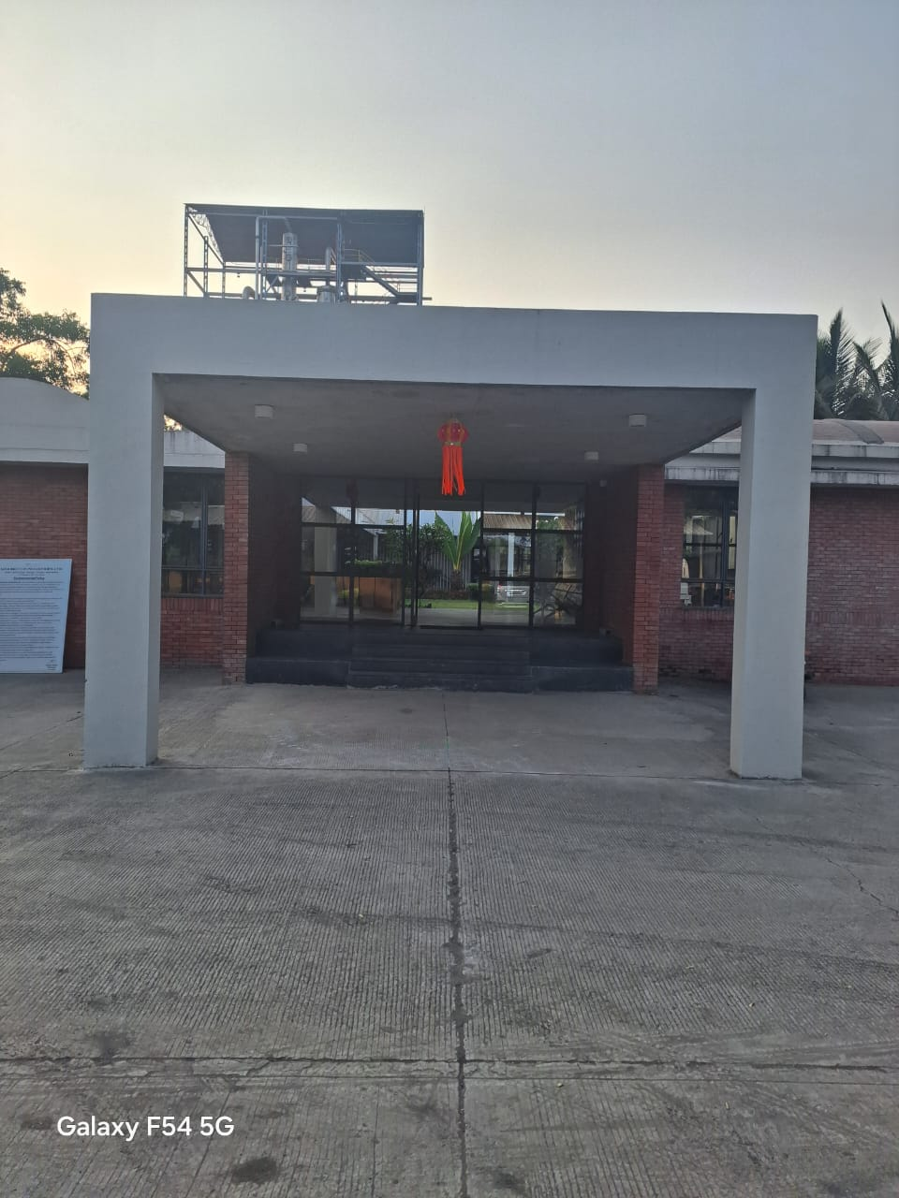

SHIVAJI D. PINGALE

B.E(CIVIL), M.I.E., F.I.V.

GOVT. REGD. VALUER, 34 AB REGN. NO. CCIT/I/-44-28
IBBI REGD NO-IBBI/RV/02/2019/12252

Flat No. 5 RamkrushnaAppt, Near JanlaxmiBank, Opp Bosco Center, Gangapur Road,

Nashik-422013. Cell: 9890278671, E-Mail. er.shivajipingale@gmail.com

TO, Date- 05/12/2024
THE CHIEF MANAGER,
STATE BANK OF INDIA,
SME BRANCH, NASHIK.

Subject: Submission of Valuation Report
Name of The Borrower | M/S. Grainotch Industries Ltd.  Industrial Building On Gat No. 238+239, At Village Bhendala, Tal- Gangapur, Dist-Aurangabad.
Address of Property | M/S. Grainotch Industries Ltd.  Industrial Building On Gat No. 238+239, At Village Bhendala, Tal- Gangapur, Dist-Aurangabad.

Sir,
Please find herewith Valuation Report as mentioned in the subject line.
We assure you our best services in future also.
With Regards,
Thanking You,

Yours’ Sincerely,

SHIVAJI D. PINGALE
GOVT. REGD. VALUER
34 AB REGN. NO. CCIT/I/-44-28/2009-10
IBBI REGN. NO.- IBBI/RV/02/2019/12252

TO, Date- 05/12/2024
THE CHIEF MANAGER,
STATE BANK OF INDIA,
SME BRANCH, NASHIK.

VALUATION REPORT OF INDUSTRIAL LAND & BUILDING.
Valuation Of The Property  Belonging To | M/S. Grainotch Industries Ltd.  Industrial Building On Gat No. 238+239, At Village Bhendala, Tal- Gangapur, Dist-Aurangabad.
Purpose | For Obtaining Fair Market Value Of Property.
Valuation As On | 05/12/2024
Address Of Property | M/S. Grainotch Industries Ltd.  Industrial Building On Gat No. 238+239, At Village Bhendala, Tal- Gangapur, Dist-Aurangabad.
Fair Market Value | Rs. 26,82,31,000.00  (Rs. Twenty six crores eighty two lakhs thirty one thousand Only)
Realizable Value | Rs. 24,14,08,000.00  (Rs. Twenty four crores fourteen lakhs eight thousand Only)
Forced Sale Value. | Rs. 21,72,67,000.00  (Rs. Twenty one crores seventy two lakhs sixty seven thousand Only)
Insurable Value | Rs. 03,25,08,000.00  (Rs. Three Crores Twenty Five Lakhs Eight Thousand Only)
Government Value | Rs. 30,35,84,000.00  (Rs. Thirty Cores Thirty Five Lakhs Eighty Four Thousand Only)

SHIVAJI D. PINGALE
GOVT. REGD. VALUER
34 AB REGN. NO. CCIT/I/-44-28/2009-10
IBBI REGN. NO.- IBBI/RV/02/2019/12252

Annexure-I
Summary Valuation Report On Properties Owned By M/S. Grainotch Industries Ltd.
Sr.No. | Particulars | Details/Information
1 | Name Of The Branch | State Bank Of India, SME Branch, Nashik.
2 | Name Of The Borrower | M/S. Grainotch Industries Ltd.  Industrial Building On Gat No. 238+239, At Village Bhendala,  Tal- Gangapur, Dist-Aurangabad.
3 | Name Of The Valuer | Shivaji D. Pingale, Govt. Regd. Valuer Regn. No. CCIT/34ab/CAT-I/44-28
4 | Date Of Visit By Valuer | 04/12/2024
5 | Description Of Property
a) | Name Of The Owner/Mortgagor | M/S. Grainotch Industries Ltd.  Industrial Building On Gat No. 238+239, At Village Bhendala,  Tal- Gangapur, Dist-Aurangabad.
b) | Extent Of Area ( In Sqm.) | Total area of Gat No. 238+239 = 95,400.00 Sqm  Total built up area = 12,647.419 sqm
c) | Area Considered for Valuation Purpose | Total area of Gat No. 238+239 = 95,400.00 Sqm  Total built up area = 12,647.419 sqm
d) | P. No./Survey No./Gut No. | Gat No. 238+239
e) | Type Of Property | Free-Hold Property
f) | Nature Of Property | Industrial Land & Building
g) | In Possession Of | Owner Occupied
h) | Location | At Village Bhendala, Tal- Gangapur, Dist-Aurangabad.
i) | Boundaries | Identified
j) | Age Of Building | Under Construction.
k) | Future Life Of Building | 60Years
l) | Fair Market Value | Rs. 26,82,31,000.00  (Rs. Twenty six crores eighty two lakhs thirty one thousand Only)
m) | Realizable Value | Rs. 24,14,08,000.00  (Rs. Twenty four crores fourteen lakhs eight thousand Only)
n) | Forced Sale Value. | Rs. 21,72,67,000.00  (Rs. Twenty one crores seventy two lakhs sixty seven thousand Only)
o) | Insurable Value | Rs. 03,25,08,000.00  (Rs. Three Crores Twenty Five Lakhs Eight Thousand Only)
p) | Government Value | Rs. 30,35,84,000.00  (Rs. Thirty Cores Thirty Five Lakhs Eighty Four Thousand Only)

Place: NASHIK
Date: 05/12/2024
SHIVAJI D. PINGALE
GOVT. REGD. VALUER
34 AB REGN. NO. CCIT/I/-44-28/2009-10
IBBI REGN. NO.- IBBI/RV/02/2019/12252

Annexure-XIV

Format-A

TO,  THE CHIEF MANAGER,  STATE BANK OF INDIA,  SME BRANCH, NASHIK. | SBI /2024  Date: 05/12/2024

VALUATION REPORT (IN RESPECT OF LAND / SITE AND BUILDING)
I. GENERAL
1. | Purpose for which the valuation is made |  |  |  |  |  |  | FOR OBTAINING FAIR MARKET VALUE OF PROPERTY.
2. | a) |  | Date of inspection |  |  |  |  | 04/12/2024
2. | b) |  | Date on which the valuation is made |  |  |  |  | 05/12/2024
3. | List of documents produced for perusal |  |  |  |  |  |  | Sale deed of Plot, MOU regarding the area distribution between plot owners, BCC, approved building plan etc.
3. | i) Assignment of Lease Deed |  |  |  |  |  |  | NSN1-4998-2021. Dated – 29/06/2021
3. | ii) Approved Building Layout with Approval no. |  |  |  |  |  |  | A.D.T.P. Town Planning Aurangabad.  A/P/We/MH/15/7333. Dated- 19/09/2016
3. | iii) Building Commencement Certificate |  |  |  |  |  |  | Not provided
3. | iii) Completion Certificate with No. |  |  |  |  |  |  | Not provided
 | iv)NA order |  |  |  |  |  |  | Collector of Aurangabad.  Vide letter no. 163/08. Dated – 31/07/2009.
4. | Name of the owner(s) and his / their address (es) with Phone no. (details of share of each owner in case of joint ownership) |  |  |  |  |  |  | M/S. Grainotch Industries Ltd.  Industrial Building On Gat No. 238+239, At Village Bhendala,  Tal- Gangapur, Dist-Aurangabad.
5. | Brief description of the property (Including leasehold / freehold etc) |  |  |  |  |  |  | Free- Hold Property  Industrial Building On Gat No. 238+239, At Village Bhendala,  Tal- Gangapur, Dist-Aurangabad.  Surrounding area is well developed for commercial and Residential Purpose. It is R.C.C Structure having Kota stone & Vitrified Tiles Flooring, flush doors, aluminium sliding windows and etc.
6. |  | Location of property
 |  | a) |  |  | Plot No. / Survey No. |  |  | Gat No. 238+239
 |  | b) |  |  | Door No. |  |  | Gat No. 238+239
 |  | c) |  |  | T. S. No. / Village |  |  | Bhendala
 |  | d) |  |  | Ward / Taluka |  |  | Gangapur
 |  | e) |  |  | Mandal / District |  |  | Aurangabad
7. |  | Postal address of the property |  |  |  |  |  | Industrial Building On Gat No. 238+239, At Village Bhendala,  Tal- Gangapur, Dist-Aurangabad.
8. |  | City / Town |  |  |  |  |  | At Village Bhendala,  Tal- Gangapur, Dist-Aurangabad.
 |  | Residential Area |  |  |  |  |  | No.
 |  | Commercial Area |  |  |  |  |  | No.
 |  | Industrial Area |  |  |  |  |  | Yes.
9. |  | Classification of the area
 |  | i) |  | High / Middle / Poor |  |  |  | Middle Class
 |  | ii) |  | Urban / Semi Urban / Rural |  |  |  | Semi Urban area.
10 |  | Coming under Corporation limit / Village Panchayat / Municipality |  |  |  |  |  | Village Panchayat
11 |  | Whether covered under any State / Central Govt. enactments (e.g. Urban Land Ceiling Act) or notified under agency area / |  |  |  |  |  | No
12 |  | In case it is an agricultural land, any conversion to house site plots is contemplated |  |  |  |  |  | No. it is Non-Agricultural plot
13. |  | Boundaries of the property
 |  |  |  |  |  | As per Approved Agreement. |  |  |  |  | As per Actual
 |  | North |  |  |  | Gat no. 239 |  |  |  |  | Gat no. 239
 |  | South |  |  |  | Gat no. 229 |  |  |  |  | Gat no. 229
 |  | East |  |  |  | Bahargaon to Bhendala Road |  |  |  |  | Bahargaon to Bhendala Road
 |  | West |  |  |  | Gat no. 2 |  |  |  |  | Gat no. 2
 |  |  |  |  |  | Both Boundaries Are Matched.
14.1 |  | Dimensions of the site
 |  |  |  |  |  |  | As per Plan |  | As per Actual Site Inspection
 |  | North |  |  |  |  | ----- |  | -----
 |  | South |  |  |  |  | ----- |  | -----
 |  | East |  |  |  |  | ----- |  | -----
 |  | West |  |  |  |  | ----- |  | -----
14.2 |  | Latitude, Longitude and Coordinates of the site |  |  |  |  |  |  | Latitude = 19.692561  Longitude = 75.069242
15 |  | Extent of the site |  |  |  |  |  |  | Total area of Gat No. 238+239 = 95,400.00 Sqm  Total built up area = 12,647.419 sqm
16 |  | Extent of the site considered for valuation (least of 14 A & 14 B) |  |  |  |  |  |  | Total area of Gat No. 238+239 = 95,400.00 Sqm  Total built up area = 12,647.419 sqm
17 |  | Whether occupied by the owner / tenant? If occupied by tenant, since how long? Rent received per month. |  |  |  |  |  |  | Under construction
II. CHARACTERISTICS OF THE SITE
1. |  | Classification of locality |  |  |  |  |  |  | It is Industrial & Agriculture Area
2. |  | Development of surrounding areas |  |  |  |  |  |  | Surrounding Area is Developed for Industrial Purpose.
3. |  | Possibility of frequent flooding / sub-merging |  |  |  |  |  |  | No.
4. |  | Feasibility to the Civic amenities like school, hospital, bus stop, market etc. |  |  |  |  |  |  | Civic Amenities are easily available From the Property.
5. |  | Level of land with topographical conditions |  |  |  |  |  |  | Levelled Plot
6. |  | Shape of land |  |  |  |  |  |  | Irregular
7. |  | Type of use to which it can be put |  |  |  |  |  |  | For Industrial Purpose.
8. |  | Any usage restriction |  |  |  |  |  |  | As per approved building plan: Industrial Purpose.
9. |  | Is plot in town planning approved layout? |  |  |  |  |  |  | Details are not Provided.
10 |  | Corner plot or intermittent plot? |  |  |  |  |  |  | Intermittent plot
11 |  | Road facilities |  |  |  |  |  |  | Available.
12 |  | Type of road available at present |  |  |  |  |  |  | Kaccha Road
13 |  | Width of road – is it below 20 ft. or more than 20 ft. |  |  |  |  |  |  | Above 20ft Wide Road.
14 |  | Is it a land – locked land? |  |  |  |  |  |  | No.
15 |  | Water potentiality |  |  |  |  |  |  | Available.
16 |  | Underground sewerage system |  |  |  |  |  |  | Available.
17 |  | Is power supply available at the site? |  |  |  |  |  |  | Available.
18 |  | Advantage of the site
18.1 |  | Property is Situated in well Developed Industrial Area, which is very near from the Bahargaon to Bhendala Road.
18.2 |  | Civic Amenities like Schools, Hospitals, Market area are Near from the Property.
19 |  | Special remarks, if any, like threat of acquisition of land for public service purposes, road widening or applicability of CRZ provisions etc. (Distance from sea-coast / tidal level must be incorporated) |  |  |  |  |  |  | N/A.
Part – A (Valuation of land)
1. |  | Size of plot |  |  |  |  |  |  | Total area of plot = 95,400.00 Sqm
 |  | North & South |  |  |  |  |  |  | N/A.
 |  | East & West |  |  |  |  |  |  | N/A.
2. |  | Total extent of the plot |  |  |  |  |  |  | Total area of plot = 95,400.00 Sqm
3. |  | Prevailing market rate |  |  |  |  |  |  | Rs. 1000 /- sqm
4. |  | Guideline rate obtained from the  Registrar’s Office (an evidence thereof to be enclosed) |  |  |  |  |  |  | Total area of plot = 95,400.00 Sqm X Rs. 960/- sqm =  Rs. 9,15,84,000.00  Total built up area = 12,647.419 sqm X Rs. 17600/- sqm =  Rs. 22,25,94,574.00  Govt valuation= Rs. 03,67,98,528.00  Say Rs. 03,67,99,000.00
5. |  | Assessed / adopted rate of valuation |  |  |  |  |  |  | Rs. 1000/- sqm
6. |  | Estimated value of land |  |  |  |  |  |  | Total area of plot = 95,400.00 Sqm X Rs. 1000/- sqm. = Rs. 9,54,00,000.00.
Part – B (Valuation of Building)
1. |  | Technical details of the building
1a) |  | Type of Building (Residential / Commercial / Industrial) |  |  |  |  |  |  | Industrial
1b) |  | Type of construction (Load bearing / RCC / Steel Framed) |  |  |  |  |  |  | R.C.C Structure
1c) |  | Year of construction |  |  |  |  |  |  | Under construction
 |  | Current Life Of the Structure |  |  |  |  |  |  | Under construction
 |  | Projected residual Life of the Structure |  |  |  |  |  |  | 60 Years.
1d) |  | Number of floors and height of each floor including basement, if any |  |  |  |  |  |  | Ground Floor Storyed with 3 Mt. Height of each floor.
1e) |  | Plinth area floor-wise |  |  |  |  |  |  | Built up area = 1326.87 sqm
1f) |  | Condition of the building
1f-i) |  | Exterior – Excellent, Good, Normal, Poor |  |  |  |  |  |  | Good
1f-ii) |  | Inferior - Excellent, Good, Normal, Poor |  |  |  |  |  |  | Good
1g) |  | Date of issue and validity of /building of approved map / plan |  |  |  |  |  |  | Approved Plan No. A/P/We/MH/15/7333.  Dated- 19/09/2016
1h) |  | Approved map / plan issuing authority |  |  |  |  |  |  | Maharashtra Industrial Development Corporation, Nashik.
1i) |  | Whether genuineness or authenticity of approved map / plan is verified |  |  |  |  |  |  | Yes.
1j) |  | Any other comments by our empanelled valuers on authentic of approved plan |  |  |  |  |  |  | Industrial Building is Constructed on as per plan sanctioned no Approved Plan No. A/P/We/MH/15/7333.  Dated- 19/09/2016
Specifications of construction (floor-wise) in respect of
S. No. |  | Description |  |  |  |  |  |  |  | Ground Floor
1. |  | Foundation |  |  |  |  |  |  |  | RCC footings.
2. |  | Basement
3. |  | Superstructure
4. |  | Joinery / Doors & Windows (please furnish details about size of frames, shutters, glazing, fitting etc. and specify the species of timber) |  |  |  |  |  |  |  | M.S. Rolling Shutter for Shed
5. |  | RCC works |  |  |  |  |  |  |  | R.C.C. work
6. |  | Plastering |  |  |  |  |  |  |  | ----
7. |  | Flooring, Skirting, dadoing |  |  |  |  |  |  |  | PCC & Vitrified tiles / Trimix flooring.
8. |  | Special finish as marble, granite, wooden panelling, grills, etc |  |  |  |  |  |  |  | Yes.
9. |  | Roofing including weather proof course |  |  |  |  |  |  |  | Yes.
10. |  | Drainage |  |  |  |  |  |  |  | Available.
S. No. |  | Description
2. |  | Compound wall |  |  |  |  |  |  |  | Available
 |  | Height |  |  |  |  |  |  |  | 2.0 Mt.
 |  | Length |  |  |  |  |  |  |  | Throughout the perimeter of plot.
 |  | Type of construction |  |  |  |  |  |  |  | Fencing compound Provided
3. |  | Electrical installation
 |  | Type of wiring |  |  |  |  |  |  |  | Casing capping Type electrification
 |  | Class of fittings (superior / ordinary / poor) |  |  |  |  |  |  |  | Ordinary
 |  | Number of light points |  |  |  |  |  |  |  | Sufficient
 |  | Fan points |  |  |  |  |  |  |  | Sufficient
 |  | Spare plug points |  |  |  |  |  |  |  | Sufficient
 |  | Any other item |  |  |  |  |  |  |  | Sufficient
4. |  | Plumbing installation
4a) |  | No. of water closets and their type |  |  |  |  |  |  |  | Sufficient
4b) |  | No. of wash basins |  |  |  |  |  |  |  | Sufficient
4c) |  | No. of urinals |  |  |  |  |  |  |  | Sufficient
4d) |  | No. of bath tubs |  |  |  |  |  |  |  | Sufficient
4e) |  | Water meter, taps, etc. |  |  |  |  |  |  |  | Sufficient
4f) |  | Any other fixtures |  |  |  |  |  |  |  | Sufficient

DETAILS OF VALUATION
Sr. No. | Description of structure | Measured built up Area  Sqm. | Depreciated Replacement cost Rs. Sqm | Depreciated Replacement cost Rs.
01 | Production Lab, Compressor Room Panel Room. RCC | 434.479 | 6,456.00 | 28,04,996.00
01 | G+2 Height 10m | 434.479 | 6,456.00 | 28,04,996.00
02 | Fermentation section shade G.I. Sheet Roof | 1150.09 | 8,608.00 | 98,99,974.00
02 | Height 13m | 1150.09 | 8,608.00 | 98,99,974.00
03 | Liquefaction Section Shed | 578.066 | 6,456.00 | 37,31,994.00
03 | G.I. Sheet Roof | 578.066 | 6,456.00 | 37,31,994.00
03 | Height 8m | 578.066 | 6,456.00 | 37,31,994.00
04 | Corn Oil Plant Roofing, | 669.14 | 10,760.00 | 71,99,946.00
04 | Colour coated Sheet Roof,
04 | (New), Height 8m
05 | Dryer & Storage | 1426.57 | 10,760.00 | 1,53,49,893.00
05 | Colour coated sheet roof, (New) height 10m | 1426.57 | 10,760.00 | 1,53,49,893.00
06 | Milling section | 76.208 | 10,760.00 | 8,19,998.000
06 | RCC Roof, G+3 | 76.208 | 10,760.00 | 8,19,998.000
06 | Height 15m | 76.208 | 10,760.00 | 8,19,998.000
07 | Grain handling Shed, | 226.76 | 10,760.00 | 24,39,937.00
07 | Colour Coated Sheet Roof, | 226.76 | 10,760.00 | 24,39,937.00
07 | Height 10m | 226.76 | 10,760.00 | 24,39,937.00
08 | Empty Grain Bags Storage | 92.936 | 6,456.00 | 5,99,994.00
08 | Colour coated Sheet Roof, | 92.936 | 6,456.00 | 5,99,994.00
08 | Heights 7m | 92.936 | 6,456.00 | 5,99,994.00
09 | ETP Office | 51.115 | 6,456.00 | 3,29,998.00
09 | RCC Roof | 51.115 | 6,456.00 | 3,29,998.00
10 | Decantation | 237.918 | 10,760.00 | 25,59,997.00
10 | RCC Roof G+3 | 237.918 | 10,760.00 | 25,59,997.00
10 | Height 13m | 237.918 | 10,760.00 | 25,59,997.00
11 | Spirit storage roofing | 464.68 | 10,760.00 | 49,99,956.00
11 | Colour coated sheet Roof, | 464.68 | 10,760.00 | 49,99,956.00
11 | Height 10m | 464.68 | 10,760.00 | 49,99,956.00
12 | Office Administration, (old) | 52.97 | 6,456.00 | 3,41,974.00
12 | Purchase | 52.97 | 6,456.00 | 3,41,974.00
13 | Account Store (old) | 52.97 | 5,380.00 | 2,84,978.00
14 | Office Empty Space ( Toilet & Wash Room) (Old) | 127.788 | 5,918.00 | 5,49,999.00
15 | General Manager & Server Room (Old) | 21.375 | 8,608.00 | 1,83,996.00
16 | Bottling plant 1 (IMFL), Colour coated sheet Roof, Height 8m | 1426.58 | 17,754.00 | 2,53,27,501.00
17 | New bottling plant 2 (CL), colour Coated sheet roof, height 8 | 1426.58 | 17,754.00 | 2,53,27,501.00
18 | Centre portion (between 2 bottling plants) IMFL & CL Office, Blend Storage | 618.029 | 10,760.00 | 66,49,992.00
19 | Guest house, RCC Height 4.2m | 325.278 | 5,380.00 | 17,49,995.00
20 | Security Guest House, colour coated sheet roof, height 3.5m | 213.75 | 6,456.00 | 13,79,970.00
21 | Security Toilet block, colour Coated sheet roof, height 3.5m | 39.49 | 4,304.00 | 1,69,964.00
22 | Security cabin RCC Roof | 32.52 | 4,304.00 | 1,39,966.00
23 | Weight bridge Cabin RCC Roof | 10.223 | 6,456.00 | 65,999.00
24 | D.G. Room, G.I Sheet Roof | 20.910 | 5,380.00 | 1,12,495.00
25 | Power house 3 MW Set, colour Coated Sheet Roof, height 10m | 232.34 | 10,760.00 | 24,99,978.00
26 | Boiler house, RCC Roof, G+1, Height 8m | 82.713 | 10,760.00 | 8,89,991.00
27 | Store, G.I. Sheet Roof | 144.05 | 6,456.00 | 9,29,986.00
28 | Coal handling System, RCC Roof, G+2 | 73.42 | 6,456.00 | 4,73,999.00
29 | Toilet Block, Roofing G.I. Sheet | 14.405 | 4,304.00 | 61,999.00
New Expansion- Additional Structures (2020-21)
01 | Bottling Plant 1 (IMFL) Colour coated sheet Roof, Height 8m (Extension) | 275.09 | 19,368.00 | 53,27,943.00
02 | Bottling Plant 2 (CL), colour Coated Sheet roof, Height 8m (Extension) | 275.09 | 19,368.00 | 53,27,943.00
03 | Staff Quarter/ Canteen, Roofing Colour Coated sheet, Height 4.5m | 228.810 | 8,608.00 | 19,69,596.00
04 | Changing room/ Security Cabin RCC, Height 12ft | 169.144 | 7,532.00 | 12,73,992.00
05 | Ethanol Loading & Unloading Shed, open shed Roofing Colour Coated sheet | 80.390 | 7,532.00 | 6,05,497.00
06 | Ethanol Storage Tank Shed, Roofing colour Coated sheet | 340.148 | 7,532.00 | 25,61,994.00
07 | Water Treatment Plant Shed (DM plant open Shed) | 315.055 | 7,532.00 | 23,72,994.00
08 | Admin Building, Office Building Front Site, RCC Ground Floor | 148.698 | 15,064.00 | 22,39,986.00
09 | Office building Front site, RCC Ground Floor | 145.910 | 15,064.00 | 21,97,988.00
10 | Office building Back Side RCC G+1 | 395.910 | 15,064.00 | 59,63,988.00
11 | Car parking Open Shed Roofing Colour Coated Sheet | 26.022 | 4,304.00 | 1,11,998.00
12 | Amenities/ Furniture/ Fixture- including new construction as follows
 | 1. Tar Roads 1800.00RMT |  |  | 2,50,00,000.00
 | 2. Ethanol underground storage tanks (2nos) 7 lakh liters cap |  |  | 2,50,00,000.00
 | 3. Compound Wall of over 1000.00 RMT |  |  | 2,50,00,000.00

 | Part C- (Extra Items) | Amount in Rs.
1. | Portico | NA
2. | Ornamental front door | NA
3. | Sit out/ Veranda with steel grills | NA
4. | Overhead water tank (20000 ltr X 35/- ltr) | NA
5. | Under Ground Water Tank | NA
 | Total | NA

Part D- (Amenities) (Amount in Rs.)
1. | Wardrobes | NA
2. | Glazed tiles | NA
3. | Extra sinks and bath tub | NA
4. | Marble / Ceramic tiles flooring | NA
5. | Interior decorations | NA
6. | Architectural elevation works | NA
7. | Panelling works | NA
8. | Aluminium works | NA
9. | Aluminium hand rails | NA
10. | False ceiling | NA
 | Total | NA

Part E- (Miscellaneous) (Amount in Rs.)
1. | Separate toilet room | NA
2. | Separate lumber room | NA
3. | Separate water tank/ sump | NA
4. | Trees, gardening | NA
 | Total | --------

Part F- (Services) (Amount in Rs.)
1. | Water supply arrangements | NA
2. | Drainage arrangements | NA
3. | Compound wall | NA
4. | C. B. deposits, fittings etc. | NA
5. | Pavement | NA
 | Total | NA

Total abstract of the entire property
Part- A | Land | Rs. 9,54,00,000.00.
Part- B | Building (Residential premises at  Ground Floor) | Rs. 17,28,30,885.00
Part- C | Extra Items
Part- D | Amenities (Interior Work)
Part- E | Miscellaneous
Part- F | Services
 | Total | Rs. 26,82,30,885.00
 | Say | Rs. 26,82,31,000.00

Notes:
Location of above said property is Located in Heart of City. Banks, market, school, hospitals, are very near to this property.
Market approach method is used for valuation purposed. Moreover, factors such as demand supply, marketability, locational attribute, accessibility, infrastructural facilities, and proposed specifications/ amenities have been considered.
Enquiry from the land owners, developers and local real estate agents for comparable sale values is adopted.
Sale instances for comparison are available within same project and in vicinity.
Prevailing market rates are in range of Rs. 800/- sqm to 1200 per sqm for Plot with similar properties and projects.
Considering all above mentioned factors, as per my opinion reasonable rate should be
Rs. 1000/- Sqm.

Fair Market Value | Rs. 26,82,31,000.00  (Rs. Twenty six crores eighty two lakhs thirty one thousand Only)
Realizable Value | Rs. 24,14,08,000.00  (Rs. Twenty four crores fourteen lakhs eight thousand Only)
Forced Sale Value. | Rs. 21,72,67,000.00  (Rs. Twenty one crores seventy two lakhs sixty seven thousand Only)
Insurable Value | Rs. 03,25,08,000.00  (Rs. Only)
Government Value | Rs. 30,35,84,000.00  (Rs. Thirty Cores Thirty Five Lakhs Eighty Four Thousand Only)

Place: Nashik
Date: 05/12/2024
SHIVAJI D. PINGALE
GOVT. REGD. VALUER
34 AB REGN. NO. CCIT/I/-44-28/2009-10
IBBI REGN. NO.- IBBI/RV/02/2019/12252

The undersigned has inspected the property detailed in the Valuation Report dated _____________ on _____________. We are satisfied that the fair and reasonable market value of the property is
Rs. 26,82,31,000.00
(Rs. Twenty six crores eighty two lakhs thirty one thousand Only)

Signature

(Name of the Branch Manager with Official seal)
Encl:
- Declaration-cum-undertaking from the valuer (Annexure-IV)
- Model code of conduct for valuer (Annexure V)

(Annexure-IV)
Format of undertaking to be submitted by Individuals/ proprietor/ partners/ directors

DECLARATION- CUM- UNDERTAKING
I, hereby solemnly affirm and state that:
- I am a citizen of India
- I will not undertake valuation of any assets in which I have a direct or indirect interest or become so interested at any time during a period of three years prior to my appointment as valuer or three years after the valuation of assets was conducted by me
- The information furnished in my valuation report dated 05/12/2024 is true and correct to the best of my knowledge and belief and I have made an impartial and true valuation of the property.
- I have personally inspected the property on 04/12/2024 The work is not subcontracted to any other valuer and carried out by myself.
- Valuation report is submitted in the format as prescribed by the Bank.
- I have not been repanelled/ delisted by any other bank and in case any such depanelment by other banks during my empanelment with you, I will inform you within 3 days of such depanelment.
- I have not been removed/dismissed from service/employment earlier
- I have not been convicted of any offence and sentenced to a term of imprisonment
- I have not been found guilty of misconduct in professional capacity
- I have not been declared to be unsound mind
- I am not an undischarged bankrupt, or has not applied to be adjudicated as a bankrupt;
- I am not an undischarged insolvent
- I have not been levied a penalty under section 271J of Income-tax Act, 1961 (43 of 1961) and time limit for filing appeal before Commissioner of Income tax (Appeals) or Income-tax Appellate Tribunal, as the case may be has expired, or such penalty has been confirmed by Income-tax Appellate Tribunal, and five years have not elapsed after levy of such penalty
- I have not been convicted of an offence connected with any proceeding under the Income Tax Act 1961, Wealth Tax Act 1957 or Gift Tax Act 1958 and
- My PAN Card number/Service Tax number as applicable is
- I undertake to keep you informed of any events or happenings which would make me ineligible for empanelment as a valuer
- I have not concealed or suppressed any material information, facts and records and I have made a complete and full disclosure
- I have read the Handbook on Policy, Standards and procedure for Real Estate Valuation, 2011 of the IBA and this report is in conformity to the “Standards” enshrined for valuation in the Part-B of the above handbook to the best of my ability
- I have read the International Valuation Standards (IVS) and the report submitted to the Bank for the respective asset class is in conformity to the “Standards” as enshrined for valuation in the IVS in “General Standards” and “Asset Standards” as applicable
- I abide by the Model Code of Conduct for empanelment of valuer in the Bank. (Annexure V- A signed copy of same to be taken and kept along with this declaration)
- I am registered under Section 34 AB of the Wealth Tax Act, 1957. (Strike off, if not applicable)
- I am valuer registered with Insolvency & Bankruptcy Board of India (IBBI) (Strike off, if not applicable)
- My CIBIL Score and credit worthiness is as per Bank’s guidelines.
- I am the proprietor / partner / authorized official of the firm / company, who is competent to sign this valuation report.
- I will undertake the valuation work on receipt of Letter of Engagement generated from the system (i.e. LLMS/LOS) only.
- Further, I hereby provide the following information.

Sl.  No. | Particulars | Valuer comment
1 | Background Information Of The Asset Being Valued; | M/S. Grainotch Industries Ltd.  Industrial Building On Gat No. 238+239, At Village Bhendala,  Tal- Gangapur, Dist-Aurangabad.
2 | Purpose Of Valuation And Appointing Authority | Bank Loan Purpose for SBI SME BRANCH, Nashik.
3 | Identity Of The Valuer And Any Other Experts Involved In The Valuation; | No other valuer, expert involved
4 | Disclosure Of Valuer Interest Or Conflict, If Any; | No.
5 | Date Of Appointment, Valuation Date And Date Of Report; | Date of Appointment: 04/12/2024
5 | Date Of Appointment, Valuation Date And Date Of Report; | Visit Date:04/12/2024
5 | Date Of Appointment, Valuation Date And Date Of Report; | Dated of Report:05/12/2024
6 | Inspections And/Or Investigations Undertaken; | 04/12/2024
7 | Nature And Sources Of The Information Used Or Relied Upon; | Local Market Rate from Enquires.
8 | Procedures Adopted In Carrying Out The Valuation And Valuation Standards Followed; | As per IBA Handbook
9 | Restrictions On Use Of The Report, If Any; | For Bank loan Purpose (SBI)
10 | Major Factors That Were Taken Into Account During The Valuation; | Location, quality of construction, material specifications etc.
11 | Major Factors That Were Not Considered During The Valuation; | N/A.
12 | Caveats, Limitations And Disclaimers To The Extent They Explain Or Elucidate The Limitations Faced By Valuer, Which Shall Not Be For The Purpose Of Limiting His Responsibility For The Valuation Report. | Legal aspect is not our purview. Kindly avail Title Search report from Panelled Advocate

(Annexure-V)

MODEL CODE OF CONDUCT FOR VALUERS

Integrity and Fairness
- A valuer shall, in the conduct of his/its business, follow high standards of integrity and fairness in all his/its dealings with his/its clients and other valuers.
- A valuer shall maintain integrity by being honest, straightforward, and forthright in all professional relationships.
- A valuer shall endeavour to ensure that he/it provides true and adequate information and shall not misrepresent any facts or situations.
- A valuer shall refrain from being involved in any action that would bring disrepute to the profession.
- A valuer shall keep public interest foremost while delivering his services.

Professional Competence and Due Care
- A valuer shall render at all times high standards of service, exercise due diligence, ensure proper care and exercise independent professional judgment.
- A valuer shall carry out professional services in accordance with the relevant technical and professional standards that may be specified from time to time
- A valuer shall continuously maintain professional knowledge and skill to provide competent professional service based on up-to-date developments in practice, prevailing regulations/guidelines and techniques.
- In the preparation of a valuation report, the valuer shall not disclaim liability for his/its expertise or deny his/its duty of care, except to the extent that the assumptions are based on statements of fact provided by the company or its auditors or consultants or information available in public domain and not generated by the valuer.
- A valuer shall not carry out any instruction of the client insofar as they are incompatible with the requirements of integrity, objectivity and independence.
- A valuer shall clearly state to his client the services that he would be competent to provide and the services for which he would be relying on other valuers or professionals or for which the client can have a separate arrangement with other valuers.

Independence and Disclosure of Interest
- A valuer shall act with objectivity in his/its professional dealings by ensuring that his/its decisions are made without the presence of any bias, conflict of interest, coercion, or undue influence of any party, whether directly connected to the valuation assignment or not.
- A valuer shall not take up an assignment if he/it or any of his/its relatives or associates is not independent in terms of association to the company.
- A valuer shall maintain complete independence in his/its professional relationships and shall conduct the valuation independent of external influences.
- A valuer shall wherever necessary disclose to the clients, possible sources of conflicts of duties and interests, while providing unbiased services.
- A valuer shall not deal in securities of any subject company after any time when he/it first becomes aware of the possibility of his/its association with the valuation, and in accordance with the Securities and Exchange Board of India (Prohibition of Insider Trading) Regulations, 2015 or till the time the valuation report becomes public, whichever is earlier.
- A valuer shall not indulge in “mandate snatching” or offering “convenience valuations” in order to cater to a company or client’s needs.
- As an independent valuer, the valuer shall not charge success fee.
- In any fairness opinion or independent expert opinion submitted by a valuer, if there has been a prior engagement in an unconnected transaction, the valuer shall declare the association with the company during the last five years.

Confidentiality
20. A valuer shall not use or divulge to other clients or any other party any confidential information about the subject company, which has come to his/its knowledge without proper and specific authority or unless there is a legal or professional right or duty to disclose.

Information Management
- A valuer shall ensure that he/ it maintains written contemporaneous records for any decision taken, the reasons for taking the decision, and the information and evidence in support of such decision. This shall be maintained so as to sufficiently enable a reasonable person to take a view on the appropriateness of his/its decisions and actions.
- A valuer shall appear, co-operate and be available for inspections and investigations carried out by the authority, any person authorised by the authority, the registered valuers organisation with which he/it is registered or any other statutory regulatory body.
- A valuer shall provide all information and records as may be required by the authority, the Tribunal, Appellate Tribunal, the registered valuers organisation with which he/it is registered, or any other statutory regulatory body.
- A valuer while respecting the confidentiality of information acquired during the course of performing professional services, shall maintain proper working papers for a period of three years or such longer period as required in its contract for a specific valuation, for production before a regulatory authority or for a peer review. In the event of a pending case before the Tribunal or Appellate Tribunal, the record shall be maintained till the disposal of the case.

Gifts and hospitality.
- A valuer or his/its relative shall not accept gifts or hospitality which undermines or affects his independence as a valuer.
Explanation: For the purposes of this code the term ‘relative’ shall have the same meaning as defined in clause (77) of Section 2 of the Companies Act, 2013 (18 of 2013).
- A valuer shall not offer gifts or hospitality or a financial or any other advantage to a public servant or any other person with a view to obtain or retain work for himself/ itself, or to obtain or retain an advantage in the conduct of profession for himself/ itself.
Remuneration and Costs.
- A valuer shall provide services for remuneration which is charged in a transparent manner, is a reasonable reflection of the work necessarily and properly undertaken, and is not inconsistent with the applicable rules.
- A valuer shall not accept any fees or charges other than those which are disclosed in a written contract with the person to whom he would be rendering service. Occupation, employability and restrictions.
- A valuer shall refrain from accepting too many assignments, if he/it is unlikely to be able to devote adequate time to each of his/ its assignments.
- A valuer shall not conduct business which in the opinion of the authority or the registered valuer organisation discredits the profession.

Miscellaneous
- A valuer shall refrain from undertaking to review the work of another valuer of the same client except under written orders from the bank or housing finance institutions and with knowledge of the concerned valuer.
- A valuer shall follow this code as amended or revised from time to time

Signature of the valuer
Name of the Valuer |  | Shivaji D. Pingale.
Address of the valuer |  | Flat No. 05, Ramkrishna Apt., Near Janlaxmi Bank, Opp. Bosco Center, Gangapur Road, Nashik- 422013.
Date: | Nashik
Place: | 05/12/2024

LOCATION PLAN.

PHOTOGRAPHES OF THE PROPERTY
 | 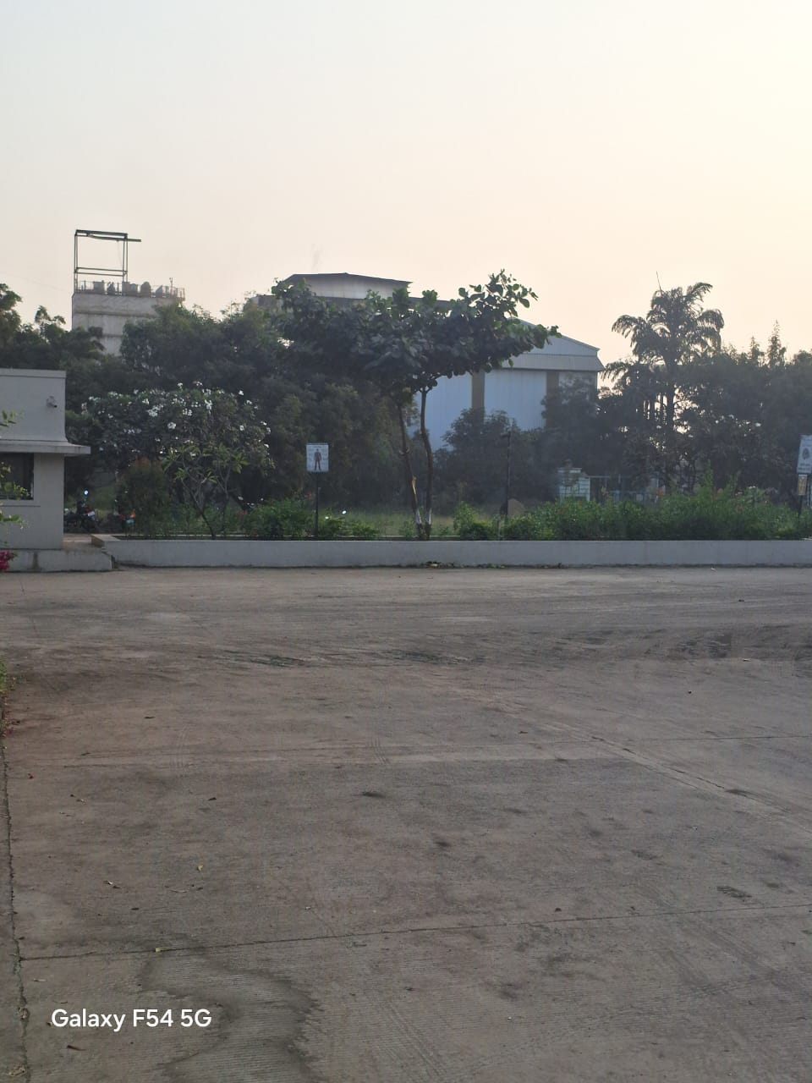
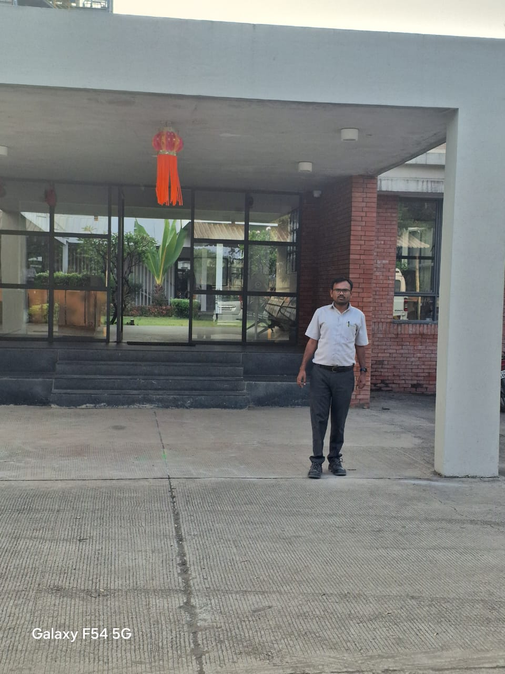 | 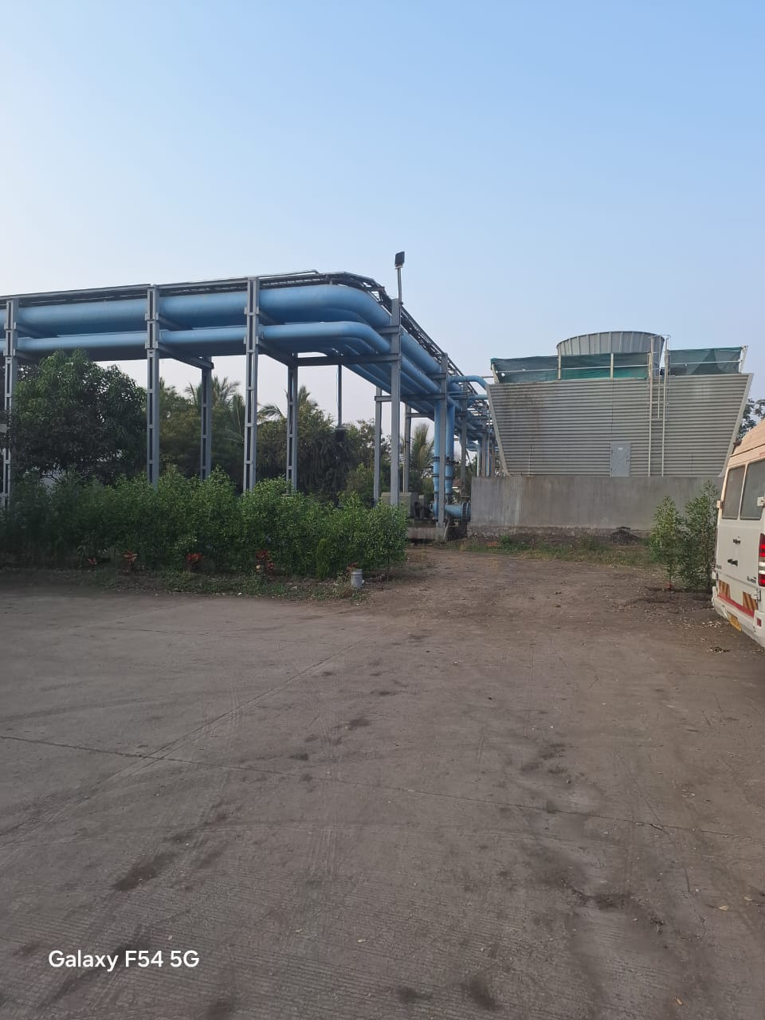
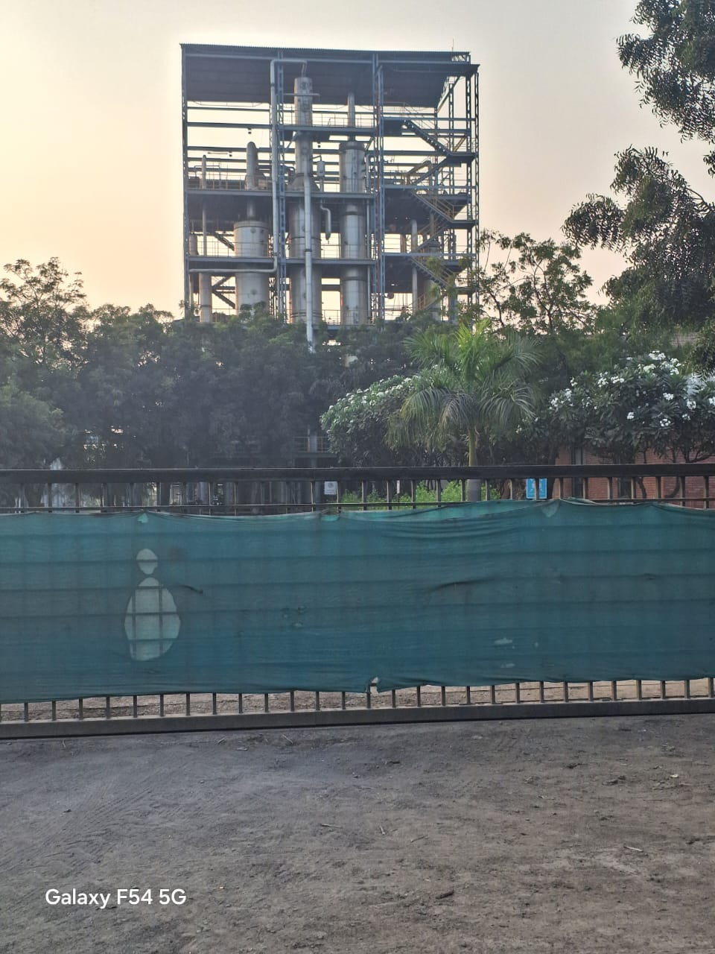 | 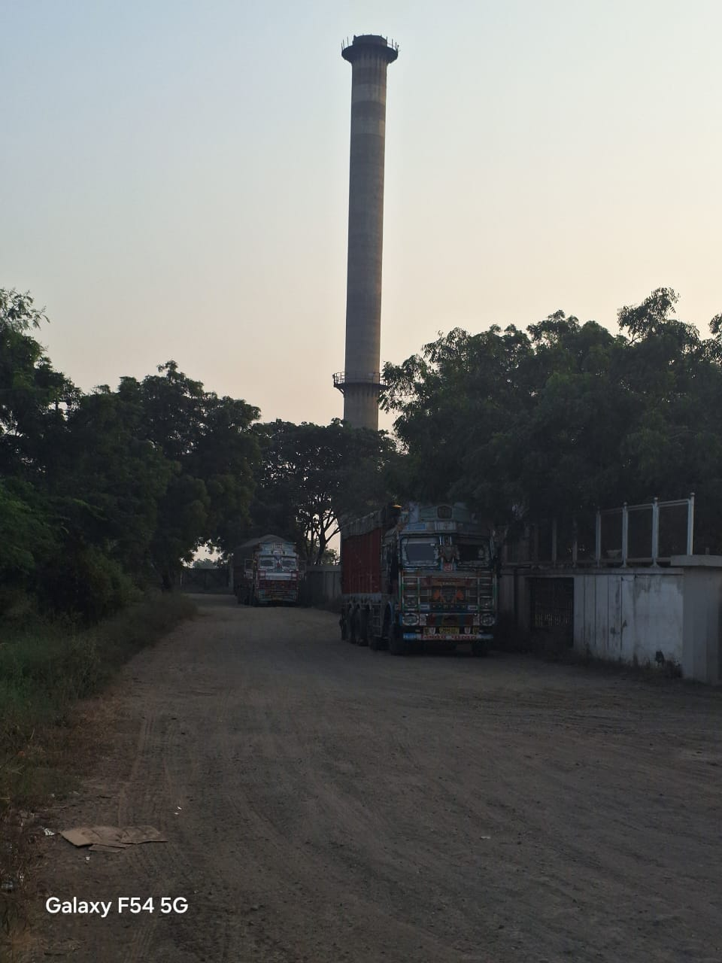

PHOTOGRAPHES OF THE PROPERTY
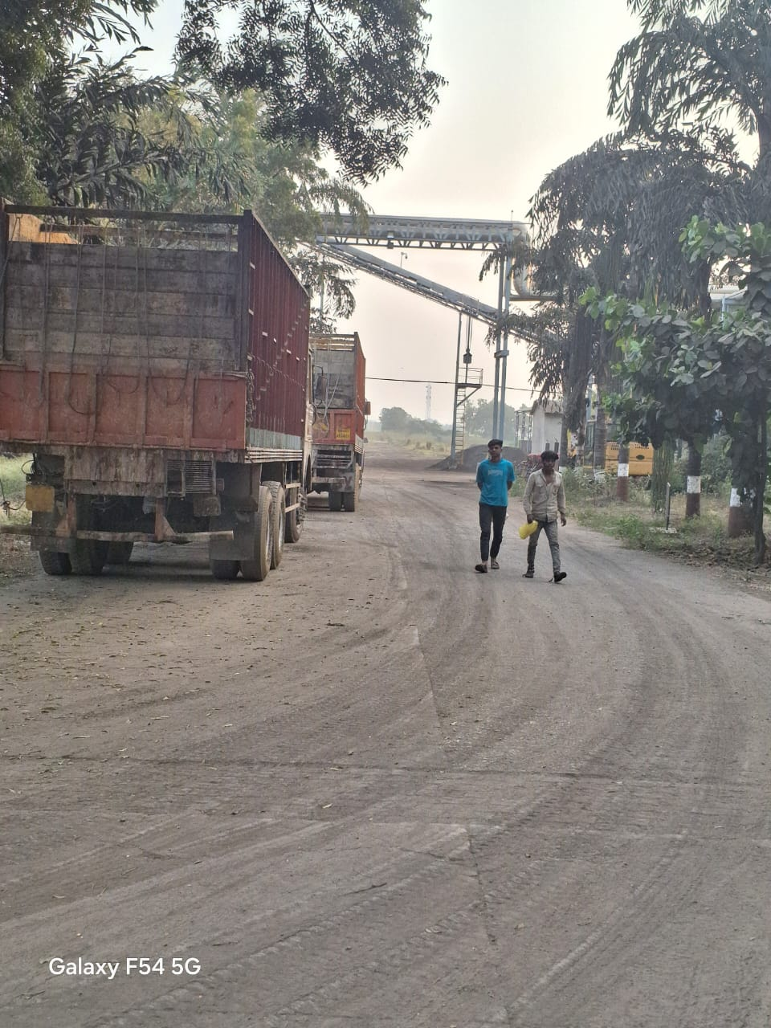 | 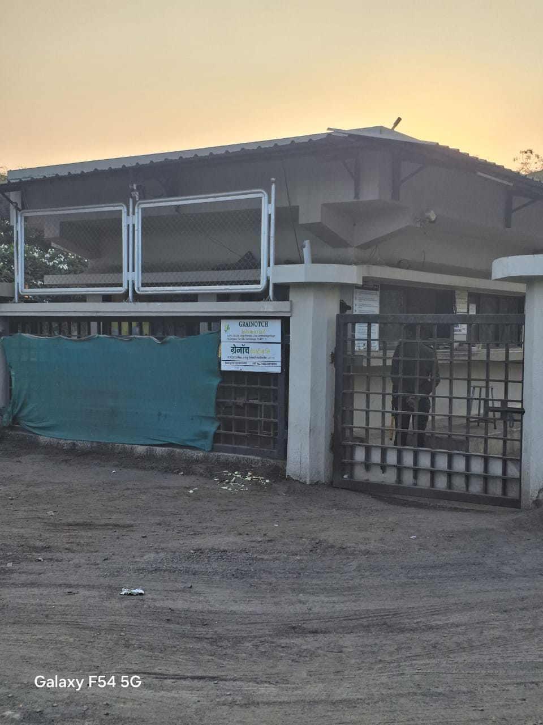
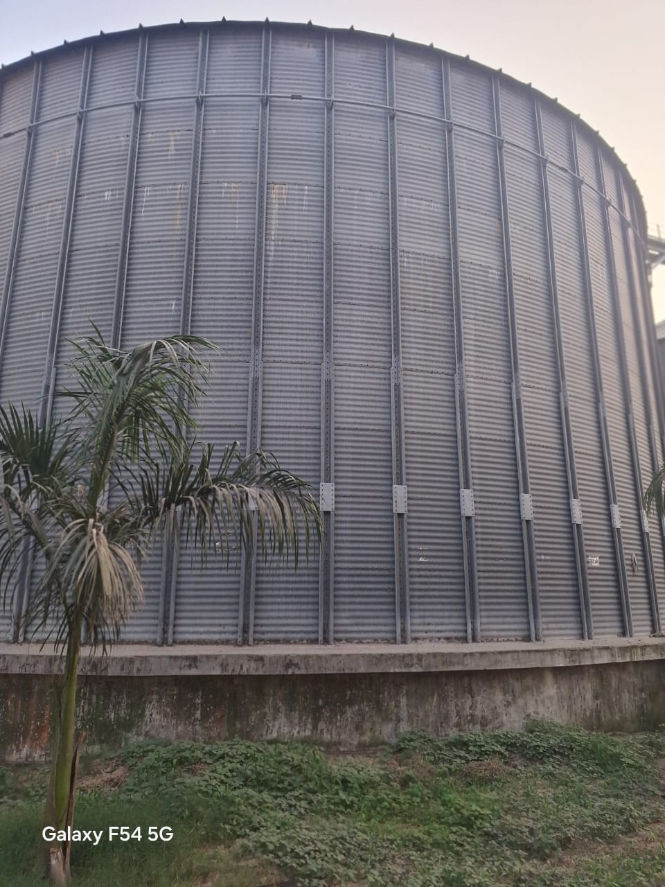 | 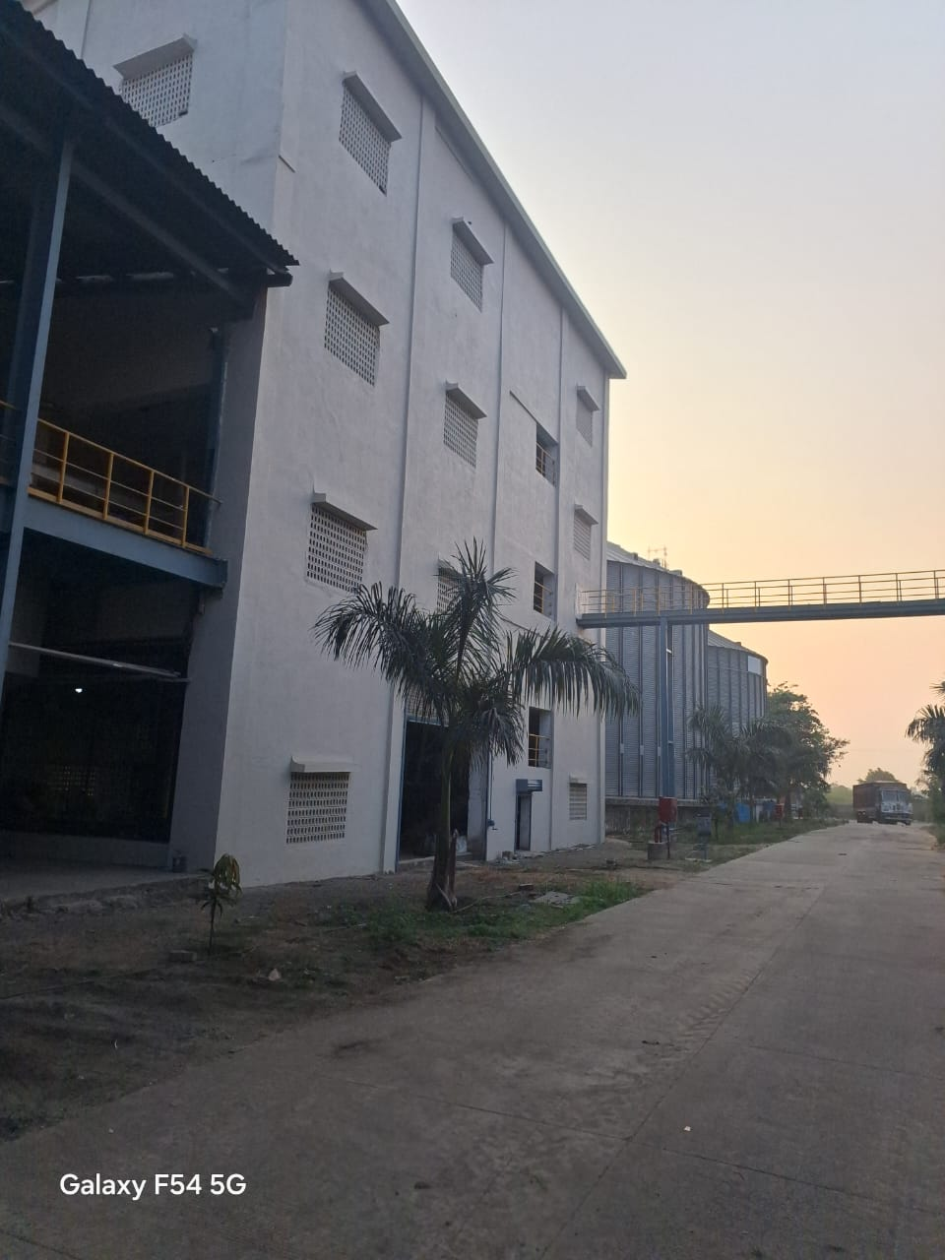
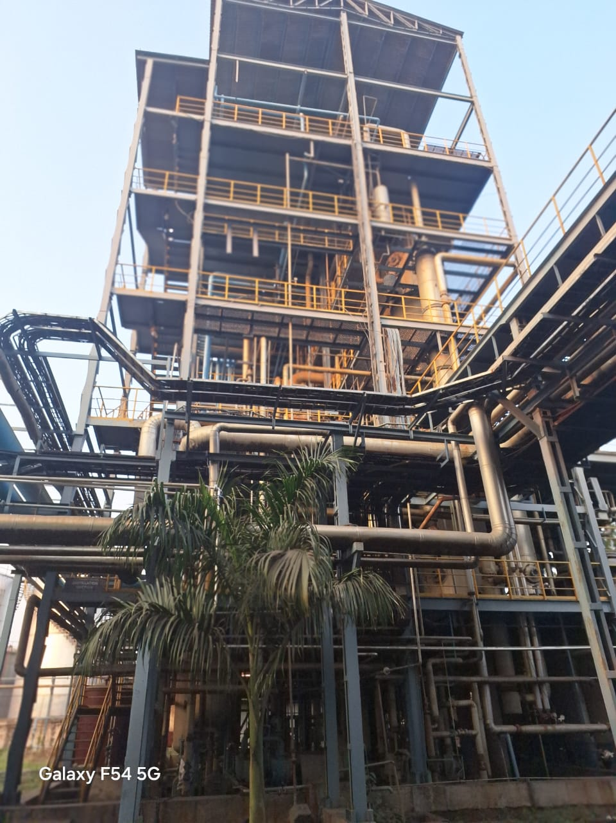 | 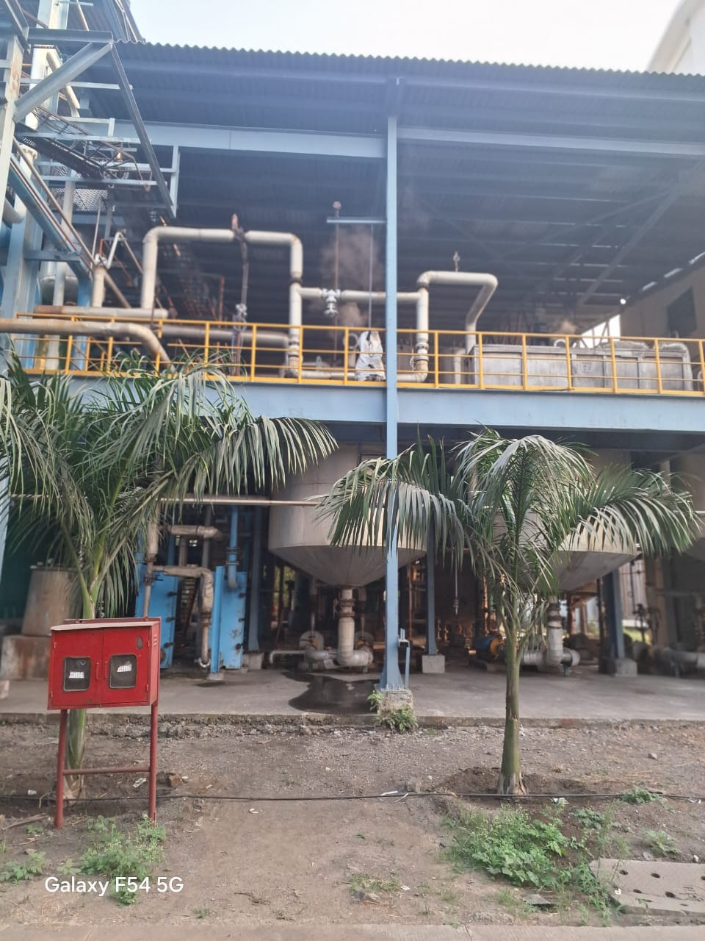

PHOTOGRAPHES OF THE PROPERTY
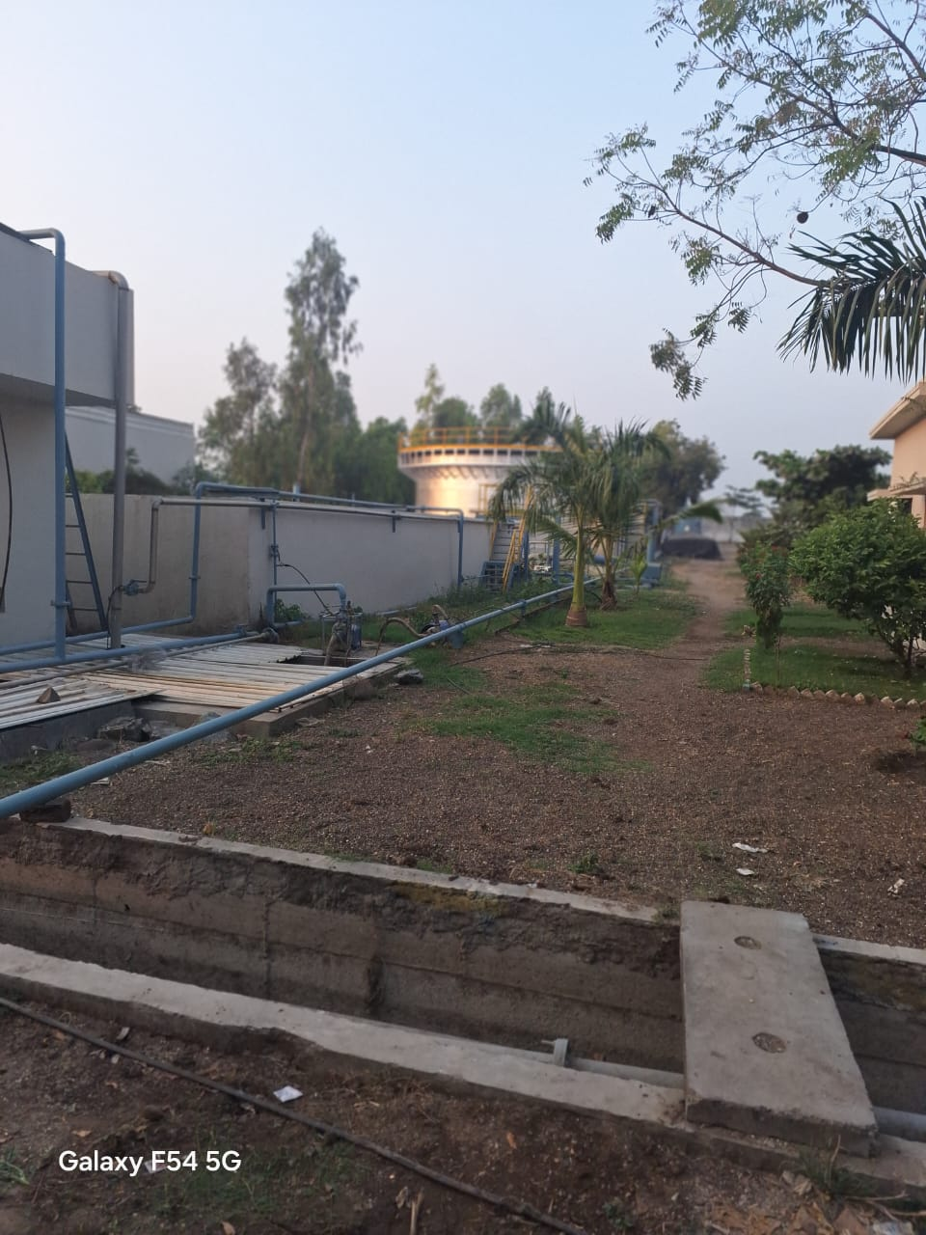 | 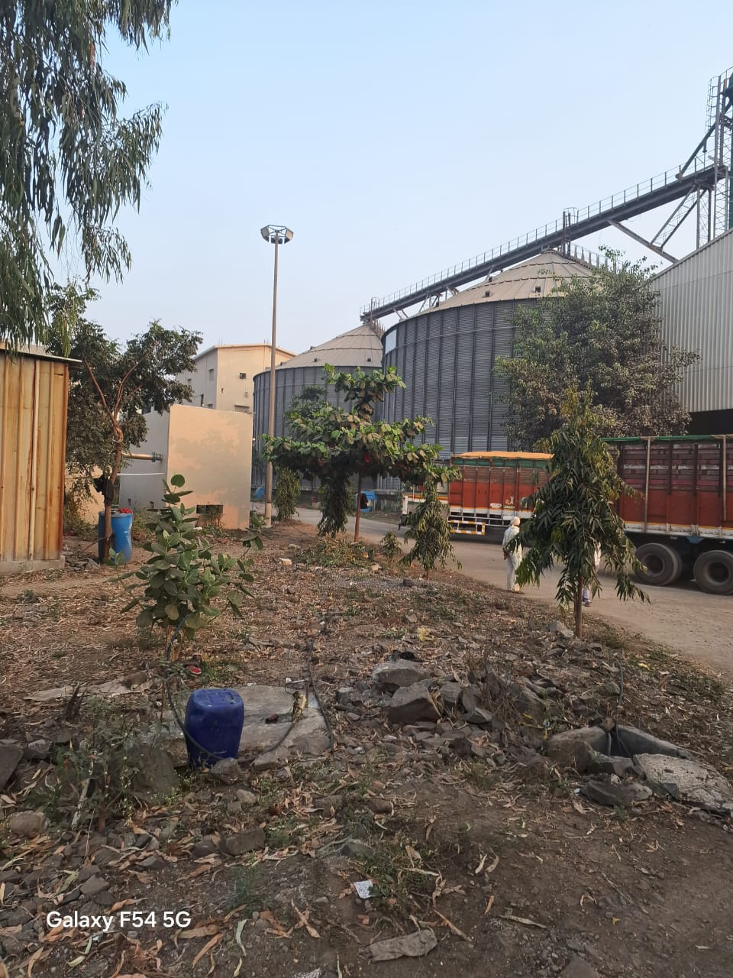
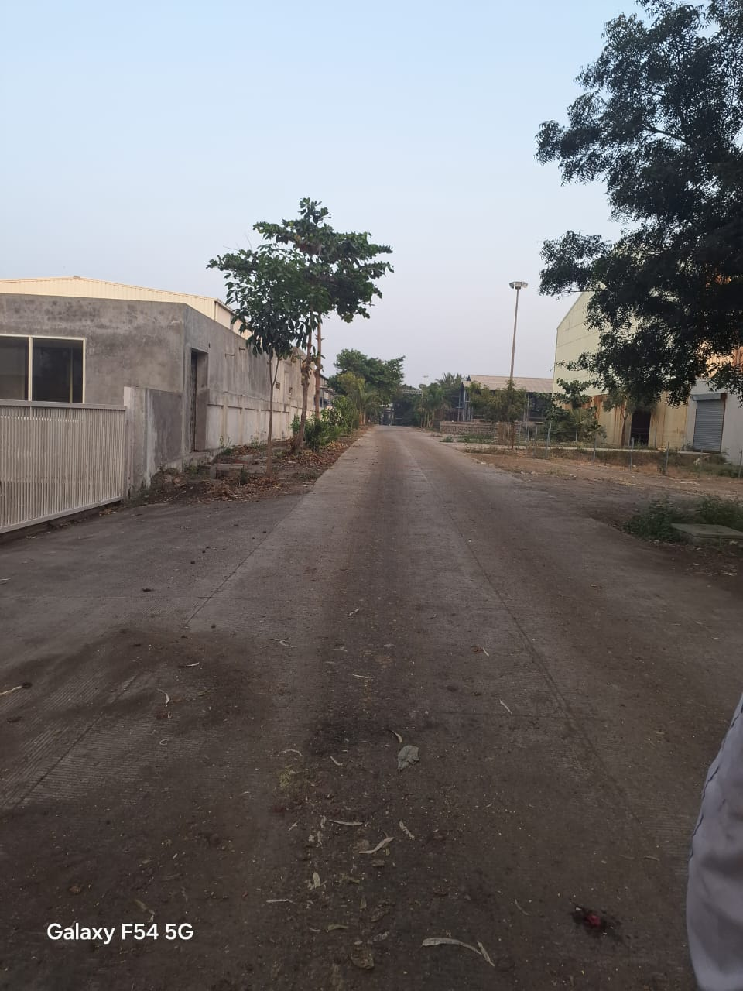 | 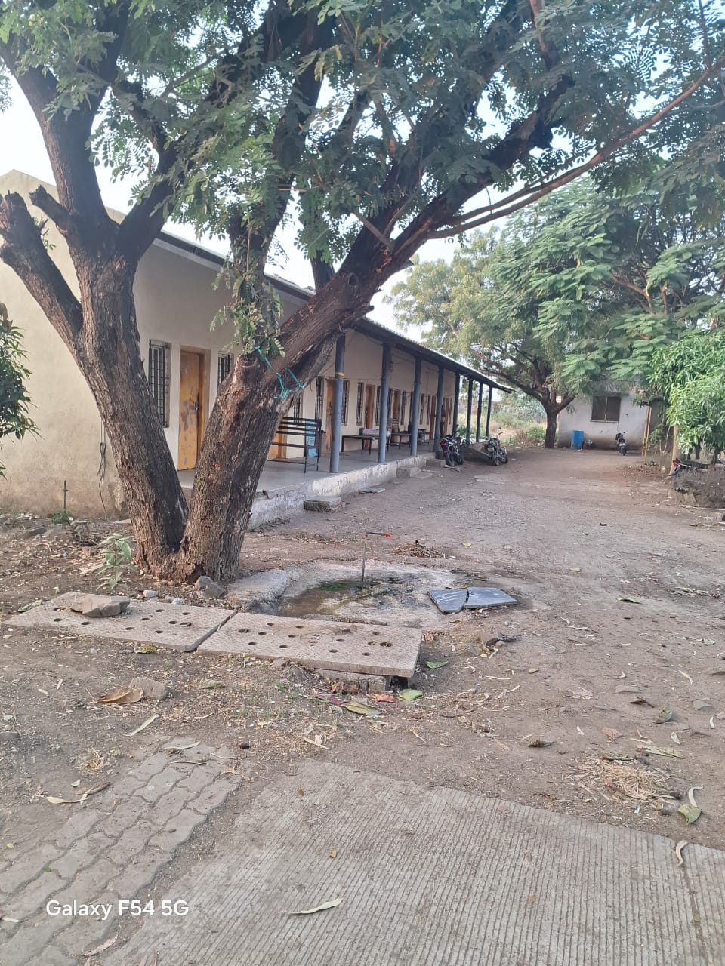
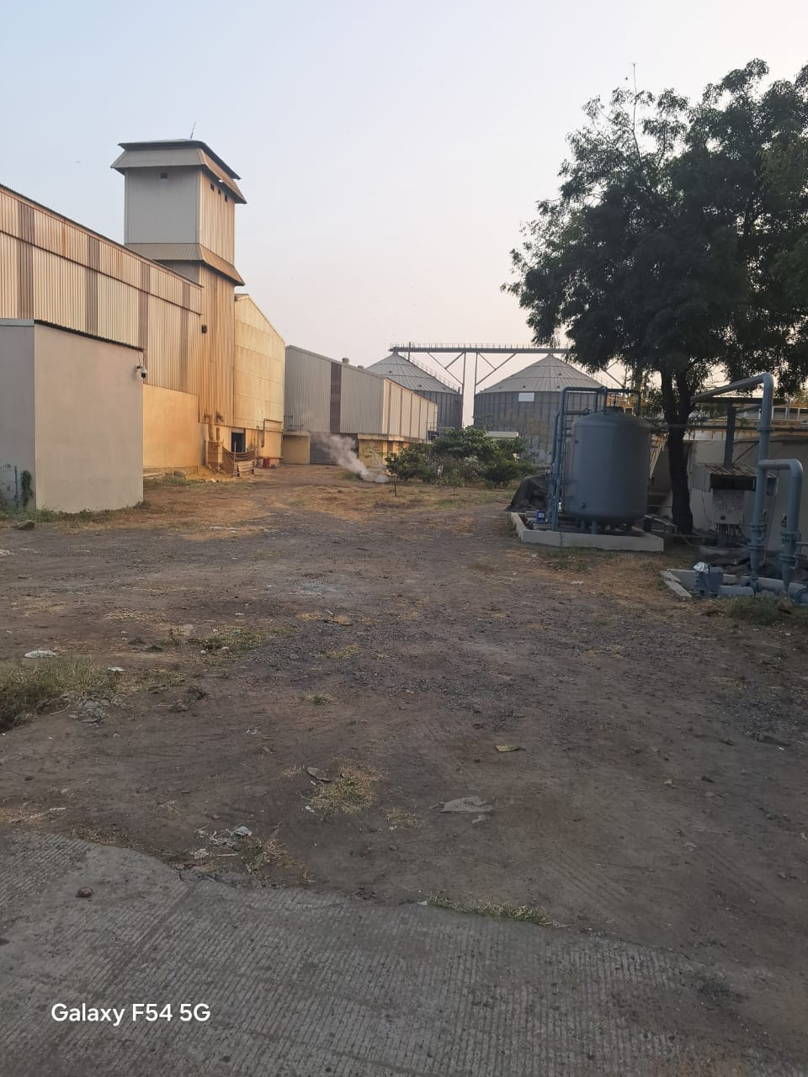 | 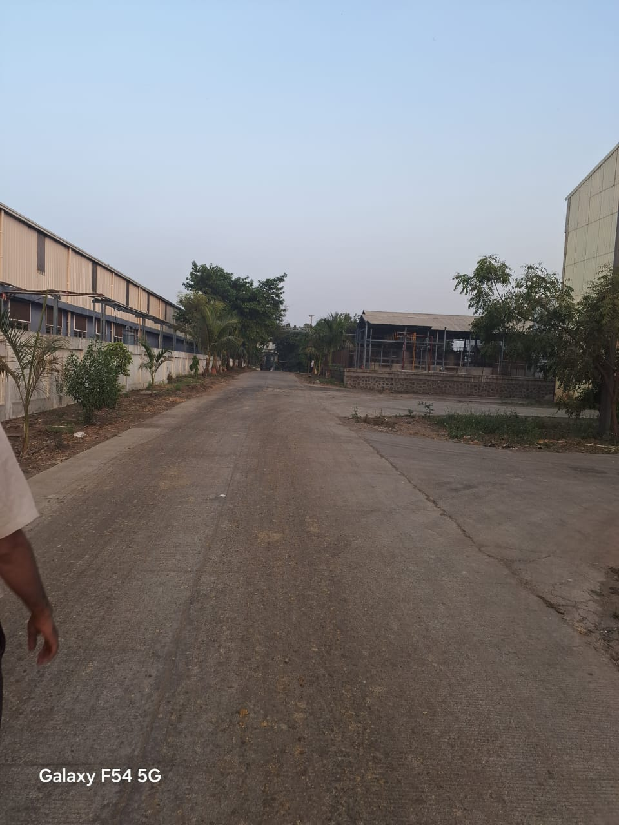

COMMENCMENT CERTIFICATE.

AREA STATEMENT.

LEASE DEED

BOUNDARIES.

KEY PLAN

EASR RATE.

