Vastu/Nashik/03/2025/014971/2311064
18/5-261-RPSP
Date: 18.03.2025

To, `
The Branch Manager,
Bank of Baroda
Regional Office Nashik Road Branch
BSNL Building, Datta Mandir Road, Nashik Road,
Nashik -422 101, State - Maharashtra, Country - India.

Sub: Vetting of Extra Amenities

Sir,

With reference to above subject, we have evaluated the Extra Amenities for Residential Flat No. 03, 1st Floor, "Sagar Nakshatra Aparment", Near Sainath Nagar Garden, Sai Nagar, Ayodhya Nagari, Dr. Nanasaheb Dharmadhikari Marg, Amrutdham, Plot No. 1, Village - Nashik, Taluka - Nashik , District - Nashik, Nashik , PIN Code - 422 003, State - Maharashtra, Country - India belongs to M/s. Nasa Construction Pvt. Ltd.. Name of Proposed Purchaser is Mrs. Mayuri Rahul Sasane.

We have verified the rates quoted as per current market rates. Details of Extra Amenities considered as per copy of Agreement for Extra Amenities issued by to Mrs. Mayuri Rahul Sasane. (First Party) Shri. Sushant Laxmanrao Patil (Second Party) received on dated 13.03.2025. The Extra Amenities amount is Rs.5,00,000/- (Rupees Five Lakh Only.)

The said Cost Vetting Certificate is valid upto next 6 months Only.

Thanking you

Sincerely yours

Manoj B. Chalikwar
Registered Valuer
Chartered Engineer (India)
Reg. No. CAT-I-F-1763
Reg. No. IBBI/RV/07/2018/10366
BOB Empanelment No.: ZO:MZ:ADV:46:941
Encl: Valuation report.

Agreement of Extra Amenities
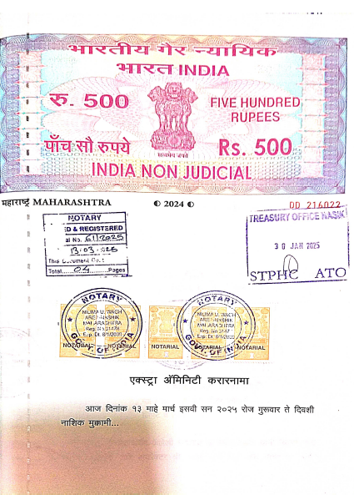
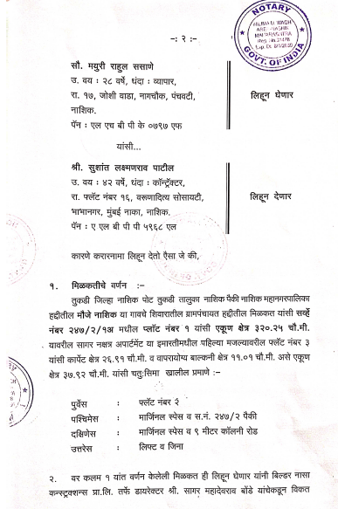

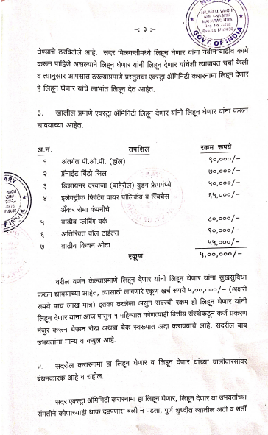
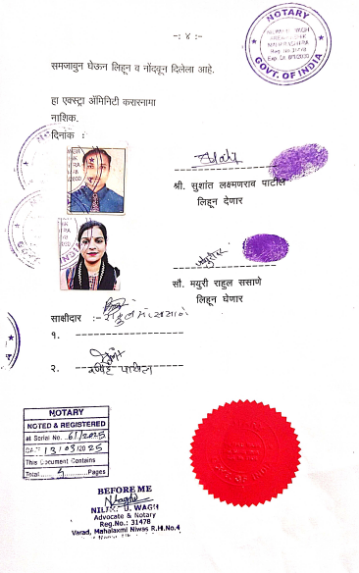

The Extra Work amount Rs.5,00,000/- (Rupees Five Lakh Only.)

