Valuation Report of the Immovable Property

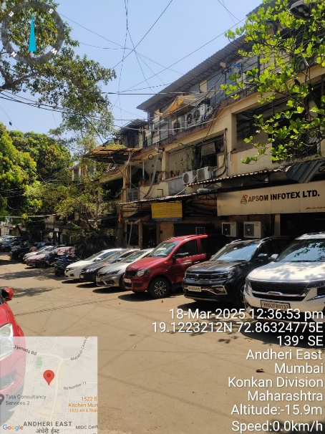

**Details of the property under consideration:**

Name of Owner: **M/s. Mani Jewel**

Industrial Unit No. 34, 1st Floor, Building Block No. A, **"Nand Bhuvan Industrial Premises Co-op. Soc. Ltd."**,

Plot No. 21, Mahakali Caves Road, Andheri (East), Mumbai,

PIN Code – 400 093, State - Maharashtra, India.

# **Longitude Latitude: 19°07'19.4"N 72°51'49.4"E**

**Intended User:**

**Axis Bank**

**CBB Branch Ahmedabad**

2nd Floor, 3rd Eye One Building | Opp. Honest, Panchavati Circle I C. G. Road I Ahmedabad-380009, India.

# Vastu/Mumbai/03/2025/014967/2311132

# 20/06-329-PSH

# Date: 20.03.2025

# **VALUER’S OPINION REPORT**

This is to certify that the property bearing Industrial Unit No. 34, 1st Floor, Building Block No. A, **"Nand Bhuvan Industrial Premises Co-op. Soc. Ltd."**, Plot No. 21, Mahakali Caves Road, Andheri (East), Mumbai, PIN Code – 400 093, State - Maharashtra, India is belongs to **M/s. Mani Jewel.**

Boundaries of the property

|  |  |
| --- | --- |
| North | Block – B & Internal Road |
| South | Nav Ketan Industrial Estate |
| East | Mahakali Caves Road |
| West | Internal Road & Mahal Industrial Estate |

Considering various parameters recorded, existing economic scenario, and the information that is available with reference to the development of neighborhood and method selected for valuation, we are of the opinion that, the property premises can be assessed are as under:

|  |  |
| --- | --- |
| **Fair Market Value of the Property** | **Rs. 2,73,87,045.00** |
| **Realizable Value** | **Rs. 2,46,48,341.00** |
| **Forced/ Distress Sale value.** | **Rs. 2,19,09,636.00** |
| **Guideline Value of the Property** | **Rs. 1,48,82,145.00** |

The valuation of the property is based on the documents produced by the concern. Legal aspects have not been taken into considerations while preparing this valuation report.

Hence certified

For, **Vastukala Consultants (I) Pvt. Ltd.**

**Sharadkumar B. Chalikwar**

B.E. (Civil), M.E. (Civil), M.Sc. (Real Estate Valuation), M.Sc. (P&M Valuation), FIE (I), FIV, FIWRS

Chairman & Managing Director

Govt. Reg. Valuer

Chartered Engineer (India)

Reg. No. (N) CCIT/1-14/52/2008-09

IBBI Reg.No. IBBI/RV/07/2019/11744

Encl: Valuation report.

|  |  |  |  |  |  |  |  |  |  |  |  |  |  |  |  |  |  |  |  |  |  |  |  |  |  |  |  |  |  |  |  |  |  |  |  |  |  |  |  |  |  |  |  |  |  |  |  |  |  |  |  |  |  |  |  |  |  |  |  |  |  |  |  |  |  |  |  |  |  |  |  |  |  |  |  |  |  |  |  |  |  |  |  |  |  |  |  |  |  |  |  |  |  |  |  |  |  |  |  |  |  |  |  |  |  |  |  |  |  |  |  |  |  |  |  |  |  |  |  |  |  |  |  |  |  |  |  |  |  |  |  |  |  |  |  |  |  |  |  |  |  |  |  |  |  |  |  |  |  |  |  |  |  |  |  |  |  |  |  |  |  |  |  |  |  |  |  |  |  |  |  |  |  |  |  |  |  |  |  |  |  |  |  |  |  |  |  |  |  |  |  |  |  |  |  |  |  |  |  |  |  |  |  |  |  |  |  |  |  |  |  |  |  |  |  |  |  |  |  |  |  |  |  |  |  |  |  |  |  |  |  |  |  |  |  |  |  |  |  |  |  |  |  |  |  |  |  |  |  |  |  |  |  |  |  |  |  |  |  |  |  |  |  |  |  |  |  |  |  |  |  |  |  |  |  |  |  |  |  |  |  |  |  |  |  |  |  |  |  |  |  |  |  |  |  |  |  |  |  |  |  |  |  |  |  |  |  |  |  |  |  |  |  |  |  |  |  |  |  |  |  |  |  |  |  |  |  |  |  |  |  |  |  |  |  |  |  |  |  |  |  |  |  |  |  |  |  |  |  |  |  |  |  |  |  |  |  |  |  |  |  |  |  |  |  |  |  |  |  |  |  |  |  |  |  |  |  |  |  |  |  |  |  |  |  |  |  |  |  |  |  |  |  |  |  |  |  |  |  |  |  |  |  |  |  |  |  |  |  |  |  |  |  |  |  |  |  |  |  |  |  |  |  |  |  |  |  |  |  |  |  |  |  |  |  |  |  |  |  |  |  |  |  |  |  |  |  |  |  |  |  |  |  |  |  |  |  |  |  |  |  |  |  |  |  |  |  |  |  |  |  |  |  |  |  |  |  |  |  |  |  |  |  |  |  |  |  |  |  |  |  |  |  |  |  |  |  |  |  |  |  |  |  |  |  |  |  |  |  |  |  |  |  |  |  |  |  |  |  |  |  |  |  |  |  |  |  |  |  |  |  |  |  |  |  |  |  |  |  |  |  |  |  |  |  |  |  |  |  |  |  |  |  |  |  |  |  |  |  |  |  |  |  |  |  |  |  |  |  |  |  |  |  |  |  |  |  |  |  |  |  |  |  |  |  |  |  |  |  |  |  |  |  |  |  |  |  |  |  |  |  |  |  |  |  |  |  |  |  |  |  |  |  |  |  |  |  |  |  |  |  |  |  |  |  |  |  |  |  |  |  |  |  |  |  |  |  |  |  |  |  |  |  |  |  |  |  |  |  |  |  |  |  |  |  |  |  |  |  |  |  |  |  |  |  |  |  |  |  |  |  |  |  |  |  |  |  |  |  |  |  |  |  |  |  |  |  |  |  |  |  |  |  |  |  |  |  |  |  |  |  |  |  |  |  |  |  |  |  |  |  |  |  |  |  |  |  |  |  |  |  |  |  |  |  |  |  |  |  |  |  |  |  |  |  |  |  |  |  |  |  |  |  |  |  |  |  |  |  |  |  |  |  |  |  |  |  |  |  |  |  |  |  |  |  |  |  |  |  |  |  |  |  |  |  |  |  |  |  |  |  |  |  |  |  |  |  |  |  |  |  |  |  |  |  |  |  |  |  |  |  |  |  |  |  |  |  |  |  |  |  |  |  |  |  |  |  |  |  |  |  |  |  |  |  |  |  |  |  |  |  |  |  |  |  |  |  |  |  |  |  |  |  |  |  |  |  |  |  |  |  |  |  |  |  |  |  |  |  |  |  |  |  |  |  |  |  |  |  |  |  |  |  |  |  |  |  |  |  |  |  |  |  |  |  |  |  |  |  |  |  |  |  |  |  |  |  |  |  |  |  |  |  |  |  |  |  |  |  |  |  |  |  |  |  |  |  |  |  |  |  |  |  |  |  |  |  |  |  |  |  |  |  |  |  |  |  |  |  |  |  |  |  |  |  |  |  |  |  |  |  |  |  |  |  |  |  |  |  |  |  |  |  |  |  |  |  |  |  |  |  |  |  |  |  |  |  |  |  |  |  |  |  |  |  |  |  |  |  |  |  |  |  |  |  |  |  |  |  |  |  |  |  |  |  |  |  |  |  |  |  |  |  |  |  |  |  |  |  |  |  |  |  |  |  |  |  |  |  |  |  |  |  |  |  |  |  |  |  |  |  |  |  |  |  |  |  |  |  |  |  |  |  |  |  |  |  |  |  |  |  |  |  |  |  |  |  |  |  |  |  |  |  |  |  |  |  |  |  |  |  |  |  |  |  |  |  |  |  |  |  |  |  |  |  |  |  |  |  |  |  |  |  |  |  |  |  |  |  |  |  |  |  |  |  |  |  |  |  |  |  |  |  |  |  |  |  |  |  |  |  |  |  |  |  |  |  |  |  |  |  |  |  |  |  |  |  |  |  |  |  |  |  |  |  |  |  |  |  |  |  |  |  |  |  |  |  |  |  |  |  |  |  |  |  |  |  |  |  |  |  |  |  |  |  |  |  |  |  |  |  |  |  |  |  |  |  |  |  |  |  |  |  |  |  |  |  |  |  |  |  |  |  |  |  |  |  |  |  |  |  |  |  |  |  |  |  |  |  |  |  |  |  |  |  |  |  |  |  |  |  |  |  |  |  |  |  |  |  |  |  |  |  |  |  |  |  |  |  |  |  |  |  |  |  |  |  |  |  |  |  |  |  |  |  |  |  |  |  |  |  |  |  |  |  |  |  |  |  |  |  |  |  |  |  |  |  |  |  |  |  |  |  |  |  |  |  |  |  |  |  |  |  |  |  |  |  |  |  |  |  |  |  |  |  |  |  |  |  |  |  |  |  |  |  |  |  |  |  |  |  |  |  |  |  |  |  |  |  |  |  |  |  |  |  |  |  |  |  |  |  |  |  |  |  |  |  |  |  |  |  |  |  |  |  |  |  |  |  |  |  |  |  |  |  |  |  |  |  |  |  |  |  |  |  |  |  |  |  |  |  |  |  |  |  |  |  |  |  |  |  |  |  |  |  |  |  |  |  |  |  |  |  |  |  |  |  |  |  |  |  |  |  |  |  |  |  |  |  |  |  |  |  |  |  |  |  |  |  |  |  |  |  |  |  |  |  |  |  |  |  |  |  |  |  |  |  |  |  |  |  |  |  |  |  |  |  |  |  |  |  |  |  |  |  |  |  |  |  |  |  |  |  |  |  |  |  |  |  |  |  |  |  |  |  |  |  |  |  |  |  |  |  |  |  |  |  |  |  |  |  |  |  |  |  |  |  |  |  |  |  |  |  |  |  |  |  |  |  |  |  |  |  |  |  |  |  |  |  |  |  |  |  |  |  |  |  |  |  |  |  |  |  |  |  |  |  |  |  |  |  |  |  |  |  |  |  |  |  |  |  |  |  |  |  |  |  |  |  |  |  |  |  |  |  |  |  |  |  |  |  |  |  |  |  |  |  |  |  |  |  |  |  |  |  |  |  |  |  |  |  |  |  |  |  |  |  |  |  |  |  |  |  |  |  |  |  |  |  |  |  |  |  |  |  |  |  |  |  |  |  |  |  |  |  |  |  |  |  |  |  |  |  |  |  |  |  |  |  |  |  |  |  |  |  |  |  |  |  |  |  |  |  |  |  |  |  |  |  |  |  |  |  |  |  |  |  |  |  |  |  |  |  |  |  |  |  |  |  |  |  |  |  |  |  |  |  |  |  |  |  |  |  |  |  |  |  |  |  |  |  |  |  |  |  |  |  |  |  |  |  |  |  |  |  |  |  |  |  |  |  |  |  |  |  |  |  |  |  |  |  |  |  |  |  |  |  |  |  |  |  |  |  |  |  |  |  |  |  |  |  |  |  |  |  |  |  |  |  |  |  |  |  |  |  |  |  |  |  |  |  |  |  |  |  |  |  |  |  |  |  |  |  |  |  |  |  |  |  |  |  |  |  |  |  |  |  |  |  |  |  |  |  |  |  |  |  |  |  |  |  |  |  |  |  |  |  |  |  |  |  |  |  |  |  |  |  |  |  |  |  |  |  |  |  |  |  |  |  |  |  |  |  |  |  |  |  |  |  |  |  |  |  |  |  |  |  |  |  |  |  |  |  |  |  |  |  |  |  |  |  |  |  |  |  |  |  |  |  |  |  |  |  |  |  |  |  |  |  |  |  |  |  |  |  |  |  |  |  |  |  |  |  |  |  |  |  |  |  |  |  |  |  |  |  |  |  |  |  |  |  |  |  |  |  |  |  |  |  |  |  |  |  |  |  |  |  |  |  |  |  |  |  |  |  |  |  |  |  |  |  |  |  |  |  |  |  |  |  |  |  |  |  |  |  |  |  |  |  |  |  |  |  |  |  |  |  |  |  |  |  |  |  |  |  |  |  |  |  |  |  |  |  |  |  |  |  |  |  |  |  |  |  |  |  |  |  |  |  |  |  |  |  |  |  |  |  |  |  |  |  |  |  |  |  |  |  |  |  |  |  |  |  |  |  |  |  |  |  |  |  |  |  |  |  |  |  |  |  |  |  |  |  |  |  |  |  |  |  |  |  |  |  |  |  |  |  |  |  |  |  |  |  |  |  |  |  |  |  |  |  |  |  |  |  |  |  |  |  |  |  |  |  |  |  |  |  |  |  |  |  |  |  |  |  |  |  |  |  |  |  |  |  |  |  |  |  |  |  |  |  |  |  |  |  |  |  |  |  |  |  |  |  |  |  |  |  |  |  |  |  |  |  |  |  |  |  |  |  |  |  |  |  |  |  |  |  |  |  |  |  |  |  |  |  |  |  |  |  |  |  |  |  |  |  |  |  |  |  |  |  |  |  |  |  |  |  |  |  |  |  |  |  |  |  |  |  |  |  |  |  |  |  |  |  |  |  |  |  |  |  |  |  |  |  |  |  |  |  |  |  |  |  |  |  |  |  |  |  |  |  |  |  |  |  |  |  |  |  |  |  |  |  |  |  |  |  |  |  |  |  |  |  |  |  |  |  |  |  |  |  |  |  |  |  |  |  |  |  |  |  |  |  |  |  |  |  |  |  |  |  |  |  |  |  |  |  |  |  |  |  |  |  |  |  |  |  |  |  |  |  |  |  |  |  |  |  |  |  |  |  |  |  |  |  |  |  |  |  |  |  |  |  |  |  |  |  |  |  |  |  |  |  |  |  |  |  |  |  |  |  |  |  |  |  |  |  |  |  |  |  |  |  |  |  |  |  |  |  |  |  |  |  |  |  |  |  |  |  |  |  |  |  |  |  |  |  |  |  |  |  |  |  |  |  |  |  |  |  |  |  |  |  |  |  |  |  |  |  |  |  |  |  |  |  |  |  |  |  |  |  |  |  |  |  |  |  |  |  |  |  |  |  |  |  |  |  |  |  |  |  |  |  |  |  |  |  |  |  |  |  |  |  |  |  |  |  |  |  |  |  |  |  |  |  |  |  |  |  |  |  |  |  |  |  |  |  |  |  |  |  |  |  |  |  |  |  |  |  |  |  |  |  |  |  |  |  |  |  |  |  |  |  |  |  |  |  |  |  |  |  |  |  |  |  |  |  |  |  |  |  |  |  |  |  |  |  |  |  |  |  |  |  |  |  |  |  |  |  |  |  |  |  |  |  |  |  |  |  |  |  |  |  |  |  |  |  |  |  |  |  |  |  |  |  |  |  |  |  |  |  |  |  |  |  |  |  |  |  |  |  |  |  |  |  |  |  |  |  |  |  |  |  |  |  |  |  |  |  |  |  |  |  |  |  |  |  |  |  |  |  |  |  |  |  |  |  |  |  |  |  |  |  |  |  |  |  |  |  |  |  |  |  |  |  |  |  |  |  |  |  |  |  |  |  |  |  |  |  |  |  |  |  |  |  |  |  |  |  |  |  |  |  |  |  |  |  |  |  |  |  |  |  |  |  |  |  |  |  |  |  |  |  |  |  |  |  |  |  |  |  |  |  |  |  |  |  |  |  |  |  |  |  |  |  |  |  |  |  |  |  |  |  |  |  |  |  |  |  |  |  |  |  |  |  |  |  |  |  |  |  |  |  |  |  |  |  |  |  |  |  |  |  |  |  |  |  |  |  |  |  |  |  |  |  |  |  |  |  |  |  |  |  |  |  |  |  |  |  |  |  |  |  |  |  |  |  |  |  |  |  |  |  |  |  |  |  |  |  |  |  |  |  |  |  |  |  |  |  |  |  |  |  |  |  |  |  |  |  |  |  |  |  |  |  |  |  |  |  |  |  |  |  |  |  |  |  |  |  |  |  |  |  |  |  |  |  |  |  |  |  |  |  |  |  |  |  |  |  |  |  |  |  |  |  |  |  |  |  |  |  |  |  |  |  |  |  |  |  |  |  |  |  |  |  |  |  |  |  |  |  |  |  |  |  |  |  |  |  |  |  |  |  |  |  |  |  |  |  |  |  |  |  |  |  |  |  |  |  |  |  |  |  |  |  |  |  |  |  |  |  |  |  |  |  |  |  |  |  |  |  |  |  |  |  |  |  |  |  |  |  |  |  |  |  |  |  |  |  |  |  |  |  |  |  |  |  |  |  |  |  |  |  |  |  |  |  |  |  |  |  |  |  |  |  |  |  |  |  |  |  |  |  |  |  |  |  |  |  |  |  |  |  |  |  |  |  |  |  |  |  |  |  |  |  |  |  |  |  |  |  |  |  |  |  |  |  |  |  |  |  |  |  |  |  |  |  |  |  |  |  |  |  |  |  |  |  |  |  |  |  |  |  |  |  |  |  |  |  |  |  |  |  |  |  |  |  |  |  |  |  |  |  |  |  |  |  |  |  |  |  |  |  |  |  |  |  |  |  |  |  |  |  |  |  |  |  |  |  |  |  |  |  |  |  |  |  |  |  |  |  |  |  |  |  |  |  |  |  |  |  |  |  |  |  |  |  |  |  |  |  |  |  |  |  |  |  |  |  |  |  |  |  |  |  |  |  |  |  |  |  |  |  |  |  |  |  |  |  |  |  |  |  |  |  |  |  |  |  |  |  |  |  |  |  |  |  |  |  |  |  |  |  |  |  |  |  |  |  |  |  |  |  |  |  |  |  |  |  |  |  |  |  |  |  |  |  |  |  |  |  |  |  |  |  |  |  |  |  |  |  |  |  |  |  |  |  |  |  |  |  |  |  |  |  |  |  |  |  |  |  |  |  |  |  |  |  |  |  |  |  |  |  |  |  |  |  |  |  |  |  |  |  |  |  |  |  |  |  |  |  |  |  |  |  |  |  |  |  |  |  |  |  |  |  |  |  |  |  |  |  |  |  |  |  |  |  |  |  |  |  |  |  |  |  |  |  |  |  |  |  |  |  |  |  |  |  |  |  |  |  |  |  |  |  |  |  |  |
| --- | --- | --- | --- | --- | --- | --- | --- | --- | --- | --- | --- | --- | --- | --- | --- | --- | --- | --- | --- | --- | --- | --- | --- | --- | --- | --- | --- | --- | --- | --- | --- | --- | --- | --- | --- | --- | --- | --- | --- | --- | --- | --- | --- | --- | --- | --- | --- | --- | --- | --- | --- | --- | --- | --- | --- | --- | --- | --- | --- | --- | --- | --- | --- | --- | --- | --- | --- | --- | --- | --- | --- | --- | --- | --- | --- | --- | --- | --- | --- | --- | --- | --- | --- | --- | --- | --- | --- | --- | --- | --- | --- | --- | --- | --- | --- | --- | --- | --- | --- | --- | --- | --- | --- | --- | --- | --- | --- | --- | --- | --- | --- | --- | --- | --- | --- | --- | --- | --- | --- | --- | --- | --- | --- | --- | --- | --- | --- | --- | --- | --- | --- | --- | --- | --- | --- | --- | --- | --- | --- | --- | --- | --- | --- | --- | --- | --- | --- | --- | --- | --- | --- | --- | --- | --- | --- | --- | --- | --- | --- | --- | --- | --- | --- | --- | --- | --- | --- | --- | --- | --- | --- | --- | --- | --- | --- | --- | --- | --- | --- | --- | --- | --- | --- | --- | --- | --- | --- | --- | --- | --- | --- | --- | --- | --- | --- | --- | --- | --- | --- | --- | --- | --- | --- | --- | --- | --- | --- | --- | --- | --- | --- | --- | --- | --- | --- | --- | --- | --- | --- | --- | --- | --- | --- | --- | --- | --- | --- | --- | --- | --- | --- | --- | --- | --- | --- | --- | --- | --- | --- | --- | --- | --- | --- | --- | --- | --- | --- | --- | --- | --- | --- | --- | --- | --- | --- | --- | --- | --- | --- | --- | --- | --- | --- | --- | --- | --- | --- | --- | --- | --- | --- | --- | --- | --- | --- | --- | --- | --- | --- | --- | --- | --- | --- | --- | --- | --- | --- | --- | --- | --- | --- | --- | --- | --- | --- | --- | --- | --- | --- | --- | --- | --- | --- | --- | --- | --- | --- | --- | --- | --- | --- | --- | --- | --- | --- | --- | --- | --- | --- | --- | --- | --- | --- | --- | --- | --- | --- | --- | --- | --- | --- | --- | --- | --- | --- | --- | --- | --- | --- | --- | --- | --- | --- | --- | --- | --- | --- | --- | --- | --- | --- | --- | --- | --- | --- | --- | --- | --- | --- | --- | --- | --- | --- | --- | --- | --- | --- | --- | --- | --- | --- | --- | --- | --- | --- | --- | --- | --- | --- | --- | --- | --- | --- | --- | --- | --- | --- | --- | --- | --- | --- | --- | --- | --- | --- | --- | --- | --- | --- | --- | --- | --- | --- | --- | --- | --- | --- | --- | --- | --- | --- | --- | --- | --- | --- | --- | --- | --- | --- | --- | --- | --- | --- | --- | --- | --- | --- | --- | --- | --- | --- | --- | --- | --- | --- | --- | --- | --- | --- | --- | --- | --- | --- | --- | --- | --- | --- | --- | --- | --- | --- | --- | --- | --- | --- | --- | --- | --- | --- | --- | --- | --- | --- | --- | --- | --- | --- | --- | --- | --- | --- | --- | --- | --- | --- | --- | --- | --- | --- | --- | --- | --- | --- | --- | --- | --- | --- | --- | --- | --- | --- | --- | --- | --- | --- | --- | --- | --- | --- | --- | --- | --- | --- | --- | --- | --- | --- | --- | --- | --- | --- | --- | --- | --- | --- | --- | --- | --- | --- | --- | --- | --- | --- | --- | --- | --- | --- | --- | --- | --- | --- | --- | --- | --- | --- | --- | --- | --- | --- | --- | --- | --- | --- | --- | --- | --- | --- | --- | --- | --- | --- | --- | --- | --- | --- | --- | --- | --- | --- | --- | --- | --- | --- | --- | --- | --- | --- | --- | --- | --- | --- | --- | --- | --- | --- | --- | --- | --- | --- | --- | --- | --- | --- | --- | --- | --- | --- | --- | --- | --- | --- | --- | --- | --- | --- | --- | --- | --- | --- | --- | --- | --- | --- | --- | --- | --- | --- | --- | --- | --- | --- | --- | --- | --- | --- | --- | --- | --- | --- | --- | --- | --- | --- | --- | --- | --- | --- | --- | --- | --- | --- | --- | --- | --- | --- | --- | --- | --- | --- | --- | --- | --- | --- | --- | --- | --- | --- | --- | --- | --- | --- | --- | --- | --- | --- | --- | --- | --- | --- | --- | --- | --- | --- | --- | --- | --- | --- | --- | --- | --- | --- | --- | --- | --- | --- | --- | --- | --- | --- | --- | --- | --- | --- | --- | --- | --- | --- | --- | --- | --- | --- | --- | --- | --- | --- | --- | --- | --- | --- | --- | --- | --- | --- | --- | --- | --- | --- | --- | --- | --- | --- | --- | --- | --- | --- | --- | --- | --- | --- | --- | --- | --- | --- | --- | --- | --- | --- | --- | --- | --- | --- | --- | --- | --- | --- | --- | --- | --- | --- | --- | --- | --- | --- | --- | --- | --- | --- | --- | --- | --- | --- | --- | --- | --- | --- | --- | --- | --- | --- | --- | --- | --- | --- | --- | --- | --- | --- | --- | --- | --- | --- | --- | --- | --- | --- | --- | --- | --- | --- | --- | --- | --- | --- | --- | --- | --- | --- | --- | --- | --- | --- | --- | --- | --- | --- | --- | --- | --- | --- | --- | --- | --- | --- | --- | --- | --- | --- | --- | --- | --- | --- | --- | --- | --- | --- | --- | --- | --- | --- | --- | --- | --- | --- | --- | --- | --- | --- | --- | --- | --- | --- | --- | --- | --- | --- | --- | --- | --- | --- | --- | --- | --- | --- | --- | --- | --- | --- | --- | --- | --- | --- | --- | --- | --- | --- | --- | --- | --- | --- | --- | --- | --- | --- | --- | --- | --- | --- | --- | --- | --- | --- | --- | --- | --- | --- | --- | --- | --- | --- | --- | --- | --- | --- | --- | --- | --- | --- | --- | --- | --- | --- | --- | --- | --- | --- | --- | --- | --- | --- | --- | --- | --- | --- | --- | --- | --- | --- | --- | --- | --- | --- | --- | --- | --- | --- | --- | --- | --- | --- | --- | --- | --- | --- | --- | --- | --- | --- | --- | --- | --- | --- | --- | --- | --- | --- | --- | --- | --- | --- | --- | --- | --- | --- | --- | --- | --- | --- | --- | --- | --- | --- | --- | --- | --- | --- | --- | --- | --- | --- | --- | --- | --- | --- | --- | --- | --- | --- | --- | --- | --- | --- | --- | --- | --- | --- | --- | --- | --- | --- | --- | --- | --- | --- | --- | --- | --- | --- | --- | --- | --- | --- | --- | --- | --- | --- | --- | --- | --- | --- | --- | --- | --- | --- | --- | --- | --- | --- | --- | --- | --- | --- | --- | --- | --- | --- | --- | --- | --- | --- | --- | --- | --- | --- | --- | --- | --- | --- | --- | --- | --- | --- | --- | --- | --- | --- | --- | --- | --- | --- | --- | --- | --- | --- | --- | --- | --- | --- | --- | --- | --- | --- | --- | --- | --- | --- | --- | --- | --- | --- | --- | --- | --- | --- | --- | --- | --- | --- | --- | --- | --- | --- | --- | --- | --- | --- | --- | --- | --- | --- | --- | --- | --- | --- | --- | --- | --- | --- | --- | --- | --- | --- | --- | --- | --- | --- | --- | --- | --- | --- | --- | --- | --- | --- | --- | --- | --- | --- | --- | --- | --- | --- | --- | --- | --- | --- | --- | --- | --- | --- | --- | --- | --- | --- | --- | --- | --- | --- | --- | --- | --- | --- | --- | --- | --- | --- | --- | --- | --- | --- | --- | --- | --- | --- | --- | --- | --- | --- | --- | --- | --- | --- | --- | --- | --- | --- | --- | --- | --- | --- | --- | --- | --- | --- | --- | --- | --- | --- | --- | --- | --- | --- | --- | --- | --- | --- | --- | --- | --- | --- | --- | --- | --- | --- | --- | --- | --- | --- | --- | --- | --- | --- | --- | --- | --- | --- | --- | --- | --- | --- | --- | --- | --- | --- | --- | --- | --- | --- | --- | --- | --- | --- | --- | --- | --- | --- | --- | --- | --- | --- | --- | --- | --- | --- | --- | --- | --- | --- | --- | --- | --- | --- | --- | --- | --- | --- | --- | --- | --- | --- | --- | --- | --- | --- | --- | --- | --- | --- | --- | --- | --- | --- | --- | --- | --- | --- | --- | --- | --- | --- | --- | --- | --- | --- | --- | --- | --- | --- | --- | --- | --- | --- | --- | --- | --- | --- | --- | --- | --- | --- | --- | --- | --- | --- | --- | --- | --- | --- | --- | --- | --- | --- | --- | --- | --- | --- | --- | --- | --- | --- | --- | --- | --- | --- | --- | --- | --- | --- | --- | --- | --- | --- | --- | --- | --- | --- | --- | --- | --- | --- | --- | --- | --- | --- | --- | --- | --- | --- | --- | --- | --- | --- | --- | --- | --- | --- | --- | --- | --- | --- | --- | --- | --- | --- | --- | --- | --- | --- | --- | --- | --- | --- | --- | --- | --- | --- | --- | --- | --- | --- | --- | --- | --- | --- | --- | --- | --- | --- | --- | --- | --- | --- | --- | --- | --- | --- | --- | --- | --- | --- | --- | --- | --- | --- | --- | --- | --- | --- | --- | --- | --- | --- | --- | --- | --- | --- | --- | --- | --- | --- | --- | --- | --- | --- | --- | --- | --- | --- | --- | --- | --- | --- | --- | --- | --- | --- | --- | --- | --- | --- | --- | --- | --- | --- | --- | --- | --- | --- | --- | --- | --- | --- | --- | --- | --- | --- | --- | --- | --- | --- | --- | --- | --- | --- | --- | --- | --- | --- | --- | --- | --- | --- | --- | --- | --- | --- | --- | --- | --- | --- | --- | --- | --- | --- | --- | --- | --- | --- | --- | --- | --- | --- | --- | --- | --- | --- | --- | --- | --- | --- | --- | --- | --- | --- | --- | --- | --- | --- | --- | --- | --- | --- | --- | --- | --- | --- | --- | --- | --- | --- | --- | --- | --- | --- | --- | --- | --- | --- | --- | --- | --- | --- | --- | --- | --- | --- | --- | --- | --- | --- | --- | --- | --- | --- | --- | --- | --- | --- | --- | --- | --- | --- | --- | --- | --- | --- | --- | --- | --- | --- | --- | --- | --- | --- | --- | --- | --- | --- | --- | --- | --- | --- | --- | --- | --- | --- | --- | --- | --- | --- | --- | --- | --- | --- | --- | --- | --- | --- | --- | --- | --- | --- | --- | --- | --- | --- | --- | --- | --- | --- | --- | --- | --- | --- | --- | --- | --- | --- | --- | --- | --- | --- | --- | --- | --- | --- | --- | --- | --- | --- | --- | --- | --- | --- | --- | --- | --- | --- | --- | --- | --- | --- | --- | --- | --- | --- | --- | --- | --- | --- | --- | --- | --- | --- | --- | --- | --- | --- | --- | --- | --- | --- | --- | --- | --- | --- | --- | --- | --- | --- | --- | --- | --- | --- | --- | --- | --- | --- | --- | --- | --- | --- | --- | --- | --- | --- | --- | --- | --- | --- | --- | --- | --- | --- | --- | --- | --- | --- | --- | --- | --- | --- | --- | --- | --- | --- | --- | --- | --- | --- | --- | --- | --- | --- | --- | --- | --- | --- | --- | --- | --- | --- | --- | --- | --- | --- | --- | --- | --- | --- | --- | --- | --- | --- | --- | --- | --- | --- | --- | --- | --- | --- | --- | --- | --- | --- | --- | --- | --- | --- | --- | --- | --- | --- | --- | --- | --- | --- | --- | --- | --- | --- | --- | --- | --- | --- | --- | --- | --- | --- | --- | --- | --- | --- | --- | --- | --- | --- | --- | --- | --- | --- | --- | --- | --- | --- | --- | --- | --- | --- | --- | --- | --- | --- | --- | --- | --- | --- | --- | --- | --- | --- | --- | --- | --- | --- | --- | --- | --- | --- | --- | --- | --- | --- | --- | --- | --- | --- | --- | --- | --- | --- | --- | --- | --- | --- | --- | --- | --- | --- | --- | --- | --- | --- | --- | --- | --- | --- | --- | --- | --- | --- | --- | --- | --- | --- | --- | --- | --- | --- | --- | --- | --- | --- | --- | --- | --- | --- | --- | --- | --- | --- | --- | --- | --- | --- | --- | --- | --- | --- | --- | --- | --- | --- | --- | --- | --- | --- | --- | --- | --- | --- | --- | --- | --- | --- | --- | --- | --- | --- | --- | --- | --- | --- | --- | --- | --- | --- | --- | --- | --- | --- | --- | --- | --- | --- | --- | --- | --- | --- | --- | --- | --- | --- | --- | --- | --- | --- | --- | --- | --- | --- | --- | --- | --- | --- | --- | --- | --- | --- | --- | --- | --- | --- | --- | --- | --- | --- | --- | --- | --- | --- | --- | --- | --- | --- | --- | --- | --- | --- | --- | --- | --- | --- | --- | --- | --- | --- | --- | --- | --- | --- | --- | --- | --- | --- | --- | --- | --- | --- | --- | --- | --- | --- | --- | --- | --- | --- | --- | --- | --- | --- | --- | --- | --- | --- | --- | --- | --- | --- | --- | --- | --- | --- | --- | --- | --- | --- | --- | --- | --- | --- | --- | --- | --- | --- | --- | --- | --- | --- | --- | --- | --- | --- | --- | --- | --- | --- | --- | --- | --- | --- | --- | --- | --- | --- | --- | --- | --- | --- | --- | --- | --- | --- | --- | --- | --- | --- | --- | --- | --- | --- | --- | --- | --- | --- | --- | --- | --- | --- | --- | --- | --- | --- | --- | --- | --- | --- | --- | --- | --- | --- | --- | --- | --- | --- | --- | --- | --- | --- | --- | --- | --- | --- | --- | --- | --- | --- | --- | --- | --- | --- | --- | --- | --- | --- | --- | --- | --- | --- | --- | --- | --- | --- | --- | --- | --- | --- | --- | --- | --- | --- | --- | --- | --- | --- | --- | --- | --- | --- | --- | --- | --- | --- | --- | --- | --- | --- | --- | --- | --- | --- | --- | --- | --- | --- | --- | --- | --- | --- | --- | --- | --- | --- | --- | --- | --- | --- | --- | --- | --- | --- | --- | --- | --- | --- | --- | --- | --- | --- | --- | --- | --- | --- | --- | --- | --- | --- | --- | --- | --- | --- | --- | --- | --- | --- | --- | --- | --- | --- | --- | --- | --- | --- | --- | --- | --- | --- | --- | --- | --- | --- | --- | --- | --- | --- | --- | --- | --- | --- | --- | --- | --- | --- | --- | --- | --- | --- | --- | --- | --- | --- | --- | --- | --- | --- | --- | --- | --- | --- | --- | --- | --- | --- | --- | --- | --- | --- | --- | --- | --- | --- | --- | --- | --- | --- | --- | --- | --- | --- | --- | --- | --- | --- | --- | --- | --- | --- | --- | --- | --- | --- | --- | --- | --- | --- | --- | --- | --- | --- | --- | --- | --- | --- | --- | --- | --- | --- | --- | --- | --- | --- | --- | --- | --- | --- | --- | --- | --- | --- | --- | --- | --- | --- | --- | --- | --- | --- | --- | --- | --- | --- | --- | --- | --- | --- | --- | --- | --- | --- | --- | --- | --- | --- | --- | --- | --- | --- | --- | --- | --- | --- | --- | --- | --- | --- | --- | --- | --- | --- | --- | --- | --- | --- | --- | --- | --- | --- | --- | --- | --- | --- | --- | --- | --- | --- | --- | --- | --- | --- | --- | --- | --- | --- | --- | --- | --- | --- | --- | --- | --- | --- | --- | --- | --- | --- | --- | --- | --- | --- | --- | --- | --- | --- | --- | --- | --- | --- | --- | --- | --- | --- | --- | --- | --- | --- | --- | --- | --- | --- | --- | --- | --- | --- | --- | --- | --- | --- | --- | --- | --- | --- | --- | --- | --- | --- | --- | --- | --- | --- | --- | --- | --- | --- | --- | --- | --- | --- | --- | --- | --- | --- | --- | --- | --- | --- | --- | --- | --- | --- | --- | --- | --- | --- | --- | --- | --- | --- | --- | --- | --- | --- | --- | --- | --- | --- | --- | --- | --- | --- | --- | --- | --- | --- | --- | --- | --- | --- | --- | --- | --- | --- | --- | --- | --- | --- | --- | --- | --- | --- | --- | --- | --- | --- | --- | --- | --- | --- | --- | --- | --- | --- | --- | --- | --- | --- | --- | --- | --- | --- | --- | --- | --- | --- | --- | --- | --- | --- | --- | --- | --- | --- | --- | --- | --- | --- | --- | --- | --- | --- | --- | --- | --- | --- | --- | --- | --- | --- | --- | --- | --- | --- | --- | --- | --- | --- | --- | --- | --- | --- | --- | --- | --- | --- | --- | --- | --- | --- | --- | --- | --- | --- | --- | --- | --- | --- | --- | --- | --- | --- | --- | --- | --- | --- | --- | --- | --- | --- | --- | --- | --- | --- | --- | --- | --- | --- | --- | --- | --- | --- | --- | --- | --- | --- | --- | --- | --- | --- | --- | --- | --- | --- | --- | --- | --- | --- | --- | --- | --- | --- | --- | --- | --- | --- | --- | --- | --- | --- | --- | --- | --- | --- | --- | --- | --- | --- | --- | --- | --- | --- | --- | --- | --- | --- | --- | --- | --- | --- | --- | --- | --- | --- | --- | --- | --- | --- | --- | --- | --- | --- | --- | --- | --- | --- | --- | --- | --- | --- | --- | --- | --- | --- | --- | --- | --- | --- | --- | --- | --- | --- | --- | --- | --- | --- | --- | --- | --- | --- | --- | --- | --- | --- | --- | --- | --- | --- | --- | --- | --- | --- | --- | --- | --- | --- | --- | --- | --- | --- | --- | --- | --- | --- | --- | --- | --- | --- | --- | --- | --- | --- | --- | --- | --- | --- | --- | --- | --- | --- | --- | --- | --- | --- | --- | --- | --- | --- | --- | --- | --- | --- | --- | --- | --- | --- | --- | --- | --- | --- | --- | --- | --- | --- | --- | --- | --- | --- | --- | --- | --- | --- | --- | --- | --- | --- | --- | --- | --- | --- | --- | --- | --- | --- | --- | --- | --- | --- | --- | --- | --- | --- | --- | --- | --- | --- | --- | --- | --- | --- | --- | --- | --- | --- | --- | --- | --- | --- | --- | --- | --- | --- | --- | --- | --- | --- | --- | --- | --- | --- | --- | --- | --- | --- | --- | --- | --- | --- | --- | --- | --- | --- | --- | --- | --- | --- | --- | --- | --- | --- | --- | --- | --- | --- | --- | --- | --- | --- | --- | --- | --- | --- | --- | --- | --- | --- | --- | --- | --- | --- | --- | --- | --- | --- | --- | --- | --- | --- | --- | --- | --- | --- | --- | --- | --- | --- | --- | --- | --- | --- | --- | --- | --- | --- | --- | --- | --- | --- | --- | --- | --- | --- | --- | --- | --- | --- | --- | --- | --- | --- | --- | --- | --- | --- | --- | --- | --- | --- | --- | --- | --- | --- | --- | --- | --- | --- | --- | --- | --- | --- | --- | --- | --- | --- | --- | --- | --- | --- | --- | --- | --- | --- | --- | --- | --- | --- | --- | --- | --- | --- | --- | --- | --- | --- | --- | --- | --- | --- | --- | --- | --- | --- | --- | --- | --- | --- | --- | --- | --- | --- | --- | --- | --- | --- | --- | --- | --- | --- | --- | --- | --- | --- | --- | --- | --- | --- | --- | --- | --- | --- | --- | --- | --- | --- | --- | --- | --- | --- | --- | --- | --- | --- | --- | --- | --- | --- | --- | --- | --- | --- | --- | --- | --- | --- | --- | --- | --- | --- | --- | --- | --- | --- | --- | --- | --- | --- | --- | --- | --- | --- | --- | --- | --- | --- | --- | --- | --- | --- | --- | --- | --- | --- | --- | --- | --- | --- | --- | --- | --- | --- | --- | --- | --- | --- | --- | --- | --- | --- | --- | --- | --- | --- | --- | --- | --- | --- | --- | --- | --- | --- | --- | --- | --- | --- | --- | --- | --- | --- | --- | --- | --- | --- | --- | --- | --- | --- | --- | --- | --- | --- | --- | --- | --- | --- | --- | --- | --- | --- | --- | --- | --- | --- | --- | --- | --- | --- | --- | --- | --- | --- | --- | --- | --- | --- | --- | --- | --- | --- | --- | --- | --- | --- | --- | --- | --- | --- | --- | --- | --- | --- | --- | --- | --- | --- | --- | --- | --- | --- | --- | --- | --- | --- | --- | --- | --- | --- | --- | --- | --- | --- | --- | --- | --- | --- | --- | --- | --- | --- | --- | --- | --- | --- | --- | --- | --- | --- | --- | --- | --- | --- | --- | --- | --- | --- | --- | --- | --- | --- | --- | --- | --- | --- | --- | --- | --- | --- | --- | --- | --- | --- | --- | --- | --- | --- | --- | --- | --- | --- | --- | --- | --- | --- | --- | --- | --- | --- | --- | --- | --- | --- | --- | --- | --- | --- | --- | --- | --- | --- | --- | --- | --- | --- | --- | --- | --- | --- | --- | --- | --- | --- | --- | --- | --- | --- | --- | --- | --- | --- | --- | --- | --- | --- | --- | --- | --- | --- | --- | --- | --- | --- | --- | --- | --- | --- | --- | --- | --- | --- | --- | --- | --- | --- | --- | --- | --- | --- | --- | --- | --- | --- | --- | --- | --- | --- | --- | --- | --- | --- | --- | --- | --- | --- | --- | --- | --- | --- | --- | --- | --- | --- | --- | --- | --- | --- | --- | --- | --- | --- | --- | --- | --- | --- | --- | --- | --- | --- | --- | --- | --- | --- | --- | --- | --- | --- | --- | --- | --- | --- | --- | --- | --- | --- | --- | --- | --- | --- | --- | --- | --- | --- | --- | --- | --- | --- | --- | --- | --- | --- | --- | --- | --- | --- | --- | --- | --- | --- | --- | --- | --- | --- | --- | --- | --- | --- | --- | --- | --- | --- | --- | --- | --- | --- | --- | --- | --- | --- | --- | --- | --- | --- | --- | --- | --- | --- | --- | --- | --- | --- | --- | --- | --- | --- | --- | --- | --- | --- | --- | --- | --- | --- | --- | --- | --- | --- | --- | --- | --- | --- | --- | --- | --- | --- | --- | --- | --- | --- | --- | --- | --- | --- | --- | --- | --- | --- | --- | --- | --- | --- | --- | --- | --- | --- | --- | --- | --- | --- | --- | --- | --- | --- | --- | --- | --- | --- | --- | --- | --- | --- | --- | --- | --- |
| **VALUATION REPORT (IN RESPECT OF INDUSTRIAL UNIT)**   |  |  |  |  |  |  |  |  |  |  |  |  |  |  |  |  |  |  |  |  |  |  |  |  |  |  |  |  |  |  |  |  |  |  | | --- | --- | --- | --- | --- | --- | --- | --- | --- | --- | --- | --- | --- | --- | --- | --- | --- | --- | --- | --- | --- | --- | --- | --- | --- | --- | --- | --- | --- | --- | --- | --- | --- | --- | | 1. | | CBB/CCMC/CCSU | | |  | | | | | | | | | | | | | Assignment No | | | | | | | |  | | | | | | | | | 2. | | Name of Owner & Address: | | | | | | | | | | | | | | | | **M/s. Mani Jewel**  Industrial Unit No. 34, 1st Floor, Building Block No. A, **"Nand Bhuvan Industrial Premises Co-op. Soc. Ltd."**, Plot No. 21, Mahakali Caves Road, Andheri (East), Mumbai, PIN Code – 400 093, State - Maharashtra, India. | | | | | | | | | | | | | | | | |  | | Name of Borrower & Address | | | | | | | | | | | | | | | | **M/s. Mani Jewel**  Industrial Unit No. 34, 1st Floor, Building Block No. A, **"Nand Bhuvan Industrial Premises Co-op. Soc. Ltd."**, Plot No. 21, Mahakali Caves Road, Andheri (East), Mumbai, PIN Code – 400 093, State - Maharashtra, India. | | | | | | | | | | | | | | | | | 3. | | Name of the Bank Official Present | | | | | | | | | | | | | | | | **No.** | | | | | | | | | | | | | | | | | Name of the Representative & Mobile No. | | | | | | | | | | | | | | | | **Mr. Vaibhav Mistry (Tenant’s Employee)**  Contact No.: 9766640171 | | | | | | | | | | | | | | | | | **4.** | | **Details of the Property Being Valued** | | | | | | | | | | | | | | | | | | | | | | | | | | | | | | | | | 4.1 | | Description of the Property | | | | | | | | | | | | | | **Ground + 2 Upper Floors** | | | | | | | | | | | | | | | | | | | 4.2 | | Location of Property | | | | | | | | | | | | | | Industrial Unit No. 34, 1st Floor, Building Block No. A, **"Nand Bhuvan Industrial Premises Co-op. Soc. Ltd."**, Plot No. 21, Mahakali Caves Road, Andheri (East), Mumbai, PIN Code – 400 093, State - Maharashtra, India. | | | | | | | | | | | | | | | | | | | (Rural / Semi Urban / Urban) | | | | | | | | | | | | | | Urban. | | | | | | | | | | | | | | | | | | | 4.3 | | Documents Provided:   1. Copy of Agreement for Sale Document No. 1231/2004 dated 03.02.2004 b/w M/s. Aurochem Laboratories (The Vendor) and M/s. Mani Jewel (The Purchaser) | | | | | | | | | | | | | | | | | | | | | | | | | | | | | | | | | 4.4 | | Plot No / Survey No. / Gut No. / Khasra No: | | | | | | Plot No. 21, Survey No.37, 39, 78 & 88, Hissa No. 1 (Part) | | | | | | | | | | | | | Road | | | | | | Mahakali Caves Road | | | | | | | | 4.5 | | Colony / Nagar / Sector | | | | | | Radha Krishna Nagar | | | | | | | | | | | | | Locality / Landmark | | | | | | Near Pinnacle Business Park | | | | | | | | 4.6 | | Village/Town/City | | | | | | Mulgaon | | | | | | | | | | | | | District: | | | | | | Mumbai Suburban District | | | | | | | | 4.7 | | State | | | | | | Maharashtra | | | | | | | | | | | | | Pin code: | | | | | | 400 093 | | | | | | | | 4.8 | | Distance from Area Office | | | | | | | | | | | | | | | | | | | 1.3 Km. | | | | | | | | | | | | | | **5.** | | **Type of Property** | | | | | | | | | | | | | | | | | | | | | | | | | | | | | | | | |  | | **(A) Plot:** (Residential / Commercial / Industrial) | | | | | | | | | | | | | | | | | | | | Industrial | | | | | | | | | | | | | Level of land with topographical conditions | | | | | | | | | | | | | | | | | | | | Levelled | | | | | | | | | | | | | Whether situated in Municipal / Corporation Limit | | | | | | | | | | | | | | | | | | | | Corporation | | | | | | | | | | | | | Any construction observed on plot | | | | | | | | | | | | | | | | | | | | Ground + 2 Upper Floors | | | | | | | | | | | | | **(B) Residential Property: (**Independent house / Bungalow / Row House / Flat) | | | | | | | | | | | | | | | | | | | | No | | | | | | | | | | | | | Civic Amenities like school, hospital, market, etc. (Available, within the radius of Km./ Not Available) | | | | | | | | | | | | | | | | | | | | All available nearby. | | | | | | | | | | | | | **(C) Commercial / Industrial Property: (**Office / Shop / Unit in a Mall / Gowdown) | | | | | | | | | | | | | | | | | | | | Industrial | | | | | | | | | | | | | **6.** | | **Accessibility / Boundaries / Others** | | | | | | | | | | | | | | | | | | | | | | | | | | | | | | | | | 6.1 | | Availability of local transport (Metro / Local Train / Bus / Personal Transport) | | | | | | | | | | | | | | | | | | Local Transport, Bus Stand, Railway Station. | | | | | | | | | | | | | | | 6.2 | | Distance from Western Express Highway Metro station 1.3 Kms. | | | | | | | | | | | | | | | | | | Bus stop/ Taxi/ Auto Stand 500 M. | | | | | | | | | | | | | | | 6.3 | | Does the approach road to the Property / Building is independent and accessible | | | | | | | | | | | | Yes | | | | | | Will it be able to accommodate a fire extinguisher | | | | | | | | | | | | | No | | 6.4 | | Does the property fall under land locked area | | | | | | | | | | | | No | | | | | | Does the property fall in a community dominated area | | | | | | | | | | | | | No | | 6.5 | | Cornered / Intermittent Plot | | | | | | | | | | | | | | | | | | Intermittent. | | | | | | | | | | | | | | | **6.6** | | **Boundaries** | **As Per Site** | | | | | | | | | | | | | | | | | **As Per Unit** | | | | | | | | | | | | | | |  | | **North** | Block – B & Internal Road | | | | | | | | | | | | | | | | | Passage | | | | | | | | | | | | | | | **South** | Nav Ketan Industrial Estate | | | | | | | | | | | | | | | | | Open Space | | | | | | | | | | | | | | | **East** | Mahakali Caves Road | | | | | | | | | | | | | | | | | Unit No. 35 | | | | | | | | | | | | | | | **West** | Internal Road & Mahal Industrial Estate | | | | | | | | | | | | | | | | | Unit No. 33 | | | | | | | | | | | | | | | 6.7 | | Class of locality (Posh / Higher Middle Class / Middle Class / Lower Middle Class / Poor) | | | | | | | | | | | | | | | | | | Middle Class | | | | | | | | | | | | | | | 6.8 | | Quality of Infrastructure in the vicinity (Excellent / Good / Average / Poor) | | | | | | | | | | | | | | | | | | Good | | | | | | | | | | | | | | | 6.9 | | Ownership Status of the Property (Free Hold / Reg. Lease / Govt. Authority) | | | | | | | | | | | | | | | | | | Freehold | | | | | | | | | | | | | | | 6.10 | | Approved usage of property (Industrial / Commercial / Residential / Mix) | | | | | | | | | | Industrial | | | | | | | | Actual usage of property (Industrial / Commercial / Residential / Mix) | | | | | | | | | | | Industrial | | | | 6.11 | | Restrictive covenants in regards to Land Use, (if any) | | | | | | | | | | | | | | | | | | Industrial. | | | | | | | | | | | | | | | 6.12 | | Type of Structure (Load Bearing / RCC / Alu form shuttering) | | | | | | | | | | | | | | | | | | RCC Framed Structure | | | | | | | | | | | | | | | 6.13 | | Number of floors | | | | | | | As per Actual | | | | | | | | | | | Ground + 2 Upper Floors | | | | | | | | | | | | | | | As per Sanctioned Plan | | | | | | | | | | | Not Provided | | | | | | | | | | | | | | | 6.14 | | Occupancy Details (Owner Occupied / Rented / Vacant) | | | | | | | | | | | | | | | | | | Tenant Occupied | | | | | | | | | | | | | | | **7.** | | **If the property is on rent:** | | | | | | | | | | | | | | | | | | | | | | | | | | | | | | | | | 7.1 | | Name of tenant / lease & Number of years in tenancy | | | | | | | | | | | | | | | | | M/s. Shashwat Atelierr LLP | | | | | | | | | | | | | | | | 7.2 | | Was there any resistance for valuation: No | | | | | | | | | | | | | | | | | If yes, from the current occupants: M/s. Shashwat Atelierr LLP | | | | | | | | | | | | | | | | 7.3 | | Does property have basic amenities | | | | | | | | Yes. | | | | | | | | | Development of surrounding area Underdeveloped / Developing / Developed | | | | | | | | | | | | | Developed | | | **8.** | | **If the property is Leasehold** | | | | | | | | | | | | | | | | | | | | | | | | | | | | | | | | | 8.1 | | Name of Lesser: N.A. | | | | | | | Nature of Lease: N.A. | | | | | | | | | | | | | | | | | | | | | | | | | | 8.2 | | Total Period of Lease: N.A. | | | | | | | If yes, from the current occupants: N.A. | | | | | | | | | | | | | | | | | | | | | | | | | | 8.3 | | Does property have basic amenities | | | | Yes. | | | Development of surrounding area Underdeveloped / Developing / Developed | | | | | | | | | | | | | | | | | | | Developed. | | | | | | | **9.** | | **Approval Details** | | | | | | | | | | | | | | | | | | | | | | | | | | | | | | | | | 9.1 | | RERA Registration Number: Not Applicable | | | | | | | | | | | | | | | Occupancy Certificate: Not Provided | | | | | | | | | | | | | | | | | | 9.2 | | Layout Approval Number: | | | | | | | | | | | | | | | Copy of Approved Plan were not provided and not verified | | | | | | | | | | | | | | | | | | Date of Approval | | | | | | | | | | | | | | | | Expiry Date | | | | | | | | | | | | | | | | 9.3 | | Building Plan Approval Number: | | | | | | | | | | | | | | | Copy of Approved Plan were not provided and not verified | | | | | | | | | | | | | | | | | | Date of Approval | | | | | | | | | | | | | | | | Expiry Date | | | | | | | | | | | | | | | | **10.** | | **Construction Details** | | | | | | | | | | | | | | | | | | | | | | | | | | | | | | | | | 10.1 | | Area of the Unit No. A-34 | | | | | | | | | | | | | | | | | **Built Up Area in Sq. Ft. = 1095.00**  **(Area As Per Agreement for Sale)** | | | | | | | | | | | | | | | | 10.2 | | Carpet Area | | | | | | | | | | | | | | | | | Carpet Area in Sq. Ft. = 1090.00  First Mezzanine Floor in Sq. Ft. = 1090.00  Loft Area in Sq. Ft. = 510.00  (Area as per Actual Site Measurement) | | | | | | | | | | | | | | | | 10.4 | | Demarcation at Site | | | | | | | | | | | | | | | | | **Yes** | | | | | | | | | | | | | | | | 10.5 | | Area Considered for Valuation | | | | | | | | | | | | | | | | | **Built Up Area in Sq. Ft. = 1095.00**  **(Area As Per Agreement for Sale)** | | | | | | | | | | | | | | | | **10.6** | | **Floor wise break up as follows** | | | | | | | | | | | | | | | | | **Current Usage** | | | | | | | | | | | | | | | |  | | **Unit No.** | | **As per Agreement** | | | | | | | **As per Deed of Declaration** | | | | | | | | (Storage / Parking / Commercial / Residential) | | | | | | | | | | | | | | | | **Unit No.** A-34 | | **1095.00 Sq. Ft.** | | | | | | | **-** | | | | | | | | Industrial | | | | | | | | | | | | | | | | 10.7 | | Amenities Details (if any): | | | | | | | | | | | | | | | | | No. | | | | | | | | | | | | | | | | 10.8 | | Floor Space Index permissible.  (Max Building Potential on Plot + Ancillary FSI 60% As per UDCPR 2020) | | | | | | | | | | | | | | | | | As per local norms | | | | | | | | | | | | | | | |  | | Actually utilized F.S.I. | | | | | | | | | | | | | | | | | * It is an Apartment building. | | | | | | | | | | | | | | | | 10.9 | | Whether the construction is as per approved  building plan and / or local building bye laws: | | | | | | | | | | | | | | | | | N.A. | | | | | | | | | | | | | | | | 10.10 | | Details of Extra Construction | | | | | | | | | | | | | | | | | N.A. | | | | | | | | | | | | | | | | 10.11 | | Percentage of Extra Construction | | | | | | | | | | | | | | | | | N.A. | | | | | | | | | | | | | | | | 10.12 | | Whether the extra construction is Compoundable OR Non-Compoundable? | | | | | | | | | | | | | | | | | Compoundable. | | | | | | | | | | | | | | | | 10.13 | | Quality of construction | | | | | | | | | | | Normal. Cracks were found at external beams & columns. Plaster of ceiling falls off. | | | | | | | | | | | | | | | | | | | | | | 10.14 | | Maintenance of the Property | | | | | | | | | | | Normal | | | | | | | | | | | | | | | | | | | | | | 10.15 | | Condition of Building | | | | | | | | | | | Poor | | | | | | | | | | | | | | | | | | | | | | 10.16 | | Current Life of the structure | | | | | 51 years. | | | | | | Projected Future Life of the Structure | | | | | | | | | | 9 Years. | | | | | | | | | | | | 10.17 | | Land Revenue / Taxes Paid upto (for Land) | | | | | Details not available | | | | | | Municipal Taxes Paid up to (for Unit) | | | | | | | | | | Details not available | | | | | | | | | | | | **11.** | | **Fair Market Value of Unit** | | | | | | | | | | | | | | | | | | | | | | | | | | | | | | | | |  | | **Particulars** | | | | | | | | | | | | | **Area in Sq. Ft.** | | | | | | | | | **Rate in Rs.** | | | | | **Value in Rs.** | | | | | | 1 | | **Unit No.** A-34 | | | | | | | | | | | | | **1095.00** | | | | | | | | | **24,000.00** | | | | | **2,62,80,000.00** | | | | | | 2 | | **Depreciation:** 76.50 %  **(**1095.00 Sq. Ft. x Rs. 2,600.00 x 19.50%) | | | | | | | | | | | | |  | | | | | | | | |  | | | | | - 21,77,955.00 | | | | | | 3 | | **TOTAL** (1-2) | | | | | | | | | | | | |  | | | | | | | | |  | | | | | **2,41,02,045.00** | | | | | | 4 | | Interior Value of the property | | | | | | | | | | | | |  | | | | | | | | |  | | | | | 32,85,000.00 | | | | | | 5 | | **Total Fair Market Value of the property** | | | | | | | | | | | | |  | | | | | | | | |  | | | | | **2,73,87,045.00** | | | | | | **12.** | | **Details of Amenities** | | | | | | | | | | | | | **No.** | | | | | | | | | | | | | | | | | | | | **13.** | | **Government Guideline value** | | | | | | | | | | | | | | | | | | | | | | | | | | | | | | | | |  | | **Particulars** | | | | | | | | | | | | | **Area in Sq. Ft.** | | | | | | | | | **Rate in Rs.** | | | | | **Value in Rs.** | | | | | | 1 | | **Unit No.** A-34 | | | | | | | | | | | | | **1095.00** | | | | | | | | | **15,580.00** | | | | | **1,70,60,100.00** | | | | | | 2 | | **Depreciation:** 76.50 %  **(**1095.00 Sq. Ft. x Rs. 2,600.00 x 19.50%) | | | | | | | | | | | | |  | | | | | | | | |  | | | | | - 21,77,955.00 | | | | | | 3 | | **TOTAL** (1-2) | | | | | | | | | | | | |  | | | | | | | | |  | | | | | **1,48,82,145.00** | | | | | |  | | | | | | | | | | | | | | | | | | | | | | | | | | | | | | | | | | | 14. | **Value of the Property** | | | | | | | | | | | | | | | | | | | | | | | | | | | | | | | | | |  |  | | | | | | | | | | | | | | **Unit No.** A-34 | | | | | | | | | | **Amenities** | | | | | **Total** | | | | | Government Guideline value | | | | | | | | | | | | | | **1,48,82,145.00** | | | | | | | | | | Nil | | | | | **1,48,82,145.00** | | | | | Market Value | | | | | | | | | | | | | | **2,73,87,045.00** | | | | | | | | | | Nil | | | | | **2,73,87,045.00** | | | | | Distressed/Forced Sale Value | | | | | | | | | | | | | |  | | | | | | | | | |  | | | | | **2,46,48,341.00** | | | | | Realizable Value | | | | | | | | | | | | | |  | | | | | | | | | |  | | | | | **2,19,09,636.00** | | | | | **Remarks** | | | | | | | | | | | | | | | | | | | | | | | | | | | | | | | | | |  | As per Site Inspection, the Industrial unit is constructed with Ground + Mezzanine Floor. As there is no documentary evidence regarding area of Mezzanine Floor. Hence, it is not considered for the purpose of valuation. The area as per agreement is only taken into consideration for the purpose of valuation. | | | | | | | | | | | | | | | | | | | | | | | | | | | | | | | | |   **Undertaking:**   1. I have our representative, has inspected the subject property on 18.03.2025 visited the property & identified the same based on the documents provided. 2. I/We have no direct or Indirect interest in the property being valued. 3. The information furnished above is true and correct to my/our knowledge 4. I/ we have not been dismissed or removed from govt. Service or convicted of an offence connected with any proceedings of income tax act, wealth tax act or gift tax act or have been blacklisted by any bank/ financial institution/ govt. Department/ public sector enterprise/ body corporate etc. 5. This valuation is prepared without any prejudice or bias to any person or institution. 6. The value of land is taken into account by making due enquires in the locality and ascertaining the sales value of the properties in the locality. 7. Any additions/alterations made to the property after the date of valuations shall not fall under the scope of this report.   For, **Vastukala Consultants (I) Pvt. Ltd.**  **Sharadkumar B. Chalikwar**  B.E. (Civil), M.E. (Civil), M.Sc. (Real Estate Valuation), M.Sc. (P&M Valuation), FIE (I), FIV, FIWRS  Chairman & Managing Director  Govt. Reg. Valuer  Chartered Engineer (India)  Reg. No. (N) CCIT/1-14/52/2008-09  IBBI Reg.No. IBBI/RV/07/2019/11744  Date: 20.03.2025   |  |  |  | | --- | --- | --- | | **Attachments** | | | | Photographs of the Property from inside & outside | : | Attached | | Location sketch for the property: | : | Attached | | Geo Tagging | : | Attached | | Topography | : | Leveled Land | | Government Value Document | : | Attached | |

**Actual Site Photographs**

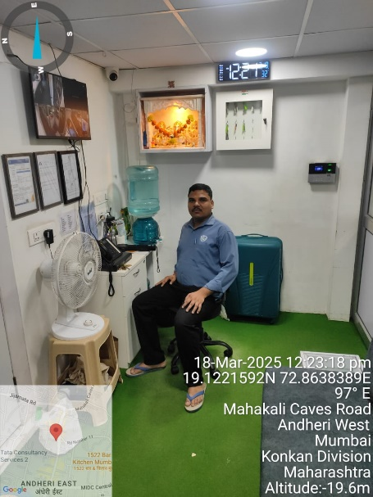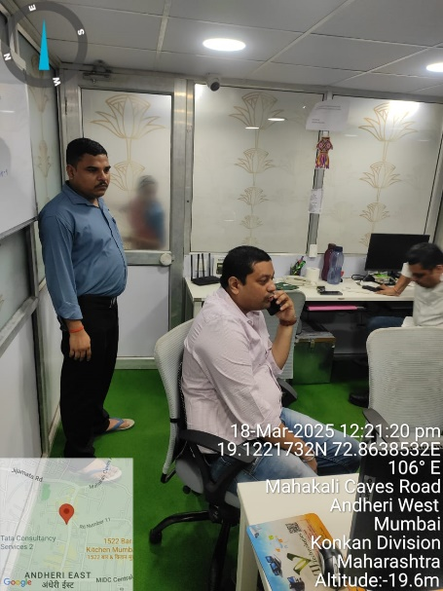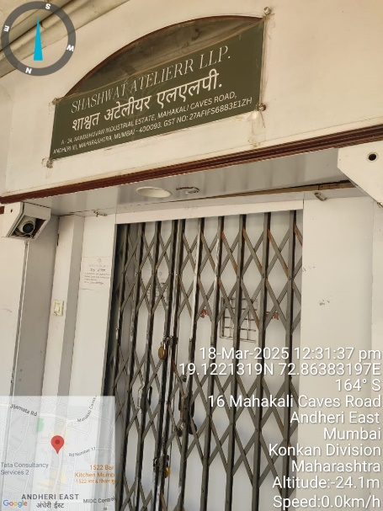

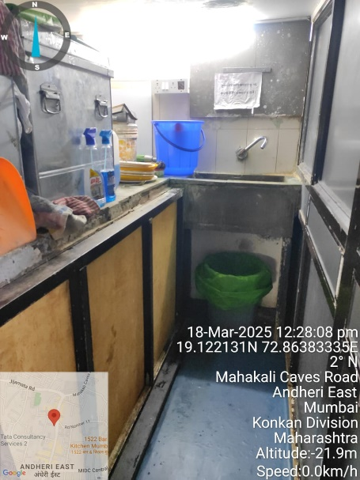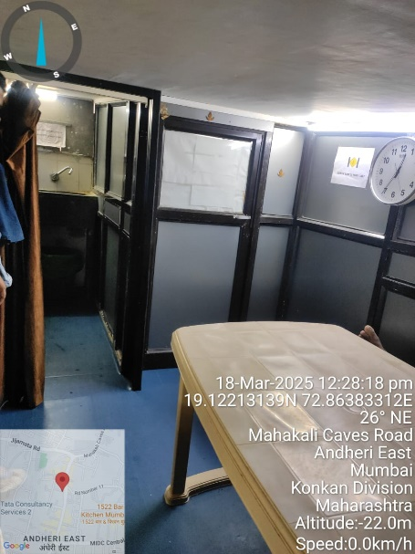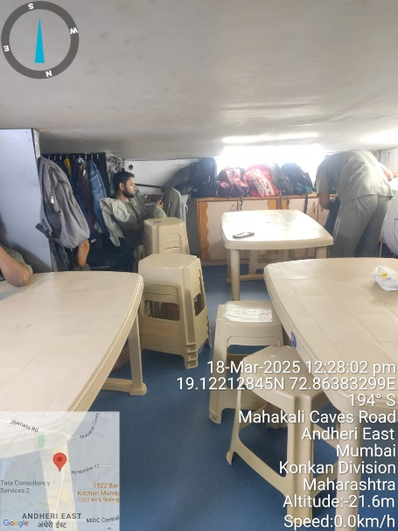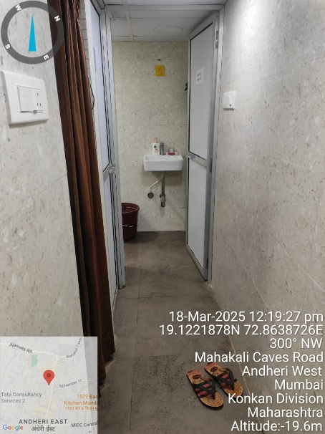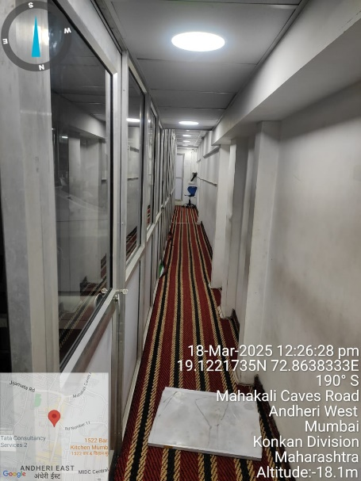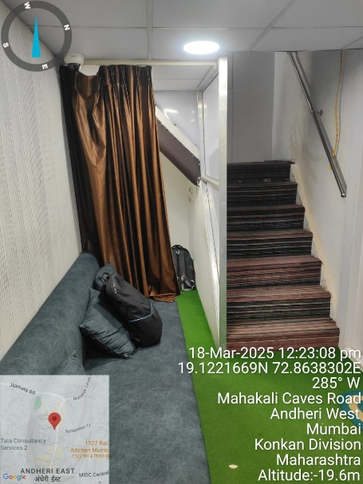

**Actual Site Photographs**

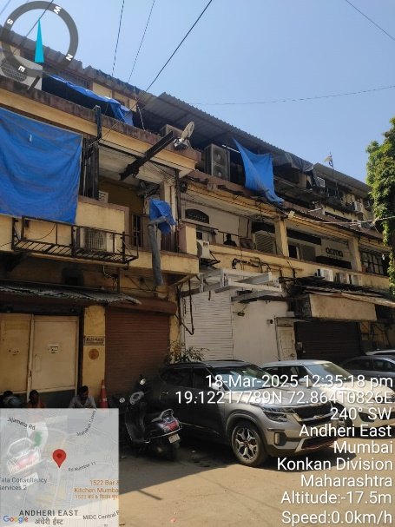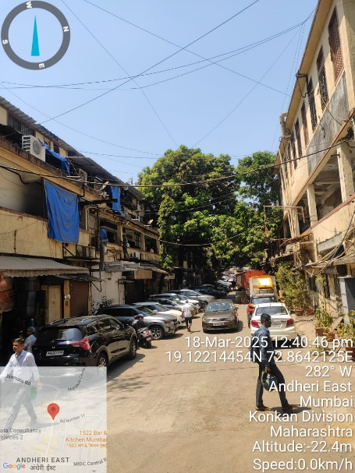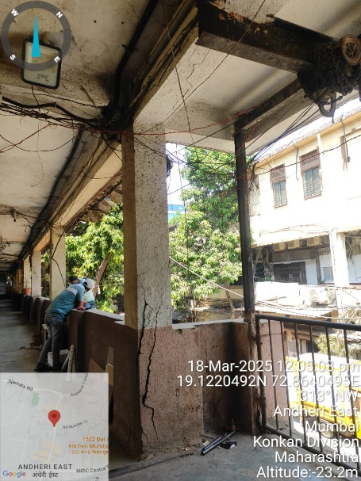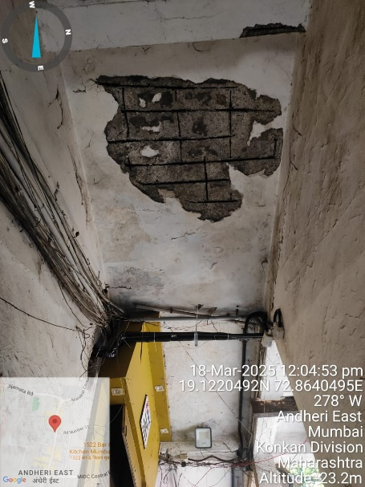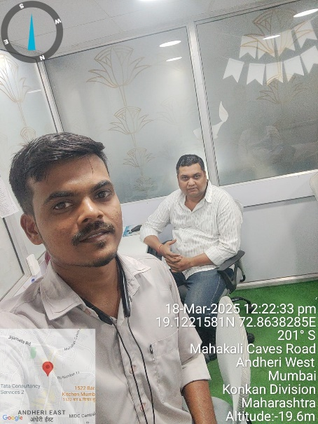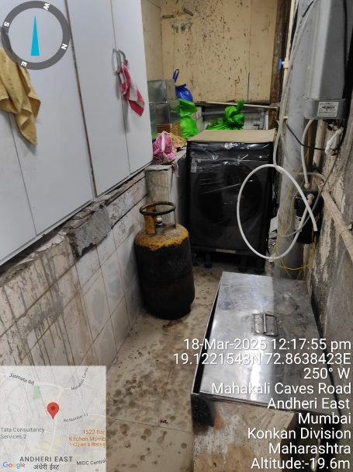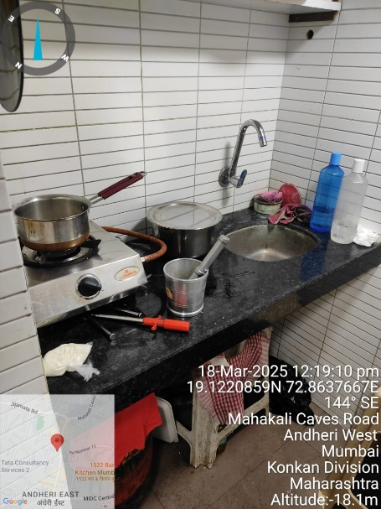

**Route Map of the Property**

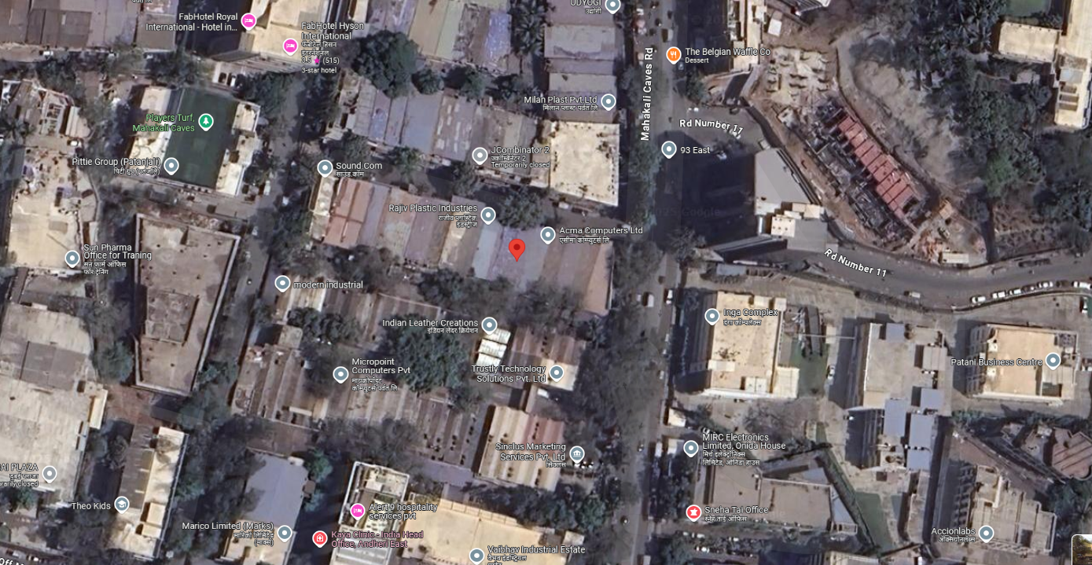

# 

# **Longitude Latitude: 19°07'19.4"N 72°51'49.4"E**

**Note**:

* Red rectangle shows Approx. Property Location.
* Blue line shows Route from Western Express Highway Metro Station @ 1.3 Km.

**Ready Reckoner Rate**

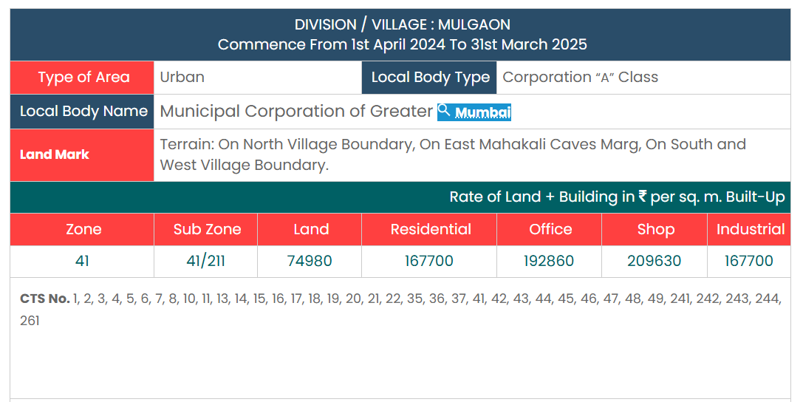

**Price Indicators**

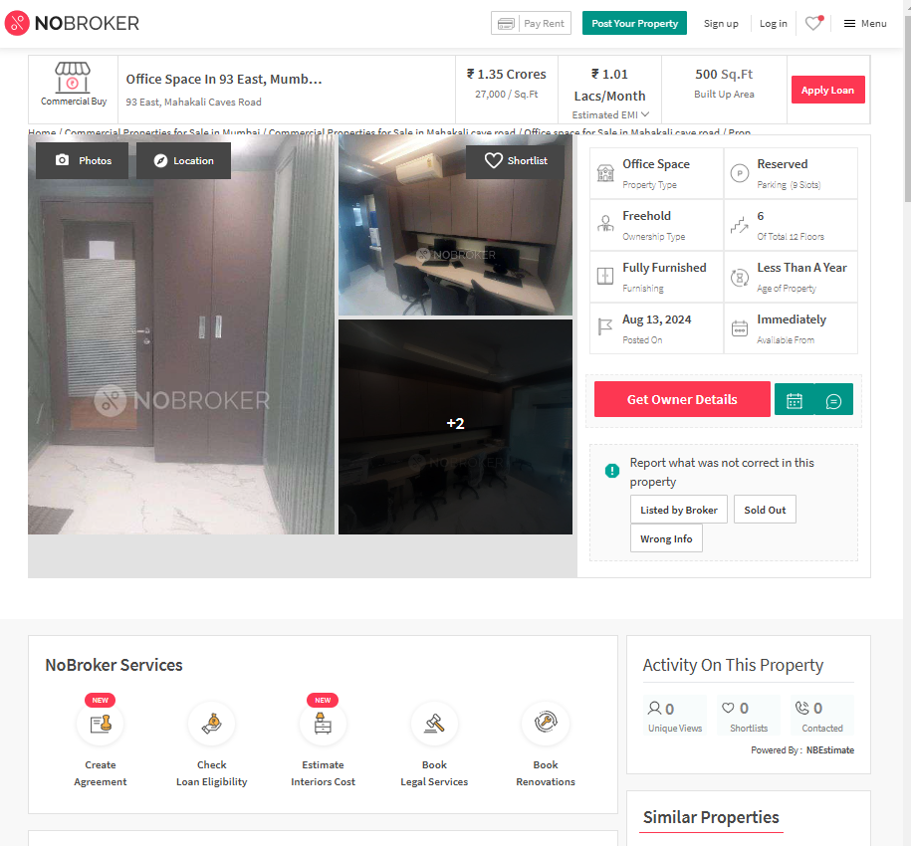

**Price Indicators**

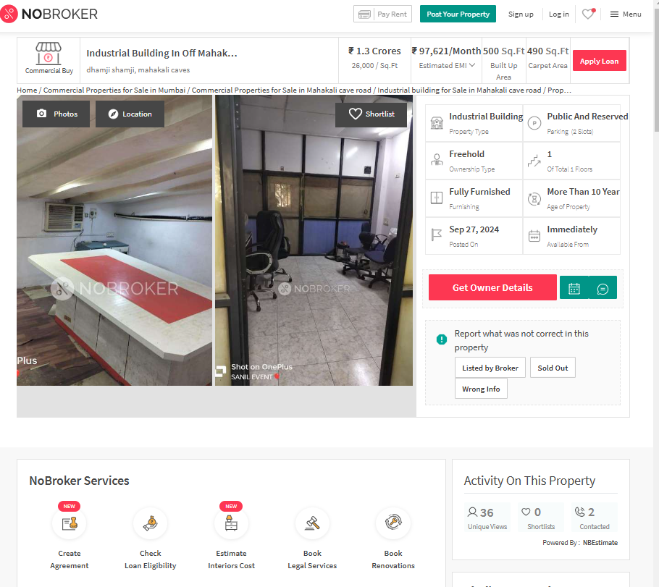

**Price Indicators**

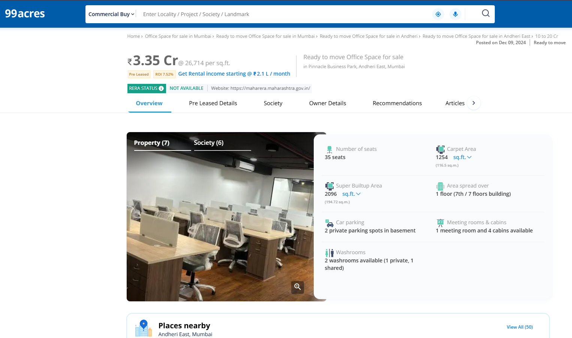

**Sale Transaction**

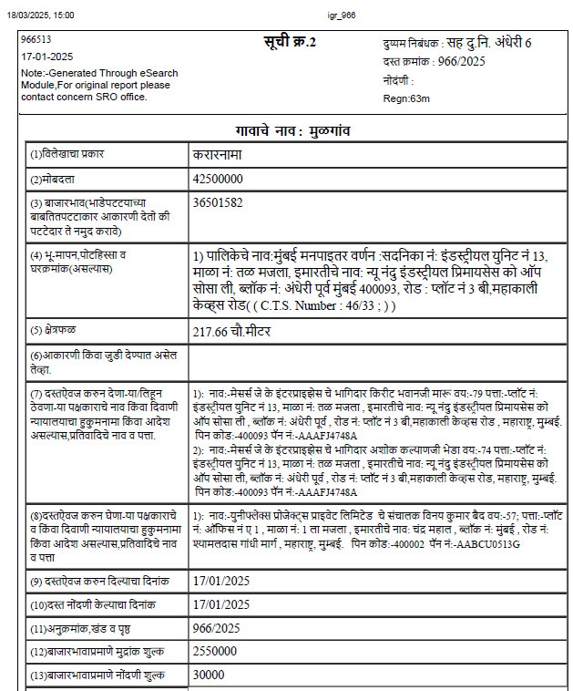

**Sale Transaction**

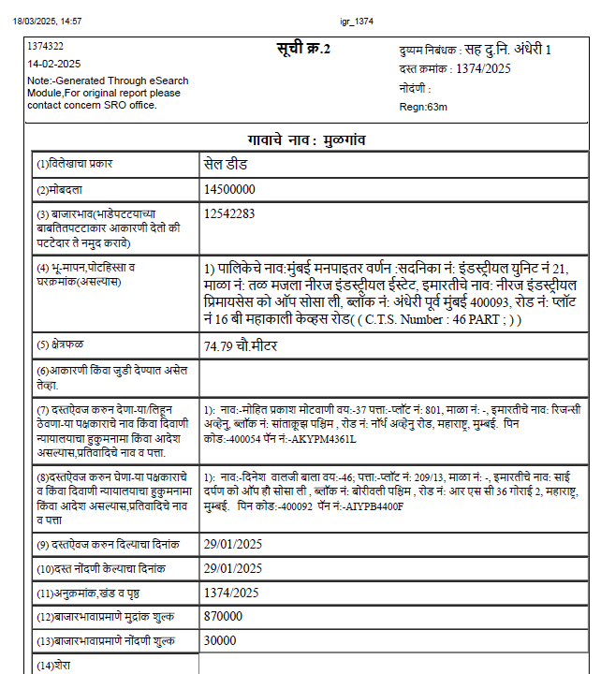

**ASSUMPTIONS, CAVEATS, LIMITATION AND DISCLAIMERS**

1. We assume no responsibility for matters of legal nature affecting the property appraised or the title thereto, nor do we render our opinion as to the title, which is assumed to be good and marketable.
2. The property is valued as though under responsible ownership.
3. It is assumed that the property is free of liens and encumbrances.
4. It is assumed that there are no hidden or unapparent conditions of the subsoil or structure that would render it more or less valuable. No responsibility is assumed for such conditions or for engineering that might be required to discover such factors.
5. The rates for valuation of the property are in accordance with the Govt. approved rates and prevailing market rates

For, **Vastukala Consultants (I) Pvt. Ltd.**

**Sharadkumar B. Chalikwar**

B.E. (Civil), M.E. (Civil), M.Sc. (Real Estate Valuation), M.Sc. (P&M Valuation), FIE (I), FIV, FIWRS

Chairman & Managing Director

Govt. Reg. Valuer

Chartered Engineer (India)

Reg. No. (N) CCIT/1-14/52/2008-09

IBBI Reg.No. IBBI/RV/07/2019/11744

Date: 20.03.2025

Place: Mumbai.