Vastu/Nashik/03/2025/014960/2311056
17/17-253 -RPSP
Date: 17.03.2025

To, `
The Branch Manager,
Bank of Baroda
Regional Office Nashik Road Branch
BSNL Building, Datta Mandir Road, Nashik Road,
Nashik -422 101, State - Maharashtra, Country - India.

Sub: Vetting of Extra Amenities

Sir,

With reference to above subject, we have evaluated the Extra Amenities for Residential Flat No. 12, 4th Floor, "Sagar Nakshatra Aparment", Near Sainath Nagar Garden, Sai Nagar, Ayodhya Nagari, Dr. Nanasaheb Dharmadhikari Marg, Amrutdham, Plot No. 1, Village - Nashik, Taluka - Nashik , District - Nashik, Nashik , 422 003, State - Maharashtra, India belongs to M/s. Nasa Construction Pvt. Ltd.. Name of Proposed Purchaser is Mrs. Harshalata Vinod Pingle.

We have verified the rates quoted as per current market rates. Details of Extra Amenities considered as per copy of Agreement for Extra Amenities issued by to Mrs. Harshalata Vinod Pingle. (First Party) Shri. Gaurav Ravindra kasar (Second Party) received on dated 13.03.2025. The Extra Amenities amount is Rs.4,00,000/- (Rupees Four Lakh Only.)

The said Cost Vetting Certificate is valid upto next 6 months Only.

Thanking you

Sincerely yours

Manoj B. Chalikwar
Registered Valuer
Chartered Engineer (India)
Reg. No. CAT-I-F-1763
Reg. No. IBBI/RV/07/2018/10366
BOB Empanelment No.: ZO:MZ:ADV:46:941
Encl: Valuation report.

Agreement of Extra Amenities
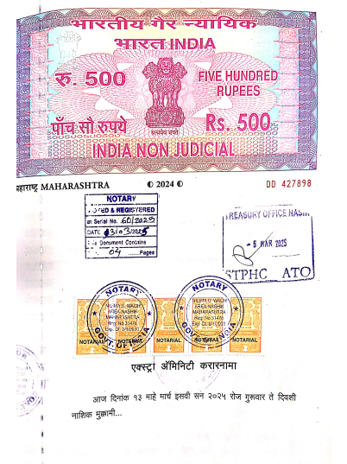
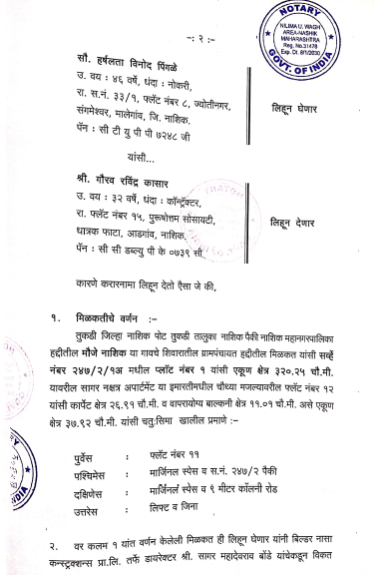

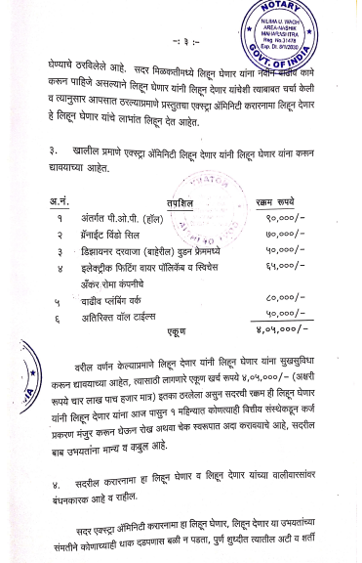
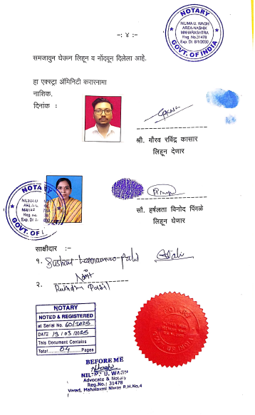

The Extra Work amount Rs.4,00,000/- (Rupees Four Lakh Only.)

