Valuation Report of the Immovable Property
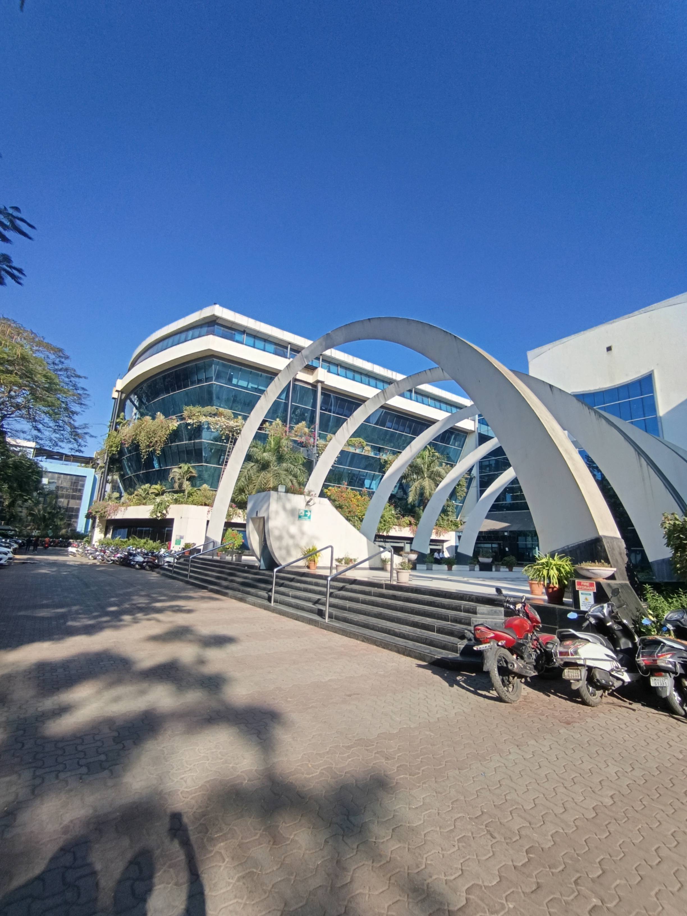

Details of the property under consideration:

Name of Owner: M/s. Dockendale Ship Management (India) Private Limited

Commercial Unit Nos. 201 to 209, 2nd Floor, Wing – A, "Technopolis Knowledge Park", Technopolis Premises Co-Op. Soc. Ltd., Mahakali Caves Road, Hanuman Nagar, Andheri (East), Mumbai - 400093, Maharashtra, India

Latitude Longitude: 19°06'59.1"N 72°51'46.6"E

Vastu/Mumbai/12/2021/28232/44153
13/29-231-VSU
Date: 09.12.2022

VALUATION OPINION REPORT

The property bearing Commercial Unit Nos. 201 to 209, 2nd Floor, Wing - A, "Technopolis Knowledge Park", Technopolis Premises Co-Op. Soc. Ltd., Mahakali Caves Road, Hanuman Nagar, Andheri (East), Mumbai - 400093, Maharashtra, India belongs to M/s. Dockendale Ship Management (India) Private Limited.

Boundaries of the property.

North | : | MIDC
South | : | Internal Road
East | : | Mistry Industrial Complex
West | : | Mahakali Caves Road
Considering various parameters recorded, existing economic scenario, and the information that is available with reference to the development of neighbourhood and method selected for valuation, we are of the opinion that, the property premises can be assessed and valued as on 31.12.2024 for accounting purpose at ` 68,18,30,361.00 (Rupees Sixty Eight Crore Eighteen Lakh Thirty Thousand Three Hundred Sixty One Only)

The valuation of the property is based on the documents produced by the concern. Legal aspects have not been taken into considerations while preparing this valuation report.

Hence certified

Manoj B. Chalikwar
Approved Valuer
Chartered Engineer (India)
Reg. No. CAT-I-F-1763
Encl.: Valuation report

VALUATION REPORT (IN RESPECT OF COMMERCIAL UNIT)
I | General
1. | Purpose for which the valuation is made |  |  | : | As per request from Client, to assess Market Value of the property under reference for accounting purpose as on 31.12.2024.
2. | a) |  | Date of inspection | : | 16.12.2024
 | b) |  | Date on which the valuation is made | : | 23.12.2024
3. | List of documents produced for perusal |  |  | :
- Copy of Sale Deed and Transfer dated 26.02.2024 between Vishindas Holaram Private Limited (Transferor) and M/s. Dockendale Ship Management (India) Private Limited (Transferee).
- Copy of Maintenance Bill vide Invoice No. TKP/24-25/M/103 dated 03.10.2024 for the period of October 2024 to December 2024 in the name of M/s. Dockendale Ship Management (India) Private Limited and Tax Invoice dated 03.10.2024.
- Copy of Electricity Bill dated 03.12.2024 for Unit Nos. 201 to 209 in the name of M/s. Dockendale Ship Management (India) Private Limited.
- Copy of Commencement Certificate vide No. CE / 7078/ BSII / AK dated 15.07.1997 issued by Municipal Corporation of Greater Mumbai.
- Copy of Occupancy Certificate vide No. CE / 7078/ BSII / AK dated 24.12.2001 issued by Municipal Corporation of Greater Mumbai.
- Copy of Approved Plan vide No. CE / 7078 / BSII / WS / AK dated 23.08.2002 issued by Municipal Corporation of Greater Mumbai.
4. | Name of the owner(s) and his / their address (es) with Phone no. (details of share of each owner in case of joint ownership) |  |  | : | M/s. Dockendale Ship Management (India) Private Limited  Address: Commercial Unit Nos. 201 to 209, 2nd Floor, Wing - A, "Technopolis Knowledge Park", Technopolis Premises Co-Op. Soc. Ltd., Mahakali Caves Road, Hanuman Nagar, Andheri (East), Mumbai - 400093, Maharashtra, India  Contact Person :  Mr. Mahesh Patwal (Assistant Manager – Accounts & Finance - 84335 81133)  Mr. Kalpesh Wayankar (Official of Accounts Department – 73045 86975)  Private Limited Company Ownership
5. | Brief description of the property (Including Leasehold / freehold etc.) |  |  | : | The property is an amalgamated commercial unit Nos. 201 to 209 located on 2nd Floor. The composition of unit is Reception + 2 Mining Department + 2 Conference Room + Training Centre (Under renovation) + Working Space + Server Room + Cafeteria + 3 Small + 1 Large Conference Rooms + Cabins + 2 Washrooms (Ladies + Gents).  The property is at 1 Km. distance from nearest Metro station Chakala (J B Nagar).
6. | Location of property |  |  | :
 | a) | Plot No. / Survey No. |  | : | -
 | b) | Door No. |  | : | Commercial Unit Nos. 201 to 209
 | c) | C. T.S. No. / Village |  | : | C.T.S. No. 238/A of Village Mulgaon & C.T.S. No. 8A, 8B of village Chakala.
 | d) | Ward / Taluka |  | : | Taluka Andheri
 | e) | Mandal / District |  | : | District – Mumbai
 | f) | Date of issue and validity of layout of approved map / plan |  | : | Copy of Approved Plan vide No. CE / 7078 / BSII / WS / AK dated 23.08.2002.
 | g) | Approved map / plan issuing authority |  | : | Municipal Corporation of Greater Mumbai.
 | h) | Whether genuineness or authenticity of approved map/ plan is verified |  | : | Yes
 | i) | Any other comments by our empanelled valuers on authentic of approved plan |  |  | No
7. | Postal address of the property |  |  | : | Commercial Unit Nos. 201 to 209, 2nd Floor, Wing - A, "Technopolis Knowledge Park", Technopolis Premises Co-Op. Soc. Ltd., Mahakali Caves Road, Hanuman Nagar, Andheri (East), Mumbai - 400093, Maharashtra, India.
8. | City / Town |  |  | : | Mumbai
 | Residential area |  |  | : | Yes
 | Commercial area |  |  | : | Yes
 | Industrial area |  |  | : | No
9. | Classification of the area |  |  | :
 | i) High / Middle / Poor |  |  | : | Middle Class
 | ii) Urban / Semi Urban / Rural |  |  | : | Urban
10. | Coming under Corporation limit / Village Panchayat / Municipality |  |  | : | Municipal Corporation of Greater Mumbai
11. | Whether covered under any State / Central Govt. enactments (e.g., Urban Land Ceiling Act) or notified under agency area/ scheduled area / cantonment area |  |  | : | No
12. | Boundaries of the property
 | North |  |  | : | MIDC
 | South |  |  | : | Internal Road
 | East |  |  | : | Mistry Industrial Complex
 | West |  |  | : | Mahakali Caves Road
13 | Dimensions of the site |  |  |  | N. A. as property under consideration is a commercial unit in a apartment building.
 |  |  |  |  | A As per the Deed | B Actuals
 | North |  |  | : | - | -
 | South |  |  | : | - | -
 | East |  |  | : | - | -
 | West |  |  | : | - | -
14. | Extent of the site |  |  | : | Carpet Area = 20,606.00 Sq. Ft. including AHU & Door Jamb Area  (Area as per Physical Measurement)  Built Up Area = 26,153.00 Sq. Ft.  (Area as per Agreement)
14.1 | Latitude, Longitude & Co-ordinates of Commercial Unit |  |  | : | 19°06'59.1"N 72°51'46.6"E
15. | Extent of the site considered for Valuation (least of 13A& 13B) |  |  | : | Built Up Area = 26,153.00 Sq. Ft.  (Area as per Agreement)
16 | Whether occupied by the owner / tenant? If occupied by tenant since how long? Rent received per month. |  |  | : | Owner occupied
II | APARTMENT BUILDING
 | Nature of the Apartment |  |  | : | Commercial
 | Location |  |  | :
 | C.T.S. No. |  |  | : | C.T.S. No. 238/A of Village Mulgaon & C.T.S. No. 8A, 8B of village Chakala.
 | Block No. |  |  | : | -
 | Ward No. |  |  | : | 'K East' Ward
 | Village / Municipality / Corporation |  |  | : | Village Mulgaon and Chakala, MCGM
 | Door No., Street or Road (Pin Code) |  |  | : | Commercial Unit Nos. 201 to 209, Mahakali Caves Road, Pin - 400093.
 | Description of the locality Residential / Commercial / Mixed |  |  | : | Mixed.
 | Year of Construction |  |  | : | 2001 (As per Occupancy Certificate)
 | Number of Floors |  |  | : | Basement + Ground + 5 Upper floors
 | Type of Structure |  |  | : | R.C.C. Framed Structure
 | Number of Dwelling units in the building |  |  | : | Owner occupied on entire 2nd Floor
 | Quality of Construction |  |  | : | Good
 | Appearance of the Building |  |  | : | Good
 | Maintenance of the Building |  |  | : | Good
 | Facilities Available |  |  | :
 | Lift |  |  | : | 6 lifts
 | Protected Water Supply |  |  | : | Municipal Water supply
 | Underground Sewerage |  |  | : | Connected to Municipal Sewerage System
 | Car parking - Open / Covered |  |  | : | 25 Nos. Car Parking (As per site information 7 Nos. Open + 18 Nos. Covered)
 | Is Compound wall existing? |  |  | : | Yes
 | Is pavement laid around the Building |  |  | : | Yes

III | COMMERCIAL UNIT
1 | The floor in which the Commercial Unit is situated | : | 2nd Floor
2 | Door No. of the Commercial Unit | : | Commercial Unit Nos. 201 to 209
3 | Specifications of the Commercial Unit | :
 | Roof | : | R.C.C. Slab
 | Flooring | : | Vitrified flooring
 | Doors | : | Teak wood flush doors and Glass doors.
 | Windows | : | Aluminium sliding windows
 | Fittings | : | Electrical wiring with Concealed.
 | Finishing | : | Cement Plastering and POP false ceiling.
4 | House Tax | :
 | Assessment No. | : | Details not available
 | Tax paid in the name of : | : | Details not available
 | Tax amount : | : | Details not available
5 | Electricity Service connection No. : | : | Consumer No. (CA No.) 9000 0130 0069 – 201 to 209
 | Meter Card is in the name of : | : | M/s. Dockendale Ship Management (India) Private Limited.
6 | How is the maintenance of the Commercial Unit? | : | Good
7 | Sale Deed executed in the name of | : | M/s. Dockendale Ship Management (India) Private Limited
8 | What is the undivided area of land as per Sale Deed? | : | Details not available
9 | What is the plinth area of the Commercial Unit? | : | Built Up Area = 26,153.00 Sq. Ft.  (Area as per Agreement)
10 | What is the floor space index (app.) | : | As per local norms
11 | What is the Carpet Area of the Commercial Unit? | : | Carpet Area = 20,606.00 Sq. Ft. including AHU & Door Jamb Area  (Area as per Physical Measurement)
12 | Is it Posh / I Class / Medium / Ordinary? | : | Middle Class
13 | Is it being used for Residential or Commercial purpose? | : | Commercial purpose
14 | Is it Owner-occupied or let out? | : | Owner occupied
15 | If rented, what is the monthly rent? | : | ` 21,15,000.00 Expected rental income per month
IV | MARKETABILITY | :
1 | How is the marketability? | : | Good
2 | What are the factors favouring for an extra Potential Value? | : | Located in developed area
3 | Any negative factors are observed which affect the market value in general? | : | No
V | Rate | :
1 | After analyzing the comparable sale instances, what is the composite rate for a similar Commercial Unit with same specifications in the adjoining locality? - (Along with details / reference of at - least two latest deals / transactions with respect to adjacent properties in the areas) | : | ` 22,500.00 to ` 24,500.00 per Sq. Ft. on Built up area
2 | Assuming it is a new construction, what is the adopted basic composite rate of the Commercial Unit under valuation after comparing with the specifications and other factors with the Commercial Unit under comparison (give details). | : | ` 23,500.00 per Sq. Ft. on Built up area including car parking
3 | Break – up for the rate | :
 | I. Building + Services | : | ` 3,000.00 per Sq. Ft.
 | II. Land + others | : | ` 20,500.00 per Sq. Ft.
4 | Guideline rate obtained from the Registrar's office (an evidence thereof to be enclosed) | : | ` 1,99,000.00 per Sq. M. i.e. ` 18,488.00 per Sq. Ft.
 | Guideline rate after depreciation | : | ` 1,72,597.00 per Sq. M. i.e. ` 16,035.00 per Sq. Ft.
VI | COMPOSITE RATE ADOPTED AFTER DEPRECIATION
a | Depreciated building rate | :
 | Replacement cost of Commercial Unit with Services (v(3)i) | : | -
 | Age of the building | : | 23 years.
 | Life of the building estimated | : | 37 years (Subject to proper, preventive periodic maintenance & structural repairs.)
 | Remark | : | At the time of visit we found part office was in working condition and part under renovation.

Details of Valuation:

Sr. No. | Description | Qty. | Rate per  unit (`) | Estimated  Value (`)
1 | Value of the Commercial Unit | 26,153.00 Sq. Ft. Built up area | 23,500.00 | 61,45,95,500.00
2 | Cost of the Interior – As per details of interior work provided by the client following value considered on completion of the renovation of entire office. | - | - | 6,72,34,861.00
  Particular | Value (`)
  Civil Work | 37,37,492.00
  Electrical Work | 87,27,687.00
  Furniture & Fixture | 2,41,34,222.00
  HVAC, Fire Fighting, Access Control, etc. | 2,83,97,173.00
  Miscellaneous items | 22,38,287.00
  Grand Total | 6,72,34,861.00
 | Total Fair Market Value |  |  | 68,18,30,361.00
 | The realizable value of the property |  |  | 61,36,47,325.00
 | Distress value of the property |  |  | 54,54,64,289.00
 | Insurable value of the property (26,153.00 Sq. Ft. Built up area x ` 3,000.00) |  |  | 7,84,59,000.00

The sales comparison approach uses the market data of sale prices to estimate the value of a real estate property . Property valuation in this method is done by comparing a property to other similar properties that have been recently sold. Comparable properties , also known as comparables, or comps , must share certain features with the property in question . Some of these include physical features such as square footage, number of rooms, condition, and age of the building; however, the most important factor is no doubt the location of the property. Adjustments are usually needed to account for differences as no two properties are exactly the same. To make proper adjustments when comparing properties, real estate appraisers must know the differences between the comparable properties and how to value these differences. The sales comparison approach is commonly used for Commercial Unit, where there are typically many comparables available to analyze. As the property is a Commercial Unit, we have adopted Sale Comparison Approach Method for the purpose of valuation .The Price for similar type of property in the nearby vicinity is in the range of ` 22,500.00 to ` 24,500.00 per Sq. Ft. Considering the rate with attached report , current market conditions , demand and supply position, Commercial Unit size, location, upswing in real estate prices , sustained demand for Commercial Unit , all round development of commercial and residential and commercial application in the locality etc. We estimate ` 23,500.00 per Sq. Ft. for valuation.

Actual site photographs
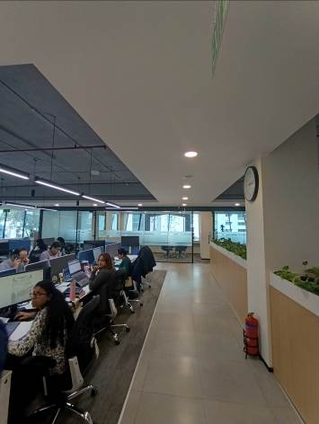
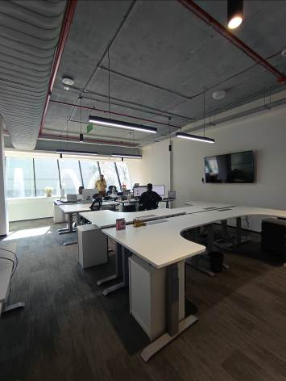
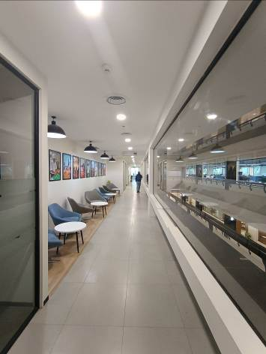

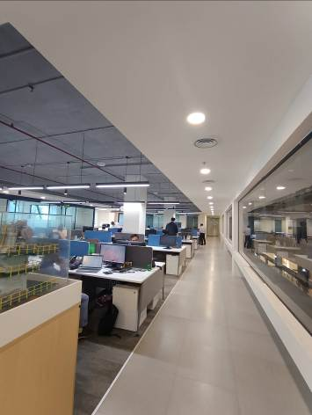
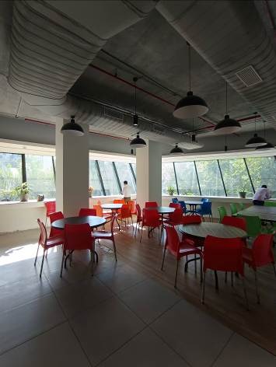
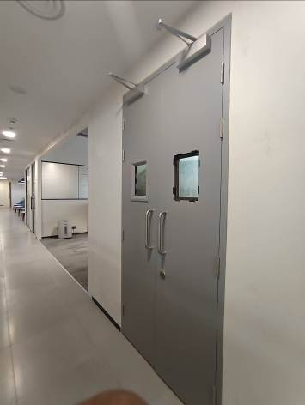

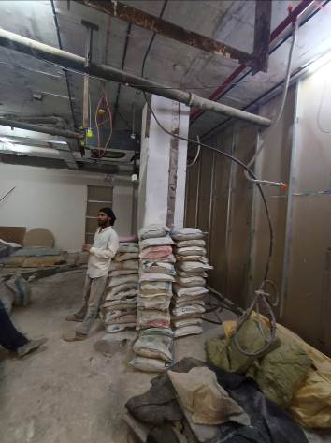
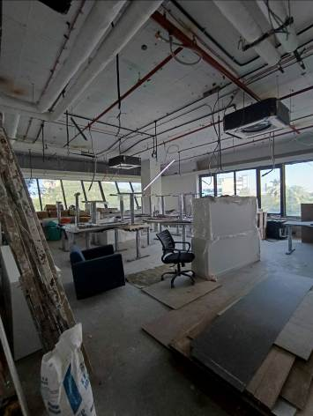
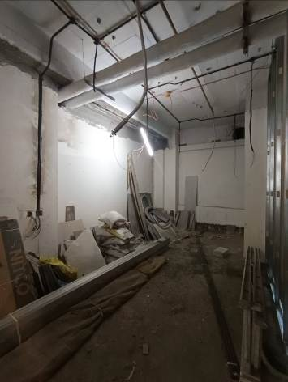

Actual site photographs
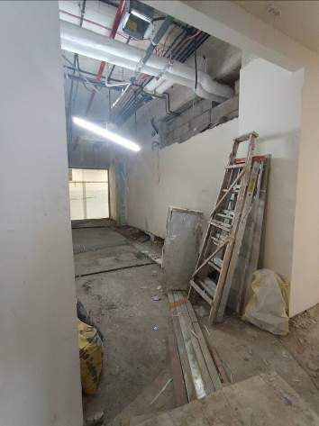
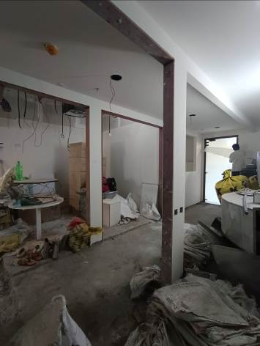
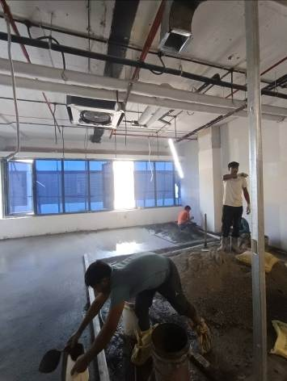

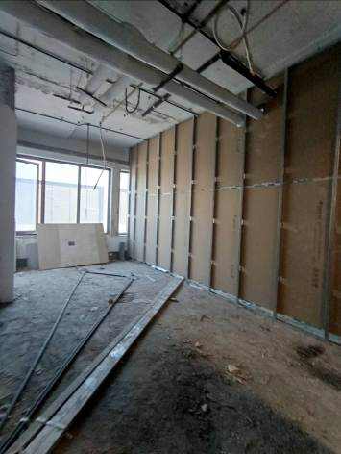
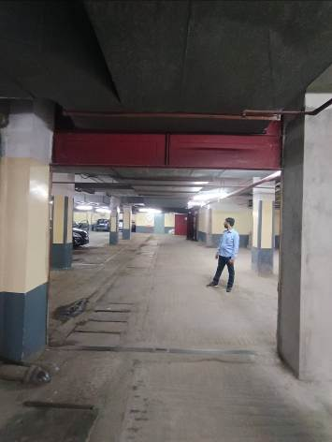
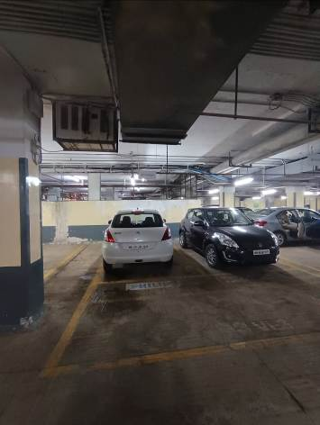
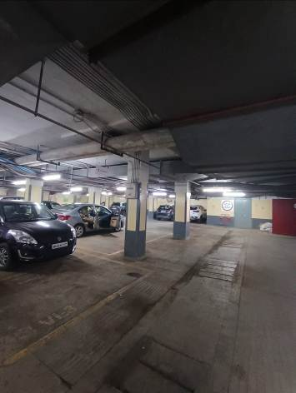
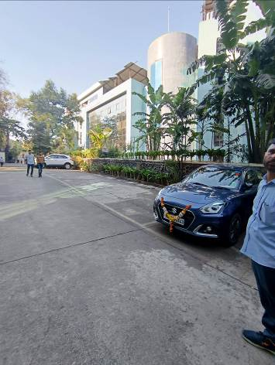
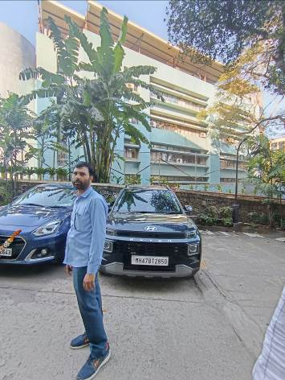
Actual site photographs

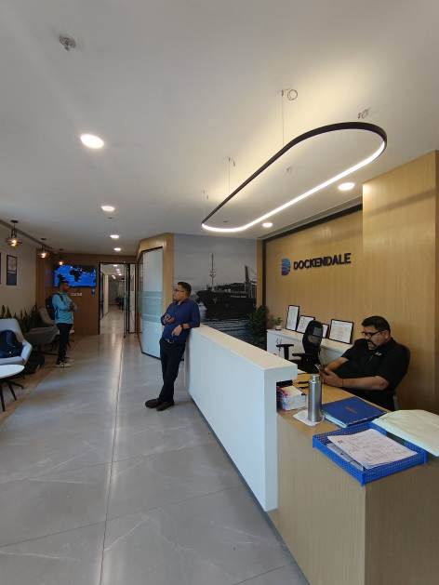
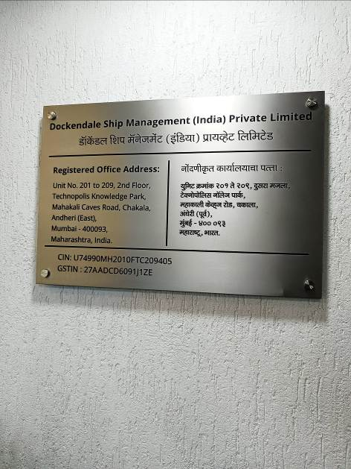
Route Map of the property
Site u/r
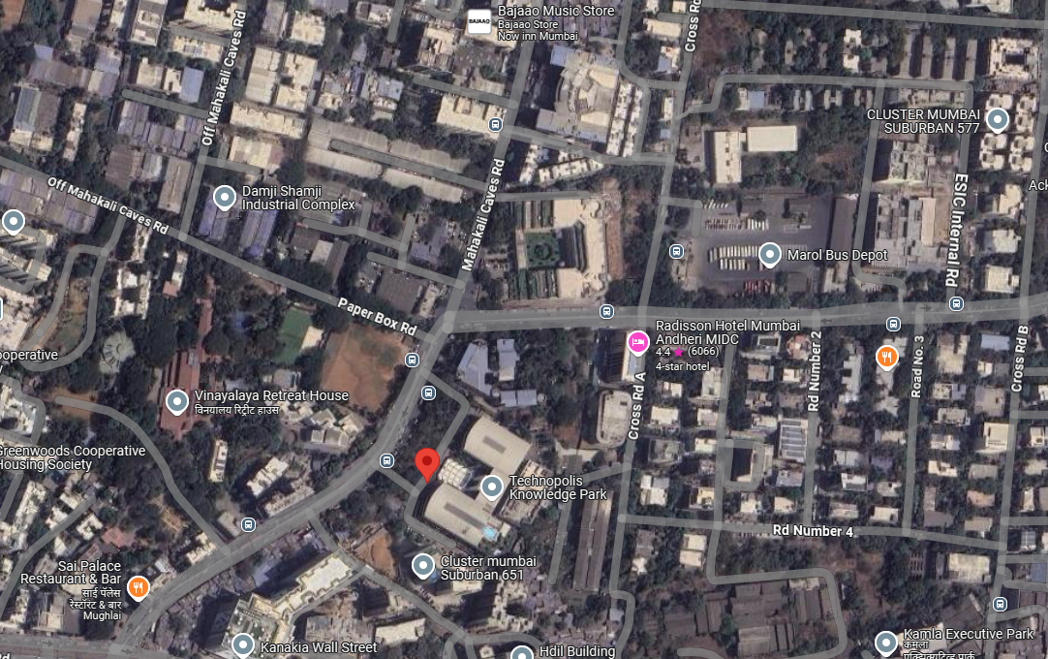

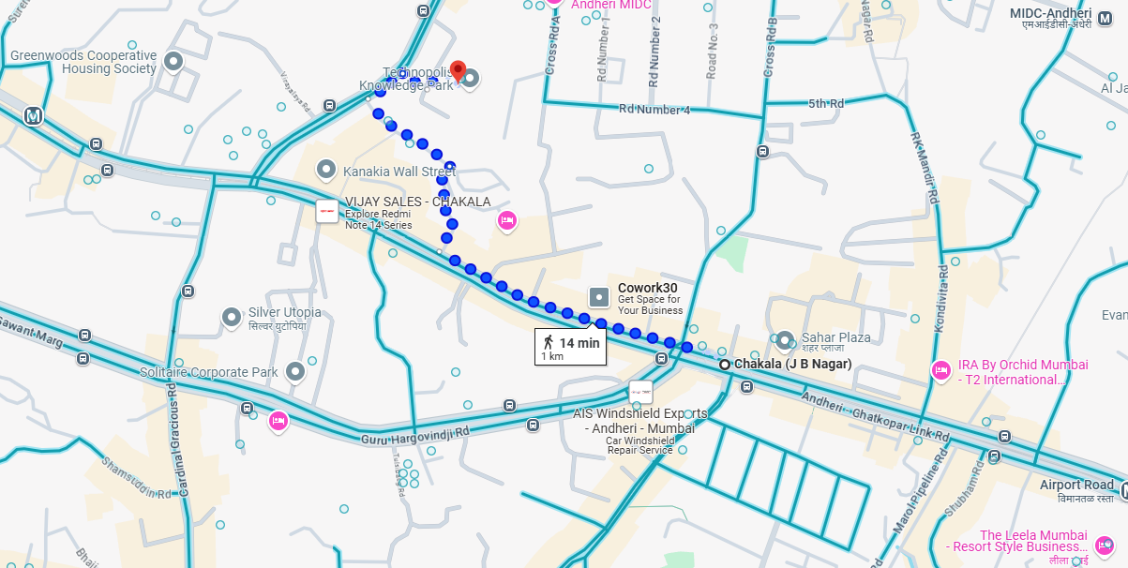



Latitude Longitude: 19°06'59.1"N 72°51'46.6"E
Note: The Blue line shows the route to site from nearest Metro station (Chakala (J B Nagar) 1 Km.)

Ready Reckoner Rate
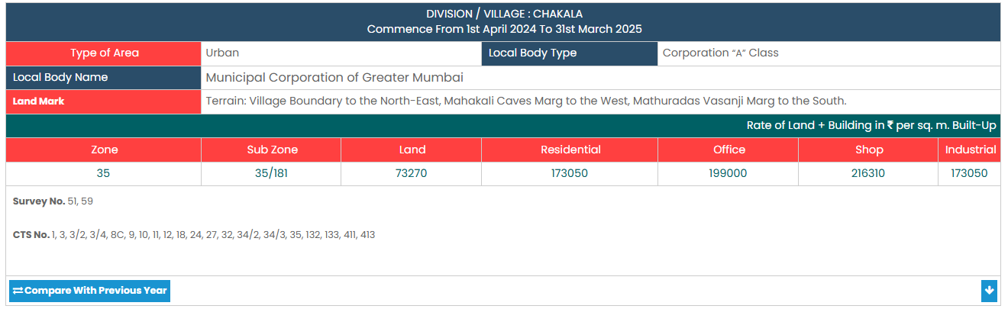
Price Indicators
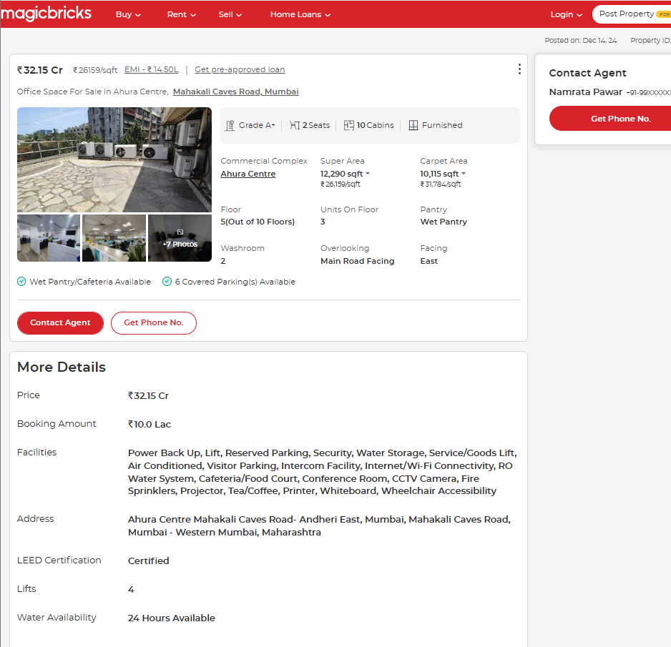

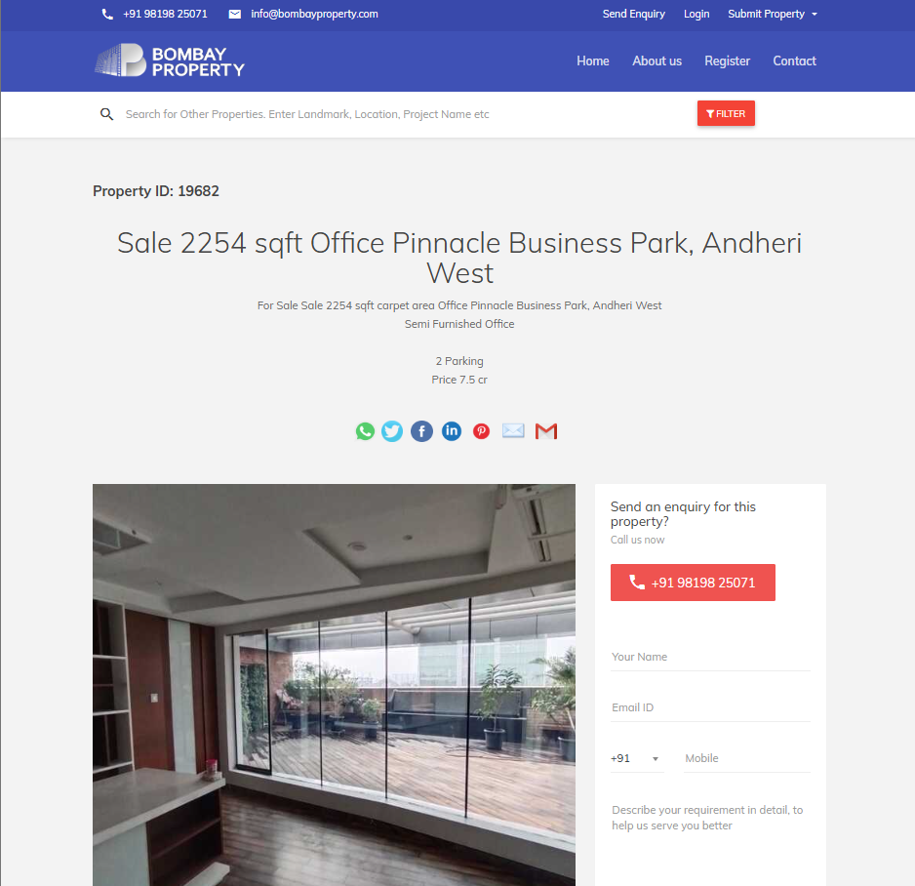

Sale Instance
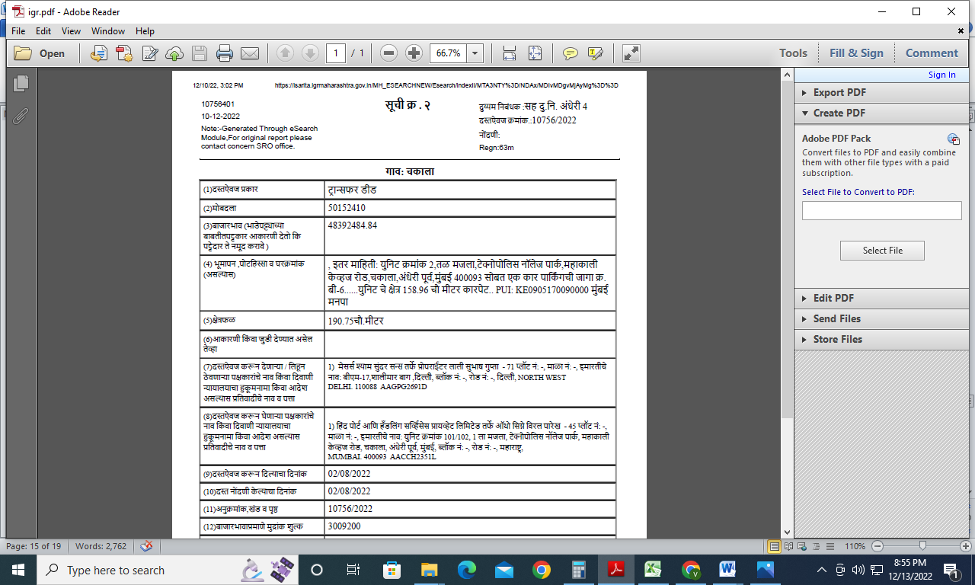
Sale Instance
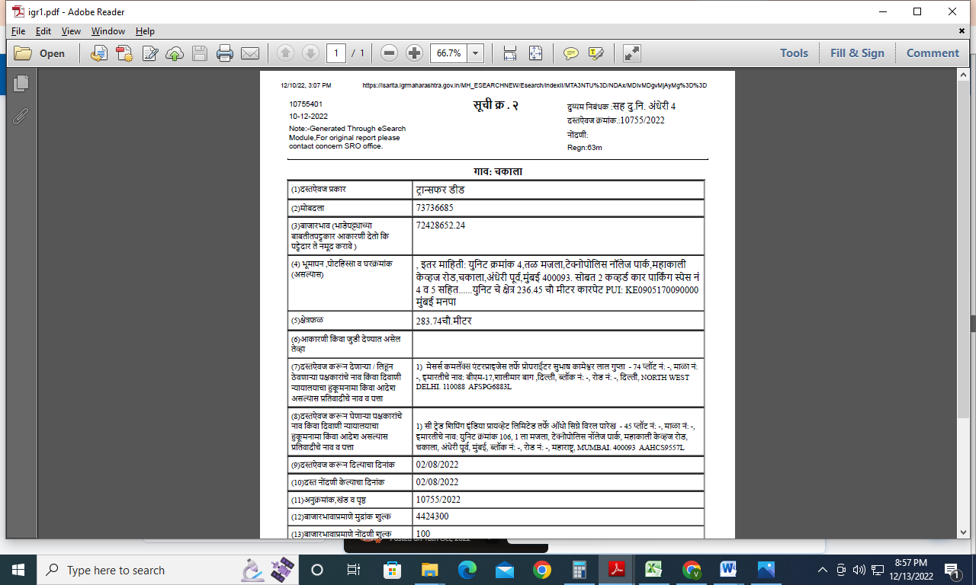
Justification for price /rate

The Market Value of the property is based on facts of markets discovered by us during our enquiries, however the government rate value in this case is less than the market value arrived by us. We are of the opinion that the value arrive by us will prove to be correct if an Auction of the subject property is carried out. As far as Market Value in Index II is concerned, it is not possible to comment on same, may be government rates are fixed by sampling during same point of time in part and whereas, Market values change every month.

In most of the cases the actual deal amount or Transaction value is not reflected in Index II because of various Market practices. As Valuer, we always try to give a value which is correct reflection of actual transaction value irrespective of any factors in market.

As a result of my appraisal and analysis, it is my considered opinion that the Market Value as on 31.12.2024 for accounting purpose of the above property in the prevailing condition with aforesaid specifications is ` 68,18,30,361.00 (Rupees Sixty Eight Crore Eighteen Lakh Thirty Thousand Three Hundred Sixty One Only).

DEFINITION OF VALUE FOR THIS SPECIFIC PURPOSE

This exercise is to assess Market Value of the property under reference as on 31.12.2024 for Accounting Purpose.

The term Fair Market Value is defined as

“The most probable price, as of a specified date, in cash, terms equivalent to cash, or in other precisely revealed terms for which the specified property rights would sell after reasonable exposure in a competitive market under all conditions requisite to a fair sale, with the buyer and seller each acting prudently knowledgeably and for self interest assuming that neither is under undue duress”.

Fundamental assumptions and conditions presumed in this definition are:

1. Buyer and seller are motivated by self-interest.
2. Buyer and seller are well informed and are acting prudently.
3. The property is exposed for a reasonable time on the open market.
4. Payment is made in cash or equivalent or in specified financing terms.

ASSUMPTIONS, CAVEATS, LIMITATION AND DISCLAIMERS
1. We assume no responsibility for matters of legal nature affecting the property appraised or the title thereto, nor do we render our opinion as to the title, which is assumed to be good and marketable.
2. The property is valued as though under responsible ownership.
3. It is assumed that the property is free of liens and encumbrances.
4. It is assumed that there are no hidden or unapparent conditions of the subsoil or structure that would render it more or less valuable. No responsibility is assumed for such conditions or for engineering that might be required to discover such factors.
5. There is no direct/ indirect interest in the property valued.
6. The rates for valuation of the property are in accordance with the Govt. approved rates and prevailing market rates.
DECLARATION OF PROFESSIONAL FEES CHARGED

We hereby declare that, our professional fees are not contingent upon the valuation findings. However, if the statute AND/OR clients demands that, the fees should be charged on the percentage of assessed value then, with the full knowledge of the AND/OR end user, it is being charged accordingly.

VALUATION OF THE PROPERTY PREMISES

Considering various parameters recorded herein above, existing economic scenario, and the information that is available with reference to the development of neighborhood and method selected for valuation, we are of the opinion that, the property premises can be assessed and Market value as on 31.12.2024 for accounting purpose for this particular purpose at ` 68,18,30,361.00 (Rupees Sixty Eight Crore Eighteen Lakh Thirty Thousand Three Hundred Sixty One Only)

Manoj B. Chalikwar
Approved Valuer
Chartered Engineer (India)
Reg. No. CAT-I-F-1763

