Vastu/Nashik/03/2025/ 014802 / 2310953
10/9-150 -RPSP
Date: 12.03.2025

To, `
The Branch Manager,
Bank of Baroda
Regional Office Nashik Road Branch
BSNL Building, Datta Mandir Road, Nashik Road,
Nashik -422 101, State - Maharashtra, Country - India.

Sub: Vetting of Extra Amenities

Sir,

With reference to above subject, we have evaluated the Extra Amenities for Residential Flat No. 501, 5th Floor, "VIVANTA SQUARE", Near Guru Goving Singh School & College , Opp. Metro Zone, Indira Nagar Annex, Pathardi Phata, Village - Pathardi-1, Taluka - Nashik, District - Nashik, Nashik, 422009, State - Maharashtra, India belongs to Mr.
Chetan Chandrakat Phate.

We have verified the rates quoted as per current market rates. Details of Extra Amenities considered as per copy of Agreement for Extra Amenities issued by to Mr. Chetan Chandrakat Phate. (First Party) Vidya Shriniwas Raut (Second Party) received on dated 15.03.2025. The Extra Amenities amount is Rs.5,00,000/- (Rupees Five Lakh Only.)

The said Cost Vetting Certificate is valid upto next 6 months Only.

Thanking you

Sincerely yours

Manoj B. Chalikwar
Registered Valuer
Chartered Engineer (India)
Reg. No. CAT-I-F-1763
Reg. No. IBBI/RV/07/2018/10366
BOB Empanelment No.: ZO:MZ:ADV:46:941
Encl: Valuation report.

Agreement of Extra Amenities
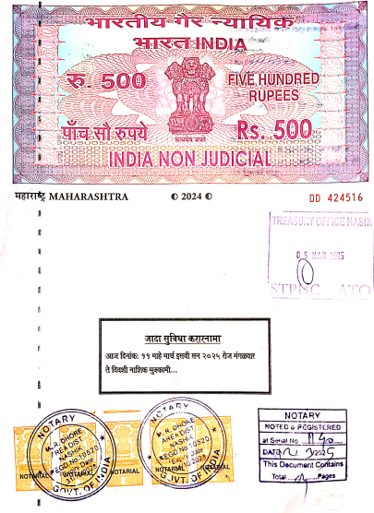
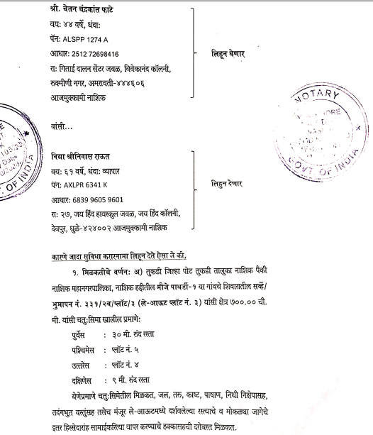

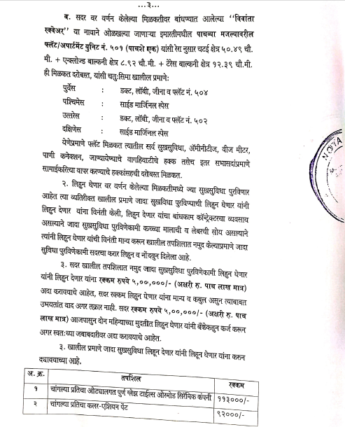
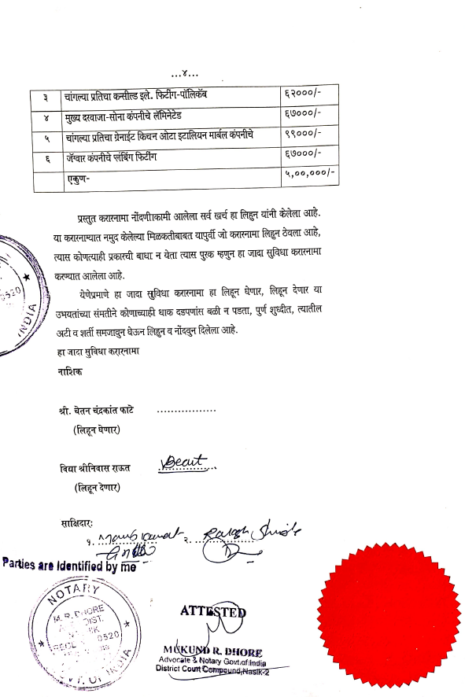

The Extra Work amount Rs.5,00,000/- (Rupees Five Lakh Only.)

