Vastu/Nashik/02/2025/014532/ 2310724
24/10-374 -RYSP
Date: 12.03.2025
To,
The Branch Manager,
Bank of Baroda
Regional Office
BSNL Building, Datta Mandir Road, Nashik Road,
Nashik, PIN – 422 101, State - Maharashtra, Country - India.

Sub: Vetting of Extra Work

Sir,

With reference to above subject, we have evaluated the Extra Work For Residential Flat No. 603, 6th Floor, " Krishna Emerald ", Near Chhatrapati Shivaji Maharaj Cricket Ground, Siemens Colony, Rane Nagar, Survey No - 890/ 1A/ 16/ 17, Plot No. 16+17, off Wadala - Pathardi Road, Taluka - Nashik, District - Nashik, Nashik, PIN Code - 422 009, State - Maharashtra, India. belongs to Shri. Swapnil Balkrushna Kothawade & Sau. Madhuri Swapnil Kothawade.

We have verified the rates quoted as per current market rates. Details of Extra Work considered as per copy of Extra Work Agreement between : Shri. Swapnil Balkrushna Kothawade & Sau. Madhuri Swapnil Kothawade (First Party). Sau. Anita Suryakant Kapile (Second Party) received on dated.18.02.2025 The Extra Work amount is Rs. 4,50,000/- (Rupees Four Lakh Fifty Thousand Only)

The said Cost Vetting Certificate is valid upto next 6 months Only.

Thanking you

Sincerely yours

Manoj Chalikwar
Govt. Reg. Valuer
Chartered Engineer (India)
Reg. No. IBBI/RV/07/2018/10366
Bank Of Baroda Empanelment No.: ZO :MZ:ADV:46:941
Encl.: Valuation report.

Agreement for Extra Work
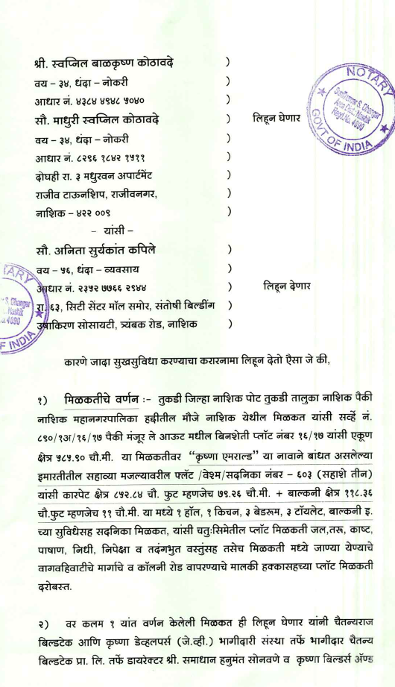
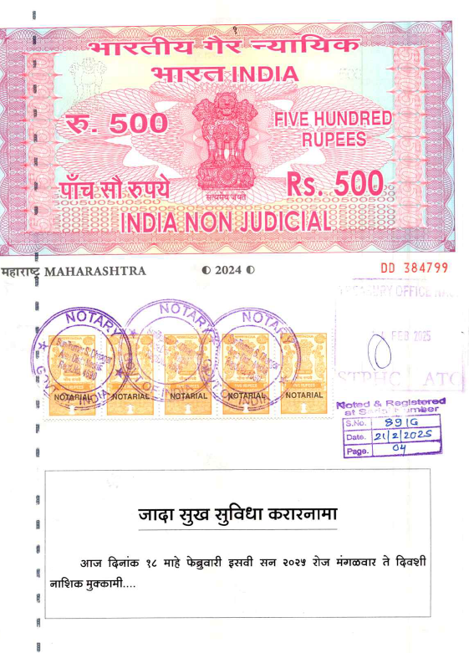

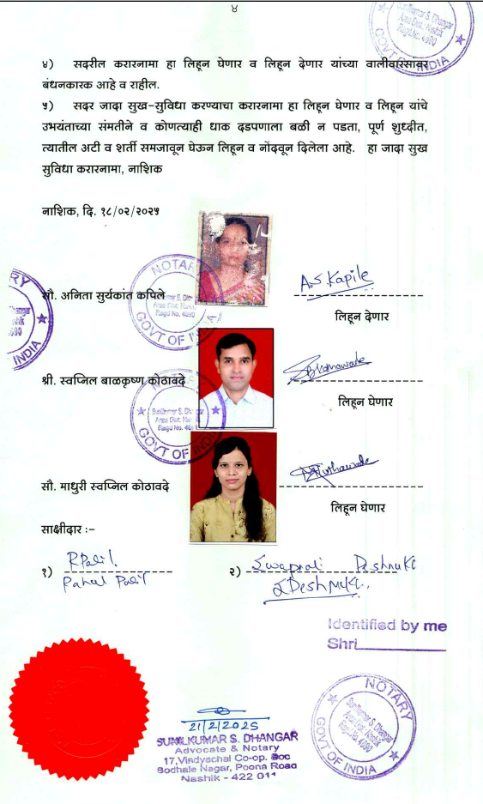
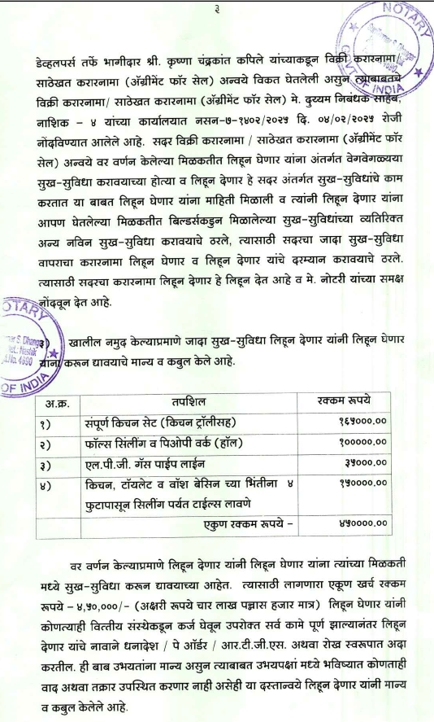

The Extra Work amount is Rs. 4,50,000/- (Rupees Four Lakh Fifty Thousand Only)

