Vastu/Nashik/03/2025/ 014861/2310983
12/2-180-RPBS
Date: 12.03.2025

To, `
The Branch Manager,
Bank of Baroda
Regional Office Nashik Road Branch
BSNL Building, Datta Mandir Road, Nashik Road,
Nashik -422 101, State - Maharashtra, Country - India.

Sub: Vetting of Extra Amenities

Sir,

With reference to above subject, we have evaluated the Extra Amenities for Residential Flat No. 601, 6th Floor, "Ashapuri Girija", Near Akshata Lawns, Ayodhya Nagari, Plot No. 8+9+10, Meri - Rasbihari Road, Taluka - Nashik, District - Nashik, Nashik, PIN Code - 422 003, State - Maharashtra, Country - India belongs to Mr. Kalpesh Satish Chaudhari & Mrs. Dhanashri Kalpesh Chaudhari.

We have verified the rates quoted as per current market rates. Details of Extra Amenities considered as per copy of Agreement for Extra Amenities issued by to Mr. Kalpesh Satish Chaudhari & Mrs. Dhanashri Kalpesh Chaudhari. (First Party) Shri. Kiran Krushna Manke (Second Party) received on dated 11. 03..2025. The Extra Amenities amount is Rs.7,00,000/- (Rupees Seven Lakh Only.)

The said Cost Vetting Certificate is valid upto next 6 months Only.

Thanking you

Sincerely yours

Manoj B. Chalikwar
Registered Valuer
Chartered Engineer (India)
Reg. No. CAT-I-F-1763
Reg. No. IBBI/RV/07/2018/10366
BOB Empanelment No.: ZO:MZ:ADV:46:941
Encl: Valuation report.

Agreement of Extra Amenities

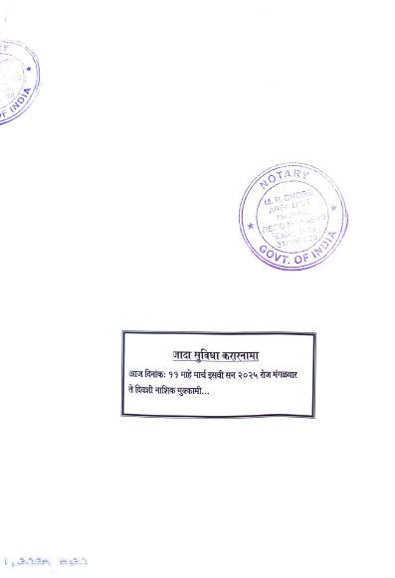
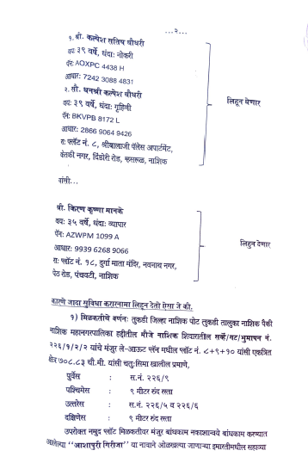

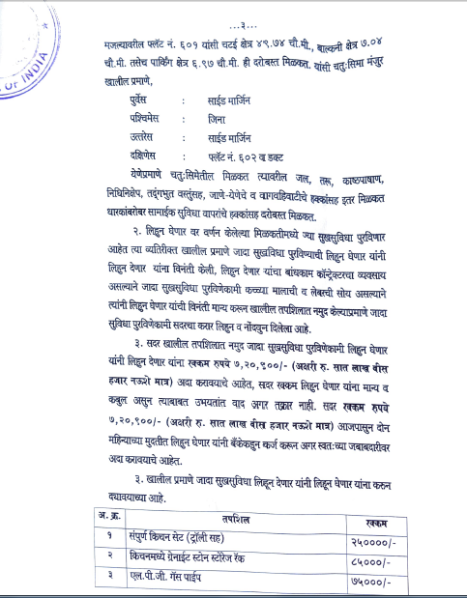
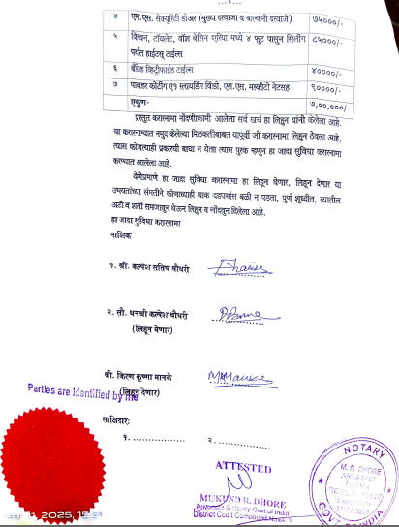

The Extra Work amount Rs.7,00,000/- (Rupees Seven Lakh Only.)

