Vastu/Nashik/03/2309713/013257/46262
21/4-411-RYSP
Date: 10.03.2025

To,
The Branch Manager,
Bank of Baroda
Regional Office
BSNL Building, Datta Mandir Road, Nashik Road,
Nashik, PIN – 422 101, State - Maharashtra, Country - India.

Sub: Vetting of Estimate

Sir,

With reference to above subject, we have evaluated the Estimate for Residential Land and Proposed Bungalow on Plot No.25, Ground + First Floor, Survey No. 284/ 1/ 1, Near Barnes School and Junior College, Deolali Camp Road, Village - Bhagur, Taluka – Nashik, District – Nashik, Pin Code – 422 502, State - Maharashtra, Country – India belongs Name of Owner: Shri. Avinash Chandra & Sau. Vandana Ganesh Meshram.

We have verified the rates quoted as per current market rates. Details of Estimates considered as per copy of Estimate Provided by Aditya Graphic’s Sign by (Mr. Nitin K. Salve Reg. No. ADTP-Nashik/ 3067/ 19) dated.28.01.2025 The Estimate amount is Rs.42,45,931/- ( Rupees Forty Two Lakh Forty Five Thousand Nine Hundred Thirty One Only.)
After Considering Amenities Taken by Architect & Copy of Estimate Given to us by Owner, we have reached to Conclusion That the Above Estimate is verified.

Note: 1) The said Cost Vetting Certificate is valid up to 6 months only.
2) It is Advisable to get periodic work completion status prior to disbursement of loan.

Thanking you

Sincerely yours

Manoj B. Chalikwar
Registered Valuer
Chartered Engineer (India)
Reg. No. CAT-I-F-1763
Reg. No. IBBI/RV/07/2018/10366
BOB Empanelment No.: ZO:MZ:ADV:46:941
Encl: Valuation Report.

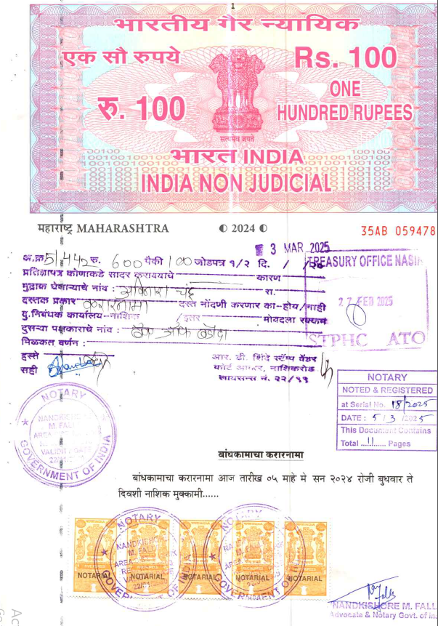
Notarized Agreement
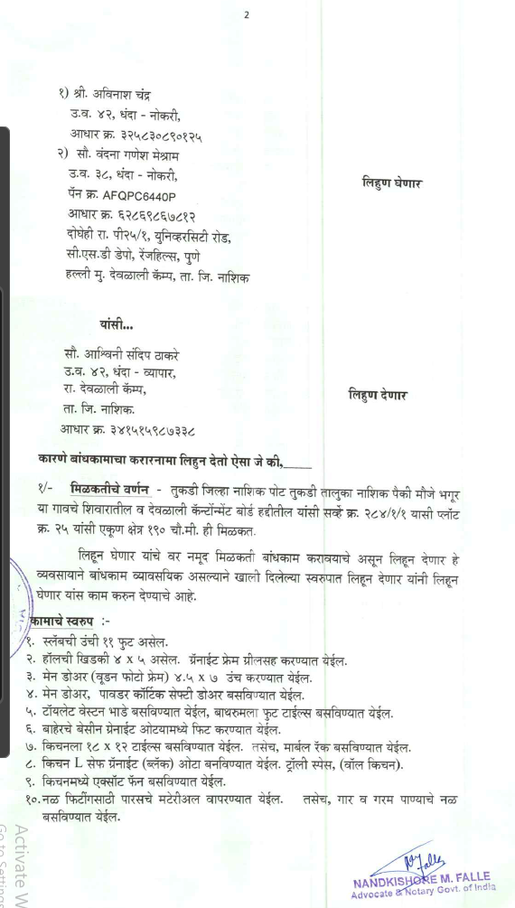

Approved Building Plan
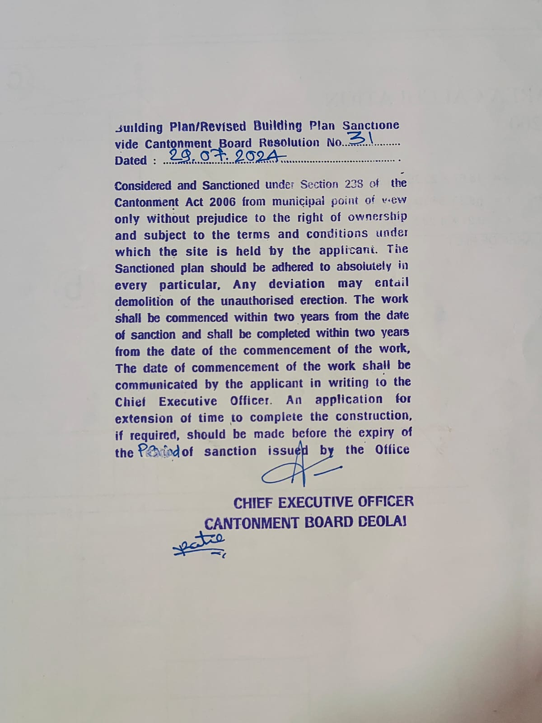

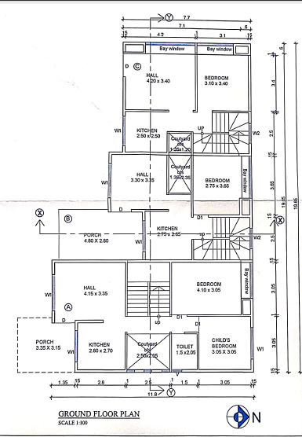
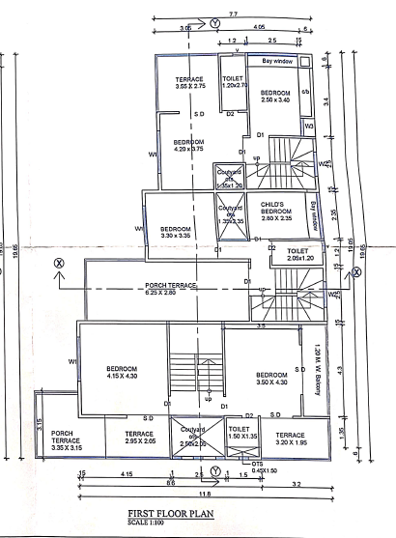

Estimate
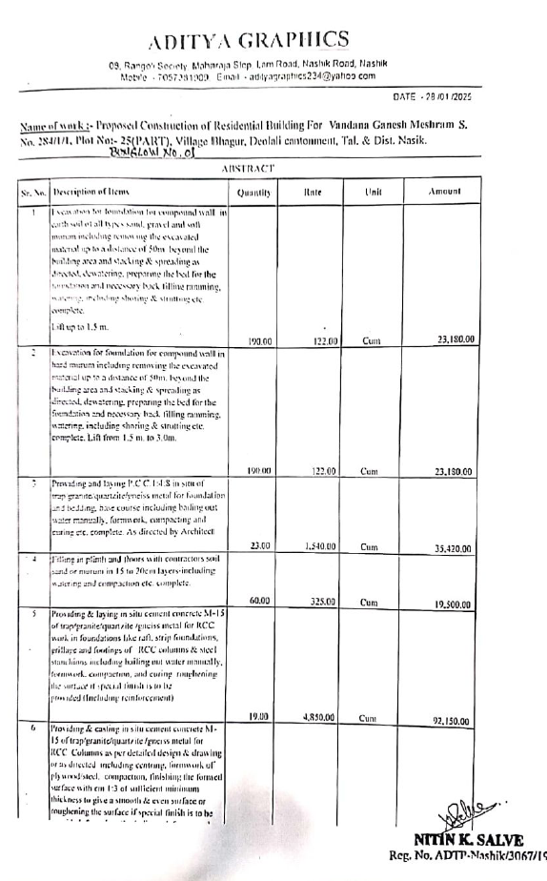

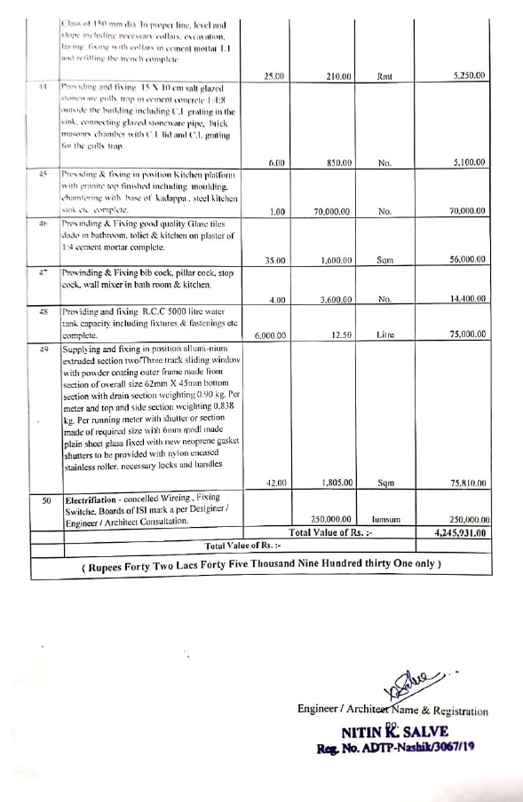

The Estimate amount is Rs.42,45,931/- ( Rupees Forty Two Lakh Forty Five Thousand Nine Hundred Thirty One Only. )

