Vastu/Nashik/01/2025/013575/2309985
09/4-104 -RPBS
Date: 07.03.2025

To, `
The Branch Manager,
Bank of Baroda
Regional Office Nashik Road Branch
BSNL Building, Datta Mandir Road, Nashik Road,
Nashik -422 101, State - Maharashtra, Country - India.

Sub: Vetting of Extra Amenities

Sir,

With reference to above subject, we have evaluated the Extra Amenities for Residential Flat No. 07, 1st Floor, "Shree Sadguru Apartment", Near Rythmic School, Prabhat Nagar, Plot No. 01, Mhasoba Wadi Road, Borgad, Village - Mhasrul, Taluka - Nashik, District - Nashik, Nashik, PIN Code - 422 004, State - Maharashtra, Country - India belongs to M/s. Shree Samrth Developers. Name of Proposed Purchaser is Sau. Manjusha Yogesh Rajguru & Shri. Yogesh Dattatraya Rajguru.

We have verified the rates quoted as per current market rates. Details of Extra Amenities considered as per copy of Agreement for Extra Amenities issued by to Sau. Manjusha Yogesh Rajguru & Shri. Yogesh Dattatraya Rajguru.
(First Party) Shri. Datta SAhebrao Ghuge (Second Party) received on dated 05.02.2025. The Extra Amenities amount is Rs.4,50,000/- (Rupees Four Lakh Fifty Thousand Only

The said Cost Vetting Certificate is valid upto next 6 months Only.

Thanking you

Sincerely yours

Manoj B. Chalikwar
Registered Valuer
Chartered Engineer (India)
Reg. No. CAT-I-F-1763
Reg. No. IBBI/RV/07/2018/10366
BOB Empanelment No.: ZO:MZ:ADV:46:941
Encl: Valuation report.

Agreement of Extra Amenities
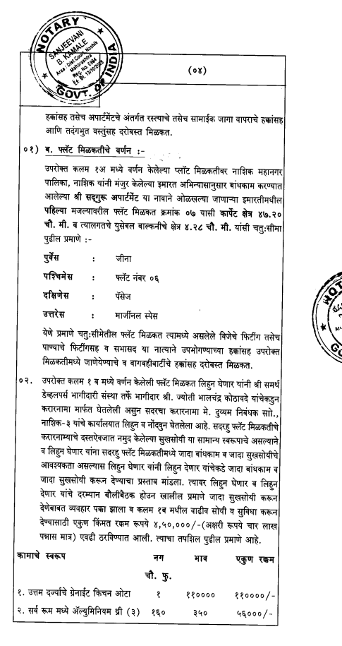
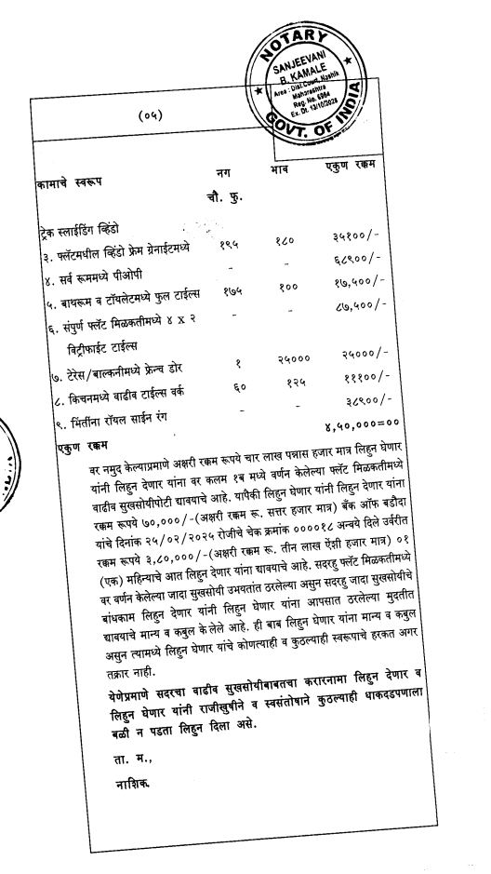

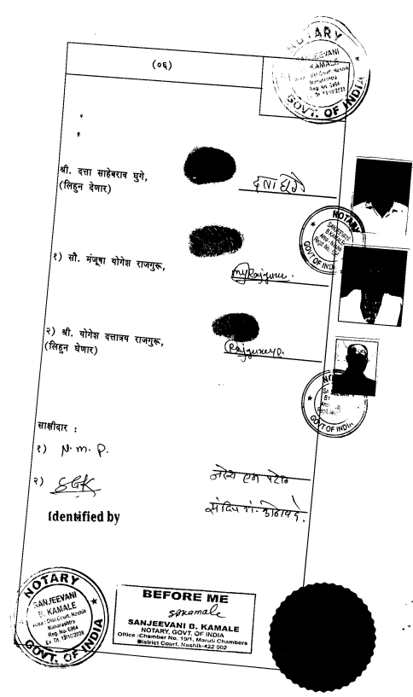

The Extra Work amount Rs.4,50,000/- (Rupees Four Lakh Fifty Thousand Only.)

