Vastu/Nashik/03/2023833/30490/46262
22/24-455-RYSP
Date: 07.03.2025

To,
The Branch Manager,
Bank of Baroda
Regional Office
BSNL Building, Datta Mandir Road, Nashik Road,
Nashik, PIN – 422 101, State - Maharashtra, Country - India.

Sub: Vetting of Estimate

Sir,

With reference to above subject, we have evaluated the Estimate for Residential Land and Proposed Bungalow on Plot No. 239, Ground Floor + First Floor, Survey No. 184/ 1+184/ A/ 1+184/ A/ 2+184/ A/ 3, C.T.S. No. 1774, Near Hindi Vidyalaya, Jai Ganesh Colony, Shramik Nagar, Village - Pimpalgaon Bahula, Taluka – Nashik, District – Nashik, Pin Code – 422 007, State - Maharashtra, Country – India. belongs Name of Proposed Purchaser : Shri. Rahul Bhaktiram More & Sau. Raju Bhaktiram More. Name of Owner : Shri. Ravindra Motiram Bachhav & Sau. Rekha Ravindra Bachhav.

We have verified the rates quoted as per current market rates. Details of Estimates considered as per copy of Estimate Provided by Ar. Saurabh H. Pagar Dated.07.03.2024 The Estimate amount is Rs.22,24,015/- (Rupees Twenty Two Lakh Twenty Four Thousand Fifteen Only.)
After Considering Amenities Taken by Architect & Copy of Estimate Given to us by Owner, we have reached to Conclusion That the Above Estimate is Verified.

Note: 1) The said Cost Vetting Certificate is valid up to 6 months Only.
2) It is Advisable to get periodic work completion status prior to disbursement of loan.

Thanking you

Sincerely yours

Sharadkumar B. Chalikwar
Govt. Reg. Valuer
Chartered Engineer (India)
Reg. No. (N) CCIT/1-14/52/2008-09
Encl: Valuation report.

Estimate
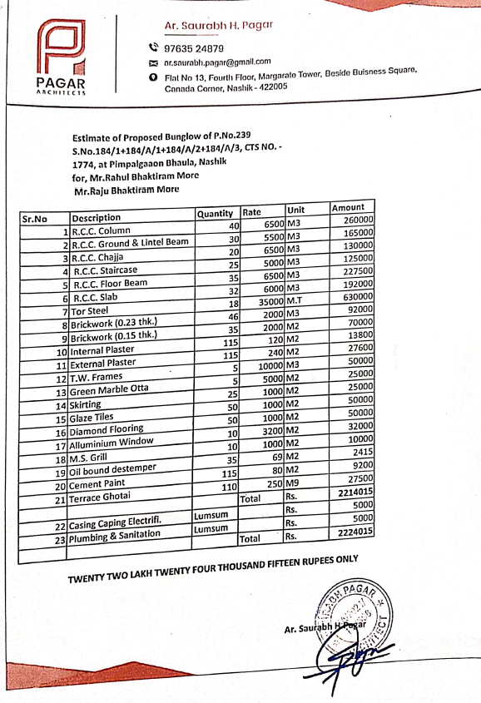

The Estimate amount is Rs.22,24,015/- ( Rupees Twenty Two Lakh Twenty Four Thousand Fifteen Only. )

