Valuation Report of the Immovable Property
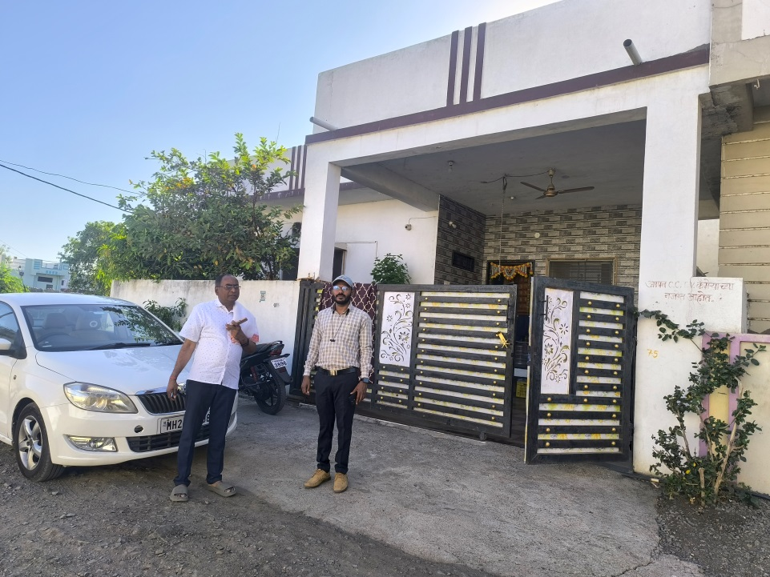

Details of the property under consideration:

Name of Owner: Mr.Jeevan S/o Uttamrao Panchal.

Plot no.39, Survey no 79/B, City Survey no.10761,
Anjenaiya Hanuman Mandir Sainik Nandanwan Society Road ,Basheer Bagh , Assadullahbad Nanded,
Tq & Dist.Nanded.

Latitude Longitude: 19.166564,77.328555

Valuation prepared for:
Punjab National bank
Chikhalwadi Br., Nanded.

Vastu/PNB/SARFEASI/02/2025/4738/ 2310903
07/1-100
Date: 07.03.2025

VALUER’S OPINION REPORT

The property bearing Plot No.39, Survey No. 79/B, City Survey No.10761, Anjanaiyah Hanuman Mandir Sainik Nandanwan Society Road, Basheer Bagh, Assadullahbad, Nanded, Tq & Dist. Nanded as per the equitable mortgage belongs to Mr.Jeevan S/o Uttamrao Panchal.

Boundaries of the property.
North | : | Plot No 40
South | : | 7.50 m wide road
East | : | 6.00m wide road
West | : | Plot no 33
Considering various parameters recorded, existing economic scenario, and the information that is available with reference to the development of neighborhood and method selected for valuation, we are of the opinion that, the property premisescan be assessed and valued for this particular purpose as under.

Guideline value of the property. | Rs 9,26,595.00
Fair Market value of the property | Rs 15,70,500.00
Realizable Value of the property. | Rs 14,13,450.00
Distress / Forced Sale Value of the property. | Rs 12,56,400.00

The valuation of the property is based on the documents produced by the concern. Legal aspects have not been taken into considerations while preparing this valuation report.

Hence certified.
For, Vastukala Consultants (I) Pvt. Ltd.

Sharadkumar B. Chalikwar
B.E.(Civil), M.E.(Civil), M.Sc. (Real Estate Valuation), M.Sc. (P&M Valuation),FIE(I), FIV, FIWRS
Chairman & Managing Director
Govt. Reg. Valuer
Chartered Engineer (India)
Reg. No. (N) CCIT/1-14/52/2008-09
IBBI Reg.No. IBBI/RV/07/2019/11744

Encl: Valuation report.
Valuation Report of Immovable Property

1. Introduction
a) |  | Name of the Property Owner  (With address & phone nos.) |  | Mr. Jeevan s/o Uttamrao Panchal
b) |  | Purpose of Valuation |  | SARFAESI Purpose.
c) |  | Authorization letter of Bank |  | Telephonic instructions from Mr.Gangadhar Hakke  Dy. Manager, Punjab National Bank, Chikhalwadi Br.,Nanded,
d) |  | Date of Inspection of Property |  | 06.03.2025
e) |  | Persons present at the time of inspection |  | Mr.Gangadhar Hakke  Dy. Manager, Punjab National Bank
f) |  | Date of Valuation |  | 06.03.2025
g) |  | Date of Report |  | 06.03.2025
h) |  | Authorization letter of Bank |  | Mr.Gangadhar Hakke  Dy Manager, Punjab National Bank
i) |  | Weather occupied by the owner/tenant? If occupied by tenant, since how long? |  | Occupied by Mr.Madhav Ganpatrao Hambarde.
2. Physical Characteristics of the Property
Brief description of the property :
- Single Storeyed Residential House Building Constructed on Plot no.39, Survey no 79/B, City Survey No.10761, Anjanaiyah Hanuman Mandir Sainik Nandanwan Society Road, Basheer Bagh , Assadullahbad, Nanded, Tq & Dist. Nanded.
- The subject property under valuation is shown and identified by Mr. Gangadhar Hakke, Dy. Manager, Punjab National Bank.
- As per the oral instructions of Mr. Gangadhar Hakke, Dy. Manager, Punjab National Bank, only Open Plot is considered for valuation.
 |  | - Plot Area details are as under:
 |  | Sr. No. | Particulars | Plot Size | Plot Area
 |  | 1. | As per Sale Deed | 15.00mx10.5m | 157.05sqm
 |  | Nearby landmark |  | Anjanaiyah Hanuman Mandir, Sainik Nandanwan Society
 |  | Postal Address of the Property |  | Plot no.39, Survey no 79/B, City Survey no.10761, Anjanaiyah Hanuman Mandir Sainik Nandanwan Society Road, Basheer Bagh , Assadullahbad Nanded, Tq & Dist. Nanded.
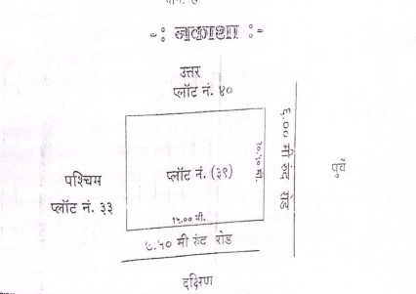
As per Document
 |  | Type of Land: Solid, Rocky, Marshy land, reclaimed land, Water-logged, Land locked. |  | Solid land
 |  | Independent access/approach to the property etc. |  | Yes
 |  | Google Map Location of the Property with a neighborhood layout map |  | Enclosed
 |  | Details of roads abutting the property |  | - 7.50 m wide road towards South  - 6.00 m wide road towards East
 |  | Description of adjoining property |  | Residential.
 |  | Plot No. Survey No. |  | S.No. 77, C.T.S.No. 10826
 |  | Ward/Village/Taluka |  | Ward 1-21, Bashirbag, Nanded.
 |  | District |  | Nanded.
 |  | Any other aspect |  | No.
b) |  | Plinth Area, Built up Area, and Saleable are to be mentioned separately and clarified |  | Presently there is single Storeyed residential House building. Only Open Plot is considered for valuation.
c) |  | Boundaries of the Flat |  | As per Documents
 |  | North |  | Plot No.40
 |  | South |  | 7.50 m Wide Road
 |  | East |  | 6.0 m Wide Road
 |  | West |  | Plot No.33
3. Town Planning parameters
a) |  | Master Plan provisions related to property in terms of land use |  | Residential.
 |  | Comment on unauthorized constructions if any |  | N.A.
 |  | Planning area/zone |  | Residential.
 |  | Developmental controls |  | As per Unified Development Control and Promotion Regulations (UDCPR) for Nanded Waghala City Municipal Corporation
 |  | Zoning regulations |  | As per Unified Development Control and Promotion Regulations (UDCPR) for Nanded Waghala City Municipal Corporation
 |  | Comment on the surrounding land uses and adjoining properties in terms of uses |  | Surrounding Area is developing Residential Area.
 |  | Comment on demolition proceedings if any |  | N.A.
 |  | Comment on compounding / regularization proceedings |  | N.A.
 |  | Any other Aspect |  | No.
4. Document Details and Legal Aspects of Property
a) |  | Following documents were made available by the Bank-
 | 1. | Photo copy of Equitable Mortgage Register (021) dated 16.02.2012
 | 2. | Photo copy Sale Deed No.3460/2011,,dated 31.03.2011,Excuteded at Joint Sub-Register ,Nanded
 | 3. | Photo Copy of P.R. Card Dated 05.04.2011
 | 4. | Photo Copy of Legal Opinion, dated 14.02.2012, issued by Adv. Ravindra Kaudge, Nanded.
 | 5. | Photo Copy of NWCMC, Nanded Property Tax Paid Receipt dated 07.03.2022., PIN No 40201211230
 | 7. | Photo Copy of Previous Valuation Report dated 14.02.2012, M/s. Rupesh Laddha & Associates
b) |  | Name of the Owner |  | Mr.Jeevan S/o Uttamrao Panchal.  As on the date of inspection it seems that Owner of subject property under valuation is Mr. Madhav Ganpatrao Hambarde.  Latest Legal report shall be obtained for verification.
c) |  | Ordinary status of freehold or leasehold including restrictions on transfer |  | Freehold
d) |  | Agreement of easement if any |  | No.
e) |  | Notification of acquisition if any |  | No apparent from the documents provided.
f) |  | Notification of road widening if any |  | No apparent from the documents provided.
g) |  | Heritage restriction, if any |  | No.
h) |  | Comment on transferability of the property ownership |  | As per TIR.
i) |  | Comment on existing mortgages/charges/encumbrances on the property, if any |  | Details not available
j) |  | Comment on whether the owners of the property have issued any guarantee (personal or corporate) as the case may be |  | Details not available.
k) |  | Building plan sanction: Authority approving the plan - Name of the Authority - Any violation from the approved Building Plan. |  | N.A.
m) |  | Whether the property is SARFAESI compliant |  | Yes.
q) |  | Any other aspect |  | No.
5. Economic Aspects of the Property
a) |  | Details of ground rent payable, |  | Not Applicable.
 |  | Details of monthly rents being recived if any, |  | Not Applicable.
 |  | Taxes and other outings |  | N.A
 |  | Property Insurance |  | No.
 |  | Monthly maintenance charges |  | No.
 |  | Security charges |  | No.
 |  | Any other aspect |  | No.
6. Socio-cultural Aspects of the Property
a) |  | Descriptive account of the location of the property in terms of social structure of the area, population, social stratification, regional origin, economic level, location of slums, squatter settlements nearby, etc. |  | Developing area.
b) |  | Whether property belongs to social infrastructure like hospital, school, old age homes etc. |  | No
7. Functional and Utilitarian Aspects of the Property
a) |  | Description of the functionality and utility of the property in terms of:
 |  | Space allocation |  | Not Applicable.
 |  | Storage Spaces |  | Not Applicable.
 |  | Utility spaces provided within the building |  | Not Applicable.
 |  | Car Parking facility |  | Not Applicable.
 |  | Balconies, etc. |  | Not Applicable.
b) |  | Any other aspect |  | No Construction.
8. Infrastructure Availability
a) |  | Description of aqua infrastructure availability in terms of
 |  | Water supply |  | Not Available.
 |  | Sewerage/sanitation System Underground or Open |  | Not Available.
 |  | Storm water drainage |  | Not Available.
b) |  | Description of other physical infrastructure facilities viz.
 |  | Solid waste management |  | Not Available.
 |  | Electricity |  | Not Available.
 |  | Road and public transport connectivity |  | Well connected with public transport
 |  | Availability of other public utilities nearby |  | All available near by
c) |  | Social infrastructure in terms of
 |  | - School |  | All available nearby.
 |  | - Medical facilities |  | All available nearby.
 |  | - Recreational facility in terms of parks and open space |  | All available nearby.
9. Marketability of the Property
a) |  | Locational attributes |  | Located in Bashirbagh
 |  | Scarcity |  | No Scarcity
 |  | Demand and supply of the kind of subject property |  | Normal
 |  | Comparable sale prices in the locality |  | Not Available
10. Engineering and Technology Aspects of the Property
a) |  | Type of construction |  | N.A.
b) |  | Material & technology used |  | N.A.
c) |  | Specifications.
S.No. |  | Description |  | Open Plot
1 |  | Foundation. |  | N.A.
2 |  | Basement. |  | N.A.
3 |  | Superstructure. |  | N.A.
4 |  | Joinery/ Doors & Windows. |  | N.A.
5 |  | RCC work. |  | N.A.
6 |  | Plastering. |  | N.A.
7 |  | Flooring, Skirting. |  | N.A.
8 |  | Kitchen Pantry Platform |  | N.A.
9 |  | Whether any weather proof course is provided. |  | N.A.
10 |  | Drainage. |  | N.A.
11 |  | Compound wall (Height, length and type of construction). |  | N.A.
12 |  | Electric installation (Type of wire, Class of fittings) |  | N.A.
13 |  | Plumbing installation (No. of water closets & wash basins etc.) |  | N.A.
14 |  | Bore well. |  | N.A.
15 |  | Wardrobes, if any. |  | N.A.
16 |  | Development of open area |  | N.A.
d) |  | Maintenance issues |  | N.A.
e) |  | Age of the building |  | N.A.
f) |  | Total life of the building |  | N.A.
g) |  | Extent of deterioration |  | N.A.
h) |  | Structural safety |  | N.A.
i) |  | Protection against natural disaster viz. earthquakes, |  | N.A.
j) |  | Visible damage in the building |  | N.A.
k) |  | System of air-conditioning |  | N.A.
l) |  | Provision of Lift |  | N.A.
m) |  | Provision of firefighting |  | N.A.
n) |  | Copies of the plan and elevation of the building to be included |  | N.A.
11. Environmental Factors
a) |  | Use of environment friendly building materials, Green Building techniques if any |  |  |  |  | NA
b) |  | Provision of rain water harvesting |  |  |  |  | NA
c) |  | Use of solar heating and lightening systems, etc., |  |  |  |  | NA
d) |  | Presence of environmental pollution in the vicinity of the property in terms of industry, heavy traffic etc. |  |  |  |  | No.
12. Architectural and aesthetic quality of the Property
a) |  | Descriptive account on whether the building is modern, old fashioned, plain looking or decorative, heritage value, presence of landscape elements etc. |  |  |  | N.A.

13.Valuation
a) | Methodology of valuation – Procedures adopted for arriving at the valuation. Valuers may consider various approaches and state explicitly the reason for adopting particular approach and assumptions made, basis adopted with supporting data, comparable sales, and reconciliation of various factors on which final value judgment is arrived at. | Market Approach Method is adopted.
b) | Prevailing Market Rate/Price trend of the Property in the locality/city from property search sites viz magickbricks.com, 99acres.com, makaan.com etc. if available | The prevailing Land rate in the vicinity is ranging between Rs. 5,000 to 10,000.00 Per Sqm.  Considering the prevailing rates in the vicinity, current market conditions, demand and supply position, Residential Building size, location, upswing in real estate prices, sustained demand for Residential building, all round development of residential application in the locality construction stage, construction specification etc. The land rate of Rs. 10000.00 per Sq.m is fair and reasonable.
c) | Guideline Rate obtained from the Stamp Duty Ready Reckoner | Land Rate: Rs. 5900.00Per Sqm.
d) | Summary of Valuation
 | - A. Guideline Value | Area in Sqm. | Rate in Rs. | Value in Rs.
 | i. Plot | 157.05 | 5900.00 | 9,26,595.00
 | ii. Guideline Value |  |  | 9,26,595.00
 | B. Fair market value | Area in Sqm. | Rate in Rs. | Value in Rs.
 | iii. Plot | 157.05 | 10,000.00 | 15,70,500.00
 | v. Fair market value |  |  | 15,70,500.00
 | vi. Summary of Valuation
 | Fair Value of the Property | Rs. 15,70,500.00
 | Realizable Value | Rs. 14,13,450.00
 | Forced/ Distress Sale value. | Rs. 16,72,800.00
 | Guideline Value of the Property | Rs. 9,26,595.00
e) | In case of variation of 20% or more in the valuation proposed by the valuer and the Guideline value provided in the State Govt. notification or Income Tax Gazette justification on variation has to be given.
 | Details of last two transactions in the locality/area to be provided, if available. | Not Available
Subject property under valuation is Plot no.39, Survey no 79/B, City Survey no.10761, Anjanaiyah Hanuman Mandir Sainik Nandanwan Society Road, Basheer Bagh , Assadullahbad Nanded, Tq & Dist. Nanded.
All Civic amenities are available nearby.
- To obtain the Sales Instances in the vicinity, we visited the Joint Sub Registrar Office, Nanded.
The Ready Reckoner rate i.e. Guide Line rate for Land property in zone 1.68 is Rs. 5900.00 per Sqm.
The above Guide line Rate is for entire block of zone 1.68
- Guideline Rates are basically generated for stamp duty purpose, at the time of purchase of the property, which are fixed for year to year for particular survey Nos., Gut. Nos., CTS Nos., etc.
- There is market trend to register the document as per the Guideline rates and not as per the market rate just to save the Stamp duty.
- Market Rates are not fixed. Market rates depend mainly on demand and supply.
- Market rates may increase or decrease as per surrounding devolvement, approach road, location, availability of amenities & services, demand and supply in surrounding areas etc.
- The Market value obtained in this report is defined as follows:
- Market value is the estimated amount for which an asset should exchange on the date of valuation between a willing seller in an Arm’s length wherein the parties had each acted knowledgeably and without compulsion. {As defined by the International Valuation Committee, London}.
Thus, the characteristics of the Market Value are:
- It is free will sale.
- b. It is an estimated amount and not a predetermined or an actual sale price.
- c. It depends on purpose of valuation.
- d. It is time-specific as on the given date.
- e. Buyers and sellers are actuated by business principles. They are unrelated & are acting independently
- Assets would be exposed to the market in the most appropriate manor to affect its disposal at the best price.
- As per the Supreme Court the Guideline rate is for stamp duty collection and not the Fair Market Value
- Social Forces, Economic forces, Government / Legal and Physical / Environmental factors influence the value of Real Estate.
- This property is situated in the developing area of MalTekdi,Railway station, Nanded.
- The cost of construction is arrived by considering the type of construction and grade, constructions specification, and Age of Building.
- The Cost Approach and Market Approach Method is adopted to arrive the Fair Market Value.
- After giving due consideration for various factors influencing the value of the property with respect to Physical, Legal, Social and Economic aspects, Location, Development in the vicinity, Road frontage, the rate of Rs. 10,000.00 Per Sqm for land is considered Fair and Reasonable and hence adopted to arrive the Fair Market value of the land.
General Remarks:
- The subject property is occupied by Mr. Madhav Ganpatrao Hambarde who is owner of the property. His wife Mrs. Ashwini Madhavrao Hambarde was present at the time of inspection. She shown the Municipal tax paid receipt of PIN 40201211230 dated 07.03.2022 (Refer Annexure-1). As per their information they have purchased the open plot from Mr. Jeevan Uttamrao Panchal who obtained the construction permission from NWCMC, Nanded and constructed the house building. They availed the loan from Axis Bank, Nanded for this property.
- The Latest TIR Report shall be obtained for verification.
- We assume no responsibility for matters of legal nature affecting the property appraised or the title thereto, nor do we render our opinion as to the title, which is assumed to be good and marketable.
- The property is valued as though under responsible ownership.

14. Declaration
I hereby declare that:
- The information provided is true and correct to the best of my knowledge and belief.
- The analysis and conclusions are limited by the reported assumptions and conditions.
- I have read the Handbook on Policy, Standard and Procedures for Real Estate Valuation by Banks and HFIs in India, 2011, issued by IBA and NHB, fully understood the provisions of the same and followed the provisions of the same to the best of my ability and this report is in conformity to the Standards of Reporting enshrined in the above Handbook.
- I have no direct or indirect interest in the above property valued.
- We have inspected the subject property on 06.03.2025 with Mr. Gangadhar Hakke, Dy. Manager, Punjab National Bank who identified the property under valuation.
- The subject property is occupied by Mr. Madhav Ganpatrao Hambarde who is owner of the property. His wife Mrs. Ashwini Madhavrao Hambarde was present at the time of inspection. She shown the Municipal tax paid receipt of PIN 40201211230 dated 07.03.2022 (Refer Annexure-1). As per their information they have purchased the open plot from Mr. Jeevan Uttamrao Panchal who obtained the construction permission from NWCMC, Nanded and constructed the house building. They availed the loan from Axis Bank, Nanded for this property.
- Latest Legal opinion Report shall be obtained for verification.
- As per the oral instruction of Mr. Gangadhar Hakke, Dy. Manager, Punjab National Bank only open plot is considered for valuation. Building is not considered for valuation.
- I am a registered Valuer under Section 34AB of Wealth Tax Act, 1957, Category-I for valuing property up to no limit
- I am an approved Valuer under SARFAESI ACT-2002 and am approved by the Bank.
- I have submitted the Valuation Report (s) directly to the Bank.

For, Vastukala Consultants (I) Pvt. Ltd

Sharadkumar B. Chalikwar
B.E.(Civil), M.E.(Civil), M.Sc. (Real Estate Valuation), M.Sc. (P&M Valuation),FIE(I), FIV, FIWRS
Chairman & Managing Director
Govt. Reg. Valuer
Chartered Engineer (India)
Reg. No. (N) CCIT/1-14/52/2008-09
IBBI Reg.No. IBBI/RV/07/2019/11744

15. Enclosures
a) | Layout plan sketch of the area in which the property is located with latitude and longitude | Yes
b) | Site Photograph of the property | Site photographs of the property are provided.
d) | Google Map location of the property | Provided
e) | Price trend of the Property in the locality/city from property search sites viz Magickbricks.com, 99Acres.com, Makan.com etc. | Govt. Ready Beckoner Rate provided.

Actual Site Photography

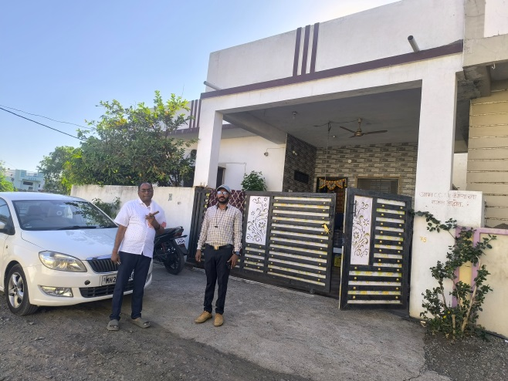
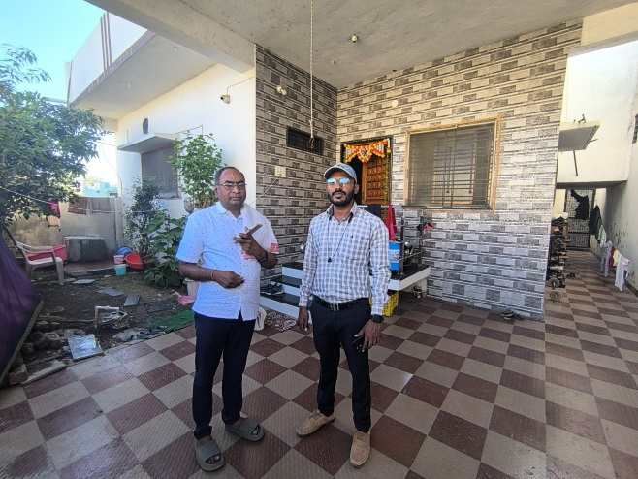

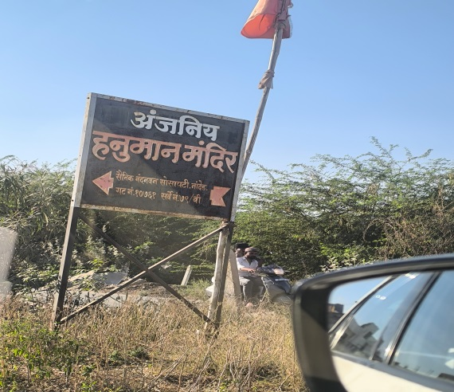
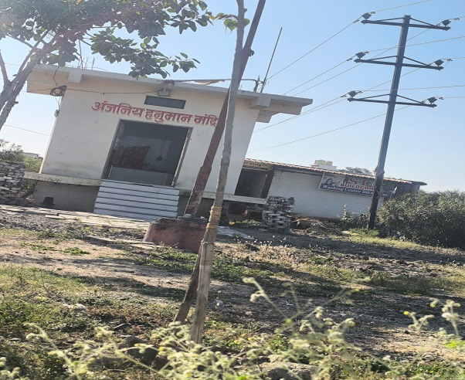

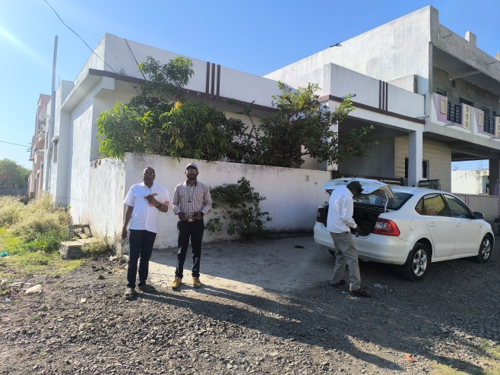

ROUTE MAP OF THE PROPERTY

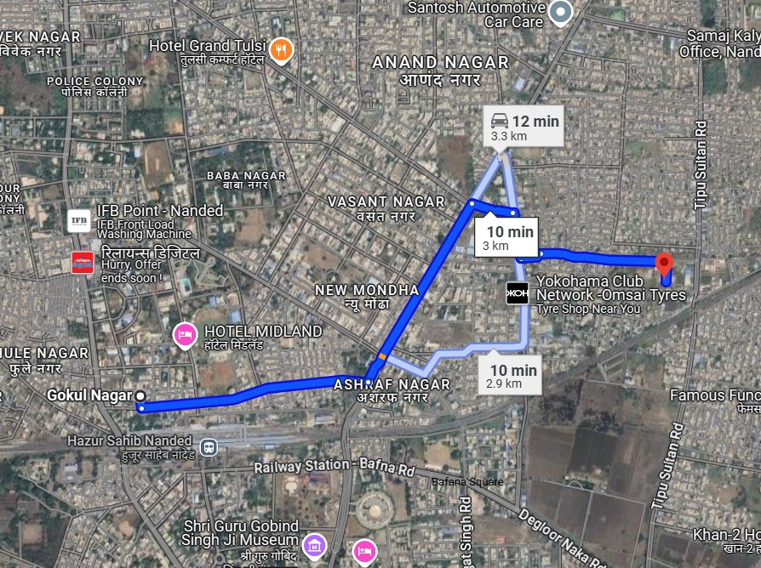

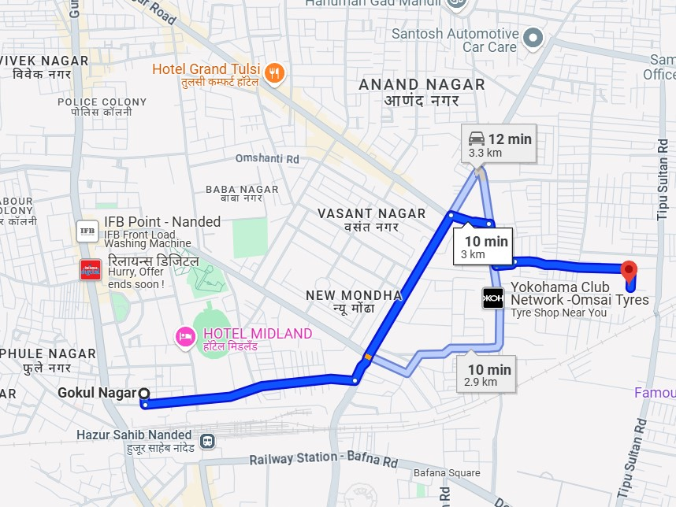

Longitude Latitude: 19.166564,77.328555
Note:
- Red Pointer shows Approx. Property Location
- Blue line shows Route from Nanded Railway Station@3.00 Km.

READY RECKONER RATE

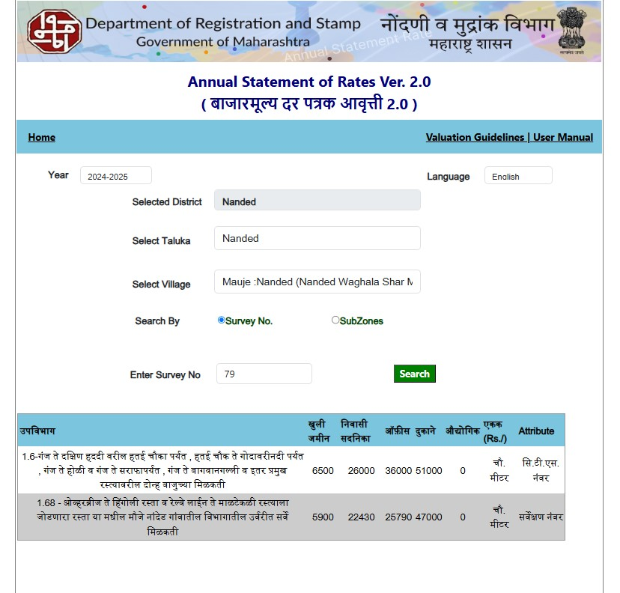

DEFINITION OF VALUE FOR THIS SPECIFIC PURPOSE

This exercise is to assess Fair Market Value of the property under reference as on 06thMarch2025.
The term Fair Market Value is defined as

“The most probable price, as of a specified date, in cash, terms equivalent to cash, or in other precisely revealed terms for which the specified property rights would sell after reasonable exposure in a competitive market under all conditions requisite to a fair sale, with the buyer and seller each acting prudently knowledgeably and for self-interest assuming that neither is under undue duress”.
Fundamental assumptions and conditions presumed in this definition are:

1. Buyer and seller are motivated by self-interest.
2. Buyer and seller are well informed and are acting prudently.
3. The property is exposed for a reasonable time on the open market.
4. Payment is made in cash or equivalent or in specified financing terms.

UNDER LYING ASSUMPTIONS
1. We assume no responsibility for matters of legal nature affecting the property appraised or the title thereto, nor do we render our opinion as to the title, which is assumed to be good and marketable.
2. The property is valued as though under responsible ownership.
3. It is assumed that the property is free of liens and encumbrances.
4. It is assumed that there are no hidden or unapparent conditions of the subsoil or structure that would render it more or less valuable. No responsibility is assumed for such conditions or for engineering that might be required to discover such factor.

DECLARATION OF PROFESSIONAL FEES CHARGED

We hereby declare that; our professional fees are not contingent upon the valuation findings. However, if the statute AND/OR clients demands that, the fees should be charged on the percentage of assessed value then, with the full knowledge of the AND/OR end user, it is being charged accordingly.

VALUATION OF THE PROPERTY PREMISES

Considering various parameters recorded herein above, existing economic scenario, and the information that is available with reference to the development of neighborhood and method selected for valuation, we are of the opinion that, the property premises along with business premium can be assessed and valued for this particular purpose at Rs.15,70,500.00 (Rupees Fifteen Lac Seventy Thousand Five hundred only).

STATEMENT OF LIMITING CONDITIONS

1. Assumptions are made to the best of our knowledge and belief. Reliance is based on the information furnished to us by the identifier AND/OR client.
2. The valuer shall not be responsible for matters of legal nature that affects the value and opinion expressed by us.
3. If our appearance is required, we will be pleased to appear and give the necessary clarification, provided the fees for each appearance (excluding traveling, dearness allowance and out of pocket expenses) is pre-determined before the acceptance of the assignment under reference.
4. In no event shall the valuer be held responsible or liable for special, direct, indirect or consequential damages, as the assignment has been completed on best efforts, available knowledge and in good intentions of persons concerned and belief.
5. If it is proved that there is an apparent negligence on the part of a valuer, liability of this assignment (whether arising from this assignment, negligence or whatsoever) is limited in respect of anyone event or series of events to the actual loss or damage sustained subject to maximum of 80% of the professional fees for the services rendered and in any case not exceeding the amount of ` 1,000/- (Rupees one Thousand Only). All the claims against us shall expire after three months from the date of submission of the valuation report provided by us.
6. We hereby declare that, the information furnished above is true and correct to the best of our knowledge and belief. We have no direct or indirect interest in the assets valued. We have not been convicted of any offence and sentenced to a term of imprisonment. We have not been found guilty of misconduct in our professional capacity.

For, Vastukala Consultants (I) Pvt. Ltd.

Sharadkumar B. Chalikwar
B.E.(Civil), M.E.(Civil), M.Sc. (Real Estate Valuation), M.Sc. (P&M Valuation),FIE(I), FIV, FIWRS
Chairman & Managing Director
Govt. Reg. Valuer
Chartered Engineer (India)
Reg. No. (N) CCIT/1-14/52/2008-09
IBBI Reg.No. IBBI/RV/07/2019/11744

Annexure-1




