Vastu/Nashik/03/2023833/30490/46262
22/24-455-RYRJ
Date: 06.03.2025

To,
The Branch Manager,
Bank of Baroda
Regional Office
BSNL Building, Datta Mandir Road, Nashik Road,
Nashik, PIN – 422 101, State - Maharashtra, Country - India.

Sub: Vetting of Estimate

Sir,

With reference to above subject, we have evaluated the Estimate for Residential Land and Proposed Bungalow on Plot No. 31+32+33/ A, Ground Floor + First Floor, Gat No. 1970, Behind Ozar Wholesale Textile Market, Near Ganesh Madir, Sinnarkar, Mumbai - Agra Road, Village - Ozar, Taluka – Niphad, District – Nashik, Pin Code – 422 206, State - Maharashtra, Country – India. belongs Shri. Balasaheb Deoram Walve.

We have verified the rates quoted as per current market rates. Details of Estimates considered as per copy of Estimate Provided by Rahul Bahiram Architects Sign by (Ar. Rahul D. Bahiram) dated.09.02.2025 The Estimate amount is Rs.41,29,568/- (Forty One Lakh Twenty Nine Thousand Five Hundred Sixty Eight Only.)
After Considering Amenities Taken by Architect & Copy of Estimate Given to us by Owner, we have reached to Conclusion That the Above Estimate is Verified.

Note: 1) The said Cost Vetting Certificate is valid up to 6 months Only.
2) It is Advisable to get periodic work completion status prior to disbursement of loan.

Thanking you

Sincerely yours

Sharadkumar B. Chalikwar
Govt. Reg. Valuer
Chartered Engineer (India)
Reg. No. (N) CCIT/1-14/52/2008-09
Encl: Valuation report.

Estimate

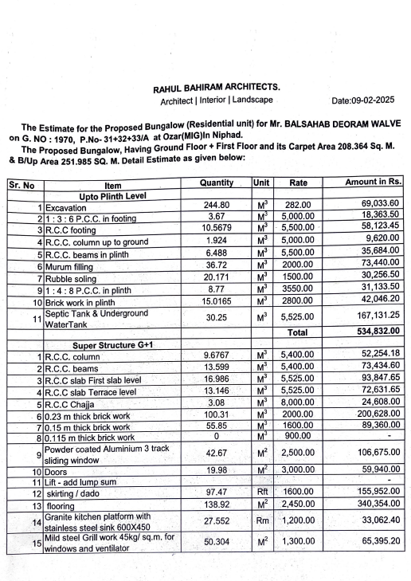
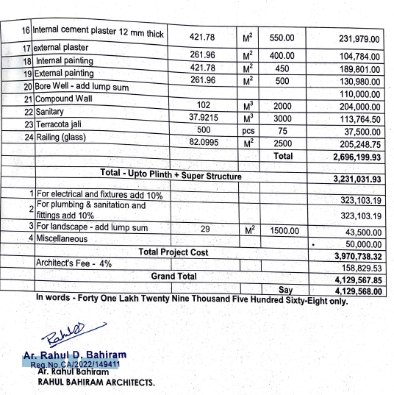

The Estimate amount is Rs.41,29,568/- ( Rupees Forty One Lakh Twenty Nine Thousand Five Hundred Sixty Eight Only. )

