Valuation Report of the Immovable Property

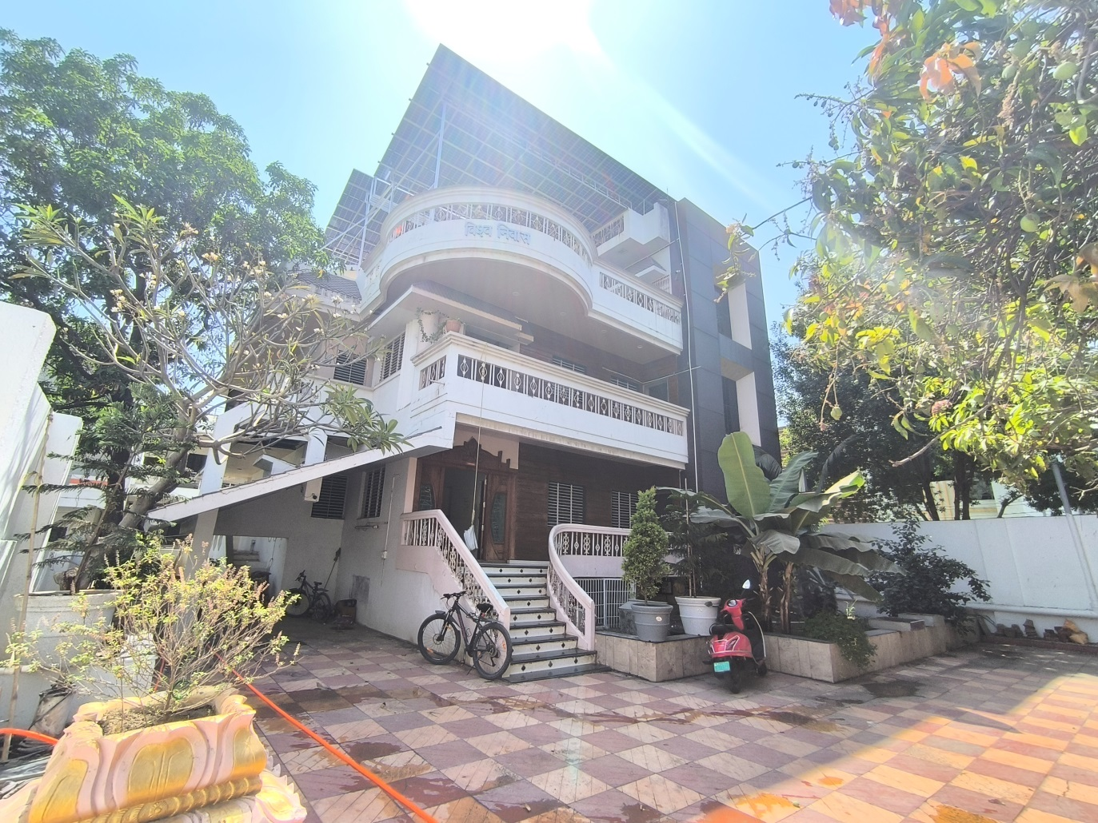

**Details of the property under consideration:**

Name of Owner: **Sow. Meerabai W/o. Bharat Raminwar.**

**"Vishwa Niwas"** Plot No. 33, S. No.221/B/2, Saibaba Nagar, Purna - Nanded Road, Mouje Wadi (Bk.), Tq. & Dist. Nanded, State - Maharashtra, Country - India.

## Longitude Latitude: 19.189560, 77.285103

**Intended User:**

**Axis Bank**

**Taroda Naka Branch,Nanded**

Vastu/Axis Bank/Nanded Br./02/2025/11190

Date: 06.03.2025

# **VALUER’S OPINION REPORT**

This is to certify that the property bearing **"Vishwa Niwas"** Plot No. 33, S. No.221/B/2, Saibaba Nagar, Purna - Nanded Road, Mouje Wadi (Bk.), Tq. & Dist. Nanded, State - Maharashtra, Country - India is belongs to **Sow. Meerabai W/o. Bharat Raminwar.**

|  |  |  |
| --- | --- | --- |
| Boundaries of the property. | | |
| North | : | Purna - Nanded Road. | |
| South | : | 20'0" Wide Road. | |
| East | : | Plot No. 32. | |
| West | : | 25'0" Wide Road. | |

Considering various parameters recorded, existing economic scenario, and the information that is available with reference to the development of neighborhood and method selected for valuation, we are of the opinion that, the property premises can be assessed are as under :

|  |  |
| --- | --- |
| **Fair Market Value of the Property** | **Rs. 5,01,68,600.00** |
| **Realizable Value of the Property** | **Rs. 4,51,51,740.00** |
| **Distressed / Forced Sale Value** **of the Property** | **Rs. 4,01,34,880.00** |
| **Guideline Value of the Property** | **Rs. 99,57,410.00** |

The valuation of the property is based on the documents produced by the concern. Legal aspects have not been taken into considerations while preparing this valuation report.

Hence certified

For, **Vastukala Consultants (I) Pvt. Ltd.**

**Sharadkumar B. Chalikwar**

B.E. (Civil), M.E. (Civil), M.Sc. (Real Estate Valuation), M.Sc. (P&M Valuation), FIE (I), FIV, FIWRS

Chairman & Managing Director

Govt. Reg. Valuer

Chartered Engineer (India)

Reg. No. (N) CCIT/1-14/52/2008-09

IBBI Reg.No. IBBI/RV/07/2019/11744

Encl: Valuation report.

|  |  |  |  |  |  |  |  |  |  |  |  |  |  |  |  |  |  |  |  |  |  |  |  |  |  |  |  |  |  |  |  |  |  |  |  |  |  |  |  |  |  |  |  |  |  |  |  |  |  |  |  |  |  |  |  |  |  |  |  |  |  |  |  |  |  |  |  |  |  |  |  |  |  |  |  |  |  |  |  |  |  |  |  |  |  |  |  |  |  |  |  |  |  |  |  |  |  |  |  |  |  |  |  |  |  |  |  |  |  |  |  |  |  |  |  |  |  |  |  |  |  |  |  |  |  |  |  |  |  |  |  |  |  |  |  |  |  |  |  |  |  |  |  |  |  |  |  |  |  |  |  |  |  |  |  |  |  |  |  |  |  |  |  |  |  |  |  |  |  |  |  |  |  |  |  |  |  |  |  |  |  |  |  |  |  |  |  |  |  |  |  |  |  |  |  |  |  |  |  |  |  |  |  |  |  |  |  |  |  |  |  |  |  |  |  |  |  |  |  |  |  |  |  |  |  |  |  |  |  |  |  |  |  |  |  |  |  |  |  |  |  |  |  |  |  |  |  |  |  |  |  |  |  |  |  |  |  |  |  |  |  |  |  |  |  |  |  |  |  |  |  |  |  |  |  |  |  |  |  |  |  |  |  |  |  |  |  |  |  |  |  |  |  |  |  |  |  |  |  |  |  |  |  |  |  |  |  |  |  |  |  |  |  |  |  |  |  |  |  |  |  |  |  |  |  |  |  |  |  |  |  |  |  |  |  |  |  |  |  |  |  |  |  |  |  |  |  |  |  |  |  |  |  |  |  |  |  |  |  |  |  |  |  |  |  |  |  |  |  |  |  |  |  |  |  |  |  |  |  |  |  |  |  |  |  |  |  |  |  |  |  |  |  |  |  |  |  |  |  |  |  |  |  |  |  |  |  |  |  |  |  |  |  |  |  |  |  |  |  |  |  |  |  |  |  |  |  |  |  |  |  |  |  |  |  |  |  |  |  |  |  |  |  |  |  |  |  |  |  |  |  |  |  |  |  |  |  |  |  |  |  |  |  |  |  |  |  |  |  |  |  |  |  |  |  |  |  |  |  |  |  |  |  |  |  |  |  |  |  |  |  |  |  |  |  |  |  |  |  |  |  |  |  |  |  |  |  |  |  |  |  |  |  |  |  |  |  |  |  |  |  |  |  |  |  |  |  |  |  |  |  |  |  |  |  |  |  |  |  |  |  |  |  |  |  |  |  |  |  |  |  |  |  |  |  |  |  |  |  |  |  |  |  |  |  |  |  |  |  |  |  |  |  |  |  |  |  |  |  |  |  |  |  |  |  |  |  |  |  |  |  |  |  |  |  |  |  |  |  |  |  |  |  |  |  |  |  |  |  |  |  |  |  |  |  |  |  |  |  |  |  |  |  |  |  |  |  |  |  |  |  |  |  |  |  |  |  |  |  |  |  |  |  |  |  |  |  |  |  |  |  |  |  |  |  |  |  |  |  |  |  |  |  |  |  |  |  |  |  |  |  |  |  |  |  |  |  |  |  |  |  |  |  |  |  |  |  |  |  |  |  |  |  |  |  |  |  |  |  |  |  |  |  |  |  |  |  |  |  |  |  |  |  |  |  |  |  |  |  |  |  |  |  |  |  |  |  |  |  |  |  |  |  |  |  |  |  |  |  |  |  |  |  |  |  |  |  |  |  |  |  |  |  |  |  |  |  |  |  |  |  |  |  |  |  |  |  |  |  |  |  |  |  |  |  |  |  |  |  |  |  |  |  |  |  |  |  |  |  |  |  |  |  |  |  |  |  |  |  |  |  |  |  |  |  |  |  |  |  |  |  |  |  |  |  |  |  |  |  |  |  |  |  |  |  |  |  |  |  |  |  |  |  |  |  |  |  |  |  |  |  |  |  |  |  |  |  |  |  |  |  |  |  |  |  |  |  |  |  |  |  |  |  |  |  |  |  |  |  |  |  |  |  |  |  |  |  |  |  |  |  |  |  |  |  |  |  |  |  |  |  |  |  |  |  |  |  |  |  |  |  |  |  |  |  |  |  |  |  |  |  |  |  |  |  |  |  |  |  |  |  |  |  |  |  |  |  |  |  |  |  |  |  |  |  |  |  |  |  |  |  |  |  |  |  |  |  |  |  |  |  |  |  |  |  |  |  |  |  |  |  |  |  |  |  |  |  |  |  |  |  |  |  |  |  |  |  |  |  |  |  |  |  |  |  |  |  |  |  |  |  |  |  |  |  |  |  |  |  |  |  |  |  |  |  |  |  |  |  |  |  |  |  |  |  |  |  |  |  |  |  |  |  |  |  |  |  |  |  |  |  |  |  |  |  |  |  |  |  |  |  |  |  |  |  |  |  |  |  |  |  |  |  |  |  |  |  |  |  |  |  |  |  |  |  |  |  |  |  |  |  |  |  |  |  |  |  |  |  |  |  |  |  |  |  |  |  |  |  |  |  |  |  |  |  |  |  |  |  |  |  |  |  |  |  |  |  |  |  |  |  |  |  |  |  |  |  |  |  |  |  |  |  |  |  |  |  |  |  |  |  |  |  |  |  |  |  |  |  |  |  |  |  |  |  |  |  |  |  |  |  |  |  |  |  |  |  |  |  |  |  |  |  |  |  |  |  |  |  |  |  |  |  |  |  |  |  |  |  |  |  |  |  |  |  |  |  |  |  |  |  |  |  |  |  |  |  |  |  |  |  |  |  |  |  |  |  |  |  |  |  |  |  |  |  |  |  |  |  |  |  |  |  |  |  |  |  |  |  |  |  |  |  |  |  |  |  |  |  |  |  |  |  |  |  |  |  |  |  |  |  |  |  |  |  |  |  |  |  |  |  |  |  |  |  |  |  |  |  |  |  |  |  |  |  |  |  |  |  |  |  |  |  |  |  |  |  |  |  |  |  |  |  |  |  |  |  |  |  |  |  |  |  |  |  |  |  |  |  |  |  |  |  |  |  |  |  |  |  |  |  |  |  |  |  |  |  |  |  |  |  |  |  |  |  |  |  |  |  |  |  |  |  |  |  |  |  |  |  |  |  |  |  |  |  |  |  |  |  |  |  |  |  |  |  |  |  |  |  |  |  |  |  |  |  |  |  |  |  |  |  |  |  |  |  |  |  |  |  |  |  |  |  |  |  |  |  |  |  |  |  |  |  |  |  |  |  |  |  |  |  |  |  |  |  |  |  |  |  |  |  |  |  |  |  |  |  |  |  |  |  |  |  |  |  |  |  |  |  |  |  |  |  |  |  |  |  |  |  |  |  |  |  |  |  |  |  |  |  |  |  |  |  |  |  |  |  |  |  |  |  |  |  |  |  |  |  |  |  |  |  |  |  |  |  |  |  |  |  |  |  |  |  |  |  |  |  |  |  |  |  |  |  |  |  |  |  |  |  |  |  |  |  |  |  |  |  |  |  |  |  |  |  |  |  |  |  |  |  |  |  |  |  |  |  |  |  |  |  |  |  |  |  |  |  |  |  |  |  |  |  |  |  |  |  |  |  |  |  |  |  |  |  |  |  |  |  |  |  |  |  |  |  |  |  |  |  |  |  |  |  |  |  |  |  |  |  |  |  |  |  |  |  |  |  |  |  |  |  |  |  |  |  |  |  |  |  |  |  |  |  |  |  |  |  |  |  |  |  |  |  |  |  |  |  |  |  |  |  |  |  |  |  |  |  |  |  |  |  |  |  |  |  |  |  |  |  |  |  |  |  |  |  |  |  |  |  |  |  |  |  |  |  |  |  |  |  |  |  |  |  |  |  |  |  |  |  |  |  |  |  |  |  |  |  |  |  |  |  |  |  |  |  |  |  |  |  |  |  |  |  |  |  |  |  |  |  |  |  |  |  |  |  |  |  |  |  |  |  |  |  |  |  |  |  |  |  |  |  |  |  |  |  |  |  |  |  |  |  |  |  |  |  |  |  |  |  |  |  |  |  |  |  |  |  |  |  |  |  |  |  |  |  |  |  |  |  |  |  |  |  |  |  |  |  |  |  |  |  |  |  |  |  |  |  |  |  |  |  |  |  |  |  |  |  |  |  |  |  |  |  |  |  |  |  |  |  |  |  |  |  |  |  |  |  |  |  |  |  |  |  |  |  |  |  |  |  |  |  |  |  |  |  |  |  |  |  |  |  |  |  |  |  |  |  |  |  |  |  |  |  |  |  |  |  |  |  |  |  |  |  |  |  |  |  |  |  |  |  |  |  |  |  |  |  |  |  |  |  |  |  |  |  |  |  |  |  |  |  |  |  |  |  |  |  |  |  |  |  |  |  |  |  |  |  |  |  |  |  |  |  |  |  |  |  |  |  |  |  |  |  |  |  |  |  |  |  |  |  |  |  |  |  |  |  |  |  |  |  |  |  |  |  |  |  |  |  |  |  |  |  |  |  |  |  |  |  |  |  |  |  |  |  |  |  |  |  |  |  |  |  |  |  |  |  |  |  |  |  |  |  |  |  |  |  |  |  |  |  |  |  |  |  |  |  |  |  |  |  |  |  |  |  |  |  |  |  |  |  |  |  |  |  |  |  |  |  |  |  |  |  |  |  |  |  |  |  |  |  |  |  |  |  |  |  |  |  |  |  |  |  |  |  |  |  |  |  |  |  |  |  |  |  |  |  |  |  |  |  |  |  |  |  |  |  |  |  |  |  |  |  |  |  |  |  |  |  |  |  |  |  |  |  |  |  |  |  |  |  |  |  |  |  |  |  |  |  |  |  |  |  |  |  |  |  |  |  |  |  |  |  |  |  |  |  |  |  |  |  |  |  |  |  |  |  |  |  |  |  |  |  |  |  |  |  |  |  |  |  |  |  |  |  |  |  |  |  |  |  |  |  |  |  |  |  |  |  |  |  |  |  |  |  |  |  |  |  |  |  |  |  |  |  |  |  |  |  |  |  |  |  |  |  |  |  |  |  |  |  |  |  |  |  |  |  |  |  |  |  |  |  |  |  |  |  |  |  |  |  |  |  |  |  |  |  |  |  |  |  |  |  |  |  |  |  |  |  |  |  |  |  |  |  |  |  |  |  |  |  |  |  |  |  |  |  |  |  |  |  |  |  |  |  |  |  |  |  |  |  |  |  |  |  |  |  |  |  |  |  |  |  |  |  |  |  |  |  |  |  |  |  |  |  |  |  |  |  |  |  |  |  |  |  |  |  |  |  |  |  |  |  |  |  |  |  |  |  |  |  |  |  |  |  |  |  |  |  |  |  |  |  |  |  |  |  |  |  |  |  |  |  |  |  |  |  |  |  |  |  |  |  |  |  |  |  |  |  |  |  |  |  |  |  |  |  |  |  |  |  |  |  |  |  |  |  |  |  |  |  |  |  |  |  |  |  |  |  |  |  |  |  |  |  |  |  |  |  |  |  |  |  |  |  |  |  |  |  |  |  |  |  |  |  |  |  |  |  |  |  |  |  |  |  |  |  |  |  |  |  |  |  |  |  |  |  |  |  |  |  |  |  |  |  |  |  |  |  |  |  |  |  |  |  |  |  |  |  |  |  |  |  |  |  |  |  |  |  |  |  |  |  |  |  |  |  |  |  |  |  |  |  |  |  |  |  |  |  |  |  |  |  |  |  |  |  |  |  |  |  |  |  |  |  |  |  |  |  |  |  |  |  |  |  |  |  |  |  |  |  |  |  |  |  |  |  |  |  |  |  |  |  |  |  |  |  |  |  |  |  |  |  |  |  |  |  |  |  |  |  |  |  |  |  |  |  |  |  |  |  |  |  |  |  |  |  |  |  |  |  |  |  |  |  |  |  |  |  |  |  |  |  |  |  |  |  |  |  |  |  |  |  |  |  |  |  |  |  |  |  |  |  |  |  |  |  |  |  |  |  |  |  |  |  |  |  |  |  |  |  |  |  |  |  |  |  |  |  |  |  |  |  |  |  |  |  |  |  |  |  |  |  |  |  |  |  |  |  |  |  |  |  |  |  |  |  |  |  |  |  |  |  |  |  |  |  |  |  |  |  |  |  |  |  |  |  |  |  |  |  |  |  |  |  |  |  |  |  |  |  |  |  |  |  |  |  |  |  |  |  |  |  |  |  |  |  |  |  |  |  |  |  |  |  |  |  |  |  |  |  |  |  |  |  |  |  |  |  |  |  |  |  |  |  |  |  |  |  |  |  |  |  |  |  |  |  |  |  |  |  |  |  |  |  |  |  |  |  |  |  |  |  |  |  |  |  |  |  |  |  |  |  |  |  |  |  |  |  |  |  |  |  |  |  |  |  |  |  |  |  |  |  |  |  |  |  |  |  |  |  |  |  |  |  |  |  |  |  |  |  |  |  |  |  |  |  |  |  |  |  |  |  |  |  |  |  |  |  |  |  |  |  |  |  |  |  |  |  |  |  |  |  |  |  |  |  |  |  |  |  |  |  |  |  |  |  |  |  |  |  |  |  |  |  |  |  |  |  |  |  |  |  |  |  |  |  |  |  |  |  |  |  |  |  |  |  |  |  |  |  |  |  |  |  |  |  |  |  |  |  |  |  |  |  |  |  |  |  |  |  |  |  |  |  |  |  |  |  |  |  |  |  |  |  |  |  |  |  |  |  |  |  |  |  |  |  |  |  |  |  |  |  |  |  |  |  |  |  |  |  |  |  |  |  |  |  |  |  |  |  |  |  |  |  |  |  |  |  |  |  |  |  |  |  |  |  |  |  |  |  |  |  |  |  |  |  |  |  |  |  |  |  |  |  |  |  |  |  |  |  |  |  |  |  |  |  |  |  |  |  |  |  |  |  |  |  |  |  |  |  |  |  |  |  |  |  |  |  |  |  |  |  |  |  |  |  |  |  |  |  |  |  |  |  |  |  |  |  |  |  |  |  |  |  |  |  |  |  |  |  |  |  |  |  |  |  |  |  |  |  |  |  |  |  |  |  |  |  |  |  |  |  |  |  |  |  |  |  |  |  |  |  |  |  |  |  |  |  |  |  |  |  |  |  |  |  |  |  |  |  |  |  |  |  |  |  |  |  |  |  |  |  |  |  |  |  |  |  |  |  |  |  |  |  |  |  |  |  |  |  |  |  |  |  |  |  |  |  |  |  |  |  |  |  |  |  |  |  |  |  |  |  |  |  |  |  |  |  |  |  |  |  |  |  |  |  |  |  |  |  |  |  |  |  |  |  |  |  |  |  |  |  |  |  |  |  |  |  |  |  |  |  |  |  |  |  |  |  |  |  |  |  |  |  |  |  |  |  |  |  |  |  |  |  |  |  |  |  |  |  |  |  |  |  |  |  |  |  |  |  |  |  |  |  |  |  |  |  |  |  |  |  |  |  |  |  |  |  |  |  |  |  |  |  |  |  |  |  |  |  |  |  |  |  |  |  |  |  |  |  |  |  |  |  |  |  |  |  |  |  |  |  |  |  |  |  |  |  |  |  |  |  |  |  |  |  |  |  |  |  |  |  |  |  |  |  |  |  |  |  |  |  |  |  |  |  |  |  |  |  |  |  |  |  |  |  |  |  |  |  |  |  |  |  |  |  |  |  |  |  |  |  |  |  |  |  |  |  |  |  |  |  |  |  |  |  |  |  |  |  |  |  |  |  |  |  |  |  |  |  |  |  |  |  |  |  |  |  |  |  |  |  |  |  |  |  |  |  |  |  |  |  |  |  |  |  |  |  |  |  |  |  |  |  |  |  |  |  |  |  |  |  |  |  |  |  |  |  |  |  |  |  |  |  |  |  |  |  |  |  |  |  |  |  |  |  |  |  |  |  |  |  |  |  |  |  |  |  |  |  |  |  |  |  |  |  |  |  |  |  |  |  |  |  |  |  |  |  |  |  |  |  |  |  |  |  |  |  |  |  |  |  |  |  |  |  |  |  |  |  |  |  |  |  |  |  |  |  |  |  |  |  |  |  |  |  |  |  |  |  |  |  |  |  |  |  |  |  |  |  |  |  |  |  |  |  |  |  |  |  |  |  |  |  |  |  |  |  |  |  |  |  |  |  |  |  |  |  |  |  |  |  |  |  |  |  |  |  |  |  |  |  |  |  |  |  |  |  |  |  |  |  |  |  |  |  |  |  |  |  |  |  |  |  |  |  |  |  |  |  |  |  |  |  |  |  |  |  |  |  |  |  |  |  |  |  |  |  |  |  |  |  |  |  |  |  |  |  |  |  |  |  |  |  |  |  |  |  |  |  |  |  |  |  |  |  |  |  |  |  |  |  |  |  |  |  |  |  |  |  |  |  |  |  |  |  |  |  |  |  |  |  |  |  |  |  |  |  |  |  |  |  |  |  |  |  |  |  |  |  |  |  |  |  |  |  |  |  |  |  |  |  |  |  |  |  |  |  |  |  |  |  |  |  |  |  |  |  |  |  |  |  |  |  |  |  |  |  |  |  |  |  |  |  |  |  |  |  |  |  |  |  |  |  |  |  |  |  |  |  |  |  |  |  |  |  |  |  |  |  |  |  |  |  |  |  |  |  |  |  |  |  |  |  |  |  |  |  |  |  |  |  |  |  |  |  |  |  |  |  |  |  |  |  |  |  |  |  |  |  |  |  |  |  |  |  |  |  |  |  |  |  |  |  |  |  |  |  |  |  |  |  |  |  |  |  |  |  |  |  |  |  |  |  |  |  |  |  |  |  |  |  |  |  |  |  |  |  |  |  |  |  |  |  |  |  |  |  |  |  |  |  |  |  |  |  |  |  |  |  |  |  |  |  |  |  |  |  |  |  |  |  |  |  |  |  |  |  |  |  |  |  |  |  |  |  |  |  |  |  |  |  |  |  |  |  |  |  |  |  |  |  |  |  |  |  |  |  |  |  |  |  |  |  |  |  |  |  |  |  |  |  |  |  |  |  |  |  |  |  |  |  |  |  |  |  |  |  |  |  |  |  |  |  |  |  |  |  |  |  |  |  |  |  |  |  |  |  |  |  |  |  |  |  |  |  |  |  |  |  |  |  |  |  |  |  |  |  |  |  |  |  |  |  |  |  |  |  |  |  |  |  |  |  |  |  |  |  |  |  |  |  |  |  |  |  |  |  |  |  |  |  |  |  |  |  |  |  |  |  |  |  |  |  |  |  |  |  |  |  |  |  |  |  |  |  |  |  |  |  |  |  |  |  |  |  |  |  |  |  |  |  |  |  |  |  |  |  |  |  |  |  |  |  |  |  |  |  |  |  |  |  |  |  |  |  |  |  |  |  |  |  |  |  |  |  |  |  |  |  |  |  |  |  |  |  |  |  |  |  |  |  |  |  |  |  |  |  |  |  |  |  |  |  |  |  |  |  |  |  |  |  |  |  |  |  |  |  |  |  |  |  |  |  |  |  |  |  |  |  |  |  |  |  |  |  |  |  |  |  |  |  |  |  |  |  |  |  |  |  |  |  |  |  |  |  |  |  |  |  |  |  |  |  |  |  |  |  |  |  |  |  |  |  |  |  |  |  |  |  |  |  |  |  |  |  |  |  |  |  |  |  |  |  |  |  |  |  |  |  |  |  |  |  |  |  |  |  |  |  |  |  |  |  |  |  |  |  |  |  |  |  |  |  |  |  |  |  |  |  |  |  |  |  |  |  |  |  |  |  |  |  |  |  |  |  |  |  |  |  |  |  |  |  |  |  |  |  |  |  |  |  |  |  |  |  |  |  |  |  |  |  |  |  |  |  |  |  |  |  |  |  |  |  |  |  |  |  |  |  |  |  |  |  |  |  |  |  |  |  |  |  |  |  |  |  |  |  |  |  |  |  |  |  |  |  |  |  |  |  |  |  |  |  |  |  |  |  |  |  |  |  |  |  |  |  |  |  |  |  |  |  |  |  |  |  |  |  |  |  |  |  |  |  |  |  |  |  |  |  |  |  |  |  |  |  |  |  |  |  |  |  |  |  |  |  |  |  |  |  |  |  |  |  |  |  |  |  |  |  |  |  |  |  |  |  |  |  |  |  |  |  |  |  |  |  |  |  |  |  |  |  |  |  |  |  |  |  |  |  |  |  |  |  |  |  |  |  |  |  |  |  |  |  |  |  |  |  |  |  |  |  |  |  |  |  |  |  |  |  |  |  |  |  |  |  |  |  |  |  |  |  |  |  |  |  |  |  |  |  |  |  |  |  |  |  |  |  |  |  |  |  |  |  |  |  |  |  |  |  |  |  |  |  |  |  |  |  |  |  |  |  |  |  |  |  |  |  |  |  |  |  |  |  |  |  |  |  |  |  |  |  |  |  |  |  |  |  |  |  |  |  |  |  |  |  |  |  |  |  |  |  |  |  |  |  |  |  |  |  |  |  |  |  |  |  |  |  |  |  |  |  |  |  |  |  |  |  |  |  |  |  |  |  |  |  |  |  |  |  |  |  |  |  |  |  |  |  |  |  |  |  |  |  |  |  |  |  |  |  |  |  |  |  |  |  |  |  |  |  |  |  |  |  |  |  |  |  |  |  |  |  |  |  |  |  |  |  |  |  |  |  |  |  |  |  |  |  |  |  |  |  |  |  |  |  |  |  |  |  |  |  |  |  |  |  |  |  |  |  |  |  |  |  |  |  |  |  |  |  |  |  |  |  |  |  |  |  |  |  |  |  |  |  |  |  |  |  |  |  |  |  |  |  |  |  |  |  |  |  |  |  |  |  |  |  |  |  |  |  |  |  |  |  |  |  |  |  |  |  |  |  |  |  |  |  |  |  |  |  |  |  |  |  |  |  |  |  |  |  |  |  |  |  |  |  |  |  |  |  |  |  |  |  |  |  |  |  |  |  |  |  |  |  |  |  |  |  |  |  |  |  |  |  |  |  |  |  |  |  |  |  |  |  |  |  |  |  |  |  |  |  |  |  |  |  |  |  |  |  |  |  |  |  |  |  |  |  |  |  |  |  |  |  |  |  |  |  |  |  |  |  |  |  |  |  |  |  |  |  |  |  |  |  |  |  |  |  |  |  |  |  |  |  |  |  |  |  |  |  |  |  |  |  |  |  |  |  |  |  |  |  |  |  |  |  |  |  |  |  |  |  |  |  |  |  |  |  |  |  |  |  |  |  |  |  |  |  |  |  |  |  |  |  |  |  |  |  |  |  |  |  |  |  |  |  |  |  |  |  |  |  |  |  |  |  |  |  |  |  |  |  |  |  |  |  |  |  |  |  |  |  |  |  |  |  |  |  |  |  |  |  |  |  |  |  |  |  |  |  |  |  |  |  |  |  |  |  |  |  |  |  |  |  |  |  |  |  |  |  |  |  |  |  |  |  |  |  |  |  |  |  |  |  |  |  |  |  |  |  |  |  |  |  |  |  |  |  |  |  |  |  |  |  |  |  |  |  |  |  |  |  |  |  |  |  |  |  |  |  |  |  |  |  |  |  |  |  |  |  |  |  |  |  |  |  |  |  |  |  |  |  |  |  |  |  |  |  |  |  |  |  |  |  |  |  |  |  |  |  |  |  |  |  |  |  |  |  |  |  |  |  |  |  |  |  |  |  |  |  |  |  |  |  |  |  |  |  |  |  |  |  |  |  |  |  |  |  |  |  |  |  |  |  |  |  |  |  |  |  |  |  |  |  |  |  |  |  |  |  |  |  |  |  |  |  |  |  |  |  |  |  |  |  |  |  |  |  |  |  |  |  |  |  |  |  |  |  |  |  |  |  |  |  |  |  |  |  |  |  |  |  |  |  |  |  |  |  |  |  |  |  |  |  |  |  |  |  |  |  |  |  |  |  |  |  |  |  |  |  |  |  |  |  |  |  |  |  |  |  |  |  |  |  |  |  |  |  |  |  |  |  |  |  |  |  |  |  |  |  |  |  |  |  |  |  |  |  |  |  |  |  |  |  |  |  |  |  |  |  |  |  |  |  |  |  |  |  |  |  |  |  |  |  |  |  |  |  |  |  |  |  |  |  |  |  |  |  |  |  |  |  |  |  |  |  |  |  |  |  |  |  |  |  |  |  |  |  |  |  |  |  |  |  |  |  |  |  |  |  |  |  |  |  |  |  |  |  |  |  |  |  |  |  |  |  |  |  |  |  |  |  |  |  |  |  |  |  |  |  |  |  |  |  |  |  |  |  |  |  |  |  |  |  |  |  |  |  |  |  |  |  |  |  |  |  |  |  |  |  |  |  |  |  |  |  |  |  |  |  |  |  |  |  |  |  |  |  |  |  |  |  |  |  |  |  |  |  |  |  |  |  |  |  |  |  |  |  |  |  |  |  |  |  |  |  |  |  |  |  |  |  |  |  |  |  |  |  |  |  |  |  |  |  |  |  |  |  |  |  |  |  |  |  |  |  |  |  |  |  |  |  |  |  |  |  |  |  |  |  |  |  |  |  |  |  |  |  |  |  |  |  |  |  |  |  |  |  |  |  |  |  |  |  |  |  |  |  |  |  |  |  |  |  |  |  |  |  |  |  |  |  |  |  |  |  |  |  |  |  |  |  |  |  |  |  |  |  |  |  |  |  |  |  |  |  |  |  |  |  |  |  |  |  |  |  |  |  |  |  |  |  |  |  |  |  |  |  |  |  |  |  |  |  |  |  |  |  |  |  |  |  |  |  |  |  |  |  |  |  |  |  |  |  |  |  |  |  |  |  |  |  |  |  |  |  |  |  |  |  |  |  |  |  |  |  |  |  |  |  |  |  |  |  |  |  |  |  |  |  |  |  |  |  |  |  |  |  |  |  |  |  |  |  |  |  |  |  |  |  |  |  |  |  |  |  |  |  |  |  |  |  |  |  |  |  |  |  |  |  |  |  |  |  |  |  |  |  |  |  |  |  |  |  |  |  |  |  |  |  |  |  |  |  |  |  |  |  |  |  |  |  |  |  |  |  |  |  |  |  |  |  |  |  |  |  |  |  |  |  |  |  |  |  |  |  |  |  |  |  |  |  |  |  |  |  |  |  |  |  |  |  |  |  |  |  |  |  |  |  |  |  |  |  |  |  |  |  |  |  |  |  |  |  |  |  |  |  |  |  |  |  |  |  |  |  |  |  |  |  |  |  |  |  |  |  |  |  |  |  |  |  |  |  |  |  |  |  |  |  |  |  |  |  |  |  |  |  |  |  |  |  |  |  |  |  |  |  |  |  |  |  |  |  |
| --- | --- | --- | --- | --- | --- | --- | --- | --- | --- | --- | --- | --- | --- | --- | --- | --- | --- | --- | --- | --- | --- | --- | --- | --- | --- | --- | --- | --- | --- | --- | --- | --- | --- | --- | --- | --- | --- | --- | --- | --- | --- | --- | --- | --- | --- | --- | --- | --- | --- | --- | --- | --- | --- | --- | --- | --- | --- | --- | --- | --- | --- | --- | --- | --- | --- | --- | --- | --- | --- | --- | --- | --- | --- | --- | --- | --- | --- | --- | --- | --- | --- | --- | --- | --- | --- | --- | --- | --- | --- | --- | --- | --- | --- | --- | --- | --- | --- | --- | --- | --- | --- | --- | --- | --- | --- | --- | --- | --- | --- | --- | --- | --- | --- | --- | --- | --- | --- | --- | --- | --- | --- | --- | --- | --- | --- | --- | --- | --- | --- | --- | --- | --- | --- | --- | --- | --- | --- | --- | --- | --- | --- | --- | --- | --- | --- | --- | --- | --- | --- | --- | --- | --- | --- | --- | --- | --- | --- | --- | --- | --- | --- | --- | --- | --- | --- | --- | --- | --- | --- | --- | --- | --- | --- | --- | --- | --- | --- | --- | --- | --- | --- | --- | --- | --- | --- | --- | --- | --- | --- | --- | --- | --- | --- | --- | --- | --- | --- | --- | --- | --- | --- | --- | --- | --- | --- | --- | --- | --- | --- | --- | --- | --- | --- | --- | --- | --- | --- | --- | --- | --- | --- | --- | --- | --- | --- | --- | --- | --- | --- | --- | --- | --- | --- | --- | --- | --- | --- | --- | --- | --- | --- | --- | --- | --- | --- | --- | --- | --- | --- | --- | --- | --- | --- | --- | --- | --- | --- | --- | --- | --- | --- | --- | --- | --- | --- | --- | --- | --- | --- | --- | --- | --- | --- | --- | --- | --- | --- | --- | --- | --- | --- | --- | --- | --- | --- | --- | --- | --- | --- | --- | --- | --- | --- | --- | --- | --- | --- | --- | --- | --- | --- | --- | --- | --- | --- | --- | --- | --- | --- | --- | --- | --- | --- | --- | --- | --- | --- | --- | --- | --- | --- | --- | --- | --- | --- | --- | --- | --- | --- | --- | --- | --- | --- | --- | --- | --- | --- | --- | --- | --- | --- | --- | --- | --- | --- | --- | --- | --- | --- | --- | --- | --- | --- | --- | --- | --- | --- | --- | --- | --- | --- | --- | --- | --- | --- | --- | --- | --- | --- | --- | --- | --- | --- | --- | --- | --- | --- | --- | --- | --- | --- | --- | --- | --- | --- | --- | --- | --- | --- | --- | --- | --- | --- | --- | --- | --- | --- | --- | --- | --- | --- | --- | --- | --- | --- | --- | --- | --- | --- | --- | --- | --- | --- | --- | --- | --- | --- | --- | --- | --- | --- | --- | --- | --- | --- | --- | --- | --- | --- | --- | --- | --- | --- | --- | --- | --- | --- | --- | --- | --- | --- | --- | --- | --- | --- | --- | --- | --- | --- | --- | --- | --- | --- | --- | --- | --- | --- | --- | --- | --- | --- | --- | --- | --- | --- | --- | --- | --- | --- | --- | --- | --- | --- | --- | --- | --- | --- | --- | --- | --- | --- | --- | --- | --- | --- | --- | --- | --- | --- | --- | --- | --- | --- | --- | --- | --- | --- | --- | --- | --- | --- | --- | --- | --- | --- | --- | --- | --- | --- | --- | --- | --- | --- | --- | --- | --- | --- | --- | --- | --- | --- | --- | --- | --- | --- | --- | --- | --- | --- | --- | --- | --- | --- | --- | --- | --- | --- | --- | --- | --- | --- | --- | --- | --- | --- | --- | --- | --- | --- | --- | --- | --- | --- | --- | --- | --- | --- | --- | --- | --- | --- | --- | --- | --- | --- | --- | --- | --- | --- | --- | --- | --- | --- | --- | --- | --- | --- | --- | --- | --- | --- | --- | --- | --- | --- | --- | --- | --- | --- | --- | --- | --- | --- | --- | --- | --- | --- | --- | --- | --- | --- | --- | --- | --- | --- | --- | --- | --- | --- | --- | --- | --- | --- | --- | --- | --- | --- | --- | --- | --- | --- | --- | --- | --- | --- | --- | --- | --- | --- | --- | --- | --- | --- | --- | --- | --- | --- | --- | --- | --- | --- | --- | --- | --- | --- | --- | --- | --- | --- | --- | --- | --- | --- | --- | --- | --- | --- | --- | --- | --- | --- | --- | --- | --- | --- | --- | --- | --- | --- | --- | --- | --- | --- | --- | --- | --- | --- | --- | --- | --- | --- | --- | --- | --- | --- | --- | --- | --- | --- | --- | --- | --- | --- | --- | --- | --- | --- | --- | --- | --- | --- | --- | --- | --- | --- | --- | --- | --- | --- | --- | --- | --- | --- | --- | --- | --- | --- | --- | --- | --- | --- | --- | --- | --- | --- | --- | --- | --- | --- | --- | --- | --- | --- | --- | --- | --- | --- | --- | --- | --- | --- | --- | --- | --- | --- | --- | --- | --- | --- | --- | --- | --- | --- | --- | --- | --- | --- | --- | --- | --- | --- | --- | --- | --- | --- | --- | --- | --- | --- | --- | --- | --- | --- | --- | --- | --- | --- | --- | --- | --- | --- | --- | --- | --- | --- | --- | --- | --- | --- | --- | --- | --- | --- | --- | --- | --- | --- | --- | --- | --- | --- | --- | --- | --- | --- | --- | --- | --- | --- | --- | --- | --- | --- | --- | --- | --- | --- | --- | --- | --- | --- | --- | --- | --- | --- | --- | --- | --- | --- | --- | --- | --- | --- | --- | --- | --- | --- | --- | --- | --- | --- | --- | --- | --- | --- | --- | --- | --- | --- | --- | --- | --- | --- | --- | --- | --- | --- | --- | --- | --- | --- | --- | --- | --- | --- | --- | --- | --- | --- | --- | --- | --- | --- | --- | --- | --- | --- | --- | --- | --- | --- | --- | --- | --- | --- | --- | --- | --- | --- | --- | --- | --- | --- | --- | --- | --- | --- | --- | --- | --- | --- | --- | --- | --- | --- | --- | --- | --- | --- | --- | --- | --- | --- | --- | --- | --- | --- | --- | --- | --- | --- | --- | --- | --- | --- | --- | --- | --- | --- | --- | --- | --- | --- | --- | --- | --- | --- | --- | --- | --- | --- | --- | --- | --- | --- | --- | --- | --- | --- | --- | --- | --- | --- | --- | --- | --- | --- | --- | --- | --- | --- | --- | --- | --- | --- | --- | --- | --- | --- | --- | --- | --- | --- | --- | --- | --- | --- | --- | --- | --- | --- | --- | --- | --- | --- | --- | --- | --- | --- | --- | --- | --- | --- | --- | --- | --- | --- | --- | --- | --- | --- | --- | --- | --- | --- | --- | --- | --- | --- | --- | --- | --- | --- | --- | --- | --- | --- | --- | --- | --- | --- | --- | --- | --- | --- | --- | --- | --- | --- | --- | --- | --- | --- | --- | --- | --- | --- | --- | --- | --- | --- | --- | --- | --- | --- | --- | --- | --- | --- | --- | --- | --- | --- | --- | --- | --- | --- | --- | --- | --- | --- | --- | --- | --- | --- | --- | --- | --- | --- | --- | --- | --- | --- | --- | --- | --- | --- | --- | --- | --- | --- | --- | --- | --- | --- | --- | --- | --- | --- | --- | --- | --- | --- | --- | --- | --- | --- | --- | --- | --- | --- | --- | --- | --- | --- | --- | --- | --- | --- | --- | --- | --- | --- | --- | --- | --- | --- | --- | --- | --- | --- | --- | --- | --- | --- | --- | --- | --- | --- | --- | --- | --- | --- | --- | --- | --- | --- | --- | --- | --- | --- | --- | --- | --- | --- | --- | --- | --- | --- | --- | --- | --- | --- | --- | --- | --- | --- | --- | --- | --- | --- | --- | --- | --- | --- | --- | --- | --- | --- | --- | --- | --- | --- | --- | --- | --- | --- | --- | --- | --- | --- | --- | --- | --- | --- | --- | --- | --- | --- | --- | --- | --- | --- | --- | --- | --- | --- | --- | --- | --- | --- | --- | --- | --- | --- | --- | --- | --- | --- | --- | --- | --- | --- | --- | --- | --- | --- | --- | --- | --- | --- | --- | --- | --- | --- | --- | --- | --- | --- | --- | --- | --- | --- | --- | --- | --- | --- | --- | --- | --- | --- | --- | --- | --- | --- | --- | --- | --- | --- | --- | --- | --- | --- | --- | --- | --- | --- | --- | --- | --- | --- | --- | --- | --- | --- | --- | --- | --- | --- | --- | --- | --- | --- | --- | --- | --- | --- | --- | --- | --- | --- | --- | --- | --- | --- | --- | --- | --- | --- | --- | --- | --- | --- | --- | --- | --- | --- | --- | --- | --- | --- | --- | --- | --- | --- | --- | --- | --- | --- | --- | --- | --- | --- | --- | --- | --- | --- | --- | --- | --- | --- | --- | --- | --- | --- | --- | --- | --- | --- | --- | --- | --- | --- | --- | --- | --- | --- | --- | --- | --- | --- | --- | --- | --- | --- | --- | --- | --- | --- | --- | --- | --- | --- | --- | --- | --- | --- | --- | --- | --- | --- | --- | --- | --- | --- | --- | --- | --- | --- | --- | --- | --- | --- | --- | --- | --- | --- | --- | --- | --- | --- | --- | --- | --- | --- | --- | --- | --- | --- | --- | --- | --- | --- | --- | --- | --- | --- | --- | --- | --- | --- | --- | --- | --- | --- | --- | --- | --- | --- | --- | --- | --- | --- | --- | --- | --- | --- | --- | --- | --- | --- | --- | --- | --- | --- | --- | --- | --- | --- | --- | --- | --- | --- | --- | --- | --- | --- | --- | --- | --- | --- | --- | --- | --- | --- | --- | --- | --- | --- | --- | --- | --- | --- | --- | --- | --- | --- | --- | --- | --- | --- | --- | --- | --- | --- | --- | --- | --- | --- | --- | --- | --- | --- | --- | --- | --- | --- | --- | --- | --- | --- | --- | --- | --- | --- | --- | --- | --- | --- | --- | --- | --- | --- | --- | --- | --- | --- | --- | --- | --- | --- | --- | --- | --- | --- | --- | --- | --- | --- | --- | --- | --- | --- | --- | --- | --- | --- | --- | --- | --- | --- | --- | --- | --- | --- | --- | --- | --- | --- | --- | --- | --- | --- | --- | --- | --- | --- | --- | --- | --- | --- | --- | --- | --- | --- | --- | --- | --- | --- | --- | --- | --- | --- | --- | --- | --- | --- | --- | --- | --- | --- | --- | --- | --- | --- | --- | --- | --- | --- | --- | --- | --- | --- | --- | --- | --- | --- | --- | --- | --- | --- | --- | --- | --- | --- | --- | --- | --- | --- | --- | --- | --- | --- | --- | --- | --- | --- | --- | --- | --- | --- | --- | --- | --- | --- | --- | --- | --- | --- | --- | --- | --- | --- | --- | --- | --- | --- | --- | --- | --- | --- | --- | --- | --- | --- | --- | --- | --- | --- | --- | --- | --- | --- | --- | --- | --- | --- | --- | --- | --- | --- | --- | --- | --- | --- | --- | --- | --- | --- | --- | --- | --- | --- | --- | --- | --- | --- | --- | --- | --- | --- | --- | --- | --- | --- | --- | --- | --- | --- | --- | --- | --- | --- | --- | --- | --- | --- | --- | --- | --- | --- | --- | --- | --- | --- | --- | --- | --- | --- | --- | --- | --- | --- | --- | --- | --- | --- | --- | --- | --- | --- | --- | --- | --- | --- | --- | --- | --- | --- | --- | --- | --- | --- | --- | --- | --- | --- | --- | --- | --- | --- | --- | --- | --- | --- | --- | --- | --- | --- | --- | --- | --- | --- | --- | --- | --- | --- | --- | --- | --- | --- | --- | --- | --- | --- | --- | --- | --- | --- | --- | --- | --- | --- | --- | --- | --- | --- | --- | --- | --- | --- | --- | --- | --- | --- | --- | --- | --- | --- | --- | --- | --- | --- | --- | --- | --- | --- | --- | --- | --- | --- | --- | --- | --- | --- | --- | --- | --- | --- | --- | --- | --- | --- | --- | --- | --- | --- | --- | --- | --- | --- | --- | --- | --- | --- | --- | --- | --- | --- | --- | --- | --- | --- | --- | --- | --- | --- | --- | --- | --- | --- | --- | --- | --- | --- | --- | --- | --- | --- | --- | --- | --- | --- | --- | --- | --- | --- | --- | --- | --- | --- | --- | --- | --- | --- | --- | --- | --- | --- | --- | --- | --- | --- | --- | --- | --- | --- | --- | --- | --- | --- | --- | --- | --- | --- | --- | --- | --- | --- | --- | --- | --- | --- | --- | --- | --- | --- | --- | --- | --- | --- | --- | --- | --- | --- | --- | --- | --- | --- | --- | --- | --- | --- | --- | --- | --- | --- | --- | --- | --- | --- | --- | --- | --- | --- | --- | --- | --- | --- | --- | --- | --- | --- | --- | --- | --- | --- | --- | --- | --- | --- | --- | --- | --- | --- | --- | --- | --- | --- | --- | --- | --- | --- | --- | --- | --- | --- | --- | --- | --- | --- | --- | --- | --- | --- | --- | --- | --- | --- | --- | --- | --- | --- | --- | --- | --- | --- | --- | --- | --- | --- | --- | --- | --- | --- | --- | --- | --- | --- | --- | --- | --- | --- | --- | --- | --- | --- | --- | --- | --- | --- | --- | --- | --- | --- | --- | --- | --- | --- | --- | --- | --- | --- | --- | --- | --- | --- | --- | --- | --- | --- | --- | --- | --- | --- | --- | --- | --- | --- | --- | --- | --- | --- | --- | --- | --- | --- | --- | --- | --- | --- | --- | --- | --- | --- | --- | --- | --- | --- | --- | --- | --- | --- | --- | --- | --- | --- | --- | --- | --- | --- | --- | --- | --- | --- | --- | --- | --- | --- | --- | --- | --- | --- | --- | --- | --- | --- | --- | --- | --- | --- | --- | --- | --- | --- | --- | --- | --- | --- | --- | --- | --- | --- | --- | --- | --- | --- | --- | --- | --- | --- | --- | --- | --- | --- | --- | --- | --- | --- | --- | --- | --- | --- | --- | --- | --- | --- | --- | --- | --- | --- | --- | --- | --- | --- | --- | --- | --- | --- | --- | --- | --- | --- | --- | --- | --- | --- | --- | --- | --- | --- | --- | --- | --- | --- | --- | --- | --- | --- | --- | --- | --- | --- | --- | --- | --- | --- | --- | --- | --- | --- | --- | --- | --- | --- | --- | --- | --- | --- | --- | --- | --- | --- | --- | --- | --- | --- | --- | --- | --- | --- | --- | --- | --- | --- | --- | --- | --- | --- | --- | --- | --- | --- | --- | --- | --- | --- | --- | --- | --- | --- | --- | --- | --- | --- | --- | --- | --- | --- | --- | --- | --- | --- | --- | --- | --- | --- | --- | --- | --- | --- | --- | --- | --- | --- | --- | --- | --- | --- | --- | --- | --- | --- | --- | --- | --- | --- | --- | --- | --- | --- | --- | --- | --- | --- | --- | --- | --- | --- | --- | --- | --- | --- | --- | --- | --- | --- | --- | --- | --- | --- | --- | --- | --- | --- | --- | --- | --- | --- | --- | --- | --- | --- | --- | --- | --- | --- | --- | --- | --- | --- | --- | --- | --- | --- | --- | --- | --- | --- | --- | --- | --- | --- | --- | --- | --- | --- | --- | --- | --- | --- | --- | --- | --- | --- | --- | --- | --- | --- | --- | --- | --- | --- | --- | --- | --- | --- | --- | --- | --- | --- | --- | --- | --- | --- | --- | --- | --- | --- | --- | --- | --- | --- | --- | --- | --- | --- | --- | --- | --- | --- | --- | --- | --- | --- | --- | --- | --- | --- | --- | --- | --- | --- | --- | --- | --- | --- | --- | --- | --- | --- | --- | --- | --- | --- | --- | --- | --- | --- | --- | --- | --- | --- | --- | --- | --- | --- | --- | --- | --- | --- | --- | --- | --- | --- | --- | --- | --- | --- | --- | --- | --- | --- | --- | --- | --- | --- | --- | --- | --- | --- | --- | --- | --- | --- | --- | --- | --- | --- | --- | --- | --- | --- | --- | --- | --- | --- | --- | --- | --- | --- | --- | --- | --- | --- | --- | --- | --- | --- | --- | --- | --- | --- | --- | --- | --- | --- | --- | --- | --- | --- | --- | --- | --- | --- | --- | --- | --- | --- | --- | --- | --- | --- | --- | --- | --- | --- | --- | --- | --- | --- | --- | --- | --- | --- | --- | --- | --- | --- | --- | --- | --- | --- | --- | --- | --- | --- | --- | --- | --- | --- | --- | --- | --- | --- | --- | --- | --- | --- | --- | --- | --- | --- | --- | --- | --- | --- | --- | --- | --- | --- | --- | --- | --- | --- | --- | --- | --- | --- | --- | --- | --- | --- | --- | --- | --- | --- | --- | --- | --- | --- | --- | --- | --- | --- | --- | --- | --- | --- | --- | --- | --- | --- | --- | --- | --- | --- | --- | --- | --- | --- | --- | --- | --- | --- | --- | --- | --- | --- | --- | --- | --- | --- | --- | --- | --- | --- | --- | --- | --- | --- | --- | --- | --- | --- | --- | --- | --- | --- | --- | --- | --- | --- | --- | --- | --- | --- | --- | --- | --- | --- | --- | --- | --- | --- | --- | --- | --- | --- | --- | --- | --- | --- | --- | --- | --- | --- | --- | --- | --- | --- | --- | --- | --- | --- | --- | --- | --- | --- | --- | --- | --- | --- | --- | --- | --- | --- | --- | --- | --- | --- | --- | --- | --- | --- | --- | --- | --- | --- | --- | --- | --- | --- | --- | --- | --- | --- | --- | --- | --- | --- | --- | --- | --- | --- | --- | --- | --- | --- | --- | --- | --- | --- | --- | --- | --- | --- | --- | --- | --- | --- | --- | --- | --- | --- | --- | --- | --- | --- | --- | --- | --- | --- | --- | --- | --- | --- | --- | --- | --- | --- | --- | --- | --- | --- | --- | --- | --- | --- | --- | --- | --- | --- | --- | --- | --- | --- | --- | --- | --- | --- | --- | --- | --- | --- | --- | --- | --- | --- | --- | --- | --- | --- | --- | --- | --- | --- | --- | --- | --- | --- | --- | --- | --- | --- | --- | --- | --- | --- | --- | --- | --- | --- | --- | --- | --- | --- | --- | --- | --- | --- | --- | --- | --- | --- | --- | --- | --- | --- | --- | --- | --- | --- | --- | --- | --- | --- | --- | --- | --- | --- | --- | --- | --- | --- | --- | --- | --- | --- | --- | --- | --- | --- | --- | --- | --- | --- | --- | --- | --- | --- | --- | --- | --- | --- | --- | --- | --- | --- | --- | --- | --- | --- | --- | --- | --- | --- | --- | --- | --- | --- | --- | --- | --- | --- | --- | --- | --- | --- | --- | --- | --- | --- | --- | --- | --- | --- | --- | --- | --- | --- | --- | --- | --- | --- | --- | --- | --- | --- | --- | --- | --- | --- | --- | --- | --- | --- | --- | --- | --- | --- | --- | --- | --- | --- | --- | --- | --- | --- | --- | --- | --- | --- | --- | --- | --- | --- | --- | --- | --- | --- | --- | --- | --- | --- | --- | --- | --- | --- | --- | --- | --- | --- | --- | --- | --- | --- | --- | --- | --- | --- | --- | --- | --- | --- | --- | --- | --- | --- | --- | --- | --- | --- | --- | --- | --- | --- | --- | --- | --- | --- | --- | --- | --- | --- | --- | --- | --- | --- | --- | --- | --- | --- | --- | --- | --- | --- | --- | --- | --- | --- | --- | --- | --- | --- | --- | --- | --- | --- | --- | --- | --- | --- | --- | --- | --- | --- | --- | --- | --- | --- | --- | --- | --- | --- | --- | --- | --- | --- | --- | --- | --- | --- | --- | --- | --- | --- | --- | --- | --- | --- | --- | --- | --- | --- | --- | --- | --- | --- | --- | --- | --- | --- | --- | --- | --- | --- | --- | --- | --- | --- | --- | --- | --- | --- | --- | --- | --- | --- | --- | --- | --- | --- | --- | --- | --- | --- | --- | --- | --- | --- | --- | --- | --- | --- | --- | --- | --- | --- | --- | --- | --- | --- | --- | --- | --- | --- | --- | --- | --- | --- | --- | --- | --- | --- | --- | --- | --- | --- | --- | --- | --- | --- | --- | --- | --- | --- | --- | --- | --- | --- | --- | --- | --- | --- | --- | --- | --- | --- | --- | --- | --- | --- | --- | --- | --- | --- | --- | --- | --- | --- | --- | --- | --- | --- | --- | --- | --- | --- | --- | --- | --- | --- | --- | --- | --- | --- | --- | --- | --- | --- | --- | --- | --- | --- | --- | --- | --- | --- | --- | --- | --- | --- | --- | --- | --- | --- | --- | --- | --- | --- | --- | --- | --- | --- | --- | --- | --- | --- | --- | --- | --- | --- | --- | --- | --- | --- | --- | --- | --- | --- | --- | --- | --- | --- | --- | --- | --- | --- | --- | --- | --- | --- | --- | --- | --- | --- | --- | --- | --- | --- | --- | --- | --- | --- | --- | --- | --- | --- | --- | --- | --- | --- | --- | --- | --- | --- | --- | --- | --- | --- | --- | --- | --- | --- | --- | --- | --- | --- | --- | --- | --- | --- | --- | --- | --- | --- | --- | --- | --- | --- | --- | --- | --- | --- | --- | --- | --- | --- | --- | --- | --- | --- | --- | --- | --- | --- | --- | --- | --- | --- | --- | --- | --- | --- | --- | --- | --- | --- | --- | --- | --- | --- | --- | --- | --- | --- | --- | --- | --- | --- | --- | --- | --- | --- | --- | --- | --- | --- | --- | --- | --- | --- | --- | --- | --- | --- | --- | --- | --- | --- | --- | --- | --- | --- | --- | --- | --- | --- | --- | --- | --- | --- | --- | --- | --- | --- | --- | --- | --- | --- | --- | --- | --- | --- | --- | --- | --- | --- | --- | --- | --- | --- | --- | --- | --- | --- | --- | --- | --- | --- | --- | --- | --- | --- | --- | --- | --- | --- | --- | --- | --- | --- | --- | --- | --- | --- | --- | --- | --- | --- | --- | --- | --- | --- | --- | --- | --- | --- | --- | --- | --- | --- | --- | --- | --- | --- | --- | --- | --- | --- | --- | --- | --- | --- | --- | --- | --- | --- | --- | --- | --- | --- | --- | --- | --- | --- | --- | --- | --- | --- | --- | --- | --- | --- | --- | --- | --- | --- | --- | --- | --- | --- | --- | --- | --- | --- | --- | --- | --- | --- | --- | --- | --- | --- | --- | --- | --- | --- | --- | --- | --- | --- | --- | --- | --- | --- | --- | --- | --- | --- | --- | --- | --- | --- | --- | --- | --- | --- | --- | --- | --- | --- | --- | --- | --- | --- | --- | --- | --- | --- | --- | --- | --- | --- | --- | --- | --- | --- | --- | --- | --- | --- | --- | --- | --- | --- | --- | --- | --- | --- | --- | --- | --- | --- | --- | --- | --- | --- | --- | --- | --- | --- | --- | --- | --- | --- | --- | --- | --- | --- | --- | --- | --- | --- | --- | --- | --- | --- | --- | --- | --- | --- | --- | --- | --- | --- | --- | --- | --- | --- | --- | --- | --- | --- | --- | --- | --- | --- | --- | --- | --- | --- | --- | --- | --- | --- | --- | --- | --- | --- | --- | --- | --- | --- | --- | --- | --- | --- | --- | --- | --- | --- | --- | --- | --- | --- | --- | --- | --- | --- | --- | --- | --- | --- | --- | --- | --- | --- | --- | --- | --- | --- | --- | --- | --- | --- | --- | --- | --- | --- | --- | --- | --- | --- | --- | --- | --- | --- | --- | --- | --- | --- | --- | --- | --- | --- | --- | --- | --- | --- | --- | --- | --- | --- | --- | --- | --- | --- | --- | --- | --- | --- | --- | --- | --- | --- | --- | --- | --- | --- | --- | --- | --- | --- | --- | --- | --- | --- | --- | --- | --- | --- | --- | --- | --- | --- | --- | --- | --- | --- | --- | --- | --- | --- | --- | --- | --- | --- | --- | --- | --- | --- | --- | --- | --- | --- | --- | --- | --- | --- | --- | --- | --- | --- | --- | --- | --- | --- | --- | --- | --- | --- | --- | --- | --- | --- | --- | --- | --- | --- | --- | --- | --- | --- | --- | --- | --- | --- | --- | --- | --- | --- | --- | --- | --- | --- | --- | --- | --- | --- | --- | --- | --- | --- | --- | --- | --- | --- | --- | --- | --- | --- | --- | --- | --- | --- | --- | --- | --- | --- | --- | --- | --- | --- | --- | --- | --- | --- | --- | --- | --- | --- | --- | --- | --- | --- | --- | --- | --- | --- | --- | --- | --- | --- | --- | --- | --- | --- | --- | --- | --- | --- | --- | --- | --- | --- | --- | --- | --- | --- | --- | --- | --- | --- | --- | --- | --- | --- | --- | --- | --- | --- | --- | --- | --- | --- | --- | --- | --- | --- | --- | --- | --- | --- | --- | --- | --- | --- | --- | --- | --- | --- | --- | --- | --- | --- | --- | --- | --- | --- | --- | --- | --- | --- | --- | --- | --- | --- | --- | --- | --- | --- | --- | --- | --- | --- | --- | --- | --- | --- | --- | --- | --- | --- | --- | --- | --- | --- | --- | --- | --- | --- | --- | --- | --- | --- | --- | --- | --- | --- | --- | --- | --- | --- | --- | --- | --- | --- | --- | --- | --- | --- | --- | --- | --- | --- | --- | --- | --- | --- | --- | --- | --- | --- | --- | --- | --- | --- | --- | --- | --- | --- | --- | --- | --- | --- | --- | --- | --- | --- | --- | --- | --- | --- | --- | --- | --- | --- | --- | --- | --- | --- | --- | --- | --- | --- | --- | --- | --- | --- | --- | --- | --- | --- | --- | --- | --- | --- | --- | --- | --- | --- | --- | --- | --- | --- | --- | --- | --- | --- | --- | --- | --- | --- | --- | --- | --- | --- | --- | --- | --- | --- | --- | --- | --- | --- | --- | --- | --- | --- | --- | --- | --- | --- | --- | --- | --- | --- | --- | --- | --- | --- | --- | --- | --- | --- | --- | --- | --- | --- | --- | --- | --- | --- | --- | --- | --- | --- | --- | --- | --- | --- | --- | --- | --- | --- | --- | --- | --- | --- | --- | --- | --- | --- | --- | --- | --- | --- | --- | --- | --- | --- | --- | --- | --- | --- | --- | --- | --- | --- | --- | --- | --- | --- | --- | --- | --- | --- | --- | --- | --- | --- | --- | --- | --- | --- | --- | --- | --- | --- | --- | --- | --- | --- | --- | --- | --- | --- | --- | --- | --- | --- | --- | --- | --- | --- | --- | --- | --- | --- | --- | --- | --- | --- | --- | --- | --- | --- | --- | --- | --- | --- | --- | --- | --- | --- | --- | --- | --- | --- | --- | --- | --- | --- | --- | --- | --- | --- | --- | --- | --- | --- | --- | --- | --- | --- | --- | --- | --- | --- | --- | --- | --- | --- | --- | --- | --- | --- | --- | --- | --- | --- | --- | --- | --- | --- | --- | --- | --- | --- | --- | --- | --- | --- | --- | --- | --- | --- | --- | --- | --- | --- | --- | --- | --- | --- | --- | --- | --- | --- | --- | --- | --- | --- | --- | --- | --- | --- | --- | --- | --- | --- | --- | --- | --- | --- | --- | --- | --- | --- | --- | --- | --- | --- | --- | --- | --- | --- | --- | --- | --- | --- | --- | --- | --- | --- | --- | --- | --- | --- | --- | --- | --- | --- | --- | --- | --- | --- | --- | --- | --- | --- | --- | --- | --- | --- | --- | --- | --- | --- | --- | --- | --- | --- | --- | --- | --- | --- | --- | --- | --- | --- | --- | --- | --- | --- | --- | --- | --- | --- | --- | --- | --- | --- | --- | --- | --- | --- | --- | --- | --- | --- | --- | --- | --- | --- | --- | --- | --- | --- | --- | --- | --- | --- | --- | --- | --- | --- | --- | --- | --- | --- | --- | --- | --- | --- | --- | --- | --- | --- | --- | --- | --- | --- | --- | --- | --- | --- | --- | --- | --- | --- | --- | --- | --- | --- | --- | --- | --- | --- | --- | --- | --- | --- | --- | --- | --- | --- | --- | --- | --- | --- | --- | --- | --- | --- | --- | --- | --- | --- | --- | --- | --- | --- | --- | --- | --- | --- | --- | --- | --- | --- | --- | --- | --- | --- | --- | --- | --- | --- | --- | --- | --- | --- | --- | --- | --- | --- | --- | --- | --- | --- | --- | --- | --- | --- | --- | --- | --- | --- | --- | --- | --- | --- | --- | --- | --- | --- | --- | --- | --- | --- | --- | --- | --- | --- | --- | --- | --- | --- | --- | --- | --- | --- | --- | --- | --- | --- | --- | --- | --- | --- | --- | --- | --- | --- | --- | --- | --- | --- | --- | --- | --- | --- | --- | --- | --- | --- | --- | --- | --- | --- | --- | --- | --- | --- | --- | --- | --- | --- | --- | --- | --- | --- | --- | --- | --- | --- | --- | --- | --- | --- | --- | --- | --- | --- | --- | --- | --- | --- | --- | --- | --- | --- | --- | --- | --- | --- | --- | --- | --- | --- | --- | --- | --- | --- | --- | --- | --- | --- | --- | --- | --- | --- | --- | --- | --- | --- | --- | --- | --- | --- | --- | --- | --- | --- | --- | --- | --- | --- | --- | --- | --- | --- | --- | --- | --- | --- | --- | --- | --- | --- | --- | --- | --- | --- | --- | --- | --- | --- | --- | --- | --- | --- | --- | --- | --- | --- | --- | --- | --- | --- | --- | --- | --- | --- | --- | --- | --- | --- | --- | --- | --- | --- | --- | --- | --- | --- | --- | --- | --- | --- | --- | --- | --- | --- | --- | --- | --- | --- | --- | --- | --- | --- | --- | --- | --- | --- | --- | --- | --- | --- | --- | --- | --- | --- | --- | --- | --- | --- | --- | --- | --- | --- | --- | --- | --- | --- | --- | --- | --- | --- | --- | --- | --- | --- | --- | --- | --- | --- | --- | --- | --- | --- | --- | --- | --- | --- | --- | --- | --- | --- | --- | --- | --- | --- | --- | --- | --- | --- | --- | --- | --- | --- | --- | --- | --- | --- | --- | --- | --- | --- | --- | --- | --- | --- | --- | --- | --- | --- | --- | --- | --- | --- | --- | --- | --- | --- | --- | --- | --- | --- | --- | --- | --- | --- | --- | --- | --- | --- | --- | --- | --- | --- | --- | --- | --- | --- | --- | --- | --- | --- | --- | --- | --- | --- | --- | --- | --- | --- | --- | --- | --- | --- | --- | --- | --- | --- | --- | --- | --- | --- | --- | --- | --- | --- | --- | --- | --- | --- | --- | --- | --- | --- | --- | --- | --- | --- | --- | --- | --- | --- | --- | --- | --- | --- | --- | --- | --- | --- | --- | --- | --- | --- | --- | --- | --- | --- | --- | --- | --- | --- | --- | --- | --- | --- | --- | --- | --- | --- | --- | --- | --- | --- | --- | --- | --- | --- | --- | --- | --- | --- | --- | --- | --- | --- | --- | --- | --- | --- | --- | --- | --- | --- | --- | --- | --- | --- | --- | --- | --- | --- | --- | --- | --- | --- | --- | --- | --- | --- | --- | --- | --- | --- | --- | --- | --- | --- | --- | --- | --- | --- | --- | --- | --- | --- | --- | --- | --- | --- | --- | --- | --- | --- | --- | --- | --- | --- | --- | --- | --- | --- | --- | --- | --- | --- | --- | --- | --- | --- | --- | --- | --- | --- | --- | --- | --- | --- | --- | --- | --- | --- | --- | --- | --- | --- | --- | --- | --- | --- | --- | --- | --- | --- | --- | --- | --- | --- | --- | --- | --- | --- | --- | --- | --- | --- | --- | --- | --- | --- | --- | --- | --- | --- | --- | --- | --- | --- | --- | --- | --- | --- | --- | --- | --- | --- | --- | --- | --- | --- | --- | --- | --- | --- | --- | --- | --- | --- | --- | --- | --- | --- | --- | --- | --- | --- | --- | --- | --- | --- | --- | --- | --- | --- | --- | --- | --- | --- | --- | --- | --- | --- | --- | --- | --- | --- | --- | --- | --- | --- | --- | --- | --- | --- | --- | --- | --- | --- | --- | --- | --- | --- | --- | --- | --- | --- | --- | --- | --- | --- | --- | --- | --- | --- | --- | --- | --- | --- | --- | --- | --- | --- | --- | --- | --- | --- | --- | --- | --- | --- | --- | --- | --- | --- | --- | --- | --- | --- | --- | --- | --- | --- | --- | --- | --- | --- | --- | --- | --- | --- | --- | --- | --- | --- | --- | --- | --- | --- | --- | --- | --- | --- | --- | --- | --- | --- | --- | --- | --- | --- | --- | --- | --- | --- | --- | --- | --- | --- | --- | --- | --- | --- | --- | --- | --- | --- | --- | --- | --- | --- | --- | --- | --- | --- | --- | --- | --- | --- | --- | --- | --- | --- | --- | --- | --- | --- | --- | --- | --- | --- | --- | --- | --- | --- | --- | --- | --- | --- | --- | --- | --- | --- | --- | --- | --- | --- | --- | --- | --- | --- | --- | --- | --- | --- | --- | --- | --- | --- | --- | --- | --- | --- | --- | --- | --- | --- | --- | --- | --- | --- | --- | --- | --- | --- | --- | --- | --- | --- | --- | --- | --- | --- | --- | --- | --- | --- | --- | --- | --- | --- | --- | --- | --- | --- | --- | --- | --- | --- | --- | --- | --- | --- | --- | --- | --- | --- | --- | --- | --- | --- | --- | --- | --- | --- | --- | --- | --- | --- | --- | --- | --- | --- | --- | --- | --- | --- | --- | --- | --- | --- | --- | --- | --- | --- | --- | --- | --- | --- | --- | --- | --- | --- | --- | --- | --- | --- | --- | --- | --- | --- | --- | --- | --- | --- | --- | --- | --- | --- | --- | --- | --- | --- | --- | --- | --- | --- | --- | --- | --- | --- | --- | --- | --- | --- | --- | --- | --- | --- | --- | --- | --- | --- | --- | --- | --- | --- | --- | --- | --- | --- | --- | --- | --- | --- | --- | --- | --- | --- | --- | --- | --- | --- | --- | --- | --- | --- | --- | --- | --- | --- | --- | --- | --- | --- | --- | --- | --- | --- | --- | --- | --- | --- | --- | --- | --- | --- | --- | --- | --- | --- | --- | --- | --- | --- | --- | --- | --- | --- | --- | --- | --- | --- | --- | --- | --- | --- | --- | --- | --- | --- | --- | --- | --- | --- | --- | --- | --- | --- | --- | --- | --- | --- | --- | --- | --- | --- | --- | --- | --- | --- | --- | --- | --- | --- | --- | --- | --- | --- | --- | --- | --- | --- | --- | --- | --- | --- | --- | --- | --- | --- | --- | --- | --- | --- | --- | --- | --- | --- | --- | --- | --- | --- | --- | --- | --- | --- | --- | --- | --- | --- | --- | --- | --- | --- | --- | --- | --- | --- | --- | --- | --- | --- | --- | --- | --- | --- | --- | --- | --- | --- | --- | --- | --- | --- | --- | --- | --- | --- | --- | --- | --- | --- | --- | --- | --- | --- | --- | --- | --- | --- | --- | --- | --- | --- | --- | --- | --- | --- | --- | --- | --- | --- | --- | --- | --- | --- | --- | --- | --- | --- | --- | --- | --- | --- | --- | --- | --- | --- | --- | --- | --- | --- | --- | --- | --- | --- | --- | --- | --- | --- | --- | --- | --- | --- | --- | --- | --- | --- | --- | --- | --- | --- | --- | --- | --- | --- | --- | --- | --- | --- | --- | --- | --- | --- | --- | --- | --- | --- | --- | --- | --- | --- | --- | --- | --- | --- | --- | --- | --- | --- | --- | --- | --- | --- | --- | --- | --- | --- | --- | --- | --- | --- | --- | --- | --- | --- | --- | --- | --- | --- | --- | --- | --- | --- | --- | --- | --- | --- | --- | --- | --- | --- | --- | --- | --- | --- | --- | --- | --- | --- | --- | --- | --- | --- | --- | --- | --- | --- | --- | --- | --- | --- | --- | --- | --- | --- | --- | --- | --- | --- | --- | --- | --- | --- | --- | --- | --- | --- | --- | --- | --- | --- | --- | --- | --- | --- | --- | --- | --- | --- | --- | --- | --- | --- | --- | --- | --- | --- | --- | --- | --- | --- | --- | --- | --- | --- | --- | --- | --- | --- | --- | --- | --- | --- | --- | --- | --- | --- | --- | --- | --- | --- | --- | --- | --- | --- | --- | --- | --- | --- | --- | --- | --- | --- | --- | --- | --- | --- | --- | --- | --- | --- | --- | --- | --- | --- | --- | --- | --- | --- | --- | --- | --- | --- | --- | --- | --- | --- | --- | --- | --- | --- | --- | --- | --- | --- | --- | --- | --- | --- | --- | --- | --- | --- | --- | --- | --- | --- | --- | --- | --- | --- | --- | --- | --- | --- | --- | --- | --- | --- | --- | --- | --- | --- | --- | --- | --- | --- | --- | --- | --- | --- | --- | --- | --- | --- | --- | --- | --- | --- | --- | --- | --- | --- | --- | --- | --- | --- | --- | --- | --- | --- | --- | --- | --- | --- | --- | --- | --- | --- | --- | --- | --- | --- | --- | --- | --- | --- | --- | --- | --- | --- | --- | --- | --- | --- | --- | --- | --- | --- | --- | --- | --- | --- | --- | --- | --- | --- | --- | --- | --- | --- | --- | --- | --- | --- | --- | --- | --- | --- | --- | --- | --- | --- | --- | --- | --- | --- | --- | --- | --- | --- | --- | --- | --- | --- | --- | --- | --- | --- | --- | --- | --- | --- | --- | --- | --- | --- | --- | --- | --- | --- | --- | --- | --- | --- | --- | --- | --- | --- | --- | --- | --- | --- | --- | --- | --- | --- | --- | --- | --- | --- | --- | --- | --- | --- | --- | --- | --- | --- | --- | --- | --- | --- | --- | --- | --- | --- | --- | --- | --- | --- | --- | --- | --- | --- | --- | --- | --- | --- | --- | --- | --- | --- | --- | --- | --- | --- | --- | --- | --- | --- | --- | --- | --- | --- | --- | --- | --- | --- | --- | --- | --- | --- | --- | --- | --- | --- | --- | --- | --- | --- | --- | --- | --- | --- | --- | --- | --- | --- | --- | --- | --- | --- | --- | --- | --- | --- | --- | --- | --- | --- | --- | --- | --- | --- | --- | --- | --- | --- | --- | --- | --- | --- | --- | --- | --- | --- | --- | --- | --- | --- | --- | --- | --- | --- | --- | --- | --- | --- | --- | --- | --- | --- | --- | --- | --- | --- | --- | --- | --- | --- | --- | --- | --- | --- | --- | --- | --- | --- | --- | --- | --- | --- | --- | --- | --- | --- | --- | --- | --- | --- | --- | --- | --- | --- | --- | --- | --- | --- | --- | --- | --- | --- | --- | --- | --- | --- | --- | --- | --- | --- | --- | --- | --- | --- | --- | --- | --- | --- | --- | --- | --- | --- | --- | --- | --- | --- | --- | --- | --- | --- | --- | --- | --- | --- | --- | --- | --- | --- | --- | --- |
| **VALUATION REPORT (IN RESPECT OF RESIDENTIAL LAND AND BUILDING)**   |  |  |  |  |  |  |  |  |  |  |  |  |  |  |  |  |  |  |  |  |  |  |  |  |  |  |  |  |  |  |  |  |  |  |  |  |  |  |  |  |  |  |  |  |  |  |  |  | | --- | --- | --- | --- | --- | --- | --- | --- | --- | --- | --- | --- | --- | --- | --- | --- | --- | --- | --- | --- | --- | --- | --- | --- | --- | --- | --- | --- | --- | --- | --- | --- | --- | --- | --- | --- | --- | --- | --- | --- | --- | --- | --- | --- | --- | --- | --- | --- | | 1. | CBB/CCMC/CCSU | | | | | | | |  | | | | | | | | | | Assignment No | | | | | | | | | | | | | | | | | - | | | | | | | | | | | | | Proposal No. | | | | | | | | | | | | | | | | | - | | | | | | | | | | | | | 2. | Authorization Letter of Bank | | | | | | | | | | | | | | | | | | Telephonic discussion on date 25.02.2025 with  **Mr.** **Chandrashekhar Shinde**  Senior Manager  |CBG : CB RM - SEG| Aurangabad |ROMG |West 1.  Email Id: Chandrashekhar1.Shinde@axisbank.com  Cell # 91-7720099907 | | | | | | | | | | | | | | | | | | | | | | | | | | | | | | Name of Borrower & Address | | | | | | | | | | | | | | | | | | **Sow. Meerabai W/o. Bharat Raminwar**  R/o. **"Vishwa Niwas"** Plot No. 33, S. No.221/B/2, Saibaba Nagar, Purna - Nanded Road, Mouje Wadi (Bk.), Tq. & Dist. Nanded.  Contact Person –  Mr. Bharat V. Raminwar. Contact No.+91 98231219000 | | | | | | | | | | | | | | | | | | | | | | | | | | | | | | 3. | Name of the Bank Official Present | | | | | | | | | | | | | | | | | | No. | | | | | | | | | | | | | | | | | | | | | | | | | | | | | | Name of the Representative & Mobile No. | | | | | | | | | | | | | | | | | | Owner's Representative, Shri. Gajanan Kulkarni**.**  Cell # 91-9890999940 | | | | | | | | | | | | | | | | | | | | | | | | | | | | | | **4.** | **Details of the Property Being Valued** | | | | | | | | | | | | | | | | | | | | | | | | | | | | | | | | | | | | | | | | | | | | | | | | 4.1 | Description of the Property | | | | | | | | | | | | | | | | | | | **"Vishwa Niwas"** **Ground + 2 Storeyed Residential Building.** | | | | | | | | | | | | | | | | | | | | | | | | | | | | | 4.2 | Location of Property | | | | | | | | | | | | | | | | | | | **"Vishwa Niwas"** Plot No. 33, S. No.221/B/2, Saibaba Nagar, Purna - Nanded Road, Mouje Wadi (Bk.), Tq. & Dist. Nanded. | | | | | | | | | | | | | | | | | | | | | | | | | | | | | (Rural / Semi Urban / Urban) | | | | | | | | | | | | | | | | | | | Semi Urban | | | | | | | | | | | | | | | | | | | | | | | | | | | | | 4.3 | Documents Provided : | | | | | | | | | | | | | | | | | | | | | | | | | | | | | | | | | | | | | | | | | | | | | | | | 1 | | | Photo Copy of Sale Deed No. 485/2001, dated 31.01.2001, Sub Registrar, Nanded - 2 | | | | | | | | | | | | | | | | | | | | | | | | | | | | | | | | | | | | | | | | | | | | | 2 | | | Photo Copy of N. A. Order of Under Section 41, 46, 49-A,vide No. 2001/A/JMB/NAA/CR-366, dated 13.06.2001 issued by Tahasildar, Nanded | | | | | | | | | | | | | | | | | | | | | | | | | | | | | | | | | | | | | | | | | | | | | 3 | | | Photo Copy of Layout, dated Nil, Approved Tahasildar, Nanded | | | | | | | | | | | | | | | | | | | | | | | | | | | | | | | | | | | | | | | | | | | | | 4 | | | Photo Copy of Grampanchayat Construction Permission Letter No. Nil, dated 30.06.2004 Signed by Sarpanch & Village Development officer, Grampanchayat office, Wadi (Bk.). Tq. & Dist. Nanded. | | | | | | | | | | | | | | | | | | | | | | | | | | | | | | | | | | | | | | | | | | | | | 5 | | | Photo Copy of Grampanchayat Sanctioned Plan, dated Nill, Sarpanch, Grampanchayat office, Wadi (Bk.).Tq. & Dist. Nanded. | | | | | | | | | | | | | | | | | | | | | | | | | | | | | | | | | | | | | | | | | | | | | 6 | | | Photo Copy of Namuna No. 8 dated 07.07.2009 year 2009 – 2010. | | | | | | | | | | | | | | | | | | | | | | | | | | | | | | | | | | | | | | | | | | | | | 7 | | | Photo Copy of National Insurance Company Limited Policy No. 272000/11/13/3100000134, Policy Period 25.04.2013 to 24.04.2033 | | | | | | | | | | | | | | | | | | | | | | | | | | | | | | | | | | | | | | | | | | | | | 4.4 | Plot No / Survey No. / Gut No. / Khasra No: | | | | | | | | | | | | Plot No. 33,  S. No.221/B/2 | | | | | | | | | | | | | | | | | Road | | | | | | | | Purna - Nanded Road. | | | | | | | | | | | 4.5 | Colony / Nagar / Sector | | | | | | | | | | | | Saibaba Nagar | | | | | | | | | | | | | | | | | Locality / Landmark | | | | | | | | Near Sindhutai Pawde CNG & Petrol Pump | | | | | | | | | | | 4.6 | Village/Town/City | | | | | | | | | | | | Village – Wadi (Bk.) | | | | | | | | | | | | | | | | | District: | | | | | | | | Nanded | | | | | | | | | | | 4.7 | State | | | | | | | | | | | | Maharashtra | | | | | | | | | | | | | | | | | Pin code: | | | | | | | | 431605 | | | | | | | | | | | 4.8 | Distance from Area Office (Nanded Kalamandir Branch) | | | | | | | | | | | | | | | | | | | | | | | | | | | | | @ 5.30 Km. | | | | | | | | | | | | | | | | | | | **5.** | **Type of Property** | | | | | | | | | | | | | | | | | | | | | | | | | | | | | | | | | | | | | | | | | | | | | | | |  | **(A) Plot:** (Residential / Commercial / Industrial) | | | | | | | | | | | | | | | | | | | | | | | | | | | | | | Residential | | | | | | | | | | | | | | | | | | Level of land with topographical conditions | | | | | | | | | | | | | | | | | | | | | | | | | | | | | | Levelled | | | | | | | | | | | | | | | | | | Whether situated in Municipal / Corporation Limit | | | | | | | | | | | | | | | | | | | | | | | | | | | | | | Grampanchayat | | | | | | | | | | | | | | | | | | Any construction observed on plot | | | | | | | | | | | | | | | | | | | | | | | | | | | | | | Yes,  Ground + 2 Storeyed Residential Building. | | | | | | | | | | | | | | | | | | **(B) Residential Property: (**Independent house / Bungalow / Row House / Flat) | | | | | | | | | | | | | | | | | | | | | | | | | | | | | | Independent house. | | | | | | | | | | | | | | | | | | Civic Amenities like school, hospital, market, etc. (Available, within the radius of Km./ Not Available) | | | | | | | | | | | | | | | | | | | | | | | | | | | | | | All available nearby. | | | | | | | | | | | | | | | | | | **(C) Commercial / Industrial Property :** (Office / Shop / Unit in a Mall / Gowdown) | | | | | | | | | | | | | | | | | | | | | | | | | | | | | | N.A. | | | | | | | | | | | | | | | | | | **6.** | **Accessibility / Boundaries / Others** | | | | | | | | | | | | | | | | | | | | | | | | | | | | | | | | | | | | | | | | | | | | | | | | 6.1 | Availability of local transport (Metro / Local Train / Bus / Personal Transport) | | | | | | | | | | | | | | | | | | | | | | | | | | | Local Transport, Bus Stand, Personal Transport. | | | | | | | | | | | | | | | | | | | | | 6.2 | Distance from Nanded Railway station 5.90 Kms. | | | | | | | | | | | | | | | | | | | | | | | | | | | Bus stop/ Taxi/ Auto Stand 0.50 kms | | | | | | | | | | | | | | | | | | | | | 6.3 | Does the approach road to the Property / Building is independent and accessible | | | | | | | | | | | | | | | | | | | | Yes. | | | | | | | Will it be able to accommodate a fire extinguisher | | | | | | | | | | | | | | | | | | | Yes. | | 6.4 | Does the property falls under land locked area | | | | | | | | | | | | | | | | | | | | No. | | | | | | | Does the property falls in a community dominated area | | | | | | | | | | | | | | | | | | | No. | | 6.5 | Cornered / Intermittent Plot | | | | | | | | | | | | | | | | | | | | | | | | | | | Cornered. | | | | | | | | | | | | | | | | | | | | | **6.6** | **Boundaries** | | | | | **As Per Layout** | | | | | | | | | | | | | | | | | | | | | | **As Per Sale Deed** | | | | | | | | | | | | | | | | | | | | |  | **North** | | | | | Purna - Nanded Road. | | | | | | | | | | | | | | | | | | | | | | Purna - Nanded Road. | | | | | | | | | | | | | | | | | | | | | **South** | | | | | 20'0" Wide Road. | | | | | | | | | | | | | | | | | | | | | | 20'0" Wide Road. | | | | | | | | | | | | | | | | | | | | | **East** | | | | | Plot No. 32. | | | | | | | | | | | | | | | | | | | | | | Plot No. 32. | | | | | | | | | | | | | | | | | | | | | **West** | | | | | 25'0" Wide Road. | | | | | | | | | | | | | | | | | | | | | | 25'0" Wide Road. | | | | | | | | | | | | | | | | | | | | | 6.7 | Class of locality (Posh / Higher Middle Class / Middle Class / Lower Middle Class / Poor) | | | | | | | | | | | | | | | | | | | | | | | | | | | Higher Middle Class. | | | | | | | | | | | | | | | | | | | | | 6.8 | Quality of Infrastructure in the vicinity (Excellent / Good / Average / Poor) | | | | | | | | | | | | | | | | | | | | | | | | | | | Good | | | | | | | | | | | | | | | | | | | | | 6.9 | Ownership Status of the Property (Free Hold / Reg. Lease / Govt. Authority) | | | | | | | | | | | | | | | | | | | | | | | | | | | Freehold | | | | | | | | | | | | | | | | | | | | | 6.10 | Approved usage of property (Industrial / Commercial / Residential / Mix) | | | | | | | | | | | | | | | | | Residential | | | | | | | | | | Actual usage of property (Industrial / Commercial / Residential / Mix) | | | | | | | | | | | | | | | | Residential | | | | | 6.11 | Restrictive covenants in regards to Land Use, (if any) | | | | | | | | | | | | | | | | | | | | | | | | | | | Residential | | | | | | | | | | | | | | | | | | | | | 6.12 | Type of Structure (Load Bearing / RCC / Aluform shuttering) | | | | | | | | | | | | | | | | | | | | | | | | | | | RCC Framed Structure | | | | | | | | | | | | | | | | | | | | | 6.13 | Number of floors | | | | | | | | | | | | | | | | | | | | | | | | | | | Ground Floor + First Floor + Second Floor. | | | | | | | | | | | | | | | | | | | | | 6.14 | Occupancy Details (Self-Occupied / Rented / Vacant) | | | | | | | | | | | | | | | | | | | | | | | | | | | Owner Occupied | | | | | | | | | | | | | | | | | | | | | **7.** | **If the property is on rent:** | | | | | | | | | | | | | | | | | | | | | | | | | | | | | | | | | | | | | | | | | | | | | | | | 7.1 | Name of tenant / lease : N.A., | | | | | | | | | | | | | | | | | | | | | Number of years in tenancy : N. A. | | | | | | | | | | | | | | | | | | | | | | | | | | | 7.2 | Was there any resistance for valuation: No | | | | | | | | | | | | | | | | | | | | | If yes, from the current occupants: N.A. | | | | | | | | | | | | | | | | | | | | | | | | | | | 7.3 | Does property have basic amenities | | | | | | | | | | | | | | | | Yes. | | | | | Development of surrounding area Underdeveloped / Developing / Developed | | | | | | | | | | | | | | | | | | | | | | | Developed. | | | | **8.** | **If the property is Leasehold** | | | | | | | | | | | | | | | | | | | | | | | | | | | | | | | | | | | | | | | | | | | | | | | | 8.1 | Name of Lesser: N.A. | | | | | | | | | | | | Nature of Lease: N.A. | | | | | | | | | | | | | | | | | | | | | | | | | | | | | | | | | | | | 8.2 | Total Period of Lease: N.A. | | | | | | | | | | | | If yes, from the current occupants: N.A. | | | | | | | | | | | | | | | | | | | | | | | | | | | | | | | | | | | | 8.3 | Does property have basic amenities | | | | | | | | | No. | | | Development of surrounding area Underdeveloped / Developing / Developed | | | | | | | | | | | | | | | | | | | | | | | | | | | | Under Developed. | | | | | | | | **9.** | **Approval Details** | | | | | | | | | | | | | | | | | | | | | | | | | | | | | | | | | | | | | | | | | | | | | | | | 9.1 | RERA Registration Number | | | | | | | | | | | | | | | | | | | | | | | | Not Applicable | | | | | | | | | | | | | | | | | | | | | | | | 9.2 | Layout Approval Number: | | | | | | | | | | | | | | | | | | | | | | | | Not Available. | | | | | | | | | | | | | | | | | | | | | | | | Date of Approval | | | | | | | | | | | | | | | | | | | | | | | | Not Available. | | | | | | | | | | | | | | | | | | | | | | | | Expiry Date | | | | | | | | | | | | | | | | | | | | | | | | Not Applicable | | | | | | | | | | | | | | | | | | | | | | | | 9.3 | Building Plan Approval Number: | | | | | | | | | | | | | | | | | | | | | | | | Contraction Permission Approved by Grampanchayat Wadi (Bk.), Tq. & Dist. Nanded.  Approval No. Nil. | | | | | | | | | | | | | | | | | | | | | | | | Date of Approval | | | | | | | | | | | | | | | | | | | | | | | | 30.06.2004 | | | | | | | | | | | | | | | | | | | | | | | | Expiry Date | | | | | | | | | | | | | | | | | | | | | | | | Not Available. | | | | | | | | | | | | | | | | | | | | | | | | **10.00** | **Plot Area Details.** | | | | | | | | | | | | | | | | | | | | | | | | | | | | | | | | | | **Area in Sqm.** | | | | | | | | | | | | | | 10.01 | Plot Area as per Sale Deed | | | | | | | | | | | | | | | | | | | | | | | | | | | | | | | | | | **1065.69** | | | | | | | | | | | | | | 10.02 | Plot Area as Layout | | | | | | | | | | | | | | | | | | | | | | | | | | | | | | | | | | **1065.69** | | | | | | | | | | | | | | 10.03 | Demarcation at Site | | | | | | | | | | | | | | | | | | | | | | | | | | | | | | | | | | Yes. | | | | | | | | | | | | | | 10.04 | Plot Area Considered for Valuation | | | | | | | | | | | | | | | | | | | | | | | | | | | | | | | | | | **1065.69** | | | | | | | | | | | | | | 10.05 | **Construction Area Details in Sqm.** | | | | | | | | | | | | | | | | | | | | | | | | | | | | | | | | | | | | | | | | | | | | | | | |  | **Sr. No.** | | | | **Floor** | | | | | | | | **Actual Built up Area** | | | | | | | | | | | | | | | | | | | **Built up area as per Grampanchayat Sanctioned Plan** | | | | | | | | | | | | | | | | | 1. | | | | Ground Floor | | | | | | | | 247.58 | | | | | | | | | | | | | | | | | | | 150.64 | | | | | | | | | | | | | | | | | 2. | | | | First Floor | | | | | | | | 203.27 | | | | | | | | | | | | | | | | | | | 203.27 | | | | | | | | | | | | | | | | | 3. | | | | Second Floor | | | | | | | | 62.56 | | | | | | | | | | | | | | | | | | | 62.56 | | | | | | | | | | | | | | | | | **Total** | | | | | | | | | | | | **513.41** | | | | | | | | | | | | | | | | | | | **416.47** | | | | | | | | | | | | | | | | | * Grampanchayat Sanctioned Plan Built up Area Considered for Valuation**: 416.47Sqm.** | | | | | | | | | | | | | | | | | | | | | | | | | | | | | | | | | | | | | | | | | | | | | | | | **10.06** | **Floor wise break up as follows** | | | | | | | | | | | | | | | | | | | | | |  | | | | | | | | | | | **Current Usage** | | | | | | | | | | | | | | |  | **Floor** | | | | | | **Actual Built up Area** | | | | | | | | | | | | | | | | **Built up area as per Grampanchayat Sanctioned Plan** | | | | | | | | | | | (Storage / Parking / Commercial /Residential) | | | | | | | | | | | | | | | Ground Floor | | | | | | 247.58 | | | | | | | | | | | | | | | | 150.64 | | | | | | | | | | | Residential | | | | | | | | | | | | | | | First Floor | | | | | | 203.27 | | | | | | | | | | | | | | | | 203.27 | | | | | | | | | | | | Second Floor | | | | | | 62.56 | | | | | | | | | | | | | | | | 62.56 | | | | | | | | | | | | **Total** | | | | | | **513.41** | | | | | | | | | | | | | | | | **416.47** | | | | | | | | | | | | 10.07 | Amenities Details (if any): | | | | | | | | | | | | | | | | | | | | | | | | | | Bore well, Gardening Compound Wall etc. | | | | | | | | | | | | | | | | | | | | | | 10.08 | Floor Space Index permissible.  (As per UDCPR for Maharashtra State) | | | | | | | | | | | | | | | | | | | | | | | | | | Basic FSI | | | | | | | | | | | | 1.10 | | | | | | | | | | Premium FSI | | | | | | | | | | | | 0.30 | | | | | | | | | | TDR | | | | | | | | | | | | 1.10 | | | | | | | | | | Ancillary FSI | | | | | | | | | | | | 60.00% of proposed FSI | | | | | | | | | | Maximum building potential on Plot including in-situ FSI | | | | | | | | | | | | 2.50 | | | | | | | | | | 10.09 | FSI Utilized | | | | | | | | | | | | | | | | | | | | | | | | | | 0.481 | | | | | | | | | | | | | | | | | | | | | | 10.10 | Whether the construction is as per approved  building plan and / or local building bye laws: | | | | | | | | | | | | | | | | | | | | | | | | | | No. | | | | | | | | | | | | | | | | | | | | | | 10.11 | Details of Extra Construction | | | | | | | | | | | | | | | | | | | | | | | | | | Floor | | | | | | | | | | | | | Extra Built up Area in Sqm. | | | | | | | | | Ground Floor | | | | | | | | | | | | | 96.94 | | | | | | | | | 10.12 | Percentage of Extra Construction | | | | | | | | | | | | | | | | | | | | | | | | | | 23.27 % | | | | | | | | | | | | | | | | | | | | | | 10.13 | Whether the extra construction is Compoundable OR Non-Compoundable? | | | | | | | | | | | | | | | | | | | | | | | | | | Non-Compoundable. | | | | | | | | | | | | | | | | | | | | | | 10.14 | Quality of construction | | | | | | | | | | | | | | | | | | | | | | | | | | Good. | | | | | | | | | | | | | | | | | | | | | | 10.15 | Maintenance of the Property | | | | | | | | | | | | | | | | | | | | | | | | | | Well maintained. | | | | | | | | | | | | | | | | | | | | | | 10.16 | Condition of Building | | | | | | | | | | | | | | | | | | | | | | | | | | Good. | | | | | | | | | | | | | | | | | | | | | | 10.17 | Current Life of the structure | | | | | | | | | | 20 year. | | | | | | | | | | | | | Projected Future Life of the Structure | | | | | | | | | | | | | | 40 Years. | | | | | | | | | | | 10.18 | Land Revenue / Taxes Paid upto (for Land) | | | | | | | | | | Details not available | | | | | | | | | | | | | Municipal Taxes Paid upto (for Building) | | | | | | | | | | | | | | Details not available | | | | | | | | | | | **11.** | **Details of Valuation:** | | | | | | | | | | | | | | | | | | | | | | | | | | | | | | | | | | | | | | | | | | | | | | | |  | **S.L** | | **Particulars of Item** | | | | | **Plinth / Built up Area In Sq. M.** | | | | | | | | **Age of Building** | | | | | **Estimated Replacement Rate Of Construction** | | | | | | | | **Replacement cost** | | | | | | | | **Depreciation**  **30.00%** | | | | | | | | | **Net Value after Depreciation** | | | 1 | | Ground Floor | | | | | 150.64 | | | | | | | | 20 | | | | | 22,000.00 | | | | | | | | 33,14,080.00 | | | | | | | | -9,94,224.00 | | | | | | | | | 23,19,856.00 | | | 2 | | First Floor | | | | | 203.27 | | | | | | | | 20 | | | | | 20,000.00 | | | | | | | | 40,65,400.00 | | | | | | | | -12,19,620.00 | | | | | | | | | 28,45,780.00 | | | 3 | | Second Floor | | | | | 62.56 | | | | | | | | 20 | | | | | 20,000.00 | | | | | | | | 12,51,200.00 | | | | | | | | -3,75,360.00 | | | | | | | | | 8,75,840.00 | | | **Total** | | | | | | | | | | | | | | | | | | | | | | | | | | | | | | | | | | | | | | | | | | | | | **60,41,476.00** | | | **Say** | | | | | | | | | | | | | | | | | | | | | | | | | | | | | | | | | | | | | | | | | | | | | **60,41,000.00** | | | **12.** | **Details of Amenities** | | | | | | | | | | | | | | | | | | | | | | | | | | | | | | | | | | | | | | | | | | | | | | | |  | 1 | | | Interior Decoration, Modular Kitchen Trolley, Bore well & Compound Wall etc. | | | | | | | | | | | | | | | | | | | | | | | | | | | | | | | | | | | | | | | | 15,00,000.00 | | | | | **Total** | | | | | | | | | | | | | | | | | | | | | | | | | | | | | | | | | | | | | | | | | | | **15,00,000.00** | | | | | **13.** | | **Government Guideline value** | | | | | | | | | | | | | | | | | | | | | | | | | | | | | | | | | | | | | | | | | | | | | | |  | | **Particulars** | | | | | | | | | | **Area in Sq. M.** | | | | | | | | | | | | | | **Rate in Rs.** | | | | | | | | | | | | | | | | **Value in Rs.** | | | | | | | 1 | | **Land** | | | | | | | | | | **1065.69** | | | | | | | | | | | | | | 3,675.00 | | | | | | | | | | | | | | | | **39,16,410.00** | | | | | | | 2 | | **Construction** | | | | | | | | | |  | | | | | | | | | | | | | | | | | | | | | | | | | | | | | | **60,41,000.00** | | | | | | |  | | **TOTAL** | | | | | | | | | | | | | | | | | | | | | | | | | | | | | | | | | | | | | | | | **99,57,410.00** | | | | | | | 14. | | **Market Value of Land** | | | | | | | | | | | | | | | | | | | | | | | | | | | | | | | | | | | | | | | | | | | | | | |  | | **Particulars** | | | | | | | | | | | | **Area in Sq. M.** | | | | | | | | | | | | **Rate in Rs.** | | | | | | | | | | | | | | | | **Value in Rs.** | | | | | | | **Land** | | | | | | | | | | | | **1065.69** | | | | | | | | | | | | 40,000.00 | | | | | | | | | | | | | | | | **4,26,27,600.00** | | | | | | | 15. | | **Value of the Property** | | | | | | | | | | | | | | | | | | | | | | | | | | | | | | | | | | | | | | | | | | | | | | |  | |  | | | | | | | | | | | | | **Land** | | | | | | | | | | | **Building** | | | | | | | **Amenities** | | | | | | | | | | **Total** | | | | | | Government Guideline value | | | | | | | | | | | | | **39,16,410.00** | | | | | | | | | | | **60,41,000.00** | | | | | | | Nil | | | | | | | | | | **99,57,410.00** | | | | | | Market Value | | | | | | | | | | | | | **4,26,27,600.00** | | | | | | | | | | | **60,41,000.00** | | | | | | | **15,00,000.00** | | | | | | | | | | **5,01,68,600.00** | | | | | | Distressed/Forced Sale Value | | | | | | | | | | | | |  | | | | | | | | | | | | | | | | | | | | | | | | | | | | **4,51,51,740.00** | | | | | | Realizable Value | | | | | | | | | | | | |  | | | | | | | | | | | | | | | | | | | | | | | | | | | | **4,01,34,880.00** | | | | | | Insurable Value | | | | | | | | | | | | |  | | | | | | | | | | | | | | | | | | | | | | | | | | | | **40,00,000.00** | | | | |  |   **Undertaking:**   1. I have / our / representative Akash D. Pardeshi (Sr. Engineer), has inspected the subject property on 04.03.2025 along with Owner's Representative Shri. Gajanan Kulkarni identified the same based on the documents provided. 2. I/We have no direct or indirect interest in the property being valued. 3. The information furnished above is true and correct to my/our knowledge 4. I/ we have not been dismissed or removed from govt. Service or convicted of an offence connected with any proceedings of income tax act, wealth tax act or gift tax act or have been blacklisted by any bank/ financial institution/ govt. Department/ public sector enterprise/ body corporate etc. 5. This valuation is prepared without any prejudice or bias to any person or institution. 6. The value of land is taken into account by making due enquires in the locality and ascertaining the sales value of the properties in the locality. 7. Any additions/alterations made to the property after the date of valuations shall not fall under the scope of this report.   For, **Vastukala Consultants (I) Pvt. Ltd.**  **Sharadkumar B. Chalikwar**  B.E. (Civil), M.E. (Civil), M.Sc. (Real Estate Valuation), M.Sc. (P&M Valuation), FIE (I), FIV, FIWRS  Chairman & Managing Director  Govt. Reg. Valuer  Chartered Engineer (India)  Reg. No. (N) CCIT/1-14/52/2008-09  IBBI Reg. No. IBBI/RV/07/2019/11744  Date: 06.03.2025 |

**Actual Site Photographs**

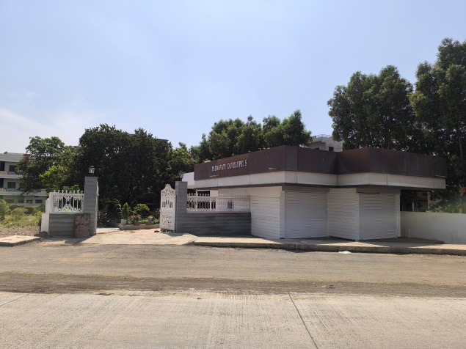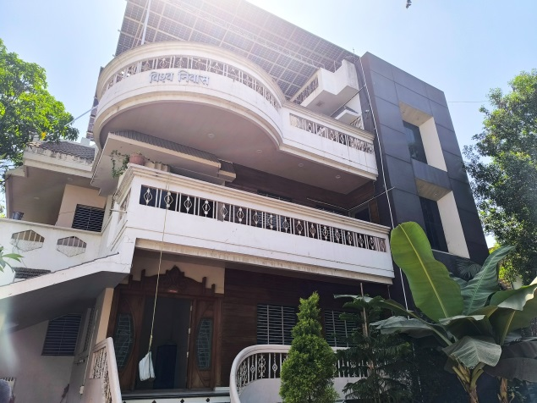

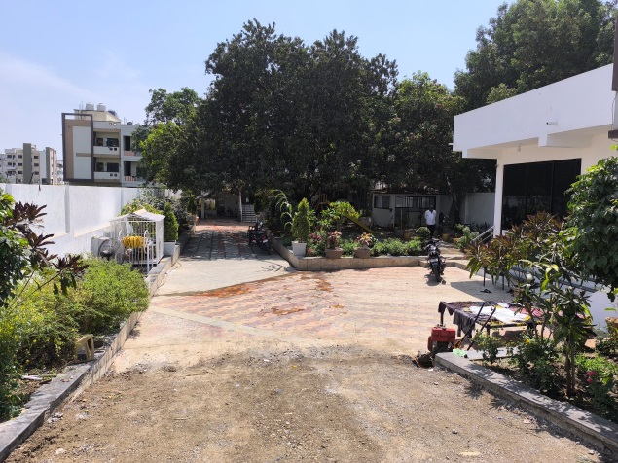 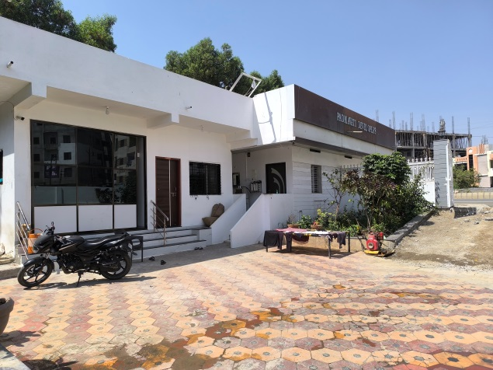

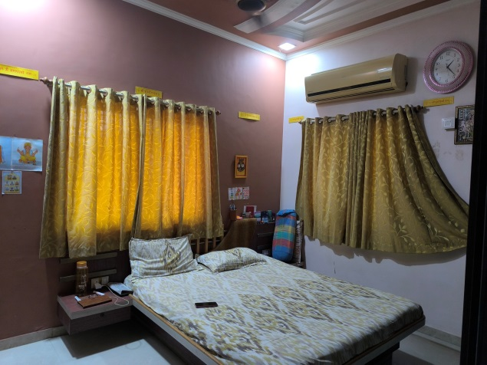 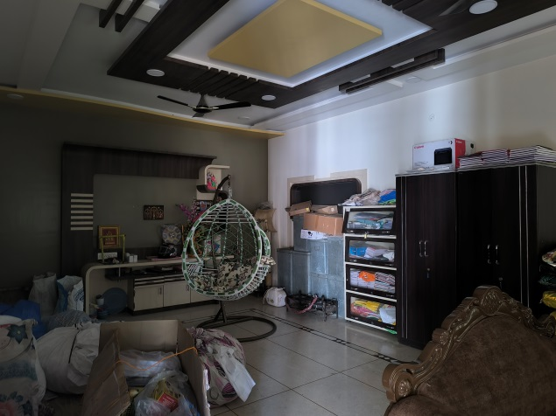

**Actual Site Photographs**

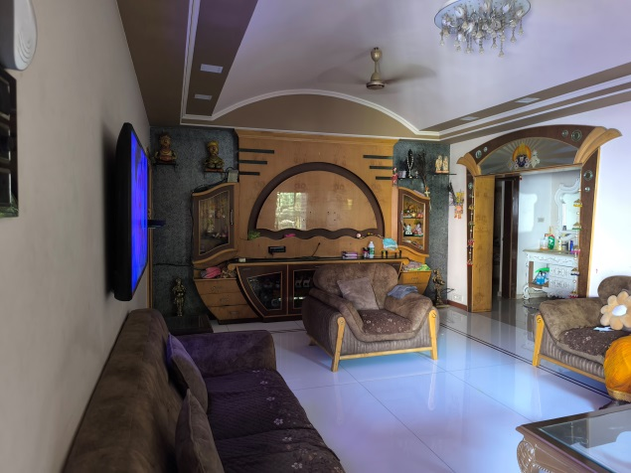 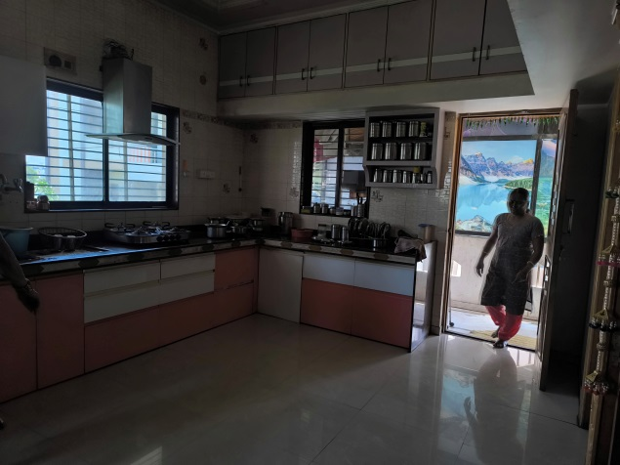

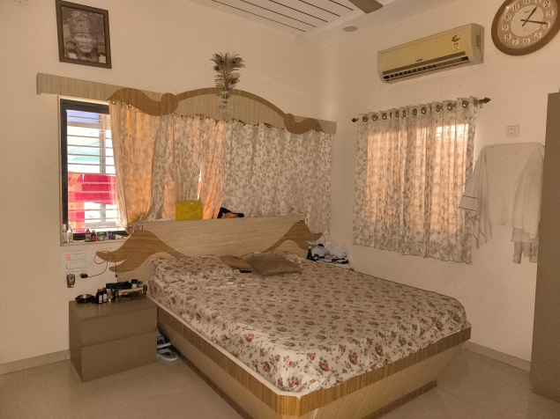 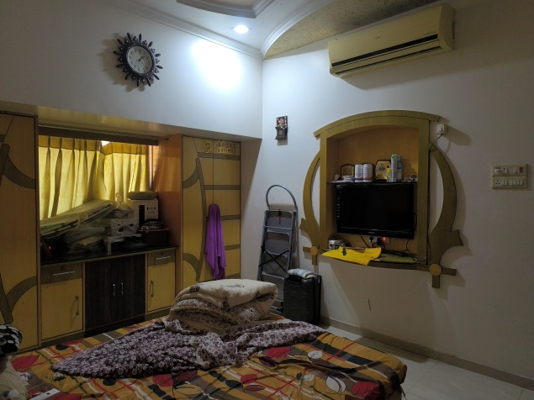

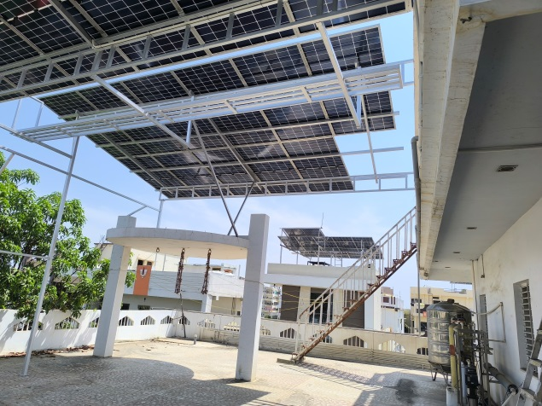 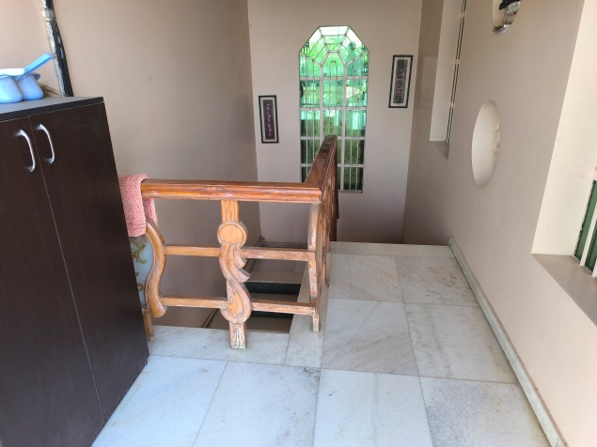

**Actual Construction Plan**

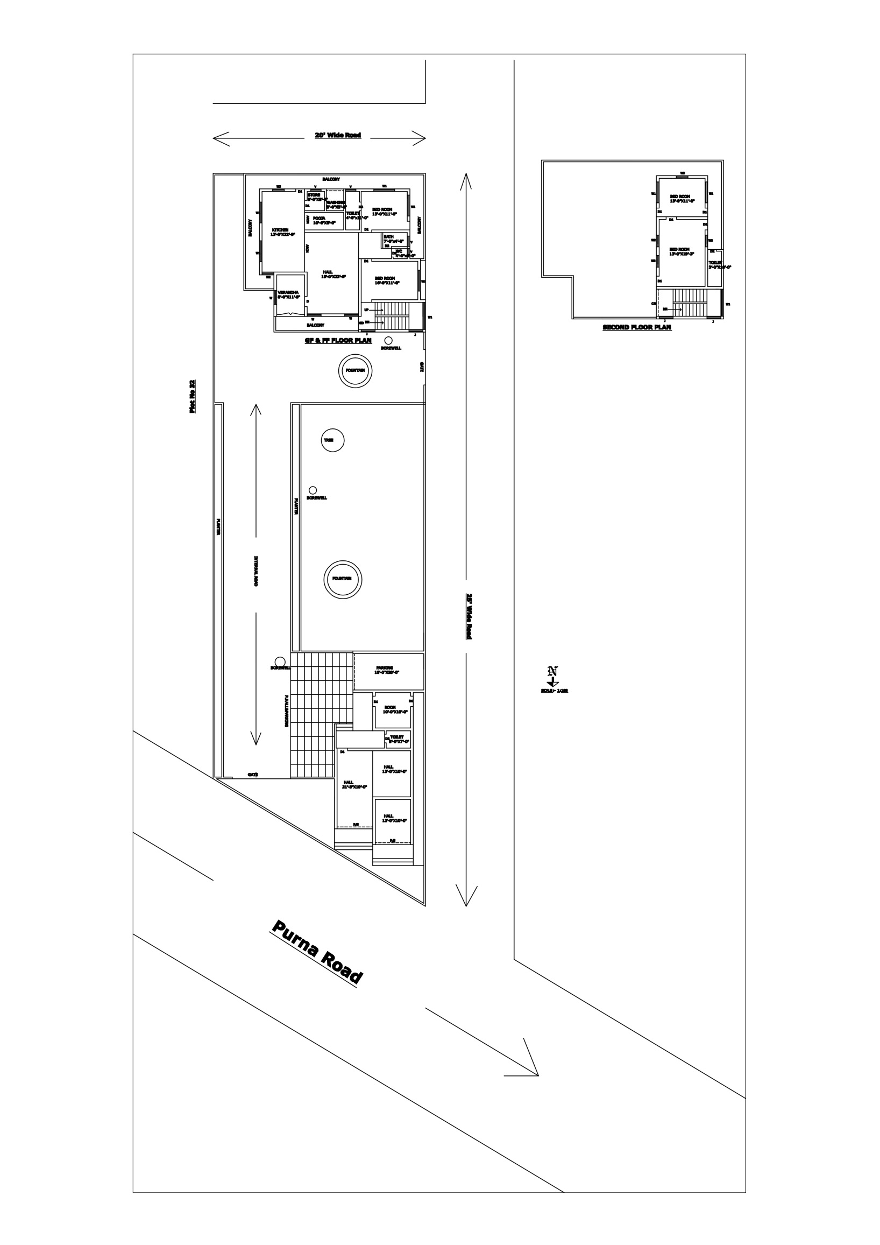

**Route Map of the Property**

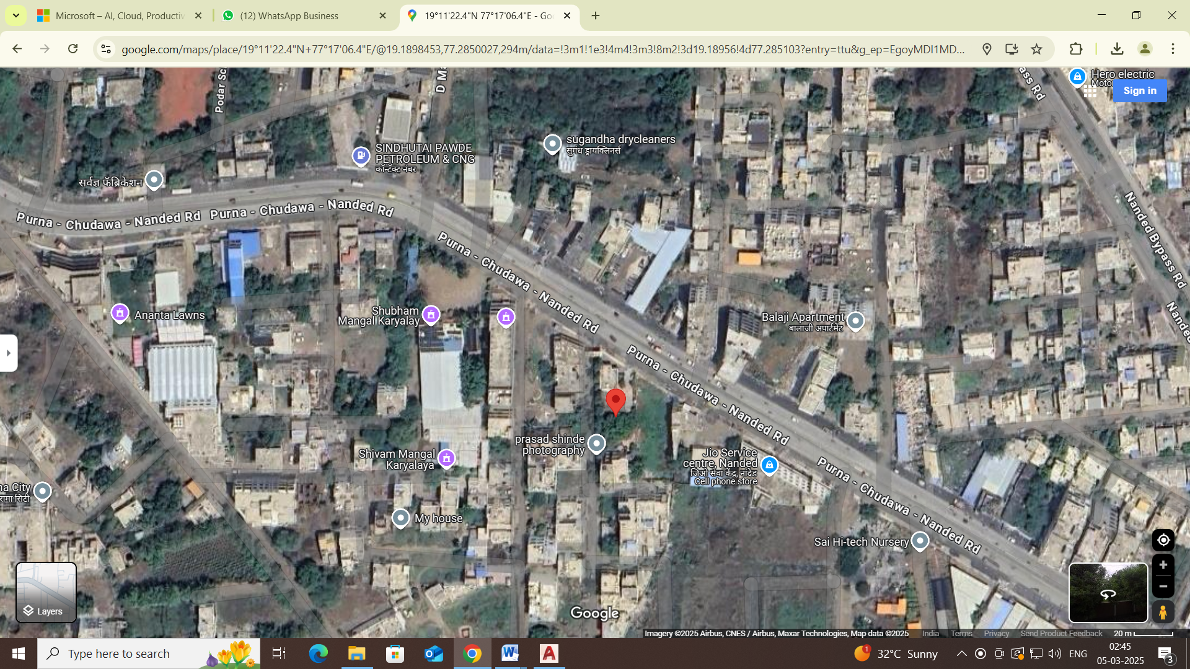

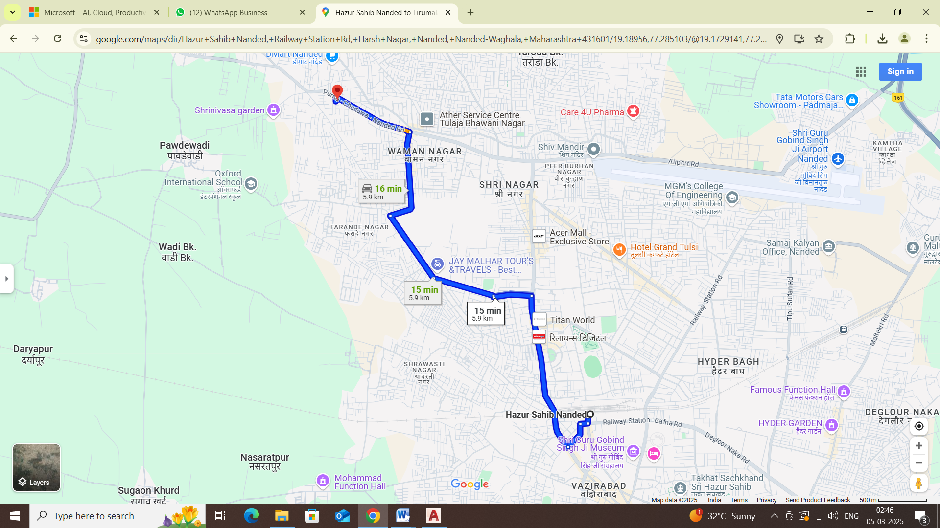

# **Longitude Latitude: 19.189560, 77.285103**

# **Note**:

* Red Pointer shows Approx. Property Location.
* Blue line shows Route from Nanded Railway Station@ 5.90 Km**.**

**Ready Reckoner Rate**

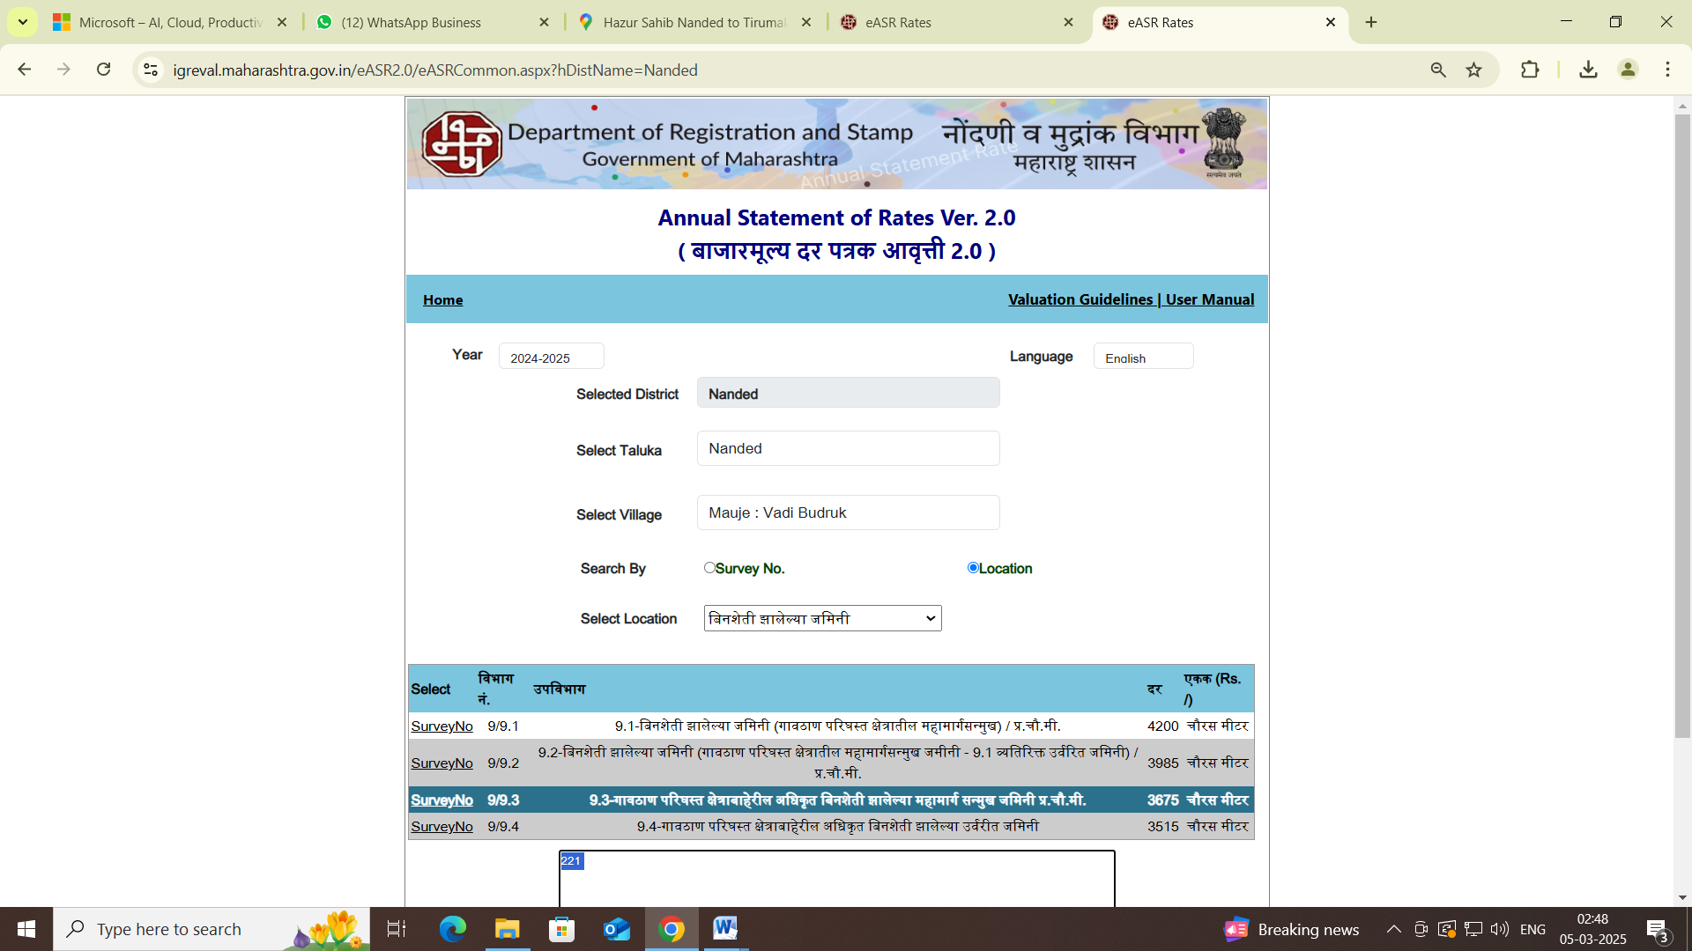

**ASSUMPTIONS, CAVEATS, LIMITATION AND DISCLAIMERS**

1. We assume no responsibility for matters of legal nature affecting the property appraised or the title thereto, nor do we render our opinion as to the title, which is assumed to be good and marketable.
2. The property is valued as though under responsible ownership.
3. It is assumed that the property is free of liens and encumbrances.
4. It is assumed that there are no hidden or unapparent conditions of the subsoil or structure that would render it more or less valuable. No responsibility is assumed for such conditions or for engineering that might be required to discover such factors.
5. The rates for valuation of the property are in accordance with the Govt. approved rates and prevailing market rates

For, **Vastukala Consultants (I) Pvt. Ltd.**

**Sharadkumar B. Chalikwar**

B.E. (Civil), M.E. (Civil), M.Sc. (Real Estate Valuation), M.Sc. (P&M Valuation), FIE (I), FIV, FIWRS

Chairman & Managing Director

Govt. Reg. Valuer

Chartered Engineer (India)

Reg. No. (N) CCIT/1-14/52/2008-09

IBBI Reg.No. IBBI/RV/07/2019/11744

Date: 06.03.2025

Place: Nanded.