Valuation Report of the Immovable Property

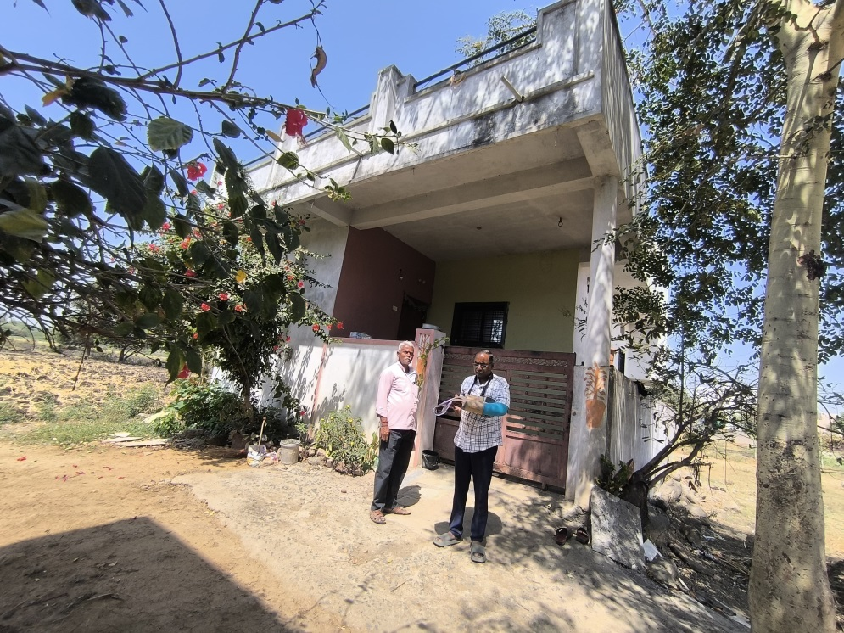

**Details of the property under consideration:**

Name of Owner: **Shri. Pandurang Keshav Kompalwar.**

Plot No.39, S.No.92/2, MCHNO 3687/39, Samarth Nagar,

Loha, Tq.Loha, Dist. Nanded.

State – Maharashtra, Country - India.

## Longitude Latitude: 18.953632, 77.120031

**Valuation Done for:**

**Axis Bank**

# **Vastukala Consultants (I) Pvt. Ltd.**

Mumbai • Delhi NCR • Aurangabad • Nanded • Indore • Pune

Raipur • Jaipur • Ahmedabad • Rajkot • Thane • Nasik

Vastu/Axis Bank/Nanded Br./02/2025/11190

Date: 06.03.2025

# **VALUER’S OPINION REPORT**

This is to certify that the property situated on Plot No.39, S.No.92/2, MCHNO 3687/39, Samarth Nagar,

Loha, Tq. Loha, Dist. Nanded, is belongs to **Shri. Pandurang Keshav Kompalwar.**

|  |  |  |
| --- | --- | --- |
| Boundaries of the property. | | |
| North | : | Plot No.40. | |
| South | : | 6.00 m.Wide Road. | |
| East | : | Plot No.38. | |
| West | : | Land of Datta Shette. | |

Considering various parameters recorded, existing economic scenario, and the information that is available with reference to the development of neighborhood and method selected for valuation, we are of the opinion that, the property premises can be assessed are as under :

|  |  |
| --- | --- |
| **Guideline Value of the Property** | **Rs. 14,91,554.00** |
| **Fair Market Value of the Property** | **Rs. 25,06,612.00** |
| **Realizable Value of the Property**  **Forced/ Distress Sale value of the Property.** | **Rs. 22,55,950.00**  **Rs. 20,05,289.00** |
|  |  |

The valuation of the property is based on the documents produced by the concern. Legal aspects have not been taken into considerations while preparing this valuation report.

Hence certified

For, **Vastukala Consultants (I) Pvt. Ltd.**

**Sharadkumar B. Chalikwar**

B.E. (Civil), M.E. (Civil), M.Sc. (Real Estate Valuation), M.Sc. (P&M Valuation), FIE (I), FIV, FIWRS

Chairman & Managing Director

Govt. Reg. Valuer

Chartered Engineer (India)

Reg. No. (N) CCIT/1-14/52/2008-09

IBBI Reg.No. IBBI/RV/07/2019/11744

Encl: Valuation report.

|  |  |  |  |  |  |  |  |  |  |  |  |  |  |  |  |  |  |  |  |  |  |  |  |  |  |  |  |  |  |  |  |  |  |  |  |  |  |  |  |  |  |  |  |  |  |  |  |  |  |  |  |  |  |  |  |  |  |  |  |  |  |  |  |  |  |  |  |  |  |  |  |  |  |  |  |  |  |  |  |  |  |  |  |  |  |  |  |  |  |  |  |  |  |  |  |  |  |  |  |  |  |  |  |  |  |  |  |  |  |  |  |  |  |  |  |  |  |  |  |  |  |  |  |  |  |  |  |  |  |  |  |  |  |  |  |  |  |  |  |  |  |  |  |  |  |  |  |  |  |  |  |  |  |  |  |  |  |  |  |  |  |  |  |  |  |  |  |  |  |  |  |  |  |  |  |  |  |  |  |  |  |  |  |  |  |  |  |  |  |  |  |  |  |  |  |  |  |  |  |  |  |  |  |  |  |  |  |  |  |  |  |  |  |  |  |  |  |  |  |  |  |  |  |  |  |  |  |  |  |  |  |  |  |  |  |  |  |  |  |  |  |  |  |  |  |  |  |  |  |  |  |  |  |  |  |  |  |  |  |  |  |  |  |  |  |  |  |  |  |  |  |  |  |  |  |  |  |  |  |  |  |  |  |  |  |  |  |  |  |  |  |  |  |  |  |  |  |  |  |  |  |  |  |  |  |  |  |  |  |  |  |  |  |  |  |  |  |  |  |  |  |  |  |  |  |  |  |  |  |  |  |  |  |  |  |  |  |  |  |  |  |  |  |  |  |  |  |  |  |  |  |  |  |  |  |  |  |  |  |  |  |  |  |  |  |  |  |  |  |  |  |  |  |  |  |  |  |  |  |  |  |  |  |  |  |  |  |  |  |  |  |  |  |  |  |  |  |  |  |  |  |  |  |  |  |  |  |  |  |  |  |  |  |  |  |  |  |  |  |  |  |  |  |  |  |  |  |  |  |  |  |  |  |  |  |  |  |  |  |  |  |  |  |  |  |  |  |  |  |  |  |  |  |  |  |  |  |  |  |  |  |  |  |  |  |  |  |  |  |  |  |  |  |  |  |  |  |  |  |  |  |  |  |  |  |  |  |  |  |  |  |  |  |  |  |  |  |  |  |  |  |  |  |  |  |  |  |  |  |  |  |  |  |  |  |  |  |  |  |  |  |  |  |  |  |  |  |  |  |  |  |  |  |  |  |  |  |  |  |  |  |  |  |  |  |  |  |  |  |  |  |  |  |  |  |  |  |  |  |  |  |  |  |  |  |  |  |  |  |  |  |  |  |  |  |  |  |  |  |  |  |  |  |  |  |  |  |  |  |  |  |  |  |  |  |  |  |  |  |  |  |  |  |  |  |  |  |  |  |  |  |  |  |  |  |  |  |  |  |  |  |  |  |  |  |  |  |  |  |  |  |  |  |  |  |  |  |  |  |  |  |  |  |  |  |  |  |  |  |  |  |  |  |  |  |  |  |  |  |  |  |  |  |  |  |  |  |  |  |  |  |  |  |  |  |  |  |  |  |  |  |  |  |  |  |  |  |  |  |  |  |  |  |  |  |  |  |  |  |  |  |  |  |  |  |  |  |  |  |  |  |  |  |  |  |  |  |  |  |  |  |  |  |  |  |  |  |  |  |  |  |  |  |  |  |  |  |  |  |  |  |  |  |  |  |  |  |  |  |  |  |  |  |  |  |  |  |  |  |  |  |  |  |  |  |  |  |  |  |  |  |  |  |  |  |  |  |  |  |  |  |  |  |  |  |  |  |  |  |  |  |  |  |  |  |  |  |  |  |  |  |  |  |  |  |  |  |  |  |  |  |  |  |  |  |  |  |  |  |  |  |  |  |  |  |  |  |  |  |  |  |  |  |  |  |  |  |  |  |  |  |  |  |  |  |  |  |  |  |  |  |  |  |  |  |  |  |  |  |  |  |  |  |  |  |  |  |  |  |  |  |  |  |  |  |  |  |  |  |  |  |  |  |  |  |  |  |  |  |  |  |  |  |  |  |  |  |  |  |  |  |  |  |  |  |  |  |  |  |  |  |  |  |  |  |  |  |  |  |  |  |  |  |  |  |  |  |  |  |  |  |  |  |  |  |  |  |  |  |  |  |  |  |  |  |  |  |  |  |  |  |  |  |  |  |  |  |  |  |  |  |  |  |  |  |  |  |  |  |  |  |  |  |  |  |  |  |  |  |  |  |  |  |  |  |  |  |  |  |  |  |  |  |  |  |  |  |  |  |  |  |  |  |  |  |  |  |  |  |  |  |  |  |  |  |  |  |  |  |  |  |  |  |  |  |  |  |  |  |  |  |  |  |  |  |  |  |  |  |  |  |  |  |  |  |  |  |  |  |  |  |  |  |  |  |  |  |  |  |  |  |  |  |  |  |  |  |  |  |  |  |  |  |  |  |  |  |  |  |  |  |  |  |  |  |  |  |  |  |  |  |  |  |  |  |  |  |  |  |  |  |  |  |  |  |  |  |  |  |  |  |  |  |  |  |  |  |  |  |  |  |  |  |  |  |  |  |  |  |  |  |  |  |  |  |  |  |  |  |  |  |  |  |  |  |  |  |  |  |  |  |  |  |  |  |  |  |  |  |  |  |  |  |  |  |  |  |  |  |  |  |  |  |  |  |  |  |  |  |  |  |  |  |  |  |  |  |  |  |  |  |  |  |  |  |  |  |  |  |  |  |  |  |  |  |  |  |  |  |  |  |  |  |  |  |  |  |  |  |  |  |  |  |  |  |  |  |  |  |  |  |  |  |  |  |  |  |  |  |  |  |  |  |  |  |  |  |  |  |  |  |  |  |  |  |  |  |  |  |  |  |  |  |  |  |  |  |  |  |  |  |  |  |  |  |  |  |  |  |  |  |  |  |  |  |  |  |  |  |  |  |  |  |  |  |  |  |  |  |  |  |  |  |  |  |  |  |  |  |  |  |  |  |  |  |  |  |  |  |  |  |  |  |  |  |  |  |  |  |  |  |  |  |  |  |  |  |  |  |  |  |  |  |  |  |  |  |  |  |  |  |  |  |  |  |  |  |  |  |  |  |  |  |  |  |  |  |  |  |  |  |  |  |  |  |  |  |  |  |  |  |  |  |  |  |  |  |  |  |  |  |  |  |  |  |  |  |  |  |  |  |  |  |  |  |  |  |  |  |  |  |  |  |  |  |  |  |  |  |  |  |  |  |  |  |  |  |  |  |  |  |  |  |  |  |  |  |  |  |  |  |  |  |  |  |  |  |  |  |  |  |  |  |  |  |  |  |  |  |  |  |  |  |  |  |  |  |  |  |  |  |  |  |  |  |  |  |  |  |  |  |  |  |  |  |  |  |  |  |  |  |  |  |  |  |  |  |  |  |  |  |  |  |  |  |  |  |  |  |  |  |  |  |  |  |  |  |  |  |  |  |  |  |  |  |  |  |  |  |  |  |  |  |  |  |  |  |  |  |  |  |  |  |  |  |  |  |  |  |  |  |  |  |  |  |  |  |  |  |  |  |  |  |  |  |  |  |  |  |  |  |  |  |  |  |  |  |  |  |  |  |  |  |  |  |  |  |  |  |  |  |  |  |  |  |  |  |  |  |  |  |  |  |  |  |  |  |  |  |  |  |  |  |  |  |  |  |  |  |  |  |  |  |  |  |  |  |  |  |  |  |  |  |  |  |  |  |  |  |  |  |  |  |  |  |  |  |  |  |  |  |  |  |  |  |  |  |  |  |  |  |  |  |  |  |  |  |  |  |  |  |  |  |  |  |  |  |  |  |  |  |  |  |  |  |  |  |  |  |  |  |  |  |  |  |  |  |  |  |  |  |  |  |  |  |  |  |  |  |  |  |  |  |  |  |  |  |  |  |  |  |  |  |  |  |  |  |  |  |  |  |  |  |  |  |  |  |  |  |  |  |  |  |  |  |  |  |  |  |  |  |  |  |  |  |  |  |  |  |  |  |  |  |  |  |  |  |  |  |  |  |  |  |  |  |  |  |  |  |  |  |  |  |  |  |  |  |  |  |  |  |  |  |  |  |  |  |  |  |  |  |  |  |  |  |  |  |  |  |  |  |  |  |  |  |  |  |  |  |  |  |  |  |  |  |  |  |  |  |  |  |  |  |  |  |  |  |  |  |  |  |  |  |  |  |  |  |  |  |  |  |  |  |  |  |  |  |  |  |  |  |  |  |  |  |  |  |  |  |  |  |  |  |  |  |  |  |  |  |  |  |  |  |  |  |  |  |  |  |  |  |  |  |  |  |  |  |  |  |  |  |  |  |  |  |  |  |  |  |  |  |  |  |  |  |  |  |  |  |  |  |  |  |  |  |  |  |  |  |  |  |  |  |  |  |  |  |  |  |  |  |  |  |  |  |  |  |  |  |  |  |  |  |  |  |  |  |  |  |  |  |  |  |  |  |  |  |  |  |  |  |  |  |  |  |  |  |  |  |  |  |  |  |  |  |  |  |  |  |  |  |  |  |  |  |  |  |  |  |  |  |  |  |  |  |  |  |  |  |  |  |  |  |  |  |  |  |  |  |  |  |  |  |  |  |  |  |  |  |  |  |  |  |  |  |  |  |  |  |  |  |  |  |  |  |  |  |  |  |  |  |  |  |  |  |  |  |  |  |  |  |  |  |  |  |  |  |  |  |  |  |  |  |  |  |  |  |  |  |  |  |  |  |  |  |  |  |  |  |  |  |  |  |  |  |  |  |  |  |  |  |  |  |  |  |  |  |  |  |  |  |  |  |  |  |  |  |  |  |  |  |  |  |  |  |  |  |  |  |  |  |  |  |  |  |  |  |  |  |  |  |  |  |  |  |  |  |  |  |  |  |  |  |  |  |  |  |  |  |  |  |  |  |  |  |  |  |  |  |  |  |  |  |  |  |  |  |  |  |  |  |  |  |  |  |  |  |  |  |  |  |  |  |  |  |  |  |  |  |  |  |  |  |  |  |  |  |  |  |  |  |  |  |  |  |  |  |  |  |  |  |  |  |  |  |  |  |  |  |  |  |  |  |  |  |  |  |  |  |  |  |  |  |  |  |  |  |  |  |  |  |  |  |  |  |  |  |  |  |  |  |  |  |  |  |  |  |  |  |  |  |  |  |  |  |  |  |  |  |  |  |  |  |  |  |  |  |  |  |  |  |  |  |  |  |  |  |  |  |  |  |  |  |  |  |  |  |  |  |  |  |  |  |  |  |  |  |  |  |  |  |  |  |  |  |  |  |  |  |  |  |  |  |  |  |  |  |  |  |  |  |  |  |  |  |  |  |  |  |  |  |  |  |  |  |  |  |  |  |  |  |  |  |  |  |  |  |  |  |  |  |  |  |  |  |  |  |  |  |  |  |  |  |  |  |  |  |  |  |  |  |  |  |  |  |  |  |  |  |  |  |  |  |  |  |  |  |  |  |  |  |  |  |  |  |  |  |  |  |  |  |  |  |  |  |  |  |  |  |  |  |  |  |  |  |  |  |  |  |  |  |  |  |  |  |  |  |  |  |  |  |  |  |  |  |  |  |  |  |  |  |  |  |  |  |  |  |  |  |  |  |  |  |  |  |  |  |  |  |  |  |  |  |  |  |  |  |  |  |  |  |  |  |  |  |  |  |  |  |  |  |  |  |  |  |  |  |  |  |  |  |  |  |  |  |  |  |  |  |  |  |  |  |  |  |  |  |  |  |  |  |  |  |  |  |  |  |  |  |  |  |  |  |  |  |  |  |  |  |  |  |  |  |  |  |  |  |  |  |  |  |  |  |  |  |  |  |  |  |  |  |  |  |  |  |  |  |  |  |  |  |  |  |  |  |  |  |  |  |  |  |  |  |  |  |  |  |  |  |  |  |  |  |  |  |  |  |  |  |  |  |  |  |  |  |  |  |  |  |  |  |  |  |  |  |  |  |  |  |  |  |  |  |  |  |  |  |  |  |  |  |  |  |  |  |  |  |  |  |  |  |  |  |  |  |  |  |  |  |  |  |  |  |  |  |  |  |  |  |  |  |  |  |  |  |  |  |  |  |  |  |  |  |  |  |  |  |  |  |  |  |  |  |  |  |  |  |  |  |  |  |  |  |  |  |  |  |  |  |  |  |  |  |  |  |  |  |  |  |  |  |  |  |  |  |  |  |  |  |  |  |  |  |  |  |  |  |  |  |  |  |  |  |  |  |  |  |  |  |  |  |  |  |  |  |  |  |  |  |  |  |  |  |  |  |  |  |  |  |  |  |  |  |  |  |  |  |  |  |  |  |  |  |  |  |  |  |  |  |  |  |  |  |  |  |  |  |  |  |  |  |  |  |  |  |  |  |  |  |  |  |  |  |  |  |  |  |  |  |  |  |  |  |  |  |  |  |  |  |  |  |  |  |  |  |  |  |  |  |  |  |  |  |  |  |  |  |  |  |  |  |  |  |  |  |  |  |  |  |  |  |  |  |  |  |  |  |  |  |  |  |  |  |  |  |  |  |  |  |  |  |  |  |  |  |  |  |  |  |  |  |  |  |  |  |  |  |  |  |  |  |  |  |  |  |  |  |  |  |  |  |  |  |  |  |  |  |  |  |  |  |  |  |  |  |  |  |  |  |  |  |  |  |  |  |  |  |  |  |  |  |  |  |  |  |  |  |  |  |  |  |  |  |  |  |  |  |  |  |  |  |  |  |  |  |  |  |  |  |  |  |  |  |  |  |  |  |  |  |  |  |  |  |  |  |  |  |  |  |  |  |  |  |  |  |  |  |  |  |  |  |  |  |  |  |  |  |  |  |  |  |  |  |  |  |  |  |  |  |  |  |  |  |  |  |  |  |  |  |  |  |  |  |  |  |  |  |  |  |  |  |  |  |  |  |  |  |  |  |  |  |  |  |  |  |  |  |  |  |  |  |  |  |  |  |  |  |  |  |  |  |  |  |  |  |  |  |  |  |  |  |  |  |  |  |  |  |  |  |  |  |  |  |  |  |  |  |  |  |  |  |  |  |  |  |  |  |  |  |  |  |  |  |  |  |  |  |  |  |  |  |  |  |  |  |  |  |  |  |  |  |  |  |  |  |  |  |  |  |  |  |  |  |  |  |  |  |  |  |  |  |  |  |  |  |  |  |  |  |  |  |  |  |  |  |  |  |  |  |  |  |  |  |  |  |  |  |  |  |  |  |  |  |  |  |  |  |  |  |  |  |  |  |  |  |  |  |  |  |  |  |  |  |  |  |  |  |  |  |  |  |  |  |  |  |  |  |  |  |  |  |  |  |  |  |  |  |  |  |  |  |  |  |  |  |  |  |  |  |  |  |  |  |  |  |  |  |  |  |  |  |  |  |  |  |  |  |  |  |  |  |  |  |  |  |  |  |  |  |  |  |  |  |  |  |  |  |  |  |  |  |  |  |  |  |  |  |  |  |  |  |  |  |  |  |  |  |  |  |  |  |  |  |  |  |  |  |  |  |  |  |  |  |  |  |  |  |  |  |  |  |  |  |  |  |  |  |  |  |  |  |  |  |  |  |  |  |  |  |  |  |  |  |  |  |  |  |  |  |  |  |  |  |  |  |  |  |  |  |  |  |  |  |  |  |  |  |  |  |  |  |  |  |  |  |  |  |  |  |  |  |  |  |  |  |  |  |  |  |  |  |  |  |  |  |  |  |  |  |  |  |  |  |  |  |  |  |  |  |  |  |  |  |  |  |  |  |  |  |  |  |  |  |  |  |  |  |  |  |  |  |  |  |  |  |  |  |  |  |  |  |  |  |  |  |  |  |  |  |  |  |  |  |  |  |  |  |  |  |  |  |  |  |  |  |  |  |  |  |  |  |  |  |  |  |  |  |  |  |  |  |  |  |  |  |  |  |  |  |  |  |  |  |  |  |  |  |  |  |  |  |  |  |  |  |  |  |  |  |  |  |  |  |  |  |  |  |  |  |  |  |  |  |  |  |  |  |  |  |  |  |  |  |  |  |  |  |  |  |  |  |  |  |  |  |  |  |  |  |  |  |  |  |  |  |  |  |  |  |  |  |  |  |  |  |  |  |  |  |  |  |  |  |  |  |  |  |  |  |  |  |  |  |  |  |  |  |  |  |  |  |  |  |  |  |  |  |  |  |  |  |  |  |  |  |  |  |  |  |  |  |  |  |  |  |  |  |  |  |  |  |  |  |  |  |  |  |  |  |  |  |  |  |  |  |  |  |  |  |  |  |  |  |  |  |  |  |  |  |  |  |  |  |  |  |  |  |  |  |  |  |  |  |  |  |  |  |  |  |  |  |  |  |  |  |  |  |  |  |  |  |  |  |  |  |  |  |  |  |  |  |  |  |  |  |  |  |  |  |  |  |  |  |  |  |  |  |  |  |  |  |  |  |  |  |  |  |  |  |  |  |  |  |  |  |  |  |  |  |  |  |  |  |  |  |  |  |  |  |  |  |  |  |  |  |  |  |  |  |  |  |  |  |  |  |  |  |  |  |  |  |  |  |  |  |  |  |  |  |  |  |  |  |  |  |  |  |  |  |  |  |  |  |  |  |  |  |  |  |  |  |  |  |  |  |  |  |  |  |  |  |  |  |  |  |  |  |  |  |  |  |  |  |  |  |  |  |  |  |  |  |  |  |  |  |  |  |  |  |  |  |  |  |  |  |  |  |  |  |  |  |  |  |  |  |  |  |  |  |  |  |  |  |  |  |  |  |  |  |  |  |  |  |  |  |  |  |  |  |  |  |  |  |  |  |  |  |  |  |  |  |  |  |  |  |  |  |  |  |  |  |  |  |  |  |  |  |  |  |  |  |  |  |  |  |  |  |  |  |  |  |  |  |  |  |  |  |  |  |  |  |  |  |  |  |  |  |  |  |  |  |  |  |  |  |  |  |  |  |  |  |  |  |  |  |  |  |  |  |  |  |  |  |  |  |  |  |  |  |  |  |  |  |  |  |  |  |  |  |  |  |  |  |  |  |  |  |  |  |  |  |  |  |  |  |  |  |  |  |  |  |  |  |  |  |  |  |  |  |  |  |  |  |  |  |  |  |  |  |  |  |  |  |  |  |  |  |  |  |  |  |  |  |  |  |  |  |  |  |  |  |  |  |  |  |  |  |  |  |  |  |  |  |  |  |  |  |  |  |  |  |  |  |  |  |  |  |  |  |  |  |  |  |  |  |  |  |  |  |  |  |  |  |  |  |  |  |  |  |  |  |  |  |  |  |  |  |  |  |  |  |  |  |  |  |  |  |  |  |  |  |  |  |  |  |  |  |  |  |  |  |  |  |  |  |  |  |  |  |  |  |  |  |  |  |  |  |  |  |  |  |  |  |  |  |  |  |  |  |  |  |  |  |  |  |  |  |  |  |  |  |  |  |  |  |  |  |  |  |  |  |  |  |  |  |  |  |  |  |  |  |  |  |  |  |  |  |  |  |  |  |  |  |  |  |  |  |  |  |  |  |  |  |  |  |  |  |  |  |  |  |  |  |  |  |  |  |  |  |  |  |  |  |  |  |  |  |  |  |  |  |  |  |  |  |  |  |  |  |  |  |  |  |  |  |  |  |  |  |  |  |  |  |  |  |  |  |  |  |  |  |  |  |  |  |  |  |  |  |  |  |  |  |  |  |  |  |  |  |  |  |  |  |  |  |  |  |  |  |  |  |  |  |  |  |  |  |  |  |  |  |  |  |  |  |  |  |  |  |  |  |  |  |  |  |  |  |  |  |  |  |  |  |  |  |  |  |  |  |  |  |  |  |  |  |  |  |  |  |  |  |  |  |  |  |  |  |  |  |  |  |  |  |  |  |  |  |  |  |  |  |  |  |  |  |  |  |  |  |  |  |  |  |  |  |  |  |  |  |  |  |  |  |  |  |  |  |  |  |  |  |  |  |  |  |  |  |  |  |  |  |  |  |  |  |  |  |  |  |  |  |  |  |  |  |  |  |  |  |  |  |  |  |  |  |  |  |  |  |  |  |  |  |  |  |  |  |  |  |  |  |  |  |  |  |  |  |  |  |  |  |  |  |  |  |  |  |  |  |  |  |  |  |  |  |  |  |  |  |  |  |  |  |  |  |  |  |  |  |  |  |  |  |  |  |  |  |  |  |  |  |  |  |  |  |  |  |  |  |  |  |  |  |  |  |  |  |  |  |  |  |  |  |  |  |  |  |  |  |  |  |  |  |  |  |  |  |  |  |  |  |  |  |  |  |  |  |  |  |  |  |  |  |  |  |  |  |  |  |  |  |  |  |  |  |  |  |  |  |  |  |  |  |  |  |  |  |  |  |  |  |  |  |  |  |  |  |  |  |  |  |  |  |  |  |  |  |  |  |  |  |  |  |  |  |  |  |  |  |  |  |  |  |  |  |  |  |  |  |  |  |  |  |  |  |  |  |  |  |  |  |  |  |  |  |  |  |  |  |  |  |  |  |  |  |  |  |  |  |  |  |  |  |  |  |  |  |  |  |  |  |  |  |  |  |  |  |  |  |  |  |  |  |  |  |  |  |  |  |  |  |  |  |  |  |  |  |  |  |  |  |  |  |  |  |  |  |  |  |  |  |  |  |  |  |  |  |  |  |  |  |  |  |  |  |  |  |  |  |  |  |  |  |  |  |  |  |  |  |  |  |  |  |  |  |  |  |  |  |  |  |  |  |  |  |  |  |  |  |  |  |  |  |  |  |  |  |  |  |  |  |  |  |  |  |  |  |  |  |  |  |  |  |  |  |  |  |  |  |  |  |  |  |  |  |  |  |  |  |  |  |  |  |  |  |  |  |  |  |  |  |  |  |  |  |  |  |  |  |  |  |  |  |  |  |  |  |  |  |  |  |  |  |  |  |  |  |  |  |  |  |  |  |  |  |  |  |  |  |  |  |  |  |  |  |  |  |  |  |  |  |  |  |  |  |  |  |  |  |  |  |  |  |  |  |  |  |  |  |  |  |  |  |  |  |  |  |  |  |  |  |  |  |  |  |  |  |  |  |  |  |  |  |  |  |  |  |  |  |  |  |  |  |  |  |  |  |  |  |  |  |  |  |  |  |  |  |  |  |  |  |  |  |  |  |  |  |  |  |  |  |  |  |  |  |  |  |  |  |  |  |  |  |  |  |  |  |  |  |  |  |  |  |  |  |  |  |  |  |  |  |  |  |  |  |  |  |  |  |  |  |  |  |  |  |  |  |  |  |  |  |  |  |  |  |  |  |  |  |  |  |  |  |  |  |  |  |  |  |  |  |  |  |  |  |  |  |  |  |  |  |  |  |  |  |  |  |  |  |  |  |  |  |  |  |  |  |  |  |  |  |  |  |  |  |  |  |  |  |  |  |  |  |  |  |  |  |  |  |  |  |  |  |  |  |  |  |  |  |  |  |  |  |  |  |  |  |  |  |  |  |  |  |  |  |  |  |  |  |  |  |  |  |  |  |  |  |  |  |  |  |  |  |  |  |  |  |  |  |  |  |  |  |  |  |  |  |  |  |  |  |  |  |  |  |  |  |  |  |  |  |  |  |  |  |  |  |  |  |  |  |  |  |  |  |  |  |  |  |  |  |  |  |  |  |  |  |  |  |  |  |  |  |  |  |  |  |  |  |  |  |  |  |  |  |  |  |  |  |  |  |  |  |  |  |  |  |  |  |  |  |  |  |  |  |  |  |  |  |  |  |  |  |  |  |  |  |  |  |  |  |  |  |  |  |  |  |  |  |  |  |  |  |  |  |  |  |  |  |  |  |  |  |  |  |  |  |  |  |  |  |  |  |  |  |  |  |  |  |  |  |  |  |  |  |  |  |  |  |  |  |  |  |  |  |  |  |  |  |  |  |  |  |  |  |  |  |  |  |  |  |  |  |  |  |  |  |  |  |  |  |  |  |  |  |  |  |  |  |  |  |  |  |  |  |  |  |  |  |  |  |  |  |  |  |  |  |  |  |  |  |  |  |  |  |  |  |  |  |  |  |  |  |  |  |  |  |  |  |  |  |  |  |  |  |  |  |  |  |  |  |  |  |  |  |  |  |  |  |  |  |  |  |  |  |  |  |  |  |  |  |  |  |  |  |  |  |  |  |  |  |  |  |  |  |  |  |  |  |  |  |  |  |  |  |  |  |  |  |  |  |  |  |  |  |  |  |  |  |  |  |  |  |  |  |  |  |  |  |  |  |  |  |  |  |  |  |  |  |  |  |  |  |  |  |  |  |  |  |  |  |  |  |  |  |  |  |  |  |  |  |  |  |  |  |  |  |  |  |  |  |  |  |  |  |  |  |  |  |  |  |  |  |  |  |  |  |  |  |  |  |  |  |  |  |  |  |  |  |  |  |  |  |  |  |  |  |  |  |  |  |  |  |  |  |  |  |  |  |  |  |  |  |  |  |  |  |  |  |  |  |  |  |  |  |  |  |  |  |  |  |  |  |  |  |  |  |  |  |  |  |  |  |  |  |  |  |  |  |  |  |  |  |  |  |  |  |  |  |  |  |  |  |  |  |  |  |  |  |  |  |  |  |  |  |  |  |  |  |  |  |  |  |  |  |  |  |  |  |  |  |  |  |  |  |  |  |  |  |  |  |  |  |  |  |  |  |  |  |  |  |  |  |  |  |  |  |  |  |  |  |  |  |  |
| --- | --- | --- | --- | --- | --- | --- | --- | --- | --- | --- | --- | --- | --- | --- | --- | --- | --- | --- | --- | --- | --- | --- | --- | --- | --- | --- | --- | --- | --- | --- | --- | --- | --- | --- | --- | --- | --- | --- | --- | --- | --- | --- | --- | --- | --- | --- | --- | --- | --- | --- | --- | --- | --- | --- | --- | --- | --- | --- | --- | --- | --- | --- | --- | --- | --- | --- | --- | --- | --- | --- | --- | --- | --- | --- | --- | --- | --- | --- | --- | --- | --- | --- | --- | --- | --- | --- | --- | --- | --- | --- | --- | --- | --- | --- | --- | --- | --- | --- | --- | --- | --- | --- | --- | --- | --- | --- | --- | --- | --- | --- | --- | --- | --- | --- | --- | --- | --- | --- | --- | --- | --- | --- | --- | --- | --- | --- | --- | --- | --- | --- | --- | --- | --- | --- | --- | --- | --- | --- | --- | --- | --- | --- | --- | --- | --- | --- | --- | --- | --- | --- | --- | --- | --- | --- | --- | --- | --- | --- | --- | --- | --- | --- | --- | --- | --- | --- | --- | --- | --- | --- | --- | --- | --- | --- | --- | --- | --- | --- | --- | --- | --- | --- | --- | --- | --- | --- | --- | --- | --- | --- | --- | --- | --- | --- | --- | --- | --- | --- | --- | --- | --- | --- | --- | --- | --- | --- | --- | --- | --- | --- | --- | --- | --- | --- | --- | --- | --- | --- | --- | --- | --- | --- | --- | --- | --- | --- | --- | --- | --- | --- | --- | --- | --- | --- | --- | --- | --- | --- | --- | --- | --- | --- | --- | --- | --- | --- | --- | --- | --- | --- | --- | --- | --- | --- | --- | --- | --- | --- | --- | --- | --- | --- | --- | --- | --- | --- | --- | --- | --- | --- | --- | --- | --- | --- | --- | --- | --- | --- | --- | --- | --- | --- | --- | --- | --- | --- | --- | --- | --- | --- | --- | --- | --- | --- | --- | --- | --- | --- | --- | --- | --- | --- | --- | --- | --- | --- | --- | --- | --- | --- | --- | --- | --- | --- | --- | --- | --- | --- | --- | --- | --- | --- | --- | --- | --- | --- | --- | --- | --- | --- | --- | --- | --- | --- | --- | --- | --- | --- | --- | --- | --- | --- | --- | --- | --- | --- | --- | --- | --- | --- | --- | --- | --- | --- | --- | --- | --- | --- | --- | --- | --- | --- | --- | --- | --- | --- | --- | --- | --- | --- | --- | --- | --- | --- | --- | --- | --- | --- | --- | --- | --- | --- | --- | --- | --- | --- | --- | --- | --- | --- | --- | --- | --- | --- | --- | --- | --- | --- | --- | --- | --- | --- | --- | --- | --- | --- | --- | --- | --- | --- | --- | --- | --- | --- | --- | --- | --- | --- | --- | --- | --- | --- | --- | --- | --- | --- | --- | --- | --- | --- | --- | --- | --- | --- | --- | --- | --- | --- | --- | --- | --- | --- | --- | --- | --- | --- | --- | --- | --- | --- | --- | --- | --- | --- | --- | --- | --- | --- | --- | --- | --- | --- | --- | --- | --- | --- | --- | --- | --- | --- | --- | --- | --- | --- | --- | --- | --- | --- | --- | --- | --- | --- | --- | --- | --- | --- | --- | --- | --- | --- | --- | --- | --- | --- | --- | --- | --- | --- | --- | --- | --- | --- | --- | --- | --- | --- | --- | --- | --- | --- | --- | --- | --- | --- | --- | --- | --- | --- | --- | --- | --- | --- | --- | --- | --- | --- | --- | --- | --- | --- | --- | --- | --- | --- | --- | --- | --- | --- | --- | --- | --- | --- | --- | --- | --- | --- | --- | --- | --- | --- | --- | --- | --- | --- | --- | --- | --- | --- | --- | --- | --- | --- | --- | --- | --- | --- | --- | --- | --- | --- | --- | --- | --- | --- | --- | --- | --- | --- | --- | --- | --- | --- | --- | --- | --- | --- | --- | --- | --- | --- | --- | --- | --- | --- | --- | --- | --- | --- | --- | --- | --- | --- | --- | --- | --- | --- | --- | --- | --- | --- | --- | --- | --- | --- | --- | --- | --- | --- | --- | --- | --- | --- | --- | --- | --- | --- | --- | --- | --- | --- | --- | --- | --- | --- | --- | --- | --- | --- | --- | --- | --- | --- | --- | --- | --- | --- | --- | --- | --- | --- | --- | --- | --- | --- | --- | --- | --- | --- | --- | --- | --- | --- | --- | --- | --- | --- | --- | --- | --- | --- | --- | --- | --- | --- | --- | --- | --- | --- | --- | --- | --- | --- | --- | --- | --- | --- | --- | --- | --- | --- | --- | --- | --- | --- | --- | --- | --- | --- | --- | --- | --- | --- | --- | --- | --- | --- | --- | --- | --- | --- | --- | --- | --- | --- | --- | --- | --- | --- | --- | --- | --- | --- | --- | --- | --- | --- | --- | --- | --- | --- | --- | --- | --- | --- | --- | --- | --- | --- | --- | --- | --- | --- | --- | --- | --- | --- | --- | --- | --- | --- | --- | --- | --- | --- | --- | --- | --- | --- | --- | --- | --- | --- | --- | --- | --- | --- | --- | --- | --- | --- | --- | --- | --- | --- | --- | --- | --- | --- | --- | --- | --- | --- | --- | --- | --- | --- | --- | --- | --- | --- | --- | --- | --- | --- | --- | --- | --- | --- | --- | --- | --- | --- | --- | --- | --- | --- | --- | --- | --- | --- | --- | --- | --- | --- | --- | --- | --- | --- | --- | --- | --- | --- | --- | --- | --- | --- | --- | --- | --- | --- | --- | --- | --- | --- | --- | --- | --- | --- | --- | --- | --- | --- | --- | --- | --- | --- | --- | --- | --- | --- | --- | --- | --- | --- | --- | --- | --- | --- | --- | --- | --- | --- | --- | --- | --- | --- | --- | --- | --- | --- | --- | --- | --- | --- | --- | --- | --- | --- | --- | --- | --- | --- | --- | --- | --- | --- | --- | --- | --- | --- | --- | --- | --- | --- | --- | --- | --- | --- | --- | --- | --- | --- | --- | --- | --- | --- | --- | --- | --- | --- | --- | --- | --- | --- | --- | --- | --- | --- | --- | --- | --- | --- | --- | --- | --- | --- | --- | --- | --- | --- | --- | --- | --- | --- | --- | --- | --- | --- | --- | --- | --- | --- | --- | --- | --- | --- | --- | --- | --- | --- | --- | --- | --- | --- | --- | --- | --- | --- | --- | --- | --- | --- | --- | --- | --- | --- | --- | --- | --- | --- | --- | --- | --- | --- | --- | --- | --- | --- | --- | --- | --- | --- | --- | --- | --- | --- | --- | --- | --- | --- | --- | --- | --- | --- | --- | --- | --- | --- | --- | --- | --- | --- | --- | --- | --- | --- | --- | --- | --- | --- | --- | --- | --- | --- | --- | --- | --- | --- | --- | --- | --- | --- | --- | --- | --- | --- | --- | --- | --- | --- | --- | --- | --- | --- | --- | --- | --- | --- | --- | --- | --- | --- | --- | --- | --- | --- | --- | --- | --- | --- | --- | --- | --- | --- | --- | --- | --- | --- | --- | --- | --- | --- | --- | --- | --- | --- | --- | --- | --- | --- | --- | --- | --- | --- | --- | --- | --- | --- | --- | --- | --- | --- | --- | --- | --- | --- | --- | --- | --- | --- | --- | --- | --- | --- | --- | --- | --- | --- | --- | --- | --- | --- | --- | --- | --- | --- | --- | --- | --- | --- | --- | --- | --- | --- | --- | --- | --- | --- | --- | --- | --- | --- | --- | --- | --- | --- | --- | --- | --- | --- | --- | --- | --- | --- | --- | --- | --- | --- | --- | --- | --- | --- | --- | --- | --- | --- | --- | --- | --- | --- | --- | --- | --- | --- | --- | --- | --- | --- | --- | --- | --- | --- | --- | --- | --- | --- | --- | --- | --- | --- | --- | --- | --- | --- | --- | --- | --- | --- | --- | --- | --- | --- | --- | --- | --- | --- | --- | --- | --- | --- | --- | --- | --- | --- | --- | --- | --- | --- | --- | --- | --- | --- | --- | --- | --- | --- | --- | --- | --- | --- | --- | --- | --- | --- | --- | --- | --- | --- | --- | --- | --- | --- | --- | --- | --- | --- | --- | --- | --- | --- | --- | --- | --- | --- | --- | --- | --- | --- | --- | --- | --- | --- | --- | --- | --- | --- | --- | --- | --- | --- | --- | --- | --- | --- | --- | --- | --- | --- | --- | --- | --- | --- | --- | --- | --- | --- | --- | --- | --- | --- | --- | --- | --- | --- | --- | --- | --- | --- | --- | --- | --- | --- | --- | --- | --- | --- | --- | --- | --- | --- | --- | --- | --- | --- | --- | --- | --- | --- | --- | --- | --- | --- | --- | --- | --- | --- | --- | --- | --- | --- | --- | --- | --- | --- | --- | --- | --- | --- | --- | --- | --- | --- | --- | --- | --- | --- | --- | --- | --- | --- | --- | --- | --- | --- | --- | --- | --- | --- | --- | --- | --- | --- | --- | --- | --- | --- | --- | --- | --- | --- | --- | --- | --- | --- | --- | --- | --- | --- | --- | --- | --- | --- | --- | --- | --- | --- | --- | --- | --- | --- | --- | --- | --- | --- | --- | --- | --- | --- | --- | --- | --- | --- | --- | --- | --- | --- | --- | --- | --- | --- | --- | --- | --- | --- | --- | --- | --- | --- | --- | --- | --- | --- | --- | --- | --- | --- | --- | --- | --- | --- | --- | --- | --- | --- | --- | --- | --- | --- | --- | --- | --- | --- | --- | --- | --- | --- | --- | --- | --- | --- | --- | --- | --- | --- | --- | --- | --- | --- | --- | --- | --- | --- | --- | --- | --- | --- | --- | --- | --- | --- | --- | --- | --- | --- | --- | --- | --- | --- | --- | --- | --- | --- | --- | --- | --- | --- | --- | --- | --- | --- | --- | --- | --- | --- | --- | --- | --- | --- | --- | --- | --- | --- | --- | --- | --- | --- | --- | --- | --- | --- | --- | --- | --- | --- | --- | --- | --- | --- | --- | --- | --- | --- | --- | --- | --- | --- | --- | --- | --- | --- | --- | --- | --- | --- | --- | --- | --- | --- | --- | --- | --- | --- | --- | --- | --- | --- | --- | --- | --- | --- | --- | --- | --- | --- | --- | --- | --- | --- | --- | --- | --- | --- | --- | --- | --- | --- | --- | --- | --- | --- | --- | --- | --- | --- | --- | --- | --- | --- | --- | --- | --- | --- | --- | --- | --- | --- | --- | --- | --- | --- | --- | --- | --- | --- | --- | --- | --- | --- | --- | --- | --- | --- | --- | --- | --- | --- | --- | --- | --- | --- | --- | --- | --- | --- | --- | --- | --- | --- | --- | --- | --- | --- | --- | --- | --- | --- | --- | --- | --- | --- | --- | --- | --- | --- | --- | --- | --- | --- | --- | --- | --- | --- | --- | --- | --- | --- | --- | --- | --- | --- | --- | --- | --- | --- | --- | --- | --- | --- | --- | --- | --- | --- | --- | --- | --- | --- | --- | --- | --- | --- | --- | --- | --- | --- | --- | --- | --- | --- | --- | --- | --- | --- | --- | --- | --- | --- | --- | --- | --- | --- | --- | --- | --- | --- | --- | --- | --- | --- | --- | --- | --- | --- | --- | --- | --- | --- | --- | --- | --- | --- | --- | --- | --- | --- | --- | --- | --- | --- | --- | --- | --- | --- | --- | --- | --- | --- | --- | --- | --- | --- | --- | --- | --- | --- | --- | --- | --- | --- | --- | --- | --- | --- | --- | --- | --- | --- | --- | --- | --- | --- | --- | --- | --- | --- | --- | --- | --- | --- | --- | --- | --- | --- | --- | --- | --- | --- | --- | --- | --- | --- | --- | --- | --- | --- | --- | --- | --- | --- | --- | --- | --- | --- | --- | --- | --- | --- | --- | --- | --- | --- | --- | --- | --- | --- | --- | --- | --- | --- | --- | --- | --- | --- | --- | --- | --- | --- | --- | --- | --- | --- | --- | --- | --- | --- | --- | --- | --- | --- | --- | --- | --- | --- | --- | --- | --- | --- | --- | --- | --- | --- | --- | --- | --- | --- | --- | --- | --- | --- | --- | --- | --- | --- | --- | --- | --- | --- | --- | --- | --- | --- | --- | --- | --- | --- | --- | --- | --- | --- | --- | --- | --- | --- | --- | --- | --- | --- | --- | --- | --- | --- | --- | --- | --- | --- | --- | --- | --- | --- | --- | --- | --- | --- | --- | --- | --- | --- | --- | --- | --- | --- | --- | --- | --- | --- | --- | --- | --- | --- | --- | --- | --- | --- | --- | --- | --- | --- | --- | --- | --- | --- | --- | --- | --- | --- | --- | --- | --- | --- | --- | --- | --- | --- | --- | --- | --- | --- | --- | --- | --- | --- | --- | --- | --- | --- | --- | --- | --- | --- | --- | --- | --- | --- | --- | --- | --- | --- | --- | --- | --- | --- | --- | --- | --- | --- | --- | --- | --- | --- | --- | --- | --- | --- | --- | --- | --- | --- | --- | --- | --- | --- | --- | --- | --- | --- | --- | --- | --- | --- | --- | --- | --- | --- | --- | --- | --- | --- | --- | --- | --- | --- | --- | --- | --- | --- | --- | --- | --- | --- | --- | --- | --- | --- | --- | --- | --- | --- | --- | --- | --- | --- | --- | --- | --- | --- | --- | --- | --- | --- | --- | --- | --- | --- | --- | --- | --- | --- | --- | --- | --- | --- | --- | --- | --- | --- | --- | --- | --- | --- | --- | --- | --- | --- | --- | --- | --- | --- | --- | --- | --- | --- | --- | --- | --- | --- | --- | --- | --- | --- | --- | --- | --- | --- | --- | --- | --- | --- | --- | --- | --- | --- | --- | --- | --- | --- | --- | --- | --- | --- | --- | --- | --- | --- | --- | --- | --- | --- | --- | --- | --- | --- | --- | --- | --- | --- | --- | --- | --- | --- | --- | --- | --- | --- | --- | --- | --- | --- | --- | --- | --- | --- | --- | --- | --- | --- | --- | --- | --- | --- | --- | --- | --- | --- | --- | --- | --- | --- | --- | --- | --- | --- | --- | --- | --- | --- | --- | --- | --- | --- | --- | --- | --- | --- | --- | --- | --- | --- | --- | --- | --- | --- | --- | --- | --- | --- | --- | --- | --- | --- | --- | --- | --- | --- | --- | --- | --- | --- | --- | --- | --- | --- | --- | --- | --- | --- | --- | --- | --- | --- | --- | --- | --- | --- | --- | --- | --- | --- | --- | --- | --- | --- | --- | --- | --- | --- | --- | --- | --- | --- | --- | --- | --- | --- | --- | --- | --- | --- | --- | --- | --- | --- | --- | --- | --- | --- | --- | --- | --- | --- | --- | --- | --- | --- | --- | --- | --- | --- | --- | --- | --- | --- | --- | --- | --- | --- | --- | --- | --- | --- | --- | --- | --- | --- | --- | --- | --- | --- | --- | --- | --- | --- | --- | --- | --- | --- | --- | --- | --- | --- | --- | --- | --- | --- | --- | --- | --- | --- | --- | --- | --- | --- | --- | --- | --- | --- | --- | --- | --- | --- | --- | --- | --- | --- | --- | --- | --- | --- | --- | --- | --- | --- | --- | --- | --- | --- | --- | --- | --- | --- | --- | --- | --- | --- | --- | --- | --- | --- | --- | --- | --- | --- | --- | --- | --- | --- | --- | --- | --- | --- | --- | --- | --- | --- | --- | --- | --- | --- | --- | --- | --- | --- | --- | --- | --- | --- | --- | --- | --- | --- | --- | --- | --- | --- | --- | --- | --- | --- | --- | --- | --- | --- | --- | --- | --- | --- | --- | --- | --- | --- | --- | --- | --- | --- | --- | --- | --- | --- | --- | --- | --- | --- | --- | --- | --- | --- | --- | --- | --- | --- | --- | --- | --- | --- | --- | --- | --- | --- | --- | --- | --- | --- | --- | --- | --- | --- | --- | --- | --- | --- | --- | --- | --- | --- | --- | --- | --- | --- | --- | --- | --- | --- | --- | --- | --- | --- | --- | --- | --- | --- | --- | --- | --- | --- | --- | --- | --- | --- | --- | --- | --- | --- | --- | --- | --- | --- | --- | --- | --- | --- | --- | --- | --- | --- | --- | --- | --- | --- | --- | --- | --- | --- | --- | --- | --- | --- | --- | --- | --- | --- | --- | --- | --- | --- | --- | --- | --- | --- | --- | --- | --- | --- | --- | --- | --- | --- | --- | --- | --- | --- | --- | --- | --- | --- | --- | --- | --- | --- | --- | --- | --- | --- | --- | --- | --- | --- | --- | --- | --- | --- | --- | --- | --- | --- | --- | --- | --- | --- | --- | --- | --- | --- | --- | --- | --- | --- | --- | --- | --- | --- | --- | --- | --- | --- | --- | --- | --- | --- | --- | --- | --- | --- | --- | --- | --- | --- | --- | --- | --- | --- | --- | --- | --- | --- | --- | --- | --- | --- | --- | --- | --- | --- | --- | --- | --- | --- | --- | --- | --- | --- | --- | --- | --- | --- | --- | --- | --- | --- | --- | --- | --- | --- | --- | --- | --- | --- | --- | --- | --- | --- | --- | --- | --- | --- | --- | --- | --- | --- | --- | --- | --- | --- | --- | --- | --- | --- | --- | --- | --- | --- | --- | --- | --- | --- | --- | --- | --- | --- | --- | --- | --- | --- | --- | --- | --- | --- | --- | --- | --- | --- | --- | --- | --- | --- | --- | --- | --- | --- | --- | --- | --- | --- | --- | --- | --- | --- | --- | --- | --- | --- | --- | --- | --- | --- | --- | --- | --- | --- | --- | --- | --- | --- | --- | --- | --- | --- | --- | --- | --- | --- | --- | --- | --- | --- | --- | --- | --- | --- | --- | --- | --- | --- | --- | --- | --- | --- | --- | --- | --- | --- | --- | --- | --- | --- | --- | --- | --- | --- | --- | --- | --- | --- | --- | --- | --- | --- | --- | --- | --- | --- | --- | --- | --- | --- | --- | --- | --- | --- | --- | --- | --- | --- | --- | --- | --- | --- | --- | --- | --- | --- | --- | --- | --- | --- | --- | --- | --- | --- | --- | --- | --- | --- | --- | --- | --- | --- | --- | --- | --- | --- | --- | --- | --- | --- | --- | --- | --- | --- | --- | --- | --- | --- | --- | --- | --- | --- | --- | --- | --- | --- | --- | --- | --- | --- | --- | --- | --- | --- | --- | --- | --- | --- | --- | --- | --- | --- | --- | --- | --- | --- | --- | --- | --- | --- | --- | --- | --- | --- | --- | --- | --- | --- | --- | --- | --- | --- | --- | --- | --- | --- | --- | --- | --- | --- | --- | --- | --- | --- | --- | --- | --- | --- | --- | --- | --- | --- | --- | --- | --- | --- | --- | --- | --- | --- | --- | --- | --- | --- | --- | --- | --- | --- | --- | --- | --- | --- | --- | --- | --- | --- | --- | --- | --- | --- | --- | --- | --- | --- | --- | --- | --- | --- | --- | --- | --- | --- | --- | --- | --- | --- | --- | --- | --- | --- | --- | --- | --- | --- | --- | --- | --- | --- | --- | --- | --- | --- | --- | --- | --- | --- | --- | --- | --- | --- | --- | --- | --- | --- | --- | --- | --- | --- | --- | --- | --- | --- | --- | --- | --- | --- | --- | --- | --- | --- | --- | --- | --- | --- | --- | --- | --- | --- | --- | --- | --- | --- | --- | --- | --- | --- | --- | --- | --- | --- | --- | --- | --- | --- | --- | --- | --- | --- | --- | --- | --- | --- | --- | --- | --- | --- | --- | --- | --- | --- | --- | --- | --- | --- | --- | --- | --- | --- | --- | --- | --- | --- | --- | --- | --- | --- | --- | --- | --- | --- | --- | --- | --- | --- | --- | --- | --- | --- | --- | --- | --- | --- | --- | --- | --- | --- | --- | --- | --- | --- | --- | --- | --- | --- | --- | --- | --- | --- | --- | --- | --- | --- | --- | --- | --- | --- | --- | --- | --- | --- | --- | --- | --- | --- | --- | --- | --- | --- | --- | --- | --- | --- | --- | --- | --- | --- | --- | --- | --- | --- | --- | --- | --- | --- | --- | --- | --- | --- | --- | --- | --- | --- | --- | --- | --- | --- | --- | --- | --- | --- | --- | --- | --- | --- | --- | --- | --- | --- | --- | --- | --- | --- | --- | --- | --- | --- | --- | --- | --- | --- | --- | --- | --- | --- | --- | --- | --- | --- | --- | --- | --- | --- | --- | --- | --- | --- | --- | --- | --- | --- | --- | --- | --- | --- | --- | --- | --- | --- | --- | --- | --- | --- | --- | --- | --- | --- | --- | --- | --- | --- | --- | --- | --- | --- | --- | --- | --- | --- | --- | --- | --- | --- | --- | --- | --- | --- | --- | --- | --- | --- | --- | --- | --- | --- | --- | --- | --- | --- | --- | --- | --- | --- | --- | --- | --- | --- | --- | --- | --- | --- | --- | --- | --- | --- | --- | --- | --- | --- | --- | --- | --- | --- | --- | --- | --- | --- | --- | --- | --- | --- | --- | --- | --- | --- | --- | --- | --- | --- | --- | --- | --- | --- | --- | --- | --- | --- | --- | --- | --- | --- | --- | --- | --- | --- | --- | --- | --- | --- | --- | --- | --- | --- | --- | --- | --- | --- | --- | --- | --- | --- | --- | --- | --- | --- | --- | --- | --- | --- | --- | --- | --- | --- | --- | --- | --- | --- | --- | --- | --- | --- | --- | --- | --- | --- | --- | --- | --- | --- | --- | --- | --- | --- | --- | --- | --- | --- | --- | --- | --- | --- | --- | --- | --- | --- | --- | --- | --- | --- | --- | --- | --- | --- | --- | --- | --- | --- | --- | --- | --- | --- | --- | --- | --- | --- | --- | --- | --- | --- | --- | --- | --- | --- | --- | --- | --- | --- | --- | --- | --- | --- | --- | --- | --- | --- | --- | --- | --- | --- | --- | --- | --- | --- | --- | --- | --- | --- | --- | --- | --- | --- | --- | --- | --- | --- | --- | --- | --- | --- | --- | --- | --- | --- | --- | --- | --- | --- | --- | --- | --- | --- | --- | --- | --- | --- | --- | --- | --- | --- | --- | --- | --- | --- | --- | --- | --- | --- | --- | --- | --- | --- | --- | --- | --- | --- | --- | --- | --- | --- | --- | --- | --- | --- | --- | --- | --- | --- | --- | --- | --- | --- | --- | --- | --- | --- | --- | --- | --- | --- | --- | --- | --- | --- | --- | --- | --- | --- | --- | --- | --- | --- | --- | --- | --- | --- | --- | --- | --- | --- | --- | --- | --- | --- | --- | --- | --- | --- | --- | --- | --- | --- | --- | --- | --- | --- | --- | --- | --- | --- | --- | --- | --- | --- | --- | --- | --- | --- | --- | --- | --- | --- | --- | --- | --- | --- | --- | --- | --- | --- | --- | --- | --- | --- | --- | --- | --- | --- | --- | --- | --- | --- | --- | --- | --- | --- | --- | --- | --- | --- | --- | --- | --- | --- | --- | --- | --- | --- | --- | --- | --- | --- | --- | --- | --- | --- | --- | --- | --- | --- | --- | --- | --- | --- | --- | --- | --- | --- | --- | --- | --- | --- | --- | --- | --- | --- | --- | --- | --- | --- | --- | --- | --- | --- | --- | --- | --- | --- | --- | --- | --- | --- | --- | --- | --- | --- | --- | --- | --- | --- | --- | --- | --- | --- | --- | --- | --- | --- | --- | --- | --- | --- | --- | --- | --- | --- | --- | --- | --- | --- | --- | --- | --- | --- | --- | --- | --- | --- | --- | --- | --- | --- | --- | --- | --- | --- | --- | --- | --- | --- | --- | --- | --- | --- | --- | --- | --- | --- | --- | --- | --- | --- | --- | --- | --- | --- | --- | --- | --- | --- | --- | --- | --- | --- | --- | --- | --- | --- | --- | --- | --- | --- | --- | --- | --- | --- | --- | --- | --- | --- | --- | --- | --- | --- | --- | --- | --- | --- | --- | --- | --- | --- | --- | --- | --- | --- | --- | --- | --- | --- | --- | --- | --- | --- | --- | --- | --- | --- | --- | --- | --- | --- | --- | --- | --- | --- | --- | --- | --- | --- | --- | --- | --- | --- | --- | --- | --- | --- | --- | --- | --- | --- | --- | --- | --- | --- | --- | --- | --- | --- | --- | --- | --- | --- | --- | --- | --- | --- | --- | --- | --- | --- | --- | --- | --- | --- | --- | --- | --- | --- | --- | --- | --- | --- | --- | --- | --- | --- | --- | --- | --- | --- | --- | --- | --- | --- | --- | --- | --- | --- | --- | --- | --- | --- | --- | --- | --- | --- | --- | --- | --- | --- | --- | --- | --- | --- | --- | --- | --- | --- | --- | --- | --- | --- | --- | --- | --- | --- | --- | --- | --- | --- | --- | --- | --- | --- | --- | --- | --- | --- | --- | --- | --- | --- | --- | --- | --- | --- | --- | --- | --- | --- | --- | --- | --- | --- | --- | --- | --- | --- | --- | --- | --- | --- | --- | --- | --- | --- | --- | --- | --- | --- | --- | --- | --- | --- | --- | --- | --- | --- | --- | --- | --- | --- | --- | --- | --- | --- | --- | --- | --- | --- | --- | --- | --- | --- | --- | --- | --- | --- | --- | --- | --- | --- | --- | --- | --- | --- | --- | --- | --- | --- | --- | --- | --- | --- | --- | --- | --- | --- | --- | --- | --- | --- | --- | --- | --- | --- | --- | --- | --- | --- | --- | --- | --- | --- | --- | --- | --- | --- | --- | --- | --- | --- | --- | --- | --- | --- | --- | --- | --- | --- | --- | --- | --- | --- | --- | --- | --- | --- | --- | --- | --- | --- | --- | --- | --- | --- | --- | --- | --- | --- | --- | --- | --- | --- | --- | --- | --- | --- | --- | --- | --- | --- | --- | --- | --- | --- | --- | --- | --- | --- | --- | --- | --- | --- | --- | --- | --- | --- | --- | --- | --- | --- | --- | --- | --- | --- | --- | --- | --- | --- | --- | --- | --- | --- | --- | --- | --- | --- | --- | --- | --- | --- | --- | --- | --- | --- | --- | --- | --- | --- | --- | --- | --- | --- | --- | --- | --- | --- | --- | --- | --- | --- | --- | --- | --- | --- | --- | --- | --- | --- | --- | --- | --- | --- | --- | --- | --- | --- | --- | --- | --- | --- | --- | --- | --- | --- | --- | --- | --- | --- | --- | --- | --- | --- | --- | --- | --- | --- | --- | --- | --- | --- | --- | --- | --- | --- | --- | --- | --- | --- | --- | --- | --- | --- | --- | --- | --- | --- | --- | --- | --- | --- | --- | --- | --- | --- | --- | --- | --- | --- | --- | --- | --- | --- | --- | --- | --- | --- | --- | --- | --- | --- | --- | --- | --- | --- | --- | --- | --- | --- | --- | --- | --- | --- | --- | --- | --- | --- | --- | --- | --- | --- | --- | --- | --- | --- | --- | --- | --- | --- | --- | --- | --- | --- | --- | --- | --- | --- | --- | --- | --- | --- | --- | --- | --- | --- | --- | --- | --- | --- | --- | --- | --- | --- | --- | --- | --- | --- | --- | --- | --- | --- | --- | --- | --- | --- | --- | --- | --- | --- | --- | --- | --- | --- | --- | --- | --- | --- | --- | --- | --- | --- | --- | --- | --- | --- | --- | --- | --- | --- | --- | --- | --- | --- | --- | --- | --- | --- | --- | --- | --- | --- | --- | --- | --- | --- | --- | --- | --- | --- | --- | --- | --- | --- | --- | --- | --- | --- | --- | --- | --- | --- | --- | --- | --- | --- | --- | --- | --- | --- | --- | --- | --- | --- | --- | --- | --- | --- | --- | --- | --- | --- | --- | --- | --- | --- | --- | --- | --- | --- | --- | --- | --- | --- | --- | --- | --- | --- | --- | --- | --- | --- | --- | --- | --- | --- | --- | --- | --- | --- | --- | --- | --- | --- | --- | --- | --- | --- | --- | --- | --- | --- | --- | --- | --- | --- | --- | --- | --- | --- | --- | --- | --- | --- | --- | --- | --- | --- | --- | --- | --- | --- | --- | --- | --- | --- | --- | --- | --- | --- | --- | --- | --- | --- | --- | --- | --- | --- | --- | --- | --- | --- | --- | --- | --- | --- | --- | --- | --- | --- | --- | --- | --- | --- | --- | --- | --- | --- | --- | --- | --- | --- | --- | --- | --- | --- | --- | --- | --- | --- | --- | --- | --- | --- | --- | --- | --- | --- | --- | --- | --- | --- | --- | --- | --- | --- | --- | --- | --- | --- | --- | --- | --- | --- | --- | --- | --- | --- | --- | --- | --- | --- | --- | --- | --- | --- | --- | --- | --- | --- | --- | --- | --- | --- | --- | --- | --- | --- | --- | --- | --- | --- | --- | --- | --- | --- | --- | --- | --- | --- | --- | --- | --- | --- | --- | --- | --- | --- | --- | --- | --- | --- | --- | --- | --- | --- | --- | --- | --- | --- | --- | --- | --- | --- | --- | --- | --- | --- | --- | --- | --- | --- | --- | --- | --- | --- | --- | --- | --- | --- | --- | --- | --- | --- | --- | --- | --- | --- | --- | --- | --- | --- | --- | --- | --- | --- | --- | --- | --- | --- | --- | --- | --- | --- | --- | --- | --- | --- | --- | --- | --- | --- | --- | --- | --- | --- | --- | --- | --- | --- | --- | --- | --- | --- | --- | --- | --- | --- | --- | --- | --- | --- | --- | --- | --- | --- | --- | --- | --- | --- | --- | --- | --- | --- | --- | --- | --- | --- | --- | --- | --- | --- | --- | --- | --- | --- | --- | --- | --- | --- | --- | --- | --- | --- | --- | --- | --- | --- | --- | --- | --- | --- | --- | --- | --- | --- | --- | --- | --- | --- | --- | --- | --- | --- | --- | --- | --- | --- | --- | --- | --- | --- | --- | --- | --- | --- | --- | --- | --- | --- | --- | --- | --- | --- | --- | --- | --- | --- | --- | --- | --- | --- | --- | --- | --- | --- | --- | --- | --- | --- | --- | --- | --- | --- | --- | --- | --- | --- | --- | --- | --- | --- | --- | --- | --- | --- | --- | --- | --- | --- | --- | --- | --- | --- | --- | --- | --- | --- | --- | --- | --- | --- | --- | --- | --- | --- | --- | --- | --- | --- | --- | --- | --- | --- | --- | --- | --- | --- | --- | --- | --- | --- | --- | --- | --- | --- | --- | --- | --- | --- | --- | --- | --- | --- | --- | --- | --- | --- | --- | --- | --- | --- | --- | --- | --- | --- | --- | --- | --- | --- | --- | --- | --- | --- | --- | --- | --- | --- | --- | --- | --- | --- | --- | --- | --- | --- | --- | --- | --- | --- | --- | --- | --- | --- | --- | --- | --- | --- | --- | --- | --- | --- | --- | --- | --- | --- | --- | --- | --- | --- | --- | --- | --- | --- | --- | --- | --- | --- | --- | --- | --- | --- | --- | --- | --- | --- | --- | --- | --- | --- | --- | --- | --- | --- | --- | --- | --- | --- | --- | --- | --- | --- | --- | --- | --- | --- | --- | --- | --- | --- | --- | --- | --- | --- | --- | --- | --- | --- | --- | --- | --- | --- | --- | --- | --- | --- | --- | --- | --- | --- | --- | --- | --- | --- | --- | --- | --- | --- | --- | --- | --- | --- | --- | --- | --- | --- | --- | --- | --- | --- | --- | --- | --- | --- | --- | --- | --- | --- | --- | --- | --- | --- | --- | --- | --- | --- | --- | --- | --- | --- | --- | --- | --- | --- | --- | --- | --- | --- | --- | --- | --- | --- | --- | --- | --- | --- | --- | --- | --- | --- | --- | --- | --- | --- | --- | --- | --- | --- | --- | --- | --- | --- | --- | --- | --- | --- | --- | --- | --- | --- | --- | --- | --- | --- | --- | --- | --- | --- | --- | --- | --- | --- | --- | --- | --- | --- | --- | --- | --- | --- | --- | --- | --- | --- | --- | --- | --- | --- | --- | --- | --- | --- | --- | --- | --- | --- | --- | --- | --- | --- | --- | --- | --- | --- | --- | --- | --- | --- | --- | --- | --- | --- | --- | --- | --- | --- | --- | --- | --- | --- | --- | --- | --- | --- | --- | --- | --- | --- | --- | --- | --- | --- | --- | --- | --- | --- | --- | --- | --- | --- | --- | --- | --- | --- | --- | --- | --- | --- | --- | --- | --- | --- | --- | --- | --- | --- | --- | --- | --- | --- | --- | --- | --- | --- | --- | --- | --- | --- | --- | --- | --- | --- | --- | --- | --- | --- | --- | --- | --- | --- | --- | --- | --- | --- | --- | --- | --- | --- | --- | --- | --- | --- | --- | --- | --- | --- | --- | --- | --- | --- | --- | --- | --- | --- | --- | --- | --- | --- | --- | --- | --- | --- | --- | --- | --- | --- | --- | --- | --- | --- | --- | --- | --- | --- | --- | --- | --- | --- | --- | --- | --- | --- | --- | --- | --- | --- | --- | --- | --- | --- | --- | --- | --- | --- | --- | --- | --- | --- | --- | --- | --- | --- | --- | --- | --- | --- | --- | --- | --- | --- | --- | --- | --- | --- | --- | --- | --- | --- | --- | --- | --- | --- | --- | --- | --- | --- | --- | --- | --- | --- | --- | --- | --- | --- | --- | --- | --- | --- | --- | --- | --- | --- | --- | --- | --- | --- | --- | --- | --- | --- | --- | --- | --- | --- | --- | --- | --- | --- | --- | --- | --- | --- | --- | --- | --- | --- | --- | --- | --- | --- | --- | --- | --- | --- | --- | --- | --- | --- | --- | --- | --- | --- | --- | --- | --- | --- | --- | --- | --- | --- | --- | --- | --- | --- | --- | --- | --- | --- | --- | --- | --- | --- | --- | --- | --- | --- | --- | --- | --- | --- | --- | --- | --- | --- | --- | --- | --- | --- | --- | --- | --- | --- | --- | --- | --- | --- | --- | --- | --- | --- | --- | --- | --- | --- | --- | --- | --- | --- | --- | --- | --- | --- | --- | --- | --- | --- | --- | --- | --- | --- | --- | --- | --- | --- | --- | --- | --- | --- | --- | --- | --- | --- | --- | --- | --- | --- | --- | --- | --- | --- | --- | --- | --- | --- | --- | --- | --- | --- | --- | --- | --- | --- | --- | --- | --- | --- | --- | --- | --- | --- | --- | --- | --- | --- | --- | --- | --- | --- | --- | --- | --- | --- | --- | --- | --- | --- | --- | --- | --- | --- | --- | --- | --- | --- | --- | --- | --- | --- | --- | --- | --- | --- | --- | --- | --- | --- | --- | --- | --- | --- | --- | --- | --- | --- | --- | --- | --- | --- | --- | --- | --- | --- | --- | --- | --- | --- | --- | --- | --- | --- | --- | --- | --- | --- | --- | --- | --- | --- | --- | --- | --- | --- | --- | --- | --- | --- | --- | --- | --- | --- | --- | --- | --- | --- | --- | --- | --- | --- | --- | --- | --- | --- | --- | --- | --- | --- | --- | --- | --- | --- | --- | --- | --- | --- | --- | --- | --- | --- | --- | --- | --- | --- | --- | --- | --- | --- | --- | --- | --- | --- | --- | --- | --- | --- | --- | --- | --- | --- | --- | --- | --- | --- | --- | --- | --- | --- | --- | --- | --- | --- | --- | --- | --- | --- | --- | --- | --- | --- | --- | --- | --- | --- | --- | --- | --- | --- | --- | --- | --- | --- | --- | --- | --- | --- | --- | --- | --- | --- | --- | --- | --- | --- | --- | --- | --- | --- | --- | --- | --- | --- | --- | --- | --- | --- | --- | --- | --- | --- | --- | --- | --- | --- | --- | --- | --- | --- | --- | --- | --- | --- | --- | --- | --- | --- | --- | --- | --- | --- | --- | --- | --- | --- | --- | --- | --- | --- | --- | --- | --- | --- | --- | --- | --- | --- | --- | --- | --- | --- | --- | --- | --- | --- | --- | --- | --- | --- | --- | --- | --- | --- | --- | --- | --- | --- | --- | --- | --- | --- | --- | --- | --- | --- | --- | --- | --- | --- | --- | --- | --- | --- | --- | --- | --- | --- | --- | --- | --- | --- | --- | --- | --- | --- | --- | --- | --- | --- | --- | --- | --- | --- | --- | --- | --- | --- | --- | --- | --- | --- | --- | --- | --- | --- | --- | --- | --- | --- | --- | --- | --- | --- | --- | --- | --- | --- | --- | --- | --- | --- | --- | --- | --- | --- | --- | --- | --- | --- | --- | --- | --- | --- | --- | --- | --- | --- | --- | --- | --- | --- | --- | --- | --- | --- | --- | --- | --- | --- | --- | --- | --- | --- | --- | --- | --- | --- | --- | --- | --- | --- | --- | --- | --- | --- | --- | --- | --- | --- | --- | --- | --- | --- | --- | --- | --- | --- | --- | --- | --- | --- | --- | --- | --- | --- | --- | --- | --- | --- | --- | --- | --- | --- | --- | --- | --- | --- | --- | --- | --- | --- | --- | --- | --- | --- | --- | --- | --- | --- | --- | --- | --- | --- | --- | --- | --- | --- | --- | --- | --- | --- | --- | --- | --- | --- | --- | --- | --- | --- | --- | --- | --- | --- | --- | --- | --- | --- | --- | --- | --- | --- | --- | --- | --- | --- | --- | --- | --- | --- | --- | --- | --- | --- | --- | --- | --- | --- | --- | --- | --- | --- | --- | --- | --- | --- | --- | --- | --- | --- | --- | --- | --- | --- | --- | --- | --- | --- | --- | --- | --- | --- | --- | --- | --- | --- |
| **VALUATION REPORT (IN RESPECT OF RESIDENTIAL LAND AND BUILDING)**   |  |  |  |  |  |  |  |  |  |  |  |  |  |  |  |  |  |  |  |  |  |  |  |  |  |  |  |  |  |  |  |  |  |  |  |  |  |  |  |  |  |  |  |  |  |  |  | | --- | --- | --- | --- | --- | --- | --- | --- | --- | --- | --- | --- | --- | --- | --- | --- | --- | --- | --- | --- | --- | --- | --- | --- | --- | --- | --- | --- | --- | --- | --- | --- | --- | --- | --- | --- | --- | --- | --- | --- | --- | --- | --- | --- | --- | --- | --- | | 1. | CBB/CCMC/CCSU | | | | | | |  | | | | | | | | | | | Assignment No | | | | | | | | | | | | | | | | - | | | | | | | | | | | | | Proposal No. | | | | | | | | | | | | | | | | - | | | | | | | | | | | | | 2. | Name of Owner & Address: | | | | | | | | | | | | | | | | | | **Shri. Pandurang Keshav Kompalwar.** R/o. Plot No.39, S.No.92/2, MCHNO 3687/39, Samarth Nagar, Loha, Tq.Loha, Dist. Nanded.  State – Maharashtra, Country - India.  Mob. No. # 9527799233 (Pandurang Keshav Kompalwar)  Mob. No. # 9096107124 (Ganraj Kompalwar) | | | | | | | | | | | | | | | | | | | | | | | | | | | | | Name of Borrower & Address | | | | | | | | | | | | | | | | | | **Shri. Pandurang Keshav Kompalwar.** R/o. Plot No.39, S.No.92/2, MCHNO 3687/39, Samarth Nagar, Loha, Tq.Loha, Dist. Nanded.  State – Maharashtra, Country - India.  Mob. No. # 9527799233 (Pandurang Keshav Kompalwar)  Mob. No. # 9096107124 (Ganraj Kompalwar) | | | | | | | | | | | | | | | | | | | | | | | | | | | | | 3. | Name of the Bank Official Present | | | | | | | | | | | | | | | | | | No. | | | | | | | | | | | | | | | | | | | | | | | | | | | | | Name of the Representative & Mobile No. | | | | | | | | | | | | | | | | | | Owner's Representative, Shri. Pandurang Keshav Kompalwar**.**  Mob. No. # 9527799233 | | | | | | | | | | | | | | | | | | | | | | | | | | | | | **4.** | **Details of the Property Being Valued** | | | | | | | | | | | | | | | | | | | | | | | | | | | | | | | | | | | | | | | | | | | | | | | 4.1 | Description of the Property | | | | | | | | | | | | | | | | | | **Ground Storeyed Residential Building.** | | | | | | | | | | | | | | | | | | | | | | | | | | | | | 4.2 | Location of Property | | | | | | | | | | | | | | | | | | Plot No.39, S.No.92/2, MCHNO 3687/39, Samarth Nagar, Loha, Tq.Loha, Dist. Nanded.  State – Maharashtra, Country - India. | | | | | | | | | | | | | | | | | | | | | | | | | | | | | (Rural / Semi Urban / Urban) | | | | | | | | | | | | | | | | | | Semi Urban | | | | | | | | | | | | | | | | | | | | | | | | | | | | | 4.3 | Documents Provided : | | | | | | | | | | | | | | | | | | | | | | | | | | | | | | | | | | | | | | | | | | | | | | | 1 | | Photo Copy of Sale Deed No. 692/2025, dated 07.02.2025, Joint Sub Registrar, Loha. | | | | | | | | | | | | | | | | | | | | | | | | | | | | | | | | | | | | | | | | | | | | | 2 | | Photo Copy of Digitally Signed 7/12. ULPIN No. 31852254692 dated 05.02.2025. | | | | | | | | | | | | | | | | | | | | | | | | | | | | | | | | | | | | | | | | | | | | | 3 | | Photo Copy of Namuna No.46, dated 2024-2025, issued by Chief officer, Municipal Council Loha, Tq.Loha, Dist. Nanded. | | | | | | | | | | | | | | | | | | | | | | | | | | | | | | | | | | | | | | | | | | | | |  | 4 | | Photo Copy of Construction Permission Plan No. Nil issued by Chief officer, Municipal Council Loha, Tq.Loha, Dist. Nanded. | | | | | | | | | | | | | | | | | | | | | | | | | | | | | | | | | | | | | | | | | | | | | 4.4 | Plot No / Survey No. / Gut No. / Khasra No: | | | | | | | | S.No.92/2 | | | | | | | | | | | | | | | Road | | | | | | | Govt Road towards East. | | | | | | | | | | | | | | | | | 4.5 | Colony / Nagar / Sector | | | | | | | | Samarth Nagar. | | | | | | | | | | | | | | | Locality / Landmark | | | | | | | Near Safalya Balaji Devasthan | | | | | | | | | | | | | | | | | 4.6 | Village/Town/City | | | | | | | | Nanded. | | | | | | | | | | | | | | | District: | | | | | | | Nanded | | | | | | | | | | | | | | | | | 4.7 | State | | | | | | | | Maharashtra | | | | | | | | | | | | | | | Pin code: | | | | | | | 431708 | | | | | | | | | | | | | | | | | 4.8 | Distance from Area Office (Nanded Branch) | | | | | | | | | | | | | | | | | | | | | | | @ 31.9 Km. | | | | | | | | | | | | | | | | | | | | | | | | **5.** | **Type of Property** | | | | | | | | | | | | | | | | | | | | | | | | | | | | | | | | | | | | | | | | | | | | | | |  | **(A) Plot:** (Residential / Commercial / Industrial) | | | | | | | | | | | | | | | | | | | | | | | | | | | | Residential. | | | | | | | | | | | | | | | | | | | Level of land with topographical conditions | | | | | | | | | | | | | | | | | | | | | | | | | | | | Levelled | | | | | | | | | | | | | | | | | | | Whether situated in Municipal / Corporation Limit | | | | | | | | | | | | | | | | | | | | | | | | | | | | Nagar Parishad. | | | | | | | | | | | | | | | | | | | Any construction observed on plot | | | | | | | | | | | | | | | | | | | | | | | | | | | | Yes, Ground Storeyed Residential Building | | | | | | | | | | | | | | | | | | | **(B) Residential Property: (**Independent house / Bungalow / Row House / Flat) | | | | | | | | | | | | | | | | | | | | | | | | | | | | Independent house. | | | | | | | | | | | | | | | | | | | Civic Amenities like school, hospital, market, etc. (Available, within the radius of Km./ Not Available) | | | | | | | | | | | | | | | | | | | | | | | | | | | | All available nearby. | | | | | | | | | | | | | | | | | | | **(C) Commercial / Industrial Property :** (Office / Shop / Unit in a Mall / Gowdown) | | | | | | | | | | | | | | | | | | | | | | | | | | | | N.A. | | | | | | | | | | | | | | | | | | | **6.** | **Accessibility / Boundaries / Others** | | | | | | | | | | | | | | | | | | | | | | | | | | | | | | | | | | | | | | | | | | | | | | | 6.1 | Availability of local transport (Metro / Local Train / Bus / Personal Transport) | | | | | | | | | | | | | | | | | | | | | | | | | | Local Transport, Bus Stand. | | | | | | | | | | | | | | | | | | | | | 6.2 | Distance from Nanded Railway station 32.00 Kms. | | | | | | | | | | | | | | | | | | | | | | | | | | Bus stop/ Taxi/ Auto Stand 1.5 kms | | | | | | | | | | | | | | | | | | | | | 6.3 | Does the approach road to the Property / Building is independent and accessible | | | | | | | | | | | | | | | | | | | Yes. | | | | | | | Will it be able to accommodate a fire extinguisher | | | | | | | | | | | | | | | | | | | No. | | 6.4 | Does the property falls under land locked area | | | | | | | | | | | | | | | | | | | No. | | | | | | | Does the property falls in a community dominated area | | | | | | | | | | | | | | | | | | | No. | | 6.5 | Cornered / Intermittent Plot | | | | | | | | | | | | | | | | | | | | | | | | | | Intermittent. | | | | | | | | | | | | | | | | | | | | | **6.6** | **Boundaries** | | | | **As Per Site** | | | | | | | | | | | | | | | | | | | | | | **As Per Documents** | | | | | | | | | | | | | | | | | | | | |  | **North** | | | | Plot No.40. | | | | | | | | | | | | | | | | | | | | | | Plot No.40. | | | | | | | | | | | | | | | | | | | | | **South** | | | | 6.00 m.Wide Road. | | | | | | | | | | | | | | | | | | | | | | 6.00 m.Wide Road. | | | | | | | | | | | | | | | | | | | | | **East** | | | | Plot No.38. | | | | | | | | | | | | | | | | | | | | | | Plot No.38. | | | | | | | | | | | | | | | | | | | | | **West** | | | | Land of Datta Shette. | | | | | | | | | | | | | | | | | | | | | | Land of Datta Shette. | | | | | | | | | | | | | | | | | | | | | 6.7 | Class of locality (Posh / Higher Middle Class / Middle Class / Lower Middle Class / Poor) | | | | | | | | | | | | | | | | | | | | | | | | | | Middle Class | | | | | | | | | | | | | | | | | | | | | 6.8 | Quality of Infrastructure in the vicinity (Excellent / Good / Average / Poor) | | | | | | | | | | | | | | | | | | | | | | | | | | Good | | | | | | | | | | | | | | | | | | | | | 6.9 | Ownership Status of the Property (Free Hold / Reg. Lease / Govt. Authority) | | | | | | | | | | | | | | | | | | | | | | | | | | Freehold | | | | | | | | | | | | | | | | | | | | | 6.10 | Approved usage of property (Industrial / Commercial / Residential / Mix) | | | | | | | | | | | | | | | | | Residential | | | | | | | | | Actual usage of property (Industrial / Commercial / Residential / Mix) | | | | | | | | | | | | | | | Residential | | | | | | 6.11 | Restrictive covenants in regards to Land Use, (if any) | | | | | | | | | | | | | | | | | | | | | | | | | | Residential | | | | | | | | | | | | | | | | | | | | | 6.12 | Type of Structure (Load Bearing / RCC / Aluform shuttering) | | | | | | | | | | | | | | | | | | | | | | | | | | RCC Framed Structure | | | | | | | | | | | | | | | | | | | | | 6.13 | Number of floors | | | | | | | | | | | | As per Actual | | | | | | | | | | | | | | Ground Floor. | | | | | | | | | | | | | | | | | | | | | 6.14 | Occupancy Details (Self-Occupied / Rented / Vacant) | | | | | | | | | | | | | | | | | | | | | | | | | | Owner Occupied | | | | | | | | | | | | | | | | | | | | | **7.** | **If the property is on rent:** | | | | | | | | | | | | | | | | | | | | | | | | | | | | | | | | | | | | | | | | | | | | | | | 7.1 | Name of tenant / lease : N.A., | | | | | | | | | | | | | | | | | | | | Number of years in tenancy : N. A. | | | | | | | | | | | | | | | | | | | | | | | | | | | 7.2 | Was there any resistance for valuation: No | | | | | | | | | | | | | | | | | | | | If yes, from the current occupants: N.A. | | | | | | | | | | | | | | | | | | | | | | | | | | | 7.3 | Does property have basic amenities | | | | | | | | | | | | | | | | Yes. | | | | Development of surrounding area Underdeveloped / Developing / Developed | | | | | | | | | | | | | | | | | | | | | | Under Developed. | | | | | **8.** | **If the property is Leasehold** | | | | | | | | | | | | | | | | | | | | | | | | | | | | | | | | | | | | | | | | | | | | | | | 8.1 | Name of Lesser: N.A. | | | | | | | | | | | | Nature of Lease: N.A. | | | | | | | | | | | | | | | | | | | | | | | | | | | | | | | | | | | 8.2 | Total Period of Lease: N.A. | | | | | | | | | | | | If yes, from the current occupants: N.A. | | | | | | | | | | | | | | | | | | | | | | | | | | | | | | | | | | | 8.3 | Does property have basic amenities | | | | | | | | | No. | | | Development of surrounding area Underdeveloped / Developing / Developed | | | | | | | | | | | | | | | | | | | | | | | | | | Under Developed. | | | | | | | | | **9.** | **Approval Details** | | | | | | | | | | | | | | | | | | | | | | | | | | | | | | | | | | | | | | | | | | | | | | | 9.1 | RERA Registration Number | | | | | | | | | | | | | | | | | | | | | | Not Applicable | | | | | | | | | | | | | | | | | | | | | | | | | 9.2 | Layout Approval Number: | | | | | | | | | | | | | | | | | | | | | | Not Available. | | | | | | | | | | | | | | | | | | | | | | | | | Date of Approval | | | | | | | | | | | | | | | | | | | | | | N.A. | | | | | | | | | | | | | | | | | | | | | | | | | Expiry Date | | | | | | | | | | | | | | | | | | | | | | N.A. | | | | | | | | | | | | | | | | | | | | | | | | | 9.3 | Building Plan Approval Number: | | | | | | | | | | | | | | | | | | | | | | Not Available. | | | | | | | | | | | | | | | | | | | | | | | | | Date of Approval | | | | | | | | | | | | | | | | | | | | | | N.A. | | | | | | | | | | | | | | | | | | | | | | | | | Expiry Date | | | | | | | | | | | | | | | | | | | | | | N.A. | | | | | | | | | | | | | | | | | | | | | | | | | **10.** | **Plot Area Details.** | | | | | | | | | | | | | | | | | | | | | | | | | | | | | | | | | | | | | | | | | | | | | | | **10.01** | **Plot Area** | | | | | | | | | | | | | | | | | | | | | | | | | | | | | | | | | **Area in Sqm.** | | | | | | | | | | | | | | 10.02 | Plot Area As per Sale Deed | | | | | | | | | | | | | | | | | | | | | | | | | | | | | | | | | 118.03 | | | | | | | | | | | | | | 10.03 | Plot Area As per Nagar Parishad Sanctioned Plan | | | | | | | | | | | | | | | | | | | | | | | | | | | | | | | | | 118.03 | | | | | | | | | | | | | | 10.04 | Demarcation at Site | | | | | | | | | | | | | | | | | | | | | | | | | | | | | | | | | Yes. | | | | | | | | | | | | | | 10.05 | Plot Area Considered for Valuation | | | | | | | | | | | | | | | | | | | | | | | | | | | | | | | | | **118.03** | | | | | | | | | | | | | | **10.06** | **Construction Area Details** | | | | | | | | | | | | | | | | | | | | | | | | | | | | | | | | | | | | | | | | | | | | | | |  | **Sr. No.** | | | **Floor** | | | | | | | | | | | | | **Actual Built up Area in Sqm.** | | | | | | | | | | | | | **Sanctioned Plan Built up Area in Sqm.** | | | | | | | | | | | | | | | | | | 1. | | | Ground Floor | | | | | | | | | | | | | 75.65 | | | | | | | | | | | | | 58.50 | | | | | | | | | | | | | | | | | | 2. | | | First Floor | | | | | | | | | | | | | - | | | | | | | | | | | | | 58.50 | | | | | | | | | | | | | | | | | | **Total** | | | | | | | | | | | | | | | | **75.65** | | | | | | | | | | | | | **117.00** | | | | | | | | | | | | | | | | | | 10.07 | * Only Ground FloorSanctioned Built up Area Considered for Valuation**: 58.50 Sqm.** | | | | | | | | | | | | | | | | | | | | | | | | | | | | | | | | | | | | | | | | | | | | | | | **10.08** | **Floor wise break up as follows** | | | | | | | | | | | | | | | | | |  | | | | | | | | | | | | | | | | | | **Current Usage** | | | | | | | | | | |  | **Floor** | | | | | **Actual Built up Area in Sqm.** | | | | | | | | | | | | | **Sanctioned Plan Built up Area in Sqm.** | | | | | | | | | | | | | | | | | | (Storage / Parking / Commercial /Residential) | | | | | | | | | | | Ground Floor | | | | | 75.65 | | | | | | | | | | | | | 58.50 | | | | | | | | | | | | | | | | | | Residential | | | | | | | | | | | First Floor | | | | | Nil | | | | | | | | | | | | | 58.50 | | | | | | | | | | | | | | | | | | | **Total** | | | | | **75.65** | | | | | | | | | | | | | **117.00** | | | | | | | | | | | | | | | | | | | 10.9 | Amenities Details (if any): | | | | | | | | | | | | | | | | | | | | | | | | | Bore well etc. | | | | | | | | | | | | | | | | | | | | | | 10.10 | Floor Space Index permissible. | | | | | | | | | | | | | | | | | | | | | | | | | Basic FSI | | | | | | | | | | | | | | | | | | | 1.10 | | | Premium FSI | | | | | | | | | | | | | | | | | | | - | | | TDR | | | | | | | | | | | | | | | | | | | - | | | Ancillary FSI | | | | | | | | | | | | | | | | | | | - | | | Maximum building potential on Plot including in-situ FSI | | | | | | | | | | | | | | | | | | | - | | | 10.11 | FSI Utilized | | | | | | | | | | | | | | | | | | | | | | | | | 1.10 | | | | | | | | | | | | | | | | | | | | | | 10.12 | Whether the construction is as per approved  building plan and / or local building bye laws: | | | | | | | | | | | | | | | | | | | | | | | | | * No. * Construction Permission ,issued by Chief officer, Municipal Council Loha, Tq.Loha, Dist. Nanded. | | | | | | | | | | | | | | | | | | | | | | 10.13 | Details of Extra Construction | | | | | | | | | | | | | | | | | | | | | | | | | Floor | | | | | | | | | | | | Extra Built up Area in Sqm. | | | | | | | | | | Ground Floor | | | | | | | | | | | | 17.15 | | | | | | | | | | 10.14 | Percentage of Extra Construction | | | | | | | | | | | | | | | | | | | | | | | | | 77.32 % | | | | | | | | | | | | | | | | | | | | | | 10.15 | Whether the extra construction is Compoundable OR Non-Compoundable? | | | | | | | | | | | | | | | | | | | | | | | | | Compoundable. | | | | | | | | | | | | | | | | | | | | | | 10.16 | Quality of construction | | | | | | | | | | | | | | | | | | | | | | | | | Good. | | | | | | | | | | | | | | | | | | | | | | 10.17 | Maintenance of the Property | | | | | | | | | | | | | | | | | | | | | | | | | Well maintained. | | | | | | | | | | | | | | | | | | | | | | 10.18 | Condition of Building | | | | | | | | | | | | | | | | | | | | | | | | | Good. | | | | | | | | | | | | | | | | | | | | | | 10.19 | Current Life of the structure | | | | | | | | | | 7 year.  (As per Owners information) | | | | | | | | | | | Projected Future Life of the Structure | | | | | | | | | | 53 Years. | | | | | | | | | | | | | | | | 10.20 | Land Revenue / Taxes Paid upto (for Land) | | | | | | | | | | Details not available | | | | | | | | | | | Municipal Taxes Paid upto (for Building) | | | | | | | | | | Details not available | | | | | | | | | | | | | | | | **11.** | **Details of Valuation:** | | | | | | | | | | | | | | | | | | | | | | | | | | | | | | | | | | | | | | | | | | | | | | |  | **S.L** | **Particulars of Item** | | | | | **Plinth / Built up Area In Sq. M.** | | | | | | | | | **Age of Building** | | | | **Estimated Replacement Rate Of Construction** | | | | | | | | **Replacement cost** | | | | | | | | **Depreciation**  **10.50%** | | | | | | | | **Net Value after Depreciation** | | | | 1 | Ground Floor | | | | | 58.50 | | | | | | | | | 7 | | | | 19,602.00 | | | | | | | | 11,46,717.00 | | | | | | | | -1,20,405.00 | | | | | | | | 10,26,312.00 | | | | **Total** | | | | | | | | | | | | | | | | | | | | | | | | | | | | | | | | | | | | | | | | | | | **10,26,312.00** | | | | **12.** | **Details of Amenities** | | | | | | | | | | | | | | | | | | | | | | | | | | | | | | | | | | | | | | | | | | | | | | |  | 1 | | Borewell. | | | | | | | | | | | | | | | | | | | | | | | | | | | | | | | | | | | | | | | 1,00,000.00 | | | | | | 2 | | Compound Wall with Gate. | | | | | | | | | | | | | | | | | | | | | | | | | | | | | | | | | | | | | | | 2,00,000.00 | | | | | | **Total** | | | | | | | | | | | | | | | | | | | | | | | | | | | | | | | | | | | | | | | | | **3,00,000.00** | | | | | | **13.** | **Government Guideline value** | | | | | | | | | | | | | | | | | | | | | | | | | | | | | | | | | | | | | | | | | | | | | | |  | **Particulars** | | | | | | | | | | | **Area in Sq. M.** | | | | | | | | | | | | | **Rate in Rs.** | | | | | | | | | | | | | | | **Value in Rs.** | | | | | | | | 1 | **Land** | | | | | | | | | | | **118.03** | | | | | | | | | | | | | 1400.00 | | | | | | | | | | | | | | | 1,65,242.00 | | | | | | | | 2 | **Construction** | | | | | | | | | | |  | | | | | | | | | | | | | | | | | | | | | | | | | | | | 10,26,312.00 | | | | | | | | 3 | **Amenities** | | | | | | | | | | |  | | | | | | | | | | | | | | | | | | | | | | | | | | | | 3,00,000.00 | | | | | | | |  | **TOTAL** | | | | | | | | | | | | | | | | | | | | | | | | | | | | | | | | | | | | | | | **14,91,554.00** | | | | | | | | 14. | **Market Value of Land** | | | | | | | | | | | | | | | | | | | | | | | | | | | | | | | | | | | | | | | | | | | | | | |  | **Particulars** | | | | | | | | | | | | | **Area in Sq. M.** | | | | | | | | | | | **Rate in Rs.** | | | | | | | | | | | | | | | **Value in Rs.** | | | | | | | | **Land** | | | | | | | | | | | | | **118.03** | | | | | | | | | | | 10,000.00 | | | | | | | | | | | | | | | **11,80,300.00** | | | | | | | | 15. | **Value of the Property** | | | | | | | | | | | | | | | | | | | | | | | | | | | | | | | | | | | | | | | | | | | | | | |  |  | | | | | | | | | | | | | | **Land** | | | | | | | | | | **Building** | | | | | | | | **Amenities** | | | | | | | | **Total** | | | | | | | Government Guideline value | | | | | | | | | | | | | | **1,65,242.00** | | | | | | | | | | **10,26,312.00** | | | | | | | | **3,00,000.00** | | | | | | | | **14,91,554.00** | | | | | | | Market Value | | | | | | | | | | | | | | **11,80,300.00** | | | | | | | | | | **10,26,312.00** | | | | | | | | **3,00,000.00** | | | | | | | | **25,06,612.00** | | | | | | | Distressed/Forced Sale Value | | | | | | | | | | | | | |  | | | | | | | | | | | | | | | | | | | | | | | | | | **20,05,289.00** | | | | | | | Realizable Value | | | | | | | | | | | | | |  | | | | | | | | | | | | | | | | | | | | | | | | | | **22,55,950.00** | | | | | | | Insurable Value | | | | | | | | | | | | | |  | | | | | | | | | | | | | | | | | | | | | | | | | | **8,21,049.00** | | | | | |  | | **Remarks** | | | | | | | | | | | | | | | | | | | | | | | | | | | | | | | | | | | | | | | | | | | | | | | * The Actual Ground Floor Built-up area is 75.65 Sqm (Refer Annexure-1) * The Sanctioned Ground Floor Built-up Area is 58.50 Sqm (Refer Annexure-2) * The built-up area considered in sale deed is 118.03 Sqm.(Refer Page No 34/36 in Sale Deed No.692/2025) * There is deviation in actual Ground floor Built-up area, Sanctioned Built-up area and Built-up in Sale deed No.692/2025. * No Side, Front and Back Margins as per Sanctioned plan. * Hence to assess the Fair Market Value by Land and Building method the land area as per sale deed and the plinth area as per Sanctioned Plan is considered. * There are cracks in compound wall and floor settlement in one bed room. * Proper maintenance is required. | | | | | | | | | | | | | | | | | | | | | | | | | | | | | | | | | | | | | | | | | | | | | |   **Undertaking:**   1. I have / our / representative Md. Shareq Salim Md. Jilani Pasha (Technical Assistant) has inspected the subject property on 04.03.2025 along with Owner's Representative Shri.Pandurang Keshav Kompalwar identified the same based on the documents provided. 2. I/We have no direct or indirect interest in the property being valued. 3. The information furnished above is true and correct to my/our knowledge 4. I/ we have not been dismissed or removed from govt. Service or convicted of an offence connected with any proceedings of income tax act, wealth tax act or gift tax act or have been blacklisted by any bank/ financial institution/ govt. Department/ public sector enterprise/ body corporate etc. 5. This valuation is prepared without any prejudice or bias to any person or institution. 6. The value of land is taken into account by making due enquires in the locality and ascertaining the sales value of the properties in the locality. 7. Any additions/alterations made to the property after the date of valuations shall not fall under the scope of this report.   For, **Vastukala Consultants (I) Pvt. Ltd.**  **Sharadkumar B. Chalikwar**  B.E. (Civil), M.E. (Civil), M.Sc. (Real Estate Valuation), M.Sc. (P&M Valuation), FIE (I), FIV, FIWRS  Chairman & Managing Director  Govt. Reg. Valuer  Chartered Engineer (India)  Reg. No. (N) CCIT/1-14/52/2008-09  IBBI Reg. No. IBBI/RV/07/2019/11744  Date: 06.03.2025   |  |  |  | | --- | --- | --- | | **Attachments** | | | | Photographs of the Property from inside & outside | : | Attached | | Location sketch for the property: | : | Attached. | | Geo Tagging | : | Attached. | | Topography | : | Leveled Land. | | Government Value Document | : | Attached. | |

**Actual Site Photographs**

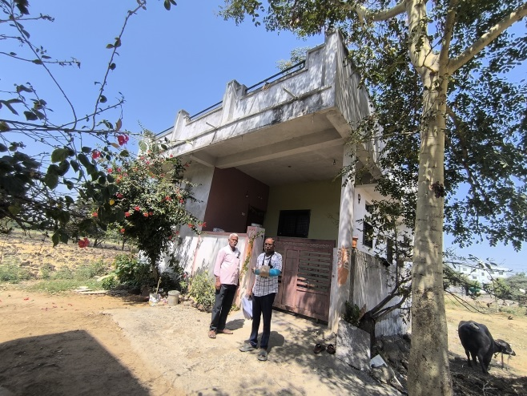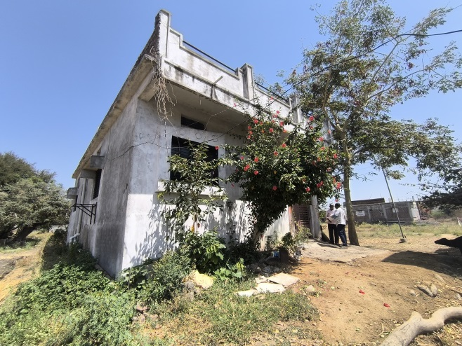

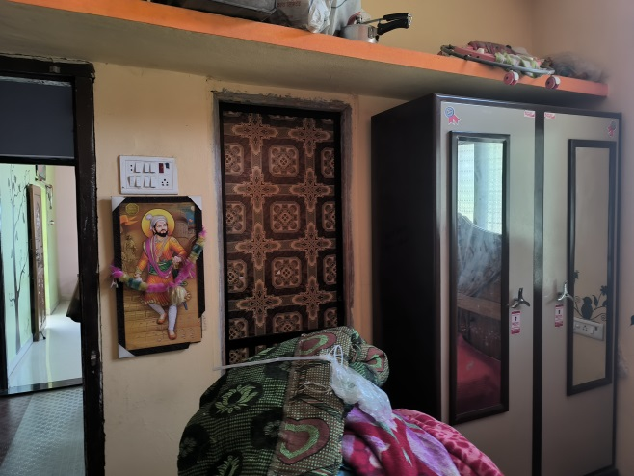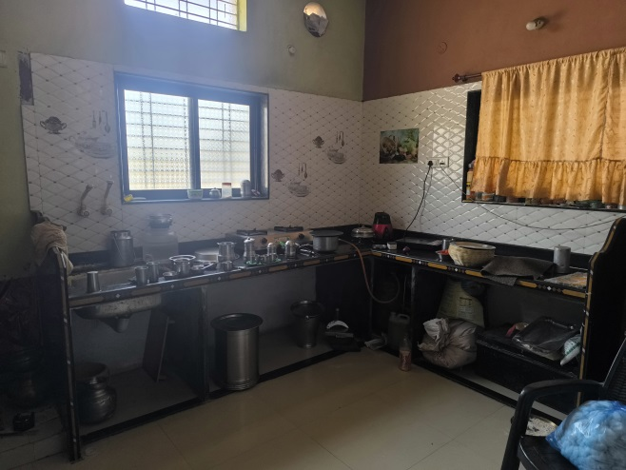

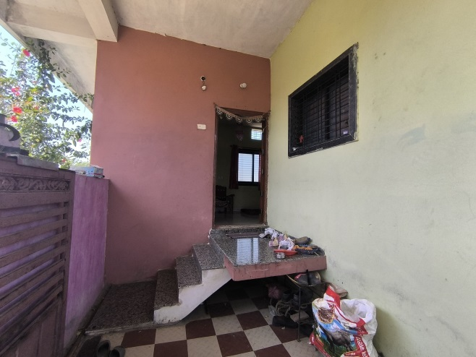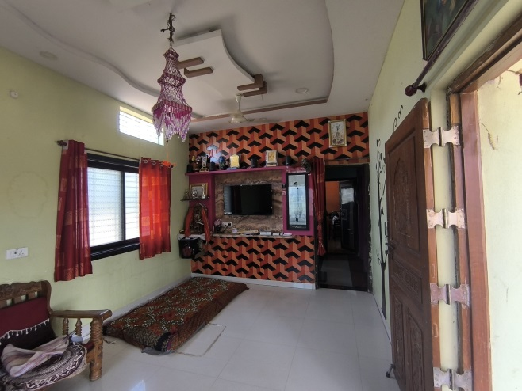

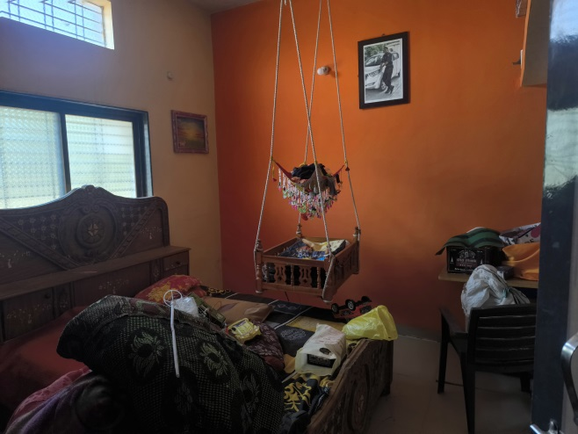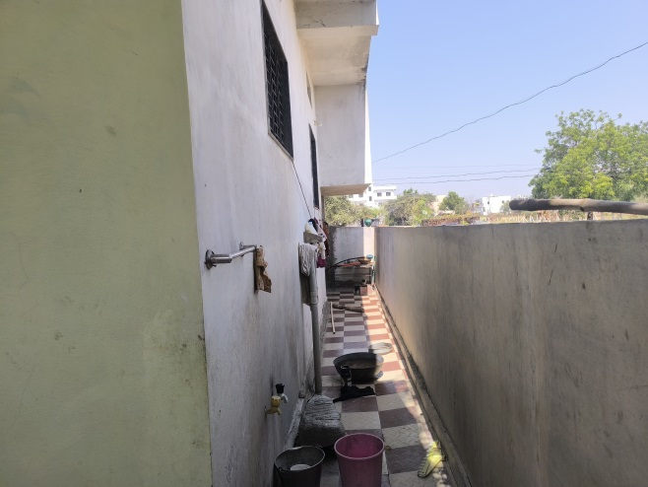

**Actual Construction Plan**

Refer Annexure-1

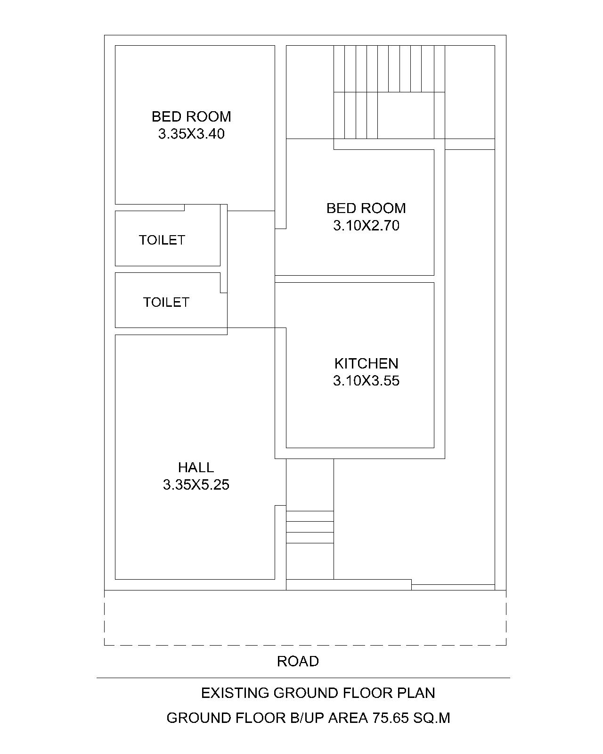

**Sanctioned Plan**

Refer Annexure-2

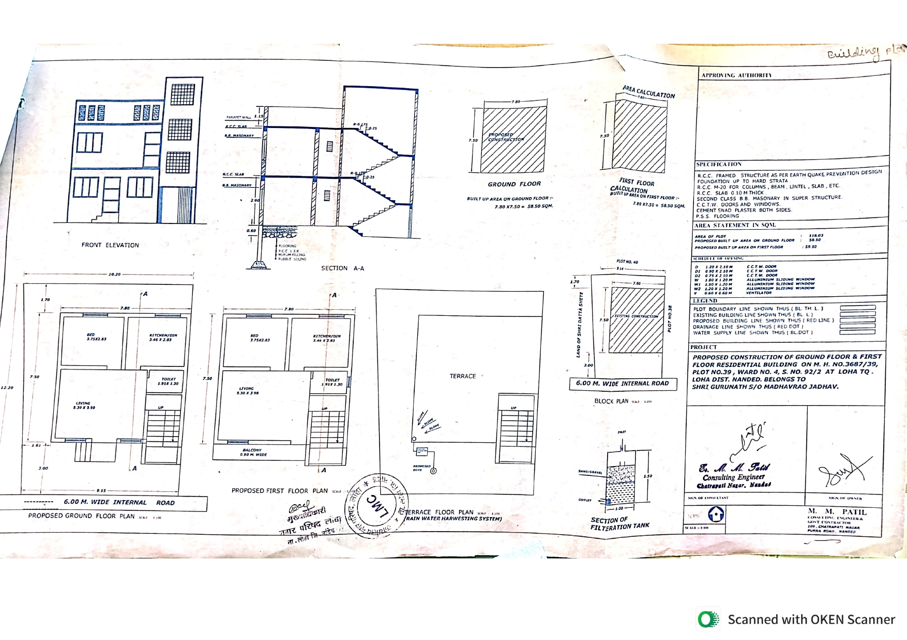

**Page No 34/36 of Sale Deed**

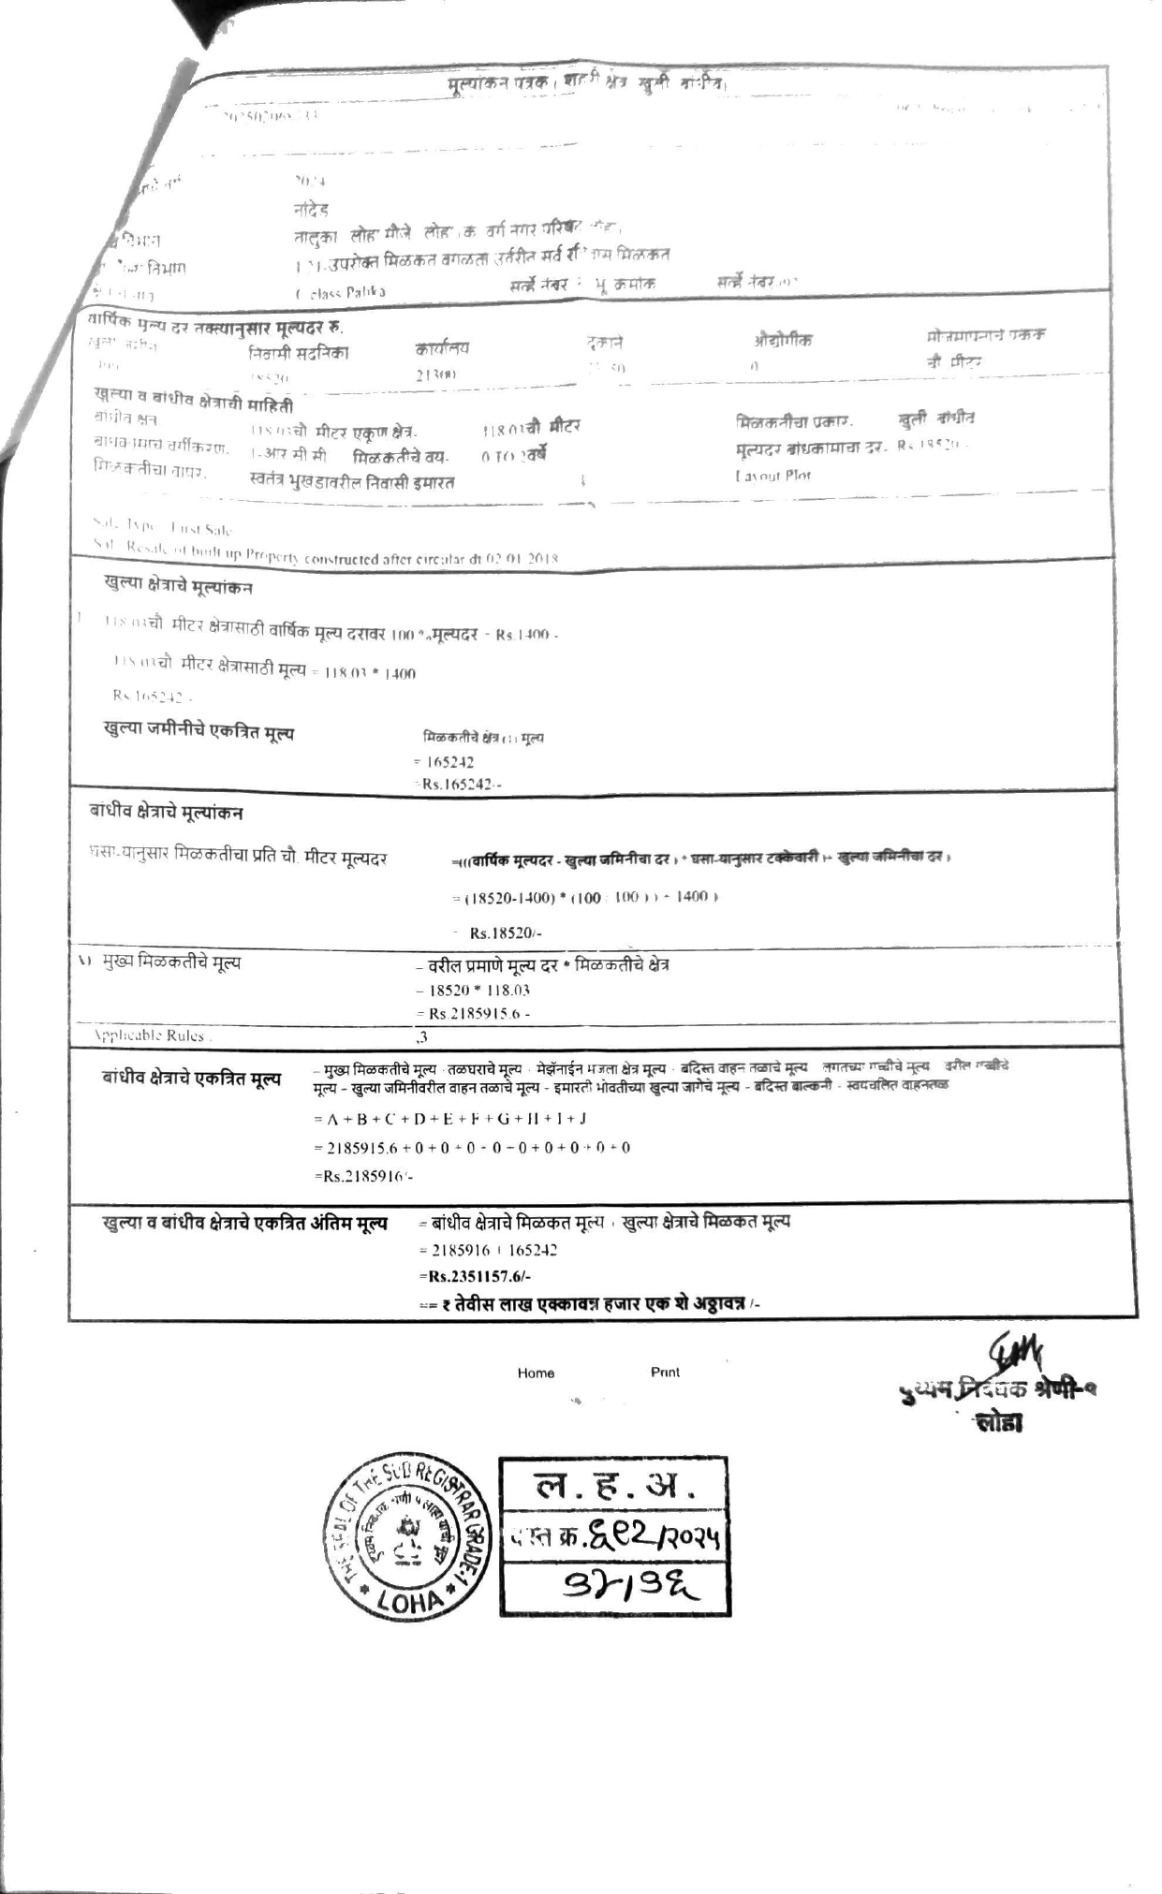

**Route Map of the Property**

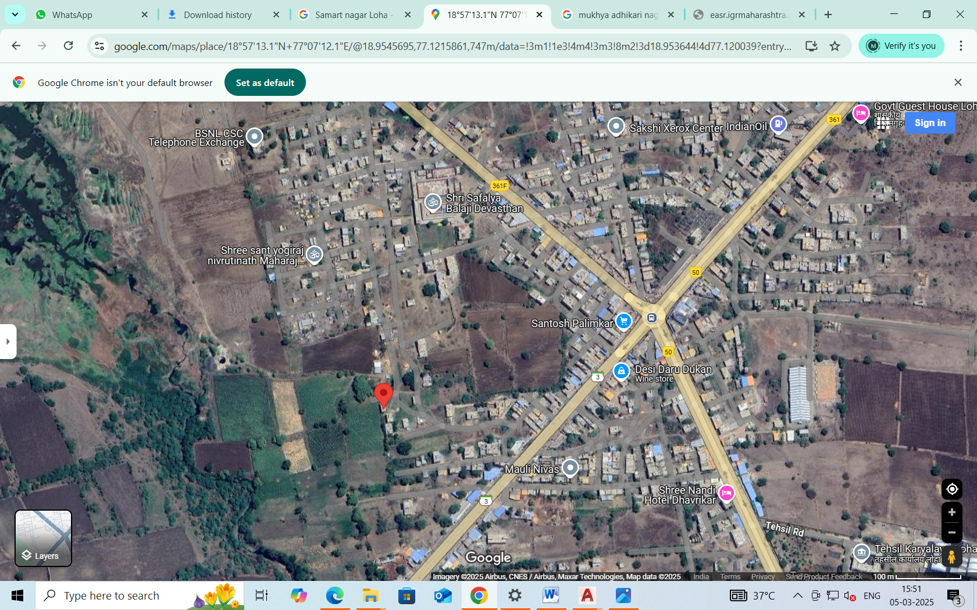

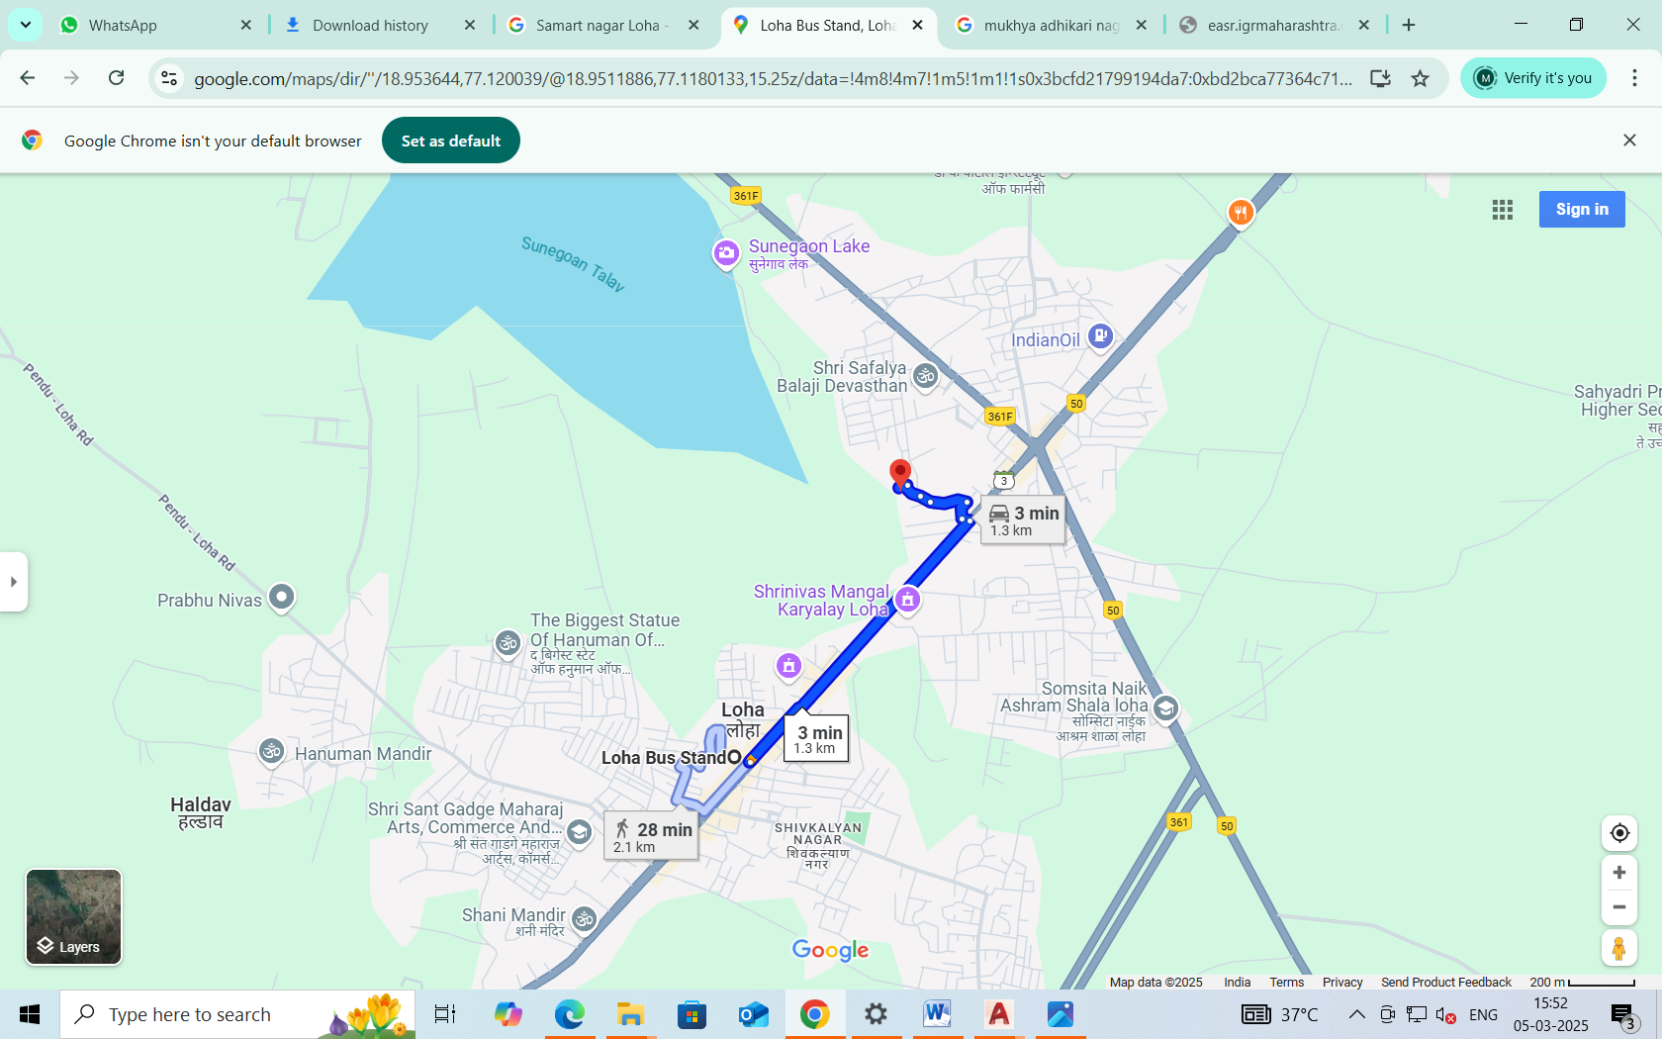

## Longitude Latitude: 18.953632, 77.120031

# **Note**:

* Red Pointer shows Approx. Property Location.
* Blue line shows Route from @ 2.1 Km**.**

**Ready Reckoner Rate**

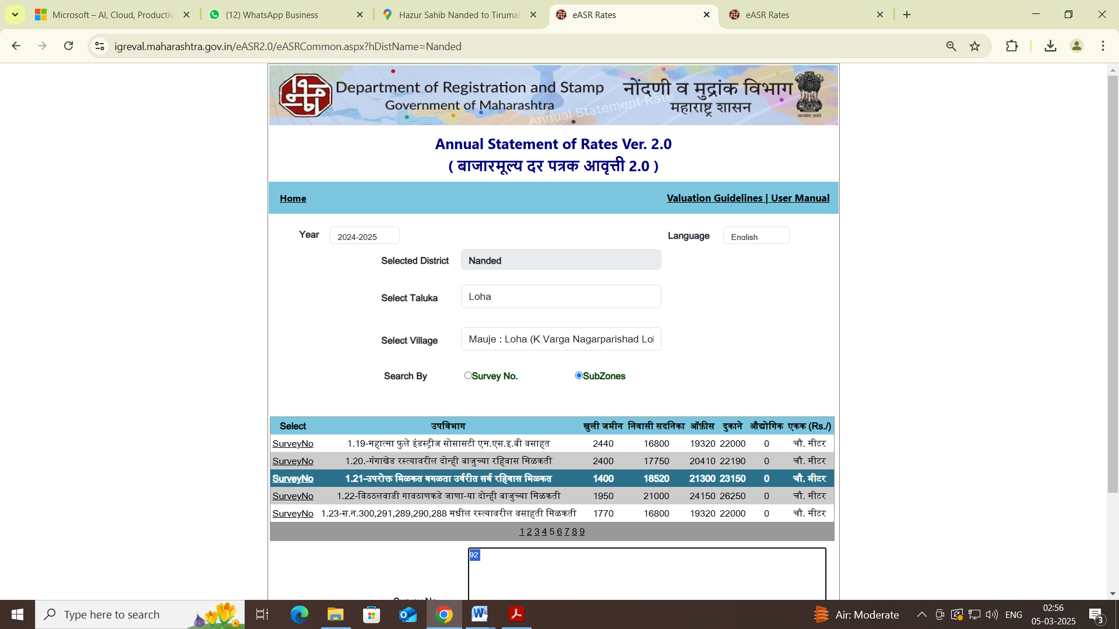

**ASSUMPTIONS, CAVEATS, LIMITATION AND DISCLAIMERS**

1. We assume no responsibility for matters of legal nature affecting the property appraised or the title thereto, nor do we render our opinion as to the title, which is assumed to be good and marketable.
2. The property is valued as though under responsible ownership.
3. It is assumed that the property is free of liens and encumbrances.
4. It is assumed that there are no hidden or unapparent conditions of the subsoil or structure that would render it more or less valuable. No responsibility is assumed for such conditions or for engineering that might be required to discover such factors.
5. The rates for valuation of the property are in accordance with the Govt. approved rates and prevailing market rates

For, **Vastukala Consultants (I) Pvt. Ltd.**

**Sharadkumar B. Chalikwar**

B.E. (Civil), M.E. (Civil), M.Sc. (Real Estate Valuation), M.Sc. (P&M Valuation), FIE (I), FIV, FIWRS

Chairman & Managing Director

Govt. Reg. Valuer

Chartered Engineer (India)

Reg. No. (N) CCIT/1-14/52/2008-09

IBBI Reg.No. IBBI/RV/07/2019/11744

Date: 06.03.2025

Place: Nanded.