VALUATION REPORT

________________________________________________________________

OF PROPERTY:

M/S. KALANTRI BROTHERS PVT LTD.
DIRECTOR. SHRI SURESH RAMESH KALANTRI.
INDUSTRIAL FACTORY BUILDING, ON GAT NO. 914 TO 933 & 936, PLOT NO. D-09, AT POST – MUSALGAON, TAL. SINNAR & DIST.- NASHIK.

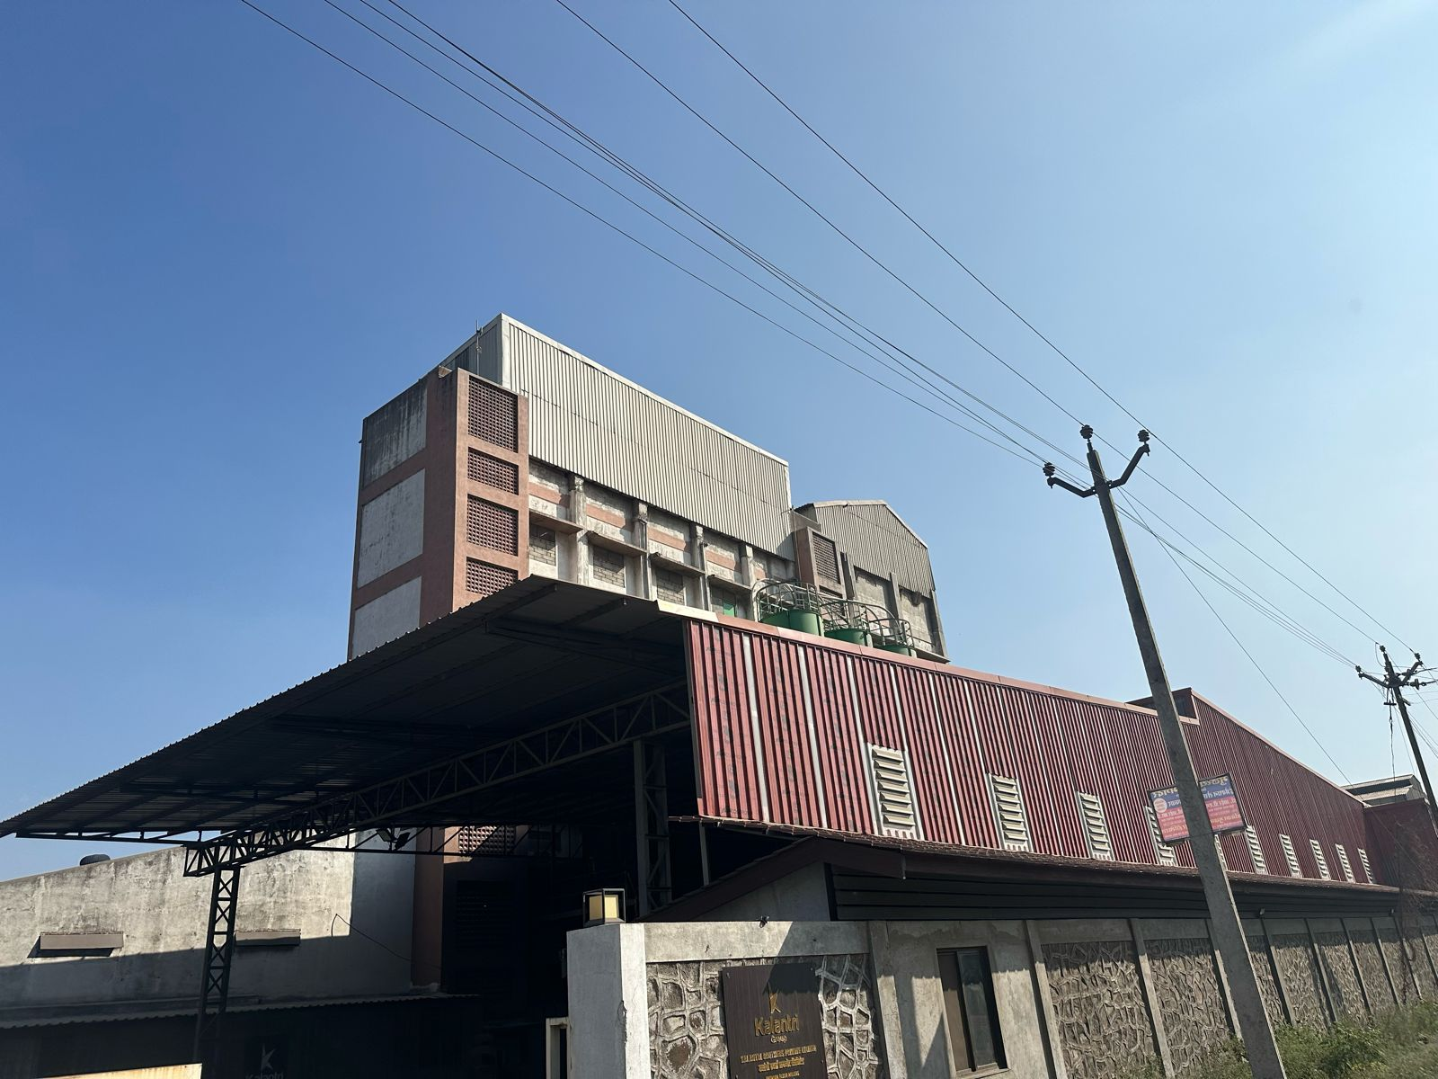

SHIVAJI D. PINGALE

B.E(CIVIL), M.I.E., F.I.V.

GOVT. REGD. VALUER, 34 AB REGN. NO. CCIT/I/-44-28
IBBI REGD NO-IBBI/RV/02/2019/12252

Flat No. 5 RamkrushnaAppt, Near Janlaxmi Bank, Opp Bosco Center, Gangapur Road, Nashik-422013. Cell: 9890278671, E-Mail. er.shivajipingale@gmail.com

TO, Date- 25/02/2025
THE CHIEF MANAGER,
BANK OF INDIA,
SATPUR BRANCH, NASHIK.

Subject: Submission of Valuation Report for
Name of The Borrower | M/S. Kalantri Brothers Pvt Ltd.  Director. Shri Suresh Ramesh Kalantri.  Industrial Factory Building, On Gat No. 914 To 933 & 936, Plot No. D-09, At Post – Musalgaon, Tal. Sinnar & Dist.- Nashik.
Address of Property | M/S. Kalantri Brothers Pvt Ltd.  Director. Shri Suresh Ramesh Kalantri.  Industrial Factory Building, On Gat No. 914 To 933 & 936, Plot No. D-09, At Post – Musalgaon, Tal. Sinnar & Dist.- Nashik.

Sir,
Please find herewith Valuation Report as mentioned in the subject line.
We assure you our best services in future also.
With Regards,
Thanking You,

Yours’ Sincerely,

SHIVAJI D. PINGALE
GOVT. REGD. VALUER
34 AB REGN. NO. CCIT/I/-44-28/2009-10
IBBI REGN. NO.- IBBI/RV/02/2019/12252

TO, Date- 25/02/2025
THE CHIEF MANAGER,
BANK OF INDIA,
SATPUR BRANCH, NASHIK.

VALUATION REPORT OF INDUSTRIAL LAND & BUILDERS.
Valuation of The Property  Belonging To | M/S. Kalantri Brothers Pvt Ltd.  Director. Shri Suresh Ramesh Kalantri.  Industrial Factory Building, On Gat No. 914 To 933 & 936, Plot No. D-09, At Post – Musalgaon, Tal. Sinnar & Dist.- Nashik.
Purpose | For Obtaining Fair Market Value Of Property.
Valuation As On | 25/02/2025
Address Of Property | M/S. Kalantri Brothers Pvt Ltd.  Director. Shri Suresh Ramesh Kalantri.  Industrial Factory Building, On Gat No. 914 To 933 & 936, Plot No. D-09, At Post – Musalgaon, Tal. Sinnar & Dist.- Nashik.
The Market Value Is | Rs. 15,62,51,000.00  (Rs. Fifteen Crores Sixty Two Lakhs Fifty One Thousand Only.)
The Realizable Value Is | Rs. 14,06,25,000.00  (Rs. Fourteen Crores Six Lakhs Twenty Five Thousand Only.)
The Distressed Sale Value | Rs. 12,65,63,000.00  (Rs. Twelve Crores Sixty Five Lakhs Sixty Three Thousand Only).
Government Value Of | Rs. 08,95,12,000.00  (Rs. Eighty Crores Ninety Five Lakhs Twelve Thousand Only).
SHIVAJI D. PINGALE
GOVT. REGD. VALUER
34 AB REGN. NO. CCIT/I/-44-28/2009-10
IBBI REGN. NO.- IBBI/RV/02/2019/12252

Annexure-I
Summary Valuation Report on Properties Owned by M/S. Kalantri Brothers Pvt Ltd.
Sr.No. | Particulars |  | Details/Information
1 | Name Of The Branch |  | Bank of India, Satpur Branch, Nashik.
2 | Name Of The Borrower |  | M/S. Kalantri Brothers Pvt Ltd.  Director. Shri. Suresh Ramesh Kalantri.  Industrial Factory Building, On Gat No. 914 To 933 & 936, Plot No. D-09, At Post – Musalgaon, Tal. Sinnar & Dist.- Nashik.
3 | Name Of The Valuer
4 | Date Of Visit By Valuer |  | 24/02/2025
5 | Description Of Property
a) | Name Of The Owner/Mortgagor |  | M/S. Kalantri Brothers Pvt Ltd.  Director. Shri. Suresh Ramesh Kalantri.  Industrial Factory Building, On Gat No. 914 To 933 & 936, Plot No. D-09, At Post – Musalgaon, Tal. Sinnar & Dist.- Nashik.
b) | Extent Of Area (In Sqm.) |  | Area of Plot No. D-09 = 8750.00 sqm.  B/Up Area of Ground Floor = 2487.60 sqm.  B/Up Area of Mezzanine Floor = 33.12 sqm.  B/Up Area of First Floor = 357.55 sqm.  B/Up Area of 2nd Floor = 357.55 sqm.  B/Up Area of 3rd Floor = 357.55 sqm.  B/Up Area of 4th Floor = 357.55 sqm.  B/Up Area of Lift & Silos = 233.59 sqm.  Total B/Up area of Building = 4184.51 sqm.
c) | Area Considered for Valuation Purpose |  | Area of Plot No. D-09 = 8750.00 sqm.  Total B/Up area of Building = 4184.51 sqm.
d) | P.No./Survey No./Gut No. |  | Gat No. 914 To 933 & 936, Plot No. D-09.
e) | Type Of Property |  | Lease-Hold Property
f) | Nature Of Property |  | Industrial Land & Building.
g) | In Possession Of |  | Owner Occupied.
h) | Location |  | At Post – Musalgaon, Tal. Sinnar & Dist.- Nashik.
i) | Boundaries |  | Identified
j) | Age Of Building |  | 10 Years
k) | Future Life Of Building |  | 50 Years.
The Market Value the Property Is |  |  | Rs. 15,62,51,000.00  (Rs. Fifteen Crores Sixty Two Lakhs Fifty One Thousand Only.)
The Realizable Value Of The Property Is |  |  | Rs. 14,06,25,000.00  (Rs. Fourteen Crores Six Lakhs Twenty Five Thousand Only.)
The Distressed Sale Value Of The |  |  | Rs. 12,65,63,000.00  (Rs. Twelve Crores Sixty Five Lakhs Sixty Three Thousand Only).
Government Value Of |  |  | Rs. 08,95,12,000.00  (Rs. Eighty Crores Ninety Five Lakhs Twelve Thousand Only).
Place: NASHIK  Date: 25/02/2025 |  | SHIVAJI D. PINGALE  GOVT. REGD. VALUER  34 AB REGN. NO. CCIT/I/-44-28/2009-10

VALUATION REPORT
To, Date:- 25/02/2025.
THE CHIEF MANAGER,
BANK OF INDIA,
SATPUR BRANCH, NASHIK.

I |  |  |  | GENERAL. |  | :
21. |  |  |  | Purposed For Which Valuation is Made. |  | : | For assessment of present market value of the Property for Loan purpose.
3. 2. |  |  |  | a. Date of Inspection. |  | : | 24/02/2025.
 |  |  |  | b. Date on Which the Valuation is Made. |  |  | 25/02/2025.
3. |  |  |  | List of Documents Perusal |  | :
 |  |  |  | 1 |  |  | Lease Deed
 |  |  |  | 2 |  |  | Building Plan
 |  |  |  | 3 |  |  | Commencement Certificate
4. |  |  |  | Name Of the Owners and his/ Their address with Phone. No. (details of Share of each owner in case of joint  Ownership. |  | : | Belonging to The Owner,  M/S. Kalantri Brothers Pvt Ltd.  Director. Shri. Suresh Ramesh Kalantri.  Industrial Factory Building, On Gat No. 914 To 933 & 936, Plot No. D-09, At Post – Musalgaon, Tal. Sinnar & Dist.- Nashik.
5. |  |  |  | Brief Description of the Property.  (Including Leasehold/Freehold etc.) |  | : | Freehold Property The property under valuation is  Proposed bungalow belonging to  M/S. Kalantri Brothers Pvt Ltd.  Director. Shri. Suresh Ramesh Kalantri.  Industrial Factory Building, On Gat No. 914 To 933 & 936, Plot No. D-09, At Post – Musalgaon, Tal. Sinnar & Dist.- Nashik. The surrounding of property is well developed. Infrastructure facilities such as roads, water supply, drainage, electricity etc. are available in this area.
6. |  |  |  | Location of the Property. |  | :
 |  |  |  | a] Plot No./Survey No. |  | : | Gat No. 914 To 933 & 936, Plot No. D-09.
 |  |  |  | b] Door No. |  |  | Gat No. 914 To 933 & 936, Plot No. D-09.
 |  |  |  | c] T.S. No. /Village. |  |  | At Post – Musalgaon, Tal. Sinnar & Dist.- Nashik.
 |  |  |  | d]Ward/Taluka. |  |  | Sinnar
 |  |  |  | e] Mandal/District. |  |  | Nashik.
7. |  |  | Postal Address of the Property |  |  |  | Industrial Factory Building, On Gat No. 914 To 933 & 936, Plot No. D-09, At Post – Musalgaon, Tal. Sinnar & Dist.- Nashik.
8 |  |  | City/Town. |  |  |  | At Post – Musalgaon, Tal. Sinnar & Dist.- Nashik.
 |  |  | Residential Area. |  |  |  | Industrial Area.
 |  |  | Commercial Area. |  |  |  | --
 |  |  | Industrial Area. |  |  |  | --
9 |  |  | Classification of the area. |  |  |  | --
 |  |  | i] High/Middle/Poor. |  |  |  | Middle Class.
 |  |  | ii] Urban/Semi Urban/Rural. |  |  |  | Rural.
10. |  |  | Coming Under Corporation Limits/  Village/Panchayat/Municipality. |  |  |  | Gram Panchayat Musalgaon
11. |  |  | Whether Covered Under any State/Central Govt. enactments (e.g. Urban Land Ceiling Act) or notified Under agency area/Scheduled Area/Cantonment area/ |  |  |  | -----
12. |  |  | Incase it is an agriculture land, any  Conversion to house site plots is Contemplated. |  |  |  | The Said Property is Non-Agricultural Land.
13. |  |  |  | Boundaries of the Property. |  |  |  | Plot No. D-09 | Plot No. D-09
 |  |  |  |  |  | : |  | As per Agreement | As per Agreement
 |  |  |  |  |  | : |  | 18.00m Wide Road | 18.00m Wide Road
 |  |  |  |  |  | : |  | Plot No. D-08 | Plot No. D-08
 |  |  |  |  |  | : |  | Plot No. D-10 | Plot No. D-10
14.1 |  |  |  | Dimension of the site.
 |  |  |  | North |  | :
 |  |  |  | South |  | :
 |  |  |  | East |  | :
 |  |  |  | West |  | :
14.2 |  |  |  | Latitude, Longitude & Co-Ordinates of Site. |  |  | Latitude – 20.056819.  Longitude – 73.714767.
15. |  |  |  | Extent of the Site. |  |  | Area of Plot No. D-09 = 8750.00 sqm.  B/Up Area of Ground Floor = 2487.60 sqm.  B/Up Area of Mezzanine Floor = 33.12 sqm.  B/Up Area of First Floor = 357.55 sqm.  B/Up Area of 2nd Floor = 357.55 sqm.  B/Up Area of 3rd Floor = 357.55 sqm.  B/Up Area of 4th Floor = 357.55 sqm.  B/Up Area of Lift & Silos = 233.59 sqm.  Total B/Up area of Building = 4184.51 sqm.
16. |  |  |  | Extent of the site Considered for Valuation (Least of 14A & 14B) |  |  | Area of Plot No. D-09 = 8750.00 sqm.  Total B/Up area of Building = 4184.51 sqm.
17. |  |  |  | Whether Occupied by the owner/ Tenant. If occupied by tenant, since how Long Rent Received per Month. |  |  | The Plot is Occupied by the Owner.
II. |  |  |  | CHARACTERISTICS OF THE SITE.
1. |  |  |  | Classification of locality. |  |  | Middle Class.
2. |  |  |  | Development of Surrounding areas. |  |  | Well Developed.
3. |  |  |  | Possibility of Frequent Flooding/sub-  Merging. |  |  | No.
4. |  |  |  | Feasibility to the Civic amenities like  School, hospital, bus stop, Market etc. |  |  | All Civic amenities available at site, like School, hospital, bus stop, Market etc.
5. |  |  |  | Level of Land with topographical Conditions. |  |  | Leveled Land.
6. |  |  |  | Shape of Land. |  |  | Rectangular.
7. |  |  |  | Type of used to which it can be put. |  |  | Industrial
8. |  |  |  | Any Usage Restriction. |  |  | N.A.
9. |  |  |  | Is plot in town Planning approved layout? |  |  | Yes
10. |  |  |  | Corner Plot or Intermittent Plot. |  |  | Intermittent Plot.
11. |  |  |  | Road Facilities. |  |  | Yes.
12. |  |  |  | Type of road available at present. |  |  | Asphalt Colony Road.
13. |  |  |  | Type of road-is it below 20Ft. or More than 20 Ft. |  |  | 9.0M wide Road
14. |  |  |  | Is it a land- locked Land? |  |  | No.
15 |  |  |  | Water Potentiality. |  |  | Good.
16 |  |  |  | Underground sewerage system. |  |  | Yes, Available.
17. |  |  |  | Is power supply available at the site. |  |  | Yes.
18. |  |  |  | Advantage of the Site. |  |  | --
Industrial Establishment is available near the
site, Street Lights, Municipal Drainage and Water
Supply has been Provided, Transport Facilities are
Available near the Site.
 |  |  |  |  |  |  | Good public & Pvt. Transport facility in the business traffic circle in the city.
19. |  |  |  | Special Remark, if Any like Threat of acquis ion of land for public service purposes, road widening or Applicability of CRZ Provisions etc. (Distance from sea-coast/tidal level must be Incorporated.) |  |  | N.A.
Part-A (Valuation of Land)
1. |  | Size of plot. |  |  |  |  | Area of Plot No. D-09 = 8750.00 sqm.
 |  | North & South
 |  | East & West
2. |  | Total Extent of the plot |  |  |  |  | Area of Plot No. D-09 = 8750.00 sqm.
3. |  | Prevailing Market rate (Along with details/reference of at least Two latest deals/transactions with respect to adjacent Properties in the areas. |  |  |  |  | Rs. 5,000/- sqm To Rs. 9,000/Sqm
4. |  | Guideline rate obtained from the Register’s office (an evidence thereof to be enclosed) |  |  |  |  | Area of Plot No. D-09 = 8750.00 sqm X 1550 sqm. =  Rs. 01,35,62,500.00.  Total Built up area = 3487.09sqm. X 21780/- sqm=  Rs. 07,59,48,820.00  Total Govt. Valuation Is Rs. 08,95,11,320.00.  Say Rs. 08,95,12,000.00
5. |  | Assessed/Adopted rate of Valuation. |  |  |  |  | Rate Rs. 7,500/- per Sq. Mt. for Plot.
6. |  | Estimated Value of land. |  |  |  |  | Area of Plot = 8750.00 sqm. X 7500/- sqm.  Rs. 06,56,25,000.00
Part-B (Valuation of Building)
1. | Technical details of the Building. |  |  |  |  |  | --
 | a] Type of Building (Residential/ Commercial/Industrial) |  |  |  |  |  | Industrial Premises.
 | b] Type of Construction. (Load Bearing/R.C.C./Steel Frame) |  |  |  |  |  | ----
 | c] Year of Construction. |  |  |  |  |  | ----
 | d] Number of Floors and Heights of each floor including basement, if any |  |  |  |  |  | ----
 | e] Plinth area floor-wise. |  |  |  |  |  | ----
 | f] Condition of the Building. |  |  |  |  |  | -----
 | I] |  |  |  | Exterior-Excellent,  Good/Normal, Poor. |  | ----
 | ii] |  |  |  | Interior- Excellent,  Good/Normal, Poor. |  | ----
 | g] Approved Map/Plan Issuing authority. (Tentative Approval Letter, Final to Be Obtain) |  |  |  |  |  | ADTP Town Planning Nashik.  Vide Letter No. 1879. Dated – 14/09/2015.  Sub Divisional Office Niphad.  Vide letter no. Jama/Kavi/825/420. Dated- 05/10/2015.
 | h] Whether geniuses or Authenticity of Approved map/Plan is verified. |  |  |  |  |  | Yes.
 | i] Any other Comments by our empaneled Valuers on authentic of Approved Plan. |  |  |  |  |  | Industrial Building, is Constructed as per Plan Sanctioned By ADTP Town Planning Nashik.  Vide Letter No. 1879. Dated – 14/09/2015.  Sub Divisional Office Niphad.  Vide letter no. Jama/Kavi/825/420. Dated- 05/10/2015.
 | J] Occupancy Certificate |  |  |  |  |  | ----
 | K] NA Order |  |  |  |  |  | ----
 | L] Lease Deed |  |  |  |  |  | Dated- 11/08/1988.

Specification of Construction (Floor-wise) in Respect of.
S. No. | Description |  |  | ----.
1. | Foundation |  |  | ----
2. | Basement |  |  | ----
3. | Superstructure |  |  | ----
4. | Joinery/Doors & Windows (Please Furnish details about size of frames, shutters, Glazing, fitting etc. And  Specify the Species of timber) |  |  | ----
5. | R.C.C. Works. |  |  | ----
6. | Plastering. |  |  | ----
7. | Flooring, Skirting, Dadoing. |  |  | ----
8. | Special Finish as Marble, granite, wooden Paneling, Grills, etc. |  |  | ----
9. | Roofing including weather proof Course. |  |  | ----
10. | Drainage.
S.  No. | Description.
2. | Compound Wall
 | Height
 | Length.
 | Type of Construction
3. | Electrical Installation.
 | Type of Wiring. |  |  | ----
 | Class of Fitting (Superior/Ordinary/Poor) |  |  | ----
 | Number of Light Points. |  |  | ----
 | Fan Point |  |  | ----
 | Spare Plug Point. |  |  | ----
 | Any Other item. |  |  | ----
4. | Plumbing Installation |  |  | ----
 | a | No. of Water Closets and their types. | ----
 | b. | No. of Wash Basin. | ----
 | c. | No. of Toilets | ----
 | d | No. of bath
 | e | Water meter, taps, etc. |  | ----
5. | House Tax Receipt.
 | Assessment No. |  |  | ----
 | Tax Paid in the name of |  |  | Shri. Suresh Ramesh Kalantri.
 | Tax Amount. |  |  | -----
6. | Electricity Service Connection no. |  |  | -----
 | Meter Card is in the name of |  |  | Shri. Suresh Ramesh Kalantri.
 | Amount Rs. |  |  | ------

DETAILS OF VALUATION(PART-B)
Sr. No | Particular  of Items | Plinth Area.  Sqm. | Roof Height  Mt. | Age of  Building.  Years | Estimated Replacement Rate of  Const. Rs. | Replacement Cost.  Rs. | Depreciation  In Rs. | Net Value After Depreciation  Rs.
01 | Factory Building | 3501.96  sqm | 28.08  mtr | 09  Years | 22000  sqm | 7,70,43,120.00 | ----- | 7,70,43,120.00
02 | ADMN Building | 126.16  sqm | 5.50  mtr | 09  Years | 22000  sqm | 27,75,520.00 | ----- | 27,75,520.00
03 | Staff | 72.80  sqm | 3.50  mtr | 09  Years | 20000  sqm | 14,56,000.00 | ----- | 14,56,000.00
04 | Cycle Stand | 125.00  sqm | 3.30  mtr | 09  Years | 5000  sqm | 6,25,000.00 | ----- | 6,25,000.00
05 | Store | 125.00  sqm | 3.0  mtr | 09  Years | 20000  sqm | 25,00,000.00 | ----- | 25,00,000.00
06 | Lift area | 7.51  sqm | ---- | 09  Years | 15000  sqm | 1,12,650.00 | ----- | 1,12,650.00
07 | Silos | 226.08  sqm | ---- | 09  Years | 18000  sqm | 40,69,440.00 | ----- | 40,69,440.00
Total Building Value. |  |  |  |  |  |  |  | 08,85,81,730.00
Part C- (Extra Items)
1. | Portico |  | -----
2. | Ornamental Front door. |  | -----
3. | Site Out/Verandah With Steel Grills. |  | -----
4. | Overhead Water tank. |  | Rs. 07,50,000.00
5. | Extra Steel/Collapsible gates. |  | -----
 | Total |  | Rs. 07,50,000.00
Part-D- (Amenities)
1. | Furniture |  | -----
2. | Glazed Tiles. |  | -----
3. | Extra Sink and bath Tub. |  | -----
4. | Marble/Ceramic tiles flooring. |  | -----
5. | Interior decorations |  | -----
6. | Architectural Elevation Works. |  | -----
7. | Laminated Doors & Shutters/Paneling Works |  | -----
8. | Aluminum Works  Kitchen Trolleys |  | -----
9. | S.S. Rails with Glass Panel |  | -----
10. | False Ceiling |  | -----
 | Total |  | -----
Part E - (Miscellaneous) (Amount in Rs.)
1. | Separate toilet room |  | -----
2. | Separate Lumber room |  | -----
3. | Separate Water tank/Sump |  | -----
4. | Trees, Gardening. |  | -----
 | Total. |  | -----
Part F-(Services) (Amount in Rs.)
1. | Water Supply arrangements. |  | -----
2. | Drainage arrangements |  | -----
3. | Compound wall -370 rmt x rs.3500/rmt |  | Rs. 12,95,000.00
4. | C.B. Deposits, Fitting etc. |  | -----
5. | Pavement |  | -----
 | Total. |  | Rs. 12,95,000.00

Total Abstract of the entire Property.
Part-A | Land. |  | Rs. 06,56,25,000.00
Part-B | Building. |  | Rs. 08,85,81,730.00
Part-C | Extra Items |  | Rs. 07,50,000.00
Part-D | Amenities.
Part-E | Services |  | Rs. 12,95,000.00
 | Total Land Market Value. |  | Rs. 15,62,51,730.00
 | Say Rs. |  | Rs. 15,62,51,000.00

As a result of my appraisal and analysis, it is my Considered Opinion that the,
Fair market value | Rs. 15,62,51,000.00  (Rs. Fifteen Crores Sixty Two Lakhs Fifty One Thousand Only.)
Realizable value | Rs. 14,06,25,000.00  (Rs. Fourteen Crores Six Lakhs Twenty Five Thousand Only.)
Distress value | Rs. 12,65,63,000.00  (Rs. Twelve Crores Sixty Five Lakhs Sixty Three Thousand Only).
Value as per Circle rate | Rs. 08,95,12,000.00  (Rs. Eighty Crores Ninety Five Lakhs Twelve Thousand Only).

Place: Nashik.
Date: 25/02/2025.
SHIVAJI D. PINGALE
GOVT. REGD. VALUER
34 AB REGN. NO. CCIT/I/-44-28/2009-10
IBBI REGN. NO.- IBBI/RV/02/2029/12252

The Undersigned has inspected the Property detailed in the Valuation Report dated.
----------------------- on --------------------- we are satisfied that the fair and reasonable
Market Value of the Property is Rs. 15,62,51,000.00
(Rs. Fifteen Crores Sixty Two Lakhs Fifty One Thousand Only.)

Signature.

(Name of the Branch Manager with Office Seal)

Annexure-II
Format - E
DECLARATION FROM VALUERS
I hereby declare that-
- The information furnished in my valuation report dated 25/02/2025 is true and correct to the best of my knowledge and belief and I have made an impartial and true valuation of the property.

- I have no direct or indirect interest in the property valued;

- My Staff Member Mr. Deepak Sonawane Has personally inspected the property on 24/02/2025, The work is not sub-contracted to any other valuer and carried out by myself.

- I have not been convicted of any offence and sentenced to a term of Imprisonment;

- I have not been found guilty of misconduct in my professional capacity.

- I have read the Handbook on Policy, Standards and procedure for Real Estate Valuation, 2011 of the IBA and this report is in conformity to the “Standards” enshrined for valuation in the Part-B of the above handbook to the best of my ability.

- I have read the International Valuation Standards (IVS) and the report submitted to the Bank for the respective asset class is in conformity to the “Standards” as enshrined for valuation in the IVS in “General Standards” and “Asset Standards” as applicable.

- I abide by the Model Code of Conduct for empanelment of valuer in the Bank. (Annexure III- A signed copy of same to be taken and kept along with this declaration)

- I am registered under Section 34 AB of the Wealth Tax Act, 1957.

- I am the proprietor / partner / authorized official of the firm / company, who is competent to sign this valuation report.

Place: NASHIK.
Date: 25/02/2025
SHIVAJI D. PINGALE.
GOVT. REGD. VALUER
REGN. NO. CCIT/34AB/CAT-I/44-28 IBBI REGD NO-IBBI/RV/02/2019/12252

SR. NO. | PARTICULARS | VALUER COMMENT
1. | Background Information of the asset being Valued. | M/S. Kalantri Brothers Pvt Ltd.  Director. Shri. Suresh Ramesh Kalantri.  Industrial Factory Building, On Gat No. 914 To 933 & 936, Plot No. D-09, At Post – Musalgaon, Tal. Sinnar & Dist.- Nashik.
2. | Purpose of Valuation and appointing authority. | Bank Loan Purposed & Appointing Authority By Manager, Bank of India, Satpur Branch, Nashik.
3. | Identity of the valuer and any other experts involved in the Valuation. | Valuer- SHIVAJI D. PINGALE.
4. | Disclosure of Valuer interest or conflict if any. | No.
5. | Date of appointment, Valuation date and date of report. | Appointment Date.22/02/2025.  Visit date. 24/02/2025.  Valuation Report date. 25/02/2025.
6. | Inspections and/or Investigation undertaken | With Purchaser.
7. | Nature and sources of the Information used or Relied upon. | Market Survey.
8. | Procedures adopted in Carrying out the Valuation and Valuation Standards Followed. | As Per Valuation Standards.
9. | Restrictions on use report, if any. | For Bank Loan Purpose Only.
10. | Major Factors that were taken into account during the Valuation. | All Factors Consider in Valuation Report.
11. | Caveats, Limitations and disclaimers to the extent they explain or elucidate the Limitations faced by valuer, which shall not be for the purpose of limiting his responsibility for Valuation Report. | The report is submitted as per the bank Format.

Date: -25/02/2025.
Place: -Nashik.
SHIVAJI D. PINGALE
GOVT. REGD. VALUER
34 AB REGN. NO. CCIT/I/-44-28/2009-10
IBBI REGN. NO.- IBBI/RV/02/2029/12252

PROPERTY PHOTOS:
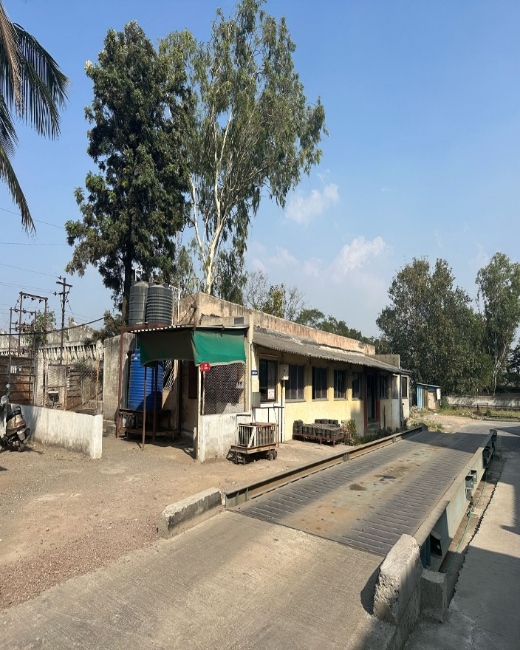 | 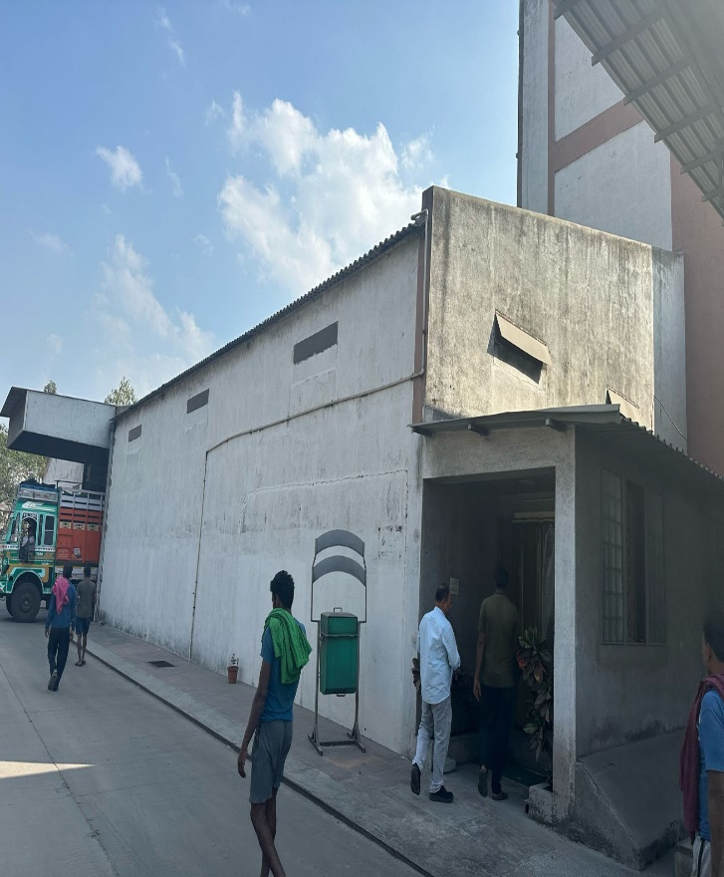
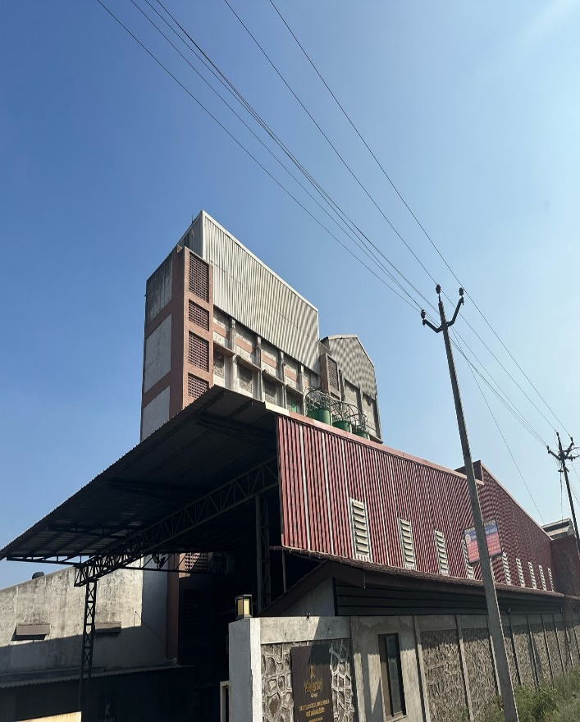 | 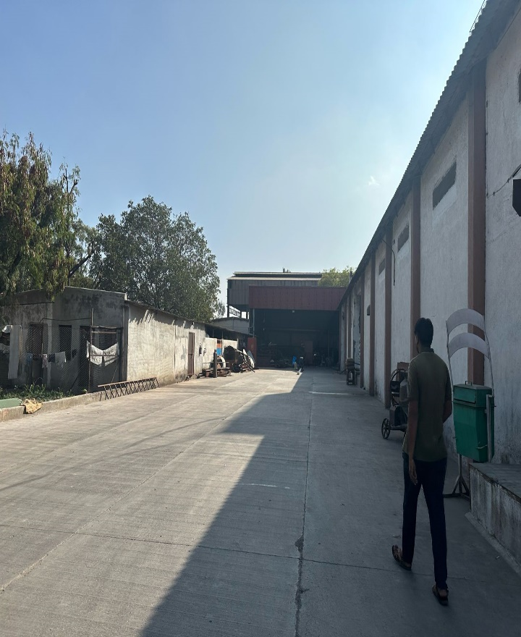

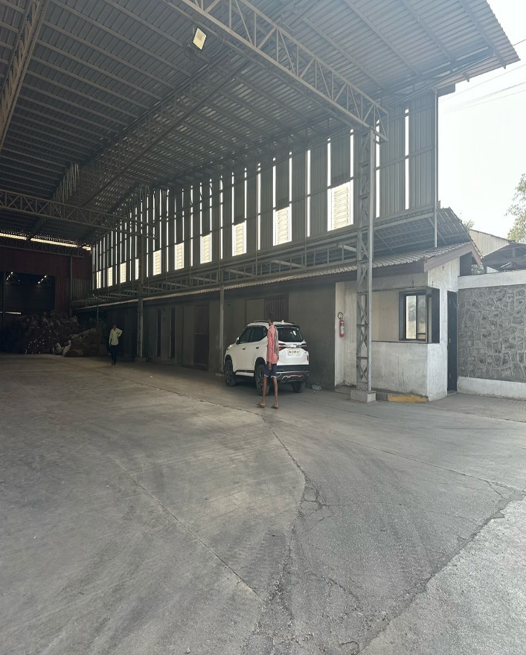 | 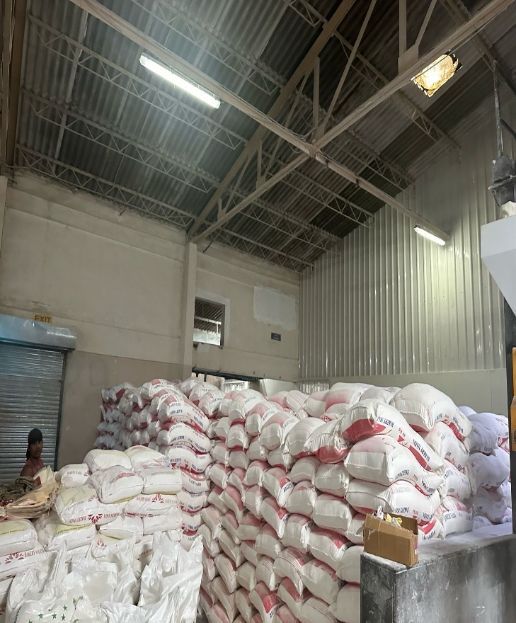
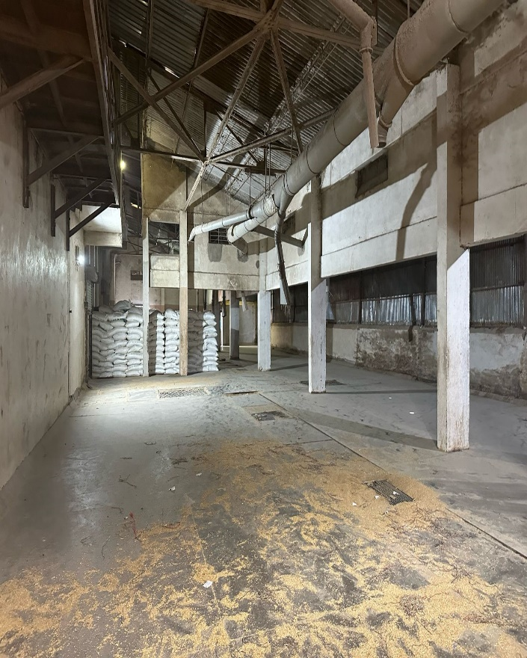 | 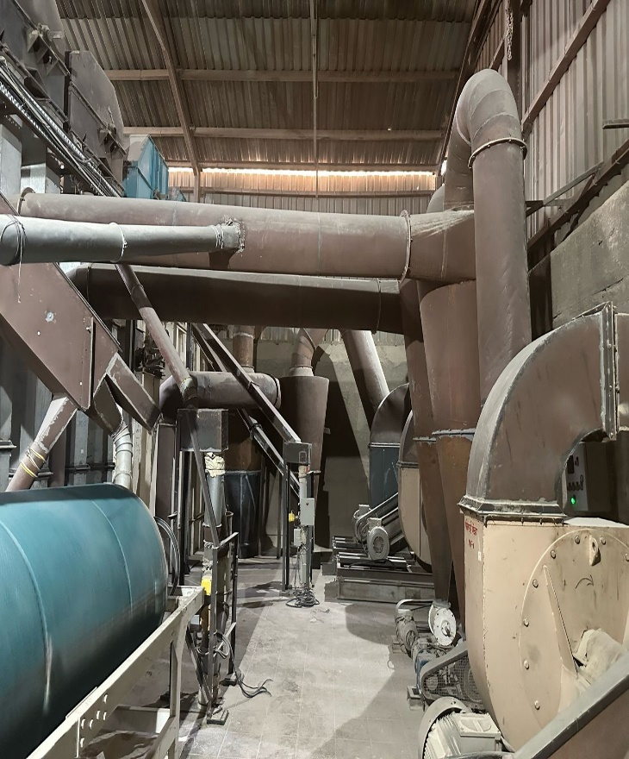
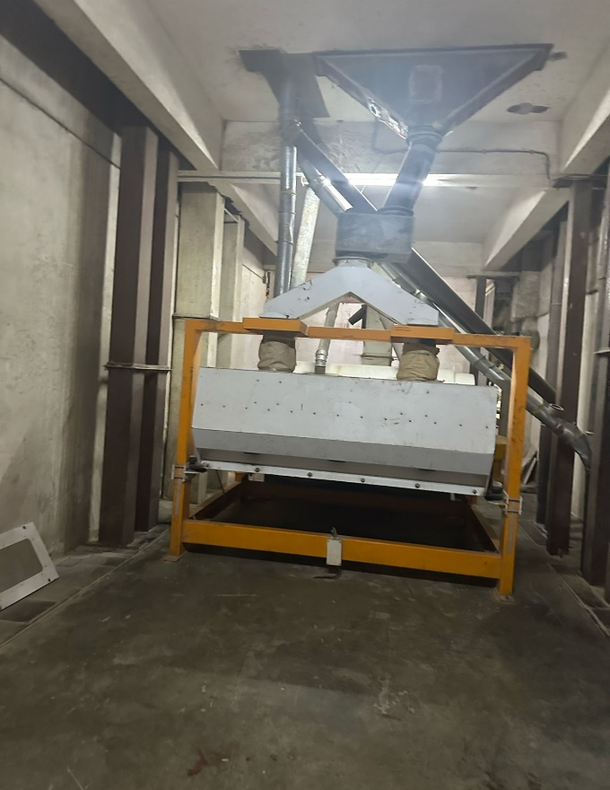 | 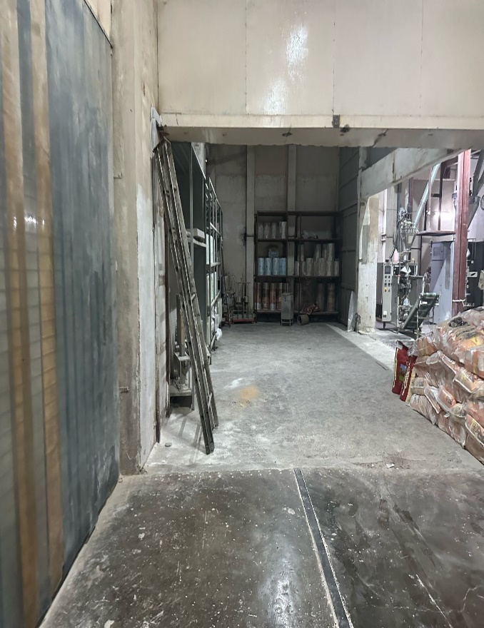
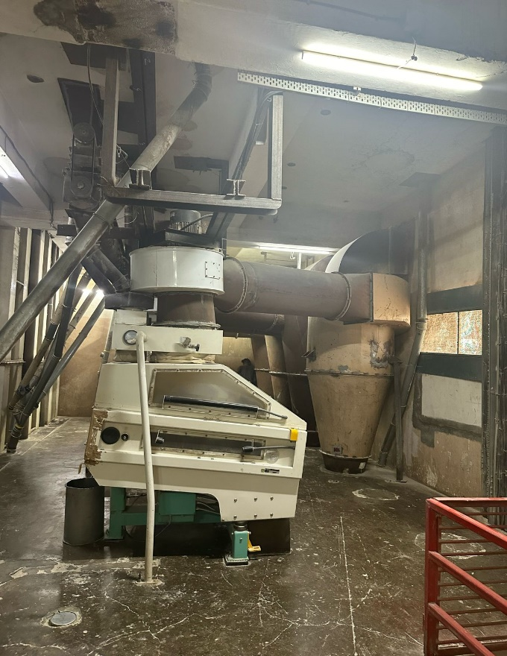 | 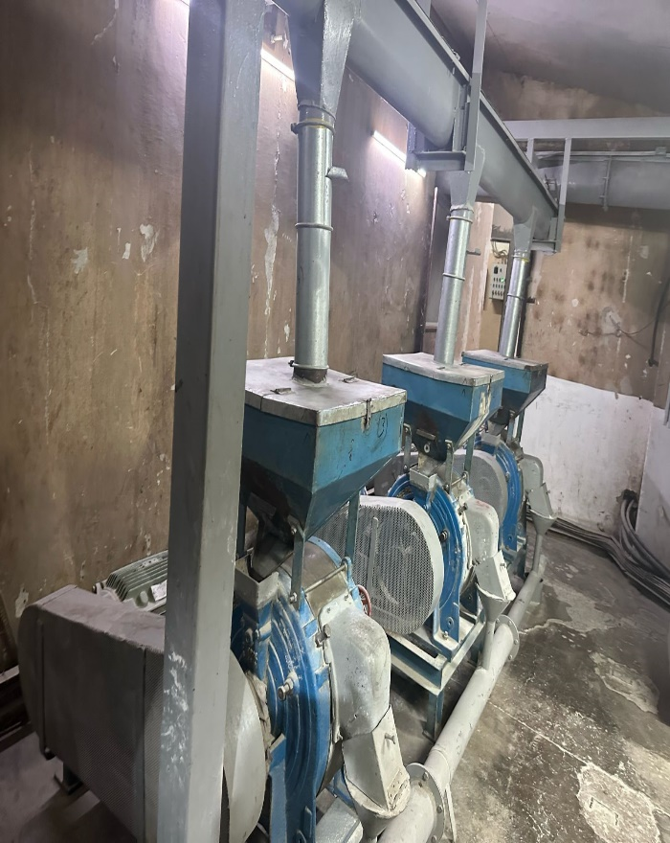

COMMENCEMENT CERTIFICATE
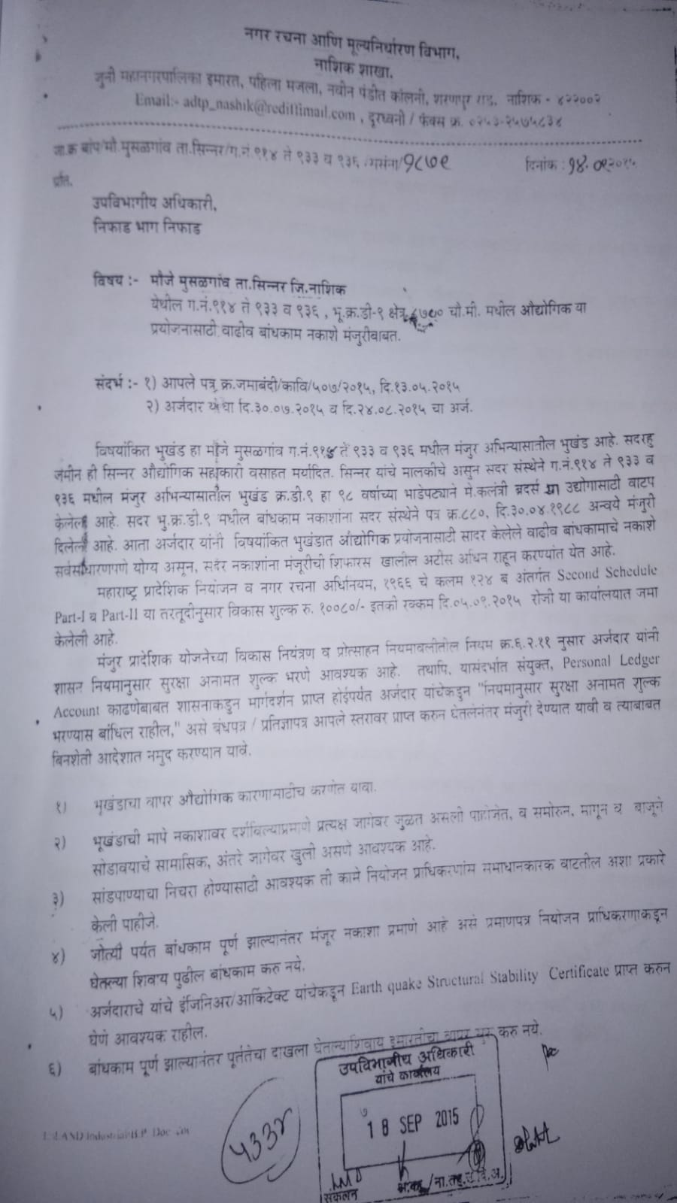

AREA STATEMENT
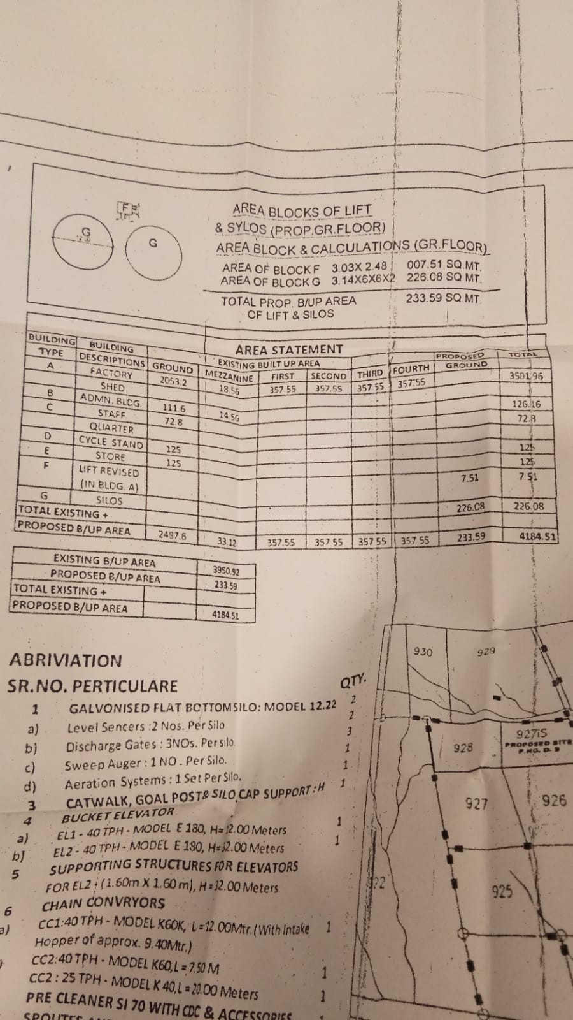

LEASE DEED.
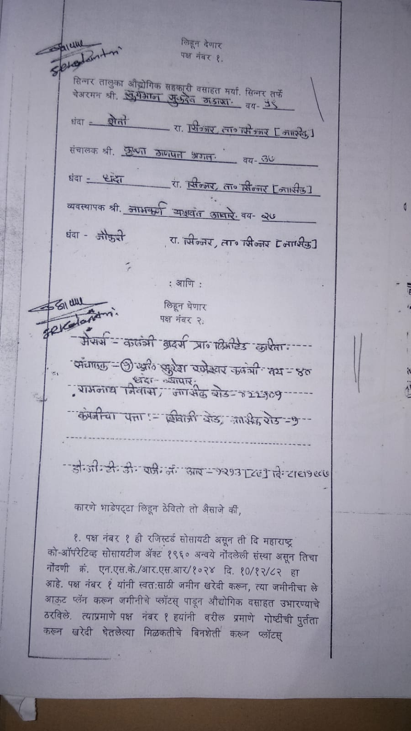

EASR RATES.
