Vastu/Nashik/02/2025/014532/ 2310724
24/10-374 -RYSP
Date: 26.02.2025
To,
The Branch Manager,
Bank of Baroda
Regional Office
BSNL Building, Datta Mandir Road, Nashik Road,
Nashik, PIN – 422 101, State - Maharashtra, Country - India.

Sub: Vetting of Extra Work

Sir,

With reference to above subject, we have evaluated the Extra Work For Residential Row Bungalow No. 15B/ 2, Ground Floor + First Floor, " Shrihari Row Bungalows ", Survey No. 242/ A, Plot No. 15/ B, Near St. Thomas Bethany Convent School, Pathardi Gaon, off Pathardi - Gaulane Road, Village – Pathardi, Taluka & District - Nashik, PIN Code – 422 010, State – Maharashtra, Country – India. belongs to Name of Proposed Purchaser : Shri. Nilesh Himmat Sonawane & Sau. Shakuntala Himmat Chaudhari, Shri. Dhiraj Himmat Sonawane. Name of Owner : Sau. Vimal Shantaram Rayte.

We have verified the rates quoted as per current market rates. Details of Extra Work considered as per copy of Extra Work Agreement between : Shri. Nilesh Himmat Sonawane & Sau. Shakuntala Himmat Chaudhari, Shri. Dhiraj Himmat Sonawane (First Party). Mr. Amol Shantaram Rayte (Second Party) received on dated.22.02.2025 The Extra Work amount is Rs. 5,00,000/- (Rupees Five Lakh Only)

The said Cost Vetting Certificate is valid upto next 6 months Only.

Thanking you

Sincerely yours

Sharadkumar B. Chalikwar
Govt. Reg. Valuer
Chartered Engineer (India)
Reg. No. (N) CCIT/1-14/52/2008-09
Encl: Valuation report.

Agreement for Extra Work
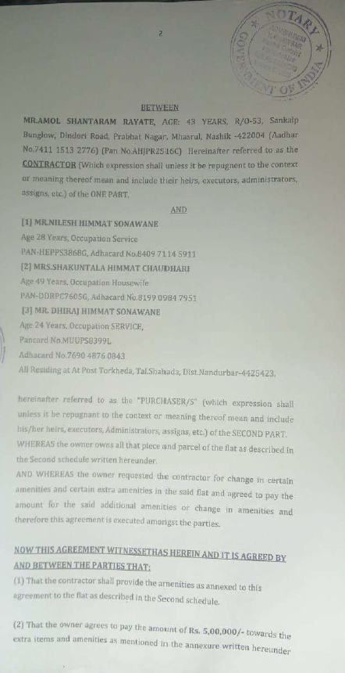
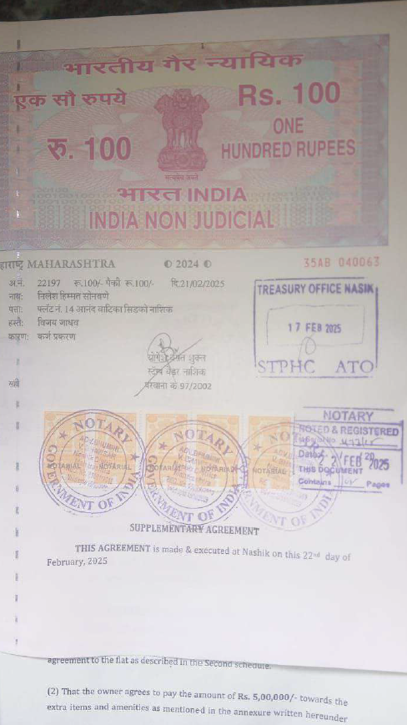

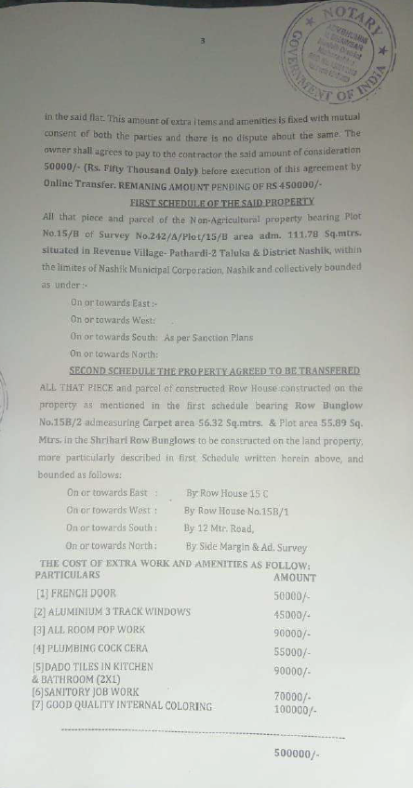
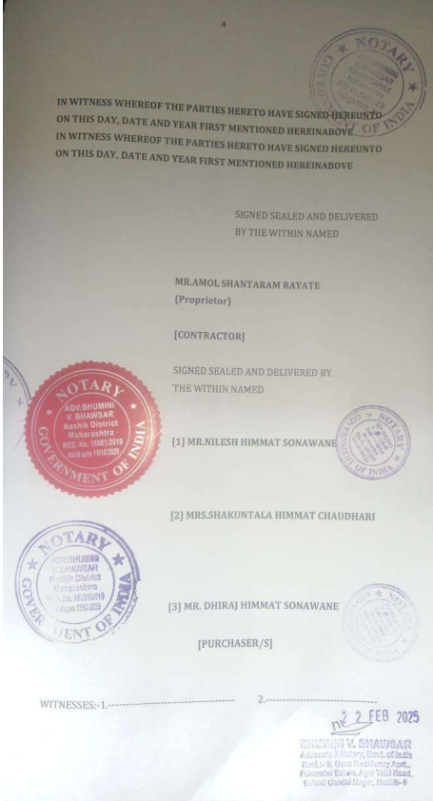

The Extra Work amount is Rs. 5,00,000/- (Rupees Five Lakh Only)

