Vastu/Nashik/02/2025/014565/ 2310754
26/6-404-RYRJ
Date: 26.02.2025
To,
The Branch Manager,
Union Bank of India
Nashik City Branch
Navondar Sankul, 1366, M-1 Racca Colony, Sharanpur Road
Nashik – 422 002, State - Maharashtra, Country - lndia.

Sub: Vetting of Extra Work

Sir,

With reference to above subject, we have evaluated the Extra Work For Residential Flat No. 4, 1st Floor, " Rajkamal Co - Op. Hsg. Soc. Ltd. Nashik ", Survey No. 6/ 1, Behind Saykhedkar Hospital, Laxmi Nagar, Durga Nagar, Trimurti-Kamatwade Road, Village - Kamatwade, Taluka - Nashik, District - Nashik, PIN Code - 422 008, State - Maharashtra, Country - India. belongs to Shri. Govind Pandurang Sasane & Sau. Radhika Govind Sasane. Name of Proposed Purchaser is Sau. Rupali Yogesh Zanzane.

We have verified the rates quoted as per current market rates. Details of Extra Work considered as per copy of Extra Work Agreement between Mrs. Rupali Yogesh Zanzane (First Party). M/r. Digambar Dharma Gaikwad (Second Party) received on dated.25.02.2025 The Extra Work amount is Rs. 4,00,000/- (Rupees Four Lakh Only)

The said Cost Vetting Certificate is valid upto next 6 months Only.

Thanking you

Sincerely yours

Sharadkumar Chalikwar
Govt. Reg. Valuer
Chartered Engineer (India)
Reg. No. [N]C.C.I.T/I -14/52/2008-09
Union Bank of India Empanelment No.: RO/CR/30129/ 2020-21

Encl.: Valuation report.

Agreement for Extra Work
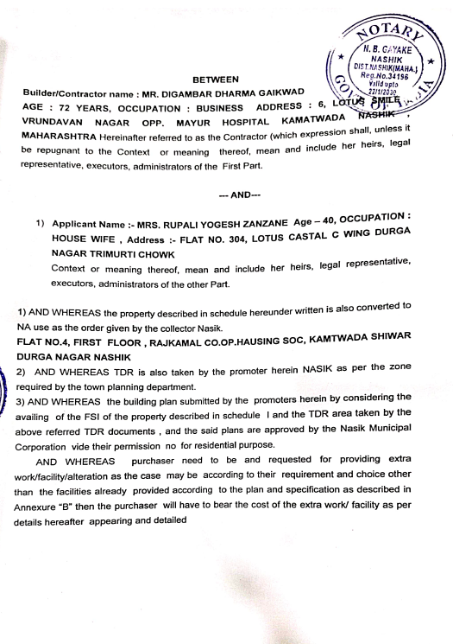
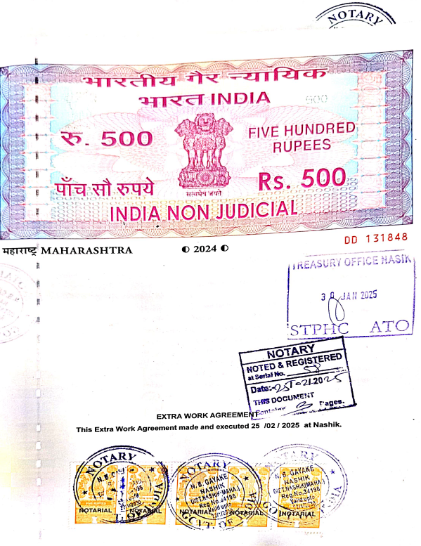

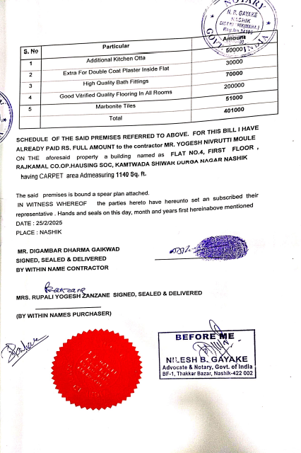

The Extra Work amount is Rs. 4,00,000/- (Rupees Four Lakh Only)

