Vastu/Nashik/02/2025//014551/2310742
25/6-392-RYBS
Date: 25.02.2025

To,
The Branch Manager,
State Bank of India
RACC Nashik Branch
RBO.2, The Wave Building, 1st Floor,
Opposite Shell Petrol Pump, Pathardi Road,
Nashik – 422 010, State – Maharashtra, Country – India.

Sub: Vetting of Estimate

Sir,

With reference to above subject, we have evaluated the Estimate for Residential Land and Proposed Bungalow on Plot No. 11, Gat No. 36+37, Behind Datta Krupa Super Specialty Hospital, Shivaji Nagar, off Saputara - Nashik Road, Mouje - Dindori, Taluka – Dindori, District – Nashik, Pin Code – 4222 02, State – Maharashtra, Country – India. belongs to Name of Owner: Trupti Mohan Chitte (Alias), Trupti Nilesh Kasture & Nilesh Devidas Kasture.

We have verified the rates quoted as per current market rates. Details of Estimates considered as per copy of Estimate Provided by Sanjay Pande dated.01.10.2021 The Estimate amount is Rs.35,50,731/- (Thirty-Five Lakh Fifty Thousand Seven Hundred Thirty-One Only.) After Considering Amenities Taken by Architect & Copy of Estimate Given to us by Owner, we have reached to Conclusion That the Above Estimate is Verified.

Note: 1) The said Cost Vetting Certificate is valid up to 6 months Only.
2) It is Advisable to get periodic work completion status prior to disbursement of loan.

Thanking you

Sincerely yours

Manoj B. Chalikwar
Registered Valuer
Chartered Engineer (India)
Reg. No. CAT-I-F-1763
Reg. No. IBBI/RV/07/2018/10366
BOB Empanelment No.: ZO:MZ:ADV:46:941
Encl: Valuation Report.

Estimate
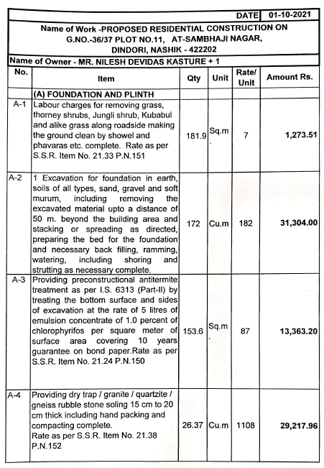
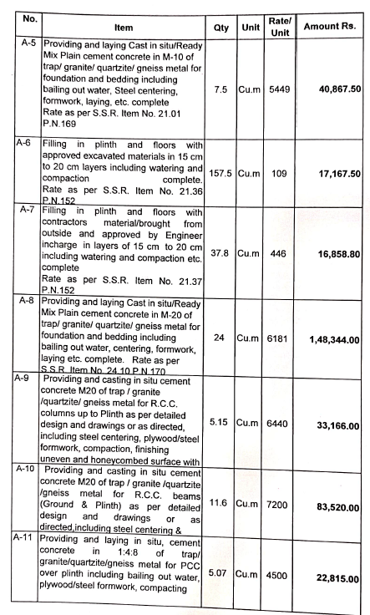

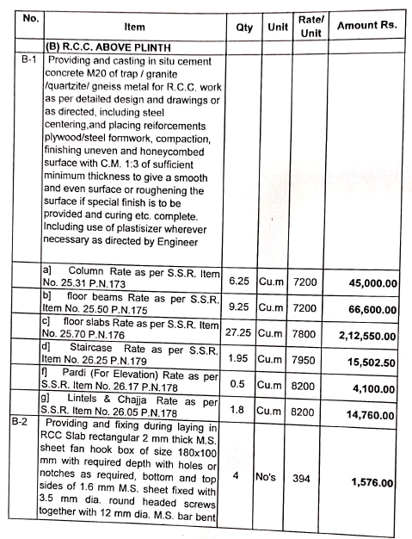
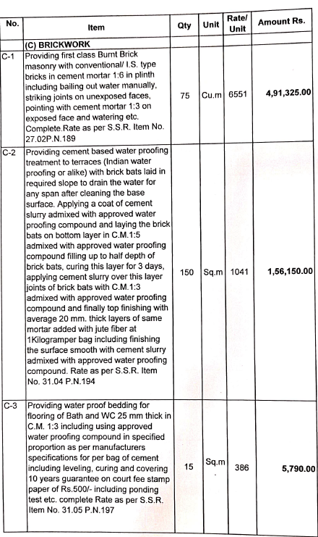

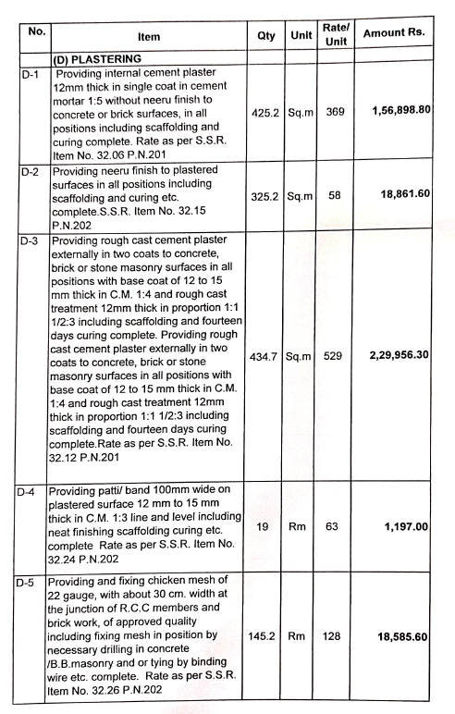
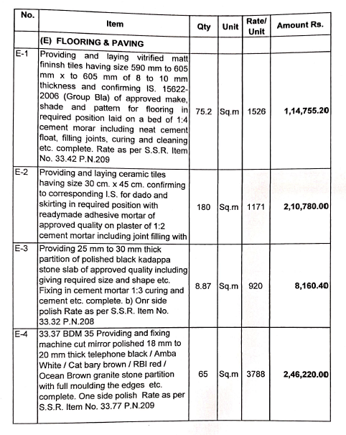

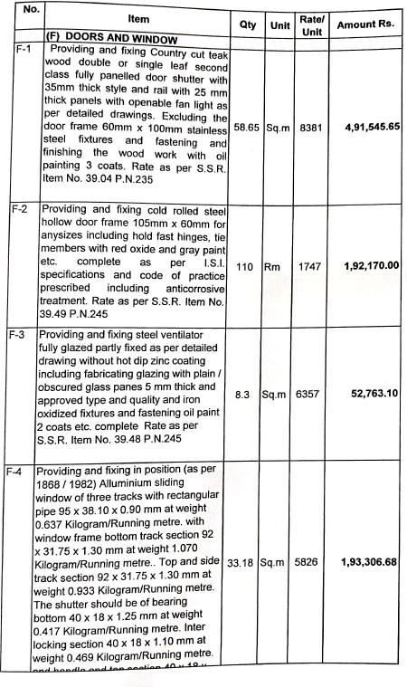
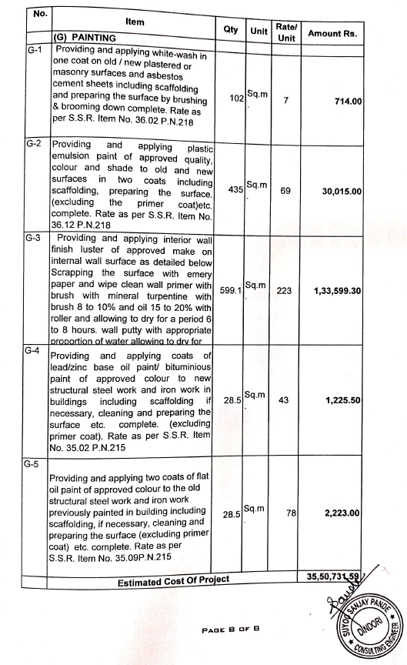

The Estimate amount is Rs.35,50,731/- (Rupees Thirty Five Lakh Fifty Thousand Seven Hundred Thirty One Only. )

