Vastu/Nashik/02/2025/014532/ 2310724
24/10-374 -RYSP
Date: 24.02.2025
To,
The Branch Manager,
Bank of Baroda
Regional Office
BSNL Building, Datta Mandir Road, Nashik Road,
Nashik, PIN – 422 101, State - Maharashtra, Country - India.

Sub: Vetting of Extra Work

Sir,

With reference to above subject, we have evaluated the Extra Work For Residential Row Bungalow No. 01, Ground Floor + First Floor, " Sai Row Bungalow ", Survey No. 98/ D, Plot No. 13/ 14/ 15/ 16/ 1, Near Sant Tukaram Maharaj Jogging Track, Shivaji Nagar, Gangapur - Satpur Link Road, Village - Gangapur, Taluka & District - Nashik, PIN Code – 422 007, State – Maharashtra, Country – India. belongs Mr. Kamlakant Karunakar Naik & Mrs. Pratibha Kamalkant Naik.

We have verified the rates quoted as per current market rates. Details of Extra Work considered as per copy of Extra Work Agreement between Mr. Kamlakant Karunakar Naik & Mrs. Pratibha Kamalkant Naik (First Party). Mr. Kiran Dilip Kharmare (Second Party) received on dated.20.02.2025 The Extra Work amount is Rs. 9,00,000/- (Rupees Nine Lakh Only)

The said Cost Vetting Certificate is valid upto next 6 months Only.

Thanking you

Sincerely yours

Sharadkumar B. Chalikwar
Govt. Reg. Valuer
Chartered Engineer (India)
Reg. No. (N) CCIT/1-14/52/2008-09
Encl: Valuation report.

Agreement for Extra Work
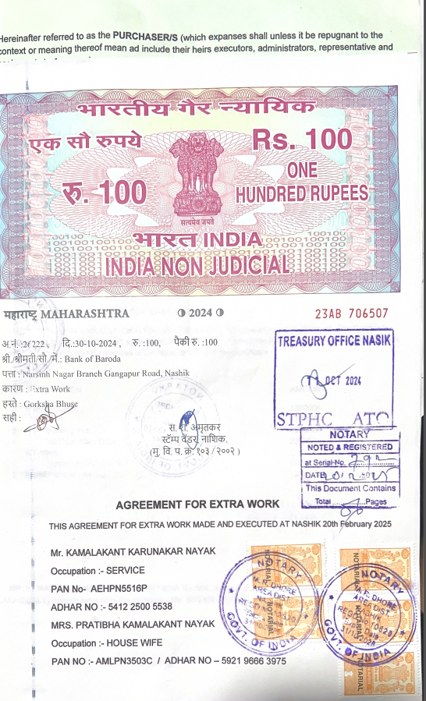
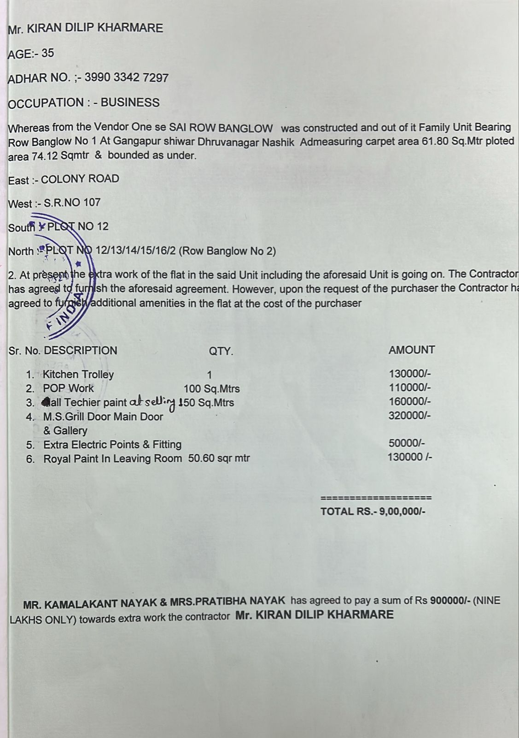

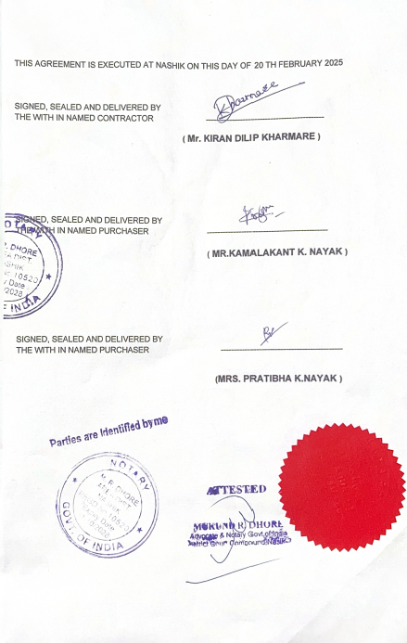

The Extra Work amount is Rs. 9,00,000/- (Rupees Nine Lakh Only)

