Vastu/Nashik/06/32014/2301224
22/20-325-RYBS
Date: 15.01.2025

To,
The Branch Manager,
State Bank of lndia
Sharanpur Road Branch
Nashik Crown Complex, Opp Rajiv Gandhi Bhavan, Sharanpur Road,
Nashik District: Nasik, State: Maharashtra, Pin code - 422 002.

Sub: Vetting of Extra Amenities

Sir,

With reference to above subject, we have evaluated the Extra Amenities for Residential Flat No. 504, 4th Floor, " Aashirvad Golden Nest " , Near NMC Water Tank, Hari Kalpesh Nagar, Dhatrak Phata, Survey No. 241/ 1/ C, Plot No. 3, Off Mumbai - Agra Road, Village - Nashik, Taluka - Nashik, District - Nashik, Nashik, PIN Code - 422 003, State - Maharashtra, Country - India belongs to Mr. Ganesh Gangaram Raut & Mrs. Anuradha Ganesh Raut.

We have verified the rates quoted as per current market rates. Details of Extra Amenities considered as per copy of Extra Amenities Agreement between Mr. Ganesh Gangaram Raut & Mrs. Anuradha Ganesh Raut. (First Party). Sanjay Ramesh Jadhav (Second Party) received on dated 20.02.2025 The Extra Amenities amount is Rs. 5,50,000/- (Rupees Five Lakh Fifty Thousand Only)

The said Cost Vetting Certificate is valid upto next 6 months Only.

Thanking you

Sincerely yours

Manoj B. Chalikwar
Registered Valuer
Chartered Engineer (India)
Reg. No. CAT-I-F-1763
SBI Empanelment No.: SME/TCC/2021-22/86/3
Encl. Valuation Report

Agreement for Extra Amenities
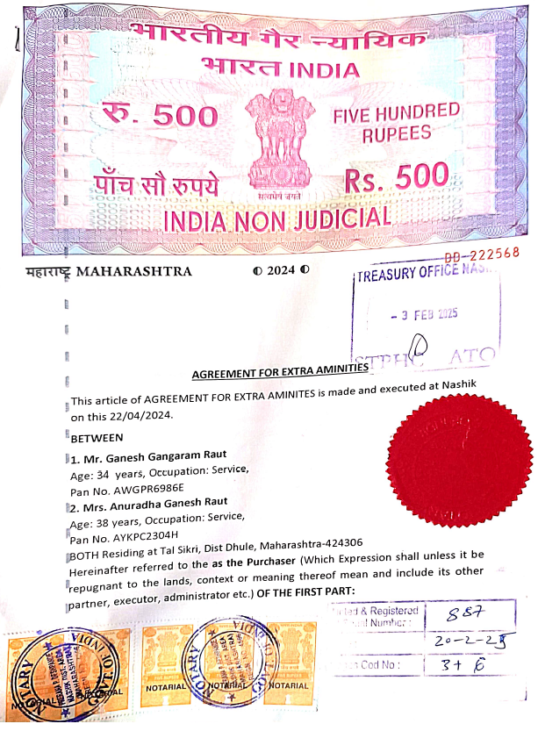
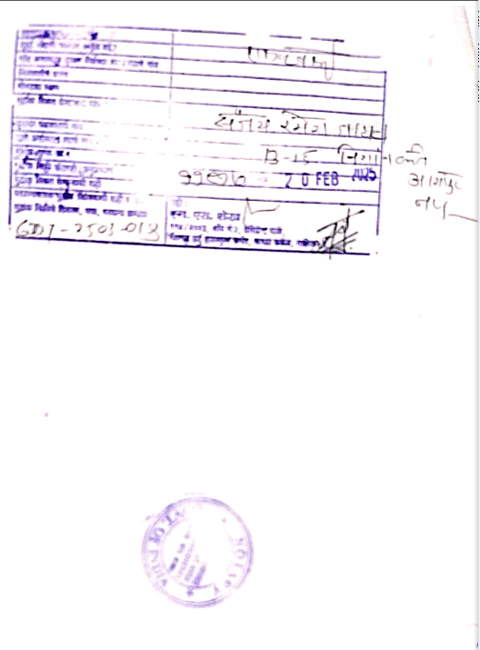

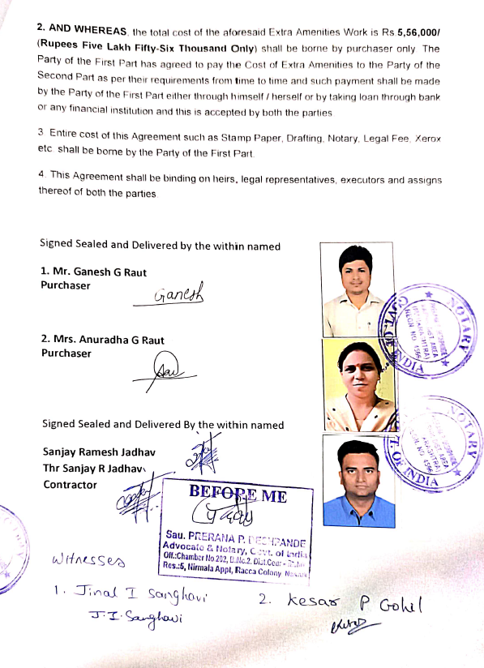
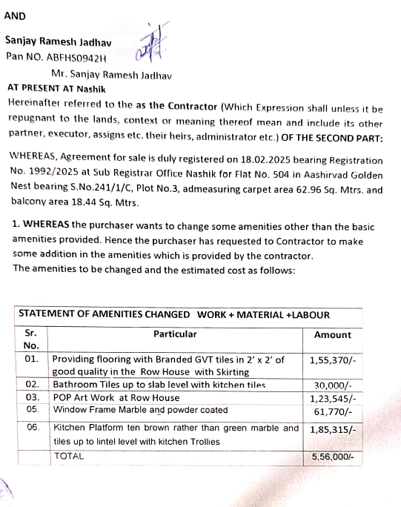

The Extra Amenities amount is Rs. 5,50,000/- (Rupees Five Lakh Fifty Thousand Only)

