7th LENDER’S INDEPENDENT ENGINEER REPORT
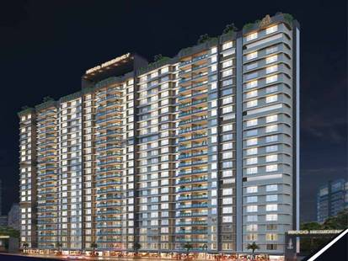

Details of the property under consideration:

Name of Project: NICCO Residency

"NICCO Residency", Proposed S. R. Scheme Residential building on Plot bearing C.T.S. No. 190 A/6/2(pt), Poonam Nagar, MMRDA Colony, JVLR Road, Village – Majas – III, Jogeshwari (East), Mumbai – 400 093, Maharashtra, India

Latitude Longitude: 19°08'19.0"N 72°52'15.7"E

Intended User:

State Bank of India
SME Chembur Branch
Unit No. 11, Building No. 11, Ground Floor, Corporate Park, Sion Trombay Road,
Chembur, Mumbai – 400 071, Maharashtra, India

Vastu/SBI/Mumbai/02/2025/14490/2309074
21/21-160-PY
Date: - 21.02.2025

SEVENTH LENDER’S INDEPENDENT ENGINEER REPORT

To,
State Bank of India
SME Chembur Branch
Unit No. 11, Building No. 11,
Ground Floor, Corporate Park,
Sion Trombay Road, Chembur,
Mumbai – 400 071,
Maharashtra, India

Subject: Construction of Proposed S. R. Scheme Residential building on Plot bearing C.T.S. No. 190 A/6/2(pt), Poonam Nagar, MMRDA Colony, JVLR Road, Village – Majas – III, Jogeshwari (East), Mumbai – 400 093, Maharashtra, India.

Ref: You’re Request for Lender’s Independent Engineer Report of under Construction Building.
Dear Sir,
- As per your instruction, we have inspected the under-construction Amenity, Rehab and Sale Building project situated on plot bearing C.T.S. No. 190 A/6/2(pt), Poonam Nagar, MMRDA Colony, JVLR Road, Village – Majas – III, Jogeshwari (East), Mumbai – 400 093, Maharashtra, India which is being developed by M/s. Neelkamal Realty & Construction LLP in order to give the physical progress at site and to certify cost incurred towards project as on 31/12/2024.
- The Construction work as per approved plan was in progress during the site visit on 07th January 2025.
- Status of work:
- For Rehab Building No. 1: Till 9th floor slab work is completed, 10th floor shuttering work & 1st to 6th floor block work is in progress.
Rehab building work is delay by 13 months.

- For Amenity Building No. 2: Building work is completed.

- For Sales Building No. 3 (Wing A, B & C): Till 15th Floor Slab work is completed, Ground to 10th Floor & 11th floor (Part) blockwork is completed, Ground, 1st & 3rd to 10th Floor plaster work, waterproofing, gypsum work, kitchen platform, flooring, kitchen tiling & toilet dadoing work, electrical & plumbing conducting is completed, Ground & 1st floor firefighting, door and window installed, internal painting work is completed, 2nd floor plaster work is completed. 16th floor shuttering work is in progress.

Sale building (Wing A, B & C) work is delay by 9 months.

- As per cost incurred certificate issued by CA Certificate actual total expenditure occurred as on 31/12/2024 is ` 144.45 Cr. for Amenity, Rehab & Sale Building (Wing A, B & C) & overall financial progress is 44.38% estimated cost of project.
- As per bills actual total expenditure occurred as on 31/12/2024 is ` 144.00 Cr. for Residential of Amenity, Rehab & Sale Building (Wing A, B & C) & overall financial progress is 44.24% estimated cost of project.
- Overall Physical progress of the Rehab building No. 1 construction as on 07/01/2025 is 23.56% as per physical site inspection.

- Overall Physical progress of the Amenity building No. 2 construction as on 07/01/2025 is 100.00% as per physical site inspection.

- Overall Physical progress of the sale building No. 3 (Wing A, B & C) construction as on 07/01/2025 is 49.74% as per physical site inspection.

- Overall Physical progress of the amenity, rehab & sale building (Wing A, B & C) construction as on 07/01/2025 is 44.90% as per physical site inspection.

NOTE:
- Amended building approval drawings for sale building no. 3 was submitted to us and has building permission are as below:
- Wing A & B: Basement (Part) + Ground Floor (Part) + Stilt Floor (Part) + 1st & 2nd (Part) Podium Floor + 3rd & 4th (Part) E – deck Floor + 4th (Part) to 21st (Part) Upper Residential Floor
- Wing C: Basement (Part) + Ground Floor (Part) + Stilt Floor (Part) + 1st & 2nd (Part) Podium Floor + 3rd & 4th (Part) E – deck Floor + 4th (Park) to 20th Upper Residential Floor
- As bank has sanctioned the loan upto 3rd floor of amenity building no. 2, 23rd floor of rehab building no. 1 & upto 19th floor of sale building no. 3 (Wing A to C).
- Hence for the LIE Report we have considered as following for Plinth Calculation.
- Rehab Building No. 1 – Ground Floor + 1st to 23rd Upper Residential Floors
- Amenity Building No. 2 – Ground Floor + 1st to 3rd Upper Residential Floors
- Sale Building No. 3 (Wing A to C) – Basement (Part) + Ground Floor (Part) + Stilt Floor (Part) + 1st & 2nd (Part) Podium Floor + 3rd & 4th (Part) E – deck Floor + 4th (Part) to 19th (Part) Upper Residential Floor

DECLARATION
- The information furnished in the report is based on our 7th site visit Dated 07/01/2025 & Document Provided by Client.
- Vastukala 6th LIE Report of the project dated 15/11/2024.
- I have no direct and indirect interest in the property examined for report.
- I have not been found guilty of misconduct in my professional capacity.

Manoj B. Chalikwar
Registered Valuer
Chartered Engineer (India)
Reg. No. IBBI/RV/07/2018/10366
Encl.: LIE report

Purpose & Methodology
• State Bank of India Banks and financial institutions require monitoring & an independent review of the progress of the sanctioned projects
VCIPL undertakes such study to independently review the progress of the project and put forward a comprehensive analysis

Advantages:
- Assurance on present practices
- Identification of risk
- Analyzing the performance of third parties
- Recommendations

The Methodology
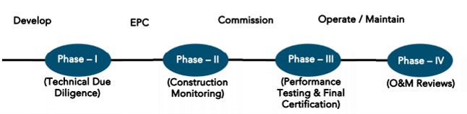
SEVENTH LENDER’S INDEPENDENT ENGINEER REPORT
OF
"NICCO RESIDENCY"

"NICCO Residency", Proposed S. R. Scheme Residential building on Plot bearing C.T.S. No. 190 A/6/2(pt), Poonam Nagar, MMRDA Colony, JVLR Road, Village – Majas – III, Jogeshwari (East), Mumbai – 400 093,
Maharashtra, India

Latitude Longitude: 19°08'19.0"N 72°52'15.7"E

NAME OF DEVELOPER: M/s. Neelkamal Realty & Construction LLP
Pursuant to instructions from State of India, SME Chembur Branch, Mumbai we have duly visited, inspected, surveyed & assessed the above said property on 07th January 2025 to determine the fair & reasonable market value of the said property/project as on Quarter ending 31st December 2024 for LIE purpose.

1. Location Details:
Proposed S. R. Scheme Residential building on Plot bearing C.T.S. No. 190 A/6/2(pt), Poonam Nagar, MMRDA Colony, JVLR Road, Village – Majas – III, Jogeshwari (East), Mumbai – 400 093. It is about 2.10 Km. travelling distance from Jogeshwari (East) Railway station. Surface transport to the property is by buses, taxis & private vehicles. The property is in developed locality. All the amenities like shops, banks, hotels, markets, schools, hospitals, etc. are all available in the surrounding locality. The area is higher middle class & developed.

2. Developer Details:
Name of builder | M/s. Neelkamal Realty & Construction LLP
Project Rera Registration Number | P51800045221
Registered office address | Office at 201-A, Vertex Vikas, Sir M.V. Road, Andheri (East),  Mumbai – 400 069, Maharashtra, India
Contact details | Contact Person:  Mrs. Mona Mehta (Consultant)  Mobile No. 7977952834
E – mail ID and website
3. Boundaries of the Property:
Direction | Particulars
On or towards North | Open Plot/R G Reservation
On or towards South | 18.30 D P Road
On or towards East | 9.0 M. D P Road
On or towards West | CTS No. 185

Introduction
As per Information on site M/s. Neelkamal Realty & Construction LLP has acquired land by conveyance Agreement dated 21.12.2018 through registered agreement vide No. BDR-18-13205-2018 dated 24.12.2018 admeasuring area is 5,669.67 Sq. M. bearing CTS No. 190/A/6/2 (Part). For the Proposed Residential Building.

Area Statement:

Land:
Date | Particular | Area in Sq. M.
21.12.2018 | CTS No. 190/A/6/2 | 5,669.67
TOTAL |  | 5,669.67

- Copy of Development Agreement dated 21.12.2018 between M/s. Advaita Estate & Development Private Limited (The Vendor) and M/s. Neelkamal Realty & Construction LLP (The Purchasers) through registered agreement vide No. BDR-18-13205-2018 dated 24.12.2018.
- Copy of Rectification Deed dated 22.07.2019 between M/s. Advaita Estate & Development Private Limited (The Vendor) and M/s. Neelkamal Realty & Construction LLP (The Purchasers) through registered agreement vide No. BDR-18-9088-2019 dated 08.08.2019.
- Copy of Confirmation Deed dated 03.04.2019 between M/s. Advaita Estate & Development Private Limited (The Vendor) and M/s. Neelkamal Realty & Construction LLP (The Purchasers) through registered agreement vide No. BDR-18-3868-2019 dated 05.04.2019.
- Copy of Indenture Agreement dated 26.05.1998 between M/s. Madhu Fantasy Land Pvt. Ltd. (The Vendor) and M/s. Advaita Estate & Development Private Limited (The Purchasers)

Building Area:

As per Approved Plan:
(I) | AREA STATEMENT |  |  |  | SLUM | NON - SLUM | TOTAL IN SQ. M.
1 | Gross Area Of Plot |  |  |  | 2,200.00 | 3,469.67 | 5,669.67
a) | Area Of Rehabilitation And Resettlement |  |  |  |  | 3,469.67 | 3,469.67
2 | Deduction For
A) | For Reservation / Road Area
a) | Proposed Rehabilitation And Resettlement (Rr 2.1) (3469.67 X 40% = 138.87 |  |  |  |  | 1,387.87 | 1,387.87
B) | For Amenity Area
a) | Area Of Amenity Plot/Plot To Be Handed Over As Per Dcr 14(A)
b) | Area Of Amenity Plot/Plot To Be Handed Over As Per Dcr 14(B)
c) | Area Of Amenity Plot/Plot To Be Handed Over As Per Dcr 15
d) | Area Of Amenity Plot/Plot To Be Handed Over As Per Dcr 32
c) | Deduction For Existing Built-Up Area To Be Retained If Any
a) | Land Component Of Existing Bus As Per Regulation Under Which The Development
3 | Total Deduction [2(A) + 2 (B) + 2 (C)] |  |  |  |  | 1,387.87 | 1,387.87
4 | Balance Area Of Plot (1 Minus 3) |  |  |  | 2,200.00 | 2,081.80 | 4,281.80
4(i) | Addition For
A) | For Reservation /Road
b) | Proposed Rehabilitation And Resettlement (Rr 2.1) (3469.67 X 40% = 138.87 |  |  |  |  | 1,387.87 | 1,387.87
5 | Plot Area Under Development (As Per Sr. No. 4 Above) |  |  |  | 2,200.00 | 3,469.67 | 5,669.67
6 | Zonal (Basic) Fsi (1 Or 1.33) |  |  |  | 4.00 OR MORE | 1.00
7 | Permissible Built-Up Area As Per Zonal (Basic) Fsi (5*6) (In Case Of Mill Land Permissible Built-Up Area Kept In Abeyance) |  |  |  |  | 3,469.67 | 3,469.67
8 | Built Up Area Equal To Area Of Land Handed Over As Per 3(A) Of Regulation 30 (A)
9 | Built Up Area In Lieu Of Cost Of Construction Of Built-Up Amenity To Be Handed Over
10 | Built Up Area Due To Additional Fsi On Payment Of Premium As Per Table No. 12 Of Regulation No. 30(A) 3 |  |  |  |  | 1,734.84 | 1,734.84
11 | Built Up Area Due To Admissible Tdr As Per Table No. 12 Of
 | Regulation No. 30 (A) Subject To Regulation No. 30 (A) 3  (DRC No. – Road/0072/2023 (road), dated- 27/12/2023, area = 69.66 Sq. M.)  (DRC No. – Res/0040/2024 (Amenity Open Space), dated- 05/02/2024, area = 175.79 Sq. M.)  (DRC No. – Road/0073/2024 (road), dated- 05/02/2024, area = 435.57 Sq. M.)  (DRC No. – Res/0042/2024 (Reservation), dated- 07/03/2024, area = 900.52 Sq. M.) |  |  |  |  | 1581.54 | 1581.54
11a | Regulation No. 30(A) subject to regulation No. 30(A)3
12 | Permissible Built-Up Area (7 + 8 + 9 + 10 + 11) |  |  |  |  | 6,786.05 | 6,786.05
13 | Proposed Built Up Area
 | Bldgs | Amenity | Rehab | Sale
 | Rehab Bldg. No. 1 |  | 4876.3 | 548.76
 | Amenity Bldg. No. 2 | 1734.36
 | Sale Bldg No. 3 |  |  | 15943.15
14 | Total Rehab Bua |  | 4876.3 |  | 4,876.30 |  | 4,876.30
15 | Total Rehab Component Area |  |  |  | 8,317.99 |  | 8,317.99
16 | Incentive Sale Area (15 X 1.00) |  |  |  | 8,317.99 |  | 8,317.99
17 | Sale Area Permissible On Non-Slum Plot |  |  |  |  | 6786.05 | 6786.05
18 | Total Area Permissible |  |  |  | 13,194.29 | 6786.05 | 19980.34
19 | Sanctioned Fsi |  |  |  | 6.00 | 1.96
20 a | Sale Bua Permissible |  |  |  | 8,317.99 | 6786.05 | 15104.04
20 b | Built Up Area Equal To Area Of Land Handed Over As Per (Regulation No. 17) |  |  |  |  | 1,387.87 | 1,387.87
20 c | Total Sale Bua Permissible |  |  |  | 8,317.99 | 8173.92 | 16491.91
20 | Total Sale Bua Proposed |  |  |  | 8,317.99 | 8173.92 | 16491.91
21 | Total Proposed Bua (Rehab + Sale) (14 + 20) |  |  |  | 13,194.29 | 8173.92 | 21368.21
22 | Tdr Generated If Any As Per Regulation 30 (A) (3469.67 X 50% = 1734.84 [(1743.36 X 30,250) / 65,040] X 1.50 + 1216.25 Sq. M. |  |  |  |  | 1,216.25 | 1,216.25
23 | Fungible Compensatory Area As Per Regulation No. 31 (3)
a) | i) Permissible Fungible Compensatory Area For Rehab Component Without Charging Premium |  |  |  |  |  | 1,706.70
 | ii) Fungible Compensatory Area Availed For Rehab Component Without Charging Premium |  |  |  |  |  | 95.28
b) | i)Basic Sale Commercial Bua |  |  |  |  |  | 735.14
 | ii)Basic Sale Residential Bua |  |  |  |  |  | 15756.77
c) | i) Permissible Commercial Fungible Compensatory By Charging Premium |  |  |  |  |  | 257.30
 | ii) Proposed Sale Commercial Fungible Compensatory Area Already Paid Wide Receipt No. 53535 Dated 13/08/2021 |  |  |  |  |  | 227.50
d) | i) Permissible Commercial Fungible Compensatory By Charging Premium |  |  |  |  |  | 5514.87
 | ii) Proposed Sale Commercial Fungible Compensatory Area Already Paid Wide Receipt No. 53535 Dated 13/08/2021 |  |  |  |  |  | 4,987.17
 | iii) Proposed Sale residential fungible compensatory area already paid wide receipt no. 783219 Dated 03/06/2024 |  |  |  |  |  | 492.82
e) | Total Proposed Sale Commercial And Residential Fungible Area 23 (C) ii + 23 (D)ii) |  |  |  |  |  | 5707.49
f) | Total Proposed Sale Commercial And Residential Fungible Area 23 (B)(F) Ii + 23 (E) |  |  |  |  |  | 22199.40
25 | Fsi Consumed On Net Plot [21/4] |  |  |  | 6.00 | 2.36
II | Others Requirements
A) | Reservation / Designments
a) | Name Of Reservation
b) | Area Of Reservation Affecting The Plot
 | Area Of Reservation Land To Be Handed/Handed Over As Per Regulation No. 17 |  |  |  |  | 1,387.87 | 1,387.87
B) | Plot Area/Built Up To Amenity To Be Handed Over As Per Regulation
 | I) 14 (A)
 | Ii) 14 (B)
 | Iii) 15
C | Requirements Of Recreational Open Space In Layout / Plot As Per Regulation No. 27
D) | Tenement Statement
 | I) Proposed Built Up Area (13 Above) |  |  |  | REFFER ABOVE STATEMENTS
 | Ii) Less Deduction Of Non - Residential Area (Shop Etc)
 | Iii) Aera Available For Tenements [(I) Minimum (Ii)]
 | Iv) Tenements Permissible Of Tenements Proposed On The Plot
 | V) Total Number Of Tenements Proposed On The Plot
e) | Parking Statements
 | I) Parking Required By Regulation For
 | Car |  |  |  | REFFER ABOVE STATEMENTS
 | Scooter/Motor Cycle
 | Ii) Covered Garbage Permissible
 | Iii) Covered Garbage Proposed
 | Car
 | Scooter / Motor Cycle
 | Outsider (Visitors)
 | Iv)Total Parking Proposed
 | Transport Vehicles Parking
 | i) Spaces For Transport Vehicles Parking Required By Regulation
 | ii) Total No. Of Transport Vehicles Parking Space Provided

List of Approvals:
- Copy of Letter of Intent (LOI) No. KE/PVT/0250/20201009/LOI dated 04.08.2021 issued by Slum Rehabilitation Authority (SRA).
- Copy of Rehab Building No. 1 IOA Letter No. SRA/ENG/KE/PVT/0250/20201009/AP/R – 1 dated 18.08.2021 issued by Slum Rehabilitation Authority (SRA).
- Copy of Amenity Building No. 2 IOA Letter No. SRA/ENG/KE/PVT/0250/20201009/AP/A – 2 dated 18.08.2021 issued by Slum Rehabilitation Authority (SRA).
- Copy of Sale Building No. 3 IOA Letter No. SRA/ENG/KE/PVT/0250/20201009/AP/S/3 dated 18.08.2021 issued by Slum Rehabilitation Authority (SRA).
- Copy of Rehab Building No. 1 Approved Plan No. KE/PVT/0250/2020/009/AP/R – 1 dated 30.09.2022 issued by Slum Rehabilitation Authority (SRA).
Approved upto: Ground Floor + 1st to 23rd Upper Residential Floor
- Copy of Amenity Building No. 2 Approved Plan No. SRA/ENG/KE/PVT/0250/2020/009/AP/A – 2 dated 18.08.2021 issued by Slum Rehabilitation Authority (SRA).
Approved upto: Ground Floor + 1st to 3rd Upper Residential Floor
- Copy of Sale Building No. 3 Approved Plan No. SRA/ENG/KE/PVT/0250/20201009/AP/S/3 dated 30.09.2022 issued by Slum Rehabilitation Authority (SRA).
Approved upto (Wing A to C): Basement (Part) + Ground Floor (Part) + Stilt Floor (Part) + 1st & 2nd (Pt.) Podium Floor + 3rd & 4th (pt.) E – deck Floor + 4th (Pt.) to 19th (Pt.) Upper Residential Floor
- Copy of Sale Building No. 3 Amended Approved Plan No. KE/PVT/0250/20201009/AP/S/3 dated 24.06.2024 issued by Slum Rehabilitation Authority (SRA).
Approved upto:
Wing A & B: Basement (Part) + Ground Floor (Part) + Stilt Floor (Part) + 1st & 2nd (Part) Podium Floor + 3rd & 4th (Part) E – deck Floor + 4th (Part) to 21st (Part) Upper Residential Floor
Wing C: Basement (Part) + Ground Floor (Part) + Stilt Floor (Part) + 1st & 2nd (Part) Podium Floor + 3rd & 4th (Part) E – deck Floor + 4th (Park) to 20th Upper Residential Floor
- Copy of Rehab Building No. 1 1st Commencement Certificate No. KE/PVT/0250/20201009/AP/R-1 dated 17.01.2023 issued by Slum Rehabilitation Authority (SRA).
(This CC is endorsed for the work for Plinth Level by excluding portion of religious structure)
- Copy of Rehab Building No. 1 2nd Commencement Certificate No. KE/PVT/0250/20201009/AP/R-1 dated 31.07.2024 issued by Slum Rehabilitation Authority (SRA).
(This CC is endorsed for the work for Ground Floor + 1st to 23rd Upper Residential Floor by excluding portion of religious structure as per approved amended plans dated 30/09/2022)
- Copy of Amenity Building No. 2 1st Commencement Certificate No. KE/PVT/0250/20201009/AP/A-2 dated 17.01.2023 issued by Slum Rehabilitation Authority (SRA).
(This CC is endorsed for the work for Plinth Level)
- Copy of Amenity Building No. 2 2nd Commencement Certificate No. KE/PVT/0250/20201009/AP/A-2 dated 23.06.2023 issued by Slum Rehabilitation Authority (SRA).
(This CC is endorsed for the work for Ground floor + 1st to 3rd Upper Floor & OHT & LMR)
- Copy of Sale Building No. 3 1st Commencement Certificate No. KE/PVT/0250/20201009/AP/S-3 dated 17.01.2023 issued by Slum Rehabilitation Authority (SRA).
(This CC is endorsed for the work for Plinth Level)
- Copy of Sale Building No. 3 2nd Commencement Certificate No. KE/PVT/0250/20201009/AP/S-3 dated 17.01.2023 issued by Slum Rehabilitation Authority (SRA).
(This CC is endorsed for the work for Ground Floor + 1st to 11th (Pt.) Upper Floors as per approved plans dated 30.09.2022)
- Copy of Sale Building No. 3 3rd Commencement Certificate No. KE/PVT/0250/20201009/AP/S-3 dated 24.06.2024 issued by Slum Rehabilitation Authority (SRA).
(This CC is endorsed for the work for Ground Floor + 1st to 13th (Pt.) Upper Floors as per approved plans dated 24.06.2024)
- Copy of Sale Building No. 3 4th Commencement Certificate No. KE/PVT/0250/20201009/AP/S-3 dated 12.09.2024 issued by Slum Rehabilitation Authority (SRA).
(This CC is endorsed for the work for Ground Floor + 1st to 18th (Pt.) Upper Floors for RCC framework & Ground Floor to 1st to 13th (pt.) upper floor for brickwork as per approved amended plans dated 24.06.2024)

LEVEL OF COMPLETION:

Amenity Buidling No. 2
Sr. No | Floor No. | Construction Area in Sq. M. | Completed Area in Sq. M. | Work Completion as on 07.01.2025 | Work Completion as on 6th LIE Report
1 | Excavation & Shore Piling |  |  | Work is Completed | Work is Completed
2 | Ground Floor | 476.44 | 476.44 | 100 % Work is completed | 100 % Work is completed
3 | 1st Floor | 508.48 | 508.48 | 100 % Work is completed | 100 % Work is completed
4 | 2nd Floor | 508.48 | 508.48 | 100 % Work is completed | 100 % Work is completed
5 | 3rd Floor | 508.48 | 508.48 | 100 % Work is completed | 100 % Work is completed
6 | Terrace Floor | 55.17 | 55.17 | 100 % Work is completed | 100 % Work is completed
Total |  | 2,057.05 | 2,057.05

Rehab Buidling No. 1
Sr. No | Floor No. | Construction Area in Sq. M. | Completed Area in Sq. M. | Work Completion as on 07.01.2025 | Work Completion as on 6th LIE Report
1 | Excavation & Shore Piling |  |  | Excavation work is completed | Work not started yet
2 | Ground Floor | 464.47 | 464.47 | Slab work is completed | Slab work is completed
3 | 1st Floor | 478.02 | 478.02 | Slab work is completed, block work is in progress | Slab work is completed
4 | 2nd Floor | 486.64 | 486.64 | Slab work is completed, block work is in progress | Slab work is completed
5 | 3rd Floor | 505.09 | 505.09 | Slab work is completed, block work is in progress | Slab work is completed
6 | 4th Floor | 505.09 | 505.09 | Slab work is completed, block work is in progress
7 | 5th Floor | 505.09 | 505.09 | Slab work is completed, block work is in progress
8 | 6th Floor | 505.09 | 505.09 | Slab work is completed, block work is in progress
9 | 7th Floor | 505.09 | 505.09 | Slab work is completed
10 | 8th Floor | 505.09 | 505.09 | Slab work is completed
11 | 9th Floor | 505.09 | 505.09 | Slab work is completed
12 | 10th Floor | 505.09 |  | Shuttering work is in progress
13 | 11th Floor | 505.09
14 | 12th Floor | 505.09
15 | 13th Floor | 505.09
16 | 14th Floor | 505.09
17 | 15th Floor | 505.09
18 | 16th Floor | 505.09
19 | 17th Floor | 505.09
20 | 18th Floor | 505.09
21 | 19th Floor | 505.09
22 | 20th Floor | 505.09
23 | 21st Floor | 505.09
24 | 22nd Floor | 505.09
25 | 23rd Floor | 505.09
26 | Terrace Floor | 30.93
Total |  | 12,066.94 | 4,964.75
No. of Puzzle Car Parking |  | 131 Nos

Sales Building No. 3 (Wing A, B & C)
Sr. No | Floor No. | Construction Area in Sq. M. | Completed Area in Sq. M. | Work Completion as on 07.01.2025 | Work Completion as on 6th LIE Report
1 | Excavation & Shore Piling |  |  | 50% Work is Completed | 50% Work is Completed
2 | Ground Floor | 1,877.06 | 938.53 | Slab Work, blockwork, plaster work, kitchen platorm, kitchen tiling, toilet dadoing, flooring, firefighting, plumbing & electrical conducting work, door & window frame work, internal painting is completed | Slab Work, blockwork, plaster work, kitchen platorm, kitchen tiling, toilet dadoing, flooring, firefighting, plumbing & electrical conducting work, door & window frame work, internal painting is completed
3 | 1st Floor | 1,877.06 | 938.53 | Slab Work, blockwork, plaster work, kitchen platorm, kitchen tiling, toilet dadoing, flooring, firefighting, plumbing & electrical conducting work, door & window frame work, internal painting is completed. | Slab Work, blockwork, plaster work, kitchen platorm, kitchen tiling, toilet dadoing, flooring, firefighting, plumbing & electrical conducting work, door & window frame work, internal painting is completed
4 | 2nd Floor | 1,877.06 | 938.53 | Slab Work, block work, waterproofing, plaster work & gypsum work is completed | Slab Work, block work, waterproofing, plaster work & gypsum work is completed
5 | 3rd Floor | 1,771.12 | 885.56 | Slab Work, block work, waterproofing, plasterwork, gypsum, kitchen platform & tiling, toilet dadoing, flooring, door & windows frames, electrical and plumbing conncealed work is completed, firefighting work is in progress. | Slab Work, block work, waterproofing, plaster work & gypsum work is completed
6 | 4th Floor | 1,654.66 | 827.33 | Slab Work, block work, waterproofing, plasterwork, gypsum, kitchen platform & tiling, toilet dadoing, flooring, door & windows frames, electrical and plumbing conncealed work is completed, firefighting work is in progress. | Slab Work, block work, waterproofing, plaster work & gypsum work is completed
7 | 5th Floor | 1,484.69 | 1,484.69 | Slab Work, block work, waterproofing, plasterwork, gypsum, kitchen platform & tiling, toilet dadoing, flooring, door & windows frames, electrical and plumbing conncealed work is completed, firefighting work is in progress. | Slab Work, block work, waterproofing, plaster work & gypsum work is completed
8 | 6th Floor | 1,484.69 | 1,484.69 | Slab Work, block work, waterproofing, plasterwork, gypsum, kitchen platform & tiling, toilet dadoing, flooring, door & windows frames, electrical and plumbing conncealed work is completed, firefighting work is in progress. | Slab Work, block work, waterproofing, plaster work & gypsum work is completed
9 | 7th Floor | 1,484.69 | 1,484.69 | Slab Work, block work, waterproofing, plasterwork, gypsum, kitchen platform & tiling, toilet dadoing, flooring, door & windows frames, electrical and plumbing conncealed work is completed | Slab Work, block work, waterproofing, plaster work & gypsum work is completed
10 | 8th Floor | 1,468.40 | 1,468.40 | Slab Work, block work, waterproofing, plasterwork, gypsum, kitchen platform & tiling, toilet dadoing, flooring, door & windows frames, electrical and plumbing conncealed work is completed | Slab Work, block work, waterproofing, plaster work & gypsum work is completed
11 | 9th Floor | 1,484.69 | 1,484.69 | Slab Work, block work, waterproofing, plasterwork, gypsum, kitchen platform & tiling, toilet dadoing, flooring, door & windows frames, electrical and plumbing conncealed work is completed | Slab Work, block work, waterproofing, plaster work & 50% gypsum work is completed
12 | 10th Floor | 1,484.69 | 1,484.69 | Slab Work, block work, waterproofing, plasterwork, gypsum, kitchen platform & tiling, toilet dadoing, flooring, door & windows frames, electrical and plumbing conncealed work is completed | Slab Work, block work is completed
13 | 11th Floor | 1,484.69 | 1,484.69 | Slab Work, 60% block work, is completed | Slab Work, 60% block work, is completed
14 | 12th Floor | 1,484.69 | 1,484.69 | Slab Work is completed | Slab Work is completed
15 | 13th Floor | 1,484.69 | 1,484.69 | Slab Work is completed | Slab Work is completed
16 | 14th Floor | 1,484.69 | 1,484.69 | Slab Work is completed | Slab Work is completed
17 | 15th Floor | 1,498.47 | 1,498.47 | Slab Work is completed | Shuttering work is in progress
18 | 16th Floor | 1,484.69 |  | Shuttering work is in progress
19 | 17th Floor | 1,484.69
20 | 18th Floor | 1,484.69
21 | 19th Floor | 990.59
22 | Terrace Floor | 160.32
Total |  | 30,990.95 | 21,796.04
No. of Puzzle Car Parking |  | 300 Nos
- As per site inspection following building work is completed as below,
- Amenity building No. 2 – 100% work is completed
- Rehab building No. 1 – Slab work is completed upto 9th floors
- Sale building No. 3 (Wing A to C) - Slab work is completed upto 15th floors.
- Amended building approval drawings for sale building no. 3 was submitted to us and has building permission are as below:
- Wing A & B: Basement (Part) + Ground Floor (Part) + Stilt Floor (Part) + 1st & 2nd (Part) Podium Floor + 3rd & 4th (Part) E – deck Floor + 4th (Part) to 21st (Part) Upper Residential Floor
- Wing C: Basement (Part) + Ground Floor (Part) + Stilt Floor (Part) + 1st & 2nd (Part) Podium Floor + 3rd & 4th (Part) E – deck Floor + 4th (Park) to 20th Upper Residential Floor
- As bank has sanctioned the loan upto 3rd floor of amenity building no. 2, 23rd floor of rehab building no. 1 & upto 19th floor of sale building no. 3 (Wing A to C).
- Hence for the LIE Report we have considered as following for Plinth Calculation.
- Rehab Building No. 1 – Ground Floor + 1st to 23rd Upper Residential Floors
- Amenity Building No. 2 – Ground Floor + 1st to 3rd Upper Residential Floors
- Sale Building No. 3 (Wing A to C) – Basement (Part) + Ground Floor (Part) + Stilt Floor (Part) + 1st & 2nd (Part) Podium Floor + 3rd & 4th (Part) E – deck Floor + 4th (Part) to 19th (Part) Upper Residential Floor

Details of the Project as Financed By SBI:

Estimated Project Cost: (As per Cost Vetting Report)
Particulars | Estimated Cost (in Cr.)
Land Cost | 36.80
Rent Cost | 3.85
Construction Cost of Rehab & Amenity Building | 48.50
Construction Cost of Sale Building | 117.27
Premium Cost / FSI / GOM Charges / fees / security Deposits & TDR Cost | 32.43
Architect Cost, RCC & Other Professional Cost | 8.29
Administrative Cost | 6.63
Marketing Cost | 16.77
Interest Cost (Bank Loan) | 50.00
Contingency Cost | 4.97
Total | 325.51

Project Cost: (as per C.A. Certificate)
Particulars | Incurred Cost (In Cr.) 31.12.2024 by M/s. Varma & Associates | Incurred Cost (In Cr.) 30.09.2024 by M/s. Varma & Associates | Net
Land Cost | 36.80 | 36.80 | -
Rent Cost | 5.15 | 5.15 | -
Construction Cost of Rehab & Amenity Building | 46.85 | 38.97 | 7.88
Construction Cost of Sale Building
Premium Cost / FSI / GOM Charges / fees / security Deposits & TDR Cost | 30.06 | 30.04 | 0.02
Architect Cost, RCC & Other Professional Cost | 2.65 | 2.65 | -
Administrative Cost | 14.32 | 11.96 | 2.36
Marketing Cost
Interest Cost (Bank Loan) | 4.26 | 3.23 | 1.03
Contingency Cost | 4.36 | - | 4.36
Total | 144.45 | 128.80 | 15.65

- The Builder has incurred about 46.85 Cr. as construction cost of all the 3 building, 30.06 Cr. for approval of project, 2.65 Cr. for Professional charges, 14.32 Cr. for admin cost & marketing cost, 4.26 Cr. for interest cost and 4.36 Cr. for contingency cost in last quarter till 31.12.2024 as per C.A. certificate issued by M/s. Varma & Associates dated 22.01.2025.

Project Cost: (as per Bills):
Particulars | Incurred Cost (in Cr.)
 | 31.12.2024 as per Bill (Inclusive GST) | 30.09.2024 as per Bill (Inclusive GST) | Net
Land Cost | 36.80 | 36.80 | -
Rent Cost | 5.30 | 5.30 | -
Construction cost of Rehab & Amenity Building | 47.08 | 38.84 | 8.25
Construction cost of Sale Building
Premium Cost / FSI / GOM Charges / fees / security Deposits & TDR Cost | 29.57 | 29.55 | 0.02
Architect Cost, RCC & Other Professional Cost | 2.73 | 2.71 | 0.02
Administrative Cost | 5.15 | 4.61 | 0.54
Marketing Cost | 13.09 | 11.06 | 2.03
Interest Cost | 4.28 | 3.25 | 1.03
Contingency Cost | - | - | -
Total | 144.00 | 132.10 | 11.89
Note:

Land Cost:
Sr. No. | Agreement Name | Date | Particulars | Total Cost in ` | Incurred Cost in `
1 | Conveyance Deed | 21.12.2018 | Purchase Cost | 35,04,00,000.00 | 35,04,00,000.00
2 |  |  | Stamp Duty | 1,75,20,000.00 | 1,75,20,000.00
3 |  |  | Reg. Fees | 30,000.00 | 30,000.00
4 |  |  |  | 1,900.00 | 1,900.00
5 | Confirmation Deed | 03.04.2019 | Stamp Duty | 500.00 | 500.00
6 |  |  | Reg. Fees | 1,900.00 | 1,900.00
7 |  |  |  | 100.00 | 100.00
5 | Rectification Deed | 22.06.2019 | Stamp Duty | 500.00 | 500.00
6 |  |  | Reg. Fees | 1,900.00 | 1,900.00
7 |  |  |  | 100.00 | 100.00
TOTAL |  |  |  | 36,79,56,900.00 | 36,79,56,900.00
As per conveyance agreement.

Summary of Bills
Sr. No. | Particulars | Amount in `  (Till 31.12.2024) | Amount in ` (in Cr.) | Amount in `  (Till 30.09.2024) | Amount in ` (in Cr.) | Net in ` (in Cr.)
1 | Construction Cost of Rehab & Amenity Building | 47,08,30,354.00 | 47.08 | 38,83,59,536.00 | 38.84 | 8.25
2 | Construction Cost of Sale Building
3 | Rent Cost | 5,29,58,946.00 | 5.30 | 5,29,58,946.00 | 5.30 | -
4 | Premium Cost / FSI / GOM Charges / fees / security Deposits & TDR Cost | 29,57,00,360.00 | 29.57 | 29,54,74,280.00 | 29.55 | 0.02
5 | Professional Cost | 2,73,43,641.00 | 2.73 | 2,71,31,105.00 | 2.71 | 0.02
6 | Administrative Cost | 5,14,92,264.00 | 5.15 | 4,60,56,475.00 | 4.61 | 0.54
7 | Marketing Cost | 13,09,06,933.00 | 13.09 | 11,05,68,115.00 | 11.06 | 2.03
TOTAL |  | 102,92,34,498.00 | 102.92 | 92,05,48,457.00 | 92.05 | 10.87
Note: Bills were provided by the client up to 31.12.2024

Interest Cost:
Sr. No | Particulars | Estimate Amount in ` | Incurred Amount in ` (till 31.12.2024) | Incurred Amount in ` (till 30.09.2024) | Difference | Balance Amount in `
1 | Interest Cost | 50,00,00,000.00 | 4,27,78,031.00 | 3,25,18,577.00 | 1,02,59,454.00 | 45,72,21,969.00
TOTAL |  | 50,00,00,000.00 | 4,27,78,031.00 | 3,25,18,577.00 | 1,02,59,454.00 | 45,72,21,969.00
Interest Cost is based on discussion with the client.

Cost of Construction as on 07th January 2025:

Rehab Building No. 1
Sr. No. | Floor | Total Construction Area in Sq. M. | Completed Area in Sq. M. | Rate per Sq. M. | Full Value after completion | % of work completed | Actual Expenditure till date in `
1 | Excavation & Piling Work | 10% of Construction Cost of Building |  |  | 3,25,80,726.00 | 100% | 3,25,80,726.00
2 | Ground | 464.47 | 464.47 | 27,000.00 | 1,25,40,673.80 | 50% | 62,70,336.90
3 | 1st | 478.02 | 478.02 | 27,000.00 | 1,29,06,523.80 | 52% | 67,11,392.38
4 | 2nd | 486.64 | 486.64 | 27,000.00 | 1,31,39,263.80 | 52% | 68,32,417.18
5 | 3rd | 505.09 | 505.09 | 27,000.00 | 1,36,37,413.80 | 52% | 70,91,455.18
6 | 4th | 505.09 | 505.09 | 27,000.00 | 1,36,37,413.80 | 52% | 70,91,455.18
7 | 5th | 505.09 | 505.09 | 27,000.00 | 1,36,37,413.80 | 52% | 70,91,455.18
8 | 6th | 505.09 | 505.09 | 27,000.00 | 1,36,37,413.80 | 52% | 70,91,455.18
9 | 7th | 505.09 | 505.09 | 27,000.00 | 1,36,37,413.80 | 50% | 68,18,706.90
10 | 8th | 505.09 | 505.09 | 27,000.00 | 1,36,37,413.80 | 50% | 68,18,706.90
11 | 9th | 505.09 | 505.09 | 27,000.00 | 1,36,37,413.80 | 40% | 54,54,965.52
12 | 10th | 505.09 |  | 27,000.00 | 1,36,37,413.80 |  | -
13 | 11th | 505.09 |  | 27,000.00 | 1,36,37,413.80 |  | -
14 | 12th | 505.09 |  | 27,000.00 | 1,36,37,413.80 |  | -
15 | 13th | 505.09 |  | 27,000.00 | 1,36,37,413.80 |  | -
16 | 14th | 505.09 |  | 27,000.00 | 1,36,37,413.80 |  | -
17 | 15th | 505.09 |  | 27,000.00 | 1,36,37,413.80 |  | -
18 | 16th | 505.09 |  | 27,000.00 | 1,36,37,413.80 |  | -
19 | 17th | 505.09 |  | 27,000.00 | 1,36,37,413.80 |  | -
20 | 18th | 505.09 |  | 27,000.00 | 1,36,37,413.80 |  | -
21 | 19th | 505.09 |  | 27,000.00 | 1,36,37,413.80 |  | -
22 | 20th | 505.09 |  | 27,000.00 | 1,36,37,413.80 |  | -
23 | 21st | 505.09 |  | 27,000.00 | 1,36,37,413.80 |  | -
24 | 22nd | 505.09 |  | 27,000.00 | 1,36,37,413.80 |  | -
25 | 23rd | 505.09 |  | 27,000.00 | 1,36,37,413.80 |  | -
26 | OHT / LMR | 30.93 |  | 27,000.00 | 8,35,110.00 |  | -
Sub - Total (A) |  | 12,066.94 | 4,964.75 |  | 35,83,87,987.20 | 27.86% | 9,98,53,072.48
PUZZLE PARKING Nos. (B) |  | 131.00 |  | 5,00,000.00 | 6,55,00,000.00 |  | -
TOTAL COST OF CONSTRUCTION (A + B) |  |  |  |  | 42,38,87,987.20 | 23.56% | 9,98,53,072.48

Amenity Building No. 2
Sr. No. | Floor | Total Construction Area in Sq. M. | Completed Area in Sq. M. | Rate per Sq. M. | Full Value after completion | % of work completed | Actual Expenditure till date in `
1 | Excavation & Piling Work | 10% of Construction Cost of Building |  |  | 55,54,035.00 | 100% | 55,54,035.00
2 | Ground | 476.44 | 476.44 | 27,000.00 | 1,28,63,880.00 | 100% | 1,28,63,880.00
3 | 1st | 508.48 | 508.48 | 27,000.00 | 1,37,28,960.00 | 100% | 1,37,28,960.00
4 | 2nd | 508.48 | 508.48 | 27,000.00 | 1,37,28,960.00 | 100% | 1,37,28,960.00
5 | 3rd | 508.48 | 508.48 | 27,000.00 | 1,37,28,960.00 | 100% | 1,37,28,960.00
6 | OHT / LMR | 55.17 | 55.17 | 27,000.00 | 14,89,590.00 | 100% | 14,89,590.00
TOTAL COST OF CONSTRUCTION |  | 2,057.05 | 2,057.05 |  | 6,10,94,385.00 | 100% | 6,10,94,385.00

Sales Building No. 3 (Wing A, B & C)
Sr. No. | Floor | Total Construction Area in Sq. M. | Completed Area in Sq. M. | Rate per Sq. M. | Full Value after completion | % of work completed | Actual Expenditure till date in `
1 | Excavation & Piling Work | 10% of Construction Cost of Building |  |  | 9,29,72,843.00 | 50% | 4,64,86,421.50
2 | Ground | 1,877.06 | 1,877.06 | 30,000.00 | 5,63,11,875.00 | 90% | 5,06,80,687.50
3 | 1st | 1,877.06 | 938.53 | 30,000.00 | 5,63,11,762.50 | 80% | 4,50,49,410.00
4 | 2nd | 1,877.06 | 938.53 | 30,000.00 | 5,63,11,762.50 | 80% | 4,50,49,410.00
5 | 3rd | 1,771.12 | 885.56 | 30,000.00 | 5,31,33,675.00 | 80% | 4,25,06,940.00
6 | 4th | 1,654.66 | 827.33 | 30,000.00 | 4,96,39,650.00 | 80% | 3,97,11,720.00
7 | 5th | 1,484.69 | 1,484.69 | 30,000.00 | 4,45,40,550.00 | 80% | 3,56,32,440.00
8 | 6th | 1,484.69 | 1,484.69 | 30,000.00 | 4,45,40,550.00 | 80% | 3,56,32,440.00
9 | 7th | 1,484.69 | 1,484.69 | 30,000.00 | 4,45,40,550.00 | 80% | 3,56,32,440.00
10 | 8th | 1,468.40 | 1,468.40 | 30,000.00 | 4,40,51,850.00 | 80% | 3,52,41,480.00
11 | 9th | 1,484.69 | 1,484.69 | 30,000.00 | 4,45,40,550.00 | 80% | 3,56,32,440.00
12 | 10th | 1,484.69 | 1,484.69 | 30,000.00 | 4,45,40,550.00 | 60% | 2,67,24,330.00
13 | 11th | 1,484.69 | 1,484.69 | 30,000.00 | 4,45,40,550.00 | 55% | 2,44,97,302.50
14 | 12th | 1,484.69 | 1,484.69 | 30,000.00 | 4,45,40,550.00 | 50% | 2,22,70,275.00
15 | 13th | 1,484.69 | 1,484.69 | 30,000.00 | 4,45,40,550.00 | 50% | 2,22,70,275.00
16 | 14th | 1,484.69 | 1,484.69 | 30,000.00 | 4,45,40,550.00 | 50% | 2,22,70,275.00
17 | 15th | 1,498.47 | 1,498.47 | 30,000.00 | 4,49,53,950.00 | 40% | 1,79,81,580.00
18 | 16th | 1,484.69 |  | 30,000.00 | 4,45,40,550.00 |  | -
19 | 17th | 1,484.69 |  | 30,000.00 | 4,45,40,550.00 |  | -
20 | 18th | 1,484.69 |  | 30,000.00 | 4,45,40,550.00 |  | -
21 | 19th | 990.59 |  | 30,000.00 | 2,97,17,700.00 |  | -
22 | OHT / LMR | 160.32 |  | 30,000.00 | 48,09,600.00 |  | -
Sub - Total (A) |  | 30,990.95 | 21,796.04 |  | 1,02,27,01,268.00 | 57.03% | 58,32,69,866.50
PUZZLE PARKING Nos. (B) |  | 300.00 |  | 5,00,000.00 | 15,00,00,000.00 |  | -
TOTAL COST OF CONSTRUCTION (A + B) |  |  |  |  | 1,17,27,01,268.00 | 49.74% | 58,32,69,866.50

SUMMARY TABLE OF PLINTH AREA CALCULATION
Sr. No. | Building | Total Construction Area in Sq. M. | Full Value after completion | Percentage of work completed | Actual Expenditure till date in `
1 | Amenity Building No. 2 | 2,057.05 | 6,10,94,385.00 | 100.00% | 6,10,94,385.00
2 | Rehab Building No. 1 | 12,066.94 | 35,83,87,987.20 | 27.86% | 9,98,53,072.48
3 | Sale Building | 30,990.95 | 1,02,27,01,268.00 | 50.26% | 58,32,69,866.50
 | Sub Total (A) | 45,114.93 | 1,44,21,83,640.20 | 51.60% | 74,42,17,323.98
4 | Puzzle Parking of Rehab Building in No. | 131.00 | 6,55,00,000.00 | 0% | -
5 | Puzzle Parking of Sale Building in No. | 300.00 | 15,00,00,000.00 | 0% | -
 | Sub Total (B) | 431.00 | 21,55,00,000.00 | 0% | -
Total Cost of Construction (A + B) |  |  | 1,65,76,83,640.20 | 44.90% | 74,42,17,323.98

Note: Details of work completed is as per site visit dated 07.01.2025 but report is prepared for 31st December quarter 2024.

- As per site inspection following building work is completed as below,
- Amenity building No. 2 – 100% work is completed
- Rehab building No. 1 – Slab work is completed upto 9th floors
- Sale building No. 3 (Wing A to C) - Slab work is completed upto 15th floors.
- Amended building approval drawings for sale building no. 3 was submitted to us and has building permission are as below:
- Wing A & B: Basement (Part) + Ground Floor (Part) + Stilt Floor (Part) + 1st & 2nd (Part) Podium Floor + 3rd & 4th (Part) E – deck Floor + 4th (Part) to 21st (Part) Upper Residential Floor
- Wing C: Basement (Part) + Ground Floor (Part) + Stilt Floor (Part) + 1st & 2nd (Part) Podium Floor + 3rd & 4th (Part) E – deck Floor + 4th (Park) to 20th Upper Residential Floor
- As bank has sanctioned the loan upto 3rd floor of amenity building no. 2, 23rd floor of rehab building no. 1 & upto 19th floor of sale building no. 3 (Wing A to C).
- Hence for the LIE Report we have considered as following for Plinth Calculation.
- Rehab Building No. 1 – Ground Floor + 1st to 23rd Upper Residential Floors
- Amenity Building No. 2 – Ground Floor + 1st to 3rd Upper Residential Floors
Sale Building No. 3 (Wing A to C) – Basement (Part) + Ground Floor (Part) + Stilt Floor (Part) + 1st & 2nd (Part) Podium Floor + 3rd & 4th (Part) E – deck Floor + 4th (Part) to 19th (Part) Upper Residential Floor
Particulars | Estimated Cost  (In Cr.) | Incurred Cost (in Cr.) |  |  | Net
 |  | Issued dated 22.01.2025 till 31.12.2024 as per CA | As per Bills upto 31.12.2024 | As per Bills upto 30.09.2024
Land Cost | 36.80 | 36.80 | 36.80 | 36.80 | -
Rent Cost | 3.85 | 5.15 | 5.30 | 5.30 | -
Construction cost of Rehab & Amenity Building | 48.50 | 46.85 | 47.08 | 38.84 | 8.25
Construction cost of Sale Building | 117.27
Premium Cost / FSI / GOM Charges / fees / security Deposits & TDR Cost | 32.43 | 30.06 | 29.57 | 29.55 | 0.02
Architect Cost, RCC & Other Professional Cost | 8.29 | 2.65 | 2.73 | 2.71 | 0.02
Administrative Cost | 6.63 | 14.32 | 5.15 | 4.61 | 0.54
Marketing Cost | 16.77 |  | 13.09 | 11.06 | 2.03
Interest Cost | 50.00 | 4.26 | 4.28 | 3.25 | 1.03
Contingency Cost | 4.97 | 4.36 | - | - | -
Total | 325.51 | 144.45 | 144.00 | 132.10 | 11.89

Note:
We have considered Other Expenses, Printing & Stationery, and Water Bills cost is consider in administrative cost header but CA has considered them in cost of construction header .
We have considered Stamp Duty, Registration Charges and Brokerage against of sale flat are cosnidered in marketing cost header.
In cost of construction builder have paid some advance payment against to some vendors but CA has not considered the advance payment of ` 0.23 Cr.
As per site inpsection, 23.56% of total work is completed, which amounts to` 9.99 Cr. for Rehab building No. 1, 100% of total work is completed, which amounts to` 6.11 Cr. for Amenity building No. 2 and 49.74% of total work is completed, which amounts to ` 58.33 Cr. for Sale Building No. 3. Hence 44.90% of total work is completed in project, which amounts to ` 74.42 Cr. However, as per data provided by client, they have incurred the cost of ` 47.08 Cr. till 31.12.2024.

Comparison of Cost incurred on dated 31.12.2024 & 30.09.2024
Particulars | 31.12.2024 as per Bill | 30.09.2024 as per Bill | Net | % of net amount
Land Cost | 36.80 | 36.80 | - | 0.00%
Rent Cost | 5.30 | 5.30 | - | 0.00%
Construction cost of Rehab & Amenity Building | 47.08 | 38.84 | 8.25 | 5.73%
Construction cost of Sale Building
Premium Cost / FSI / GOM Charges / fees / security Deposits & TDR Cost | 29.57 | 29.55 | 0.02 | 0.01%
Architect Cost, RCC & Other Professional Cost | 2.73 | 2.71 | 0.02 | 0.01%
Administrative Cost | 5.15 | 4.61 | 0.54 | 0.38%
Marketing Cost | 13.09 | 11.06 | 2.03 | 1.41%
Interest Cost | 4.28 | 3.25 | 1.03 | 0.72%
Contingency Cost | - | - | - | 0.00%
Total | 144.00 | 132.10 | 11.89 | 8.26%

% of Fund Utilised till 31st December 2024
Particulars | Estimated Project Cost  (in Cr.) | Incurred cost as on 31.12.2024 | % of Incurred Cost | % of Estimated Project Cost
Land Cost | 36.80 | 36.80 | 99.99% | 11.30%
Rent Cost | 3.85 | 5.30 | 137.56% | 1.63%
Construction cost of Rehab & Amenity Building | 48.50 | 47.08 | 28.40% | 14.46%
Construction cost of Sale Building | 117.27
Premium Cost / FSI / GOM Charges / fees / security Deposits | 32.43 | 29.57 | 91.18% | 9.08%
Architect Cost, RCC & Other Professional Cost | 8.29 | 2.73 | 32.98% | 0.84%
Administrative Cost | 6.63 | 5.15 | 77.67% | 1.58%
Marketing Cost | 16.77 | 13.09 | 78.06% | 4.02%
Interest Cost | 50.00 | 4.28 | 8.56% | 1.31%
Contingency Cost | 4.97 | - | 0.00% | 0.00%
Total | 325.51 | 144.00 | 44.24% | 44.24%
Based on above Calculation it is found that total Project cost incurred is 44.24% of the Total Project Cost.

Means of Finance:
Sr. No. | Particulars | Exp. Cumulative (Cr.)
 | Equity share capital / Quassi Loan from Promoter | 15.60
 | Unsecured Loan | 25.10
 | Sales (Advance from customer) | 62.60
 | Bank Laon Amount | 42.37
 | Total | 145.67
The Details of the Means of Finance are provided by Client as on 31.12.2024.

Mandatory Arrangements:
Sr. No. | Particulars | Status
 | Rainwater Harvesting | To be executed after RCC Structure
 | Firefighting System | To be executed after RCC Structure
 | Solid Waste Management | To be executed after RCC Structure

Quality of Construction:
Sr. No. | Particulars | Status
 | Soundness of Structures | Executing as per approved Structural Design
 | Look of Structures | Good
 | Quality of Material Used | Good
 | Safety Measures for Construction/labour | Taken Care by Contractor

Schedule V/s. Actual Progress:

Rehab Building No. 1
Activity | Date of Implementation | Date of Completion | Status
Land | December 2018 | April 2019 | Completed
Development of Land | August 2021 | January 2023 | Completed
Foundation Work |  |  | Completed
Ground Floor Slab | 01/04/2023 | 30/06/2023 | Slab work is completed
1st Floor Slab | 01/07/2023 | 31/07/2023 | Slab work is completed
2nd Floor Slab | 01/08/2023 | 26/08/2023 | Slab work is completed
3rd Floor Slab | 27/08/2023 | 16/09/2023 | Slab work is completed, delay by 13 months
4th Floor Slab | 17/09/2023 | 07/10/2023 | Slab work is completed, delay by 13 months
5th Floor Slab | 08/10/2023 | 28/10/2023 | Slab work is completed, delay by 13 months
6th Floor Slab | 29/10/2023 | 18/11/2023 | Slab work is completed, delay by 13 months
7th Floor Slab | 19/11/2023 | 04/12/2023 | Slab work is completed, delay by 13 months
8th Floor Slab | 05/12/2023 | 20/12/2023 | Slab work is completed, delay by 13 months
9th Floor Slab | 21/12/2023 | 05/01/2023 | Slab work is completed, delay by 13 months
10th Floor Slab | 06/01/2023 | 21/01/2024 | Shuttering work is in progress, delay 13 months
11th Floor Slab | 22/01/2024 | 06/02/2024
12th Floor Slab | 07/02/2024 | 22/02/2024
13th Floor Slab | 23/02/2024 | 09/03/2024
14th Floor Slab | 10/03/2024 | 20/03/2024
15th Floor Slab | 21/03/2024 | 31/03/2024
16th Floor Slab | 01/04/2024 | 11/04/2024
17th Floor Slab | 12/04/2024 | 22/04/2024
18th Floor Slab | 23/04/2024 | 03/05/2024
19th Floor Slab | 04/05/2024 | 14/05/2024
20th Floor Slab | 15/05/2024 | 25/05/2024
21st Floor Slab | 26/05/2024 | 05/06/2024
22nd Floor Slab | 06/06/2024 | 16/06/2024
23rd Floor Slab | 17/06/2024 | 27/06/2024
Block work / Internal Plaster work | 01/12/2023 | 31/12/2024 | 1st to 6th floor block work in progress
Terrace Parapet wall / Overhead water tank / Lift Machine room / compound wall / External Plaster work | 31/12/2023 | 31/12/2024
Electric Work | 01/04/2024 | 31/03/2025
Water Proofing
Plumbing Work
Tiling / Marble Flooring | 15/12/2023 | 31/12/2025
Door Frames | 01/02/2024 | 31/03/2025
Window Installation
Staircase Flooring | 15/12/2023 | 31/12/2025
Staircase Railing
Refuge Area Flooring
Internal Painting | 30/09/2024 | 30/06/2025
External Painting
Lift Work | December 2025
Fire Fighting Installation
Stack Parking
CP Fitting & Sanitary Work
Final Finishing & Fitting
Rehab building No. 1 work is delay by 13 months.

Amenity Building No. 2
Activity | Date of Implementation | Date of Completion | Status
Land | December 2018 | April 2019 | Completed
Development of Land | August 2021 | January 2023 | Completed
Foundation Work |  |  | Completed
Ground Floor Slab |  |  | Slab work is Completed
1st Floor Slab |  |  | Slab work is Completed
2nd Floor Slab |  |  | Slab work is Completed
3rd Floor Slab |  |  | Slab work is in progress
Block work / Internal Plaster work |  |  | Work is completed
Terrace Parapet wall / Overhead water tank / Lift Machine room / compound wall / External Plaster work |  |  | Work is completed
Electric Work |  |  | Work is completed
Water Proofing |  |  | Work is completed
Plumbing Work |  |  | Work is completed
Tiling / Marble Flooring |  |  | Work is completed
Door Frames |  |  | Work is completed
Window Installation |  |  | Work is completed
Staircase Flooring |  |  | Work is completed
Staircase Railing |  |  | Work is completed
Refuge Area Flooring |  |  | Work is completed
Internal Painting |  |  | Work is completed
External Painting |  |  | Work is completed
Lift Work |  |  | Work is completed
Fire Fighting Installation |  |  | Work is completed
Stack Parking |  |  | Work is completed
CP Fitting & Sanitary Work |  |  | Work is completed
Final Finishing & Fitting |  |  | Work is completed
Work progress schedule is not shared by the developer.

Sale Building No. 3 (Wing A, B & C)
Activity | Date of Implementation | Date of Completion | Status
Land | December 2018 | April 2019 | Completed
Development of Land | August 2021 | January 2023 | Completed
Foundation Work |  |  | Completed
Ground Floor Slab | 01/04/2023 | 30/06/2023 | Wing A, B & C Slab work is Completed
1st Floor Slab | 01/07/2023 | 31/07/2023 | Wing A, B & C Slab work is Completed
2nd Floor Slab | 01/08/2023 | 26/08/2023 | Wing A, B & C Slab work is Completed
3rd Floor Slab | 27/08/2023 | 16/09/2023 | Wing A, B & C Slab work is Completed
4th Floor Slab | 17/09/2023 | 07/10/2023 | Wing A, B & C Slab work is Completed
5th Floor Slab | 08/10/2023 | 28/10/2023 | Wing A, B & C Slab work is Completed
6th Floor Slab | 29/10/2023 | 18/11/2023 | Wing A, B & C Slab work is Completed
7th Floor Slab | 19/11/2023 | 04/12/2023 | Wing A, B & C Slab work is Completed
8th Floor Slab | 05/12/2023 | 20/12/2023 | Wing A, B & C Slab work is Completed
9th Floor Slab | 21/12/2023 | 05/01/2023 | Wing A, B & C Slab work is Completed
10th Floor Slab | 06/01/2024 | 21/01/2024 | Wing A, B & C Slab work is Completed
11th Floor Slab | 22/01/2024 | 06/02/2024 | Wing A, B & C Slab work is Completed
12th Floor Slab | 07/02/2024 | 22/02/2024 | Wing A, B & C Slab work is Completed
13th Floor Slab | 23/02/2024 | 09/03/2024 | Wing A, B & C Slab work is Completed
14th Floor Slab | 10/03/2024 | 20/03/2024 | Wing A, B & C Slab work is Completed, delay by 8 months
15th Floor Slab | 21/03/2024 | 31/03/2024 | Wing A, B & C Slab work is Completed, delay by 9 months
16th Floor Slab | 01/04/2024 | 11/04/2024 | Shuttering work is in progress
17th Floor Slab | 12/04/2024 | 22/04/2024
18th Floor Slab | 23/04/2024 | 03/05/2024
19th Floor Slab | 04/05/2024 | 14/05/2024
Block work / Internal Plaster work | 01/12/2023 | 31/12/2024 | Ground to 7th Floor block work is completed, 8th floor block work is in progress
Terrace Parapet wall / Overhead water tank / Lift Machine room / compound wall / External Plaster work | 31/12/2023 | 31/12/2024
Electric Work | 01/04/2024 | 31/03/2025 | Ground & 1st floor work is completed
Water Proofing |  |  | Ground & 1st floor work is completed
Plumbing Work |  |  | Ground & 1st floor work is completed
Tiling / Marble Flooring | 15/12/2023 | 31/12/2025 | Ground & 1st floor work is completed
Door Frames | 01/02/2024 | 31/03/2025 | Ground & 1st floor work is completed
Window Installation |  |  | Ground & 1st floor work is completed
Staircase Flooring | 15/12/2023 | 31/12/2025 | Ground & 1st floor work is completed
Staircase Railing |  |  | Ground & 1st floor work is completed
Refuge Area Flooring
Internal Painting | 30/09/2024 | 30/06/2024 | Ground & 1st floor work is completed
External Painting
Lift Work | December 2025
Fire Fighting Installation |  |  | Ground & 1st floor work is completed
Stack Parking
CP Fitting & Sanitary Work | 01/04/2024 | 31/03/2025 | Ground & 1st floor work is completed
Final Finishing & Fitting | December 2025
Sale building No. 3 (Wing A, B & C) work is delay by 9 months.

Action initiated to complete the project in time:
- For Rehab Building No. 1: Till 9th floor slab work is completed, 10th floor shuttering work & 1st to 6th floor block work is in progress.
Rehab building work is delay by 13 months.

- For Amenity Building No. 2: Building work is completed.

- For Sales Building No. 3 (Wing A, B & C): Till 15th Floor Slab work is completed, Ground to 10th Floor & 11th floor (Part) blockwork is completed, Ground, 1st & 3rd to 10th Floor plaster work, waterproofing, gypsum work, kitchen platform, flooring, kitchen tiling & toilet dadoing work, electrical & plumbing conducting is completed, Ground & 1st floor firefighting, door and window installed, internal painting work is completed, 2nd floor plaster work is completed. 16th floor shuttering work is in progress.

Sale building (Wing A, B & C) work is delay by 9 months.

The developers have Major work on themselves only hence (all Manpower (Labour Contractor) and material resources) shall be enhanced by the Developer to meet the TimeLine. Detailed periodic progress report needs to be checked for timely completion of project.

Multiple activists to be done for achieving the timely progress & detailed periodic bar chart, is to be submitted for the further next quarter.

Comments related to cost overrun if any:
The cost of Project is ` 325.51 Cr., project cost will overrun as two additional floors are added in Sale Building No. 3 (Wing A to C).
- As per site inspection following building work is completed as below,
- Amenity building No. 2 – 100% work is completed
- Rehab building No. 1 – Slab work is completed upto 9th floors
- Sale building No. 3 (Wing A to C) - Slab work is completed upto 15th floors.
- Amended building approval drawings for sale building no. 3 was submitted to us and has building permission are as below:
- Wing A & B: Basement (Part) + Ground Floor (Part) + Stilt Floor (Part) + 1st & 2nd (Part) Podium Floor + 3rd & 4th (Part) E – deck Floor + 4th (Part) to 21st (Part) Upper Residential Floor
- Wing C: Basement (Part) + Ground Floor (Part) + Stilt Floor (Part) + 1st & 2nd (Part) Podium Floor + 3rd & 4th (Part) E – deck Floor + 4th (Park) to 20th Upper Residential Floor
- As bank has sanctioned the loan upto 3rd floor of amenity building no. 2, 23rd floor of rehab building no. 1 & upto 19th floor of sale building no. 3 (Wing A to C).
- Hence for the LIE Report we have considered as following for Plinth Calculation.
- Rehab Building No. 1 – Ground Floor + 1st to 23rd Upper Residential Floors
- Amenity Building No. 2 – Ground Floor + 1st to 3rd Upper Residential Floors
- Sale Building No. 3 (Wing A to C) – Basement (Part) + Ground Floor (Part) + Stilt Floor (Part) + 1st & 2nd (Part) Podium Floor + 3rd & 4th (Part) E – deck Floor + 4th (Part) to 19th (Part) Upper Residential Floor

Balance investment required for completion of project:
We opinion amount of ` 181.51 Cr. Will be required to complete the Project.

Mandatory Approval Status:
Sr. No. | Particulars | Name of Department | Status | Order Details
1 | Letter of Intent (LOI) Building | Slum Rehabilitation Authority (SRA) | Obtained and available at site | KE/PVT/0250/20201009/LOI dated 04.08.2021
2A | Rehab Building No. 1 IOA | Slum Rehabilitation Authority (SRA) | Obtained and available at site | SRA/ENG/KE/PVT/0250/20201009/AP/R – 1 dated 18.08.2021
2B | Amenity Building No. 2 IOA | Slum Rehabilitation Authority (SRA) | Obtained and available at site | SRA/ENG/KE/PVT/0250/20201009/AP/A – 2 dated 18.08.2021
2C | Sale Building No. 3 IOA | Slum Rehabilitation Authority (SRA) | Obtained and available at site | SRA/ENG/KE/PVT/0250/20201009/AP/S/3 dated 18.08.2021
3A | Rehab Building No. 1 Approved Plan | Slum Rehabilitation Authority (SRA) | Obtained and available at site | KE/PVT/0250/2020/009/AP/R – 1 dated 30.09.2022
3B | Amenity Building No. 2 Approved Plan | Slum Rehabilitation Authority (SRA) | Obtained and available at site | SRA/ENG/KE/PVT/0250/2020/009/AP/A – 2 dated 18.08.2021
3C | Sale Building No. 3 Approved Plan | Slum Rehabilitation Authority (SRA) | Obtained and available at site | SRA/ENG/KE/PVT/0250/20201009/AP/S/3 dated 30.09.2022
3D | Sale Building No. 3 Amended Approved Plan | Slum Rehabilitation Authority (SRA) | Obtained and available at site | KE/PVT/0250/20201009/AP/S-3 dated 24.06.2024
4A | First C.C. of Rehab Building No. 1 | Slum Rehabilitation Authority (SRA) | Obtained and available at site | KE/PVT/0250/20201009/AP/R-1 dated 17.01.2023. This CC is endorsed for the work for Plinth Level by excluding portion of religious structure
4B | Second C.C. of Rehab Building No. 1 | Slum Rehabilitation Authority (SRA) | Obtained and available at site | KE/PVT/0250/20201009/AP/R-1 dated 31.07.2024. (This CC is endorsed for the work for Ground Floor + 1st to 23rd Upper Residential Floor by excluding portion of religious structure as per approved amended plans dated 30/09/2022)
5A | First C.C. of Amenity Building No. 2 | Slum Rehabilitation Authority (SRA) | Obtained and available at site | KE/PVT/0250/20201009/AP/A-2 dated 17.01.2023. This CC is endorsed for the work for Plinth Level
5B | Second C.C. of Amenity Building No. 2 | Slum Rehabilitation Authority (SRA) | Obtained and available at site | KE/PVT/0250/20201009/AP/A-2 dated 23.06.2023. This CC is endorsed for the work for Ground Floor + 1st to 3rd Floor + OHT & LMR
6A | First C.C. of Sale Building No. 3 | Slum Rehabilitation Authority (SRA) | Obtained and available at site | KE/PVT/0250/20201009/AP/S-3 dated 17.01.2023. This CC is endorsed for the work for Plinth Level
6B | Second C.C. of Sale Building No. 3 | Slum Rehabilitation Authority (SRA) | Obtained and available at site | KE/PVT/0250/20201009/AP/S-3 dated 17.01.2023  (This CC is endorsed for the work for Ground Floor + 1st to 11th (Pt.) Upper Floors as per approved plans dated 30.09.2022)
6C | Third C.C. of Sale Building No. 3 | Slum Rehabilitation Authority (SRA) | Obtained and available at site | KE/PVT/0250/20201009/AP/S-3 dated 24.06.2024  (This CC is endorsed for the work for Ground Floor + 1st to 13th (Pt.) Upper Floors as per approved plans dated 24.06.2024)
6D | Fourth C.C. of Sale Building No. 3 | Slum Rehabilitation Authority (SRA) | Obtained and available at site | KE/PVT/0250/20201009/AP/S-3 dated 12.09.2024  (This CC is endorsed for the work for Ground Floor + 1st to 18th (Pt.) Upper Floors for RCC framework & Ground Floor to 1st to 13th (pt.) upper floor for brickwork as per approved amended plans dated 24.06.2024)
6E | Fifth C.C. of Sale Building No. 3 | Slum Rehabilitation Authority (SRA) | Pending
7A | Occupancy of Rehab Building No. 1 | Slum Rehabilitation Authority (SRA) | Pending (Project is not completed)
7B | Occupancy of Amenity Building No. 2 | Slum Rehabilitation Authority (SRA) | Pending (Project is not completed)
7C | Occupancy of Sale Building No. 3 | Slum Rehabilitation Authority (SRA) | Pending (Project is not completed)

Documents Required for Occupancy Certificate
- Notice u/s 337/342 of MMC Act, 1888 in prescribed format & application u/s 44/69 of MR&TP Act, 1966 along with complete set of plans (15 sets or as required in) as prescribed in the regulation 5(2) of DCR-1991, indicating therein the prominent roads, landmarks in the neighbourhood near the site under reference on the location plan as well as block plan.
- Form of supervision by Architect / Licensed Surveyor (L.S.) / Structural Engineer / Site Supervisor in the prescribed proforma.
- ULC Clearance if necessary.
- Property Register Card in words and in the name of applicant, issued along with City Survey Plan/ True Extract.
- Triangulation calculation for area of the plot, & Architect / L.S.'s certificate for area of the plot as prescribed in regulation 5(3 (ii) (c) of DCR-1991.
- Owner/ applicant's affidavit for area of the plot.
- Certified copy of General Body Resolution of Society wherever applicable or as the conditions may be.
- In case of GOVT. / MCGM land, NOC from Collector/ Concern Authority of Govt. / Estate dept. of MCGM.
- Survey Remarks & or B form from T.P.
- In case plot is to be developed by deriving a "Right of Way", a registered agreement from the concerned owner.
- Copy of approved layout / sub-division / Amalgamation along with terms & conditions.
- In case of no cutting of trees, Self-certification by Consultants & Developer for the same along with plan showing the details of tree on plot duly certified by both Architect/ L.S. & Developer.
- Formation level of Roads from E.E. (Roads) dept.
- Invert level of nearby manhole from E.E (Sewerage Operation) dept.
- Invert level remarks from E.E. (S.W.D.) dept. / Survey Remarks.
- Nalla Remarks from E.E. (S.W.D.) Dept., wherever required.
- Digitally signed, appointment and acceptance of all consultants appointed by developer, such as,
- Structural Engineer
- Site Supervisor
- Licensed Plumber (SWD, Water, and SP)
- Public Health Consultant (Rainwater Harvesting/PCO/SWM).
- Mech. & Elect. Consultant.
- Road Construction.
- Fire Safety.
- Traffic/parking.
- Horticulturist.
- Digitally signed, Remarks, design, planning, etc. from the respective consultant for the following.
- Third party certification parking arrangement and maneuverability.
- Internal SWD.
- Internal Water works and Rainwater harvesting.
- Internal Drainage Works.
- Internal Mechanical & Electrical.
- Structural design & plan showing the structural details for the proposed building.
- Detail Plan & Design for Sewerage Treatment Plant from consultant, wherever required.
- Internal Road.
- Horticulture.
- Solid Waste Management Plan.
- Registered comprehensive undertaking/ declaration from the developer agreeing to the Terms & Conditions of the approval.
- Copies of plan showing Demarcation for Regular/ sanctioned/ proposed lines and reservations through A.E. (Survey) jointly with DILR.
- Identification proforma with PAN Card of applicant, all consultants, Architects/L.S.

Status Insurance Coverage:
Information not provided

Remark:
- As per site inspection following building work is completed as below,
- Amenity building No. 2 – 100% work is completed
- Rehab building No. 1 – Slab work is completed upto 9th floors
- Sale building No. 3 (Wing A to C) - Slab work is completed upto 15th floors.
- Amended building approval drawings for sale building no. 3 was submitted to us and has building permission are as below:
- Wing A & B: Basement (Part) + Ground Floor (Part) + Stilt Floor (Part) + 1st & 2nd (Part) Podium Floor + 3rd & 4th (Part) E – deck Floor + 4th (Part) to 21st (Part) Upper Residential Floor
- Wing C: Basement (Part) + Ground Floor (Part) + Stilt Floor (Part) + 1st & 2nd (Part) Podium Floor + 3rd & 4th (Part) E – deck Floor + 4th (Park) to 20th Upper Residential Floor
- As bank has sanctioned the loan upto 3rd floor of amenity building no. 2, 23rd floor of rehab building no. 1 & upto 19th floor of sale building no. 3 (Wing A to C).
- Hence for the LIE Report we have considered as following for Plinth Calculation.
- Rehab Building No. 1 – Ground Floor + 1st to 23rd Upper Residential Floors
- Amenity Building No. 2 – Ground Floor + 1st to 3rd Upper Residential Floors
- Sale Building No. 3 (Wing A to C) – Basement (Part) + Ground Floor (Part) + Stilt Floor (Part) + 1st & 2nd (Part) Podium Floor + 3rd & 4th (Part) E – deck Floor + 4th (Part) to 19th (Part) Upper Residential Floor

Assumptions & Remarks:
- The adequacy of Engineering / Structural design is beyond the scope of our assignment.
- As per Bank sanctioned letter Amenity, Rehab cum Sale building (Wing A, B & C) estimated project completion date is 31st December 2025.
- Amenity building No. 2 work is completed & Rehab Building No. 1 work is delay by 13 months & Sale building No. 3 (Wing A, B & C) work is delay by 8 months as per schedule mentioned in the bank sanctioned letter.
- We opinion that the project will be completed as per estimated completion date mentioned in RERA Certificate as 31.12.2026.
- As per RERA Certificate estimated project completion date is 31/12/2026.
- The cost is certified based on the assumptions that the project will be completed within period. Few assumptions were made regarding inflation & cost rise etc. during construction period.

Manoj B. Chalikwar
Registered Valuer
Chartered Engineer (India)
Reg. No. IBBI/RV/07/2018/10366

About the Project:
1. Introduction
a) | Project Name  (With Address & Phone Nos.) | "NICCO Residency", Proposed S. R. Scheme Residential building on Plot bearing C.T.S. No. 190 A/6/2(pt), Poonam Nagar, MMRDA Colony, JVLR Road, Village – Majas – III, Jogeshwari (East), Mumbai – 400 093, Maharashtra, India  Contact Person:  Mrs. Mona Mehta  Mobile No. 79779 52834
b) | Purpose of Valuation | As per request from State Bank of India, SME Chembur Branch to give the physical progress at site and to certify cost incurred towards project as on 31/12/2024 of the Project for LIE purpose.
c) | Date of Inspection of Property | 07.01.2025
d) | Date of LIE Report | 21.02.2025
e) | Name of the Developer of Property  (in case of developer built properties) | M/s. Neelkamal Realty & Construction LLP  Office No. 201A, 2nd Floor, Wing No. A, Vikas Vertex, Behind Andheri Police Station, Andheri (East), Mumbai – 400 069, Maharashtra, India
2. Physical Characteristics of the Property
a) | Location of the Property | "NICCO Residency", Proposed S. R. Scheme Residential building on Plot bearing C.T.S. No. 190 A/6/2(pt), Poonam Nagar, MMRDA Colony, JVLR Road, Village – Majas – III, Jogeshwari (East), Mumbai – 400 093, Maharashtra, India
 | Brief description of the property
TYPE OF THE BUILDING
- Rehab Building No. 1

No. of Floors | Ground Floor + 1st to 23rd Upper Residential Floor
Building type | Residential Rehab Building

- Amenity Building No. 2

No. of Floors | Ground Floor + 1st to 3rd Upper Residential Floor
Building type | Amenity building

- Sale Building No. 3 (Wing A, B & C)

No. of Floors | Ground Floor + 1st to 19th Upper Residential Floor
Building type | Residential Sale building

Rehab Building No. 1, Amenity Building No. 2 & Sale Building No. 3 work is given on contract based for RCC contract. Developer has grant to the contractor do the work of construction and completion includes Concrete work, Reinforcement work, Masonry, Internal Plaster, External Plaster and other miscellaneous work such as repairing, joints b/w concrete and masonry surface, etc. Bill must be paid on measurement of construction area exclusive of Steel, Cement & other construction material.
Lift & lift installation contract is not finalized till now.
Firefighting work contract is not finalized.

PROPOSED DATE OF COMPLETION & FUTURE LIFE:
Expected completion date as per RERA is 31st December 2026

ABOUT PROJECT:
Nicco Residency is a well-planned project that is ideally positioned in Jogeshwari East, Mumbai. This precisely planned Nicco Residency project's prices are available in the range of Rs. 1. 90 Cr - 4. 32 Cr. It is spread over a sprawling area of 1 Acre. The entire project consists of over 252 residential units.
It is a wonderfully crafted Residential property that is likely to impress you. The residential dwellings are in Under Construction state. Flat are the various types of units available, each of which has been created to provide total satisfaction. The residential units offered are spacious and available in different sizes as 2 BHK Flat (772. 0 Sq. Ft. - 826. 0 Sq. Ft.), 3 BHK Flat (1002. 0 Sq. Ft. - 1228. 0 Sq. Ft.), 4 BHK Flat (1671. 0 Sq. Ft. - 1671. 0 Sq. Ft.). The project comprises of 3 well-executed towers which offer a nice view of the surroundings. This sought-after project is already commissioned in 01 April 2023. The project is available for possession from 01 December 2026.
This world class Nicco Residency has been granted. its commencement certificate. The project's occupancy certificate not granted. The well-known builder Neelkamal Realty & Construction LLP has developed Nicco Residency project. Nicco Residency is creating a benchmark with top-in-class amenities including Earth quake resistant, Grand Entrance lobby, Multipurpose Hall, Meditation Area, Fire Fighting Equipment, Indoor Games Room, Kids play area, CCTV Camera, Swimming Pool, Garden View. Planning to invest in this exclusive property. You can visit the property at MMRDA Colony, Kranti Nagar, Jogeshwari East, Mumbai, Maharashtra. This project comes under the pincode of 400060.
 | Postal Address of the Property | "NICCO Residency", Proposed S. R. Scheme Residential building on Plot bearing C.T.S. No. 190 A/6/2(pt), Poonam Nagar, MMRDA Colony, JVLR Road, Village – Majas – III, Jogeshwari (East), Mumbai – 400 093, Maharashtra, India
 | Area of the plot/land  (Supported by a plan) | Plot Area: 4,281.80 Sq. M.
 | Type of Land: Solid, Rocky, Marsh land, reclaimed land, Water-logged, Land locked. | Solid land
 | Independent access/approach to the property etc. | Yes
 | Google Map Location of the Property with a neighborhood layout map | Provided
 | Details of roads abutting the property | North Side – 30 M wide road  West Side – 15 M wide road
 | Description of adjoining property | Located in Higher Middle-class locality
 | Plot No. Survey No. | C.T.S. No. 190 A/6/2(pt)
 | Ward/Village/Taluka | Village Majas - III, Taluka – Andheri
 | Sub-Registry/Block | Mumbai Suburban
 | District | District - Mumbai Suburban
b) | Boundaries of the Plot
 | As per Agreement | As per RERA Certificate | Actual
North | Jogeshwari – Vikhroli Link Road | Jogeshwari – Vikhroli Link Road | Jogeshwari – Vikhroli Link Road
South | CTS No. 190A (Part) | CTS 190 A By 5 of Village Majas | Slum Area
East | CTS No. 190A (Part) | CTS No 188 | Slum Area
West | S. V. P. Road | Vallabhai Patel Road | Vallabhai Patel Road

4. Document Details and Legal Aspects of Property:
a) | Ownership Documents (Building Permission, Commencement Certificate & Status of Plan)
 | Sale Deed, Gift Deed, Lease Deed
 | - Copy of Development Agreement dated 21.12.2018 between M/s. Advaita Estate & Development Private Limited (The Vendor) and M/s. Neelkamal Realty & Construction LLP (The Purchasers) through registered agreement vide No. BDR-18-13205-2018 dated 24.12.2018.
 | - Copy of Rectification Deed dated 22.07.2019 between M/s. Advaita Estate & Development Private Limited (The Vendor) and M/s. Neelkamal Realty & Construction LLP (The Purchasers) through registered agreement vide No. BDR-18-9088-2019 dated 08.08.2019.
 | - Copy of Confirmation Deed dated 03.04.2019 between M/s. Advaita Estate & Development Private Limited (The Vendor) and M/s. Neelkamal Realty & Construction LLP (The Purchasers) through registered agreement vide No. BDR-18-3868-2019 dated 05.04.2019.
 | - Copy of Indenture Agreement dated 26.05.1998 between M/s. Madhu Fantasy Land Pvt. Ltd. (The Vendor) and M/s. Advaita Estate & Development Private Limited (The Purchasers)
 | - Copy of Letter of Intent (LOI) No. KE/PVT/0250/20201009/LOI dated 04.08.2021 issued by Slum Rehabilitation Authority (SRA).
 | - Copy of Rehab Building No. 1 IOA Letter No. SRA/ENG/KE/PVT/0250/20201009/AP/R – 1 dated 18.08.2021 issued by Slum Rehabilitation Authority (SRA).
 | - Copy of Amenity Building No. 2 IOA Letter No. SRA/ENG/KE/PVT/0250/20201009/AP/A – 2 dated 18.08.2021 issued by Slum Rehabilitation Authority (SRA).
 | - Copy of Sale Building No. 3 IOA Letter No. SRA/ENG/KE/PVT/0250/20201009/AP/S/3 dated 18.08.2021 issued by Slum Rehabilitation Authority (SRA).
- Copy of Rehab Building No. 1 Approved Plan No. KE/PVT/0250/2020/009/AP/R – 1 dated 30.09.2022 issued by Slum Rehabilitation Authority (SRA).
Approved upto: Ground Floor + 1st to 23rd Upper Residential Floor
- Copy of Amenity Building No. 2 Approved Plan No. SRA/ENG/KE/PVT/0250/2020/009/AP/A – 2 dated 18.08.2021 issued by Slum Rehabilitation Authority (SRA).
Approved upto: Ground Floor + 1st to 3rd Upper Residential Floor
- Copy of Sale Building No. 3 Approved Plan No. SRA/ENG/KE/PVT/0250/2020/009/AP/S/3 dated 30.09.2022 issued by Slum Rehabilitation Authority (SRA).
Approved upto (Wing A to C): Basement (Part) + Ground Floor (Part) + Stilt Floor (Part) + 1st & 2nd (Pt.) Podium Floor + 3rd & 4th (pt.) E – deck Floor + 4th (Pt.) to 19th (Pt.) Upper Residential Floor
- Copy of Rehab Building No. 1 Commencement Certificate No. KE/PVT/0250/20201009/AP/R-1 dated 17.01.2023 issued by Slum Rehabilitation Authority (SRA).
(This CC is endorsed for the work for Plinth Level by excluding portion of religious structure)
- Copy of Amenity Building No. 2 Commencement Certificate No. KE/PVT/0250/20201009/AP/A-2 dated 17.01.2023 issued by Slum Rehabilitation Authority (SRA).
(This CC is endorsed for the work for Plinth Level)
- Copy of Sale Building No. 3 Commencement Certificate No. KE/PVT/0250/20201009/AP/S-3 dated 17.01.2023 issued by Slum Rehabilitation Authority (SRA).
(This CC is endorsed for the work for Plinth Level)
 | - Copy of Annexure II Letter No. Sub–District/AT–Nasaka/Andheri-2/Office – 1/S. R. 6/2020/No.573/2021 dated 05.03.2021 issued by Subdistrict Collector of Andheri – 2.
 | - Copy of No Objection Certificate for Height Clearance NOC ID. SNCR/WEST/B/120421/639260 dated 07.02.2022 valid upto 06.02.2030 issued by Airports Authority of India.
 | - Copy of DP Remark Plan No. CHE/DP34202109111346644/DP/K/E dated 27.09.2021 issued by Municipal Corporation of Greater Mumbai (MCGM).
 | - Copy of Engineer Certificate dated 22.02.2023 issued by Dhaval H. Shah.
 | - Copy of CA Certificate (Form 3) dated 22.02.2023 issued by Rajan Menda.
 | - Copy of CA Certificate dated 03.05.2023 issued by M/s. Varma & Associates
 | - Copy of RERA Certificate No. P51800050433 dated 12.04.2023 issued by Maharashtra Real Estate Regulatory Authority.
 | - Copy of Property Card
 | - Copy of Approval Cost / Premium Charges Estimation Letter dated 11.05.2023 issued by M/s. Jiyani Consultancy LLP
- Copy of Amenity Building No. 2 Commencement Certificate No. KE/PVT/0250/20201009/AP/A-2 dated 23.06.2023 issued by Slum Rehabilitation Authority (SRA).
(This CC is endorsed for the work for Ground Floor + 1st to 3rd Floor + OHT & LMR)
 | - Bills Upto 31.07.2023
 | - Copy of CA Certificate dated 23.08.2023 for cost incurred till 31.07.2023 issued by M/s. Varma & Associates
 | - Copy of CA Certificate dated 31.10.2023 for cost incurred till 30.09.2023 issued by M/s. Varma & Associates
 | - Copy of Bills From 01.08.2023 to 30.09.2023
- Copy of Sale Building No. 3 2nd Commencement Certificate No. KE/PVT/0250/20201009/AP/S-3 dated 17.01.2023 issued by Slum Rehabilitation Authority (SRA).
(This CC is endorsed for the work for Ground Floor + 1st to 11th (Pt.) Upper Floors as per approved plans dated 30.09.2022)
 | - Copy of CA Certificate dated 24.02.2024 for cost incurred till 31.12.2023 issued by M/s. Varma & Associates
 | - Copy of Bills From 01.09.2023 to 31.12.2023
 | - Copy of CA Certificate dated 27.04.2024 for cost incurred till 31.03.2024 issued by M/s. Varma & Associates
 | - Copy of Bills From 01.10.2024 to 31.03.2024
 | - Copy of CA Certificate dated 16.07.2024 for cost incurred till 30.06.2024 issued by M/s. Varma & Associates
 | - Copy of Bills From 01.04.2024 to 30.06.2024
- Copy of Sale Building No. 3 3rd Commencement Certificate No. KE/PVT/0250/20201009/AP/S-3 dated 17.01.2023 issued by Slum Rehabilitation Authority (SRA).
(This CC is endorsed for the work for Ground Floor + 1st to 11th (Pt.) Upper Floors as per approved plans dated 30.09.2022)
- Copy of Sale Building No. 3 Amended Approved Plan No. KE/PVT/0250/20201009/AP/S/3 dated 24.06.2024 issued by Slum Rehabilitation Authority (SRA).
Approved upto:
Wing A & B: Basement (Part) + Ground Floor (Part) + Stilt Floor (Part) + 1st & 2nd (Part) Podium Floor + 3rd & 4th (Part) E – deck Floor + 4th (Part) to 21st (Part) Upper Residential Floor
Wing C: Basement (Part) + Ground Floor (Part) + Stilt Floor (Part) + 1st & 2nd (Part) Podium Floor + 3rd & 4th (Part) E – deck Floor + 4th (Park) to 20th Upper Residential Floor
 | - Copy of CA Certificate dated 15.10.2024 for cost incurred till 31.09.2024 issued by M/s. Varma & Associates
 | - Copy of Bills From 01.07.2024 to 30.09.2024
- Copy of Rehab Building No. 1 2nd Commencement Certificate No. KE/PVT/0250/20201009/AP/R-1 dated 31.07.2024 issued by Slum Rehabilitation Authority (SRA).
(This CC is endorsed for the work for Ground Floor + 1st to 23rd Upper Residential Floor by excluding portion of religious structure as per approved amended plans dated 30/09/2022)
 | - Copy of Bank Sanctioned Letter Dated 08.08.2023 issued by State Bank of India.

b) | Documents verified for present LIE report
 | - Copy of CA Certificate dated 22.01.2025 for cost incurred till 31.12.2024 issued by M/s. Varma & Associates
 | - Copy of Bills From 01.10.2024 to 31.12.2024
- Copy of Sale Building No. 3 4th Commencement Certificate No. KE/PVT/0250/20201009/AP/S-3 dated 12.09.2024 issued by Slum Rehabilitation Authority (SRA).
(This CC is endorsed for the work for Ground Floor + 1st to 18th (Pt.) Upper Floors for RCC framework & Ground Floor to 1st to 13th (pt.) upper floor for brickwork as per approved amended plans dated 24.06.2024)

Actual Site Photographs As on 07.01.2025
AMENITY BUILDING NO. 2
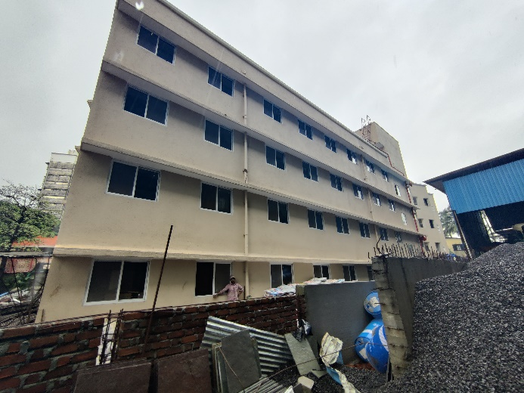
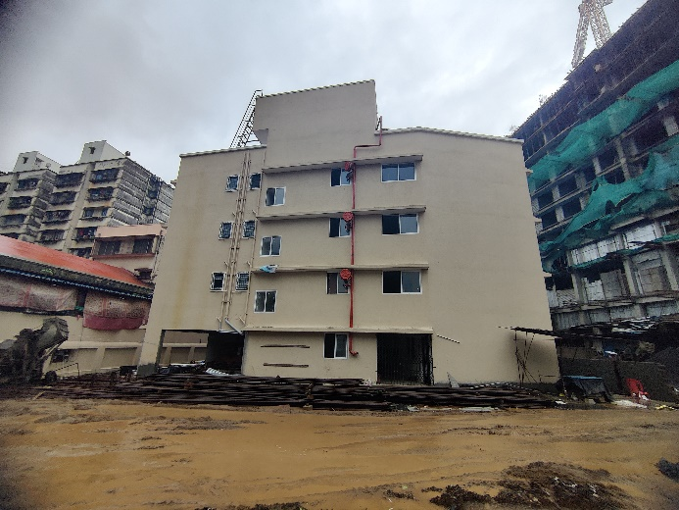

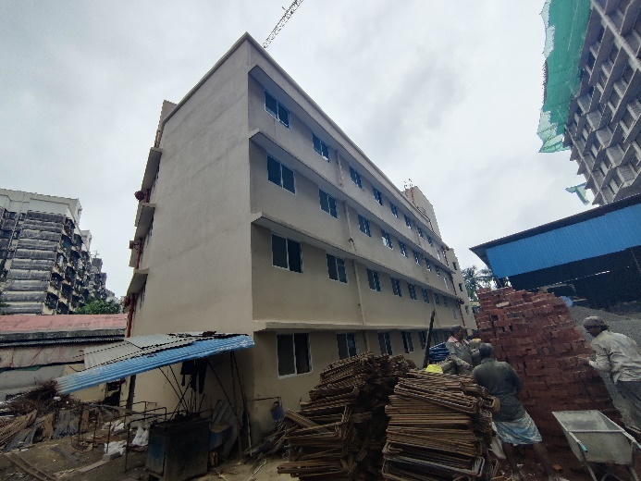
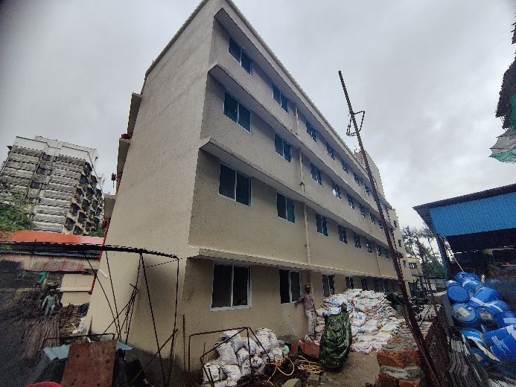
Actual Site Photographs As on 07.01.2025
REHAB BUILDING NO. 1
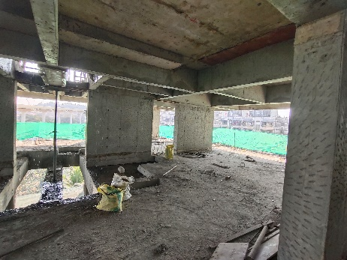
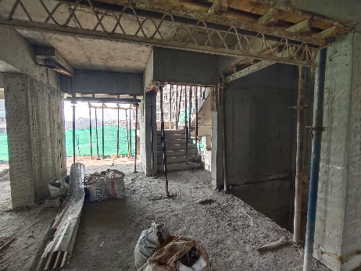
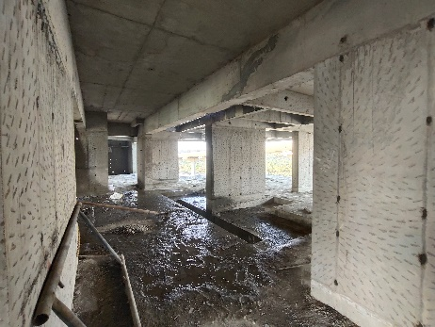
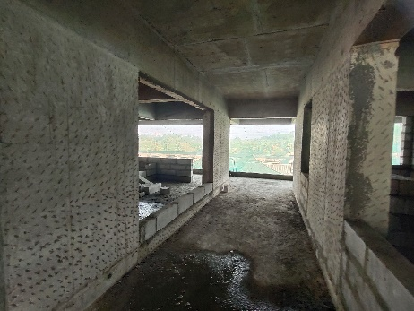
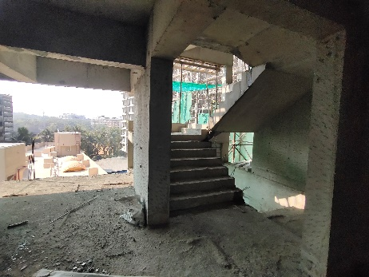
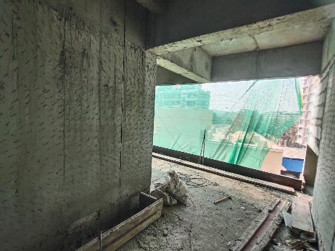
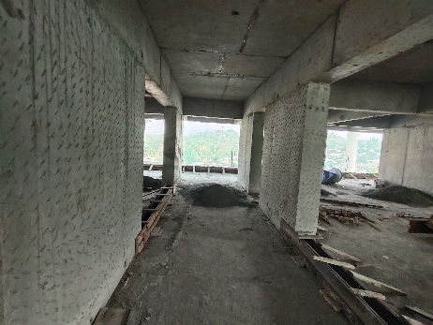
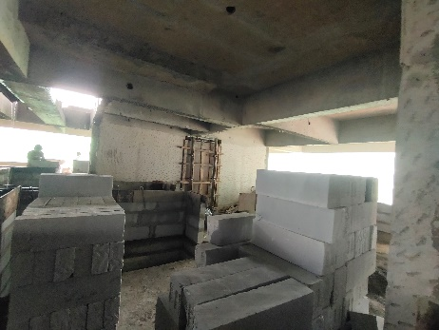
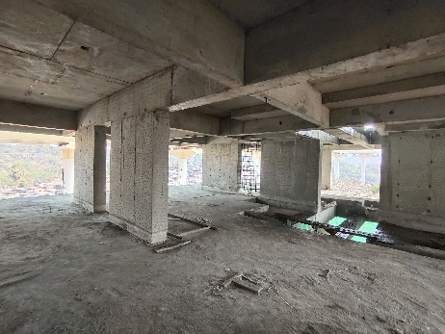
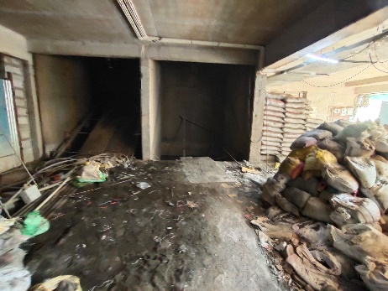
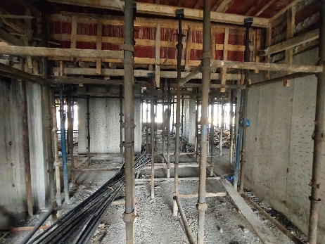
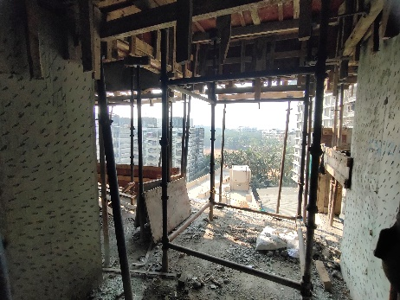
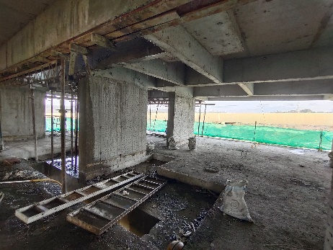
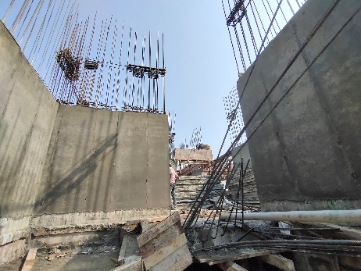
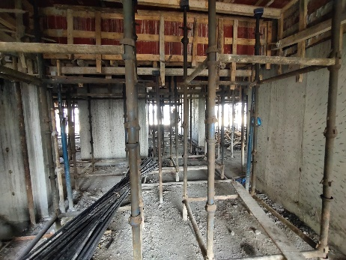
Actual Site Photographs As on 07.01.2025
REHAB BUILDING NO. 1
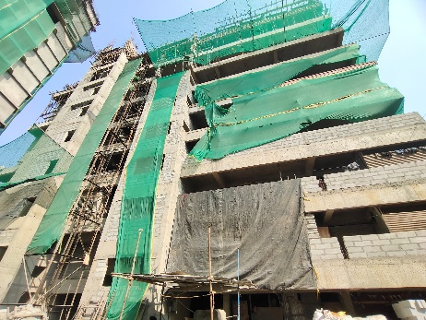
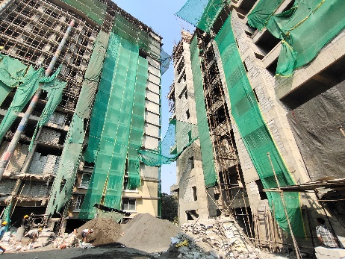
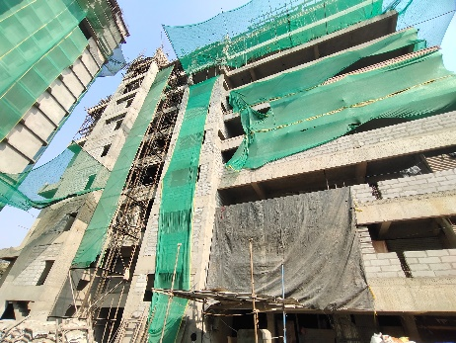
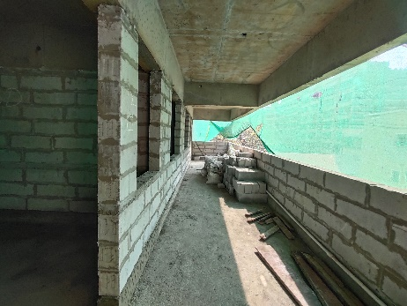
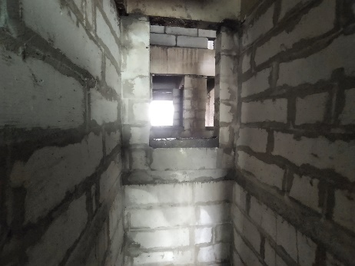
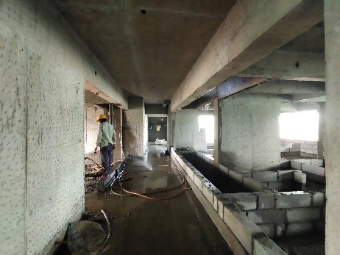
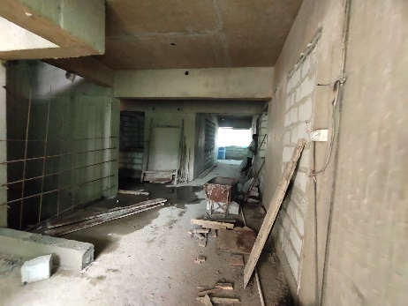
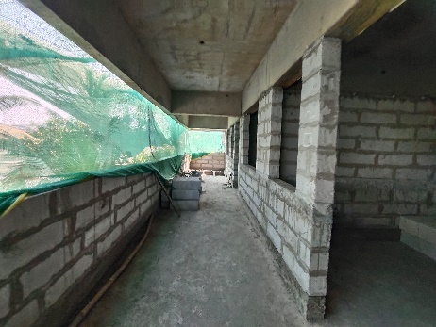
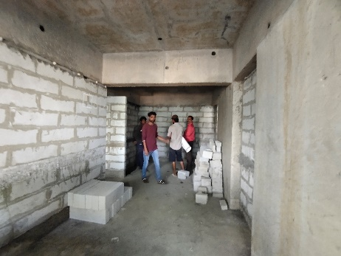
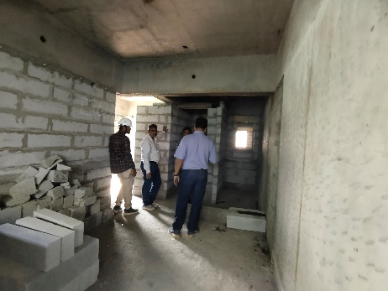
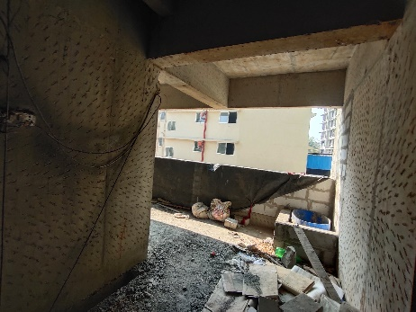
Actual Site Photographs As on 07.01.2025
SALE BUILDING NO. 3
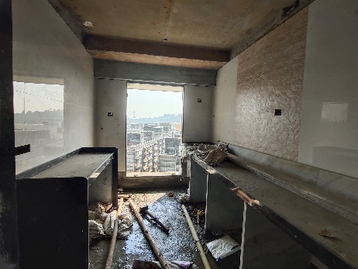
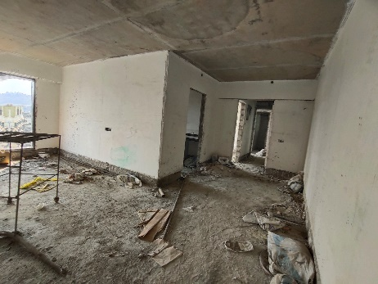
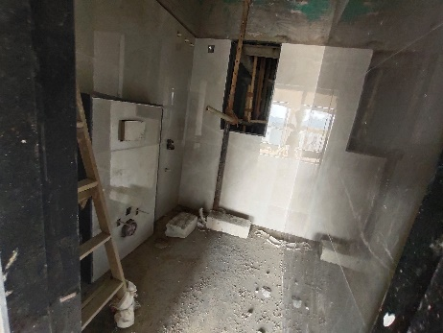

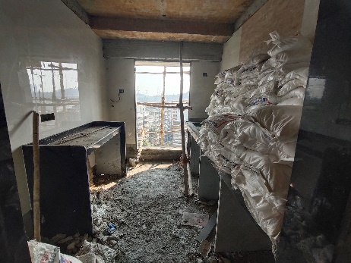
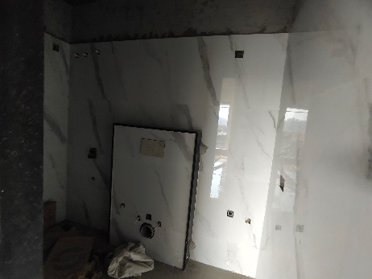
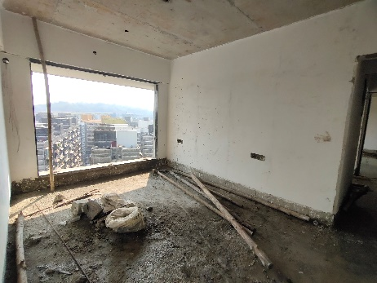

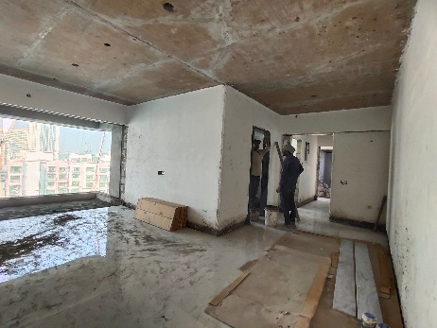
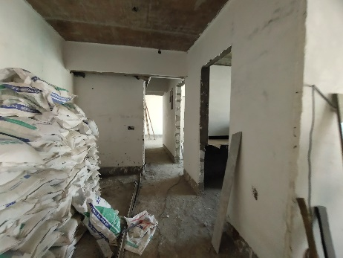
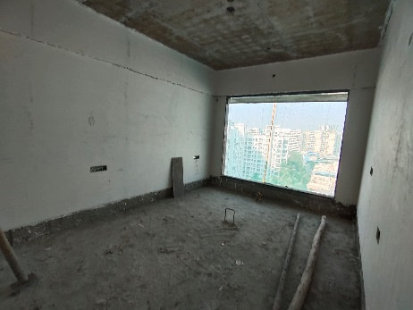

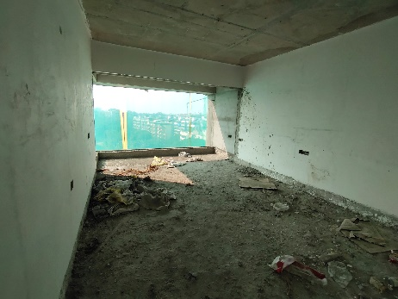
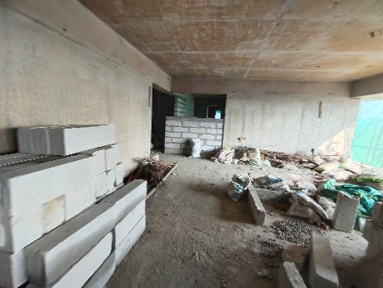
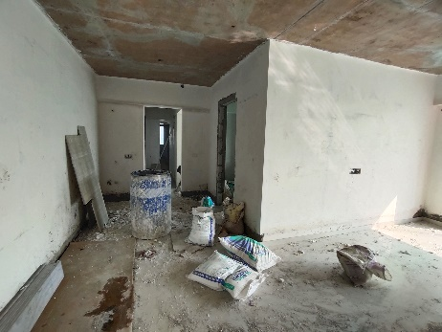
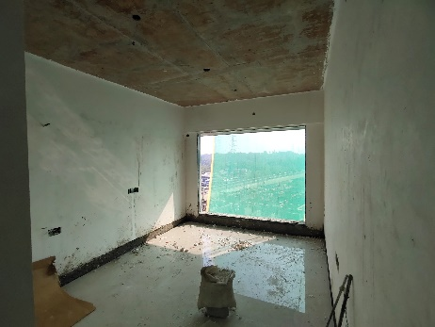
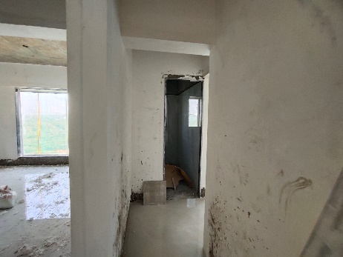
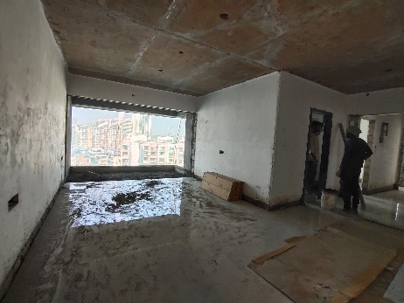
Actual Site Photographs As on 07.01.2025
SALE BUILDING NO. 3
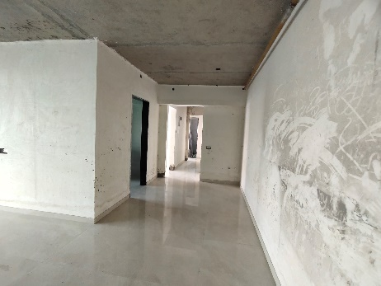
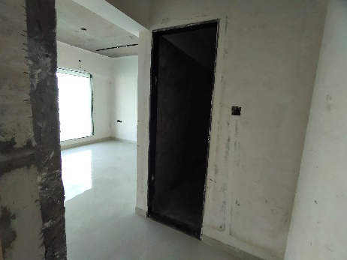
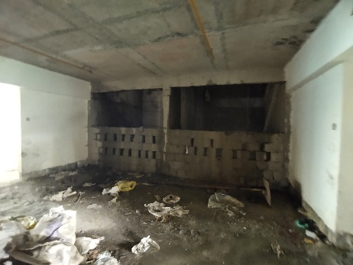

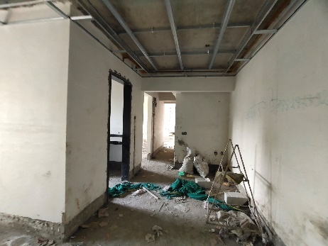
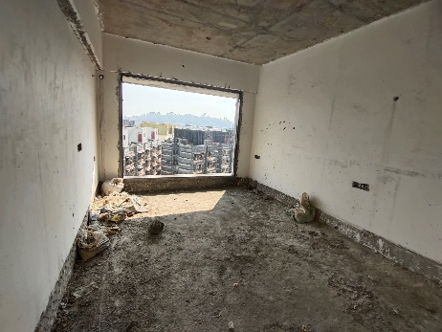
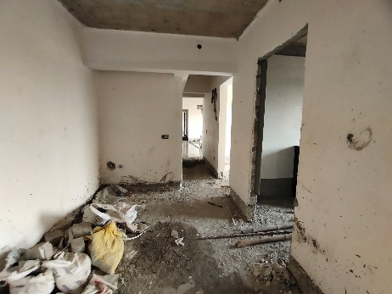
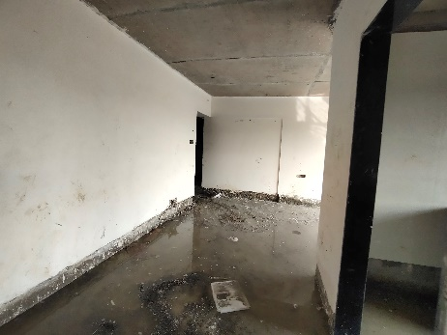
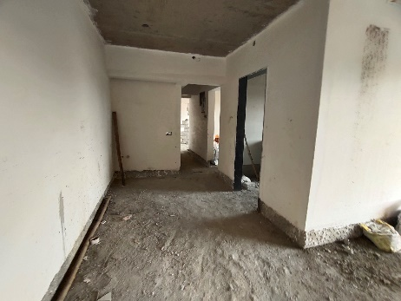
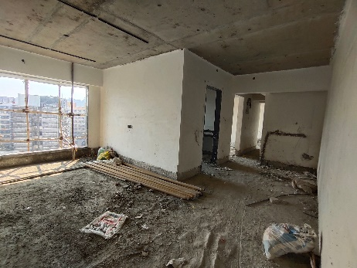
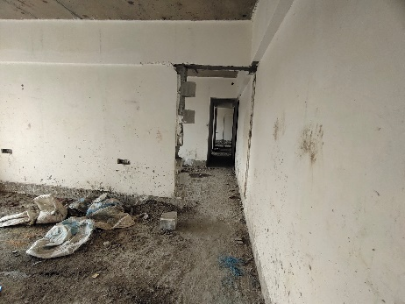
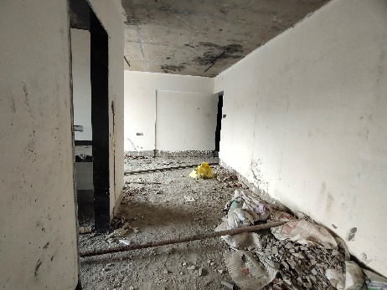
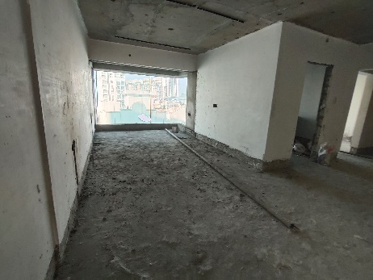
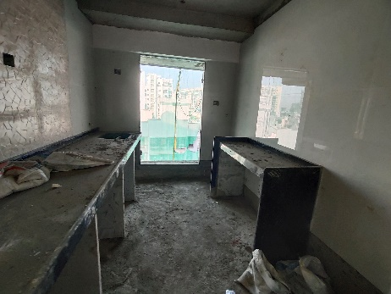
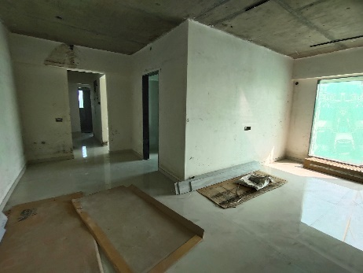
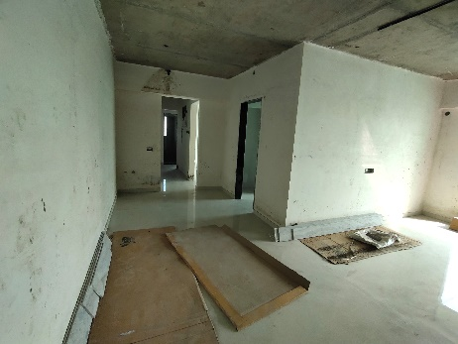
Actual Site Photographs As on 07.01.2025
SALE BUILDING NO. 3
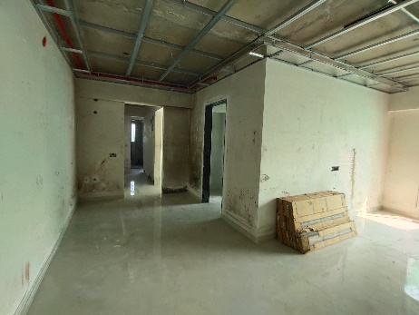
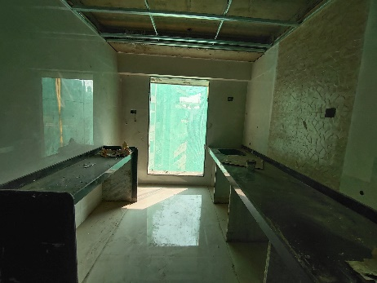
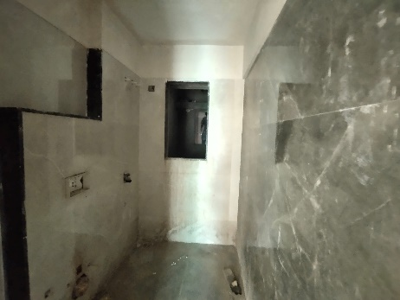

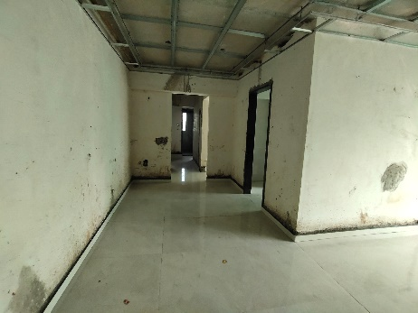
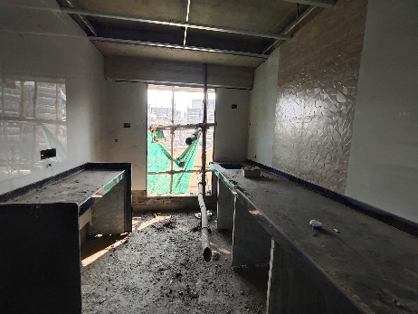
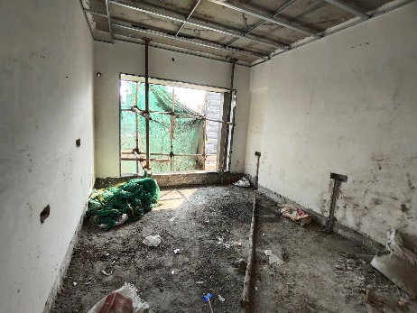
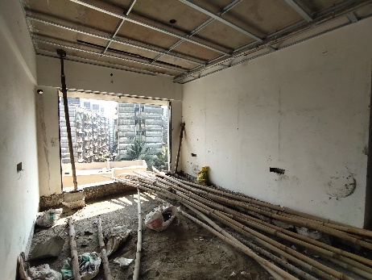
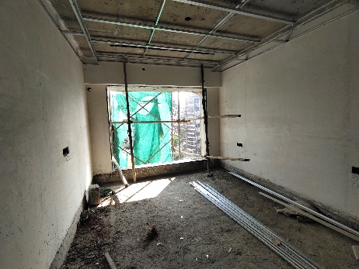
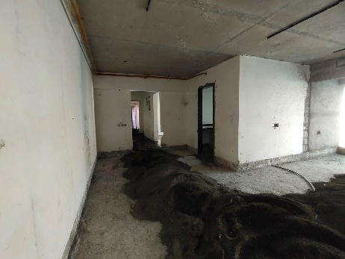
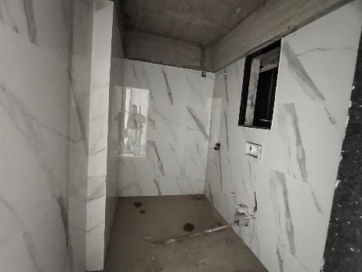
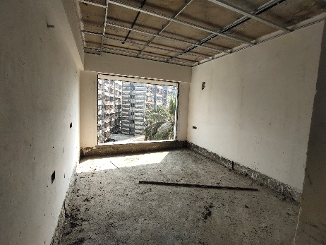
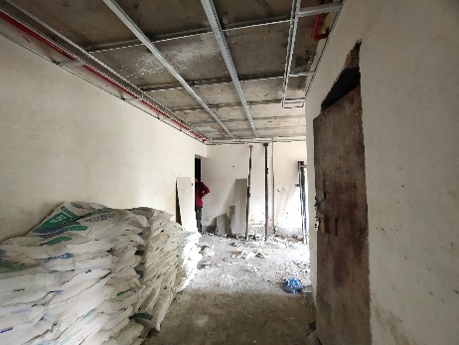
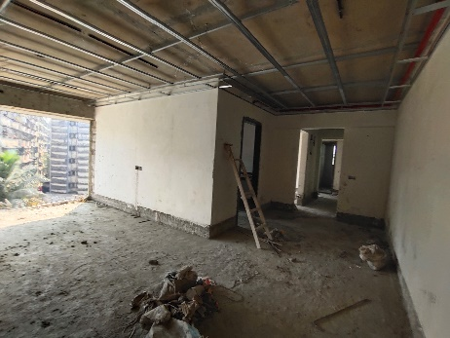
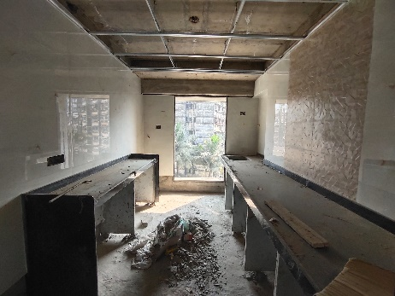
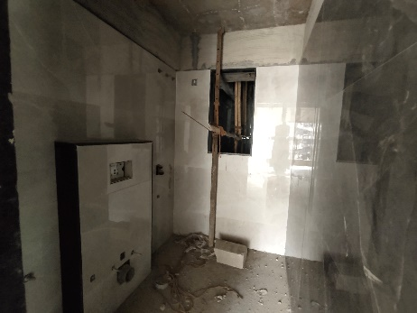
Actual Site Photographs As on 07.01.2025
SALE BUILDING NO. 3
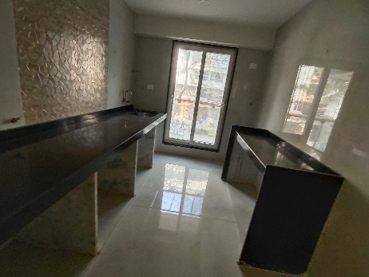
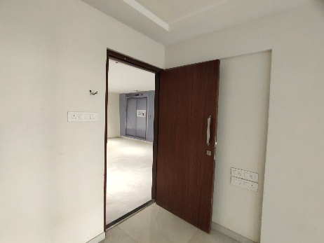
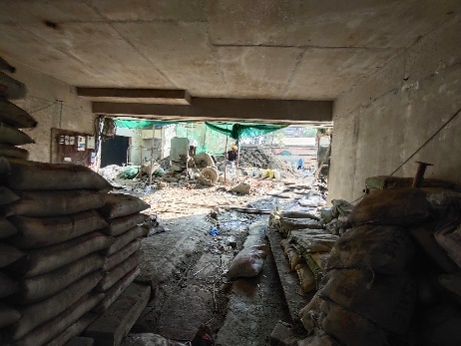
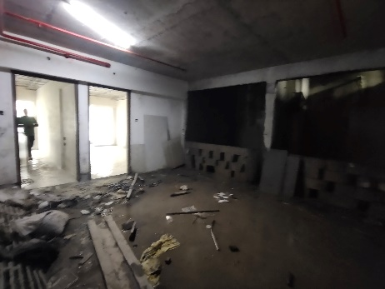
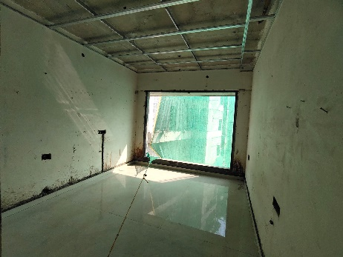
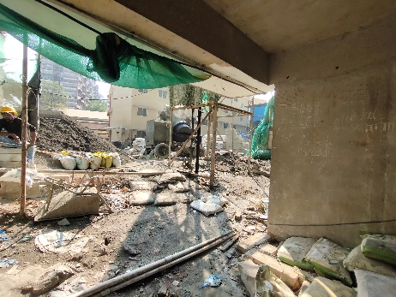
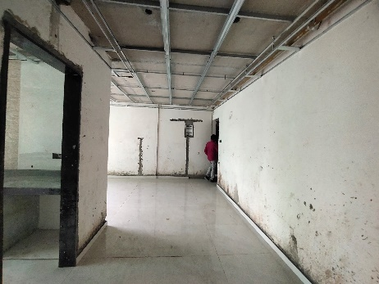
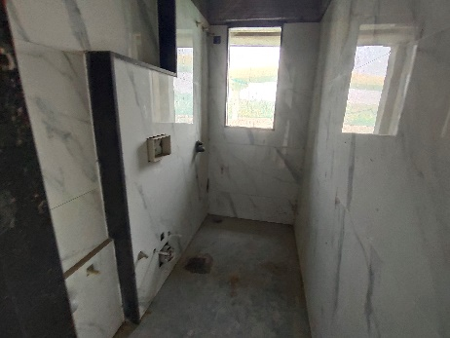
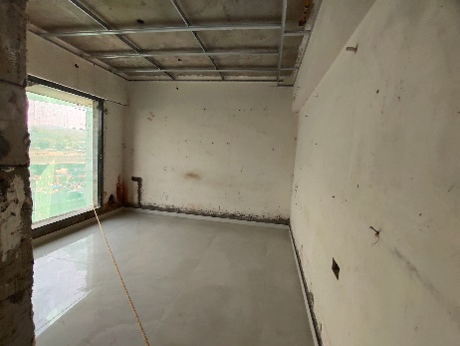
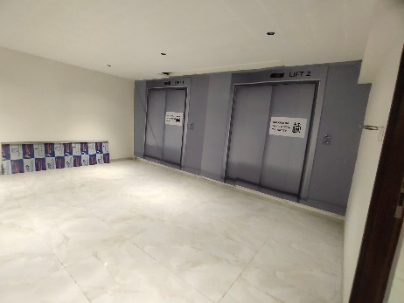
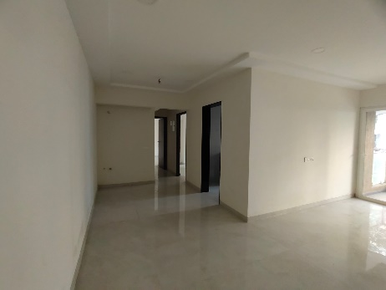
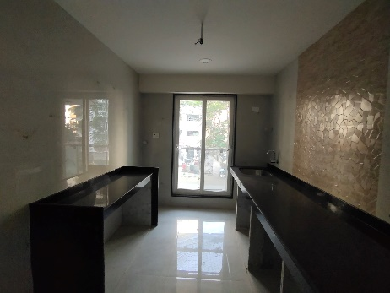
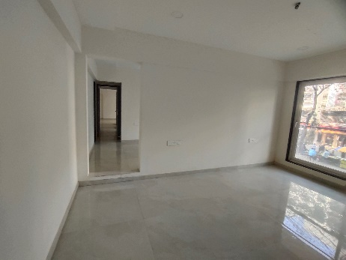
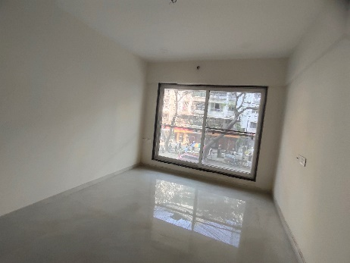
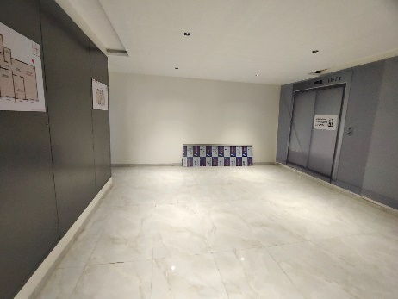
Actual Site Photographs As on 07.01.2025
SALE BUILDING NO. 3
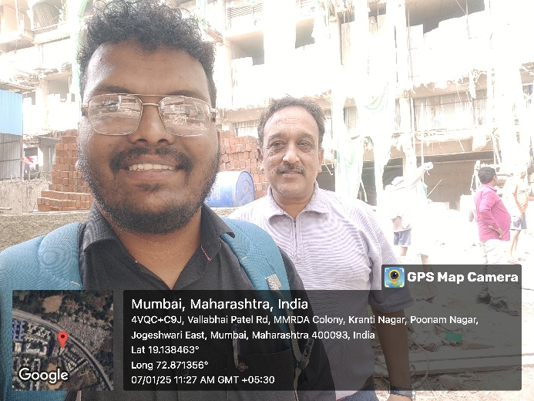
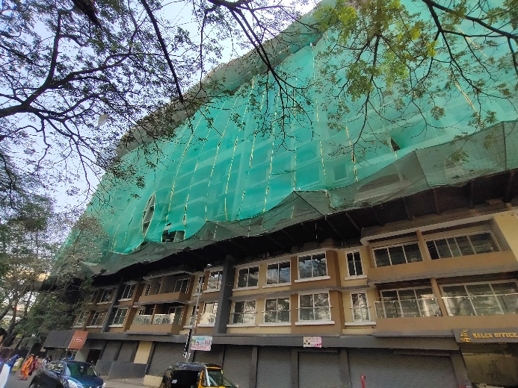
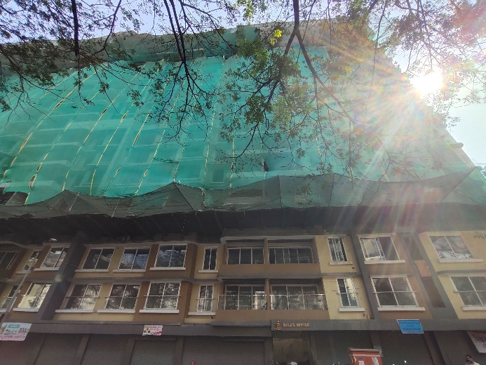
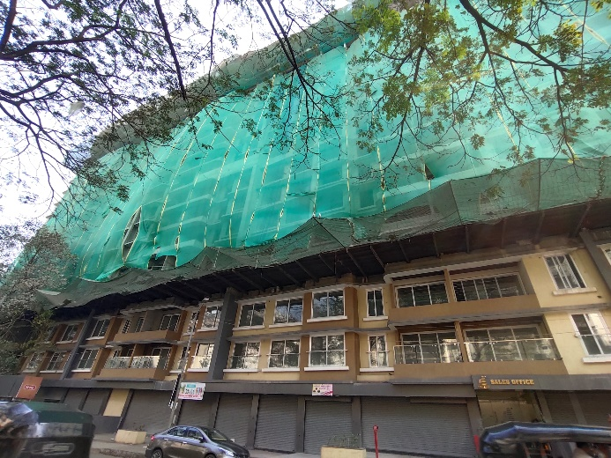
Route Map of the property
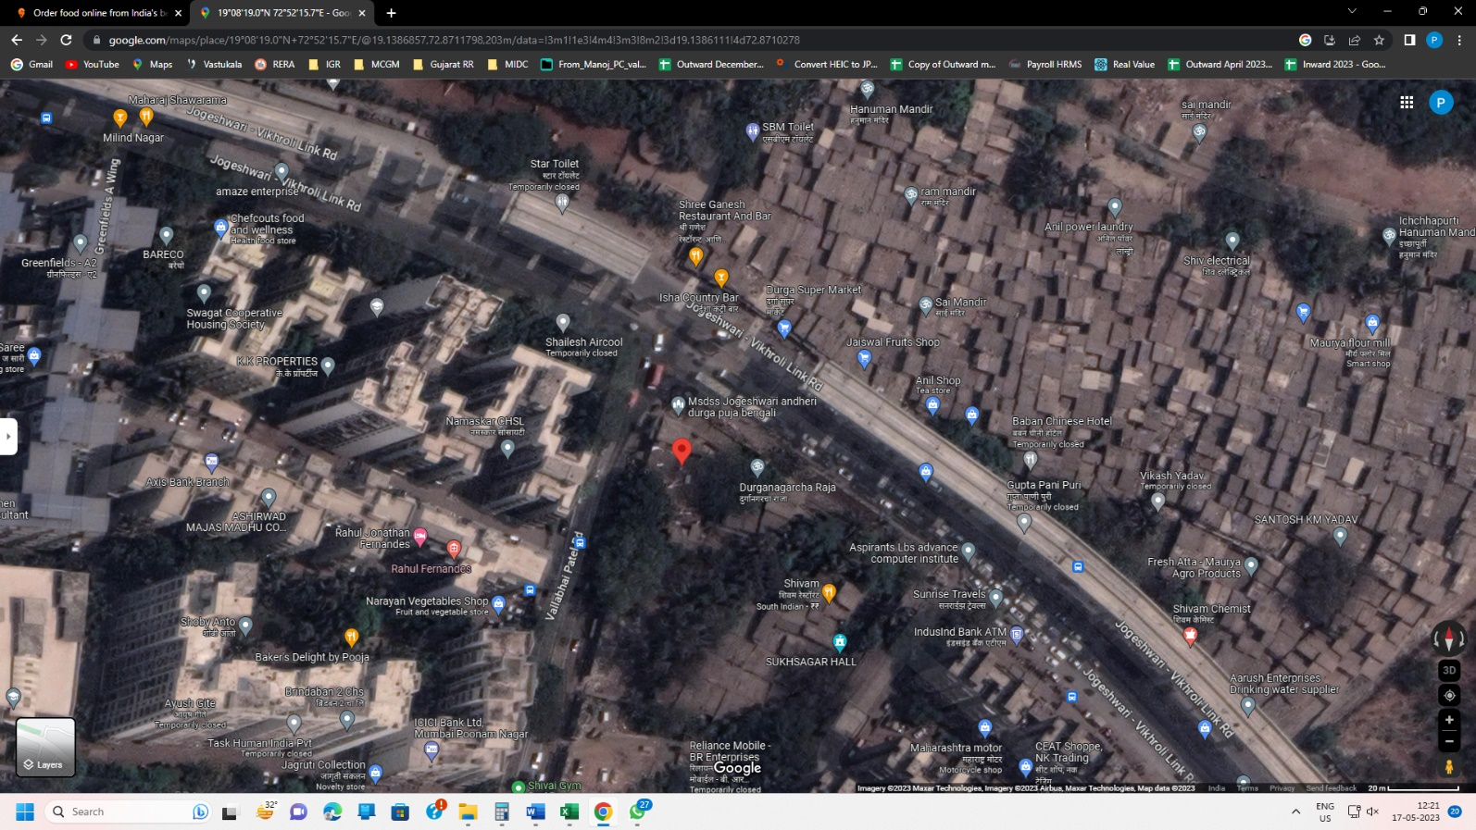
Site u/r

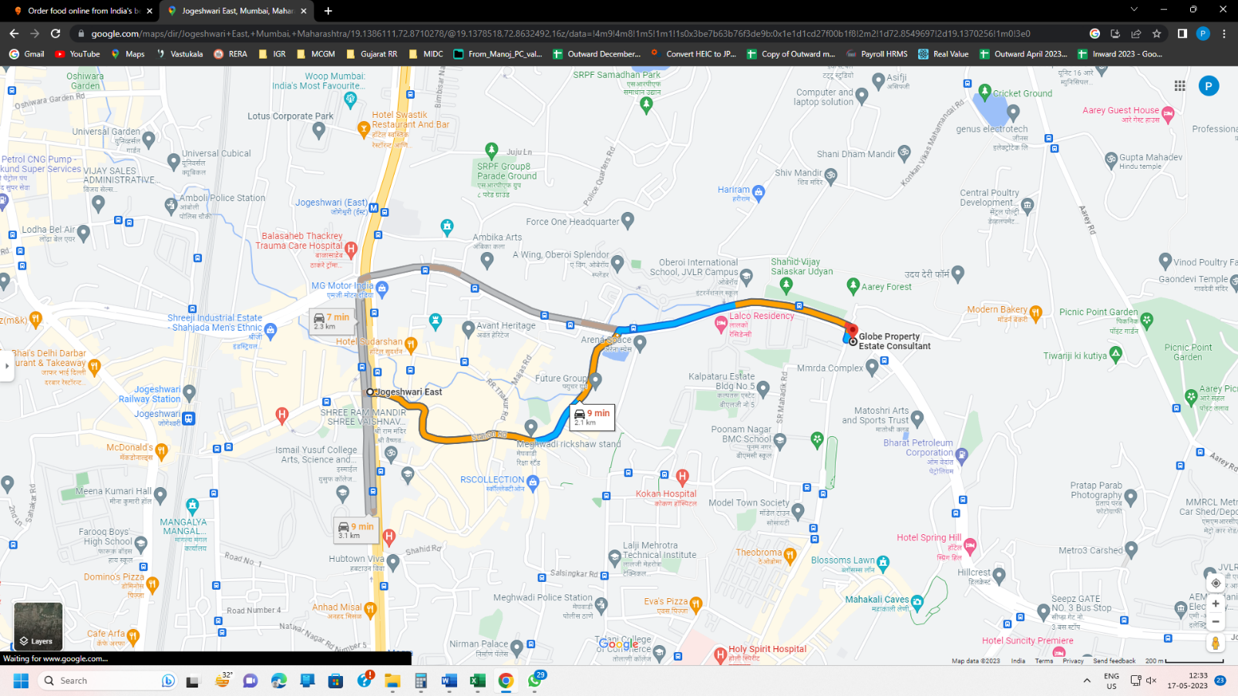

Latitude Longitude: 19°08'19.0"N 72°52'15.7"E

Note: The Blue line shows the route to site from nearest railway station (Jogeshwari – 2.10 Km.)
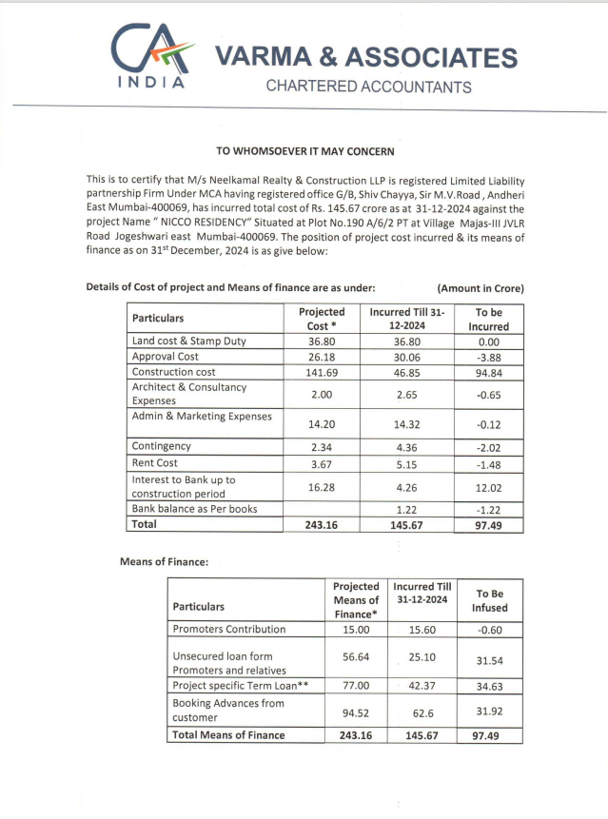
CA Certificate Dated 22.01.2025 cost incurred till 31.12.2024

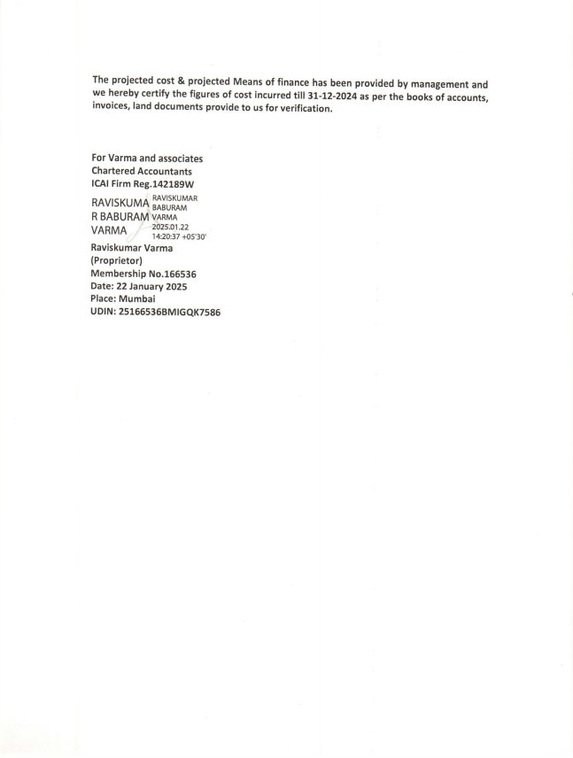
CA Certificate Dated 22.01.2025 cost incurred till 31.12.2024

