5th LENDERS INDEPENDENT ENGINEER REPORT
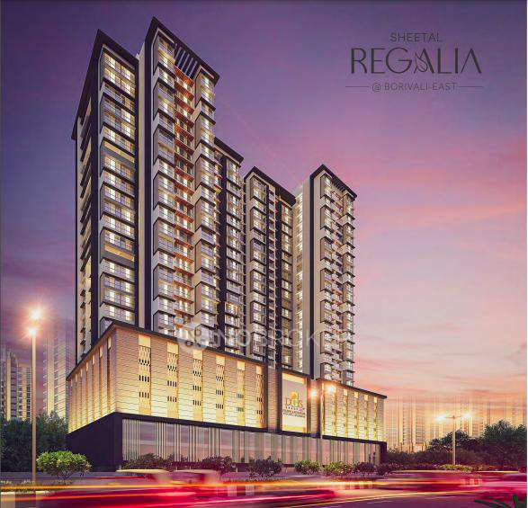

Details of the property under consideration:

Name of Project: “Sheetal Regalia”

"Sheetal Regalia", Proposed S. R. Scheme Commercial cum Residential building on Plot bearing C.T.S. No. 2293/B, Nensey Complex Building, Sant Dnyaneshwar Road & Western Expressway, Village – Dahisar, Borivali (East), Mumbai – 400 066, State – Maharashtra, Country – India

Latitude Longitude: 19°14'17.2"N 72°51'50.9"E

Valuation Prepared for:

State Bank of India
SME Chembur Branch
Unit No. 11, Building No. 11, Ground Floor, Corporate Park, Sion Trombay Road,
Chembur, Mumbai, Pin Code – 400 071, State - Maharashtra, Country – India

Vastu/SBI/Mumbai/10/2024/12015/2308770
23/10-310-PY
Date: - 21.10.2024

FIFTH LENDERS INDEPENDENT ENGINEER REPORT

To,
State Bank of India
SME Chembur Branch
Unit No. 11, Building No. 11,
Ground Floor, Corporate Park,
Sion Trombay Road, Chembur,
Mumbai, Pin Code – 400 071,
State - Maharashtra, Country – India

Subject: Construction of Proposed S. R. Scheme Commercial cum Residential building on Plot bearing C.T.S. No. 2293/B, Nensey Complex Building, Sant Dnyaneshwar Road & Western Expressway, Village – Dahisar, Borivali (East), Mumbai – 400 066, State – Maharashtra, Country – India.

Ref: You’re Request for Lenders Independent Engineer Report of under Construction Building.
Dear Sir,
- As per your instruction, we have inspected the under-construction PTC and Sale Building project situated on plot bearing C.T.S. No. 2293/B, Nensey Complex Building, Sant Dnyaneshwar Road & Western Expressway, Village – Dahisar, Borivali (East), Mumbai – 400 066, State – Maharashtra, Country – India which is being developed by M/s. DGS Township Pvt. Ltd. in order to give the physical progress at site and to certify cost incurred towards project as on 31/12/2023.
- The Construction work as per approved plan was in progress during the site visit on 07th October 2024.
- Status of work:
- For PTC Building (Building Name “Sheetal Sahayog”): 17th Floor slab work is completed.
- For Sales Building (Wing A & B): 11th Residential floor slab shuttering work is in progress, 10th Residential floor slab work is completed. Till 3rd floor block work, plaster work is completed as per previous approved plan.
- As per cost incurred certificate issued by CA Certificate actual total expenditure occurred as on 30/09/2024 is ` 202.18 Cr. for Commercial cum Residential of Sale Building (Wing A & B) as per previous approved plan is proposed of Ground Floor + 1st Commercial Floor + 2nd to 5th Podium Floor + 1st to 21st Habitable Residential Floors and PTC building at different location.
- Overall financial progress as per C.A. certificate including land cost as on 30/09/2024 is 69.76% estimated cost of project.
- Overall Physical progress of the sale building construction as on 07/10/2024 is 52.29% as per physical site inspection.

- Overall Physical progress of the sale building construction including Mivan Material on Site as on 07/10/2024 is 59.68%.

- Overall Physical progress of the sale building construction including Mivan Material & Other Material on Site as on 07/10/2024 is 69.32%.

- Construction Cost of the sale building construction including Mivan Material, other material on site & Advance payment to the Vendors till 30/06/2024 is 71.00 % as per bills.

- Overall Physical progress of the PTC building construction as on 07/10/2024 is 50.00% as per physical site inspection.

- Commercial cum Residential Sale Building (A & B) amended approved plan is propsoed of Ground Floor + 1st & 2nd Commercial Floor + 1st to 3rd Podium Floor + 4th E – level Floor + 1st to 20th (Part) Habitable Floor Plan No. N / PVT / 0105 / 20220623 / AP / S dated 04.04.2024 issued by Slum Rehabiliation Authority (SRA).

- The construction area of the building is increase by 49,956.39 Sq. Ft. as per the amended approved plan.

DECLARATION
- The information furnished in the report is based on our 5th site visit Dated 07/10/2024 & Document Provided by Client.
- Vastukala 4th LIE Report of the project dated 03/08/2024.
- Vastukala Project Report of the project dated 17/06/2023.
- Vastukala Cost Vetting Report dated 12/09/2023.
- I have no direct and indirect interest in the property examined for report.
- I have not been found guilty of misconduct in my professional capacity.

Manoj B. Chalikwar
Registered Valuer
Chartered Engineer (India)
Reg. No. IBBI/RV/07/2018/10366

Encl.: LIE report

Purpose & Methodology
• State Bank of India Banks and financial institutions require monitoring & an independent review of the progress of the sanctioned projects
VCIPL undertakes such study to independently review the progress of the project and put forward a comprehensive analysis

Advantages:
- Assurance on present practices
- Identification of risk
- Analyzing the performance of third parties
- Recommendations

The Methodology
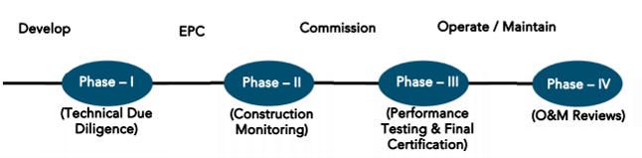
FIFTH LENDERS INDEPENDENT ENGINEER REPORT
OF
"SHEETAL REGALIA"

"Sheetal Regalia", Proposed S. R. Scheme Commercial cum Residential building on Plot bearing
C.T.S. No. 2293/B, Nensey Complex Building, Sant Dnyaneshwar Road & Western Expressway,
Village – Dahisar, Borivali (East), Mumbai – 400 066, State – Maharashtra, Country – India

Latitude Longitude: 19°14'17.2"N 72°51'50.9"E

NAME OF DEVELOPER: M/s. DGS Township Pvt. Ltd.
Pursuant to instructions from State of India, SME Chembur Branch, Chembur we have duly visited, inspected, surveyed & assessed the above said property on 07th October 2024 to determine the fair & reasonable market value of the said property/project as on Quarter ending 30th September 2024 for LIE purpose.

1. Location Details:
Proposed S. R. Scheme Commercial cum Residential building on Plot bearing C.T.S. No. 2293/B, Nensey Complex Building, Sant Dnyaneshwar Road & Western Expressway, Village – Dahisar, Borivali (East), Mumbai – 400 066. It is about 1.60 Km. travelling distance from Borivali (East) Railway station. Surface transport to the property is by buses, taxis & private vehicles. The property is in developed locality. All the amenities like shops, banks, hotels, markets, schools, hospitals, etc. are all available in the surrounding locality. The area is higher middle class & developed.

2. Developer Details:
Name of builder | M/s. DGS Township Pvt. Ltd.
Project Rera Registration Number | P51800048237
Registered office address | DGS house, 1st floor, Sheetal Krupa, Aarey Road, Walawalkar Street, Goregaon (E), Mumbai – 400 063, State - Maharashtra, Country – India
Contact details | Contact Person:  Mr. Prabudh Khandelwal (Consultants)  Mobile No. 7738001775  Mr. Deep Shah (Consultants)  Mobile No. 7977861026  Mr. Arvind Dwidedv (Project Manager)  Mobile No. 9164498569
E – mail ID and website
3. Boundaries of the Property:
Direction | Particulars
On or towards North | Shree Adinath Tower
On or towards South | Shree Jagadeeshwari Temple
On or towards East | Sant Dnyaneshwar Road
On or towards West | Western Expressway

Introduction
As per Information on site M/s. DGS Township Pvt. Ltd. has acquired land by Developer Agreement dated 25.03.2021 through registered agreement vide No. BRL-9-4505-2021 dated 26.03.2021 admeasuring area is 5,669.67 Sq. M. bearing CTS No. 190/A/6/2 (Part). For the Proposed Commercial cum Residential (Rehab cum Sale) Building.

Area Statement:

Land:
Date | Particular | Area in Sq. M.
21.12.2018 | CTS No. 190/A/6/2 | 5,669.67
TOTAL |  | 5,669.67

- Copy of Developer Agreement dated 25.03.2021 between M/s. Nensey Complex Building Co-operative Housing Society Ltd. (The Society) and M/s. DGS Township Pvt. Ltd. (The Developers) through registered agreement vide No. BRL-9-4505-2021 dated 26.03.2021.
- Copy of Supplementary Agreement dated 15.07.2022 between M/s. Nensey Complex Building Co-operative Housing Society Ltd. (The Society) and M/s. DGS Township Pvt. Ltd. (The Developers) through registered agreement vide No. BLR-9-11639-2022 dated 15.07.2022.

Building Area:

As per Approved Plan:
A | AREA OF PLOT | Regu. 33 (11) |  | TOTAL
1 | Area Of Plot | 5599.00 |  | 5599.00
2 | Deduction For
A | Road Set Back Area | Nil |  | Nil
B | 5% Amenity Plot area to MCGM as Pos | 279.95 |  | 279.95
C | Total (= a + b) | 279.95 |  | 279.95
3 | Balance Area Plot (1-2c) | 5319.05 |  | 5319.05
4 | NET Area Plot for FSI Purpose | 5319.05 |  | 5319.05
5 | Maximum Permissible FSI on Plot | 4.00 |  | -
6 | Maximum Permissible BUA on Plot | 21276.20 |  | 22321.20
7 | Basic Zonal FSI / BUA | 5319.05 |  | 5319.05
8 | PERMISSIBLE BUILT-UP AREA AS PER REGULATION 30(C) PROTECTED DEVELOPMENT) EXISTING BLDG (K)= 3360.04 SQ.MT (As Per Approved Plan U/No. CE/1537/BSII/A/R Dtd. 05.08.1974) EXISTING BLDG (L) = 4027.87 SQ.MT (As Per Approved Plan U/No. CE/1538/BSII/A/R OCC Granted Dtd. 31.05.1975) TOTAL BUA (BLDG-K+L) = 7387.91 SQ.MT  (7387.91-5319.05 = 2068.86 SQ.MT) | 2068.86 |  | 2068.86
9 | Balance FSI Potential (=7-8-9) | 13888.29 |  | 13888.29
10 | Sale Bua For Against PTC Area = 6944.145  (=110 Above X 50%) | 6944.15 |  | 6944.15
11 | Sale Incentive Bua Under Reg. 33(11)  (= 10 Above X 50%) | 6944.15 |  | 6944.15
12 | Details of FSI Availed as Per Reg. 33 (11) Of DCPR 2034 | ZONAL | INCENTIVE | SALE | TOTAL
A | Permissible BUA U/REG. 33(11) (Before clubbing) | 5319.05 | 6944.15 | 6944.15 | 19207.34
B | Permissible BUA U/REG. 33(11) (After clubbing) | 12263.195 |  |  | 12263.195
C | Permissible Built-Up Area as Per Regulation 30 (C)  (Protected Development) | 2068.86 |  |  | 2,068.86
D | TOTAL PERMISSIBLE BUA (13b + 13c) | 14332.055 |  | 6944.145 | 21276.20
14 | Total permissible Bua Proposed | 21276.20
 | Proposed Built Up Area | 21276.20
A | PTC Built Up Area
B | Existing Tenant Built Up Area = 7225.36
C | Sale Built Up Area = 14050.84
B | Details of residential / non residential areas | 21276.20
1 | Purely residential built up area | 16502.68
A | PTC Built Up Area
B | Existing Tenant Built Up Area = 7225.36
C | Sale Built Up Area = 9277.32
2 | Remaining Non – residential builtup area | 4773.52
A | PTC built up area
B | Temple built up area = 65.45
C | Sale Comm. Built up area = 4708.07
3 | Total Resi. & Non Resi. B. U. Area (B1+ B2) | 21276.20
C | Detail of FSI availed as per DCR 35 (4) | 21276.20
1  I  II  III | Fungible BUA permissible for pureluy Resi. & Comm.  Sale resi permissible fungible area (b1(c X 35%))  (9277.32 X 35%) = 3247.06  Existing Resi. Permissible Fungible Area (B1 9b X 35%))  (7225.36 X 35%) = 2528.87  Sale comm permssible fungible area (B2 (C X 35%))  (4773.52 X 35%) = 1670.73 | 7446.66
2  I  II  III | Fungible BUA Proposed for purely Res. & Comm  Proposed sale fungible BU Area = 3261.30  Proposed existing tnt fungible BU Area = 2343.32  Proposed Sale comm. Fungible BU area = 1647.82 | 7252.44
3 | Total Fungible Built Up Area vide DCR 35 (4) (C2) | 7252.44
4 | Total Gross Built Up Area proposed (14 + C3) | 28528.64
D | Tenement Statement
I | Proposed Area (item B1 above)
II | Less Deduction of Non resi Area (Shop, etc.)
III | Area avaiable for tenements (I minus II)
IV | Tenements permissible (density of tenements / Hectare)
V | Tenements Proposed
VI | Tenements Existing
 | Total Tenements on the plot
E | Parking Statement
I | Parking required by regulations for  Car  Scooter / Motor cycle  Outsiders (Visitors)
II | Covered garage permissible
III | Covered Garages Proposed  Car  Scooter / Motor cycle  Outsiders (Visitors)
14 | Total Parking provided
F | Transport Vehicles Parking
I | Spaces for transport vehicles parking required by regulations
II | Total no. of transport vehicles parking spaces provided | 1,971.99

Construction Area As per Previous Approved Plan
Sr. | Floor | Total Construction Area in Sq. Ft.
1 | Ground Floor | 28,543.54
2 | 1st Commercial Floor | 29,453.21
3 | 2nd Podium Floor | 36,741.07
4 | 3rd Podium Floor | 36,741.03
5 | 4th Podium Floor | 36,741.03
6 | 5th Podium Floor | 6,424.28
7 | 1st Habitable Floor | 14,132.49
8 | 2nd Habitable Floor | 17,783.53
9 | 3rd Habitable Floor | 17,783.53
10 | 4th Habitable Floor | 17,788.69
11 | 5th Habitable Floor | 17,788.69
12 | 6th Habitable Floor | 17,836.92
13 | 7th Habitable Floor | 17,897.95
14 | 8th Habitable Floor | 14,356.49
15 | 9th Habitable Floor | 18,014.09
16 | 10th Habitable Floor | 18,125.61
17 | 11th Habitable Floor | 18,125.61
18 | 12th Habitable Floor | 18,125.61
19 | 13th Habitable Floor | 18,125.61
20 | 14th Habitable Floor | 18,125.61
21 | 15th Habitable Floor | 17,205.39
22 | 16th Habitable Floor | 18,125.61
23 | 17th Habitable Floor | 18,125.61
24 | 18th Habitable Floor | 18,125.61
25 | 19th Habitable Floor | 18,125.61
26 | 20th Habitable Floor | 18,125.61
27 | 21st Habitable Floor | 14,873.16
28 | Terrace / OHT | 4,721.31
TOTAL |  | 5,46,082.46

Construction Area As per Amended Approved Plan
Sr. | Floor As per Amended approved plan | Total Construction Area in Sq. Ft.
1 | Ground Floor | 33,799.93
2 | 1st Commercial Floor | 34,362.02
3 | 2nd Commercial Floor | 34,702.92
4 | 1st Podium Floor | 37,280.58
5 | 2nd Podium Floor | 37,280.58
6 | 3rd Podium Floor | 37,280.58
7 | 4th E - Level Floor | 34,900.55
8 | 1st Habitable Floor | 16,459.99
9 | 2nd Habitable Floor | 16,459.99
10 | 3rd Habitable Floor | 16,459.99
11 | 4th Habitable Floor | 16,504.55
12 | 5th Habitable Floor | 16,956.85
13 | 6th Habitable Floor | 17,038.23
14 | 7th Habitable Floor | 17,038.23
15 | 8th Habitable Floor | 17,885.57
16 | 9th Habitable Floor | 18,037.45
17 | 10th Habitable Floor | 18,037.45
18 | 11th Habitable Floor | 18,037.45
19 | 12th Habitable Floor | 18,037.45
20 | 13th Habitable Floor | 18,037.45
21 | 14th Habitable Floor | 18,037.45
22 | 15th Habitable Floor | 18,231.85
23 | 16th Habitable Floor | 18,037.45
24 | 17th Habitable Floor | 18,037.45
25 | 18th Habitable Floor | 18,037.45
26 | 19th Habitable Floor | 18,037.45
27 | 20th (Part) Habitable Floor | 8,222.40
28 | Terrace / OHT | 4,799.56
TOTAL |  | 5,96,038.85

NOTE:
- Construction Area is Increase by 49,956.39 Sq. Ft. in Amended Approved Plan
- Amended Approved Plan is sanctioned for Ground Floor + 1st & 2nd Commercial Floor + 1st to 3rd Podium Floor + 4th E – Level Floor + 1st to 20th (Part) Habitable Residential Floors
- As bank has sanctioned the loan as per previous approved plan upto Ground Floor + 1st Commercial Floor + 2nd to 5th Podium Floor + 1st to 21st Habitable Residential Floors.
- Hence for the LIE report we have considered as Ground Floor + 1st Commercial Floor + 2nd to 5th Podium Floor + 1st to 21st Habitable Residential Floors for Plinth Calculation.

List of Approvals:
- Copy of Sale Building IOA Letter No. R-N/PVT/0105/20220623/AP/S dated 19.09.2022 issued by Slum Rehabilitation Authority (SRA).
- Copy of 1st Sale Building Approved Plan No. RN/PVT/0105/20220623/AP/S dated 13.02.2023 issued by Slum Rehabilitation Authority (SRA).
Approved upto:
Wing A & B: Ground Floor + 1st Commercial Floor + 2nd to 5th Podium Floor + 1st to 16th Habitable Residential Floors
- Copy of Amended Sale Building Approved Plan No. N / PVT / 0105 / 20220623 / AP / S dated 04.04.2024 issued by Slum Rehabilitation Authority (SRA).
Approved upto:
Wing A & B: Ground Floor + 1st & 2nd Commercial Floor + 1st to 3rd Podium Floor + 4th E – Level Floor + 1st to 20th (Part) Habitable Residential Floors
- Copy of Sale Building Concession / Architect Drawing Plan dated 23.12.2022 issued by Slum Rehabilitation Authority (SRA).
Sanctioned Upto:
Wing A & B: Ground Floor + 1st Commercial Floor + 2nd to 5th Podium Floor + 1st to 21st Habitable Residential Floors
- Copy of 1st Sale Building Commencement Certificate No. RN/PVT/0105/20220623/AP/S dated 04.10.2022 issued by Slum Rehabilitation Authority (SRA).
(This CC is endorsed for the work for Plinth Floor)
- Copy of 2nd Sale Building Commencement Certificate No. RN/PVT/0105/20220623/AP/S dated 13.02.2023 issued by Slum Rehabilitation Authority (SRA).
(This CC is re – endorsed as per approved amended plan dated 13.02.2023)
- Copy of 3rd Sale Building Commencement Certificate No. RN/PVT/0105/20220623/AP/S dated 12.05.2023 issued by Slum Rehabilitation Authority (SRA).
(This CC is further extended from Ground to 5th Amenity floor, 1st to 5th upper Resi. Floor of “A Wing’ & 1st to 4th Upper Resi. Floor of ‘B Wing’ as per approved amended plan dated 13.02.2023)
- Copy of 4th Sale Building Commencement Certificate No. RN/PVT/0105/20220623/AP/S dated 29.12.2023 issued by Slum Rehabilitation Authority (SRA).
(This CC is further extended from Ground to 5th Amenity floor, 1st to 21st (pt.) upper Resi. Floor of “A Wing’ & 1st to 21st (Pt.) Upper Resi. Floor & (including OHWT & LMR) of ‘B Wing’ as per approved amended plan dated 29.12.2023)
- Copy of 5th Sale Building Commencement Certificate No. RN/PVT/0105/20220623/AP/S dated 10.04.2024 issued by Slum Rehabilitation Authority (SRA).
(This CC is re endersoed as per approved amended plan dated 04.04.2024 Ground Floor + 1st & 2nd Commercial Floor + 1st to 3rd Podium Floor + 4th E – Level Floor + 1st to 20th (Part) Habitable Residential Floors)
- Copy of Fire NOC Certificate No. FB/HR/R-4/140 dated 23.09.2022 issued Municipal Corporation of Greater Mumbai, Mumbai Fire Brigade.
- Copy of Height Clearance Certificate No. JUHU/WEST/B/112521/637084 dated 14.12.2021 valid upto 13.12.2029 issued by Airports Authority of India.
- Copy of Environmental Clearance Certificate No. SIA/MH/MIS/285552/2022 dated 30.05.2023 issued by State Environment Impact Assessment Authority (SEIAA), Maharashtra.
- Copy of Pollution Control Certificate No. Format1.0/CC/UAN No. 0000161904/CE/2305001444 dated 19.05.2023 issued by Maharashtra Pollution Control Board.

LEVEL OF COMPLETION:
For PTC Building (Building Name “Sheetal Sahayog”): 8th Floor slab work is completed.
For Sales Building (Wing A & B): 6th Residential floor slab work is completed. Till 2nd floor block work, plaster work is completed as per previous approved plan.

PTC Buidling
Sr. | Floor No. | Construction Area in Sq. Ft. | Work Completion as per 4th LIE Report | Work Completion as on 07.10.2024
1 | Ground Floor + 1st to 23rd Floor | 74,747.00 | 8th floor slab work is completed | 17th floor slab work is completed
Total |  | 74,747.00
As per Architect Letter promoters have to hand-over built-up area / construction area equivalent to 6944.145 Sq. M. or 74,747 Sq. Ft. to SRA Authority in the form of PTC (Project Transit Camp). PTC building named is Sheetal Sahayog.

Sales Building (Wing A & B)
Sr. | Floor No. | Construction Area in Sq. Ft. | Completed Area in Sq. Ft. | Work Completion as per 4th LIE Report | Work Completion as on 07.10.2024
1 | Excavation & Shore Piling |  |  | Work is Completed | Work is completed
2 | Ground Floor | 28,543.54 | 28,543.54 | Slab Work, Block work, Plaster work, flooring, Door & Windows, Electrical & Plumbing, firefighting works are completed (Sales Offices) | Slab Work, Block work, Plaster work, flooring, Door & Windows, Electrical & Plumbing, firefighting works, Lift, Staircase flooring are completed (Sales Offices)
3 | 1st Comm. Floor | 29,453.21 | 29,453.21 | Slab Work, Block work, Plaster work, flooring, Door & Windows, Electrical & Plumbing, are completed (Sales Offices) | Slab Work, Block work, Plaster work, flooring, Door & Windows, Electrical & Plumbing, firefighting works, Lift, Staircase flooring are completed
4 | 2nd Podium Floor | 36,741.07 | 36,741.07 | Slab Work, block work, gypsum, plaster, flooring work is completed | Slab Work, Block work, Plaster work, flooring, Door & Windows, Electrical & Plumbing, firefighting works, Lift, Staircase flooring are completed
5 | 3rd Podium Floor | 36,741.03 | 36,741.03 | Slab Work is completed | Slab Work is completed
6 | 4th Podium Floor | 36,741.03 | 36,741.03 | Slab Work is completed | Slab Work is completed
7 | 5th Podium Floor | 6,424.28 | 6,424.28 | Slab Work is completed | Slab Work is completed
8 | 1st Floor | 14,132.49 | 14,132.49 | Slab Work is completed | Slab Work & Block work is completed
9 | 2nd Floor | 17,783.53 | 17,783.53 | Slab work is completed | Slab Work & Block work is completed
10 | 3rd Floor | 17,783.53 | 17,783.53 | Slab work is completed | Slab Work & Block work is completed
11 | 4th Floor | 17,788.69 | 17,788.69 | Slab work is completed | Slab work is completed
12 | 5th Floor | 17,788.69 | 17,788.69 | Slab work is completed | Slab work is completed
13 | 6th Floor | 17,836.92 | 17,836.92 | Slab work is completed | Slab work is completed
14 | 7th Floor | 17,897.95 | 17,897.95 | Shuttering work is in progress | Slab work is completed
15 | 8th Floor | 14,356.49 | 14,356.49 |  | Slab work is completed
16 | 9th Floor | 18,014.09 | 18,014.09 |  | Slab work is completed
17 | 10th Floor | 18,125.61 | 18,125.61 |  | Slab work is completed
18 | 11th Floor | 18,125.61 |  |  | Shuttering work is in progress
19 | 12th Floor | 18,125.61
20 | 13th Floor | 18,125.61
21 | 14th Floor | 18,125.61
22 | 15th Floor | 17,205.39
23 | 16th Floor | 18,125.61
24 | 17th Floor | 18,125.61
25 | 18th Floor | 18,125.61
26 | 19th Floor | 18,125.61
27 | 20th Floor | 18,125.61
28 | 21st Floor | 14,873.61
29 | Terrace Floor / OHT / LMR | 4,721.31
Total |  | 5,46,082.46 | 3,46,152.14

NOTE:
- Construction Area is Increase by 49,956.39 Sq. Ft. in Amended Approved Plan
- Amended Approved Plan is sanctioned for Ground Floor + 1st & 2nd Commercial Floor + 1st to 3rd Podium Floor + 4th E – Level Floor + 1st to 20th (Part) Habitable Residential Floors
- As bank has sanctioned the loan as per previous approved plan upto Ground Floor + 1st Commercial Floor + 2nd to 5th Podium Floor + 1st to 21st Habitable Residential Floors.
- Hence for the LIE report we have considered as Ground Floor + 1st Commercial Floor + 2nd to 5th Podium Floor + 1st to 21st Habitable Residential Floors for Plinth Calculation.

Details of the Project as Financed By SBI:

Estimated Project Cost: (As per Cost Vetting Report)
Particulars | Estimated Cost (in Cr.)
Land & Stamp Cost | 2.86
Rent Cost | 41.20
Construction Cost of PTC Building | 14.95
Construction Cost of Sale Building | 155.63
Approval Cost including Premium Cost / FSI / GOM Charges / fees & TDR Cost | 31.15
Architect Cost, RCC & Other Professional Cost | 2.56
Administrative Cost | 4.26
Marketing Cost | 8.09
Interest Cost (Bank Loan) | 23.99
Contingency Cost | 5.12
Total | 289.81

Project Cost: (as per C.A. Certificate)
Particulars | Incurred Cost (In Cr.) 30.09.2024 by M/s. Vinay Tiwari & Associates | Incurred Cost (In Cr.) 30.06.2024 by M/s. Vinay Tiwari & Associates | Net
Land & Stamp Cost | 2.86 | 2.86 | -
Rent Cost | 25.31 | 20.81 | 4.50
Construction Cost of PTC Building | 11.50 | 6.70 | 4.80
Construction Cost of Sale Building | 119.09 | 99.97 | 19.12
Approval Cost including Premium Cost / FSI / GOM Charges / fees & TDR Cost | 30.14 | 24.67 | 5.47
Architect Cost, RCC & Other Professional Cost | 1.12 | 1.25 | -0.13
Administrative Cost | 2.40 | 2.14 | 0.26
Marketing Cost | 5.14 | 5.11 | 0.03
Interest Cost (Bank Loan) | 4.62 | 2.88 | 1.74
Contingency Cost | - | - | -
Total | 202.18 | 166.39 | 35.79
- The Builder has incurred about 25.31 for Rent Cost, 11.50 Cr. for construction cost for PTC Building, 119.09 Cr. as construction cost of Rehab cum Sale building, 30.14 Cr. for approval of project, 1.12 Cr. for Professional Cost, 2.40 Cr. for Admin cost, 5.14 Cr. for marketing cost, 4.62 Cr. for interest cost till 30.09.2024 as per C.A. certificate issued by M/s. Vinay Tiwari & Associates dated 17.10.2024.

Project Cost: (as per Bills):
Particulars | Incurred Cost (in Cr.)
 | 30.06.2024 as per Bill (Inclusive GST) | 30.06.2024 as per Bill (Inclusive GST) | Net
Land Cost | 2.86 | 2.86 | -
Rent Cost | 25.32 | 20.81 | 4.51
Construction cost of PTC Building | 11.50 | 6.70 | 4.80
Construction cost of Sale Building | 110.50 | 99.97 | 10.53
Approval Cost including Premium Cost / FSI / GOM Charges / fees & TDR Cost | 30.14 | 24.67 | 5.47
Architect Cost, RCC & Other Professional Cost | 1.64 | 1.25 | 0.39
Administrative Cost | 2.59 | 2.14 | 0.45
Marketing Cost | 5.17 | 5.11 | 0.06
Interest Cost | 4.62 | 2.88 | 1.74
Contingency Cost | - | - | -
Total | 194.33 | 166.38 | 27.94

Land Cost:
Sr. No. | Agreement Name | Date | Particulars | Total Cost in ` | Incurred Cost in `
1 | Development Agreement | 15.07.2022 | Stamp Duty | 2,85,54,200.00 | 2,85,54,200.00
2 |  |  | Reg. Fees | 30,000.00 | 30,000.00
3 |  |  |  | 2,000.00 | 2,000.00
4 | Supplementary Agreement | 26.09.2021 | Stamp Duty | 500.00 | 500.00
5 | Power of Attorney | 27.04.2021 | Stamp Duty | 1,100.00 | 1,100.00
 | TOTAL |  |  | 2,85,87,800.00 | 2,85,87,800.00
As per agreement.
Summary of Bills
Sr. No. | Particulars | Amount in `  (till 30.09.2023) | Amount in ` (in Cr.) | Amount in `  (till 30.06.2023) | Amount in ` (in Cr.) | Net
1 | Construction Cost of PTC Building | 11,49,88,850.00 | 11.50 | 6,70,05,250.00 | 6.70 | 4.80
2 | Construction Cost of Sale Building | 110,49,66,752.00 | 110.50 | 99,96,84,712.00 | 99.97 | 10.53
3 | Rent Cost | 25,31,50,050.00 | 25.32 | 20,80,96,000.00 | 20.81 | 4.51
4 | Premium Cost / FSI / GOM Charges / fees / security Deposits & TDR Cost | 30,13,74,900.00 | 30.14 | 24,66,91,000.00 | 24.67 | 5.47
5 | Professional Cost | 1,64,40,150.00 | 1.64 | 1,25,00,150.00 | 1.25 | 0.39
6 | Administrative Cost | 2,58,79,878.00 | 2.59 | 2,14,10,550.00 | 2.14 | 0.45
7 | Marketing Cost | 5,16,79,792.00 | 5.17 | 5,11,07,235.00 | 5.11 | 0.06
TOTAL |  | 186,84,80,372.00 | 186.85 | 160,64,94,897.00 | 160.65 | 26.20
Note: Bills were provided by the client up to 30.09.2024

Interest Cost:
Sr. No | Particulars | Estimate Amount in ` | Incurred Amount in ` (till 30.09.2024) | Incurred Amount in ` (till 30.06.2024) | Difference | Balance Amount in `
1 | Interest Cost | 23,99,00,000.00 | 4,62,00,000.00 | 2,87,55,065.00 | 1,74,44,935.00 | 19,37,00,000.00
TOTAL |  | 23,99,00,000.00 | 4,62,00,000.00 | 2,87,55,065.00 | 1,74,44,935.00 | 19,37,00,000.00

Cost of Construction as on 07th October 2024

PTC Building

Sr. | Floor | Total Construction Area in Sq. Ft. | Rate per Sq. Ft. | Full Value after completion | % of work completed | Actual Expenditure till date in ` as per bills
1 | Ground Floor + 1st to 23rd Floor | 74,747.00 | 2,000.00 | 14,94,94,000.00 | 50% | 7,47,47,000.00
TOTAL |  | 74,747.00 |  | 14,94,94,000.00 | 50% | 7,47,47,000.00

Rehab cum Sales Building (Wing A & B)
Sr. | Floor | Total Construction Area in Sq. Ft. | Completed Area in Sq. Ft. | Rate per Sq. Ft. | Full Value after completion | % of work completed | Actual Expenditure till date in `
1 | Ground Floor | 28,543.54 | 28,543.54 | 2,850.00 | 8,13,49,102.22 | 90% | 8,66,96,817.27
2 | 1st Commercial Floor | 29,453.21 | 29,453.21 | 2,850.00 | 8,39,41,649.30 | 90% | 8,81,38,593.71
3 | 2nd Podium Floor | 36,741.07 | 36,741.07 | 2,850.00 | 10,47,12,040.66 | 90% | 8,90,12,991.65
4 | 3rd Podium Floor | 36,741.03 | 36,741.03 | 2,850.00 | 10,47,11,936.36 | 70% | 7,43,74,748.72
5 | 4th Podium Floor | 36,741.03 | 36,741.03 | 2,850.00 | 10,47,11,936.36 | 70% | 7,43,74,748.72
6 | 5th Podium Floor | 6,424.28 | 6,424.28 | 2,850.00 | 1,83,09,192.64 | 70% | 7,43,74,748.72
7 | 1st Floor | 14,132.49 | 14,132.49 | 2,850.00 | 4,02,77,585.56 | 64% | 6,36,58,599.11
8 | 2nd Floor | 17,783.53 | 17,783.53 | 2,850.00 | 5,06,83,052.86 | 64% | 3,00,23,014.25
9 | 3rd Floor | 17,783.53 | 17,783.53 | 2,850.00 | 5,06,83,052.86 | 64% | 3,00,23,014.25
10 | 4th Floor | 17,788.69 | 17,788.69 | 2,850.00 | 5,06,97,778.01 | 64% | 3,00,23,014.25
11 | 5th Floor | 17,788.69 | 17,788.69 | 2,850.00 | 5,06,97,778.01 | 50% | 2,35,18,982.10
12 | 6th Floor | 17,836.92 | 17,836.92 | 2,850.00 | 5,08,35,212.77 | 50% | 2,41,63,514.27
13 | 7th Floor | 17,897.95 | 17,897.95 | 2,850.00 | 5,10,09,153.62 | 50% | 2,42,79,474.84
14 | 8th Floor | 14,356.49 | 14,356.49 | 2,850.00 | 4,09,15,982.25 | 50% | 2,42,79,474.84
15 | 9th Floor | 18,014.09 | 18,014.09 | 2,850.00 | 5,13,40,162.77 | 50% | 2,54,86,937.31
16 | 10th Floor | 18,125.61 | 18,125.61 | 2,850.00 | 5,16,57,980.63 | 50% | 2,57,03,366.36
17 | 11th Floor | 18,125.61 |  | 2,850.00 | 5,16,57,980.63
18 | 12th Floor | 18,125.61 |  | 2,850.00 | 5,16,57,980.63
19 | 13th Floor | 18,125.61 |  | 2,850.00 | 5,16,57,980.63
20 | 14th Floor | 18,125.61 |  | 2,850.00 | 5,16,57,980.63
21 | 15th Floor | 17,205.39 |  | 2,850.00 | 4,90,35,369.71
22 | 16th Floor | 18,125.61 |  | 2,850.00 | 5,16,57,980.63
23 | 17th Floor | 18,125.61 |  | 2,850.00 | 5,16,57,980.63
24 | 18th Floor | 18,125.61 |  | 2,850.00 | 5,16,57,980.63
25 | 19th Floor | 18,125.61 |  | 2,850.00 | 5,16,57,980.63
26 | 20th Floor | 18,125.61 |  | 2,850.00 | 5,16,57,980.63
27 | 21st Floor | 14,873.16 |  | 2,850.00 | 4,23,88,497.45
28 | Terrace / OHT | 4,721.31 |  | 2,850.00 | 1,34,55,721.19
TOTAL |  | 5,46,082.46 | 2,77,758.01 |  | 1,55,63,35,011.00 | 52.29% | 81,38,35,407.00

Note: Details of work completed is as per site visit dated 07.10.2024 but report is prepared for 30th September 2024.

NOTE:
- Construction Area is Increase by 49,956.39 Sq. Ft. in Amended Approved Plan
- Amended Approved Plan is sanctioned for Ground Floor + 1st & 2nd Commercial Floor + 1st to 3rd Podium Floor + 4th E – Level Floor + 1st to 20th (Part) Habitable Residential Floors
- As bank has sanctioned the loan as per previous approved plan upto Ground Floor + 1st Commercial Floor + 2nd to 5th Podium Floor + 1st to 21st Habitable Residential Floors.
- Hence for the LIE report we have considered as Ground Floor + 1st Commercial Floor + 2nd to 5th Podium Floor + 1st to 21st Habitable Residential Floors for Plinth Calculation.

Particulars | Estimated Cost  (In Cr.) | Incurred Cost (in Cr.) |  |  | Net
 |  | Issued dated 17.10.2024 till 30.09.2024 as per CA | As per Bills upto 30.09.2024 | As per Bills upto 30.06.2024
Land Cost | 2.86 | 2.86 | 2.86 | 2.86 | -
Rent Cost | 41.20 | 25.31 | 25.32 | 20.81 | 4.51
Construction cost of PTC Building | 14.95 | 11.50 | 11.50 | 6.70 | 4.80
Construction cost of Sale Building | 155.63 | 119.09 | 110.50 | 99.97 | 10.53
Approval Cost including Premium Cost / FSI / GOM Charges / fees & TDR Cost | 31.15 | 30.14 | 30.14 | 24.67 | 5.47
Architect Cost, RCC & Other Professional Cost | 2.56 | 1.12 | 1.64 | 1.25 | 0.39
Administrative Cost | 4.26 | 2.40 | 2.59 | 2.14 | 0.45
Marketing Cost | 8.09 | 5.14 | 5.17 | 5.11 | 0.06
Interest Cost | 23.99 | 4.62 | 4.62 | 2.88 | 1.74
Contingency Cost | 5.12 | - | - | - | -
Total | 289.81 | 202.18 | 194.33 | 166.38 | 27.94

Note:
We have considered Other Expenses, Printing & Stationery is consider in Admininstrative cost header but CA has considered them in cost of construction header .
We have considered Testing Charges, Geotechinal Report cost is consider in Professional sot header but CA has considered them in cost of construction header .

For PTC Building:
As per plinth area, calculation the work completed is up to 5000% of total work, which comes to ` 7.47 Cr. for PTC building. However, company has incurred cost of ` 11.50 Cr. till 30.09.2024 as per bill which is inclusive of onsite material and for advance payment against to suppliers and vendors.

For Sale Building:
As per plinth area, calculation the work completed is up to 52.29% of total work, which comes to ` 81.38 Cr. for Rehab cum Sale building. However, company has incurred cost of ` 110.50 Cr. till 30.09.2024 as per bill which is inclusive of major purchase cost of 11.50 Cr. for Mivan Shuttering material, 15.00 Cr. for onsite material and 2.61 Cr. for advance payment against to suppliers and vendors.

Comparison of Cost incurred on dated 30.09.2024 & 30.06.2024
Particulars | 30.09.2024 as per Bill | 30.06.2024 as per Bill | Net | % of net amount
Land Cost | 2.86 | 2.86 | - | 0.00%
Rent Cost | 25.32 | 20.81 | 4.51 | 2.32%
Construction cost of PTC Building | 11.50 | 6.70 | 4.80 | 2.47%
Construction cost of Sale Building | 110.50 | 99.97 | 10.53 | 5.42%
Approval Cost including Premium Cost / FSI / GOM Charges / fees & TDR Cost | 30.14 | 24.67 | 5.47 | 2.81%
Architect Cost, RCC & Other Professional Cost | 1.64 | 1.25 | 0.39 | 0.20%
Administrative Cost | 2.59 | 2.14 | 0.45 | 0.23%
Marketing Cost | 5.17 | 5.11 | 0.06 | 0.03%
Interest Cost | 4.62 | 2.88 | 1.74 | 0.90%
Contingency Cost | - | - | - | 0.00%
Total | 194.33 | 166.38 | 27.94 | 14.38%

% of Fund Utilised till 30th September 2024
Particulars | Estimated Cost (in Cr.) | Incurred Cost as on 30.09.2024 | % of Incurred Cost | % of Estimated Project Cost
Land & Stamp Cost | 2.86 | 2.86 | 99.96% | 0.99%
Rent Cost | 41.20 | 25.32 | 61.44% | 8.74%
Construction Cost of PTC Building | 14.95 | 11.50 | 76.92% | 3.97%
Construction Cost of Sale Building | 155.63 | 110.50 | 71.00% | 38.13%
Approval Cost including Premium Cost / FSI / GOM Charges / fees & TDR Cost | 31.15 | 30.14 | 96.75% | 10.40%
Architect Cost, RCC & Other Professional Cost | 2.56 | 1.64 | 64.22% | 0.57%
Administrative Cost | 4.26 | 2.59 | 60.75% | 0.89%
Marketing Cost | 8.09 | 5.17 | 63.88% | 1.78%
Interest Cost (Bank Loan) | 23.99 | 4.62 | 19.26% | 1.59%
Contingency Cost | 5.12 | - | 0.00% | 0.00%
Total | 325.51 | 194.33 | 67.05% | 67.05%
Based on above Calculation it is found that total Project cost incurred is 67.05% of the Total Project Cost.

Means of Finance:
Sr. No. | Particulars | Exp. Cumulative (Cr.)
 | Equity share capital / Quassi Loan from Promoter | 25.00
 | Unsecured Loan | 21.05
 | Sales (Advance from customer) | 73.30
 | Bank Laon Amount | 91.85
 | Vendors Payable | -
 | Total | 211.20
The Details of the Means of Finance are provided by Client as on 30.09.2024.

Mandatory Arrangements:
Sr. No. | Particulars | Status
 | Rainwater Harvesting | To be executed after RCC Structure
 | Firefighting System | To be executed after RCC Structure
 | Solid Waste Management | To be executed after RCC Structure

Quality of Construction:
Sr. No. | Particulars | Status
 | Soundness of Structures | Executing as per approved Structural Design
 | Look of Structures | Good
 | Quality of Material Used | Good
 | Safety Measures for Construction/labour | Taken Care by Contractor

Schedule V/s. Actual Progress:
Activity | Date of Implementation | Date of Completion | Status
Land | June - 2023 |  | Completed
Development of Land |  |  | Completed
Foundation Work |  |  | Completed
Ground Floor Slab |  |  | Slab work is Completed
1st Podium Slab | September – 2023 | August – 2023 | Slab work is Completed
2nd Podium Slab | December – 2023 | October – 2023 | Slab work is Completed
3rd Podium Slab |  |  | Slab work is Completed
4th Podium Slab |  |  | Slab work is Completed
5th Podium Slab | March – 2024 | Dec – 2023 | Slab work is Completed
1st Floor Slab |  | Jan – 2024 | Slab work is Completed
2nd Floor Slab | June – 2024 | March – 2024 | Slab work is completed
3rd Floor Slab |  |  | Slab work is completed
4th Floor Slab |  |  | Slab work is completed
5th Floor Slab |  |  | Slab work is completed
6th Floor Slab | September – 2024 |  | Slab work is completed
7th Floor Slab |  |  | Slab work is completed
8th Floor Slab |  |  | Slab work is completed
9th Floor Slab |  |  | Slab work is completed
10th Floor Slab | December – 2024 |  | Slab work is completed
11th Floor Slab
12th Floor Slab
13th Floor Slab | March – 2025
14th Floor Slab
15th Floor Slab
16th Floor Slab | June – 2025
17th Floor Slab
18th Floor Slab
19th Floor Slab | September – 2025
20th Floor Slab
21st Floor Slab
Block work / Internal Plaster work | March – 2024 to June – 2026 |  | Ground Floor to 3rd Floor work is completed
Terrace Parapet wall / Overhead water tank / Lift Machine room / compound wall / External Plaster work | March – 2026
Electric Work | March – 2024 to September – 2026
Water Proofing
Plumbing Work
Tiling / Marble Flooring
Door Frames
Window Installation
Staircase Flooring | June – 2023 to September 2026
Staircase Railing
Refuge Area Flooring
Internal Painting | September - 2025 to September 2026
External Painting
Lift Work | September 2026
Fire Fighting Installation
Stack Parking
CP Fitting & Sanitary Work
Final Finishing & Fitting

Action initiated to complete the project in time:
For PTC Building (Building Name “Sheetal Sahayog”): 17th Floor slab work is completed.
For Sales Building (Wing A & B): 11th Residential floor slab shuttering work is in progress, 10th Residential floor slab work is completed. Till 3rd floor block work, plaster work is completed as per previous approved plan.

Comments related to cost overrun if any:
The cost of Project is ` 289.81 Cr.,
Hence, this project cost will overrun as the amended approved plan is sanctioned for Ground Floor + 1st & 2nd Commercial Floor + 1st to 3rd Podium Floor + 4th E – Level Floor + 1st to 20th (Part) Habitable Residential Floors and construction area is increase by 49,956.39 Sq. Ft.
Additional construction area & additional inventory is not sanctioned by the SBI and it is recommended to get revised Project Report & Cost Vetting Report for clarification of the actual project cost overrun and income from the sales inventory.

Balance investment required for completion of project:
We opinion amount of ` 95.48 Cr. Will be required to complete the Project.

Mandatory Approval Status:
Sr. No. | Particulars | Name of Department | Status | Order Details
1 | Letter of Intent (LOI) Building | Slum Rehabilitation Authority (SRA) | Obtained and available at site | R-N/PVT/0105/20220623/AP/S dated 19.09.2022
2 | Sale Building IOA | Slum Rehabilitation Authority (SRA) | Obtained and available at site | R-N/PVT/0105/20220623/AP/S dated 19.09.2022
3A | Sale Building Approved Plan | Slum Rehabilitation Authority (SRA) | Obtained and available at site | RN/PVT/0105/20220623/AP/S dated 13.02.2023  Approved upto:  Wing A & B: Ground Floor + 1st Commercial Floor + 2nd to 5th Podium Floor + 1st to 16th Habitable Residential Floors
3B | Amended Sale Building Approved Plan | Slum Rehabilitation Authority (SRA) | Obtained and available at site | N / PVT / 0105 / 20220623 / AP / S dated 04.04.2024  Approved upto:  Wing A & B: Ground Floor + 1st & 2nd Commercial Floor + 1st to 3rd Podium Floor + 4th E – Level Floor + 1st to 20th (Part) Habitable Residential Floors
4A | First C.C. of Sale Building | Slum Rehabilitation Authority (SRA) | Obtained and available at site | RN/PVT/0105/20220623/AP/S dated 04.10.2022. This CC is endorsed for the work for Plinth Level
4B | Second C.C. of Sale Building | Slum Rehabilitation Authority (SRA) | Obtained and available at site | RN/PVT/0105/20220623/AP/S dated 13.02.2023. This CC is re – endorsed as per approved amended plan dated 13.02.2023
4C | Third C.C. of Sale Building | Slum Rehabilitation Authority (SRA) | Obtained and available at site | RN/PVT/0105/20220623/AP/S dated 12.05.2023. This CC is further extended from Ground to 5th Amenity floor, 1st to 5th upper Resi. Floor of “A Wing’ & 1st to 4th Upper Resi. Floor of ‘B Wing’ as per approved amended plan dated 13.02.2023
4D | Fourth C.C. of Sale Building | Slum Rehabilitation Authority (SRA) | Obtained and available at site | RN/PVT/0105/20220623/AP/S dated 29.12.2023. (This CC is further extended from Ground to 5th Amenity floor, 1st to 21st (pt.) upper Resi. Floor of “A Wing’ & 1st to 21st (Pt.) Upper Resi. Floor & (including OHWT & LMR) of ‘B Wing’ as per approved amended plan dated 29.12.2023)
4E | Fifth C.C. of Sale Building | Slum Rehabilitation Authority (SRA) | Obtained and available at site | RN/PVT/0105/20220623/AP/S dated 10.04.2024 issued by Slum Rehabilitation Authority (SRA).  (This CC is re endersoed as per approved amended plan dated 04.04.2024 Ground Floor + 1st & 2nd Commercial Floor + 1st to 3rd Podium Floor + 4th E – Level Floor + 1st to 20th (Part) Habitable Residential Floors)
5A | Occupancy of PTC Building | Slum Rehabilitation Authority (SRA) | Pending (Project is not completed)
5B | Occupancy of Sale Building | Slum Rehabilitation Authority (SRA) | Pending (Project is not completed)

Documents Required for Occupancy Certificate
- Notice u/s 337/342 of MMC Act, 1888 in prescribed format & application u/s 44/69 of MR&TP Act, 1966 along with complete set of plans (15 sets or as required in) as prescribed in the regulation 5(2) of DCR-1991, indicating therein the prominent roads, landmarks in the neighbourhood near the site under reference on the location plan as well as block plan.
- Form of supervision by Architect / Licensed Surveyor (L.S.) / Structural Engineer / Site Supervisor in the prescribed proforma.
- ULC Clearance if necessary.
- Property Register Card in words and in the name of applicant, issued along with City Survey Plan/ True Extract.
- Triangulation calculation for area of the plot, & Architect / L.S.'s certificate for area of the plot as prescribed in regulation 5(3 (ii) (c) of DCR-1991.
- Owner/ applicant's affidavit for area of the plot.
- Certified copy of General Body Resolution of Society wherever applicable or as the conditions may be.
- In case of GOVT. / MCGM land, NOC from Collector/ Concern Authority of Govt. / Estate dept. of MCGM.
- Survey Remarks & or B form from T.P.
- In case plot is to be developed by deriving a "Right of Way", a registered agreement from the concerned owner.
- Copy of approved layout / sub-division / Amalgamation along with terms & conditions.
- In case of no cutting of trees, Self-certification by Consultants & Developer for the same along with plan showing the details of tree on plot duly certified by both Architect/ L.S. & Developer.
- Formation level of Roads from E.E. (Roads) dept.
- Invert level of nearby manhole from E.E (Sewerage Operation) dept.
- Invert level remarks from E.E. (S.W.D.) dept. / Survey Remarks.
- Nalla Remarks from E.E. (S.W.D.) Dept., wherever required.
- Digitally signed, appointment and acceptance of all consultants appointed by developer, such as,
- Structural Engineer
- Site Supervisor
- Licensed Plumber (SWD, Water, and SP)
- Public Health Consultant (Rainwater Harvesting/PCO/SWM).
- Mech. & Elect. Consultant.
- Road Construction.
- Fire Safety.
- Traffic/parking.
- Horticulturist.
- Digitally signed, Remarks, design, planning, etc. from the respective consultant for the following.
- Third party certification parking arrangement and maneuverability.
- Internal SWD.
- Internal Water works and Rainwater harvesting.
- Internal Drainage Works.
- Internal Mechanical & Electrical.
- Structural design & plan showing the structural details for the proposed building.
- Detail Plan & Design for Sewerage Treatment Plant from consultant, wherever required.
- Internal Road.
- Horticulture.
- Solid Waste Management Plan.
- Registered comprehensive undertaking/ declaration from the developer agreeing to the Terms & Conditions of the approval.
- Copies of plan showing Demarcation for Regular/ sanctioned/ proposed lines and reservations through A.E. (Survey) jointly with DILR.
- Identification proforma with PAN Card of applicant, all consultants, Architects/L.S.

Status Insurance Coverage:
Information not provided

Remark:
The project cost will overrun as the amended approved plan is sanctioned for Ground Floor + 1st & 2nd Commercial Floor + 1st to 3rd Podium Floor + 4th E – Level Floor + 1st to 20th (Part) Habitable Residential Floors and construction area is increase by 49,956.39 Sq. Ft.

Assumptions & Remarks:
- The adequacy of Engineering / Structural design is beyond the scope of our assignment.
- As per Bank sanctioned letter dated 17.11.2023 estimated project completion date is September 2026.
- As per RERA Certificate estimated project completion date is 31/12/2028.
- The cost is certified based on the assumptions that the project will be completed within period as per bank sanction letter. Few assumptions were made regarding inflation & cost rise etc. during construction period.

Manoj B. Chalikwar
Registered Valuer
Chartered Engineer (India)
Reg. No. IBBI/RV/07/2018/10366

About the Project:
1. Introduction
a) | Project Name  (With Address & Phone Nos.) | "Sheetal Regalia", Proposed S. R. Scheme Commercial cum Residential building on Plot bearing C.T.S. No. 2293/B, Nensey Complex Building, Sant Dnyaneshwar Road & Western Expressway, Village – Dahisar, Borivali (East), Mumbai – 400 066, State – Maharashtra, Country – India  Contact Person:  Mr. Prabudh Khandelwal (Consultants)  Mobile No. 7738001775  Mr. Deep Shah (Consultants)  Mobile No. 7977861026  Mr. Arvind Dwidedv (Project Manager)  Mobile No. 9164498569
b) | Purpose of Valuation | As per request from State Bank of India, SME Chembur Branch to assess fair market value of the Project for LIE purpose.
c) | Date of Inspection of Property | 07.10.2024
d) | Date of LIE Report | 21.10.2024
e) | Name of the Developer of Property  (in case of developer built properties) | M/s. DGS Township Pvt. Ltd.  DGS house, 1st floor, Sheetal Krupa, Aarey Road, Walawalkar Street, Goregaon (E), Mumbai – 400 063, State - Maharashtra, Country – India
2. Physical Characteristics of the Property
a) | Location of the Property | "Sheetal Regalia", Proposed S. R. Scheme Commercial cum Residential building on Plot bearing C.T.S. No. 2293/B, Nensey Complex Building, Sant Dnyaneshwar Road & Western Expressway, Village – Dahisar, Borivali (East), Mumbai – 400 066, State – Maharashtra, Country – India
 | Brief description of the property
TYPE OF THE BUILDING
- Sale Building
No. of Floors | Ground Floor + 1st Commercial Floor + 2nd to 5th Podium Floor + 1st to 21st Habitable Residential Floors
Building type | Commercial cum Residential of Rehab cum Sale Building

- PTC Building
No. of Floors | Ground Floor + 1st to 23rd Upper Residential Floors
Building type | Residential of Rehab Building
As per Architect Letter promoters have to hand-over built-up area / construction area equivalent to 6944.145 Sq. M. or 74,747 Sq. Ft. to SRA Authority in the form of PTC (Project Transit Camp).

Rehab cum Sale Building work is given on contract based for RCC contract. Developer has grant to the contractor do the work of construction and completion includes Concrete work, Reinforcement work, Masonry, Internal Plaster, External Plaster and other miscellaneous work such as repairing, joints b/w concrete and masonry surface, etc. Bill must be paid on measurement of construction area exclusive of Steel, Cement & other construction material.
Lift & lift installation contract is not finalized till now.
Firefighting work contract is not finalized.

PROPOSED DATE OF COMPLETION & FUTURE LIFE:
Expected completion date as per RERA is 31st December 2028

ABOUT PROJECT:
Favourably located in Borivali East in Mumbai, Sheetal Regalia is a meticulously planned project. Enjoy a niche living experience in this complex with units available from Rs. 1.52 Cr - 2.56 Cr. This project has its expanse over an area of 1 Acre. A total of 150 are present in the project.
A professionally conceptualised Residential property, this state-of-the art project is visually appealing. The residential dwellings are in Under Construction state. The property features various unit types as Flat, which are constructed to offer complete satisfaction. The property units offer a comfortable space, and vary in size from 3 BHK Flat (1030.0 Sq. Ft. - 1432.0 Sq. Ft.), 2 BHK Flat (750.0 Sq. Ft. - 1020.0 Sq. Ft.). The project comprises of 3 well-executed towers which offer a nice view of the surroundings. The launch date of this much awaited project is 01 December 2022. Its official date of possession is 01 December 2028.
The commencement certificate of this well-planned project has been granted. The status of the occupancy certificate of this project not granted. Sheetal Regalia has been developed by the well-known builder DGS Group. Available with all facilities and amenities including Swimming Pool, Banquet Hall, Jogging and Strolling Track, Grand Entrance lobby, Kids play area, Indoor Games Room, Meditation Area, Cricket net practice, Sheetal Regalia is an ideal option to enjoy a contemporary lifestyle. Planning to invest in this exclusive property? You can visit the property at Sant Dnyaneshwar Marg Borivali East, Mumbai. The pin code for this project is 400066. With all modern conveniences at your disposal, Sheetal Regalia will ensure a quality living experience.
 | Postal Address of the Property | "Sheetal Regalia", Proposed S. R. Scheme Commercial cum Residential building on Plot bearing C.T.S. No. 2293/B, Nensey Complex Building, Sant Dnyaneshwar Road & Western Expressway, Village – Dahisar, Borivali (East), Mumbai – 400 066, State – Maharashtra, Country – India
 | Area of the plot/land  (Supported by a plan) | Net Plot area = 5,319.05 Sq. M.
 | Type of Land: Solid, Rocky, Marsh land, reclaimed land, Water-logged, Land locked. | Solid land
 | Independent access/approach to the property etc. | Yes
 | Google Map Location of the Property with a neighborhood layout map | Provided
 | Details of roads abutting the property | Proposed road of 30 M wide road
 | Description of adjoining property | Located in Higher Middle-class locality
 | Plot No. Survey No. | C.T.S. No. 2293/B
 | Ward/Village/Taluka | Village – Dahisar, Taluka – Borivali
 | Sub-Registry/Block | Mumbai Suburban
 | District | District - Mumbai Suburban
b) | Boundaries of the Plot
 | As per Agreement | As per RERA Certificate | Actual
North | Shree Adinath Tower | CTS NO 2367 | Shree Adinath Tower
South | Bank of India Quarters | CTS NO 2156 | Shree Jagadeeshwari Temple
East | Sant Dnyaneshwar Marg | Road | Sant Dnyaneshwar Road
West | Western Expressway | WE Highway | Western Expressway

4. Document Details and Legal Aspects of Property:
a) | Ownership Documents (Building Permission, Commencement Certificate & Status of Plan)
 | Sale Deed, Gift Deed, Lease Deed
 | - Copy of Developer Agreement dated 25.03.2021 between M/s. Nensey Complex Building Co-operative Housing Society Ltd. (The Society) and M/s. DGS Township Pvt. Ltd. (The Developers) through registered agreement vide No. BRL-9-4505-2021 dated 26.03.2021.
 | - Copy of Supplementary Agreement dated 15.07.2022 between M/s. Nensey Complex Building Co-operative Housing Society Ltd. (The Society) and M/s. DGS Township Pvt. Ltd. (The Developers) through registered agreement vide No. BLR-9-11639-2022 dated 15.07.2022.
 | - Copy of Sale Building IOA Letter No. R-N/PVT/0105/20220623/AP/S dated 19.09.2022 issued by Slum Rehabilitation Authority (SRA).
- Copy of 1st Sale Building Approved Plan No. RN/PVT/0105/20220623/AP/S dated 13.02.2023 issued by Slum Rehabilitation Authority (SRA).
Approved upto: Wing A & B: Ground Floor + 1st Commercial Floor + 2nd to 5th Podium Floor + 1st to 16th Habitable Residential Floors
- Copy of Sale Building Concession / Architect Drawing Plan dated 23.12.2022 issued by Slum Rehabilitation Authority (SRA).
Sanctioned Upto: Wing A & B: Ground Floor + 1st Commercial Floor + 2nd to 5th Podium Floor + 1st to 21st Habitable Residential Floors
- Copy of 1st Sale Building Commencement Certificate No. RN/PVT/0105/20220623/AP/S dated 04.10.2022 issued by Slum Rehabilitation Authority (SRA).
(This CC is endorsed for the work for Plinth Floor)
- Copy of 2nd Sale Building Commencement Certificate No. RN/PVT/0105/20220623/AP/S dated 13.02.2023 issued by Slum Rehabilitation Authority (SRA).
(This CC is re – endorsed as per approved amended plan dated 13.02.2023)
- Copy of 3rd Sale Building Commencement Certificate No. RN/PVT/0105/20220623/AP/S dated 12.05.2023 issued by Slum Rehabilitation Authority (SRA).
(This CC is further extended from Ground to 5th Amenity floor, 1st to 5th upper Resi. Floor of “A Wing’ & 1st to 4th Upper Resi. Floor of ‘B Wing’ as per approved amended plan dated 13.02.2023)
 | - Copy of Fire NOC Certificate No. FB/HR/R-4/140 dated 23.09.2022 issued Municipal Corporation of Greater Mumbai, Mumbai Fire Brigade.
 | - Copy of Height Clearance Certificate No. JUHU/WEST/B/112521/637084 dated 14.12.2021 valid upto 13.12.2029 issued by Airports Authority of India.
 | - Copy of Environmental Clearance Certificate No. SIA/MH/MIS/285552/2022 dated 30.05.2023 issued by State Environment Impact Assessment Authority (SEIAA), Maharashtra.
 | - Copy of Pollution Control Certificate No. Format1.0/CC/UAN No. 0000161904/CE/2305001444 dated 19.05.2023 issued by Maharashtra Pollution Control Board.
 | - Copy of CA Certificate dated 25.08.2023 issued by M/s. Rajpurohit & Tiwari Chartered Accountants.
 | - Copy of RERA Certificate No. P51800048237 dated 19.12.2022 issued by Maharashtra Real Estate Regulatory Authority.
 | - Copy of Architect Certificate for Sale Building Construction Area Statement issued by M/s. Arch View Associates.
 | - Copy of Architect Certificate for PTC Building Construction Area Statement issued by M/s. Arch View Associates.
 | - Copy of CA Certificate dated 23.11.2023 issued by M/s. Rajpurohit & Tiwari Chartered Accountants.
 | - Copy of Engineer Certificate dated 22.02.2023 issued by Dhaval H. Shah.
 | - Copy of CA Certificate dated 30.01.2024 issued by M/s. Rajpurohit & Tiwari Chartered Accountants.
 | - Copy of Bills from 01.11.2023 to 31.12.2023
 | - Copy of CA Certificate dated 04.05.2024 issued by M/s. Rajpurohit & Tiwari Chartered Accountants.
 | - Copy of Bills from 01.01.2024 to 31.03.2024
- Copy of 4th Sale Building Commencement Certificate No. RN/PVT/0105/20220623/AP/S dated 29.12.2023 issued by Slum Rehabilitation Authority (SRA).
(This CC is further extended from Ground to 5th Amenity floor, 1st to 21st (pt.) upper Resi. Floor of “A Wing’ & 1st to 21st (Pt.) Upper Resi. Floor & (including OHWT & LMR) of ‘B Wing’ as per approved amended plan dated 29.12.2023)
 | - Copy of Engineer Certificate dated 31.03.2024 issued by Arun M Dwivedi.
 | - Copy of Architect Certificate dated 23.04.2024 issued by Rasik P. Hingoo Associates.
 | - Copy of CA Certificate (Form 3) dated 30.04.2024 issued by M/s. Rajpurohit & Tiwari Chartered Accountants.
 | - Copy of CA Certificate dated 23.07.2024 issued by M/s. Vinay Tiwari & Associates.
 | - Copy of Bills from 01.04.2024 to 30.06.2024
- Copy of Amended Approved Plan No. N / PVT / 0105 / 20220623 / AP / S dated 04.04.2024 issued by Slum Rehabilitation Authority (SRA).
Approved Upto:
- Wing A & B: Ground Floor + 1st & 2nd Commercial Floor + 1st to 3rd Podium Floor + 4th E – Level Floor + 1st to 20th (Part) Habitable Residential Floors and construction area is increase by 49,956.39 Sq. Ft.)
- Copy of 5th Sale Building Commencement Certificate No. RN/PVT/0105/20220623/AP/S dated 10.04.2024 issued by Slum Rehabilitation Authority (SRA).
- (This CC is re endersoed as per approved amended plan dated 04.04.2024 Ground Floor + 1st & 2nd Commercial Floor + 1st to 3rd Podium Floor + 4th E – Level Floor + 1st to 20th (Part) Habitable Residential Floors)
 | - Copy of Engineer Certificate dated 12.07.2024 issued by Arun M Dwivedi.
 | - Copy of Architect Certificate dated 16.07.2024 issued by Rasik P. Hingoo Associates.
 | - Copy of CA Certificate (Form 3) dated 16.07.2024 issued by M/s. Vinay Tiwari & Associates.

b) | Documents verified for present LIE report
 | - Copy of CA Certificate dated 17.10.2024 issued by M/s. Vinay Tiwari & Associates.
 | - Copy of Bills from 01.06.2024 to 30.09.2024

Actual Site Photographs As on 07.10.2024 (PTC Building)
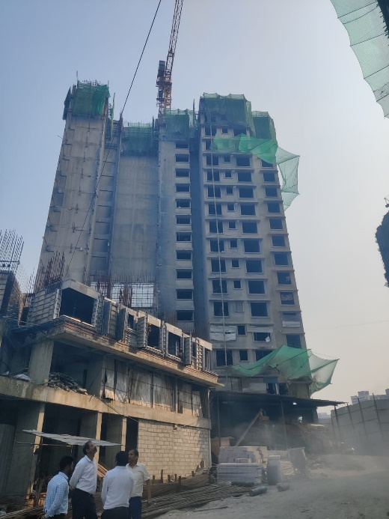
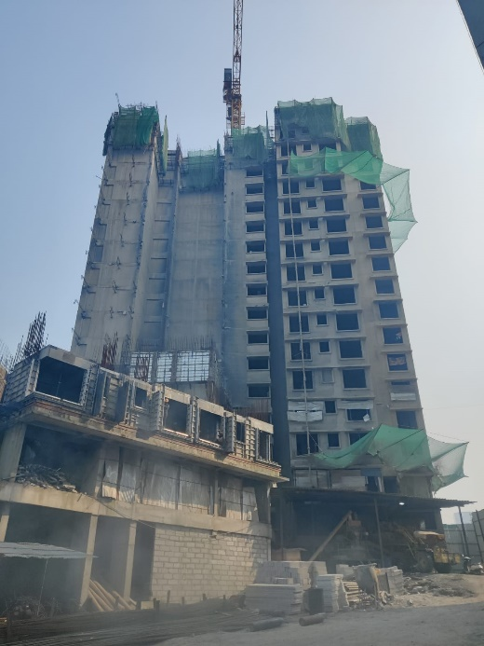
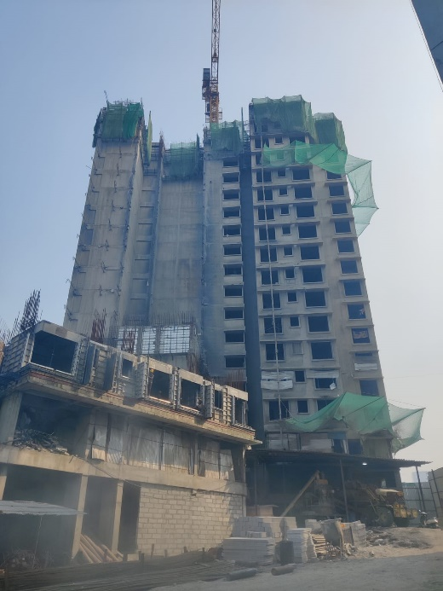
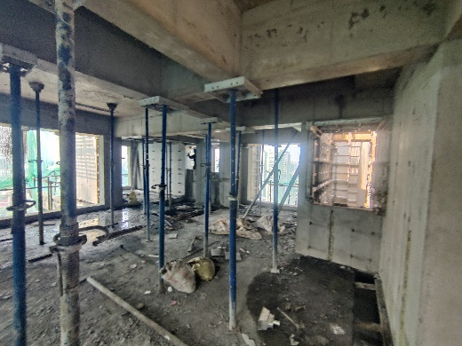
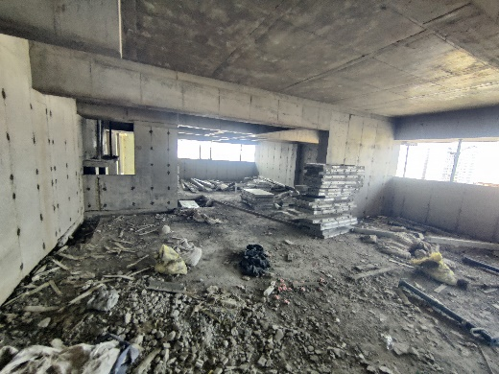
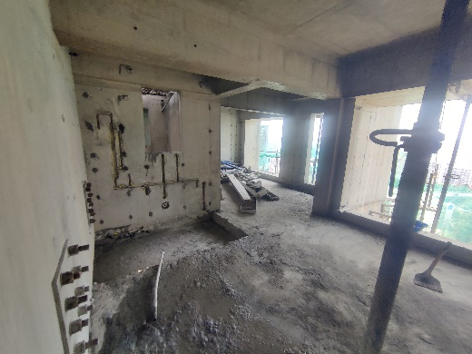
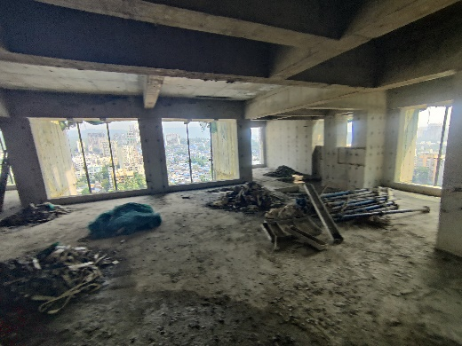
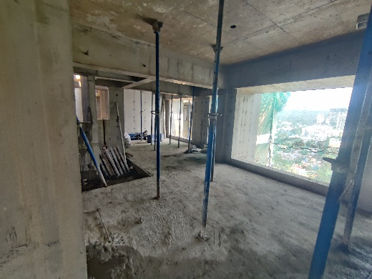
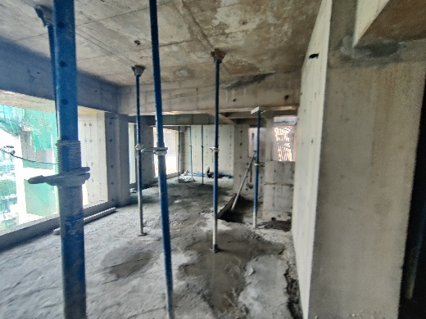
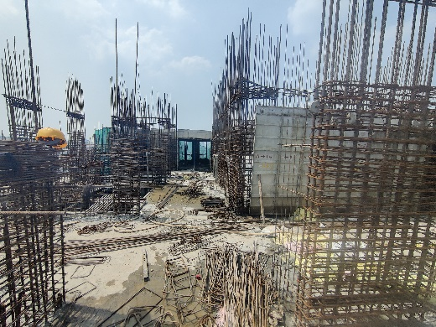
Actual Site Photographs As on 07.10.2024 (Sale Building)
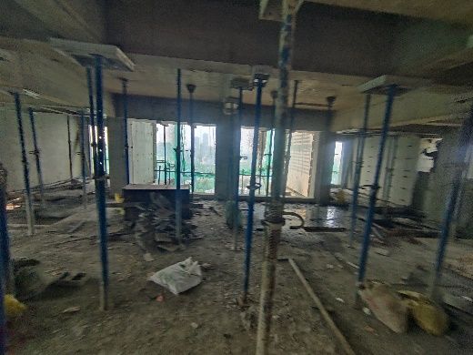
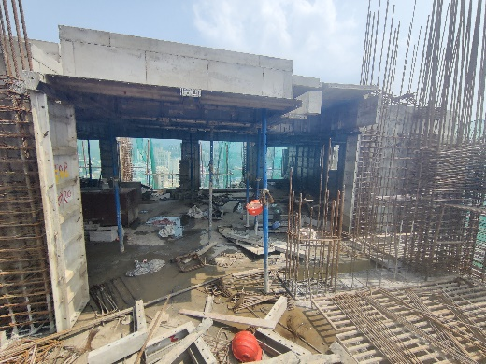
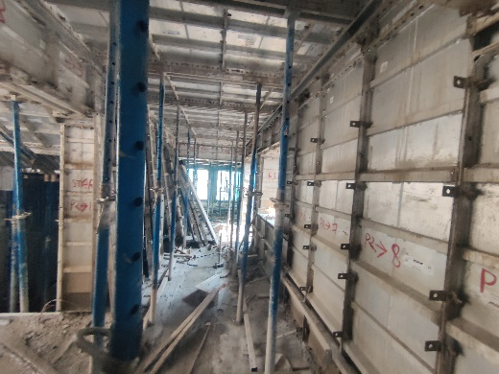
Actual Site Photographs As on 07.10.2024 (Sale Building)
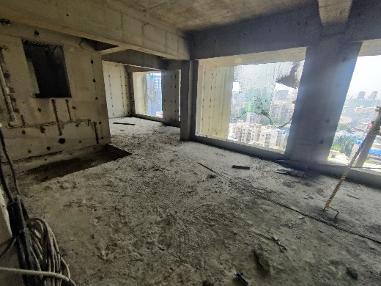
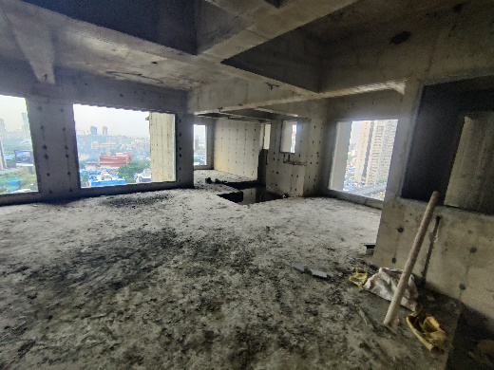
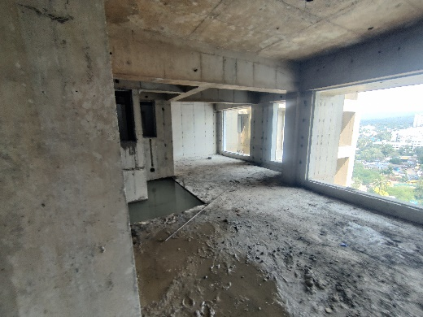
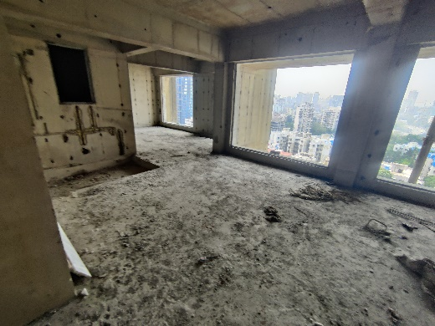
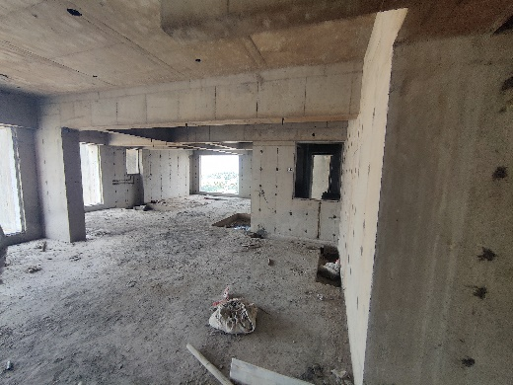
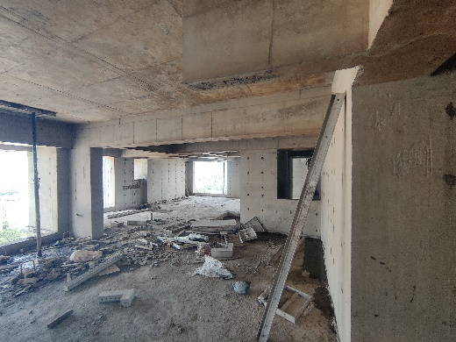
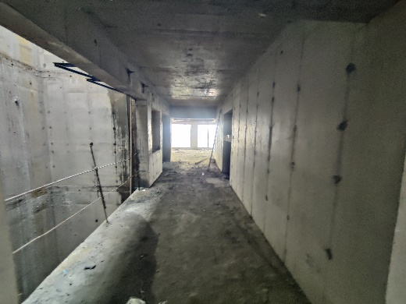
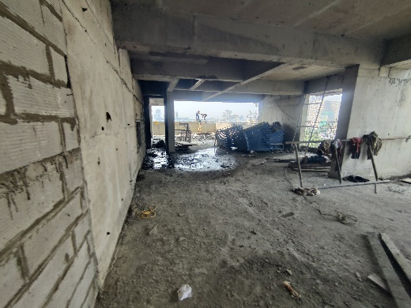
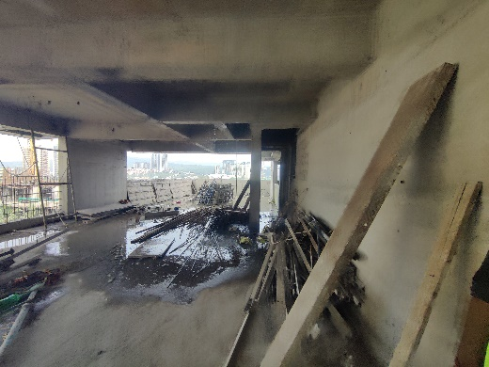
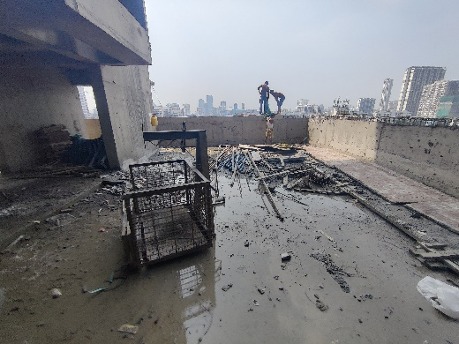
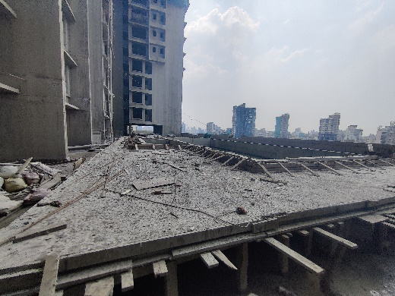
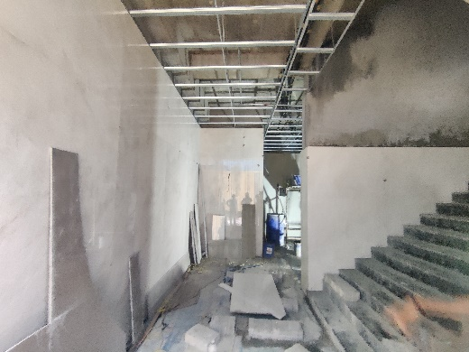
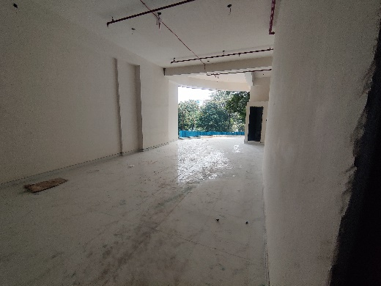
Actual Site Photographs As on 07.10.2024 (Sale Building)
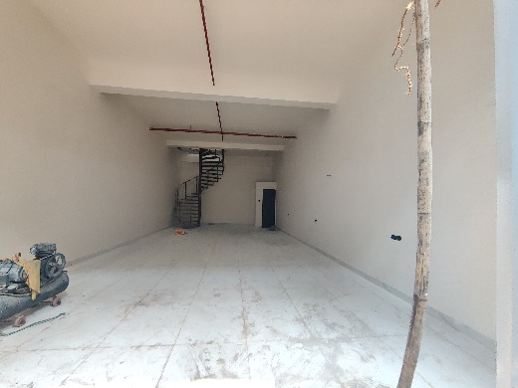
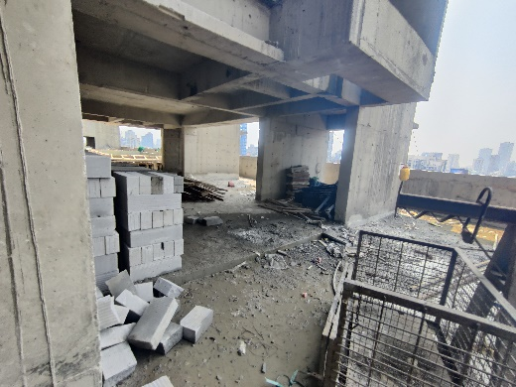
Actual Site Photographs As on 07.10.2024 (Sale Building)
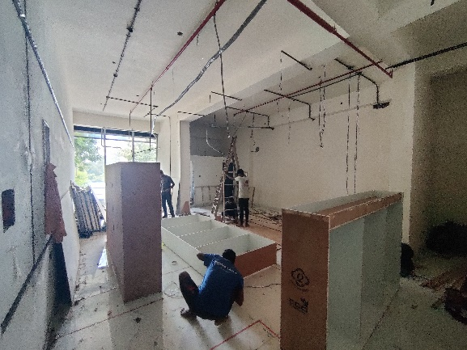
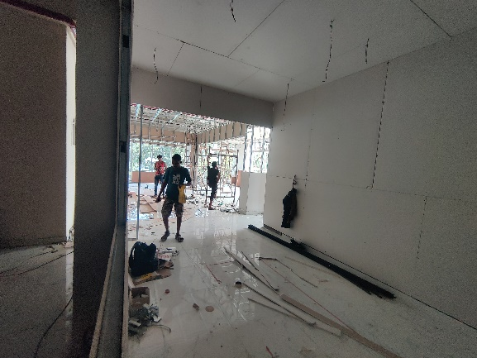
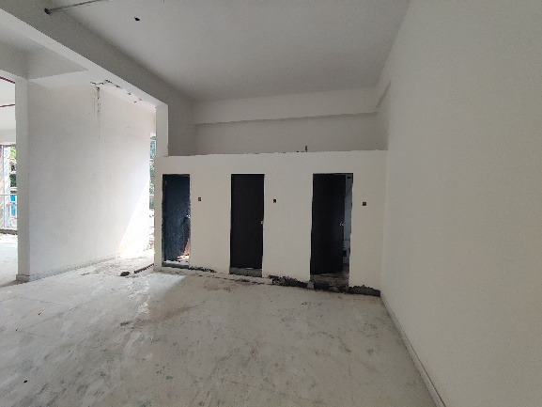
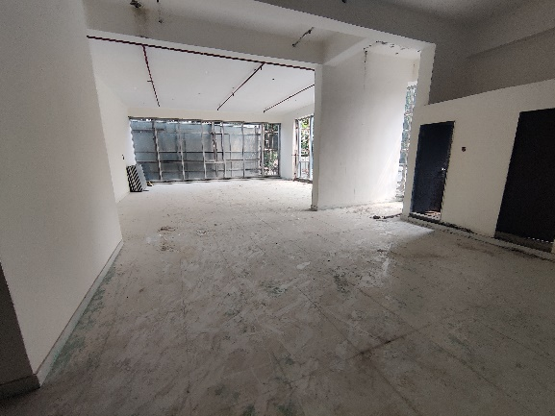
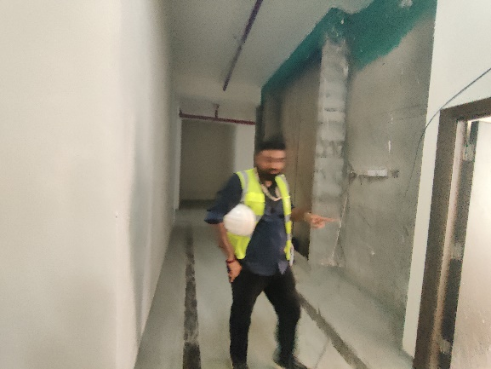
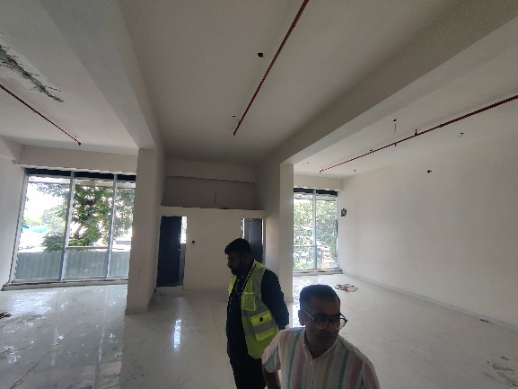
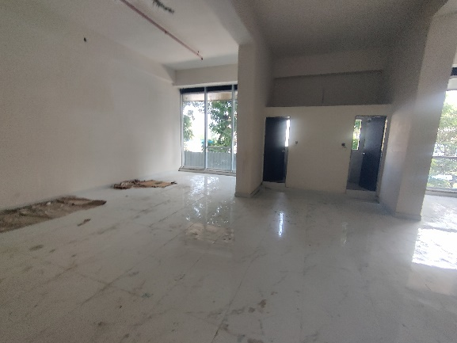
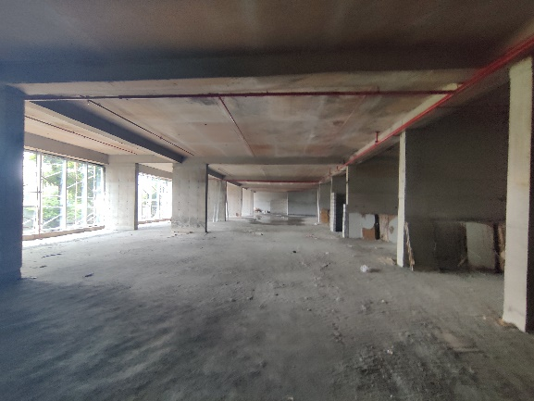
Actual Site Photographs As on 07.10.2024 (Sale Building)
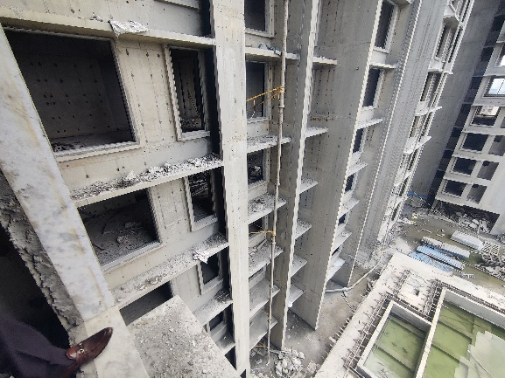
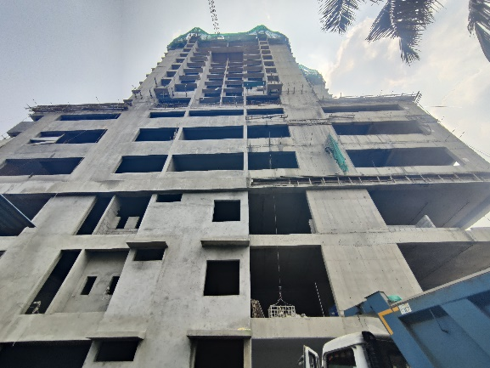
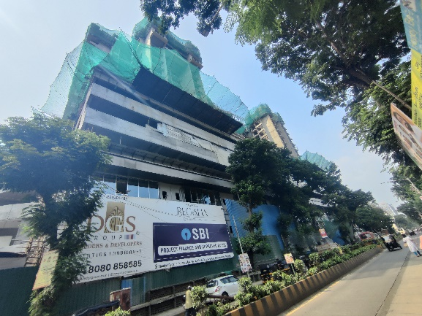
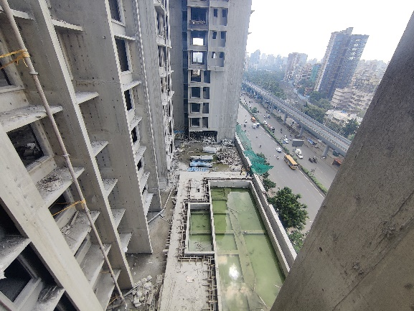
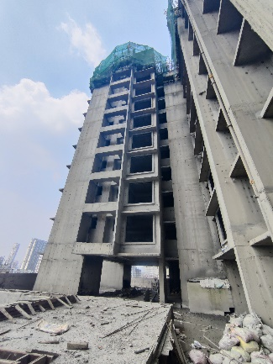
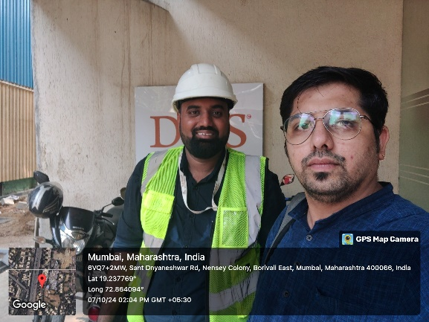
Route Map of the property
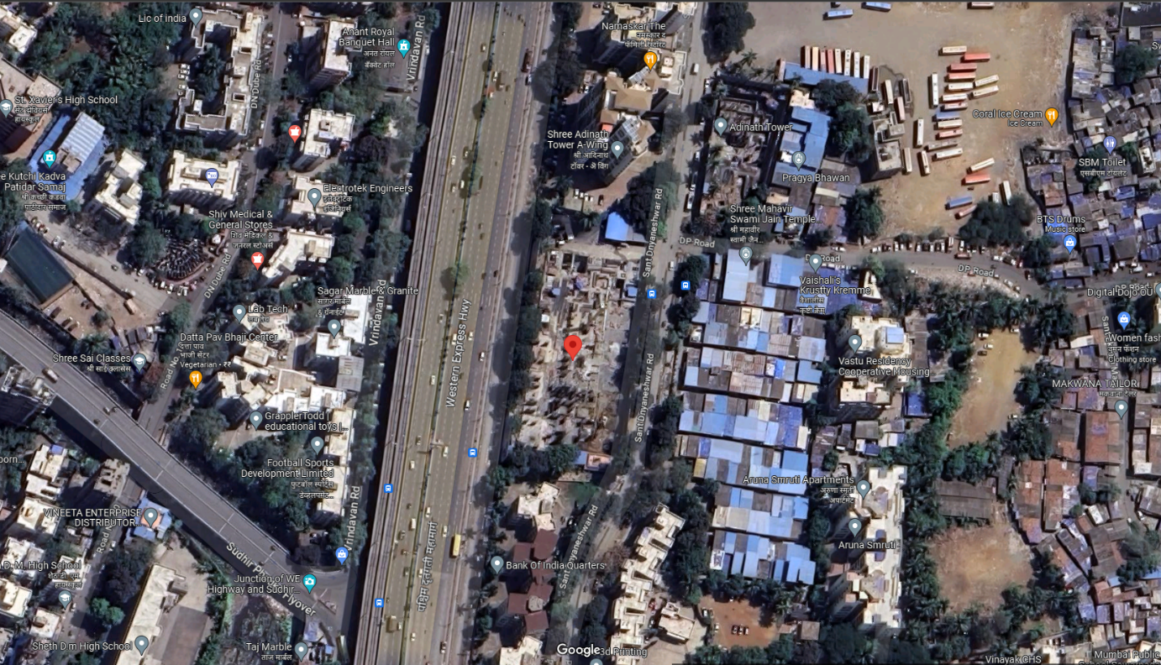
Site u/r

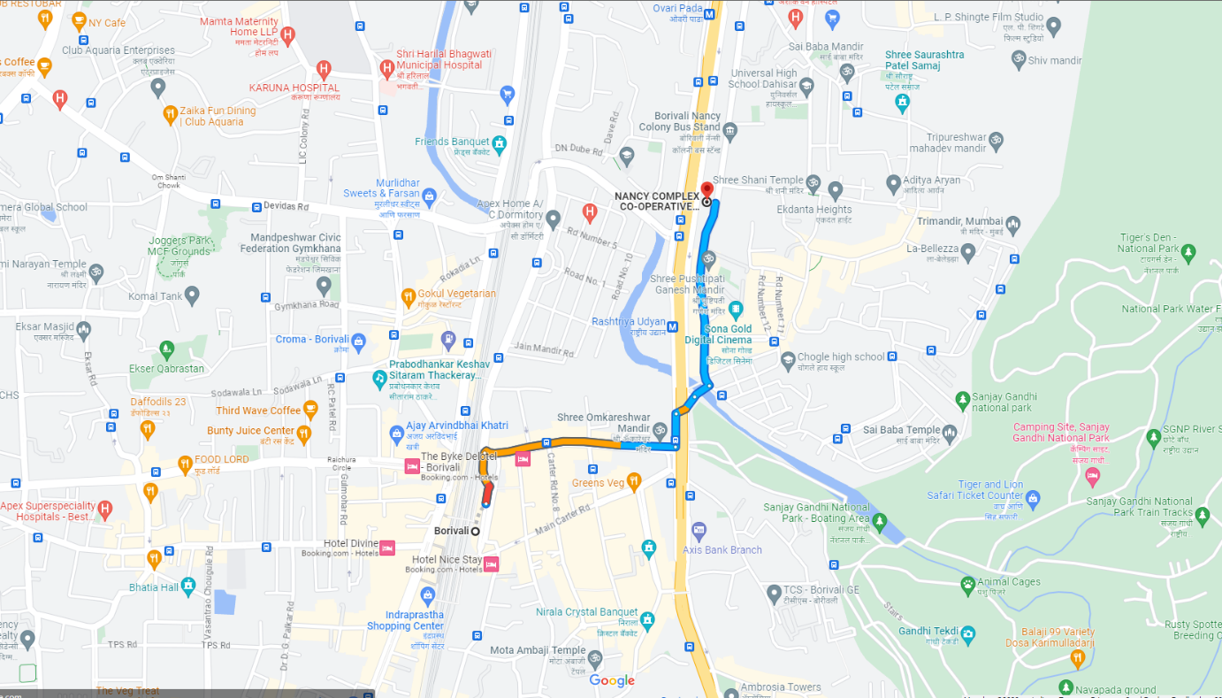

Latitude Longitude: 19°14'17.2"N 72°51'50.9"E

Note: The Blue line shows the route to site from nearest railway station (Borivali – 1.60 Km.)
CA Certificate Dated 17.10.2024 cost incurred till 30.09.2024
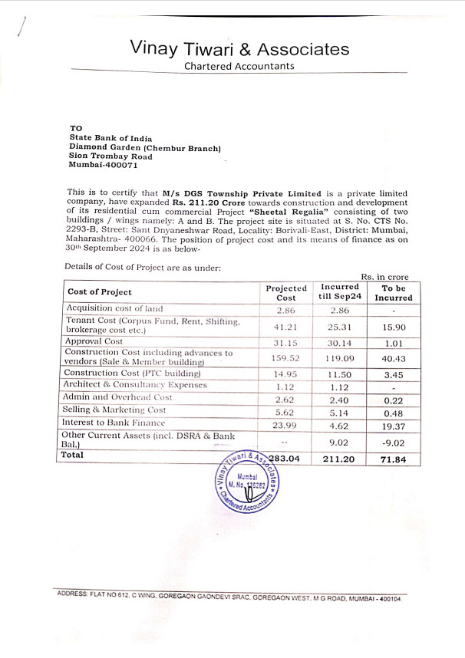

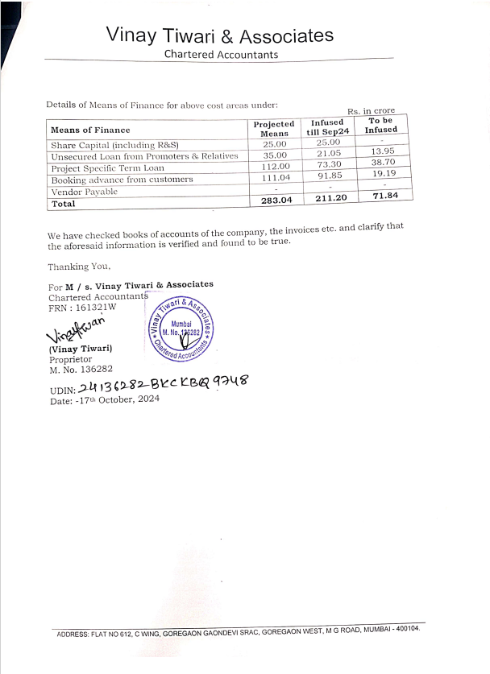
CA Certificate Dated 17.10.2024 cost incurred till 30.09.2024

