Valuation Report of the Immovable Property
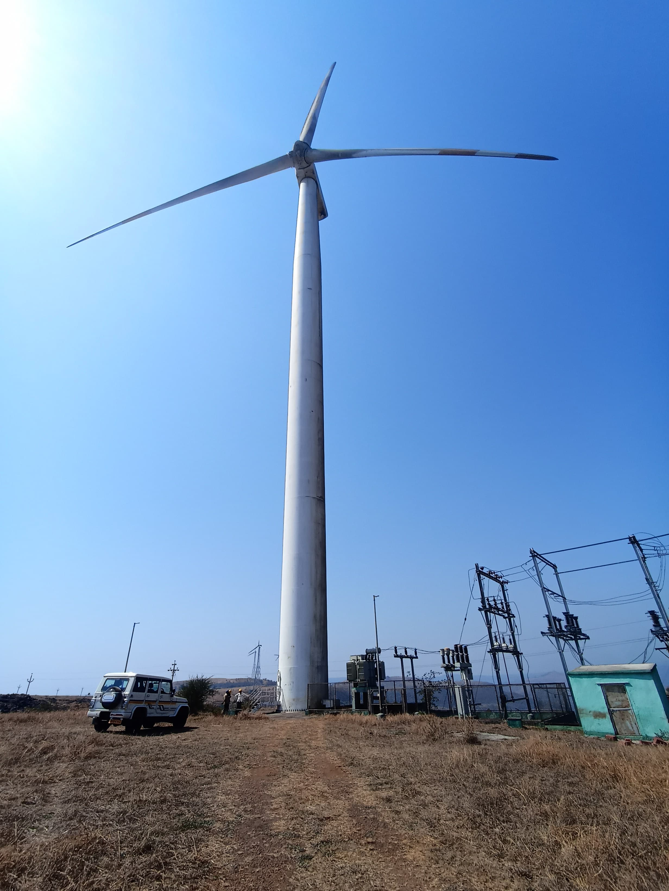

Details of the property under consideration:

Name of Owner: M/s. L. B. Kunjir

Industrial Land used for WTG No. GP-044 & GP-045 located at Gut Nos. 237/1(pt), 237/3(pt) & 237/4(pt),
Village - Charan, Taluka – Shirala, District – Sangli – 415 405, Maharashtra, India

GP-044:- 17°04'29.6"N 73°59'35.9"E

GP-045:- 17°04'21.6"N 73°59'39.1"E

Intended Users:
SVC Co-Operative Bank Ltd.
Kothrud Branch, Pune
Office No. 303, Chintamani Pride, Near City Pride Theatre, Kothrud, Pune – 411038, Maharashtra, India

Vastu/Thane/02/2025/14444/2310737
25/01-387-VSUA
Date: 25.02.2025

VALUATION OPINION REPORT

This is to certify that the property bearing Industrial Land used for WTG No. GP-044 & GP-045 located at Gut Nos. 237/1(pt), 237/3(pt) & 237/4(pt), Village - Charan, Taluka – Shirala, District – Sangli – 415 405, Maharashtra, India belongs to M/s. L. B. Kunjir.

Boundaries of the property.

 |  | Gut Nos. 237/1(pt), 237/3(pt) |  |  | Gut Nos. 237/1(pt), 237/4(pt)
 |  | Gut Nos. 237/1(pt) |  | Gut Nos. 237/3(pt) | Gut Nos. 237/1(pt) | Gut Nos. 237/4(pt)
North | : | Remaining area of Gut No. 237/1 |  | Gut No. 237/1 and Gut No. 236 | Remaining area of Gut No. 237/1 | Gut No. 237/5
South | : | Remaining area of Gut No. 237/1 |  | Gut No. 237/4 | Remaining area of Gut No. 237/1 and Gut No. 292 | Gut No. 292
East | : | Village boundary of Velapur |  | Gut No. 237/1 | Village boundary of Velapur | Gut No. 237/1
West | : | Gut No. 237/3 |  | Remaining area of Gut No. 237/3 | Gut No. 237/4 | Gut No. 237/5
Considering various parameters recorded, existing economic scenario, and the information that is available with reference to the development of neighborhood and method selected for valuation, we are of the opinion that, the property premises can be assessed for this particular purpose at
Particulars | Fair Market Value  In (`) | Realizable Value  In (`) | Distress Sale Value  In (`)
GP – 044 - Gut Nos. 237/1(pt), 237/3(pt) | 18,30,000/- | 16,47,000/- | 14,64,000/-
GP – 045 - Gut Nos. 237/1(pt), 237/4(pt) | 18,30,000/- | 16,47,000/- | 14,64,000/-

The valuation of the property is based on the documents produced by the concern. Legal aspects have not been taken into considerations while preparing this valuation report.

Manoj B. Chalikwar
Govt. Reg. Valuer
Chartered Engineer (India)
Reg. No. IBBI/RV/07/2018/10366
SVC CO-OPERATIVE BANK LTD Empanelment No.: CO/Tec/BUS/526/ 20-21(L&B)
Encl: Valuation report.

Vastukala Consultants (I) Pvt. Ltd.
B1-001, U/B Floor, Boomerang, Chandivali Farm Road, Powai, Andheri (East), Mumbai - 400 072.

To,
The Branch Manager,
SVC Co-Operative Bank Ltd.
Kothrud Branch, Pune
Office No. 303, Chintamani Pride,
Near City Pride Theatre, Kothrud,
Pune – 411038, Maharashtra, India
VALUATION REPORT (IN RESPECT OF INDUSTRIAL LAND)
I | General
1. | Purpose for which the valuation is made |  |  | : | To assess value of the property for Bank Loan Purpose.
2. | a) |  | Date of inspection | : | 19.02.2025
 | b) |  | Date on which the valuation is made | : | 25.02.2025
3. | Documents produced for perusal |  |  | : | - Copy of 7/12 Revenue Extract of each Gut Number  - Copy of N.A. Order vide No. NA / Ind / SR / 17 / 2012 dated 24.10.2012 issued by Walwa Vibhag, Islampur for Gut Nos. 237/1(pt), 237/3(pt)  - Copy of N.A. Order vide No. NA / Ind / SR / 19 / 2012 dated 24.10.2012 issued by Walwa Vibhag, Islampur for Gut Nos. 237/1(pt), 237/4(pt)  - Copy of Sale Deed vide No. 255/2012 dated 27.02.2012 for Gut Nos. 237/1(pt), 237/4(pt)  - Copy of Sale Deed vide No. 254/2012 dated 27.02.2012 for Gut Nos. 237/1(pt), 237/3(pt)
4. | Name of the owner(s) and his / their address (es) with Phone no. (details of share of each owner in case of joint ownership) |  |  | : | M/s. L. B. Kunjir  Address: Industrial Land used for WTG No. GP-044 & GP-045 located at Gut Nos. 237/1(pt), 237/3(pt) & 237/4(pt), Village - Charan, Taluka – Shirala, District – Sangli – 415 405, Maharashtra, India  Contact Person:  Mr. Devasi Kumar (Senior Manage-Suzlon)  Contact No.: +91 90999 12316  Partnership Firm  Details of share of each partner not available.
5. | Brief description of the property (Including Leasehold / freehold etc.) |  |  | :
Property
The property under valuation is Industrial Land used for WTG No. GP-044 & GP-045. It is located at about 16 KM. from Shedgewadi MSRTC Bus Stand.

Plot
As per site inspection Industrial Land used for WTG No. GP-044 & GP-045 on Gut Nos. 237/1(pt), 237/3(pt) & 237/4(pt). There are no physical boundaries for the plot under reference.
As per Sale Deed and N.A. Order plot area are as under and considered for valuation :
WTG No. | Gut Nos. | Plot areas (Sq. M.) | Plot areas (Hector)
GP-044 | Gut Nos. 237/1(pt), 237/3(pt) | 12,200.00 | 1.22
GP-045 | Gut Nos. 237/1(pt), 237/4(pt) | 12,200.00 | 1.22
 | Total | 24,400.00 | 2.44

6. | Location of property |  |  | :
 | a) | Plot No. / Survey No. |  | : | Gut Nos. 237/1(pt), 237/3(pt) & 237/4(pt)
 | b) | Door No. |  | : | WTG Location No. GP-044 & GP-045
 | c) | T.S. No. / Village |  | : | Village – Charan
 | d) | Ward / Tehsil |  | : | Taluka – Shirala
 | e) | Mandal / District |  | : | District – Sangli
 | f) | Date of issue and validity of layout of approved map / plan |  | : | Not applicable being valuation for industrial land used for windmill
 | g) | Approved map / plan issuing authority |  | :
 | h) | Whether genuineness or authenticity of approved map/ plan is verified |  | :
 | i) | Any other comments by our empanelled valuers on authentic of approved plan |  |  | -
7. | Postal address of the property |  |  | : | Industrial Land used for WTG No. GP-044 & GP-045 located at Gut Nos. 237/1(pt), 237/3(pt) & 237/4(pt), Village - Charan, Taluka – Shirala, District – Sangli – 415 405, Maharashtra, India
8. | City / Town |  |  | : | Sangli
 | Residential area |  |  | : | No
 | Commercial area |  |  | : | No
 | Industrial area |  |  | : | Yes
9. | Classification of the area |  |  | :
 | i) High / Middle / Poor |  |  | : | Poor Class
 | ii) Urban / Semi Urban / Rural |  |  | : | Rural
10. | Coming under Corporation limit / Village Panchayat / Municipality |  |  | : | Gram Panchayat Charan
11. | Whether covered under any State / Central Govt. enactments (e.g., Urban Land Ceiling Act) or notified under agency area/ scheduled area / cantonment area |  |  | : | No
12. | Boundaries of the property
 | Actual | Gut Nos. 237/1(pt), 237/3(pt) |  | Gut Nos. 237/1(pt), 237/4(pt)
 | Actual | Gut No. 237/1(pt) | Gut No. 237/3(pt) | Gut No. 237/1(pt) | Gut No. 237/4(pt)
North | Open plot | Remaining area of Gut No. 237/1 | Gut No. 237/1 and Gut No. 236 | Remaining area of Gut No. 237/1 | Gut No. 237/5
South | Open plot | Remaining area of Gut No. 237/1 | Gut No. 237/4 | Remaining area of Gut No. 237/1 and Gut No. 292 | Gut No. 292
East | Open plot | Village boundary of Velapur | Gut No. 237/1 | Village boundary of Velapur | Gut No. 237/1
West | Open plot | Gut No. 237/3 | Remaining area of Gut No. 237/3 | Gut No. 237/4 | Gut No. 237/5

13 | Dimensions of the site |  |  |  | N.A., The plots are irregular in size & without Demarcation.
14. | Extent of the site |  |  | :
  Gut Nos. | Plot areas  (Sq. M.) | Plot areas (Hector)
  Gut Nos. 237/1(pt), 237/3(pt) - GP-044 | 12,200.00 | 1.22
  Gut Nos. 237/1(pt), 237/4(pt) - GP-045 | 12,200.00 | 1.22
  Total | 24,400.00 | 2.44
14. | Latitude, Longitude & Co-ordinates of House |  |  | : | GP-044:- 17°04'29.6"N 73°59'35.9"E  GP-045:- 17°04'21.6"N 73°59'39.1"E
15. | Extent of the site considered for Valuation (least of 13A& 13B) |  |  | :
  Gut Nos. | Plot areas  (Sq. M.) | Plot areas (Hector)
  Gut Nos. 237/1(pt), 237/3(pt) - GP-044 | 12,200.00 | 1.22
  Gut Nos. 237/1(pt), 237/4(pt)- GP-045 | 12,200.00 | 1.22
  Total | 24,400.00 | 2.44
16 | Whether occupied by the owner / tenant? If occupied by tenant since how long? Rent received per month. |  |  | : | Owner Occupied
II | APARTMENT BUILDING
 | Nature of the Apartment |  |  | : | As per brief description
 | Location |  |  | :
 | C.T.S. No. |  |  | : | -
 | Block No. |  |  | : | -
 | Ward No. |  |  | : | -
 | Village / Municipality / Corporation |  |  | : | Village – Charan
 | Door No., Street or Road |  |  | : | Industrial Land used for WTG No. GP-044 & GP-045 located at Gut Nos. 237/1(pt), 237/3(pt) & 237/4(pt), Village - Charan, Taluka – Shirala, District – Sangli – 415 405, Maharashtra, India
 | Description of the locality Residential / Commercial / Mixed |  |  | : | Industrial area
 | Year of Construction |  |  | : | Not applicable being valuation of plot only.
 | Number of Floors |  |  | : | Not applicable being valuation of plot only.
 | Type of Structure |  |  | : | Not applicable being valuation of plot only.
 | Number of Dwelling units in the building |  |  | : | Not applicable being valuation of plot only.
 | Quality of Construction |  |  | : | Not applicable being valuation of plot only.
 | Appearance of the Building |  |  | : | Not applicable being valuation of plot only.
 | Maintenance of the Building |  |  | : | Not applicable being valuation of plot only.
 | Facilities Available |  |  | : | Not applicable being valuation of plot only.
 | Lift |  |  | : | Not applicable being valuation of plot only.
 | Protected Water Supply |  |  | : | Not applicable being valuation of plot only.
 | Underground Sewerage |  |  | : | Not applicable being valuation of plot only.
 | Car parking - Open / Covered |  |  | : | Open parking
 | Is Compound wall existing? |  |  | : | Not applicable being valuation of plot only.
 | Is pavement laid around the building |  |  | : | Not applicable being valuation of plot only.
III | HOUSE
1 | The floor in which the House is situated |  |  | : | Not applicable being valuation of plot only.
2 | Door No. of the House |  |  | : | Not applicable being valuation of plot only.
3 | Specifications of the House |  |  | : | Not applicable being valuation of plot only.
 | Roof |  |  | : | Not applicable being valuation of plot only.
 | Flooring |  |  | : | Not applicable being valuation of plot only.
 | Doors |  |  | : | Not applicable being valuation of plot only.
 | Windows |  |  | : | Not applicable being valuation of plot only.
 | Fittings |  |  | : | Not applicable being valuation of plot only.
 | Finishing |  |  | : | Not applicable being valuation of plot only.
4 | House Tax |  |  | :
 | Assessment No. |  |  | : | Details not available
 | Tax paid in the name of: |  |  | : | Details not available
 | Tax amount: |  |  | : | Details not available
5 | Electricity Service connection No.: |  |  | : | Details not available
 | Meter Card is in the name of: |  |  | : | Details not available
6 | How is the maintenance of the Godown? |  |  | : | Not applicable being valuation of plot only.
7 | Lease Deed executed in the name of |  |  | : | Not applicable being valuation of plot only.
8 | What is the undivided area of land as per Lease Deed? |  |  | : | Not applicable being valuation of plot only.
9 | What is the plinth area of the House? |  |  | : | Not applicable being valuation of plot only.
10 | What is the floor space index (app.) |  |  | : | Not applicable being valuation of plot only.
11 | Is it Posh / I Class / Medium / Ordinary? |  |  | : | Not applicable being valuation of plot only.
12 | Is it being used for Residential or Commercial purpose? |  |  | : | Industrial Purpose for WTG
13 | Is it Owner-occupied or let out? |  |  | : | Owner Occupied
14 | If rented, what is the monthly rent? |  |  | : | N.A.
IV | MARKETABILITY |  |  | :
1 | How is the marketability? |  |  | : | Normal
2 | What are the factors favouring for an extra Potential Value? |  |  | : | -
3 | Any negative factors are observed which affect the market value in general? |  |  | : | No development in nearby area can be only used for WTG.
V | Rate |  |  | :
1 | After analyzing the comparable sale instances, what is the composite rate for a similar House with same specifications in the adjoining locality? - (Along with details / reference of at - least two latest deals / transactions with respect to adjacent properties in the areas) |  |  | : | ` 14,00,000/- to ` 16,00,000/- per Hector for industrial land used for windmill
2 | Assuming it is a new construction, what is the adopted basic composite rate of the House under valuation after comparing with the specifications and other factors with the House under comparison (give details). |  |  | : | Not applicable being valuation of plot only.
3 | Break – up for the rate |  |  | :
 | I. Building + Services |  |  | : | Not applicable being valuation of plot only.
 | II. Land + others |  |  | : | ` 15,00,000/- per Hector for industrial land used for windmill
4 | Guideline rate obtained from the Government Portal (an evidence thereof to be enclosed) of land |  |  | : | Industrial Land - ` 1,080/- per Sq. M.
VI | COMPOSITE RATE ADOPTED AFTER DEPRECIATION
a | Depreciated building rate |  |  | :
 | Replacement cost of House with Services (v(3)i) |  |  | : | Not applicable being valuation of plot only.
 | Age of the building |  |  | : | Particular | Year of Construction | Total life of Structure |  | Age Of Build. In Years | * Balance Life of Structures in Years
 | Life of the building estimated |  |  | : | Not applicable being valuation of plot only.
 | Depreciation percentage assuming the salvage value as 10% |  |  | : | Not applicable being valuation of plot only.
 | Depreciated Ratio of the building |  |  | : | Not applicable being valuation of plot only.
b | Total composite rate arrived for Valuation |  |  | :
 | Depreciated building rate VI (a) |  |  | : | Not applicable being valuation of plot only.
 | Rate for Land & other V (3) ii |  |  | : | Industrial Land - ` 1,080/- per Sq. M.
Remarks:
- Plot under valuation is industrial N.A. land used for windmill as per N.A. Order. We have considered the area as per Sale Deed / N.A. Order for the purpose of valuation.
- Though the property is industrial N.A. land, it is used for windmill purpose. The location is very remote from the village area. There are no physical boundaries for the plot under reference. Without any proper road connectivity. No development in the nearby area.
- As the property is Industrial N.A. rate for calculation of Government / Ready Reckoner Value is higher. But there is no industrial development in nearby area or plot. Only part portion required for leveling & plinth of WTG is developed, hence the Government value is higher than Fair Market Value. We have appreciated agricultural rate with wind mill for fair market value of plot.

Government / Ready Reckoner Value of land
Plot area = 12,200.00 Sq. M. for each WTG | Rate per Sq. M. | Value in `
500.00 | 1,080.00 | 5,40,000.00
1,500.00 | 972.00 | 14,58,000.00
2,000.00 | 864.00 | 17,28,000.00
6,000.00 | 648.00 | 38,88,000.00
2,200.00 | 540.00 | 11,88,000.00
GP-044 - Gut Nos. 237/1(pt), 237/3(pt) |  | 88,02,000.00
GP-045 - Gut Nos. 237/1(pt), 237/4(pt) |  | 88,02,000.00
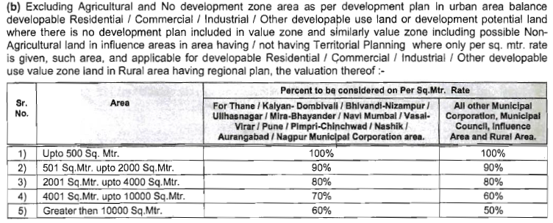

Details of Valuation:

Sr. No. | Description | Plot Area in  Hector | Rate per  unit (`) | Value  In (`) | Realizable Value  In (`) | Distress Sale Value  In (`)
1 | Present value of the Property
 | GP-044 - Gut Nos. 237/1(pt), 237/3(pt) | 1.22 | 15,00,000/- | 18,30,000/- | 16,47,000/- | 14,64,000/-
 | GP-045 - Gut Nos. 237/1(pt), 237/4(pt) | 1.22 | 15,00,000/- | 18,30,000/- | 16,47,000/- | 14,64,000/-
 | Guideline value of the property | For 88,02,000.00 for each WTG

Justification for price /rate
The Market Value of the property is based on facts of markets discovered by us during our enquiries, however the government rate value in this case is more than the market value arrived by us. We are of the opinion that the value arrive by us will prove to be correct if an Auction of the subject property is carried out. As far as Market Value as per property document is concerned, it is not possible to comment on same, may be government rates are fixed by sampling during same point of time in part and whereas, Market values change every month.

In most of the cases the actual deal amount or Transaction value is not reflected in the property documents because of various Market practices. As Valuer, we always try to give a value which is correct reflection of actual transaction value irrespective of any factors in market.

Approach adopted for valuation: Cost Approach

- Land cost can be estimated using the Sales Comparison Approach by studying recent sales of land close to the subject property, and these sales should be comparable in size and location with subject property.

- The property is an industrial land for windmill purpose, we have adopted Sale Comparison Method for the purpose of valuation.
- The Price for similar type of property in the nearby vicinity is in the range of ` 14,00,000/- to ` 16,00,000/- per Hector for land Considering the rate with attached report, current market conditions, demand and supply position, Land size, location, sustained demand for industrial building / Plot, all round development of commercial and industrial application in the locality etc. We estimate ` 15,00,000/- per Hector for Land

The saleability of the property is: Good
Expected rental values per month: N.A.
Any likely income it may generate: Rental Income
Layout Plan – Gut Nos. 237/1 (pt) & 237/3 (pt) - GP-044
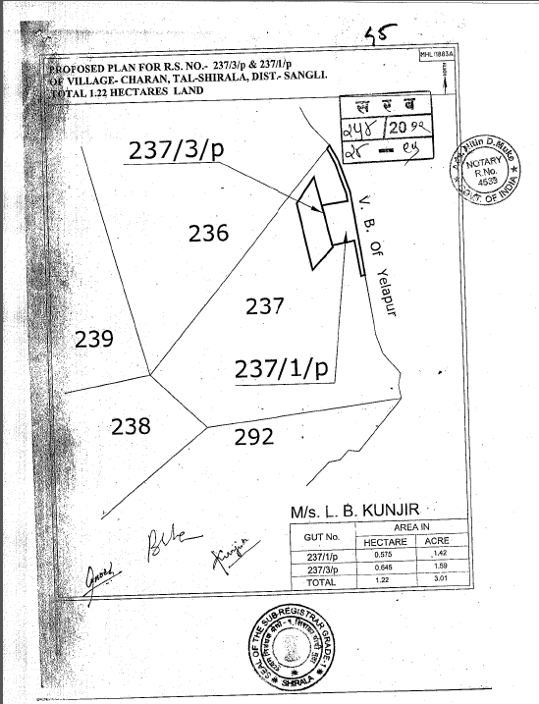
Layout Plan – Gut Nos. 237/1 (pt) & 237/4 (pt) - GP-045
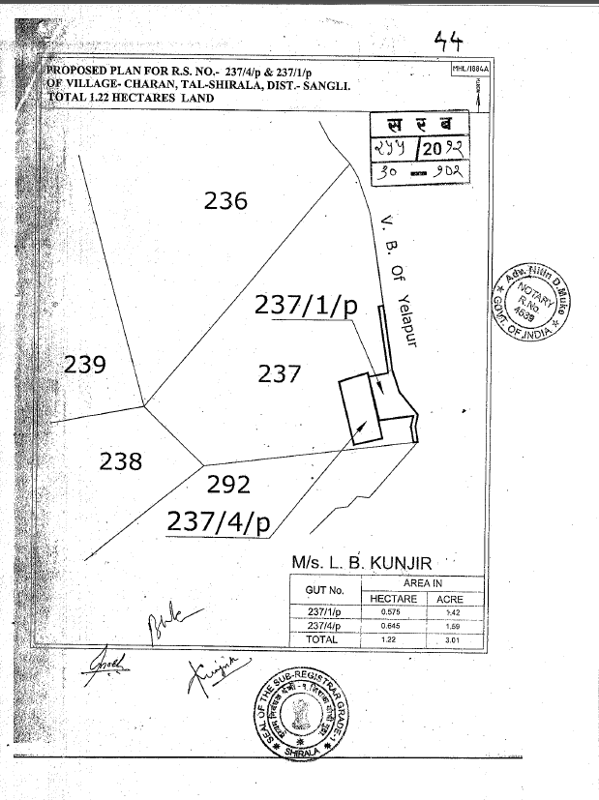
Actual site photographs – GP-044
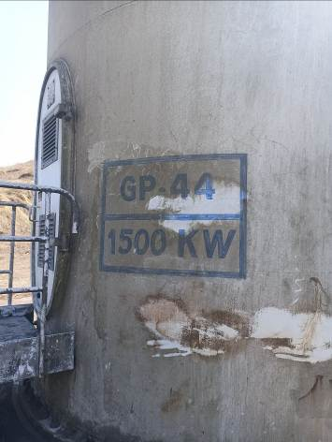
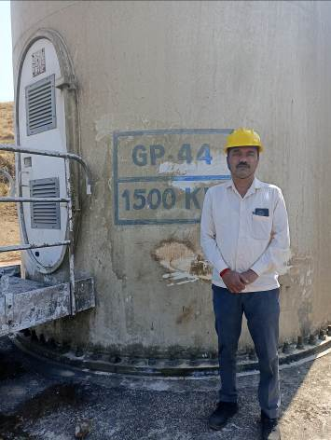
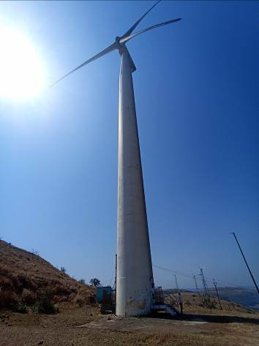

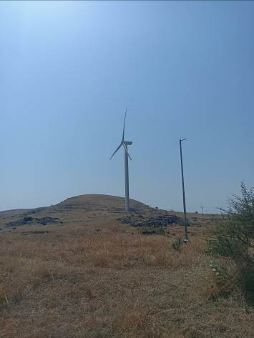
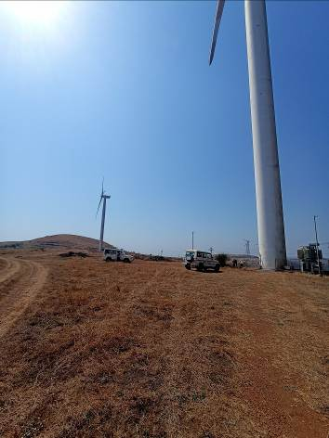

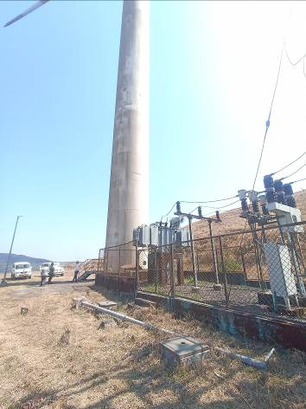
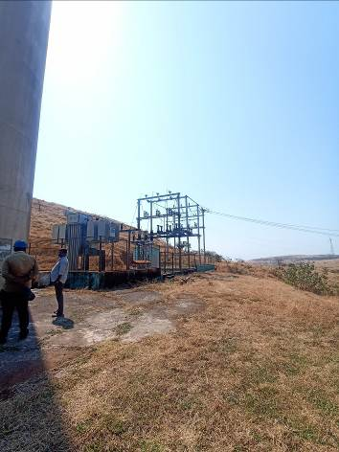
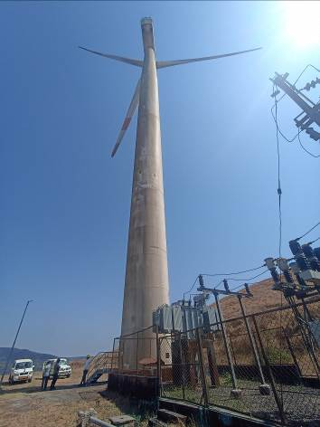
Actual site photographs – GP-045

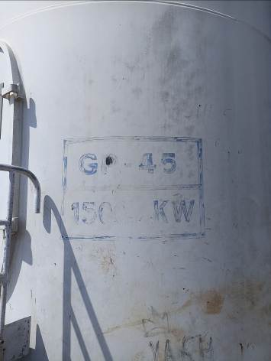
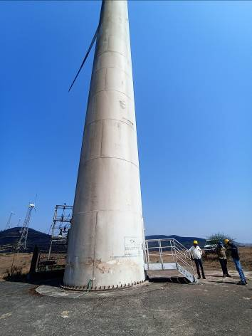

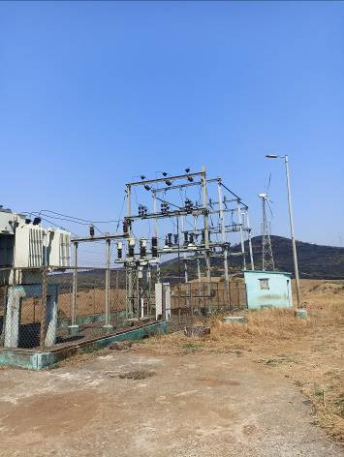
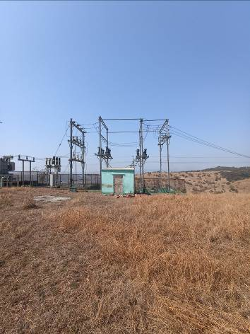

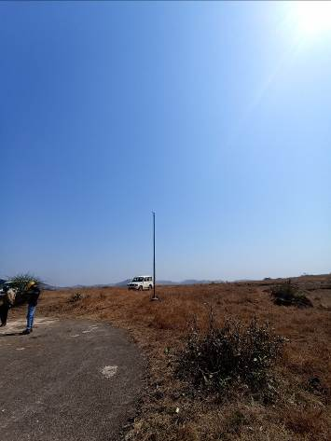
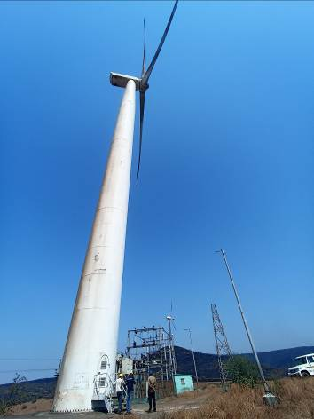
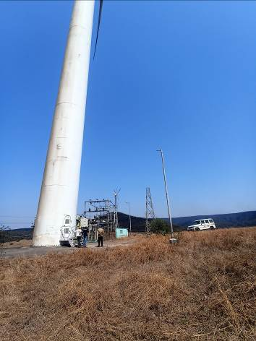

Route Map of the property
Site u/r
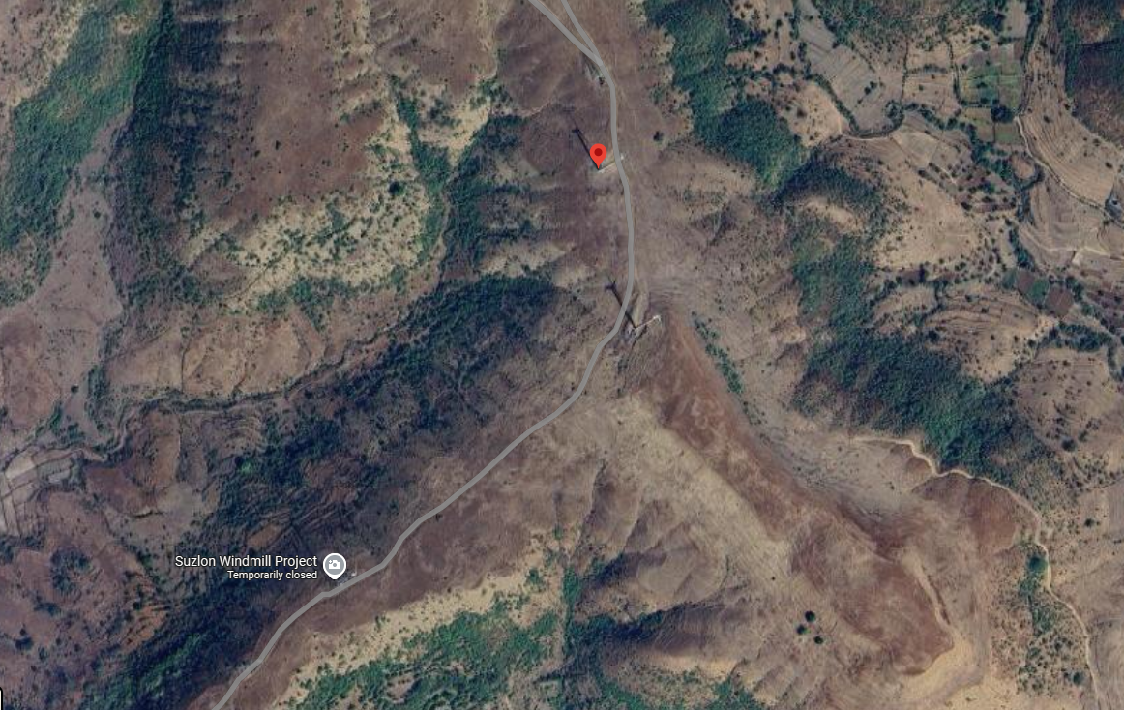

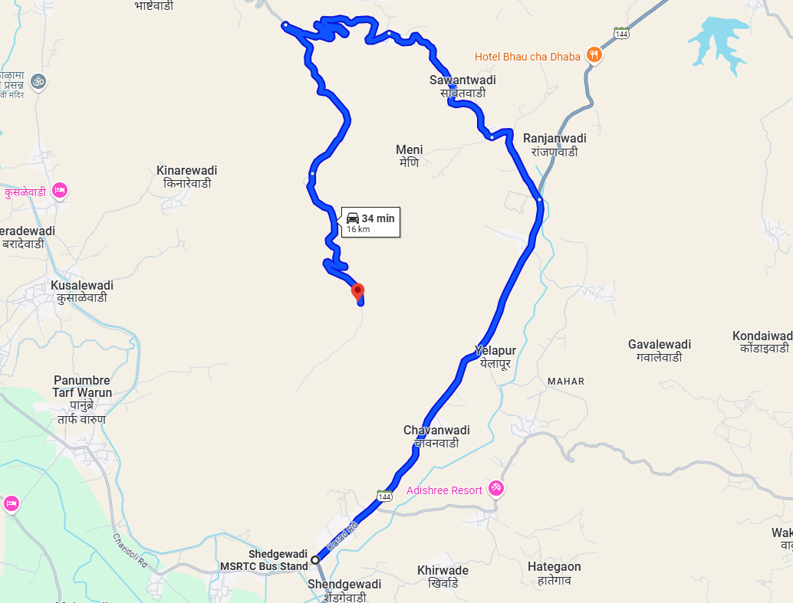



GP-044:- 17°04'29.6"N 73°59'35.9"E

GP-045:- 17°04'21.6"N 73°59'39.1"E

Note: The Blue line shows the route to site from nearest MSRTC Bus Stand (Shedgewadi – 16 KM.)
Price Indicator

Plot area | 14.16 H
Value | ` 55,00,000.00
Rate per Hector | ` 3,88,418.00

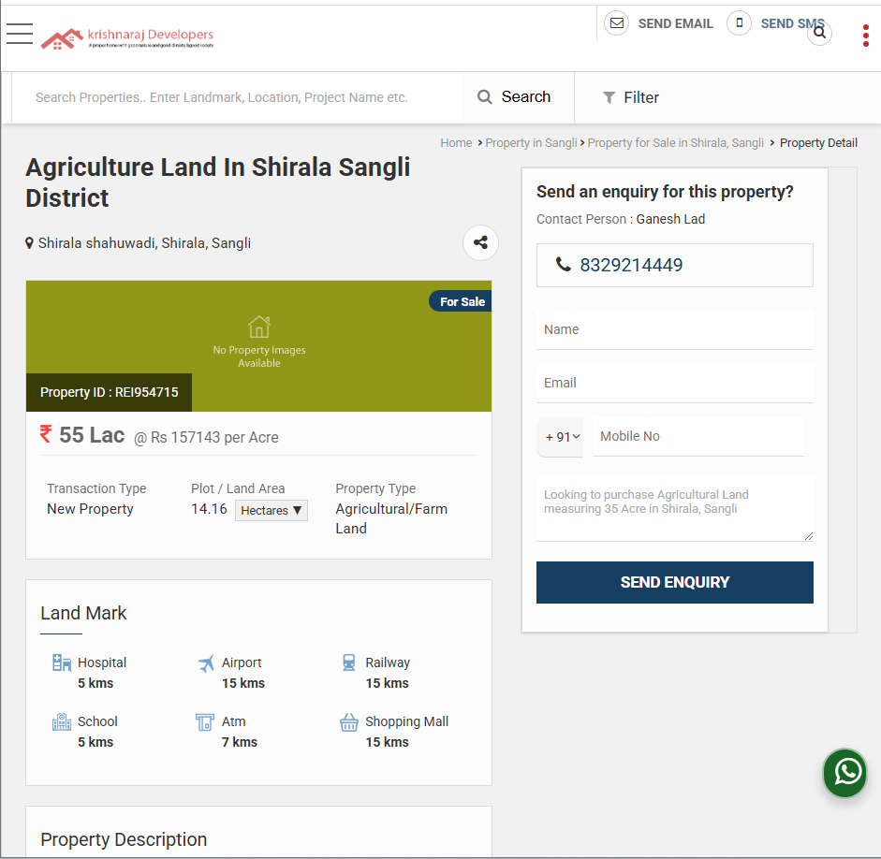
Price Indicator

Plot area | 91,960.00 Sq. M. i.e. 9.196 Hector
Value | ` 1,52,68,500.00
Rate per Hector | ` 16,60,341.00
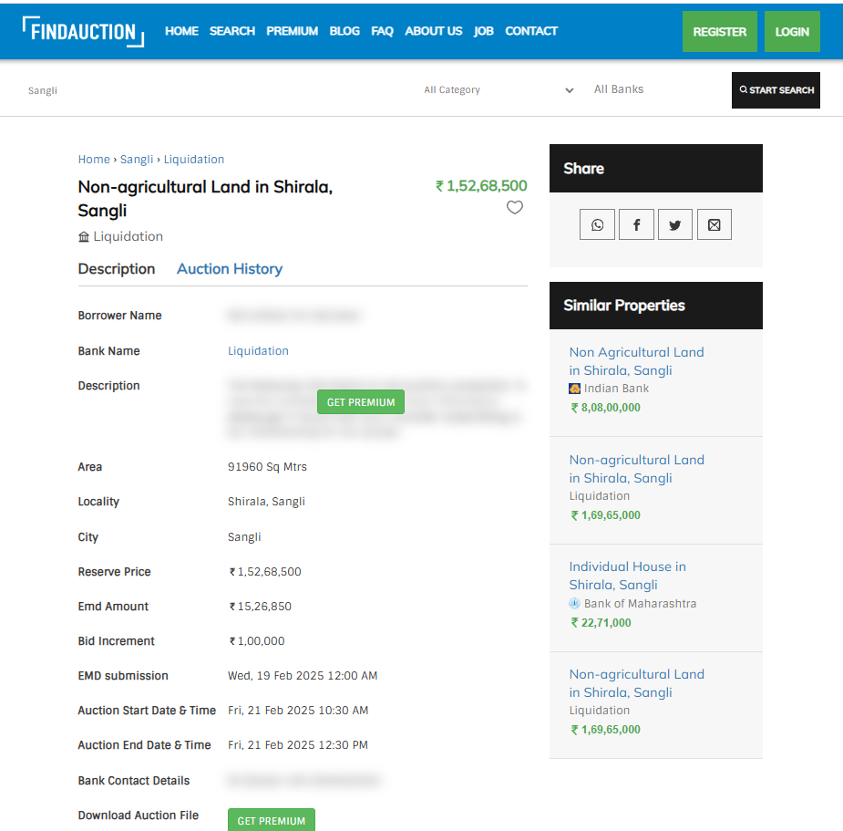
Ready Reckoner Rate

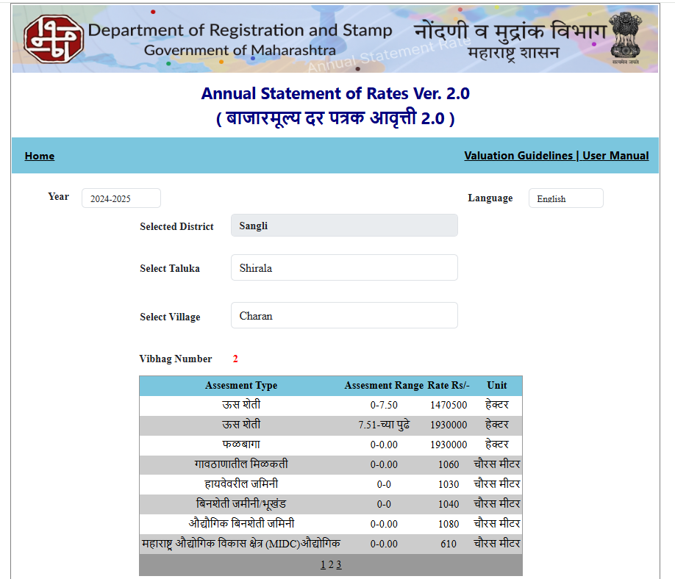

As a result of my appraisal and analysis, it is my considered opinion that the value of the above property in the prevailing condition with aforesaid specifications:

Particulars | Fair Market Value  In (`) | Realizable Value  In (`) | Distress Sale Value  In (`)
Gut Nos. 237/1(pt), 237/3(pt) | 18,30,000/- | 16,47,000/- | 14,64,000/-
Gut Nos. 237/1(pt), 237/4(pt) | 18,30,000/- | 16,47,000/- | 14,64,000/-

Manoj B. Chalikwar
Govt. Reg. Valuer
Chartered Engineer (India)
Reg. No. IBBI/RV/07/2018/10366
SVC CO-OPERATIVE BANK LTD Empanelment No.: CO/Tec/BUS/526/ 20-21(L&B)

The undersigned has inspected the property detailed in the Valuation Report dated _______________________

on ____________________. We are satisfied that the fair and reasonable market value of the property is `_________________________ (Rupees ________________________________________________________

________________________________________only).

Date
Signature
(Name & Designation of the Inspecting Official/s)

Countersigned
(BRANCH MANAGER)

Enclosures
 | Declaration-cum-undertaking from the valuer (Annexure- I) | Attached
 | Model code of conduct for valuer - (Annexure II) | Attached
(Annexure-I)

DECLARATION-CUM-UNDERTAKING

I, Manoj Chalikwar son of Shri. Baburao Chalikwar do hereby solemnly affirm and state that:

- I am a citizen of India.

- I will not undertake valuation of any assets in which I have a direct or indirect interest or become so interested at any time during a period of three years prior to my appointment as valuer or three years after the valuation of assets was conducted by me.

- The information furnished in my valuation report dated 25.02.2025 is true and correct to the best of my knowledge and belief and I have made an impartial and true valuation of the property.

- My engineer Mr. Vaibhav Bhagat has personally inspected the property on 19.02.2025. The work is not sub - contracted to any other valuer and carried out by myself.

- Valuation report is submitted in the format as prescribed by the bank.

- I have not been depanelled / delisted by any other bank and in case any such depanelment by other banks during my empanelment with you, I will inform you within 3 days of such depanelment.

- I have not been removed / dismissed from service / employment earlier.

- I have not been convicted of any offence and sentenced to a term of imprisonment

- I have not been found guilty of misconduct in my professional capacity.

- I have not been declared to be unsound mind

- I am not an undischarged bankrupt, or has not applied to be adjudicated as a bankrupt;

- I am not an undischarged insolvent.

- I have not been levied a penalty under section 271J of Income-tax Act, 1961 (43 of 1961) and time limit for filing appeal before Commissioner of Income-tax (Appeals) or Income-tax Appellate Tribunal, as the case may be has expired, or such penalty has been confirmed by Income-tax Appellate Tribunal, and five years have not elapsed after levy of such penalty.

- I have not been convicted of an offence connected with any proceeding under the Income Tax Act 1961, Wealth Tax Act 1957 or Gift Tax Act 1958 and

- My PAN Card number as applicable is AERPC9086P.

- I undertake to keep you informed of any events or happenings which would make me ineligible for empanelment as a valuer

- I have not concealed or suppressed any material information, facts and records and I have made a complete and full disclosure

- I have read the Handbook on Policy, Standards and procedure for Real Estate Valuation, 2011 of the IBA and this report is in conformity to the "Standards" enshrined for valuation in the Part - B of the above handbook to the best of my ability.

- I have read the International Valuation Standards (IVS) and the report submitted to the Bank for the respective asset class is in conformity to the "Standards" as enshrined for valuation in the IVS in "General Standards" and "Asset Standards" as applicable. The valuation report is submitted in the prescribed format of the bank.

- I abide by the Model Code of Conduct for empanelment of valuer in the Bank. (Annexure V - A signed copy of same to be taken and kept along with this declaration)

- I am valuer registered with Insolvency & Bankruptcy Board of India (IBBI)

- My CIBIL Score and credit worthiness is as per Bank's guidelines.

- I am Director of the company of the company, who is competent to sign this valuation report.

- I will undertake the valuation work on receipt of Letter of Engagement generated from the system (i.e. LLMS / LOS) only.

- Further, I hereby provide the following information.

Sr.  No. | Particulars | Valuer comment
 | background information of the asset being valued; | The property is acquired by M/s. L. B. Kunjir
 | purpose of valuation and appointing authority | As per the request from SVC Co-Operative Bank Ltd., Kothrud Branch, Pune to assess fair market value of the property for bank loan purpose.
 | identity of the valuer and any other experts involved in the valuation; | Manoj B. Chalikwar – Regd. Valuer  Prakash – Valuation Engineer  Vaishali Sarmalkar – Technical Manager
 | disclosure of valuer interest or conflict, if any; | We have no interest, either direct or indirect, in the property valued. Further to state that we do not have relation or any connection with property owner / applicant directly or indirectly. Further to state that we are an independent Valuer and in no way related to property owner / applicant
 | date of appointment, valuation date and date of report; | Date of Appointment – 19.02.2025  Valuation Date – 25.02.2025  Date of Report – 25.02.2025
 | inspections and/or investigations undertaken; | Physical Inspection done on 19.02.2025
 | nature and sources of the information used or relied upon; | - Market Survey at the time of site visit  - Ready Reckoner rates / Circle rates  - Online Price Indicators on real estate portals  - Enquiries with Real estate consultants  - Existing data of Valuation assignments carried out by us
 | procedures adopted in carrying out the valuation and valuation standards followed; | Cost Approach (For building construction)  Comparative Sales Method / Market Approach (For Land component)
 | restrictions on use of the report, if any; | This valuation is for the use of the party to whom it is addressed and for no other purpose. No responsibility is accepted to any third party who may use or rely on the whole or any part of this valuation. The valuer has no pecuniary interest that would conflict with the proper valuation of the property.
 | major factors that were taken into account during the valuation; | current market conditions, demand and supply position, Land size, location, sustained demand for industrial premises / Plot, all round development of industrial application in the locality etc.
 | Major factors that were not taken into account during the valuation; | Nil
 | Caveats, limitations and disclaimers to the extent they explain or elucidate the limitations faced by valuer, which shall not be for the purpose of limiting his responsibility for the valuation report. | Attached

Assumptions, Disclaimers, Limitations & Qualifications

Value Subject to Change
The subject appraisal exercise is based on prevailing market dynamics as on 25th February 2025 and does not take into account any unforeseeable developments which could impact the same in the future.

Our Investigations
We are not engaged to carry out all possible investigations in relation to the subject property. Where in our report we identify certain limitations to our investigations, this is to enable the reliant party to instruct further investigations where considered appropriate or where we recommend as necessary prior to reliance. Vastukala Consultants India Pvt. Ltd. (VCIPL) is not liable for any loss occasioned by a decision not to conduct further investigations.

Assumptions
Assumptions are a necessary part of undertaking valuations. VCIPL adopts assumptions for the purpose of providing valuation advise because some matters are not capable of accurate calculations or fall outside the scope of our expertise, or out instructions. The reliant party accepts that the valuation contains certain specific assumptions and acknowledge and accept the risk of that if any of the assumptions adopted in the valuation are incorrect, then this may have an effect on the valuation.

Information Supplied by Others
The appraisal is based on the information provided by the client. The same has been assumed to be correct and has been used for appraisal exercise. Where it is stated in the report that another party has supplied information to VCIPL, this information is believed to be reliable but VCIPL can accept no responsibility if this should prove not to be so.

Future Matters
To the extent that the valuation includes any statement as to a future matter, that statement is provided as an estimate and/or opinion based on the information known to VCIPL at the date of this document. VCIPL does not warrant that such statements are accurate or correct.

Map and Plans
Any sketch, plan or map in this report is included to assist the reader while visualising the property and assume no responsibility in connection with such matters.

Site Details
Based on inputs received from Client and site visit conducted, we understand that the subject property is industrial land admeasuring 12,200.00 Sq. M. i.e. 1.22 Hector each in the name of M/s. L. B. Kunjir. At Present, the property is owner occupied. Further, VCIPL has assumed that the subject property is free from any encroachment and is available as on the date of the appraisal.

Property Title
Based on our discussion with the Client, we understand that the subject property is owned by M/s. L. B. Kunjir. For the purpose of this appraisal exercise, we have assumed that the subject property has a clear title and is free from any encumbrances, disputes and claims. VCIPL has made no further enquiries with the relevant local authorities in this regard and does not certify the property as having a clear and marketable title. Further, no legal advice regarding the title and ownership of the subject property has been obtained for the purpose of this appraisal exercise. It has been assumed that the title deeds are clear and marketable.

Environmental Conditions
We have assumed that the subject property is not contaminated and is not adversely affected by any existing or proposed environmental law and any processes which are carried out on the property are regulated by environmental legislation and are properly licensed by the appropriate authorities.

Area
Based on the information provided by the Client, we understand that the property is industrial land admeasuring 12,200.00 Sq. M. i.e. 1.22 Hector each.

Condition & Repair
In the absence of any information to the contrary, we have assumed that there are no abnormal ground conditions, nor archaeological remains present which might adversely affect the current or future occupation, development or value of the property. The property is free from rat, infestation, structural or latent defect. No currently known deleterious or hazardous materials or suspect techniques will be used in the construction of or subsequent alteration or additions to the property and comments made in the property details do not purport to express an opinion about, or advise upon, the condition of uninspected parts and should not be taken as making an implied representation or statement about such parts

Valuation Methodology
The cost approach is a Real Property Valuation method which considers the value of a property as the cost of the land plus the replacement cost of the building (construction costs) minus the physical and functional depreciation.

Land cost can be estimated using the Sales Comparison Approach by studying recent sales of land close to the subject property, and these sales should be comparable in size and location with subject property.

There are different ways to estimate replacement costs, the most common being finding out the cost to build a square foot of comparable properties multiplied by the total square footage of the building. The cost approach is commonly used for Residential Bungalow, row houses, independent buildings, Industrial Building and real estate properties that are not easily sold like schools, hospitals, government buildings. The property is a residential land and independent house thereof, we have adopted Cost approach / Land and Building Method for the purpose of valuation.
In case of inadequate recent transaction activity in the subject micro-market, the appraiser would collate details of older transactions. Subsequently, the appraiser would analyse rental / capital value trends in the subject micro-market in order to calculate the percentage increase / decrease in values since the date of the identified transactions. This percentage would then be adopted to project the current value of the same.
Where reliance has been placed upon external sources of information in applying the valuation methodologies, unless otherwise specifically instructed by Client and/or stated in the valuation, VCIPL has not independently verified that information and VCIPL does not advise nor accept it as reliable. The person or entity to whom the report is addressed acknowledges and accepts the risk that if any of the unverified information in the valuation is incorrect, then this may have an effect on the valuation.

Not a Structural Survey
We state that this is a valuation report and not a structural survey
Other
All measurements, areas and ages quoted in our report are approximate

Legal
We have not made any allowances with respect to any existing or proposed local legislation relating to taxation on realization of the sale value of the subject property. VCIPL is not required to give testimony or to appear in court by reason of this appraisal report, with reference to the property in question, unless arrangement has been made thereof. Further, no legal advice on any aspects has been obtained for the purpose of this appraisal exercise

Property specific assumptions
Based on inputs received from the client and site visit conducted, we understand that the subject property is industrial land admeasuring 12,200.00 Sq. M. i.e. 1.22 Hector each.

ASSUMPTIONS, CAVEATS, LIMITATION AND DISCLAIMERS
1. We assume no responsibility for matters of legal nature affecting the property appraised or the title thereto, nor do we render our opinion as to the title, which is assumed to be good and marketable.
2. The property is valued as though under responsible ownership.
3. It is assumed that the property is free of liens and encumbrances.
4. It is assumed that there are no hidden or unapparent conditions of the subsoil or structure that would render it more or less valuable. No responsibility is assumed for such conditions or for engineering that might be required to discover such factors.
5. There is no direct/ indirect interest in the property valued.
6. The rates for valuation of the property are in accordance with the Govt. approved rates and prevailing market rates.

(Annexure - II)

MODEL CODE OF CONDUCT FOR VALUERS

Integrity and Fairness
- A valuer shall, in the conduct of his/its business, follow high standards of integrity and fairness in all his/its dealings with his/its clients and other valuers.
- A valuer shall maintain integrity by being honest, straightforward, and forthright in all professional relationships.
- A valuer shall endeavour to ensure that he/it provides true and adequate information and shall not misrepresent any facts or situations.
- A valuer shall refrain from being involved in any action that would bring disrepute to the profession.
- A valuer shall keep public interest foremost while delivering his services.

Professional Competence and Due Care
- A valuer shall render at all times high standards of service, exercise due diligence, ensure proper care and exercise independent professional judgment.
- A valuer shall carry out professional services in accordance with the relevant technical and professional standards that may be specified from time to time.
- A valuer shall continuously maintain professional knowledge and skill to provide competent professional service based on up-to-date developments in practice, prevailing regulations / guidelines and techniques.
- In the preparation of a valuation report, the valuer shall not disclaim liability for his/its expertise or deny his/its duty of care, except to the extent that the assumptions are based on statements of fact provided by the company or its auditors or consultants or information available in public domain and not generated by the valuer.
- A valuer shall not carry out any instruction of the client insofar as they are incompatible with the requirements of integrity, objectivity and independence.
- A valuer shall clearly state to his client the services that he would be competent to provide and the services for which he would be relying on other valuers or professionals or for which the client can have a separate arrangement with other valuers.

Independence and Disclosure of Interest
- A valuer shall act with objectivity in his/its professional dealings by ensuring that his/its decisions are made without the presence of any bias, conflict of interest, coercion, or undue influence of any party, whether directly connected to the valuation assignment or not.
- A valuer shall not take up an assignment if he/it or any of his/its relatives or associates is not independent in terms of association to the company.
- A valuer shall maintain complete independence in his/its professional relationships and shall conduct the valuation independent of external influences.
- A valuer shall wherever necessary disclose to the clients, possible sources of conflicts of duties and interests, while providing unbiased services.
- A valuer shall not deal in securities of any subject company after any time when he/it first becomes aware of the possibility of his / its association with the valuation, and in accordance with the Securities and Exchange Board of India (Prohibition of Insider Trading)Regulations,2015 or till the time the valuation report becomes public, whichever is earlier.
- A valuer shall not indulge in "mandate snatching" or offering "convenience valuations" in order to cater to a company or client's needs.
- As an independent valuer, the valuer shall not charge success fee.
- In any fairness opinion or independent expert opinion submitted by a valuer, if there has been a prior engagement in an unconnected transaction, the valuer shall declare the association with the company during the last five years.

Confidentiality
- A valuer shall not use or divulge to other clients or any other party any confidential information about the subject company, which has come to his / its knowledge without proper and specific authority or unless there is a legal or professional right or duty to disclose.

Information Management
- A valuer shall ensure that he/ it maintains written contemporaneous records for any decision taken, the reasons for taking the decision, and the information and evidence in support of such decision. This shall be maintained so as to sufficiently enable a reasonable person to take a view on the appropriateness of his /its decisions and actions.
- A valuer shall appear, co-operate and be available for inspections and investigations carried out by the authority, any person authorised by the authority, the registered valuers organisation with which he/it is registered or any other statutory regulatory body.
- A valuer shall provide all information and records as may be required by the authority, the Tribunal, Appellate Tribunal, the registered valuers organisation with which he/it is registered, or any other statutory regulatory body.
- A valuer while respecting the confidentiality of information acquired during the course of performing professional services, shall maintain proper working papers for a period of three years or such longer period as required in its contract for a specific valuation, for production before a regulatory authority or for a peer review. In the event of a pending case before the Tribunal or Appellate Tribunal, the record shall be maintained till the disposal of the case.

Gifts and hospitality:
- A valuer or his / its relative shall not accept gifts or hospitality which undermines or affects his independence as a valuer.
Explanation: For the purposes of this code the term 'relative' shall have the same meaning as defined in clause (77) of Section 2 of the Companies Act, 2013 (18 of 2013).
- A valuer shall not offer gifts or hospitality or a financial or any other advantage to a public servant or any other person with a view to obtain or retain work for himself / itself, or to obtain or retain an advantage in the conduct of profession for himself / itself.

Remuneration and Costs.
- A valuer shall provide services for remuneration which is charged in a transparent manner, is a reasonable reflection of the work necessarily and properly undertaken, and is not inconsistent with the applicable rules.
- A valuer shall not accept any fees or charges other than those which are disclosed in a written contract with the person to whom he would be rendering service.

Occupation, employability and restrictions.
- A valuer shall refrain from accepting too many assignments, if he/it is unlikely to be able to devote adequate time to each of his/ its assignments.
- A valuer shall not conduct business which in the opinion of the authority or the registered valuer organisation discredits the profession.
Miscellaneous
- A valuer shall refrain from undertaking to review the work of another valuer of the same client except under written orders from the bank or housing finance institutions and with knowledge of the concerned valuer.
- A valuer shall follow this code as amended or revised from time to time.

Manoj B. Chalikwar
Govt. Reg. Valuer
Chartered Engineer (India)
Reg. No. IBBI/RV/07/2018/10366
SVC CO-OPERATIVE BANK LTD Empanelment No.: CO/Tec/BUS/526/ 20-21(L&B)

