Vastu/Mumbai/02/2025/14396/2309081  
15/27-166-BHVS  
Date: 20.02.2025

**Structural Stability Report**

Structural Observation Report Residential Flat No. 104, 1st Floor, **"Goregaon Naval Co - Op Hsg. Soc. Ltd."**, Plot No. 66/67, L. T. Road No. 04, M.G. Road, Tilak Nagar, Village - Pahadi Goregaon, Goregaon (West), Taluka - Borivali, District - Mumbai Suburban, Pin - 400 104, State - Maharashtra, India.

Name of Owner: **Mr. Harish Manohar Hegiste.**

This is to certify that on visual inspection, it appears that the structure at **"Goregaon Naval Co - Op Hsg. Soc. Ltd."** is in Normal condition and the future life can be reasonably taken under Normal condition and with proper periodic repairs & maintenance is about 12 years.

**General Information**:

|  |  |  |
| --- | --- | --- |
| **A.** | **Introduction** | |
| 1 | Name of Building | **"Goregaon Naval Co - Op Hsg. Soc. Ltd."** |
| 2 | Property Address | Residential Flat No. 104, 1st Floor, **"Goregaon Naval Co - Op Hsg. Soc. Ltd."**, Plot No. 66/67, L. T. Road No. 04, M.G. Road, Tilak Nagar, Village - Pahadi Goregaon, Goregaon (West), Taluka - Borivali, District - Mumbai Suburban, Pin - 400 104, State - Maharashtra, India. |
| 3 | Type of Building | Residential |
| 4 | No. of Floors | Ground + 4 Upper Floors |
| 5 | Whether stilt / podium / open parking provided | Open Parking |
| 6 | Type of Construction | R.C.C. Framed Structure |
| 7 | Type of Foundation | R.C.C. Footing |
| 8 | Thickness of the External Walls | 9” thick brick walls both sides plastered |
| 9 | Type of Compound | Brick Masonry Walls |
| 10 | Year of Construction | 1977 (As per Occupancy Certificate) |
| 11 | Present age of building | 48 years |
| 12 | Residual age of the building | 12 years Subject to proper, preventive periodic maintenance & structural repairs. |
| 13 | No. of flats (Per Floor) | 1st Floor is having 4 Flats |
| 14 | Methodology adopted | As per visual site inspection |

|  |  |  |
| --- | --- | --- |
| **B.** | **External Observation of the Building** | |
| 1 | Plaster | Normal Condition |
| 2 | Chajjas | Normal Condition |
| 3 | Plumbing | Normal Condition |
| 4 | Cracks on the external walls | Not Found |
| 5 | Filling cracks on the external walls | Not Found |
| 6 | Cracks on columns & beams | Not Found |
| 7 | Vegetation | Found |
| 8 | Leakages of water in the drainage pipes or water pipes | Not Found |
| 9 | Dampness external in the wall due to leakages | Not Found |
| 10 | Any other observation about the condition of external side of the building | Structural Stability Report from licensed structural engineers not provided for our verification. |
| **C** | **Internal Observation of the common areas of the building and captioned premises** | |
| 1 | Beams (Cracks & Leakages) | Not Found |
| 2 | Columns (Cracks & Leakages) | Not Found |
| 3 | Ceiling (Cracks & Leakages) | Not Found |
| 4 | Leakages inside the property | Not Found |
| 5 | Painting inside the property | Normal |
| 6 | Maintenance of staircase & cracks | Normal |

|  |  |  |
| --- | --- | --- |
| **D** | **Common Observation** | |
| 1 | Structural Audit of the Building Under Bye – Laws No. 77 of the Model Bye Laws (Co-Operative Societies Act / Rules) | As per bye Laws No. 77 of Co-Op. Societies bye Laws under the Act the society shall conduct a Structural Audit of the building of the society as follows |
| 2 | Remark | 1. **At the time of site inspection, external condition of the building is normal, dampness not found, leakages are not found & Cracks are not found.** 2. **Structural Stability Report from licensed structural engineers not provided for our verification.** |

|  |  |
| --- | --- |
| **E** | **Conclusion** |
| The captioned building is having Ground + 4 Upper Floors which are constructed in year 1977 (As per Occupancy Certificate). Estimated future life under present circumstances is about 12 years subject to proper, preventive periodic maintenance & structural repairs.  The inspection dated 19.02.2025 of building. The building is well as the property is maintained in normal condition & will stand future life subject to proper, preventive periodic maintenance & Good structural repairs.  Our Observations about the structure are given above.  The above assessment is based on visual inspection only. Separate structural audit from licensed structural engineers is advised to assess exact balance life of structure. | |

**Manoj Chalikwar**

Govt. Reg. Valuer

Chartered Engineer (India)

Reg. No. IBBI/RV/07/2018/10366

State Bank of India Empanelment No.: SME/TCC/38/IBBI/3

Encl.: Valuation report

**Actual site photographs**

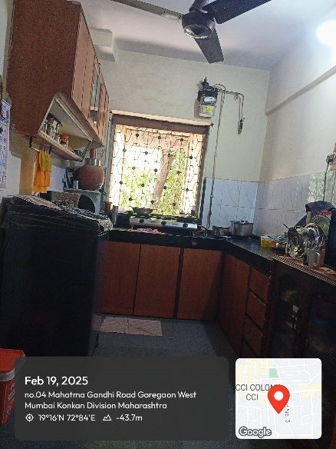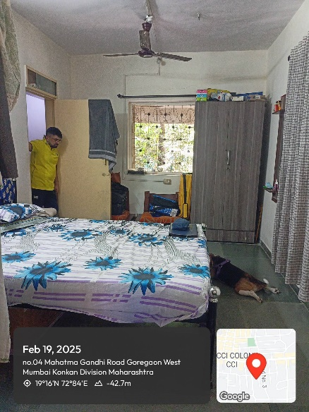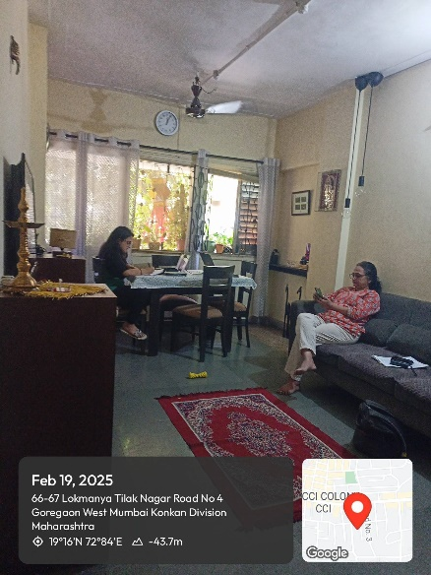

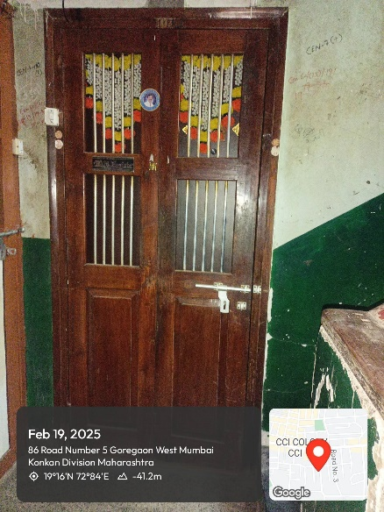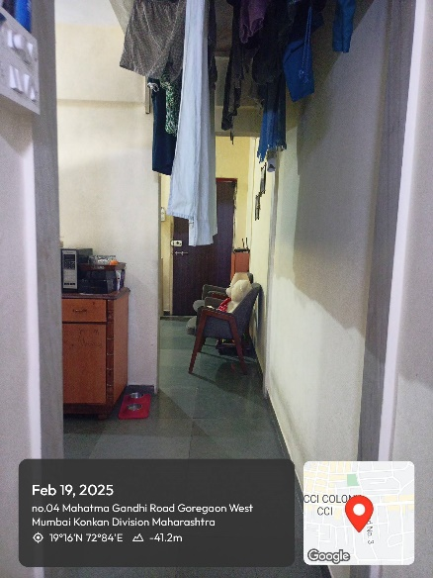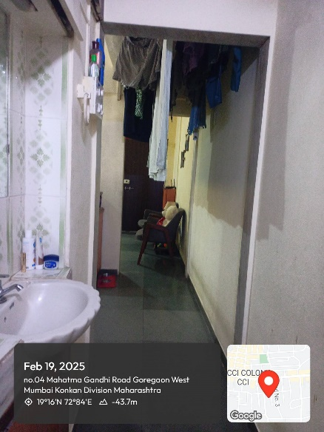



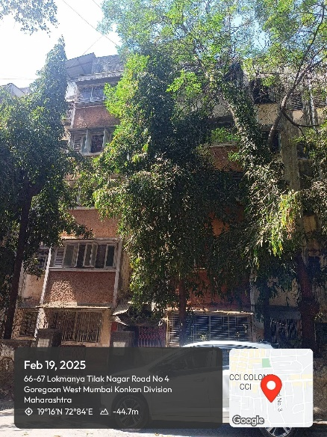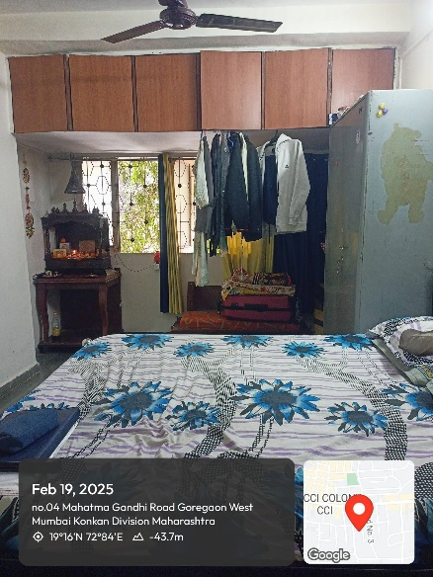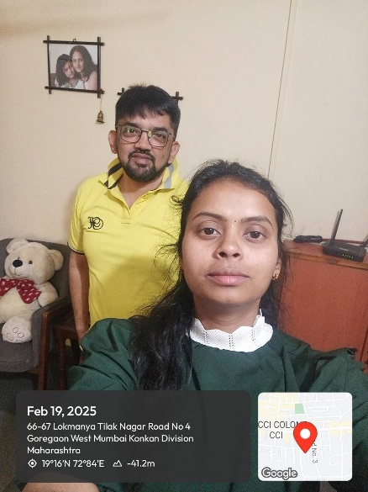

**Actual site photographs**

