WORK PROGRESS REPORT

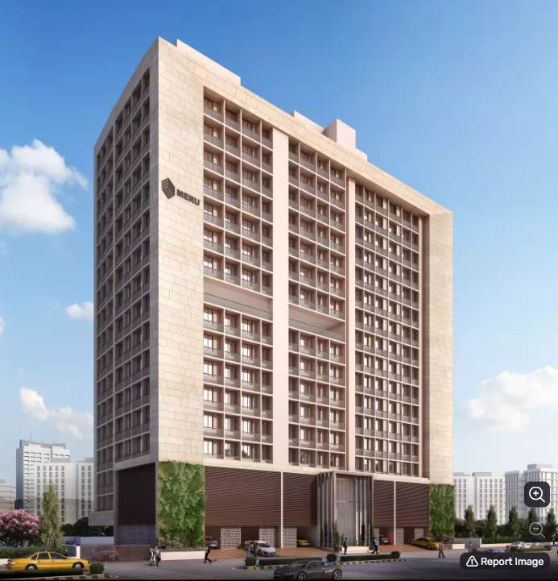

**Details of the property under consideration:**

**Name of Project: Yojan One**

**"Yojan One", Proposed Slum Rehabilitation Scheme Residential Building on plot bearing on**

**C.T.S. No.131 (pt),131/1 to 131/50, 131/52 to 131/84, Match Factory Lane, H.P.K Marg,**

**Village – Kurla (IV), Kurla (West), Mumbai – 400 070, Maharashtra, India**

**Latitude Longitude: 19°04'08.2"N 72°52'33.2"E**

Intended User:

State Bank of India

SME Chembur Branch

Unit No. 11, Building No. 11, Ground Floor, Corporate Park, Sion Trombay Road,

Chembur, Mumbai, Pin Code – 400 071, Maharashtra, India

Vastu/SBI/Mumbai/02/2025/14347/2308922

15/02-07-PY

Date: - 15.02.2025

WORK PROGRESS REPORT

**To,**

**State Bank of India**

SME Chembur Branch

Unit No. 11, Building No. 11,

Ground Floor, Corporate Park,

Sion Trombay Road, Chembur,

Mumbai – 400 071,

Maharashtra, India

Subject: Construction of Proposed Slum Rehabilitation Scheme - Residential Building on plot bearing on C.T.S. No.131,131/1 to 131/50, 131/52 to 131/84 Match Factory Lane, H.P.K Marg, Village – Kurla (IV), Kurla (West), Mumbai – 400 070, Maharashtra, India.

**Ref:** You’re Request for Work Progress Report of under Construction Building.

**Dear Sir,**

1. As per your instruction, we have inspected the under-construction Rehab and Sale Building project situated on plot bearing C.T.S. No.131,131/1 to 131/50, 131/52 to 131/84 Match Factory Lane, H.P.K Marg, Village – Kurla (IV), Kurla (West), Mumbai – 400 070, Maharashtra, India which is being developed by M/s. Meru Realty LLP in order to give the physical progress at site as on 12/02/2025.
2. **The Construction work as per approved plan was in progress during the site visit on 12th February 2025.**
3. **Status of work:**
4. **For Rehab Building:** Slab work, blockwork, plaster work, flooring, kitchen platform, kitchen & toilet tiling, waterproofing, firefighting, Gypsum work, plumbing & electrical concealed work, painting & sanitary fitting are completed, Doors & Windows & Lift and mechanical car lift are installed & final finishing work is in progress.

**Rehab building work is delay by 1 year.**

1. **For Sale Building:** Till 16th Floor Slab work, Terrace bottom slab work is completed, 1st to 12th floor block work is completed, on 13th floor 85% block work is completed, 1st to 11th plaster work, kitchen platform, Wing A 1st to 10th floor gypsum work, kitchen tiling work is completed and 13th floor block work is in progress.

**Sale building work is delay by 6 months.**

1. Overall Physical progress of the rehab building construction as on 08/01/2025 is 98.00% as per physical site inspection.
2. Overall Physical progress of the sale building construction as on 12/02/2025 is 63.04% as per physical site inspection.
3. Overall Physical progress of the rehab & sale building construction as on 12/02/2025 is 74.53% as per physical site inspection.
4. Overall Physical progress of the rehab & sale building construction as on 12/02/2025 is 78.80% as per physical site inspection and material on site and advance payment to vendors..

**DECLARATION**

1. The information furnished in the report is based on our 9th site visit Dated 14/02/2025 & Document Provided by Client.
2. Vastukala 8th LIE Report dated 15/02/2025.
3. I have no direct and indirect interest in the property examined for report.
4. I have not been found guilty of misconduct in my professional capacity.

**Manoj B. Chalikwar**

Registered Valuer

Chartered Engineer (India)

Reg. No. IBBI/RV/07/2018/10366

Encl.: LIE report

# Purpose & Methodology

* State Bank of India Banks and financial institutions require monitoring & an independent review of the progress of the sanctioned projects
* **VCIPL** undertakes such study to independently review the progress of the project and put forward a comprehensive analysis

# Advantages:

* Assurance on present practices
* Identification of risk
* Analyzing the performance of third parties
* Recommendations

# The Methodology

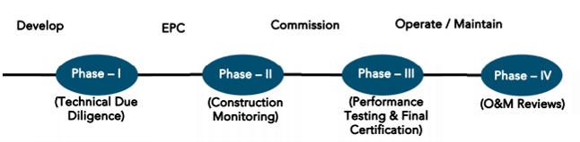

**WORK PROGRESS REPORT**

**OF**

**"YOJAN ONE"**

**"Yojan One",** Proposed Slum Rehabilitation Scheme Residential Building on plot bearing on C.T.S. No.131 (pt),131/1 to 131/50, 131/52 to 131/84, Match Factory Lane, H.P.K Marg, Village – Kurla (IV), Kurla (West),

Mumbai – 400 070, Maharashtra, India

**Latitude Longitude: 19°04'08.2"N 72°52'33.2"E**

**NAME OF DEVELOPER: M/s. Meru Realty LLP**

|  |
| --- |
| Pursuant to instructions from State of India, SME Chembur Branch, we have duly visited, inspected, surveyed & assessed the above said property on **12th February 2025** to determine the work completion status of the said property/project as on 12th February 2025.  **1. Location Details:**  Proposed Residential Building on plot bearing on C.T.S. No.131,131/1 to 131/50, 131/52 to 131/84 Match Factory Lane, H.P.K Marg, Village – Kurla (IV), Kurla (West), Mumbai – 400 070 It is about 850 M. tarvelling distance from Kurla Railway station. Surface transport to the property is by buses, taxis & private vehicles. The property is in developed locality. All the amenities like shops, banks, hotels, markets, schools, hospitals, etc. are all available in the surrounding locality. The area is higher middle class & developed. |

**2. Developer Details:**

|  |  |
| --- | --- |
| **Name of builder** | **M/s. Meru Realty LLP** |
| **Project Rera Registration Number** | **P51800028864** |
| **Registered office address** | Office No. 243, Behind Akshaya Jewellers, Opp. Kurla Police Staion, Sarveshwar Mandir Marg, Kurla (West), Mumbai, Pin Code – 400070, State - Maharashtra, Country – India |
| **Contact details** | **Contact Person:**  Mr. Arnik A. Shah (Director)  Mobile No. 9930084006 |
| **E – mail ID and website** | [merurealtyllp@gmail.com](mailto:merurealtyllp@gmail.com)  [www.merurealty.in](http://www.merurealty.in) |

**3. Boundaries of the Property:**

|  |  |
| --- | --- |
| **Direction** | **Particulars** |
| **On or towards North** | Manraj Heights |
| **On or towards South** | Slum Area |
| **On or towards East** | HP Keluskar Marg |
| **On or towards West** | Slum Area |

# Introduction

**As per Information on site M/s. Meru Realty LLP** has acquired land by Conveyance Deed dated 10.10.2017 admeasuring **area is 3,674.10 Sq. M.** bearing **C.T.S. No.131,131/1 to 131/50, 131/52 to 131/84 & 132.** For the Proposed Residential Building.

# Area Statement:

# Land:

|  |  |  |
| --- | --- | --- |
| **Date** | **Particular** | **Area in Sq. M.** |
| 10.10.2017 | C.T.S. No.131,131/1 to 131/50, 131/52 to 131/84 & 132 | 3,674.10 |
| TOTAL | | 3,674.10 |

1. Copy of Conveyance Deed dated 10.10.2017 b/w M/s. A. H. Wadia Trust (The Vendors) & M/s. Meru Realty LLP (The Purchasers)

# Building Area As per Approved Plan:

| **Sr. No.** | **Area Statement** | **Area in Sq. M.** |
| --- | --- | --- |
| **1** | Area of Plot | 3,248.10 |
| **a** | Area of Reservation in Plot |  |
| **b** | Area of Road Set Back | 261.19 |
| **c** | Area of DP Road | - |
| **2** | Ductions For |  |
| **A** | For Reservation / Road Area | - |
| **a** | Road Set Back Area to Be Handed Over (100%) (Regulation No. (16) | 261.19 |
| **b** | Proposed DP Road to Be Handed Over (100%)  (Regulation No. (16) | - |
| **c** | i) Reservation Area to Be Handed Over (100%) (Regulation No. (17) |  |
|  | ii) Reservation Area to Be Handed Over as Per AR (Regulation No. (17) | - |
| **B** | For Amenity Area | - |
| **a** | Area of Amenity Plots / Plots to Be Handed Over as Per DSR 14 A | - |
| **b** | Area of Amenity Plots / Plots to Be Handed Over as Per DSR 14 B | - |
| **c** | Area of Amenity Plots / Plots to Be Handed Over as Per DSR 35 (Abeyance) | - |
| **C** | Deduction For Existing BUA to Be Retained If Any / Land Component of Existing BUA/ Existing BUA as Per Regulation Under which the Development Was Allowed | - |
| **3** | Total Deduction [(2(A) +2(B)+2(C)] and when Applicable | 2,986.91 |
| **4** | Balance Area of Plot (1 Minus 3) | - |
| **5** | Plot Area Under Development After Area to Be Handed Over to MCGM / Applicable Authority as Per SR No. 4 Above | - |
| **6** | Zonal (Basic FSI (0.50 or 0.75 or 0.33) | - |
| **SR 1.1** | Minimum FSI to Be Attained as Per Clouse Use 3.8 of 33 (10) of DCPR 2034 | - |
| **SR 1.2** | Permissible FSI as Per 33(11)A | - |
| **7** | Built Up Area as Per Zonal (Basic) FSI (5X6) (In Case of Mill Land Permissible BUA / Keep in Abeyance |  |
| **8** | Built Up Equal to Area of Land Handed Over as Per Regulation 30 (A) |  |
|  | i) As Per 2(A) And 2 (B) Except 2(A) (C) ii) Above with In Cap of Permissible TDR as Column 6 of Table-12 On Remaining/ Balance Plot |  |
|  | ii) In Case of 2 (A)(C) ii) Permissible Over and Above Permissible BUA on Remaining/ Balance Plot. |  |
| **9** | Built Up Area In Lieu of Cost of Construction of Built-Up Amenity to Be Handed Over (Within the Limit of Premises BUA On Remaining Plot) |  |
| **10** | Built Up Area Due to Additional FSI on Payment of Premium as per Table No. 12 of Regulation No. 30 (A) On Remaining / Balance Plot |  |
| **11** | Built Up Area Due to Admissible TDR as Per Table No. 12 of Regulation NC 30 (A) And 32 On remaining / Balance Plot |  |
| **12** | Permissible Built-Up Area (As the Case May Be with / without BUA as Per 2 (C) |  |
| **SR 2.1** | Proposed Built Up Area of Rehab | 4,903.76 |
|  | Rehab Component | 5,945.47 |
|  | Permissible Sale Component (Incentive x Rehab Component) 5945.64 X 1.10 | 5945.64 X 1.10 |
| **SR 2.2** | Permissible Built-Up Transit Tenements for SRA / of Total Additional BUA |  |
|  | Permissible BUA for Sale Components of Total Additional BUA | 6,540.02 |
| **SR 3** | Total BUA Sanctioned for The Project | 11,443.78 |
| **13** | Proposed BUA (As the Case May Be with / Without BUA as Per 2C |  |
| **SR 4.1** | Total BUA Proposed to Be Consumed In Situ |  |
| **SR 4.1** | Proposed BUA for Transit Tenements For SRA/Of Total Additional BUA |  |
|  | Proposed BUA for Sale Component of Total Additional BUA | 6,540.02 |
| **14** | TDR Generate If Any as Per Regulation No. 30 (A) And 32 |  |
| **SR 5** | TDR Generate in Schedule |  |
| **15** | Fungible Compensatory Area as Per Regulation No. 31(3) |  |
| **a** | i) Permissible Fungible Compensatory Area for Rehab Component Without Charging Premium | 1,716.52 |
|  | ii) Fungible Compensatory Area Availed for Rehab Component Without Charging Premium | 155.52 |
| **b** | i) Permissible Fungible Compensatory Area by Charging Premium for Sale | 2,289.00 |
|  | ii) Fungible Compensatory Area Availed on Payment of Premium for Sale | 2,283.29 |
| **16** | i) Total BUA Including Fungible for Rehab Component |  |
| **SR 6** | ii) Total BUA Including Fungible for Sale Component | 8,823.31 |
|  | Total Built Up Area Proposed Including Fungible Compensatory Area [13 + 15 (a) (ii) + 15 (b)(ii)] |  |
| **17** | FSI Consumed on Net Plot 13 SR 4.1 / 4 |  |

# List of Approvals:

1. Copy of IOD Plan for Rehab Building No. L/PVT/0076/20180604/LOI dated 28.08.2020 issued by Slum Rehabilitation Authority (SRA).
2. Copy of Approved Plan for Rehab Building No. L/PVT/0076/20180604/AP/R dated 15.09.2020 issued by Slum Rehabilitation Authority (SRA).

**Approval Up to: Basement + Ground Floor + 1st to 15th Upper Floors**

1. Copy of Amended Approved Plan for Rehab Building No. SRA/ENG/L/PVT/0076/20180604/AP/R dated 24.08.2023 issued by Slum Rehabilitation Authority (SRA).

**Approval Up to: Basement + Ground Floor + 1st to 17th Upper Floors**

1. Copy of 1st Commencement Certificate for Rehab Building No. L/PVT/0076/20180604/AP/R dated 29.01.2021 issued by Slum Rehabilitation Authority (SRA).

**(This CC is now endorsed for the work of Plinth Level)**

1. Copy of 2nd Commencement Certificate for Rehab Building No. L/PVT/0076/20180604/AP/R dated 29.06.2021 issued by Slum Rehabilitation Authority (SRA).

**(This CC is now endorsed for the work of Basement + Ground Floor + 1st to 15th Upper Floors including OHT& LMR)**

1. Copy of IOD Plan for Sale Building No. L/PVT/0076/20180604/AP/S dated 15.09.2020 issued by Slum Rehabilitation Authority (SRA).
2. Copy of Approved Plan for Sale Building No. L/PVT/0076/20180604/AP/LAY dated 24.11.2020 issued by Slum Rehabilitation Authority (SRA).

**Approval Up to: Ground Floor + 1st to 11th Upper Floors**

1. Copy of 1st Amended Approved Plan for Sale Building No. L/PVT/0076/20180604/AP/S dated 14.10.2021 issued by Slum Rehabilitation Authority (SRA).

**Approval Up to: Ground Floor + 1st to 16th Upper Floors**

1. Copy of 2nd Amended Approved Plan for Sale Building No. SRA/ENG/L/PVT/0076/2018/0604/AP/S dated 23.01.2023 issued by Slum Rehabilitation Authority (SRA).

**Approval Up to: Ground Floor + 1st to 16th Upper Floors**

1. Copy of 3rd Amended Approved Plan for Sale Building No. L/PVT/0076/20180604/AP/S dated 24.08.2023 issued by Slum Rehabilitation Authority (SRA).

**Approval Up to: Ground Floor + 1st to 14th Upper Floors**

1. Copy of Concession Plan for Sale dated 23.01.2023 issued by Slum Rehabilitation Authority (SRA).

**Approval Up to: Ground Floor + 1st to 16th Upper Floors**

1. Copy of 1st Commencement Certificate for Sale Building No. L/PVT/0076/20180604/AP/S dated 10.02.2021 issued by Slum Rehabilitation Authority (SRA).

**(This CC is now endorsed for the work of Plinth level)**

1. Copy of 2nd Commencement Certificate for Sale Building No. L/PVT/0076/20180604/AP/S dated 25.10.2021 issued by Slum Rehabilitation Authority (SRA).

**(This CC is now endorsed for the work of Ground Floor + 1st to 3rd Upper Floors)**

1. Copy of 3rd Commencement Certificate for Sale Building No. L/PVT/0076/20180604/AP/S dated 23.01.2023 issued by Slum Rehabilitation Authority (SRA).

**(This CC is now endorsed for the work of Ground Floor + 1st to 6th Upper Floors)**

1. Copy of 4th Commencement Certificate for Sale Building No. L/PVT/0076/20180604/AP/S dated 05.09.2023 issued by Slum Rehabilitation Authority (SRA).

**(This CC is now endorsed for the work of Ground Floor + 1st to 10th Upper Floors)**

1. Copy of 5th Commencement Certificate for Sale Building No. L/PVT/0076/20180604/AP/S dated 07.03.2024 issued by Slum Rehabilitation Authority (SRA).

**(This CC is now endorsed for the work of Ground Floor + 1st to 14th Upper Floors + OWH Tank + LMR room as per amended approved plans 24.08.2023)**

# LEVEL OF COMPLETION:

# REHAB BUILDING

| Sr. No | Floor Nos. | Construction Area  in Sq. M. | Completed Area in Sq. M. | Work Completion as on 8th LIE Report | Work Completion as on 12.02.2025 |
| --- | --- | --- | --- | --- | --- |
| 1 | Deep Excavation  & Piling Work |  |  | Excavation & Piling work is completed | Excavation & Piling work is completed |
| 2 | Basement | 508.14 | 508.14 | Slab work, blockwork, Plasterwork, Gypsum work, Firefighting, Waterproofing, Kitchen Platform, Flooring, Kitchen & Toilet tiling, Doors & Windows are installed Plumbing work, Electrical concealed work, Passage & Staircase flooring work is completed, Lift are installed | Slab work, blockwork, Plasterwork, Gypsum work, Firefighting, Waterproofing, Kitchen Platform, Flooring, Kitchen & Toilet tiling, Doors & Windows are installed Plumbing work, Electrical concealed work, Passage & Staircase flooring work is completed, Lift are installed |
| 3 | Ground Floor | 458.54 | 458.54 | Slab work, blockwork, Plasterwork, Gypsum work, Firefighting, Waterproofing, Kitchen Platform, Flooring, Kitchen & Toilet tiling, Doors & Windows are installed Plumbing work, Electrical concealed work, Passage & Staircase flooring work, painting, sanitary fitting work is completed, Lift are installed | Slab work, blockwork, Plasterwork, Gypsum work, Firefighting, Waterproofing, Kitchen Platform, Flooring, Kitchen & Toilet tiling, Doors & Windows are installed Plumbing work, Electrical concealed work, Passage & Staircase flooring work, painting, sanitary fitting work is completed, Lift are installed |
| 4 | 1st Floor | 464.21 | 464.21 | Slab work, blockwork, Plasterwork, Gypsum work, Firefighting, Waterproofing, Kitchen Platform, Flooring, Kitchen & Toilet tiling, Doors & Windows are installed Plumbing work, Electrical concealed work, Passage & Staircase flooring work, painting, sanitary fitting work is completed, Lift are installed | Slab work, blockwork, Plasterwork, Gypsum work, Firefighting, Waterproofing, Kitchen Platform, Flooring, Kitchen & Toilet tiling, Doors & Windows are installed Plumbing work, Electrical concealed work, Passage & Staircase flooring work, painting, sanitary fitting work is completed, Lift are installed |
| 5 | 2nd Floor | 457.14 | 457.14 | Slab work, blockwork, Plasterwork, Gypsum work, Firefighting, Waterproofing, Kitchen Platform, Flooring, Kitchen & Toilet tiling, Doors & Windows are installed Plumbing work, Electrical concealed work, Passage & Staircase flooring work, painting, sanitary fitting work is completed, Lift are installed | Slab work, blockwork, Plasterwork, Gypsum work, Firefighting, Waterproofing, Kitchen Platform, Flooring, Kitchen & Toilet tiling, Doors & Windows are installed Plumbing work, Electrical concealed work, Passage & Staircase flooring work, painting, sanitary fitting work is completed, Lift are installed |
| 6 | 3rd Floor | 453.64 | 453.64 | Slab work, blockwork, Plasterwork, Gypsum work, Firefighting, Waterproofing, Kitchen Platform, Flooring, Kitchen & Toilet tiling, Doors & Windows are installed Plumbing work, Electrical concealed work, Passage & Staircase flooring work, painting, sanitary fitting work is completed, Lift are installed | Slab work, blockwork, Plasterwork, Gypsum work, Firefighting, Waterproofing, Kitchen Platform, Flooring, Kitchen & Toilet tiling, Doors & Windows are installed Plumbing work, Electrical concealed work, Passage & Staircase flooring work, painting, sanitary fitting work is completed, Lift are installed |
| 7 | 4th Floor | 453.64 | 453.64 | Slab work, blockwork, Plasterwork, Gypsum work, Firefighting, Waterproofing, Kitchen Platform, Flooring, Kitchen & Toilet tiling, Doors & Windows are installed Plumbing work, Electrical concealed work, Passage & Staircase flooring work, painting, sanitary fitting work is completed, Lift are installed | Slab work, blockwork, Plasterwork, Gypsum work, Firefighting, Waterproofing, Kitchen Platform, Flooring, Kitchen & Toilet tiling, Doors & Windows are installed Plumbing work, Electrical concealed work, Passage & Staircase flooring work, painting, sanitary fitting work is completed, Lift are installed |
| 8 | 5th Floor | 453.64 | 453.64 | Slab work, blockwork, Plasterwork, Gypsum work, Firefighting, Waterproofing, Kitchen Platform, Flooring, Kitchen & Toilet tiling, Doors & Windows are installed Plumbing work, Electrical concealed work, Passage & Staircase flooring work, painting, sanitary fitting work is completed, Lift are installed | Slab work, blockwork, Plasterwork, Gypsum work, Firefighting, Waterproofing, Kitchen Platform, Flooring, Kitchen & Toilet tiling, Doors & Windows are installed Plumbing work, Electrical concealed work, Passage & Staircase flooring work, painting, sanitary fitting work is completed, Lift are installed |
| 9 | 6th Floor | 453.64 | 453.64 | Slab work, blockwork, Plasterwork, Gypsum work, Firefighting, Waterproofing, Kitchen Platform, Flooring, Kitchen & Toilet tiling, Doors & Windows are installed Plumbing work, Electrical concealed work, Passage & Staircase flooring work, painting, sanitary fitting work is completed, Lift are installed | Slab work, blockwork, Plasterwork, Gypsum work, Firefighting, Waterproofing, Kitchen Platform, Flooring, Kitchen & Toilet tiling, Doors & Windows are installed Plumbing work, Electrical concealed work, Passage & Staircase flooring work, painting, sanitary fitting work is completed, Lift are installed |
| 10 | 7th Floor | 453.64 | 453.64 | Slab work, blockwork, Plasterwork, Gypsum work, Firefighting, Waterproofing, Kitchen Platform, Flooring, Kitchen & Toilet tiling, Doors & Windows are installed Plumbing work, Electrical concealed work, Passage & Staircase flooring work, painting, sanitary fitting work is completed, Lift are installed | Slab work, blockwork, Plasterwork, Gypsum work, Firefighting, Waterproofing, Kitchen Platform, Flooring, Kitchen & Toilet tiling, Doors & Windows are installed Plumbing work, Electrical concealed work, Passage & Staircase flooring work, painting, sanitary fitting work is completed, Lift are installed |
| 11 | 8th Floor | 456.64 | 456.64 | Slab work, blockwork, Plasterwork, Gypsum work, Firefighting, Waterproofing, Kitchen Platform, Flooring, Kitchen & Toilet tiling, Doors & Windows are installed Plumbing work, Electrical concealed work, Passage & Staircase flooring work, painting, sanitary fitting work is completed, Lift are installed | Slab work, blockwork, Plasterwork, Gypsum work, Firefighting, Waterproofing, Kitchen Platform, Flooring, Kitchen & Toilet tiling, Doors & Windows are installed Plumbing work, Electrical concealed work, Passage & Staircase flooring work, painting, sanitary fitting work is completed, Lift are installed |
| 12 | 9th Floor | 453.64 | 453.64 | Slab work, blockwork, Plasterwork, Gypsum work, Firefighting, Waterproofing, Kitchen Platform, Flooring, Kitchen & Toilet tiling, Doors & Windows are installed Plumbing work, Electrical concealed work, Passage & Staircase flooring work, painting, sanitary fitting work is completed, Lift are installed | Slab work, blockwork, Plasterwork, Gypsum work, Firefighting, Waterproofing, Kitchen Platform, Flooring, Kitchen & Toilet tiling, Doors & Windows are installed Plumbing work, Electrical concealed work, Passage & Staircase flooring work, painting, sanitary fitting work is completed, Lift are installed |
| 13 | 10th Floor | 453.64 | 453.64 | Slab work, blockwork, Plasterwork, Gypsum work, Firefighting, Waterproofing, Kitchen Platform, Flooring, Kitchen & Toilet tiling, Doors & Windows are installed Plumbing work, Electrical concealed work, Passage & Staircase flooring work, painting, sanitary fitting work is completed, Lift are installed | Slab work, blockwork, Plasterwork, Gypsum work, Firefighting, Waterproofing, Kitchen Platform, Flooring, Kitchen & Toilet tiling, Doors & Windows are installed Plumbing work, Electrical concealed work, Passage & Staircase flooring work, painting, sanitary fitting work is completed, Lift are installed |
| 14 | 11th Floor | 453.64 | 453.64 | Slab work, blockwork, Plasterwork, Gypsum work, Firefighting, Waterproofing, Kitchen Platform, Flooring, Kitchen & Toilet tiling, Doors & Windows are installed Plumbing work, Electrical concealed work, Passage & Staircase flooring work, painting, sanitary fitting work is completed, Lift are installed | Slab work, blockwork, Plasterwork, Gypsum work, Firefighting, Waterproofing, Kitchen Platform, Flooring, Kitchen & Toilet tiling, Doors & Windows are installed Plumbing work, Electrical concealed work, Passage & Staircase flooring work, painting, sanitary fitting work is completed, Lift are installed |
| 15 | 12th Floor | 453.64 | 453.64 | Slab work, blockwork, Plasterwork, Gypsum work, Firefighting, Waterproofing, Kitchen Platform, Flooring, Kitchen & Toilet tiling, Doors & Windows are installed Plumbing work, Electrical concealed work, Passage & Staircase flooring work, painting, sanitary fitting work is completed, Lift are installed | Slab work, blockwork, Plasterwork, Gypsum work, Firefighting, Waterproofing, Kitchen Platform, Flooring, Kitchen & Toilet tiling, Doors & Windows are installed Plumbing work, Electrical concealed work, Passage & Staircase flooring work, painting, sanitary fitting work is completed, Lift are installed |
| 16 | 13th Floor | 453.64 | 453.64 | Slab work, blockwork, Plasterwork, Gypsum work, Firefighting, Waterproofing, Kitchen Platform, Flooring, Kitchen & Toilet tiling, Doors & Windows are installed Plumbing work, Electrical concealed work, Passage & Staircase flooring work, painting, sanitary fitting work is completed, Lift are installed | Slab work, blockwork, Plasterwork, Gypsum work, Firefighting, Waterproofing, Kitchen Platform, Flooring, Kitchen & Toilet tiling, Doors & Windows are installed Plumbing work, Electrical concealed work, Passage & Staircase flooring work, painting, sanitary fitting work is completed, Lift are installed |
| 17 | 14th Floor | 453.64 | 453.64 | Slab work, blockwork, Plasterwork, Gypsum work, Firefighting, Waterproofing, Kitchen Platform, Flooring, Kitchen & Toilet tiling, Doors & Windows are installed Plumbing work, Electrical concealed work, Passage & Staircase flooring work, painting, sanitary fitting work is completed, Lift are installed | Slab work, blockwork, Plasterwork, Gypsum work, Firefighting, Waterproofing, Kitchen Platform, Flooring, Kitchen & Toilet tiling, Doors & Windows are installed Plumbing work, Electrical concealed work, Passage & Staircase flooring work, painting, sanitary fitting work is completed, Lift are installed |
| 18 | 15th Floor | 306.54 | 306.54 | Slab work, blockwork, Plasterwork, Gypsum work, Firefighting, Waterproofing, Kitchen Platform, Flooring, Kitchen & Toilet tiling, Doors & Windows are installed Plumbing work, Electrical concealed work, Passage & Staircase flooring work, painting, sanitary fitting work is completed, Lift are installed | Slab work, blockwork, Plasterwork, Gypsum work, Firefighting, Waterproofing, Kitchen Platform, Flooring, Kitchen & Toilet tiling, Doors & Windows are installed Plumbing work, Electrical concealed work, Passage & Staircase flooring work, painting, sanitary fitting work is completed, Lift are installed |
| 19 | 16th Floor | - | - | Slab work, blockwork, Plasterwork, Gypsum work, Firefighting, Waterproofing, Kitchen Platform, Flooring, Kitchen & Toilet tiling, Doors & Windows are installed Plumbing work, Electrical concealed work, Passage & Staircase flooring work, painting, sanitary fitting work is completed, Lift are installed | Slab work, blockwork, Plasterwork, Gypsum work, Firefighting, Waterproofing, Kitchen Platform, Flooring, Kitchen & Toilet tiling, Doors & Windows are installed Plumbing work, Electrical concealed work, Passage & Staircase flooring work, painting, sanitary fitting work is completed, Lift are installed |
| 20 | 17th Floor | - | - | Slab work, blockwork, Plasterwork, Gypsum work, Firefighting, Waterproofing, Kitchen Platform, Flooring, Kitchen & Toilet tiling, Doors & Windows are installed Plumbing work, Electrical concealed work, Passage & Staircase flooring work, painting, sanitary fitting work is completed, Lift are installed | Slab work, blockwork, Plasterwork, Gypsum work, Firefighting, Waterproofing, Kitchen Platform, Flooring, Kitchen & Toilet tiling, Doors & Windows are installed Plumbing work, Electrical concealed work, Passage & Staircase flooring work, painting, sanitary fitting work is completed, Lift are installed |
| 21 | Terrace | 39.15 | 39.15 | Slab work, blockwork, Plasterwork, Gypsum work, Firefighting, Waterproofing, Kitchen Platform, Flooring, Kitchen & Toilet tiling, Doors & Windows are installed Plumbing work, Electrical concealed work, Passage & Staircase flooring work, painting, sanitary fitting work is completed, Lift are installed | Slab work, blockwork, Plasterwork, Gypsum work, Firefighting, Waterproofing, Kitchen Platform, Flooring, Kitchen & Toilet tiling, Doors & Windows are installed Plumbing work, Electrical concealed work, Passage & Staircase flooring work, painting, sanitary fitting work is completed, Lift are installed |
| 22 | **No. Parking** | 24.00 | 24.00 | Stack parking work is completed | Stack parking work is completed |
|  | **Total** | **7,680.40** | **7,680.40** |  |  |

# SALE BUILDING

| Sr. No | Floor Nos. | Construction Area in Sq. M. | Completed Area in Sq. M. | Work Completion as on 8th LIE Report | Work Completion as on 14.02.2025 |
| --- | --- | --- | --- | --- | --- |
| 1 | **Deep Excavation**  **& Piling Work** | | | Excavation & Piling work is completed | Excavation & Piling work is completed |
| 2 | **Ground Floor** | 948.93 | 948.93 | Slab work is completed | Slab work & block work is completed |
| 3 | **1st Floor** | 943.22 | 943.22 | Slab work, Block work, plaster work, gypsum work & waterproofing work is completed & 1 flat is uses as sales offices | Slab work, block work, plaster work, kitchen platform work is completed, Wing A – Flooring, Kitchen tiling, Toilet tiling, concealed plumbing is completed |
| 4 | **2nd Floor** | 915.04 | 915.04 | Slab work, Block work, plaster work, gypsum work, Flooring, Kitchen tiling & platform, toilet dadoing & waterproofing work is completed | Slab work, block work, plaster work, kitchen platform work is completed, Wing A – Flooring, Kitchen tiling, Toilet tiling, concealed plumbing is completed |
| 5 | **3rd Floor** | 813.76 | 813.76 | Slab work, 75% Block work, is completed | Slab work, block work, plaster work, kitchen platform work is completed, Wing A – Flooring, Kitchen tiling, Toilet tiling, concealed plumbing is completed |
| 6 | **4th Floor** | 813.76 | 813.76 | Slab work, Block work, plaster work is completed | Slab work, block work, plaster work, kitchen platform work is completed, Wing A – Flooring, Kitchen tiling, Toilet tiling, concealed plumbing is completed |
| 7 | **5th Floor** | 813.76 | 813.76 | Slab work, 75% Block work, 75% plaster work, 75% gypsum work is completed | Slab work, block work, plaster work, kitchen platform work is completed, Wing A – Flooring, Kitchen tiling, Toilet tiling, concealed plumbing is completed |
| 8 | **6th Floor** | 813.76 | 813.76 | Slab work, Block work, plaster work, 75% gypsum work & waterproofing work is completed | Slab work, block work, plaster work, kitchen platform work is completed, Wing A – Kitchen tiling, concealed plumbing is completed, Toilet tiling work is in progress |
| 9 | **7th Floor** | 813.76 | 813.76 | Slab work, Block work, 85% plaster work & 50% gypsum work is completed | Slab work, block work, plaster work, kitchen platform work is completed, Wing A – Kitchen tiling, concealed plumbing is completed, Toilet tiling work is in progress |
| 10 | **8th Floor** | 813.76 | 813.76 | Slab work, Block work & 75% plaster work is completed | Slab work, block work, plaster work, kitchen platform work is completed, Wing A – Kitchen tiling, concealed plumbing is completed, Toilet tiling work is in progress |
| 11 | **9th Floor** | 813.76 | 813.76 | Slab work & 75% Block work is completed | Slab work, block work, plaster work, kitchen platform work is completed, Wing A – Kitchen tiling, concealed plumbing is completed, Toilet tiling work is in progress |
| 12 | **10th Floor** | 813.76 | 813.76 | Slab work & 90% Block work is completed | Slab work, block work, plaster work, kitchen platform work is completed, Wing A – Kitchen tiling, concealed plumbing is completed, Toilet tiling work is in progress |
| 13 | **11th Floor** | 813.76 | 813.76 | Slab work is completed, Block work is in progress | Slab work, block work, plaster work is completed, Wing A – Gypsum work is completed |
| 14 | **12th Floor** | 813.76 | 813.76 | Slab work is completed, Block work is in progress | Slab work & 95% block work is completed, Block work is in progress |
| 15 | **13th Floor** | 813.76 | 813.76 | Slab work is completed | Slab work & 85% block work is completed, Block work is in progress |
| 16 | **14th Floor** | 813.76 | 813.76 | Slab work is completed | Slab work is completed |
| 17 | **15th Floor** | 813.76 |  | Shuttering work is in progress | Slab work is completed |
| 18 | **16th floor** | 831.79 |  |  | Slab work is completed |
| 19 | **Terrace** | 137.84 |  |  | Bottom Slab work is completed |
| 20 | No. Parking | 92 |  |  |  |
|  | **Total** | **14,355.69** | **10,944.79** |  |  |

* **As per site inspection, rehab building slab work is completed upto 17th Floors and sale building slab work is completed upto 14th floors.**
* **Revised building approval drawings for rehab building was submitted to us and has building permission upto 17th Floor only.**
* **Revised building approval drawings for sale building was submitted to us and has building permission upto 14th Floor only and after the OC of rehab building & sale building 15th & 16th floor LOI & CC we be sanctioned by SRA authority.**
* **As bank has sanctioned the loan upto 15th floor of rehab building & upto 16th floor of sale building.**
* **Hence for the LIE Report we have considered as following for Plinth Calculation.**

**Rehab Building – Basement (Part) + Ground Floor + 1st to 15th floor**

**Sale Building – Ground Floor + 1st to 16th floor.**

# Cost of Construction as on 12th February 2025:

# REHAB BUILDING

|  |  |  |  |  |  |  |  |
| --- | --- | --- | --- | --- | --- | --- | --- |
| PLINTH AREA CALCULATION | | | | | | | |
| Sr. No | **Floor Nos.** | **Construction Area in Sq. M.** | **Completed Area in Sq. M.** | **Rate per Sq. M.** | **Full Value after completion** | **% of work completed** | **Actual Expenditure till date in `** |
| 1 | Deep Excavation & Piling Work | | | | 2,04,01,000.00 | 100% | 2,04,01,000.00 |
| 2 | **Basement** | 508.14 | 508.14 | 25,000.00 | 1,27,03,500.00 | 98% | 1,24,49,430.00 |
| 3 | **Ground Floor** | 458.54 | 458.54 | 25,000.00 | 1,14,63,500.00 | 98% | 1,12,34,230.00 |
| 4 | **1st Floor** | 464.21 | 464.21 | 25,000.00 | 1,16,05,250.00 | 98% | 1,13,73,145.00 |
| 5 | **2nd Floor** | 457.14 | 457.14 | 25,000.00 | 1,14,28,500.00 | 98% | 1,11,99,930.00 |
| 6 | **3rd Floor** | 453.64 | 453.64 | 25,000.00 | 1,13,41,000.00 | 98% | 1,11,14,180.00 |
| 7 | **4th Floor** | 453.64 | 453.64 | 25,000.00 | 1,13,41,000.00 | 98% | 1,11,14,180.00 |
| 8 | **5th Floor** | 453.64 | 453.64 | 25,000.00 | 1,13,41,000.00 | 98% | 1,11,14,180.00 |
| 9 | **6th Floor** | 453.64 | 453.64 | 25,000.00 | 1,13,41,000.00 | 98% | 1,11,14,180.00 |
| 10 | **7th Floor** | 453.64 | 453.64 | 25,000.00 | 1,13,41,000.00 | 98% | 1,11,14,180.00 |
| 11 | **8th Floor** | 456.64 | 456.64 | 25,000.00 | 1,14,16,000.00 | 98% | 1,11,87,680.00 |
| 12 | **9th Floor** | 453.64 | 453.64 | 25,000.00 | 1,13,41,000.00 | 98% | 1,11,14,180.00 |
| 13 | **10th Floor** | 453.64 | 453.64 | 25,000.00 | 1,13,41,000.00 | 98% | 1,11,14,180.00 |
| 14 | **11th Floor** | 453.64 | 453.64 | 25,000.00 | 1,13,41,000.00 | 98% | 1,11,14,180.00 |
| 15 | **12th Floor** | 453.64 | 453.64 | 25,000.00 | 1,13,41,000.00 | 98% | 1,11,14,180.00 |
| 16 | **13th Floor** | 453.64 | 453.64 | 25,000.00 | 1,13,41,000.00 | 98% | 1,11,14,180.00 |
| 17 | **14th Floor** | 453.64 | 453.64 | 25,000.00 | 1,13,41,000.00 | 98% | 1,11,14,180.00 |
| 18 | **15th Floor** | 306.54 | 306.54 | 25,000.00 | 76,63,500.00 | 98% | 75,10,230.00 |
| 19 | **Terrace** | 39.15 | 39.15 | 25,000.00 | 9,78,750.00 | 98% | 9,59,175.00 |
| 20 | No. Parking | 24.00 |  | 5,00,000.00 | 1,20,00,000.00 | 98% | 1,17,60,000.00 |
|  | **Total** | **7,680.40** | **7,680.40** |  | **22,44,11,000.00** | **98.18%** | **22,03,30,800.00** |

##### Note: Details of work completed is as per site visit dated 12.02.2025.

# SALE BUILDING

|  |  |  |  |  |  |  |  |
| --- | --- | --- | --- | --- | --- | --- | --- |
| Sr. No | Floor Nos. | Construction Area in Sq. M. | Completed Area in Sq. M. | Rate per Sq. M. | Full Value after completion | % of work completed | Actual Expenditure till date in ` |
| 1 | Deep Excavation & Piling Work | | | | 4,33,08,885.00 | 100% | 4,33,08,885.00 |
| 2 | **Ground Floor** | 948.93 | 948.93 | 27,000.00 | 2,56,21,110.00 | 60% | 1,53,72,666.00 |
| 3 | **1st Floor** | 943.22 | 943.22 | 27,000.00 | 2,54,66,950.80 | 78% | 1,98,64,221.62 |
| 4 | **2nd Floor** | 915.04 | 915.04 | 27,000.00 | 2,47,06,169.10 | 78% | 1,92,70,811.90 |
| 5 | **3rd Floor** | 813.76 | 813.76 | 27,000.00 | 2,19,71,503.80 | 75% | 1,64,78,627.85 |
| 6 | **4th Floor** | 813.76 | 813.76 | 27,000.00 | 2,19,71,503.80 | 75% | 1,64,78,627.85 |
| 7 | **5th Floor** | 813.76 | 813.76 | 27,000.00 | 2,19,71,503.80 | 75% | 1,64,78,627.85 |
| 8 | **6th Floor** | 813.76 | 813.76 | 27,000.00 | 2,19,71,503.80 | 72% | 1,58,19,482.74 |
| 9 | **7th Floor** | 813.76 | 813.76 | 27,000.00 | 2,19,71,503.80 | 72% | 1,58,19,482.74 |
| 10 | **8th Floor** | 813.76 | 813.76 | 27,000.00 | 2,19,71,503.80 | 72% | 1,58,19,482.74 |
| 11 | **9th Floor** | 813.76 | 813.76 | 27,000.00 | 2,19,71,503.80 | 72% | 1,58,19,482.74 |
| 12 | **10th Floor** | 813.76 | 813.76 | 27,000.00 | 2,19,71,503.80 | 72% | 1,58,19,482.74 |
| 13 | **11th Floor** | 813.76 | 813.76 | 27,000.00 | 2,19,71,503.80 | 70% | 1,53,80,052.66 |
| 14 | **12th Floor** | 813.76 | 813.76 | 27,000.00 | 2,19,71,503.80 | 62% | 1,36,22,332.36 |
| 15 | **13th Floor** | 813.76 | 813.76 | 27,000.00 | 2,19,71,503.80 | 56% | 1,23,04,042.13 |
| 16 | **14th Floor** | 813.76 | 813.76 | 27,000.00 | 2,19,71,503.80 | 50% | 1,09,85,751.90 |
| 17 | **15th Floor** | 813.76 |  | 27,000.00 | 2,19,71,503.80 | 50% | 1,09,85,751.90 |
| 18 | **16th floor** | 831.79 |  | 27,000.00 | 2,24,58,278.70 | 50% | 1,12,29,139.35 |
| 19 | **Terrace** | 137.84 |  | 27,000.00 | 37,21,680.00 | 40% | 14,88,672.00 |
| SUB - TOTAL | | **14,355.69** | **13,386.07** |  | **43,09,12,623.00** | **70.16%** | **30,23,45,624.00** |
| 20 | No. Parking | 92 |  | 5,00,000.00 | 4,60,00,000.00 | 0% | - |
|  | **Total** | **14,355.69** | **12,572.31** |  | **47,69,12,623.00** | **63.40%** | **30,23,45,624.00** |

##### Note: Details of work completed is as per site visit dated 12.02.2025.

# SUMMARY

|  |  |  |  |  |  |
| --- | --- | --- | --- | --- | --- |
| Sr. No. | Building | Total Construction Area in Sq. M. | Cost of Construction | % of work completed | Actual Expenditure till date in ` |
| 1 | Rehab Building No. 1 | 7,680.40 | 21,24,11,000.00 | 98.00% | 20,85,70,800.00 |
| 2 | Sale Building | 14,355.69 | 43,09,12,623.00 | 70.16% | 30,23,45,624.00 |
|  | **Sub Total (A)** | **22,036.09** | **64,33,23,623.00** | **79.42%** | **51,09,16,424.00** |
| 3 | Puzzle Parking of Rehab Building in No. | 24.00 | 1,20,00,000.00 | 98% | 1,17,60,000.00 |
| 4 | Puzzle Parking of Sale Building in No. | 92.00 | 4,60,00,000.00 | 0% | - |
|  | **Sub Total (B)** | **116.00** | **5,80,00,000.00** | **20.28%** | **1,17,60,000.00** |
| Total Cost of Construction (A + B) | | | **70,13,23,623.00** | **74.53%** | **52,26,76,424.00** |

# Schedule V/s. Actual Progress:

# REHAB BUILDING

| Activity | Date of Implementation | Date of Completion | Status |
| --- | --- | --- | --- |
| Land | April 2017 | September 2017 | Completed |
| Development of Land | November 2019 | July 2020 | Completed |
| Foundation Work |  |  | Completed |
| Basement |  | September 2021 | Slab work is Completed |
| Ground Floor Slab | 01.10.2021 | 20.10.2021 | Slab work is Completed |
| 1st Floor Slab | 21.10.2021 | 10.11.2021 | Slab work is Completed |
| 2nd Floor Slab | 11.11.2021 | 30.11.2021 | Slab work is Completed |
| 3rd Floor Slab | 1.12.2021 | 31.12.2021 | Slab work is Completed |
| 4th Floor Slab | 01.01.2022 | 20.01.2022 | Slab work is Completed |
| 5th Floor Slab | 21.01.2022 | 10.02.2022 | Slab work is Completed |
| 6th Floor Slab | 11.02.2022 | 28.02.2022 | Slab work is Completed |
| 7th Floor Slab | 01.03.2022 | 31.03.2022 | Slab work is Completed |
| 8th Floor Slab | 01.04.2022 | 30.06.2022 | Slab work is Completed |
| 9th Floor Slab | 01.07.2022 | 30.09.2022 | Slab work is Completed |
| 10th Floor Slab | 01.10.2022 | 15.11.2022 | Slab work is Completed |
| 11th Floor Slab | 15.11.2022 | 31.12.2022 | Slab work is Completed |
| 12th Floor Slab | 01.01.2023 | 31.01.2023 | Slab work is Completed |
| 13th Floor Slab | 01.02.2023 | 28.02.2023 | Slab work is Completed |
| 14th Floor Slab | 01.03.2023 | 31.03.2023 | Slab work is Completed |
| 15th Floor Slab | 01.04.2023 | 30.04.2023 | Slab work is Completed |
| Block work / Internal Plaster work | 01.01.2022 | 31.10.2023 | Block work & Plaster work is completed |
| Terrace Parapet wall / Overhead water tank / Lift Machine room / compound wall / External Plaster work | 01.11.2022 | 31.12.2023 | Terrace Parapet wall, Overhead water tank work, Lift machine room & External Plaster work is completed |
| Electric Work | 01.11.2022 | 31.12.2023 | Work is completed |
| Water Proofing | Work is completed |
| Plumbing Work | Work is completed |
| Tiling / Marble Flooring | Work is completed |
| Door Frames | Work is completed |
| Window Installation | Work is completed |
| Staircase Flooring | Work is completed |
| Staircase Railing | Work is completed |
| Refuge Area Flooring | Work is completed & Delay 1 year |
| Internal Painting | Work is completed & Delay 1 year |
| External Painting | Work is completed & Delay 1 year |
| Lift Work | Work is completed |
| Fire Fighting Installation | Work is completed |
| Stack Parking | Work is completed & Delay 1 year |
| CP Fitting & Sanitary Work | Work is completed & Delay 1 year |
| Final Finishing & Fitting |  | December 2023 | Work is in progress & Delay 1 year |

**Rehab building work is delay by 1 year.**

# SALE BUILDING

| Activity | Date of Implementation | Date of Completion | Status |
| --- | --- | --- | --- |
| Land | April 2017 | September 2017 | Completed |
| Development of Land | November 2019 | July 2020 | Completed |
| Foundation Work | 01.10.2021 | 31.12.2022 | Completed |
| Ground Floor Slab | 01.01.2023 | 31.03.2023 | Slab work is Completed |
| 1st Floor Slab | 01.04.2023 | 30.04.2023 | Slab work is Completed |
| 2nd Floor Slab | 01.05.2023 | 31.05.2023 | Slab work is Completed |
| 3rd Floor Slab | 01.06.2023 | 20.07.2023 | Slab work is Completed |
| 4th Floor Slab | 21.07.2023 | 31.08.2023 | Slab work is Completed |
| 5th Floor Slab | 01.09.2023 | 30.09.2023 | Slab work is Completed |
| 6th Floor Slab | 01.10.2023 | 31.10.2023 | Slab work is Completed |
| 7th Floor Slab | 01.11.2023 | 30.11.2023 | Slab work is Completed |
| 8th Floor Slab | 01.12.2023 | 31.12.2023 | Slab work is Completed |
| 9th Floor Slab | 01.01.2024 | 31.01.2024 | Slab work is Completed |
| 10th Floor Slab | 01.02.2024 | 29.02.2024 | Slab work is Completed |
| 11th Floor Slab | 01.03.2024 | 31.03.2024 | Slab work is Completed |
| 12th Floor Slab | 01.04.2024 | 30.04.2024 | Slab work is Completed |
| 13th Floor Slab | 01.05.2024 | 31.05.2024 | Slab work is Completed |
| 14th Floor Slab | 01.06.2024 | 30.06.2024 | Slab work is Completed |
| 15th Floor Slab | 01.07.2024 | 31.07.2024 | Delay by 6 months & Slab work is Completed |
| 16th Floor Slab | 01.08.2024 | 31.08.2024 | Delay by 6 months & Slab work is Completed |
| Block work / Internal Plaster work | 01.10.2023 | 31.03.2025 | 1st to 11th Floor Block work is completed, 12th floor block work is in progress  1st to 10th floor internal plaster work is completed |
| Terrace Parapet wall / Overhead water tank / Lift Machine room / compound wall / External Plaster work | 01.01.2024 | 31.03.2025 |  |
| Electric Work | 01.10.2023 | 31.12.2025 |  |
| Water Proofing | 1st & 2nd floor water proofing is completed |
| Plumbing Work |  |
| Tiling / Marble Flooring | 01.08.2024 | 31.12.2025 | Partly 1st & 2nd floor water proofing is completed |
| Door Frames | 01.01.2025 | 31.12.2025 |  |
| Window Installation |  |
| Staircase Flooring | 01.08.2024 | 31.12.2025 |  |
| Staircase Railing |  |
| Refuge Area Flooring |  |
| Internal Painting | 01.04.2025 | 31.12.2025 |  |
| External Painting |  |
| Lift Work |  |  |  |
| Fire Fighting Installation |  |  |  |
| Stack Parking |  |  |  |
| CP Fitting & Sanitary Work | 01.10.2023 | 31.12.2025 |  |
| Final Finishing & Fitting |  |  |  |

**Sale building work is delay by 6 months.**

# Action initiated to complete the project in time:

**For Rehab Building:** Slab work, blockwork, plaster work, flooring, kitchen platform, kitchen & toilet tiling, waterproofing, firefighting, Gypsum work, plumbing & electrical concealed work, painting & sanitary fitting are completed, Doors & Windows & Lift and mechanical car lift are installed & final finishing work is in progress.

**Rehab building work is delay by 1 year.**

**For Sale Building:** Till 16th Floor Slab work, Terrace bottom slab work is completed, 1st to 12th floor block work is completed, on 13th floor 85% block work is completed, 1st to 11th plaster work, kitchen platform, Wing A 1st to 10th floor gypsum work, kitchen tiling work is completed and 13th floor block work is in progress.

**Sale building work is delay by 6 months.**

**The developers have Major work on themselves only hence (all Manpower (Labour Contractor) and material resources) shall be enhanced by the Developer to meet the TimeLine. Detailed periodic progress report needs to be checked for timely completion of project.**

**Multiple activists to be done for achieving the timely progress & detailed periodic bar chart, is to be submitted for the further next quarter.**

# Mandatory Approval Status:

|  |  |  |  |  |
| --- | --- | --- | --- | --- |
| **Sr. No.** | **Particulars** | **Name of Department** | **Status** | **Order Details** |
| **1A** | IOD of Rehab Building | Slum Rehabilitation Authority (SRA). | Obtained and available at site | L/PVT/0076/20180604/LOI dated 28.08.2020 |
| **1B** | Approved Plan of Rehab Building | Slum Rehabilitation Authority (SRA). | Obtained and available at site | L/PVT/0076/20180604/AP/R dated 15.09.2020 |
| **1C** | 1st Amended Approved plan of Rehab Building | Slum Rehabilitation Authority (SRA). | Obtained and available at site | L/PVT/0076/20180604/AP/R dated 24.08.2023 |
| **1D** | IOD of Sale Building | Slum Rehabilitation Authority (SRA). | Obtained and available at site | L/PVT/0076/20180604/AP/S dated 15.09.2020 |
| **1E** | Approved Plan of Sale Building | Slum Rehabilitation Authority (SRA). | Obtained and available at site | L/PVT/0076/20180604/AP/LAY dated 24.11.2020 |
| **1F** | 1st Amended Approved plan of Sale Building | Slum Rehabilitation Authority (SRA). | Obtained and available at site | L/PVT/0076/20180604/AP/S dated 14.10.2021 |
| **1G** | 2nd Amended Approved plan of Sale Building | Slum Rehabilitation Authority (SRA). | Obtained and available at site | SRA/ENG/L/PVT/0076/2018/0604/AP/S dated 23.01.2023 |
| **1H** | 3rd Amended Approved plan of Sale Building | Slum Rehabilitation Authority (SRA). | Obtained and available at site | SRA/ENG/L/PVT/0076/20180604/AP/S dated 24.08.2023 |
| **2A** | First C.C. for Rehab Building | Slum Rehabilitation Authority (SRA). | Obtained and available at site | V.P. No. S02/0021/08TMC/TDD/4217/22 dated 10.10.2022. This CC is endorsed for the work for Plinth level |
| **2B** | Second C.C. for Rehab Building | Slum Rehabilitation Authority (SRA). | Obtained and available at site | L/PVT/0076/20180604/AP/R dated 29.06.2021. This CC is endorsed for the work for Basement + Ground Floor + 1st to 15th Upper Floors including OHT& LMR |
| **2C** | First C.C. for Sale Building | Slum Rehabilitation Authority (SRA). | Obtained and available at site | L/PVT/0076/20180604/AP/S dated 10.02.2021. This CC is endorsed for the work for Plinth Level |
| **2D** | Second C.C. for Sale Building | Slum Rehabilitation Authority (SRA). | Obtained and available at site | L/PVT/0076/20180604/AP/S dated 25.10.2021. This CC is endorsed for the work for Ground Floor + 1st to 3rd Upper Floors |
| **2E** | Third C. C. for Sale Building | Slum Rehabilitation Authority (SRA). | Obtained and available at site | L/PVT/0076/20180604/AP/S dated 23.01.2023. This CC is endorsed for the work for Ground Floor + 1st to 6th Upper Floors |
| **2F** | Fourth C. C. for Sale Building | Slum Rehabilitation Authority (SRA). | Obtained and available at site | L/PVT/0076/20180604/AP/S dated 05.09.2023. This CC is endorsed for the work for Ground Floor + 1st to 10th Upper Floors |
| **2G** | Fifth C. C. for Sale Building | Slum Rehabilitation Authority (SRA). | Obtained and available at site | L/PVT/0076/20180604/AP/S dated 07.03.2024. This CC is endorsed for the work for Ground Floor + 1st to 14th Upper Floors as per amended approved plan 24.08.2023. |
| **2H** | Sixth C. C. for Sale Building | Slum Rehabilitation Authority (SRA). | Pending |  |
| **3A** | Occupancy of Rehab Building | Slum Rehabilitation Authority (SRA). | Pending (Project is not completed) |  |
| **3B** | Occupancy of Sale Building | Slum Rehabilitation Authority (SRA). | Pending (Project is not completed) |  |

# Assumptions & Remarks:

* The adequacy of Engineering / Structural design is beyond the scope of our assignment.
* As per Bank sanctioned letter Rehab building estimated completion dated is 31st December 2023 & sale building estimated project completion date is 31st December 2025.
* Rehab building work is delay by 1 year & Sale building work is delay by 6 months as per schedule mentioned in the bank sanctioned letter.
* We opinion that the project is will be completed as per estimated completion date mentioned in RERA Certificate as 30.06.2026.
* As per RERA Certificate estimated project completion date is 30/06/2026.
* The cost is certified based on the assumptions that the project will be completed within period. Few assumptions were made regarding inflation & cost rise etc. during construction period.

**Manoj B. Chalikwar**

Registered Valuer

Chartered Engineer (India)

Reg. No. IBBI/RV/07/2018/10366

**About the Project:**

|  |  |  |
| --- | --- | --- |
| **1. Introduction** | |  |
| a) | Project Name  (With Address & Phone Nos.) | **"Yojan One",** Proposed Slum Rehabilitation Scheme Residential Building on plot bearing on C.T.S. No.131 (pt),131/1 to 131/50, 131/52 to 131/84, Match Factory Lane, H.P.K Marg, Village – Kurla (IV), Kurla (West), Mumbai, Pin Code – 400 070, State - Maharashtra, Country – India  Contact Person:  Mr. Arnik A. Shah (Director)  Mobile No. 9930084006 |
| b) | Purpose of Valuation | As per request from State Bank of India, SME Chembur Branch to give the physical progress at site 12/02/2025 of the Project for banking purpose. |
| c) | Date of Inspection of Property | 14.02.2025 |
| d) | Date of LIE Report | 15.02.2025 |
| e) | Name of the Developer of Property  (in case of developer built properties) | M/s. Meru Realty LLP  Office No. 243, Behind Akshaya Jewellers, Opp. Kurla Police Staion, Sarveshwar Mandir Marg, Kurla (West), Mumbai, Pin Code – 400070, State - Maharashtra, Country – India |
| **2. Physical Characteristics of the Property** | | |
| a) | Location of the Property | **"Yojan One",** Proposed Slum Rehabilitation Scheme Residential Building on plot bearing on C.T.S. No.131 (pt),131/1 to 131/50, 131/52 to 131/84, Match Factory Lane, H.P.K Marg, Village – Kurla (IV), Kurla (West), Mumbai, Pin Code – 400 070, State - Maharashtra, Country – India |
| Brief description of the property |  |
|  | **About "Yojan One" Project:**  Yojan One is strategically located in Kurla West and is a well-planned project. A location so convenient, a project so viable, a home so cozy. A life so secure, peaceful and comfortable; everything so perfect. The promise of lifestyle that is at the very heart of the city. A life so full of cheer, it will put a smile one everyone's face. The property units offer a comfortable space, and vary in size from 1 BHK Flat (369.00 to 416.00 Sq. Ft.), 2 BHK Flat (572.00 Sq. Ft. to 591.00 Sq. Ft.).  At Yojan One you get to enjoy the best of facilities and amenities, such as Lift, Landscape Garden, Children Play Area, Mediation Deck, Banquet Hall, Jogging Track.  TYPE OF THE BUILDING   |  |  |  | | --- | --- | --- | | **Project Name** | **Building** | **Number of Floors** | | **"Yojan One"** | **REHAB** | Basement + Ground Floor + 1st to15th Upper Floor + Terrace Floor | | **SALE** | Ground Floor + 1st to16th Upper Floor + Terrace Floor |   Building work is given on contract based for RCC contract. Developer has grant to the contractor do the work of construction and completion includes Concrete work, Reinforcement work, Masonry, Internal Plaster, External Plaster and other miscellaneous work such as repairing, joints b/w concrete and masonry surface, etc. Bill must be paid on measurement of construction area exclusive of Steel, Cement & other construction material.  Lift & lift installation contract is not finalized till now.  Firefighting work contract is finalized.  **PROPOSED DATE OF COMPLETION & FUTURE LIFE:**  Expected completion date as per RERA is 30th September 2026 | |
|  | Nearby landmark | Kurla Station |
| Postal Address of the Property | **"Yojan One",** Proposed Slum Rehabilitation Scheme Residential Building on plot bearing on C.T.S. No.131 (pt),131/1 to 131/50, 131/52 to 131/84, Match Factory Lane, H.P.K Marg, Village – Kurla (IV), Kurla (West), Mumbai, Pin Code – 400 070, State - Maharashtra, Country – India |
|  | Area of the plot/land  (Supported by a plan) | Plot Area: 2,986.91 Sq. M. |
| Type of Land: Solid, Rocky, Marsh land, reclaimed land, Water-logged, Land locked. | Solid land |
|  | Independent access/approach to the property etc. | Yes |
| Google Map Location of the Property with a neighborhood layout map | Provided |
|  | Details of roads abutting the property | 30.00 Mt. wide Road |
| Description of adjoining property | Located in Higher Middle-class locality |
| Plot No. Survey No. | C.T.S. No.131,131/1 to 131/50, 131/52 to 131/84 |
| Ward/Village/Taluka | Village – Kurla (IV), Taluka – Kurla |
| Sub-Registry/Block | Mumbai Suburban |
| District | District – Mumbai Suburban |
| b) | **Boundaries of the Plot** |  |
|  | |  |  |  |  | | --- | --- | --- | --- | |  | **As per Agreement** | **As per RERA Certificate** | **Actual** | | **North** | CTS No. 131pt | CTS No. 131pt & 132 | Manraj Heights | | **South** | CTS No 177 &181 | CTS No 177 &181 | Slum Area | | **East** | HP Keluskar Marg | 13.40 M. D P Road | HP Keluskar Marg | | **West** | CTS No 131pt, 133, 134, 135 & 136 | CTS No 132, 135 & 136 | Slum Area | | |

**Actual Site Photographs**

**Rehab Building**

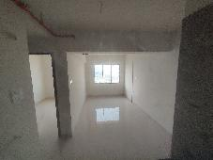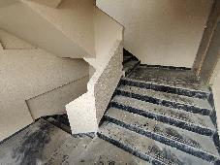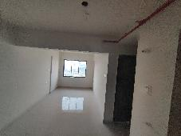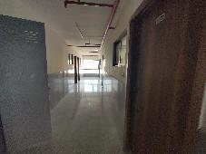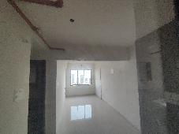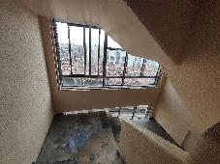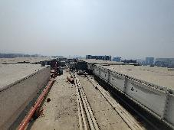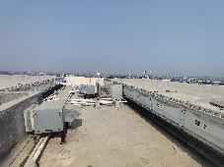

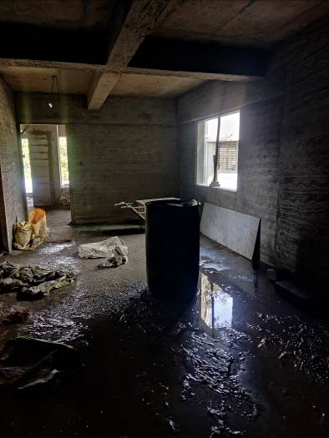**Actual Site Photographs**

**Rehab Building**

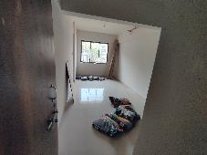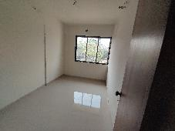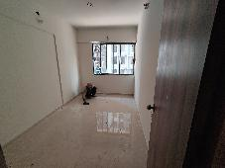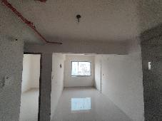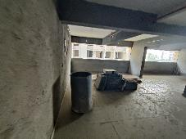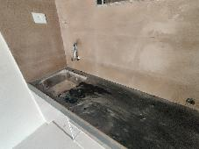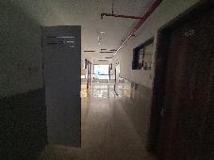

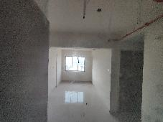**Actual Site Photographs**

**Rehab Building**

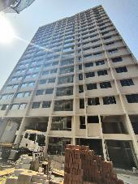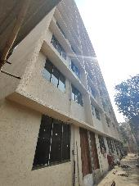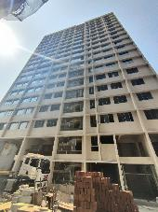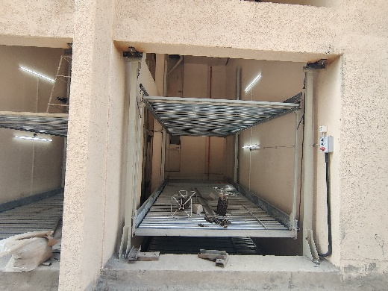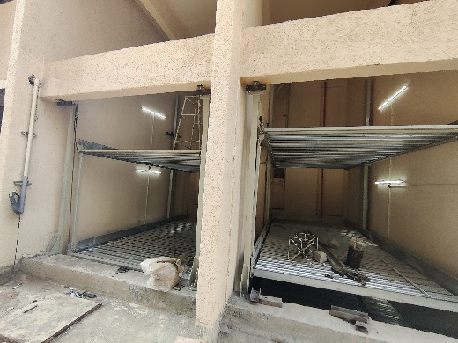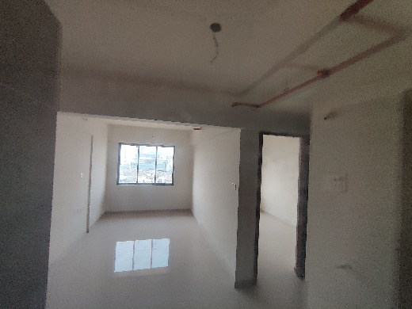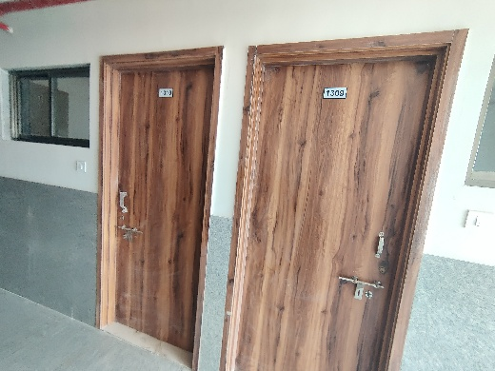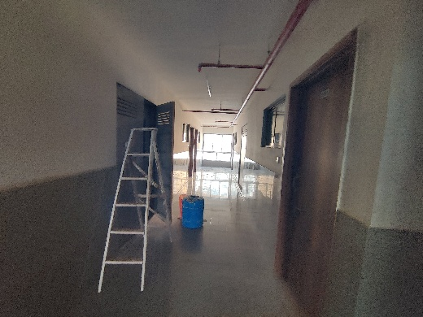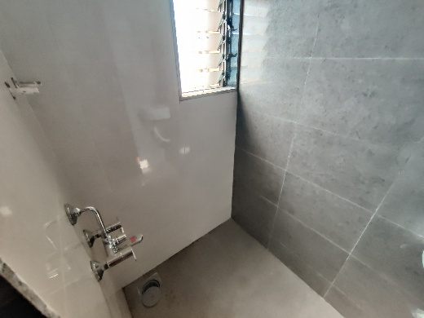

**Actual Site Photographs**

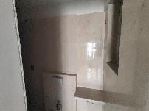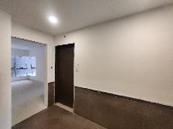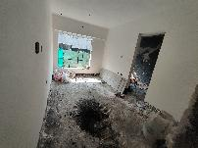**Sale Building**

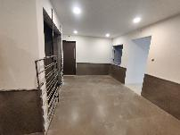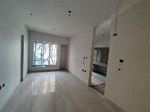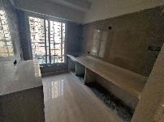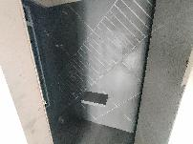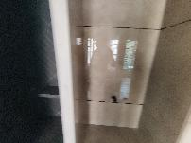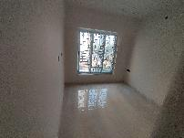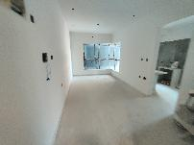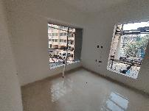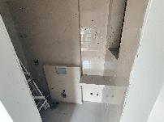

**Actual Site Photographs**

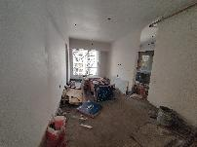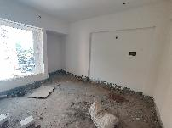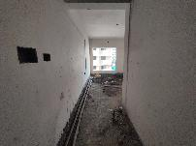**Sale Building**

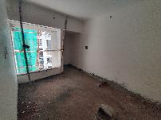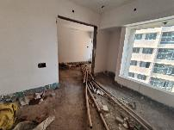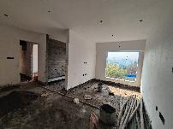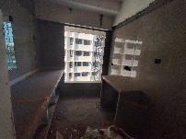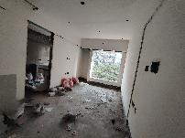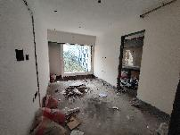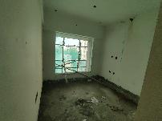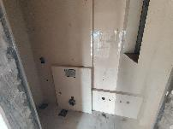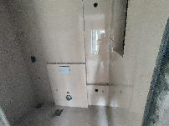

**Actual Site Photographs**

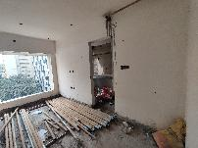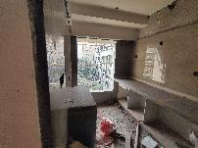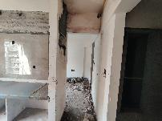**Sale Building**

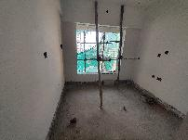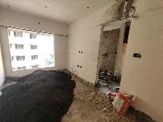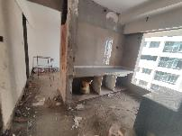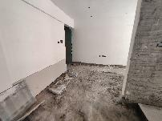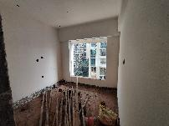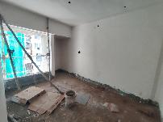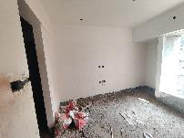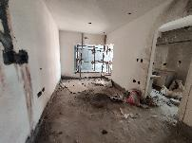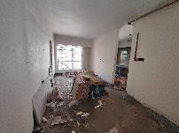

**Actual Site Photographs**

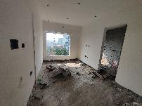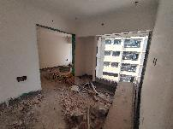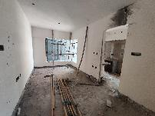**Sale Building**

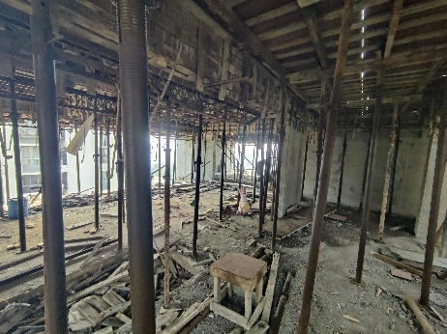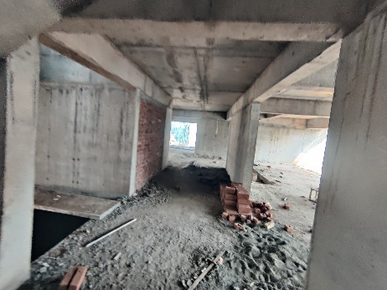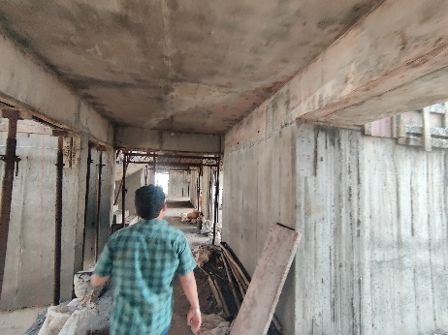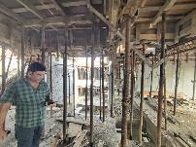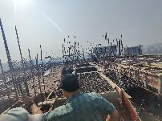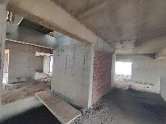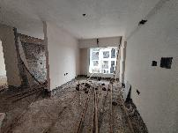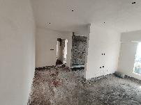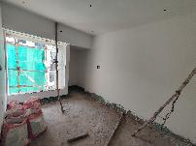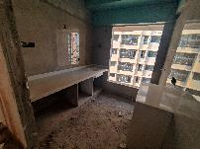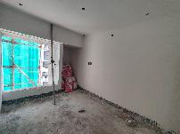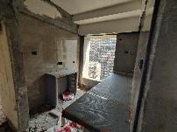

**Actual Site Photographs**

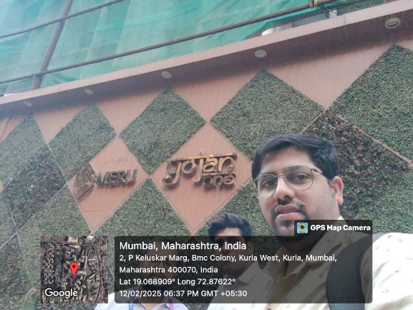**Sale Building**

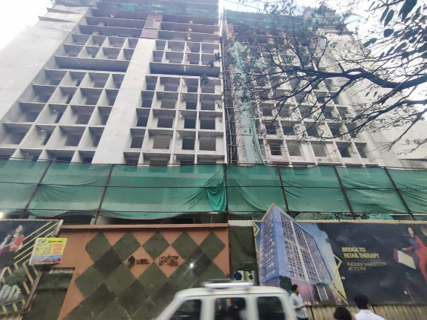

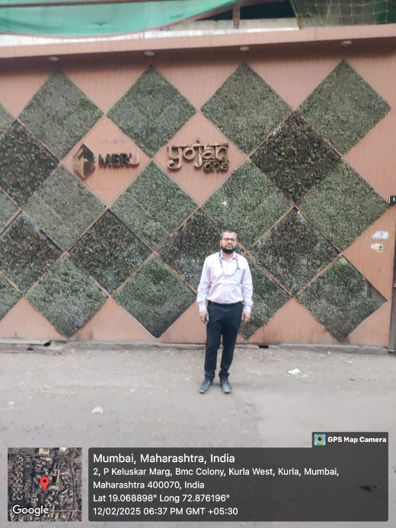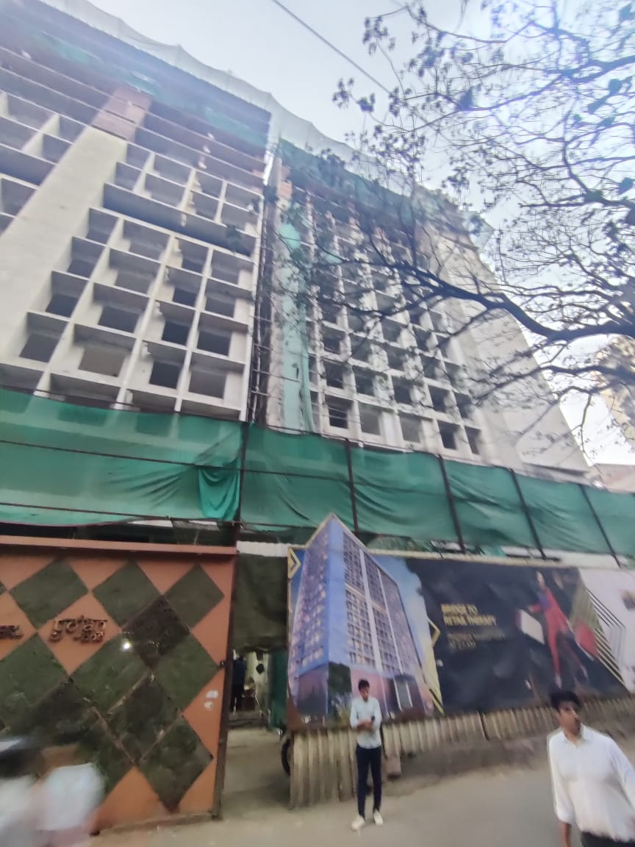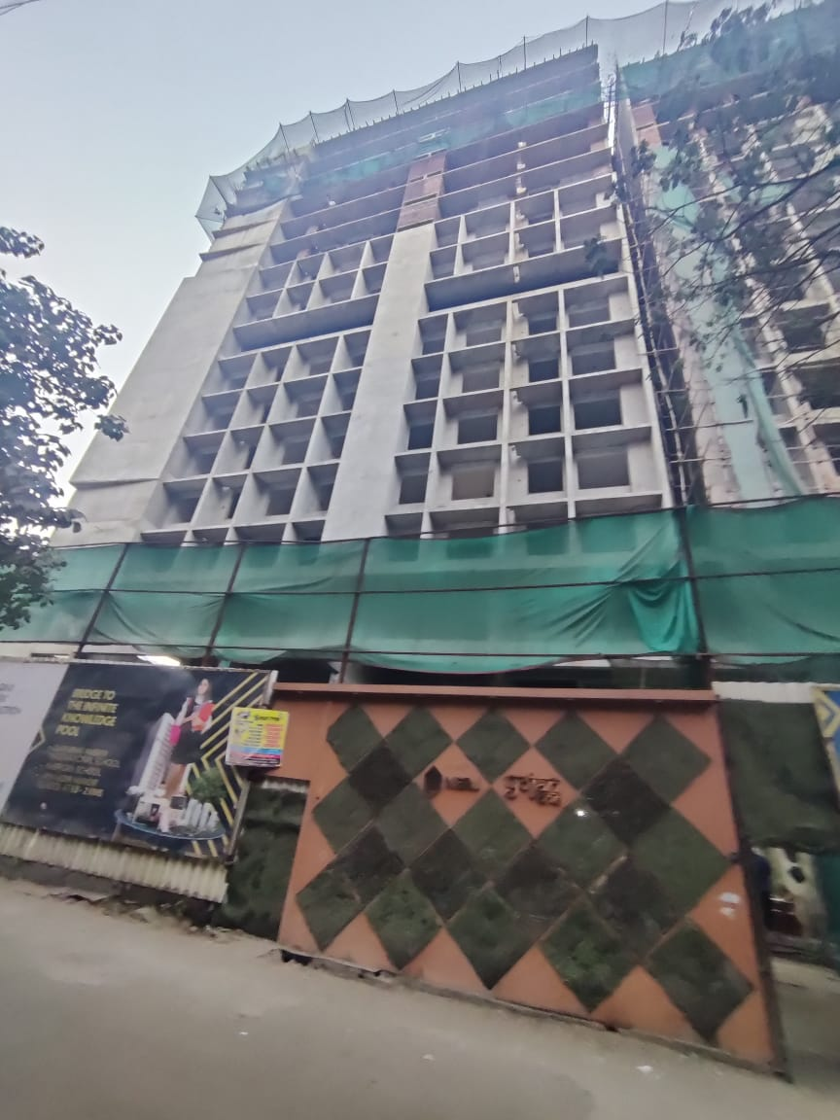

**Route Map of the property**

**Site u/r**

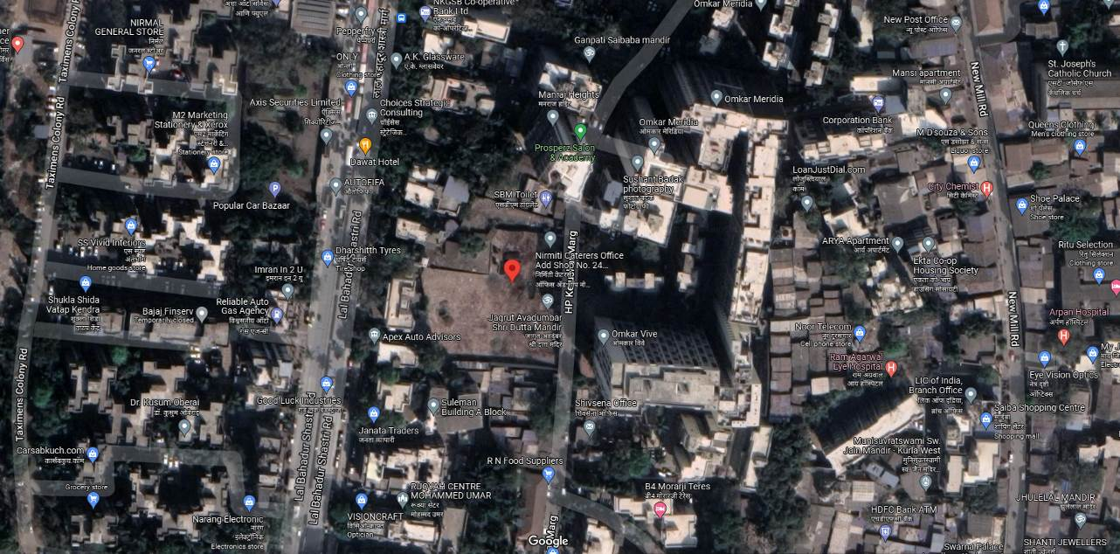

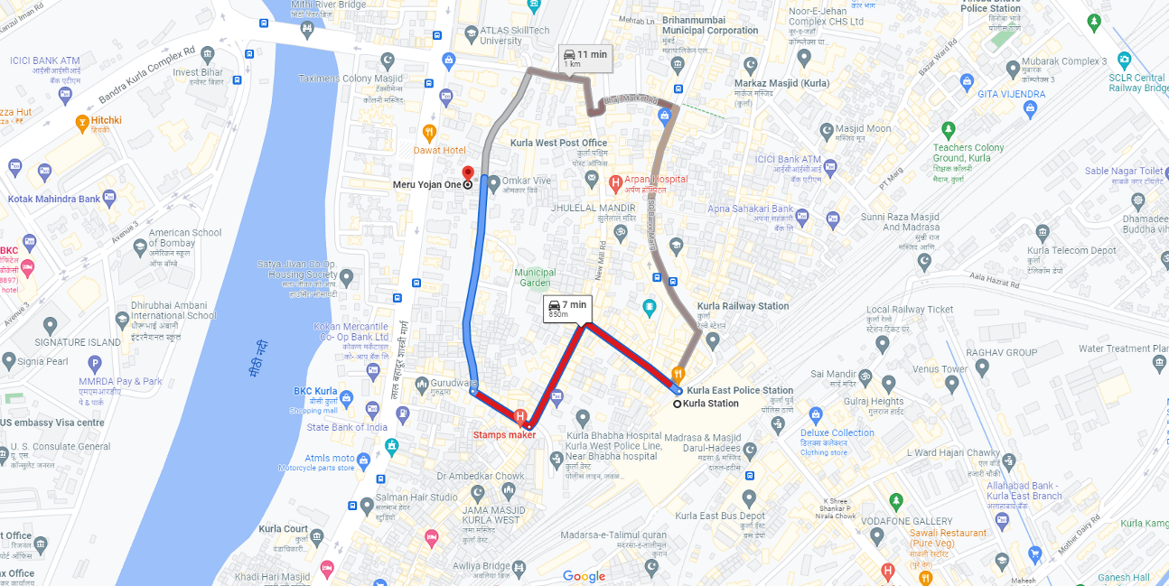

## Latitude Longitude: 19°04'08.2"N 72°52'33.2"E

Note: The Blue line shows the route to site from nearest railway station (Kurla – 850 M.)