Valuation Report of the Immovable Property

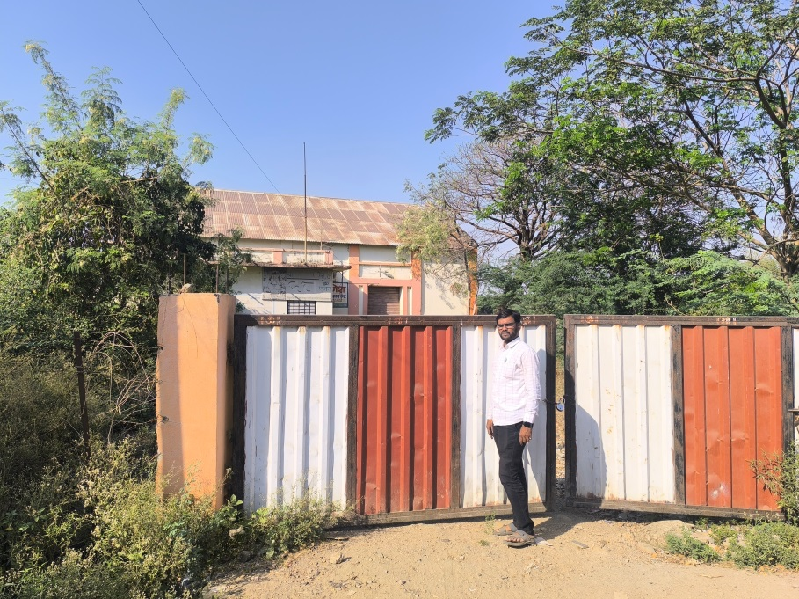

**Details of the property under consideration:**

**Name of Owner: Mr. Suhas Suryakantrao Pratapwar**

**Mr. Subhash Vithalrao Pratapwar &**

**Mr. Balaji Ramrao Yeramwar**

Southern Portion of M.H. No. 6137, Center Portion of 6137/1 & Northern Portion of 6137/2 (New),

& Old M.H. No. 4704, 4704/1 & 4704/2, Gut No. 8, Mondha Corner to Pump House Road,

Mondha, Degloor,Taluka - Degloor, District - Nanded, Maharashtra, India.

# **Longitude Latitude: 18.552570, 77.574351**

**Valuation Done for:**

**Axis Bank**

**Nanded Branch**

Vastu/Axis Bank/Nanded/03/2025/14344/2310958

10/14-155-BHSC

Date: 10.03.2025

# **VALUER’S OPINION REPORT**

This is to certify that the property bearing Southern Portion of M.H. No. 6137, Center Portion of 6137/1 & Northern Portion of 6137/2 (New), & Old M.H. No. 4704, 4704/1 & 4704/2, Gut No. 8, Mondha Corner to Pump House Road, Mondha, Degloor,Taluka - Degloor, District - Nanded, Maharashtra, India belongs to **Mr. Suhas Suryakantrao Pratapwar, Mr. Subhash Vithalrao Pratapwar & Mr. Balaji Ramrao Yeramwar.**

|  |  |  |  |
| --- | --- | --- | --- |
| Boundaries of the property. | Southern Portion of M.H. No. 6137 | Central Portion of 6137/1 | Northern Portion of 6137/2 (New) |
| North | Open area of Mr. Anil  Trimbakrao Patil | Tin Shed Mr. Suhas Suryakant Pratapwar, Mr. Subhash Vithalrao Pratapwar & Mr. Balaji Ramrao Yeramwar (M.H. No. 6137) | Tin Shed Mr. Suhas Suryakant Pratapwar, Mr. Subhash Vithalrao Pratapwar & Mr. Balaji Ramrao Yeramwar (M.H. No. 6137/1) |
| South | Land of Mr. Suhas Suryakantrao Pratapwar, Mr. Subhash Vithalrao Pratapwar & Mr. Balaji Ramrao Yeramwar. (M.H. No. 6137/1) | Land of Mr. Suhas Suryakantrao Pratapwar, Mr. Subhash Vithalrao Pratapwar & Mr. Balaji Ramrao Yeramwar. (M.H. No. 6137/2) | Old Pump House Road |
| East | Open Area of Mr. Anil Trimbakrao Patil | Open Area of Mr. Anil Trimbakrao Patil | Open Area of Mr. Anil Trimbakrao Patil |
| West | Old Pump House Road | Old Pump House Road | Old Pump House Road |

Considering various parameters recorded, existing economic scenario, and the information that is available with reference to the development of neighborhood and method selected for valuation, we are of the opinion that, the property premises can be assessed are as under:

|  |  |
| --- | --- |
| **Guideline Value of the Property** | **Rs. 10,50,000.00** |
| **Fair Market Value of the Property** | **Rs. 1,75,00,000.00** |
| **Realizable Value of the Property** | **Rs. 1,57,50,000.00** |
| **Forced/ Distress Sale value of the Property.** | **Rs. 1,40,00,000.00** |

The valuation of the property is based on the documents produced by the concern. Legal aspects have not been taken into considerations while preparing this valuation report.

Hence certified

For, **Vastukala Consultants (I) Pvt. Ltd**.

**Sharadkumar B. Chalikwar**

B.E. (Civil), M.E. (Civil), M.Sc. (Real Estate Valuation), M.Sc. (P&M Valuation), FIE (I), FIV, FIWRS

Chairman & Managing Director

Govt. Reg. Valuer

Chartered Engineer (India)

Reg. No. (N) CCIT/1-14/52/2008-09

IBBI Reg.No. IBBI/RV/07/2019/117

|  |  |  |  |  |  |  |  |  |  |  |  |  |  |  |  |  |  |  |  |  |  |  |  |  |  |  |  |  |  |  |  |  |  |  |  |  |  |  |  |  |  |  |  |  |  |  |  |  |  |  |  |  |  |  |  |  |  |  |  |  |  |  |  |  |  |  |  |  |  |  |  |  |  |  |  |  |  |  |  |  |  |  |  |  |  |  |  |  |  |  |  |  |  |  |  |  |  |  |  |  |  |  |  |  |  |  |  |  |  |  |  |  |  |  |  |  |  |  |  |  |  |  |  |  |  |  |  |  |  |  |  |  |  |  |  |  |  |  |  |  |  |  |  |  |  |  |  |  |  |  |  |  |  |  |  |  |  |  |  |  |  |  |  |  |  |  |  |  |  |  |  |  |  |  |  |  |  |  |  |  |  |  |  |  |  |  |  |  |  |  |  |  |  |  |  |  |  |  |  |  |  |  |  |  |  |  |  |  |  |  |  |  |  |  |  |  |  |  |  |  |  |  |  |  |  |  |  |  |  |  |  |  |  |  |  |  |  |  |  |  |  |  |  |  |  |  |  |  |  |  |  |  |  |  |  |  |  |  |  |  |  |  |  |  |  |  |  |  |  |  |  |  |  |  |  |  |  |  |  |  |  |  |  |  |  |  |  |  |  |  |  |  |  |  |  |  |  |  |  |  |  |  |  |  |  |  |  |  |  |  |  |  |  |  |  |  |  |  |  |  |  |  |  |  |  |  |  |  |  |  |  |  |  |  |  |  |  |  |  |  |  |  |  |  |  |  |  |  |  |  |  |  |  |  |  |  |  |  |  |  |  |  |  |  |  |  |  |  |  |  |  |  |  |  |  |  |  |  |  |  |  |  |  |  |  |  |  |  |  |  |  |  |  |  |  |  |  |  |  |  |  |  |  |  |  |  |  |  |  |  |  |  |  |  |  |  |  |  |  |  |  |  |  |  |  |  |  |  |  |  |  |  |  |  |  |  |  |  |  |  |  |  |  |  |  |  |  |  |  |  |  |  |  |  |  |  |  |  |  |  |  |  |  |  |  |  |  |  |  |  |  |  |  |  |  |  |  |  |  |  |  |  |  |  |  |  |  |  |  |  |  |  |  |  |  |  |  |  |  |  |  |  |  |  |  |  |  |  |  |  |  |  |  |  |  |  |  |  |  |  |  |  |  |  |  |  |  |  |  |  |  |  |  |  |  |  |  |  |  |  |  |  |  |  |  |  |  |  |  |  |  |  |  |  |  |  |  |  |  |  |  |  |  |  |  |  |  |  |  |  |  |  |  |  |  |  |  |  |  |  |  |  |  |  |  |  |  |  |  |  |  |  |  |  |  |  |  |  |  |  |  |  |  |  |  |  |  |  |  |  |  |  |  |  |  |  |  |  |  |  |  |  |  |  |  |  |  |  |  |  |  |  |  |  |  |  |  |  |  |  |  |  |  |  |  |  |  |  |  |  |  |  |  |  |  |  |  |  |  |  |  |  |  |  |  |  |  |  |  |  |  |  |  |  |  |  |  |  |  |  |  |  |  |  |  |  |  |  |  |  |  |  |  |  |  |  |  |  |  |  |  |  |  |  |  |  |  |  |  |  |  |  |  |  |  |  |  |  |  |  |  |  |  |  |  |  |  |  |  |  |  |  |  |  |  |  |  |  |  |  |  |  |  |  |  |  |  |  |  |  |  |  |  |  |  |  |  |  |  |  |  |  |  |  |  |  |  |  |  |  |  |  |  |  |  |  |  |  |  |  |  |  |  |  |  |  |  |  |  |  |  |  |  |  |  |  |  |  |  |  |  |  |  |  |  |  |  |  |  |  |  |  |  |  |  |  |  |  |  |  |  |  |  |  |  |  |  |  |  |  |  |  |  |  |  |  |  |  |  |  |  |  |  |  |  |  |  |  |  |  |  |  |  |  |  |  |  |  |  |  |  |  |  |  |  |  |  |  |  |  |  |  |  |  |  |  |  |  |  |  |  |  |  |  |  |  |  |  |  |  |  |  |  |  |  |  |  |  |  |  |  |  |  |  |  |  |  |  |  |  |  |  |  |  |  |  |  |  |  |  |  |  |  |  |  |  |  |  |  |  |  |  |  |  |  |  |  |  |  |  |  |  |  |  |  |  |  |  |  |  |  |  |  |  |  |  |  |  |  |  |  |  |  |  |  |  |  |  |  |  |  |  |  |  |  |  |  |  |  |  |  |  |  |  |  |  |  |  |  |  |  |  |  |  |  |  |  |  |  |  |  |  |  |  |  |  |  |  |  |  |  |  |  |  |  |  |  |  |  |  |  |  |  |  |  |  |  |  |  |  |  |  |  |  |  |  |  |  |  |  |  |  |  |  |  |  |  |  |  |  |  |  |  |  |  |  |  |  |  |  |  |  |  |  |  |  |  |  |  |  |  |  |  |  |  |  |  |  |  |  |  |  |  |  |  |  |  |  |  |  |  |  |  |  |  |  |  |  |  |  |  |  |  |  |  |  |  |  |  |  |  |  |  |  |  |  |  |  |  |  |  |  |  |  |  |  |  |  |  |  |  |  |  |  |  |  |  |  |  |  |  |  |  |  |  |  |  |  |  |  |  |  |  |  |  |  |  |  |  |  |  |  |  |  |  |  |  |  |  |  |  |  |  |  |  |  |  |  |  |  |  |  |  |  |  |  |  |  |  |  |  |  |  |  |  |  |  |  |  |  |  |  |  |  |  |  |  |  |  |  |  |  |  |  |  |  |  |  |  |  |  |  |  |  |  |  |  |  |  |  |  |  |  |  |  |  |  |  |  |  |  |  |  |  |  |  |  |  |  |  |  |  |  |  |  |  |  |  |  |  |  |  |  |  |  |  |  |  |  |  |  |  |  |  |  |  |  |  |  |  |  |  |  |  |  |  |  |  |  |  |  |  |  |  |  |  |  |  |  |  |  |  |  |  |  |  |  |  |  |  |  |  |  |  |  |  |  |  |  |  |  |  |  |  |  |  |  |  |  |  |  |  |  |  |  |  |  |  |  |  |  |  |  |  |  |  |  |  |  |  |  |  |  |  |  |  |  |  |  |  |  |  |  |  |  |  |  |  |  |  |  |  |  |  |  |  |  |  |  |  |  |  |  |  |  |  |  |  |  |  |  |  |  |  |  |  |  |  |  |  |  |  |  |  |  |  |  |  |  |  |  |  |  |  |  |  |  |  |  |  |  |  |  |  |  |  |  |  |  |  |  |  |  |  |  |  |  |  |  |  |  |  |  |  |  |  |  |  |  |  |  |  |  |  |  |  |  |  |  |  |  |  |  |  |  |  |  |  |  |  |  |  |  |  |  |  |  |  |  |  |  |  |  |  |  |  |  |  |  |  |  |  |  |  |  |  |  |  |  |  |  |  |  |  |  |  |  |  |  |  |  |  |  |  |  |  |  |  |  |  |  |  |  |  |  |  |  |  |  |  |  |  |  |  |  |  |  |  |  |  |  |  |  |  |  |  |  |  |  |  |  |  |  |  |  |  |  |  |  |  |  |  |  |  |  |  |  |  |  |  |  |  |  |  |  |  |  |  |  |  |  |  |  |  |  |  |  |  |  |  |  |  |  |  |  |  |  |  |  |  |  |  |  |  |  |  |  |  |  |  |  |  |  |  |  |  |  |  |  |  |  |  |  |  |  |  |  |  |  |  |  |  |  |  |  |  |  |  |  |  |  |  |  |  |  |  |  |  |  |  |  |  |  |  |  |  |  |  |  |  |  |  |  |  |  |  |  |  |  |  |  |  |  |  |  |  |  |  |  |  |  |  |  |  |  |  |  |  |  |  |  |  |  |  |  |  |  |  |  |  |  |  |  |  |  |  |  |  |  |  |  |  |  |  |  |  |  |  |  |  |  |  |  |  |  |  |  |  |  |  |  |  |  |  |  |  |  |  |  |  |  |  |  |  |  |  |  |  |  |  |  |  |  |  |  |  |  |  |  |  |  |  |  |  |  |  |  |  |  |  |  |  |  |  |  |  |  |  |  |  |  |  |  |  |  |  |  |  |  |  |  |  |  |  |  |  |  |  |  |  |  |  |  |  |  |  |  |  |  |  |  |  |  |  |  |  |  |  |  |  |  |  |  |  |  |  |  |  |  |  |  |  |  |  |  |  |  |  |  |  |  |  |  |  |  |  |  |  |  |  |  |  |  |  |  |  |  |  |  |  |  |  |  |  |  |  |  |  |  |  |  |  |  |  |  |  |  |  |  |  |  |  |  |  |  |  |  |  |  |  |  |  |  |  |  |  |  |  |  |  |  |  |  |  |  |  |  |  |  |  |  |  |  |  |  |  |  |  |  |  |  |  |  |  |  |  |  |  |  |  |  |  |  |  |  |  |  |  |  |  |  |  |  |  |  |  |  |  |  |  |  |  |  |  |  |  |  |  |  |  |  |  |  |  |  |  |  |  |  |  |  |  |  |  |  |  |  |  |  |  |  |  |  |  |  |  |  |  |  |  |  |  |  |  |  |  |  |  |  |  |  |  |  |  |  |  |  |  |  |  |  |  |  |  |  |  |  |  |  |  |  |  |  |  |  |  |  |  |  |  |  |  |  |  |  |  |  |  |  |  |  |  |  |  |  |  |  |  |  |  |  |  |  |  |  |  |  |  |  |  |  |  |  |  |  |  |  |  |  |  |  |  |  |  |  |  |  |  |  |  |  |  |  |  |  |  |  |  |  |  |  |  |  |  |  |  |  |  |  |  |  |  |  |  |  |  |  |  |  |  |  |  |  |  |  |  |  |  |  |  |  |  |  |  |  |  |  |  |  |  |  |  |  |  |  |  |  |  |  |  |  |  |  |  |  |  |  |  |  |  |  |  |  |  |  |  |  |  |  |  |  |  |  |  |  |  |  |  |  |  |  |  |  |  |  |  |  |  |  |  |  |  |  |  |  |  |  |  |  |  |  |  |  |  |  |  |  |  |  |  |  |  |  |  |  |  |  |  |  |  |  |  |  |  |  |  |  |  |  |  |  |  |  |  |  |  |  |  |  |  |  |  |  |  |  |  |  |  |  |  |  |  |  |  |  |  |  |  |  |  |  |  |  |  |  |  |  |  |  |  |  |  |  |  |  |  |  |  |  |  |  |  |  |  |  |  |  |  |  |  |  |  |  |  |  |  |  |  |  |  |  |  |  |  |  |  |  |  |  |  |  |  |  |  |  |  |  |  |  |  |  |  |  |  |  |  |  |  |  |  |  |  |  |  |  |  |  |  |  |  |  |  |  |  |  |  |  |  |  |  |  |  |  |  |  |  |  |  |  |  |  |  |  |  |  |  |  |  |  |  |  |  |  |  |  |  |  |  |  |  |  |  |  |  |  |  |  |  |  |  |  |  |  |  |  |  |  |  |  |  |  |  |  |  |  |  |  |  |  |  |  |  |  |  |  |  |  |  |  |  |  |  |  |  |  |  |  |  |  |  |  |  |  |  |  |  |  |  |  |  |  |  |  |  |  |  |  |  |  |  |  |  |  |  |  |  |  |  |  |  |  |  |  |  |  |  |  |  |  |  |  |  |  |  |  |  |  |  |  |  |  |  |  |  |  |  |  |  |  |  |  |  |  |  |  |  |  |  |  |  |  |  |  |  |  |  |  |  |  |  |  |  |  |  |  |  |  |  |  |  |  |  |  |  |  |  |  |  |  |  |  |  |  |  |  |  |  |  |  |  |  |  |  |  |  |  |  |  |  |  |  |  |  |  |  |  |  |  |  |  |  |  |  |  |  |  |  |  |  |  |  |  |  |  |  |  |  |  |  |  |  |  |  |  |  |  |  |  |  |  |  |  |  |  |  |  |  |  |  |  |  |  |  |  |  |  |  |  |  |  |  |  |  |  |  |  |  |  |  |  |  |  |  |  |  |  |  |  |  |  |  |  |  |  |  |  |  |  |  |  |  |  |  |  |  |  |  |  |  |  |  |  |  |  |  |  |  |  |  |  |  |  |  |  |  |  |  |  |  |  |  |  |  |  |  |  |  |  |  |  |  |  |  |  |  |  |  |  |  |  |  |  |  |  |  |  |  |  |  |  |  |  |  |  |  |  |  |  |  |  |  |  |  |  |  |  |  |  |  |  |  |  |  |  |  |  |  |  |  |  |  |  |  |  |  |  |  |  |  |  |  |  |  |  |  |  |  |  |  |  |  |  |  |  |  |  |  |  |  |  |  |  |  |  |  |  |
| --- | --- | --- | --- | --- | --- | --- | --- | --- | --- | --- | --- | --- | --- | --- | --- | --- | --- | --- | --- | --- | --- | --- | --- | --- | --- | --- | --- | --- | --- | --- | --- | --- | --- | --- | --- | --- | --- | --- | --- | --- | --- | --- | --- | --- | --- | --- | --- | --- | --- | --- | --- | --- | --- | --- | --- | --- | --- | --- | --- | --- | --- | --- | --- | --- | --- | --- | --- | --- | --- | --- | --- | --- | --- | --- | --- | --- | --- | --- | --- | --- | --- | --- | --- | --- | --- | --- | --- | --- | --- | --- | --- | --- | --- | --- | --- | --- | --- | --- | --- | --- | --- | --- | --- | --- | --- | --- | --- | --- | --- | --- | --- | --- | --- | --- | --- | --- | --- | --- | --- | --- | --- | --- | --- | --- | --- | --- | --- | --- | --- | --- | --- | --- | --- | --- | --- | --- | --- | --- | --- | --- | --- | --- | --- | --- | --- | --- | --- | --- | --- | --- | --- | --- | --- | --- | --- | --- | --- | --- | --- | --- | --- | --- | --- | --- | --- | --- | --- | --- | --- | --- | --- | --- | --- | --- | --- | --- | --- | --- | --- | --- | --- | --- | --- | --- | --- | --- | --- | --- | --- | --- | --- | --- | --- | --- | --- | --- | --- | --- | --- | --- | --- | --- | --- | --- | --- | --- | --- | --- | --- | --- | --- | --- | --- | --- | --- | --- | --- | --- | --- | --- | --- | --- | --- | --- | --- | --- | --- | --- | --- | --- | --- | --- | --- | --- | --- | --- | --- | --- | --- | --- | --- | --- | --- | --- | --- | --- | --- | --- | --- | --- | --- | --- | --- | --- | --- | --- | --- | --- | --- | --- | --- | --- | --- | --- | --- | --- | --- | --- | --- | --- | --- | --- | --- | --- | --- | --- | --- | --- | --- | --- | --- | --- | --- | --- | --- | --- | --- | --- | --- | --- | --- | --- | --- | --- | --- | --- | --- | --- | --- | --- | --- | --- | --- | --- | --- | --- | --- | --- | --- | --- | --- | --- | --- | --- | --- | --- | --- | --- | --- | --- | --- | --- | --- | --- | --- | --- | --- | --- | --- | --- | --- | --- | --- | --- | --- | --- | --- | --- | --- | --- | --- | --- | --- | --- | --- | --- | --- | --- | --- | --- | --- | --- | --- | --- | --- | --- | --- | --- | --- | --- | --- | --- | --- | --- | --- | --- | --- | --- | --- | --- | --- | --- | --- | --- | --- | --- | --- | --- | --- | --- | --- | --- | --- | --- | --- | --- | --- | --- | --- | --- | --- | --- | --- | --- | --- | --- | --- | --- | --- | --- | --- | --- | --- | --- | --- | --- | --- | --- | --- | --- | --- | --- | --- | --- | --- | --- | --- | --- | --- | --- | --- | --- | --- | --- | --- | --- | --- | --- | --- | --- | --- | --- | --- | --- | --- | --- | --- | --- | --- | --- | --- | --- | --- | --- | --- | --- | --- | --- | --- | --- | --- | --- | --- | --- | --- | --- | --- | --- | --- | --- | --- | --- | --- | --- | --- | --- | --- | --- | --- | --- | --- | --- | --- | --- | --- | --- | --- | --- | --- | --- | --- | --- | --- | --- | --- | --- | --- | --- | --- | --- | --- | --- | --- | --- | --- | --- | --- | --- | --- | --- | --- | --- | --- | --- | --- | --- | --- | --- | --- | --- | --- | --- | --- | --- | --- | --- | --- | --- | --- | --- | --- | --- | --- | --- | --- | --- | --- | --- | --- | --- | --- | --- | --- | --- | --- | --- | --- | --- | --- | --- | --- | --- | --- | --- | --- | --- | --- | --- | --- | --- | --- | --- | --- | --- | --- | --- | --- | --- | --- | --- | --- | --- | --- | --- | --- | --- | --- | --- | --- | --- | --- | --- | --- | --- | --- | --- | --- | --- | --- | --- | --- | --- | --- | --- | --- | --- | --- | --- | --- | --- | --- | --- | --- | --- | --- | --- | --- | --- | --- | --- | --- | --- | --- | --- | --- | --- | --- | --- | --- | --- | --- | --- | --- | --- | --- | --- | --- | --- | --- | --- | --- | --- | --- | --- | --- | --- | --- | --- | --- | --- | --- | --- | --- | --- | --- | --- | --- | --- | --- | --- | --- | --- | --- | --- | --- | --- | --- | --- | --- | --- | --- | --- | --- | --- | --- | --- | --- | --- | --- | --- | --- | --- | --- | --- | --- | --- | --- | --- | --- | --- | --- | --- | --- | --- | --- | --- | --- | --- | --- | --- | --- | --- | --- | --- | --- | --- | --- | --- | --- | --- | --- | --- | --- | --- | --- | --- | --- | --- | --- | --- | --- | --- | --- | --- | --- | --- | --- | --- | --- | --- | --- | --- | --- | --- | --- | --- | --- | --- | --- | --- | --- | --- | --- | --- | --- | --- | --- | --- | --- | --- | --- | --- | --- | --- | --- | --- | --- | --- | --- | --- | --- | --- | --- | --- | --- | --- | --- | --- | --- | --- | --- | --- | --- | --- | --- | --- | --- | --- | --- | --- | --- | --- | --- | --- | --- | --- | --- | --- | --- | --- | --- | --- | --- | --- | --- | --- | --- | --- | --- | --- | --- | --- | --- | --- | --- | --- | --- | --- | --- | --- | --- | --- | --- | --- | --- | --- | --- | --- | --- | --- | --- | --- | --- | --- | --- | --- | --- | --- | --- | --- | --- | --- | --- | --- | --- | --- | --- | --- | --- | --- | --- | --- | --- | --- | --- | --- | --- | --- | --- | --- | --- | --- | --- | --- | --- | --- | --- | --- | --- | --- | --- | --- | --- | --- | --- | --- | --- | --- | --- | --- | --- | --- | --- | --- | --- | --- | --- | --- | --- | --- | --- | --- | --- | --- | --- | --- | --- | --- | --- | --- | --- | --- | --- | --- | --- | --- | --- | --- | --- | --- | --- | --- | --- | --- | --- | --- | --- | --- | --- | --- | --- | --- | --- | --- | --- | --- | --- | --- | --- | --- | --- | --- | --- | --- | --- | --- | --- | --- | --- | --- | --- | --- | --- | --- | --- | --- | --- | --- | --- | --- | --- | --- | --- | --- | --- | --- | --- | --- | --- | --- | --- | --- | --- | --- | --- | --- | --- | --- | --- | --- | --- | --- | --- | --- | --- | --- | --- | --- | --- | --- | --- | --- | --- | --- | --- | --- | --- | --- | --- | --- | --- | --- | --- | --- | --- | --- | --- | --- | --- | --- | --- | --- | --- | --- | --- | --- | --- | --- | --- | --- | --- | --- | --- | --- | --- | --- | --- | --- | --- | --- | --- | --- | --- | --- | --- | --- | --- | --- | --- | --- | --- | --- | --- | --- | --- | --- | --- | --- | --- | --- | --- | --- | --- | --- | --- | --- | --- | --- | --- | --- | --- | --- | --- | --- | --- | --- | --- | --- | --- | --- | --- | --- | --- | --- | --- | --- | --- | --- | --- | --- | --- | --- | --- | --- | --- | --- | --- | --- | --- | --- | --- | --- | --- | --- | --- | --- | --- | --- | --- | --- | --- | --- | --- | --- | --- | --- | --- | --- | --- | --- | --- | --- | --- | --- | --- | --- | --- | --- | --- | --- | --- | --- | --- | --- | --- | --- | --- | --- | --- | --- | --- | --- | --- | --- | --- | --- | --- | --- | --- | --- | --- | --- | --- | --- | --- | --- | --- | --- | --- | --- | --- | --- | --- | --- | --- | --- | --- | --- | --- | --- | --- | --- | --- | --- | --- | --- | --- | --- | --- | --- | --- | --- | --- | --- | --- | --- | --- | --- | --- | --- | --- | --- | --- | --- | --- | --- | --- | --- | --- | --- | --- | --- | --- | --- | --- | --- | --- | --- | --- | --- | --- | --- | --- | --- | --- | --- | --- | --- | --- | --- | --- | --- | --- | --- | --- | --- | --- | --- | --- | --- | --- | --- | --- | --- | --- | --- | --- | --- | --- | --- | --- | --- | --- | --- | --- | --- | --- | --- | --- | --- | --- | --- | --- | --- | --- | --- | --- | --- | --- | --- | --- | --- | --- | --- | --- | --- | --- | --- | --- | --- | --- | --- | --- | --- | --- | --- | --- | --- | --- | --- | --- | --- | --- | --- | --- | --- | --- | --- | --- | --- | --- | --- | --- | --- | --- | --- | --- | --- | --- | --- | --- | --- | --- | --- | --- | --- | --- | --- | --- | --- | --- | --- | --- | --- | --- | --- | --- | --- | --- | --- | --- | --- | --- | --- | --- | --- | --- | --- | --- | --- | --- | --- | --- | --- | --- | --- | --- | --- | --- | --- | --- | --- | --- | --- | --- | --- | --- | --- | --- | --- | --- | --- | --- | --- | --- | --- | --- | --- | --- | --- | --- | --- | --- | --- | --- | --- | --- | --- | --- | --- | --- | --- | --- | --- | --- | --- | --- | --- | --- | --- | --- | --- | --- | --- | --- | --- | --- | --- | --- | --- | --- | --- | --- | --- | --- | --- | --- | --- | --- | --- | --- | --- | --- | --- | --- | --- | --- | --- | --- | --- | --- | --- | --- | --- | --- | --- | --- | --- | --- | --- | --- | --- | --- | --- | --- | --- | --- | --- | --- | --- | --- | --- | --- | --- | --- | --- | --- | --- | --- | --- | --- | --- | --- | --- | --- | --- | --- | --- | --- | --- | --- | --- | --- | --- | --- | --- | --- | --- | --- | --- | --- | --- | --- | --- | --- | --- | --- | --- | --- | --- | --- | --- | --- | --- | --- | --- | --- | --- | --- | --- | --- | --- | --- | --- | --- | --- | --- | --- | --- | --- | --- | --- | --- | --- | --- | --- | --- | --- | --- | --- | --- | --- | --- | --- | --- | --- | --- | --- | --- | --- | --- | --- | --- | --- | --- | --- | --- | --- | --- | --- | --- | --- | --- | --- | --- | --- | --- | --- | --- | --- | --- | --- | --- | --- | --- | --- | --- | --- | --- | --- | --- | --- | --- | --- | --- | --- | --- | --- | --- | --- | --- | --- | --- | --- | --- | --- | --- | --- | --- | --- | --- | --- | --- | --- | --- | --- | --- | --- | --- | --- | --- | --- | --- | --- | --- | --- | --- | --- | --- | --- | --- | --- | --- | --- | --- | --- | --- | --- | --- | --- | --- | --- | --- | --- | --- | --- | --- | --- | --- | --- | --- | --- | --- | --- | --- | --- | --- | --- | --- | --- | --- | --- | --- | --- | --- | --- | --- | --- | --- | --- | --- | --- | --- | --- | --- | --- | --- | --- | --- | --- | --- | --- | --- | --- | --- | --- | --- | --- | --- | --- | --- | --- | --- | --- | --- | --- | --- | --- | --- | --- | --- | --- | --- | --- | --- | --- | --- | --- | --- | --- | --- | --- | --- | --- | --- | --- | --- | --- | --- | --- | --- | --- | --- | --- | --- | --- | --- | --- | --- | --- | --- | --- | --- | --- | --- | --- | --- | --- | --- | --- | --- | --- | --- | --- | --- | --- | --- | --- | --- | --- | --- | --- | --- | --- | --- | --- | --- | --- | --- | --- | --- | --- | --- | --- | --- | --- | --- | --- | --- | --- | --- | --- | --- | --- | --- | --- | --- | --- | --- | --- | --- | --- | --- | --- | --- | --- | --- | --- | --- | --- | --- | --- | --- | --- | --- | --- | --- | --- | --- | --- | --- | --- | --- | --- | --- | --- | --- | --- | --- | --- | --- | --- | --- | --- | --- | --- | --- | --- | --- | --- | --- | --- | --- | --- | --- | --- | --- | --- | --- | --- | --- | --- | --- | --- | --- | --- | --- | --- | --- | --- | --- | --- | --- | --- | --- | --- | --- | --- | --- | --- | --- | --- | --- | --- | --- | --- | --- | --- | --- | --- | --- | --- | --- | --- | --- | --- | --- | --- | --- | --- | --- | --- | --- | --- | --- | --- | --- | --- | --- | --- | --- | --- | --- | --- | --- | --- | --- | --- | --- | --- | --- | --- | --- | --- | --- | --- | --- | --- | --- | --- | --- | --- | --- | --- | --- | --- | --- | --- | --- | --- | --- | --- | --- | --- | --- | --- | --- | --- | --- | --- | --- | --- | --- | --- | --- | --- | --- | --- | --- | --- | --- | --- | --- | --- | --- | --- | --- | --- | --- | --- | --- | --- | --- | --- | --- | --- | --- | --- | --- | --- | --- | --- | --- | --- | --- | --- | --- | --- | --- | --- | --- | --- | --- | --- | --- | --- | --- | --- | --- | --- | --- | --- | --- | --- | --- | --- | --- | --- | --- | --- | --- | --- | --- | --- | --- | --- | --- | --- | --- | --- | --- | --- | --- | --- | --- | --- | --- | --- | --- | --- | --- | --- | --- | --- | --- | --- | --- | --- | --- | --- | --- | --- | --- | --- | --- | --- | --- | --- | --- | --- | --- | --- | --- | --- | --- | --- | --- | --- | --- | --- | --- | --- | --- | --- | --- | --- | --- | --- | --- | --- | --- | --- | --- | --- | --- | --- | --- | --- | --- | --- | --- | --- | --- | --- | --- | --- | --- | --- | --- | --- | --- | --- | --- | --- | --- | --- | --- | --- | --- | --- | --- | --- | --- | --- | --- | --- | --- | --- | --- | --- | --- | --- | --- | --- | --- | --- | --- | --- | --- | --- | --- | --- | --- | --- | --- | --- | --- | --- | --- | --- | --- | --- | --- | --- | --- | --- | --- | --- | --- | --- | --- | --- | --- | --- | --- | --- | --- | --- | --- | --- | --- | --- | --- | --- | --- | --- | --- | --- | --- | --- | --- | --- | --- | --- | --- | --- | --- | --- | --- | --- | --- | --- | --- | --- | --- | --- | --- | --- | --- | --- | --- | --- | --- | --- | --- | --- | --- | --- | --- | --- | --- | --- | --- | --- | --- | --- | --- | --- | --- | --- | --- | --- | --- | --- | --- | --- | --- | --- | --- | --- | --- | --- | --- | --- | --- | --- | --- | --- | --- | --- | --- | --- | --- | --- | --- | --- | --- | --- | --- | --- | --- | --- | --- | --- | --- | --- | --- | --- | --- | --- | --- | --- | --- | --- | --- | --- | --- | --- | --- | --- | --- | --- | --- | --- | --- | --- | --- | --- | --- | --- | --- | --- | --- | --- | --- | --- | --- | --- | --- | --- | --- | --- | --- | --- | --- | --- | --- | --- | --- | --- | --- | --- | --- | --- | --- | --- | --- | --- | --- | --- | --- | --- | --- | --- | --- | --- | --- | --- | --- | --- | --- | --- | --- | --- | --- | --- | --- | --- | --- | --- | --- | --- | --- | --- | --- | --- | --- | --- | --- | --- | --- | --- | --- | --- | --- | --- | --- | --- | --- | --- | --- | --- | --- | --- | --- | --- | --- | --- | --- | --- | --- | --- | --- | --- | --- | --- | --- | --- | --- | --- | --- | --- | --- | --- | --- | --- | --- | --- | --- | --- | --- | --- | --- | --- | --- | --- | --- | --- | --- | --- | --- | --- | --- | --- | --- | --- | --- | --- | --- | --- | --- | --- | --- | --- | --- | --- | --- | --- | --- | --- | --- | --- | --- | --- | --- | --- | --- | --- | --- | --- | --- | --- | --- | --- | --- | --- | --- | --- | --- | --- | --- | --- | --- | --- | --- | --- | --- | --- | --- | --- | --- | --- | --- | --- | --- | --- | --- | --- | --- | --- | --- | --- | --- | --- | --- | --- | --- | --- | --- | --- | --- | --- | --- | --- | --- | --- | --- | --- | --- | --- | --- | --- | --- | --- | --- | --- | --- | --- | --- | --- | --- | --- | --- | --- | --- | --- | --- | --- | --- | --- | --- | --- | --- | --- | --- | --- | --- | --- | --- | --- | --- | --- | --- | --- | --- | --- | --- | --- | --- | --- | --- | --- | --- | --- | --- | --- | --- | --- | --- | --- | --- | --- | --- | --- | --- | --- | --- | --- | --- | --- | --- | --- | --- | --- | --- | --- | --- | --- | --- | --- | --- | --- | --- | --- | --- | --- | --- | --- | --- | --- | --- | --- | --- | --- | --- | --- | --- | --- | --- | --- | --- | --- | --- | --- | --- | --- | --- | --- | --- | --- | --- | --- | --- | --- | --- | --- | --- | --- | --- | --- | --- | --- | --- | --- | --- | --- | --- | --- | --- | --- | --- | --- | --- | --- | --- | --- | --- | --- | --- | --- | --- | --- | --- | --- | --- | --- | --- | --- | --- | --- | --- | --- | --- | --- | --- | --- | --- | --- | --- | --- | --- | --- | --- | --- | --- | --- | --- | --- | --- | --- | --- | --- | --- | --- | --- | --- | --- | --- | --- | --- | --- | --- | --- | --- | --- | --- | --- | --- | --- | --- | --- | --- | --- | --- | --- | --- | --- | --- | --- | --- | --- | --- | --- | --- | --- | --- | --- | --- | --- | --- | --- | --- | --- | --- | --- | --- | --- | --- | --- | --- | --- | --- | --- | --- | --- | --- | --- | --- | --- | --- | --- | --- | --- | --- | --- | --- | --- | --- | --- | --- | --- | --- | --- | --- | --- | --- | --- | --- | --- | --- | --- | --- | --- | --- | --- | --- | --- | --- | --- | --- | --- | --- | --- | --- | --- | --- | --- | --- | --- | --- | --- | --- | --- | --- | --- | --- | --- | --- | --- | --- | --- | --- | --- | --- | --- | --- | --- | --- | --- | --- | --- | --- | --- | --- | --- | --- | --- | --- | --- | --- | --- | --- | --- | --- | --- | --- | --- | --- | --- | --- | --- | --- | --- | --- | --- | --- | --- | --- | --- | --- | --- | --- | --- | --- | --- | --- | --- | --- | --- | --- | --- | --- | --- | --- | --- | --- | --- | --- | --- | --- | --- | --- | --- | --- | --- | --- | --- | --- | --- | --- | --- | --- | --- | --- | --- | --- | --- | --- | --- | --- | --- | --- | --- | --- | --- | --- | --- | --- | --- | --- | --- | --- | --- | --- | --- | --- | --- | --- | --- | --- | --- | --- | --- | --- | --- | --- | --- | --- | --- | --- | --- | --- | --- | --- | --- | --- | --- | --- | --- | --- | --- | --- | --- | --- | --- | --- | --- | --- | --- | --- | --- | --- | --- | --- | --- | --- | --- | --- | --- | --- | --- | --- | --- | --- | --- | --- | --- | --- | --- | --- | --- | --- | --- | --- | --- | --- | --- | --- | --- | --- | --- | --- | --- | --- | --- | --- |
| **VALUATION REPORT (IN RESPECT OF LAND AND BUILDING)**   |  |  |  |  |  |  |  |  |  |  |  |  |  |  |  |  |  |  |  |  |  | | --- | --- | --- | --- | --- | --- | --- | --- | --- | --- | --- | --- | --- | --- | --- | --- | --- | --- | --- | --- | --- | | 1. | CBB/CCMC/CCSU | | |  | | | |  | | | | | - | | | | | | | | | - | | | | | - | | | | | | | | | 2. | Name of Owner & Address: | | | | | | | **Mr. Suhas Suryakantrao Pratapwar,**  **Mr. Subhash Vithalrao Pratapwar &**  **Mr. Balaji Ramrao Yeramwar.**  R/o. New M.H, No, 6137, 6137/1 & 6137/2 &  Old M.H. No. 4704, 4704/1 &.4704/2, Mondha Corner to Pump House Road, Mondha, Taluka - Degloor,  Dist- Nanded. | | | | | | | | | | | | | | Name of Borrower & Address | | | | | | | **Mr. Suhas Suryakantrao Pratapwar,**  **Mr. Subhash Vithalrao Pratapwar &**  **Mr. Balaji Ramrao Yeramwar.**  R/o. New M.H, No, 6137, 6137/1 & 6137/2 &  Old M.H. No. 4704, 4704/1 &.4704/2, Mondha Corner to Pump House Road, Mondha, Taluka-Degloor, District-Nanded. | | | | | | | | | | | | | | 3. | Name of the Bank Official Present | | | | | | | No. | | | | | | | | | | | | | | Name of the Representative & Mobile No. | | | | | | | Mr. Ravi Zanvar  Mob. No. # 9890804662 | | | | | | | | | | | | | | **4.** | **Details of the Property Being Valued** | | | | | | | | | | | | | | | | | | | | | 4.1 | Description of the Property | | | | | | | The Subject Property is Freehold RCC Structure with G.l. Sheet roofing  Office cum Godown Shed. | | | | | | | | | | | | | | 4.2 | Location of Property | | | | | | | Southern Portion of M.H. No. 6137, Center Portion of 6137/1 & Northern Portion of 6137/2 (New), & Old M.H. No. 4704, 4704/1 & 4704/2, Gut No. 8, Mondha Corner to Pump House Road, Mondha, Degloor, Taluka - Degloor, District - Nanded, Maharashtra, India | | | | | | | | | | | | | | (Rural / Semi Urban / Urban) | | | | | | | Semi Urban. | | | | | | | | | | | | | | Documents Provided: | | | | | | | | | | | | | | | | | | | | | 1 | Photo Copy of Sale Deed No. 287/2013, dated 11.02.2013, between Mr. Suhas Suryakantrao Pratapwar, Mr. Subhash Vithalrao Pratapwar & Mr. Balaji Ramrao Yeramwar. from Mr. Sardar S/o Sarwar Saheb, Sub Registrar, Degloor. | | | | | | | | | | | | | | | | | | | | 2 | Photo Copy of Sale Deed No. 288/2013, dated 11.02.2013, between Mr. Suhas Suryakantrao Pratapwar, Mr. Subhash Vithalrao Pratapwar & Mr. Balaji Ramrao Yeramwar from Sow Shahin W/o. Mohd. Toufik Saheb, Sub Registrar, Degloor. | | | | | | | | | | | | | | | | | | | | 3 | Photo Copy of Sale Deed No. 289/2013, dated 11.02.2013, between Mr. Suhas Suryakantrao Pratapwar, Mr. Subhash Vithalrao Pratapwar & Mr. Balaji Ramrao Yeramwar from Sow Shahin W/o. Mohd. Toufik Saheb, Sub Registrar, Degloor. | | | | | | | | | | | | | | | | | | | | 4 | Photo Copy of Regularized under Gunthewari in M.H.No. 6137, dated 02.08.2008, Chief Officer, Degloor Municipal Council, Degloor. | | | | | | | | | | | | | | | | | | | | 5 | Photo Copy of Regularized under Gunthewari in M.H.No. 6137/1, dated 02.08.2008, Chief Officer, Degloor Municipal Council, Degloor. | | | | | | | | | | | | | | | | | | | | 6 | Photo Copy of Regularized under Gunthewari in M.H.No. 6137/2, dated 02.08.2008, Chief Officer, Degloor Municipal Council, Degloor. | | | | | | | | | | | | | | | | | | | | 7 | Photo Copy of Property Register Certificate in Sothern Portion of M.H. No. 6137, vide No. 2461/2020, dated 20.05.2020, Chief Officer, Degloor municipal Council, Degloor. | | | | | | | | | | | | | | | | | | | | 8 | Photo Copy of Property Register Certificate in Sothern Portion of M.H. No. 6137/1, vide No. 2461/2020, dated 20.05.2020, Chief Officer, Degloor municipal Council, Degloor. | | | | | | | | | | | | | | | | | | | | 9 | Photo Copy of Property Register Certificate in Sothern Portion of M.H. No. 6137/2, vide No. 2461/2020, dated 20.05.2020, Chief Officer, Degloor municipal Council, Degloor. | | | | | | | | | | | | | | | | | | | | 10 | Photo Copy Namuna No. 43, Rule (74) in M.H. No. 6137, vide No. 2461/2020 dated 20.02.2020, Chief Officer, Degloor municipal Council, Degloor. | | | | | | | | | | | | | | | | | | | |  | 11 | Photo Copy Namuna No. 43, Rule (74) in M.H. No. 6137/1, vide No. 2461/2020 dated 20.02.2020, Chief Officer, Degloor municipal Council, Degloor. | | | | | | | | | | | | | | | | | | | | 12 | Photo Copy Namuna No. 43, Rule (74) in M.H. No. 6137/2, vide No. 2461/2020 dated 20.02.2020, Chief Officer, Degloor Municipal Council, Degloor. | | | | | | | | | | | | | | | | | | | | 13 | Photo Copy of Namuna No. 9 Ferfar Register No. 12561 in M.H. No. 6137, dated 04.10.2020, Talathi Sajja, Degloor. | | | | | | | | | | | | | | | | | | | | 14 | Photo Copy of Namuna No. 9 Ferfar Register No. 12561 in M.H. No. 6137/1, dated 04.10.2020, Talathi Sajja, Degloor. | | | | | | | | | | | | | | | | | | | | 15 | Photo Copy of Namuna No. 9 Ferfar Register No. 12561 in M.H. No. 6137/2, dated 04.10.2020, Talathi Sajja, Degloor. | | | | | | | | | | | | | | | | | | | | 16 | Photo Copy of Tax Paid Receipt No. 100, Block No. 725, dated 24.12.2019, year 2019 to 2020, Degloor Municipal Council, Degloor. | | | | | | | | | | | | | | | | | | | | 17 | Photo Copy of Toach Plan in gut No. 8, by Superintendent of Land Record, Degloor. | | | | | | | | | | | | | | | | | | | | 18 | Photo Copy of Search Report dated 29.05.2020, prepared by Adv. Sandeep R. Warkhinde, Degloor. | | | | | | | | | | | | | | | | | | | | 4.4 | Plot No / Survey No. / Gut No./ Khasra No: | | | Southern Portion of M.H. No. 6137, Center Portion of 6137/1 & Northern Portion of 6137/2 (New), & Old M.H. No. 4704, 4704/1 & 4704/2, Gut No. 8 | | | | | | Road | | | | | Mondha Corner to Pump House Road | | | | | | | 4.5 | Colony / Nagar / Sector | | | Mondha | | | | | | Locality / Landmark | | | | | Mondha | | | | | | | 4.6 | Village/Town/City | | | Degloor | | | | | | District: | | | | | Nanded | | | | | | | 4.7 | State | | | Maharashtra | | | | | | Pin code: | | | | | 431 717 | | | | | | | 4.8 | Distance from Area Office | | | | | | | | | Within @ 1.0 Km | | | | | | | | | | | | **5.** | **Type of Property** | | | | | | | | | | | | | | | | | | | | |  | **(A) Plot:** (Residential / Commercial / Industrial) | | | | | | | | | | | Commercial | | | | | | | | | | Level of land with topographical conditions | | | | | | | | | | | Leveled | | | | | | | | | | Whether situated in Municipal / Corporation Limit | | | | | | | | | | | Municipal | | | | | | | | | | Any construction observed on plot | | | | | | | | | | | Yes, Construction of Office Cum Godown | | | | | | | | | | **(B) Residential Property: (**Independent house / Bungalow / Row House / Flat) | | | | | | | | | | | No | | | | | | | | | | Civic Amenities like school, hospital, market, etc. (Available, within the radius of Km./ Not Available) | | | | | | | | | | | All available in village Basmat. | | | | | | | | | | **(C) Commercial / Industrial Property :** (Office / Shop / Unit in a Mall / Gowdown) | | | | | | | | | | | Office Cum Godown | | | | | | | | | | **6.0** | **Accessibility / Boundaries / Others** | | | | | | | | | | | | | | | | | | | | | 6.1 | Availability of local transport (Metro / Local Train / Bus / Personal Transport) | | | | | | | | | | Local Transport, Bus Stand, Railway Station, Personal Transport. | | | | | | | | | | | 6.2 | Distance from Nanded Railway station @ 90.30 Km | | | | | | | | | | Bus Stand within 1.4 Km  Taxi/Auto Stand within walkable distance | | | | | | | | | | | 6.3 | Does the approach road to the Property / Building is independent and accessible | | | | | Yes. | | | | | Will it be able to accommodate a fire extinguisher | | | | | | | | | No | | 6.4 | Does the property fall under land locked area | | | | | No. | | | | | Does the property fall in a community dominated area | | | | | | | | | No | | 6.5 | Cornered / Intermittent Plot | | | | | | | | | | Corner Plot. | | | | | | | | | | | **6.6** | **Boundaries** | | | | | | | | | | | | | | | | | | | | | **Boundaries of the property.** | | **Southern Portion of M.H. No. 6137** | | | | | | **Central Portion of 6137/1** | | | | | | **Northern Portion of 6137/2 (New)** | | | | | | | North | | Open area of Mr. Anil  Trimbakrao Patil | | | | | | Tin Shed Mr. Suhas Suryakant Pratapwar, Mr. Subhash Vithalrao Pratapwar & Mr. Balaji Ramrao Yeramwar (M.H. No. 6137) | | | | | | Tin Shed Mr. Suhas Suryakant Pratapwar, Mr. Subhash Vithalrao Pratapwar & Mr. Balaji Ramrao Yeramwar (M.H. No. 6137/1) | | | | | | | South | | Land of Mr. Suhas Suryakantrao Pratapwar, Mr. Subhash Vithalrao Pratapwar & Mr. Balaji Ramrao Yeramwar. (M.H. No. 6137/1) | | | | | | Land of Mr. Suhas Suryakantrao Pratapwar, Mr. Subhash Vithalrao Pratapwar & Mr. Balaji Ramrao Yeramwar. (M.H. No. 6137/2) | | | | | | Old Pump House Road | | | | | | | East | | Open Area of Mr. Anil Trimbakrao Patil | | | | | | Open Area of Mr. Anil Trimbakrao Patil | | | | | | Open Area of Mr. Anil Trimbakrao Patil | | | | | | | West | | Old Pump House Road | | | | | | Old Pump House Road | | | | | | Old Pump House Road | | | | | | |  | **North** | | | | | | | | | | Property of Mr. Anil Trimbakrao Patil | | | | | | | | | | | **South** | | | | | | | | | | Old Pump House Road | | | | | | | | | | | **East** | | | | | | | | | | Property of Mr. Anil Trimbakrao Patil | | | | | | | | | | | **West** | | | | | | | | | | Old Pump House Road | | | | | | | | | | | 6.7 | Class of locality (Posh / Higher Middle Class / Middle Class / Lower Middle Class / Poor) | | | | | | | | | | Middle Class | | | | | | | | | | | 6.8 | Quality of Infrastructure in the vicinity (Excellent / Good / Average / Poor) | | | | | | | | | | Good | | | | | | | | | | | 6.9 | Ownership Status of the Property (Free Hold / Reg. Lease / Govt. Authority) | | | | | | | | | | Freehold | | | | | | | | | | | 6.10 | Approved usage of property (Industrial / Commercial / Residential / Mix) | | | | Commercial | | | | | | Actual usage of property (Industrial / Commercial / Residential / Mix) | | | | | | | | Commercial | | | 6.11 | Restrictive covenants in regards to Land Use, (if any) | | | | | | | | | | Commercial | | | | | | | | | | | 6.12 | Type of Structure (Load Bearing / RCC / Aluform shuttering) | | | | | | | | | | RCC Structure with G.l. Sheet roofing | | | | | | | | | | | 6.13 | Number of floors | | | As per Actual | | | | | | | **Single Storeyed** | | | | | | | | | | | As per Sanctioned Plan | | | | | | | **Single Storeyed** | | | | | | | | | | | 6.14 | Occupancy Details (Self-Occupied / Rented / Vacant) | | | | | | | | | | Owner Occupied. | | | | | | | | | | | **7.** | **If the property is on rent** | | | | | | | | | | | | | | | | | | | | | 7.1 | Name of tenant / lease & Number of years in tenancy | | | | | | | | | | No. | | | | | | | | | | | 7.2 | Was there any resistance for valuation | | | | No. | | | | | | If yes, from the current occupants | | | | | | | N.A. | | | | 7.3 | Does property have basic amenities | | | | Yes. | | | | | | Development of surrounding area Underdeveloped / Developing / Developed | | | | | | | Under developed | | | | **8.** | **If the property is Leasehold** | | | | | | | | | | | | | | | | | | | | | 8.1 | Name of Lesser | | | N.A. | Nature of Lease: | | | | | | | | | | | | | N.A. | | | | 8.2 | Total Period of Lease | | | N.A. | If yes, from the current occupants | | | | | | | | | | | | | N.A. | | | | 8.3 | Does property have basic amenities | | | No. | Development of surrounding area Underdeveloped / Developing / Developed | | | | | | | | | | | | | Developed | | | | **9.** | **Approval Details** | | | | | | | | | | | | | | | | | | | | | 9.1 | RERA Registration Number | | | | | | | Details not available | | | | | | | | | | | | | | 9.2 | Layout Approval Number: | | | | | | | Details not available | | | | | | | | | | | | | | Date of Approval | | | | | | | Details not available | | | | | | | | | | | | | | Expiry Date | | | | | | | Details not available | | | | | | | | | | | | | | 9.3 | Building Plan Approval Number: | | | | | | | Details not available | | | | | | | | | | | | | | Date of Approval | | | | | | | Details not available | | | | | | | | | | | | | | Expiry Date | | | | | | | Details not available | | | | | | | | | | | | | | 9.4 | Occupancy Certificate | | | | | | | Details not available | | | | | | | | | | | | | | **10.00** | **Plot Area Details.** | | | | | | | | | | | | | | | | | | | | | **10.01** | **Plot Area** | | | | | | | | | | | | | | | | | | | | | **10.02** | **Area of Plot As per Sale Deed** | | | | | | | | | **Plot Size** | | | | | | **Plot Area in Sqm.** | | | | | | Southern Portion of M.H. No. 6137, Sale Deed No.288/2013 | | | | | | | | | 15.90 m x 11.60 m | | | | | | 184.00 | | | | | | Central Portion of 6137/1 Sale Deed No. 287/2013 | | | | | | | | | 7.10 m x 3.50 m | | | | | | 24.80 | | | | | | Northern Portion of 6137/2 Sale Deed No. 289/2013 | | | | | | | | | 17.963 m x 16.24 m | | | | | | 291.20 | | | | | |  | | | | | | | | | **Total** | | | | | | **500.00** | | | | | | 10.03 | Area of the plot as per Regularizes under Gunthewari Order | | | | | | | | | | | | | | |  | | | | | |  | Southern Portion of M.H. No. 6137 | | | | | | | | | | | | | | | 184.90 | | | | | |  | Central Portion of 6137/1 | | | | | | | | | | | | | | | 24.80 | | | | | |  | Northern Portion of 6137/2 | | | | | | | | | | | | | | | 291.20 | | | | | |  | **Total** | | | | | | | | | | | | | | | **500.90 Sqm** | | | | | | 10.04 | Demarcation at Site | | | | | | | | | | | | | | | **31.25 M X 16.00 M** | | | | | | **10.05** | **Construction Area Details** | | | | | | Current Usage | | | | | | | | | | | | | | |  | **Floor** | | | **Built up area as per Sanctioned Plan in Sq. M.** | | | | **(Storage / Parking / Commercial / Residential)** | | | | | | | | | | | | | | Godown | | | 184.00 | | | | Commercial | | | | | | | | | | | | | | Office | | | 24.80 | | | | Commercial | | | | | | | | | | | | | | 10.06 | Amenities Details (if any): | | | | | | | Wire Fencing Compound Wall & M.S Gate | | | | | | | | | | | | | | 10.07 | Floor Space Index permissible | | | | | | | Basic FSI | | | | | | 1.10 | | | | | | | | Premium FSI | | | | | | 0.50 | | | | | | | | Ancillary FSI | | | | | | 60% of basic FSI + Premium FSI | | | | | | | | Total FSI Permissible | | | | | | (1.10 + 0.50) 1.60 = 2.56 | | | | | | | | 10.09 | FSI Utilized | | | | | | | 0.41 | | | | | | | | | | | | | | 10.10 | Whether the construction is as per approved building plan and / or local building bye laws: | | | | | | | * No * Sanctioned Plan ls not available for comments | | | | | | | | | | | | | | 10.11 | Details of Extra Construction | | | | | | | No | | | | | | | | | | | | | | 10.12 | Percentage of Extra Construction | | | | | | | - | | | | | | | | | | | | | | 10.13 | Whether the extra construction is Compoundable OR Non-Compoundable? | | | | | | | Compoundable | | | | | | | | | | | | | | 10.14 | Quality of construction | | | | | | | Good. | | | | | | | | | | | | | | 10.15 | Maintenance of the Property | | | | | | | N.A | | | | | | | | | | | | | | 10.16 | Condition of Building | | | | | | | Good. | | | | | | | | | | | | | | 10.17 | Current Life of the structure | | | 50 Years | | | | Projected Future Life of the Structure | | | | | 10 Years. | | | | | | | | | 10.18 | Land Revenue / Taxes Paid up to (for Land) | | | Details not available | | | | Municipal Taxes Paid up to (for Building) | | | | | Tax Amount in Rs. 20,394.00, Tax Paid Receipt No. 100,  Book No. 725, dated 24.12.2019, year 2019 to 2020,  Degloor Municipal Degloor | | | | | | | | | **11.** | **Details of Valuation:** | | | | | | | | | | | | | | | | | | | | |  | |  |  |  |  |  |  |  |  |  |  | | --- | --- | --- | --- | --- | --- | --- | --- | --- | --- | | **Floor** | **Constructed Area** | **Year Of Const.** | **Age of the building** | **Total Life of Structure** | **Estimated Replacement Rate** | **Balance Life of Structures in Years** | **Depreciated Rate to be considered** | **Depreciated Value to be considered** | **Replacement Cost** | |  | **(Sq. M)** |  | **(Years)** |  | **(`)** |  | **(`)** | **(`)** | **(`)** | |  |  |  |  |  |  |  |  |  |  | | | | | | | | | | | | | | | | | | | | | | **12.** | **Government Guideline value** | | | | | | | | | | | | | | | | | | | | |  | **Particulars** | | | | **Area in Sq. M.** | | | **Rate in Rs.** | | | | | | | | | **Value in Rs.** | | | | | 1 | Land | | | | 500.00 | | | 2100.00 | | | | | | | | | 10,50,000.00 | | | | |  | **TOTAL** | | | | | | | | | | | | | | | | **10,50,000.00** | | | | | **13.** | **Market Value of Land** | | | | | | | | | | | | | | | | | | | | |  | **Particulars** | | | | **Area in Sq. M.** | | | **Rate in Rs.** | | | | | | | | | **Value in Rs.** | | | | | **Land** | | | | 500.00 | | | 35,000.00 | | | | | | | | | 1,75,00,000.00 | | | | | **14.** | **Value of the Property** | | | | | | | | | | | | | | | | | | | | |  |  | | | | **Land** | | | **Building** | | | | | **Amenities** | | | | **Total** | | | | | Market Value | | | | 1,75,00,000.00 | | | **-** | | | | | - | | | | 1,75,00,000.00 | | | | | Total Market Value | | | | | | | | | | | | | | | | **1,75,00,000.00** | | | | | Realizable Value | | | | | | | | | | | | | | | | **1,57,50,000.00** | | | | | Distressed/Forced Sale Value | | | | | | | | | | | | | | | | **1,40,00,000.00** | | | | | Insurable Value | | | | | | | | | | | | | | | | **Nil** | | | |  | |  | **Remark:**   * No Construction is available, hence cost of construction is not considered for valuation. * Only Land cost is considered for valuation. | | | | | | | | | | | | | | | | | | | | **O** |   **Undertaking:**   1. I have / our / representative Md. Shareq has inspected the subject property on 23.02.2025 along with Mr. Vishwanath P. Nagnath Dake identified the same based on the documents provided. 2. I/We have no direct or Indirect interest in the property being valued. 3. The information furnished above is true and correct to my/our knowledge 4. I/ we have not been dismissed or removed from govt. Service or convicted of an offence connected with any proceedings of income tax act, wealth tax act or gift tax act or have been blacklisted by any bank/ financial institution/ govt. Department/ public sector enterprise/ body corporate etc. 5. This valuation is prepared without any prejudice or bias to any person or institution. 6. The value of land is taken into account by making due enquires in the locality and ascertaining the sales value of the properties in the locality. 7. Any additions/alterations made to the property after the date of valuations shall not fall under the scope of this report.   For, **Vastukala Consultants (I) Pvt. Ltd.**  **Sharadkumar B. Chalikwar**  B.E. (Civil), M.E. (Civil), M.Sc. (Real Estate Valuation), M.Sc. (P&M Valuation), FIE (I), FIV, FIWRS  Chairman & Managing Director  Govt. Reg. Valuer  Chartered Engineer (India)  Reg. No. (N) CCIT/1-14/52/2008-09  IBBI Reg.No. IBBI/RV/07/2019/11744  Date: 10.03.2025   |  |  |  | | --- | --- | --- | | **Attachments** | | | | Photographs of the Property from inside & outside | : | Attached | | Location sketch for the property: | : | Attached | | Geo Tagging | : | Attached | | Topography | : | Leveled Land | | Government Value Document | : | Attached | |

**Actual Site Photographs**

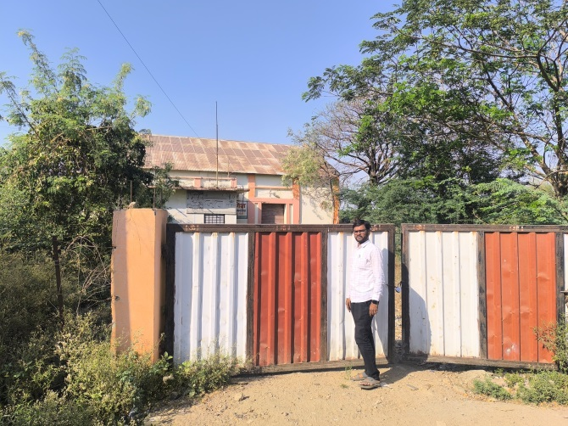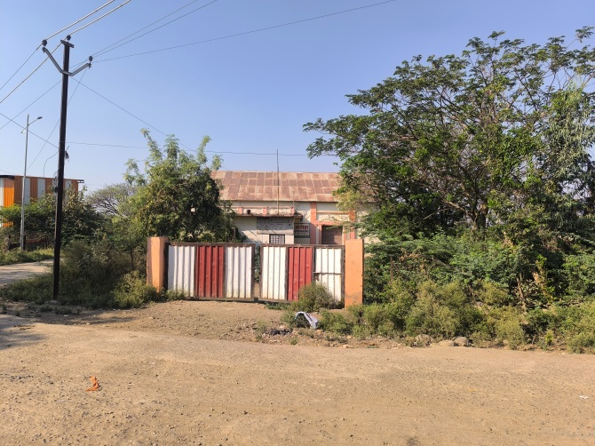

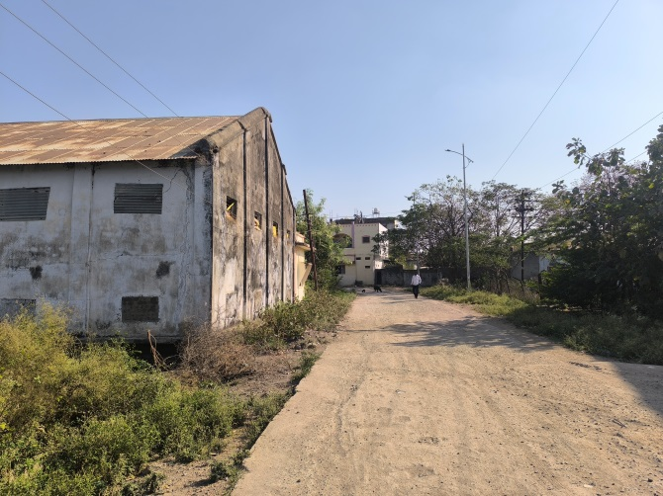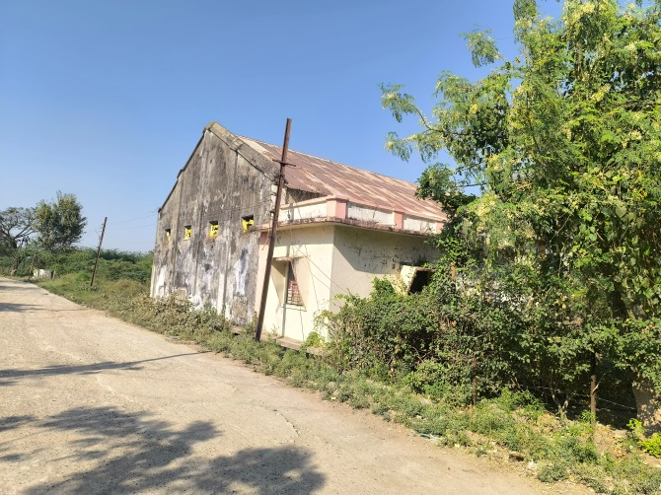

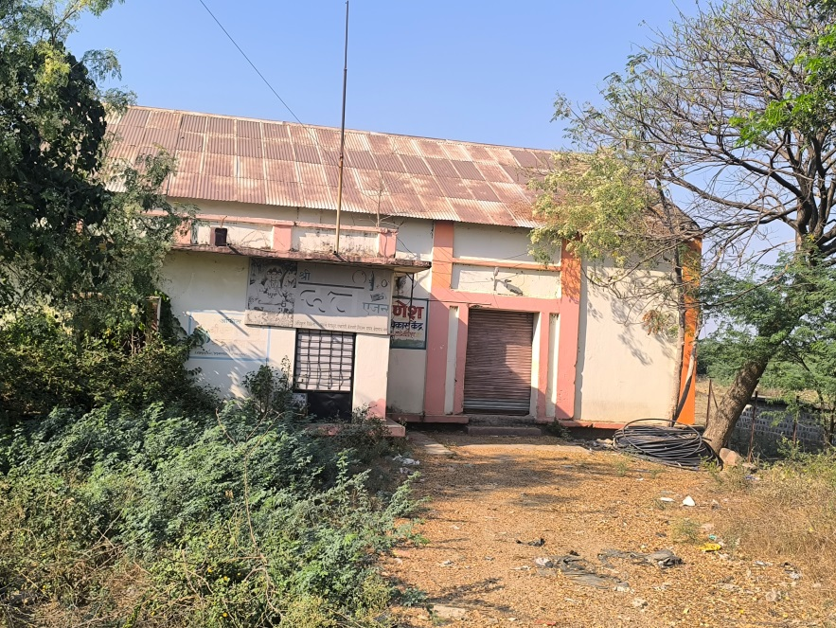

**Construction Plan**

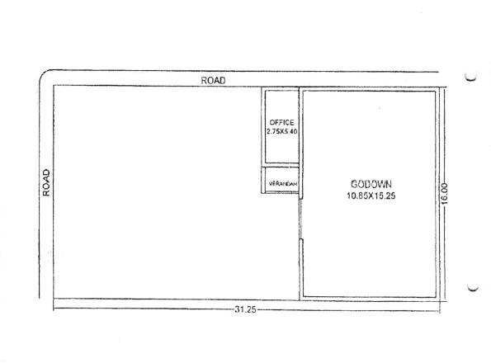

**Construction as per site**

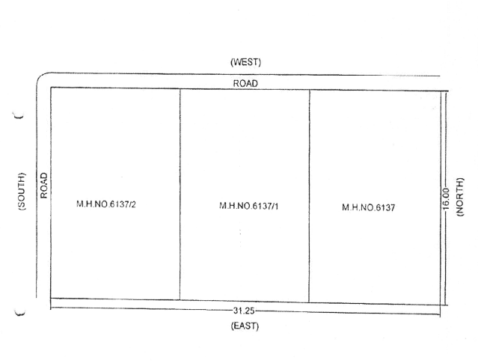

**Route Map of the property**

**Site u/r**

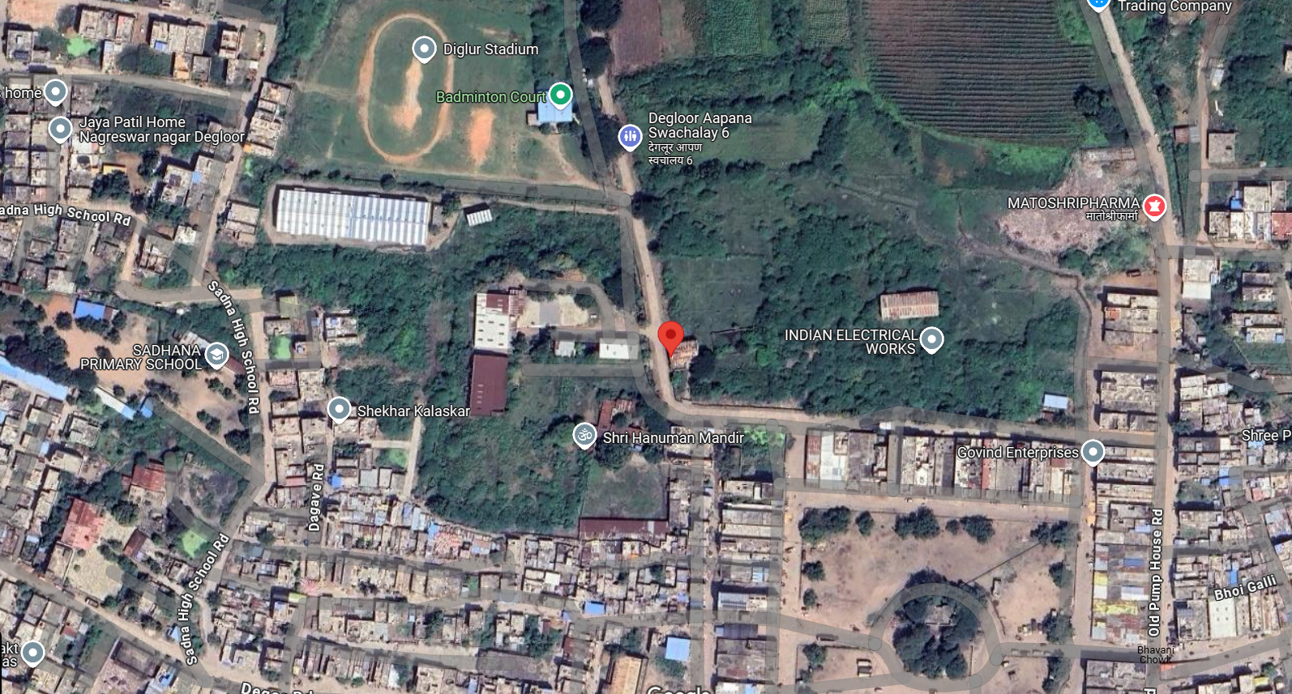

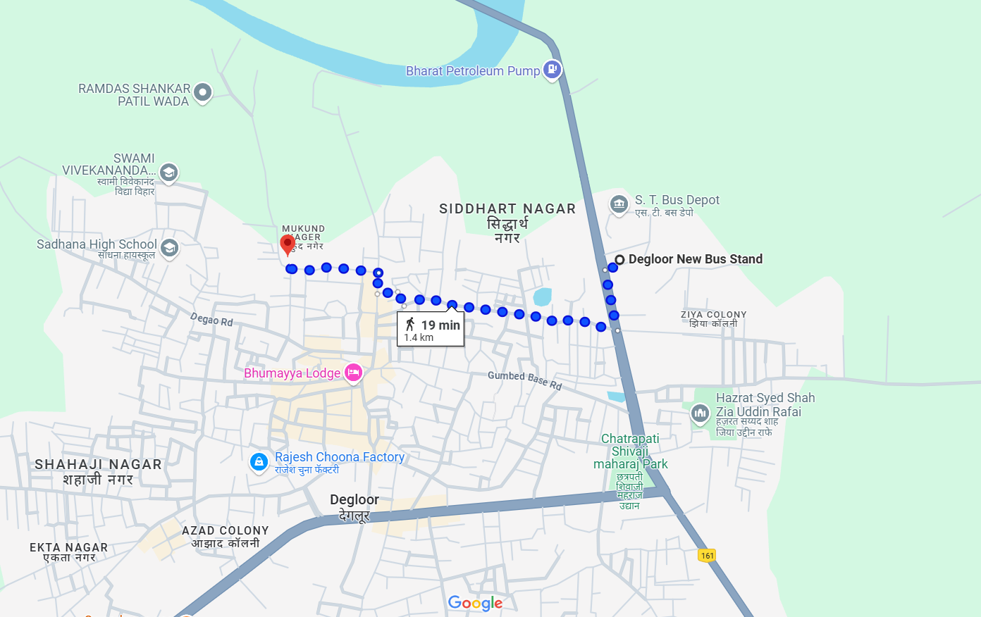

**Latitude Longitude: 18.552570, 77.574351**

Note: The Blue line shows the route to site from nearest Bus Stop (Degloor - 1.4 KM.)

**Ready Reckoner Rate**

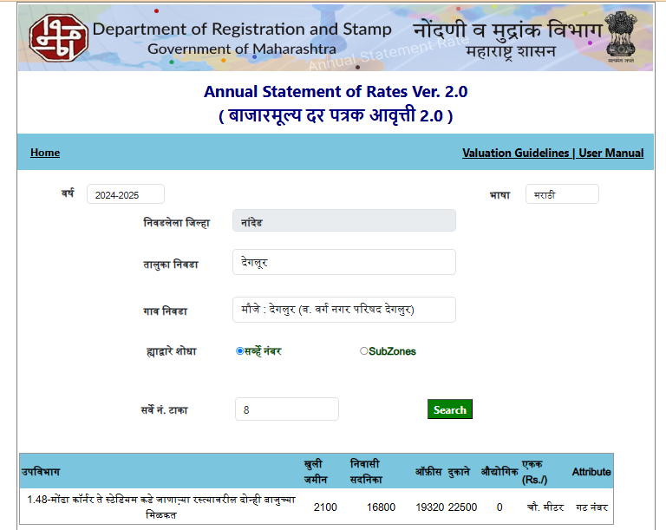

**ASSUMPTIONS, CAVEATS, LIMITATION AND DISCLAIMERS**

1. We assume no responsibility for matters of legal nature affecting the property appraised or the title thereto, nor do we render our opinion as to the title, which is assumed to be good and marketable.
2. The property is valued as though under responsible ownership.
3. It is assumed that the property is free of liens and encumbrances.
4. It is assumed that there are no hidden or unapparent conditions of the subsoil or structure that would render it more or less valuable. No responsibility is assumed for such conditions or for engineering that might be required to discover such factors.
5. The rates for valuation of the property are in accordance with the Govt. approved rates and prevailing market rates

For, **Vastukala Consultants (I) Pvt. Ltd.**

**Sharadkumar B. Chalikwar**

B.E. (Civil), M.E. (Civil), M.Sc. (Real Estate Valuation), M.Sc. (P&M Valuation), FIE (I), FIV, FIWRS

Chairman & Managing Director

Govt. Reg. Valuer

Chartered Engineer (India)

Reg. No. (N) CCIT/1-14/52/2008-09

IBBI Reg.No. IBBI/RV/07/2019/11744

Date: 10.03.2025

Place: Nanded.