Valuation Report of the Immovable Property

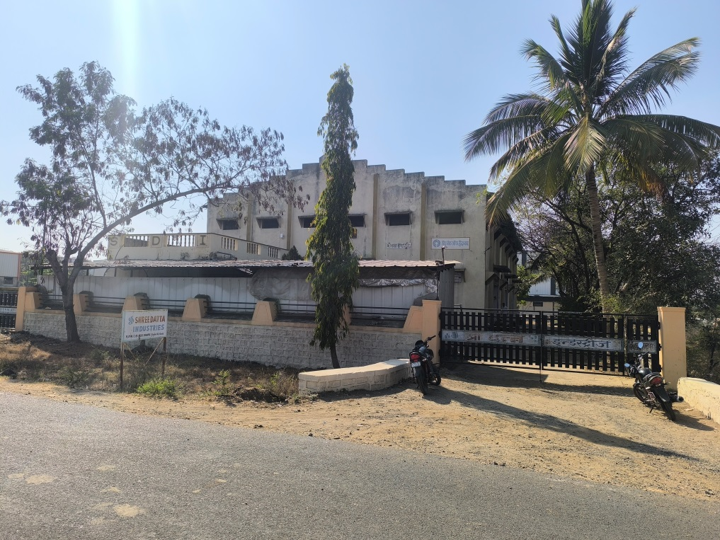

**Details of the property under consideration:**

**Name of Lessor: Maharashtra Industrial Development Corporation**

**Lesse: M/s. Shri. Datta Industries**

**Proprietor**

**Shri. Suhas Suryakantrao Pratapwar**

**M/s. Shri. Datta Industries,** Plot No. C - 20, Khanapur Industrial Area, M.l.D.C., Within the limits of

Village - Khanapur, Taluka - Degloor, District – Nanded,

Maharashtra, India.

# **Longitude Latitude: 18.610282, 77.573665**

# **Valuation Done for:**

**Axis Bank**

**Nanded Branch**

.

Vastu/Axis Bank/Nanded/01/2025/13548/2310006

10/08-125-BH

Date: 04.03.2025

# **VALUER’S OPINION REPORT**

This is to certify that the property bearing **M/s. Shri. Datta Industries,** Plot No. C - 20, Khanapur Industrial Area, M.l.D.C., Within the limits of Village - Khanapur, Taluka - Degloor, District – Nanded, Maharashtra, India.

belongs to **Lessor: Maharashtra Industrial Development Corporation, Lessee: M/s. Shri. Datta Industries Proprietor Shri. Suhas Suryakantrao Pratapwar.**

|  |  |  |
| --- | --- | --- |
| Boundaries of the property. | | |
| North | : | Plot No. C - 21 | |
| South | : | MIDC Land (Open Space) | |
| East | : | 25.00 m wide M.I.D.C Road | |
| West | : | Plot No. C - 29 | |

Considering various parameters recorded, existing economic scenario, and the information that is available with reference to the development of neighborhood and method selected for valuation, we are of the opinion that, the property premises can be assessed are as under:

|  |  |
| --- | --- |
| **Guideline Value of the Property** | **Rs. 1,31,61,929.00** |
| **Fair Market Value of the Property** | **Rs. 1,48,39,000.00** |
| **Realizable Value of the Property** | **Rs. 1,33,55,100.00** |
| **Forced/ Distress Sale value of the Property.** | **Rs. 1,18,71,200.00** |

The valuation of the property is based on the documents produced by the concern. Legal aspects have not been taken into considerations while preparing this valuation report.

Hence certified

For, **Vastukala Consultants (I) Pvt. Ltd.**

**Sharadkumar B. Chalikwar**

B.E. (Civil), M.E. (Civil), M.Sc. (Real Estate Valuation), M.Sc. (P&M Valuation), FIE (I), FIV, FIWRS

Chairman & Managing Director

Govt. Reg. Valuer

Chartered Engineer (India)

Reg. No. (N) CCIT/1-14/52/2008-09

IBBI Reg.No. IBBI/RV/07/2019/1174

|  |  |  |  |  |  |  |  |  |  |  |  |  |  |  |  |  |  |  |  |  |  |  |  |  |  |  |  |  |  |  |  |  |  |  |  |  |  |  |  |  |  |  |  |  |  |  |  |  |  |  |  |  |  |  |  |  |  |  |  |  |  |  |  |  |  |  |  |  |  |  |  |  |  |  |  |  |  |  |  |  |  |  |  |  |  |  |  |  |  |  |  |  |  |  |  |  |  |  |  |  |  |  |  |  |  |  |  |  |  |  |  |  |  |  |  |  |  |  |  |  |  |  |  |  |  |  |  |  |  |  |  |  |  |  |  |  |  |  |  |  |  |  |  |  |  |  |  |  |  |  |  |  |  |  |  |  |  |  |  |  |  |  |  |  |  |  |  |  |  |  |  |  |  |  |  |  |  |  |  |  |  |  |  |  |  |  |  |  |  |  |  |  |  |  |  |  |  |  |  |  |  |  |  |  |  |  |  |  |  |  |  |  |  |  |  |  |  |  |  |  |  |  |  |  |  |  |  |  |  |  |  |  |  |  |  |  |  |  |  |  |  |  |  |  |  |  |  |  |  |  |  |  |  |  |  |  |  |  |  |  |  |  |  |  |  |  |  |  |  |  |  |  |  |  |  |  |  |  |  |  |  |  |  |  |  |  |  |  |  |  |  |  |  |  |  |  |  |  |  |  |  |  |  |  |  |  |  |  |  |  |  |  |  |  |  |  |  |  |  |  |  |  |  |  |  |  |  |  |  |  |  |  |  |  |  |  |  |  |  |  |  |  |  |  |  |  |  |  |  |  |  |  |  |  |  |  |  |  |  |  |  |  |  |  |  |  |  |  |  |  |  |  |  |  |  |  |  |  |  |  |  |  |  |  |  |  |  |  |  |  |  |  |  |  |  |  |  |  |  |  |  |  |  |  |  |  |  |  |  |  |  |  |  |  |  |  |  |  |  |  |  |  |  |  |  |  |  |  |  |  |  |  |  |  |  |  |  |  |  |  |  |  |  |  |  |  |  |  |  |  |  |  |  |  |  |  |  |  |  |  |  |  |  |  |  |  |  |  |  |  |  |  |  |  |  |  |  |  |  |  |  |  |  |  |  |  |  |  |  |  |  |  |  |  |  |  |  |  |  |  |  |  |  |  |  |  |  |  |  |  |  |  |  |  |  |  |  |  |  |  |  |  |  |  |  |  |  |  |  |  |  |  |  |  |  |  |  |  |  |  |  |  |  |  |  |  |  |  |  |  |  |  |  |  |  |  |  |  |  |  |  |  |  |  |  |  |  |  |  |  |  |  |  |  |  |  |  |  |  |  |  |  |  |  |  |  |  |  |  |  |  |  |  |  |  |  |  |  |  |  |  |  |  |  |  |  |  |  |  |  |  |  |  |  |  |  |  |  |  |  |  |  |  |  |  |  |  |  |  |  |  |  |  |  |  |  |  |  |  |  |  |  |  |  |  |  |  |  |  |  |  |  |  |  |  |  |  |  |  |  |  |  |  |  |  |  |  |  |  |  |  |  |  |  |  |  |  |  |  |  |  |  |  |  |  |  |  |  |  |  |  |  |  |  |  |  |  |  |  |  |  |  |  |  |  |  |  |  |  |  |  |  |  |  |  |  |  |  |  |  |  |  |  |  |  |  |  |  |  |  |  |  |  |  |  |  |  |  |  |  |  |  |  |  |  |  |  |  |  |  |  |  |  |  |  |  |  |  |  |  |  |  |  |  |  |  |  |  |  |  |  |  |  |  |  |  |  |  |  |  |  |  |  |  |  |  |  |  |  |  |  |  |  |  |  |  |  |  |  |  |  |  |  |  |  |  |  |  |  |  |  |  |  |  |  |  |  |  |  |  |  |  |  |  |  |  |  |  |  |  |  |  |  |  |  |  |  |  |  |  |  |  |  |  |  |  |  |  |  |  |  |  |  |  |  |  |  |  |  |  |  |  |  |  |  |  |  |  |  |  |  |  |  |  |  |  |  |  |  |  |  |  |  |  |  |  |  |  |  |  |  |  |  |  |  |  |  |  |  |  |  |  |  |  |  |  |  |  |  |  |  |  |  |  |  |  |  |  |  |  |  |  |  |  |  |  |  |  |  |  |  |  |  |  |  |  |  |  |  |  |  |  |  |  |  |  |  |  |  |  |  |  |  |  |  |  |  |  |  |  |  |  |  |  |  |  |  |  |  |  |  |  |  |  |  |  |  |  |  |  |  |  |  |  |  |  |  |  |  |  |  |  |  |  |  |  |  |  |  |  |  |  |  |  |  |  |  |  |  |  |  |  |  |  |  |  |  |  |  |  |  |  |  |  |  |  |  |  |  |  |  |  |  |  |  |  |  |  |  |  |  |  |  |  |  |  |  |  |  |  |  |  |  |  |  |  |  |  |  |  |  |  |  |  |  |  |  |  |  |  |  |  |  |  |  |  |  |  |  |  |  |  |  |  |  |  |  |  |  |  |  |  |  |  |  |  |  |  |  |  |  |  |  |  |  |  |  |  |  |  |  |  |  |  |  |  |  |  |  |  |  |  |  |  |  |  |  |  |  |  |  |  |  |  |  |  |  |  |  |  |  |  |  |  |  |  |  |  |  |  |  |  |  |  |  |  |  |  |  |  |  |  |  |  |  |  |  |  |  |  |  |  |  |  |  |  |  |  |  |  |  |  |  |  |  |  |  |  |  |  |  |  |  |  |  |  |  |  |  |  |  |  |  |  |  |  |  |  |  |  |  |  |  |  |  |  |  |  |  |  |  |  |  |  |  |  |  |  |  |  |  |  |  |  |  |  |  |  |  |  |  |  |  |  |  |  |  |  |  |  |  |  |  |  |  |  |  |  |  |  |  |  |  |  |  |  |  |  |  |  |  |  |  |  |  |  |  |  |  |  |  |  |  |  |  |  |  |  |  |  |  |  |  |  |  |  |  |  |  |  |  |  |  |  |  |  |  |  |  |  |  |  |  |  |  |  |  |  |  |  |  |  |  |  |  |  |  |  |  |  |  |  |  |  |  |  |  |  |  |  |  |  |  |  |  |  |  |  |  |  |  |  |  |  |  |  |  |  |  |  |  |  |  |  |  |  |  |  |  |  |  |  |  |  |  |  |  |  |  |  |  |  |  |  |  |  |  |  |  |  |  |  |  |  |  |  |  |  |  |  |  |  |  |  |  |  |  |  |  |  |  |  |  |  |  |  |  |  |  |  |  |  |  |  |  |  |  |  |  |  |  |  |  |  |  |  |  |  |  |  |  |  |  |  |  |  |  |  |  |  |  |  |  |  |  |  |  |  |  |  |  |  |  |  |  |  |  |  |  |  |  |  |  |  |  |  |  |  |  |  |  |  |  |  |  |  |  |  |  |  |  |  |  |  |  |  |  |  |  |  |  |  |  |  |  |  |  |  |  |  |  |  |  |  |  |  |  |  |  |  |  |  |  |  |  |  |  |  |  |  |  |  |  |  |  |  |  |  |  |  |  |  |  |  |  |  |  |  |  |  |  |  |  |  |  |  |  |  |  |  |  |  |  |  |  |  |  |  |  |  |  |  |  |  |  |  |  |  |  |  |  |  |  |  |  |  |  |  |  |  |  |  |  |  |  |  |  |  |  |  |  |  |  |  |  |  |  |  |  |  |  |  |  |  |  |  |  |  |  |  |  |  |  |  |  |  |  |  |  |  |  |  |  |  |  |  |  |  |  |  |  |  |  |  |  |  |  |  |  |  |  |  |  |  |  |  |  |  |  |  |  |  |  |  |  |  |  |  |  |  |  |  |  |  |  |  |  |  |  |  |  |  |  |  |  |  |  |  |  |  |  |  |  |  |  |  |  |  |  |  |  |  |  |  |  |  |  |  |  |  |  |  |  |  |  |  |  |  |  |  |  |  |  |  |  |  |  |  |  |  |  |  |  |  |  |  |  |  |  |  |  |  |  |  |  |  |  |  |  |  |  |  |  |  |  |  |  |  |  |  |  |  |  |  |  |  |  |  |  |  |  |  |  |  |  |  |  |  |  |  |  |  |  |  |  |  |  |  |  |  |  |  |  |  |  |  |  |  |  |  |  |  |  |  |  |  |  |  |  |  |  |  |  |  |  |  |  |  |  |  |  |  |  |  |  |  |  |  |  |  |  |  |  |  |  |  |  |  |  |  |  |  |  |  |  |  |  |  |  |  |  |  |  |  |  |  |  |  |  |  |  |  |  |  |  |  |  |  |  |  |  |  |  |  |  |  |  |  |  |  |  |  |  |  |  |  |  |  |  |  |  |  |  |  |  |  |  |  |  |  |  |  |  |  |  |  |  |  |  |  |  |  |  |  |  |  |  |  |  |  |  |  |  |  |  |  |  |  |  |  |  |  |  |  |  |  |  |  |  |  |  |  |  |  |  |  |  |  |  |  |  |  |  |  |  |  |  |  |  |  |  |  |  |  |  |  |  |  |  |  |  |  |  |  |  |  |  |  |  |  |  |  |  |  |  |  |  |  |  |  |  |  |  |  |  |  |  |  |  |  |  |  |  |  |  |  |  |  |  |  |  |  |  |  |  |  |  |  |  |  |  |  |  |  |  |  |  |  |  |  |  |  |  |  |  |  |  |  |  |  |  |  |  |  |  |  |  |  |  |  |  |  |  |  |  |  |  |  |  |  |  |  |  |  |  |  |  |  |  |  |  |  |  |  |  |  |  |  |  |  |  |  |  |  |  |  |  |  |  |  |  |  |  |  |  |  |  |  |  |  |  |  |  |  |  |  |  |  |  |  |  |  |  |  |  |  |  |  |  |  |  |  |  |  |  |  |  |  |  |  |  |  |  |  |  |  |  |  |  |  |  |  |  |  |  |  |  |  |  |  |  |  |  |  |  |  |  |  |  |  |  |  |  |  |  |  |  |  |  |  |  |  |  |  |  |  |  |  |  |  |  |  |  |  |  |  |  |  |  |  |  |  |  |  |  |  |  |  |  |  |  |  |  |  |  |  |  |  |  |  |  |  |  |  |  |  |  |  |  |  |  |  |  |  |  |  |  |  |  |  |  |  |  |  |  |  |  |  |  |  |  |  |  |  |  |  |  |  |  |  |  |  |  |  |  |  |  |  |  |  |  |  |  |  |  |  |  |  |  |  |  |  |  |  |  |  |  |  |  |  |  |  |  |  |  |  |  |  |  |  |  |  |  |  |  |  |  |  |  |  |  |  |  |  |  |  |  |  |  |  |  |  |  |  |  |  |  |  |  |  |  |  |  |  |  |  |  |  |  |  |  |  |  |  |  |  |  |  |  |  |  |  |  |  |  |  |  |  |  |  |  |  |  |  |  |  |  |  |  |  |  |  |  |  |  |  |  |  |  |  |  |  |  |  |  |  |  |  |  |  |  |  |  |  |  |  |  |  |  |  |  |  |  |  |  |  |  |  |  |  |  |  |  |  |  |  |  |  |  |  |  |  |  |  |  |  |  |  |  |  |  |  |  |  |  |  |  |  |  |  |  |  |  |  |  |  |  |  |  |  |  |  |  |  |  |  |  |  |  |  |  |  |  |  |  |  |  |  |  |  |  |  |  |  |  |  |  |  |  |  |  |  |  |  |  |  |  |  |  |  |  |  |  |  |  |  |  |  |  |  |  |  |  |  |  |  |  |  |  |  |  |  |  |  |  |  |  |  |  |  |  |  |  |  |  |  |  |  |  |  |  |  |  |  |  |  |  |  |  |  |  |  |  |  |  |  |  |  |  |  |  |  |  |  |  |  |  |  |  |  |  |  |  |  |  |  |  |  |  |  |  |  |  |  |  |  |  |  |  |  |  |  |  |  |  |  |  |  |  |  |  |  |  |  |  |  |  |  |  |  |  |  |  |  |  |  |  |  |  |  |  |  |  |  |  |  |  |  |  |  |  |  |  |  |  |  |  |  |  |  |  |  |  |  |  |  |  |  |  |  |  |  |  |  |  |  |  |  |  |  |  |  |  |  |  |  |  |  |  |  |  |  |  |  |  |  |  |  |  |  |  |  |  |  |  |  |  |  |  |  |  |  |  |  |  |  |  |  |  |  |  |  |  |  |  |  |  |  |  |  |  |  |  |  |  |  |  |  |  |  |  |  |  |  |  |  |  |  |  |  |  |  |  |  |  |  |  |  |  |  |  |  |  |  |  |  |  |  |  |  |  |  |
| --- | --- | --- | --- | --- | --- | --- | --- | --- | --- | --- | --- | --- | --- | --- | --- | --- | --- | --- | --- | --- | --- | --- | --- | --- | --- | --- | --- | --- | --- | --- | --- | --- | --- | --- | --- | --- | --- | --- | --- | --- | --- | --- | --- | --- | --- | --- | --- | --- | --- | --- | --- | --- | --- | --- | --- | --- | --- | --- | --- | --- | --- | --- | --- | --- | --- | --- | --- | --- | --- | --- | --- | --- | --- | --- | --- | --- | --- | --- | --- | --- | --- | --- | --- | --- | --- | --- | --- | --- | --- | --- | --- | --- | --- | --- | --- | --- | --- | --- | --- | --- | --- | --- | --- | --- | --- | --- | --- | --- | --- | --- | --- | --- | --- | --- | --- | --- | --- | --- | --- | --- | --- | --- | --- | --- | --- | --- | --- | --- | --- | --- | --- | --- | --- | --- | --- | --- | --- | --- | --- | --- | --- | --- | --- | --- | --- | --- | --- | --- | --- | --- | --- | --- | --- | --- | --- | --- | --- | --- | --- | --- | --- | --- | --- | --- | --- | --- | --- | --- | --- | --- | --- | --- | --- | --- | --- | --- | --- | --- | --- | --- | --- | --- | --- | --- | --- | --- | --- | --- | --- | --- | --- | --- | --- | --- | --- | --- | --- | --- | --- | --- | --- | --- | --- | --- | --- | --- | --- | --- | --- | --- | --- | --- | --- | --- | --- | --- | --- | --- | --- | --- | --- | --- | --- | --- | --- | --- | --- | --- | --- | --- | --- | --- | --- | --- | --- | --- | --- | --- | --- | --- | --- | --- | --- | --- | --- | --- | --- | --- | --- | --- | --- | --- | --- | --- | --- | --- | --- | --- | --- | --- | --- | --- | --- | --- | --- | --- | --- | --- | --- | --- | --- | --- | --- | --- | --- | --- | --- | --- | --- | --- | --- | --- | --- | --- | --- | --- | --- | --- | --- | --- | --- | --- | --- | --- | --- | --- | --- | --- | --- | --- | --- | --- | --- | --- | --- | --- | --- | --- | --- | --- | --- | --- | --- | --- | --- | --- | --- | --- | --- | --- | --- | --- | --- | --- | --- | --- | --- | --- | --- | --- | --- | --- | --- | --- | --- | --- | --- | --- | --- | --- | --- | --- | --- | --- | --- | --- | --- | --- | --- | --- | --- | --- | --- | --- | --- | --- | --- | --- | --- | --- | --- | --- | --- | --- | --- | --- | --- | --- | --- | --- | --- | --- | --- | --- | --- | --- | --- | --- | --- | --- | --- | --- | --- | --- | --- | --- | --- | --- | --- | --- | --- | --- | --- | --- | --- | --- | --- | --- | --- | --- | --- | --- | --- | --- | --- | --- | --- | --- | --- | --- | --- | --- | --- | --- | --- | --- | --- | --- | --- | --- | --- | --- | --- | --- | --- | --- | --- | --- | --- | --- | --- | --- | --- | --- | --- | --- | --- | --- | --- | --- | --- | --- | --- | --- | --- | --- | --- | --- | --- | --- | --- | --- | --- | --- | --- | --- | --- | --- | --- | --- | --- | --- | --- | --- | --- | --- | --- | --- | --- | --- | --- | --- | --- | --- | --- | --- | --- | --- | --- | --- | --- | --- | --- | --- | --- | --- | --- | --- | --- | --- | --- | --- | --- | --- | --- | --- | --- | --- | --- | --- | --- | --- | --- | --- | --- | --- | --- | --- | --- | --- | --- | --- | --- | --- | --- | --- | --- | --- | --- | --- | --- | --- | --- | --- | --- | --- | --- | --- | --- | --- | --- | --- | --- | --- | --- | --- | --- | --- | --- | --- | --- | --- | --- | --- | --- | --- | --- | --- | --- | --- | --- | --- | --- | --- | --- | --- | --- | --- | --- | --- | --- | --- | --- | --- | --- | --- | --- | --- | --- | --- | --- | --- | --- | --- | --- | --- | --- | --- | --- | --- | --- | --- | --- | --- | --- | --- | --- | --- | --- | --- | --- | --- | --- | --- | --- | --- | --- | --- | --- | --- | --- | --- | --- | --- | --- | --- | --- | --- | --- | --- | --- | --- | --- | --- | --- | --- | --- | --- | --- | --- | --- | --- | --- | --- | --- | --- | --- | --- | --- | --- | --- | --- | --- | --- | --- | --- | --- | --- | --- | --- | --- | --- | --- | --- | --- | --- | --- | --- | --- | --- | --- | --- | --- | --- | --- | --- | --- | --- | --- | --- | --- | --- | --- | --- | --- | --- | --- | --- | --- | --- | --- | --- | --- | --- | --- | --- | --- | --- | --- | --- | --- | --- | --- | --- | --- | --- | --- | --- | --- | --- | --- | --- | --- | --- | --- | --- | --- | --- | --- | --- | --- | --- | --- | --- | --- | --- | --- | --- | --- | --- | --- | --- | --- | --- | --- | --- | --- | --- | --- | --- | --- | --- | --- | --- | --- | --- | --- | --- | --- | --- | --- | --- | --- | --- | --- | --- | --- | --- | --- | --- | --- | --- | --- | --- | --- | --- | --- | --- | --- | --- | --- | --- | --- | --- | --- | --- | --- | --- | --- | --- | --- | --- | --- | --- | --- | --- | --- | --- | --- | --- | --- | --- | --- | --- | --- | --- | --- | --- | --- | --- | --- | --- | --- | --- | --- | --- | --- | --- | --- | --- | --- | --- | --- | --- | --- | --- | --- | --- | --- | --- | --- | --- | --- | --- | --- | --- | --- | --- | --- | --- | --- | --- | --- | --- | --- | --- | --- | --- | --- | --- | --- | --- | --- | --- | --- | --- | --- | --- | --- | --- | --- | --- | --- | --- | --- | --- | --- | --- | --- | --- | --- | --- | --- | --- | --- | --- | --- | --- | --- | --- | --- | --- | --- | --- | --- | --- | --- | --- | --- | --- | --- | --- | --- | --- | --- | --- | --- | --- | --- | --- | --- | --- | --- | --- | --- | --- | --- | --- | --- | --- | --- | --- | --- | --- | --- | --- | --- | --- | --- | --- | --- | --- | --- | --- | --- | --- | --- | --- | --- | --- | --- | --- | --- | --- | --- | --- | --- | --- | --- | --- | --- | --- | --- | --- | --- | --- | --- | --- | --- | --- | --- | --- | --- | --- | --- | --- | --- | --- | --- | --- | --- | --- | --- | --- | --- | --- | --- | --- | --- | --- | --- | --- | --- | --- | --- | --- | --- | --- | --- | --- | --- | --- | --- | --- | --- | --- | --- | --- | --- | --- | --- | --- | --- | --- | --- | --- | --- | --- | --- | --- | --- | --- | --- | --- | --- | --- | --- | --- | --- | --- | --- | --- | --- | --- | --- | --- | --- | --- | --- | --- | --- | --- | --- | --- | --- | --- | --- | --- | --- | --- | --- | --- | --- | --- | --- | --- | --- | --- | --- | --- | --- | --- | --- | --- | --- | --- | --- | --- | --- | --- | --- | --- | --- | --- | --- | --- | --- | --- | --- | --- | --- | --- | --- | --- | --- | --- | --- | --- | --- | --- | --- | --- | --- | --- | --- | --- | --- | --- | --- | --- | --- | --- | --- | --- | --- | --- | --- | --- | --- | --- | --- | --- | --- | --- | --- | --- | --- | --- | --- | --- | --- | --- | --- | --- | --- | --- | --- | --- | --- | --- | --- | --- | --- | --- | --- | --- | --- | --- | --- | --- | --- | --- | --- | --- | --- | --- | --- | --- | --- | --- | --- | --- | --- | --- | --- | --- | --- | --- | --- | --- | --- | --- | --- | --- | --- | --- | --- | --- | --- | --- | --- | --- | --- | --- | --- | --- | --- | --- | --- | --- | --- | --- | --- | --- | --- | --- | --- | --- | --- | --- | --- | --- | --- | --- | --- | --- | --- | --- | --- | --- | --- | --- | --- | --- | --- | --- | --- | --- | --- | --- | --- | --- | --- | --- | --- | --- | --- | --- | --- | --- | --- | --- | --- | --- | --- | --- | --- | --- | --- | --- | --- | --- | --- | --- | --- | --- | --- | --- | --- | --- | --- | --- | --- | --- | --- | --- | --- | --- | --- | --- | --- | --- | --- | --- | --- | --- | --- | --- | --- | --- | --- | --- | --- | --- | --- | --- | --- | --- | --- | --- | --- | --- | --- | --- | --- | --- | --- | --- | --- | --- | --- | --- | --- | --- | --- | --- | --- | --- | --- | --- | --- | --- | --- | --- | --- | --- | --- | --- | --- | --- | --- | --- | --- | --- | --- | --- | --- | --- | --- | --- | --- | --- | --- | --- | --- | --- | --- | --- | --- | --- | --- | --- | --- | --- | --- | --- | --- | --- | --- | --- | --- | --- | --- | --- | --- | --- | --- | --- | --- | --- | --- | --- | --- | --- | --- | --- | --- | --- | --- | --- | --- | --- | --- | --- | --- | --- | --- | --- | --- | --- | --- | --- | --- | --- | --- | --- | --- | --- | --- | --- | --- | --- | --- | --- | --- | --- | --- | --- | --- | --- | --- | --- | --- | --- | --- | --- | --- | --- | --- | --- | --- | --- | --- | --- | --- | --- | --- | --- | --- | --- | --- | --- | --- | --- | --- | --- | --- | --- | --- | --- | --- | --- | --- | --- | --- | --- | --- | --- | --- | --- | --- | --- | --- | --- | --- | --- | --- | --- | --- | --- | --- | --- | --- | --- | --- | --- | --- | --- | --- | --- | --- | --- | --- | --- | --- | --- | --- | --- | --- | --- | --- | --- | --- | --- | --- | --- | --- | --- | --- | --- | --- | --- | --- | --- | --- | --- | --- | --- | --- | --- | --- | --- | --- | --- | --- | --- | --- | --- | --- | --- | --- | --- | --- | --- | --- | --- | --- | --- | --- | --- | --- | --- | --- | --- | --- | --- | --- | --- | --- | --- | --- | --- | --- | --- | --- | --- | --- | --- | --- | --- | --- | --- | --- | --- | --- | --- | --- | --- | --- | --- | --- | --- | --- | --- | --- | --- | --- | --- | --- | --- | --- | --- | --- | --- | --- | --- | --- | --- | --- | --- | --- | --- | --- | --- | --- | --- | --- | --- | --- | --- | --- | --- | --- | --- | --- | --- | --- | --- | --- | --- | --- | --- | --- | --- | --- | --- | --- | --- | --- | --- | --- | --- | --- | --- | --- | --- | --- | --- | --- | --- | --- | --- | --- | --- | --- | --- | --- | --- | --- | --- | --- | --- | --- | --- | --- | --- | --- | --- | --- | --- | --- | --- | --- | --- | --- | --- | --- | --- | --- | --- | --- | --- | --- | --- | --- | --- | --- | --- | --- | --- | --- | --- | --- | --- | --- | --- | --- | --- | --- | --- | --- | --- | --- | --- | --- | --- | --- | --- | --- | --- | --- | --- | --- | --- | --- | --- | --- | --- | --- | --- | --- | --- | --- | --- | --- | --- | --- | --- | --- | --- | --- | --- | --- | --- | --- | --- | --- | --- | --- | --- | --- | --- | --- | --- | --- | --- | --- | --- | --- | --- | --- | --- | --- | --- | --- | --- | --- | --- | --- | --- | --- | --- | --- | --- | --- | --- | --- | --- | --- | --- | --- | --- | --- | --- | --- | --- | --- | --- | --- | --- | --- | --- | --- | --- | --- | --- | --- | --- | --- | --- | --- | --- | --- | --- | --- | --- | --- | --- | --- | --- | --- | --- | --- | --- | --- | --- | --- | --- | --- | --- | --- | --- | --- | --- | --- | --- | --- | --- | --- | --- | --- | --- | --- | --- | --- | --- | --- | --- | --- | --- | --- | --- | --- | --- | --- | --- | --- | --- | --- | --- | --- | --- | --- | --- | --- | --- | --- | --- | --- | --- | --- | --- | --- | --- | --- | --- | --- | --- | --- | --- | --- | --- | --- | --- | --- | --- | --- | --- | --- | --- | --- | --- | --- | --- | --- | --- | --- | --- | --- | --- | --- | --- | --- | --- | --- | --- | --- | --- | --- | --- | --- | --- | --- | --- | --- | --- | --- | --- | --- | --- | --- | --- | --- | --- | --- | --- | --- | --- | --- | --- | --- | --- | --- | --- | --- | --- | --- | --- | --- | --- | --- | --- | --- | --- | --- | --- | --- | --- | --- | --- | --- | --- | --- | --- | --- | --- | --- | --- | --- | --- | --- | --- | --- | --- | --- | --- | --- | --- | --- | --- | --- | --- | --- | --- | --- | --- | --- | --- | --- | --- | --- | --- | --- | --- | --- | --- | --- | --- | --- | --- | --- | --- | --- | --- | --- | --- | --- | --- | --- | --- | --- | --- | --- | --- | --- | --- | --- | --- | --- | --- | --- | --- | --- | --- | --- | --- | --- | --- | --- | --- | --- | --- | --- | --- | --- | --- | --- | --- | --- | --- | --- | --- | --- | --- | --- | --- | --- | --- | --- | --- | --- | --- | --- | --- | --- | --- | --- | --- | --- | --- | --- | --- | --- | --- | --- | --- | --- | --- | --- | --- | --- | --- | --- | --- | --- | --- | --- | --- | --- | --- | --- | --- | --- | --- | --- | --- | --- | --- | --- | --- | --- | --- | --- | --- | --- | --- | --- | --- | --- | --- | --- | --- | --- | --- | --- | --- | --- | --- | --- | --- | --- | --- | --- | --- | --- | --- | --- | --- | --- | --- | --- | --- | --- | --- | --- | --- | --- | --- | --- | --- | --- | --- | --- | --- | --- | --- | --- | --- | --- | --- | --- | --- | --- | --- | --- | --- | --- | --- | --- | --- | --- | --- | --- | --- | --- | --- | --- | --- | --- | --- | --- | --- | --- | --- | --- | --- | --- | --- | --- | --- | --- | --- | --- | --- | --- | --- | --- | --- | --- | --- | --- | --- | --- | --- | --- | --- | --- | --- | --- | --- | --- | --- | --- | --- | --- | --- | --- | --- | --- | --- | --- | --- | --- | --- | --- | --- | --- | --- | --- | --- | --- | --- | --- | --- | --- | --- | --- | --- | --- | --- | --- | --- | --- | --- | --- | --- | --- | --- | --- | --- | --- | --- | --- | --- | --- | --- | --- | --- | --- | --- | --- | --- | --- | --- | --- | --- | --- | --- | --- | --- | --- | --- | --- | --- | --- | --- | --- | --- | --- | --- | --- | --- | --- | --- | --- | --- | --- | --- | --- | --- | --- | --- | --- | --- | --- | --- | --- | --- | --- | --- | --- | --- | --- | --- | --- | --- | --- | --- | --- | --- | --- | --- | --- | --- | --- | --- | --- | --- | --- | --- | --- | --- | --- | --- | --- | --- | --- | --- | --- | --- | --- | --- | --- | --- | --- | --- | --- | --- | --- | --- | --- | --- | --- | --- | --- | --- | --- | --- | --- | --- | --- | --- | --- | --- | --- | --- | --- | --- | --- | --- | --- | --- | --- | --- | --- | --- | --- | --- | --- | --- | --- | --- | --- | --- | --- | --- | --- | --- | --- | --- | --- | --- | --- | --- | --- | --- | --- | --- | --- | --- | --- | --- | --- | --- | --- | --- | --- | --- | --- | --- | --- | --- | --- | --- | --- | --- | --- | --- | --- | --- | --- | --- | --- | --- | --- | --- | --- | --- | --- | --- | --- | --- | --- | --- | --- | --- | --- | --- | --- | --- | --- | --- | --- | --- | --- | --- | --- | --- | --- | --- | --- | --- | --- | --- | --- | --- | --- | --- | --- | --- | --- | --- | --- | --- | --- | --- | --- | --- | --- | --- | --- | --- | --- | --- | --- | --- | --- | --- | --- | --- | --- | --- | --- | --- | --- | --- | --- | --- | --- | --- | --- | --- | --- | --- | --- | --- | --- | --- | --- | --- | --- | --- | --- | --- | --- | --- | --- | --- | --- | --- | --- | --- | --- | --- | --- | --- | --- | --- | --- | --- | --- | --- | --- | --- | --- | --- | --- | --- | --- | --- | --- | --- | --- | --- | --- | --- | --- | --- | --- | --- | --- | --- | --- | --- | --- | --- | --- | --- | --- | --- | --- | --- | --- | --- | --- | --- | --- | --- | --- | --- | --- | --- | --- | --- | --- | --- | --- | --- | --- | --- | --- | --- | --- | --- | --- | --- | --- | --- | --- | --- | --- | --- | --- | --- | --- | --- | --- | --- | --- | --- | --- | --- | --- | --- | --- | --- | --- | --- | --- | --- | --- | --- | --- | --- | --- | --- | --- | --- | --- | --- | --- | --- | --- | --- | --- | --- | --- | --- | --- | --- | --- | --- | --- | --- | --- | --- | --- | --- | --- | --- | --- | --- | --- | --- | --- | --- | --- | --- | --- | --- | --- | --- | --- | --- | --- | --- | --- | --- | --- | --- | --- | --- | --- | --- | --- | --- | --- | --- | --- | --- | --- | --- | --- | --- | --- | --- | --- | --- | --- | --- | --- | --- | --- | --- | --- | --- | --- | --- | --- | --- | --- | --- | --- | --- | --- | --- | --- | --- | --- | --- | --- | --- | --- | --- | --- | --- | --- | --- | --- | --- | --- | --- | --- | --- | --- | --- | --- | --- | --- | --- | --- | --- | --- | --- | --- | --- | --- | --- | --- | --- | --- | --- | --- | --- | --- | --- | --- | --- | --- | --- | --- | --- | --- | --- | --- | --- | --- | --- | --- | --- | --- | --- | --- | --- | --- | --- | --- | --- | --- | --- | --- | --- | --- | --- | --- | --- | --- | --- | --- | --- | --- | --- | --- | --- | --- | --- | --- | --- | --- | --- | --- | --- | --- | --- | --- | --- | --- | --- | --- | --- | --- | --- | --- | --- | --- | --- | --- | --- | --- | --- | --- | --- | --- | --- | --- | --- | --- | --- | --- | --- | --- | --- | --- | --- | --- | --- | --- | --- | --- | --- | --- | --- | --- | --- | --- | --- | --- | --- | --- | --- | --- | --- | --- | --- | --- | --- | --- | --- | --- | --- | --- | --- | --- | --- | --- | --- | --- | --- | --- | --- | --- | --- | --- | --- | --- | --- | --- | --- | --- | --- | --- | --- | --- | --- | --- | --- | --- | --- | --- | --- | --- | --- | --- | --- | --- | --- | --- | --- | --- | --- | --- | --- | --- | --- | --- | --- | --- | --- | --- | --- | --- | --- | --- | --- | --- | --- | --- | --- | --- | --- | --- | --- | --- | --- | --- | --- | --- | --- | --- | --- | --- | --- | --- | --- | --- | --- | --- | --- | --- | --- | --- | --- |
| **VALUATION REPORT (IN RESPECT OF LAND AND BUILDING)**   |  |  |  |  |  |  |  |  |  |  |  |  |  |  |  |  |  |  |  |  |  |  |  |  |  | | --- | --- | --- | --- | --- | --- | --- | --- | --- | --- | --- | --- | --- | --- | --- | --- | --- | --- | --- | --- | --- | --- | --- | --- | --- | | 1. | CBB/CCMC/CCSU | |  | | | | | |  | | | | | | | - | | | | | | | | | | - | | | | | | | - | | | | | | | | | | 2. | Name of Owner & Address: | | | | | | | | **Lessee: M/s. Shri. Datta Industries Proprietor**  **Shri. Suhas Suryakantrao Pratapwar**  **R/o** House No. 6137, 6137/2, Pump House Road, Degloor, District – Nanded, Maharashtra, India | | | | | | | | | | | | | | | | | Name of Borrower & Address | | | | | | | | **M/s. Shri. Datta Industries Proprietor**  **Shri. Suhas Suryakantrao Pratapwar**  **R/o** House No. 6137, 6137/2, Pump House Road, Degloor, District – Nanded, Maharashtra, India | | | | | | | | | | | | | | | | | 3. | Name of the Bank Official Present | | | | | | | | No. | | | | | | | | | | | | | | | | | Name of the Representative & Mobile No. | | | | | | | | Mr. Ravi Zanvar  Mob. No. # 9890804662 | | | | | | | | | | | | | | | | | **4.** | **Details of the Property Being Valued** | | | | | | | | | | | | | | | | | | | | | | | | | 4.1 | Description of the Property | | | | | | | | The Subject Property is Leasehold RCC Structure with G.l. Sheet roofing industrial Building.  The unit under Maintenance and used for Dall Mill,  **Name of Lessor: Maharashtra Industrial Development Corporation**  **Lessee: M/s. Shri. Datta Industries Proprietor**  **Shri. Suhas Suryakantrao Pratapwar,**  Lease Period: Leased for 95 years from the date of commencement of Lease : 01.02.2008  Rent: Rs, 1/- Per Annum | | | | | | | | | | | | | | | | | 4.2 | Location of Property | | | | | | | | Plot No. C – 20, Khanapur Industrial Area, M.l.D.C., Within the limits of Village, Khanapur, Taluka - Degloor, District – Nanded, Maharashtra, India. | | | | | | | | | | | | | | | | | (Rural / Semi Urban / Urban) | | | | | | | | Rural | | | | | | | | | | | | | | | | | 4.3 | Documents Provided: | | | | | | | | | | | | | | | | | | | | | | | | | 1 | Photo Copy of MIDC Allotment Land Order No. RLT / DGR/Case No. 57/2130 dated 15.05.2008 from  MIDC to M/s. Shri. Datta Industries Partner’s, Shri. Suhas Suryakantrao Pratapwar, Regional Officer M.I.D.C, Nanded. | | | | | | | | | | | | | | | | | | | | | | | | 2 | Photo Copy of MIDC Possession Receipt dated 29.05.2009 between MIDC & Lease: from  MIDC to M/s. Shri. Datta Industries Partner’s, Shri. Suhas Suryakantrao Pratapwar, Regional Officer M.I.D.C, Latur, Place – Degloor. | | | | | | | | | | | | | | | | | | | | | | | | 3 | Photo Copy of Agreement to lease vide No. 1589/2008 dated 16.02.2008 executive between MIDC And Lessee: M/s. Shri. Datta Industries Partner’s, Shri. Suhas Suryakantrao Pratapwar. | | | | | | | | | | | | | | | | | | | | | | | | 4 | Photo Copy of MIDC Tax Receipt Online Payment Ref. No. CT08734646, Dated 14.08.2021 in the month July 2021, Deputy Engineer, MIDC, Nanded | | | | | | | | | | | | | | | | | | | | | | | | 5 | Photo copy of Industrial Building Approved Plan Vide Permit No/. 617, dated 05.05.2010, special Planning Authority & Executive Engineer, MIDC , Division, Nanded. | | | | | | | | | | | | | | | | | | | | | | | | 6 | Photo copy of Building Completion Certificate vide No. IFMS ; No. EE / NND / DB / 678 OF 2010, dated 20.05.2010, Executive Engineer, MIDC, Division, Nanded. | | | | | | | | | | | | | | | | | | | | | | | | 4.4 | Plot No / Survey No. / Gut No./ Khasra No: | | Plot No. C - 20 | | | | | | | | | Road | | | | M.I.D.C Road | | | | | | | | | | 4.5 | Colony / Nagar / Sector | | M.I.D.C Khanapur | | | | | | | | | Locality / Landmark | | | | M.I.D.C Khanapur | | | | | | | | | | 4.6 | Village/Town/City | | Khanapur, Taluka - Degloor | | | | | | | | | District: | | | | Nanded | | | | | | | | | | 4.7 | State | | Maharashtra | | | | | | | | | Pin code: | | | | 431 512 | | | | | | | | | | 4.8 | Distance from Area Office (Nanded Branch) | | | | | | | | | | | Within @ 8.8 Km | | | | | | | | | | | | | |  | **Type of Property** | | | | | | | | | | | | | | | | | | | | | | | | |  | **(A) Plot:** (Residential / Commercial / Industrial) | | | | | | | | | | | | | | Industrial | | | | | | | | | | | Level of land with topographical conditions | | | | | | | | | | | | | | Leveled | | | | | | | | | | | Whether situated in Municipal / Corporation Limit | | | | | | | | | | | | | | Municipal | | | | | | | | | | | Any construction observed on plot | | | | | | | | | | | | | | Yes, RCC Framed with G.I Sheet Roofing Industrial Building | | | | | | | | | | | **(B) Residential Property: (**Independent house / Bungalow / Row House / Flat) | | | | | | | | | | | | | | N.A | | | | | | | | | | | Civic Amenities like school, hospital, market, etc. (Available, within the radius of Km./ Not Available) | | | | | | | | | | | | | | All available near by | | | | | | | | | | | **(C) Commercial / Industrial Property:** (Office / Shop / Unit in a Mall / Godown) | | | | | | | | | | | | | | Dall Mill | | | | | | | | | | | **6.0** | **Accessibility / Boundaries / Others** | | | | | | | | | | | | | | | | | | | | | | | | | 6.1 | Availability of local transport (Metro / Local Train / Bus / Personal Transport) | | | | | | | | | | | | | Local Transport, Bus, Railway Station, Industrial Building | | | | | | | | | | | | 6.2 | Distance from Degloor New Bus Stand @ 7.6 Km | | | | | | | | | | | | | Bus Stop/ taxi/Auto stand Within 1.00km | | | | | | | | | | | | 6.3 | Does the approach road to the Property / Building is independent and accessible | | | | | | | Yes. | | | | | | Will it be able to accommodate a fire extinguisher | | | | | | | | | No | | | 6.4 | Does the property fall under land locked area | | | | | | | No. | | | | | | Does the property fall in a community dominated area | | | | | | | | | No | | | 6.5 | Cornered / Intermittent Plot | | | | | | | | | | | | | Intermittent Plot. | | | | | | | | | | | |  | **Boundaries** | | | | | | | | | | | | | **As Per Site** | | | | | | | | | | | | **North** | | | | | | | | | | | | | Plot No. C - 21 | | | | | | | | | | | | **South** | | | | | | | | | | | | | MIDC Land (Open Space) | | | | | | | | | | | | **East** | | | | | | | | | | | | | 25.00 m wide M.I.D.C Road | | | | | | | | | | | | **West** | | | | | | | | | | | | | Plot No. C - 29 | | | | | | | | | | | | 6.7 | Class of locality (Posh / Higher Middle Class / Middle Class / Lower Middle Class / Poor) | | | | | | | | | | | | | Middle Class | | | | | | | | | | | | 6.8 | Quality of Infrastructure in the vicinity (Excellent / Good / Average / Poor) | | | | | | | | | | | | | Average | | | | | | | | | | | | 6.9 | Ownership Status of the Property (Free Hold / Reg. Lease / Govt. Authority) | | | | | | | | | | | | | Leasehold | | | | | | | | | | | | 6.10 | Approved usage of property (Industrial / Commercial / Residential / Mix) | | | | | Industrial | | | | Actual usage of property (Industrial / Commercial / Residential / Mix) | | | | | | | | | | | | Industrial | | | | 6.11 | Restrictive covenants in regards to Land Use, (if any) | | | | | | | | | | | | | Industrial | | | | | | | | | | | | 6.12 | Type of Structure (Load Bearing / RCC / Alu form shuttering) | | | | | | | | | | | | | RCC Framed with G.I Sheet Roofing Industrial Building | | | | | | | | | | | | 6.13 | Number of floors | | As per Actual | | | | | | | | | | | Ground Floor | | | | | | | | | | | | As per Sanctioned Plan | | | | | | | | | | | Ground Floor | | | | | | | | | | | | 6.14 | Occupancy Details (Self-Occupied / Rented / Vacant) | | | | | | | | | | | | | Self-Occupied. | | | | | | | | | | | | **7.** | **If the property is on rent** | | | | | | | | | | | | | | | | | | | | | | | | | 7.1 | Name of tenant / lease & Number of years in tenancy | | | | | | | | | | | | | No. | | | | | | | | | | | | 7.2 | Was there any resistance for valuation | | | | | No. | If yes, from the current occupants | | | | | | | | | | | | | | N.A. | | | | | 7.3 | Does property have basic amenities | | | | | Yes. | Development of surrounding area Underdeveloped / Developing / Developed | | | | | | | | | | | | | | developed | | | | | **8.** | **If the property is Leasehold** | | | | | | | | | | | | | | | | | | | | | | | | | 8.1 | Name of Lesser | | Maharashtra Industrial Development Corporation | | | | | Nature of Lessee: | | | | | | | | | | | | Perpetual | | | | | | 8.2 | Total Period of Lease | | Leased for 95 years from the d of commencement | | | | | If yes, from the current occupants | | | | | | | | | | | | 16.12.2008 | | | | | | 8.3 | Does property have basic amenities | | No. | | | | | Development of surrounding area Underdeveloped / Developing / Developed | | | | | | | | | | | | Developing | | | | | | **9.** | **Approval Details** | | | | | | | | | | | | | | | | | | | | | | | | | 9.1 | RERA Registration Number | | | | | | | | Not Applicable | | | | | | | | | | | | | | | | | 9.2 | Layout Approval Number: | | | | | | | | Not Applicable | | | | | | | | | | | | | | | | | Date of Approval | | | | | | | | Not Available. | | | | | | | | | | | | | | | | | Expiry Date | | | | | | | | Not Available. | | | | | | | | | | | | | | | | | 9.3 | Building Plan Approval Number: | | | | | | | | 617 | | | | | | | | | | | | | | | | | Date of Approval | | | | | | | | 05.05.2010 | | | | | | | | | | | | | | | | | Expiry Date | | | | | | | | - | | | | | | | | | | | | | | | | | 9.4 | Occupancy Certificate | | | | | | | | Not Applicable | | | | | | | | | | | | | | | | | **10.00** | **Plot Area Details.** | | | | | | | | | | | | | | | | | | | | | | | | | **10.01** | **Plot Area** | | | | | | | | | | | | | | | **Area in Sq. M.** | | | | | | | | | | 10.02 | Plot Area As per Sale Deed **(A) –** | | | | | | | | | | | | | | | 1500.00 | | | | | | | | | | 10.03 | Plot Area as per sanctioned Plan **(B)** | | | | | | | | | | | | | | | 1500.00 | | | | | | | | | | 10.04 | **Construction** | | | | | | | | | | | | | | |  | | | | | | | | | | 10.05 | As per Approved Plan | | | | | | | | | | | | | | | **973.13** | | | | | | | | | | 10.06 | As per Occupancy Certificate | | | | | | | | | | | | | | | **973.13** | | | | | | | | | | 10.07 | Demarcation of site | | | | | | | | | | | | | | | **50.00 M x 30.00 m** | | | | | | | | | | **10.08** | **Floor wise break up as follows** | | | | | | | | **Current Usage** | | | | | | | | | | | | | | | | |  | **Floor** | | **Built up area** | | | | | | **(Storage / Parking / Commercial / Residential)** | | | | | | | | | | | | | | | | | Ground Floor | | 973.13 | | | | | | Industrial | | | | | | | | | | | | | | | | | Amenities Details (if any): | | | | | | | | Compound Wall, M. S. Gate etc. | | | | | | | | | | | | | | | | | 10.09 | FSI Utilized | | | | | | | | 0.64 | | | | | | | | | | | | | | | | | 10.10 | Floor Space Index permissible | | | | | | | | 0.50 | | | | | | | | | | | | | | | | | 10.11 | Whether the construction is as per approved building plan and / or local building bye laws: | | | | | | | | Yes | | | | | | | | | | | | | | | | | 10.12 | Details of Extra Construction | | | | | | | | No | | | | | | | | | | | | | | | | | 10.13 | Percentage of Extra Construction | | | | | | | | N.A | | | | | | | | | | | | | | | | | 10.14 | Whether the extra construction is Compoundable OR Non-Compoundable? | | | | | | | | Compoundable | | | | | | | | | | | | | | | | | 10.15 | Quality of construction | | | | | | | | Good. | | | | | | | | | | | | | | | | | 10.16 | Maintenance of the Property | | | | | | | | Periodical Maintenance is required | | | | | | | | | | | | | | | | | 10.17 | Condition of Building | | | | | | | | Good. | | | | | | | | | | | | | | | | | 10.18 | Current Life of the structure | | 15 Years | | | | | | Projected Future Life of the Structure | | | | | | | | | 35 Years. | | | | | | | | 10.19 | Land Revenue / Taxes Paid upto (for Land) | | Details not available | | | | | | Municipal Taxes Paid up to (for Building) | | | | | | | | | Details not available | | | | | | | | **11.** | **Details of Valuation:** | | | | | | | | | | | | | | | | | | | | | | | | | |  |  |  |  |  |  |  |  |  |  | | --- | --- | --- | --- | --- | --- | --- | --- | --- | --- | | **Floor** | **Constructed Area** | **Year Of Const.** | **Age of the building** | **Total Life of Structure** | **Estimated Replacement Rate** | **Balance Life of Structures in Years** | **Replacement Cost** | **Depreciated Value to be considered**  **(27.00%)** | **Estimated Replacement Cost** | |  | **(Sq. M)** |  | **(Years)** |  |  |  |  |  | **(`)** | | Industrial Building | 973.13 | 2010 | 15 | 50 | 18,000.00 | 35 | 1,75,16,340.00 | 47,29,411.00 | 1,27,86,929.00 | | **TOTAL** | | | | | | | | | **1,27,86,929.00** | | | | | | | | | | | | | | | | | | | | | | | | | | | **12.** | **Government Guideline value** | | | | | | | | | | | | | | | | | | | | | | | | |  | **Particulars** | | | | **Area in Sq. M.** | | | | | | | | **Rate in Rs.** | | | | | | **Value in Rs.** | | | | | | | 1 | Land | | | | 1500.00 | | | | | | | | 250.00 | | | | | | 3,75,000.00 | | | | | | | 2 | Construction | | | | As per valuation table | | | | | | | | | | | | | | 1,27,86,929.00 | | | | | |  | **TOTAL** | | | | | | | | | | | | | | | | | | **1,31,61,929.00** | | | | | | 13. | **Market Value of Land** | | | | | | | | | | | | | | | | | | | | | | | |  | **Particulars** | | | **Area in Sq. M.** | | | | | | | **Rate in Rs.** | | | | | | | | **Value in Rs.** | | | | | | | **Land** | | | 1500.00 | | | | | | | 1,368.00 | | | | | | | | 20,52,000.00 | | | | | | | 14. | **Value of the Property** | | | | | | | | | | | | | | | | | | | | | | | |  |  | | | **Land** | | | | | | | **Building** | | | | | | **Amenities** | | **Total** | | | | | | | Market Value | | | 20,52,000.00 | | | | | | | 1,27,86,929.00 | | | | | | - | | **1,48,38,929.00** | | | | | | | **Say** | | | | | | | | | | | | | | | | | | **1,48,39,000.00** | | | | | | **Total Fair Market Value** | | | | | | | | | | | | | | | | | | **1,48,39,000.00** | | | | | | **Realizable Value** | | | | | | | | | | | | | | | | | | **1,33,55,100.00** | | | | | | **Distressed / Forced Sale Value** | | | | | | | | | | | | | | | | | | **1,18,71,200.00** | | | | | | **Insurable Value** | | | | | | | | | | | | | | | | | | **1,02,29,543.00** | | | | |  | | | **Remark:** | | | | | | | | | | | | | | | | | | | | | | |  | |   **Undertaking:**   1. I have / our / representative Md. Shareq has inspected the subject property on 23.02.2025 along with Mr. Ravi Zanvar identified the same based on the documents provided. 2. I/We have no direct or Indirect interest in the property being valued. 3. The information furnished above is true and correct to my/our knowledge 4. I/ we have not been dismissed or removed from govt. Service or convicted of an offence connected with any proceedings of income tax act, wealth tax act or gift tax act or have been blacklisted by any bank/ financial institution/ govt. Department/ public sector enterprise/ body corporate etc. 5. This valuation is prepared without any prejudice or bias to any person or institution. 6. The value of land is taken into account by making due enquires in the locality and ascertaining the sales value of the properties in the locality. 7. Any additions/alterations made to the property after the date of valuations shall not fall under the scope of this report.   For, **Vastukala Consultants (I) Pvt. Ltd.**  **Sharadkumar B. Chalikwar**  B.E. (Civil), M.E. (Civil), M.Sc. (Real Estate Valuation), M.Sc. (P&M Valuation), FIE (I), FIV, FIWRS  Chairman & Managing Director  Govt. Reg. Valuer  Chartered Engineer (India)  Reg. No. (N) CCIT/1-14/52/2008-09  IBBI Reg.No. IBBI/RV/07/2019/11744  Date: 10.03.2025   |  |  |  | | --- | --- | --- | | **Attachments** | | | | Photographs of the Property from inside & outside | : | Attached | | Location sketch for the property: | : | Attached | | Geo Tagging | : | Attached | | Topography | : | Leveled Land | | Government Value Document | : | Attached | |

**Actual Site Photographs**

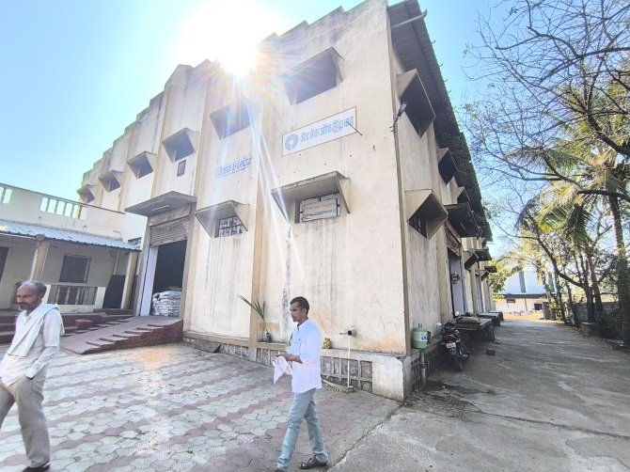 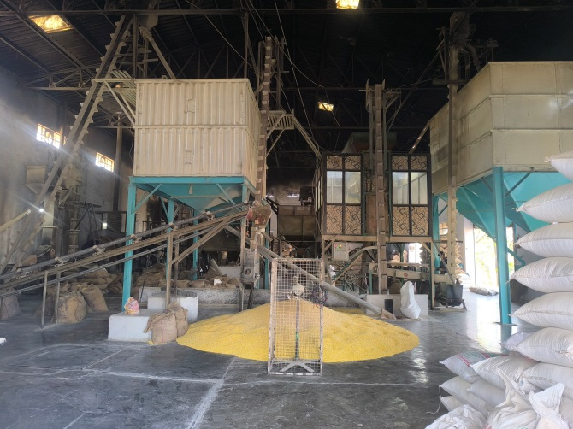

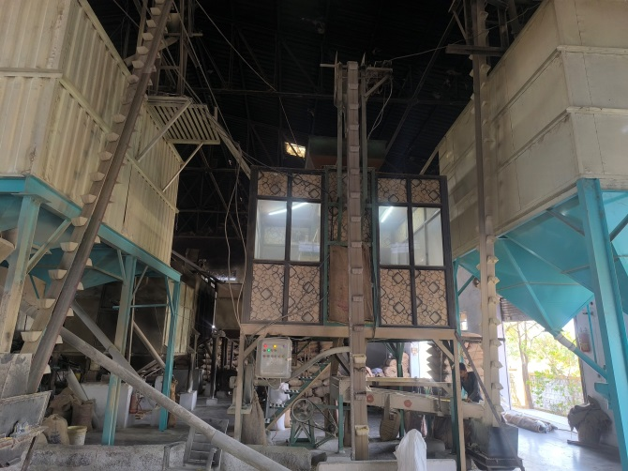 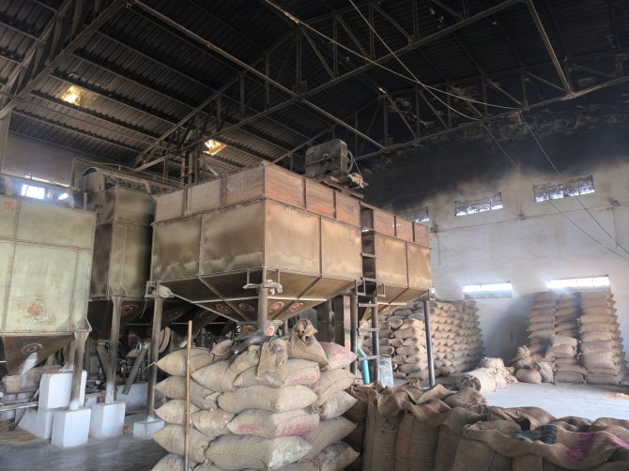

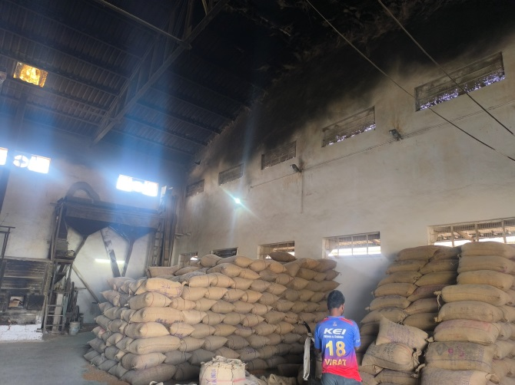 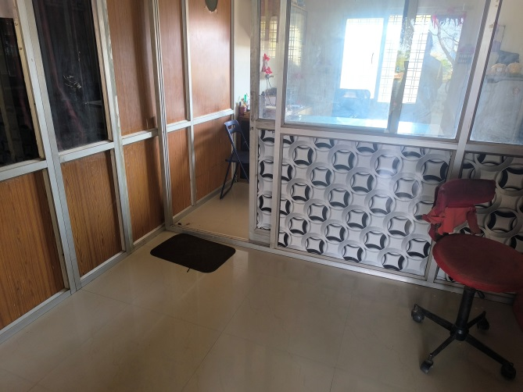

**Actual Site Photographs**

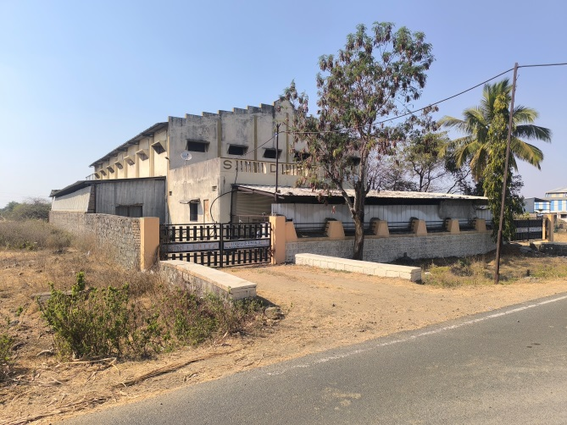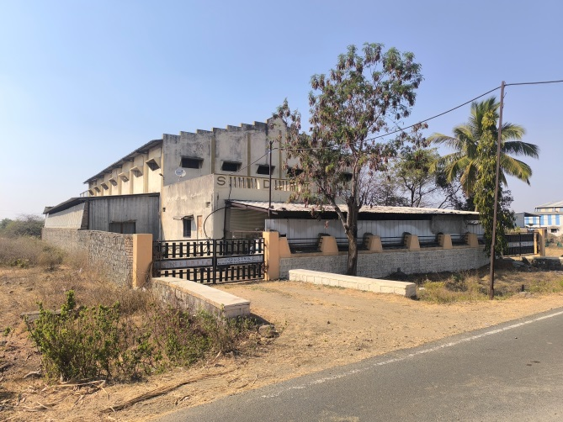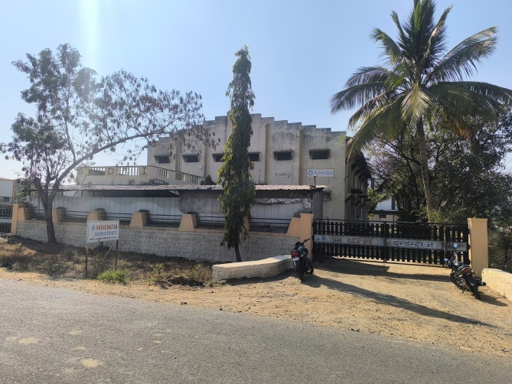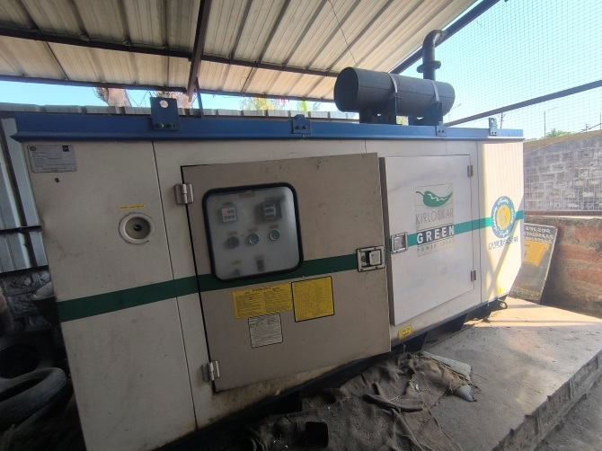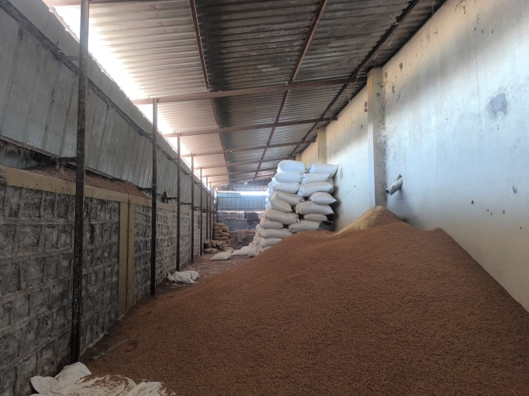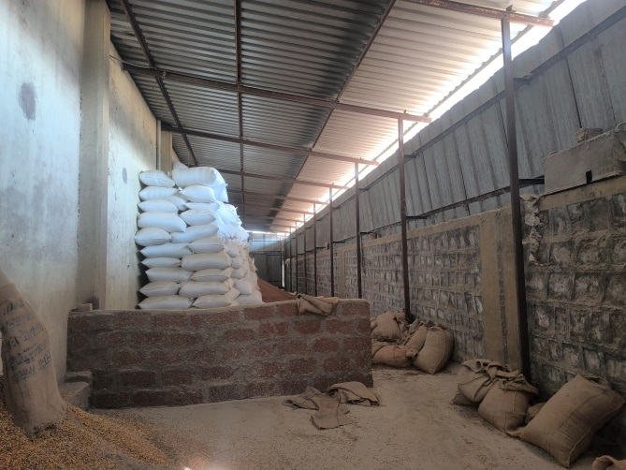**Actual Plan**

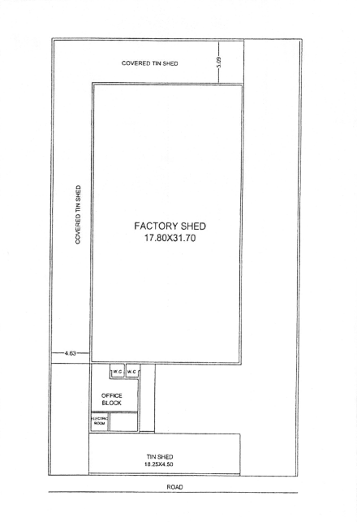

**Route Map of the property**

**Site u/r**

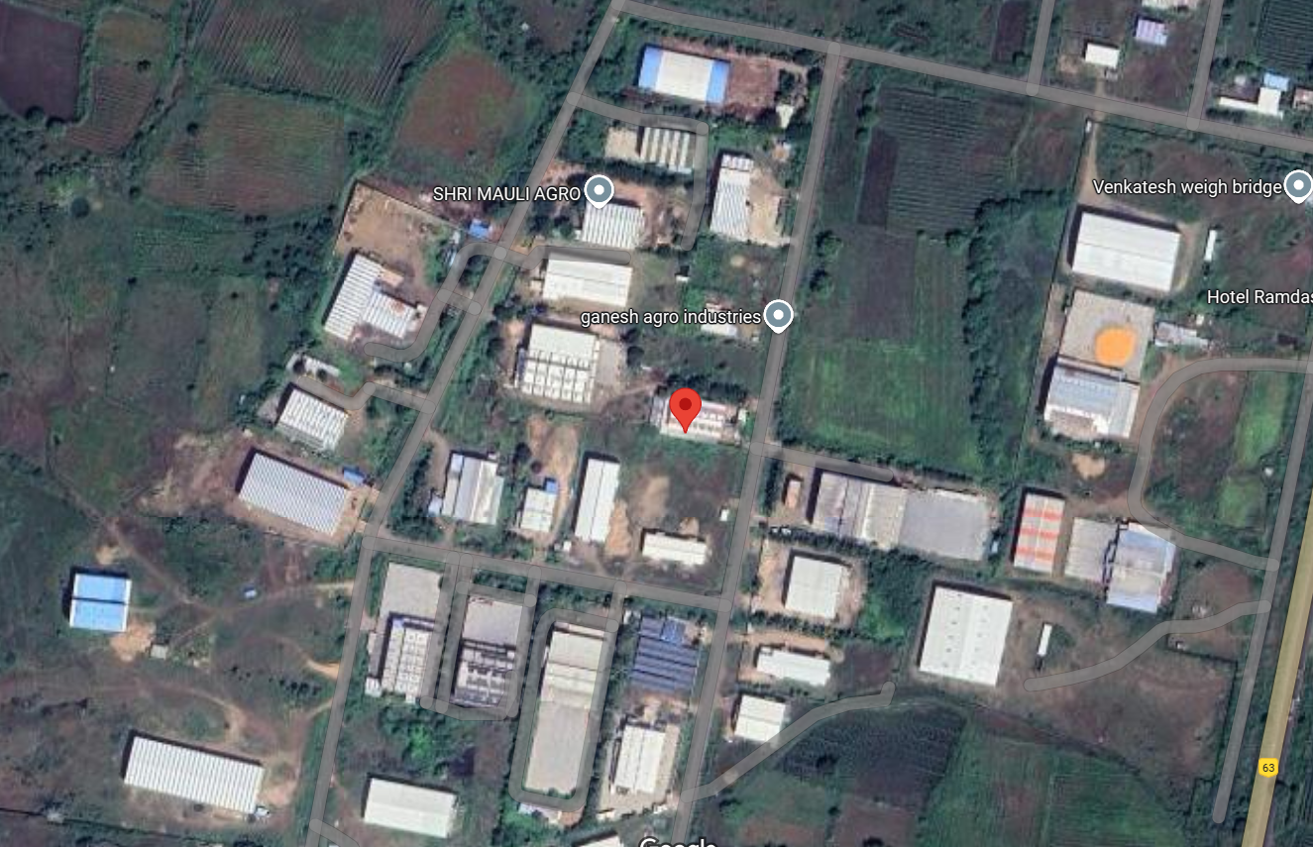

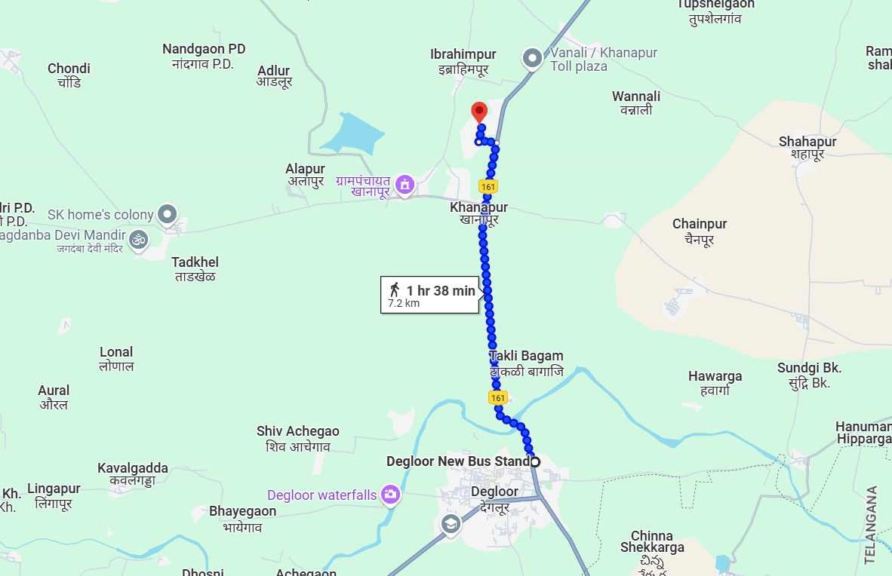

**Latitude Longitude: 18.610282, 77.573665**

Note: The Blue line shows the route to site from nearest Bus Stop (Degloor – 7.2 KM.)

**MIDC CIRCLE RATE**

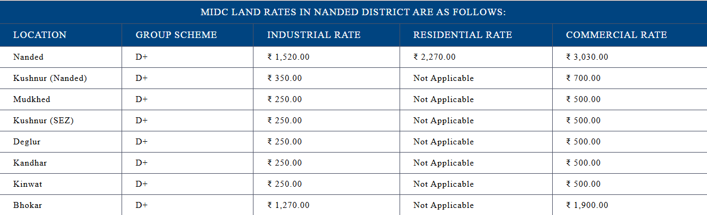

**READY RECKONER RATE**

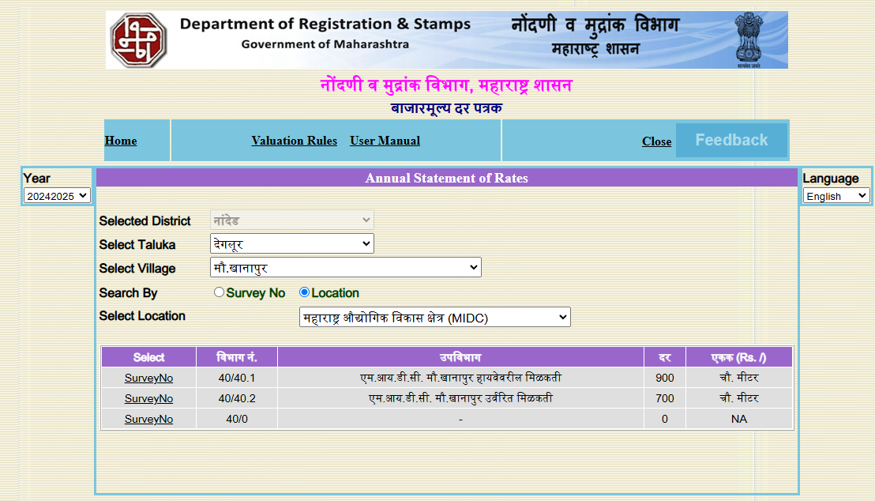

**M.I.D.C. AUCTION RATE**

|  |  |
| --- | --- |
| **Date of Auction** | **May 2022** |
| Kandhar | 1,331/- per Sqm. |
| Krushnoor | 888/- per Sqm. |
| Degloor | 1,368/- per Sqm. |

There is no big size plot in auction in Nanded, MIDC. For small size plot like 16 Sqm. Auction rate ranges from Rs.1500/- to Rs.2000/- before 2 years back.

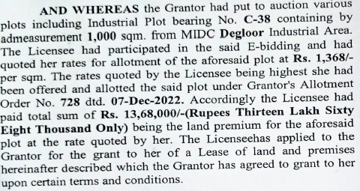

**ASSUMPTIONS, CAVEATS, LIMITATION AND DISCLAIMERS**

1. We assume no responsibility for matters of legal nature affecting the property appraised or the title thereto, nor do we render our opinion as to the title, which is assumed to be good and marketable.
2. The property is valued as though under responsible ownership.
3. It is assumed that the property is free of liens and encumbrances.
4. It is assumed that there are no hidden or unapparent conditions of the subsoil or structure that would render it more or less valuable. No responsibility is assumed for such conditions or for engineering that might be required to discover such factors.
5. The rates for valuation of the property are in accordance with the Govt. approved rates and prevailing market rates

For, **Vastukala Consultants (I) Pvt. Ltd.**

**Sharadkumar B. Chalikwar**

B.E. (Civil), M.E. (Civil), M.Sc. (Real Estate Valuation), M.Sc. (P&M Valuation), FIE (I), FIV, FIWRS

Chairman & Managing Director

Govt. Reg. Valuer

Chartered Engineer (India)

Reg. No. (N) CCIT/1-14/52/2008-09

IBBI Reg.No. IBBI/RV/07/2019/11744

Date: 10.03.2025

Place: Nanded.