Valuation Report of the Immovable Property

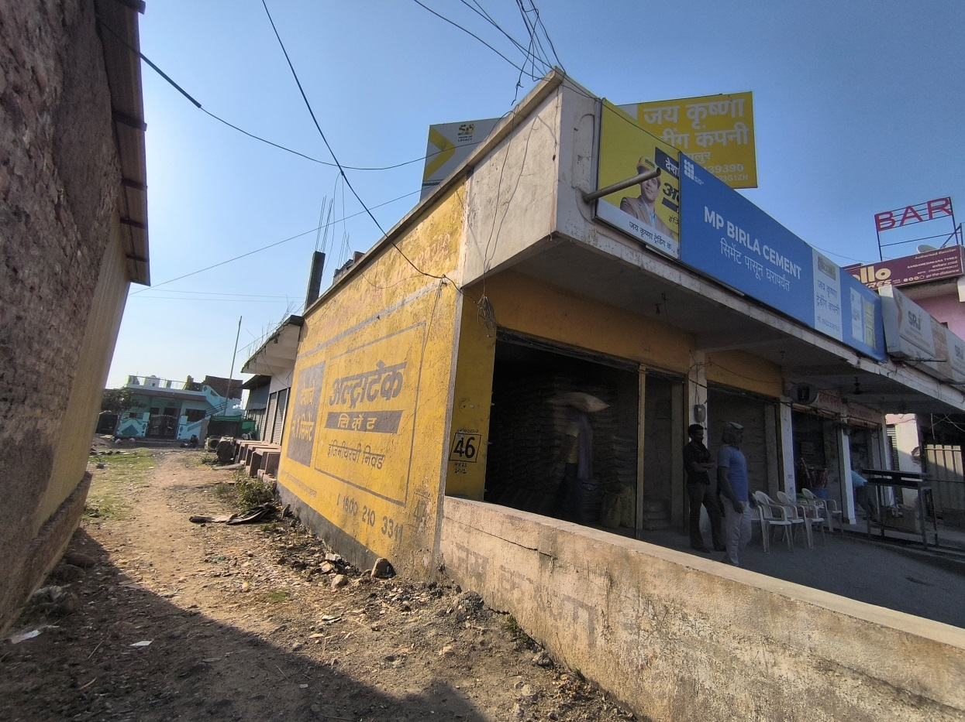

**Details of the property under consideration:**

**Name of Owner: Sow. Jaishri W/o Anil Chalikwar**

M. H. No. 8721, Southern Portion of Plot No. 7, Survey No. 28 /1 / 4, Gut No. 43, Sarkar Colony,

Opposite of New Bus Stand, Degloor, Taluka - Degloor,

District - Nanded, Maharashtra, India.

# **Longitude Latitude: 18.553112, 77.582756**

**Valuation Done for:**

**Axis Bank**

**Nanded Branch**

Vastu/Axis Bank/Nanded/03/2025/14341/2310960

10/16-157 -BHSC

Date: 10.03.2025

# **VALUER’S OPINION REPORT**

This is to certify that the property bearing M. H. No. 8721, Southern Portion of Plot No. 7, Survey No. 28 /1 / 4, Gut No. 43, Sarkar Colony, Opposite of New Bus Stand, Degloor, Taluka - Degloor, District - Nanded, Maharashtra, India belongs to **Sow. Jaishri W/o Anil Chalikwar**

|  |  |
| --- | --- |
| Boundaries of the property. |  |
| North | House of Shri. Prakash Hanmalu Bejgamwar |
| South | Internal Road |
| East | Nanded – Nizamsagar Road |
| West | Land of S. No. 28/1/4 in Gut No. 43 |

Considering various parameters recorded, existing economic scenario, and the information that is available with reference to the development of neighborhood and method selected for valuation, we are of the opinion that, the property premises can be assessed are as under:

|  |  |
| --- | --- |
| **Guideline Value of the Property** | **Rs. 38,16,850.00** |
| **Fair Market Value of the Property** | **Rs. 1,16,00,240.00** |
| **Realizable Value of the Property** | **Rs. 1,04,40,216.00** |
| **Forced/ Distress Sale value of the Property.** | **Rs. 92,80,192.00** |

The valuation of the property is based on the documents produced by the concern. Legal aspects have not been taken into considerations while preparing this valuation report.

Hence certified

For, **Vastukala Consultants (I) Pvt. Ltd**.

**Sharadkumar B. Chalikwar**

B.E. (Civil), M.E. (Civil), M.Sc. (Real Estate Valuation), M.Sc. (P&M Valuation), FIE (I), FIV, FIWRS

Chairman & Managing Director

Govt. Reg. Valuer

Chartered Engineer (India)

Reg. No. (N) CCIT/1-14/52/2008-09

IBBI Reg.No. IBBI/RV/07/2019/117

|  |  |  |  |  |  |  |  |  |  |  |  |  |  |  |  |  |  |  |  |  |  |  |  |  |  |  |  |  |  |  |  |  |  |  |  |  |  |  |  |  |  |  |  |  |  |  |  |  |  |  |  |  |  |  |  |  |  |  |  |  |  |  |  |  |  |  |  |  |  |  |  |  |  |  |  |  |  |  |  |  |  |  |  |  |  |  |  |  |  |  |  |  |  |  |  |  |  |  |  |  |  |  |  |  |  |  |  |  |  |  |  |  |  |  |  |  |  |  |  |  |  |  |  |  |  |  |  |  |  |  |  |  |  |  |  |  |  |  |  |  |  |  |  |  |  |  |  |  |  |  |  |  |  |  |  |  |  |  |  |  |  |  |  |  |  |  |  |  |  |  |  |  |  |  |  |  |  |  |  |  |  |  |  |  |  |  |  |  |  |  |  |  |  |  |  |  |  |  |  |  |  |  |  |  |  |  |  |  |  |  |  |  |  |  |  |  |  |  |  |  |  |  |  |  |  |  |  |  |  |  |  |  |  |  |  |  |  |  |  |  |  |  |  |  |  |  |  |  |  |  |  |  |  |  |  |  |  |  |  |  |  |  |  |  |  |  |  |  |  |  |  |  |  |  |  |  |  |  |  |  |  |  |  |  |  |  |  |  |  |  |  |  |  |  |  |  |  |  |  |  |  |  |  |  |  |  |  |  |  |  |  |  |  |  |  |  |  |  |  |  |  |  |  |  |  |  |  |  |  |  |  |  |  |  |  |  |  |  |  |  |  |  |  |  |  |  |  |  |  |  |  |  |  |  |  |  |  |  |  |  |  |  |  |  |  |  |  |  |  |  |  |  |  |  |  |  |  |  |  |  |  |  |  |  |  |  |  |  |  |  |  |  |  |  |  |  |  |  |  |  |  |  |  |  |  |  |  |  |  |  |  |  |  |  |  |  |  |  |  |  |  |  |  |  |  |  |  |  |  |  |  |  |  |  |  |  |  |  |  |  |  |  |  |  |  |  |  |  |  |  |  |  |  |  |  |  |  |  |  |  |  |  |  |  |  |  |  |  |  |  |  |  |  |  |  |  |  |  |  |  |  |  |  |  |  |  |  |  |  |  |  |  |  |  |  |  |  |  |  |  |  |  |  |  |  |  |  |  |  |  |  |  |  |  |  |  |  |  |  |  |  |  |  |  |  |  |  |  |  |  |  |  |  |  |  |  |  |  |  |  |  |  |  |  |  |  |  |  |  |  |  |  |  |  |  |  |  |  |  |  |  |  |  |  |  |  |  |  |  |  |  |  |  |  |  |  |  |  |  |  |  |  |  |  |  |  |  |  |  |  |  |  |  |  |  |  |  |  |  |  |  |  |  |  |  |  |  |  |  |  |  |  |  |  |  |  |  |  |  |  |  |  |  |  |  |  |  |  |  |  |  |  |  |  |  |  |  |  |  |  |  |  |  |  |  |  |  |  |  |  |  |  |  |  |  |  |  |  |  |  |  |  |  |  |  |  |  |  |  |  |  |  |  |  |  |  |  |  |  |  |  |  |  |  |  |  |  |  |  |  |  |  |  |  |  |  |  |  |  |  |  |  |  |  |  |  |  |  |  |  |  |  |  |  |  |  |  |  |  |  |  |  |  |  |  |  |  |  |  |  |  |  |  |  |  |  |  |  |  |  |  |  |  |  |  |  |  |  |  |  |  |  |  |  |  |  |  |  |  |  |  |  |  |  |  |  |  |  |  |  |  |  |  |  |  |  |  |  |  |  |  |  |  |  |  |  |  |  |  |  |  |  |  |  |  |  |  |  |  |  |  |  |  |  |  |  |  |  |  |  |  |  |  |  |  |  |  |  |  |  |  |  |  |  |  |  |  |  |  |  |  |  |  |  |  |  |  |  |  |  |  |  |  |  |  |  |  |  |  |  |  |  |  |  |  |  |  |  |  |  |  |  |  |  |  |  |  |  |  |  |  |  |  |  |  |  |  |  |  |  |  |  |  |  |  |  |  |  |  |  |  |  |  |  |  |  |  |  |  |  |  |  |  |  |  |  |  |  |  |  |  |  |  |  |  |  |  |  |  |  |  |  |  |  |  |  |  |  |  |  |  |  |  |  |  |  |  |  |  |  |  |  |  |  |  |  |  |  |  |  |  |  |  |  |  |  |  |  |  |  |  |  |  |  |  |  |  |  |  |  |  |  |  |  |  |  |  |  |  |  |  |  |  |  |  |  |  |  |  |  |  |  |  |  |  |  |  |  |  |  |  |  |  |  |  |  |  |  |  |  |  |  |  |  |  |  |  |  |  |  |  |  |  |  |  |  |  |  |  |  |  |  |  |  |  |  |  |  |  |  |  |  |  |  |  |  |  |  |  |  |  |  |  |  |  |  |  |  |  |  |  |  |  |  |  |  |  |  |  |  |  |  |  |  |  |  |  |  |  |  |  |  |  |  |  |  |  |  |  |  |  |  |  |  |  |  |  |  |  |  |  |  |  |  |  |  |  |  |  |  |  |  |  |  |  |  |  |  |  |  |  |  |  |  |  |  |  |  |  |  |  |  |  |  |  |  |  |  |  |  |  |  |  |  |  |  |  |  |  |  |  |  |  |  |  |  |  |  |  |  |  |  |  |  |  |  |  |  |  |  |  |  |  |  |  |  |  |  |  |  |  |  |  |  |  |  |  |  |  |  |  |  |  |  |  |  |  |  |  |  |  |  |  |  |  |  |  |  |  |  |  |  |  |  |  |  |  |  |  |  |  |  |  |  |  |  |  |  |  |  |  |  |  |  |  |  |  |  |  |  |  |  |  |  |  |  |  |  |  |  |  |  |  |  |  |  |  |  |  |  |  |  |  |  |  |  |  |  |  |  |  |  |  |  |  |  |  |  |  |  |  |  |  |  |  |  |  |  |  |  |  |  |  |  |  |  |  |  |  |  |  |  |  |  |  |  |  |  |  |  |  |  |  |  |  |  |  |  |  |  |  |  |  |  |  |  |  |  |  |  |  |  |  |  |  |  |  |  |  |  |  |  |  |  |  |  |  |  |  |  |  |  |  |  |  |  |  |  |  |  |  |  |  |  |  |  |  |  |  |  |  |  |  |  |  |  |  |  |  |  |  |  |  |  |  |  |  |  |  |  |  |  |  |  |  |  |  |  |  |  |  |  |  |  |  |  |  |  |  |  |  |  |  |  |  |  |  |  |  |  |  |  |  |  |  |  |  |  |  |  |  |  |  |  |  |  |  |  |  |  |  |  |  |  |  |  |  |  |  |  |  |  |  |  |  |  |  |  |  |  |  |  |  |  |  |  |  |  |  |  |  |  |  |  |  |  |  |  |  |  |  |  |  |  |  |  |  |  |  |  |  |  |  |  |  |  |  |  |  |  |  |  |  |  |  |  |  |  |  |  |  |  |  |  |  |  |  |  |  |  |  |  |  |  |  |  |  |  |  |  |  |  |  |  |  |  |  |  |  |  |  |  |  |  |  |  |  |  |  |  |  |  |  |  |  |  |  |  |  |  |  |  |  |  |  |  |  |  |  |  |  |  |  |  |  |  |  |  |  |  |  |  |  |  |  |  |  |  |  |  |  |  |  |  |  |  |  |  |  |  |  |  |  |  |  |  |  |  |  |  |  |  |  |  |  |  |  |  |  |  |  |  |  |  |  |  |  |  |  |  |  |  |  |  |  |  |  |  |  |  |  |  |  |  |  |  |  |  |  |  |  |  |  |  |  |  |  |  |  |  |  |  |  |  |  |  |  |  |  |  |  |  |  |  |  |  |  |  |  |  |  |  |  |  |  |  |  |  |  |  |  |  |  |  |  |  |  |  |  |  |  |  |  |  |  |  |  |  |  |  |  |  |  |  |  |  |  |  |  |  |  |  |  |  |  |  |  |  |  |  |  |  |  |  |  |  |  |  |  |  |  |  |  |  |  |  |  |  |  |  |  |  |  |  |  |  |  |  |  |  |  |  |  |  |  |  |  |  |  |  |  |  |  |  |  |  |  |  |  |  |  |  |  |  |  |  |  |  |  |  |  |  |  |  |  |  |  |  |  |  |  |  |  |  |  |  |  |  |  |  |  |  |  |  |  |  |  |  |  |  |  |  |  |  |  |  |  |  |  |  |  |  |  |  |  |  |  |  |  |  |  |  |  |  |  |  |  |  |  |  |  |  |  |  |  |  |  |  |  |  |  |  |  |  |  |  |  |  |  |  |  |  |  |  |  |  |  |  |  |  |  |  |  |  |  |  |  |  |  |  |  |  |  |  |  |  |  |  |  |  |  |  |  |  |  |  |  |  |  |  |  |  |  |  |  |  |  |  |  |  |  |  |  |  |  |  |  |  |  |  |  |  |  |  |  |  |  |  |  |  |  |  |  |  |  |  |  |  |  |  |  |  |  |  |  |  |  |  |  |  |  |  |  |  |  |  |  |  |  |  |  |  |  |  |  |  |  |  |  |  |  |  |  |  |  |  |  |  |  |  |  |  |  |  |  |  |  |  |  |  |  |  |  |  |  |  |  |  |  |  |  |  |  |  |  |  |  |  |  |  |  |  |  |  |  |  |  |  |  |  |  |  |  |  |  |  |  |  |  |  |  |  |  |  |  |  |  |  |  |  |  |  |  |  |  |  |  |  |  |  |  |  |  |  |  |  |  |  |  |  |  |  |  |  |  |  |  |  |  |  |  |  |  |  |  |  |  |  |  |  |  |  |  |  |  |  |  |  |  |  |  |  |  |  |  |  |  |  |  |  |  |  |  |  |  |  |  |  |  |  |  |  |  |  |  |  |  |  |  |  |  |  |  |  |  |  |  |  |  |  |  |  |  |  |  |  |  |  |  |  |  |  |  |  |  |  |  |  |  |  |  |  |  |  |  |  |  |  |  |  |  |  |  |  |  |  |  |  |  |  |  |  |  |  |  |  |  |  |  |  |  |  |  |  |  |  |  |  |  |  |  |  |  |  |  |  |  |  |  |  |  |  |  |  |  |  |  |  |  |  |  |  |  |  |  |  |  |  |  |  |  |  |  |  |  |  |  |  |  |  |  |  |  |  |  |  |  |  |  |  |  |  |  |  |  |  |  |  |  |  |  |  |  |  |  |  |  |  |  |  |  |  |  |  |  |  |  |  |  |  |  |  |  |  |  |  |  |  |  |  |  |  |  |  |  |  |  |  |  |  |  |  |  |  |  |  |  |  |  |  |  |  |  |  |  |  |  |  |  |  |  |  |  |  |  |  |  |  |  |  |  |  |  |  |  |  |  |  |  |  |  |  |  |  |  |  |  |  |  |  |  |  |  |  |  |  |  |  |  |  |  |  |  |  |  |  |  |  |  |  |  |  |  |  |  |  |  |  |  |  |  |  |  |  |  |  |  |  |  |  |  |  |  |  |  |  |  |  |  |  |  |  |  |  |  |  |  |  |  |  |  |  |  |  |  |  |  |  |  |  |  |  |  |  |  |  |  |  |  |  |  |  |  |  |  |  |  |  |  |  |  |  |  |  |  |  |  |  |  |  |  |  |  |  |  |  |  |  |  |  |  |  |  |  |  |  |  |  |  |  |  |  |  |  |  |  |  |  |  |  |  |  |  |  |  |  |  |  |  |  |  |  |  |  |  |  |  |  |  |  |  |  |  |  |  |  |  |  |  |  |  |  |  |  |  |  |  |  |  |  |  |  |  |  |  |  |  |  |  |  |  |  |  |  |  |  |  |  |  |  |  |  |  |  |  |  |  |  |  |  |  |  |  |  |  |  |  |  |  |  |  |  |  |  |  |  |  |  |  |  |  |  |  |  |  |  |  |  |  |  |  |  |  |  |  |  |  |  |  |  |  |  |  |  |  |  |  |  |  |  |  |  |  |  |  |  |  |  |  |  |  |  |  |  |  |  |  |  |  |  |  |
| --- | --- | --- | --- | --- | --- | --- | --- | --- | --- | --- | --- | --- | --- | --- | --- | --- | --- | --- | --- | --- | --- | --- | --- | --- | --- | --- | --- | --- | --- | --- | --- | --- | --- | --- | --- | --- | --- | --- | --- | --- | --- | --- | --- | --- | --- | --- | --- | --- | --- | --- | --- | --- | --- | --- | --- | --- | --- | --- | --- | --- | --- | --- | --- | --- | --- | --- | --- | --- | --- | --- | --- | --- | --- | --- | --- | --- | --- | --- | --- | --- | --- | --- | --- | --- | --- | --- | --- | --- | --- | --- | --- | --- | --- | --- | --- | --- | --- | --- | --- | --- | --- | --- | --- | --- | --- | --- | --- | --- | --- | --- | --- | --- | --- | --- | --- | --- | --- | --- | --- | --- | --- | --- | --- | --- | --- | --- | --- | --- | --- | --- | --- | --- | --- | --- | --- | --- | --- | --- | --- | --- | --- | --- | --- | --- | --- | --- | --- | --- | --- | --- | --- | --- | --- | --- | --- | --- | --- | --- | --- | --- | --- | --- | --- | --- | --- | --- | --- | --- | --- | --- | --- | --- | --- | --- | --- | --- | --- | --- | --- | --- | --- | --- | --- | --- | --- | --- | --- | --- | --- | --- | --- | --- | --- | --- | --- | --- | --- | --- | --- | --- | --- | --- | --- | --- | --- | --- | --- | --- | --- | --- | --- | --- | --- | --- | --- | --- | --- | --- | --- | --- | --- | --- | --- | --- | --- | --- | --- | --- | --- | --- | --- | --- | --- | --- | --- | --- | --- | --- | --- | --- | --- | --- | --- | --- | --- | --- | --- | --- | --- | --- | --- | --- | --- | --- | --- | --- | --- | --- | --- | --- | --- | --- | --- | --- | --- | --- | --- | --- | --- | --- | --- | --- | --- | --- | --- | --- | --- | --- | --- | --- | --- | --- | --- | --- | --- | --- | --- | --- | --- | --- | --- | --- | --- | --- | --- | --- | --- | --- | --- | --- | --- | --- | --- | --- | --- | --- | --- | --- | --- | --- | --- | --- | --- | --- | --- | --- | --- | --- | --- | --- | --- | --- | --- | --- | --- | --- | --- | --- | --- | --- | --- | --- | --- | --- | --- | --- | --- | --- | --- | --- | --- | --- | --- | --- | --- | --- | --- | --- | --- | --- | --- | --- | --- | --- | --- | --- | --- | --- | --- | --- | --- | --- | --- | --- | --- | --- | --- | --- | --- | --- | --- | --- | --- | --- | --- | --- | --- | --- | --- | --- | --- | --- | --- | --- | --- | --- | --- | --- | --- | --- | --- | --- | --- | --- | --- | --- | --- | --- | --- | --- | --- | --- | --- | --- | --- | --- | --- | --- | --- | --- | --- | --- | --- | --- | --- | --- | --- | --- | --- | --- | --- | --- | --- | --- | --- | --- | --- | --- | --- | --- | --- | --- | --- | --- | --- | --- | --- | --- | --- | --- | --- | --- | --- | --- | --- | --- | --- | --- | --- | --- | --- | --- | --- | --- | --- | --- | --- | --- | --- | --- | --- | --- | --- | --- | --- | --- | --- | --- | --- | --- | --- | --- | --- | --- | --- | --- | --- | --- | --- | --- | --- | --- | --- | --- | --- | --- | --- | --- | --- | --- | --- | --- | --- | --- | --- | --- | --- | --- | --- | --- | --- | --- | --- | --- | --- | --- | --- | --- | --- | --- | --- | --- | --- | --- | --- | --- | --- | --- | --- | --- | --- | --- | --- | --- | --- | --- | --- | --- | --- | --- | --- | --- | --- | --- | --- | --- | --- | --- | --- | --- | --- | --- | --- | --- | --- | --- | --- | --- | --- | --- | --- | --- | --- | --- | --- | --- | --- | --- | --- | --- | --- | --- | --- | --- | --- | --- | --- | --- | --- | --- | --- | --- | --- | --- | --- | --- | --- | --- | --- | --- | --- | --- | --- | --- | --- | --- | --- | --- | --- | --- | --- | --- | --- | --- | --- | --- | --- | --- | --- | --- | --- | --- | --- | --- | --- | --- | --- | --- | --- | --- | --- | --- | --- | --- | --- | --- | --- | --- | --- | --- | --- | --- | --- | --- | --- | --- | --- | --- | --- | --- | --- | --- | --- | --- | --- | --- | --- | --- | --- | --- | --- | --- | --- | --- | --- | --- | --- | --- | --- | --- | --- | --- | --- | --- | --- | --- | --- | --- | --- | --- | --- | --- | --- | --- | --- | --- | --- | --- | --- | --- | --- | --- | --- | --- | --- | --- | --- | --- | --- | --- | --- | --- | --- | --- | --- | --- | --- | --- | --- | --- | --- | --- | --- | --- | --- | --- | --- | --- | --- | --- | --- | --- | --- | --- | --- | --- | --- | --- | --- | --- | --- | --- | --- | --- | --- | --- | --- | --- | --- | --- | --- | --- | --- | --- | --- | --- | --- | --- | --- | --- | --- | --- | --- | --- | --- | --- | --- | --- | --- | --- | --- | --- | --- | --- | --- | --- | --- | --- | --- | --- | --- | --- | --- | --- | --- | --- | --- | --- | --- | --- | --- | --- | --- | --- | --- | --- | --- | --- | --- | --- | --- | --- | --- | --- | --- | --- | --- | --- | --- | --- | --- | --- | --- | --- | --- | --- | --- | --- | --- | --- | --- | --- | --- | --- | --- | --- | --- | --- | --- | --- | --- | --- | --- | --- | --- | --- | --- | --- | --- | --- | --- | --- | --- | --- | --- | --- | --- | --- | --- | --- | --- | --- | --- | --- | --- | --- | --- | --- | --- | --- | --- | --- | --- | --- | --- | --- | --- | --- | --- | --- | --- | --- | --- | --- | --- | --- | --- | --- | --- | --- | --- | --- | --- | --- | --- | --- | --- | --- | --- | --- | --- | --- | --- | --- | --- | --- | --- | --- | --- | --- | --- | --- | --- | --- | --- | --- | --- | --- | --- | --- | --- | --- | --- | --- | --- | --- | --- | --- | --- | --- | --- | --- | --- | --- | --- | --- | --- | --- | --- | --- | --- | --- | --- | --- | --- | --- | --- | --- | --- | --- | --- | --- | --- | --- | --- | --- | --- | --- | --- | --- | --- | --- | --- | --- | --- | --- | --- | --- | --- | --- | --- | --- | --- | --- | --- | --- | --- | --- | --- | --- | --- | --- | --- | --- | --- | --- | --- | --- | --- | --- | --- | --- | --- | --- | --- | --- | --- | --- | --- | --- | --- | --- | --- | --- | --- | --- | --- | --- | --- | --- | --- | --- | --- | --- | --- | --- | --- | --- | --- | --- | --- | --- | --- | --- | --- | --- | --- | --- | --- | --- | --- | --- | --- | --- | --- | --- | --- | --- | --- | --- | --- | --- | --- | --- | --- | --- | --- | --- | --- | --- | --- | --- | --- | --- | --- | --- | --- | --- | --- | --- | --- | --- | --- | --- | --- | --- | --- | --- | --- | --- | --- | --- | --- | --- | --- | --- | --- | --- | --- | --- | --- | --- | --- | --- | --- | --- | --- | --- | --- | --- | --- | --- | --- | --- | --- | --- | --- | --- | --- | --- | --- | --- | --- | --- | --- | --- | --- | --- | --- | --- | --- | --- | --- | --- | --- | --- | --- | --- | --- | --- | --- | --- | --- | --- | --- | --- | --- | --- | --- | --- | --- | --- | --- | --- | --- | --- | --- | --- | --- | --- | --- | --- | --- | --- | --- | --- | --- | --- | --- | --- | --- | --- | --- | --- | --- | --- | --- | --- | --- | --- | --- | --- | --- | --- | --- | --- | --- | --- | --- | --- | --- | --- | --- | --- | --- | --- | --- | --- | --- | --- | --- | --- | --- | --- | --- | --- | --- | --- | --- | --- | --- | --- | --- | --- | --- | --- | --- | --- | --- | --- | --- | --- | --- | --- | --- | --- | --- | --- | --- | --- | --- | --- | --- | --- | --- | --- | --- | --- | --- | --- | --- | --- | --- | --- | --- | --- | --- | --- | --- | --- | --- | --- | --- | --- | --- | --- | --- | --- | --- | --- | --- | --- | --- | --- | --- | --- | --- | --- | --- | --- | --- | --- | --- | --- | --- | --- | --- | --- | --- | --- | --- | --- | --- | --- | --- | --- | --- | --- | --- | --- | --- | --- | --- | --- | --- | --- | --- | --- | --- | --- | --- | --- | --- | --- | --- | --- | --- | --- | --- | --- | --- | --- | --- | --- | --- | --- | --- | --- | --- | --- | --- | --- | --- | --- | --- | --- | --- | --- | --- | --- | --- | --- | --- | --- | --- | --- | --- | --- | --- | --- | --- | --- | --- | --- | --- | --- | --- | --- | --- | --- | --- | --- | --- | --- | --- | --- | --- | --- | --- | --- | --- | --- | --- | --- | --- | --- | --- | --- | --- | --- | --- | --- | --- | --- | --- | --- | --- | --- | --- | --- | --- | --- | --- | --- | --- | --- | --- | --- | --- | --- | --- | --- | --- | --- | --- | --- | --- | --- | --- | --- | --- | --- | --- | --- | --- | --- | --- | --- | --- | --- | --- | --- | --- | --- | --- | --- | --- | --- | --- | --- | --- | --- | --- | --- | --- | --- | --- | --- | --- | --- | --- | --- | --- | --- | --- | --- | --- | --- | --- | --- | --- | --- | --- | --- | --- | --- | --- | --- | --- | --- | --- | --- | --- | --- | --- | --- | --- | --- | --- | --- | --- | --- | --- | --- | --- | --- | --- | --- | --- | --- | --- | --- | --- | --- | --- | --- | --- | --- | --- | --- | --- | --- | --- | --- | --- | --- | --- | --- | --- | --- | --- | --- | --- | --- | --- | --- | --- | --- | --- | --- | --- | --- | --- | --- | --- | --- | --- | --- | --- | --- | --- | --- | --- | --- | --- | --- | --- | --- | --- | --- | --- | --- | --- | --- | --- | --- | --- | --- | --- | --- | --- | --- | --- | --- | --- | --- | --- | --- | --- | --- | --- | --- | --- | --- | --- | --- | --- | --- | --- | --- | --- | --- | --- | --- | --- | --- | --- | --- | --- | --- | --- | --- | --- | --- | --- | --- | --- | --- | --- | --- | --- | --- | --- | --- | --- | --- | --- | --- | --- | --- | --- | --- | --- | --- | --- | --- | --- | --- | --- | --- | --- | --- | --- | --- | --- | --- | --- | --- | --- | --- | --- | --- | --- | --- | --- | --- | --- | --- | --- | --- | --- | --- | --- | --- | --- | --- | --- | --- | --- | --- | --- | --- | --- | --- | --- | --- | --- | --- | --- | --- | --- | --- | --- | --- | --- | --- | --- | --- | --- | --- | --- | --- | --- | --- | --- | --- | --- | --- | --- | --- | --- | --- | --- | --- | --- | --- | --- | --- | --- | --- | --- | --- | --- | --- | --- | --- | --- | --- | --- | --- | --- | --- | --- | --- | --- | --- | --- | --- | --- | --- | --- | --- | --- | --- | --- | --- | --- | --- | --- | --- | --- | --- | --- | --- | --- | --- | --- | --- | --- | --- | --- | --- | --- | --- | --- | --- | --- | --- | --- | --- | --- | --- | --- | --- | --- | --- | --- | --- | --- | --- | --- | --- | --- | --- | --- | --- | --- | --- | --- | --- | --- | --- | --- | --- | --- | --- | --- | --- | --- | --- | --- | --- | --- | --- | --- | --- | --- | --- | --- | --- | --- | --- | --- | --- | --- | --- | --- | --- | --- | --- | --- | --- | --- | --- | --- | --- | --- | --- | --- | --- | --- | --- | --- | --- | --- | --- | --- | --- | --- | --- | --- | --- | --- | --- | --- | --- | --- | --- | --- | --- | --- | --- | --- | --- | --- | --- | --- | --- | --- | --- | --- | --- | --- | --- | --- | --- | --- | --- | --- | --- | --- | --- | --- | --- | --- | --- | --- | --- | --- | --- | --- | --- | --- | --- | --- | --- | --- | --- | --- | --- | --- | --- | --- | --- | --- | --- | --- | --- | --- | --- | --- | --- | --- | --- | --- | --- | --- | --- | --- | --- | --- | --- | --- | --- | --- | --- | --- | --- | --- | --- | --- | --- | --- | --- | --- | --- | --- | --- | --- | --- | --- | --- | --- | --- | --- | --- | --- | --- | --- | --- | --- | --- | --- | --- | --- | --- | --- | --- | --- | --- | --- | --- | --- | --- | --- | --- | --- | --- | --- | --- | --- | --- | --- | --- | --- | --- | --- | --- | --- | --- | --- | --- | --- | --- | --- | --- | --- | --- | --- | --- | --- | --- | --- | --- | --- | --- | --- | --- | --- | --- | --- | --- | --- | --- | --- | --- | --- | --- | --- | --- | --- | --- | --- | --- | --- | --- | --- | --- | --- | --- | --- | --- | --- | --- | --- | --- | --- | --- | --- | --- | --- | --- | --- | --- | --- | --- | --- | --- | --- | --- | --- | --- | --- | --- | --- | --- | --- | --- | --- | --- | --- | --- | --- | --- | --- | --- | --- | --- | --- | --- | --- | --- | --- | --- | --- | --- | --- | --- | --- | --- | --- | --- | --- | --- | --- | --- | --- | --- | --- | --- | --- | --- | --- | --- | --- | --- | --- | --- | --- | --- | --- | --- | --- | --- | --- | --- | --- | --- | --- | --- | --- | --- | --- | --- | --- | --- | --- | --- | --- | --- | --- | --- | --- | --- | --- | --- | --- | --- | --- | --- | --- | --- | --- | --- | --- | --- | --- | --- | --- | --- | --- | --- | --- | --- | --- | --- | --- | --- | --- | --- | --- | --- | --- | --- | --- | --- | --- | --- | --- | --- | --- | --- | --- | --- | --- | --- | --- | --- | --- | --- | --- | --- | --- | --- | --- | --- | --- | --- | --- | --- | --- | --- | --- | --- | --- | --- | --- | --- | --- | --- | --- | --- | --- | --- | --- | --- | --- | --- | --- | --- | --- | --- | --- | --- | --- | --- | --- | --- | --- | --- | --- | --- | --- | --- | --- | --- | --- | --- | --- | --- | --- | --- | --- | --- | --- | --- | --- | --- | --- | --- | --- | --- | --- | --- | --- | --- | --- | --- | --- | --- | --- | --- | --- | --- | --- | --- | --- | --- | --- | --- | --- | --- | --- | --- | --- | --- | --- | --- | --- | --- | --- | --- | --- | --- | --- | --- | --- | --- | --- | --- | --- | --- | --- | --- | --- | --- | --- | --- | --- | --- | --- | --- | --- | --- | --- | --- | --- | --- | --- | --- | --- | --- | --- | --- | --- | --- | --- | --- | --- | --- | --- | --- | --- | --- | --- | --- | --- | --- | --- | --- | --- | --- | --- | --- | --- | --- | --- | --- | --- | --- | --- | --- | --- | --- | --- | --- | --- | --- | --- | --- | --- | --- | --- | --- | --- | --- | --- | --- | --- | --- | --- | --- | --- | --- | --- | --- | --- | --- | --- | --- | --- | --- | --- | --- | --- | --- | --- | --- | --- | --- | --- | --- | --- | --- | --- | --- | --- | --- | --- | --- | --- | --- | --- | --- | --- | --- | --- | --- | --- | --- | --- | --- | --- | --- | --- | --- | --- | --- | --- | --- | --- | --- | --- | --- | --- | --- | --- | --- | --- | --- | --- | --- | --- | --- | --- | --- | --- | --- | --- | --- | --- | --- | --- | --- | --- | --- | --- | --- | --- | --- | --- | --- | --- | --- | --- | --- | --- | --- | --- | --- | --- | --- | --- | --- | --- | --- | --- | --- | --- | --- | --- | --- | --- | --- | --- | --- | --- | --- | --- | --- | --- | --- | --- | --- | --- | --- | --- | --- | --- | --- | --- | --- | --- | --- | --- | --- | --- | --- | --- | --- | --- | --- | --- | --- | --- | --- | --- | --- | --- | --- | --- | --- | --- | --- | --- | --- | --- | --- | --- | --- | --- | --- | --- | --- | --- | --- | --- | --- | --- | --- | --- | --- | --- | --- | --- | --- | --- | --- | --- | --- | --- | --- | --- | --- | --- | --- | --- | --- | --- | --- | --- | --- | --- | --- | --- | --- | --- | --- | --- | --- | --- | --- | --- | --- | --- | --- | --- | --- | --- | --- | --- | --- | --- | --- | --- | --- | --- | --- | --- | --- | --- | --- | --- | --- | --- | --- | --- | --- | --- | --- | --- | --- | --- | --- | --- | --- | --- | --- | --- | --- | --- | --- | --- | --- | --- | --- | --- | --- | --- | --- | --- | --- | --- | --- | --- | --- | --- | --- | --- | --- | --- | --- | --- | --- | --- | --- | --- | --- | --- | --- | --- | --- | --- | --- | --- | --- | --- | --- | --- | --- | --- | --- | --- | --- | --- | --- | --- | --- | --- | --- | --- | --- | --- | --- | --- | --- | --- | --- | --- | --- | --- | --- | --- | --- | --- | --- | --- | --- | --- | --- | --- | --- | --- | --- | --- | --- | --- | --- | --- | --- | --- | --- | --- | --- | --- | --- | --- | --- | --- | --- | --- | --- | --- | --- | --- | --- | --- | --- | --- | --- | --- | --- | --- | --- | --- | --- | --- | --- | --- | --- | --- | --- | --- | --- | --- | --- | --- | --- | --- | --- | --- | --- | --- | --- | --- | --- | --- | --- | --- | --- | --- | --- | --- | --- | --- | --- | --- | --- | --- | --- | --- | --- | --- | --- | --- | --- | --- | --- | --- | --- | --- | --- | --- | --- | --- | --- | --- | --- | --- | --- | --- | --- | --- | --- | --- | --- | --- | --- | --- | --- | --- | --- | --- | --- | --- | --- | --- | --- | --- | --- | --- | --- | --- | --- | --- | --- | --- | --- | --- | --- | --- |
| **VALUATION REPORT (IN RESPECT OF LAND AND BUILDING)**   |  |  |  |  |  |  |  |  |  |  |  |  |  |  |  |  |  |  |  |  |  |  |  |  | | --- | --- | --- | --- | --- | --- | --- | --- | --- | --- | --- | --- | --- | --- | --- | --- | --- | --- | --- | --- | --- | --- | --- | --- | | 1. | CBB/CCMC/CCSU | | | | |  | | | | |  | | | | | - | | | | | | | | | - | | | | | - | | | | | | | | | 2. | Name of Owner & Address: | | | | | | | | | | **Sow. Jaishri W/o Anil Chalikwar**  R/o. Line Galli, Degloor, Taluka - Degloor, District - Nanded, Maharashtra, India. | | | | | | | | | | | | | | Name of Borrower & Address | | | | | | | | | | **Sow. Jaishri W/o Anil Chalikwar**  R/o. Line Galli, Degloor, Taluka - Degloor, District - Nanded, Maharashtra, India. | | | | | | | | | | | | | | 3. | Name of the Bank Official Present | | | | | | | | | | No. | | | | | | | | | | | | | | Name of the Representative & Mobile No. | | | | | | | | | | No. | | | | | | | | | | | | | | **4.** | **Details of the Property Being Valued** | | | | | | | | | | | | | | | | | | | | | | | | 4.1 | Description of the Property | | | | | | | | | | * Ground Floor Commercial Shop Premises situated on Nanded – Hyderabad State High Way, In front of Degloor Bus Stand. * G.F. Consist of six shops which are tenant occupied * Subject Property under valuation is acquired by owner from Mr. Parkash Hanumant Bejgamwar in the year 2007 admeasuring land area 232.34 Sqm. Which includes Built up area 58.87 Sqm. Then owner has obtained construction permission from municipal council Degloor in year 2004 for entire Permission. | | | | | | | | | | | | | | 4.2 | Location of Property | | | | | | | | | | M. H. No. 8721, Southern Portion of Plot No. 7, Survey No. 28 /1 / 4, Gut No. 43, Sarkar Colony, Opposite of New Bus Stand, Degloor, Taluka - Degloor, District - Nanded, Maharashtra, India. | | | | | | | | | | | | | | (Rural / Semi Urban / Urban) | | | | | | | | | | Urban. | | | | | | | | | | | | | | 4.3 | Documents Provided: | | | | | | | | | | | | | | | | | | | | | | | | 1 | | Photo Copy of Sale Deed No. 1149/2007, dated 20.06.2007, between Registered at Sub Registrar, Degloor between Sow. Jaishri W/o Anil Chalikwar from Mr. Prakash Hanmanulu Bejgamwar. | | | | | | | | | | | | | | | | | | | | | | 2 | | Photo Copy of Property Nond Certificate vide no. NA. PA. / 4582 / 2021, dated 06.08.2021, Chief Officer, Degloor Municipal Council, Degloor. | | | | | | | | | | | | | | | | | | | | | | 3 | | Photo Copy of Namuna No. 43 (Rule 74) Tax Assessment in the year 200 2001, dated 17.08.2021, Chief Officer, Degloor Municipal Council, Degloor. | | | | | | | | | | | | | | | | | | | | | | 4 | | Photo Copy Sanction Layout approved by Municipal Council, Degloor dated 29.01.2000 | | | | | | | | | | | | | | | | | | | | | | 5 | | Photo Copy of Building Permission & Commencement Certificate vide letter No. NA. PA / 9 / BADNDHKAM / 5691, dated 29.03.2024, Chief Officer, Degloor Municipal Council, Degloor. | | | | | | | | | | | | | | | | | | | | | | 6 | | Photo Copy of Sanction Plan Chief Officer, Degloor Municipal Council, Degloor. | | | | | | | | | | | | | | | | | | | | | | 7 | | Photo Copy of Completion Certificate (Appendix – F) Bharat R. Atkaliwar, Consulting Arch / Engg. Govt. Approved Valuer, Degloor, Degloor Municipal Council, Degloor. | | | | | | | | | | | | | | | | | | | | | | 8 | | Photo Copy of Title Report dated 16.01.2015, Adv. K.M. Deshpande | | | | | | | | | | | | | | | | | | | | | | 4.4 | Plot No / Survey No. / Gut No./ Khasra No: | | | | | M. H. No. 8721, Southern Portion of Plot No. 7, Survey No. 28 /1 / 4, Gut No. 43, Sarkar Colony, Opposite of New Bus Stand, Degloor, Taluka - Degloor, District - Nanded, Maharashtra, India. | | | | | | Road | | | | Nanded – Hyderabad Road | | | | | | | | | 4.5 | Colony / Nagar / Sector | | | | | Sarkar Colony | | | | | | Locality / Landmark | | | | In front of Degloor Bus Stand | | | | | | | | | 4.6 | Village/Town/City | | | | | Degloor | | | | | | District: | | | | Nanded | | | | | | | | | 4.7 | State | | | | | Maharashtra | | | | | | Pin code: | | | | 431 717 | | | | | | | | | 4.8 | Distance from Area Office (Nanded Branch) | | | | | | | | | | | Within @ 1.0 Km | | | | | | | | | | | | | **5.** | **Type of Property** | | | | | | | | | | | | | | | | | | | | | | | |  | **(A) Plot:** (Residential / Commercial / Industrial) | | | | | | | | | | | | | | Commercial | | | | | | | | | | Level of land with topographical conditions | | | | | | | | | | | | | | Leveled | | | | | | | | | | Whether situated in Municipal / Corporation Limit | | | | | | | | | | | | | | Municipal Limit | | | | | | | | | | Any construction observed on plot | | | | | | | | | | | | | | Yes,  Actual – 6 Shops | | | | | | | | | | **(B) Residential Property: (**Independent house / Bungalow / Row House / Flat) | | | | | | | | | | | | | | Commercial Shop Property | | | | | | | | | | Civic Amenities like school, hospital, market, etc. (Available, within the radius of Km./ Not Available) | | | | | | | | | | | | | | All available in village Basmat. | | | | | | | | | | **(C) Commercial / Industrial Property:** (Office / Shop / Unit in a Mall / Gowdown) | | | | | | | | | | | | | | Commercial Shops on Ground Floor. | | | | | | | | | | **6.0** | **Accessibility / Boundaries / Others** | | | | | | | | | | | | | | | | | | | | | | | | 6.1 | Availability of local transport (Metro / Local Train / Bus / Personal Transport) | | | | | | | | | | | | Local Transport, Bus Stand, Railway Station, Personal Transport. | | | | | | | | | | | | 6.2 | Distance from Nanded Railway station @90.00 Km | | | | | | | | | | | | Bus Stand within  Taxi/Auto Stand within walkable distance | | | | | | | | | | | | 6.3 | Does the approach road to the Property / Building is independent and accessible | | | | | | | Yes. | | | | | Will it be able to accommodate a fire extinguisher | | | | | | | | | | Yes | | 6.4 | Does the property fall under land locked area | | | | | | | No. | | | | | Does the property fall in a community dominated area | | | | | | | | | | No | | 6.5 | Cornered / Intermittent Plot | | | | | | | | | | | | Corner Plot. | | | | | | | | | | | | **6.6** | **Boundaries** | | | | | | | | | | | | | | | | | | | | | | | | **Boundaries of the property.** | | | | **As per Sale Deed** | | | | | | | | **As per Actual** | | | | | | | | | | | | North | | | | House of Shri. Prakash Hanmalu Bejgamwar | | | | | | | | House & Open Space of alienator | | | | | | | | | | | | South | | | | Internal Road | | | | | | | | Internal Road | | | | | | | | | | | | East | | | | Nanded – Nizamsagar Road | | | | | | | | Nanded – Nizamsagar Road | | | | | | | | | | | | West | | | | Land of S. No. 28/1/4 in Gut No. 43 | | | | | | | | Open Space out of Sy. No. 28/1/4 | | | | | | | | | | | | 6.7 | Class of locality (Posh / Higher Middle Class / Middle Class / Lower Middle Class / Poor) | | | | | | | | | | | | Middle Class  Located in front d New Bus Stand &  Nanded - Hyderabad State High way | | | | | | | | | | | | 6.8 | Quality of Infrastructure in the vicinity (Excellent / Good / Average / Poor) | | | | | | | | | | | | Good | | | | | | | | | | | | 6.9 | Ownership Status of the Property (Free Hold / Reg. Lease / Govt. Authority) | | | | | | | | | | | | Freehold | | | | | | | | | | | | 6.10 | Approved usage of property (Industrial / Commercial / Residential / Mix) | | | | | | Commercial | | | | | | Actual usage of property (Industrial / Commercial / Residential / Mix) | | | | | | | Mix Use | | | | | 6.11 | Restrictive covenants in regards to Land Use, (if any) | | | | | | | | | | | | Commercial | | | | | | | | | | | | 6.12 | Type of Structure (Load Bearing / RCC / Alu form shuttering) | | | | | | | | | | | | RCC Structure | | | | | | | | | | | | 6.13 | Number of floors | | | | | As per Actual | | | | | | | **Ground Floor** | | | | | | | | | | | | As per Sanctioned Plan | | | | | | | **Ground Floor** | | | | | | | | | | | | 6.14 | Occupancy Details (Self-Occupied / Rented / Vacant) | | | | | | | | | | | | Fully tenant Occupied. | | | | | | | | | | | | **7.** | **If the property is on rent** | | | | | | | | | | | | | | | | | | | | | | | | 7.1 | Name of tenant / lease & Number of years in tenancy | | | | | | | | | | | | No. | | | | | | | | | | | | 7.2 | Was there any resistance for valuation | | | | | | No. | | | | | | If yes, from the current occupants | | | | | | | | N.A. | | | | 7.3 | Does property have basic amenities | | | | | | Yes. | | | | | | Development of surrounding area Underdeveloped / Developing / Developed | | | | | | | | Under developed | | | | **8.** | **If the property is Leasehold** | | | | | | | | | | | | | | | | | | | | | | | | 8.1 | Name of Lesser | | | | | N.A. | Nature of Lease: | | | | | | | | | | | | | | N.A. | | | | 8.2 | Total Period of Lease | | | | | N.A. | If yes, from the current occupants | | | | | | | | | | | | | | N.A. | | | | 8.3 | Does property have basic amenities | | | | | No. | Development of surrounding area Underdeveloped / Developing / Developed | | | | | | | | | | | | | | Underdeveloped | | | | **9.** | **Approval Details** | | | | | | | | | | | | | | | | | | | | | | | | 9.1 | RERA Registration Number | | | | | | | | | | Details not available. | | | | | | | | | | | | | | 9.2 | Layout Approval Number: | | | | | | | | | | Municipal Council, Degloor. | | | | | | | | | | | | | | Date of Approval | | | | | | | | | | 29.01.2000. | | | | | | | | | | | | | | Expiry Date | | | | | | | | | | Details not available | | | | | | | | | | | | | | 9.3 | Building Plan Approval Number: | | | | | | | | | | NA. PA / 9 / BADNDHKAM / 5691 | | | | | | | | | | | | | | Date of Approval | | | | | | | | | | 29.03.2004 | | | | | | | | | | | | | | Expiry Date | | | | | | | | | | Valid for one Year from the date of approval. | | | | | | | | | | | | | | 9.4 | Occupancy Certificate | | | | | | | | | | Chief Officer, Degloor Municipal Council, Degloor. | | | | | | | | | | | | | | **10.00** | **Plot Area Details.** | | | | | | | | | | | | | | | | | | | | | | | | **10.01** | **Plot Area** | | | | | | | | | | | | | | | | | | | | | | | |  | Plot Size As per Sale Deed (Southern Portion of Plot No. 7) | | | | | | | | | | | | | | | 100’0’’ X 25’0’’ : 30.48 X 7.62 Mts. | | | | | | | | | Area of the Plot as per Sale Deed (Southern Portion of Plot No. 7) | | | | | | | | | | | | | | | 2500 Sq. Ft. : 323.34Sqm | | | | | | | | | 10.02 | Demarcation at Site | | | | | | | | | | | | | | | **Yes** | | | | | | | | | **10.03** | **Construction Area Details** | | | | | | | | | Current Usage | | | | | | | | | | | | | | |  | **Floor** | | | | | **Built up area as per Sanctioned Plan in Sq. M.** | | | | | **(Storage / Parking / Commercial / Residential)** | | | | | | | | | | | | | | Ground Floor | | | | | 164.76 | | | | | Commercial | | | | | | | | | | | | | | 10.04 | Amenities Details (if any): | | | | | | | | | | No | | | | | | | | | | | | | | 10.05 | Floor Space Index permissible | | | | | | | | | | Basic FSI | | | | | | | 1.10 | | | | | | | FSI on payment of premium | | | | | | | 0.30 | | | | | | | Maximum permissible TDR Loading | | | | | | | 0.60 | | | | | | | Maximum Building potential on plot | | | | | | | 2.00 | | | | | | | 10.06 | FSI Utilized | | | | | | | | | | N.A | | | | | | | | | | | | | | 10.07 | Whether the construction is as per approved building plan and / or local building bye laws: | | | | | | | | | | N.A | | | | | | | | | | | | | | 10.08 | Details of Extra Construction | | | | | | | | | | N.A | | | | | | | | | | | | | | 10.09 | Percentage of Extra Construction | | | | | | | | | | N.A | | | | | | | | | | | | | | 10.10 | Whether the extra construction is Compoundable OR Non-Compoundable? | | | | | | | | | | N.A | | | | | | | | | | | | | | 10.11 | Quality of construction | | | | | | | | | | N.A | | | | | | | | | | | | | | 10.12 | Maintenance of the Property | | | | | | | | | | N.A | | | | | | | | | | | | | | 10.13 | Condition of Building | | | | | | | | | | N.A | | | | | | | | | | | | | | 10.14 | Current Life of the structure | | | | | 20 | | | | | Projected Future Life of the Structure | | | | | 40 | | | | | | | | | 10.15 | Land Revenue / Taxes Paid upto (for Land) | | | | | Details not available | | | | | Municipal Taxes Paid up to (for Building) | | | | | Details not Available. | | | | | | | | | **11.** | **Details of Valuation:** | | | | | | | | | | | | | | | | | | | | | | | |  | **S.L** | **Particulars of Item** | | **Plinth / Built up Area In**  **Sqm.** | | | **Age of Building** | | **Estimated Replacement Rate Of Construction** | | | | | **Replacement cost** | | | **Depreciation**  **30.00%** | | | | | **Net Value after Depreciation** | | | 1 | Ground Floor | | 164.76 | | | 20 | | 20,000.00 | | | | | 32,95,200.00 | | | -9,88,560.00 | | | | | 23,06,640.00 | | | **Total** | | | | | | | | | | | | | | | | | | | | | **23,06,640.00** | | | **12.** | **Government Guideline value** | | | | | | | | | | | | | | | | | | | | | | | |  | **Particulars** | | | | | | **Area in Sq. M.** | | | | **Rate in Rs.** | | | | | | | | **Value in Rs.** | | | | | | 1 | Land | | | | | | 232.34 | | | | 6500.00 | | | | | | | | 15,10,210.00 | | | | | | 2 | Building | | | | | | As per Table | | | | | | | | | | | | **23,06,640.00** | | | | | |  | **TOTAL** | | | | | | | | | | | | | | | | | | **38,16,850.00** | | | | | | 13. | **Market Value of Land** | | | | | | | | | | | | | | | | | | | | | | | |  | **Particulars** | | | | | | **Area in Sq. M.** | | | | **Rate in Rs.** | | | | | | | | **Value in Rs.** | | | | | | **Land** | | | | | | 232.34 | | | | 40,000.00 | | | | | | | | 92,93,600.00 | | | | | | 14. | **Value of the Property** | | | | | | | | | | | | | | | | | | | | | | | |  |  | | | | | | **Land** | | | | **Building** | | | | | **Amenities** | | | **Total** | | | | | | Market Value | | | | | | 92,93,600.00 | | | | 23,06,640.00 | | | | | - | | | **1,16,00,240.00** | | | | | | Total Market Value | | | | | | | | | | | | | | | | | | **1,16,00,240.00** | | | | | | Realizable Value | | | | | | | | | | | | | | | | | | **1,04,40,216.00** | | | | | | Distressed/Forced Sale Value | | | | | | | | | | | | | | | | | | **92,80,192.00** | | | | | | Insurable Value | | | | | | | | | | | | | | | | | | **18,45,312.00** | | | | |  |   **Undertaking:**   1. I have / our / representative Md. Shareq has inspected the subject property on 23.02.2025 along with Mr. Vishwanath P. Nagnath Dake identified the same based on the documents provided. 2. I/We have no direct or Indirect interest in the property being valued. 3. The information furnished above is true and correct to my/our knowledge 4. I/ we have not been dismissed or removed from govt. Service or convicted of an offence connected with any proceedings of income tax act, wealth tax act or gift tax act or have been blacklisted by any bank/ financial institution/ govt. Department/ public sector enterprise/ body corporate etc. 5. This valuation is prepared without any prejudice or bias to any person or institution. 6. The value of land is taken into account by making due enquires in the locality and ascertaining the sales value of the properties in the locality. 7. Any additions/alterations made to the property after the date of valuations shall not fall under the scope of this report.   For, **Vastukala Consultants (I) Pvt. Ltd.**  **Sharadkumar B. Chalikwar**  B.E. (Civil), M.E. (Civil), M.Sc. (Real Estate Valuation), M.Sc. (P&M Valuation), FIE (I), FIV, FIWRS  Chairman & Managing Director  Govt. Reg. Valuer  Chartered Engineer (India)  Reg. No. (N) CCIT/1-14/52/2008-09  IBBI Reg.No. IBBI/RV/07/2019/11744  Date: 10.03.2025   |  |  |  | | --- | --- | --- | | **Attachments** | | | | Photographs of the Property from inside & outside | : | Attached | | Location sketch for the property: | : | Attached | | Geo Tagging | : | Attached | | Topography | : | Leveled Land | | Government Value Document | : | Attached | |

**Actual Site Photographs**

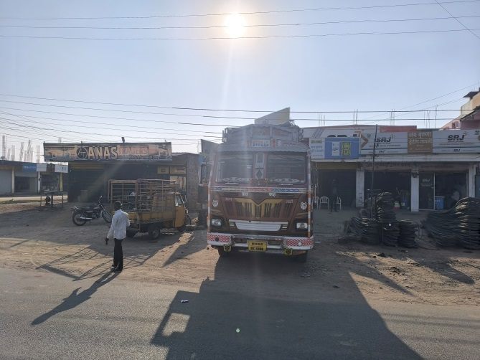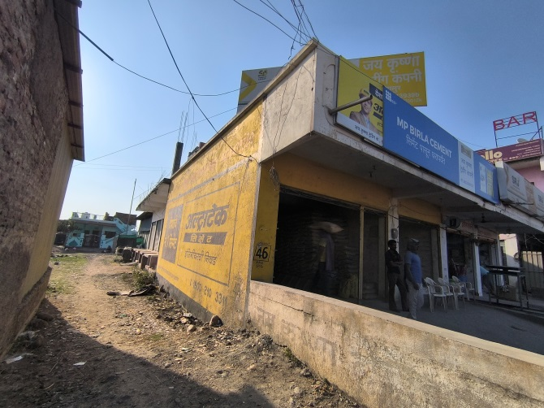

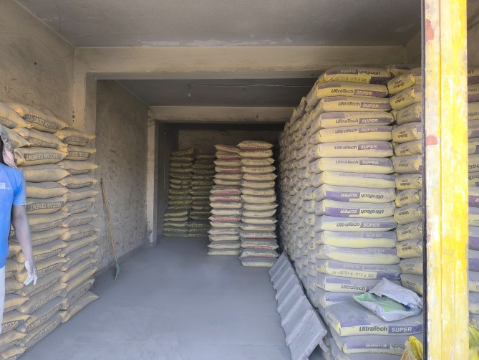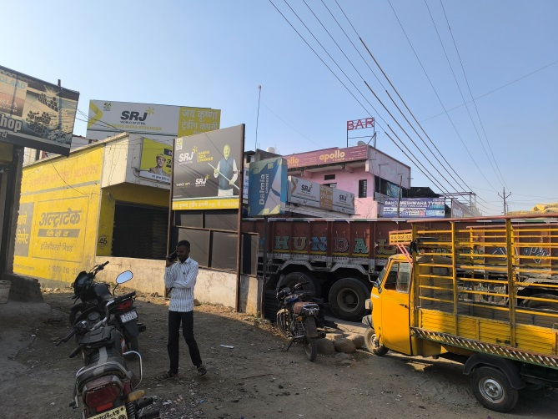

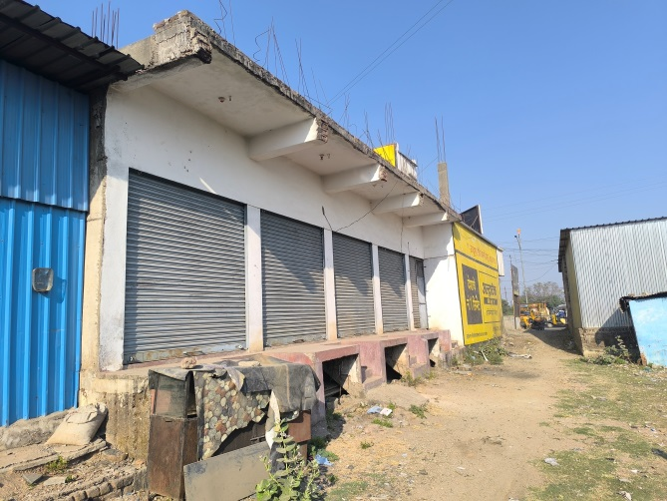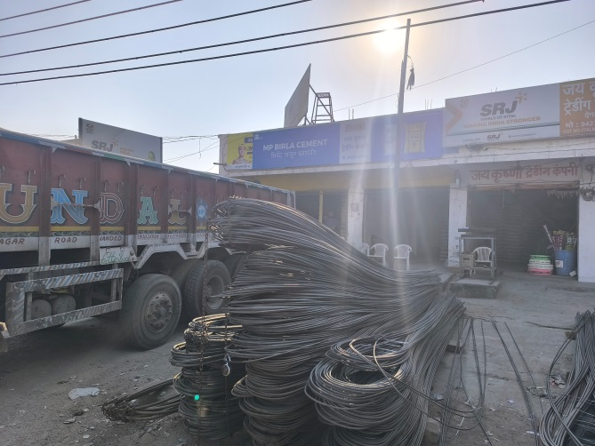

**Actual Construction Plan**

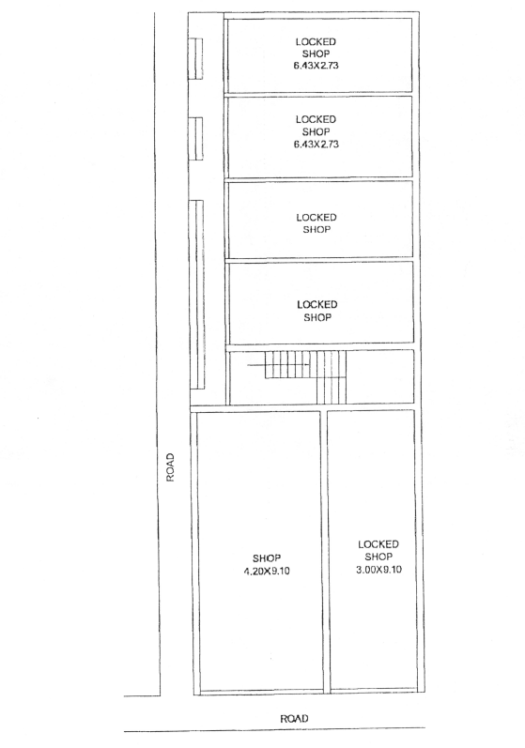

**Route Map of the property**

**Site u/r**

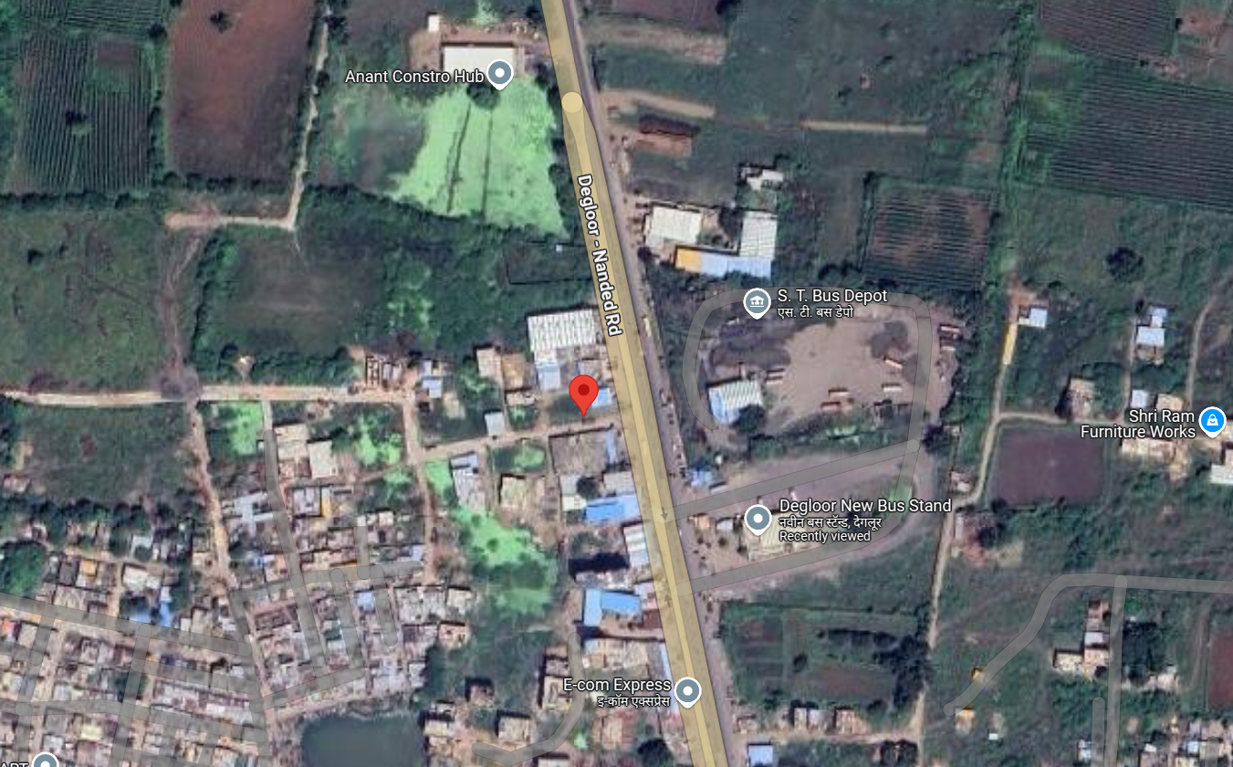

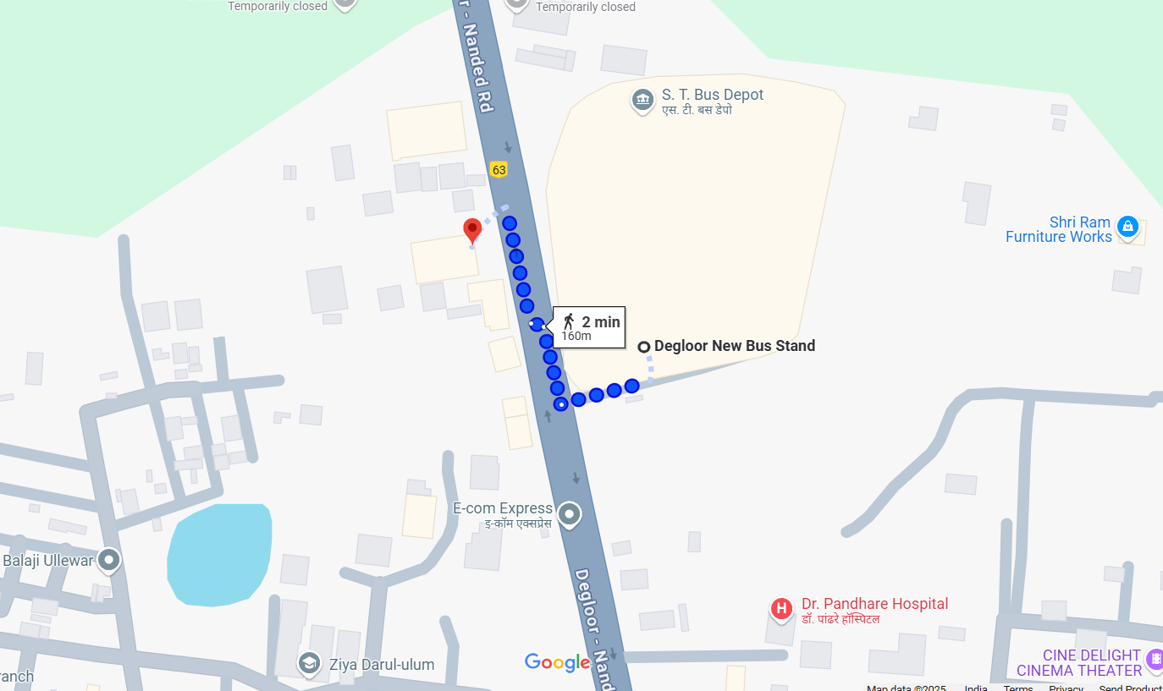

# **Latitude Longitude: 18.553112, 77.582756**

Note: The Blue line shows the route to site from nearest Bus Stop (Degloor - 160 Mts.)

**Ready Reckoner Rate**

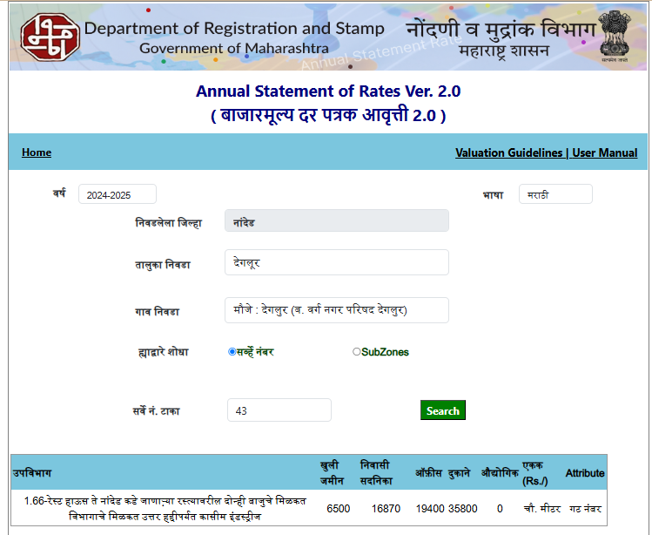

**ASSUMPTIONS, CAVEATS, LIMITATION AND DISCLAIMERS**

1. We assume no responsibility for matters of legal nature affecting the property appraised or the title thereto, nor do we render our opinion as to the title, which is assumed to be good and marketable.
2. The property is valued as though under responsible ownership.
3. It is assumed that the property is free of liens and encumbrances.
4. It is assumed that there are no hidden or unapparent conditions of the subsoil or structure that would render it more or less valuable. No responsibility is assumed for such conditions or for engineering that might be required to discover such factors.
5. The rates for valuation of the property are in accordance with the Govt. approved rates and prevailing market rates

For, **Vastukala Consultants (I) Pvt. Ltd.**

**Sharadkumar B. Chalikwar**

B.E. (Civil), M.E. (Civil), M.Sc. (Real Estate Valuation), M.Sc. (P&M Valuation), FIE (I), FIV, FIWRS

Chairman & Managing Director

Govt. Reg. Valuer

Chartered Engineer (India)

Reg. No. (N) CCIT/1-14/52/2008-09

IBBI Reg. No. IBBI/RV/07/2019/11744

Date: 10.03.2025

Place: Nanded.