Valuation Report of the Immovable Property

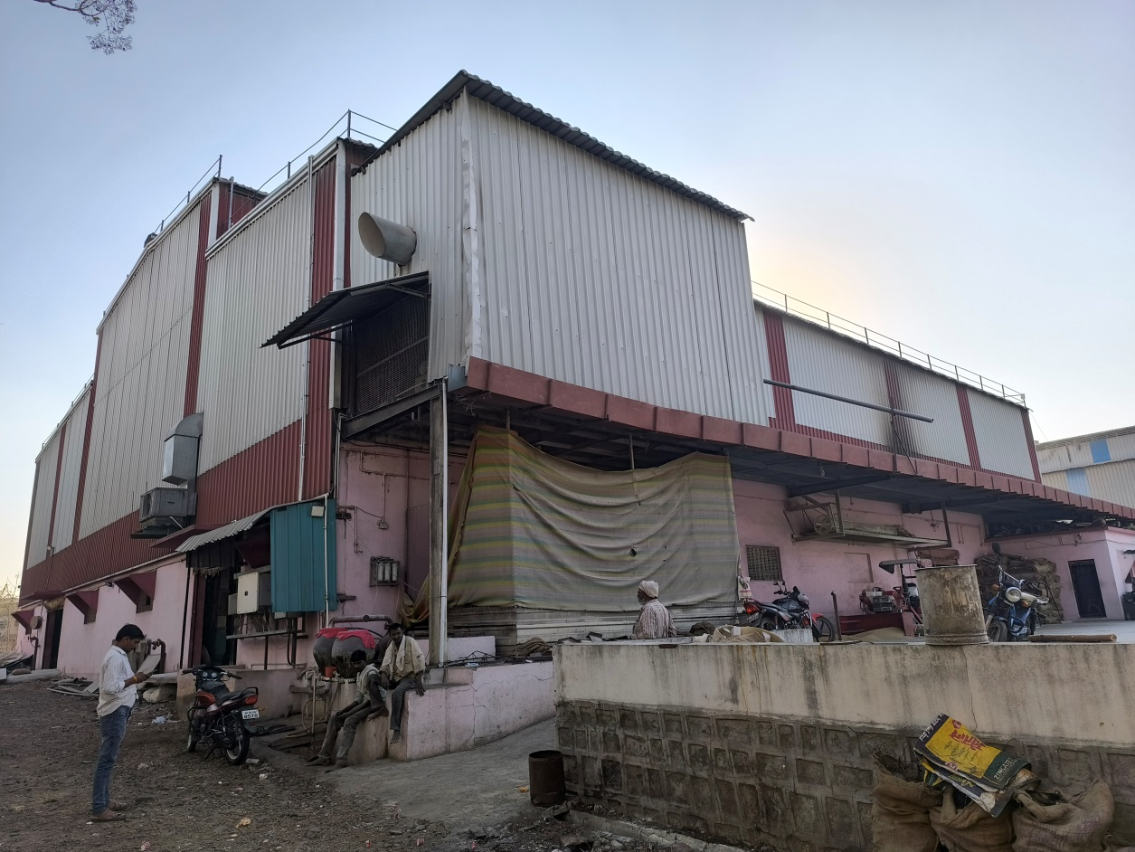

**Details of the property under consideration:**

**Name of Lessor: Maharashtra Industrial Development Corporation**

**Lessee: M/s. Aditya Dall Industries Proprietor**

**Shri. Anup Vijayrao Chalikwar**

**M/s, Aditya Dall Industries,** Plot No. C - 54/2, Khanapur Industrial Area,

M.l.D.C., within the limits of Village - Khanapur, Taluka - Degloor, District - Nanded

Maharashtra, India.

# **Longitude Latitude: 18.609028, 77.572469**

# **Valuation Done for:**

**Axis Bank**

**Nanded Branch**

.

Vastu/Axis Bank/Nanded/01/2025/13548/2310006

10/08-125-BH

Date: 14.02.2025

# **VALUER’S OPINION REPORT**

This is to certify that the property bearing **M/s, Aditya Dall Industries,** Plot No. C - 54/2, Khanapur Industrial Area,

M.l.D.C., Within the limits of Village, Khanapur, Taluka - Degloor, District – Nanded, Maharashtra, India belongs to **Lessor: Maharashtra Industrial Development Corporation, Lessee: M/s. Aditya Dall Industries Proprietor**

**Shri. Anup Vijayrao Chalikwar.**

|  |  |  |
| --- | --- | --- |
| Boundaries of the property. | | |
| North | : | 25.0 m wide M.I.D.C Road | |
| South | : | Plot No. C- 54/3 | |
| East | : | Plot No. C- 18 | |
| West | : | Plot No. C- 54/1 | |

Considering various parameters recorded, existing economic scenario, and the information that is available with reference to the development of neighborhood and method selected for valuation, we are of the opinion that, the property premises can be assessed are as under:

|  |  |
| --- | --- |
| **Guideline Value of the Property** | **Rs. 2,95,80,711.00** |
| **Fair Market Value of the Property** | **Rs. 3,50,52,711.00** |
| **Realizable Value of the Property** | **Rs. 3,15,47,439.00** |
| **Forced/ Distress Sale value of the Property.** | **Rs. 2,80,42,168.00** |

The valuation of the property is based on the documents produced by the concern. Legal aspects have not been taken into considerations while preparing this valuation report.

Hence certified

For, **Vastukala Consultants (I) Pvt. Ltd.**

**Sharadkumar B. Chalikwar**

B.E. (Civil), M.E. (Civil), M.Sc. (Real Estate Valuation), M.Sc. (P&M Valuation), FIE (I), FIV, FIWRS

Chairman & Managing Director

Govt. Reg. Valuer

Chartered Engineer (India)

Reg. No. (N) CCIT/1-14/52/2008-09

IBBI Reg.No. IBBI/RV/07/2019/11744

|  |  |  |  |  |  |  |  |  |  |  |  |  |  |  |  |  |  |  |  |  |  |  |  |  |  |  |  |  |  |  |  |  |  |  |  |  |  |  |  |  |  |  |  |  |  |  |  |  |  |  |  |  |  |  |  |  |  |  |  |  |  |  |  |  |  |  |  |  |  |  |  |  |  |  |  |  |  |  |  |  |  |  |  |  |  |  |  |  |  |  |  |  |  |  |  |  |  |  |  |  |  |  |  |  |  |  |  |  |  |  |  |  |  |  |  |  |  |  |  |  |  |  |  |  |  |  |  |  |  |  |  |  |  |  |  |  |  |  |  |  |  |  |  |  |  |  |  |  |  |  |  |  |  |  |  |  |  |  |  |  |  |  |  |  |  |  |  |  |  |  |  |  |  |  |  |  |  |  |  |  |  |  |  |  |  |  |  |  |  |  |  |  |  |  |  |  |  |  |  |  |  |  |  |  |  |  |  |  |  |  |  |  |  |  |  |  |  |  |  |  |  |  |  |  |  |  |  |  |  |  |  |  |  |  |  |  |  |  |  |  |  |  |  |  |  |  |  |  |  |  |  |  |  |  |  |  |  |  |  |  |  |  |  |  |  |  |  |  |  |  |  |  |  |  |  |  |  |  |  |  |  |  |  |  |  |  |  |  |  |  |  |  |  |  |  |  |  |  |  |  |  |  |  |  |  |  |  |  |  |  |  |  |  |  |  |  |  |  |  |  |  |  |  |  |  |  |  |  |  |  |  |  |  |  |  |  |  |  |  |  |  |  |  |  |  |  |  |  |  |  |  |  |  |  |  |  |  |  |  |  |  |  |  |  |  |  |  |  |  |  |  |  |  |  |  |  |  |  |  |  |  |  |  |  |  |  |  |  |  |  |  |  |  |  |  |  |  |  |  |  |  |  |  |  |  |  |  |  |  |  |  |  |  |  |  |  |  |  |  |  |  |  |  |  |  |  |  |  |  |  |  |  |  |  |  |  |  |  |  |  |  |  |  |  |  |  |  |  |  |  |  |  |  |  |  |  |  |  |  |  |  |  |  |  |  |  |  |  |  |  |  |  |  |  |  |  |  |  |  |  |  |  |  |  |  |  |  |  |  |  |  |  |  |  |  |  |  |  |  |  |  |  |  |  |  |  |  |  |  |  |  |  |  |  |  |  |  |  |  |  |  |  |  |  |  |  |  |  |  |  |  |  |  |  |  |  |  |  |  |  |  |  |  |  |  |  |  |  |  |  |  |  |  |  |  |  |  |  |  |  |  |  |  |  |  |  |  |  |  |  |  |  |  |  |  |  |  |  |  |  |  |  |  |  |  |  |  |  |  |  |  |  |  |  |  |  |  |  |  |  |  |  |  |  |  |  |  |  |  |  |  |  |  |  |  |  |  |  |  |  |  |  |  |  |  |  |  |  |  |  |  |  |  |  |  |  |  |  |  |  |  |  |  |  |  |  |  |  |  |  |  |  |  |  |  |  |  |  |  |  |  |  |  |  |  |  |  |  |  |  |  |  |  |  |  |  |  |  |  |  |  |  |  |  |  |  |  |  |  |  |  |  |  |  |  |  |  |  |  |  |  |  |  |  |  |  |  |  |  |  |  |  |  |  |  |  |  |  |  |  |  |  |  |  |  |  |  |  |  |  |  |  |  |  |  |  |  |  |  |  |  |  |  |  |  |  |  |  |  |  |  |  |  |  |  |  |  |  |  |  |  |  |  |  |  |  |  |  |  |  |  |  |  |  |  |  |  |  |  |  |  |  |  |  |  |  |  |  |  |  |  |  |  |  |  |  |  |  |  |  |  |  |  |  |  |  |  |  |  |  |  |  |  |  |  |  |  |  |  |  |  |  |  |  |  |  |  |  |  |  |  |  |  |  |  |  |  |  |  |  |  |  |  |  |  |  |  |  |  |  |  |  |  |  |  |  |  |  |  |  |  |  |  |  |  |  |  |  |  |  |  |  |  |  |  |  |  |  |  |  |  |  |  |  |  |  |  |  |  |  |  |  |  |  |  |  |  |  |  |  |  |  |  |  |  |  |  |  |  |  |  |  |  |  |  |  |  |  |  |  |  |  |  |  |  |  |  |  |  |  |  |  |  |  |  |  |  |  |  |  |  |  |  |  |  |  |  |  |  |  |  |  |  |  |  |  |  |  |  |  |  |  |  |  |  |  |  |  |  |  |  |  |  |  |  |  |  |  |  |  |  |  |  |  |  |  |  |  |  |  |  |  |  |  |  |  |  |  |  |  |  |  |  |  |  |  |  |  |  |  |  |  |  |  |  |  |  |  |  |  |  |  |  |  |  |  |  |  |  |  |  |  |  |  |  |  |  |  |  |  |  |  |  |  |  |  |  |  |  |  |  |  |  |  |  |  |  |  |  |  |  |  |  |  |  |  |  |  |  |  |  |  |  |  |  |  |  |  |  |  |  |  |  |  |  |  |  |  |  |  |  |  |  |  |  |  |  |  |  |  |  |  |  |  |  |  |  |  |  |  |  |  |  |  |  |  |  |  |  |  |  |  |  |  |  |  |  |  |  |  |  |  |  |  |  |  |  |  |  |  |  |  |  |  |  |  |  |  |  |  |  |  |  |  |  |  |  |  |  |  |  |  |  |  |  |  |  |  |  |  |  |  |  |  |  |  |  |  |  |  |  |  |  |  |  |  |  |  |  |  |  |  |  |  |  |  |  |  |  |  |  |  |  |  |  |  |  |  |  |  |  |  |  |  |  |  |  |  |  |  |  |  |  |  |  |  |  |  |  |  |  |  |  |  |  |  |  |  |  |  |  |  |  |  |  |  |  |  |  |  |  |  |  |  |  |  |  |  |  |  |  |  |  |  |  |  |  |  |  |  |  |  |  |  |  |  |  |  |  |  |  |  |  |  |  |  |  |  |  |  |  |  |  |  |  |  |  |  |  |  |  |  |  |  |  |  |  |  |  |  |  |  |  |  |  |  |  |  |  |  |  |  |  |  |  |  |  |  |  |  |  |  |  |  |  |  |  |  |  |  |  |  |  |  |  |  |  |  |  |  |  |  |  |  |  |  |  |  |  |  |  |  |  |  |  |  |  |  |  |  |  |  |  |  |  |  |  |  |  |  |  |  |  |  |  |  |  |  |  |  |  |  |  |  |  |  |  |  |  |  |  |  |  |  |  |  |  |  |  |  |  |  |  |  |  |  |  |  |  |  |  |  |  |  |  |  |  |  |  |  |  |  |  |  |  |  |  |  |  |  |  |  |  |  |  |  |  |  |  |  |  |  |  |  |  |  |  |  |  |  |  |  |  |  |  |  |  |  |  |  |  |  |  |  |  |  |  |  |  |  |  |  |  |  |  |  |  |  |  |  |  |  |  |  |  |  |  |  |  |  |  |  |  |  |  |  |  |  |  |  |  |  |  |  |  |  |  |  |  |  |  |  |  |  |  |  |  |  |  |  |  |  |  |  |  |  |  |  |  |  |  |  |  |  |  |  |  |  |  |  |  |  |  |  |  |  |  |  |  |  |  |  |  |  |  |  |  |  |  |  |  |  |  |  |  |  |  |  |  |  |  |  |  |  |  |  |  |  |  |  |  |  |  |  |  |  |  |  |  |  |  |  |  |  |  |  |  |  |  |  |  |  |  |  |  |  |  |  |  |  |  |  |  |  |  |  |  |  |  |  |  |  |  |  |  |  |  |  |  |  |  |  |  |  |  |  |  |  |  |  |  |  |  |  |  |  |  |  |
| --- | --- | --- | --- | --- | --- | --- | --- | --- | --- | --- | --- | --- | --- | --- | --- | --- | --- | --- | --- | --- | --- | --- | --- | --- | --- | --- | --- | --- | --- | --- | --- | --- | --- | --- | --- | --- | --- | --- | --- | --- | --- | --- | --- | --- | --- | --- | --- | --- | --- | --- | --- | --- | --- | --- | --- | --- | --- | --- | --- | --- | --- | --- | --- | --- | --- | --- | --- | --- | --- | --- | --- | --- | --- | --- | --- | --- | --- | --- | --- | --- | --- | --- | --- | --- | --- | --- | --- | --- | --- | --- | --- | --- | --- | --- | --- | --- | --- | --- | --- | --- | --- | --- | --- | --- | --- | --- | --- | --- | --- | --- | --- | --- | --- | --- | --- | --- | --- | --- | --- | --- | --- | --- | --- | --- | --- | --- | --- | --- | --- | --- | --- | --- | --- | --- | --- | --- | --- | --- | --- | --- | --- | --- | --- | --- | --- | --- | --- | --- | --- | --- | --- | --- | --- | --- | --- | --- | --- | --- | --- | --- | --- | --- | --- | --- | --- | --- | --- | --- | --- | --- | --- | --- | --- | --- | --- | --- | --- | --- | --- | --- | --- | --- | --- | --- | --- | --- | --- | --- | --- | --- | --- | --- | --- | --- | --- | --- | --- | --- | --- | --- | --- | --- | --- | --- | --- | --- | --- | --- | --- | --- | --- | --- | --- | --- | --- | --- | --- | --- | --- | --- | --- | --- | --- | --- | --- | --- | --- | --- | --- | --- | --- | --- | --- | --- | --- | --- | --- | --- | --- | --- | --- | --- | --- | --- | --- | --- | --- | --- | --- | --- | --- | --- | --- | --- | --- | --- | --- | --- | --- | --- | --- | --- | --- | --- | --- | --- | --- | --- | --- | --- | --- | --- | --- | --- | --- | --- | --- | --- | --- | --- | --- | --- | --- | --- | --- | --- | --- | --- | --- | --- | --- | --- | --- | --- | --- | --- | --- | --- | --- | --- | --- | --- | --- | --- | --- | --- | --- | --- | --- | --- | --- | --- | --- | --- | --- | --- | --- | --- | --- | --- | --- | --- | --- | --- | --- | --- | --- | --- | --- | --- | --- | --- | --- | --- | --- | --- | --- | --- | --- | --- | --- | --- | --- | --- | --- | --- | --- | --- | --- | --- | --- | --- | --- | --- | --- | --- | --- | --- | --- | --- | --- | --- | --- | --- | --- | --- | --- | --- | --- | --- | --- | --- | --- | --- | --- | --- | --- | --- | --- | --- | --- | --- | --- | --- | --- | --- | --- | --- | --- | --- | --- | --- | --- | --- | --- | --- | --- | --- | --- | --- | --- | --- | --- | --- | --- | --- | --- | --- | --- | --- | --- | --- | --- | --- | --- | --- | --- | --- | --- | --- | --- | --- | --- | --- | --- | --- | --- | --- | --- | --- | --- | --- | --- | --- | --- | --- | --- | --- | --- | --- | --- | --- | --- | --- | --- | --- | --- | --- | --- | --- | --- | --- | --- | --- | --- | --- | --- | --- | --- | --- | --- | --- | --- | --- | --- | --- | --- | --- | --- | --- | --- | --- | --- | --- | --- | --- | --- | --- | --- | --- | --- | --- | --- | --- | --- | --- | --- | --- | --- | --- | --- | --- | --- | --- | --- | --- | --- | --- | --- | --- | --- | --- | --- | --- | --- | --- | --- | --- | --- | --- | --- | --- | --- | --- | --- | --- | --- | --- | --- | --- | --- | --- | --- | --- | --- | --- | --- | --- | --- | --- | --- | --- | --- | --- | --- | --- | --- | --- | --- | --- | --- | --- | --- | --- | --- | --- | --- | --- | --- | --- | --- | --- | --- | --- | --- | --- | --- | --- | --- | --- | --- | --- | --- | --- | --- | --- | --- | --- | --- | --- | --- | --- | --- | --- | --- | --- | --- | --- | --- | --- | --- | --- | --- | --- | --- | --- | --- | --- | --- | --- | --- | --- | --- | --- | --- | --- | --- | --- | --- | --- | --- | --- | --- | --- | --- | --- | --- | --- | --- | --- | --- | --- | --- | --- | --- | --- | --- | --- | --- | --- | --- | --- | --- | --- | --- | --- | --- | --- | --- | --- | --- | --- | --- | --- | --- | --- | --- | --- | --- | --- | --- | --- | --- | --- | --- | --- | --- | --- | --- | --- | --- | --- | --- | --- | --- | --- | --- | --- | --- | --- | --- | --- | --- | --- | --- | --- | --- | --- | --- | --- | --- | --- | --- | --- | --- | --- | --- | --- | --- | --- | --- | --- | --- | --- | --- | --- | --- | --- | --- | --- | --- | --- | --- | --- | --- | --- | --- | --- | --- | --- | --- | --- | --- | --- | --- | --- | --- | --- | --- | --- | --- | --- | --- | --- | --- | --- | --- | --- | --- | --- | --- | --- | --- | --- | --- | --- | --- | --- | --- | --- | --- | --- | --- | --- | --- | --- | --- | --- | --- | --- | --- | --- | --- | --- | --- | --- | --- | --- | --- | --- | --- | --- | --- | --- | --- | --- | --- | --- | --- | --- | --- | --- | --- | --- | --- | --- | --- | --- | --- | --- | --- | --- | --- | --- | --- | --- | --- | --- | --- | --- | --- | --- | --- | --- | --- | --- | --- | --- | --- | --- | --- | --- | --- | --- | --- | --- | --- | --- | --- | --- | --- | --- | --- | --- | --- | --- | --- | --- | --- | --- | --- | --- | --- | --- | --- | --- | --- | --- | --- | --- | --- | --- | --- | --- | --- | --- | --- | --- | --- | --- | --- | --- | --- | --- | --- | --- | --- | --- | --- | --- | --- | --- | --- | --- | --- | --- | --- | --- | --- | --- | --- | --- | --- | --- | --- | --- | --- | --- | --- | --- | --- | --- | --- | --- | --- | --- | --- | --- | --- | --- | --- | --- | --- | --- | --- | --- | --- | --- | --- | --- | --- | --- | --- | --- | --- | --- | --- | --- | --- | --- | --- | --- | --- | --- | --- | --- | --- | --- | --- | --- | --- | --- | --- | --- | --- | --- | --- | --- | --- | --- | --- | --- | --- | --- | --- | --- | --- | --- | --- | --- | --- | --- | --- | --- | --- | --- | --- | --- | --- | --- | --- | --- | --- | --- | --- | --- | --- | --- | --- | --- | --- | --- | --- | --- | --- | --- | --- | --- | --- | --- | --- | --- | --- | --- | --- | --- | --- | --- | --- | --- | --- | --- | --- | --- | --- | --- | --- | --- | --- | --- | --- | --- | --- | --- | --- | --- | --- | --- | --- | --- | --- | --- | --- | --- | --- | --- | --- | --- | --- | --- | --- | --- | --- | --- | --- | --- | --- | --- | --- | --- | --- | --- | --- | --- | --- | --- | --- | --- | --- | --- | --- | --- | --- | --- | --- | --- | --- | --- | --- | --- | --- | --- | --- | --- | --- | --- | --- | --- | --- | --- | --- | --- | --- | --- | --- | --- | --- | --- | --- | --- | --- | --- | --- | --- | --- | --- | --- | --- | --- | --- | --- | --- | --- | --- | --- | --- | --- | --- | --- | --- | --- | --- | --- | --- | --- | --- | --- | --- | --- | --- | --- | --- | --- | --- | --- | --- | --- | --- | --- | --- | --- | --- | --- | --- | --- | --- | --- | --- | --- | --- | --- | --- | --- | --- | --- | --- | --- | --- | --- | --- | --- | --- | --- | --- | --- | --- | --- | --- | --- | --- | --- | --- | --- | --- | --- | --- | --- | --- | --- | --- | --- | --- | --- | --- | --- | --- | --- | --- | --- | --- | --- | --- | --- | --- | --- | --- | --- | --- | --- | --- | --- | --- | --- | --- | --- | --- | --- | --- | --- | --- | --- | --- | --- | --- | --- | --- | --- | --- | --- | --- | --- | --- | --- | --- | --- | --- | --- | --- | --- | --- | --- | --- | --- | --- | --- | --- | --- | --- | --- | --- | --- | --- | --- | --- | --- | --- | --- | --- | --- | --- | --- | --- | --- | --- | --- | --- | --- | --- | --- | --- | --- | --- | --- | --- | --- | --- | --- | --- | --- | --- | --- | --- | --- | --- | --- | --- | --- | --- | --- | --- | --- | --- | --- | --- | --- | --- | --- | --- | --- | --- | --- | --- | --- | --- | --- | --- | --- | --- | --- | --- | --- | --- | --- | --- | --- | --- | --- | --- | --- | --- | --- | --- | --- | --- | --- | --- | --- | --- | --- | --- | --- | --- | --- | --- | --- | --- | --- | --- | --- | --- | --- | --- | --- | --- | --- | --- | --- | --- | --- | --- | --- | --- | --- | --- | --- | --- | --- | --- | --- | --- | --- | --- | --- | --- | --- | --- | --- | --- | --- | --- | --- | --- | --- | --- | --- | --- | --- | --- | --- | --- | --- | --- | --- | --- | --- | --- | --- | --- | --- | --- | --- | --- | --- | --- | --- | --- | --- | --- | --- | --- | --- | --- | --- | --- | --- | --- | --- | --- | --- | --- | --- | --- | --- | --- | --- | --- | --- | --- | --- | --- | --- | --- | --- | --- | --- | --- | --- | --- | --- | --- | --- | --- | --- | --- | --- | --- | --- | --- | --- | --- | --- | --- | --- | --- | --- | --- | --- | --- | --- | --- | --- | --- | --- | --- | --- | --- | --- | --- | --- | --- | --- | --- | --- | --- | --- | --- | --- | --- | --- | --- | --- | --- | --- | --- | --- | --- | --- | --- | --- | --- | --- | --- | --- | --- | --- | --- | --- | --- | --- | --- | --- | --- | --- | --- | --- | --- | --- | --- | --- | --- | --- | --- | --- | --- | --- | --- | --- | --- | --- | --- | --- | --- | --- | --- | --- | --- | --- | --- | --- | --- | --- | --- | --- | --- | --- | --- | --- | --- | --- | --- | --- | --- | --- | --- | --- | --- | --- | --- | --- | --- | --- | --- | --- | --- | --- | --- | --- | --- | --- | --- | --- | --- | --- | --- | --- | --- | --- | --- | --- | --- | --- | --- | --- | --- | --- | --- | --- | --- | --- | --- | --- | --- | --- | --- | --- | --- | --- | --- | --- | --- | --- | --- | --- | --- | --- | --- | --- | --- | --- | --- | --- | --- | --- | --- | --- | --- | --- | --- | --- | --- | --- | --- | --- | --- | --- | --- | --- | --- | --- | --- | --- | --- | --- | --- | --- | --- | --- | --- | --- | --- | --- | --- | --- | --- | --- | --- | --- | --- | --- | --- | --- | --- | --- | --- | --- | --- | --- | --- | --- | --- | --- | --- | --- | --- | --- | --- | --- | --- | --- | --- | --- | --- | --- | --- | --- | --- | --- | --- | --- | --- | --- | --- | --- | --- | --- | --- | --- | --- | --- | --- | --- | --- | --- | --- | --- | --- | --- | --- | --- | --- | --- | --- | --- | --- | --- | --- | --- | --- | --- | --- | --- | --- | --- | --- | --- | --- | --- | --- | --- | --- | --- | --- | --- | --- | --- | --- | --- | --- | --- | --- | --- | --- | --- | --- | --- | --- | --- | --- | --- | --- | --- | --- | --- | --- | --- | --- | --- | --- |
| **VALUATION REPORT (IN RESPECT OF LAND AND BUILDING)**   |  |  |  |  |  |  |  |  |  |  |  |  |  |  |  | | --- | --- | --- | --- | --- | --- | --- | --- | --- | --- | --- | --- | --- | --- | --- | | 1. | CBB/CCMC/CCSU | |  | | | |  | | | - | | | | | | - | | | - | | | | | | 2. | Name of Owner & Address: | | | | | | **Lessee: M/s. Aditya Dall Industries Proprietor**  **Shri. Anup Vijayrao Chalikwar.**  **R/o** Taluka - Degloor, District – Nanded, Maharashtra, India  **Cell No. 9420667077 / 7507708888** | | | | | | | | | Name of Borrower & Address | | | | | | **Lessee: M/s. Aditya Dall Industries Proprietor**  **Shri. Anup Vijayrao Chalikwar.**  **R/o** Taluka - Degloor, District – Nanded, Maharashtra, India  **Cell No. 9420667077 / 7507708888** | | | | | | | | | 3. | Name of the Bank Official Present | | | | | | No. | | | | | | | | | Name of the Representative & Mobile No. | | | | | | No. | | | | | | | | | **4.** | **Details of the Property Being Valued** | | | | | | | | | | | | | | | 4.1 | Description of the Property | | | | | | The Subject Property is Leasehold RCC Structure with G.l. Sheet roofing industrial Building.  The unit under Maintenance and used for Dall Mill,  **Lessor: Maharashtra Industrial Development Corporation**  **Lessee: M/s. Aditya Dall Industries Proprietor**  **Shri. Anup Vijayrao Chalikwar.**  Lease Period: Leased for 95 years from the date of commencement of Lease : 01.04,2012  Rent: Rs, 1/- Per Annum | | | | | | | | | 4.2 | Location of Property | | | | | | Plot No. C - 54/2, Khanapur Industrial Area, M.l.D.C., Within the limits of Village, Khanapur, Taluka - Degloor, District – Nanded, Maharashtra, India. | | | | | | | | | (Rural / Semi Urban / Urban) | | | | | | Rural | | | | | | | | | 4.3 | Documents Provided: | | | | | | | | | | | | | | | 1 | Photo Copy of Agreement to Lease vide No. 1609/2012 dated 30.05.2012, executed between MIDC  Lessee: M/s. Aditya Dall Industries Proprietor, Shri. Anup Vijayrao Chalikwar., Sub Register, Degloor. | | | | | | | | | | | | | | 2 | Photo Copy of M.I.D.C Allotment of land Order No. MIDC / RO (NED) / DGR / LMS – 115 / 650 dated 12.04.2012 from M.I.D.C to M/s. Aditya Dall Industries Proprietor, Shri. Anup Vijayrao Chalikwar., Sub Register, Degloor. | | | | | | | | | | | | | | 3 | Photo Copy of M.I.D.C Possession Receipt 30.04.2012 between M.I.D.C to M/s. Aditya Dall Industries Proprietor, Shri. Anup Vijayrao Chalikwar., Sub Register, Degloor. | | | | | | | | | | | | | |  | 4 | Photo Copy of Lease Deed No. 650 / 2015 dated 27.03.2015 executed between M.I.D.C to M/s. Aditya Dall Industries Proprietor, Shri. Anup Vijayrao Chalikwar., Sub Register, Degloor. | | | | | | | | | | | | | |  | 5 | Photo copy of Occupancy Certificate with Annexure - A, vide No. MIDC / EEN / DB / A 09153, dated  07.01.2019, Special Planning Authority & Executive Engineer, M.I.D.C, Division Nanded. | | | | | | | | | | | | | |  | 6 | Photo copy of Industrial Building Approved Plan vide permit No. B 76928, dated 07.01.2016, Special Planning Authority & Executive Engineer, M.I.D.C, Division Nanded. | | | | | | | | | | | | | | 4.4 | Plot No / Survey No. / Gut No./ Khasra No: | | Plot No. C - 54/2 | | | Road | | | | M.I.D.C Road | | | | | | 4.5 | Colony / Nagar / Sector | | M.I.D.C Khanapur | | | Locality / Landmark | | | | M.I.D.C Khanapur | | | | | | 4.6 | Village/Town/City | | Khanapur, Taluka - Degloor | | | District: | | | | Nanded | | | | | | 4.7 | State | | Maharashtra | | | Pin code: | | | | 431 512 | | | | | | 4.8 | Distance from Area Office | | | | | Within @ 8.8 Km | | | | | | | | | | **5.** | **Type of Property** | | | | | | | | | | | | | | |  | **(A) Plot:** (Residential / Commercial / Industrial) | | | | | | | | Industrial | | | | | | | Level of land with topographical conditions | | | | | | | | Leveled | | | | | | | Whether situated in Municipal / Corporation Limit | | | | | | | | Municipal | | | | | | | Any construction observed on plot | | | | | | | | Yes, RCC Framed with G.I Sheet Roofing Industrial Building | | | | | | | **(B) Residential Property: (**Independent house / Bungalow / Row House / Flat) | | | | | | | | N.A | | | | | | | Civic Amenities like school, hospital, market, etc. (Available, within the radius of Km./ Not Available) | | | | | | | | All available near by | | | | | | | **(C) Commercial / Industrial Property:** (Office / Shop / Unit in a Mall / Gowdown) | | | | | | | | Dall Mill | | | | | | | **6.0** | **Accessibility / Boundaries / Others** | | | | | | | | | | | | | | | 6.1 | Availability of local transport (Metro / Local Train / Bus / Personal Transport) | | | | | | | Local Transport, Bus, Railway Station, Industrial Building | | | | | | | | 6.2 | Distance from Nanded Railway station @ 29.3 Km | | | | | | | N.A | | | | | | | | 6.3 | Does the approach road to the Property / Building is independent and accessible | | | | Yes. | | | Will it be able to accommodate a fire extinguisher | | | | | | No | | 6.4 | Does the property fall under land locked area | | | | No. | | | Does the property fall in a community dominated area | | | | | | No | | 6.5 | Cornered / Intermittent Plot | | | | | | | Intermittent Plot. | | | | | | | |  | **Boundaries** | | | | | | | **As Per Site** | | | | | | | |  | **North** | | | | | | | 25.0 M Wide M.I.D.C Road | | | | | | | | **South** | | | | | | | Plot No. C-54/3 | | | | | | | | **East** | | | | | | | Plot No. C-18 | | | | | | | | **West** | | | | | | | Plot No. C-54/1 | | | | | | | | 6.7 | Class of locality (Posh / Higher Middle Class / Middle Class / Lower Middle Class / Poor) | | | | | | | Middle Class | | | | | | | | 6.8 | Quality of Infrastructure in the vicinity (Excellent / Good / Average / Poor) | | | | | | | Average | | | | | | | | 6.9 | Ownership Status of the Property (Free Hold / Reg. Lease / Govt. Authority) | | | | | | | Leasehold | | | | | | | | 6.10 | Approved usage of property (Industrial / Commercial / Residential / Mix) | | | Industrial | | | | Actual usage of property (Industrial / Commercial / Residential / Mix) | | | | Industrial | | | | 6.11 | Restrictive covenants in regards to Land Use, (if any) | | | | | | | Industrial | | | | | | | | 6.12 | Type of Structure (Load Bearing / RCC / Alu form shuttering) | | | | | | | Yes, RCC Framed with G.I Sheet Roofing Industrial Building | | | | | | | | 6.13 | Number of floors | | As per Actual | | | | | Ground Floor | | | | | | | | As per Sanctioned Plan | | | | | Ground Floor | | | | | | | | 6.14 | Occupancy Details (Self-Occupied / Rented / Vacant) | | | | | | | Owner Occupied. | | | | | | | | **7.** | **If the property is on rent** | | | | | | | | | | | | | | | 7.1 | Name of tenant / lease & Number of years in tenancy | | | | | | | No. | | | | | | | | 7.2 | Was there any resistance for valuation | | | No. | | | | If yes, from the current occupants | | | | | N.A. | | | 7.3 | Does property have basic amenities | | | Yes. | | | | Development of surrounding area Underdeveloped / Developing / Developed | | | | | Under developed | | | **8.** | **If the property is Leasehold** | | | | | | | | | | | | | | | 8.1 | Name of Lesser | | N.A. | Nature of Lease: | | | | | | | | | N.A. | | | 8.2 | Total Period of Lease | | N.A. | If yes, from the current occupants | | | | | | | | | N.A. | | | 8.3 | Does property have basic amenities | | No. | Development of surrounding area Underdeveloped / Developing / Developed | | | | | | | | | Underdeveloped | | | **9.** | **Approval Details** | | | | | | | | | | | | | | | 9.1 | RERA Registration Number | | | | | | Not Applicable | | | | | | | | | 9.2 | Layout Approval Number: | | | | | | M.I.D.C / EEN / DB / A 09153, dated  07.01.2019, Special Planning Authority & Executive Engineer, M.I.D.C, Division Nanded. | | | | | | | | | Date of Approval | | | | | | Not Available. | | | | | | | | | Expiry Date | | | | | | Not Available. | | | | | | | | | 9.3 | Building Plan Approval Number: | | | | | | B 76928 | | | | | | | | | Date of Approval | | | | | | 10.06.2016 | | | | | | | | | Expiry Date | | | | | | - | | | | | | | | | 9.4 | Occupancy Certificate | | | | | | Special Planning Authority & Executive Engineer  M.l.D.C, Nanded Division | | | | | | | | | **10.00** | **Plot Area Details.** | | | | | | | | | | | | | | | **10.01** | **Plot Area** | | | | | | | | | **Area in Sq. M.** | | | | | | 10.02 | Plot Area As per Sale Deed **(A) –** | | | | | | | | | 4000.00 | | | | | | 10.03 | Plot Area as per sanctioned Plan **(B)** | | | | | | | | | 4000.00 | | | | | | 10.04 | **Construction** | | | | | | | | |  | | | | | | 10.05 | As per Approved Plan | | | | | | | | | **1897.77** | | | | | | 10.06 | As per Occupancy Certificate | | | | | | | | | **1897.77** | | | | | | 10.07 | Demarcation of site | | | | | | | | | **50.00 M x 80.00 m** | | | | | | **10.06** | **Floor wise break up as follows** | | | | | | **Current Usage** | | | | | | | | |  | **Floor** | | **Built up area** | | | | **(Storage / Parking / Commercial / Residential)** | | | | | | | | | As per Approved Plan | | 1897.77 | | | | Industrial | | | | | | | | | As per Occupancy Certificate | | 1897.77 | | | | Industrial | | | | | | | | | 10.07 | Amenities Details (if any): | | | | | | Drying Platform,Sortex Platform, Compound Wall,  M.S. Gate, External Development etc, | | | | | | | | | 10.08 | Floor Space Index permissible | | | | | | 0.50 | | | | | | | | | 10.09 | FSI Utilized | | | | | | 0.474 | | | | | | | | | 10.10 | Whether the construction is as per approved building plan and / or local building bye laws: | | | | | | Yes | | | | | | | | | 10.11 | Details of Extra Construction | | | | | | No | | | | | | | | | 10.12 | Percentage of Extra Construction | | | | | | N.A | | | | | | | | | 10.13 | Whether the extra construction is Compoundable OR Non-Compoundable? | | | | | | Compoundable | | | | | | | | | 10.14 | Quality of construction | | | | | | Good. | | | | | | | | | 10.15 | Maintenance of the Property | | | | | | Periodical Maintenance is required | | | | | | | | | 10.16 | Condition of Building | | | | | | Good. | | | | | | | | | 10.17 | Current Life of the structure | | 9 Years | | | | Projected Future Life of the Structure | | | 41 Years. | | | | | | 10.18 | Land Revenue / Taxes Paid upto (for Land) | | Details not available | | | | Municipal Taxes Paid up to (for Building) | | | Details not available | | | | | | **11.** | **Details of Valuation:** | | | | | | | | | | | | | | | |  |  |  |  |  |  |  |  |  |  | | --- | --- | --- | --- | --- | --- | --- | --- | --- | --- | | **Floor** | **Constructed Area** | **Year Of Const.** | **Age of the building** | **Total Life of Structure** | **Estimated Replacement Rate** | **Balance Life of Structures in Years** | **Replacement Cost** | **Depreciated Value to be considered** | **Replacement Cost** | |  | **(Sq. M)** |  | **(Years)** |  |  |  |  | **(16.20)** | **(`)** | | Industrial Building | 1894.77 | 2016 | 9 | 50 | 18,000.00 | 41 | 3,41,05,860.00 | 55,25,149.00 | 2,85,80,711.00 | |  |  |  |  |  |  |  |  | TOTAL | **2,85,80,711.00** | | | | | | | | | | | | | | | | | **12.** | **Government Guideline value** | | | | | | | | | | | | | | |  | **Particulars** | | | **Area in Sq. M.** | | | **Rate in Rs.** | | | | **Value in Rs.** | | | | | 1 | Land | | | 4000.00 | | | 250.00 | | | | 10,00,000.00 | | | | | 2 | Construction | | | As per valuation table | | | | | | | **2,95,80,711.00** | | | | |  | **TOTAL** | | | | | | | | | | **2,95,80,711.00** | | | | | 13. | **Market Value of Land** | | | | | | | | | | | | | | |  | **Particulars** | | | **Area in Sq. M.** | | | **Rate in Rs.** | | | | **Value in Rs.** | | | | | **Land** | | | 4000.00 | | | 1,368.00 | | | | 54,72,000.00 | | | | | 14. | **Value of the Property** | | | | | | | | | | | | | | |  |  | | | **Land** | | | **Building** | | | **Amenities** | **Total** | | | | | Market Value | | | 2,95,80,711.00 | | | 54,72,000.00 | | | - | **3,50,52,711.00** | | | | | Total Market Value | | | | | | | | | | **3,50,52,711.00** | | | | | Realizable Value | | | | | | | | | | **3,15,47,439.00** | | | | | Distressed/Forced Sale Value | | | | | | | | | | **2,80,42,168.00** | | | | | Insurable Value | | | | | | | | | | **2,36,64,568.00** | | | |  | |  | **Remark:** | | | | | | | | | | | | | |  |   **Undertaking:**   1. I have / our / representative Md. Shareq has inspected the subject property on 23.02.2025 along with Mr. Vishwanath P. Nagnath Dake identified the same based on the documents provided. 2. I/We have no direct or Indirect interest in the property being valued. 3. The information furnished above is true and correct to my/our knowledge 4. I/ we have not been dismissed or removed from govt. Service or convicted of an offence connected with any proceedings of income tax act, wealth tax act or gift tax act or have been blacklisted by any bank/ financial institution/ govt. Department/ public sector enterprise/ body corporate etc. 5. This valuation is prepared without any prejudice or bias to any person or institution. 6. The value of land is taken into account by making due enquires in the locality and ascertaining the sales value of the properties in the locality. 7. Any additions/alterations made to the property after the date of valuations shall not fall under the scope of this report.   For, **Vastukala Consultants (I) Pvt. Ltd.**  **Sharadkumar B. Chalikwar**  B.E. (Civil), M.E. (Civil), M.Sc. (Real Estate Valuation), M.Sc. (P&M Valuation), FIE (I), FIV, FIWRS  Chairman & Managing Director  Govt. Reg. Valuer  Chartered Engineer (India)  Reg. No. (N) CCIT/1-14/52/2008-09  IBBI Reg.No. IBBI/RV/07/2019/11744  Date: 10.03.2025   |  |  |  | | --- | --- | --- | | **Attachments** | | | | Photographs of the Property from inside & outside | : | Attached | | Location sketch for the property: | : | Attached | | Geo Tagging | : | Attached | | Topography | : | Leveled Land | | Government Value Document | : | Attached | |

**Actual Site Photographs**

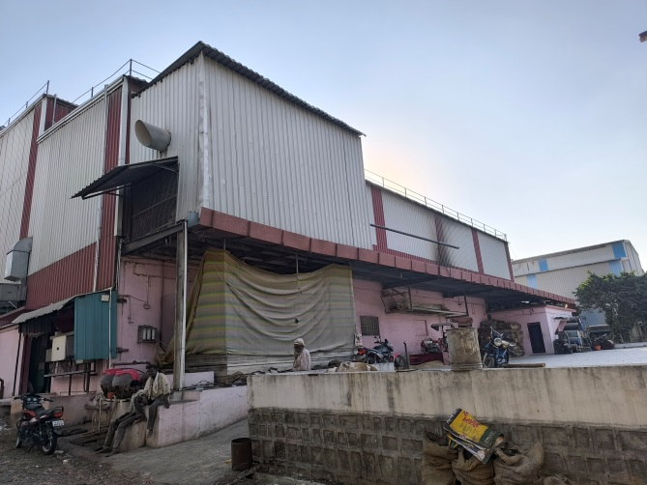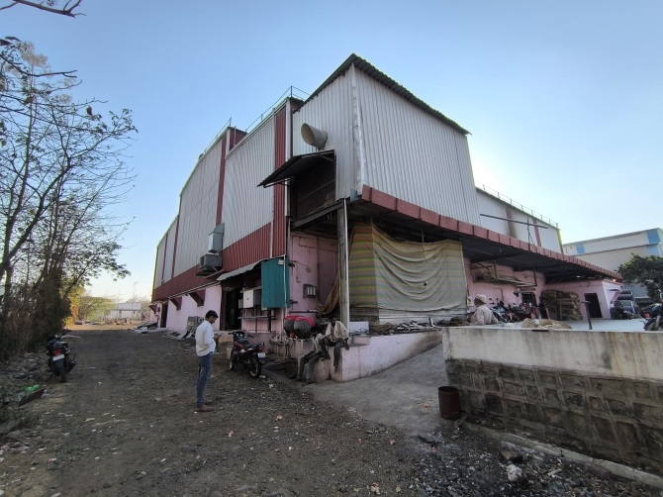

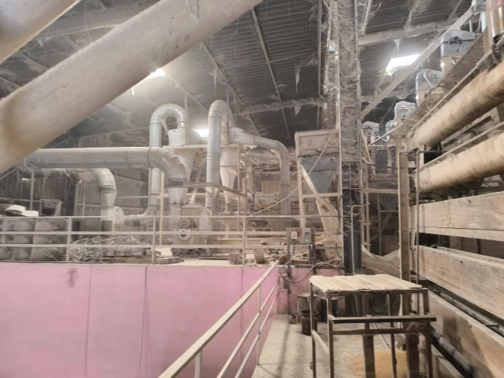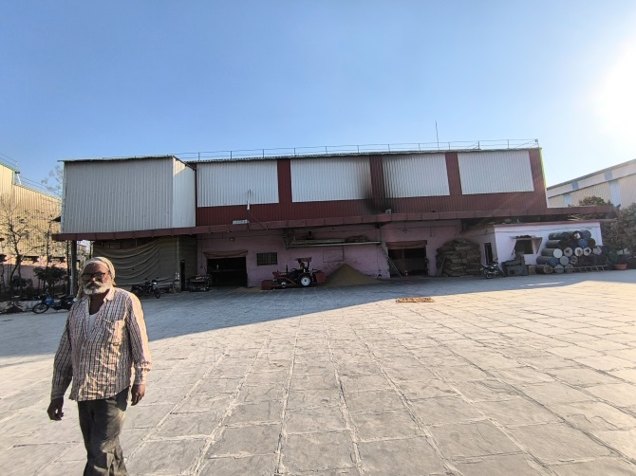

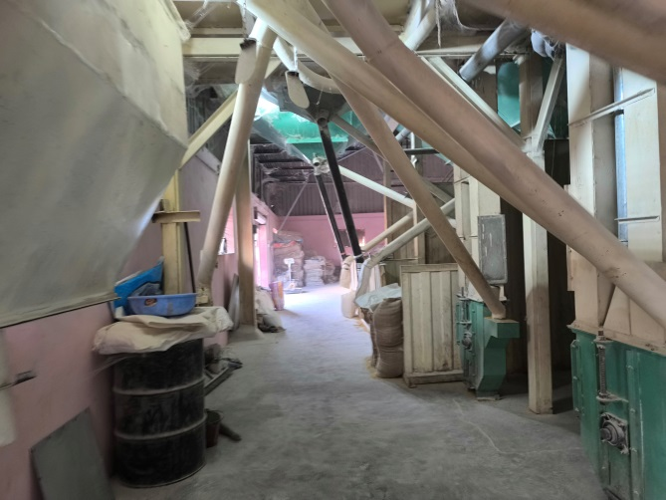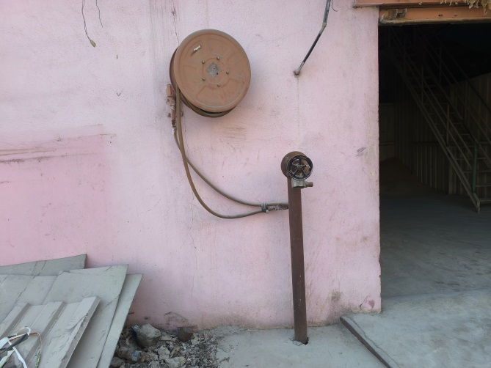

**Actual Site Photographs**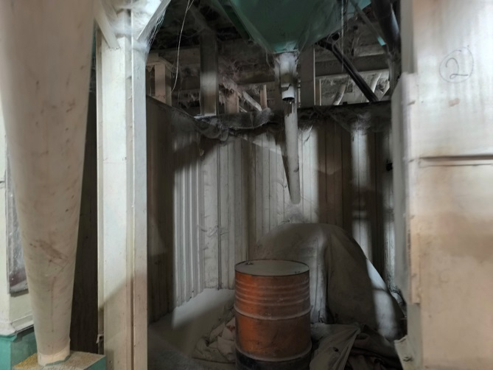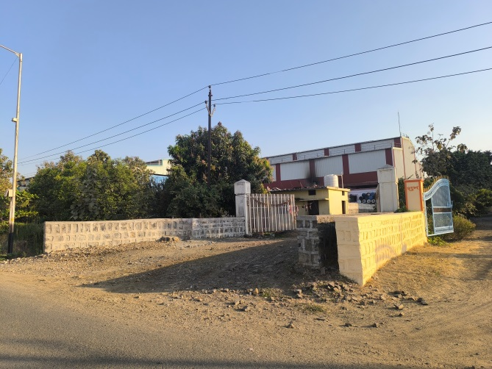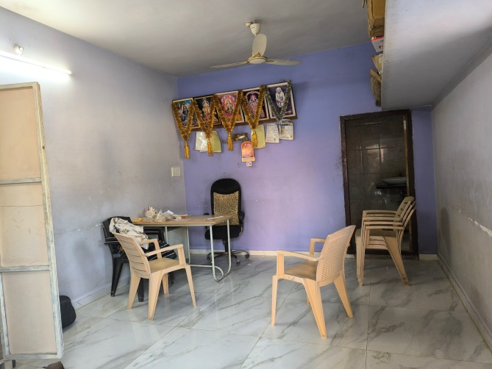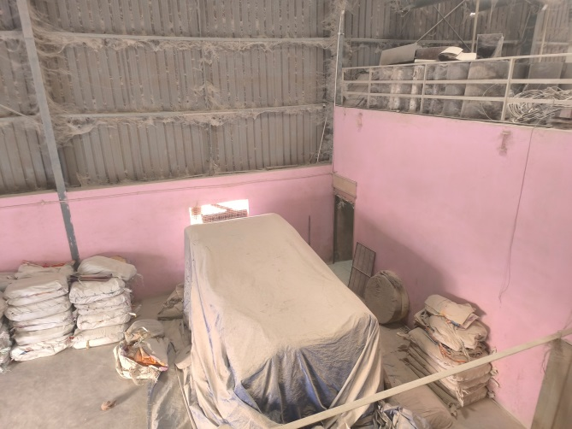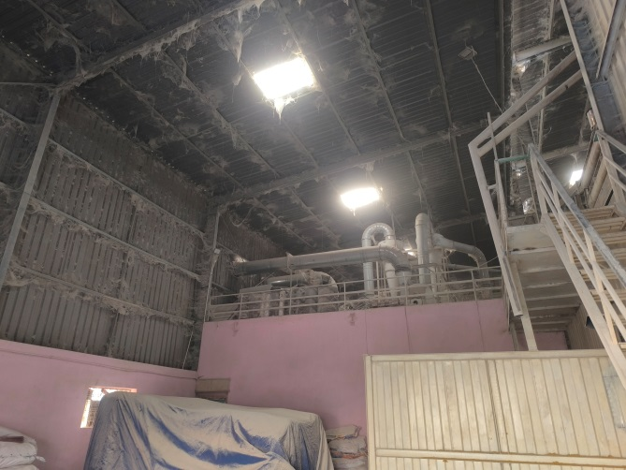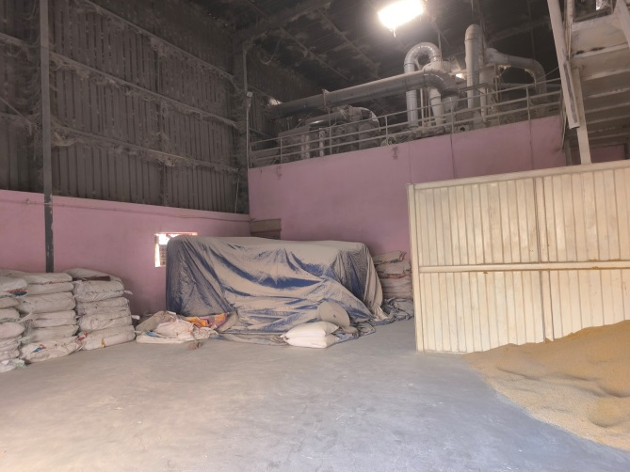

**Route Map of the property**

**Site u/r**

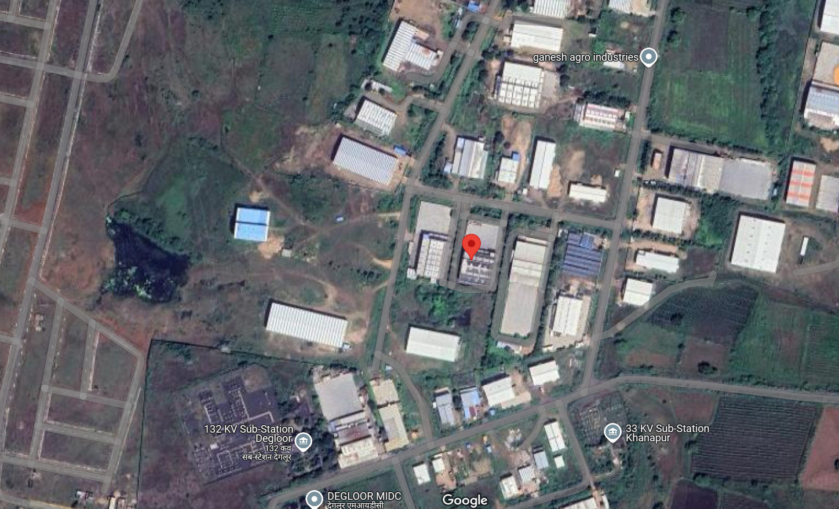

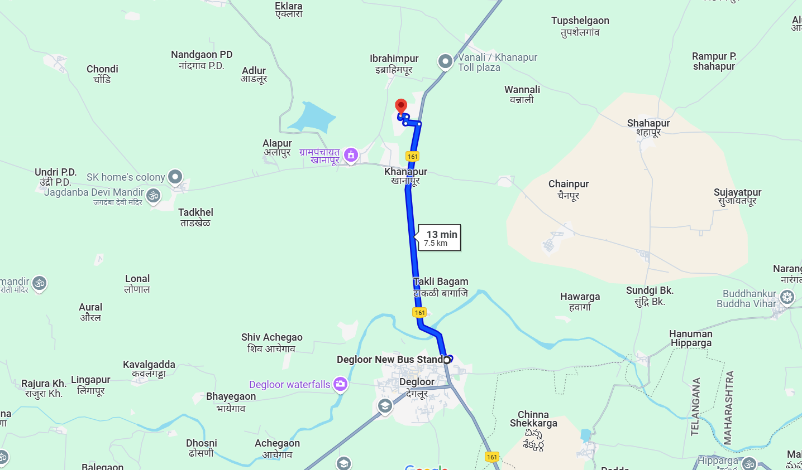

**Latitude Longitude: 18.609028, 77.572469**

Note: The Blue line shows the route to site from nearest Bus Stop (Degloor – 7.5 KM.)

**MIDC CIRCLE RATE**

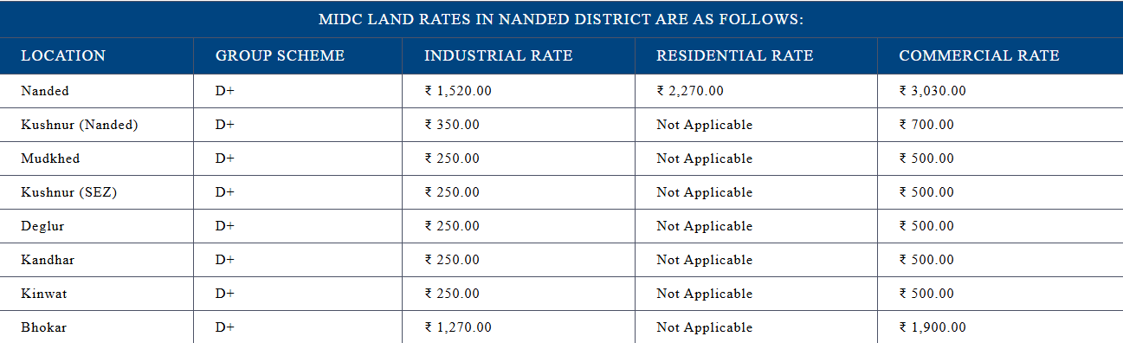

**READY RECKONER RATE**

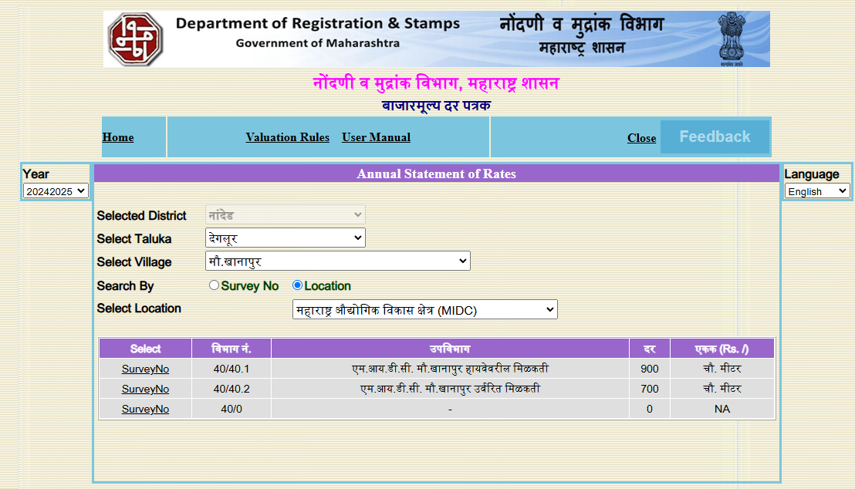

**ASSUMPTIONS, CAVEATS, LIMITATION AND DISCLAIMERS**

1. We assume no responsibility for matters of legal nature affecting the property appraised or the title thereto, nor do we render our opinion as to the title, which is assumed to be good and marketable.
2. The property is valued as though under responsible ownership.
3. It is assumed that the property is free of liens and encumbrances.
4. It is assumed that there are no hidden or unapparent conditions of the subsoil or structure that would render it more or less valuable. No responsibility is assumed for such conditions or for engineering that might be required to discover such factors.
5. The rates for valuation of the property are in accordance with the Govt. approved rates and prevailing market rates

For, **Vastukala Consultants (I) Pvt. Ltd.**

**Sharadkumar B. Chalikwar**

B.E. (Civil), M.E. (Civil), M.Sc. (Real Estate Valuation), M.Sc. (P&M Valuation), FIE (I), FIV, FIWRS

Chairman & Managing Director

Govt. Reg. Valuer

Chartered Engineer (India)

Reg. No. (N) CCIT/1-14/52/2008-09

IBBI Reg.No. IBBI/RV/07/2019/11744

Date: 10.03.2025

Place: Nanded.