3rd LENDER’S INDEPENDENT ENGINEER REPORT
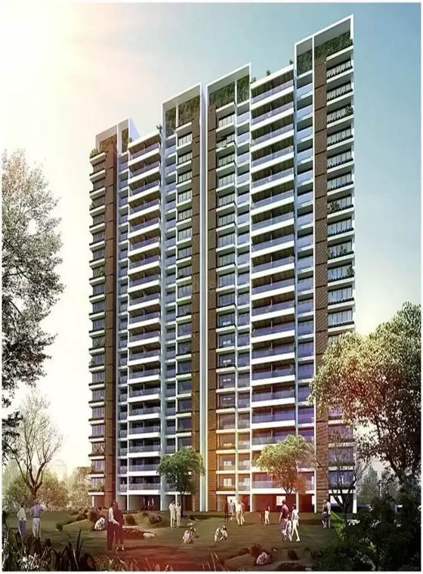

Details of the property under consideration:

Name of Project: “One Meraki Wing C”

"One Meraki Wing C" Proposed Residential Building on Plot bearing, CTS No. 619/14, 619/15, 619/21A & 619/21B, Motibaug, Opp R.K Studio, V.N Purav Marg, Village – Borla,
Chembur (West), Mumbai – 400 071, State - Maharashtra, Country - India

Latitude Longitude: 19°02’54.3”N 72°54’29.6”E

Valuation Prepared for:

State Bank of India
SME Chembur Branch
Unit No. 11, Building No. 11, Ground Floor, Corporate Park, Sion Trombay Road,
Chembur, Mumbai, Pin Code – 400 071, State - Maharashtra, Country – India

Vastu/SBI/Mumbai/11/2024/12338/2309025
13/04-110-PY
Date: - 13.11.2024

THIRD LENDER’S INDEPENDENT ENGINEER REPORT

To,
State Bank of India
SME Chembur Branch
Unit No. 11, Building No. 11,
Ground Floor, Corporate Park,
Sion Trombay Road, Chembur,
Mumbai, Pin Code – 400 071,
State - Maharashtra, Country – India

Subject: Construction of Proposed Residential Building Wing C on Plot bearing, CTS No. 619/14, 619/15, 619/21A & 619/21B, Motibaug, Opp. R.K Studio, V.N Purav Marg, Village – Borla, Chembur (West), Mumbai – 400 071, State - Maharashtra, Country - India.

Ref: You’re Request for Lenders Independent Engineer Report of under Construction Building.
Dear Sir,
- As per your instruction, we have inspected the under-construction Sale Building project situated on plot bearing CTS No. 619/14, 619/15, 619/21A & 619/21B, Motibaug, Opp. R.K Studio, V.N Purav Marg, Village – Borla, Chembur (West), Mumbai – 400 071, State - Maharashtra, Country - India which is being developed by M/s. Meraki Habitats LLP in order to give the physical progress at site and to certify cost incurred towards project as on 30/06/2024.
- The Construction work as per approved plan was in progress during the site visit on 16th October 2024.
- Status of work:
- For Sales Building (Wing C): Till 14th floor slab work, 2nd to 6th & 8th to 10th floor block work, 2nd to 6th & 8th to 9th floor plaster work, 7th & 11th floor 50% block work and 10th floor 75% plaster work is completed. 15th floor Slab shuttering work is in progress.
- As per cost incurred certificate issued by CA Certificate actual total expenditure occurred as on 30/09/2024 is ` 59.96 Cr. for Residential of Sale Building (Wing C) & overall financial progress is 61.67% estimated cost of project.
- As per bills actual total expenditure occurred as on 30/09/2024 is ` 60.13 Cr. for Residential of Sale Building (Wing C) & overall financial progress is 61.85% estimated cost of project.
- Overall Physical progress of the sale building construction as on 05/07/2024 is 51.05% as per physical site inspection.

DECLARATION
- The information furnished in the report is based on our 3rd site visit Dated 16/10/2024 & Document Provided by Client.
- Vastukala Consultants (I) Pvt. Ltd. 2nd LIE Report of the project dated 25/07/2024.
- Vastukala Consultants (I) Pvt. Ltd. Project Report of the project dated 15/01/2024.
- Vastukala Consultants (I) Pvt. Ltd. Cost Vetting Report dated 15/01/2024.
- I have no direct and indirect interest in the property examined for report.
- I have not been found guilty of misconduct in my professional capacity.

Manoj B. Chalikwar
Registered Valuer
Chartered Engineer (India)
Reg. No. IBBI/RV/07/2018/10366

Encl.: LIE report

Purpose & Methodology
• State Bank of India Banks and financial institutions require monitoring & an independent review of the progress of the sanctioned projects
VCIPL undertakes such study to independently review the progress of the project and put forward a comprehensive analysis

Advantages:
- Assurance on present practices
- Identification of risk
- Analyzing the performance of third parties
- Recommendations

The Methodology
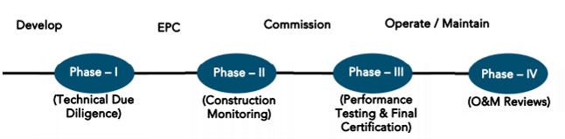
THIRD LENDER’S INDEPENDENT ENGINEER REPORT
OF
"ONE MERAKI WING C"

"One Meraki Wing C", Proposed Residential Building on Plot bearing, CTS No. 619/14, 619/15, 619/21A & 619/21B, Motibaug, Opp. R.K Studio, V.N Purav Marg, Village – Borla, Chembur (West), Mumbai – 400 071, State - Maharashtra, Country – India

Latitude Longitude: 19°02’54.3”N 72°54’29.6”E

NAME OF DEVELOPER: M/s. Meraki Habitats LLP
Pursuant to instructions from State of India, SME Chembur Branch, Chembur we have duly visited, inspected, surveyed & assessed the above said property on 16th October 2024 to determine the fair & reasonable market value of the said property/project as on Quarter ending 30th September 2024 for LIE purpose.

1. Location Details:
Proposed Residential Building on Plot bearing, CTS No. 619/14, 619/15, 619/21A & 619/21B, Motibaug, Opp. R.K Studio, V.N Purav Marg, Village – Borla, Chembur (West), Mumbai – 400 071. It is about 2 Km. walking distance from Chembur Railway station. Surface transport to the property is by buses, taxis & private vehicles. The property is in developed locality. All the amenities like shops, banks, hotels, markets, schools, hospitals, etc. are all available in the surrounding locality. The area is higher middle class & developed.

2. Developer Details:
Name of builder | M/s. Meraki Habitats LLP
Project Rera Registration Number | P51800048237
Registered office address | Office No. 501, 5th Floor, Meraki Arena, Motibaug, Opp. R. K. Studio, V.N Purav Marg, Chembur (West), Mumbai – 400 071, State - Maharashtra, Country – India
Contact details | Contact Person:  Mr. Akshay Patani (Senior Executive Manager)  Mobile No. 9820620783  Mr. Vishal Tapal (Accountant)  Mobile No. 8080700006
E – mail ID and website
3. Boundaries of the Property:
Direction | Particulars
On or towards North | Open Plot
On or towards South | D Wing and V.N Purav Marg
On or towards East | Mahinder Chamber
On or towards West | A and B Wing

Introduction
As per Information on site M/s. Meraki Habitats LLP formerly known as M/s. Shiv Sabari Developers has acquired land by Conveyance Deed Date 31.03.2006 & 17.01.2017 admeasuring area is 19,954.30 Sq. M. bearing CTS No. 619(14), 619(15), 619(21) and 667. For the Proposed Residential Building.

Area Statement:

Land:
Date | Particular | Area in Sq. M.
31.03.2006 | CTS No. 619(14), 619(15), 619(21) | 17,181.30
17.01.2017 | CTS No. 667 | 2,773.00
TOTAL |  | 19,954.30

- Copy of Deed of Conveyance dated 31.03.2006 b/w Mr. Fatema Ali Sutarwala & 6 others (The Vendors) And M/s. Shiv Sabari Developers (The Purchaser)
- Copy of Deed of Conveyance dated 17.01.2017 b/w M/s. Natraj Realcon Pvt. Ltd. (The Vendors) And M/s. Shiv Sabari Developers (The Purchaser).

Building Area:

I | Area Statement
1) | Gross area of Plot | 19916.05
a) | Area of Reservation in Plot
b) | Area of Road Set back
c) | Area of DP Road
2) | Deduction for
A | For reservation/road area
a) | Road set-back area to be handed over (100%) (Regulation no. 16)
b) | Proposed d p road to be handed over (100%) (Regulation no. 16)
c) | Reservation area to be handed over as per AR (Regulation no. 17)
 | Existing Recreation Ground Reservation area (plot) | 2623.00
 | Reservation Play Ground area (plot) to be handed over (Regulation no 17 of DCR 2034) | 406.05
 | Reservation Garden area (plot) to be handed over (Regulation no 17 of DCPR 2034) | 2939.50
d) | Encroachment area | 133.00
B | For amenity area
a) | Area of amenity plot/plots to be handed over as per dcr 14(a)
b) | Area of amenity plot/plots to be handed over as per dcr 14(b)
c) | Area of amenity plot/plots to be handed over as per dcr 15
d) | Area of amenity plot/plots to be handed over as per dcr 35
C | Deduction for existing built-up area to be retained if any
a) | Land component of existing BUA as per regulation under which the development was allowed
3) | Total deduction (2(A) +2(B) +2(C)) | 6103.55
4) | Balance area of plot (1 minus 3) | 13812.50
4A | ADD FOR F.S.I AS PER PROPOSED ACCOMODATION AND RESERVATION
 | Existing Recreation Ground Reservation area (plot)
 | Reservation Garden area (plot) to be handed over (Regulation no 17)
 | Reservation Garden area (plot) to be handed over (Regulation no 17) | 2496.19
5) | Plot area under development (4 + 2 A(a)) | 16308.69
6) | Zonal (basic) FSI (1 or 1.33) | One
7) | Permissible built-up area as per zonal (basic) FSI (5*6) | 16308.69
8) | Built up area equal to area of land handed over as per 3(a) of regulation 30(a)
9) | Built up area in Lieu of cost of construction of built-up amenity to be handed over
10) | Built up area due to additional FSI on payment of premium as per table no 12-regulation no 30(a) | 8154.35
11) | Built up area due to additional FSI on payment of premium as per table no 12-regulation no 30(a)3 | 11188.54
12) | Reservation Garden area plot to be handed over (Regulation no. 17)
12(a) | TDR generated Amenity area set-off as per regulation 14(B) | 1702.72
13) | Incentive FSI as per regulation 30(18)
14) | Permissible built-up area | 37354.3
b) | Proposed built up area in building no. 1 | 21600.36
c) | Proposed built up area in building no. 2 | 3343.65
d) | Proposed built up area in building no. 3 | 12337.97
15 | Total Proposed built up area in building no 31(3) | 37281.98
16 | Fungible commentary area as per regulation 31(3)
a) | i) Permissible Fungible Compensatory Commercial Area Rehab component without charging premium
b) | ii) Fungible Compensatory Commercial area availed for Rehab component without charging premium | 5061.21
c) | i) Permissible Fungible Compensatory Commercial Area Rehab component without charging premium
d) | ii) Fungible Compensatory Commercial area availed for Rehab component without charging premium
e) | i) Permissible Fungible Compensatory Commercial Area Rehab component without charging premium
17 | ii) Fungible Compensatory Commercial Residential area availed on payment of premium | 7987.49
18 | Total Fungible Compensatory area by charging premium | 13048.70
II | Total Built up Area proposed including Fungible Compensatory Area (15 + 16(a)(ii) + 16(b)(ii) | 50330.68
A | FSI consumed on Net Plot (15/4) | 2.29
a) | Other Requirements
b) | Reservation/Designation
c) | Name of Reservation
d) | Area of Reservation affecting the plot
e) | Area of Reservation land to be handed over as per Regulation No. 17
(B) | Built up area of Amenity to be handed over as per Regulation No.17
 | Area /Built up Amenity to be handed over as per Regulation No
 | (I) 14(A)
 | (ii) 14(b)
 | (iii) 15
(C) | Requirement of Recreational Open Space in Layout/ Plot as per Regulation No. 27
(D) | Tenement Statement
 | (i) Proposed built up area (13 above) | 50330.68
 | (ii) Less deduction of Non-residential area (Shop etc) | 14460.61
 | (iii) Area available for tenements ((i) minus(ii)) | 35870.07
 | (iv) Tenements permissible (Density of tenements/hectare) | 1614 Nos
 | (v) Total number of Tenements proposed on the plot | 283 Nos
(E) | Parking Statement
 | (i) Parking required by regulations for
 | Car
 | Scooter/Motor Cycle | 446 Nos
 | Outsider (Visitor)
 | (i) Covered garage permissible
 | (iii) Covered Garages proposed
 | Car
 | Scooter/Motor Cycle
 | Outsider (Visitor)
 | (iv) Total parking provided | 762 Nos
(F) | Transport Vehicle Parking
 | (i) Space for transport vehicle parking required by Regulations
 | (ii) Total No. of transport vehicles parking spaces provided

List of Approvals:
- Copy of IOD No. CHE/ES/0840/M/W/337(NEW) issued by Municipal Corporation of Greater Mumbai
- Copy of Approved Plans No. CHE/ES/0840/M/W/337(NEW) dated 28.12.2021 issued by Municipal Corporation of Greater Mumbai
Approved upto: Wing C: 3 Basement + Ground Floor + 1st Podium Floor + 2nd to 19th Upper Floors
- Copy of 1st Commencement Certificate No. CHE/ES/0840/M/W/337(NEW) dated 29.12.2023 issued by Municipal Corporation of Greater Mumbai
(This C.C. up to top of Stilt Slab of Wing C of Building No. 1, as per approved IOD plans dated 28.12.2021)
- Copy of 2nd Commencement Certificate No. CHE/ES/0840/M/W/337(NEW) dated 29.12.2023 issued by Municipal Corporation of Greater Mumbai
(C.C. for 3 Basement + Ground Floor + 1st Podium Floor + 2nd to 19th Upper Floors (Full C.C.) of Wing C, as per approved plans dated 28.12.2021)

LEVEL OF COMPLETION:

Sales Building (Wing C)
Sr. No | Floor No. | Construction Area in Sq. M. | Completed Area in Sq. M. | Work Completion as on 13.11.2024 | Work Completion as 2nd LIE Report as on 04.07.2024
1 | Excavation & Shore Piling |  |  | Work is Completed | Work is Completed
2 | Basement 1 | 1,761.59 | 1,761.59 | Slab work is completed | Slab work is completed
3 | Basement 2 | 1,761.59 | 1,761.59 | Slab work is completed | Slab work is completed
3 | Basement 3 | 1,761.59 | 1,761.59 | Slab work is completed | Slab work is completed
4 | Ground Floor | 1,860.68 | 1,860.68 | Slab work is completed | Slab work is completed
5 | 1st Floor | 794.10 | 794.10 | Slab work is completed | Slab work is completed
6 | 2nd Floor | 496.76 | 496.76 | Slab work, block work & plaster work is completed | Slab work is completed
7 | 3rd Floor | 496.76 | 496.76 | Slab work, block work & plaster work is completed | Slab work is completed
8 | 4th Floor | 496.76 | 496.76 | Slab work, block work & plaster work is completed | Slab work is completed
9 | 5th Floor | 496.76 | 496.76 | Slab work, block work & plaster work is completed | Shuttering work is in progress
10 | 6th Floor | 496.76 | 496.76 | Slab work, block work & plaster work is completed
11 | 7th Floor | 491.46 | 491.46 | Slab work, 50% block work & 50% plaster work is completed
12 | 8th Floor | 498.31 | 498.31 | Slab work, block work & plaster work is completed
13 | 9th Floor | 496.76 | 496.76 | Slab work, block work & plaster work is completed
14 | 10th Floor | 496.76 | 496.76 | Slab work, block work & 75% plaster work is completed
15 | 11th Floor | 496.76 | 496.76 | Slab work & 75% block work is completed
16 | 12th Floor | 496.76 | 496.76 | Slab work is completed
17 | 13th Floor | 496.76 | 496.76 | Slab work is completed
18 | 14th Floor | 491.45 | 491.45 | Slab work is completed
19 | 15th Floor | 498.31 |  | Shuttering work is in progress
20 | 16th Floor | 496.76
21 | 17th Floor | 496.76
22 | 18th Floor | 496.76
23 | 19th Floor | 496.76
24 | Terrace Floor | 39.15
Total |  | 16,912.81 | 9,429.82

Details of the Project as Financed By SBI:

Estimated Project Cost: (As per Cost Vetting Report)
Particulars | Estimated Cost (in Cr.)
Land & Stamp Cost | 12.50
Construction Cost of Sale Building | 55.81
Approval Cost including Premium Cost / FSI / GOM Charges / fees & TDR Cost | 13.02
Architect Cost, RCC & Other Professional Cost | 0.56
Administrative Cost | 3.07
Marketing Cost | 5.35
Interest Cost (Bank Loan) | 6.91
Total | 106.76

Project Cost: (as per C.A. Certificate)
Particulars | Incurred Cost (In Cr.) till 30.09.2024 by M/s K. F. Jetsey & Co. | Incurred Cost (In Cr.) till 30.06.2024 by M/s K. F. Jetsey & Co. | Net
Land & Stamp Cost | 12.50 | 12.50 | -
Construction Cost of Sale Building | 34.95 | 23.56 | 11.39
Approval Cost including Premium Cost / FSI / GOM Charges / fees & TDR Cost | 10.60 | 10.60 | -
Architect Cost, RCC & Other Professional Cost | 0.11 | 0.33 | -0.22
Administrative Cost | 0.50 | 0.25 | 0.25
Marketing Cost | 0.76 | 0.64 | 0.12
Interest Cost (Bank Loan) | 0.54 | 0.09 | 0.45
Total | 59.96 | 47.97 | 11.99
- The Builder has incurred about 34.95 Cr. as construction cost, 0.11 Cr. for Professional cost, 0.50 Cr. Admin Cost, 0.76 Cr. Marketing Cost & 0.54 Cr. interest cost till 30.09.2024 as per C.A. certificate issued by M/s. K. F. Jetsey & Co. dated 21.10.2024.

Project Cost: (as per Bills):
Particulars | Incurred Cost (in Cr.) |  | Net
 | 30.09.2024 as per Bill (Inclusive GST) | 30.06.2024 as per Bill (Inclusive GST)
Land Cost | 12.50 | 12.50 | -
Construction cost of Sale Building | 33.67 | 22.80 | 10.87
Approval Cost including Premium Cost / FSI / GOM Charges / fees & TDR Cost | 10.60 | 10.60 | -
Architect Cost, RCC & Other Professional Cost | 0.35 | 0.33 | 0.01
Administrative Cost | 1.71 | 1.00 | 0.71
Marketing Cost | 0.76 | 0.45 | 0.32
Interest Cost | 0.54 | 0.09 | 0.44
Total | 60.13 | 47.78 | 12.35
Note:

Land Cost:
Sr. No. | Land Cost: | Amount (in `)
1 | Payment to Land Owners | 43,71,53,000.00
2 | Payment to Tenants | 30,40,88,299.00
3 | Stamp Duty | 3,86,02,044.00
4 | Tenancy Purchase Cost & Other Cost | 6,85,64,179.00
 | Total Land Cost | 84,84,07,522.00
As per conveyance deed.
Sr. No. | Particulars | Land Cost (in Rs.) | BUA | % of Land Covered
1 | Arena (Commercial) | 21,96,07,901.47 | 16,122.03 | 28%
2 | One Meraki -Wing A & B | 19,82,40,325.86 | 14,171.63 | 25%
3 | One Meraki -Wing C | 12,50,00,430.49 | 7,223.11 | 13%
4 | One Meraki -Wing D | 13,51,44,430.49 | 7,223.11 | 13%
5 | One Meraki -Wing E | 7,98,41,530.97 | 5,861.39 | 10%
6 | Platina | 9,05,72,902.70 | 6,649.21 | 12%
TOTAL |  | 84,84,07,522.00 | 57,250.48 | 100%
As per information from client, 13% of land is covered for Wing C so proportionate land cost for One Meraki – Wing C Project is ` 12,50,00,430.00 i.e., ` 12.50 Cr.
Summary of Bills
Sr. No. | Particulars | Amount in `  (till 30.09.2024) | Amount in ` (in Cr.) | Amount in `  (till 30.06.2024) | Amount in ` (in Cr.) | Net
1 | Construction Cost of Sale Building | 33,66,96,122.00 | 33.67 | 22,80,45,860.00 | 22.80 | 10.87
2 | Premium Cost / FSI / GOM Charges / fees / security Deposits & TDR Cost | 10,60,06,165.00 | 10.60 | 10,60,06,165.00 | 10.60 | -
3 | Professional Cost | 34,80,879.00 | 0.35 | 33,41,970.00 | 0.33 | 0.01
4 | Administrative Cost | 1,71,27,384.00 | 1.71 | 99,87,469.00 | 1.00 | 0.71
5 | Marketing Cost | 76,21,680.00 | 0.76 | 44,55,348.00 | 0.45 | 0.32
TOTAL |  | 47,09,32,229.00 | 47.09 | 35,18,36,812.00 | 35.18 | 11.91
Note: Bills were provided by the client up to 30.09.2024

Interest Cost:
Sr. No | Particulars | Estimate Amount in ` | Incurred Amount in ` (till 30.09.2024) | Incurred Amount in ` (till 30.06.2024) | Difference in ` | Balance Amount in `
1 | Interest Cost | 6,91,00,000.00 | 53,55,026.00 | 9,13,270.00 | 44,41,756.00 | 6,37,44,974.00
TOTAL |  | 6,91,00,000.00 | 53,55,026.00 | 9,13,270.00 | 44,41,756.00 | 6,37,44,974.00
Interest Cost is based on discussion with the client.

Cost of Construction as on 16th October 2024:

Sales Building (Wing C)
Plinth Area Calculation
Sr. No | Floor Nos. | Construction Area in Sq. M. | Completed Area in Sq. M. | Rate per Sq. M. | Full Value after completion | % of work completed | Actual Expenditure till date in `
1 | Deep Excavation & Piling Working (As per Bills) |  |  |  | 5,07,38,418.00 | 100% | 5,07,38,418.00
2 | Basement 1 | 1,761.59 | 1,761.59 | 30,000.00 | 5,28,47,700.00 | 50% | 2,64,23,850.00
3 | Basement 2 | 1,761.59 | 1,761.59 | 30,000.00 | 5,28,47,700.00 | 50% | 2,64,23,850.00
4 | Basement 3 | 1,761.59 | 1,761.59 | 30,000.00 | 5,28,47,700.00 | 50% | 2,64,23,850.00
5 | Ground Floor | 1,860.68 | 1,860.68 | 30,000.00 | 5,58,20,400.00 | 50% | 2,79,10,200.00
6 | 1st Podium Floor | 794.10 | 794.10 | 30,000.00 | 2,38,23,000.00 | 50% | 1,19,11,500.00
7 | 2nd Floor | 496.76 | 496.76 | 30,000.00 | 1,49,02,680.00 | 65% | 96,86,742.00
8 | 3rd Floor | 496.76 | 496.76 | 30,000.00 | 1,49,02,680.00 | 65% | 96,86,742.00
9 | 4th Floor | 496.76 | 496.76 | 30,000.00 | 1,49,02,680.00 | 65% | 96,86,742.00
10 | 5th Floor | 496.76 | 496.76 | 30,000.00 | 1,49,02,680.00 | 65% | 96,86,742.00
11 | 6th Floor | 496.76 | 496.76 | 30,000.00 | 1,49,02,680.00 | 65% | 96,86,742.00
12 | 7th Floor | 491.46 | 491.46 | 30,000.00 | 1,47,43,800.00 | 58% | 85,51,404.00
13 | 8th Floor | 498.31 | 498.31 | 30,000.00 | 1,49,49,180.00 | 65% | 97,16,967.00
14 | 9th Floor | 496.76 | 496.76 | 30,000.00 | 1,49,02,680.00 | 65% | 96,86,742.00
15 | 10th Floor | 496.76 | 496.76 | 30,000.00 | 1,49,02,680.00 | 62% | 92,39,661.60
16 | 11th Floor | 496.76 | 496.76 | 30,000.00 | 1,49,02,680.00 | 58% | 86,43,554.40
17 | 12th Floor | 496.76 | 496.76 | 30,000.00 | 1,49,02,680.00 | 50% | 74,51,340.00
18 | 13th Floor | 496.76 | 496.76 | 30,000.00 | 1,49,02,680.00 | 50% | 74,51,340.00
19 | 14th Floor | 491.45 | 491.45 | 30,000.00 | 1,47,43,500.00 | 40% | 58,97,400.00
20 | 15th Floor | 498.31 |  | 30,000.00 | 1,49,49,180.00
21 | 16th Floor | 496.76 |  | 30,000.00 | 1,49,02,680.00
22 | 17th Floor | 496.76 |  | 30,000.00 | 1,49,02,680.00
23 | 18th Floor | 496.76 |  | 30,000.00 | 1,49,02,680.00
24 | 19th Floor | 496.76 |  | 30,000.00 | 1,49,02,680.00
25 | Terrace | 39.15 |  | 30,000.00 | 11,74,500.00
Total |  | 16,912.81 | 7,939.55 |  | 55,81,22,598.00 | 51.05% | 28,49,03,787.00

Note: Details of work completed is as per site visit dated 16.10.2024 but report is prepared for 30th September 2024.

Particulars | Estimated Cost  (In Cr.) | Incurred Cost (in Cr.) |  |  | Net
 |  | Issued dated 21.10.2024 till 30.09.2024 as per CA | As per Bills upto 30.09.2024 | As per Bills upto 30.06.2024
Land Cost | 12.50 | 12.50 | 12.50 | 12.50 | -
Construction cost of Sale Building | 55.81 | 34.95 | 33.67 | 22.80 | 10.87
Approval Cost including Premium Cost / FSI / GOM Charges / fees & TDR Cost | 13.02 | 10.60 | 10.60 | 10.60 | -
Architect Cost, RCC & Other Professional Cost | 0.56 | 0.11 | 0.35 | 0.33 | 0.01
Administrative Cost | 3.07 | 0.50 | 1.71 | 1.00 | 0.71
Marketing Cost | 5.35 | 0.76 | 0.76 | 0.45 | 0.32
Interest Cost | 6.91 | 0.54 | 0.54 | 0.09 | 0.44
Total | 106.76 | 59.96 | 60.13 | 47.78 | 12.35

Note:
We have considered Water Charges in Admininstrative cost header but CA has considered them in cost of construction header .
We have considered Testing Charges, Geotechinal Report cost is consider in Professional cost header but CA has considered them in cost of construction header .
We have considered bank loan processing charges in Administrative cost header bu CA has considered them in marketing cost header.
As per site inspection, 51.05% of total work is completed, which amounts to ` 28.49 Cr. However, as per data provided by client, they have incurred the cost of ` 33.67 Cr. till 30.09.2024 which consits of adavnces to vendors and cost incurred for on site matertial.

Comparison of Cost incurred on dated 30.09.2024 & 30.06.2024
Particulars | 30.09.2024 as per Bill | 30.06.2024 as per Bill | Net | % of net amount
Land Cost | 12.50 | 12.50 | - | 0.00%
Construction cost of Sale Building | 33.67 | 22.80 | 10.87 | 18.08%
Approval Cost including Premium Cost / FSI / GOM Charges / fees & TDR Cost | 10.60 | 10.60 | - | 0.00%
Architect Cost, RCC & Other Professional Cost | 0.35 | 0.33 | 0.01 | 0.02%
Administrative Cost | 1.71 | 1.00 | 0.71 | 1.18%
Marketing Cost | 0.76 | 0.45 | 0.32 | 0.53%
Interest Cost | 0.54 | 0.09 | 0.44 | 0.73%
Total | 60.13 | 47.78 | 12.35 | 100.00%

% of Fund Utilised till 30th September 2024
Particulars | Estimated Cost (in Cr.) | Incurred Cost as on 30.09.2024 | % of Incurred Cost | % of Estimated Project Cost
Land & Stamp Cost | 12.50 | 12.50 | 100.00% | 12.86%
Construction Cost of Sale Building | 55.81 | 33.67 | 60.33% | 34.63%
Approval Cost including Premium Cost / FSI / GOM Charges / fees & TDR Cost | 13.02 | 10.60 | 81.42% | 10.90%
Architect Cost, RCC & Other Professional Cost | 0.56 | 0.35 | 62.16% | 0.36%
Administrative Cost | 3.07 | 1.71 | 55.79% | 1.76%
Marketing Cost | 5.35 | 0.76 | 14.25% | 0.78%
Interest Cost (Bank Loan) | 6.91 | 0.54 | 7.75% | 0.55%
Total | 106.76 | 60.13 | 61.85% | 61.85%
Based on above Calculation it is found that total Project cost incurred is 61.85% of the Total Project Cost.

Means of Finance:
Sr. No. | Particulars | Exp. Cumulative (Cr.)
 | Equity share capital / Quassi Loan from Promoter | 31.83
 | Sales (Advance from customer) | 7.94
 | Bank Laon Amount | 25.70
 | Total | 65.47
The Details of the Means of Finance are provided by Client as on 30.09.2024.

Mandatory Arrangements:
Sr. No. | Particulars | Status
 | Rainwater Harvesting | To be executed after RCC Structure
 | Firefighting System | To be executed after RCC Structure
 | Solid Waste Management | To be executed after RCC Structure

Quality of Construction:
Sr. No. | Particulars | Status
 | Soundness of Structures | Executing as per approved Structural Design
 | Look of Structures | Good
 | Quality of Material Used | Good
 | Safety Measures for Construction/labour | Taken Care by Contractor

Schedule V/s. Actual Progress:
Activity | Date of Implementation | Date of Completion | Status
Land |  |  | Completed
Development of Land |  |  | Completed
Foundation Work |  |  | Completed
Ground Floor Slab |  |  | Slab work is Completed
1st Floor Slab |  |  | Slab work is Completed
2nd Floor Slab |  |  | Slab work is Completed
3rd Floor Slab |  |  | Slab work is Completed
4th Floor Slab |  |  | Slab work is Completed
5th Floor Slab |  |  | Slab work is Completed
6th Floor Slab |  |  | Slab work is Completed
7th Floor Slab |  |  | Slab work is Completed
8th Floor Slab |  |  | Slab work is Completed
9th Floor Slab |  |  | Slab work is Completed
10th Floor Slab |  |  | Slab work is Completed
11th Floor Slab |  |  | Slab work is Completed
12th Floor Slab |  |  | Slab work is Completed
13th Floor Slab |  |  | Slab work is Completed
14th Floor Slab |  |  | Shuttering work is in progress
15th Floor Slab
16th Floor Slab
17th Floor Slab
18th Floor Slab
19th Floor Slab
Block work / Internal Plaster work |  |  | 2nd to 6th & 8th to 10th floor block work, 2nd to 6th & 8th to 9th floor plaster work, 7th & 11th floor 50% block work and 10th floor 75% plaster work
Terrace Parapet wall / Overhead water tank / Lift Machine room / compound wall / External Plaster work
Electric Work
Water Proofing
Plumbing Work
Tiling / Marble Flooring
Door Frames
Window Installation
Staircase Flooring
Staircase Railing
Refuge Area Flooring
Internal Painting
External Painting
Lift Work
Fire Fighting Installation
Stack Parking
CP Fitting & Sanitary Work
Final Finishing & Fitting
Work progress schedule is not shared by the developer.

Action initiated to complete the project in time:
For Sales Building (Wing C): Till 14th floor slab work, 2nd to 6th & 8th to 10th floor block work, 2nd to 6th & 8th to 9th floor plaster work, 7th & 11th floor 50% block work and 10th floor 75% plaster work is completed. 15th floor Slab shuttering work is in progress.

Comments related to cost overrun if any:
The cost of Project is ` 97.22 Cr.

Balance investment required for completion of project:
We opinion amount of ` 37.09 Cr. Will be required to complete the Project.

Mandatory Approval Status:
Sr. No. | Particulars | Name of Department | Status | Order Details
1 | IOD of Building & Approved Plan | Municipal Corporation of Greater Mumbai (MCGM). | Obtained and available at site | No. CHE/ES/0840/M/W/337(NEW) dated 28.12.2021
2A | First C.C. | Municipal Corporation of Greater Mumbai (MCGM). | Obtained and available at site | No. CHE/ES/0840/M/W/337(NEW) dated 29.12.2023. This CC is endorsed for the work upto top of Stilt Slab of Wing C of Building No. 1, as per approved IOD plans dated 28.12.2021
2B | Second C.C. | Municipal Corporation of Greater Mumbai (MCGM). | Obtained and available at site | No. CHE/ES/0840/M/W/337(NEW) dated 29.12.2023.  (This CC is endorsed for the work for 3 Basement + Ground Floor + 1st Podium Floor + 2nd to 19th Upper Floors (Full C.C.) of Wing C, as per approved plans dated 28.12.2021)
3B | Occupancy | Municipal Corporation of Greater Mumbai (MCGM). | Pending (Project is not completed)

Status Insurance Coverage:
Particulars | Descriptions | Particulars | Descriptions
Policy No. | 0000000038623167 | Policy Issued Date | 31.03.2024
Period of Insurance | From 03.05.2023 to 31.12.2026 | Total Sum Insured | ` 55,00,00,000.00
Insurance Policy Name | Contractors All Risk Policy | Issued By | SBI General Insurance
Type of Cover / Benefit | 1. Material Damage / Contract Price  2. Third Party Liabilities/ All accidents during policy period

Assumptions & Remarks:
- The adequacy of Engineering / Structural design is beyond the scope of our assignment.
- Estimated project completion date is 31/12/2026 for Sales Building respectively. The cost is certified based on the assumptions that the project will be completed within period. Few assumptions were made regarding inflation & cost rise etc. during construction period.

Manoj B. Chalikwar
Registered Valuer
Chartered Engineer (India)
Reg. No. IBBI/RV/07/2018/10366

About the Project:
1. Introduction
a) | Project Name  (With Address & Phone Nos.) | "One Meraki Wing C", Proposed Building on Plot bearing, CTS No. 619/14, 619/15, 619/21A & 619/21B, Motibaug, Opp R.K Studio, V.N Purav Marg, Village – Borla, Chembur (West), Mumbai – 400 071, State - Maharashtra, Country – India  Contact Person:  Mr. Akshay Patani (Senior Executive Manager)  Mobile No. 9820620783  Mr. Vishal Tapal (Accountant)  Mobile No. 8080700006
b) | Purpose of Valuation | As per request from State Bank of India, SME Chembur Branch to assess fair market value of the Project for LIE purpose.
c) | Date of Inspection of Property | 16.10.2024
d) | Date of LIE Report | 13.11.2024
e) | Name of the Developer of Property  (in case of developer built properties) | M/s. Meraki Habitats LLP  Office No. 501, 5th Floor, Meraki Arena, Motibaug, Opp. R. K. Studio, V.N Purav Marg, Chembur (West), Mumbai – 400 071, State - Maharashtra, Country – India
2. Physical Characteristics of the Property
a) | Location of the Property | "One Meraki Wing C", Proposed Building on Plot bearing, CTS No. 619/14, 619/15, 619/21A & 619/21B, Motibaug, Opp R.K Studio, V.N Purav Marg, Village – Borla, Chembur (West), Mumbai – 400 071, State - Maharashtra, Country – India
 | Brief description of the property
TYPE OF THE BUILDING
- Sale Building (Wing C)

No. of Floors | 3 Basement + Ground Floor + 1st Podium Floor + 2nd to 19th Residential Floor
Building type | Residential Sale building

Sales Building work is given on contract based for RCC contract. Developer has grant to the contractor do the work of construction and completion includes Concrete work, Reinforcement work, Masonry, Internal Plaster, External Plaster, and other miscellaneous work such as repairing, joints b/w concrete and masonry surface, etc. Bill must be paid on measurement of construction area exclusive of Steel, Cement & other construction material.
Lift & lift installation contract is not finalized till now.
Firefighting work contract is not finalized.

PROPOSED DATE OF COMPLETION & FUTURE LIFE:
Expected completion date as per RERA is 31st December 2025

ABOUT PROJECT:
One Meraki by Meraki Habitats LLP is situated in Chembur, Mumbai. The project focuses on one sense of open space to create a perfect living space. Each home is open to let the positive vibes come in, with impressive views of lush greenery. Every convenience you need is close at hand. Opulent and Efficient, One Meraki is a place that is filled up with tranquillity and calmness. The homes have everything for your convenience and promise a luxurious yet comfortable lifestyle. Feel the essence of freshness inside the house and indulge into a peaceful gathering with your loved ones.
It has an availability of comfy apartments of 3 and 4 BHK in the Chembur region of Mumbai. The apartments are all ready to move in phase. Necessities including park, bank, hospital, bus station, petrol pump, ATM, restaurant all are available in the neighbourhood. The other guarantees of the project are a contamination free setting along with covered parking space for each apartment, gym, club house, and security for 24 hours, a power back up system and much more. The price range of the apartments is about Rs 4.1 to 4.8 crore.
 | Postal Address of the Property | "One Meraki Wing C", Proposed S. R. Scheme Commercial cum Residential building on Plot bearing C.T.S. No. 2293/B, Nensey Complex Building, Sant Dnyaneshwar Road & Western Expressway, Village – Dahisar, Borivali (East), Mumbai – 400 066, State – Maharashtra, Country – India
 | Area of the plot/land  (Supported by a plan) | Plot Area: 17,181.30 Sq. M.
 | Type of Land: Solid, Rocky, Marsh land, reclaimed land, Water-logged, Land locked. | Solid land
 | Independent access/approach to the property etc. | Yes
 | Google Map Location of the Property with a neighborhood layout map | Provided
 | Details of roads abutting the property | 30.00 Mt. wide Road
 | Description of adjoining property | Located in Higher Middle-class locality
 | Plot No. Survey No. | C. T. S. No. 619/14, 619/15, 619/21A & 619/21B
 | Ward/Village/Taluka | Village – Borla, Taluka - Kurla
 | Sub-Registry/Block | Mumbai Suburban
 | District | District - Mumbai Suburban
b) | Boundaries of the Plot
 | As per Agreement | As per RERA Certificate | Actual
North | CTS No.646,646/1,7 | CTS No 646 | Open Plot
South | CTS No.619/21, 667 | V N Purav Marg | D Wing and V.N Purav Marg
East | CTS No.647,619/22 | 12 M Wide D.P. Road | Mahinder Chamber
West | CTS No.619/20 | CTS no 619 20 | A and B Wing

4. Document Details and Legal Aspects of Property:
a) | Ownership Documents (Building Permission, Commencement Certificate & Status of Plan)
 | Sale Deed, Gift Deed, Lease Deed
 | - Copy of Deed of Conveyance dated 17.01.2017 b/w M/s. Natraj Realcon Pvt. Ltd. (The Vendors) And M/s. Shiv Sabari Developers (The Purchaser)
 | - Copy of Deed of Conveyance dated 31.03.2006 b/w Mr. Fatema Ali Sutarwala & 6 others (The Vendors) And M/s. Shiv Sabari Developers (The Purchaser)
 | - Copy of Development Permission Certificate No. Dy. Ch.E./B.P./4024/E.S. dated on 27.08.2021 issued by Municipal Corporation of Greater Mumbai
 | - Copy of IOD No. CHE/ES/0840/M/W/337(NEW) issued by Municipal Corporation of Greater Mumbai
- Copy of 1st Commencement Certificate No. CHE/ES/0840/M/W/337(NEW) dated 29.12.2023 issued by Municipal Corporation of Greater Mumbai
(C.C. up to top of Stilt Slab of Wing C of Building No. 1, as per approved IOD plans dated 28.12.2021)
- Copy of Approved Plans No. CHE/ES/0840/M/W/337(NEW) dated 28.12.2021 issued by Municipal Corporation of Greater Mumbai
Approval Upto: 3 Basement + Ground Floor + 1st Podium Floor + 2nd to 19th Upper Floors
- Copy of 2nd Commencement Certificate No. CHE/ES/0840/M/W/337(NEW) dated 29.12.2023 issued by Municipal Corporation of Greater Mumbai
(C.C. for 3 Basement + Ground Floor + 1st Podium Floor + 2nd to 19th Upper Floors (Full C.C.) of Wing C, as per approved plans dated 28.12.2021)
 | - Copy of CA Certificate dated 08.01.2024 issued by M/s. K. F. Jetsey & Co.
 | - Copy of CA Certificate dated 02.08.2023 issued by M/s. K. F. Jetsey & Co.
 | - Copy of Title Report dated 14.11.2020 issued by M/s. J Law Associates.
 | - Copy of Name Change Certificate dated 06.01.2022 from M/s. Shiv Sabari Developers to M/s. Meraki Habitats LLP.
 | - Copy of RERA Certificate No. P51800050796 dated 03.05.2023 issued by Maharashtra Real Estate Regulatory Authority.
 | - Copy of Bills till 31.03.2024.
 | - Copy of CA Certificate dated 14.05.2024 issued by M/s. K. F. Jetsey & Co.
 | - Copy of CA Certificate dated 22.07.2024 for cost incurred till 30.06.2024 issued by M/s. K. F. Jetsey & Co.
 | - Copy of Bills from 01.04.2024 to 30.06.2024

b) | Documents verified for present LIE report
 | - Copy of CA Certificate dated 21.10.2024 for cost incurred till 30.06.2024 issued by M/s. K. F. Jetsey & Co.
 | - Copy of Bills from 01.07.2024 to 30.09.2024

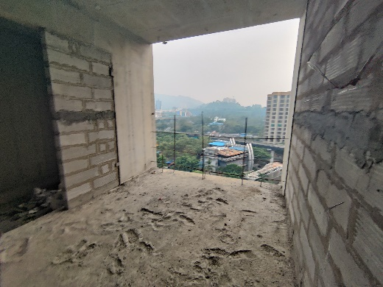
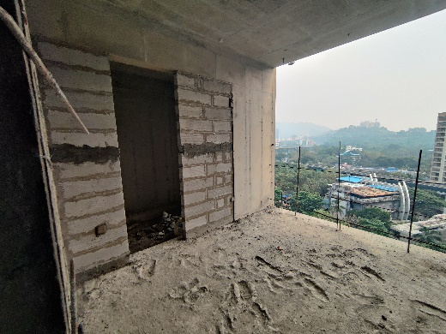
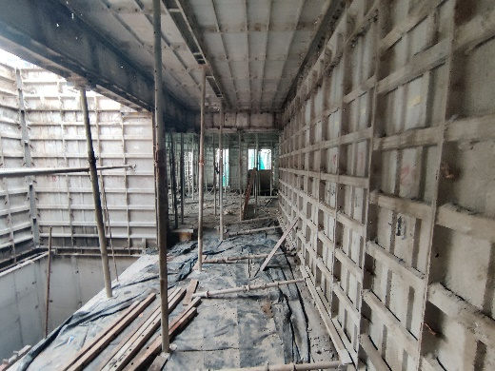
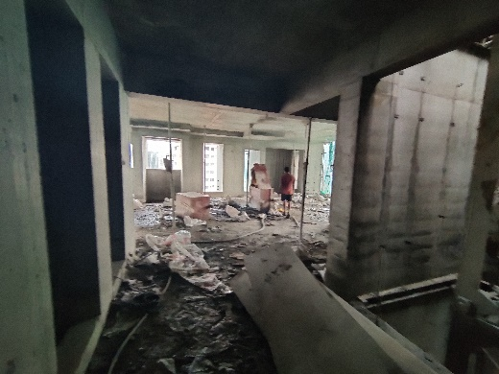
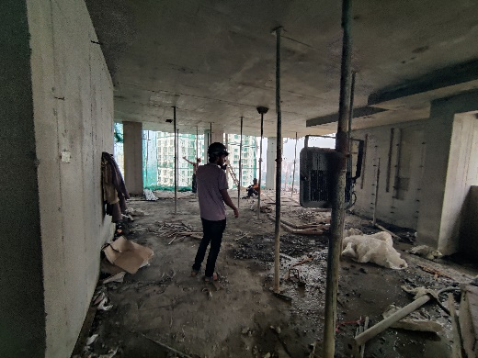
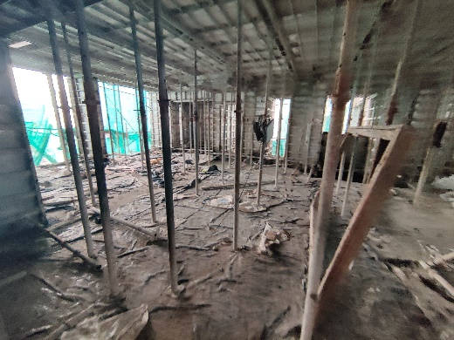
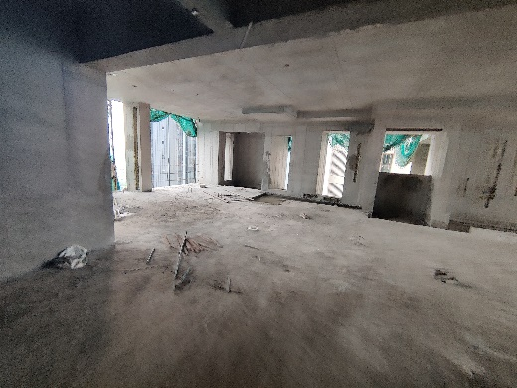
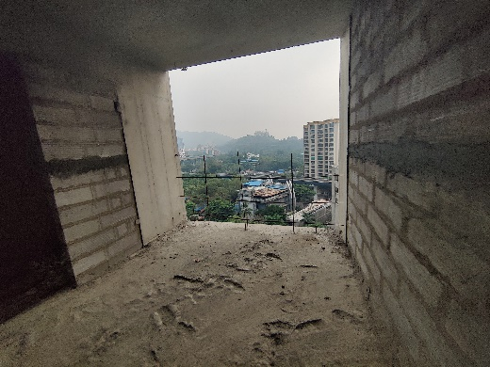
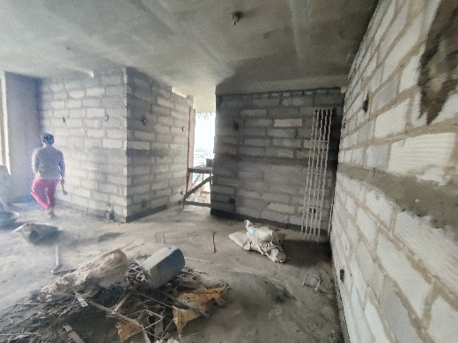
Actual Site Photographs As on 16.10.2024
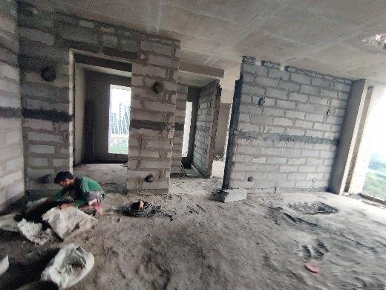
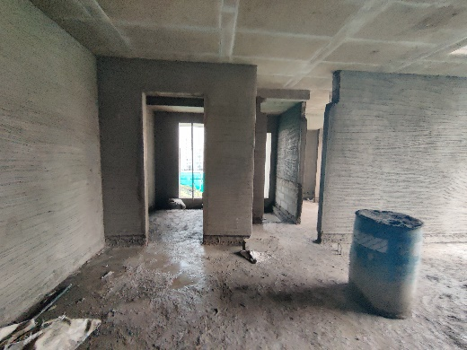
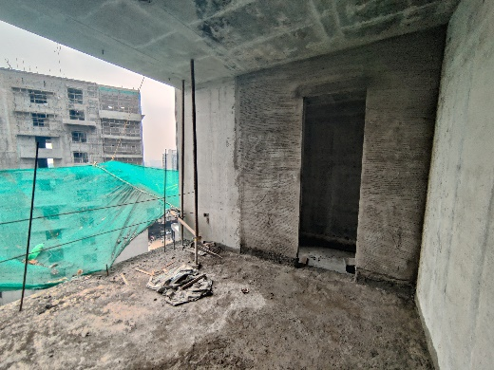
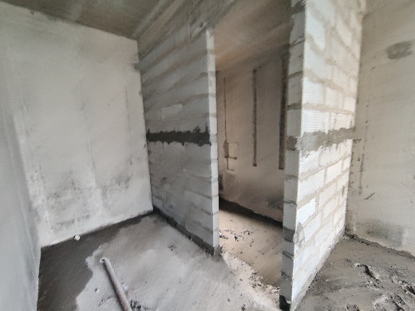
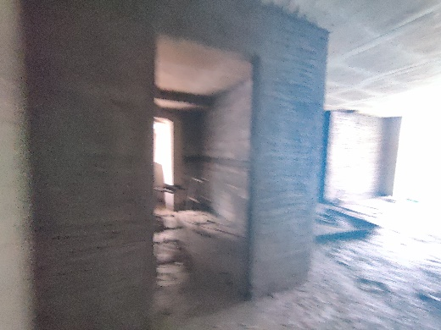
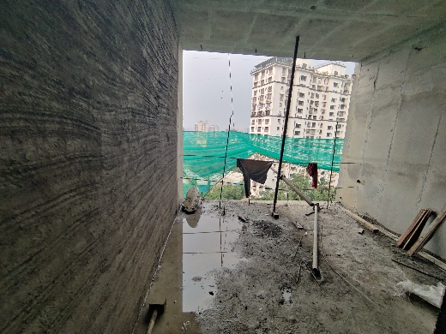
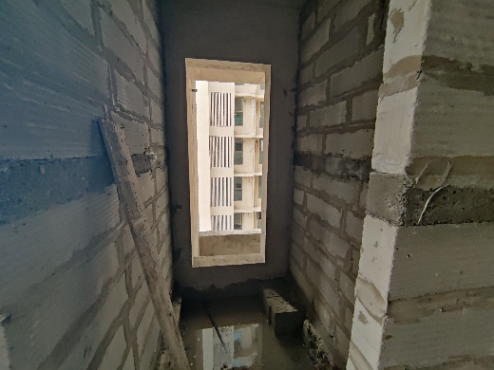
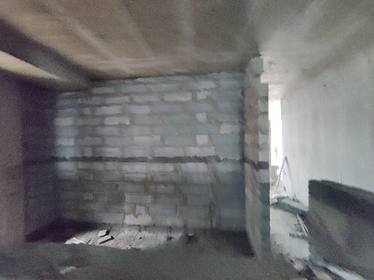
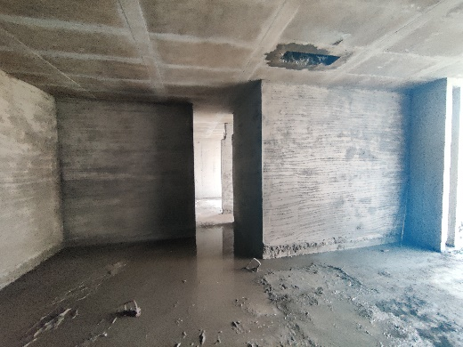
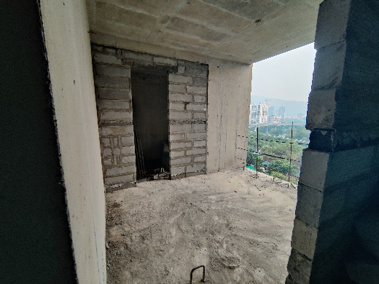
Actual Site Photographs As on 16.10.2024
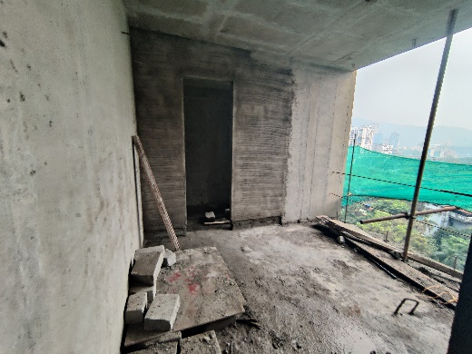
Actual Site Photographs As on 16.10.2024
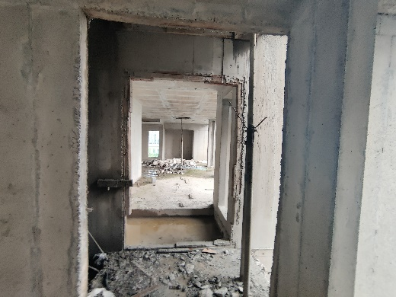
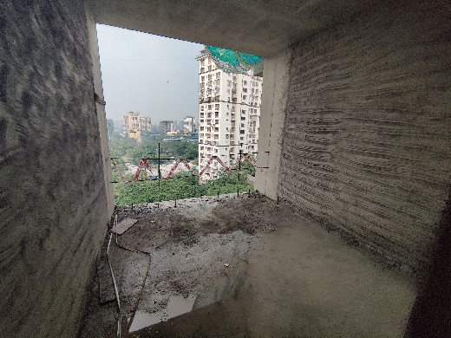
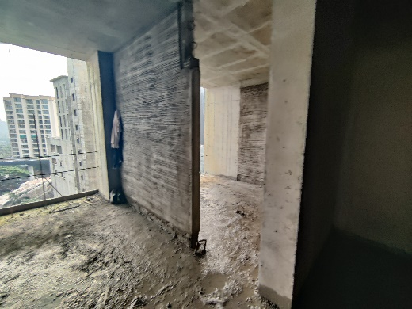
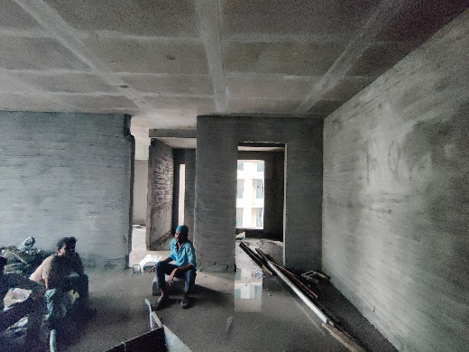
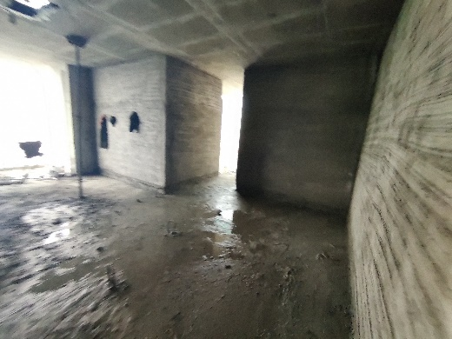
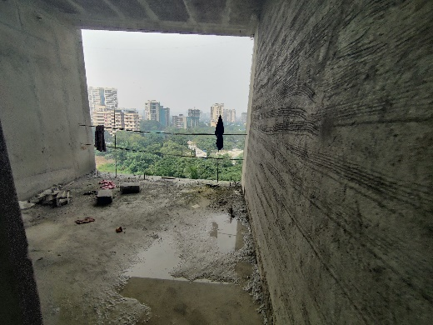
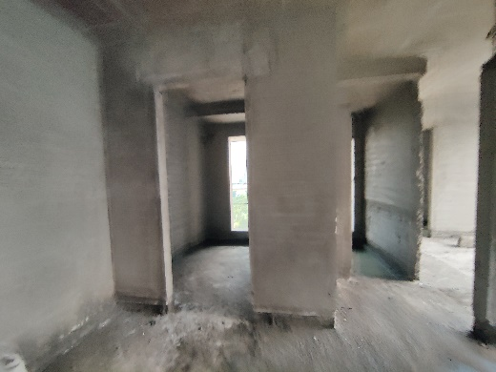
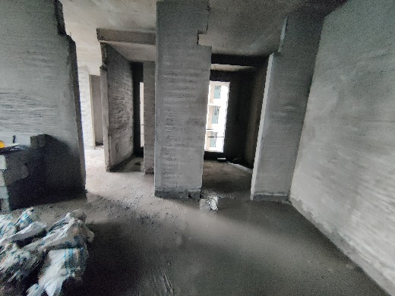
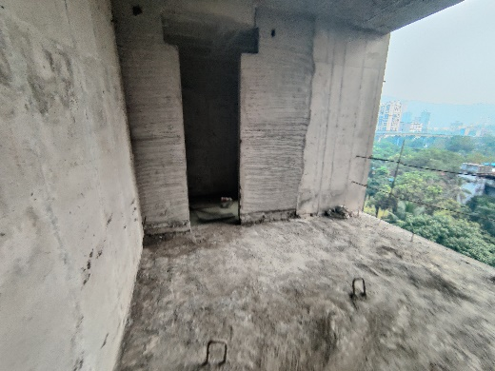
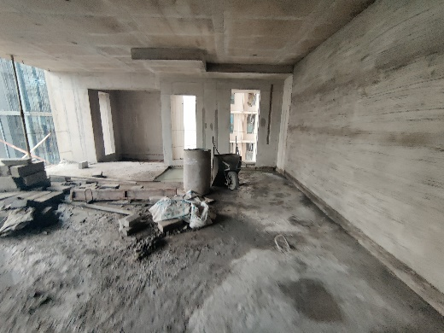
Actual Site Photographs As on 16.10.2024
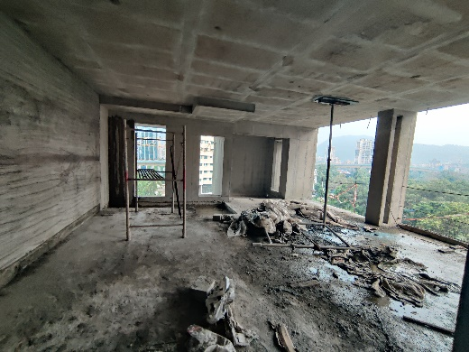
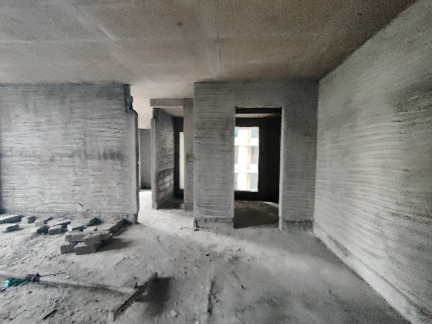
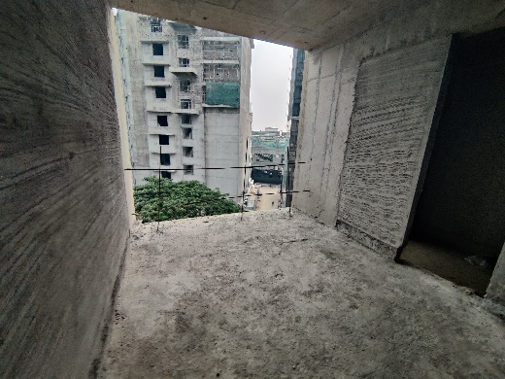
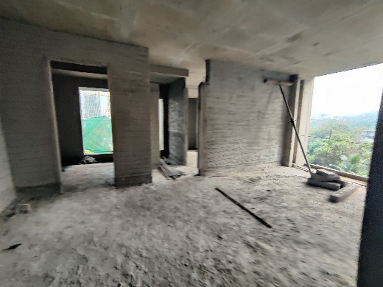
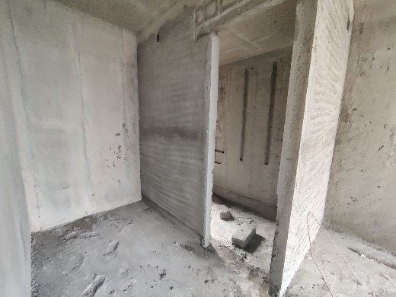
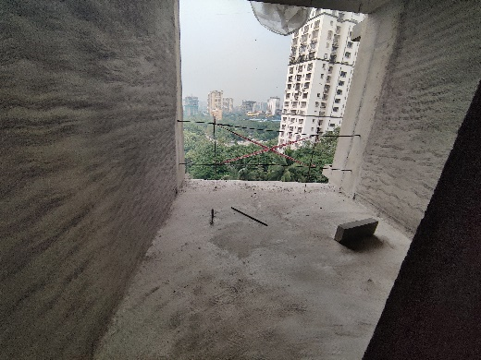
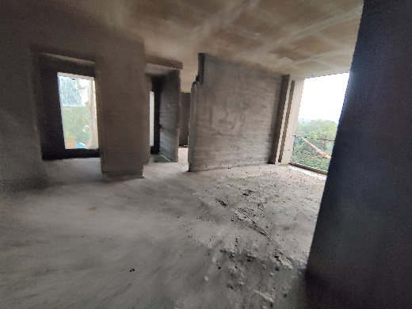
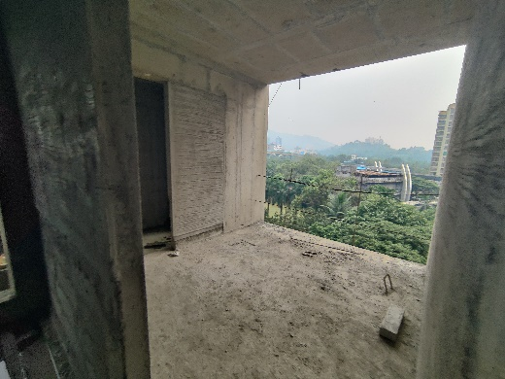
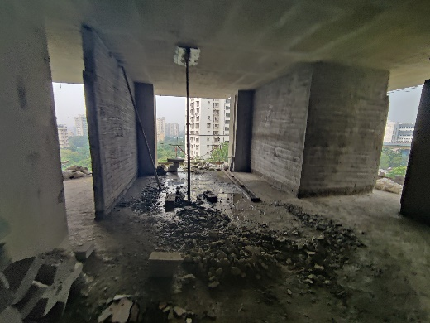
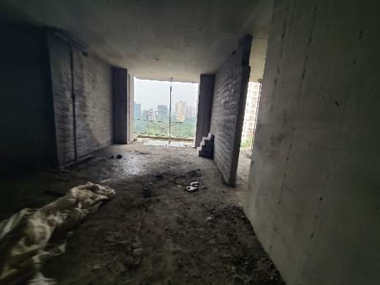
Actual Site Photographs As on 16.10.2024
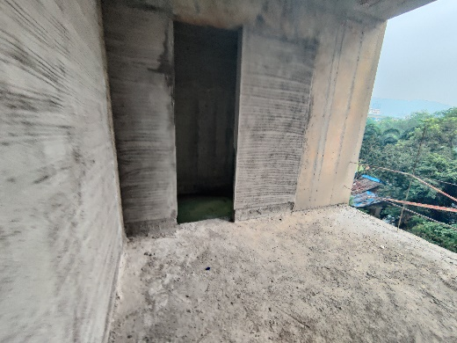
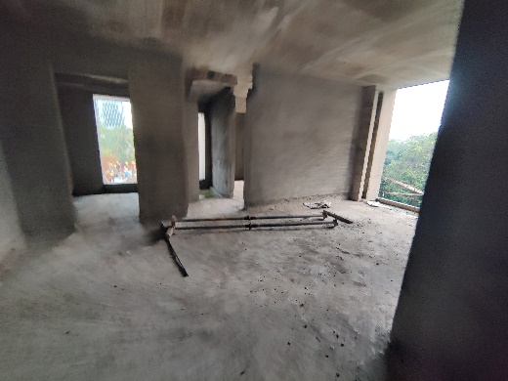
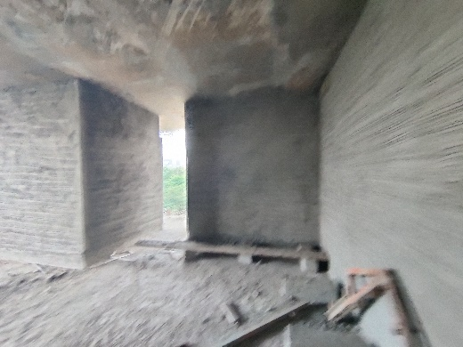
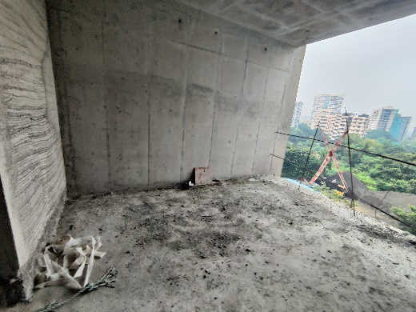
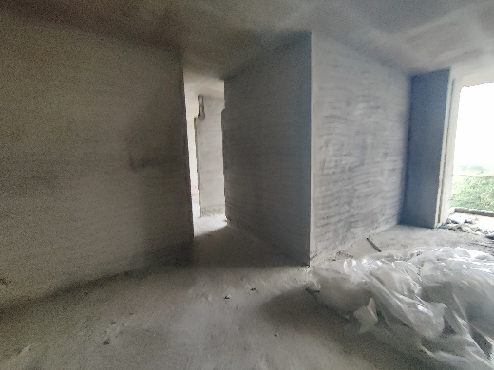
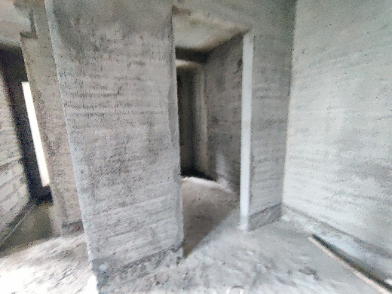
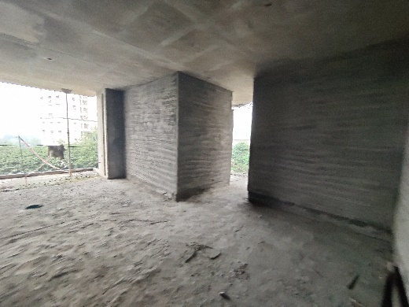
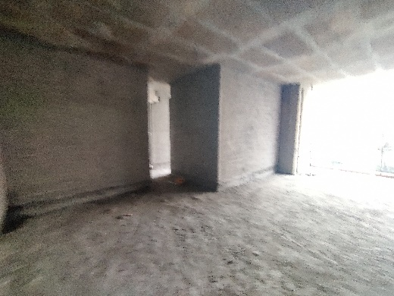
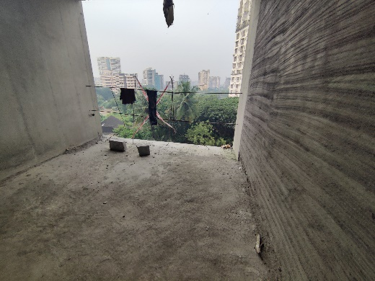
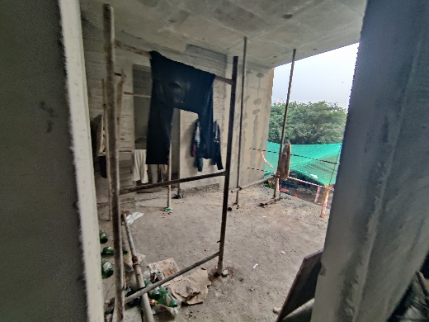
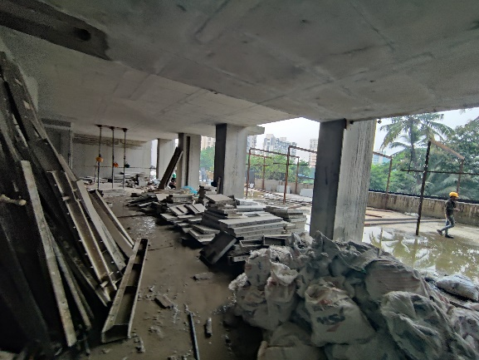
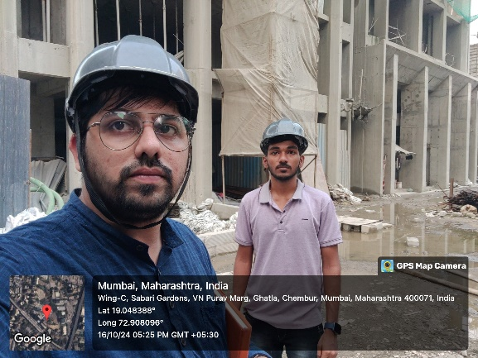
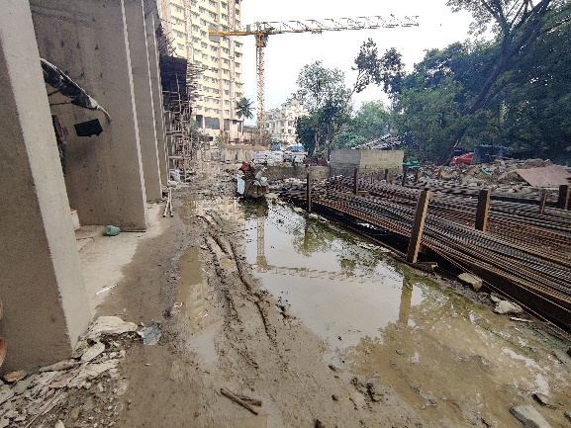
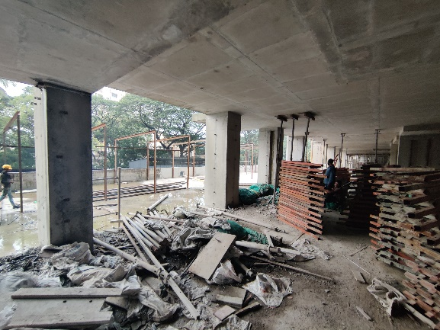
Actual Site Photographs As on 16.10.2024

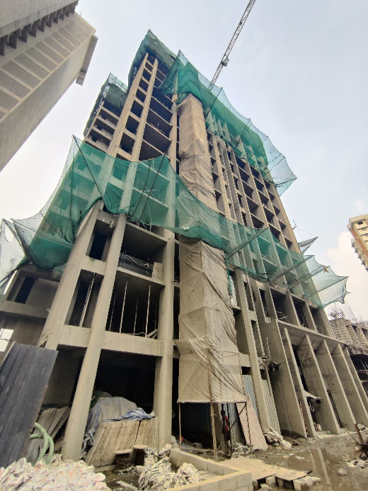
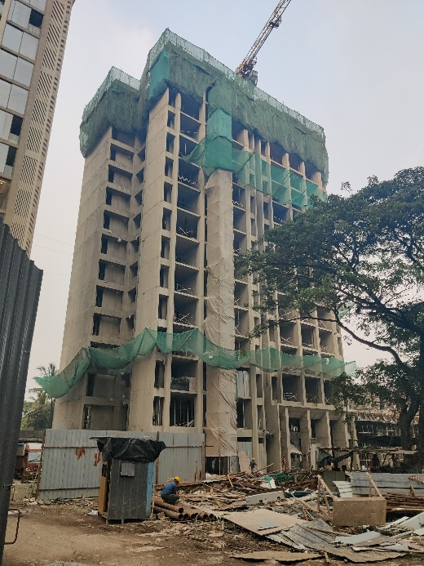
Route Map of the property
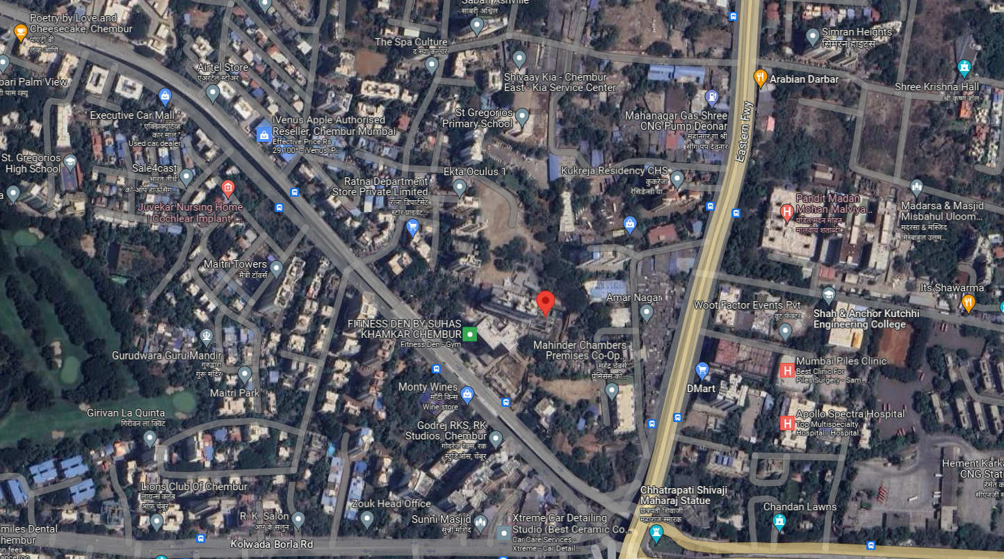
Site u/r

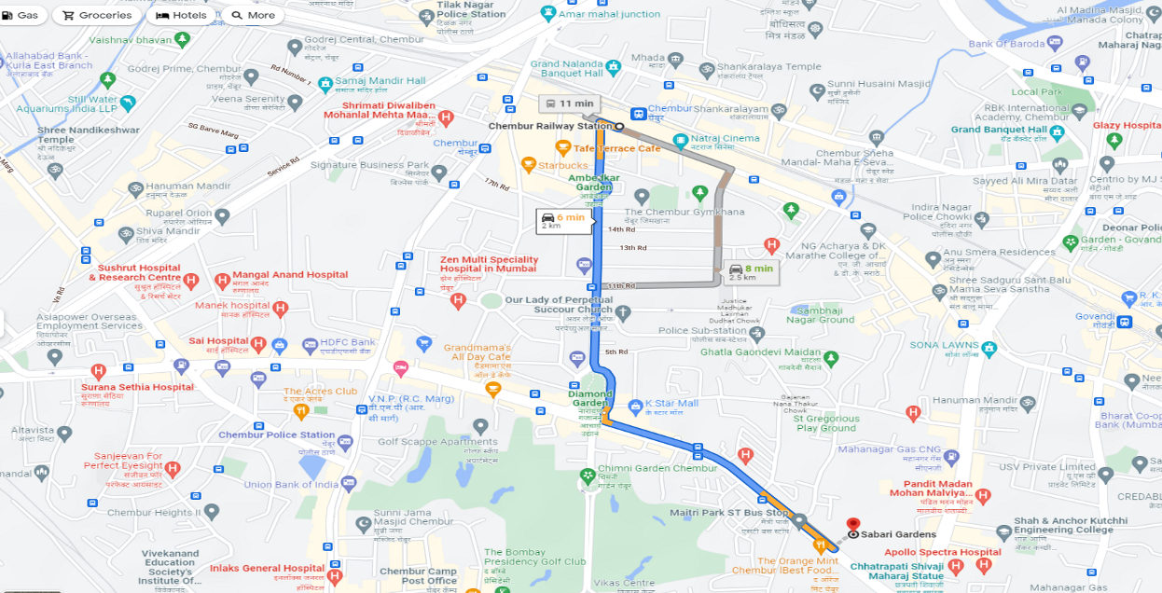

Latitude Longitude: 19°02'54.3"N 72°54'29.6"E

Note: The Blue line shows the route to site from nearest railway station (Chembur – 2.00 Km.)
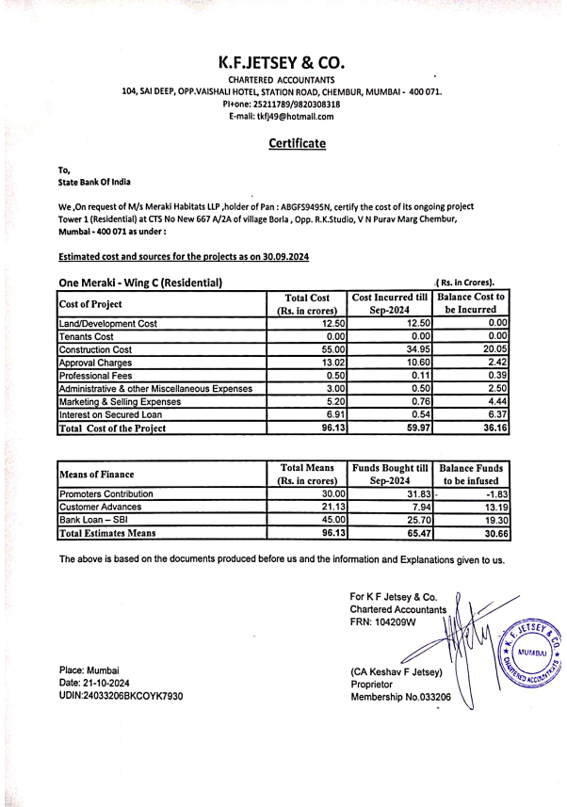
CA Certificate Dated 21.10.2024 till 30.09.2024

