Vastu/Mumbai/02/2025/014290/2309945  
06/06-64-JASH  
 Date: 15.02.2025

**Structural Stability Report**

Structural Observation Residential Flat No. 1102, 11th Floor, **"Rajendra Ratna Co-op. Hsg. Soc. Ltd."**, Plot No. 1, Mahesh Nagar, S. V. Road, Near MTNL Exchange, Village - Malad South, Goregaon (West), Mumbai, Taluka

- Borivali, District - Mumbai Suburban, PIN - 400 104, State - Maharashtra, Country - India.

Name of Owner: **Shri. Sureshkumar B. Maroo S/o. Shri. Benishankar S. Maroo &**

**Shri. Benishankar Sitaram Maroo S/o. Shri. Sitaram Maroo**

This is to certify that on visual inspection, it appears that the structure at **"Rajendra Ratna Co-op. Hsg. Soc. Ltd."** is in good condition and the future life can be reasonably taken under good condition and with proper periodic repairs & maintenance is about 10 years.

**General Information**:

|  |  |  |
| --- | --- | --- |
| **A.** | **Introduction** | |
| 1 | Name of Building | **“Rajendra Ratna Co-op. Hsg. Soc. Ltd.”** |
| 2 | Property Address | Residential Flat No. 1102, 11th Floor, "Rajendra Ratna Co-op. Hsg. Soc. Ltd.", Plot No. 1, Mahesh Nagar, S. V. Road, Near MTNL Exchange, Village - Malad South, Goregaon (West), Mumbai, Taluka - Borivali, District - Mumbai Suburban, PIN - 400 104, State - Maharashtra, Country - India. |
| 3 | Type of Building | Residential |
| 4 | No. of Floors | Ground + 12 Upper Floors |
| 5 | Whether stilt / podium / open parking provided | Open Car Parking Space |
| 6 | Type of Construction | R.C.C. Framed Structure |
| 7 | Type of Foundation | R.C.C. Footing |
| 8 | Thickness of the External Walls | 9” thick brick walls both sides plastered |
| 9 | Type of Compound | Brick Masonry Walls |
| 10 | Year of Construction | 1975 (As per Agreement) |
| 11 | Present age of building | 50 years |
| 12 | Expected balance lift of the building | 10 years Subject to proper, preventive periodic maintenance & structural repairs. |
| 13 | No. of flats (Per Floor) | 11th Floor is having 5 Flats |
| 14 | Methodology adopted | As per visual site inspection |

|  |  |  |
| --- | --- | --- |
| **B.** | **External Observation of the Building** | |
| 1 | Plaster | Good Condition |
| 2 | Chajjas | Good Condition |
| 3 | Plumbing | Good Condition |
| 4 | Cracks on the external walls | Not Found |
| 5 | Filling cracks on the external walls | Not Found |
| 6 | Cracks on columns & beams | Not Found |
| 7 | Vegetation | Not Found |
| 8 | Leakages of water in the drainage pipes or water pipes | Not Found |
| 9 | Dampness external in the wall due to leakages | Not Found |
| 10 | Any other observation about the condition of external side of the building | Structural Stability Report from licensed structural engineers not provided for our verification. |
| **C** | **Internal Observation of the common areas of the building and captioned premises** | |
| 1 | Beams (Cracks & Leakages) | Found some places |
| 2 | Columns (Cracks & Leakages) | Found some places |
| 3 | Ceiling (Cracks & Leakages) | Found some places |
| 4 | Leakages inside the property | Found some places |
| 5 | Painting inside the property | Normal Condition |
| 6 | Maintenance of staircase & cracks | Normal |

|  |  |  |
| --- | --- | --- |
| **D** | **Common Observation** | |
| 1 | Structural Audit of the Building Under Bye – Laws No. 77 of the Model Bye Laws (Co-Operative Societies Act / Rules) | As per bye Laws No. 77 of Co-Op. Societies bye Laws under the Act the society shall conduct a Structural Audit of the building of the society as follows |
| 2 | Remark | 1. **At the time of site inspection, external condition of the building is good, dampness not found, leakages & minor Cracks are found internally.** 2. **Structural Stability Report from licensed structural engineers not provided for our verification.** |

|  |  |
| --- | --- |
| **E** | **Conclusion** |
| The captioned building is having Ground + 12 upper floors which are constructed in year 1975 (As per Agreement). Estimated future life under present circumstances is about 10 years subject to proper, preventive periodic maintenance & structural repairs.  The inspection dated 22.03.2024 and Revisited on 14/02/2025 of building. The building is well as the property is maintained in good condition & will stand future life subject to proper, preventive periodic maintenance & structural repairs.  Our Observations about the structure are given above.  The above assessment is based on visual inspection only. Separate structural audit from licensed structural engineers is advised to assess exact balance life of structure. | |

**Manoj Chalikwar**

Structural Engineer Licence No. STATE/R/2025/APL/15680

Govt. Reg. Valuer

Chartered Engineer (India)

Reg. No. IBBI/RV/07/2018/10366

State Bank of India Empanelment No.: SME/TCC/38/IBBI/3

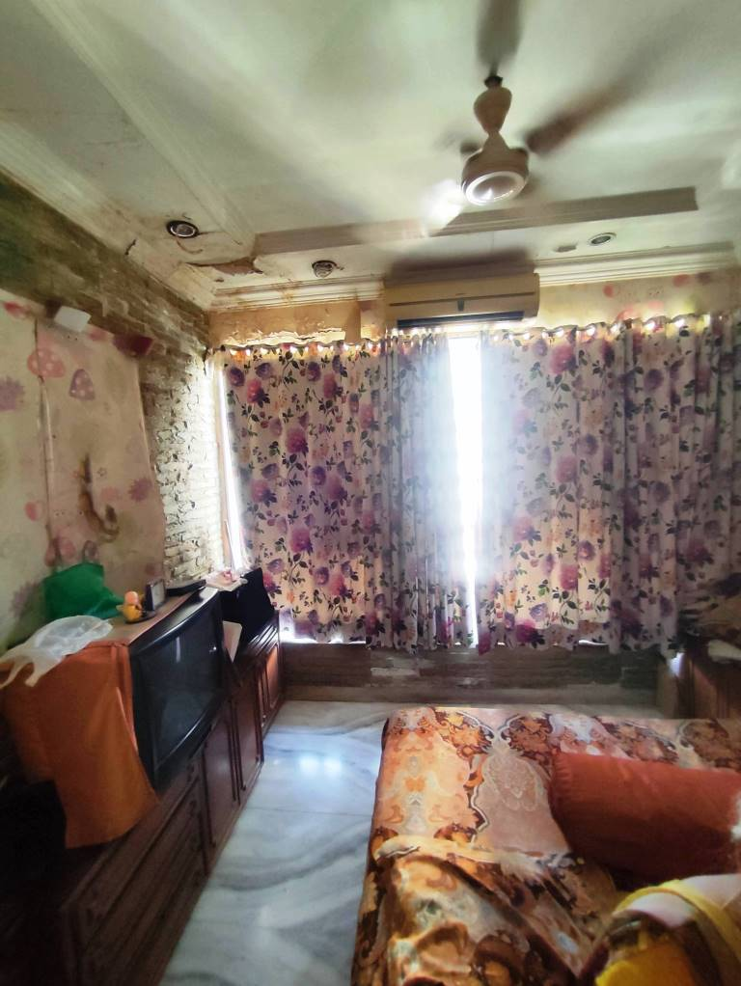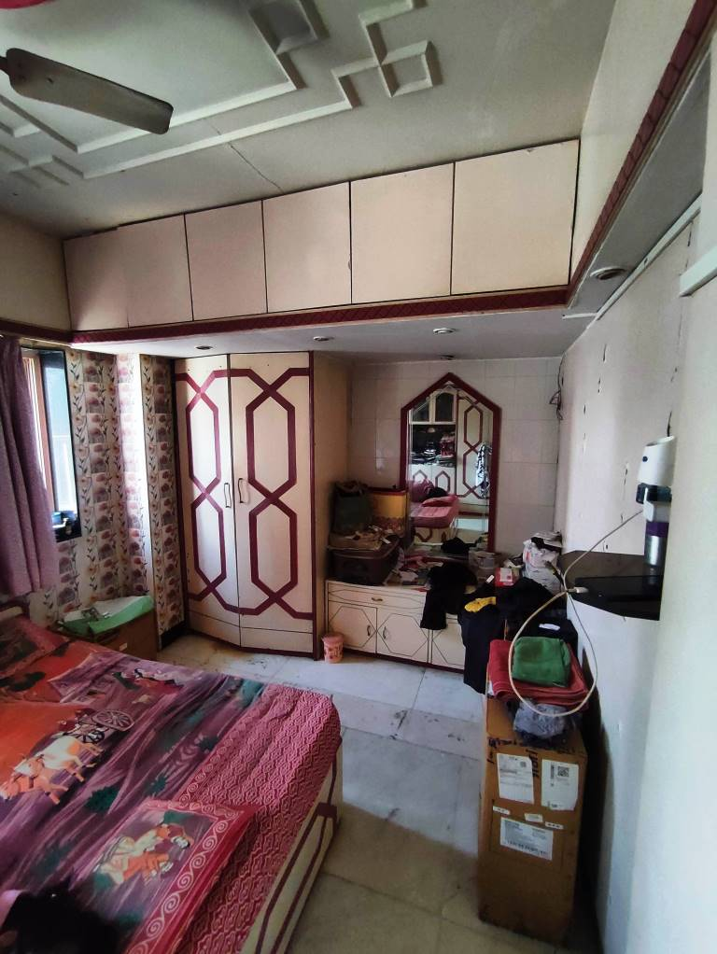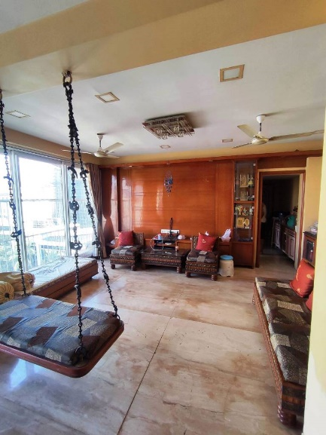**Actual site photographs**

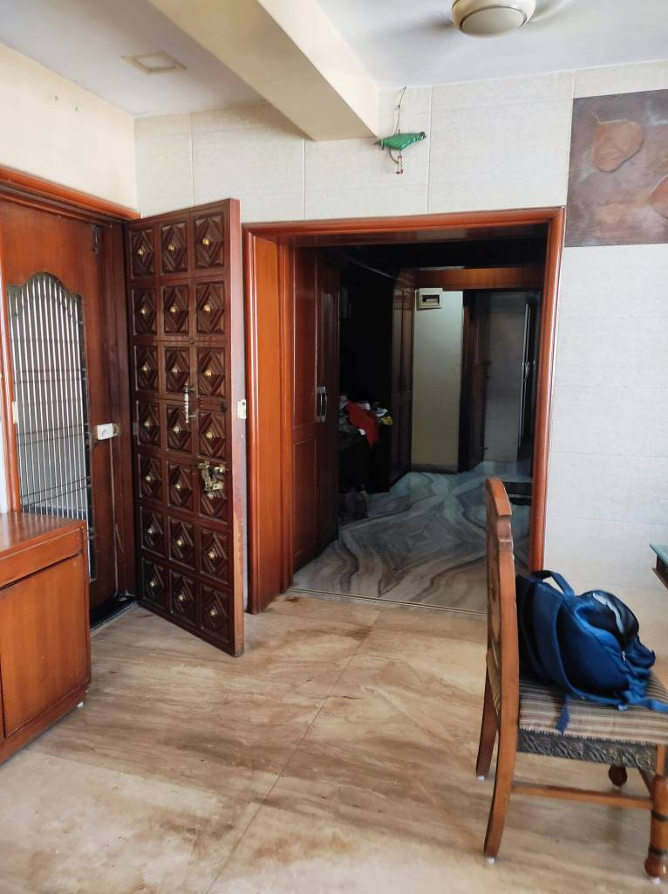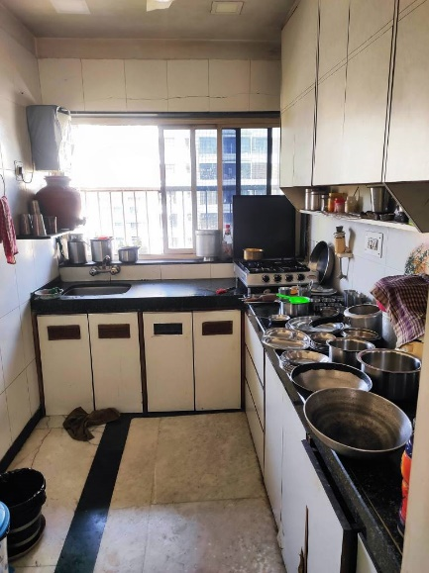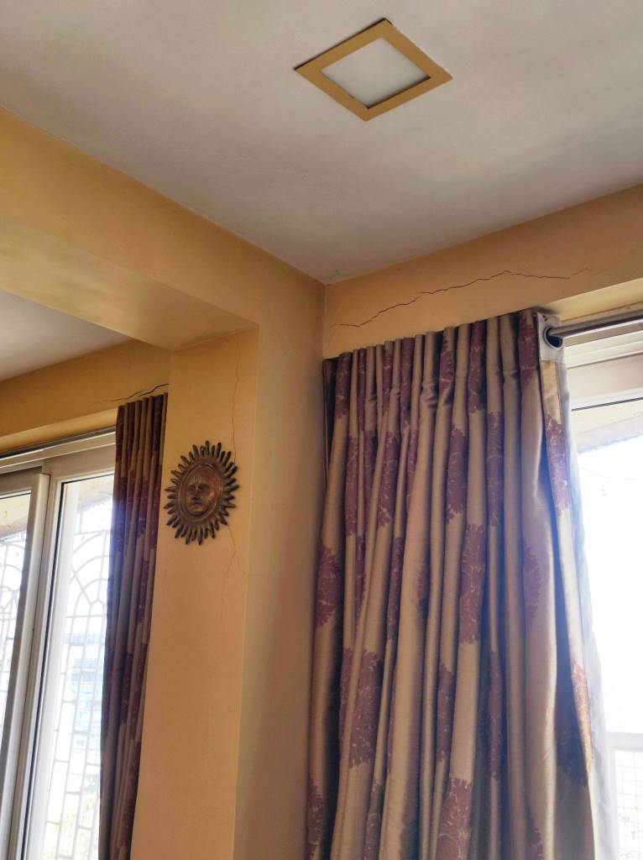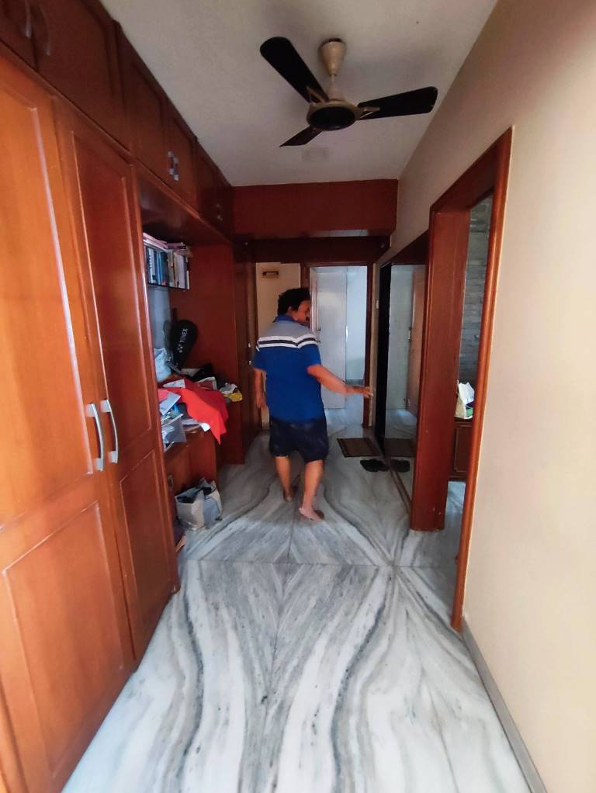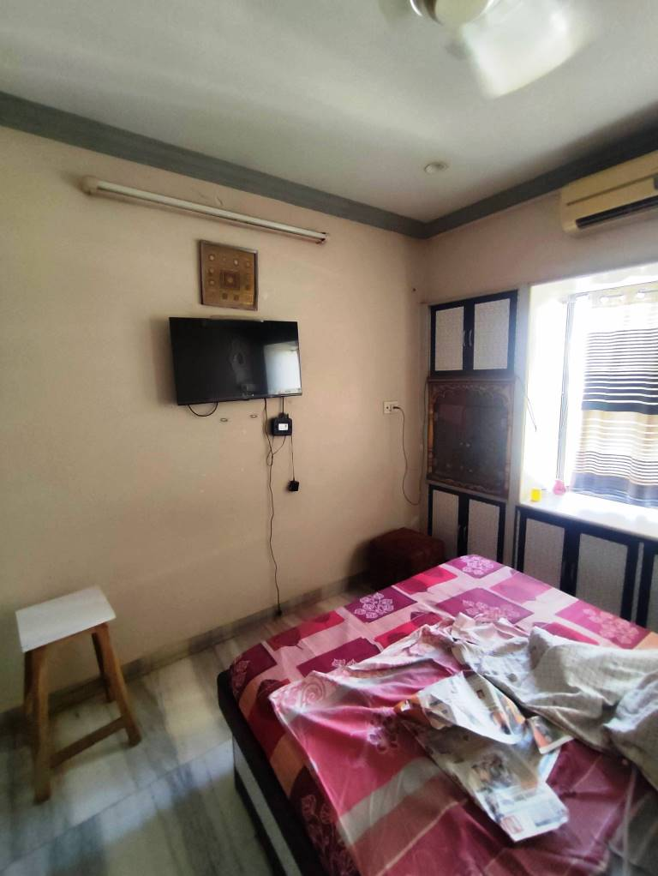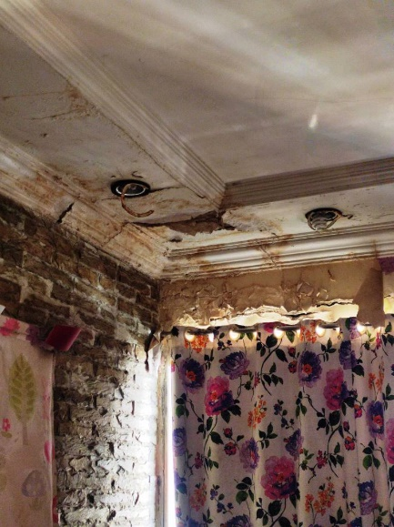

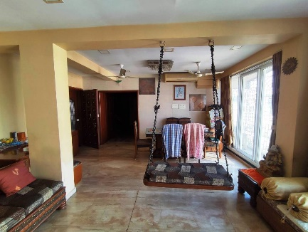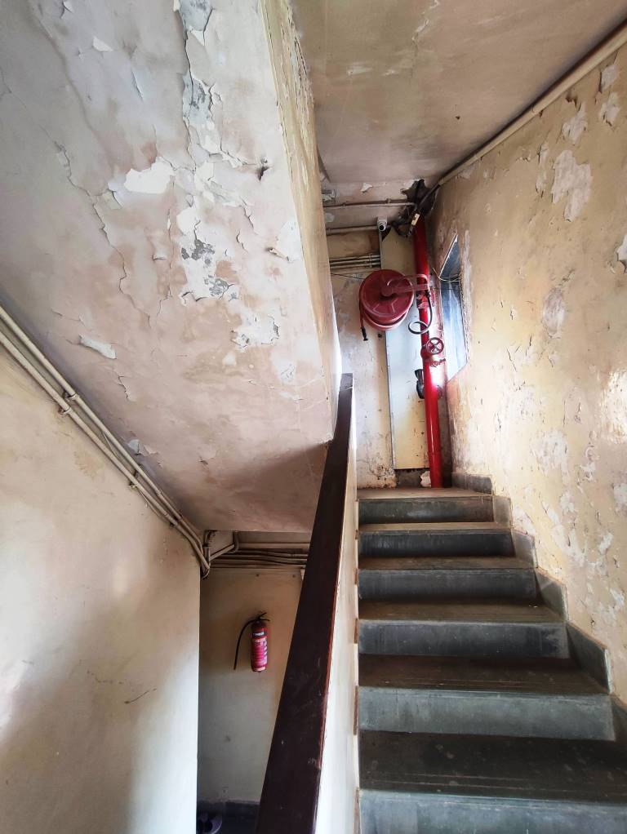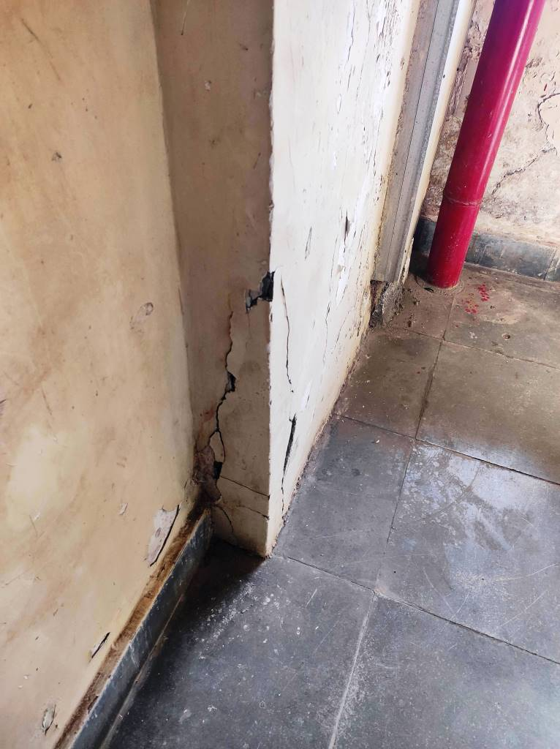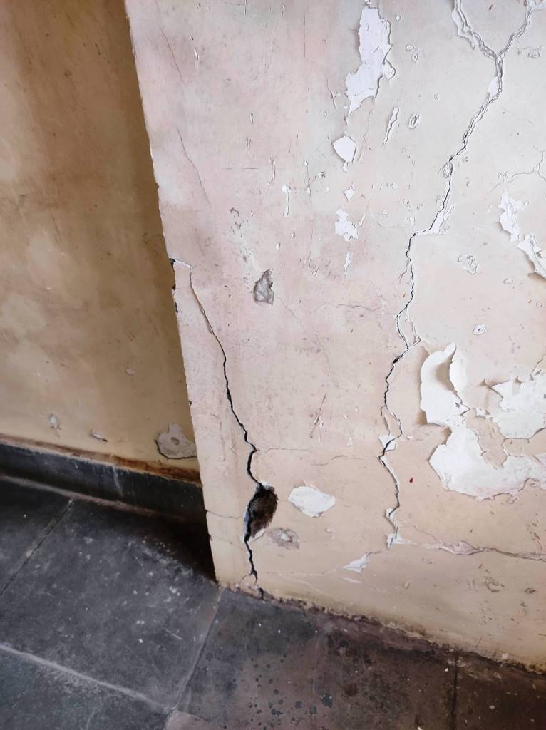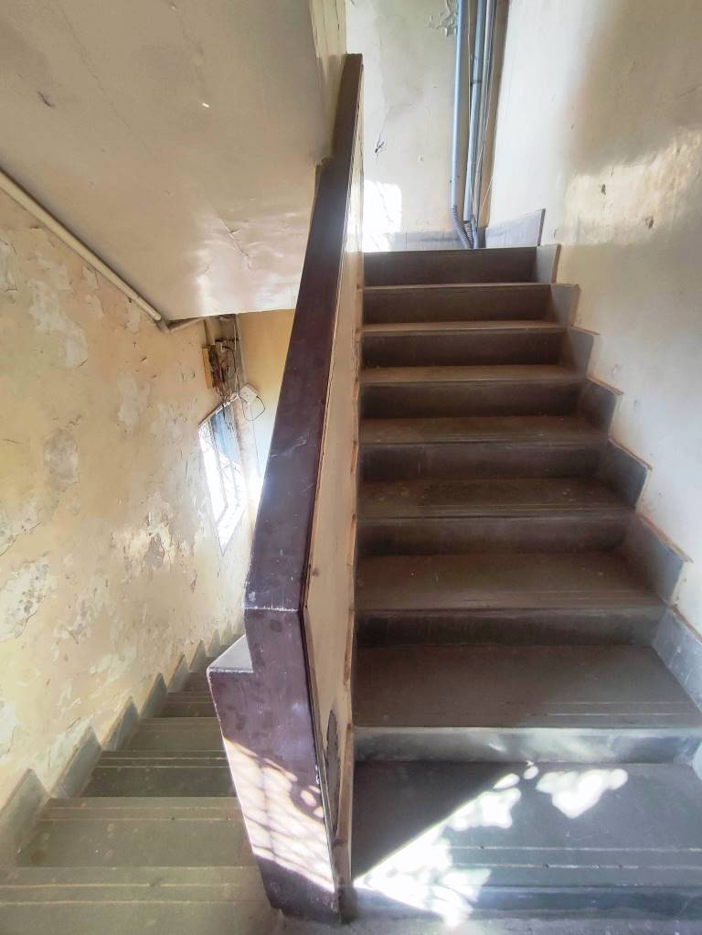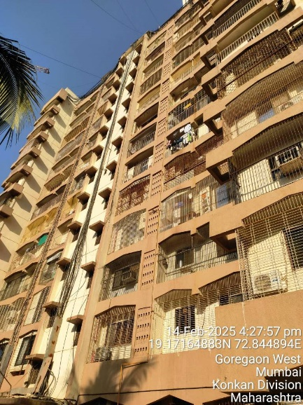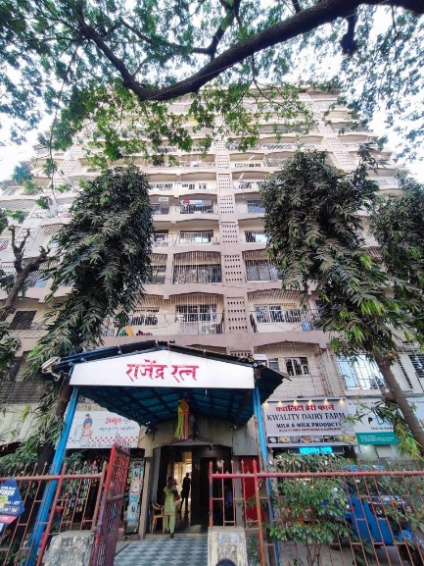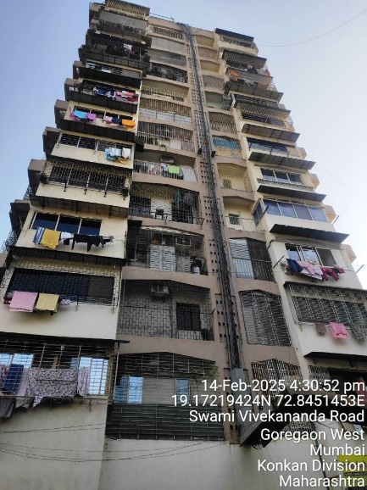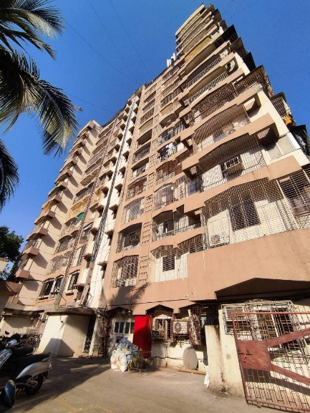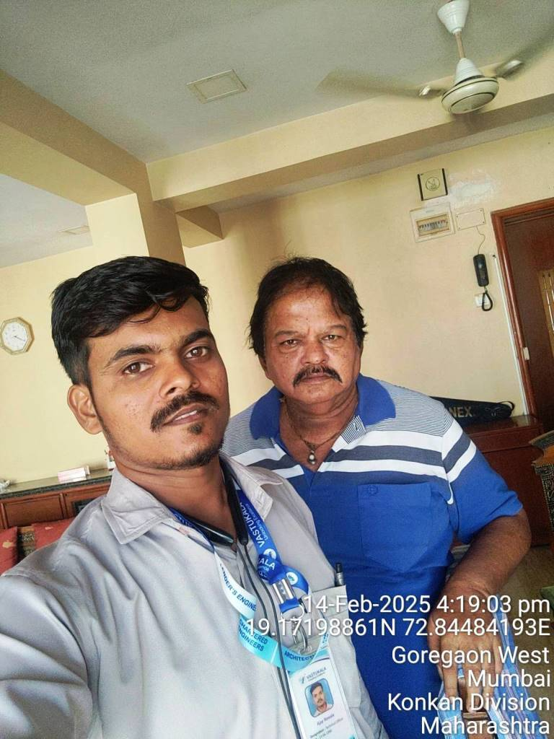**Actual site photographs**