Vastu/Nashik/02/2025/014264/2310516
12/5-166 -RYSP
Date: 12.02.2025
To,
The Branch Manager,
Bank of Baroda
Regional Office
BSNL Building, Datta Mandir Road, Nashik Road,
Nashik, PIN – 422 101, State - Maharashtra, Country - India.

Sub: Vetting of Extra Work

Sir,

With reference to above subject, we have evaluated the Extra Work For Residential Row Bungalow No. 10, Ground Floor + First Floor, " Sai Row Bungalow ", Survey No. 98/ D, Plot No. 13/ 14/ 15/ 16/ 10, Near Sant Tukaram Maharaj Jogging Track, Shivaji Nagar, Gangapur - Satpur Link Road, Village - Gangapur, Taluka & District - Nashik, PIN Code – 422 007, State – Maharashtra, Country – India. belongs Shri. Bhagwat Sahdev Khirade & Lata Sahadev Khirade.

We have verified the rates quoted as per current market rates. Details of Extra Work considered as per copy of Extra Work Agreement between Shri. Bhagwat Sahdev Khirade & Lata Sahadev Khirade (First Party). Sau. Ashwini Gajanan Kawnde (Second Party) received on dated.17.01.2025 The Extra Work amount is Rs. 3,50,000/- (Rupees Three Lakh Fifty Thousand Only)

The said Cost Vetting Certificate is valid upto next 6 months Only.

Thanking you

Sincerely yours

Manoj B. Chalikwar
Registered Valuer
Chartered Engineer (India)
Reg. No. CAT-I-F-1763
Reg. No. IBBI/RV/07/2018/10366
BOB Empanelment No.: ZO:MZ:ADV:46:941
Encl: Valuation report.

Agreement for Extra Work
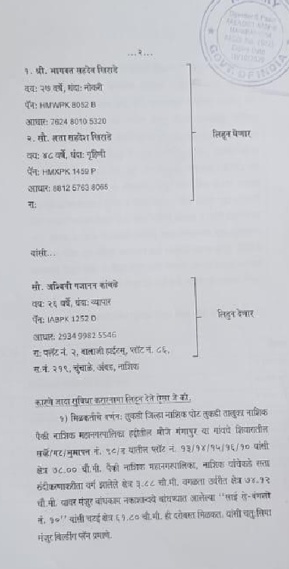
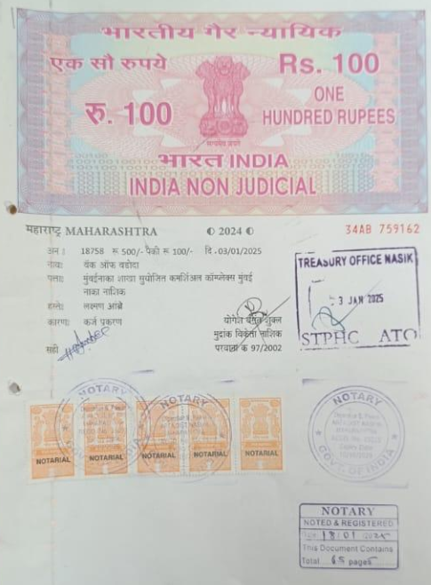

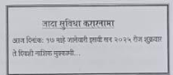

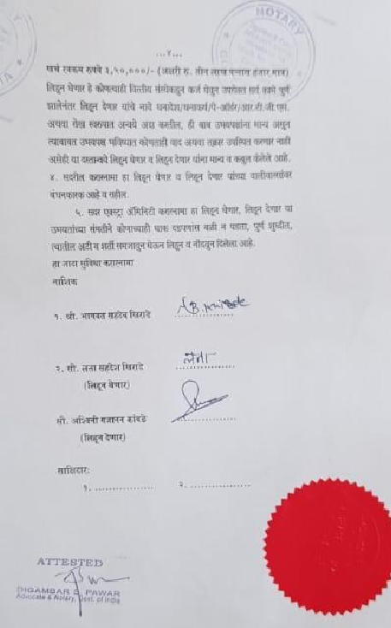
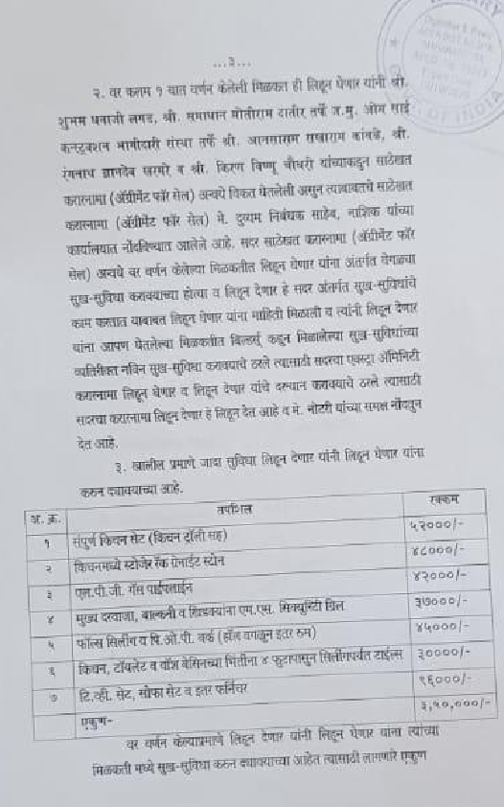

The Extra Work amount is Rs. 3,50,000/- (Rupees Three Lakh Fifty Thousand Only)

