Vastu/Mumbai/02/2022/014252/2310825  
03/2-22-BSM  
 Date: 03.03.2025

**C E R T I F I C A T E**

It is hereby certified that We have inspected The Construction Work of Strong Room of Currency Chest using for storing of Currency Notes & Coins situated at Office No. 1429, Ground Floor, **BANK OF INDIA**, Branch Shanipar, Bajirao Road, Near Janta Sahkari Bank and Shanipar Temple, Pune, State - Maharashtra, India, 411 002, is Suitable & Secure for the Period From 01.04.2025 to 31.03.2026

## Sharadkumar B. Chalikwar

Structural Engineer License No.: STATE/R/2022/APL/01785

Govt. Reg. Valuer

Chartered Engineer (India)

Reg. No. (N) CCIT/1-14/52/2008-09

Encl: Request letter & Photographs.

**Actual Site Photographs**

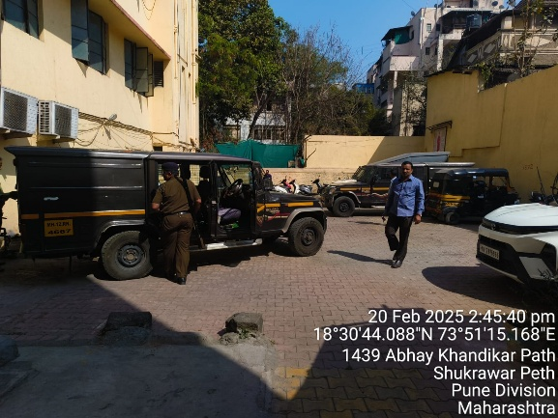 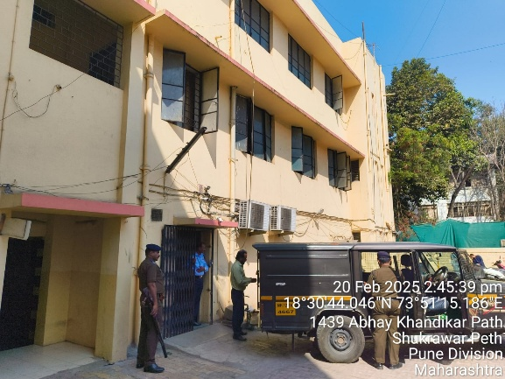

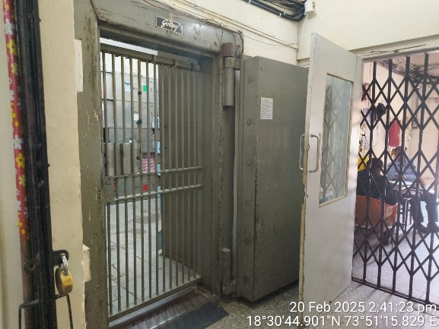 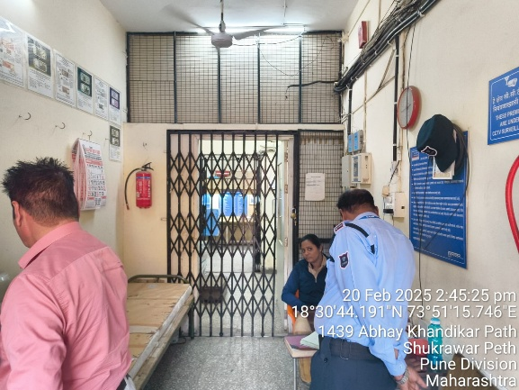

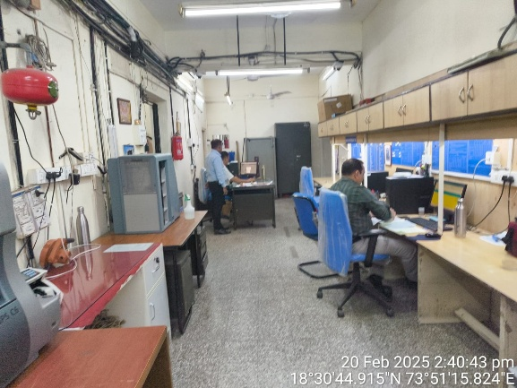 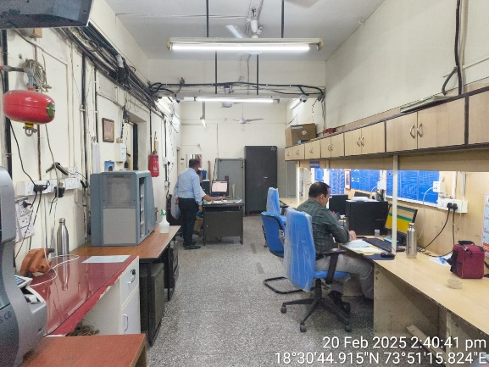

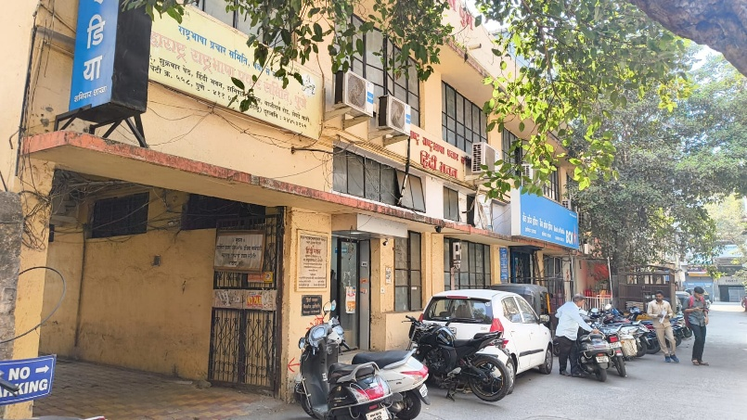

**Route Map of the property**

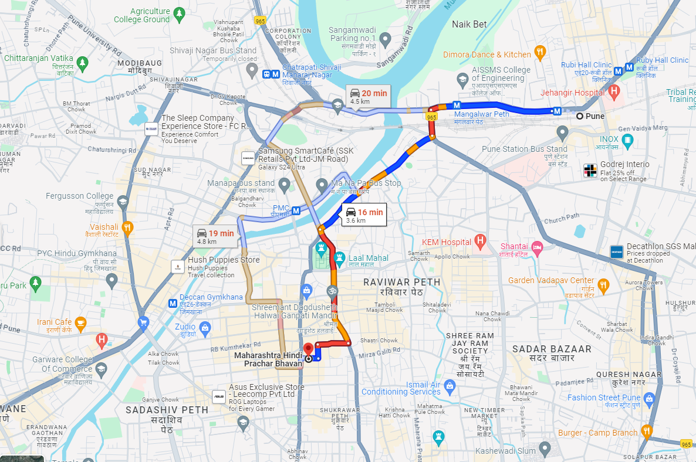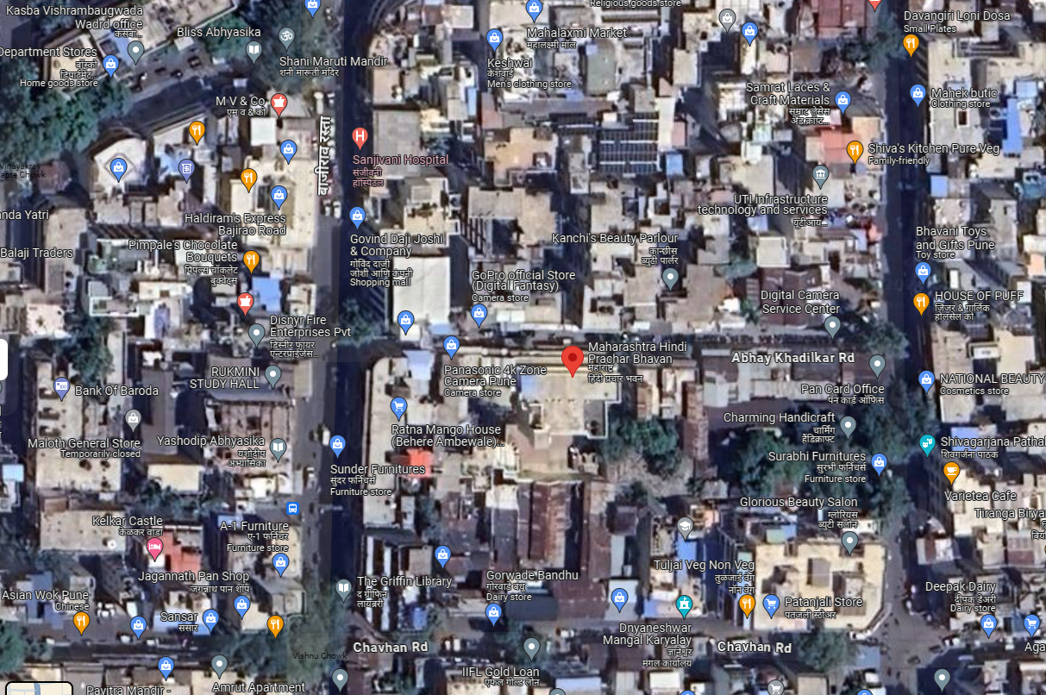

# **Latitude Longitude: 18°30'44.7"N 73°51'15.9"E**

**Note:** The Blue line shows the route to site from nearest railway station (Pune – 3.6 Km.)