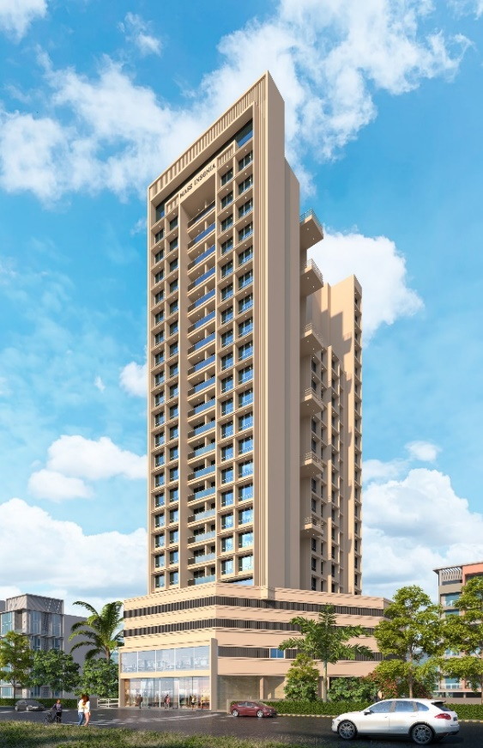
2nd LENDER’S INDEPENDENT ENGINEER REPORT

Details of the property under consideration:

Name of Project: Mass Insignia

"Mass Insignia", Proposed Residential cum Commercial building on Plot bearing Plot No. 59,
Sector No. 34A, Kharghar, Navi Mumbai, Taluka & District – Panvel, PIN – 410 210,
Maharashtra, India

Latitude Longitude: 19°04'10.5"N 73°05'01.7"E

Intended User:

State Bank of India
Panvel Branch
278/1, Safiya Terrace, Mulla Park, M. G. Road, Panvel, Navi Mumbai,
PIN – 410 206, Maharashtra, India

Vastu/SBI/Mumbai/02/2025/14209/2306843
10/03-287-PY
Date: - 10.02.2025

SECOND LENDER’S INDEPENDENT ENGINEER REPORT

To,
The Branch Manager,
State Bank of India
Panvel Branch
278/1, Safiya Terrace,
Mulla Park, M. G. Road,
Panvel, Navi Mumbai, PIN – 410 206,
Maharashtra, India

Subject: Construction of Proposed Residential cum Commercial building on Plot bearing Plot No. 59, Sector No. 34A, Kharghar, Navi Mumbai, Taluka & District – Panvel, PIN – 410 210, Maharashtra, India

Ref: You’re Request for Lenders Independent Engineer Report of under Construction Building.
Dear Sir,
- As per your instruction, we have inspected the under-construction Proposed Residential cum Commercial building on Plot bearing Plot No. 59, Sector No. 34A, Kharghar, Navi Mumbai, Taluka & District – Panvel, PIN – 410 210, Maharashtra, India which is being developed by M/s. Mass Realty in order to give the physical progress at site and to certify cost incurred towards project as on 31/12/2024.
- The Construction work as per approved plan was in progress during the site visit on 28th January 2025.
- Status of work:
- For Sale Building: Till 13th Floor Slab work, Ground Floor + Mezzanine & 4th to 10th floor block work, 5th & 6th floor & 7th floor (5 flats) Plaster work, Ground + 7th floor door frame & window frame water proofing work is completed, 14th floor shuttering work is in progress & 11th floor block work & 8th floor plaster work is in progress.

- As per cost incurred certificate issued by CA Certificate actual total expenditure occurred as on 31/12/2024 is ` 35.52 Cr. for Sale Building & overall financial progress is 53.20% estimated cost of project.
- As per bills actual total expenditure occurred as on 31/12/2024 is ` 35.53 Cr. for Residential of Sale Building & overall financial progress is 53.23% estimated cost of project.
- Overall Physical progress of the sale building construction as on 28/01/2025 is 45.20% as per physical site inspection.

DECLARATION

- The information furnished in the report is based on our 2nd site visit Dated 28/01/2025 & Document Provided by Client.
- Vastukala 1st LIE Report of the project dated 21/06/2024.
- Vastukala Project Report of the project dated 28/12/2023.
- Vastukala Cost Vetting Report of the project dated 28/12/2023.
- I have no direct and indirect interest in the property examined for report.
- I have not been found guilty of misconduct in my professional capacity.

Manoj B. Chalikwar
Registered Valuer
Chartered Engineer (India)
Reg. No. IBBI / RV / 07/2018/10366
Reg. No. CAT-I-F-1763
Encl.: LIE report

Purpose & Methodology
• State Bank of India Banks and financial institutions require monitoring & an independent review of the progress of the sanctioned projects
VCIPL undertakes such study to independently review the progress of the project and put forward a comprehensive analysis

Advantages:
- Assurance on present practices
- Identification of risk
- Analyzing the performance of third parties
- Recommendations

The Methodology
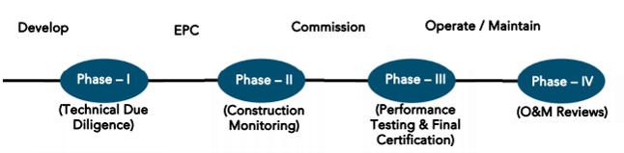
SECOND LENDER’S INDEPENDENT ENGINEER REPORT
OF
"MASS INSIGNIA"
"Mass Insignia", Proposed Residential cum Commercial building on Plot bearing Plot No. 59,
Sector No. 34A, Kharghar, Navi Mumbai, Taluka & District – Panvel, PIN – 410 210, Maharashtra, India

Latitude Longitude: 19°04'10.5"N 73°05'01.7"E

NAME OF DEVELOPER: M/s. Mass Realty
Pursuant to instructions from State of India, Panvel Branch, we have duly visited, inspected, surveyed & assessed the above said property on 28th January 2025 to determine the fair & reasonable market value of the said property/project as on Quarter ending 31st December 2024 for LIE purpose.

1. Location Details:
Proposed Residential cum Commercial building on Plot bearing Plot No. 59, Sector No. 34A, Kharghar, Navi Mumbai, Taluka & District – Panvel, PIN – 410 210. It is about 6.20 Km. travelling distance from Kharghar Railway station. Surface transport to the property is by buses, taxis & private vehicles. The property is in developed locality. All the amenities like shops, banks, hotels, markets, schools, hospitals, etc. are all available in the surrounding locality. The area is middle class & developed.

2. Developer Details:
Name of Developer | M/s. Mass Realty
Project Rera Registration Number | P52000053186
Registered office address | Office No. 601, 6th Floor, Thacker Tower, Plot No. 86, Sector No. 17, Vashi, Navi Mumbai, PIN – 400 703, Maharashtra, India
Contact details | Contact Person:  Mr. Bhavesh Gangar (Owner)  Mobile No. 9819183417  Mr. Prathmesh Deshmukh (Site Engineer)  Mb. No. 7387046363
E – mail ID and website | massrealty601@gmail.com
3. Boundaries of the Property:
Direction | Particulars
On or towards North | Open Plot
On or towards South | Under Construction Building
On or towards East | Under Construction Building
On or towards West | Sai Mannat Road

Introduction
As per Information on site M/s. Mass Realty has acquired land by Lease Deed dated 01.08.2022 through registered vide No. PVL-5/12670/2022 dated 01.08.2022 admeasuring area 1,953.90 Sq. M. bearing Plot No. 59, Sector – 34A. For the Proposed development of Residential cum Commercial Building.

Area Statement:

Land:
Date | Particular | Area in Sq. M.
01.08.2022 | Plot No. 59, Sector – 34A | 1,953.90
TOTAL |  | 1,953.90

- Copy of Lease Agreement dated 01.08.2022 between City and Industrial Development Corporation of Maharashtra Ltd. (CIDCO) (The Corporation) and M/s. Mass Realty (The Licensee) through registered agreement vide No. PVL-5/12670/2022 dated 01.08.2022.
- Copy of Corrigendum to Allotment Letter No. CIDCO/MM-I(Commercial)/2022/948 dated 12.05.2022 issued by City and Industrial Development Corporation of Maharashtra Ltd. (CIDCO).
- Copy of Allotment of Residential + Commercial Plot Letter No. 3622/1000949/805 dated 27.04.2022 issued by City and Industrial Development Corporation of Maharashtra Ltd. (CIDCO).

Building Area As per Approved Plan:
Sr. No. |  | Particulars | Area (Sq. M.)
1 |  | Area of plot (Minimum area of a, b, c to be considered) | 1,953.90
 | a | As per ownership document (7/12, CTS extract) | 1,953.90
 | b | As per measurement sheet | 1,953.90
 | c | As per site | 1,953.90
2 |  | Deductions for
 | a | Proposed D. P. / D. P. Road widening area / service road / highway widening | -
 | b | Any DP reservations area | -
 |  | Total (a + b) | -
3 |  | Balance area of plot (1 – 2) | 1,953.90
4 |  | Amenity spaces (if applicable)
 | a | required | -
 | b | Adjustment of 2(b), if any | -
 | c | Balance proposed | -
5 |  | Net Plot Area (3 – 4(c)) | 1,953.90
6 |  | Recreational Open space (if available)
 | a | Required | -
 | b | Proposed | -
7 |  | Internal Road area | -
8 |  | Plotable Area | 1,953.90
9 | a | Built up area with reference to basic FSI as per front road width (Sr. No. 5 X basic FSI) – Min. of 1.5 as per UDCPR | 2,930.850
 | b | Permissible commercial area | 439.628
 | c | Proposed commercial area (basic excluding ancillary) | 283.935
10 |  | Addition of FSI on payment of premium
 | a | Maximum permissible premium FSI – based on road width / TOD zone. (Plot area X 0.9 premium FSI) plus additional FSI as per Note 3 of 10.10.1 (plot area X 0.1) | 1,953.90
 | b | Proposed FSI on payment | 1,953.90
11 |  | In-situ FSI / TDR loading
 | a | In-situ area against DP road (2.0 X Sr. No. 2(a)), if any | -
 | b | In-situ area against amenity space if handed over (2.00 or 1.85 X Sr. No. 4(b) and / or (c)), | -
 | c | TDR area | -
 | d | Total in-situ / TDR loading proposed (11 (a) + (b) + (c)) | -
12 |  | Additional FSI area under Chapter No. 7
13 |  | Total entitlement of FSI in the proposal
 | a | [9 (a) + 10 (b) + 11 (d)] or 12 whichever is applicable | 4,884.75
 | b | Permissible ancillary area FSI upto 60% or 80% on balance potential with payment of charges | 2,989.467
 | c | Proposed Ancillary area FSI | 2,950.396
 | d | Total entitlement (a + b) | 7,874.217
14 |  | Maximum utilization limit of FSI (building potential) permissible as per road width [{as per regulation no. 6.1 or 6.2 or 6.3 or 6.4 as applicable} X 1.6 or 1.8] read with Note 3 of 10.10.1 | 4.029
15 |  | Total Built-up area in proposal | 7,835.15
 | a | Existing Built-up Area | -
 |  | Residential | -
 |  | Commercial | -
 | b | Proposed Built-up Area (as per P-line) | 7,835.15
 |  | Residential | 7,324.06
 |  | Commercial | 511.083
 | c | Total (a + b) (shall not be more than 13{d}) | 7,835.15
16 |  | FSI Consumed (15/13) (should not be more than serial no. 14 above) | 0.995
17 |  | Area for inclusive housing, if any
 | a | Required (20% of Sr. No. 5) | -
 | b | Proposed | -

List of Approvals:
- Copy of Approved Plan No. CIDCO/BP-18496/TPO(NM & K)/2023/11057 dated 18.08.2023 issued by City and Industrial Development Corporation of Maharashtra Ltd. (CIDCO)
Approved upto: Ground Floor + Mezzanine Floor + 1st Commercial Floor + 2nd to 4th Podium Floors + 5th to 19th Upper Residential Floors
- Copy of Commencement Certificate No. CIDCO/BP-18496/TPO (NM & K)/2023/11057 dated 18.08.2023 issued by City and Industrial Development Corporation of Maharashtra Ltd. (CIDCO).
(This CC is endorsed for the work for Ground Floor + Mezzanine Floor + 1st Commercial Floor + 2nd to 4th Podium Floors + 5th to 19th Upper Residential Floors for Net Built – Up Area of 7835.10 Sq. M.)
- Copy of Fire NOC Certificate No. CIDCO/FIRE/HQ/2023/E-222730 dated 30.06.2023 issued by City and Industrial Development Corporation of Maharashtra Ltd. (CIDCO).
- Copy of No Objection Certificate for Height Clearance NOC ID No. NAVI/WEST/B/081122/688949 dated 06.10.2022 valid upto 05.10.2023 issued by Airports Authority of India.

LEVEL OF COMPLETION:

Sales Building
Sr. No | Floor No. | Construction Area in Sq. M. | Completed Area in Sq. M. | Work Completion as on 28.01.2025 | Work Completion as on 15.06.2024
1 | Excavation & Shore Piling |  |  | Work is Completed | Work is Completed
2 | Ground Floor | 1,027.68 | 1,027.68 | Slab Work, block work, door & window frame, plaster work, waterproofing work is completed. | Slab Work is completed
3 | Mezzanine | 670.40 | 670.40 | Slab Work & block work is completed | Slab Work is completed
4 | 1st Floor | 963.37 | 963.37 | Slab Work is completed, block work is in progress | Slab Work is completed
5 | 2nd Floor | 990.33 | 990.33 | Slab Work, block work, waterproofing work is completed. | Slab Work is completed
6 | 3rd Floor | 990.33 | 990.33 | Slab Work, block work, waterproofing work is completed. | Slab Work is completed
7 | 4th Floor | 615.77 | 615.77 | Slab Work, block work, waterproofing work is completed. | Slab Work is completed
8 | 5th Floor | 551.83 | 551.83 | Slab Work, block work, door & window frame, plaster work, waterproofing work is completed. | Shuttering work is completed
9 | 6th Floor | 551.83 | 551.83 | Slab Work, block work, door & window frame, plaster work, waterproofing work is completed.
10 | 7th Floor | 588.28 | 588.28 | Slab Work, block work, door & window frame, 5 flats (80%) plaster work, waterproofing work is completed.
11 | 8th Floor | 551.77 | 551.77 | Slab Work, block work is completed, plaster work, door & window frame work is in progress.
12 | 9th Floor | 551.77 | 551.77 | Slab Work, block work is completed, door frame work is in progress.
13 | 10th Floor | 588.28 | 588.28 | Slab Work, block work is completed, door frame work is in progress.
14 | 11th Floor | 551.77 | 551.77 | Slab Work is completed, block work is in progress
15 | 12th Floor | 551.77 | 551.77 | Slab Work is completed
16 | 13th Floor | 585.99 | 585.99 | Slab Work is completed
17 | 14th Floor | 542.23 |  | Shuttering work is completed
18 | 15th Floor | 410.14
19 | 16th Floor | 448.47
20 | 17th Floor | 411.96
21 | 18th Floor | 411.96
22 | 19th Floor | 411.96
Total |  | 12,967.83 | 10,331.13

Details of the Project as Financed By SBI:

Estimated Project Cost: (As per Cost Vetting Report)
Particulars | Estimated Cost (in Cr.)
Land Cost | 17.98
Construction cost of Building | 35.01
Premium Cost / FSI / GOM Charges / fees / security Deposits | 5.44
Architect Cost, RCC & Other Professional Cost | 1.40
Administrative Cost | 1.05
Marketing Cost | 1.68
Interest Cost | 3.50
Contingency Cost | 0.70
Total | 66.76

Project Cost: (as per C.A. Certificate)
Particulars | Incurred Cost (In Cr.) till 31.12.2024 dated 15.01.2025 by M/s. J B Patel and Associates | Incurred Cost (In Cr.) till 22.05.2024 dated 27.05.2024 by M/s. Jatin Vora & Associates | Net
Land Cost | 17.98 | 17.98 | -
Construction cost of Building | 11.47 | 5.65 | 5.82
Premium Cost / FSI / GOM Charges / fees / security Deposits | 5.55 | 5.13 | 0.42
Architect Cost, RCC & Other Professional Cost | 0.51 | 0.14 | 0.37
Administrative Cost
Marketing Cost
Interest Cost | - | - | -
Contingency Cost | - | - | -
Total | 35.52 | 28.90 | 6.62

- The Builder has incurred about 11.47 Cr. as construction cost, 5.55 Cr. for approval of project, 0.51 Cr. for others cost in last quarter till 31.12.2024 as per C.A. certificate issued by M/s. J B Patel and Associates dated 15.01.2025.

Project Cost: (as per Bills):
Particulars | Incurred Cost (in Cr.) |  | Net
 | 31.12.2024 as per Bill (Inclusive GST) | 15.06.2024 as per Bill (Inclusive GST)
Land Cost | 17.98 | 17.98 | -
Construction cost of Building | 9.82 | 5.95 | 3.88
Premium Cost / FSI / GOM Charges / fees / security Deposits | 5.31 | 5.14 | 0.17
Architect Cost, RCC & Other Professional Cost | 0.17 | 0.14 | 0.03
Administrative Cost | 1.09 | 0.65 | 0.44
Marketing Cost | 0.99 | 0.23 | 0.76
Interest Cost | 0.16 | - | 0.16
Contingency Cost | - | - | -
Total | 35.53 | 30.09 | 5.44
Note:

Land Cost:
Sr. | Agreement Name | Date | Particulars | Total Cost in ` | Incurred Cost in `
1 | Lease Agreement | 01.08.2022 | Purchase | 16,71,63,960.60 | 16,71,63,960.60
2 |  |  | Stamp Duty | 83,58,500.00 | 83,58,500.00
3 |  |  | Reg. Fees | 30,000.00 | 30,000.00
4 |  |  |  | 800.00 | 800.00
5 |  |  | Other Charges | 23,93,870.38 | 23,93,870.38
6 |  |  | GST Amount | 19,00,895.12 | 19,00,895.12
TOTAL |  |  |  | 17,98,48,026.00 | 17,98,48,026.00
As per Lease agreement.
Summary of Bills
Sr. No. | Particulars | Amount in `  (till 31.12.2024) | Amount in ` (in Cr.) | Amount in `  (till 15.06.2024) | Amount in ` (in Cr.) | Net
1 | Construction Cost | 9,82,35,577.00 | 9.82 | 5,94,53,019.00 | 5.95 | 3.88
2 | Premium Cost / FSI / GOM Charges / fees / security Deposits | 5,30,77,865.00 | 5.31 | 5,13,94,540.00 | 5.14 | 0.17
3 | Professional Cost | 17,05,306.00 | 0.17 | 14,01,427.00 | 0.14 | 0.03
4 | Administrative Cost | 1,09,18,498.00 | 1.09 | 64,74,663.00 | 0.65 | 0.44
5 | Marketing Cost | 99,22,101.00 | 0.99 | 23,32,717.00 | 0.23 | 0.76
6 | Contingency Cost | - | - | - | - | -
TOTAL |  | 17,38,59,347.00 | 17.39 | 12,10,56,366.00 | 12.11 | 5.28
Note: Bills were provided by the client up to 31.12.2024

Interest Cost:
Sr. No | Particulars | Estimate Amount in ` | Incurred Amount in ` (till 31.12.2024) | Incurred Amount in ` (till 15.06.2024) | Difference in ` | Balance Amount in `
1 | Interest Cost | 3,50,00,000.00 | 16,31,987.00 | - | 16,31,987.00 | 3,33,68,013.00
TOTAL |  | 3,50,00,000.00 | 16,31,987.00 | - | 16,31,987.00 | 3,33,68,013.00
Interest Cost is based on discussion with the client.

Cost of Construction as on 28th January 2025:
Sr. No | Floor | Total Construction Area in Sq. M. | Completed Area in Sq. M. | Rate per Sq. M. | Full Value after completion | % of work completed | Actual Expenditure till date in `
1 | Ground Floor | 1,027.68 | 1,027.68 | 27,000.00 | 2,77,47,279.00 | 65% | 1,80,35,731.35
2 | Mezzanine | 670.40 | 670.40 | 27,000.00 | 1,81,00,773.00 | 60% | 1,08,60,463.80
3 | 1st Floor | 963.37 | 963.37 | 27,000.00 | 2,60,11,017.00 | 50% | 1,30,05,508.50
4 | 2nd Floor | 990.33 | 990.33 | 27,000.00 | 2,67,38,910.00 | 50% | 1,33,69,455.00
5 | 3rd Floor | 990.33 | 990.33 | 27,000.00 | 2,67,38,910.00 | 50% | 1,33,69,455.00
6 | 4th Floor | 615.77 | 615.77 | 27,000.00 | 1,66,25,790.00 | 60% | 99,75,474.00
7 | 5th Floor | 551.83 | 551.83 | 27,000.00 | 1,48,99,275.00 | 70% | 1,04,29,492.50
8 | 6th Floor | 551.83 | 551.83 | 27,000.00 | 1,48,99,275.00 | 70% | 1,04,29,492.50
9 | 7th Floor | 588.28 | 588.28 | 27,000.00 | 1,58,83,425.00 | 64% | 1,01,65,392.00
10 | 8th Floor | 551.77 | 551.77 | 27,000.00 | 1,48,97,655.00 | 60% | 89,38,593.00
11 | 9th Floor | 551.77 | 551.77 | 27,000.00 | 1,48,97,655.00 | 60% | 89,38,593.00
12 | 10th Floor | 588.28 | 588.28 | 27,000.00 | 1,58,83,506.00 | 60% | 95,30,103.60
13 | 11th Floor | 551.77 | 551.77 | 27,000.00 | 1,48,97,655.00 | 50% | 74,48,827.50
14 | 12th Floor | 551.77 | 551.77 | 27,000.00 | 1,48,97,655.00 | 50% | 74,48,827.50
15 | 13th Floor | 585.99 | 585.99 | 27,000.00 | 1,58,21,730.00 | 40% | 63,28,692.00
16 | 14th Floor | 542.23 |  | 27,000.00 | 1,46,40,129.00 |  | -
17 | 15th Floor | 410.14 |  | 27,000.00 | 1,10,73,645.00 |  | -
18 | 16th Floor | 448.47 |  | 27,000.00 | 1,21,08,636.00 |  | -
19 | 17th Floor | 411.96 |  | 27,000.00 | 1,11,22,866.00 |  | -
20 | 18th Floor | 411.96 |  | 27,000.00 | 1,11,22,866.00 |  | -
21 | 19th Floor | 411.96 |  | 27,000.00 | 1,11,22,866.00 |  | -
TOTAL |  | 12,967.83 | 10,331.13 |  | 35,01,31,518.00 | 45.20% | 15,82,74,101.25

Note: Details of work completed is as per site visit dated 28.01.2025 but report is prepared for 31st December quarter 2024.

Particulars | Estimated Cost  (In Cr.) | Incurred Cost (in Cr.) |  |  | Net
 |  | Issued dated 15.01.2025 till 31.12.2024 as per CA | As per Bills upto 31.12.2024 | As per Bills upto 15.06.2024
Land Cost | 17.98 | 17.98 | 17.98 | 17.98 | -
Construction cost of Building | 35.01 | 11.47 | 9.82 | 5.95 | 3.88
Premium Cost / FSI / GOM Charges / fees / security Deposits | 5.44 | 5.55 | 5.31 | 5.14 | 0.17
Architect Cost, RCC & Other Professional Cost | 1.40 | 0.51 | 0.17 | 0.14 | 0.03
Administrative Cost | 1.05 |  | 1.09 | 0.65 | 0.44
Marketing Cost | 1.68 |  | 0.99 | 0.23 | 0.76
Interest Cost | 3.50 | - | 0.16 | - | 0.16
Contingency Cost | 0.70 | - | - | - | -
Total | 66.76 | 35.52 | 35.53 | 30.09 | 5.44

Note:
We have considered Water Charges, security charges, bank processing fees, in Admininstrative cost header but CA has considered them in cost of construction header .
We have considered interest cost in Interest cost header but CA has considered them in cost of construction header .
As per site inspection, 45.20% of total work is completed, which amounts to ` 15.83 Cr. However, as per data provided by client, they have incurred the cost of ` 9.82 Cr. till 30.09.2024.

Comparison of Cost incurred on dated 31.12.2024 & 15.06.2024
Particulars | 31.12.2024 as per Bill | 15.06.2024 as per Bill | Net | % of net amount
Land Cost | 17.98 | 17.98 | - | 0.00%
Construction cost of Building | 9.82 | 5.95 | 3.88 | 10.92%
Premium Cost / FSI / GOM Charges / fees / security Deposits | 5.31 | 5.14 | 0.17 | 0.48%
Architect Cost, RCC & Other Professional Cost | 0.17 | 0.14 | 0.03 | 0.08%
Administrative Cost | 1.09 | 0.65 | 0.44 | 1.24%
Marketing Cost | 0.99 | 0.23 | 0.76 | 2.14%
Interest Cost | 0.16 | - | 0.16 | 0.45%
Contingency Cost | - | - | - | 0.00%
Total | 35.53 | 30.09 | 5.44 | 15.31%

% of Fund Utilised till 31st December 2024
Particulars | Estimated Project Cost  (in Cr.) | Incurred cost as on 31.12.2024 | % of Incurred Cost | % of Estimated Project Cost
Land Cost | 17.98 | 17.98 | 100.00% | 26.94%
Construction cost of Building | 35.01 | 9.82 | 28.06% | 14.71%
Premium Cost / FSI / GOM Charges / fees / security Deposits | 5.44 | 5.31 | 97.57% | 7.95%
Architect Cost, RCC & Other Professional Cost | 1.40 | 0.17 | 12.18% | 0.26%
Administrative Cost | 1.05 | 1.09 | 103.99% | 1.64%
Marketing Cost | 1.68 | 0.99 | 59.06% | 1.49%
Interest Cost | 3.50 | 0.16 | 4.66% | 0.24%
Contingency Cost | 0.70 | - | 0.00% | 0.00%
Total | 66.76 | 35.53 | 53.23% | 53.23%
Based on above Calculation it is found that total Project cost incurred is 53.23% of the Total Project Cost.

Means of Finance:
Sr. No. | Particulars | Exp. Cumulative (Cr.)
 | Equity share capital / Quassi Loan from Promoter (Partner’s Capital) | 4.65
 | Sales (Advance from customer) | 7.98
 | Bank Laon Amount | 2.04
 | Unsecured Loan amount | 20.84
 | Total | 35.52
The Details of the Means of Finance are provided by Client as on 31.12.2024.

Mandatory Arrangements:
Sr. No. | Particulars | Status
 | Rainwater Harvesting | To be executed after RCC Structure
 | Firefighting System | To be executed after RCC Structure
 | Solid Waste Management | To be executed after RCC Structure

Quality of Construction:
Sr. No. | Particulars | Status
 | Soundness of Structures | Executing as per approved Structural Design
 | Look of Structures | Good
 | Quality of Material Used | Good
 | Safety Measures for Construction/labour | Taken Care by Contractor

Schedule V/s. Actual Progress:
Activity | Date of Implementation | Date of Completion | Status
Land | October 2023 | December 2023 | Completed
Development of Land |  |  | Completed
Foundation Work |  |  | Completed
Ground Floor Slab | January 2024 | March 2024 | Slab work is Completed
1st Floor Slab |  |  | Slab work is Completed
2nd Floor Slab |  |  | Slab work is Completed
3rd Floor Slab | April 2024 | June 2024 | Slab work is Completed
4th Floor Slab |  |  | Slab work is Completed
5th Floor Slab |  |  | Slab work is Completed
6th Floor Slab | July 2024 | September 2024 | Slab work is Completed
7th Floor Slab |  |  | Slab work is Completed
8th Floor Slab |  |  | Slab work is Completed
9th Floor Slab | October 2024 | December 2024 | Slab work is Completed
10th Floor Slab |  |  | Slab work is Completed
11th Floor Slab |  |  | Slab work is Completed
12th Floor Slab | January 2025 | March 2025 | Slab work is Completed
13th Floor Slab |  |  | Slab work is Completed
14th Floor Slab |  |  | Shuttering work is in progress
15th Floor Slab | April 2025 | June 2025
16th Floor Slab
17th Floor Slab
18th Floor Slab | July 2025 | September 2025
19th Floor Slab
Block work / Internal Plaster work | October 2025 | March 2026 | Ground, Mezzanine Floor & 5th & 6th floor block work is completed
Terrace Parapet wall / Overhead water tank / Lift Machine room / compound wall / External Plaster work | July 2025 | March 2027
Electric Work | April 2026 | June 2026
Water Proofing
Plumbing Work
Tiling / Marble Flooring
Door Frames
Window Installation
Staircase Flooring
Staircase Railing
Refuge Area Flooring
Internal Painting | January 2027 | March 2027
External Painting
Lift Work | October 2026 | December 2026
Fire Fighting Installation
CP Fitting & Sanitary Work | July 2027 | September 2027
Final Finishing & Fitting | January 2028 | March 2028

Action initiated to complete the project in time:
For Sales Building: Till 13th Floor Slab work, Ground Floor + Mezzanine & 4th to 10th floor block work, 5th & 6th floor & 7th floor (5 flats) Plaster work, Ground + 7th floor door frame & window frame water proofing work is completed, 14th floor shuttering work is in progress & 11th floor block work & 8th floor plaster work is in progress.

Comments related to cost overrun if any:
The cost of Sales Building is ` 66.76 Cr.

Balance investment required for completion of project:
We opinion amount of ` 31.23 Cr. Will be required to complete the Project.

Mandatory Approval Status:
Sr. No. | Particulars | Name of Department | Status | Order Details
1 | Approved Plan | City and Industrial Development Corporation of Maharashtra Ltd. (CIDCO) | Obtained and available at site | CIDCO / BP – 18496 / TPO (NM & K) / 2023 / 11057 dated 18.08.2023
2 | First C.C. | City and Industrial Development Corporation of Maharashtra Ltd. (CIDCO) | Obtained and available at site | CIDCO / BP – 18496 / TPO (NM & K) / 2023 / 11057 dated 18.08.2023. This CC is endorsed for the work for Ground Floor + Mezzanine Floor + 1st Commercial Floor + 2nd to 4th Podium Floors + 5th to 19th Upper Residential Floors for Net Built – Up Area of 7835.10 Sq. M.
3 | Fire NOC | City and Industrial Development Corporation of Maharashtra Ltd. (CIDCO) | Obtained and available at site | CIDCO /FIRE / HQ / 2023 / E – 222730 dated 30.06.2023
4 | Height Clearance NOC | Airports Authority of India | Obtained and available at site | ID No. NAVI / WEST / B / 081122 / 688949 dated 06.10.2022 valid upto 05.10.2023
5 | Occupancy | City and Industrial Development Corporation of Maharashtra Ltd. (CIDCO) | Pending (Project is not completed)

Status Insurance Coverage:
Particulars | Descriptions | Particulars | Descriptions
Policy No. | 0000000039889415 | Policy Issued Date | 09.07.2024
Period of Insurance | From 02.07.2024 to 31.12.2027 | Total Sum Insured | ` 35,59,00,000.00
Insurance Policy Name | Contractors All Risk Policy | Issued By | SBI General Insurance
Type of Cover / Benefit | 1. Material Damage / Contract Price  2. Third Party Liabilities/ All accidents during policy period

Assumptions & Remarks:
- The adequacy of Engineering / Structural design is beyond the scope of our assignment.
- Estimated project completion date is 31/12/2027 for Sales Building respectively. The cost is certified based on the assumptions that the project will be completed within period. Few assumptions were made regarding inflation & cost rise etc. during construction period.

Manoj B. Chalikwar
Registered Valuer
Chartered Engineer (India)
Reg. No. IBBI / RV / 07/2018/10366
Reg. No. CAT-I-F-1763

About the Project:
1. Introduction
a) | Project Name  (With Address & Phone Nos.) | "Mass Insignia", Proposed Residential cum Commercial building on Plot bearing Plot No. 59, Sector No. 34A, Kharghar, Navi Mumbai, Taluka & District – Panvel, Pin Code – 410 210, State – Maharashtra, Country – India  Contact Person:  Mr. Bhavesh Gangar (Owner)  Mobile No. 9819183417  Mr. Prathmesh Deshmukh (Site Engineer)  Mb. No. 7387046363
b) | Purpose of Valuation | As per request from State Bank of India, Panvel Branch to give the physical progress at site and to certify cost incurred towards project as on 30/09/2024 of the Project for LIE purpose.
c) | Date of Inspection of Property | 28.01.2025
d) | Date of LIE Report | 10.02.2025
e) | Name of the Developer of Property  (in case of developer built properties) | M/s. Mass Realty  Office No. 601, 6th Floor, Thacker Tower, Plot No. 86, Sector No. 17, Vashi, Navi Mumbai, Pin Code – 400 703, State - Maharashtra, Country – India
2. Physical Characteristics of the Property
a) | Location of the Property | "Mass Insignia", Proposed Residential cum Commercial building on Plot bearing Plot No. 59, Sector No. 34A, Kharghar, Navi Mumbai, Taluka & District – Panvel, Pin Code – 410 210, State – Maharashtra, Country – India
 | Brief description of the property
TYPE OF THE BUILDING
Residential cum Commercial Sales Building

No. of Floors | Ground Floor + Mezzanine Floor + 1st Commercial Floor + 2nd to 4th Podium Floors + 5th to 19th Upper Residential Floors
Building type | Residential cum Commercial Sale building

Sales Building work is given on contract based for RCC contract. Developer has grant to the contractor do the work of construction and completion includes Concrete work, Reinforcement work, Masonry, Internal Plaster, External Plaster and other miscellaneous work such as repairing, joints b/w concrete and masonry surface, etc. Bill must be paid on measurement of construction area exclusive of Steel, Cement & other construction material.
Lift & lift installation contract is not finalized till now.
Firefighting work contract is not finalized.

PROPOSED DATE OF COMPLETION & FUTURE LIFE:
Expected completion date as per RERA is 31st December 2027.

ABOUT PROJECT:

Mass Insignia is a beautiful project, a well-planned living space which is the hallmark of thoughtfully laid out flats at reasonable prices. Mass Insignia brings a lifestyle that befits royalty with its beautiful apartments at Kharghar. Your home will now serve as a perfect get-away after a tiring day at work, as Mass Insignia will make you forget that you are living in the heart of the city. These residential apartments in Kharghar offer luxurious homes that amazingly escape the noise of the city center. In addition to that, there are a number of benefits of living in apartments with good locality. Mass Insignia is conveniently located at Kharghar to provide unmatched connectivity from all the important landmarks and places of everyday utility such as various well-known hospitals, educational institutions, super-marts, parks, entertainment spots, recreational centres.
 | Nearby landmark
 | Postal Address of the Property | "Mass Insignia", Proposed Residential cum Commercial building on Plot bearing Plot No. 59, Sector No. 34A, Kharghar, Navi Mumbai, Taluka & District – Panvel, Pin Code – 410 210, State – Maharashtra, Country – India
 | Area of the plot/land  (Supported by a plan) | Net Plot Area: 1,953.90 Sq. M.
 | Type of Land: Solid, Rocky, Marsh land, reclaimed land, Water-logged, Land locked. | Solid land
 | Independent access/approach to the property etc. | Yes
 | Google Map Location of the Property with a neighborhood layout map | Provided
 | Details of roads abutting the property | 12 M wide road
 | Description of adjoining property | Located in Middle-class locality
 | Plot No. Survey No. | Plot No. 59, Sector No. 34A
 | Ward/Village/Taluka | Kharghar, Navi Mumbai, Taluka – Panvel
 | Sub-Registry/Block | Kharghar
 | District | District - Panvel
b) | Boundaries of the Plot
 | As per Agreement | As per RERA Certificate | Actual
North | Plot No. 60 | Plot No. 60 | Open Plot
South | Plot No. 58 & Plot No. 56 | Plot No. 58 & Plot No. 60 | Under Construction Building
East | Plot No. 55 | Plot No. 55 | Under Construction Building
West | 15.00 M wide Road | 15 M. wide Road | Sai Mannat Road

4. Document Details and Legal Aspects of Property:
a) | Ownership Documents (Building Permission, Commencement Certificate & Status of Plan)
 | Sale Deed, Gift Deed, Lease Deed
 | - Copy of Lease Agreement dated 01.08.2022 between City and Industrial Development Corporation of Maharashtra Ltd. (CIDCO) (The Corporation) and M/s. Mass Realty (The Licensee) through registered agreement vide No. PVL-5/12670/2022 dated 01.08.2022.
 | - Copy of Corrigendum to Allotment Letter No. CIDCO/MM-I(Commercial)/2022/948 dated 12.05.2022 issued by City and Industrial Development Corporation of Maharashtra Ltd. (CIDCO).
 | - Copy of Allotment of Residential + Commercial Plot Letter No. 3622/1000949/805 dated 27.04.2022 issued by City and Industrial Development Corporation of Maharashtra Ltd. (CIDCO)
- Copy of Approved Plan No. CIDCO/BP-18496/TPO(NM & K)/2023/11057 dated 18.08.2023 issued by City and Industrial Development Corporation of Maharashtra Ltd. (CIDCO)
Approved upto: Ground Floor + Mezzanine Floor + 1st Commercial Floor + 2nd to 4th Podium Floors + 5th to 19th Upper Residential Floors
- Copy of Commencement Certificate No. CIDCO/BP-18496/TPO (NM & K)/2023/11057 dated 18.08.2023 issued by City and Industrial Development Corporation of Maharashtra Ltd. (CIDCO).
(This CC is endorsed for the work for Ground Floor + Mezzanine Floor + 1st Commercial Floor + 2nd to 4th Podium Floors + 5th to 19th Upper Residential Floors for Net Built – Up Area of 7835.10 Sq. M.)
 | - Copy of Fire NOC Certificate No. CIDCO/FIRE/HQ/2023/E-222730 dated 30.06.2023 issued by City and Industrial Development Corporation of Maharashtra Ltd. (CIDCO).
 | - Copy of No Objection Certificate for Height Clearance NOC ID No. NAVI/WEST/B/081122/688949 dated 06.10.2022 valid upto 05.10.2023 issued by Airports Authority of India.
 | - Copy of CA Certificate (Form 3) dated 28.08.2023 issued by M/s. J B Patel & Associates
 | - Copy of CA Certificate dated 15.12.2023 issued by M/s. Jatin Vora & Associates
 | - Copy of RERA Certificate No. P52000053186 dated 21.11.2023 issued by Maharashtra Real Estate Regulatory Authority (MAHRERA).
 | - Copy of Engineer’s Certificate dated 24.08.2023 issued by M/s. S. R. Consultants.
 | - Copy of CA Certificate dated 27.05.2024 issued by Jatin Vora & Associates.
 | - Copy of CA Certificate (Form 3) dated 18.06.2024 issued by M/s. J B Patel & Associates
 | - Copy of Bills till 15.06.2024

b) | Documents verified for present LIE report
 | - Copy of CA Certificate dated 15.01.2025 for cost incurred till 31.12.2024 issued by M/s. J B Patel and Associates.
 | - Copy of Bills from 16.06.2024 to 31.12.2024
 | - Copy of SBI Sanction Letter No. PANVEL MAIN (00448)/ADV/RMRE/2023-24/02 dated 28.02.2024 issued by State Bank of India, Panvel Branch.
 | - Copy of Mortgage Deed dated 14.05.2024 between M/s. State Bank of India (Mortgagee) and M/s. Mass Realty (Mortgagor) Reg. Doc. No. PVL/3632/2024 dated 14.05.2024
 | - Copy of Policy No. 0000000039889415 dated 09.07.2024 Insurance period from 02.07.2024 to 31.12.2027 issued by SBI General Insurance.
Actual Site Photographs as on 28.01.2025
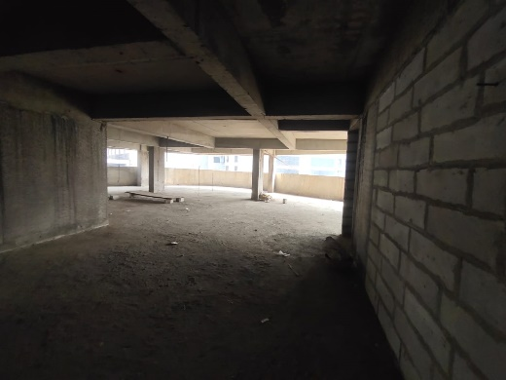
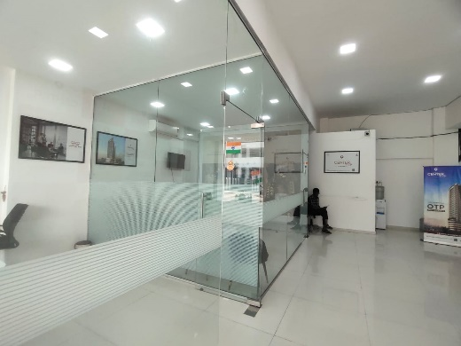
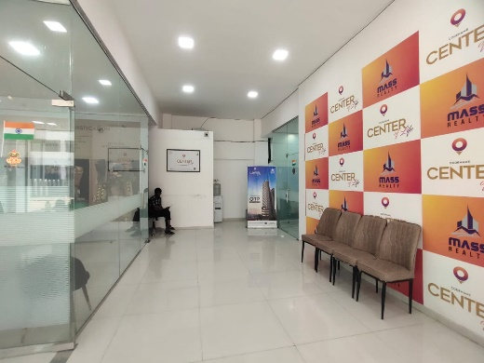
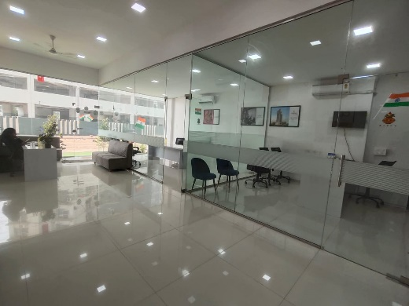
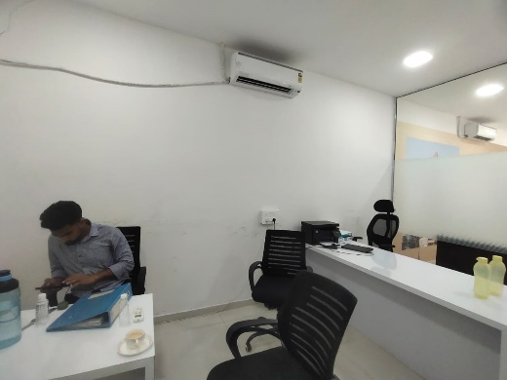
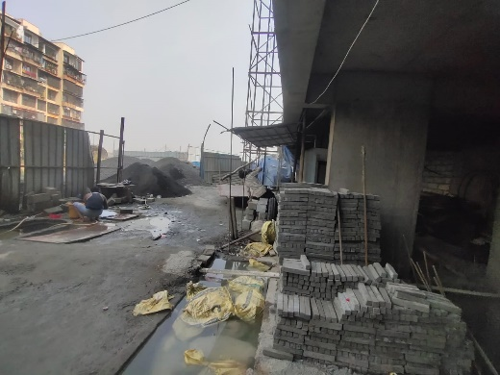
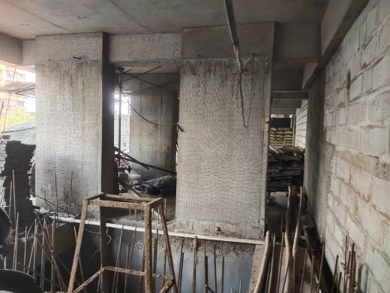
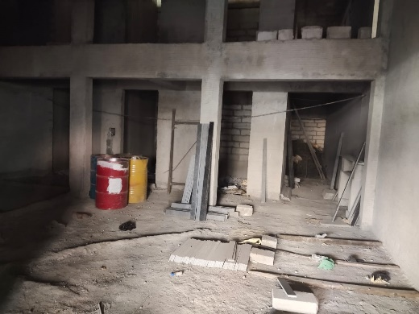
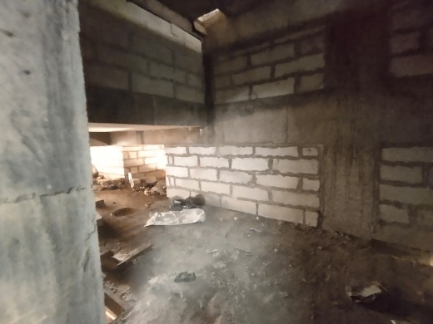
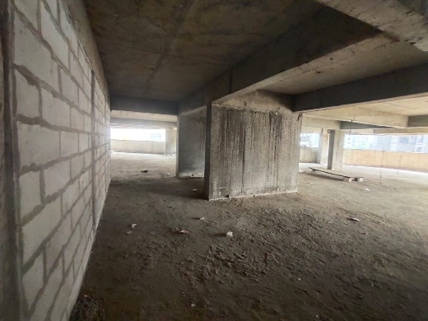
Actual Site Photographs as on 28.01.2025
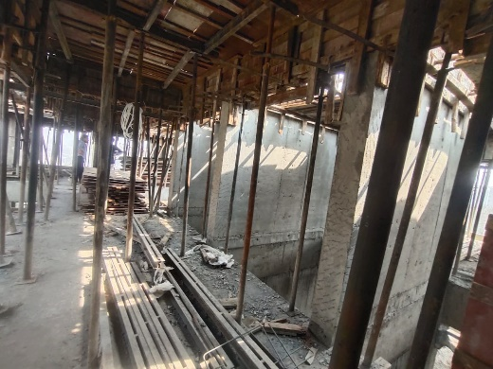
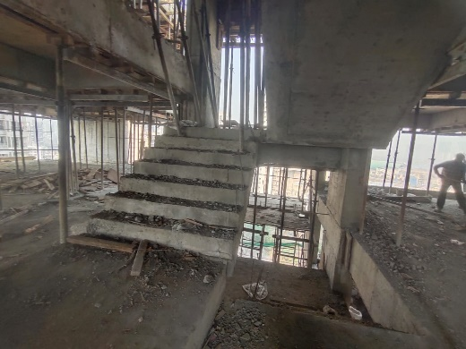
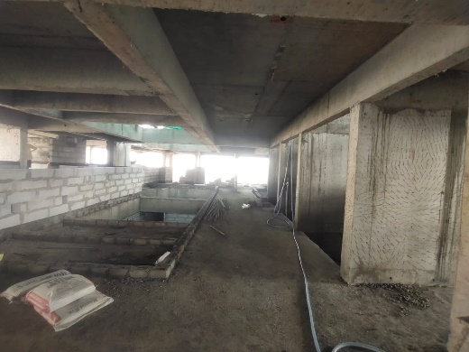
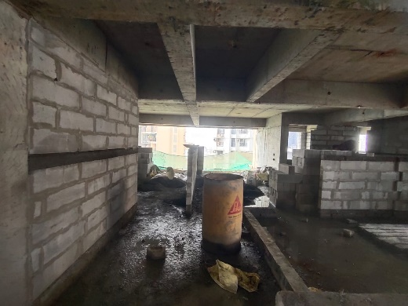
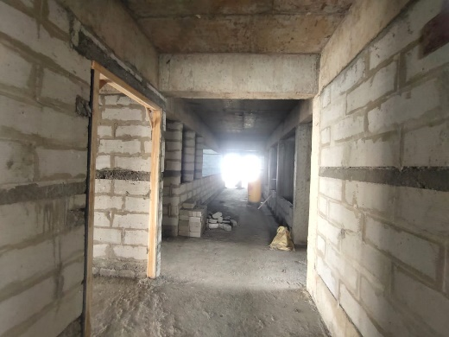
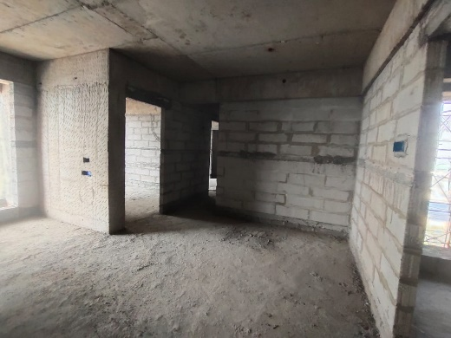
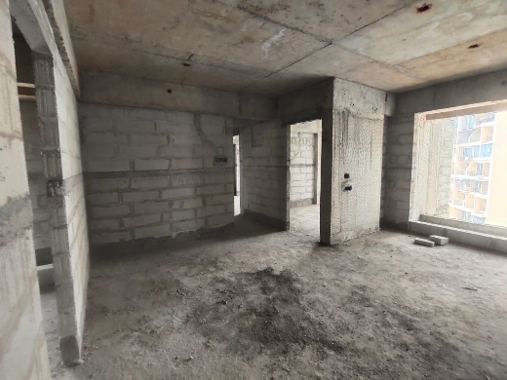
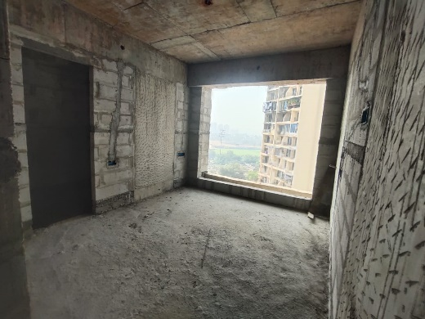
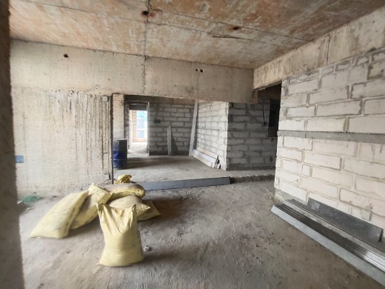
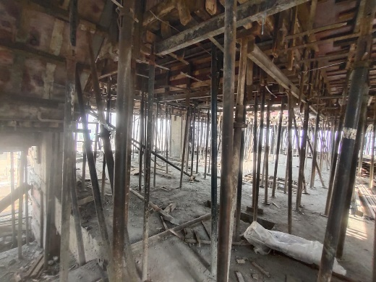
Actual Site Photographs as on 28.01.2025
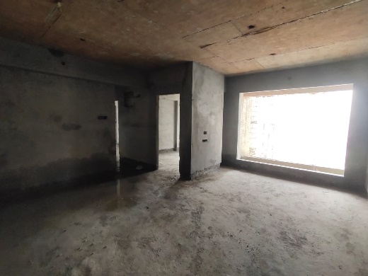
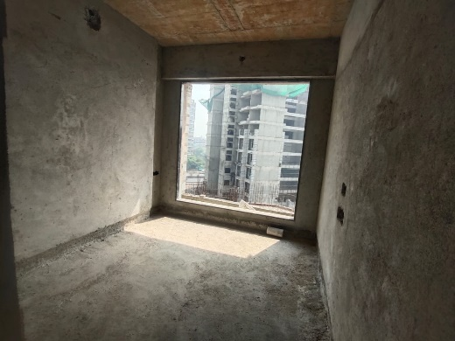
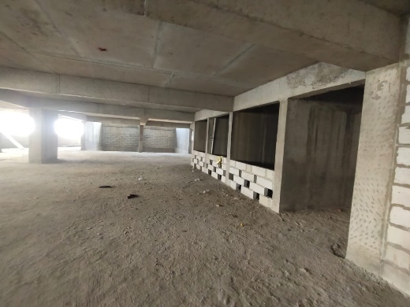
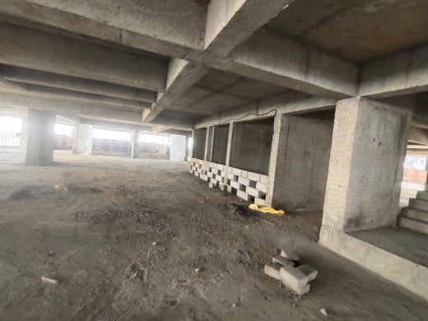
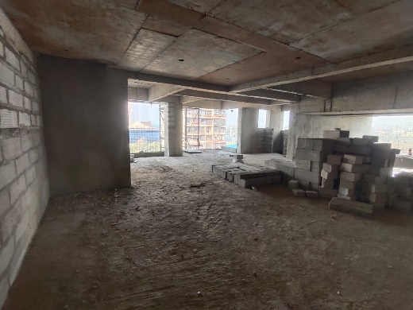
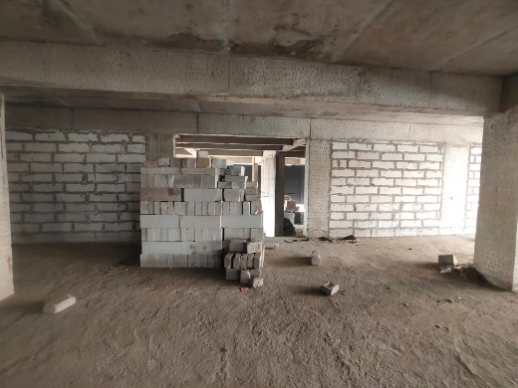
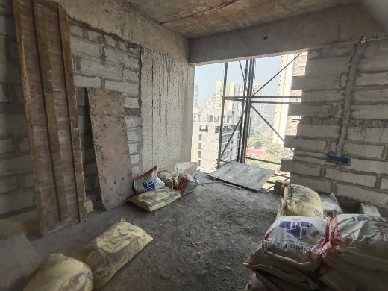
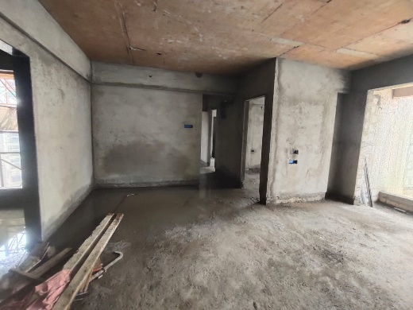
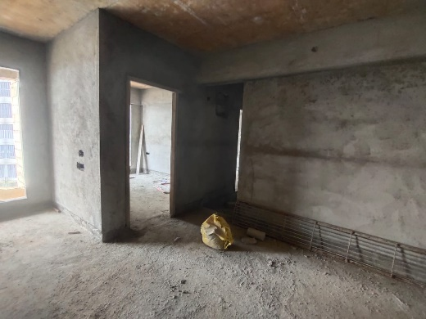
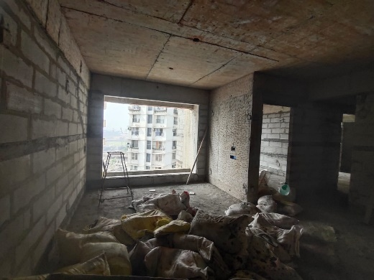
Actual Site Photographs as on 28.01.2025
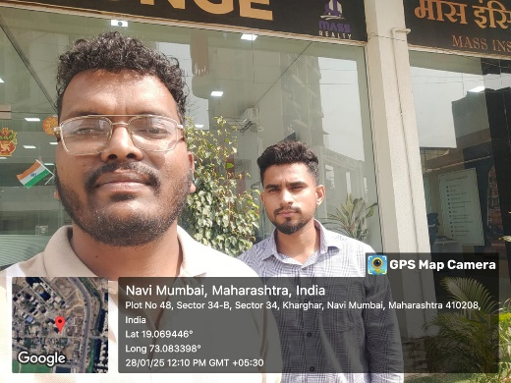
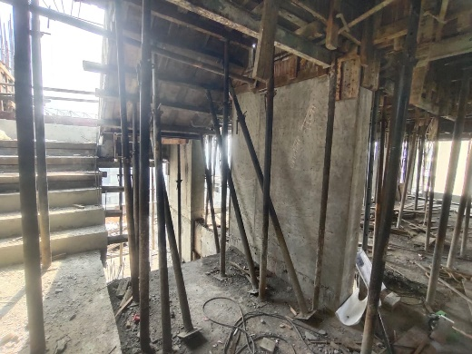
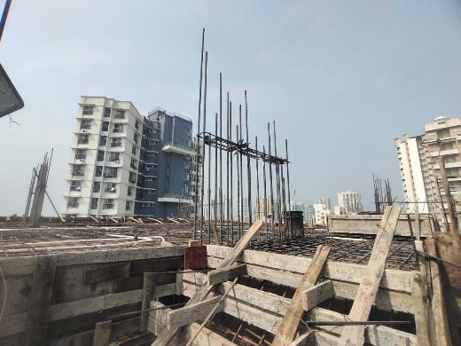
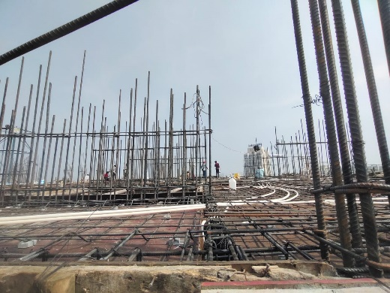

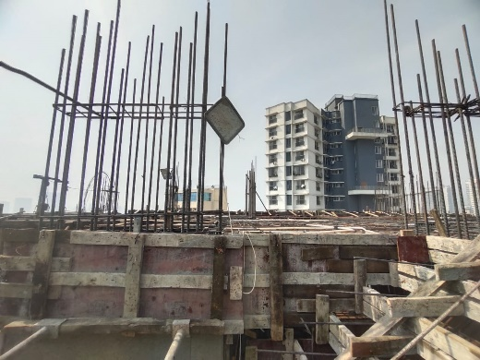

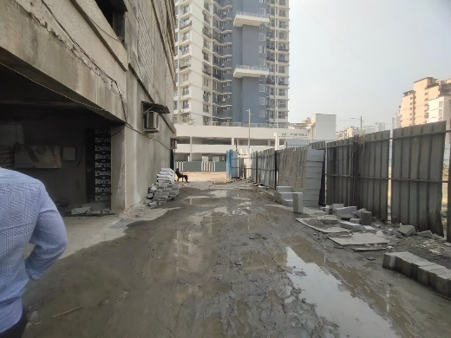

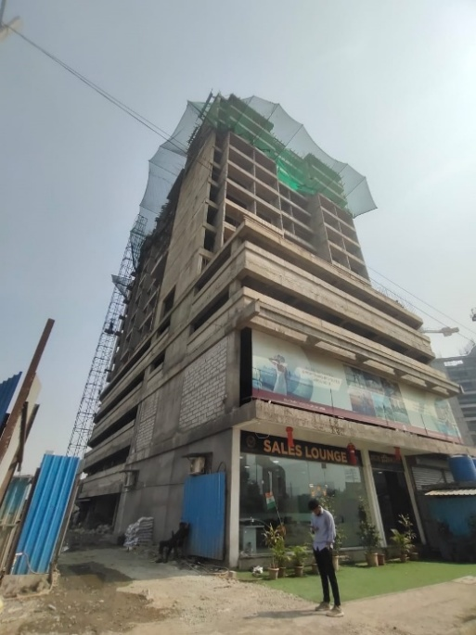
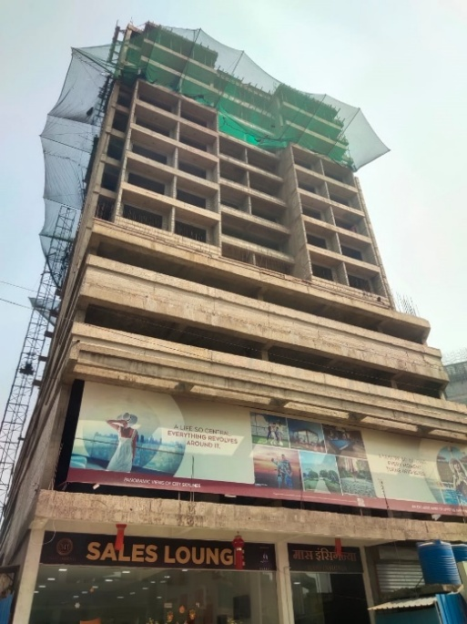

Route Map of the property
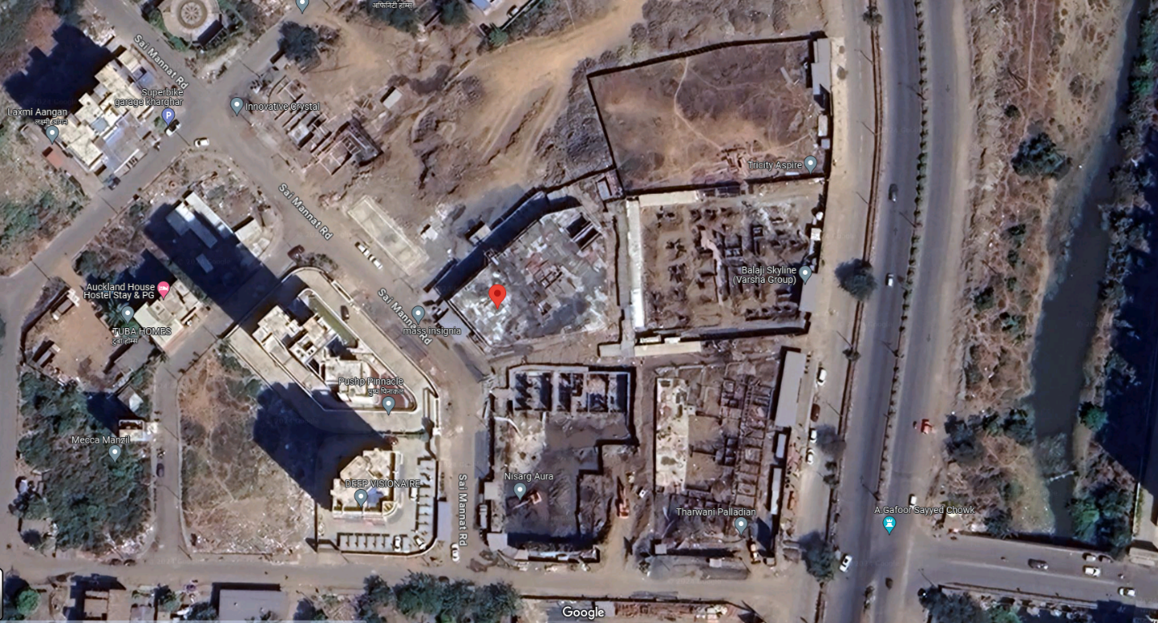
Site u/r

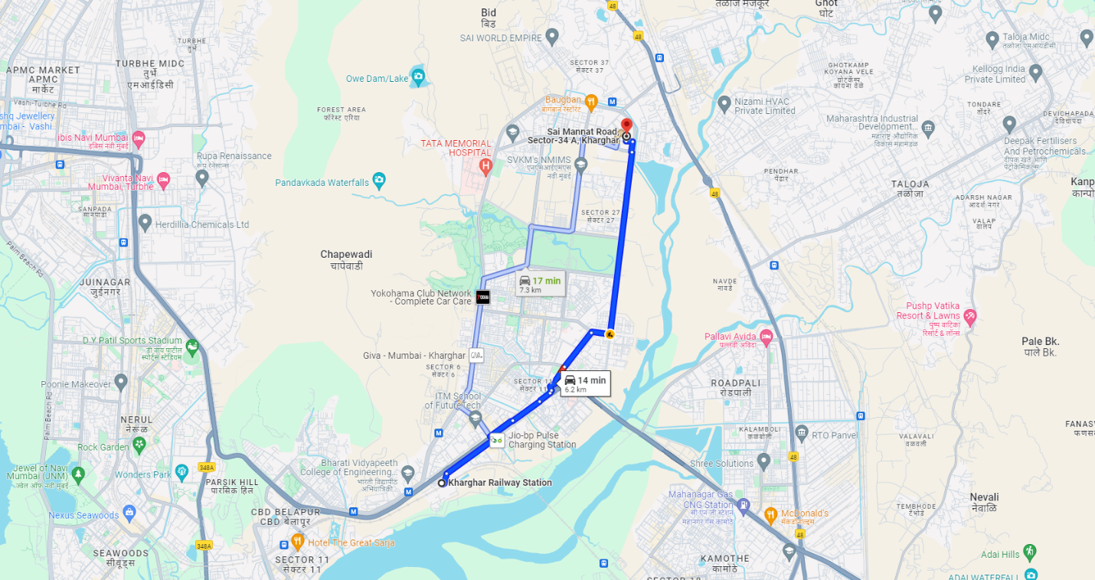

Latitude Longitude: 19°04'10.3"N 73°05'01.4"E

Note: The Blue line shows the route to site from nearest railway station (Kharghar – 6.20 Km.)
CA Certificate Dated 15.01.2025 cost incurred till 31.12.2024
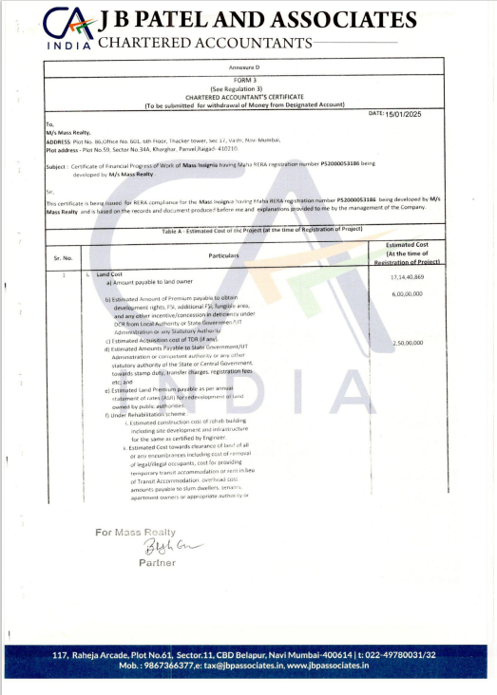

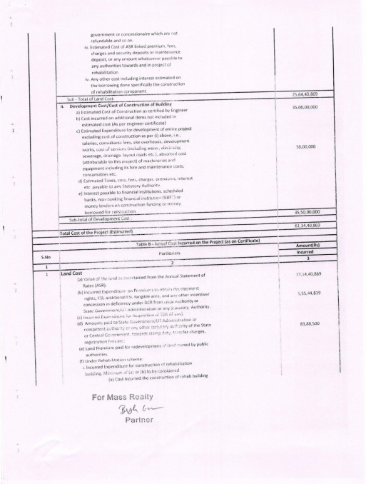
CA Certificate Dated 15.01.2025 cost incurred till 31.12.2024

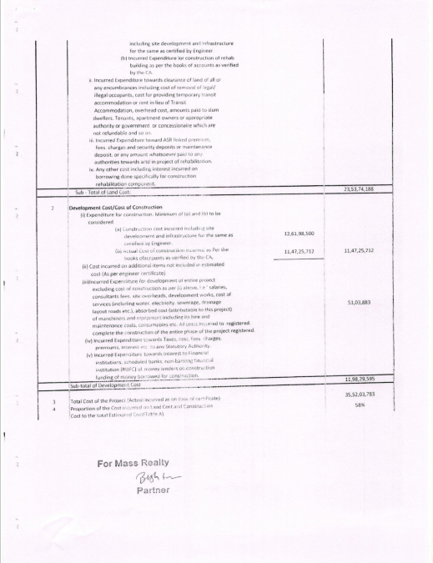
CA Certificate Dated 15.01.2025 cost incurred till 31.12.2024

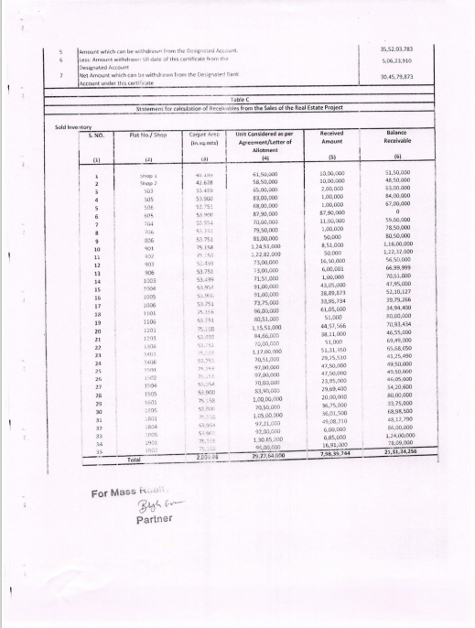
CA Certificate Dated 15.01.2025 cost incurred till 31.12.2024

CA Certificate Dated 15.01.2025 cost incurred till 31.12.2024
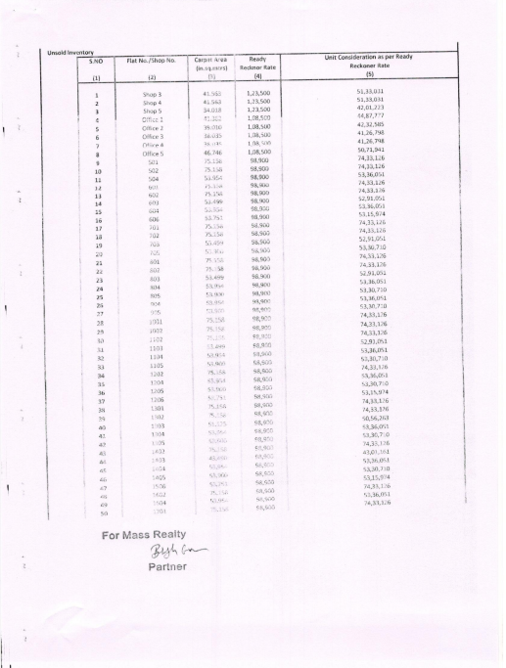
CA Certificate Dated 15.01.2025 cost incurred till 31.12.2024
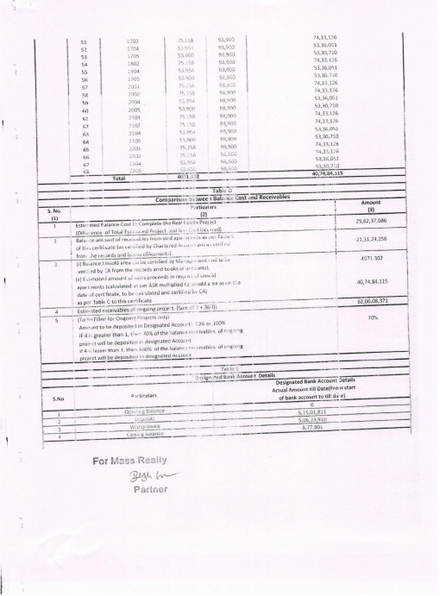
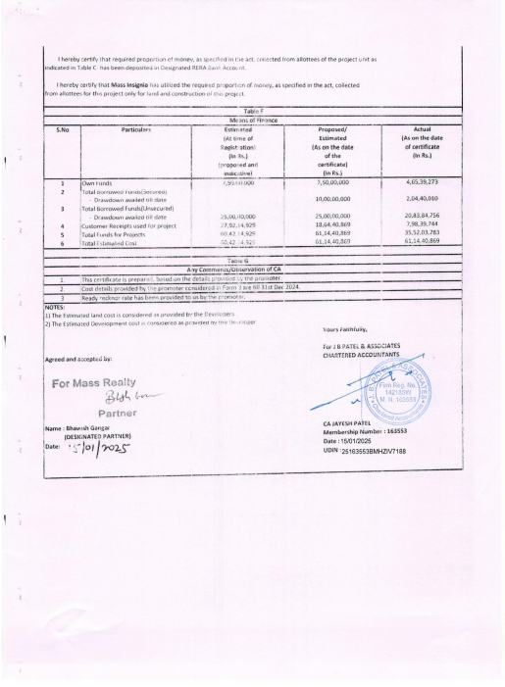
CA Certificate Dated 15.01.2025 cost incurred till 31.12.2024

