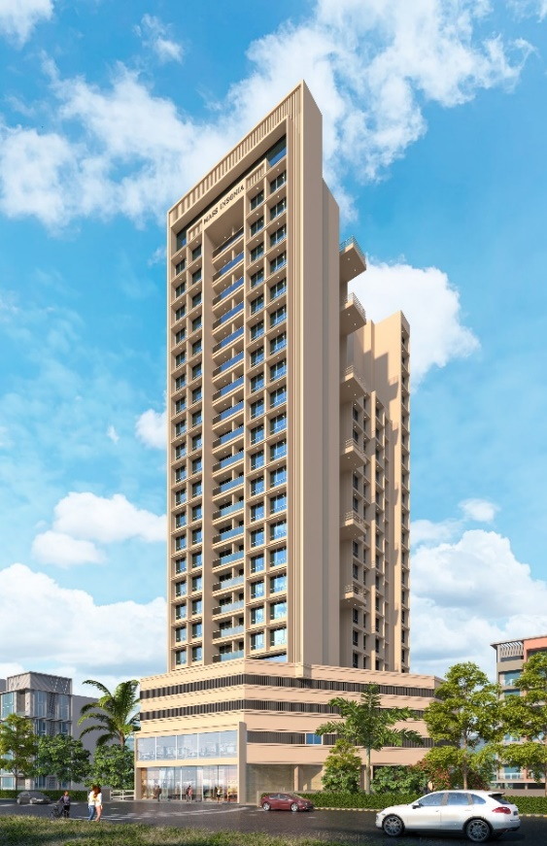1st LENDER’S INDEPENDENT ENGINEER REPORT

**Details of the property under consideration:**

**Name of Project: Mass Insignia**

**"Mass Insignia", Proposed Residential cum Commercial building on Plot bearing Plot No. 59,**

**Sector No. 34A, Kharghar, Navi Mumbai, Taluka & District – Panvel, Pin Code – 410 210,**

**State – Maharashtra, Country – India**

**Latitude Longitude: 19°04'10.5"N 73°05'01.7"E**

Intended User:

State Bank of India

Panvel Branch

278/1, Safiya Terrace, Mulla Park, M. G. Road, Panvel, Navi Mumbai,

Pin Code – 410 206, State - Maharashtra, Country – India

Vastu/SBI/Mumbai/06/2024/9428/2306843

21/03-287-PY

Date: - 21.06.2024

FIRST LENDER’S INDEPENDENT ENGINEER REPORT

**To,**

**The Branch Manager,**

**State Bank of India**

**Panvel Branch**

278/1, Safiya Terrace,

Mulla Park, M. G. Road,

Panvel, Navi Mumbai, Pin Code – 410 206,

State - Maharashtra, Country – India

Subject: Construction of Proposed Proposed Residential cum Commercial building on Plot bearing Plot No. 59, Sector No. 34A, Kharghar, Navi Mumbai, Taluka & District – Panvel, Pin Code – 410 210, State – Maharashtra, Country – India

**Ref:** You’re Request for Lenders Independent Engineer Report of under Construction Building.

**Dear Sir,**

**The Construction work as per approved plan was in progress during the site visit on 15th June 2024. Total expenditure occurred as on 15/06/2024 on this project by M/s. Mass Realty is ` 30.09 Cr. & as per CA Certificate actual total expenditure occurred as on 22/05/2024 is ` 28.90 Cr. Hence, release of Balance Amount as requested by M/s. Mass Realty is hereby recommended.**

**DECLARATION**

1. The information furnished in the report is based on our 1st site visit Dated 15/06/2024 & Document Provided by Client.
2. Vastukala Project Report of the project dated 28/12/2023.
3. Vastukala Cost Vetting Report of the project dated 28/12/2023.
4. I have no direct and indirect interest in the property examined for report.
5. I have not been found guilty of misconduct in my professional capacity.

**Manoj B. Chalikwar**

Registered Valuer

Chartered Engineer (India)

Reg. No. IBBI / RV / 07/2018/10366

Reg. No. CAT-I-F-1763

Encl.: LIE report

# Purpose & Methodology

• State Bank of India Banks and financial institutions require monitoring & an independent review of the progress of the sanctioned projects

**VCIPL** undertakes such study to independently review the progress of the project and put forward a comprehensive analysis

# Advantages:

* Assurance on present practices
* Identification of risk
* Analyzing the performance of third parties
* Recommendations

# The Methodology

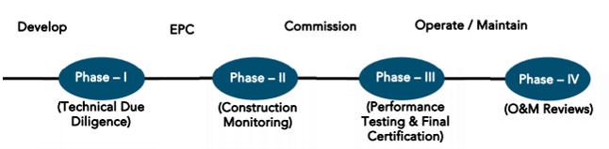

**FIRST LENDER’S INDEPENDENT ENGINEER REPORT**

**OF**

**"MASS INSIGNIA"**

**"Mass Insignia", Proposed Residential cum Commercial building on Plot bearing Plot No. 59,**

**Sector No. 34A, Kharghar, Navi Mumbai, Taluka & District – Panvel, Pin Code – 410 210,**

**State – Maharashtra, Country – India**

**Latitude Longitude: 19°04'10.5"N 73°05'01.7"E**

**NAME OF DEVELOPER: M/s. Mass Realty**

|  |
| --- |
| Pursuant to instructions from State of India, Panvel Branch, we have duly visited, inspected, surveyed & assessed the above said property on **15th June 2024** to determine the fair & reasonable market value of the said property/project as on Quarter ending **15th June 2024** for LIE purpose.  **1. Location Details:**  Proposed Residential cum Commercial building on Plot bearing Plot No. 59, Sector No. 34A, Kharghar, Navi Mumbai, Taluka & District – Panvel, Pin Code – 410 210. It is about 6.20 Km. travelling distance from Kharghar Railway station. Surface transport to the property is by buses, taxis & private vehicles. The property is in developed locality. All the amenities like shops, banks, hotels, markets, schools, hospitals, etc. are all available in the surrounding locality. The area is middle class & developed. |

**2. Developer Details:**

|  |  |
| --- | --- |
| **Name of Developer** | **M/s. Mass Realty** |
| **Project Rera Registration Number** | **P52000053186** |
| **Registered office address** | Office No. 601, 6th Floor, Thacker Tower, Plot No. 86, Sector No. 17, Vashi, Navi Mumbai, Pin Code – 400 703, State - Maharashtra, Country – India |
| **Contact details** | **Contact Person:**  Mr. Bhavesh Gangar (Owner)  Mobile No. 9819183417  Mr. Prathmesh Deshmukh (Site Engineer)  Mb. No. 7387046363 |
| **E – mail ID and website** | [massrealty601@gmail.com](mailto:massrealty601@gmail.com) |

**3. Boundaries of the Property:**

|  |  |
| --- | --- |
| **Direction** | **Particulars** |
| **On or towards North** | Open Plot |
| **On or towards South** | Under Construction Building |
| **On or towards East** | Under Construction Building |
| **On or towards West** | Sai Mannat Road |

# Introduction

**As per Information on site M/s. Mass Realty** has acquired land by Lease Deed dated 01.08.2022 through registered vide No. PVL-5/12670/2022 dated 01.08.2022 admeasuring **area 1,953.90 Sq. M.** bearing **Plot No. 59, Sector – 34A.** For the Proposed development of Residential cum Commercial Building.

# Area Statement:

# Land:

|  |  |  |
| --- | --- | --- |
| **Date** | **Particular** | **Area in Sq. M.** |
| 01.08.2022 | Plot No. 59, Sector – 34A | 1,953.90 |
| TOTAL | | 1,953.90 |

1. Copy of Lease Agreement dated 01.08.2022 between City and Industrial Development Corporation of Maharashtra Ltd. (CIDCO) (The Corporation) and M/s. Mass Realty (The Licensee) through registered agreement vide No. PVL-5/12670/2022 dated 01.08.2022.
2. Copy of Corrigendum to Allotment Letter No. CIDCO/MM-I(Commercial)/2022/948 dated 12.05.2022 issued by City and Industrial Development Corporation of Maharashtra Ltd. (CIDCO).
3. Copy of Allotment of Residential + Commercial Plot Letter No. 3622/1000949/805 dated 27.04.2022 issued by City and Industrial Development Corporation of Maharashtra Ltd. (CIDCO).

# Building Area As per Approved Plan:

| **Sr. No.** | | **Particulars** | **Area (Sq. M.)** |
| --- | --- | --- | --- |
| **1** |  | Area of plot (Minimum area of a, b, c to be considered) | 1,953.90 |
| a | As per ownership document (7/12, CTS extract) | 1,953.90 |
| b | As per measurement sheet | 1,953.90 |
| c | As per site | 1,953.90 |
| **2** |  | Deductions for |  |
| a | Proposed D. P. / D. P. Road widening area / service road / highway widening | - |
| b | Any DP reservations area | - |
|  | Total (a + b) | - |
| **3** |  | Balance area of plot (1 – 2) | 1,953.90 |
| **4** |  | Amenity spaces (if applicable) |  |
| a | required | - |
| b | Adjustment of 2(b), if any | - |
| c | Balance proposed | - |
| **5** |  | Net Plot Area (3 – 4(c)) | 1,953.90 |
| **6** |  | Recreational Open space (if available) |  |
| a | Required | - |
| b | Proposed | - |
| **7** |  | Internal Road area | - |
| **8** |  | Plotable Area | 1,953.90 |
| **9** | a | Built up area with reference to basic FSI as per front road width (Sr. No. 5 X basic FSI) – Min. of 1.5 as per UDCPR | 2,930.850 |
| b | Permissible commercial area | 439.628 |
| c | Proposed commercial area (basic excluding ancillary) | 283.935 |
| **10** |  | Addition of FSI on payment of premium |  |
| a | Maximum permissible premium FSI – based on road width / TOD zone. (Plot area X 0.9 premium FSI) plus additional FSI as per Note 3 of 10.10.1 (plot area X 0.1) | 1,953.90 |
| b | Proposed FSI on payment | 1,953.90 |
| **11** |  | In-situ FSI / TDR loading |  |
| a | In-situ area against DP road (2.0 X Sr. No. 2(a)), if any | - |
| b | In-situ area against amenity space if handed over (2.00 or 1.85 X Sr. No. 4(b) and / or (c)), | - |
| c | TDR area | - |
| d | Total in-situ / TDR loading proposed (11 (a) + (b) + (c)) | - |
| **12** |  | Additional FSI area under Chapter No. 7 |  |
| **13** |  | Total entitlement of FSI in the proposal |  |
| a | [9 (a) + 10 (b) + 11 (d)] or 12 whichever is applicable | 4,884.75 |
| b | Permissible ancillary area FSI upto 60% or 80% on balance potential with payment of charges | 2,989.467 |
| c | Proposed Ancillary area FSI | 2,950.396 |
| d | Total entitlement (a + b) | 7,874.217 |
| **14** |  | Maximum utilization limit of FSI (building potential) permissible as per road width [{as per regulation no. 6.1 or 6.2 or 6.3 or 6.4 as applicable} X 1.6 or 1.8] read with Note 3 of 10.10.1 | 4.029 |
| **15** |  | Total Built-up area in proposal | 7,835.15 |
| a | Existing Built-up Area | - |
|  | Residential | - |
|  | Commercial | - |
| b | Proposed Built-up Area (as per P-line) | 7,835.15 |
|  | Residential | 7,324.06 |
|  | Commercial | 511.083 |
| c | Total (a + b) (shall not be more than 13{d}) | 7,835.15 |
| **16** |  | FSI Consumed (15/13) (should not be more than serial no. 14 above) | 0.995 |
| **17** |  | Area for inclusive housing, if any |  |
| a | Required (20% of Sr. No. 5) | - |
| b | Proposed | - |

# List of Approvals:

1. Copy of Approved Plan No. CIDCO/BP-18496/TPO(NM & K)/2023/11057 dated 18.08.2023 issued by City and Industrial Development Corporation of Maharashtra Ltd. (CIDCO)

**Approved upto: Ground Floor + Mezzanine Floor + 1st Commercial Floor + 2nd to 4th Podium Floors + 5th to 19th Upper Residential Floors**

1. Copy of Commencement Certificate No. CIDCO/BP-18496/TPO (NM & K)/2023/11057 dated 18.08.2023 issued by City and Industrial Development Corporation of Maharashtra Ltd. (CIDCO).

**(This CC is endorsed for the work for Ground Floor + Mezzanine Floor + 1st Commercial Floor + 2nd to 4th Podium Floors + 5th to 19th Upper Residential Floors for Net Built – Up Area of 7835.10 Sq. M.)**

1. Copy of Fire NOC Certificate No. CIDCO/FIRE/HQ/2023/E-222730 dated 30.06.2023 issued by City and Industrial Development Corporation of Maharashtra Ltd. (CIDCO).
2. Copy of No Objection Certificate for Height Clearance NOC ID No. NAVI/WEST/B/081122/688949 dated 06.10.2022 valid upto 05.10.2023 issued by Airports Authority of India.

# LEVEL OF COMPLETION:

# Sales Building

| Sr. No | Floor No. | Construction Area in Sq. M. | Completed Area in Sq. M. | Work Completion as on 15.06.2024 |
| --- | --- | --- | --- | --- |
| 1 | Excavation & Shore Piling | | | Work is Completed |
| 2 | Ground Floor | 1,027.68 | 1,027.68 | Slab Work is completed |
| 3 | Mezzanine | 670.40 | 670.40 | Slab Work is completed |
| 4 | 1st Floor | 963.37 | 963.37 | Slab Work is completed |
| 5 | 2nd Floor | 990.33 | 990.33 | Slab Work is completed |
| 6 | 3rd Floor | 990.33 | 990.33 | Slab Work is completed |
| 7 | 4th Floor | 615.77 | 615.77 | Slab Work is completed |
| 8 | 5th Floor | 551.83 |  | Shuttering work is completed |
| 9 | 6th Floor | 551.83 |  |  |
| 10 | 7th Floor | 588.28 |  |  |
| 11 | 8th Floor | 551.77 |  |  |
| 12 | 9th Floor | 551.77 |  |  |
| 13 | 10th Floor | 588.28 |  |  |
| 14 | 11th Floor | 551.77 |  |  |
| 15 | 12th Floor | 551.77 |  |  |
| 16 | 13th Floor | 585.99 |  |  |
| 17 | 14th Floor | 542.23 |  |  |
| 18 | 15th Floor | 410.14 |  |  |
| 19 | 16th Floor | 448.47 |  |  |
| 20 | 17th Floor | 411.96 |  |  |
| 21 | 18th Floor | 411.96 |  |  |
| 22 | 19th Floor | 411.96 |  |  |
| Total | | **12,967.83** | **5,257.88** |  |

# Details of the Project as Financed By SBI:

# Project Cost: (as per C.A. Certificate)

|  |  |  |
| --- | --- | --- |
| **Particulars** | **Estimated Cost (in Cr.)** | **Incurred Cost (In Cr.) till 22.05.2024 dated 27.05.2024 by M/s. Jatin Vora & Associates** |
| Land Cost | 17.98 | 17.98 |
| Construction cost of Building | 35.01 | 5.65 |
| Premium Cost / FSI / GOM Charges / fees / security Deposits | 5.44 | 5.13 |
| Architect Cost, RCC & Other Professional Cost | 1.40 | 0.14 |
| Administrative Cost | 1.05 |
| Marketing Cost | 1.68 |
| Interest Cost | 3.50 | - |
| Contingency Cost | 0.70 | - |
| **Total** | **66.76** | **28.90** |

* **The Builder has incurred about 17.98 Cr. as land cost, 5.65 Cr. as construction cost, 5.13 Cr. for approval of project, 0.14 Cr. for others cost in last quarter till 22.05.2024 as per C.A. certificate issued by M/s. Jatin Vora & Associates dated 27.05.2024.**

# Project Cost: (as per Bills):

|  |  |
| --- | --- |
| **Particulars** | **Incurred Cost (in Cr.)** |
| **15.06.2024 as per Bill (Inclusive GST)** |
| Land Cost | 17.98 |
| Construction cost of Building | 5.95 |
| Premium Cost / FSI / GOM Charges / fees / security Deposits | 5.14 |
| Architect Cost, RCC & Other Professional Cost | 0.14 |
| Administrative Cost | 0.65 |
| Marketing Cost | 0.23 |
| Interest Cost | - |
| Contingency Cost | - |
| **Total** | **30.09** |

Note:

# Land Cost:

|  |  |  |  |  |  |
| --- | --- | --- | --- | --- | --- |
| Sr. | Agreement Name | Date | Particulars | Total Cost in ` | Incurred Cost in ` |
| 1 | Lease Agreement | 01.08.2022 | Purchase | 16,71,63,960.60 | 16,71,63,960.60 |
| 2 | Stamp Duty | 83,58,500.00 | 83,58,500.00 |
| 3 | Reg. Fees | 30,000.00 | 30,000.00 |
| 4 | 800.00 | 800.00 |
| 5 | Other Charges | 23,93,870.38 | 23,93,870.38 |
| 6 | GST Amount | 19,00,895.12 | 19,00,895.12 |
| TOTAL | | | | **17,98,48,026.00** | **17,98,48,026.00** |

As per Lease agreement.

|  |  |  |  |
| --- | --- | --- | --- |
| **Summary of Bills** | | | |
| **Sr. No.** | **Particulars** | **Amount in `**  **(till 15.06.2024)** | **Amount in ` (in Cr.)** |
| **1** | Construction Cost | 5,94,53,019.00 | 5.95 |
| **2** | Premium Cost / FSI / GOM Charges / fees / security Deposits | 5,13,94,540.00 | 5.14 |
| **3** | Professional Cost | 14,01,427.00 | 0.14 |
| **4** | Administrative Cost | 64,74,663.00 | 0.65 |
| **5** | Marketing Cost | 23,32,717.00 | 0.23 |
| **6** | Contingency Cost | - | - |
| **TOTAL** | | **12,10,56,366.00** | **12.11** |

Note: Bills were provided by the client up to 15.06.2024

# Interest Cost:

|  |  |  |  |  |
| --- | --- | --- | --- | --- |
| **Sr. No** | **Particulars** | **Estimate Amount in `** | **Incurred Amount in ` (till 15.06.2024)** | **Balance Amount in `** |
| **1** | Interest Cost | 3,50,00,000.00 | - | 3,50,00,000.00 |
| **TOTAL** | | **3,50,00,000.00** | **-** | **3,50,00,000.00** |

Interest Cost is based on discussion with the client.

# Cost of Construction as on 15th June 2024:

|  |  |  |  |  |  |  |  |
| --- | --- | --- | --- | --- | --- | --- | --- |
| Sr. No. | Floor | Total Construction Area in Sq. M. | Completed Area in Sq. M. | Rate per Sq. M. | Full Value after completion | % of work completed | Actual Expenditure till date in ` |
| 1 | Ground Floor | 1,027.68 | 1,027.68 | 27,000.00 | 2,77,47,279.00 | 50% | 1,38,73,639.50 |
| 2 | Mezzanine | 670.40 | 670.40 | 27,000.00 | 1,81,00,773.00 | 50% | 90,50,386.50 |
| 3 | 1st Floor | 963.37 | 963.37 | 27,000.00 | 2,60,11,017.00 | 50% | 1,30,05,508.50 |
| 4 | 2nd Floor | 990.33 | 990.33 | 27,000.00 | 2,67,38,910.00 | 50% | 1,33,69,455.00 |
| 5 | 3rd Floor | 990.33 | 990.33 | 27,000.00 | 2,67,38,910.00 | 50% | 1,33,69,455.00 |
| 6 | 4th Floor | 615.77 | 615.77 | 27,000.00 | 1,66,25,790.00 | 40% | 66,50,316.00 |
| 7 | 5th Floor | 551.83 |  | 27,000.00 | 1,48,99,275.00 |  | - |
| 8 | 6th Floor | 551.83 |  | 27,000.00 | 1,48,99,275.00 |  | - |
| 9 | 7th Floor | 588.28 |  | 27,000.00 | 1,58,83,425.00 |  | - |
| 10 | 8th Floor | 551.77 |  | 27,000.00 | 1,48,97,655.00 |  | - |
| 11 | 9th Floor | 551.77 |  | 27,000.00 | 1,48,97,655.00 |  | - |
| 12 | 10th Floor | 588.28 |  | 27,000.00 | 1,58,83,506.00 |  | - |
| 13 | 11th Floor | 551.77 |  | 27,000.00 | 1,48,97,655.00 |  | - |
| 14 | 12th Floor | 551.77 |  | 27,000.00 | 1,48,97,655.00 |  | - |
| 15 | 13th Floor | 585.99 |  | 27,000.00 | 1,58,21,730.00 |  | - |
| 16 | 14th Floor | 542.23 |  | 27,000.00 | 1,46,40,129.00 |  | - |
| 17 | 15th Floor | 410.14 |  | 27,000.00 | 1,10,73,645.00 |  | - |
| 18 | 16th Floor | 448.47 |  | 27,000.00 | 1,21,08,636.00 |  | - |
| 19 | 17th Floor | 411.96 |  | 27,000.00 | 1,11,22,866.00 |  | - |
| 20 | 18th Floor | 411.96 |  | 27,000.00 | 1,11,22,866.00 |  | - |
| 21 | 19th Floor | 411.96 |  | 27,000.00 | 1,11,22,866.00 |  | - |
| TOTAL | | **12,967.83** | **5,257.88** |  | **35,01,31,518.00** | **19.80%** | **6,93,18,760.50** |

##### Note: Details of work completed is as per site visit dated 15.06.2024 but report is prepared for 15th June quarter 2024.

|  |  |  |  |  |
| --- | --- | --- | --- | --- |
| **Particulars** | **Estimated Cost**  **(In Cr.)** | **Incurred Cost (in Cr.)** | | **Net** |
| **Issued dated 27.05.2024 till 22.05.2024 as per CA** | **As per Bills upto 29.02.2024** |
| Land Cost | 17.98 | 17.98 | 17.98 | - |
| Construction cost of Building | 35.01 | 5.65 | 5.95 | 0.30 |
| Premium Cost / FSI / GOM Charges / fees / security Deposits | 5.44 | 5.13 | 5.14 | 0.01 |
| Architect Cost, RCC & Other Professional Cost | 1.40 | 0.14 | 0.14 | 0.88 |
| Administrative Cost | 1.05 | 0.65 |
| Marketing Cost | 1.68 | 0.23 |
| Interest Cost | 3.50 | - | - | - |
| Contingency Cost | 0.70 | - | - | - |
| **Total** | **66.76** | **28.90** | **30.09** | **1.19** |

Note:

* We have considered the bills till 15.06.2024 but CA has considered bills till 22.05.2024.
* As per site inspection, 19.80% of total work is completed, which amounts to ` 6.93 Cr. However, as per data provided by client, they have incurre the cost of ` 5.95 Cr. till 15.06.2024 as per bill .

# Comparison of Cost incurred on dated 15.06.2024 & CA Certificate

|  |  |  |  |  |
| --- | --- | --- | --- | --- |
| Particulars | 15.06.2024 as per Bill | As per CA Certiifcate | Net | % of net amount |
| Land Cost | 17.98 | 17.98 | - | 0.00% |
| Construction cost of Building | 5.95 | 5.65 | 0.30 | 1.00% |
| Premium Cost / FSI / GOM Charges / fees / security Deposits | 5.14 | 5.13 | 0.01 | 0.03% |
| Architect Cost, RCC & Other Professional Cost | 0.14 | 0.14 | 0.88 | 2.93% |
| Administrative Cost | 0.65 |
| Marketing Cost | 0.23 |
| Interest Cost | - | - | - | 0.00% |
| Contingency Cost | - | - | - | 0.00% |
| Total | **30.09** | **28.90** | **1.19** | **3.95%** |

# % of Fund Utilised till 15th June 2024

|  |  |  |  |  |
| --- | --- | --- | --- | --- |
| Particulars | Estimated Project Cost  (in Cr.) | Incurred cost as on 15.06.2024 | % of Incurred Cost | % of Estimated Project Cost |
| Land Cost | 17.98 | 17.98 | 100.00% | 26.94% |
| Construction cost of Building | 35.01 | 5.95 | 16.98% | 8.91% |
| Premium Cost / FSI / GOM Charges / fees / security Deposits | 5.44 | 5.14 | 94.48% | 7.70% |
| Architect Cost, RCC & Other Professional Cost | 1.40 | 0.14 | 10.01% | 0.21% |
| Administrative Cost | 1.05 | 0.65 | 61.66% | 0.97% |
| Marketing Cost | 1.68 | 0.23 | 13.89% | 0.35% |
| Interest Cost | 3.50 | - | 0.00% | 0.00% |
| Contingency Cost | 0.70 | - | 0.00% | 0.00% |
| Total | **66.76** | **30.09** | **45.07%** | **45.07%** |

Based on above Calculation it is found that total Project cost incurred is 45.07% of the Total Project Cost.

# Means of Finance:

|  |  |  |
| --- | --- | --- |
| **Sr. No.** | **Particulars** | **Exp. Cumulative (Cr.)** |
|  | Equity share capital / Quassi Loan from Promoter (Partner’s Capital) | 6.50 |
|  | Sales (Advance from customer) | - |
|  | Bank Laon Amount | - |
|  | Unsecured Loan amount | 27.75 |
|  | **Total** | **34.25** |

The Details of the Means of Finance are provided by Client as on 22.05.2024.

# Mandatory Arrangements:

|  |  |  |
| --- | --- | --- |
| **Sr. No.** | **Particulars** | **Status** |
|  | Rainwater Harvesting | To be executed after RCC Structure |
|  | Firefighting System | To be executed after RCC Structure |
|  | Solid Waste Management | To be executed after RCC Structure |

# Quality of Construction:

|  |  |  |
| --- | --- | --- |
| **Sr. No.** | **Particulars** | **Status** |
|  | Soundness of Structures | Executing as per approved Structural Design |
|  | Look of Structures | Good |
|  | Quality of Material Used | Good |
|  | Safety Measures for Construction/labour | Taken Care by Contractor |

# Schedule V/s. Actual Progress:

| Activity | Date of Implementation | Date of Completion | Status |
| --- | --- | --- | --- |
| Land |  |  | Completed |
| Development of Land |  |  | Completed |
| Foundation Work |  |  | Completed |
| Ground Floor Slab |  |  | Slab work is Completed |
| 1st Floor Slab |  |  | Slab work is Completed |
| 2nd Floor Slab |  |  | Slab work is Completed |
| 3rd Floor Slab |  |  | Slab work is Completed |
| 4th Floor Slab |  |  | Slab work is Completed |
| 5th Floor Slab |  |  | Shuttering work is in progress |
| 6th Floor Slab |  |  |  |
| 7th Floor Slab |  |  |  |
| 8th Floor Slab |  |  |  |
| 9th Floor Slab |  |  |  |
| 10th Floor Slab |  |  |  |
| 11th Floor Slab |  |  |  |
| 12th Floor Slab |  |  |  |
| 13th Floor Slab |  |  |  |
| 14th Floor Slab |  |  |  |
| 15th Floor Slab |  |  |  |
| 16th Floor Slab |  |  |  |
| 17th Floor Slab |  |  |  |
| 18th Floor Slab |  |  |  |
| 19th Floor Slab |  |  |  |
| Block work / Internal Plaster work |  |  |  |
| Terrace Parapet wall / Overhead water tank / Lift Machine room / compound wall / External Plaster work |  |  |  |
| Electric Work |  |  |  |
| Water Proofing |  |  |  |
| Plumbing Work |  |  |  |
| Tiling / Marble Flooring |  |  |  |
| Door Frames |  |  |  |
| Window Installation |  |  |  |
| Staircase Flooring |  |  |  |
| Staircase Railing |  |  |  |
| Refuge Area Flooring |  |  |  |
| Internal Painting |  |  |  |
| External Painting |  |  |  |
| Lift Work |  |  |  |
| Fire Fighting Installation |  |  |  |
| CP Fitting & Sanitary Work |  |  |  |
| Final Finishing & Fitting |  |  |  |

# Action initiated to complete the project in time:

**For Sales Building:** 4th Floor Slab work is completed, 5th floor shuttering work is in progress.

# Comments related to cost overrun if any:

The cost of Sales Building is ` 66.76 Cr.

# Balance investment required for completion of project:

We opinion amount of **` 36.67 Cr.** Will be required to complete the Project.

# Mandatory Approval Status:

| **Sr. No.** | **Particulars** | **Name of Department** | **Status** | **Order Details** |
| --- | --- | --- | --- | --- |
| **1** | Approved Plan | City and Industrial Development Corporation of Maharashtra Ltd. (CIDCO) | Obtained and available at site | CIDCO / BP – 18496 / TPO (NM & K) / 2023 / 11057 dated 18.08.2023 |
| **2** | First C.C. | City and Industrial Development Corporation of Maharashtra Ltd. (CIDCO) | Obtained and available at site | * CIDCO / BP – 18496 / TPO (NM & K) / 2023 / 11057 dated 18.08.2023. This CC is endorsed for the work for Ground Floor + Mezzanine Floor + 1st Commercial Floor + 2nd to 4th Podium Floors + 5th to 19th Upper Residential Floors for Net Built – Up Area of 7835.10 Sq. M. |
| **3** | Fire NOC | City and Industrial Development Corporation of Maharashtra Ltd. (CIDCO) | Obtained and available at site | * CIDCO /FIRE / HQ / 2023 / E – 222730 dated 30.06.2023 |
| **4** | Height Clearance NOC | Airports Authority of India | Obtained and available at site | * ID No. NAVI / WEST / B / 081122 / 688949 dated 06.10.2022 valid upto 05.10.2023 |
| **5** | Occupancy | City and Industrial Development Corporation of Maharashtra Ltd. (CIDCO) | Pending (Project is not completed) |  |

# Status Insurance Coverage:

Information not provided

# Assumptions & Remarks:

* The adequacy of Engineering / Structural design is beyond the scope of our assignment.
* Estimated project completion date is 31/12/2027 for Sales Building respectively. The cost is certified based on the assumptions that the project will be completed within period. Few assumptions were made regarding inflation & cost rise etc. during construction period.

**Manoj B. Chalikwar**

Registered Valuer

Chartered Engineer (India)

Reg. No. IBBI / RV / 07/2018/10366

Reg. No. CAT-I-F-1763

**About the Project:**

|  |  |  |
| --- | --- | --- |
| **1. Introduction** | |  |
| a) | Project Name  (With Address & Phone Nos.) | **"Mass Insignia",** Proposed Residential cum Commercial building on Plot bearing Plot No. 59, Sector No. 34A, Kharghar, Navi Mumbai, Taluka & District – Panvel, Pin Code – 410 210, State – Maharashtra, Country – India  Contact Person:  Mr. Bhavesh Gangar (Owner)  Mobile No. 9819183417  Mr. Prathmesh Deshmukh (Site Engineer)  Mb. No. 7387046363 |
| b) | Purpose of Valuation | As per request from State Bank of India, Panvel Branch to assess fair market value of the Project for LIE purpose. |
| c) | Date of Inspection of Property | 15.06.2024 |
| d) | Date of LIE Report | 21.06.2024 |
| e) | Name of the Developer of Property  (in case of developer built properties) | **M/s. Mass Realty**  Office No. 601, 6th Floor, Thacker Tower, Plot No. 86, Sector No. 17, Vashi, Navi Mumbai, Pin Code – 400 703, State - Maharashtra, Country – India |
| **2. Physical Characteristics of the Property** | | |
| a) | Location of the Property | **"Mass Insignia",** Proposed Residential cum Commercial building on Plot bearing Plot No. 59, Sector No. 34A, Kharghar, Navi Mumbai, Taluka & District – Panvel, Pin Code – 410 210, State – Maharashtra, Country – India |
| Brief description of the property |  |
|  | **TYPE OF THE BUILDING**  **Residential cum Commercial Sales Building**   |  |  | | --- | --- | | No. of Floors | Ground Floor + Mezzanine Floor + 1st Commercial Floor + 2nd to 4th Podium Floors + 5th to 19th Upper Residential Floors | | Building type | Residential cum Commercial Sale building |   Sales Building work is given on contract based for RCC contract. Developer has grant to the contractor do the work of construction and completion includes Concrete work, Reinforcement work, Masonry, Internal Plaster, External Plaster and other miscellaneous work such as repairing, joints b/w concrete and masonry surface, etc. Bill must be paid on measurement of construction area exclusive of Steel, Cement & other construction material.  Lift & lift installation contract is not finalized till now.  Firefighting work contract is not finalized.  **PROPOSED DATE OF COMPLETION & FUTURE LIFE:**  Expected completion date as per RERA is 31st December 2027.  **ABOUT PROJECT:**  Mass Insignia is a beautiful project, a well-planned living space which is the hallmark of thoughtfully laid out flats at reasonable prices. Mass Insignia brings a lifestyle that befits royalty with its beautiful apartments at Kharghar. Your home will now serve as a perfect get-away after a tiring day at work, as Mass Insignia will make you forget that you are living in the heart of the city. These residential apartments in Kharghar offer luxurious homes that amazingly escape the noise of the city center. In addition to that, there are a number of benefits of living in apartments with good locality. Mass Insignia is conveniently located at Kharghar to provide unmatched connectivity from all the important landmarks and places of everyday utility such as various well-known hospitals, educational institutions, super-marts, parks, entertainment spots, recreational centres. | |
|  | Nearby landmark |  |
| Postal Address of the Property | **"Mass Insignia",** Proposed Residential cum Commercial building on Plot bearing Plot No. 59, Sector No. 34A, Kharghar, Navi Mumbai, Taluka & District – Panvel, Pin Code – 410 210, State – Maharashtra, Country – India |
|  | Area of the plot/land  (Supported by a plan) | Net Plot Area: 1,953.90 Sq. M. |
| Type of Land: Solid, Rocky, Marsh land, reclaimed land, Water-logged, Land locked. | Solid land |
|  | Independent access/approach to the property etc. | Yes |
| Google Map Location of the Property with a neighborhood layout map | Provided |
|  | Details of roads abutting the property | 12 M wide road |
| Description of adjoining property | Located in Middle-class locality |
| Plot No. Survey No. | Plot No. 59, Sector No. 34A |
| Ward/Village/Taluka | Kharghar, Navi Mumbai, Taluka – Panvel |
| Sub-Registry/Block | Kharghar |
| District | District - Panvel |
| b) | **Boundaries of the Plot** |  |
|  | |  |  |  |  | | --- | --- | --- | --- | |  | **As per Agreement** | **As per RERA Certificate** | **Actual** | | **North** | Plot No. 60 | Plot No. 60 | Open Plot | | **South** | Plot No. 58 & Plot No. 56 | Plot No. 58 & Plot No. 60 | Under Construction Building | | **East** | Plot No. 55 | Plot No. 55 | Under Construction Building | | **West** | 15.00 M wide Road | 15 M. wide Road | Sai Mannat Road | | |

|  |  |
| --- | --- |
| **4. Document Details and Legal Aspects of Property:** | |
| a) | Ownership Documents (**Building Permission, Commencement Certificate & Status of Plan)** |
|  | Sale Deed, Gift Deed, Lease Deed |
| 1. Copy of Lease Agreement dated 01.08.2022 between City and Industrial Development Corporation of Maharashtra Ltd. (CIDCO) (The Corporation) and M/s. Mass Realty (The Licensee) through registered agreement vide No. PVL-5/12670/2022 dated 01.08.2022. |
| 1. Copy of Corrigendum to Allotment Letter No. CIDCO/MM-I(Commercial)/2022/948 dated 12.05.2022 issued by City and Industrial Development Corporation of Maharashtra Ltd. (CIDCO). |
| 1. Copy of Allotment of Residential + Commercial Plot Letter No. 3622/1000949/805 dated 27.04.2022 issued by City and Industrial Development Corporation of Maharashtra Ltd. (CIDCO) |
| 1. Copy of Approved Plan No. CIDCO/BP-18496/TPO(NM & K)/2023/11057 dated 18.08.2023 issued by City and Industrial Development Corporation of Maharashtra Ltd. (CIDCO)   **Approved upto: Ground Floor + Mezzanine Floor + 1st Commercial Floor + 2nd to 4th Podium Floors + 5th to 19th Upper Residential Floors** |
| 1. Copy of Commencement Certificate No. CIDCO/BP-18496/TPO (NM & K)/2023/11057 dated 18.08.2023 issued by City and Industrial Development Corporation of Maharashtra Ltd. (CIDCO).   **(This CC is endorsed for the work for Ground Floor + Mezzanine Floor + 1st Commercial Floor + 2nd to 4th Podium Floors + 5th to 19th Upper Residential Floors for Net Built – Up Area of 7835.10 Sq. M.)** |
| 1. Copy of Fire NOC Certificate No. CIDCO/FIRE/HQ/2023/E-222730 dated 30.06.2023 issued by City and Industrial Development Corporation of Maharashtra Ltd. (CIDCO). |
| 1. Copy of No Objection Certificate for Height Clearance NOC ID No. NAVI/WEST/B/081122/688949 dated 06.10.2022 valid upto 05.10.2023 issued by Airports Authority of India. |
| 1. Copy of CA Certificate (Form 3) dated 28.08.2023 issued by M/s. J B Patel & Associates |
| 1. Copy of CA Certificate dated 15.12.2023 issued by M/s. Jatin Vora & Associates |
| 1. Copy of RERA Certificate No. P52000053186 dated 21.11.2023 issued by Maharashtra Real Estate Regulatory Authority (MAHRERA). |
| 1. Copy of Engineer’s Certificate dated 24.08.2023 issued by M/s. S. R. Consultants. |
| 1. Copy of CA Certificate dated 27.05.2024 issued by Jatin Vora & Associates. |
| 1. Copy of CA Certificate (Form 3) dated 18.06.2024 issued by M/s. J B Patel & Associates |
| 1. Copy of Bills till 15.06.2024 |

**Actual Site Photographs as on 15.06.2024**

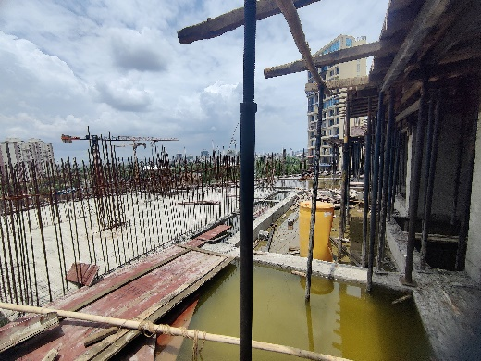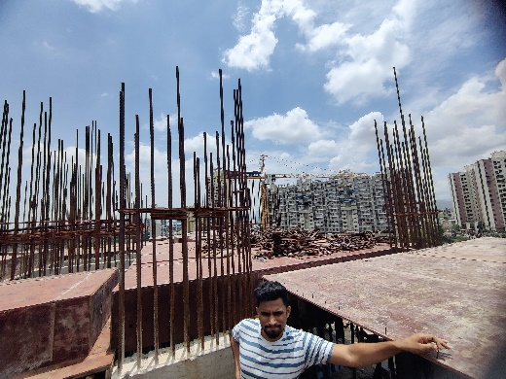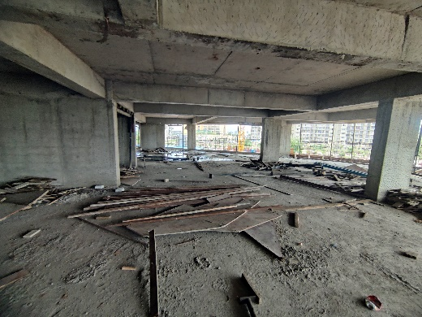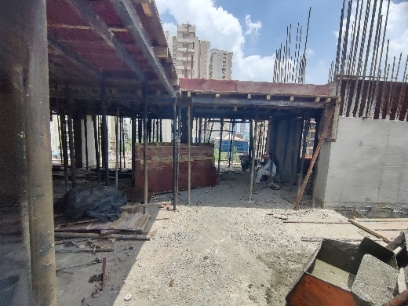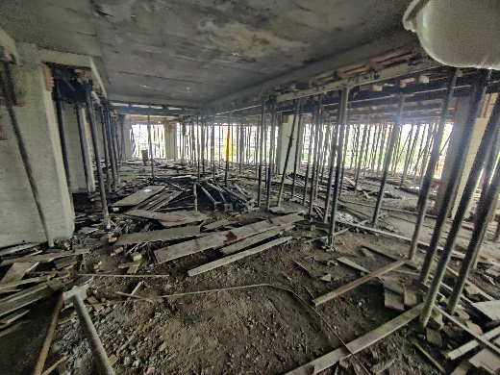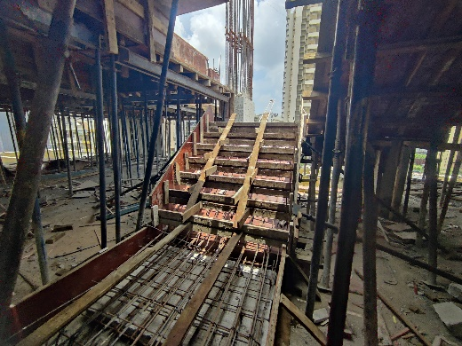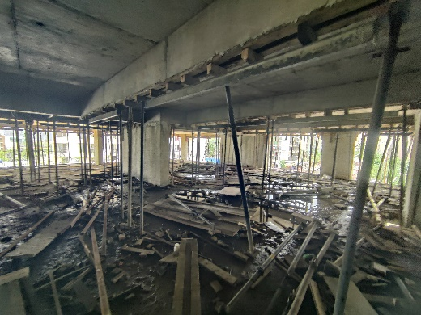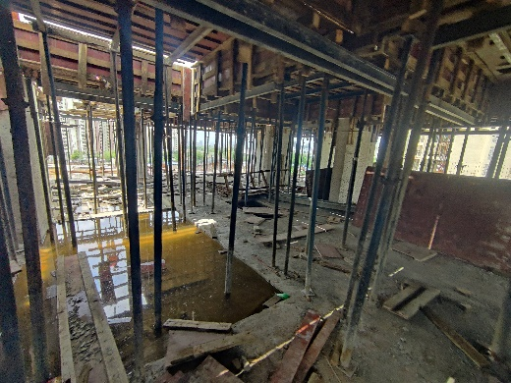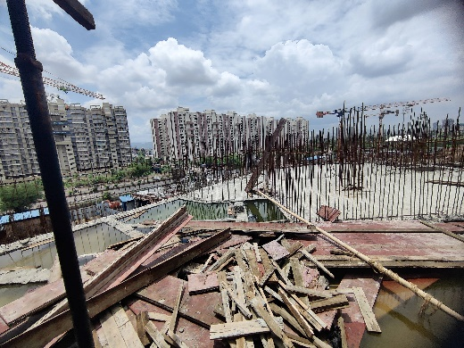

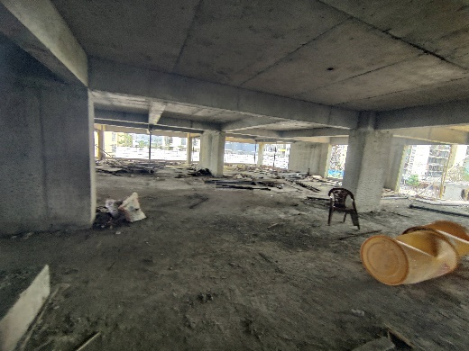

**Actual Site Photographs as on 15.06.2024**

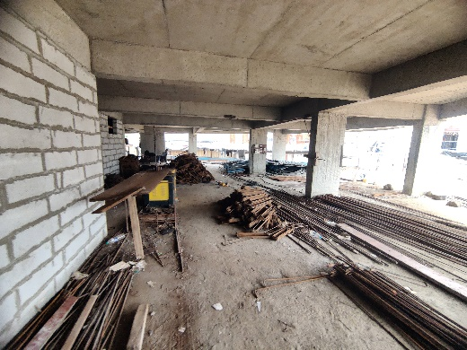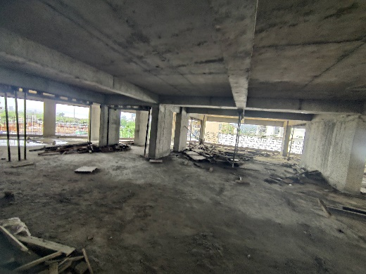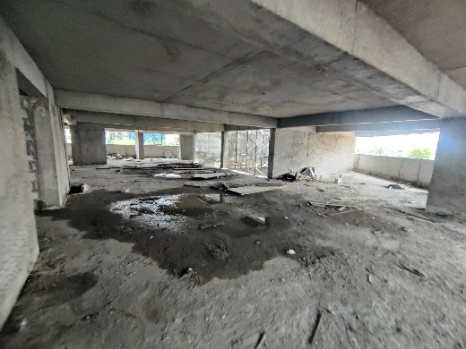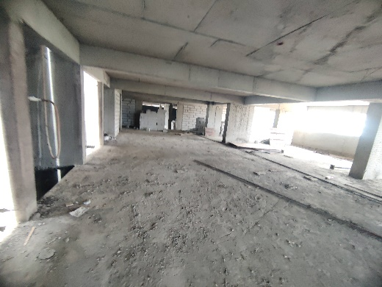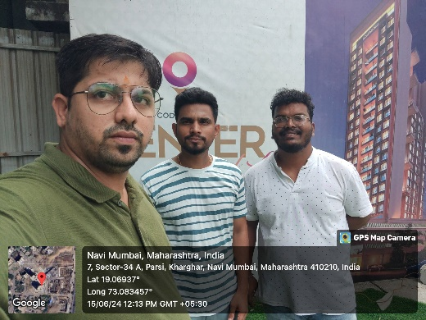

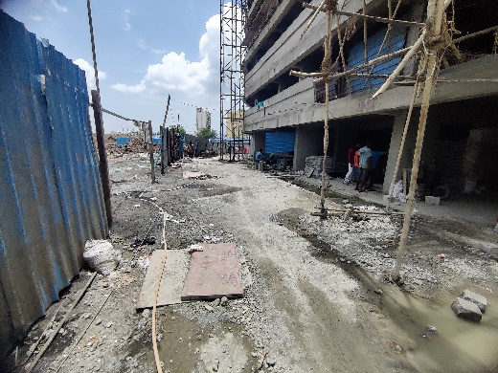

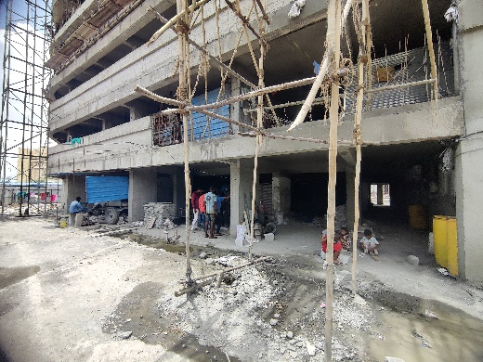

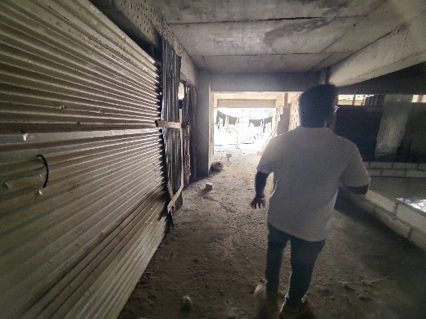

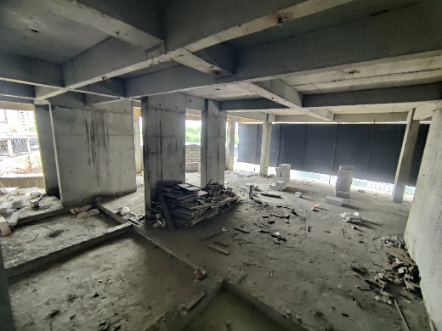

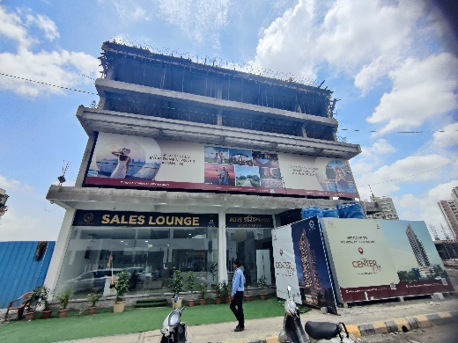

s

**Route Map of the property**

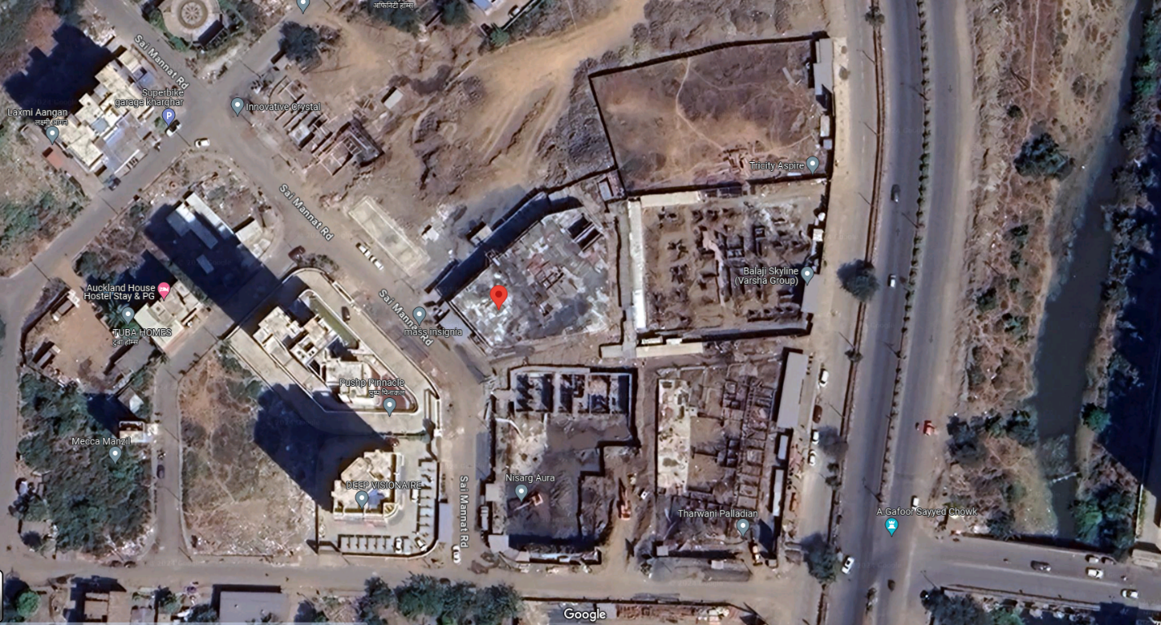**Site u/r**

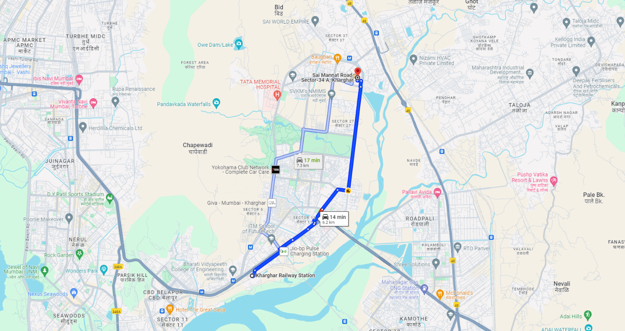

## Latitude Longitude: 19°04'10.3"N 73°05'01.4"E

Note: The Blue line shows the route to site from nearest railway station (Kharghar – 6.20 Km.)

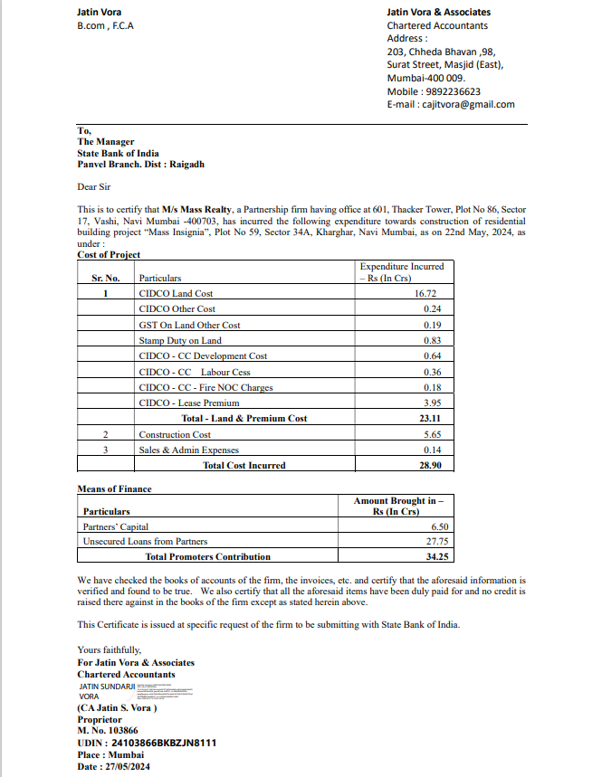**CA Certificate Dated 27.05.2024 cost incurred till 22.05.2024**