Vastu/Nashik/12/2024013342/2309805
26/25-503 -RPBS
Date: 04.02.2025

To,
The Branch Manager
Union Bank of India
RLP Nashik Branch
Nawandar Sankul, 1366, Racca Colony, Near Soni Paithani, Sharanpur Road,
Nashik – 422 002, State – Maharashtra, Country – India.

Sub: Vetting of Home Improvement

Sir,

With reference to above subject, we have evaluated the Home Improvement for Residential Flat No. 305, 3rd Floor, "Yogiraj Apartment", Opp. Shiv Nagar Jogging Track & Sports Ground, Plot No. 1+2, Dharmaveer Sambhaji Raje Chowk, Dr. Nanasaheb Dharmadhikari Marg, Village - Nashik, Taluka - Nashik, District - Nashik, Nashik, 422003, State - Maharashtra, India belongs to Shri. Chetan Bhalchandra Yeola.

We have verified the rates quoted as per current market rates. Details of Home Improvement considered as per copy of Home Improvement between Shri. Chetan Bhalchandra Yeola (First Party) G Square Interior (Second Party) received on dated.06.02.2025. The Extra Work amount is Rs. 9,30,000/- (Rupees Nine Lakh Thirty Thousand Only)

The said Cost Vetting Certificate is valid upto next 6 months Only.

Thanking you

Sincerely yours

Sharadkumar B. Chalikwar
Govt. Reg. Valuer
Chartered Engineer (India)
Reg. No. (N) CCIT/1-14/52/2008-09

Vetting of Home Improvement

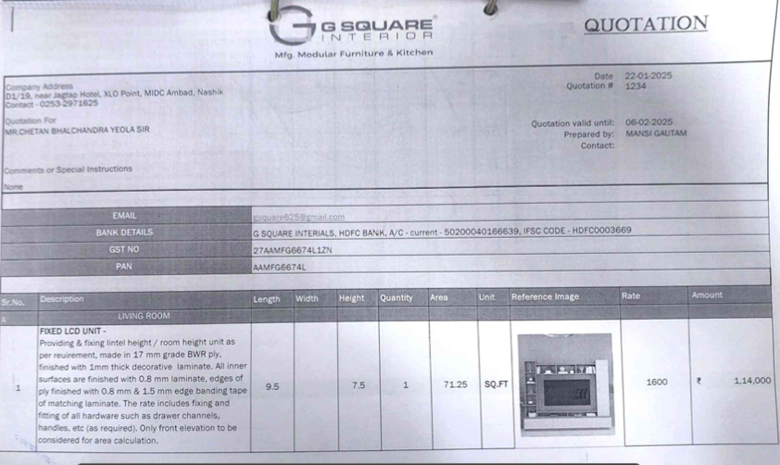

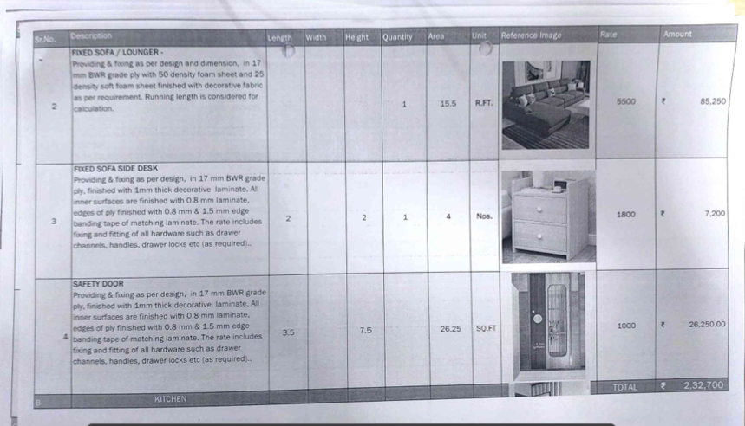

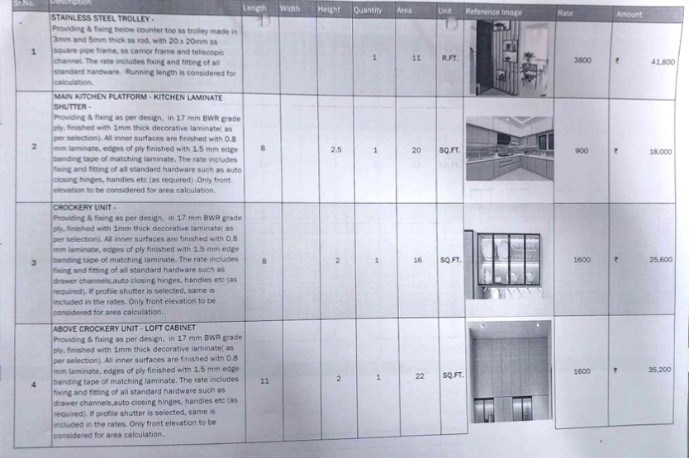

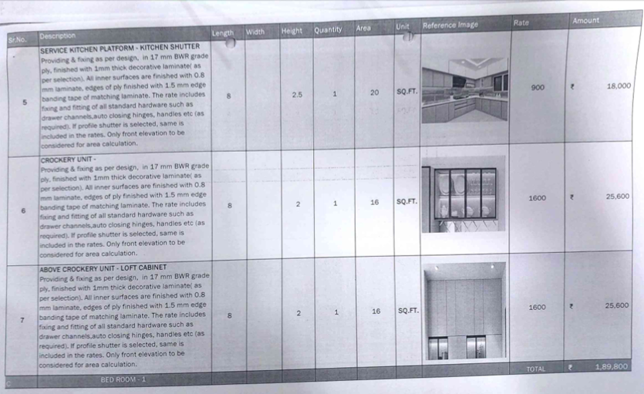

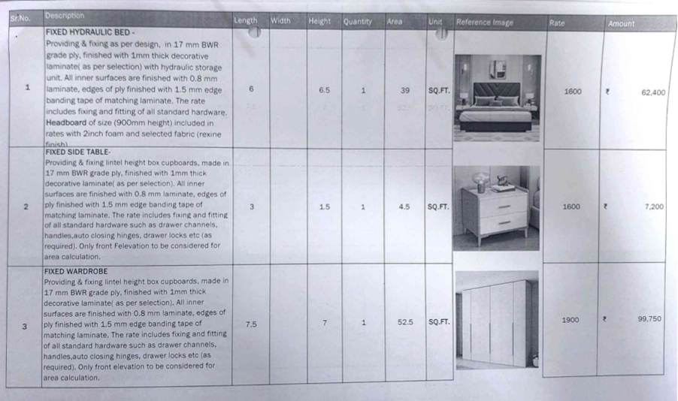

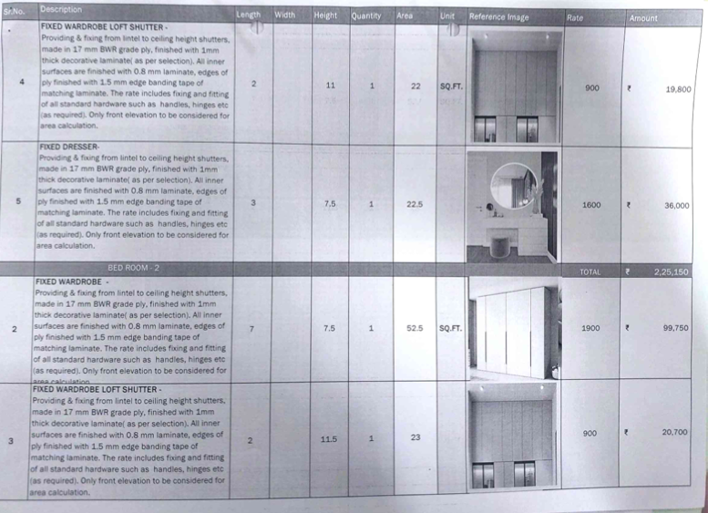

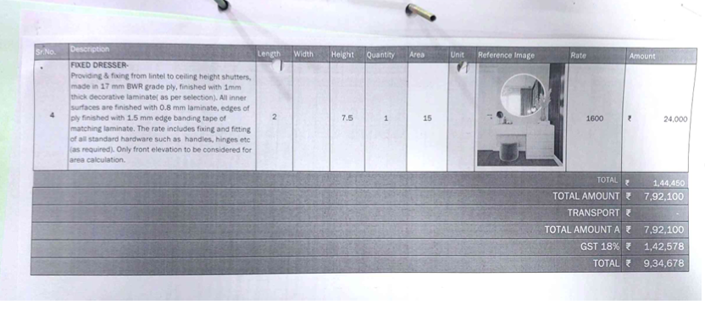

The Extra Work amount is Rs. 9,30,000/- (Rupees Nine Lakh Thirty Thousand Only)

