Vastu/Nashik/01/2025/014030/2310316
30/9-435-RPSP
Date: 30.01.2025

To, `
The Branch Manager,
Bank of Baroda
Regional Office Nashik Road Branch
BSNL Building, Datta Mandir Road, Nashik Road,
Nashik -422 101, State - Maharashtra, Country - India.

Sub: Vetting of Extra Amenities

Sir,

With reference to above subject, we have evaluated the Extra Amenities for Residential Flat No. 301, 3rd Floor, "Shree Krishna Apartment Co-Op. Housing Society Ltd.", Near Kaka Gadre Mangal Karyalaya, Gole Colony, Ashok Stambh, Plot No. 28, Final Plot No. 74, T.P.S-1, Gangapur Road, Taluka - Nashik, District - Nashik, Nashik, PIN Code - 422 002, State - Maharashtra, Country - India belongs to Shri. Chandrakant Murlidhar Thete. Name of Proposed Purchaser is Shri. Nitin Mohan Pawar & Shri. Swapnil Mohan Pawar.

We have verified the rates quoted as per current market rates. Details of Extra Amenities considered as per copy of Agreement for Extra Amenities issued by to Shri. Chandrakant Murlidhar Thete. Name of Proposed Purchaser is Shri. Nitin Mohan Pawar & Shri. Swapnil Mohan Pawar. (First Party) Shri. Balu Ananda Mahale (Second Party) received on dated 29.01.2025. The Extra Amenities amount is Rs.6,20,000/- (Rupees Six Lakh Twenty Thousand Only.)

The said Cost Vetting Certificate is valid upto next 6 months Only.

Thanking you

Sincerely yours

Manoj B. Chalikwar
Registered Valuer
Chartered Engineer (India)
Reg. No. CAT-I-F-1763
Reg. No. IBBI/RV/07/2018/10366
BOB Empanelment No.: ZO:MZ:ADV:46:941
Encl: Valuation report.
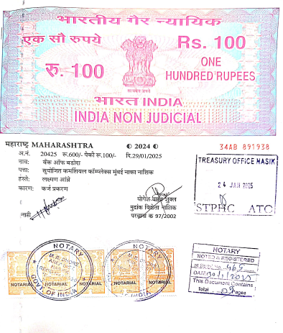
Agreement of Extra Amenities
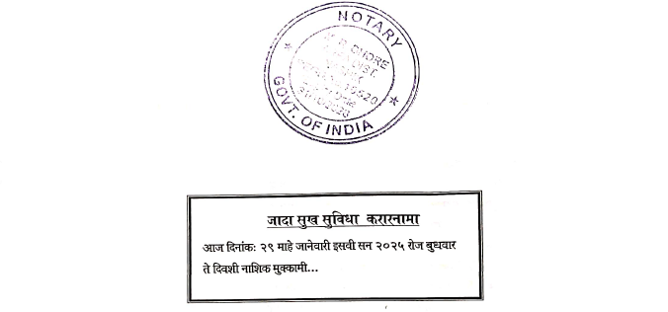

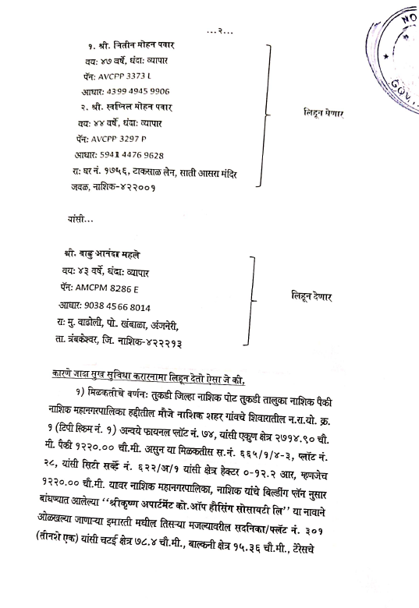

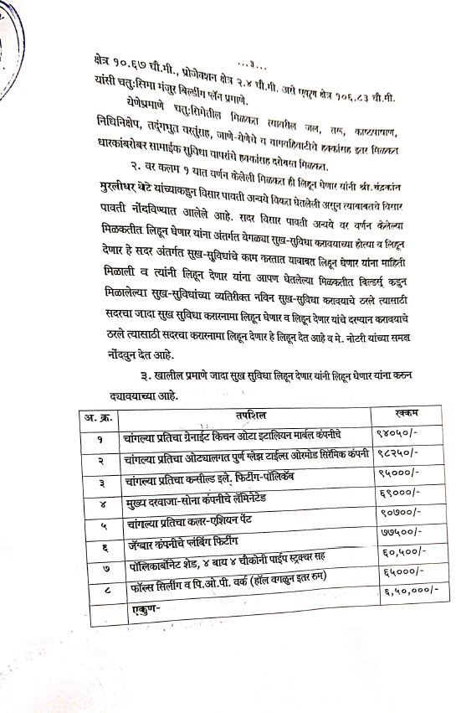
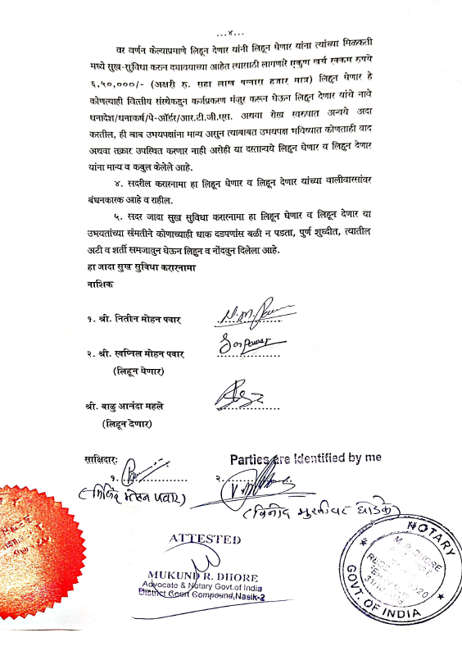

The Extra Work amount Rs.6,20,000/- (Rupees Six Lakh Twenty Thousand Only.)

