Valuation Report of the Immovable Property

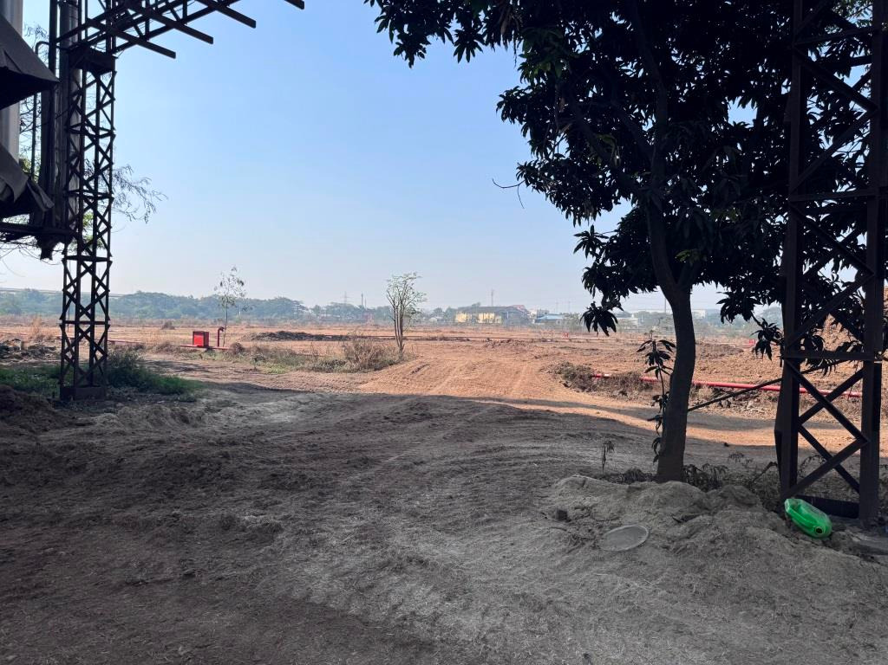

Details of the property under consideration:

Name of Owner: M/s. Nagreeka Exports Ltd.

Industrial Land on Plot No. T- 48, MIDC, Kagal - Hatkanangale, Five Star Industrial Area, Village -Talandage, Taluka Hatkanangale, Dist. Kolhapur, Pin Code - 416236, State - Maharashtra, Country - India

Longitude Latitude: 16°36'50.8"N 74°21'07.4"E

Intended User:
M/s. Nagreeka Exports Ltd.

INDEX
Particulars Page No.

1. VALUATION OPINION REPORT 3
2. VALUATION REPORT (IN RESPECT OF LAND AND STRUCTURES) 4
3. TOTAL ABSTRACT OF THE ENTIRE PROPERTY 7
4. ACTUAL SITE PHOTOGRAPHS 9
5. ROUTE MAP OF THE PROPERTY 10
6. MIDC CIRCLE RATE 11
7. MIDC LAYOUT 12
8. ASSUMPTIONS, DISCLAIMERS, LIMITATIONS & QUALIFICATIONS 15
9. ASSUMPTIONS, CAVEATS, LIMITATION AND DISCLAIMERS 18

Vastu/Mumbai/01/2025/014015/2310310
30/3-429 -SSPBS
Date: 30.01.2025

VALUATION OPINION REPORT
This is to certify that the property bearing Industrial Land on Plot No. T-48, MIDC, Kagal - Hatkanangale, Five Star Industrial Area, Village -Talandage, Taluka Hatkanangale, Dist. Kolhapur, PIN - 416236, Maharashtra, India belongs to M/s. Nagreeka Exports Ltd.
Boundaries of the property as per site.
North | : | MIDC Road 30.00 M. R/W
South | : | MIDC Road 60.00 M. R/W
East | : | MIDC Road 30.00 M. R/W
West | : | VP Industries Unit No 021 Mahalaxmi Textiles

Considering various parameters recorded, existing economic scenario, and the information that is available with reference to the development of neighborhood and method selected for valuation, we are of the opinion that, the property premises can be assessed and Fair Market Value for this particular purpose at
Particulars | Area in Sq. M. | Rate per Sq. M. (`) | Value (`)
- Land | 1,27,576.00 | 980/- | 12,50,24,480.00
- Building | We Area Considering Only Land for Valuation

The valuation of the property is based on the documents produced by the concerned. Legal aspects have not been taken into consideration while preparing this valuation report.
Hence certified.

Manoj B. Chalikwar
Registered Valuer
Chartered Engineer (India)
Reg. No. CAT-I-F-1763
Encl.: Valuation Report

Vastukala Consultants (I) Pvt. Ltd.
B1-001, U/B Floor, Boomerang, Chandivali Farm Road, Powai, Andheri (East), Mumbai – 400 072

VALUATION REPORT (IN RESPECT OF LAND AND STRUCTURES)

I
General
1. | Purpose for which the valuation is made |  |  | : | To assess the Fair Market Value for private purpose.
2. | a) | Date of inspection |  | : | 23.01.2025
 | b) | Date on which the valuation is made |  | : | 30.01.2025
3. | Copy of List of documents produced for perusal:
- Copy of Factory License No. 123001313100831 dated 15.05.2018 issued by Government of Maharashtra.
- Copy of Occupancy Certificate No. TB/KH/T-48/B76952/2013 dated 12.06.2013 issued by Maharashtra Industrial Development Corporation.
- Copy of Lease Agreement dated 28.11.2007 between Maharashtra Industrial Development Corporation (Grantor) and M/s. Nagreeka Exports Limited (The Licensee) through Reg. Doc. No. 408/2007 dated 27.11.2007.
- Copy of Property tax Paid Receipt dated 02.02.2019.
4. | Name of the owner(s) and his / their address (es) with Phone no. (details of share of each owner in case of joint ownership) |  |  | : | M/s. Nagreeka Exports Ltd.  Address:  Industrial Land on Plot No. T-48, MIDC, Kagal - Hatkanangale, Five Star Industrial Area, Village -Talandage, Taluka Hatkanangale, Dist. Kolhapur, Pin Code - 416236, State - Maharashtra, Country - India  Contact Person:  Mr. Kailash Parashar (Plant head)  Contact Number: 89563 05681  Limited Company Ownership
5. | Brief description of the property (Including Leasehold / freehold etc.) |  |  | :
The immovable property comprises of leasehold land & Factory Building thereof. The property is located in a developing area having good infrastructure, well connected by road and train. It is located at about – 20.00 km. travelling distance from Kolhapur Railway Station & 15.5 Km Travelling Distance from Kolhapur Airport.

Land
We have considered Factory Land admeasuring 1,27,576 Sq. M. for Valuation as per Lease deed & MIDC Layout Plan.

Structure:
The property consists of Factory Building.

The composition of the Factory Building as per site is as below –
Sr. No. | Particular | Type of Structure
A. | Phase 1
1 | Yarn Dyeing Unit-Ground Floor | PEB Structure with brick wall masonry partly
2 | Yarn Dyeing Unit-first Floor | PEB Structure with brick wall masonry partly
B. | Phase 2
1 | Cotton Godown - G + 1 | RCC Structure with GI Sheet
2 | Yard Dyeing Unit - Ground Floor | PEB Structure with brick wall masonry partly
3 | Canteen | RCC Structure
4 | Metering Room | RCC Structure
5 | ETP Plant (U.S.E.F) | RCC Structure
6 | Boiler House | AC Sheet Structure

6. | Location of property |  |  | :
 | a) | Plot No. / Survey No. |  | : | Plot No. T - 48
 | b) | Door No. |  | : | Not Applicable
 | c) | C.T.S. No. / Village |  | : | Village – Talandage
 | d) | Ward / Taluka |  | : | Taluka – Hatkanangale
 | e) | Mandal / District |  | : | District - Kolhapur
7. | Postal address of the property |  |  | : | Industrial Land on Plot No. T- 48, MIDC, Kagal - Hatkanangale, Five Star Industrial Area, Village -Talandage, Taluka Hatkanangale, Dist. Kolhapur, Pin Code - 416236, State - Maharashtra, Country - India
8. | City / Town |  |  | : | Kolhapur
 | Residential area |  |  | : | No
 | Commercial area |  |  | : | No
 | Industrial area |  |  | : | Yes
9. | Classification of the area |  |  | :
 | i) High / Middle / Poor |  |  | : | Middle Class
 | ii) Urban / Semi Urban / Rural |  |  | : | Semi - Urban
10. | Coming under Corporation limit / Village Panchayat / Municipality |  |  | : | Maharashtra Industrial Development Corporation (MIDC)
11. | Whether covered under any State / Central Govt. enactments (e.g., Urban Land Ceiling Act) or notified under agency area/ scheduled area / cantonment area |  |  | : | No
12. | In Case it is Agricultural land, any conversion to house site plots is contemplated |  |  | : | N.A.
 | Landmark |  |  | : | Kagal 5 Star MIDC
13. | Boundaries of the property
 | Particulars |  | North | South |  | East |  | West
 | As per Site Visit
 |  |  | Road | Kagal MIDC Road |  | Road & Oswal FM Hammerle Textiles Limited |  | VP Industries – Unit No 2
 | As per Sale Deed
 |  |  | MIDC Road 30 M | MIDC Road 60 M |  | MIDC Road 30.00 |  | Plot No T – 49 & MIDC Land
13.1 | Dimensions of the site |  |  | :
 |  |  |  |  | A As per the Deed |  | B Actuals
 | North |  |  |  | N.A. as the Plot is irregular in shape.
 | South
 | East
 | West
13.2 | Latitude, Longitude & Co-ordinates of property |  |  |  | 16°36'50.8"N 74°21'07.4"E
14. | Extent of the site |  |  | : | Land area = 1,27,576 Sq. M.  (Area as per Lease Agreement)
 | Extent of the site considered for Valuation (least of 14A& 14B) |  |  | :
16 | Whether occupied by the owner / tenant? If occupied by tenant since how long? Rent received per month. |  |  | : | Owner Occupied
II | CHARACTERSTICS OF THE SITE
 | Classification of locality |  |  | : | Middle class
 | Development of surrounding areas |  |  | : | Developing
 | Possibility of frequent flooding/ sub-merging |  |  | : | No
 | Feasibility to the Civic amenities like School, Hospital, Bus Stop, Market etc. |  |  | : | All available near by
 | Level of land with topographical conditions |  |  | : | Plain
 | Shape of land |  |  | : | Rectangular
 | Type of use to which it can be put |  |  | : | For Industrial purpose
 | Any usage restriction |  |  | : | Industrial
 | Is plot in town planning approved layout? |  |  | : | Yes
 | Corner plot or intermittent plot? |  |  | : | Intermediate
 | Road facilities |  |  | : | Yes
 | Type of road available at present |  |  | : | B.T. Road
 | Width of road – is it below 20 ft. or more than 20 ft. |  |  | : | More than 20 ft.
 | Is it a Land – Locked land? |  |  | : | No
 | Water potentiality |  |  | : | Good
 | Underground sewerage system |  |  | : | Available
 | Is Power supply is available in the site |  |  | : | Yes
 | Advantages of the site |  |  | : | Located in developing area
 | Special remarks, if any like threat of acquisition of land for publics service purposes, road widening or applicability of CRZ provisions etc. (Distance from sea-cost / tidal level must be incorporated) |  |  | : | No
Part – A (Valuation of land)
1 | Size of plot |  |  | : | Land area = 1,27,576 Sq. M.  (Area as per Lease Agreement)
 | North & South |  |  | : | -
 | East & West |  |  | : | -
2 | Total extent of the plot |  |  | : | Land area = 1,27,576 Sq. M.  (Area as per Lease Agreement)
3 | Prevailing market rate (Along with details / reference of at least two latest deals / transactions with respect to adjacent properties in the areas) |  |  | : | ` 850/- to ` 1000/- per Sq. M.  Details of online listings are attached with the report.
4 | Government Ready Reckoner Rate of Land – MIDC Circle Rate |  |  | : | ₹ 980/- per Sq. M.
5 | Assessed / adopted rate of valuation of Land |  |  | : | ` 980/- per Sq. M.
6 | Estimated value of land |  |  | : | ` 12,50,24,480/-
Part – B (Valuation of Building)
1 | Technical details of the building |  |  | :
 | - Type of Building (Residential / Commercial / Industrial) |  |  | : | Industrial Factory
 | - Year of construction |  |  | : | 2012 & 2017
 | - Number of floors and height of each floor including basement, if any |  |  | : | NA
 | - Plinth area floor-wise |  |  | : | NA
 | - Condition of the building |  |  | : | NA
 | - Exterior – Excellent, Good, Normal, Poor |  |  | : | NA
 | - Interior – Excellent, Good, Normal, Poor |  |  | : | NA
 | - Date of issue and validity of layout of approved map |  |  | : | NA

Government Value

Particulars | Area in Sq. M. | Rate per Sq. M. ( `) | Value in (`)
Land | 1,27,576.00 | 980/- | 12,50,24,480/-
Structure | Not Applicable Here we are Considering only Land Valuation. |  | -
Total |  |  | 12,50,24,480/-

TOTAL ABSTRACT OF THE ENTIRE PROPERTY

Part - A | Land |  | ` 12,50,24,480/-
Part - B | Buildings |  | -
 | Land Development |  | -
Part – C | Compound Wall |  | -
Part – D | Amenities |  | -
Part - E | Pavement |  | -
Part - F | Services |  | -
 | Fair Market Value In (`) |  | ` 12,50,24,480/-
 | Realisable Value In (`) |  | ` 11,25,22,032/-
 | Distress Value In (`) |  | ` 10,00,19,584/-
 | Insurable Value In (`) |  | -
Remarks | - In This Valuation we only consider Land Valuation.

Justification for price /rate
The Market Value of the property is based on facts of markets discovered by us during our enquiries, however the government rate value in this case is less than the market value arrived by us. We are of the opinion that the value arrive by us will prove to be correct if an Auction of the subject property is carried out. As far as Market Value as per property document is concerned, it is not possible to comment on same, may be government rates are fixed by sampling during same point of time in part and whereas, Market values change every month.
In most of the cases the actual deal amount or Transaction value is not reflected in the property documents because of various Market practices. As Valuer, we always try to give a value which is correct reflection of actual transaction value irrespective of any factors in market.
Method of Valuation / Approach
Land cost can be estimated using the Sales Comparison Approach by studying recent sales of land close to the subject property, and these sales should be comparable in size and location with subject property.

There are different ways to estimate replacement costs, the most common being finding out the cost to build a square foot of comparable properties multiplied by the total square footage of the building. The cost approach is commonly used for Residential House, Commercial Building and properties mentioned above.

As the property is Industrial land, we have adopted Cost approach / Land and Building Method for the purpose of valuation. The Price for similar type of property in the nearby vicinity is in the range of ` 850/- to ` 1000/- per Sq. M. for land Considering the rate with attached report, current market conditions, demand and supply position, Land size, location, sustained demand for Commercial Plot, all round development of industrial and commercial application in the locality etc. We estimate ` 980/- per Sq. M. for Land with appropriate cost of construction for valuation.

The saleability of the property is: Normal
Expected rental values per month: N.A.
Any likely income it may generate: N.A.

ACTUAL SITE PHOTOGRAPHS

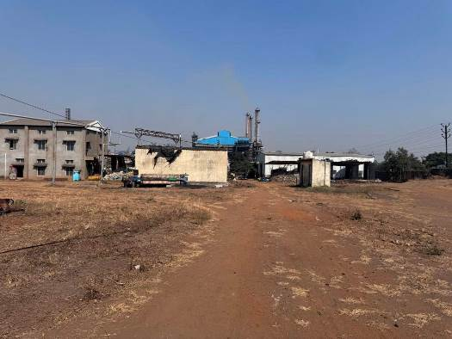
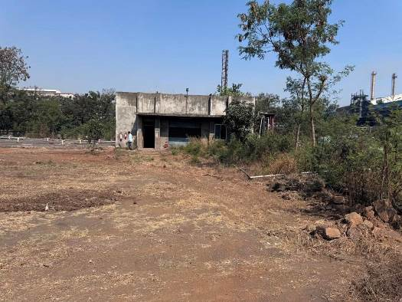
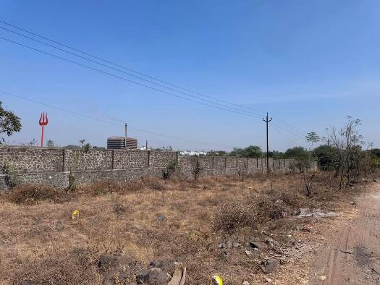
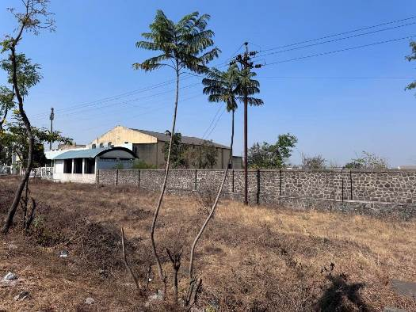
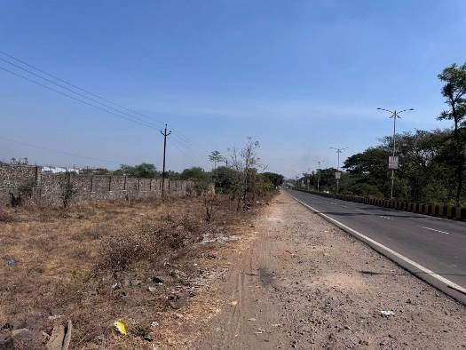
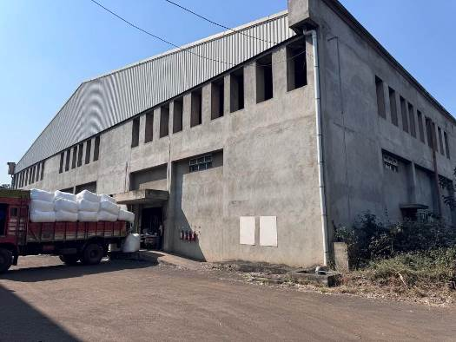
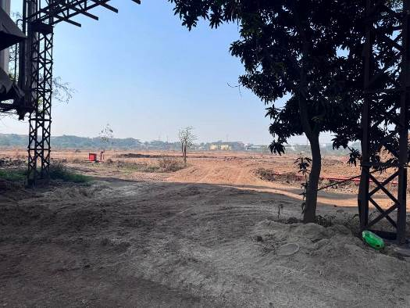
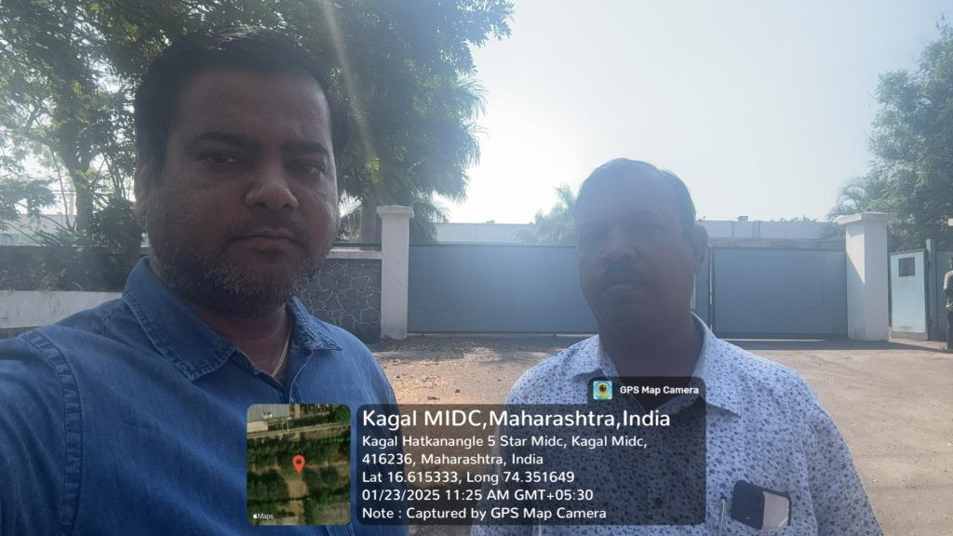

ROUTE MAP OF THE PROPERTY
Site u/r
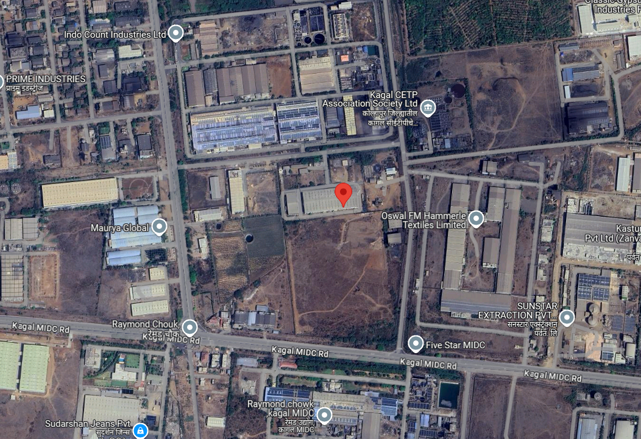

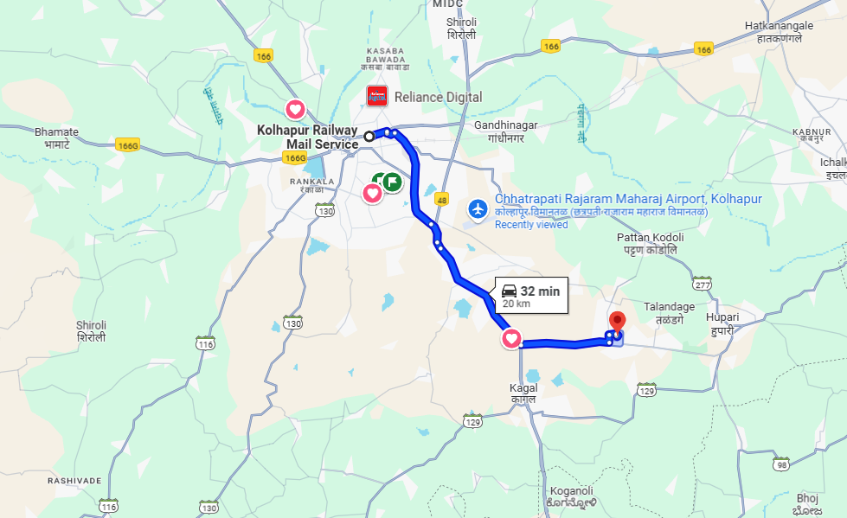

Longitude Latitude: 16°36'50.8"N 74°21'07.4"E
Note: The Blue line shows the route to site from nearest railway station (Kolhapur – 20.00 km.)

MIDC CIRCLE RATE

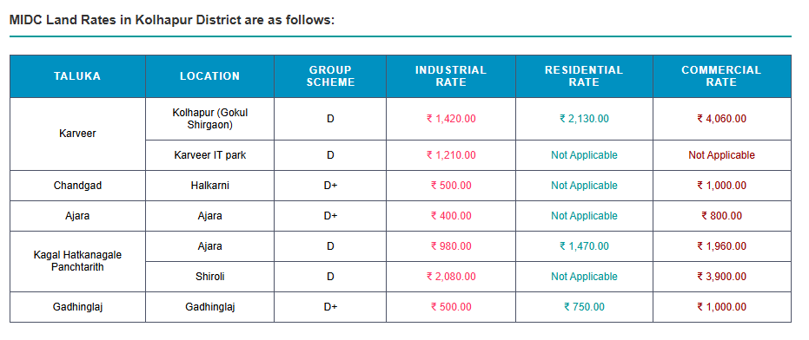

MIDC LAYOUT
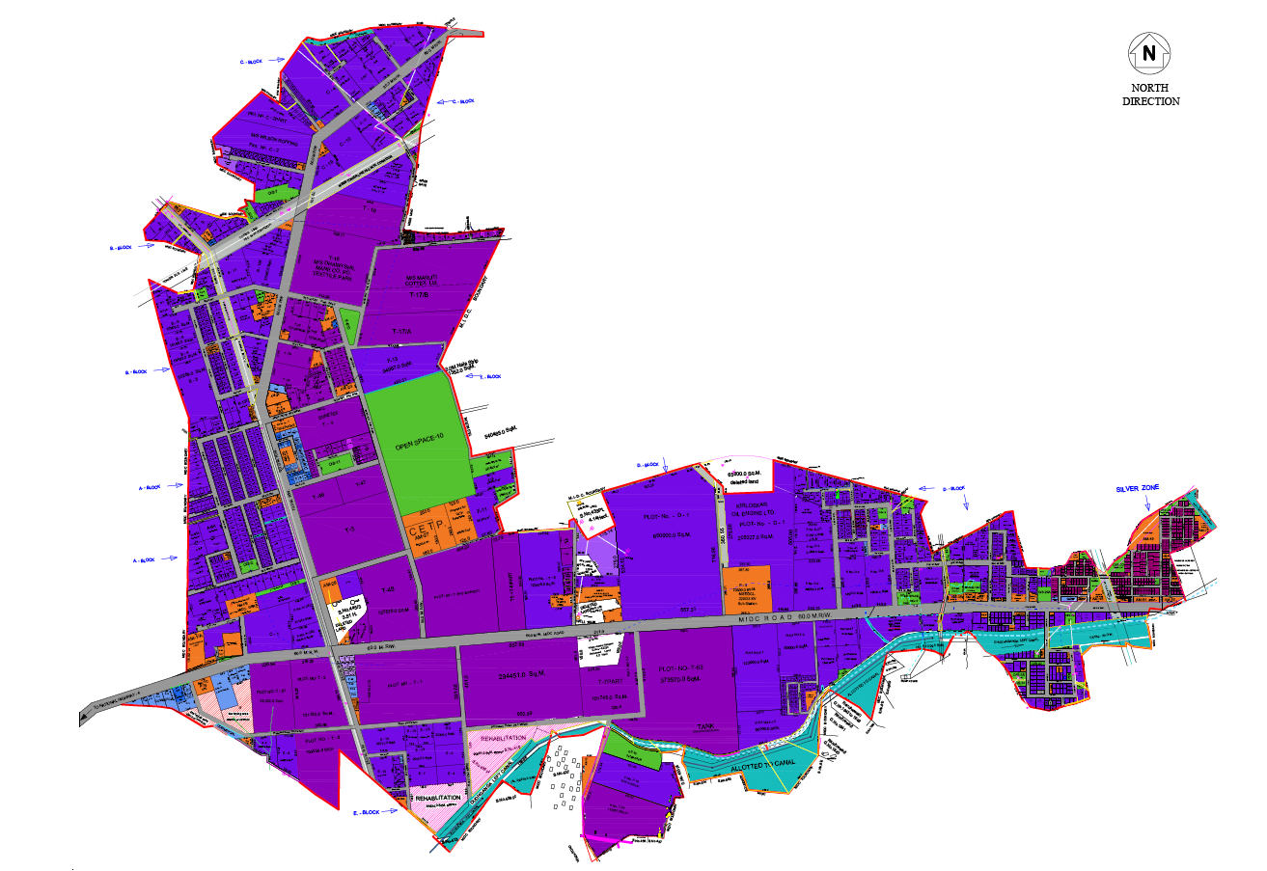

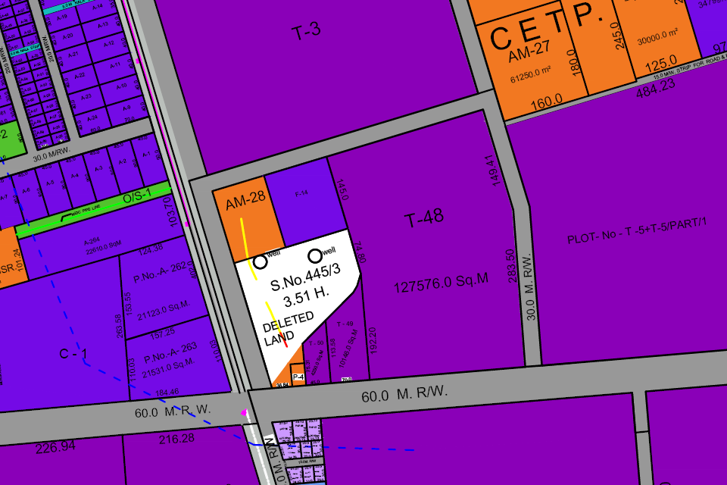

As a result of my appraisal and analysis, it is my considered opinion that the Fair Market Value for this particular above property in the prevailing condition with aforesaid specification is as below –

Particulars | Fair Market Value In (`) | Realizable Value In (`) | Distress Sale Value In (`)
Land | 12,50,24,480/- | 11,25,22,032/- | 10,00,19,584/-

Place: Mumbai
Date: 30.01.2025

Manoj B. Chalikwar
Registered Valuer
Chartered Engineer (India)
Reg. No. CAT-I-F-1763

Sr. No. | Particulars | Valuer comment
1 | Background information of the asset being valued; | The land under consideration is owned by M/s. Nagreeka Exports Ltd.
2 | Purpose of valuation and appointing authority | To assess the Fair Market Value of the Land.
3 | Identity of the Valuer and any other experts involved in the valuation; | Manoj B. Chalikwar - Regd. Valuer  Avinash Pandey – Regd. Valuer  Prayush Parekh – Senior Valuation Engineer  Saiprasad Patil – Valuation Engineer  Binu Surendran - Technical Manager
4 | Disclosure of Valuer interest or conflict, if any; | We have no interest, either direct or indirect, in the property valued. Further to state that we do not have relation or any connection with property owner / applicant directly or indirectly. Further to state that we are an independent Valuer and in no way related to property owner / applicant
5 | Date of appointment, valuation date and date of report; | Date of Appointment – 22.01.2025  Valuation Date – 30.01.2025  Date of Report – 30.01.2025
6 | Inspections and/or investigations undertaken; | Physical Inspection done on date 23.01.2025
7 | Nature and sources of the information used or relied upon; | - Market Survey at the time of site visit  - Ready Reckoner rates / Circle rates  - Online Price Indicators on real estate portals  - Enquiries with Real estate consultants  - Existing data of Valuation assignments carried out by us
8 | Procedures adopted in carrying out the valuation and valuation standards followed; | Comparative Sales Method (For Land component)
9 | Restrictions on use of the report, if any; | This valuation is for the use of the party to whom it is addressed and for no other purpose. No responsibility is accepted to any third party who may use or rely on the whole or any part of this valuation. The valuer has no pecuniary interest that would conflict with the proper valuation of the property.
10 | Major factors that were taken into account during the valuation. | Current market conditions, demand and supply position, Commercial land size, location, sustained demand for Commercial land, all round development of commercial and industrial application in the locality etc.
11 | Major factors that were not taken into account during the valuation. | Nil
11 | Caveats, limitations, and disclaimers to the extent they explain or elucidate the limitations faced by valuer, which shall not be for the purpose of limiting his responsibility for the valuation report. | Attached

ASSUMPTIONS, DISCLAIMERS, LIMITATIONS & QUALIFICATIONS

Value Subject to Change
The subject appraisal exercise is based on prevailing market dynamics as on 30th January 2025 and does not take into account any unforeseeable developments which could impact the same in the future.
Our Investigations
We are not engaged to carry out all possible investigations in relation to the subject property. Where in our report we identify certain limitations to our investigations, this is to enable the reliant party to instruct further investigations where considered appropriate or where we recommend as necessary prior to reliance. Vastukala Consultants India Pvt. Ltd. (VCIPL) is not liable for any loss occasioned by a decision not to conduct further investigations.
Assumptions
Assumptions are a necessary part of undertaking valuations. VCIPL adopts assumptions for the purpose of providing valuation advice because some matters are not capable of accurate calculations or fall outside the scope of our expertise, or out instructions. The reliant party accepts that the valuation contains certain specific assumptions and acknowledge and accept the risk of that if any of the assumptions adopted in the valuation are incorrect, then this may have an effect on the valuation.
Information Supplied by Others
The appraisal is based on the information provided by the client. The same has been assumed to be correct and has been used for appraisal exercise. Where it is stated in the report that another party has supplied information to VCIPL, this information is believed to be reliable but VCIPL can accept no responsibility if this should prove not to be so.
Future Matters
To the extent that the valuation includes any statement as to a future matter, that statement is provided as an estimate and/or opinion based on the information known to VCIPL at the date of this document. VCIPL does not warrant that such statements are accurate or correct.
Map and Plans
Any sketch, plan or map in this report is included to assist the reader while visualizing the property and assume no responsibility in connection with such matters.
Site Details
Based on inputs received from Client's representative and site visit conducted, we understand that the subject property is land parcel total admeasuring 1,27,576 Sq. M. The property is owned by M/s. Nagreeka Exports Ltd. At present, the property is various lessee occupied. Further, VCIPL has assumed that the subject property is free from any encroachment and is available as on the date of the appraisal.
Property Title
Based on our discussion with the Client, we understand that the property is owned by M/s. Nagreeka Exports Ltd. For the purpose of this appraisal exercise, we have assumed that the subject property has a clear title and is free from any encumbrances, disputes and claims. VCIPL has made no further enquiries with the relevant local authorities in this regard and does not certify the property as having a clear and marketable title. Further, no legal advice regarding the title and ownership of the subject property has been obtained for the purpose of this appraisal exercise. It has been assumed that the title deeds are clear and marketable.
Environmental Conditions
We have assumed that the subject property is not contaminated and is not adversely affected by any existing or proposed environmental law and any processes which are carried out on the property are regulated by environmental legislation and are properly licensed by the appropriate authorities.
Town Planning
The permissible land use, zoning, achievable FSI, area statement adopted for purpose of this valuation is based on the information provided by the Client's representative and the same has been adopted for this valuation purpose. VCIPL has assumed the same to be correct and permissible. VCIPL has not validated the same from any authority.
Area
Based on the documents, we understand that the subject property is contiguous land parcel total admeasuring 1,27,576 Sq. M.
Condition & Repair
In the absence of any information to the contrary, we have assumed that there are no abnormal ground conditions, nor archaeological remains present which might adversely affect the current or future occupation, development or value of the property. The property is free from rat, infestation, structural or latent defect. No currently known deleterious or hazardous materials or suspect techniques will be used in the construction of or subsequent alteration or additions to the property and comments made in the property details do not purport to express an opinion about, or advise upon, the condition of uninspected parts and should not be taken as making an implied representation or statement about such parts.

Valuation Methodology
Land cost can be estimated using the Sales Comparison Approach by studying recent sales of land close to the subject property, and these sales should be comparable in size and location with subject property.
There are different ways to estimate replacement costs, the most common being finding out the cost to build a square foot of comparable properties multiplied by the total square footage of the building. The cost approach is commonly used for Residential House, Commercial Building and properties mentioned above.
Where reliance has been placed upon external sources of information in applying the valuation methodologies, unless otherwise specifically instructed by Client and/or stated in the valuation, VCIPL has not independently verified that information and VCIPL does not advise nor accept it as reliable. The person or entity to whom the report is addressed acknowledges and accepts the risk that if any of the unverified information in the valuation is incorrect, then this may have an effect on the valuation.
Not a Structural Survey
We state that this is a valuation report and not a structural survey.
Other
All measurements, areas and ages quoted in our report are approximate.
Legal
We have not made any allowances with respect to any existing or proposed local legislation relating to taxation on realization of the sale value of the subject property. VCIPL is not required to give testimony or to appear in court by reason of this appraisal report, with reference to the property in question, unless arrangement has been made thereof. Further, no legal advice on any aspects has been obtained for the purpose of this appraisal exercise.
Property specific assumptions
Based on inputs received from the client and site visit conducted, we understand that the subject property is land total admeasuring 1,27,576 Sq. M. It is occupied by M/s. Nagreeka Exports Ltd.

ASSUMPTIONS, CAVEATS, LIMITATION AND DISCLAIMERS
- We assume no responsibility for matters of legal nature affecting the property appraised or the title thereto, nor do we render our opinion as to the title, which is assumed to be good and marketable.
- The property is valued as though under responsible ownership.
- It is assumed that the property is free of liens and encumbrances.
- It is assumed that there are no hidden or unapparent conditions of the subsoil or structure that would render it more or less valuable. No responsibility is assumed for such conditions or for engineering that might be required to discover such factors.
- There is no direct/ indirect interest in the property valued.
- The rates for valuation of the property are in accordance with the Govt. approved rates and prevailing market rates.

Manoj B. Chalikwar
Registered Valuer
Chartered Engineer (India)
Reg. No. CAT-I-F-1763

