Vastu/Nashik/01/2025/013575/2309985
09/4-104 -RPBS
Date: 29.01.2025

To, `
The Branch Manager,
Bank of Baroda
Regional Office Nashik Road Branch
BSNL Building, Datta Mandir Road, Nashik Road,
Nashik -422 101, State - Maharashtra, Country - India.

Sub: Vetting of Extra Amenities

Sir,

With reference to above subject, we have evaluated the Extra Amenities for Residential Flat No. 1103, 11th Floor, "Imperial Tower", Near Dalimb Market, Plot No. 1+2 , Kailash Nagar, Sambhaji Nagar Road, Village - Dasak Shiwar, Taluka - Nashik, District - Nashik, Nashik, 422003, State - Maharashtra, India belongs to Shri. Chandrashekhar Jagannath Shirvadkar & Sau. Mansi Chandrashekhar Shirvadkar

We have verified the rates quoted as per current market rates. Details of Extra Amenities considered as per copy of Agreement for Extra Amenities issued by to Shri. Chandrashekhar Jagannath Shirvadkar & Sau. Mansi Chandrashekhar Shirvadkar (First Party) Linashri Vijay Bhamare Alies Dhanashri Anandrao Patil (Second Party) received on dated 20.01.2025. The Extra Amenities amount is Rs.6,00,000/- (Rupees Six Lakh Only.)

The said Cost Vetting Certificate is valid upto next 6 months Only.

Thanking you

Sincerely yours

Manoj B. Chalikwar
Registered Valuer
Chartered Engineer (India)
Reg. No. CAT-I-F-1763
Reg. No. IBBI/RV/07/2018/10366
BOB Empanelment No.: ZO:MZ:ADV:46:941
Encl: Valuation report.

Agreement of Extra Amenities

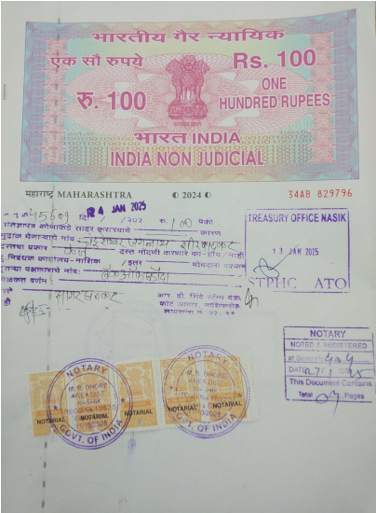
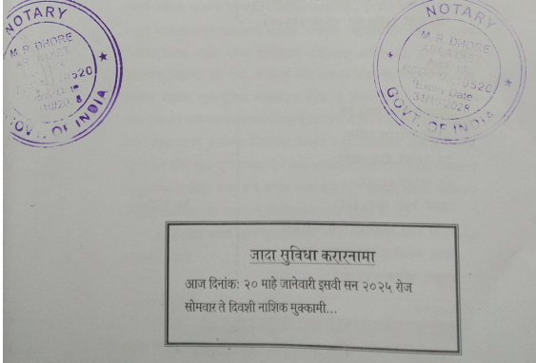

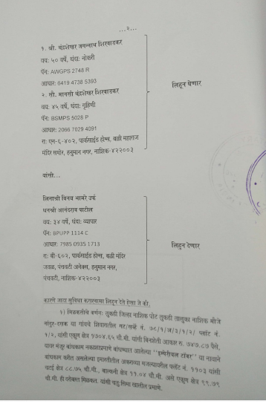

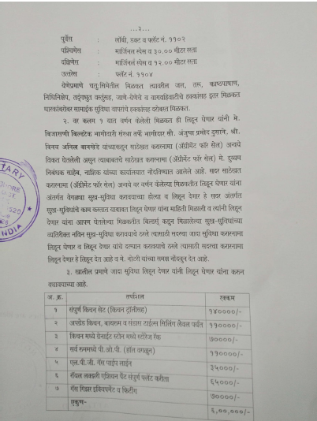
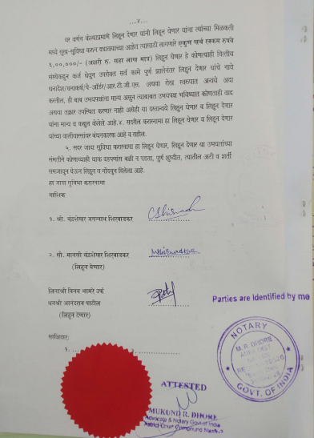

The Extra Work amount Rs.6,00,000/- (Rupees Six Lakh Only.)

