Vastu/Nashik/01/2025/013980/2310280
28/10-399 -RPBS
Date: 28.01.2025

To, `
The Branch Manager,
Bank of Maharashtra
Indira Nagar Branch
Rathchakra Chowk, Nashik 422009,

Sub: Vetting of Extra Amenities

Sir,

With reference to above subject, we have evaluated the Extra Amenities for Residential Flat No. 06, 1st Floor, "Vijay Residency Apartment", Opp. To Shree Tirumala Omkar Apartment, Near NMC Water Tank, Sadguru Nagar, Right Canal Road, Plot No. 26+27, Village - Anandwalli, Taluka - Nashik, District - Nashik, Nashik, PIN Code - 422 0013, State - Maharashtra, Country -India belongs to Shri. Yogesh Gangaram Dongare & Sau. Tarabai Gangaram Dongare.

We have verified the rates quoted as per current market rates. Details of work and Extra Amenities considered as per copy of Agreement for Extra Amenities issued by to Mr. Yogesh Gangaram Dongare & Mrs. Tarabai Gangaram Dongare (First Party) and Archin Suresh Kondhare (Second Party) received on dated 27.01.2025. The Extra Amenities amount is Rs.2,40,000/- (Rupees Two Lakh Forty Thousand Only.)

The said Cost Vetting Certificate is valid upto next 6 months Only.

Thanking you

Sincerely yours

Sharadkumar Chalikwar
Govt. Reg. Valuer
Chartered Engineer (India)
Reg. No. [N]C.C.I.T/I -14/52/2008-09
Bank Of Maharashtra Empanelment No.: AX-8/NZ/Panal Valuer/2022-23
Encl.: Valuation report

Agreement for Extra Amenities
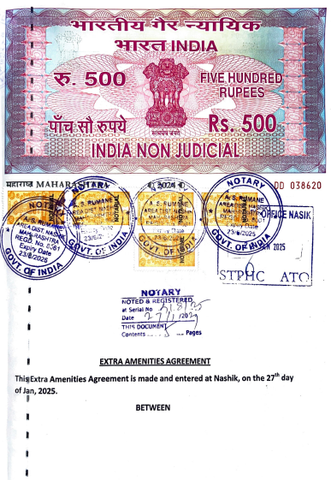
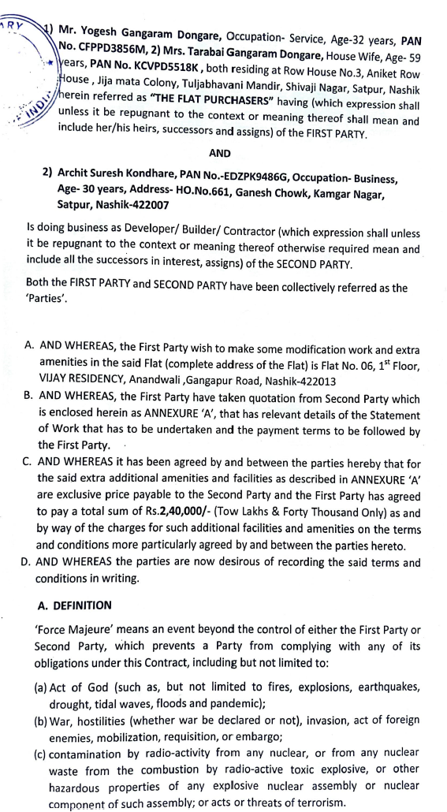

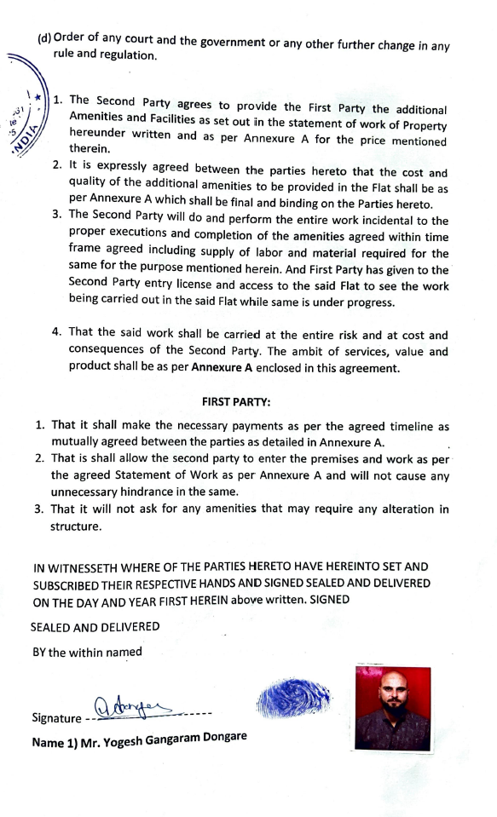
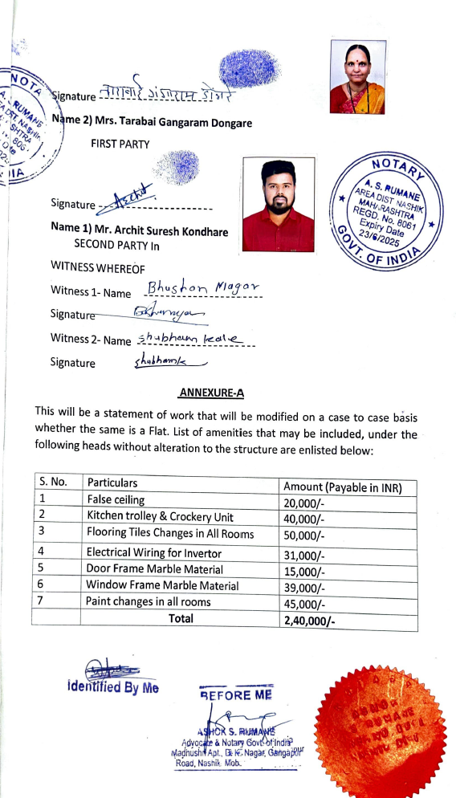

The Extra Amenities amount is Rs.2,40,000/- (Rupees Two Lakh Forty Thousand Only.)

