Vastu/Nashik/01/2025/013575/2309985
09/4-104 -RPBS
Date: 27.01.2025

To, `
The Branch Manager,
Bank of Baroda
Regional Office Nashik Road Branch
BSNL Building, Datta Mandir Road, Nashik Road,
Nashik -422 101, State - Maharashtra, Country - India.

Sub: Vetting of Extra Amenities

Sir,

With reference to above subject, we have evaluated the Extra Amenities for Residential Flat No. 06, 2nd Floor, "Orchid Galaxy", Near Golden Lawns, Kalpataru Nagar, Plot No. 19+20, Pakhal Rd, Village - Wadala, Taluka - Nashik, District - Nashik, Nashik, PIN Code - 422 006, State - Maharashtra, Country - India belongs to Shri. Mohammad Zaheer Muzaffar Kokani & Mohammad Azharoddin Muzaffar Kokani. Name of Proposed Purchaser is Shri. Hussain Hiraji Bagwan & Sau. Meena Hussain Bagwan.

We have verified the rates quoted as per current market rates. Details of Extra Amenities considered as per copy of Agreement for Extra Amenities issued by to Shri. Hussain Hiraji Bagwan & Sau. Meena Hussain Bagwan (First Party) Shri. Mushtak Takshin Khan (Second Party) received on dated 16.12.2024. The Extra Amenities amount is Rs.4,00,000/- (Rupees Four Lakh Only.)

The said Cost Vetting Certificate is valid upto next 6 months Only.

Thanking you

Sincerely yours

Manoj B. Chalikwar
Registered Valuer
Chartered Engineer (India)
Reg. No. CAT-I-F-1763
Reg. No. IBBI/RV/07/2018/10366
BOB Empanelment No.: ZO:MZ:ADV:46:941
Encl: Valuation report.

Agreement of Extra Amenities
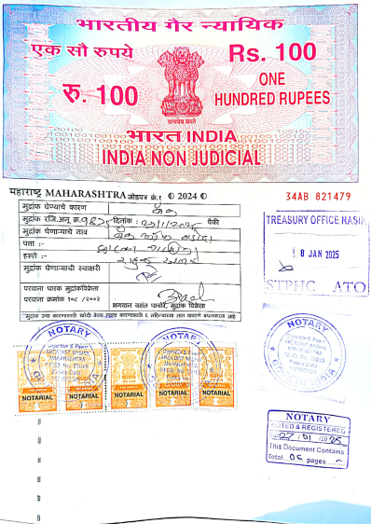
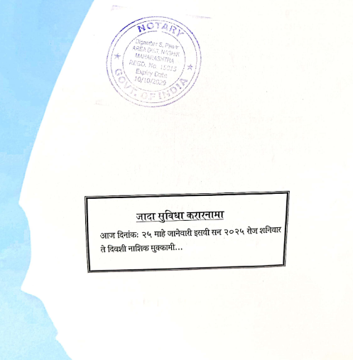

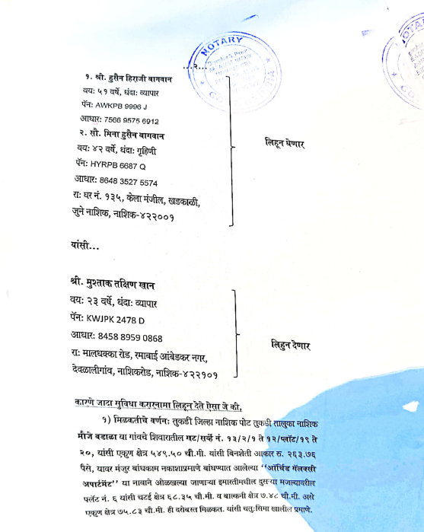

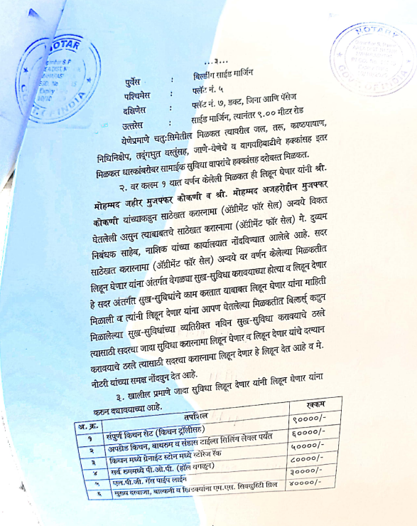
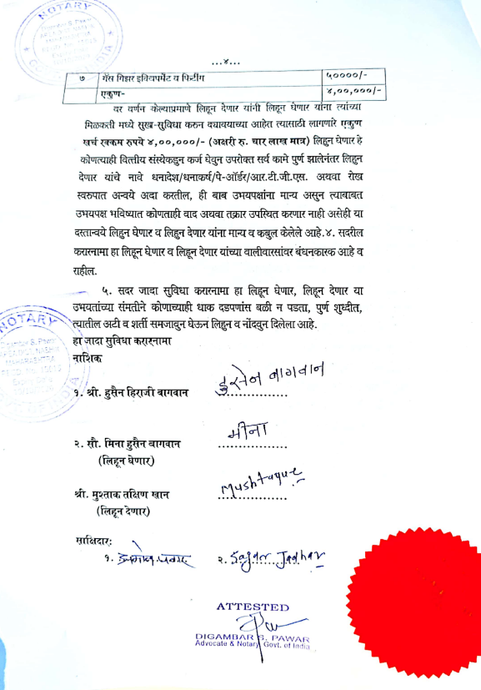

The Extra Work amount Rs.4,00,000/- (Rupees Four Lakh Only.)

