Vastu/Nashik/01/2025/013896 /2310213
24/13-332- MCBS
Date: 24.01.2025
To,
The Branch Manager,
Canara Bank
Bhayander (west) Branch
“Yajurwed”, Chandrakant Niwas, Station Road,
Bhayander (west), Dist -Thane PIN – 401 101
State - Maharashtra, Country - India.

Sub: Vetting of Extra Amenities

Sir,

With reference to above subject, we have evaluated the quote for Residential Flat No. F-1007, 10th Floor " Tirupati Pooja Building ", Near Ideal Park Garden, Orange Hospital Gali, Bhayander (East) Dist - Thane PIN Code – 401 105, State - Maharashtra, India belongs to Shri. Prabhakar Kumar.

We have verified the rates quoted as per current market rates. Details of interior work considered as per copy of Quotation of M/s. S K Enterprises (Civil Contractor & Labour work) received on dated. 16.01.2025. The interior amount is Rs. 12,18,000/- (Rupees Twelve Lakh Eighteen Thousand Only)

The said Cost Vetting Certificate is valid upto next 6 months Only.

Thanking you

Sincerely yours

Manoj B. Chalikwar
Registered Valuer
Chartered Engineer (India)
Reg. No. CAT-I-F-1763
Reg. No. IBBI/RV/07/2018/10366
BOB Empanelment No.: ZO:MZ:ADV:46:941
Encl: Valuation report.

Quotation for Interior works
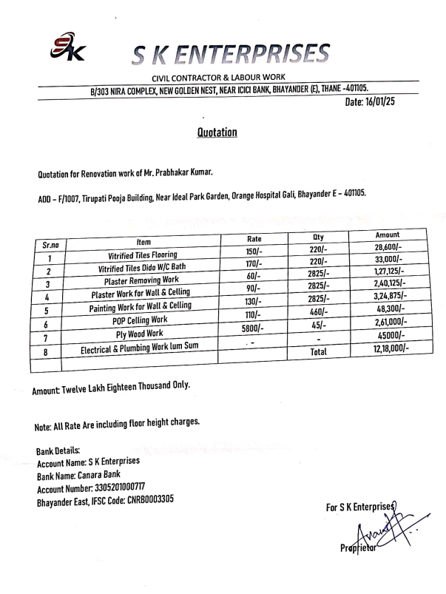

The Extra Amenities amount is Rs. 12,18,000/- (Rupees Twelve Lakh Eighteen Thousand Only)

