Vastu/Nashik/03/2023833/30490/46262
22/24-455-RYBS
Date: 24.01.2025

To,
The Branch Manager,
Bank of Baroda
Regional Office
BSNL Building, Datta Mandir Road, Nashik Road,
Nashik, PIN – 422 101, State - Maharashtra, Country - India.

Sub: Vetting of Cost of Construction

Sir,

With reference to above subject, we have evaluated the Cost of Construction for Residential Land and Proposed Bungalow on Plot No. 21+22, Ground Floor + First Floor + Second Floor, Survey No. 30/ 6, (Old Survey No. 30/1/1+2/1+3/1+4/5+5), Behind Croma - Inox Signal & Sagar Sweet, Ashoka Marg, Pujya Sri Sri Ravishankar Marg, Village - Wadala, Taluka – Nashik, District – Nashik, Pin Code – 422 006, State - Maharashtra, Country – India. belongs Shri. Amit Arun Pekam & Sau. Shruti Amit Pekam.

We have verified the rates quoted as per current market rates. Details of Cost of Construction considered as per copy of Cost of Construction Agreement between Shri. Amit Arun Pekam & Sau. Shruti Amit Pekam (First Party). Sketch Art (Architects & Interior Designers) (Second Party) received on dated.27.08.2024. The Cost of Construction amount is Rs. 1,32,00,000/- (Rupees One Crore Thirty Two Lakh Only)

The said Cost Vetting Certificate is valid up to next 6 months Only.

Thanking you

Sincerely yours

Manoj B. Chalikwar
Registered Valuer
Chartered Engineer (India)
Reg. No. CAT-I-F-1763
Reg. No. IBBI/RV/07/2018/10366
BOB Empanelment No.: ZO:MZ:ADV:46:941
Encl: Valuation Report.

Estimate For Cost of Construction
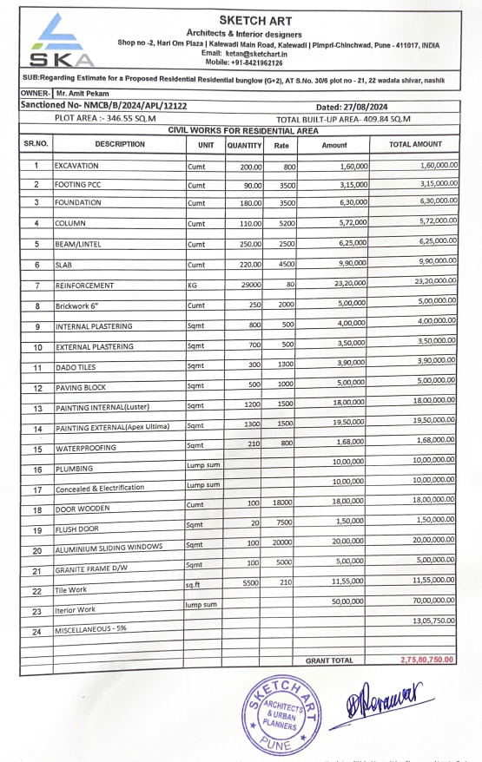

The Cost of Construction amount is Rs.1,32,00,000/- ( Rupees One Crore Thirty Two Lakh Only. )

