Vastu/Nashik/01/2025/013884/2310209
24/9-328-RVRJ
Date: 24.01.2025
To,
The Branch Manager,
Bank of Baroda
Regional Office
BSNL Building, Datta Mandir Road, Nashik Road,
Nashik, PIN – 422 101, State - Maharashtra, Country - India.

Sub: Vetting of Extra Amenities

Sir,

With reference to above subject, we have evaluated the Extra Amenities For Residential Flat No. 201, 2nd Floor,
"Shree Vaishnavi Apartment - I", Near Podar International School, Buddha Vihar, Survey No. 239/ 13, Plot No. 28, off Ekta Green Villa Road, Village - Pathardi, Taluka -Nashik, District - Nashik, Nashik, PIN Code - 422 010, State - Maharashtra, Country -India belongs to M/s. Shree Vaishnavi Buildcon Partnership. Name of Proposed Purchaser is Shri. Saner Pramod Dilip & Sau. Alkabai Dilip Patil.

We have verified the rates quoted as per current market rates. Details of Extra Amenities considered as per copy of Extra Amenities Agreement between Shri. Saner Pramod Dilip & Sau. Alkabai Dilip Patil (First Party). Shri. Prashant Madhukar Gaikwad (Second Party) received on dated. 21.01.2025. The Extra Amenities amount is Rs. 5,40,000/- (Rupees Five Lakh Forty Thousand Only)

The said Cost Vetting Certificate is valid up to next 6 months Only.

Thanking you

Sincerely yours

Manoj B. Chalikwar
Registered Valuer
Chartered Engineer (India)
Reg. No. CAT-I-F-1763
Reg. No. IBBI/RV/07/2018/10366
BOB Empanelment No.: ZO:MZ:ADV:46:941
Encl: Valuation report.

Agreement for Extra Amenities

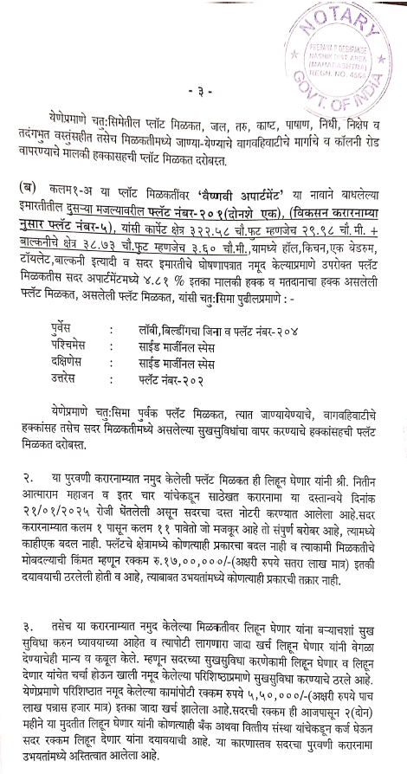
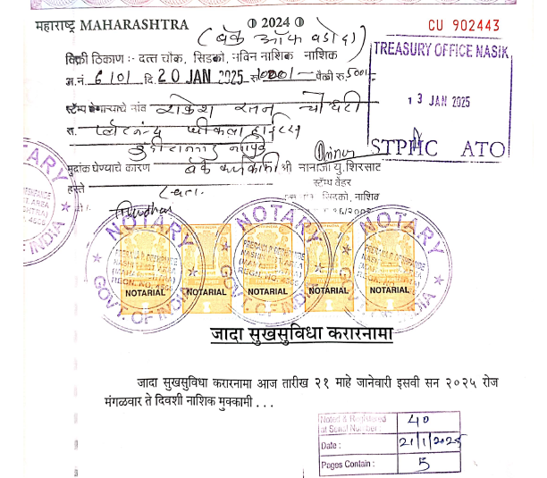

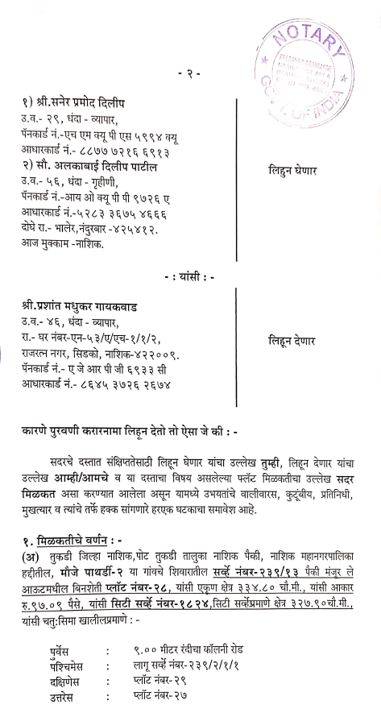

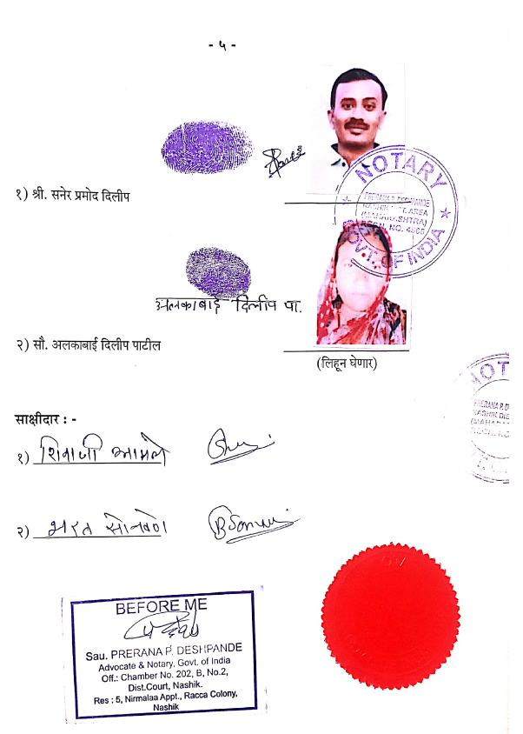
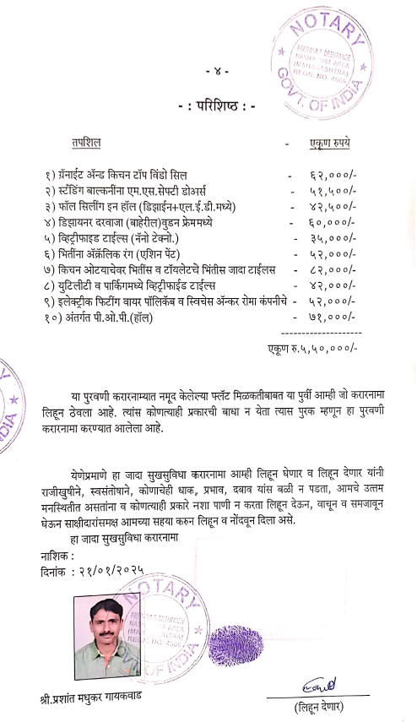

The Extra Amenities amount is Rs. 5,40,000/- (Rupees Five Lakh Forty Thousand Only)

