2nd LENDER’S INDEPENDENT ENGINEER REPORT

**Details of the property under consideration:**

**Name of Project: “Aneesh Apartment Co. Op. Housing Soc. Ltd.”**

**"Aneesh Apartment Co. Op. Housing Soc. Ltd., Proposed Redevelopment Building on Plot Bearing**

**C.T.S. No. 503C, S. No. 212A, Hissa No. 3, S. No. 214 Part, Plot No. 1, Azad Lane, Off S. V. Road,**

**K / W Ward, Village – Vile Parle, Andheri (West), Mumbai – 400 058, State – Maharashtra,**

**Country – India**

**Latitude Longitude: 19°06'49.2"N 72°50'29.4"E**

Valuation Prepared for:

State Bank of India

SME Chembur Branch

Unit No. 11, Building No. 11, Ground Floor, Corporate Park, Sion Trombay Road,

Chembur, Mumbai, Pin Code – 400 071, State - Maharashtra, Country – India

Vastu/SBI/Mumbai/12/2024/12713/2309304

02/02-02-PY

Date: - 29.11.2024

SECOND LENDER’S INDEPENDENT ENGINEER REPORT

**To,**

**State Bank of India**

SME Chembur Branch

Unit No. 11, Building No. 11,

Ground Floor, Corporate Park,

Sion Trombay Road, Chembur,

Mumbai, Pin Code – 400 071,

State - Maharashtra, Country – India

Subject: Construction of Proposed Redevelopment Building on Plot Bearing C.T.S. No. 503C, S. No. 212A, Hissa No. 3, S. No. 214 Part, Plot No. 1, Azad Lane, Off S. V. Road, K / W Ward, Village – Vile Parle, Andheri (West), Mumbai – 400 058, State - Maharashtra, Country - India.

**Ref:** You’re Request for Lenders Independent Engineer Report of under Construction Building.

**Dear Sir,**

1. As per your instruction, we have inspected the under-construction Rehab cum Sale Building project situated on plot bearing C.T.S. No. 503C, S. No. 212A, Hissa No. 3, S. No. 214 Part, Plot No. 1, Azad Lane, Off S. V. Road, K / W Ward, Village – Vile Parle, Andheri (West), Mumbai – 400 058, State - Maharashtra, Country - India which is being developed by M/s. Banaji Silverline Developers LLP in order to give the physical progress at site and to certify cost incurred towards project as on 30/09/2024.
2. **The Construction work as per approved plan was in progress during the site visit on 18th October 2024.**
3. **Status of work:**
4. **For Rehab cum Sales Building:** Excavation work & Plinth work is completed, 1st floor shuttering work is in progress.
5. As per cost incurred certificate issued by **CA Certificate actual total expenditure occurred as on 30/09/2024 is ` 10.69 Cr. for Residential of Rehab cum Sale Building & overall financial progress is 23.97% estimated cost of project.**
6. As per bills **actual total expenditure occurred as on 30/09/2024 is ` 10.42 Cr. for Residential of Rehab cum Sale Building & overall financial progress is 23.37% estimated cost of project.**
7. Overall Physical progress of the sale building construction as on 18/10/2024 is 14% as per physical site inspection.

**DECLARATION**

1. The information furnished in the report is based on our 2nd site visit Dated 18/10/2024 & Document Provided by Client.
2. Vastukala Consultants (I) Pvt. Ltd. 1st LIE Report of the project dated 20/07/2024.
3. Vastukala Consultants (I) Pvt. Ltd. Project Report of the project dated 03/06/2024.
4. Vastukala Consultants (I) Pvt. Ltd. Cost Vetting Report dated 03/06/2024.
5. I have no direct and indirect interest in the property examined for report.
6. I have not been found guilty of misconduct in my professional capacity.

**Manoj B. Chalikwar**

Registered Valuer

Chartered Engineer (India)

Reg. No. IBBI/RV/07/2018/10366

Encl.: LIE report

# Purpose & Methodology

• State Bank of India Banks and financial institutions require monitoring & an independent review of the progress of the sanctioned projects

**VCIPL** undertakes such study to independently review the progress of the project and put forward a comprehensive analysis

# Advantages:

* Assurance on present practices
* Identification of risk
* Analyzing the performance of third parties
* Recommendations

# The Methodology

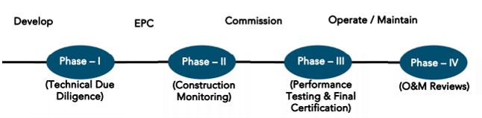

**SECOND LENDER’S INDEPENDENT ENGINEER REPORT**

**OF**

**"** **Aneesh Apartment Co.op. Housing Soc. Ltd."**

**"Aneesh Apartment Co. Op. Housing Soc. Ltd., Proposed Redevelopment Building on Plot Bearing**

**C.T.S. No. 503C, S. No. 212A, Hissa No. 3, S. No. 214 Part, Plot No. 1, Azad Lane, Off S. V. Road,**

**K / W Ward, Village – Vile Parle, Andheri (West), Mumbai – 400 058, State – Maharashtra, Country – India**

**Latitude Longitude: 19°06'49.2"N 72°50'29.4"E**

**NAME OF DEVELOPER: M/s. Banaji Silverline Developers LLP**

|  |
| --- |
| Pursuant to instructions from State of India, SME Chembur Branch, Chembur we have duly visited, inspected, surveyed & assessed the above said property on **18th October 2024** to determine the fair & reasonable market value of the said property/project as on Quarter ending **30th September 2024** for LIE purpose.  **1. Location Details:**  Proposed Redevelopment Building on Plot Bearing C.T.S. No. 503C, S. No. 212A, Hissa No. 3, S. No. 214 Part, Plot No. 1, (Azad Lane, Off S. V. Road, K / W Ward, Village – Vile Parle, Andheri (West), Mumbai – 400 058. It is about 950 M. travelling distance from Andheri (West) Railway station. Surface transport to the property is by buses, taxis & private vehicles. The property is in developed locality. All the amenities like shops, banks, hotels, markets, schools, hospitals, etc. are all available in the surrounding locality. The area is higher middle class & developed. |

**2. Developer Details:**

|  |  |
| --- | --- |
| **Name of builder** | **M/s. Banaji Silverline Developers LLP** |
| **Project Rera Registration Number** | **P51800056463** |
| **Registered office address** | Ground Floor, Dilavaz Apartment, Lallubhai Park Road, Opp. Rajpuriya Boys Hostel, Andheri (West) Mumbai – 400 058, State - Maharashtra, Country – India |
| **Contact details** | **Contact Person:**  Mr. Kailas Sinari (Consultants)  Mobile No. 9820950342  Mr. Md. Saif (Site Supervisor)  Mobile No. 9945305067  Mrs. Jaya (Accountant)  Mobile No. 9326124271 |
| **E – mail ID and website** |  |

**3. Boundaries of the Property:**

|  |  |
| --- | --- |
| **Direction** | **Particulars** |
| **On or towards North** | Azad Lane |
| **On or towards South** | Chandra Air Building |
| **On or towards East** | Reporters Bungalow & Shree Lohana Vidhyarthi Bhavan |
| **On or towards West** | Azad Apartments |

# Introduction

**As per Information on site M/s. Banaji Silverline Developers LLP** has acquired land by Developer Agreement Date 19.04.2023 through registered agreement Doc. No. BDR-18/6851/2023 dated 20.04.2023 admeasuring **area is 695.40 Sq. M.** bearing **C.T.S. No. 503C, S. No. 212A, Hissa No. 3, S. No. 214 Part, Plot No. 1.** For the Proposed Redevelopment Residential Building.

# Area Statement:

# Land:

|  |  |  |
| --- | --- | --- |
| **Date** | **Particular** | **Area in Sq. M.** |
| 19.04.2023 | C.T.S. No. 503C, S. No. 212A, Hissa No. 3, S. No. 214 Part, Plot No. 1 | 695.40 |
| TOTAL | | 695.40 |

1. Copy of Developer Agreement dated 19.04.2023 between M/s. Aneesh Apartments Co-operative Housing Society Ltd. (The Society) and M/s. Banaji Silverline Developers LLP (The Developers) through registered agreement Doc. No. BDR-18/6851/2023 dated 20.04.2023.

# Building Area (As per Approved Plan):

| **AREA STATEMENT** | | | |
| --- | --- | --- | --- |
| 1 | Area of Plot (As Per P. R. Card of C.T.S. No. 503c) | | 695.40 |
|  | a. | Area of reservation plot |  |
|  | b. | Area of road set back |  |
|  | C. | Area of DP road |  |
| 2 | Deduction For | |  |
| A | For Reservation / Road Plot | |  |
|  | a. | Road set back area |  |
|  | b. | Proposed DP. road to be handed over (100%) (reg. No. 16) |  |
|  | c. | i) RESERVATION AREA TO BE HANDED OVER (100%) (REG. NO. 17) |  |
|  |  | ii) RESERVATION AREA TO BE HANDED OVER AS PER AR (REG. NO. 17) |  |
| B | For Amenity Area | |  |
|  | a. | Area of amenity plot/plots to be handed over as per dcr 14 (a) |  |
|  | b. | Area of amenity plot/plots to be handed over as per dcr 14 (b) |  |
|  | c. | Area of amenity plot/plots to be handed over as per dcr 35 (abeyance) |  |
| 3 | Total deduction [(2a) + (2b) + (2c)] | |  |
| 4 | Balance area of plot (1 minus 3) | | 695.40 |
| 5 | Plot area under development after areas to be handed over to MCGM/appropriate authority as per sr.no. 4 above | | 695.40 |
| 6 | FSI | | 2.20 |
| 7 | Permissible built-up area as per FSI (5 x 6) | | 1,529.88 |
| 8 | Built up equal to area of land handed over as per regulation 30(a) | |  |
|  | i | As per 2(a) and 2(b) except 2(a) (c) (ii) above with in cap of "admissible TDR" as column 6 of table-12 on remaining/balance plot. |  |
|  | ii | In case of 2(a) (c) (ii) permissible over and above permissible BUA on remaining/balance plot. |  |
| 9 | Built up area in lieu of cost of construction of built-up amenity to be handed over (within the limit of permissible BUA on remaining plot) | |  |
| 10a | Permissible zonal BUA (plot area x 1.00) | | 695.40 |
| 10b | Built up area due to " additional FSI by charging premium" as per table no. 12 of regulation no. 30(a) on remaining/balance plot. (Plot area x 0.50) | | 347.70 |
| 11 | Built up area due to admissible "TDR" as per table no. 12 of regulation no. 30(a) and 32 on remaining/balance plot (plot area x 0.70) (120 Sq. M. as 33 (7) (b) incentive area + 366.78 Sq. M. as TDR = 486.78 Sq. M. | | 486.78 |
| 12 | PERMISSIBLE BUA (10a + 10b + 11) | | 1,529.88 |
| 13 | Proposed built up area [ as the case may be with/without BUA as per 2 (c)] | | 1,529.88 |
| 14 | TDR generated if any as per regulation 30(a) and 32 | |  |
| 15 | Fungible compensatory area as per reg. 31 (3) | |  |
|  | a. | i) Permissible fungible compensatory area for rehab component without charging premium. | 272.58 |
|  |  | ii) Fungible compensatory area availed for rehab component without charging premium. | 235.30 |
|  |  | iii) Permissible fungible compensatory area for rehab non-residential component without charging premium |  |
|  |  | iv) Fungible compensatory area availed for rehab non-residential component without charging premium |  |
|  | b. | i) Permissible fungible compensatory area by charging premium (perm. Sale BUA = 751.08 Sq. M. x 35% = 262.88 Sq. M.) | 262.88 |
|  |  | ii) Fungible compensatory area availed on payment of premium | 261.35 |
| 16 | Total built up area proposed including fungible compensatory area [3 + 15(a) (ii) + 15 (a) (iv) + 15 (b) (ii)] | | 2,026.53 |
| 17 | FSI consumed on net plot [13/4] | | 2.20 |
|  | OTHER REQUIREMENTS: | |  |
| A | Reservation/designation | |  |
|  | a. | Name of reservation |  |
|  | b. | Area of reservation affecting the plot |  |
|  | c. | Area of reservation land to be handed over as per regulation no. 17 |  |
|  | d. | Built up area of amenity to be handed over as per regulation no. 17 |  |
|  | e. | Area/built up area of designation |  |
| B | Plot area/built up amenity to be handed over as per regulation no | |  |
|  | i | 14 (A) |  |
|  | ii | 14 (B) |  |
|  | iii | 15 |  |
| C | Requirement of recreational open space in layout/plot as per regulation no. 27 | |  |
| D | TENEMENT STATEMENT | |  |
|  | i | Proposed built up area (16 above) | 2,026.53 |
|  | ii | Less deduction of non-residential area (shop etc.) | - |
|  | iii | AREA AVAILABLE FOR TENMENTS (i) MINUS (ii) | 2,026.53 |
|  | iv | Tenement permissible (density of tenements/hectare) | 31.00 |
|  | v | Total number of tenements proposed on the plot | 23.00 |
| E | PARKING STATEMENT | |  |
|  | i | Parking required by regulation for: (as per concession approved under file no. P-17042/2023/(503c)/k/w ward/vile parle-k/w/337/1/new dated 23.10.2023) | 44.00 |
|  |  | Car | 27.00 |
|  |  | Scooter/ motor cycle |  |
|  |  | Outsiders (visitors) | 17.00 |
|  | ii | Covered garage permissible |  |
|  | iii | Covered garage proposed |  |
|  |  | Car | 27.00 |
|  |  | Scooter/ motor cycle |  |
|  |  | Outsiders (visitors) | 15.00 |
|  | iv | Total parking provided | 42.00 |
| D | TRANSPORT VEHICLES PARKING | |  |
|  | i | Spaces for transport vehicles parking required by reg. |  |
|  | ii | Total no. Of transport vehicle parking provided. |  |

# Building Area (As per Concession Drawing Plan):

| **Area Statement** | | | |
| --- | --- | --- | --- |
| 1 | Area Of Plot (As Per P. R. Card of C.T.S. No. 503c) | | 695.40 |
|  | A. | Area Of Reservation Plot | - |
|  | B. | Area Of Road Set Back | - |
|  | C. | Area Of DP Road | - |
| 2 | Deduction For | | - |
| 2a | For Reservation / Road Plot | | - |
|  | A. | Road Set Back Area | - |
|  | B. | Proposed D.P. Road to Be Handed Over (100%) (Reg. No. 16) | - |
|  | C. | I) Reservation Area to Be Handed Over (100%) (Reg. No. 17) | - |
|  |  | II) Reservation Area to Be Handed Over as Per (Reg. No. 17) | - |
| 2b | For Amenity Area | | - |
|  | A. | Area Of Amenity Plot/Plots to Be Handed Over as Per Dcr 14 (A) | - |
|  | B. | Area Of Amenity Plot/Plots to Be Handed Over as Per Dcr 14 (B) | - |
|  | C. | Area Of Amenity Plot/Plots to Be Handed Over as Per Dcr 35 (Abeyance) | - |
| 2c | Deduction For Existing B.U.A. To Be Retained If Any/Land Component of Existing B.U.A. Existing as Per Regulation Under Which the Development Was Allowed | | - |
| 3 | Total Deduction [(2a) + (2b) + (2c)] | | . |
| 4 | Balance Area Of Plot (1 Minus 3) | | 695.40 |
| 5 | Plot Area Under Development After Areas to Be Handed Over to MCGM/Appropriate Authority as Per Sr. No. 4 Above | | 695.40 |
| 6 | FSI | | 4.00 |
| 7 | Permissible Built-Up Area as Per FSI (5 x 6) | | 2,781.60 |
| 8 | Built Up Equal to Area of Land Handed Over as Per Regulation 30(A) | | - |
|  | I | As Per 2(A) And 2(B) Except 2(A) (C) (ii) Above with In Cap Of "Admissible TDR" As Column 6 Of Table-12 On Remaining/Balance Plot. | - |
|  | ii | In Case Of 2(A) (C) (ii) Permissible Over and Above Permissible BUA on Remaining/Balance Plot. | - |
| 9 | Built Up Area In Lieu Of Cost of Construction of Built-Up Amenity to Be Handed Over (Within the Limit of Permissible Bua on Remaining Plot) | | - |
| 10 | Built Up Area Due To " Additional FSI By Charging Premium" As Per Table No. 12 Of Regulation No. 30(A) On Remaining/Balance Plot. (Plot Area X 0.50) | | 347.70 |
| 11 | Built Up Area Due to Admissible "TDR" As Per Table No. 12 Of Regulation No. 30(A) And 32 On Remaining/Balance Plot (Plot Area X 0.70) (120 Sq. M. As 33 (7) (B) Incentive Area + 366.78 Sq. M. As TDR = 486.78 Sq. M. | | 486.78 |
| 12 | 12a | I) Permissible Zonal Bua | 695.40 |
|  |  | ii) Built Up Area Can Be Consumed on Plot Due to Admissible TDR/Additional FSI As Per Table No. 12 Of Regulation No 30 (A) And 32 On Remaining/Balance Plot. | 834.48 |
|  |  | iii) Permissible Bua Can Be Consumed on Plot For 33 (12) (B) | 451.66 |
|  | 12b | Permissible Built-Up Area [ As the Case May Be With/Without Bua as Per 2 (C)] {[12a (I) + (ii) + (iii)]} | 1,981.54 |
| 13 | Proposed Built Up Area [ As the Case May Be With/Without Bua As Per 2 (C)] | | 1,981.54 |
| 14 | TDR Generated If Any as Per Regulation 30(A) And 32 | | - |
| 15 | Fungible Compensatory Area as Per Reg. 31 (3) | | - |
|  | A. | I) Permissible Fungible Compensatory Area for Rehab Component Without Charging Premium. | 377.85 |
|  |  | ii) Fungible Compensatory Area Availed for Rehab Component Without Charging Premium. | 286.84 |
|  |  | iii) Permissible Fungible Compensatory Area for Rehab Non-Residential Component Without Charging Premium | - |
|  |  | iv) Fungible Compensatory Area Availed for Rehab Non-Residential Component Without Charging Premium | - |
|  | B. | i) Permissible Fungible Compensatory Area by Charging Premium (Perm. Sale Bua = 751.08 Sq. M. X 35% = 262.88 Sq. M.) | 288.44 |
|  |  | ii) Fungible Compensatory Area Availed on Payment Of Premium | 251.21 |
| 16 | Total Built Up Area Proposed Including Fungible Compensatory Area [ 13 + 15(A) (ii) + 15 (A) (Iv) + 15 (B) (ii)] | | 2,519.59 |
| 17 | FSI Consumed on Net Plot [13/5] | | 2.85 |
|  | Other Requirements: | | - |
| A | Reservation/Designation | | - |
|  | A. | Name Of Reservation | - |
|  | B. | Area Of Reservation Affecting the Plot | - |
|  | C. | Area Of Reservation Land to Be Handed Over as Per Regulation No. 17 | - |
|  | D. | Built Up Area of Amenity to Be Handed Over as Per Regulation No. 17 | - |
|  | E. | Area/Built Up Area of Designation | - |
| B | Plot Area/Built Up Amenity to Be Handed Over as Per Regulation No | | - |
|  | I | 14 (A) | - |
|  | ii | 14 (B) | - |
|  | iii | 15 | - |
| C | Requirement Of Recreational Open Space in Layout/Plot as Per Regulation No. 27 | | - |
| D | Tenement Statement | |  |
|  | i | Proposed Built Up Area (16 Above) | 2,519.59 |
|  | ii | Less Deduction of Non-Residential Area (Shop Etc.) | - |
|  | iii | Area Available for Tenements (I) Minus (ii) | 2,519.59 |
|  | iv | Tenement Permissible (Density of Tenements/Hectare) | 31.00 |
|  | v | Total Number of Tenements Proposed on The Plot | 33.00 |
| E | Parking Statement | |  |
|  | i | Parking Required by Regulation For: (As Per Concession Approved Under File No. P-17042/2023/(503c)/K/W Ward/Vile Parle-K/W/337/1/New Dated 23.10.2023) | 44.00 |
|  |  | Car | 29.00 |
|  |  | Scooter/ Motor Cycle | - |
|  |  | Outsiders (Visitors) | 15.00 |
|  | ii | Covered Garage Permissible | - |
|  | iii | Covered Garage Proposed | - |
|  |  | Car | 29.00 |
|  |  | Scooter/ Motor Cycle | - |
|  |  | Outsiders (Visitors) | 13.00 |
|  | iv | Total Parking Provided | 42.00 |
| D | Transport Vehicles Parking | |  |
|  | i | Spaces For Transport Vehicles Parking Required by Reg. | - |
|  | ii | Total No. Of Transport Vehicle Parking Provided. | - |

# List of Approvals:

1. Copy of Intimation of Disapproval (IOD) Letter No. P-17042/2023/(503C)/K/W Ward/Vile Parle-K/W/IOD/1/New dated 06.02.2024 issued by Municipal Corporation of Greater Mumbai (MCGM).
2. Copy of Approved Plan P-17042/2023/(503C)/K/W Ward/Vile Parle-K/W/IOD/1/New dated 06.02.2024 issued by Municipal Corporation of Greater Mumbai (MCGM).

Approved upto: Basement (Part) + Ground Floor + 1st to 7th Upper Floors+ 8th (Pt) Upper Floors.

1. Copy of 1st Commencement Certificate No. P-17042/2023/(503C)/K/W Ward/Vile Parle-K/W/CC/1/New dated 19.03.2024 valid upto 18.03.2025 issued by Municipal Corporation of Greater Mumbai (MCGM).

(This CC is endorsed for the work for up to plinth level as per approved plan dated 06.02.2024)

1. Copy of 2nd Commencement Certificate No. P-17042/2023/(503C)/K/W Ward/Vile Parle- K/W/FCC/1/New dated 24.09.2024 valid upto 18.03.2025 issued by Municipal Corporation of Greater Mumbai (MCGM).

(This CC is endorsed for the work for Basement (Part) + Ground Floor + 1st to 6th Upper Floors as per IOD approved plan dated 06.02.2024)

1. Copy of Concession Drawing Plan Dated 16.05.2023 submitted to Municipal Corporation of Greater Mumbai (MCGM).

Approval upto: Basement (Part) + Ground Floor + 1st to 9th Upper Floors

# LEVEL OF COMPLETION:

# Rehab cum Sales Building

| Sr. | Floor No. | Construction Area in Sq. M. | Completed Area in Sq. M. | Work Completion as on 18.10.2024 | Work Completion as on 1st LIE Report |
| --- | --- | --- | --- | --- | --- |
| 1 | Excavation & Shore Piling | | | Work is Completed | Work is Completed |
| 2 | Basement (Part) | 249.09 | 249.09 | Slab work is Completed | Plinth work is in progress |
| 3 | Ground Floor | 297.62 | 297.62 | Slab work is Completed |  |
| 3 | 1st Floor | 297.62 |  | Shuttering work is in progress |  |
| 4 | 2nd Floor | 300.92 |  |  |  |
| 5 | 3rd Floor | 310.74 |  |  |  |
| 6 | 4th Floor | 310.74 |  |  |  |
| 7 | 5th Floor | 327.92 |  |  |  |
| 8 | 6th Floor | 327.92 |  |  |  |
| 9 | 7th Floor | 327.92 |  |  |  |
| 10 | 8th Floor | 327.92 |  |  |  |
| 11 | 9th Floor | 327.92 |  |  |  |
| 12 | Terrace Floor / OHT | 59.27 |  |  |  |
| Total | | 3,465.60 | 546.71 |  |  |
| No. of Stack Parking | | 42 Nos. |  |  |  |

# Details of the Project as Financed By SBI:

# Estimated Project Cost: (As per Cost Vetting Report)

|  |  |
| --- | --- |
| **Particulars** | **Estimated Cost (` in Cr.)** |
| Land & Stamp Cost | 0.81 |
| Rent Cost | 3.95 |
| Construction Cost of Rehab cum Sale Building | 15.44 |
| TDR Cost | 3.42 |
| Approval Cost including Premium Cost / FSI / GOM Charges / fees Cost | 13.63 |
| Architect Cost, RCC & Other Professional Cost | 0.77 |
| Administrative Cost | 0.93 |
| Marketing Cost | 1.19 |
| Interest Cost (Bank Loan) | 4.00 |
| Contingency Cost | 0.46 |
| **Total** | **44.60** |

# Project Cost: (as per C.A. Certificate)

|  |  |  |  |
| --- | --- | --- | --- |
| **Particulars** | **Incurred Cost (In Cr.) till 30.09.2024 by M/s Shyam Prajapati & Associates.** | **Incurred Cost (In Cr.) till 30.06.2024 by M/s Shyam Prajapati & Associates.** | **Net** |
| Land & Stamp Cost | 0.81 | 0.81 | - |
| Rent Cost | 1.13 | 1.03 | 0.10 |
| Construction Cost of Rehab cum Sale Building | 1.51 | 1.29 | 0.22 |
| TDR Cost | 2.84 | 2.84 | - |
| Approval Cost including Premium Cost / FSI / GOM Charges / fees Cost | 2.99 | 2.86 | 0.13 |
| Architect Cost, RCC & Other Professional Cost | 1.11 | 0.43 | 0.46 |
| Administrative Cost | 0.22 |
| Marketing Cost | - |
| Interest Cost (Bank Loan) | 0.29 | - | 0.29 |
| Contingency Cost |  | - | - |
| **Total** | **10.69** | **9.48** | **1.21** |

* **The Builder has incurred about 1.13 for rent cost, 1.51 Cr. as construction cost, 2.99 Cr. for approval cost, 1.11 Cr. for professional cost, administrative cost & marketing cost, 0.29 Cr. for interest cost till 30.09.2024 as per C.A. certificate issued by M/s. Shyam Prajapati & Associates dated 18.10.2024.**

# Project Cost: (as per Bills):

|  |  |  |  |
| --- | --- | --- | --- |
| **Particulars** | **Incurred Cost (in Cr.)** | | |
| **30.09.2024 as per Bill (Inclusive GST)** | **30.06.2024 as per Bill (Inclusive GST)** | **Net** |
| Land & Stamp Cost | 0.81 | 0.81 | - |
| Rent Cost | 1.13 | 1.04 | 0.09 |
| Construction Cost of Rehab cum Sale Building | 1.29 | 1.29 | - |
| TDR Cost | 2.84 | 2.84 | - |
| Approval Cost including Premium Cost / FSI / GOM Charges / fees Cost | 2.99 | 2.86 | 0.13 |
| Architect Cost, RCC & Other Professional Cost | 0.72 | 0.43 | 0.29 |
| Administrative Cost | 0.63 | 0.22 | 0.41 |
| Marketing Cost | - | - | - |
| Interest Cost (Bank Loan) | 0.29 | - | 0.29 |
| Contingency Cost | - | - | - |
| **Total** | **10.71** | **9.50** | **1.21** |

Note:

# Land Cost:

|  |  |  |  |  |  |
| --- | --- | --- | --- | --- | --- |
| Sr. No. | Agreement Name | Date | Particulars | Amount in ` | Incurred Amount in ` |
| 1 | Development Agreement | 19-04-2023 | Stamp Duty | 81,16,000.00 | 81,16,000.00 |
| 2 | Reg. Fees | 30,000.00 | 30,000.00 |
| 3 | 1,800.00 | 1,800.00 |
|  | TOTAL | | | 81,47,800.00 | 81,47,800.00 |

As per developer agreement.

|  |  |  |  |  |  |  |
| --- | --- | --- | --- | --- | --- | --- |
| **Summary of Bills** | | | | | | |
| **Sr. No.** | **Particulars** | **Amount in `**  **(till 30.09.2024)** | **Amount in ` (in Cr.)** | **Amount in `**  **(till 30.06.2024)** | **Amount in ` (in Cr.)** | **Net** |
| 1 | Construction Cost of Rehab cum Sale Building | 1,28,81,839.00 | 1.29 | 1,28,81,839.00 | 1.29 | - |
| 2 | Rent Cost | 1,13,35,330.00 | 1.13 | 1,03,98,140.00 | 1.04 | 0.09 |
| 3 | TDR Cost | 2,84,12,136.00 | 2.84 | 2,84,12,136.00 | 2.84 | - |
| 4 | Approval Cost including Premium Cost / FSI / GOM Charges / fees Cost | 2,99,09,667.00 | 2.99 | 2,86,40,910,.00 | 2.86 | 0.13 |
| 5 | Professional Cost | 72,13,908.00 | 0.72 | 43,37,240.00 | 0.43 | 0.29 |
| 6 | Administrative Cost | 63,14,408.00 | 0.63 | 22,29,254.00 | 0.22 | 0.41 |
| 7 | Marketing Cost | 22,500.00 | 0.00 | - | - | 0.00 |
| **TOTAL** | | **9,60,89,788.00** | **9.61** | **8,68,99,519.00** | **8.69** | **0.92** |

Note: Bills were provided by the client up to 30.09.2024

# Interest Cost:

|  |  |  |  |  |  |  |
| --- | --- | --- | --- | --- | --- | --- |
| **Sr. No** | **Particulars** | **Estimate Amount in `** | **Incurred Amount in ` (till 30.09.2024)** | **Incurred Amount in ` (till 30.06.2024)** | **Difference in `** | **Balance Amount in `** |
| **1** | Interest Cost | 4,00,00,000.00 | - | - | - | 3,71,38,074.00 |
| **TOTAL** | | **4,00,00,000.00** | **-** | **-** | **-** | **3,71,38,074.00** |

# Cost of Construction as on 18th October 2024:

# Rehab cum Sales Building

|  |  |  |  |  |  |  |  |
| --- | --- | --- | --- | --- | --- | --- | --- |
| Plinth Area Calculation | | | | | | | |
| Sr. No | **Floor Nos.** | **Construction Area in Sq. M.** | **Completed Area in Sq. M.** | **Rate per Sq. M.** | **Full Value after completion** | **% of work completed** | **Actual Expenditure till date in `** |
| 1 | Deep Excavation & Piling Working | | | | 1,21,29,600.00 | 100% | 1,21,29,600.00 |
| 2 | Basement 1 | 249.09 | 249.09 | 35,000.00 | 87,18,150.00 | 50% | 43,59,075.00 |
| 3 | Ground Floor | 297.62 | 297.62 | 35,000.00 | 1,04,16,700.00 | 50% | 52,08,350.00 |
| 4 | 1st Floor | 297.62 |  | 35,000.00 | 1,04,16,700.00 |  |  |
| 5 | 2nd Floor | 300.92 |  | 35,000.00 | 1,05,32,200.00 |  |  |
| 6 | 3rd Floor | 310.74 |  | 35,000.00 | 1,08,75,900.00 |  |  |
| 7 | 4th Floor | 310.74 |  | 35,000.00 | 1,08,75,900.00 |  |  |
| 8 | 5th Floor | 327.92 |  | 35,000.00 | 1,14,77,200.00 |  |  |
| 9 | 6th Floor | 327.92 |  | 35,000.00 | 1,14,77,200.00 |  |  |
| 10 | 7th Floor | 327.92 |  | 35,000.00 | 1,14,77,200.00 |  |  |
| 11 | 8th Floor | 327.92 |  | 35,000.00 | 1,14,77,200.00 |  |  |
| 12 | 9th Floor | 327.92 |  | 35,000.00 | 1,14,77,200.00 |  |  |
| 13 | Terrace | 59.27 |  | 35,000.00 | 20,74,450.00 |  |  |
| Sub - Total | | 3,465.60 | 546.71 |  | 13,34,25,600.00 |  | 2,16,97,025.00 |
| No. of Stack Parking | | 42.00 |  | 5,00,000.00 | 2,10,00,000.00 |  |  |
| Total cost of construction | | | | | **15,44,25,600.00** | **14%** | **2,16,97,025.00** |

##### Note: Details of work completed is as per site visit dated 18.10.2024 but report is prepared for 30th September 2024.

|  |  |  |  |  |  |
| --- | --- | --- | --- | --- | --- |
| **Particulars** | **Estimated Cost**  **(In Cr.)** | **Incurred Cost (in Cr.)** | | | **Net** |
| **Issued dated 18.10.2024 till 30.09.2024 as per CA** | **As per Bills upto 30.09.2024** | **As per Bills upto 30.06.2024** |
| Land & Stamp Cost | 0.81 | 0.81 | 0.81 | 0.81 | - |
| Rent Cost | 3.95 | 1.13 | 1.13 | 1.04 | 0.09 |
| Construction Cost of Rehab cum Sale Building | 15.44 | 1.51 | 1.29 | 1.29 | - |
| TDR Cost | 3.42 | 2.84 | 2.84 | 2.84 | - |
| Approval Cost including Premium Cost / FSI / GOM Charges / fees Cost | 13.63 | 2.99 | 2.99 | 2.86 | 0.13 |
| Architect Cost, RCC & Other Professional Cost | 0.77 | 1.11 | 0.72 | 0.43 | 0.29 |
| Administrative Cost | 0.93 | 0.63 | 0.22 | 0.41 |
| Marketing Cost | 1.19 | - | - | - |
| Interest Cost (Bank Loan) | 4.00 | 0.29 | 0.29 | - | 0.29 |
| Contingency Cost | 0.46 |  | - | - | - |
| **Total** | **44.60** | **10.69** | **10.71** | **9.50** | **1.21** |

Note:

We have considered Other Expenses, Printing & Stationery, and Water Bills cost is consider in on-site expenditure cost header but CA has considered them in cost of construction header .

As per site inspection, 8% of total work is completed, which amounts to ` 1.21 Cr. However, as per data provided by client, they have incurred the cost of ` 1.29 Cr. till 30.09.2024.

# Comparison of Cost incurred on dated 30.09.2024 & 30.06.2024

|  |  |  |  |  |
| --- | --- | --- | --- | --- |
| Particulars | 30.09.2024 as per Bill | 30.06.2024 as per Bill | Net | % of net amount |
| Land & Stamp Cost | 0.81 | 0.81 | - | 0.00% |
| Rent Cost | 1.13 | 1.04 | 0.09 | 0.84% |
| Construction Cost of Rehab cum Sale Building | 1.29 | 1.29 | - | 0.00% |
| TDR Cost | 2.84 | 2.84 | - | 0.00% |
| Approval Cost including Premium Cost / FSI / GOM Charges / fees Cost | 2.99 | 2.86 | 0.13 | 1.21% |
| Architect Cost, RCC & Other Professional Cost | 0.72 | 0.43 | 0.29 | 2.71% |
| Administrative Cost | 0.63 | 0.22 | 0.41 | 3.83% |
| Marketing Cost | - | - | - | 0.00% |
| Interest Cost (Bank Loan) | 0.29 | - | 0.29 | 2.71% |
| Contingency Cost | - | - | - | 0.00% |
| Total | **10.71** | **9.50** | **1.21** | **11.30%** |

# % of Fund Utilised till 30th September 2024

|  |  |  |  |  |
| --- | --- | --- | --- | --- |
| Particulars | Estimated Cost (in Cr.) | Incurred Cost as on 30.09.2024 | % of Incurred Cost | % of Estimated Project Cost |
| Land & Stamp Cost | 0.81 | 0.81 | 100.00% | 1.83% |
| Rent Cost | 3.95 | 1.13 | 28.70% | 2.54% |
| Construction Cost of Rehab cum Sale Building | 15.44 | 1.29 | 8.34% | 2.89% |
| TDR Cost | 3.42 | 2.84 | 83.08% | 6.37% |
| Approval Cost including Premium Cost / FSI / GOM Charges / fees Cost | 13.63 | 2.99 | 21.94% | 6.71% |
| Architect Cost, RCC & Other Professional Cost | 0.77 | 0.72 | 93.69% | 1.62% |
| Administrative Cost | 0.93 | 0.63 | 67.90% | 1.42% |
| Marketing Cost | 1.19 | - | 0.19% | 0.01% |
| Interest Cost (Bank Loan) | 4.00 | 0.29 | 7.15% | 0.64% |
| Contingency Cost | 0.46 | - | 0.00% | 0.00% |
| Total | **44.60** | **10.71** | **24.01%** | **24.01%** |

Based on above Calculation it is found that total Project cost incurred is 24.01% of the Total Project Cost.

# Means of Finance:

|  |  |  |
| --- | --- | --- |
| **Sr. No.** | **Particulars** | **Exp. Cumulative (Cr.)** |
|  | Equity share capital / Quassi Loan from Promoter | 3.19 |
|  | Sales (Advance from customer) | - |
|  | Bank Laon Amount | 7.50 |
|  | **Total** | **10.69** |

The Details of the Means of Finance are provided by Client as on 30.09.2024.

# Mandatory Arrangements:

|  |  |  |
| --- | --- | --- |
| **Sr. No.** | **Particulars** | **Status** |
|  | Rainwater Harvesting | To be executed after RCC Structure |
|  | Firefighting System | To be executed after RCC Structure |
|  | Solid Waste Management | To be executed after RCC Structure |

# Quality of Construction:

|  |  |  |
| --- | --- | --- |
| **Sr. No.** | **Particulars** | **Status** |
|  | Soundness of Structures | Executing as per approved Structural Design |
|  | Look of Structures | Good |
|  | Quality of Material Used | Good |
|  | Safety Measures for Construction/labour | Taken Care by Contractor |

# Schedule V/s. Actual Progress:

| Activity | Date of Implementation | Date of Completion | Status |
| --- | --- | --- | --- |
| Land |  |  | Completed |
| Development of Land |  |  | Completed |
| Foundation Work | June 2024 | | Footing work is in progress |
| Basment Floor Slab | July 2024 | September 2024 | Slab work is in progress |
| Ground Floor Slab | Slab work is in progress |
| 1st Floor Slab | October 2024 | December 2024 | Shuttering work is in progress |
| 2nd Floor Slab |  |
| 3rd Floor Slab | January 2025 | March 2025 |  |
| 4th Floor Slab |  |
| 5th Floor Slab |  |
| 6th Floor Slab | April 2025 | June 2025 |  |
| 7th Floor Slab |  |
| 8th Floor Slab |  |
| 9th Floor Slab |  |
| Block work / Internal Plaster work | January 2025 | September 2025 |  |
| Terrace Parapet wall / Overhead water tank / Lift Machine room / compound wall / External Plaster work | April | December 2025 |  |
| Electric Work | October 2025 | March 2026 |  |
| Water Proofing |  |
| Plumbing Work |  |
| Tiling / Marble Flooring |  |
| Door Frames |  |
| Window Installation |  |
| Staircase Flooring |  |
| Staircase Railing |  |
| Refuge Area Flooring |  |
| Internal Painting |  |
| External Painting |  |
| Lift Work |  |
| Fire Fighting Installation |  |
| Stack Parking | April 2026 | June 2026 |  |
| CP Fitting & Sanitary Work |  |
| Final Finishing & Fitting |  |

# Action initiated to complete the project in time:

**For Rehab Cum Sales Building:** Excavation work & Plinth work is completed, 1st floor shuttering work is in progress.

# Comments related to cost overrun if any:

The cost of Project is ` 44.60 Cr.

# Balance investment required for completion of project:

We opinion amount of **` 33.89 Cr.** Will be required to complete the Project.

# Mandatory Approval Status:

|  |  |  |  |  |
| --- | --- | --- | --- | --- |
| **Sr. No.** | **Particulars** | **Name of Department** | **Status** | **Order Details** |
| **1A** | IOD of Building & Approved Plan | Municipal Corporation of Greater Mumbai (MCGM). | Obtained and available at site | No. P-17042/2023/(503C)/K/W Ward/Vile Parle-K/W/IOD/1/New dated 06.02.2024 |
| **1B** | Amended Approved Plan | Municipal Corporation of Greater Mumbai (MCGM). | Pending |  |
| **2A** | First C.C. | Municipal Corporation of Greater Mumbai (MCGM). | Obtained and available at site | No. P-17042/2023/(503C)/K/W Ward/Vile Parle-K/W/CC/1/New dated 19.03.2024 valid upto 18.03.2025. This CC is endorsed for the work upto plinth level, as per approved plans dated 06.02.2024. |
| **2B** | Second C.C. | Municipal Corporation of Greater Mumbai (MCGM). | Obtained and available at site | No. P-17042/2023/(503C)/K/W Ward/Vile Parle- K/W/FCC/1/New dated 24.09.2024 valid upto 18.03.2025. This CC is endorsed for the work for Basement (Part) + Ground Floor + 1st to 6th Upper Floors as per IOD approved plan dated 06.02.2024 |
| **2C** | Third C. C. | Municipal Corporation of Greater Mumbai (MCGM). | Pending |  |
| **3B** | Occupancy | Municipal Corporation of Greater Mumbai (MCGM). | Pending (Project is not completed) |  |

# Status Insurance Coverage:

|  |  |  |  |
| --- | --- | --- | --- |
| **Particulars** | **Descriptions** | **Particulars** | **Descriptions** |
| **Policy No.** | 0000000040172955 | **Policy Issued Date** | 31.07.2024 |
| **Period of Insurance** | From 24.07.2024 to 31.12.2027 | **Total Sum Insured** | ` 15,44,00,000.00 |
| **Insurance Policy Name** | Contractors All Risk Policy | **Issued By** | SBI General Insurance |
| **Type of Cover / Benefit** | 1. Material Damage / Contract Price  2. Third Party Liabilities/ All accidents during policy period | | |

# Assumptions & Remarks:

* The adequacy of Engineering / Structural design is beyond the scope of our assignment.
* As per Bank sanctioned letter Rehab cum Sale building estimated completion dated is 30th June 2026.
* We opinion that the project is will be completed as per estimated completion date mentioned in sanctioned letter.
* As per RERA Certificate estimated project completion date is 31/03/2026.
* The cost is certified based on the assumptions that the project will be completed within period. Few assumptions were made regarding inflation & cost rise etc. during construction period.

**Manoj B. Chalikwar**

Registered Valuer

Chartered Engineer (India)

Reg. No. IBBI/RV/07/2018/10366

**About the Project:**

|  |  |  |
| --- | --- | --- |
| **1. Introduction** | |  |
| a) | Project Name  (With Address & Phone Nos.) | **"Aneesh Apartment Co. Op. Housing Soc. Ltd.”,** Proposed Redevelopment Building on Plot Bearing C.T.S. No. 503C, S. No. 212A, Hissa No. 3, S. No. 214 Part, Plot No. 1, Azad Lane, Off S. V. Road, K / W Ward, Village – Vile Parle, Andheri (West), Mumbai – 400 058, State – Maharashtra, Country – India  Contact Person:  Mr. Kailas Sinari (Consultants)  Mobile No. 9820950342  Mr. Md. Saif (Site Supervisor)  Mobile No. 9945305067 |
| b) | Purpose of Valuation | As per request from State Bank of India, SME Chembur Branch to give the physical progress at site and to certify cost incurred towards project as on 30/09/2024 of the Project for LIE purpose. |
| c) | Date of Inspection of Property | 18.10.2024 |
| d) | Date of LIE Report | 29.11.2024 |
| e) | Name of the Developer of Property  (in case of developer built properties) | M/s. Banaji Silverline Developers LLP  Ground Floor, Dilavaz Apartment, Lallubhai Park Road, Opp. Rajpuriya Boys Hostel, Andheri (West) Mumbai – 400 058, State - Maharashtra, Country – India |
| **2. Physical Characteristics of the Property** | | |
| a) | Location of the Property | **"Aneesh Apartment Co. Op. Housing Soc. Ltd.”,** Proposed Redevelopment Building on Plot Bearing C.T.S. No. 503C, S. No. 212A, Hissa No. 3, S. No. 214 Part, Plot No. 1, Azad Lane, Off S. V. Road, K / W Ward, Village – Vile Parle, Andheri (West), Mumbai – 400 058, State – Maharashtra, Country – India |
| Brief description of the property |  |
|  | **TYPE OF THE BUILDING**   1. **Sale Building (Wing C)**  |  |  | | --- | --- | | No. of Floors | Basement (Part) + Ground Floor + 1st to 9th Residential Floor | | Building type | Residential Rehab cum Sale building |   Rehab cum Sales Building work is given on contract based for RCC contract. Developer has grant to the contractor do the work of construction and completion includes Concrete work, Reinforcement work, Masonry, Internal Plaster, External Plaster, and other miscellaneous work such as repairing, joints b/w concrete and masonry surface, etc. Bill must be paid on measurement of construction area exclusive of Steel, Cement & other construction material.  Lift & lift installation contract is not finalized till now.  Firefighting work contract is not finalized.  **PROPOSED DATE OF COMPLETION & FUTURE LIFE:**  Expected completion date as per RERA is 31st March 2026. | |
|  | Postal Address of the Property | **"Aneesh Apartment Co. Op. Housing Soc. Ltd.”,** Proposed Redevelopment Building on Plot Bearing C.T.S. No. 503C, S. No. 212A, Hissa No. 3, S. No. 214 Part, Plot No. 1, Azad Lane, Off S. V. Road, K / W Ward, Village – Vile Parle, Andheri (West), Mumbai – 400 058, State – Maharashtra, Country – India |
|  | Area of the plot/land  (Supported by a plan) | Plot Area: 695.40 Sq. M. |
| Type of Land: Solid, Rocky, Marsh land, reclaimed land, Water-logged, Land locked. | Solid land |
|  | Independent access/approach to the property etc. | Yes |
| Google Map Location of the Property with a neighborhood layout map | Provided |
|  | Details of roads abutting the property | 12.00 Mt. wide Road |
| Description of adjoining property | Located in Higher Middle-class locality |
| Plot No. Survey No. | C.T.S. No. 503C, S. No. 212A, Hissa No. 3, S. No. 214 Part, Plot No. 1 |
| Ward/Village/Taluka | Village – Vile Parle, Taluka - Andheri |
| Sub-Registry/Block | Mumbai Suburban |
| District | District - Mumbai Suburban |
| b) | **Boundaries of the Plot** |  |
|  | |  |  |  |  | | --- | --- | --- | --- | |  | **As per Agreement** | **As per RERA Certificate** | **Actual** | | **North** | Garden Plot and Azad Street | Garden Plot and Azad Street | Azad Lane | | **South** | Sanskar Jyot School | Sanskar Jyot School | Chandra Air Building | | **East** | Plot No. A – 2 and A – 3 | Plot No. A – 2 and A – 3 | Reporters Bungalow & Shree Lohana Vidhyarthi Bhavan | | **West** | Govind and Ram Co – operative Housing Society Ltd. | Govind and Ram Co – operative Housing Society Ltd. | Azad Apartments | | |

|  |  |
| --- | --- |
| **4. Document Details and Legal Aspects of Property:** | |
| a) | Ownership Documents (**Building Permission, Commencement Certificate & Status of Plan)** |
|  | Sale Deed, Gift Deed, Lease Deed |
| 1. Copy of Developer Agreement dated 19.04.2023 between M/s. Aneesh Apartments Co-operative Housing Society Ltd. (The Society) and M/s. Banaji Silverline Developers LLP (The Developers) through registered agreement Doc. No. BDR-18/6851/2023 dated 20.04.2023. |
| 1. Copy of Sale of TDR (FSI) Agreement dated 11.12.2023 between M/s. Gurukrupa Developers (Transferor) and M/s. Banaji Silverline Developers LLP (Transferee) of 243.50 Sq. M. (TDR FSI Area) through DRC No. SRA/1504/Spillover/Final bearing Folio No. TDR/SRP/HE-16 ward Phase -I/Spillover/Final dated 23.11.2023. |
| 1. Copy of Transfer / Utilisation of TDR (FSI) Agreement dated 04.12.2023 between M/s. National Textile Corporation Ltd. (Transferor) and M/s. Banaji Silverline Developers LLP (Transferee) of 143.60 Sq. M. (TDR FSI Area) through DRC No. 000933 bearing Folio No. TDR/City/Ward/G/N-12/I(DRC) dated 20.03.2017. |
| 1. Copy of Intimation of Disapproval (IOD) Letter No. P-17042/2023/(503C)/K/W Ward/Vile Parle-K/W/IOD/1/New dated 06.02.2024 issued by Municipal Corporation of Greater Mumbai (MCGM). |
| 1. Copy of Approved Plan P-17042/2023/(503C)/K/W Ward/Vile Parle-K/W/IOD/1/New dated 06.02.2024 issued by Municipal Corporation of Greater Mumbai (MCGM).   Approved upto: Basement (Part) + Ground Floor + 1st to 7th Upper Floors + 8th (Part) Upper Floors. |
| 1. Copy of Commencement Certificate No. P-17042/2023/(503C)/K/W Ward/Vile Parle-K/W/CC/1/New dated 19.03.2024 valid upto 18.03.2025 issued by Municipal Corporation of Greater Mumbai (MCGM).   (This CC is endorsed for the work for up to plinth level as per approved plan dated 06.02.2024) |
| 1. Copy of Concession Drawing Plan Dated 16.05.2023 submitted to Municipal Corporation of Greater Mumbai (MCGM).   Approval upto: Basement (Part) + Ground Floor + 1st to 9th Upper Floors |
| 1. Copy of No Objection Certificate for Height Clearance Noc ID No. JUHU/WEST/B/042123/753707 dated 09.05.2023 valid upto 08.05.2031 issued Airports Authority of India. |
| 1. Copy of CA Certificate dated 14.05.2024 issued by M/s. Shyam Prajapati & Associates. |
| 1. Copy of CA (Form 3) Certificate dated 30.04.2024 issued by M/s. Priyesh Jain & Associates. |
| 1. Copy of Architect’s Certificate dated 14.05.2024 issued by Kaushal Chouhan. |
| 1. Copy of Engineer’s Certificate dated 30.04.2024 issued by Fahad Bhati. |
| 1. Copy of Application for RERA Certificate Application No. REA51800160151 dated 15.05.2024 submitted to Maharashtra Real Estate Regulatory Authority (MAHRERA) |
| 1. Copy of Estimated BMC approval cost bifurcation issued by M/s. Banaji & Associates. |
| 1. Copy of RERA Certificate No. P51800056463 dated 05.06.2024 issued to Maharashtra Real Estate Regulatory Authority (MAHRERA). |
| 1. Copy of Bills till 30.06.2024. |
| 1. Copy of CA Certificate dated 18.07.2024 issued by M/s. Shyam Prajapati & Associates. |

|  |  |
| --- | --- |
| b) | **Documents verified for present LIE report** |
|  | 1. Copy of 2nd Commencement Certificate No. P-17042/2023/(503C)/K/W Ward/Vile Parle- K/W/FCC/1/New dated 24.09.2024 valid upto 18.03.2025 issued by Municipal Corporation of Greater Mumbai (MCGM).   (This CC is endorsed for the work for Basement (Part) + Ground Floor + 1st to 6th Upper Floors as per IOD approved plan dated 06.02.2024). |
| 1. Copy of CA Certificate Form 3 dated 18.10.2024 issued by M/s. Shyam Prajapati & Associates |
| 1. Copy of Bills From 01.07.2024 to 30.09.2024 |
| 1. Copy of Insurance Policy No. 0000000040172955 dated 31.07.2024 issued by SBI General Insurance. |
| 1. Copy of Architect’s Certificate dated 04.11.2024 issued by Mr. Kaushal Chouhan |
| 1. Copy of Engineer’s Certificate dated 04.11.2024 issued by M/s. Banaji Silverline Developers LLP. |

**Actual Site Photographs As on 18.10.2024**

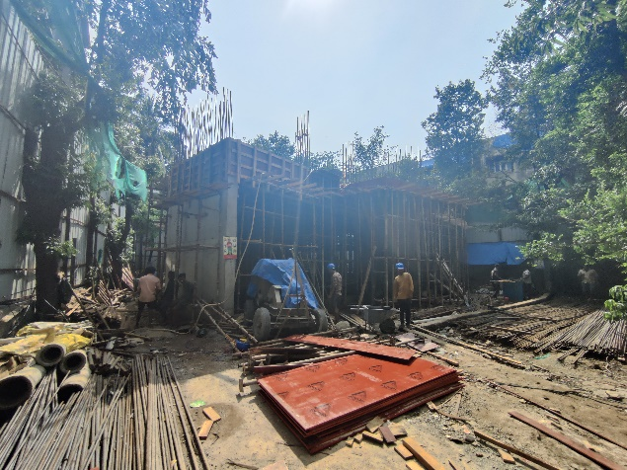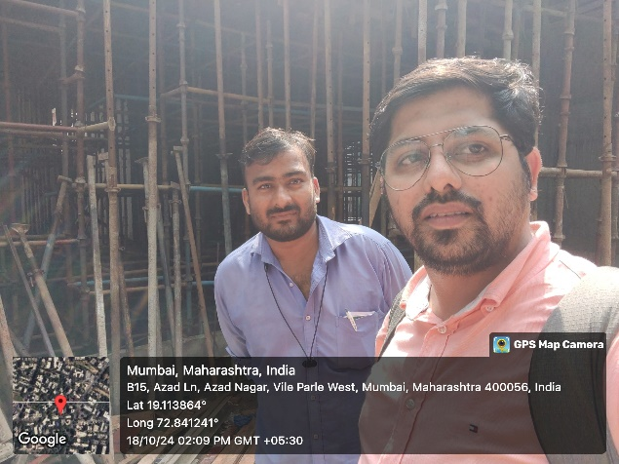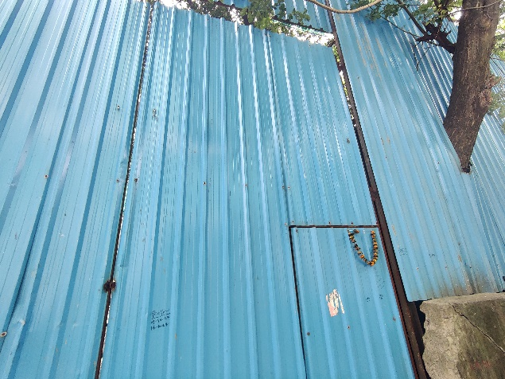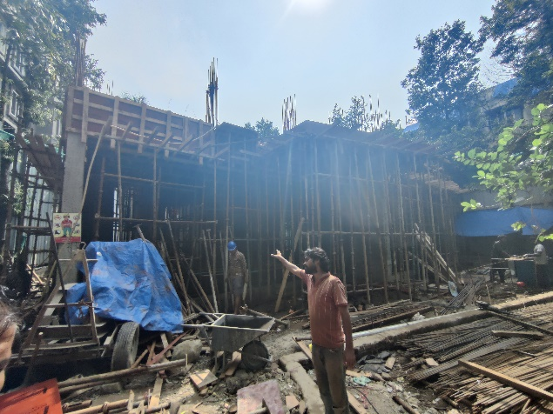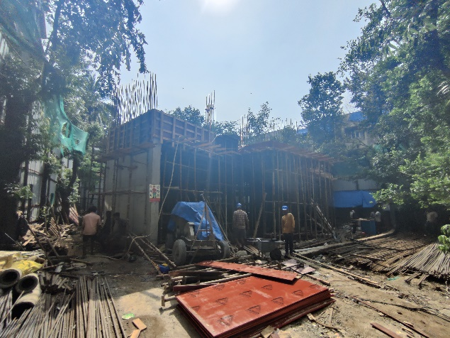

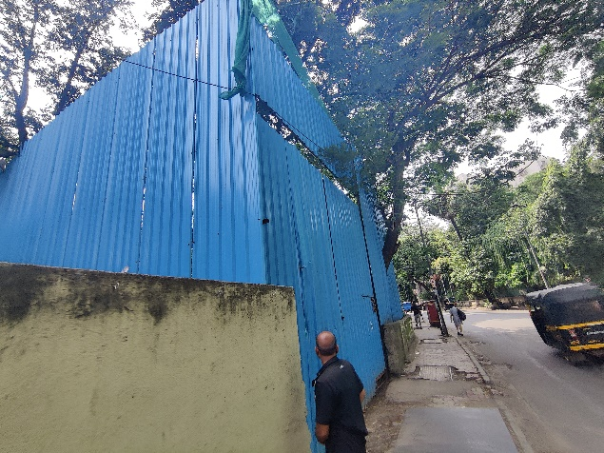

**Route Map of the property**

**Site u/r**

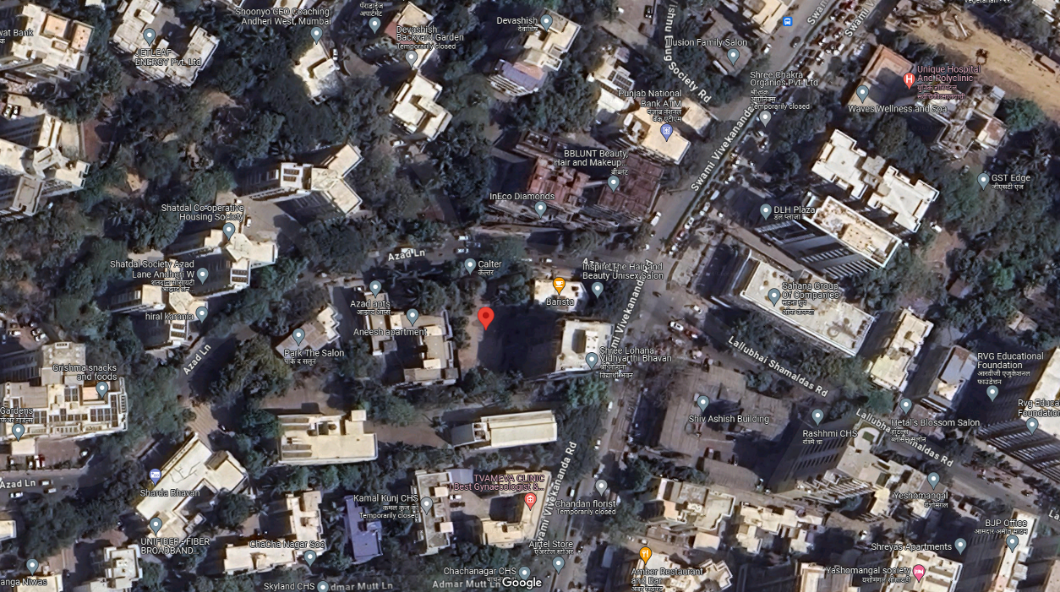

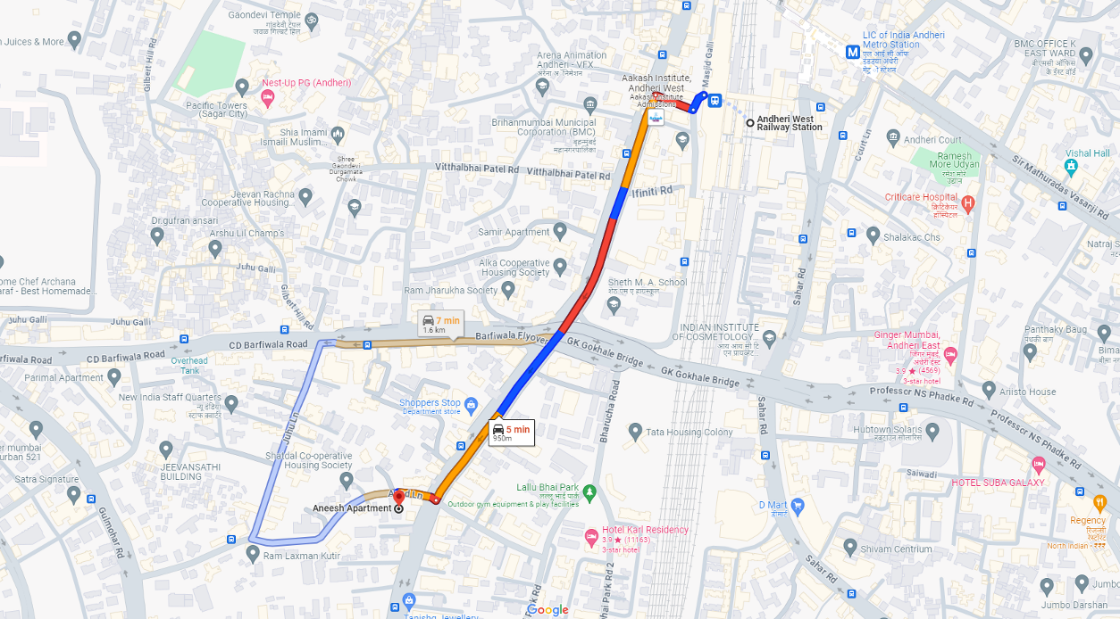

## Latitude Longitude: 19°06'49.2"N 72°50'29.4"E

Note: The Blue line shows the route to site from nearest railway station (Andheri (West) – 950M.)

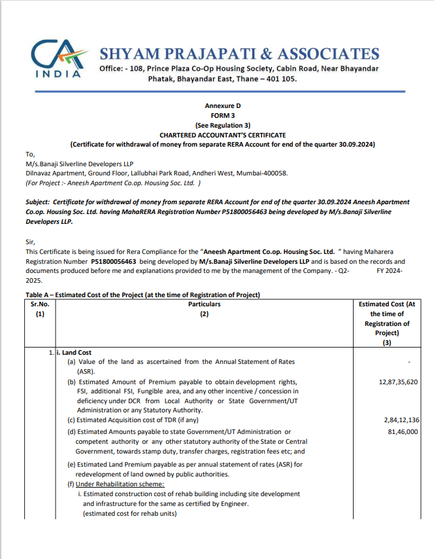**CA Certificate Dated 18.10.2024 till 30.09.2024 issued by M/s. Shyam Prajapati & Associates.**

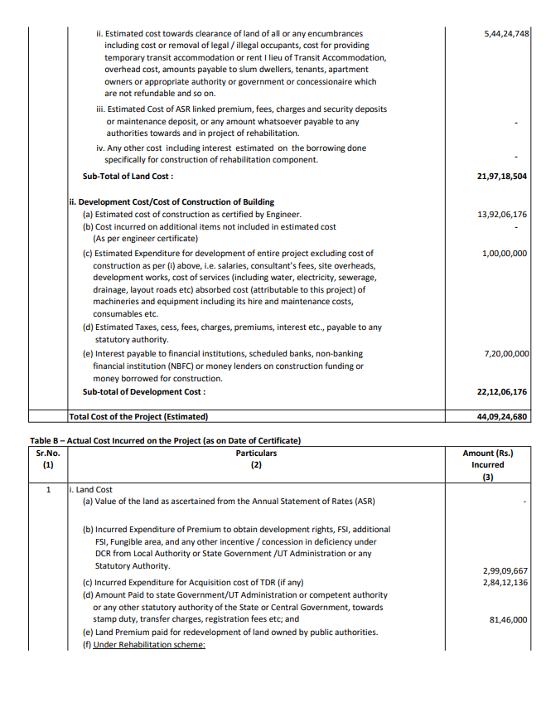**CA Certificate Dated 18.10.2024 till 30.09.2024 issued by M/s. Shyam Prajapati & Associates.**

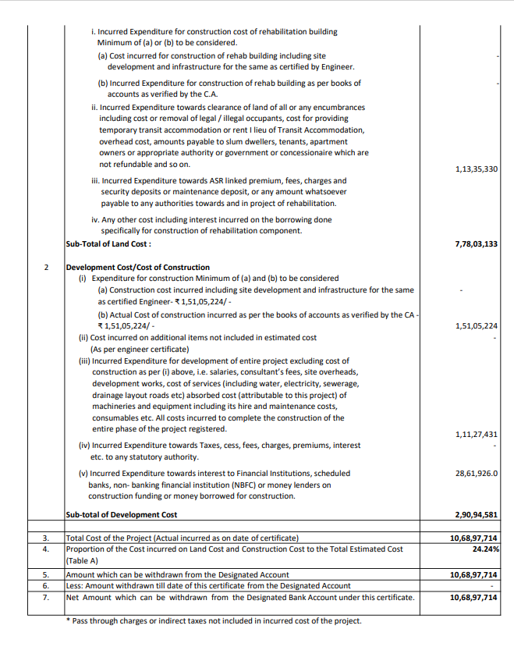**CA Certificate Dated 18.10.2024 till 30.09.2024 issued by M/s. Shyam Prajapati & Associates.**

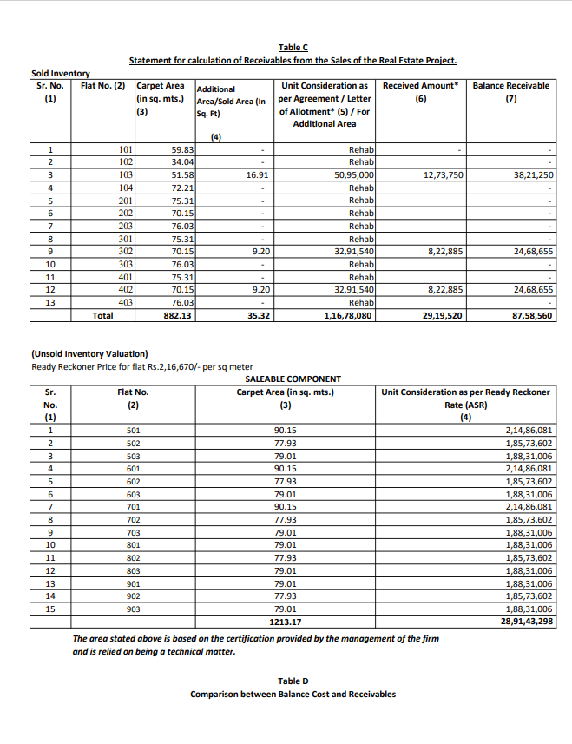**CA Certificate Dated 18.10.2024 till 30.09.2024 issued by M/s. Shyam Prajapati & Associates.**

**CA Certificate Dated 18.10.2024 till 30.09.2024 issued by M/s. Shyam Prajapati & Associates.**

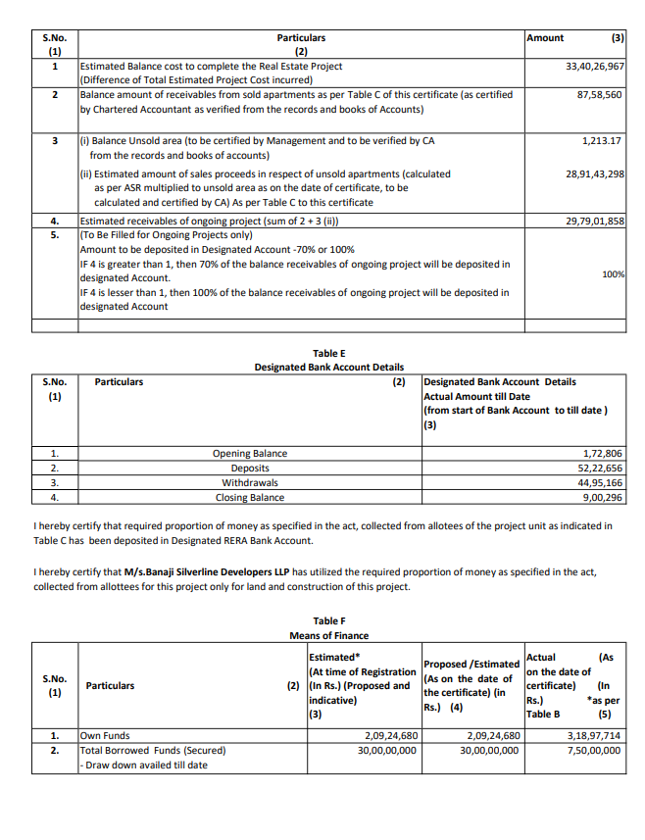

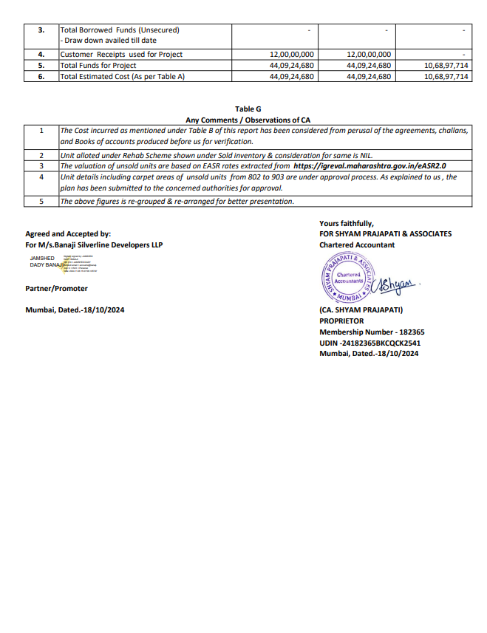**CA Certificate Dated 18.10.2024 till 30.09.2024 issued by M/s. Shyam Prajapati & Associates.**