Vastu/Nashik/01/2025/013833 /2310163
22/12-282-RYBS
Date: 22.01.2025

To, `
The Branch Manager,
State Bank of lndia
RACPC Nashik
1st Floor, Patel Plaza, N.D.Patel Road, Opp BSNL,
Landmark Seawoods Navratna Hotel Nashik-422001.

Sub: Vetting of Supplementary Agreement

Sir,

With reference to above subject, we have evaluated the Vetting of Supplementary Agreement for Residential Row House No. 15, Ground Floor, Type-D, Jadhav Park, Survey No.179/ 2+179/ 3, CTS No. 6482 (P), Behind Manish Hardware, Bajrang Nagar, Prof. Gorakhe Nagar, Keval Park Road, Village - Satpur, Taluka - Nashik, District - Nashik, PIN Code – 422 007, State – Maharashtra, Country – India. belongs Shri. Viki Suklal Mahajan & Sau. Vandana Suklal Mahajan.

We have verified the rates quoted as per current market rates. Details of work and Extra Amenities considered as per copy of Supplementary Agreement issued Shri. Viki Suklal Mahajan & Sau. Vandana Suklal Mahajan (First Party) Mr. Ankit Haribhau Waghchaure (Second Party) received on dated 26.12.2024 The Supplementary Agreement amount is Rs.4,25,000/- (Rupees Four Lakh Twenty Five Only.)

The said Cost Vetting Certificate is valid upto next 6 months Only.

Thanking you

Sincerely yours

Manoj B. Chalikwar
Registered Valuer
Chartered Engineer (India)
Reg. No. CAT-I-F-1763
Reg. No. IBBI/RV/07/2018/10366
BOB Empanelment No.: ZO:MZ:ADV:46:941
Encl: Valuation report.

Supplementary Agreement
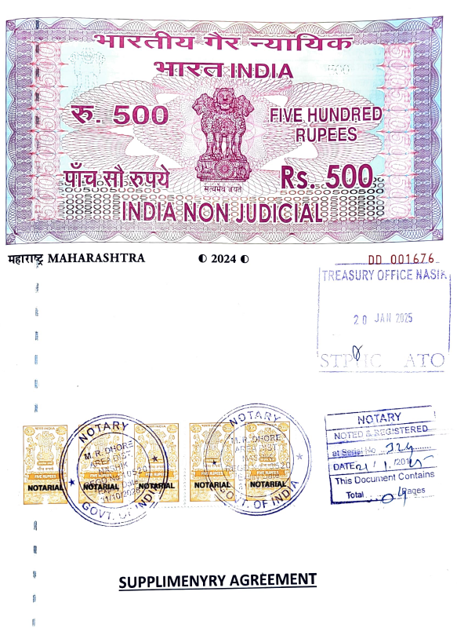
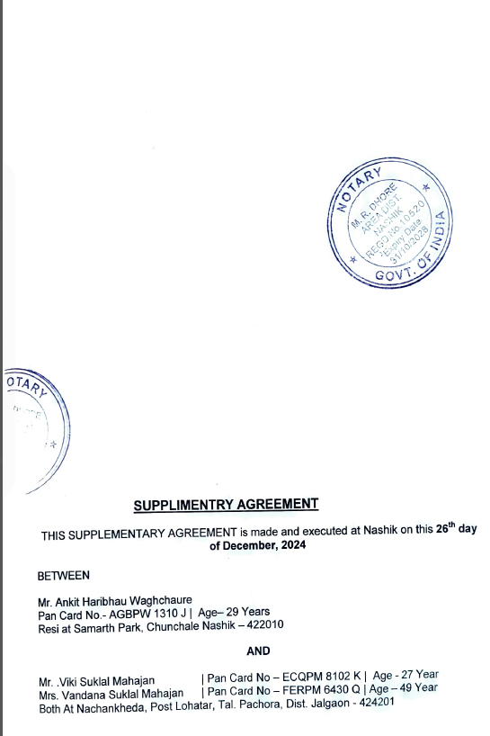

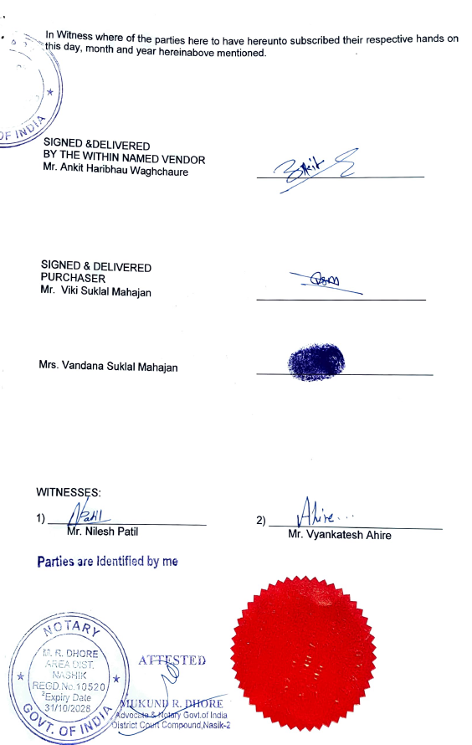
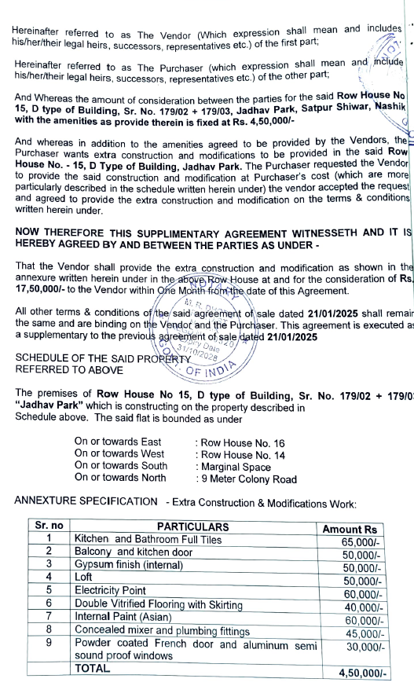

The Extra Amenities amount is Rs.4,25,000/- (Rupees Four Lakh Twenty-Five Only.)

