**Valuation Report of the Immovable Property**

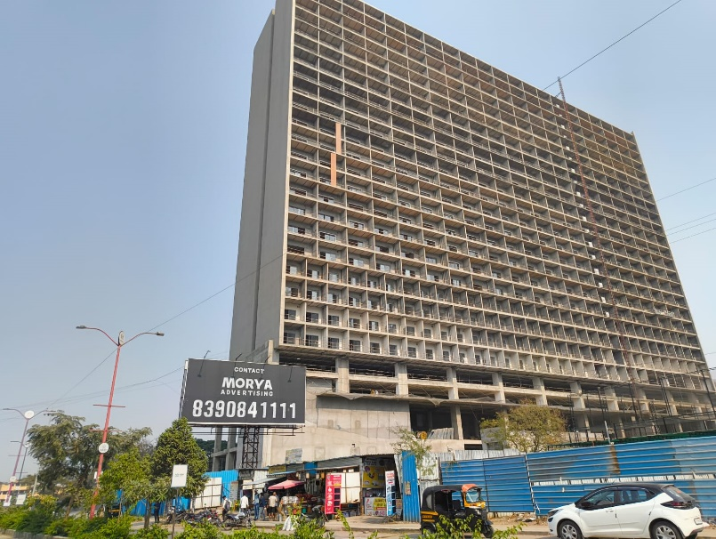

**Details of the property under consideration:**

Name of Owner: **Mrs. Mahajan Prabhawati V.**

Commercial Unit No. 22, 6th Floor, **“Solitaire Business Hub – III, Phase II, Baner”**, Village – Baner, Taluka – Haveli, District – Pune, PIN Code – 411 045, Maharashtra, India

**Latitude Longitude - 18°33'26.1"N 73°47'07.7"E**

**Intended Users:**

**Mrs. Mahajan Prabhawati V.**

Vastu/Nanded/01/2025/013820/2306275

11/02-135-SKVS

Date: 23.01.2025

**VALUATION OPINION REPORT**

This is to certify that the property bearing Commercial Unit No. 22, 6th Floor, **“Solitaire Business Hub – III, Phase II, Baner”**, Village – Baner, Taluka – Haveli, District – Pune, PIN Code – 411 045, Maharashtra, India belongs to **Mrs. Mahajan Prabhawati V.**

|  |  |  |
| --- | --- | --- |
| **Boundaries of the property.** | | |
| North | : | Road | |
| South | : | Trooferz Sports Turf & Club | |
| East | : | Open Land | |
| West | : | Road | |

Considering various parameters recorded, existing economic scenario, and the information that is available with reference to the development of neighbourhood and method selected for valuation, we are of the opinion that, the property premises can be assessed and valued for **Immigration Visa Application** purpose at:

|  |  |  |
| --- | --- | --- |
| Particulars | Value of the property After completion | Proportionate Realizable Value of the property |
| In INR (₹) | ₹ 96,56,000.00 | ₹ 82,07,600.00 |
| In USD (US$) | US$ 111,712.29 | US$ 94,955.45 |

**In ₹ 96,56,000.00 (Rupees Ninety Six Lakh Fifty Six Thousand Only) After completion of construction.** As per Site Inspection, 85% Construction Work is Completed&the proportionate realizable value as on today is **₹ 82,07,600.00 (Rupees Eighty Two Lakhs Seven Thousand Six Hundred Only).**

**In US$ 111,712.29 (United State Dollar One Hundred Eleven Thousand Seven Hundred Twelve Only) After completion.**

**Note: at conversion rate of 1 Indian Rupee equals to 0.012 United States Dollar as on 23.01.2025**

The valuation of the property is based on the documents produced by the concern. Legal aspects have not been taken into considerations while preparing this report.

Hence certified

**Sharadkumar B. Chalikwar**

B.E. (Civil), M.E. (Civil), M.Sc. (Real Estate Valuation),

M.Sc. (P&M Valuation), FIE (I), FIV, FIWRS

Chairman & Managing Director

Govt. Reg. Valuer

Chartered Engineer (India)

Reg. No. (N) CCIT/1-14/52/2008-09

Encl: Valuation report

**VALUATION REPORT IN RESPECT OF IMMOVABLE PROPERTY**

|  |  |  |  |  |  |  |
| --- | --- | --- | --- | --- | --- | --- |
| 1 | Date of Inspection | | 23.01.2025 | | | |
| 2 | Purpose of valuation | | As per request from Private Client - **Mrs. Mahajan Prabhawati V.**, to assess Fair Market Value of the property under reference for **Immigration Visa Application** purpose | | | |
| 3 | Name and address of the Valuer | | **Sharadkumar B. Chalikwar**  **Vastukala Consultants (I) Pvt. Ltd.**  28, Stadium Complex, Gokul Nagar, Nanded – 431602. | | | |
| 4 | List of Documents Handed Over to The Valuer by The Customer:   1. Copy of Agreement for Sale dated 07.01.2022 b/w. Baner Land Developers LLP (Promoter) and Mrs. Mahajan Prabhawati V. (Allottee) 2. Copy of RERA Certificate Document No. P52100025108 dated 08/09/2021 issued by Maharashtra Real Estate Regulatory Authority 3. Copy of Commencement Certificate Document No. CC / 1439 / 21 dated 27.08.2021 issued by Pune Municipal Corporation 4. Copy of Approved Plan Document No. CC / 0055 / 23 dated 10.04.2023 issued by Pune Municipal Corporation. | | | | | |
| 5 | Details of enquiries made/ visited to government offices for arriving fair market value. | | Market analysis | | | |
| 6 | Factors for determining its market value. | | Location, development of surrounding area, type of construction, construction specifications, age of building, condition of the premises & building, facilities provided and its prevailing market rate. | | | |
| 7 | ANY CRITICAL ASPECTS ASSOCIATED WITH PROPERTY | | No | | | |
| 8 | Present/Expected Income from the property | | ₹ 32,000.00 Expected rental income per month.  US$ 370.21 Expected rental income per month. | | | |
|  | **Property Details** | |  | | | |
| 9 | Name(s) of the Owner | | **Mrs. Mahajan Prabhawati V.** | | | |
|  | Address | | Commercial Unit No. 22, 6th Floor, **“Solitaire Business Hub – III, Phase II, Baner”**, Village – Baner, Taluka – Haveli, District – Pune, PIN Code – 411 045, Maharashtra, India | | | |
| 10 | If the property is under joint ownership/ co-ownership share of each such owner/ are the share is undivided. | | Sole Ownership | | | |
| 11 | Brief description of the property. | | The property is a Commercial Unit / Office in under construction Building. The Commercial Unit / Office is located on 6th floor.  At the time of site visit, builder has not allowed for Internal Site Inspection, Measurement & Photographs of the property. Hence, our report is based on external visit & documents provided by bank only.  As per Approved Plan, the composition of Commercial Unit / Office is Office + Balcony Area.  The property is at 9.3 Km. distance from nearest railway station Dapodi.  **At the time of inspection Building was under construction, extent of completion as under:** | | | |
|  | **Stage of Construction** | |  | | | |
|  | **If under construction, extent of completion** | |  | | | |
|  | |  |  |  |  | | --- | --- | --- | --- | | Foundation | **Completed** | RCC Plinth | **Completed** | | Basement | **Completed** | Ground / Stilt | **Completed** | | Podium | **Completed** | RCC Floors | **Completed** | | Internal & External Brick Work | **Completed** | Internal & External Plastering | **Completed** | | Doors & Windows | **Completed** | Flooring | **Completed** | | Plumbing | **Completed** |  |  | | **Total** | **85% Work Completed** |  | | | | | | | |
| 12 | Location of the property (C.T.S. No., Survey No., Hissa No., Plot No., etc.). | | Hissa No. 3, 4, 5, 6 and 7 bearing Survey No. 9 of Village - Baner | | | |
| 13 | **Boundaries** | | **As on site** | **As per documents** | | |
|  | North | | Road | By 18 meter wide Development Plan Road and land bearing Survey No. 8, Baner | | |
|  | South | | Trooferz Sports Turf & Club | By lands out of Survey No. 9/1, 9/2 and 12,Baner | | |
|  | East | | Open Land | By land out of Survey No. 10, Baner | | |
|  | West | | Road | By 24 meter wide Development Plan Road | | |
| 14 | Matching of Boundaries | | - | | | |
| 15 | Route map | | Enclosed | | | |
| 16 | Any specific identification marks | | Opposite Oakwood Hills Society | | | |
| 17 | Whether covered under Corporation/ Panchayat / Municipality. | | Pune Municipal Corporation | | | |
| 18 | Whether covered under any land ceiling of State/ Central Government. | | No | | | |
| 19 | Is the land freehold/ leasehold. | | Freehold | | | |
| 20 | Are there any restrictive covenants in regard to use of Land? If so attach a copy of the covenant. | | As Per Agreement | | | |
| 21 | Type of the property | | Commercial | | | |
| 22 | Year of acquisition/ purchase. | | Sale Deed dated 07.01.2022 | | | |
| 23 | Purchase value as per document | | 73,85,600.00 | | | |
| 24 | Whether the property is occupied by owner or tenant. If occupied by tenant since how long he is staying and the amount of rent being paid. | | Building Under Construction | | | |
| 25 | Classification of the site | |  | | | |
|  | 1. Population group | | Semi Urban | | | |
|  | 1. High/ Middle/ Poor class | | Middle Class | | | |
|  | 1. Residential / Commercial | | Commercial | | | |
|  | 1. Development of surrounding area | | Developed | | | |
|  | 1. Possibility of any threat to the property (Floods, calamities etc.). | | No | | | |
| 26 | Proximity of civic amenities (like school, hospital, bus stop, market etc.). | | Near By | | | |
| 27 | Level of the land (Plain, rock etc.) | | Plain | | | |
| 28 | Terrain of the Land. | | Levelled | | | |
| 29 | Shape of the land (Square/ rectangle etc.). | | Irregular | | | |
| 30 | Type of use to which it can be put (for construction of house, factory etc.). | | Commercial Unit | | | |
| 31 | Whether the plot is under town planning approved layout? | | Information not Available | | | |
| 32 | Whether the building is intermittent or corner? | | Corner | | | |
| 33 | Whether any road facility is available? | | Yes | | | |
| 34 | Type of road available (B.T/Cement Road etc.). | | B.T. Road | | | |
| 35 | Front Width of the Road? | | 9.00 M. Wide Road | | | |
| 36 | Source of water & water potentiality. | | Proposed Municipal Water Supply | | | |
| 37 | Type of Sewerage System. | | Proposed Connected to Municipal Sewerage System | | | |
| 38 | Availability of power supply. | | Building Under Construction | | | |
| 39 | Advantages of the site. | | Located in developed area | | | |
| 40 | Disadvantages of the site. | | No | | | |
| 41 | Give instances of sales of immovable property in the locality on a separate sheet, indicating the name & address of the property, registration No. sale price and area of land sold. | | As per Sub-Registrar of Assurance records | | | |
|  | **Valuation of the property:** | | | | | |
| 42 | Total area of the Commercial Unit / Office | | **Carpet Area in Sq. Ft. = 475.00**  **Attached Balcony Area in Sq. Ft. = 93.00**  **Total Carpet Area in Sq. Ft. = 568.00**  **(Area as per Agreement for Sale)**  Built up Area in Sq. Ft. = 681.60  (Total Carpet Area as per Agreement + 20%) | | | |
| 43 | Prevailing market rate. | | ₹ 17,000.00 per Sq. Ft. on Carpet Area | | | |
| 44 | Floor Rise Rate per Sq. Ft. | | ₹ 0.00 | | | |
| 45 | PLC Rate per Sq. Ft. | | ₹ 0.00 | | | |
| 46 | Total Rate per Sq. Ft. | | ₹ 17,000.00 per Sq. Ft. on Carpet Area | | | |
| 47 | Value of the property | | ₹ **96,56,000.00** | **US$ 111,712.29** | | |
| 48 | The realizable value of the property (90%) | | ₹ **86,90,400.00** | **US$ 100,541.06** | | |
| 49 | Distress value of the property (80%) | | ₹ **77,24,800.00** | **US$ 89,369.83** | | |
| 50 | Insurance value of the property | | ₹ **17,04,000.00** | **US$ 19,713.93** | | |
|  | **Technical details of the building:** | | | | | |
| 51 | Type of building (Residential/ Commercial/ Industrial). | | Commercial | | | |
| 52 | Year of construction. | | Building under construction | | | |
| 53 | Future life of the property. | | 60 years after completion Subject to proper, preventive periodic maintenance & structural repairs. | | | |
| 54 | No. of floors and height of each floor including basement. | | 2 Basement + Lower Ground + Upper Ground + Stilt/Ground + Mezzanine + 2 Level Podium Parking + 1st to 22nd upper floors (As per Approved Plan) | | | |
|  | **Type of construction** | | | | | |
| 55 | (Load bearing/ R.C.C./ Steel framed) | | R.C.C. Framed Structure | | | |
|  | **Condition of the building.** | | | | | |
| 56 | External (excellent/ good/ normal/ poor) | | Building Under Construction | | | |
| 57 | Internal (excellent/ good/ normal/ poor). | | Building Under Construction | | | |
| 58 | Whether the Commercial Unit / Office is constructed strictly according to the sanctioned plan, details of variations noticed if any and effect of the same on the valuation | | N.A., External Site Visit only | | | |
| 59 | **Remarks** |  | | | | |
|  | **Specifications of Construction:** | | | | | |
| **sr.** | **Description** | | **6th Floor** | | | |
| A | Foundation | | R.C.C. Foundation | | | |
| B | Basement | | Yes | | | |
| C | Superstructure | | R.C.C. frame work with 9 inch thick B. B. Masonry for external walls.6 inch thick B.B. Masonry for internal walls | | | |
| D | Joinery/Doors/Windows | | Teakwood door framed with flush doors; Powder coated aluminium sliding windows | | | |
| E | RCC Work | | R.C.C. Framed Structure | | | |
| F | Plastering | | Cement Plastering + POP finish | | | |
| G | Flooring, Skirting | | Verified tiles flooring | | | |
| H | Kitchen Platform | | N.A | | | |
| I | Whether any proof course is provided? | | Yes | | | |
| J | Drainage | | Connected to Municipal Sewerage System | | | |
| K | Compound Wall (Height, length and type of construction) | | N.A | | | |
| L | Electric Installation (Type of wire, Class of construction) | | Proposed Concealed | | | |
| M | Plumbing Installation (No. of closets and wash basins etc.) | | Proposed Concealed | | | |
| N | Bore Well | | Not Provided | | | |
| O | Wardrobes, if any | | N.A. | | | |
| P | Development of open area | | Basement + Stilt Parking, Chequered tile in open spaces, etc. | | | |
|  | **Valuation of proposed construction/ additions/ renovation if any:** | | | | | |
| 60 | **SUMMARY OF VALUATION:** | |  | | | |
|  | Part I Land | | N.A. as composite method is used for valuation | | | |
|  | Part II Building | | ₹  **96,56,000.00** | | | **US$ 111,712.29** |
|  | Part III Other amenities/ Miscellaneous | | ₹ 0.00 | | | |
|  | Part IV Proposed construction | | ₹ 0.00 | | | |
|  | **TOTAL.** | | ₹  **96,56,000.00** | | | **US$ 111,712.29** |
|  | **Calculation:** | | | | | |
| **1** | **Construction** | |  | | | |
| 1.01 | Built up Area of Commercial Unit / Office | | 681.60 Sq. Ft. | | | |
| 1.02 | Rate per Sq. Ft. | | ₹ 2,500.00 | | | |
| 1.03 | Cost of Construction = (1.01x1.02) | | ₹ 17,04,000.00 | | **US$ 19,713.93** | |
| **2** | **Value of property** | |  | | | |
| 2.01 | Carpet Area of Commercial Unit / Office | | 568.00 Sq. Ft. | | | |
| 2.02 | Rate per Sq. Ft. | | ₹ 17,000.00 | | | |
| 2.03 | Value of Commercial Unit / Office (2.01x2.02) | | ₹  **96,56,000.00** | | | **US$ 111,712.29** |
| **3** | **Total value of the property.** | | ₹  **96,56,000.00** | | | **US$ 111,712.29** |

I certify that,

I/ my authorized representative has inspected the subject property on 23.01.2025.

The rates for valuation of the property are in accordance with the prevailing market rates.

There is no direct/ indirect interest in the property valued.

The fair value of the property as on 23.01.2025 is

**In ₹ 96,56,000.00 (Rupees Ninety Six Lakh Fifty Six Thousand Only) After completion of construction.** As per Site Inspection, 85% Construction Work is Completed&the proportionate realizable value as on today is **₹ 82,07,600.00 (Rupees Eighty Two Lakhs Seven Thousand Six Hundred Only).**

**In US$ 111,712.29 (United State Dollar One Hundred Eleven Thousand Seven Hundred Twelve Only) After completion.**

**Note: at conversion rate of 1 Indian Rupee equals to 0.012 United States Dollar as on 23.01.2025**

Date: 23.01.2025

Place: Nanded

**Sharadkumar B. Chalikwar**

B.E. (Civil), M.E. (Civil), M.Sc. (Real Estate Valuation),

M.Sc. (P&M Valuation), FIE (I), FIV, FIWRS

Chairman & Managing Director

Govt. Reg. Valuer

Chartered Engineer (India)

Reg. No. (N) CCIT/1-14/52/2008-09

**Actual site photographs**

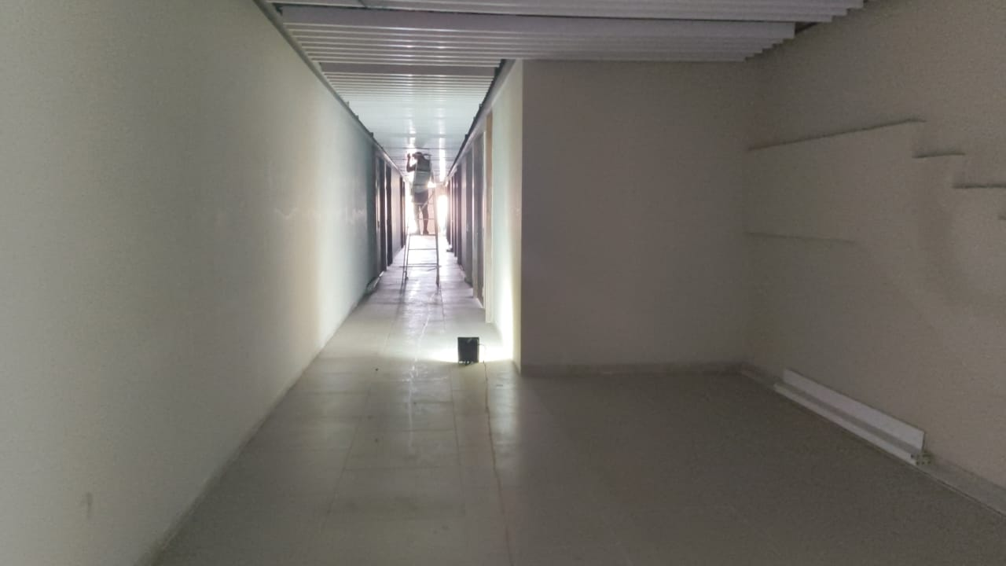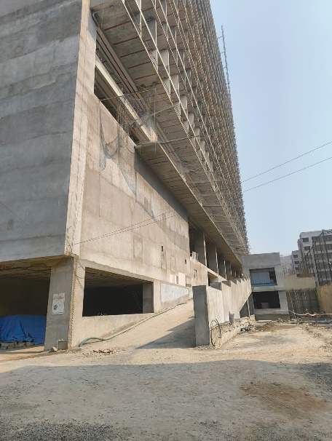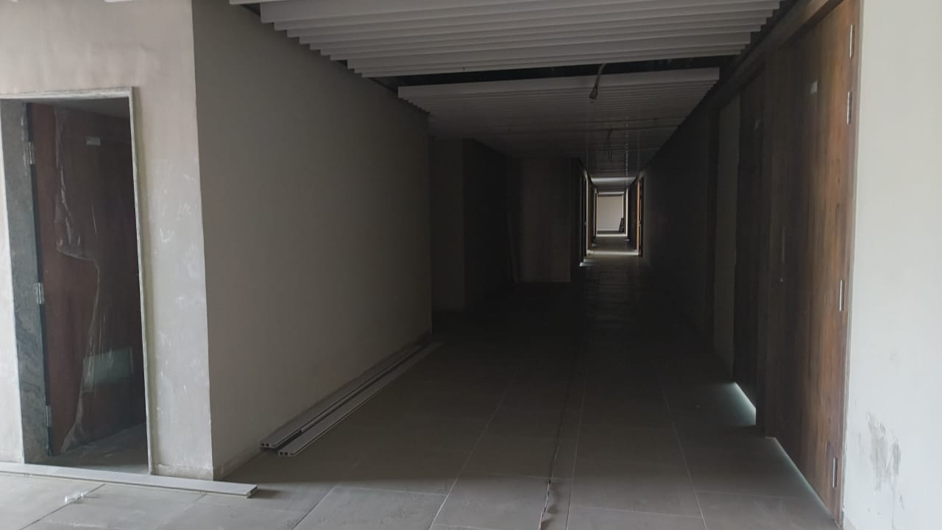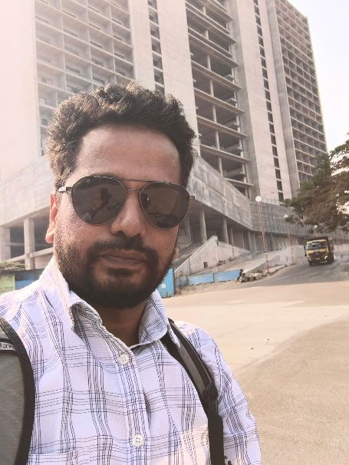

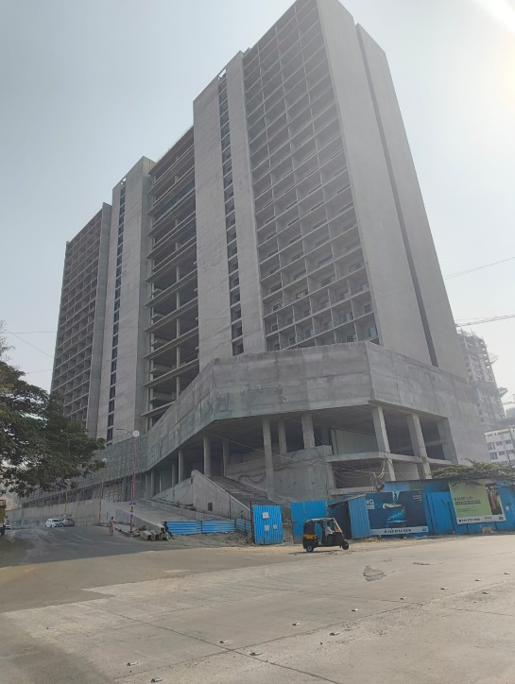

**Route Map of the property**

**Site u/r**

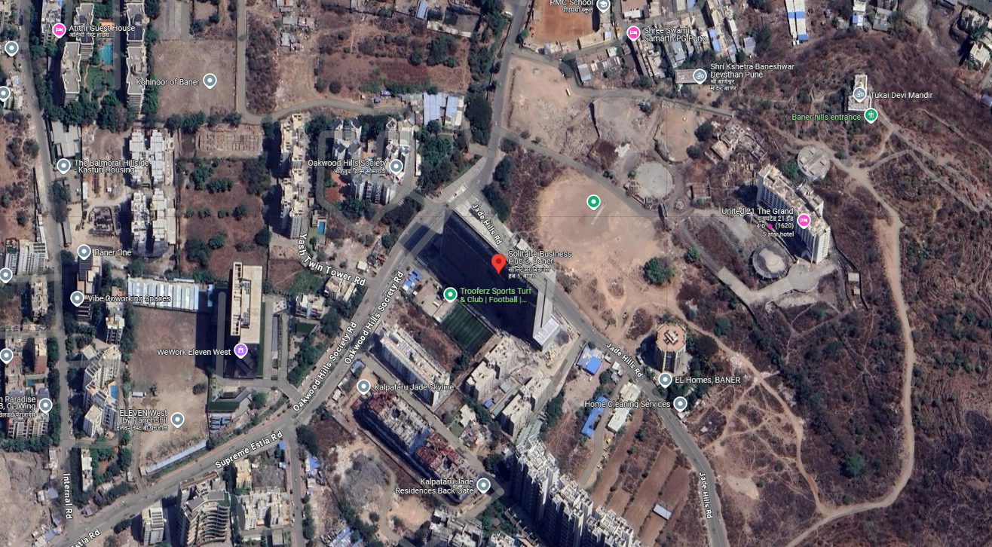

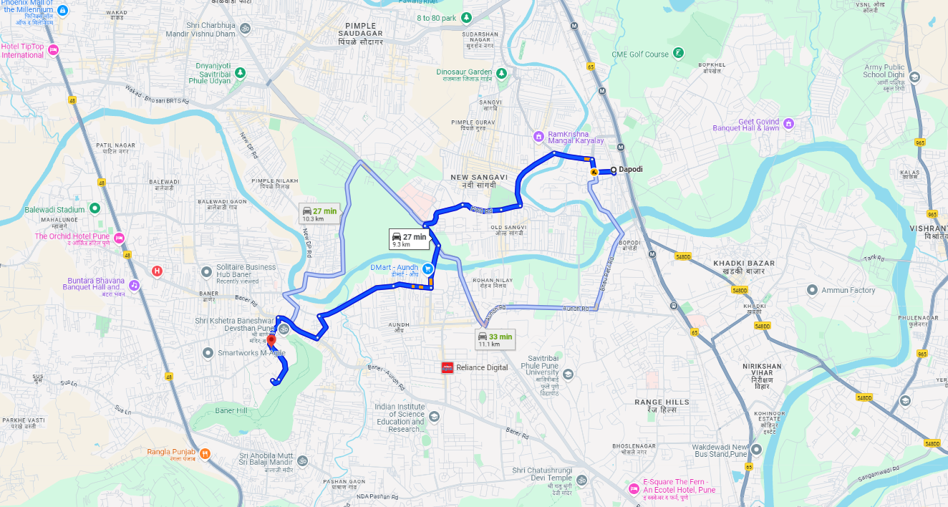

**Longitude Latitude: 18°33'26.1"N 73°47'07.7"E  
Note:** The Blue line shows the route to site from nearest railway station (Dapodi – 9.3 Km.)

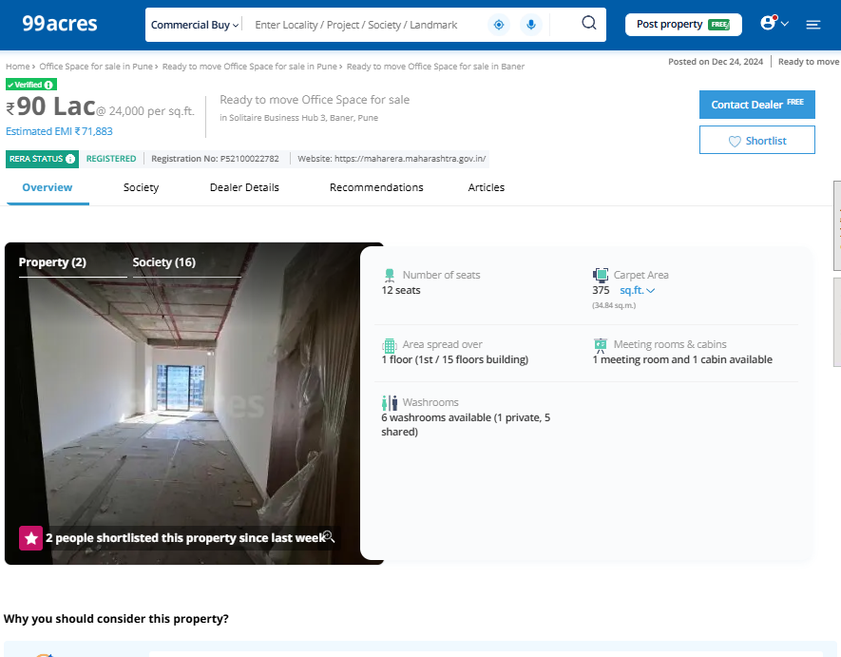**Price Indicators**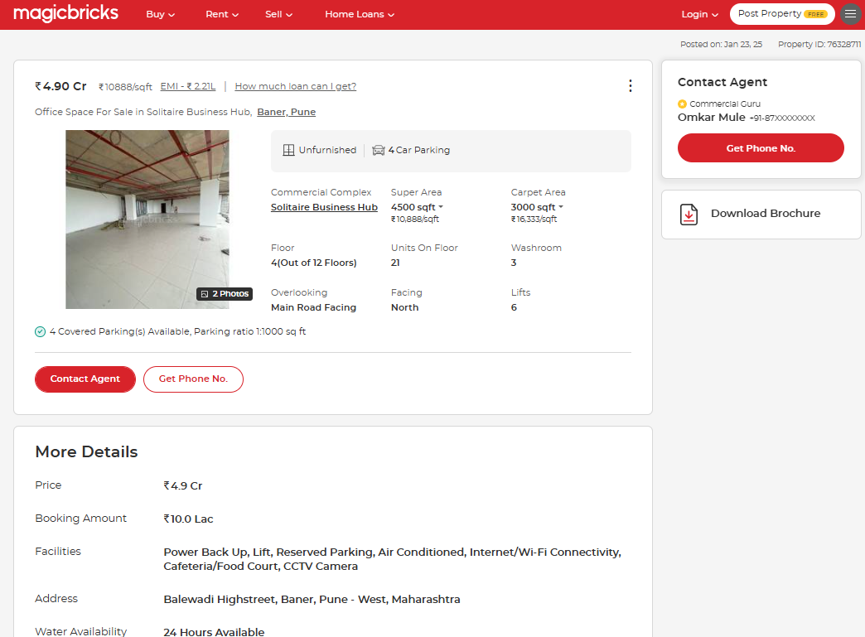

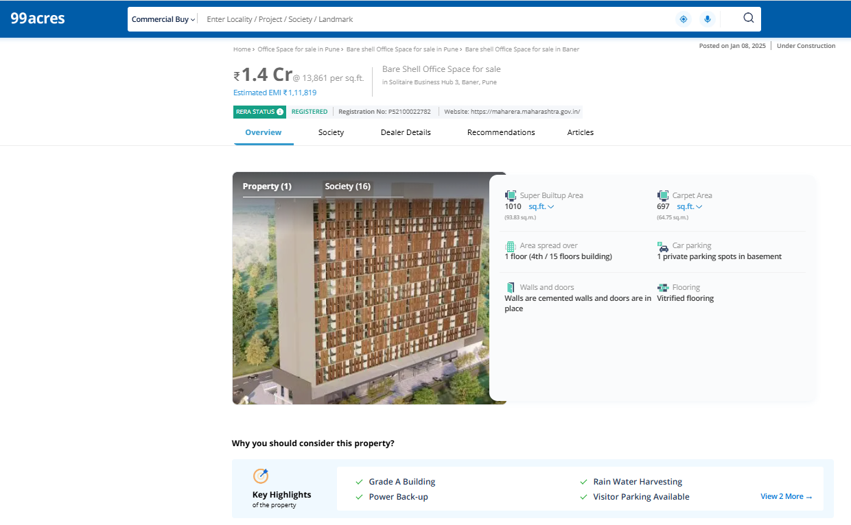**Price Indicators**

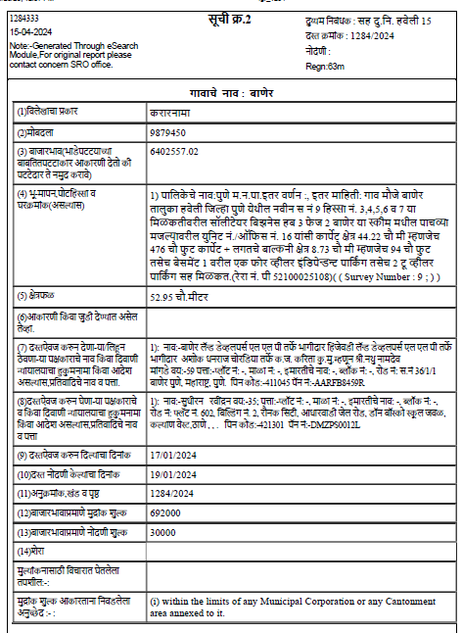**Sale Instances**

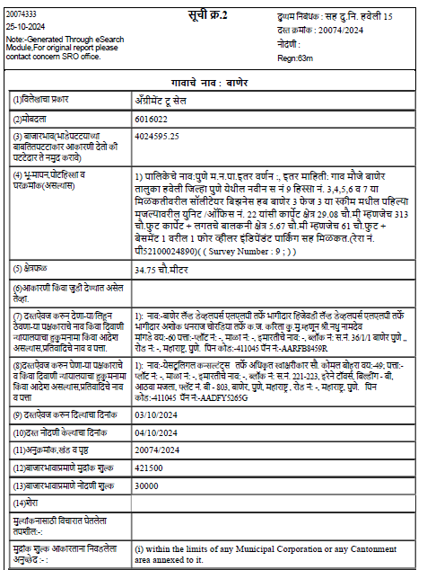**Sale Instances**

**Currency Rate**

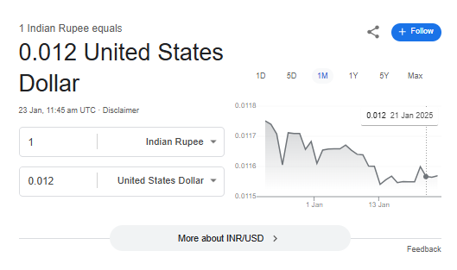

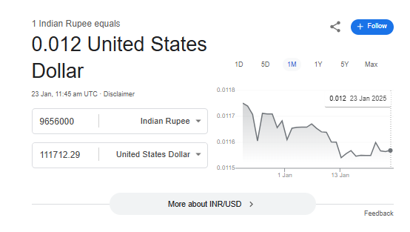

**Ready Reckoner Rate**

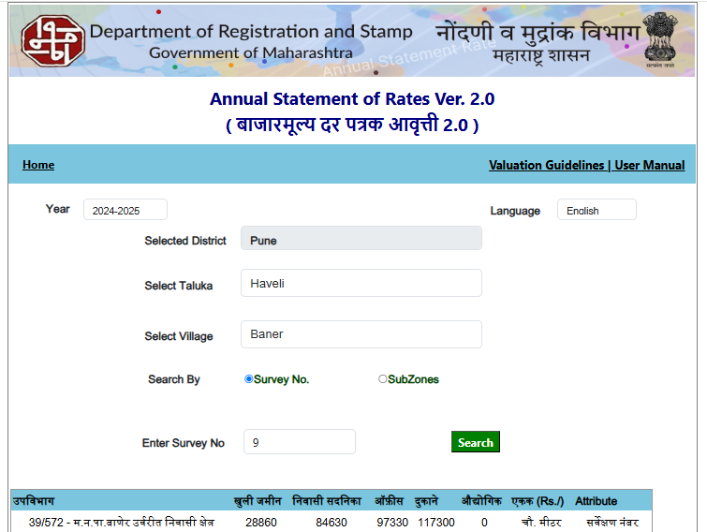

**DEFINITION OF VALUE FOR THIS SPECIFIC PURPOSE**

This exercise is to assess Fair Market Value of the property under reference for **Immigration Visa Application** purpose as on dated **23rd January 2025.**

The term Fair Market Value is defined as

*"The most probable price, as of a specified date, in cash, terms equivalent to cash, or in other precisely revealed terms for which the specified property rights would sell after reasonable exposure in a competitive market under all conditions requisite to a fair sale, with the buyer and seller each acting prudently knowledgeably and for self-interest assuming that neither is under undue duress"*

Fundamental assumptions and conditions presumed in this definition are:

1. Buyer and seller are motivated by self-interest.
2. Buyer and seller are well informed and are acting prudently.
3. The property is exposed for a reasonable time on the open market.
4. Payment is made in cash or equivalent or in specified financing terms.

**ASSUMPTIONS, CAVEATS, LIMITATION AND DISCLAIMERS**

1. We assume no responsibility for matters of legal nature affecting the property appraised or the title thereto, nor do we render our opinion as to the title, which is assumed to be good and marketable.
2. The property is valued as though under responsible ownership.
3. It is assumed that there are no hidden or unapparent conditions of the subsoil or structure that would render it more or less valuable. No responsibility is assumed for such conditions or for engineering that might be required to discover such factors.
4. There is no direct/ indirect interest in the property valued.
5. The rates for valuation of the property are in accordance with the prevailing market rates.

**DECLARATION OF PROFESSIONAL FEES CHARGED**

We hereby declare that; our professional fees are not contingent upon the valuation findings. However, if the statute AND/OR clients demands that, the fees should be charged on the percentage of assessed value then, with the full knowledge of the AND/OR end user, it is being charged accordingly.

**VALUATION OF THE PROPERTY PREMISES**

Considering various parameters recorded herein above, existing economic scenario, and the information that is available with reference to the development of neighbourhood and method selected for valuation, we are of the opinion that, the property premises can be assessed and valued for Visa Application Purpose as on day for

|  |  |  |
| --- | --- | --- |
| Particulars | Value of the property After completion | Proportionate Realizable Value of the property |
| In INR (₹) | ₹ 96,56,000.00 | ₹ 82,07,600.00 |
| In USD (US$) | US$ 111,712.29 | US$ 94,955.45 |

**In ₹ 96,56,000.00 (Rupees Ninety Six Lakh Fifty Six Thousand Only) After completion of construction.** As per Site Inspection, 85% Construction Work is Completed&the proportionate realizable value as on today is **₹ 82,07,600.00 (Rupees Eighty Two Lakhs Seven Thousand Six Hundred Only).**

**In US$ 111,712.29 (United State Dollar One Hundred Eleven Thousand Seven Hundred Twelve Only) After completion.**

**Note: at conversion rate of 1 Indian Rupee equals to 0.012 United States Dollar as on 23.01.2025**

**Sharadkumar B. Chalikwar**

B.E. (Civil), M.E. (Civil), M.Sc. (Real Estate Valuation),

M.Sc. (P&M Valuation), FIE (I), FIV, FIWRS

Chairman & Managing Director

Govt. Reg. Valuer

Chartered Engineer (India)

Reg. No. (N) CCIT/1-14/52/2008-09

Encl: Valuation report