**Valuation Report of the Immovable Property**

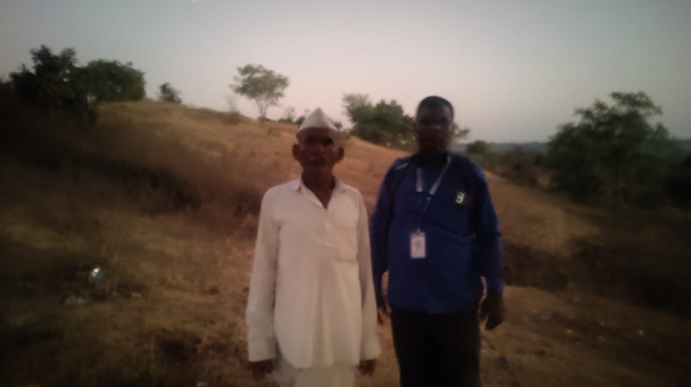

**Details of the property under consideration:**

Name of Owner: **Mr. Vijaykumar Vyankati Mahajan**

Agricultural Land bearing Survey No. 23, Village – Umardari, Taluka – Mukhed, District – Nanded,

Pin Code – 431715, State - Maharashtra, Country – India.

**Latitude Longitude - 18°42'30.5"N 77°23'00.0"E**

**Intended Users:**

**Mr. Vijaykumar Vyankati Mahajan**

**R/O Mahajan Niwas, Kaliji Tekadi Road, Old Mondha, Nanded - 431601**

Vastu/Nanded/01/2024/013816/2310239

25/20-358-SPAS

Date: 24.01.2025

**VALUATION OPINION REPORT**

This is to certify that the property Agricultural Land bearing Survey No. 23, Village – Umardari, Taluka – Mukhed,

District – Nanded, Pin Code – 431715, State - Maharashtra, Country – India belongs to **Mr. Vijaykumar Vyankati Mahajan.**

|  |  |
| --- | --- |
| Boundaries of the property. | |
| North | Shahir Annabhau Sathe Mahavidyalaya |
| South | Land of Narayan Mukkawar |
| East | Land of Garudkar |
| West | Land of Ashok Wanjari |

Considering various parameters recorded, existing economic scenario, and the information that is available with reference to the development of neighbourhood and method selected for valuation, we are of the opinion that, the property premises can be assessed and valued for the specific purpose at

**In ` 5,11,25,000.00 (Rupees Five Crore Eleven Lakh Twenty Five Thousand Only).**

**In US$ 592,770.81 (United State Doller Five Hundred Ninety Two Thousand Seven Hundred Seventy Only).**

**Note: at conversion rate of 1 Indian Rupee equals to 0.012 United States Dollar as on 24.01.2025**

The valuation of the property is based on the documents produced by the concern. Legal aspects have not been taken into considerations while preparing this report.

Hence certified

**Sharadkumar B. Chalikwar**

B.E. (Civil), M.E. (Civil), M.Sc. (Real Estate Valuation),

M.Sc. (P&M Valuation), FIE (I), FIV, FIWRS

Chairman & Managing Director

Govt. Reg. Valuer

Chartered Engineer (India)

Reg. No. (N) CCIT/1-14/52/2008-09

Reg No. IBBI/RV/07/2019/11744

Encl: Valuation report

**VALUATION REPORT IN RESPECT OF IMMOVABLE PROPERTY**

|  |  |  |  |  |  |
| --- | --- | --- | --- | --- | --- |
| 1 | Date of Inspection | | 20.01.2024 | | |
| 2 | Purpose of valuation | | As per the request from Mr. Vijaykumar Vyankati Mahajan, to assess Fair Market Value of the property under reference for **Immigration Visa Application** purpose | | |
| 3 | Name and address of the Valuer | | **Sharadkumar B. Chalikwar**  **Vastukala Consultants (I) Pvt. Ltd.**  28, Stadium Complex, Gokul Nagar, Nanded – 431 602.  Email: nanded@vastukala.co.in | | |
| 4 | List of Documents Handed Over to The Valuer By The Customer:   1. Copy of 7/12 extract. | | | | |
| 5 | Details of enquiries made/ visited to government offices for arriving fair market value. | | Market analysis | | |
| 6 | Factors for determining its market value. | | Location, development of surrounding area, type of construction, construction specifications, age of building, condition of the premises & building, facilities provided and its prevailing market rate. | | |
| 7 | ANY CRITICAL ASPECTS ASSOCIATED WITH PROPERTY | | No | | |
| 8 | Present/Expected Income from the property | | NA | | |
|  | **Property Details** | |  | | |
| 9 | Name(s) of the Owner | | **Mr. Vijaykumar Vyankati Mahajan** | | |
|  | Address | | Agricultural Land bearing Survey No. 23, Village – Umardari, Taluka – Mukhed, District – Nanded, Pin Code – 431715, State - Maharashtra, Country – India. | | |
| 10 | If the property is under joint ownership/ co-ownership share of each such owner/ are the share is undivided. | | Sole Ownership | | |
| 11 | Brief description of the property. | | The property is located in a developing area having well connected by road. It is located at about 1.9 KM. travelling distance from Mukhed Bus Stop.  The property is Agricultural Freehold Land.  **As per 7/12, the land area is 4 Hectare 09 Aar i.e. 10.225 Acres which is considered for the purpose of valuation.** | | |
|  | **If under construction, extent of completion** | | **N.A.** | | |
| 12 | Location of the property (C.T.S. No., Survey No., Hissa No., Plot No., etc.). | | Survey No. 23 of Village – Umardari | | |
| 13 | **Boundaries** | | **As on site** | **As per documents** | |
|  | North | | Shahir Annabhau Sathe Mahavidyalaya | Details not available | |
|  | South | | Land of Narayan Mukkawar | Details not available | |
|  | East | | Land of Garudkar | Details not available | |
|  | West | | Land of Ashok Wanjari | Details not available | |
| 14 | Matching of Boundaries | | - | | |
| 15 | Route map | | Enclosed | | |
| 16 | Any specific identification marks | | NA | | |
| 17 | Whether covered under Corporation/ Panchayat / Municipality. | | Gram Panchayat Umardari | | |
| 18 | Whether covered under any land ceiling of State/ Central Government. | | No | | |
| 19 | Is the land freehold/ leasehold. | | Freehold | | |
| 20 | Are there any restrictive covenants in regard to use of Land? If so attach a copy of the covenant. | | NA | | |
| 21 | Type of the property | | Agricultural | | |
| 22 | Year of acquisition/ purchase. | | Old ancestors’ property | | |
| 23 | Purchase value as per document | | N.A. | | |
| 24 | Whether the property is occupied by owner or tenant. If occupied by tenant since how long he is staying and the amount of rent being paid. | | Under Owner’s possession | | |
| 25 | Classification of the site | |  | | |
|  | 1. Population group | | Rural | | |
|  | 1. High/ Middle/ Poor class | | Middle Class | | |
|  | 1. Residential / Commercial | | Agricultural | | |
|  | 1. Development of surrounding area | | Developing | | |
|  | 1. Possibility of any threat to the property (Floods, calamities etc.). | | No | | |
| 26 | Proximity of civic amenities (like school, hospital, bus stop, market etc.). | | Near By | | |
| 27 | Level of the land (Plain, rock etc.) | | Plain | | |
| 28 | Terrain of the Land. | | Levelled | | |
| 29 | Shape of the land (Square/ rectangle etc.). | | Irregular | | |
| 30 | Type of use to which it can be put (for construction of house, factory etc.). | | Agricultural | | |
| 31 | Whether the plot is under town planning approved layout? | | Agricultural | | |
| 32 | Whether the building is intermittent or corner? | | Intermittent | | |
| 33 | Whether any road facility is available? | | Yes | | |
| 34 | Type of road available (B.T/Cement Road etc.). | | B.T. Road | | |
| 35 | Front Width of the Road? | | 9.00 M. Wide Road | | |
| 36 | Source of water & water potentiality. | | Available | | |
| 37 | Type of Sewerage System. | | N.A. the property under consideration is Agricultural Land Only. | | |
| 38 | Availability of power supply. | | No | | |
| 39 | Advantages of the site. | | Located in developing area | | |
| 40 | Disadvantages of the site. | | No | | |
| 41 | Give instances of sales of immovable property in the locality on a separate sheet, indicating the name & address of the property, registration No. sale price and area of land sold. | | No | | |
|  | **Valuation of the property:** | | | | |
| 42 | Total area of the Agricultural land | | 10.225 Acres | | |
| 43 | Prevailing market rate. | | ` 50,00,000.00 | | |
| 44 | Value of the property | | **₹ 5,11,25,000.00** | **US$ 592,770.81** | |
| 45 | The realizable value of the property (90%) | | **₹ 4,60,12,500.00** | **US$ 533,493.73** | |
| 46 | Distress value of the property (80%) | | **₹ 4,09,00,000.00** | **US$ 474,216.65** | |
| 47 | Insurance value of the property | |  |  | |
|  | **Technical details of the building:** | | | | |
| 48 | Type of building (Residential/ Commercial/ Industrial). | | N.A. the property under consideration is Agricultural Land Only. | | |
| 49 | Year of construction. | | N.A. the property under consideration is Agricultural Land Only. | | |
| 50 | Future life of the property. | | N.A. the property under consideration is Agricultural Land Only. | | |
| 51 | No. of floors and height of each floor including basement. | | N.A. the property under consideration is Agricultural Land Only. | | |
|  | **Type of construction** | | | | |
| 52 | (Load bearing/ R.C.C./ Steel framed) | | N.A. the property under consideration is Agricultural Land Only. | | |
|  | **Condition of the building.** | | | | |
| 53 | External (excellent/ good/ normal/ poor) | | N.A. the property under consideration is Agricultural Land Only. | | |
| 54 | Internal (excellent/ good/ normal/ poor). | | N.A. the property under consideration is Agricultural Land Only. | | |
| 55 | Whether the Residential Flat is constructed strictly according to the sanctioned plan, details of variations noticed if any and effect of the same on the valuation | | N.A. the property under consideration is Agricultural Land Only. | | |
| 56 | **Remarks** |  | | | |
|  | **Specifications of Construction:** | | | | |
| **sr.** | **Description** | | **Not Applicable** | | |
| A | Foundation | | N.A. the property under consideration is Agricultural Land Only. | | |
| B | Basement | | N.A. the property under consideration is Agricultural Land Only. | | |
| C | Superstructure | | N.A. the property under consideration is Agricultural Land Only. | | |
| D | Joinery/Doors/Windows | | N.A. the property under consideration is Agricultural Land Only. | | |
| E | RCC Work | | N.A. the property under consideration is Agricultural Land Only. | | |
| F | Plastering | | N.A. the property under consideration is Agricultural Land Only. | | |
| G | Flooring, Skirting | | N.A. the property under consideration is Agricultural Land Only. | | |
| H | Kitchen Platform | | N.A. the property under consideration is Agricultural Land Only. | | |
| I | Whether any proof course is provided? | | N.A. the property under consideration is Agricultural Land Only. | | |
| J | Drainage | | N.A. the property under consideration is Agricultural Land Only. | | |
| K | Compound Wall (Height, length and type of construction) | | N.A. the property under consideration is Agricultural Land Only. | | |
| L | Electric Installation (Type of wire, Class of construction) | | N.A. the property under consideration is Agricultural Land Only. | | |
| M | Plumbing Installation (No. of closets and wash basins etc.) | | N.A. the property under consideration is Agricultural Land Only. | | |
| N | Bore Well | | N.A. the property under consideration is Agricultural Land Only. | | |
| O | Wardrobes, if any | | N.A. the property under consideration is Agricultural Land Only. | | |
| P | Development of open area | | N.A. the property under consideration is Agricultural Land Only. | | |
|  | **Valuation of proposed construction/ additions/ renovation if any: NO** | | | | |
|  | **Valuation of LAND** | | | | |
|  | **Area of Land in Acres** | | 10.225 Acres | | |
|  | **Rate of Land per Acre** | | ₹ 50,00,000.00 | | |
|  | **Total Value of Land** | | ₹ 5,11,25,000.00 | | |
| 60 | **SUMMARY OF VALUATION:** | |  | | |
|  | Part I Land | | ₹ 5,11,25,000.00 | | US $ **592,770.81** |
|  | **Part II Building** | | N.A. the property under consideration is Agricultural Land Only. | | |
|  | Part III Other amenities/ Miscellaneous | | N.A. the property under consideration is Agricultural Land Only. | | |
|  | Part IV Proposed construction | | N.A. the property under consideration is Agricultural Land Only. | | |
|  | **TOTAL** | | **` 5,11,25,000.00** | | **US$ 592,770.81** |
|  | **Calculation:** | | | | |
| **1** | **Construction** | |  | | |
| 1.01 | Built up Area of Residential Flat | | N.A. the property under consideration is Agricultural Land Only. | | |
| 1.02 | Rate per Sq. Ft. | | N.A. the property under consideration is Agricultural Land Only. | | |
| 1.03 | Cost of Construction = (1.01x1.02) | | N.A. the property under consideration is Agricultural Land Only. | | |
| **2** | **Value of property** | |  | | |
| 2.01 | Built Up Area of Building | | N.A. the property under consideration is Agricultural Land Only. | | |
| 2.02 | Rate per Sq. Ft. | | N.A. the property under consideration is Agricultural Land Only. | | |
| 2.03 | Value of Residential Flat = (2.01x2.02) | |  | |  |
| **3** | **Total value of the property. (Land)** | | **` 5,11,25,000.00** | | **US$ 592,770.81** |

I certify that,

I/ my authorized representative has inspected the subject property on 20.01.2025.

The rates for valuation of the property are in accordance with the prevailing market rates.

There is no direct/ indirect interest in the property valued.

The fair value of the property as on 24.01.2025 is

**In ` 5,11,25,000.00 (Rupees Five Crore Eleven Lakh Twenty Five Thousand Only).**

**In US$ 592,770.81 (United State Doller Five Hundred Ninety Two Thousand Seven Hundred Seventy Only).**

**Note: at conversion rate of 1 Indian Rupee equals to 0.012 United States Dollar as on 24.01.2025**

Date: 24.01.2025

Place: Nanded

**Sharadkumar B. Chalikwar**

B.E. (Civil), M.E. (Civil), M.Sc. (Real Estate Valuation),

M.Sc. (P&M Valuation), FIE (I), FIV, FIWRS

Chairman & Managing Director

Govt. Reg. Valuer

Chartered Engineer (India)

Reg. No. (N) CCIT/1-14/52/2008-09

Reg No. IBBI/RV/07/2019/11744

**Actual site photographs**



**Route Map of the property**

**Site u/r**

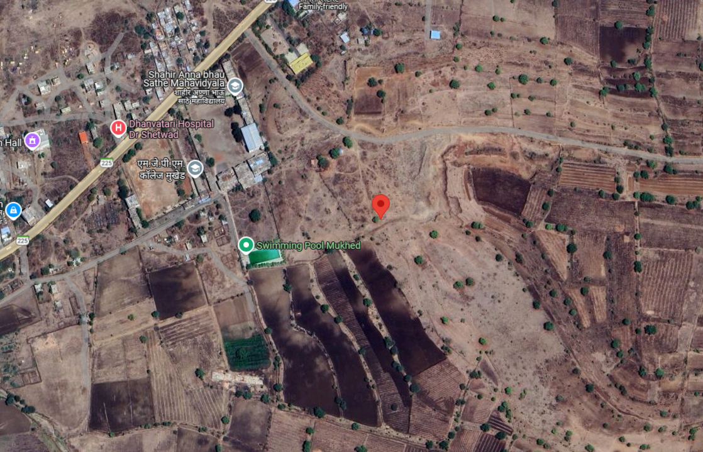

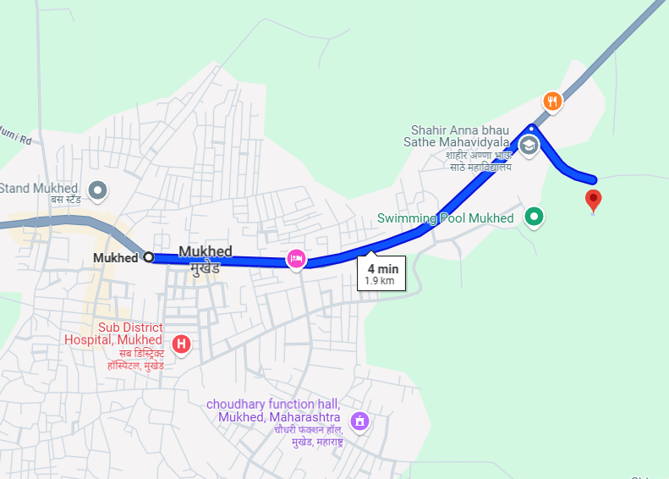

**Latitude Longitude - 18°42'30.5"N 77°23'00.0"E**

**Note**: The Blue line shows the route to site from nearest BUS station – (Mukhed– 1.9 KM)

**Government Ready Reckoner Rate**

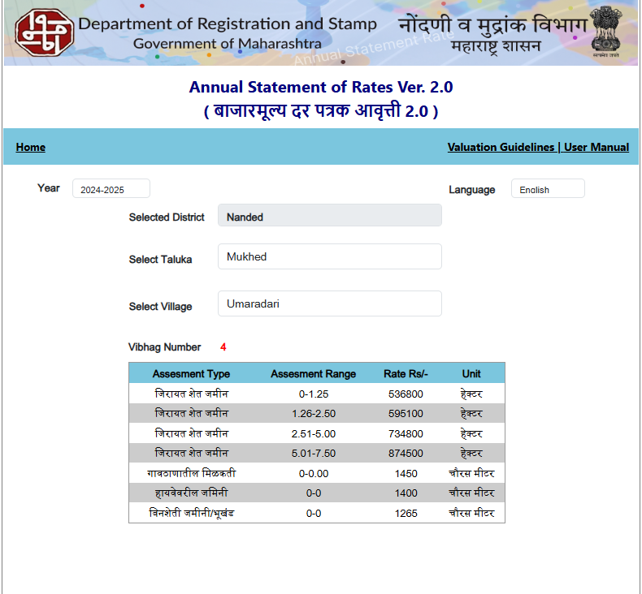

**Currency Rate**

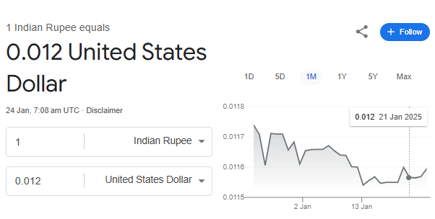

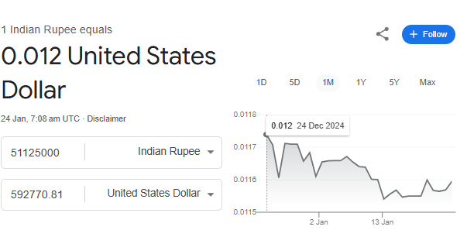

**DEFINITION OF VALUE FOR THIS SPECIFIC PURPOSE**

This exercise is to assess Fair Market Value of the property under reference for **Immigration Visa Application** purpose as on dated **24th January 2025.**

The term Fair Market Value is defined as

*"The most probable price, as of a specified date, in cash, terms equivalent to cash, or in other precisely revealed terms for which the specified property rights would sell after reasonable exposure in a competitive market under all conditions requisite to a fair sale, with the buyer and seller each acting prudently knowledgeably and for self-interest assuming that neither is under undue duress"*

Fundamental assumptions and conditions presumed in this definition are:

1. Buyer and seller are motivated by self-interest.
2. Buyer and seller are well informed and are acting prudently.
3. The property is exposed for a reasonable time on the open market.
4. Payment is made in cash or equivalent or in specified financing terms.

**ASSUMPTIONS, CAVEATS, LIMITATION AND DISCLAIMERS**

1. We assume no responsibility for matters of legal nature affecting the property appraised or the title thereto, nor do we render our opinion as to the title, which is assumed to be good and marketable.
2. The property is valued as though under responsible ownership.
3. It is assumed that there are no hidden or unapparent conditions of the subsoil or structure that would render it more or less valuable. No responsibility is assumed for such conditions or for engineering that might be required to discover such factors.
4. There is no direct/ indirect interest in the property valued.
5. The rates for valuation of the property are in accordance with the prevailing market rates.

**DECLARATION OF PROFESSIONAL FEES CHARGED**

We hereby declare that; our professional fees are not contingent upon the valuation findings. However, if the statute AND/OR clients demand that, the fees should be charged on the percentage of assessed value then, with the full knowledge of the AND/OR end user, it is being charged accordingly.

**VALUATION OF THE PROPERTY PREMISES**

Considering various parameters recorded, existing economic scenario, and the information that is available with reference to the development of neighbourhood and method selected for valuation, we are of the opinion that, the property premises can be assessed and valued for the specific purpose at

**In ` 5,11,25,000.00 (Rupees Five Crore Eleven Lakh Twenty Five Thousand Only).**

**In US$ 592,770.81 (United State Doller Five Hundred Ninety Two Thousand Seven Hundred Seventy Only).**

**Note: at conversion rate of 1 Indian Rupee equals to 0.012 United States Dollar as on 24.01.2025**

**Sharadkumar B. Chalikwar**

B B.E. (Civil), M.E. (Civil), M.Sc. (Real Estate Valuation),

M.Sc. (P&M Valuation), FIE (I), FIV, FIWRS

Chairman & Managing Director

Govt. Reg. Valuer

Chartered Engineer (India)

Reg. No. (N) CCIT/1-14/52/2008-09

Reg No. IBBI/RV/07/2019/11744