**Valuation Report of the Immovable Property**

**Details of the property under consideration:**

Name of Owner: **Mr. Vijaykumar Vyankati Mahajan.**

Agricultural Land Survey No. 23, Village – Umardari, Taluka – Mukhed, District – Nanded,

Pin Code – 431715, State - Maharashtra, Country – India.

**Latitude Longitude - 18°42'30.5"N 77°23'00.0"E**

**Intended Users:**

**Private Clients**

Vastu/Mumbai/05/2024/8648/2306275

11/02-135-SKVS

Date: 11.05.2024

**VALUATION OPINION REPORT**

This is to certify that the property Agricultural Land Survey No. 23, Village – Umardari, Taluka – Mukhed,

District – Nanded, Pin Code – 431715, State - Maharashtra, Country – India.

belongs to **Mr. Vijaykumar Vyankati Mahajan.**

|  |  |
| --- | --- |
| Boundaries of the property. | |
| North | NA |
| South | NA |
| East | NA |
| West | NA |

Considering various parameters recorded, existing economic scenario, and the information that is available with reference to the development of neighbourhood and method selected for valuation, we are of the opinion that, the property premises can be assessed and valued for **Immigration Visa Application** purpose at

**In ` 5,11,25,000.00 (Rupees Five Crore Eleven Lakh Twenty-Five Thousand Only).**

**In US$ 5,91,194.00 (United State Doller Five Lakh Ninety-One Thousand One Hundred Ninety-Four Only).**

**Note: at conversion rate of 1 Indian Rupee equals to 0.012 United States Dollar as on 21.01.2025**

The valuation of the property is based on the documents produced by the concern. Legal aspects have not been taken into considerations while preparing this report.

Hence certified

**Manoj B. Chalikwar**

Registered Valuer

Chartered Engineer (India)

Reg. No. CAT-I-F-1763

Encl: Valuation report.

**VALUATION REPORT IN RESPECT OF IMMOVABLE PROPERTY**

|  |  |  |  |  |  |
| --- | --- | --- | --- | --- | --- |
| 1 | Date of Inspection | | 10.05.2024 | | |
| 2 | Purpose of valuation | | As per request from Private Clients, to assess Fair Market Value of the property under reference for **Immigration Visa Application** purpose | | |
| 3 | Name and address of the Valuer | | **Manoj B. Chalikwar**  **Vastukala Consultants (I) Pvt. Ltd.**  B1-001, U/B Floor, Boomerang, Chandivali Farm Road,  Powai, Andheri (East), Mumbai - 400 072.  Email: mumbai@vastukala.org | | |
| 4 | List of Documents Handed Over to The Valuer By The Customer:   1. Copy of 7/12 extract. | | | | |
| 5 | Details of enquiries made/ visited to government offices for arriving fair market value. | | Market analysis | | |
| 6 | Factors for determining its market value. | | Location, development of surrounding area, type of construction, construction specifications, age of building, condition of the premises & building, facilities provided and its prevailing market rate. | | |
| 7 | ANY CRITICAL ASPECTS ASSOCIATED WITH PROPERTY | | No | | |
| 8 | Present/Expected Income from the property | | NA | | |
|  | **Property Details** | |  | | |
| 9 | Name(s) of the Owner | | **Mr. Vijaykumar Vyankati Mahajan.** | | |
|  | Address | | Agricultural Land Survey No. 23, Village – Umardari, Taluka – Mukhed, District – Nanded, Pin Code – 431715, State - Maharashtra, Country – India. | | |
| 10 | If the property is under joint ownership/ co-ownership share of each such owner/ are the share is undivided. | | Joint Ownership | | |
| 11 | Brief description of the property. | | NA We Consider Only Land for Valuation | | |
|  | **If under construction, extent of completion** | | **N.A.** | | |
| 12 | Location of the property (C.T.S. No., Survey No., Hissa No., Plot No., etc.). | | Survey No. 23 of Village – Umardari | | |
| 13 | **Boundaries** | | **As on site** | **As per documents** | |
|  | North | | NA | Details not available | |
|  | South | | NA | Details not available | |
|  | East | | NA | Details not available | |
|  | West | | NA | Details not available | |
| 14 | Matching of Boundaries | | - | | |
| 15 | Route map | | Enclosed | | |
| 16 | Any specific identification marks | | NA | | |
| 17 | Whether covered under Corporation/ Panchayat / Municipality. | | Gram Panchayat Umardari | | |
| 18 | Whether covered under any land ceiling of State/ Central Government. | | No | | |
| 19 | Is the land freehold/ leasehold. | | Freehold | | |
| 20 | Are there any restrictive covenants in regard to use of Land? If so attach a copy of the covenant. | | NA | | |
| 21 | Type of the property | | Agricultural | | |
| 22 | Year of acquisition/ purchase. | | - | | |
| 23 | Purchase value as per document | | - | | |
| 24 | Whether the property is occupied by owner or tenant. If occupied by tenant since how long he is staying and the amount of rent being paid. | | Owner Occupied | | |
| 25 | Classification of the site | |  | | |
|  | 1. Population group | | Rural | | |
|  | 1. High/ Middle/ Poor class | | Middle Class | | |
|  | 1. Residential / Commercial | | Agricultural | | |
|  | 1. Development of surrounding area | | Developing | | |
|  | 1. Possibility of any threat to the property (Floods, calamities etc.). | | No | | |
| 26 | Proximity of civic amenities (like school, hospital, bus stop, market etc.). | | Near By | | |
| 27 | Level of the land (Plain, rock etc.) | | Plain | | |
| 28 | Terrain of the Land. | | Levelled | | |
| 29 | Shape of the land (Square/ rectangle etc.). | | Irregular | | |
| 30 | Type of use to which it can be put (for construction of house, factory etc.). | | Residential House | | |
| 31 | Whether the plot is under town planning approved layout? | | Information not Available | | |
| 32 | Whether the building is intermittent or corner? | | Intermittent | | |
| 33 | Whether any road facility is available? | | Yes | | |
| 34 | Type of road available (B.T/Cement Road etc.). | | B.T. Road | | |
| 35 | Front Width of the Road? | | 9.00 M. Wide Road | | |
| 36 | Source of water & water potentiality. | | No | | |
| 37 | Type of Sewerage System. | | Connected to Nagar Parishad Sewerage System | | |
| 38 | Availability of power supply. | | No | | |
| 39 | Advantages of the site. | | Located in developing area | | |
| 40 | Disadvantages of the site. | | No | | |
| 41 | Give instances of sales of immovable property in the locality on a separate sheet, indicating the name & address of the property, registration No. sale price and area of land sold. | | No | | |
|  | **Valuation of the property:** | | | | |
| 42 | Total area of the Residential Flat | | **NA** | | |
| 43 | Prevailing market rate. | | ` 0.00 | | |
| 44 | Floor Rise Rate per Sq. Ft. | | ` 0.00 | | |
| 45 | PLC Rate per Sq. Ft. | | ` 0.00 | | |
| 46 | Total Rate per Sq. Ft. | | ` 0.00 | | |
| 47 | Value of the property | | **₹ 5.11,25,000.00** | **US$ 5,91,194.00** | |
| 48 | The realizable value of the property (90%) | | **₹ 4,60,12,500.00** | **US$ 5,32,075.00** | |
| 49 | Distress value of the property (80%) | | **₹ 4,09,00,000.00** | **US$ 4,72,955.00** | |
| 50 | Insurance value of the property | |  |  | |
|  | **Technical details of the building:** | | | | |
| 51 | Type of building (Residential/ Commercial/ Industrial). | | NA | | |
| 52 | Year of construction. | | NA | | |
| 53 | Future life of the property. | | Information Not Available | | |
| 54 | No. of floors and height of each floor including basement. | | - | | |
|  | **Type of construction** | | | | |
| 55 | (Load bearing/ R.C.C./ Steel framed) | | - | | |
|  | **Condition of the building.** | | | | |
| 56 | External (excellent/ good/ normal/ poor) | | NA | | |
| 57 | Internal (excellent/ good/ normal/ poor). | | NA | | |
| 58 | Whether the Residential Flat is constructed strictly according to the sanctioned plan, details of variations noticed if any and effect of the same on the valuation | | Not Applicable, We Are doing valuation for Land Only | | |
| 59 | **Remarks** |  | | | |
|  | **Specifications of Construction:** | | | | |
| **sr.** | **Description** | | **Not Applicable** | | |
| A | Foundation | | No | | |
| B | Basement | | No | | |
| C | Superstructure | | No | | |
| D | Joinery/Doors/Windows | | No | | |
| E | RCC Work | | No | | |
| F | Plastering | | No | | |
| G | Flooring, Skirting | | No | | |
| H | Kitchen Platform | | No | | |
| I | Whether any proof course is provided? | | No | | |
| J | Drainage | | No | | |
| K | Compound Wall (Height, length and type of construction) | | No | | |
| L | Electric Installation (Type of wire, Class of construction) | | Open | | |
| M | Plumbing Installation (No. of closets and wash basins etc.) | | Open | | |
| N | Bore Well | | Not Provided | | |
| O | Wardrobes, if any | | No | | |
| P | Development of open area | | No | | |
|  | **Valuation of proposed construction/ additions/ renovation if any: NO** | | | | |
|  | **Valuation of LAND** | | | | |
|  | **Area of Land in Acres** | | 10.225 Acre i.e., 4.09 Ha. | | |
|  | **Rate of Land per Acre** | | ₹ 50,00,000.00 | | |
|  | **Total Value of Land** | | ₹ 5,11,25,000.00 | | |
| 60 | **SUMMARY OF VALUATION:** | |  | | |
|  | Part I Land | | ₹ 5,11,25,000.00 | | US $ 5,91,194.00 |
|  | **Part II Building** | | **Not Applicable** | |  |
|  | Part III Other amenities/ Miscellaneous | | ` 0.00 | | |
|  | Part IV Proposed construction | | ` 0.00 | | |
|  | **TOTAL.** | | **` 5,11,25,000.00** | | **US$ 5,91,194.00** |
|  | **Calculation:** | | | | |
| **1** | **Construction** | |  | | |
| 1.01 | Built up Area of Residential Flat | | NA | | |
| 1.02 | Rate per Sq. Ft. | | NA | | |
| 1.03 | Cost of Construction = (1.01x1.02) | | NA | | |
| **2** | **Value of property** | |  | | |
| 2.01 | Built Up Area of Building | | NA | | |
| 2.02 | Rate per Sq. Ft. | | NA | | |
| 2.03 | Value of Residential Flat = (2.01x2.02) | |  | |  |
| **3** | **Total value of the property. (Land)** | | **` 5,11,25,000.00** | | **US$ 5,91,194.00** |

I certify that,

I/ my authorized representative has inspected the subject property on 10.05.2024.

The rates for valuation of the property are in accordance with the prevailing market rates.

There is no direct/ indirect interest in the property valued.

The fair value of the property as on 21.01.2025 is

**In ` 5,11,25,000.00 (Rupees Five Crore Eleven Lakh Twenty-Five Thousand Only).**

**In US$ 5,91,194.00 (United State Doller Five Lakh Ninety-One Thousand One Hundred Ninety-Four Only).**

**Note: at conversion rate of 1 Indian Rupee equals to 0.012 United States Dollar as on 21.01.2025**

Date: 21.01.2025

Place: Mumbai

**Manoj B. Chalikwar**

Registered Valuer

Chartered Engineer (India)

Reg. No. CAT-I-F-17631930

**Actual site photographs**

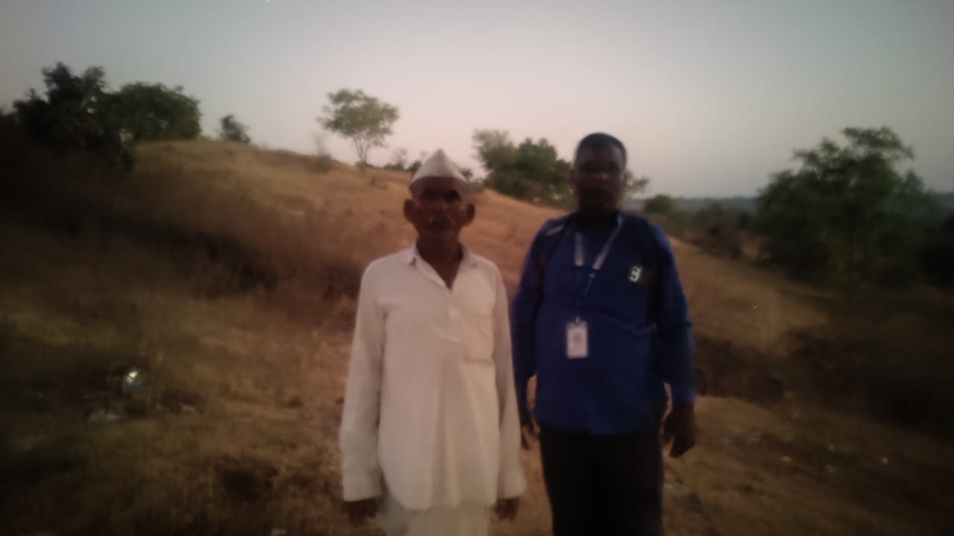

**Route Map of the property**

**Site u/r**

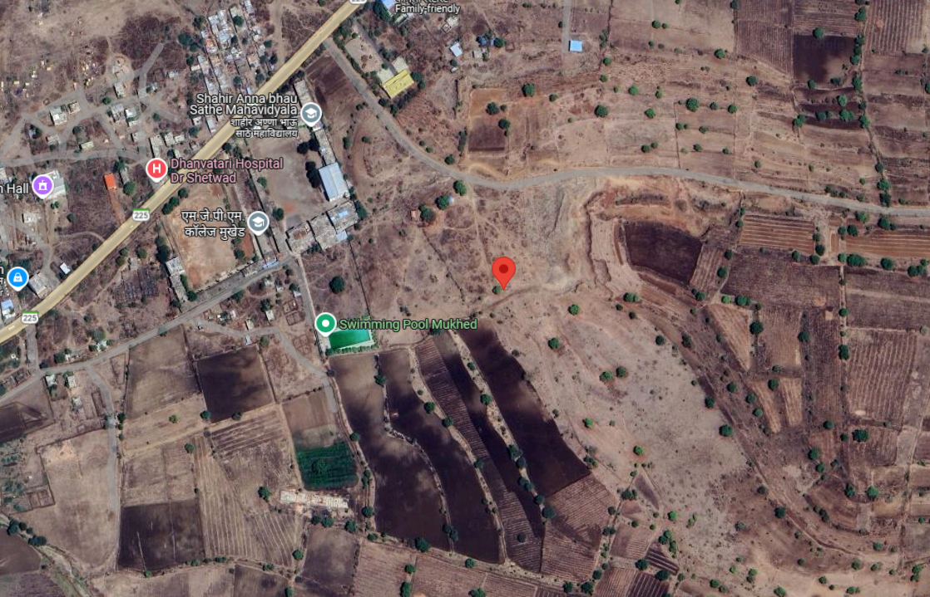

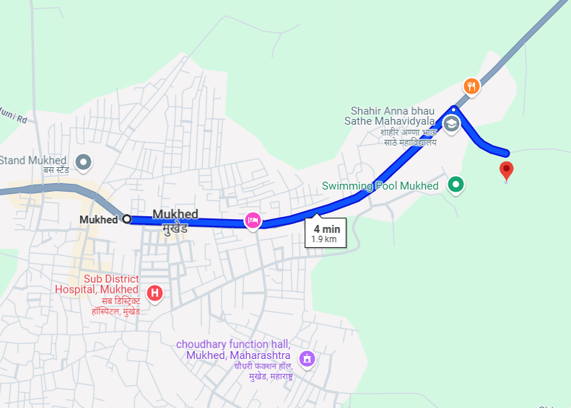

**Latitude Longitude - 18°42'30.5"N 77°23'00.0"E**

**Note**: The Blue line shows the route to site from nearest BUS station – (Mukhed– 1.9 KM)

**Currency Rate**

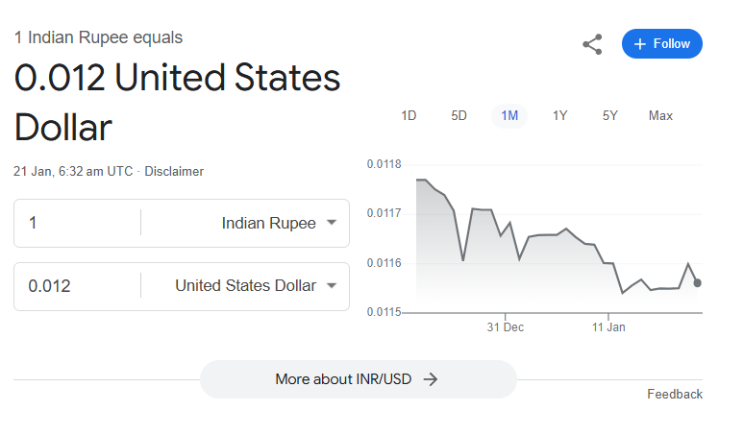

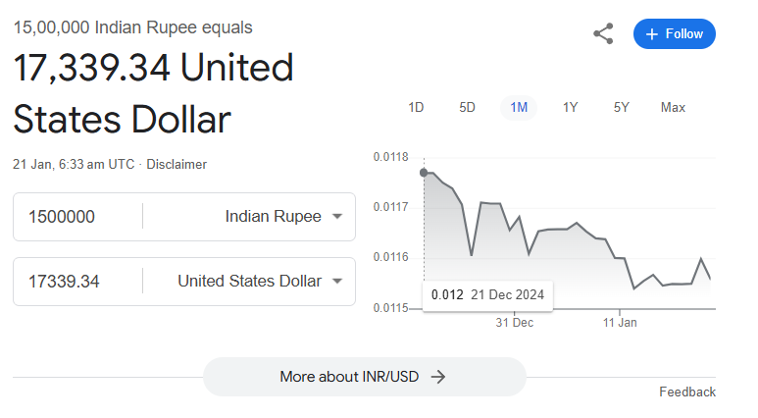

**DEFINITION OF VALUE FOR THIS SPECIFIC PURPOSE**

This exercise is to assess Fair Market Value of the property under reference for **Immigration Visa Application** purpose as on dated **21st January 2025.**

The term Fair Market Value is defined as

*"The most probable price, as of a specified date, in cash, terms equivalent to cash, or in other precisely revealed terms for which the specified property rights would sell after reasonable exposure in a competitive market under all conditions requisite to a fair sale, with the buyer and seller each acting prudently knowledgeably and for self-interest assuming that neither is under undue duress"*

Fundamental assumptions and conditions presumed in this definition are:

1. Buyer and seller are motivated by self-interest.
2. Buyer and seller are well informed and are acting prudently.
3. The property is exposed for a reasonable time on the open market.
4. Payment is made in cash or equivalent or in specified financing terms.

**ASSUMPTIONS, CAVEATS, LIMITATION AND DISCLAIMERS**

1. We assume no responsibility for matters of legal nature affecting the property appraised or the title thereto, nor do we render our opinion as to the title, which is assumed to be good and marketable.
2. The property is valued as though under responsible ownership.
3. It is assumed that there are no hidden or unapparent conditions of the subsoil or structure that would render it more or less valuable. No responsibility is assumed for such conditions or for engineering that might be required to discover such factors.
4. There is no direct/ indirect interest in the property valued.
5. The rates for valuation of the property are in accordance with the prevailing market rates.

**DECLARATION OF PROFESSIONAL FEES CHARGED**

We hereby declare that; our professional fees are not contingent upon the valuation findings. However, if the statute AND/OR clients demand that, the fees should be charged on the percentage of assessed value then, with the full knowledge of the AND/OR end user, it is being charged accordingly.

**VALUATION OF THE PROPERTY PREMISES**

Considering various parameters recorded herein above, existing economic scenario, and the information that is available with reference to the development of neighbourhood and method selected for valuation, we are of the opinion that, the property premises can be assessed and valued for Visa Application Purpose as on day for **In ` 5,11,25,000.00 (Rupees Five Crore Eleven Lakh Twenty-Five Thousand Only).**

**In US$ 5,91,194.00 (United State Doller Five Lakh Ninety-One Thousand One Hundred Ninety-Four Only).**

**Note: at conversion rate of 1 Indian Rupee equals to 0.012 United States Dollar as on 21.01.2025**

**Manoj B. Chalikwar**

Registered Valuer

Chartered Engineer (India)

Reg. No. CAT-I-F-1763

**The Indian Institution of Valuers Certificate**

